Western Australia
WORKPLACE AGREEMENTS ACT 1993

Workplace Agreements Regulations 1993
Section 4A of the Workplace Agreements Act 1993 which gives effect to these regulations expired on 14 Sep 2003

Western Australia
Workplace Agreements Regulations 1993
Contents
Part 1 — Preliminary
1. Citation 1
2. Commencement 1
Part 2 — Lodgement of agreements for registration or approval
3. Lodgement of agreements for registration or approval 2
Part 3 — Notice of industrial action
5. Notices of intention to take industrial action 4
Part 4 — Miscellaneous
6. Keeping of employment records 5
7. Employers in the public sector 5
Schedule 1
Notes
Compilation table 17

Western Australia
WORKPLACE AGREEMENTS ACT 1993
Workplace Agreements Regulations 1993

Part 1 — Preliminary

1. Citation
These regulations may be cited as the Workplace Agreements Regulations 1993.

2. Commencement
These regulations come into operation on the day on which the Workplace Agreements Act 1993 comes into operation.

Part 2 — Lodgement of agreements for registration or approval
[Heading inserted in Gazette 9 June 1998 p.3145.]

3. Lodgement of agreements for registration or approval
(1) This regulation applies to an agreement that is —
(a) a workplace agreement;
(b) an agreement under section 23 (1) or 24 (1) of the Act;
(c) a collective workplace agreement to which Part 2A of the Act applies; or
(d) an agreement under section 23 (1) of the Act as applied by section 40J (1) of the Act.
(2) A person who wishes to lodge an agreement with the Commissioner for registration, or with the Tribunal for approval, as is applicable to the case, must do so in accordance with subregulations (3), (4) and (5).
(3) An agreement must be accompanied by a completed application to register or to approve, as is applicable to the case, in the form of Form 1 in Schedule 1 unless the Commissioner is of the view that the information required to be set out in Form 1 is adequately contained in the lodged agreement or in any other accompanying document.
(4) A collective workplace agreement to which Part 2A of the Act applies or an agreement under section 23 (1) as applied by section 40J (1) of the Act must be accompanied by the information required to be set out in Form 2 in Schedule 1.
(5) An agreement or any accompanying form or document may be lodged —
(a) by presenting a signed copy of it at the Commissioner’s registry office between the hours of 8.30 a.m. and 5.00 p.m. from Monday to Friday, except on a day that is a public holiday or a public service holiday;
(b) by posting a signed copy of it by registered post addressed to the Commissioner’s registry office; or
(c) by sending a facsimile of the original document by facsimile transmission to the Commissioner’s registry office.
(6) Unless the contrary is proved, lodgement of an agreement or any accompanying form or document by registered post is to be treated as being effected at the time when the post would have been delivered in the ordinary course of delivery of registered post.
(7) Where an agreement or any accompanying form or document (“document”) is sent by facsimile transmission, lodgement of the document is to be treated as being effected upon completion of the transmission of the document unless it is subsequently established by or on behalf of the Commissioner that the document was not in fact received by the registry office facsimile machine or that the facsimile received was not legible or complete.
(8) The Commissioner may refuse to accept an agreement for registration or lodgement unless —
(a) it is typed on one side only of the paper; and
(b) it is in the English language.
[Regulation 3 inserted in Gazette 9 June 1998 pp.3145-6.]

[4. Repealed in Gazette 9 June 1998 p.3145.]

Part 3 — Notice of industrial action

5. Notices of intention to take industrial action
(1) A notice under section 79 (1) of the Act of intention to take industrial action is to be —
(a) in the form of Form 3 in Schedule 1; and
(b) served on a party —
(i) by delivering it to the party personally;
(ii) by sending it by registered post to the party’s usual or last known place of abode, or if he or she is the principal of a business, at the party’s usual or last known place of business;
(iii) where the party is a corporation or an association of persons (whether incorporated or not), by delivering or leaving the notice or sending the notice by registered post, addressed in each case to the corporation or association at its principal place of business or principal office in the State; or
(iv) by sending it by facsimile transmission to the party’s facsimile machine number.
(2) Unless the contrary is proved, service by registered post is to be treated as being effected at the time when the post would have been delivered in the ordinary course of delivery of registered post.
(3) Where the notice is sent by facsimile transmission, service of the notice is to be treated as being effected upon completion of the transmission unless it is subsequently established by the party to be served that the notice was not in fact received by the party’s facsimile machine or that the facsimile received was not legible or complete.
[Regulation 5 amended in Gazette 9 June 1998 p.3146.]

Part 4 — Miscellaneous

6. Keeping of employment records
For the purposes of section 47 (3) (a) of the Act, records must be —
(a) in a form that is legible and prepared using indelible material; or
(b) stored in an electronic form that is capable of being reproduced in a legible printed format,
and made, in relation to each payment to the employee, within 14 days of the payment.

7. Employers in the public sector
(1) This regulation —
(a) applies to a workplace agreement to which a person who comes within section 43 (1) of the Act is a party; and
(b) prescribes who is to be the employer of any such person for the purposes of section 44 (1) of the Act.
(2) If in law the person has a contract of employment the employer is the employer under that contract.
(3) If in law the person does not have a contract of employment the employer is the person who has power to appoint or employ the person or persons of the category to which the person belongs.
(4) If under subregulation (2) or (3) the Governor would otherwise be the employer, the employer is the Minister responsible for the administration of the government department, body, agency, or establishment in which the person principally carries out his or her duties.
(5) The fact that a person is prescribed as an employer by this regulations is not to be read limiting the exercise of any power of delegation that the person has under a written law.
[Regulation 7 inserted by Gazette 22 February 1994 p.723.]

Schedule 1
FORMS
Form 1
[reg. 3 (3)]
Workplace Agreements Act 1993 sections 29 and 40F
APPLICATION FOR REGISTRATION OR APPROVAL OF AGREEMENT
Please complete sections 1 - 7 inclusive
1. I/we wish to have the attached agreement registered as (where applicable):
An individual workplace agreement.
A collective workplace agreement (other than an agreement intended to prevail over a federal award).
An agreement under section 23 (1) of the Act (addition of party or parties to a collective workplace agreement).
An agreement under section 24 (1) of the Act (cancellation of a workplace agreement).
A collective workplace agreement or addition to a collective workplace agreement intended to prevail over a federal award. (If this option is ticked, a Form 2 must also be complete. See Employer Guide for details).
2. EMPLOYER (complete below or state page number in agreement where details are found).
COMPANY NAME (Pty. Ltd., Ltd., Inc. or individual’s name)
TRADING NAME
BUSINESS ADDRESS
MAILING ADDRESS
(if different)
Postcode:
PHONE
CONTACT NAME & POSITION
3. EMPLOYEE(S)
Attach typed schedule OR state page of agreement where details are found OR enter details on reverse of this form.
4. A party requests a meeting with the Commissioner/Tribunal. Indicate name(s) if ticked. [] if yes
5. Have you previously lodged a workplace agreement with this office?
[] if yes
6. Is the employer a public sector agency? [] if yes
7. Signature(s) of applicant (s)
……………………………………………………………………………..
Date
……………………………………………………………………………..
Name(s) (PLEASE PRINT)
If this form is lodged by a bargaining agent authorized to do so
Name of bargaining agent: ………………………………………………
Address for service: ……………………………………………………….
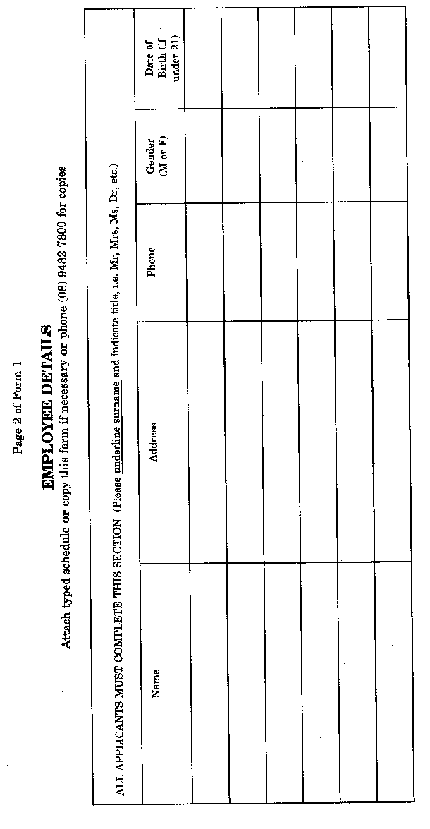
Form 2
[reg. 3 (4)]
Workplace Agreements Act 1993 section 40F
INFORMATION FOR TRIBUNAL’S CONSIDERATION UNDER SECTION 40G
Page 1
Please complete sections 1 - 5 inclusive
See Employer Guide for more information on what the Tribunal needs to be satisfied of when approving a workplace agreement under section 40G of the Act.
1. List in full the award or awards that cover the employees’ work.

2. What is the employees’ award classification? (If employees are on different classifications please list the award classification and title for each employee).

3. How was the effect of the workplace agreement explained to the employees? (e.g. by written information, informal discussions, informal meetings).

4. Has the employer offered a workplace agreement in the same terms to all employees doing the same kind of work as the employees covered by this application?

[] if yes

If no, what are the reasons?

Page 2 of Form 2
COMPLETE THIS PAGE FOR EACH AWARD CLASSIFICATION GROUP WHERE TERMS AND CONDITIONS ARE THE SAME
Please make copies of this page if necessary or phone
(08) 9482 7800 for copies.

5. Describe how the workplace agreement differs from the award in relation to the following 4 matters:
 | Award | Workplace Agreement
Pay (e.g. base rates, allowances, shift/overtime/ penalty rates, casual rates.)
Hours (e.g. ordinary time hours of work, span of hours, rest breaks.)
Leave (e.g. annual leave, personal/carer’s leave, sick leave, long service leave.)
Other main differences
(e.g. new classifications, superannuation.)
6. I declare that the information provided on this form is provided in good faith and to the best of my knowledge is true and correct.

Name of person making declaration:

.................................................................... ....................................................
Full name (PLEASE PRINT) (Position)

.................................................................... ....................................................
(Signature) (Date)
If this form is lodged by a bargaining agent authorized to do so
Name of bargaining agent: .................................................................................
Address for service: ...........................................................................................
Form 3
[reg. 5 (1) (a)]
Workplace Agreements Act 1993 section 79 (1)
NOTICE OF INTENTION TO TAKE INDUSTRIAL ACTION
Expired workplace agreement No. of 19
Date of expiry …………………
To: ......................................................................................................................
............................................................................................................................
............................................................................................................................
(Name and address of party to be served)
Take notice that ..................................................................................................
............................................................................................................................
............................................................................................................................
(Name(s) of party or parties intending to take industrial action)
intend(s) to take industrial action for the purpose of obtaining a new workplace agreement in place of the expired workplace agreement specified above.
Nature of proposed industrial action ..................................................................
............................................................................................................................
............................................................................................................................
............................................................................................................................
Place/places of proposed industrial action .........................................................
............................................................................................................................
............................................................................................................................
Commencement date and time of proposed industrial action ............................
............................................................................................................................
............................................................................................................................
Duration of proposed industrial action ..............................................................
............................................................................................................................
(Attach schedule if insufficient space for details)
………………………………….
Signature(s) of party or parties
intending to take industrial action
………………………………….
Date
(Attach schedule if insufficient space
for all signatures on this form)
If this form is lodged by a bargaining agent authorized to do so
Name of bargaining agent: .................................................................................
Address for service: ...........................................................................................
— See over for information as to service of notices —
Page 2 of Form 3
A notice in this form must be served at least 7 days before the commencement of the proposed industrial action.
Service of notices
Regulation 5 (1) (b) of the Workplace Agreements Regulations 1993 provides that a notice under section 79 (1) of the Act of intention to take industrial action is to be served on a party —
(a) by delivering it to the party personally;
(b) by sending it by registered post to the party’s usual or last known place of abode, or if he or she is the principal of a business, at the party’s usual or last known place of business;
(c) where the party is a corporation or an association of persons (whether incorporated or not), by delivering or leaving the notice or sending the notice by registered post, addressed in each case to the corporation or association at its principal place of business or principal office in the State; or
(d) by sending it by facsimile transmission to the party’s facsimile machine number.
[Schedule 1 amended in Gazette 9 June 1998 pp.3146-50.]

Notes
^{1.} This is a compilation of the Workplace Agreements Regulations 1993 and includes the amendments referred to in the following Table.

Compilation table
Citation | Gazettal | Commencement
Workplace Agreements Regulations 1993 | 30 Nov 1993 pp.6443-48 | 1 Dec 1993 (see regulation 2 and Gazette 30 Nov 1993 p.6439)
Workplace Agreements Amendment Regulations 1994 | 22 Feb 1994 p.723 | 22 February 1994
Workplace Agreements Amendment Regulations (No. 2) 1994 | 23 Dec 1994 p.7082 | 23 Dec 1994
Workplace Agreements Amendment Regulations 1998 | 9 Jun 1998 pp.3145-50 | 9 Jun 1998
Section 4A of the Workplace Agreements Act 1993 which gives effect to these regulations expired on 14 Sep 2003

