Western Australia
Country Areas Water Supply Act 1947

Fitzroy Crossing Water Reserve Order 2009

Western Australia
Fitzroy Crossing Water Reserve Order 2009
Contents
1. Citation 1
2. Commencement 1
3. Fitzroy Crossing Water Reserve boundary altered 1
4. Information plan of the Fitzroy Crossing Water Reserve 2
Schedule 1 — Fitzroy Crossing Water Reserve
Notes
Compilation table 4

Western Australia
Country Areas Water Supply Act 1947
Fitzroy Crossing Water Reserve Order 2009
Made by the Governor in Executive Council under section 9(1) of the Act.

1. Citation
This order is the Fitzroy Crossing Water Reserve Order 2009.

2. Commencement
This order comes into operation as follows —
(a) clauses 1 and 2 — on the day on which this order is published in the Gazette;
(b) the rest of the order — on the day after that day.

3. Fitzroy Crossing Water Reserve boundary altered
The boundaries of the water reserve called the Fitzroy Crossing Water Reserve are altered from those —
(a) shown bordered _________ on the Department of Water plan 4573; and
(b) constituted and defined by Order in Council published in the Gazette 27 March 1975,
to those —
(c) shown bordered in bold, enclosing a variety of shaded areas, on the Department of Water plan 4573; and
(d) outlined by means of coordinates annexed to that plan.

4. Information plan of the Fitzroy Crossing Water Reserve
The boundary of the Fitzroy Crossing Water Reserve is shown, for information purposes, in the plan in Schedule 1.

Schedule 1 — Fitzroy Crossing Water Reserve
[cl. 4]
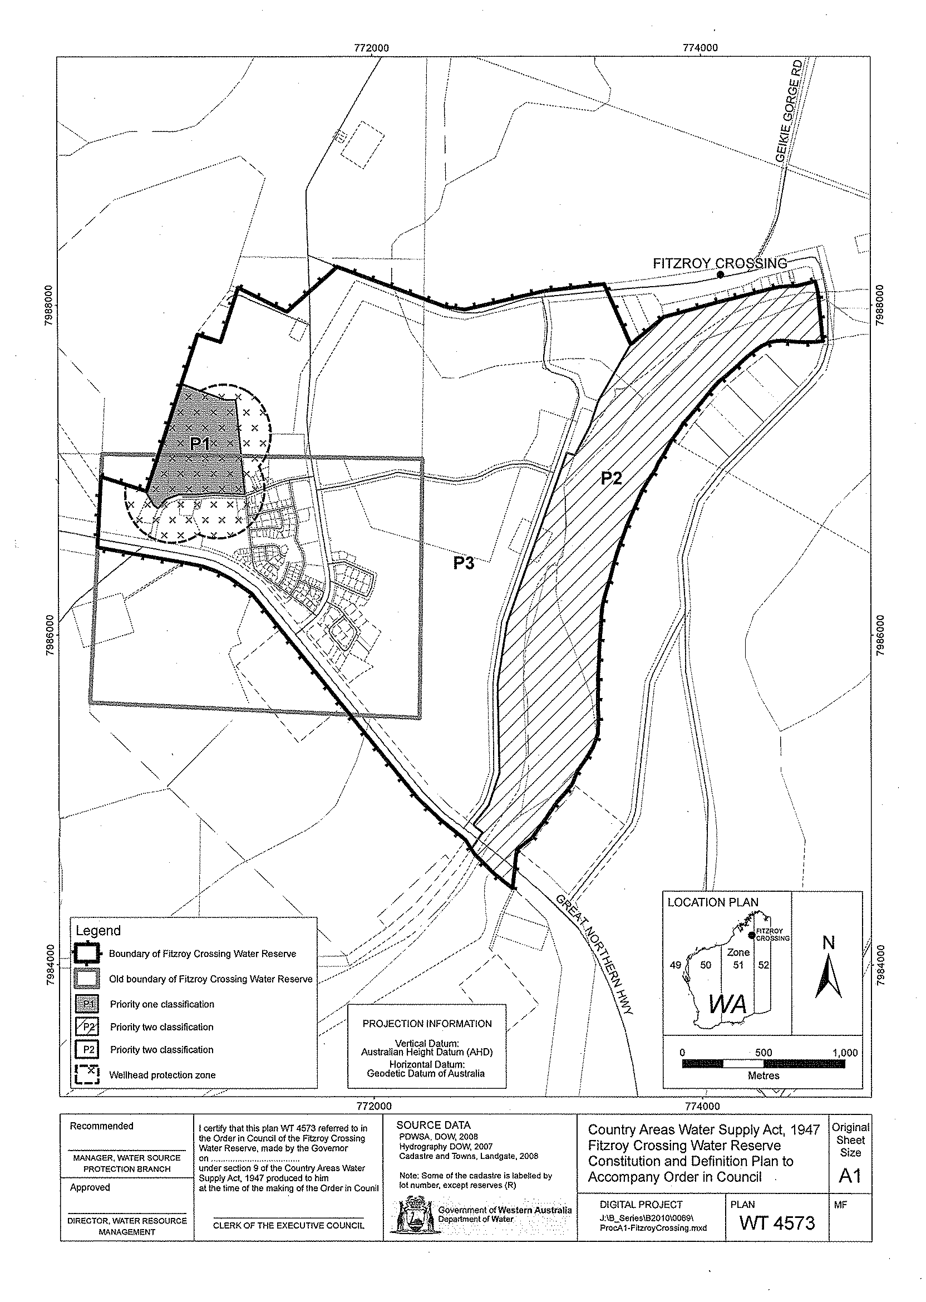

Notes
¹ This is a compilation of the Fitzroy Crossing Water Reserve Order 2009. The following table contains information about that order.

Compilation table
Citation | Gazettal | Commencement
Fitzroy Crossing Water Reserve Order 2009 | 1 May 2009 p. 1443-4 | cl. 1 and 2: 1 May 2009 (see cl. 2(a));  Order other than cl. 1 and 2: 2 May 2009 (see cl. 2(b))

