Western Australia
Museum Act 1969

Museum Regulations 1973

Reprinted under the Reprints Act 1984 as
at 2 April 2004
Western Australia
Museum Regulations 1973
Contents
1. Citation 1
3. Interpretation 1
4. Common Seal 2
5. Admission to Museum, etc. 3
6. Notice prohibiting access to certain areas 3
7. Behaviour when on Museum property 4
8. Certain equipment, explosives etc. prohibited 5
9. Unclaimed specimens 5
10. Removal of disorderly persons 5
11. Damage, etc. on Museum land or premises 6
12. Minor offences in Museum building 7
13. Cloaking articles 7
14. No photography, etc. without permission 8
15. Wardens 8
Schedule
Notes
Compilation table 10
Defined terms

Reprinted under the Reprints Act 1984 as
at 2 April 2004
Western Australia
Museum Act 1969
Museum Regulations 1973

1. Citation
These Regulations may be cited as the Museum Regulations 1973 ¹.

[2. Omitted under the Reprints Act 1984 s. 7(4)(f).]

3. Interpretation
(1) In these regulations —
the Act means the Museum Act 1969;
the Director means the person appointed under the Act as Director of the Museum and includes the person from time to time acting in the place of the Director;
the Museum means the body corporate, known as “The Western Australian Museum”, constituted by the Act;
the Trustees mean the Trustees of the Museum appointed pursuant to the Act;
warden means a person appointed by the Trustees to be a warden for the purposes of these regulations, whether a member of the staff of the Museum or in an honorary capacity.
(2) These regulations —
(a) apply in relation to any land under the control or management of the Trustees pursuant to any Act, whether vested in the Museum or otherwise, including any reserve, site or protected area administered by or on behalf of the Trustees in relation to which the Trustees have a duty under the Act;
(b) apply in relation to the land and buildings of the Museum at Perth, and to any branch of the Museum;
(c) do not apply to any Trustee, to the Director or any officer of the Museum, or to any person authorised in writing by the Director, whilst lawfully acting in the performance of his duties in relation to any land or buildings to which these regulations apply.
(3) The Trustees may, by notice in the Gazette apply these regulations to any municipal museum recognised by the Trustees.

4. Common Seal
(1) The form of the Common Seal of the Museum shall be —
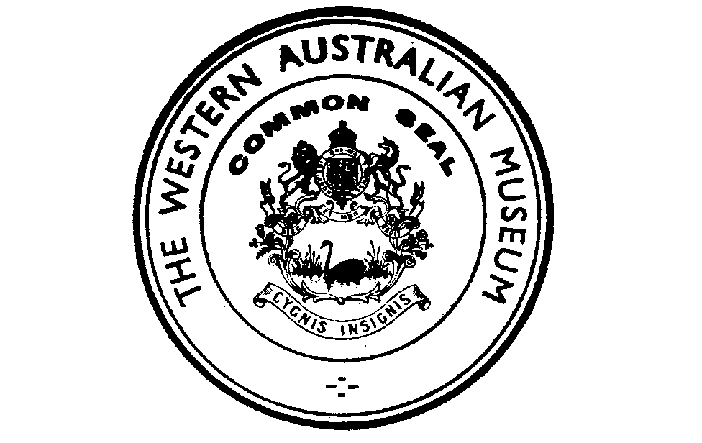

(2) The Common Seal shall be kept in safe custody by the Chairman of the Trustees, or if the Chairman so directs, by the Director.
(3) The Common Seal shall not be affixed to any document unless —
(a) the Trustees have directed by resolution at a regular meeting that the Common Seal be affixed to the document; and
(b) the Common Seal is affixed by the Chairman or the Vice-Chairman of Trustees in the presence of the Director.

5. Admission to Museum, etc.
The Trustees —
(a) may determine to what portion of the lands or buildings to which these regulations apply the public, or any person or class of persons specified by the Trustees, shall be admitted and the conditions upon which admittance shall be allowed;
(b) shall cause notice of any determination under this regulation of the days and hours during which any place is open for admission to the public to be exhibited; or
(c) may restrict access to any land or building, or any portion thereof, either generally or in relation to a specified person or class of persons, at any time, whether otherwise open to admission or not.

6. Notice prohibiting access to certain areas
(1) The Trustees may, by notice —
(a) served personally;
(b) erected or displayed in a prominent position on or near that land or building; or
(c) published in the Gazette,
prohibit access to any land or building, or any portion thereof, either generally or in relation to any specified person or class of persons, and any such prohibition may vary as to time, circumstance or otherwise as specified in the notice.
(2) A person shall not, without the consent of the Director, enter or remain on any land or in any part of any building to which the public is not admitted or contrary to the conditions upon which the public is admitted, or contrary to the provisions of a notice given under subregulation (1).
Penalty: $100.

7. Behaviour when on Museum property
Whilst on any land or building to which these regulations apply a person —
(a) shall obey any reasonable direction of the Director or any member of the staff of the Museum or a warden;
(b) shall not wilfully obstruct the Director or any member of the staff of the Museum or a warden in the execution of his duty, or fail or refuse to state his name and address when lawfully required to do so, or state a false name or address, or fail or refuse to leave that land or building when required to do so;
(c) shall not behave in a disorderly manner, or use violent or abusive or offensive language, or create or take part in any disturbance, or cause a nuisance, or wilfully disturb or annoy any other person in the proper use of that land or building, or permit any animal belonging to him or under his control to enter any building or cause damage on any land;
(d) shall not, without the consent of the Director, handle, mark, deface, move, disturb, uncover, damage, destroy, or remove any specimen, relic, artefact, inscription, arrangement, or other object or exhibit in the possession or care of the Museum, or wilfully disturb the general surrounding environment.
Penalty: $100.

8. Certain equipment, explosives etc. prohibited
Except under and in accordance with the prior approval of the Director a person shall not bring on to any land or building to which these regulations apply —
(a) any diving equipment, digging equipment, lifting equipment, or explosive; or
(b) any food, beverage or other article for sale.
Penalty: $100.

9. Unclaimed specimens
(1) Where a specimen or other thing has been received on behalf of the Museum for the purposes of identification or for a similar purpose and at the time it was received no undertaking was given to return it to the person from whom it was received, the Director may, at his discretion, retain that specimen or other thing for Museum use or he may destroy or dispose of it as he thinks fit if it is not reclaimed from the Museum within 30 days of its receipt.
(2) No liability arises in respect of the destruction or disposal of a thing carried out in pursuance of this regulation.

10. Removal of disorderly persons
The Director, any member of the staff of the Museum, or a warden, with such assistants as he thinks necessary, may remove from any land or building to which these regulations apply —
(a) any person behaving in a disorderly manner;
(b) any person who appears to be intoxicated;
(c) any person who appears to be using the land or premises for any unlawful purpose or for a purpose contrary to the objects of the Act;
(d) any person who has committed a breach of these regulations if it appears that his continued presence may lead to a further breach of the regulations.

11. Damage, etc. on Museum land or premises
On any land or premises to which these regulations apply, a person shall not, without the written consent of the Director or a person authorised in writing by the Director, —
(a) alter, damage, or destroy any notice, boundary, fence, shelter, grille, cutting, drain, protective work or other thing which the Museum has, or has caused to be, erected, constructed, made or placed thereon or therein;
(b) dig any hole or otherwise disturb the surface of the ground, or remove or disturb any stone, soil, sand, rock or gravel, or any other natural object;
(c) cut, pick, pull, break, remove, take, injure, poison, strip or destroy any tree, shrub, herb, grass or other plant or part thereof whether living or dead;
(d) post, stick, stamp, stencil, paint, draw or otherwise affix or make any mark, symbol, lettering, notice, advertisement, poster, sign or document of any description;
(e) except in a place approved or provided for the purpose —
(i) drive, tow, operate or park any vehicle;
(ii) camp, erect tents or shelters, light fires or make fireplaces;
(iii) deposit or leave any refuse, rubbish or litter; or
(iv) take, ride or drive, graze or agist any horse, cattle, sheep, goat, camel, donkey or pig, or allow any such animal to remain;
(f) unlock, unfasten or leave open any gate unless duly authorised to do so; or
(g) except with the prior written approval of the Director and in accordance with such requirements as he may impose, take any photograph or make any recording for the purpose of commercial reproduction or publication.
Penalty: $50.

12. Minor offences in Museum building
(1) A person shall not, in any building to which these regulations apply —
(a) loiter or sleep, or lie on the chairs, table or floor or elsewhere;
(b) expectorate;
(c) smoke in an area not set aside for that purpose;
(d) partake of refreshment, except with the consent of the Director or in a place provided for the purpose; or
(e) bet or gamble.
Penalty: $20.

13. Cloaking articles
(1) A person entering a building to which these regulations apply may be required to deposit, in the place specified by a notice posted in a prominent position at or near the entrance, any umbrella, bag, overcoat, parcel or other article of a kind described in that notice that he has in his possession.
Penalty: $10.
(2) Where any article deposited in accordance with this regulation is not reclaimed within 7 days the Museum may forward the article to the Police.
(3) The Museum shall not be liable for any loss of or damage to any article deposited or forwarded to the Police in accordance with this regulation.

14. No photography, etc. without permission
A person shall not, without the consent in writing of the Director, publish any photograph, recording or reproduction of any object, exhibit or other thing in the possession or care of the Museum.
Penalty: $100.

15. Wardens
(1) A person appointed by the Trustees to be a warden for the purposes of these regulations may exercise such powers as the Trustees may by resolution confer upon him, either throughout the State or in a specified area or areas only, according to the terms of his appointment.
(2) A person appointed to be an honorary warden shall be furnished with a certificate in the form set out in the schedule to this regulation evidencing his appointment and shall produce such certificate whenever required to do so by any person in respect of whom he has exercised or is about to exercise any of his powers under these regulations or the Act.

Schedule
MUSEUM ACT 1969
Name ......................................................................................................................
of (Address) ...........................................................................................................
is hereby certified to have been appointed as an honorary warden by the Trustees in relation to —
Area in which
the warden is
authorised to act ............................................................................................ ............................................................................................
The validity of this certificate expires on ..............................................................
(Date)
.....................................................................
.......................................................................
Director.
Signature of warden ................................................................

Notes
¹ This is a reprint as at 2 April 2004 of the Museum Regulations 1973. The following table contains information about those regulations and any reprint.

Compilation table
Citation | Gazettal | Commencement
Museum Regulations 1973 | 21 Sep 1973 p. 3503-6 | 21 Sep 1973
Reprint 1: The Museum Regulations 1973 as at 2 Apr 2004

Defined terms

[This is a list of terms defined and the provisions where they are defined. The list is not part of the law.]
Defined term Provision(s)
the Act 3(1)
the Director 3(1)
the Museum 3(1)
the Trustees 3(1)
warden 3(1)

