Western Australia
ABORIGINAL COMMUNITIES ACT 1979

Djarindjin Aboriginal Community By-laws

Western Australia
Djarindjin Aboriginal Community By-laws
Contents
Part 1 — Preliminary
1. Citation 2
2. Definitions 2
3. Council permission 2
Part 2 — Community land
4. Permission to enter Community land 3
5. Restricted access areas 3
6. Homes 3
Part 3 — Traffic
7. Restricted traffic areas 4
8. Traffic signs 4
9. Careless or dangerous driving and driving while intoxicated 4
Part 4 — Alcohol
10. Regulation of alcohol 5
Part 5 — Miscellaneous
11. Damage to property 9
12. Rubbish 9
13. Disorderly behaviour 9
Part 6 — Enforcement
14. Offences 10
15. Police powers 10
16. Penalties 10
Notes
Compilation table 12
Defined terms

Western Australia
ABORIGINAL COMMUNITIES ACT 1979
Djarindjin Aboriginal Community By-laws

Part 1 — Preliminary

1. Citation
These by-laws may be cited as the Djarindjin Aboriginal Community By-laws.

2. Definitions
In these by-laws —
Community means the Djarindjin Aboriginal Community;
Community land means the land declared by the Governor under section 6 of the Act to be the community lands of the Community;
Corporation means the Djarindjin Aboriginal Corporation Incorporated.
Council means the council of the Corporation;
member of the Community means a person who the Council accepts as a member of the Community for the time being;
vehicle means a vehicle as defined in the Road Traffic Act 1974.

3. Council permission
Where a by-law provides that the Council may grant permission to a person to do an act that would otherwise not be permitted, the Council —
(a) may grant or refuse to grant that permission;
(b) may grant permission subject to any conditions it thinks fit;
(c) may, if it has granted permission, revoke that permission at any time;
(d) need not give reasons for its decision; and
(e) may notify the person concerned of the granting, refusal to grant or revocation of the permission either orally or in writing.

Part 2 — Community land

4. Permission to enter Community land
(1) Subject to any other written law, a person who is not a member of the Community must not enter or remain on Community land without the prior permission of the Council.
(2) The Council may delegate its power to permit people to enter or remain on Community land to any member of the Council or employee of the Corporation.

5. Restricted access areas
(1) Subject to any other written law, the Council may declare any part of the Community land to be a restricted access area.
(2) For each restricted access area the Council must erect signs identifying the area and indicating who is permitted to enter that area and under what conditions they may do so.
(3) A person must not enter a restricted access area contrary to a sign erected under sub-bylaw (2).

6. Homes
A person —
(a) must not enter the home of another person without the prior permission of that other person; and
(b) if in another person’s home, must leave promptly when asked to do so by that other person.

Part 3 — Traffic

7. Restricted traffic areas
(1) Subject to any other written law, the Council may declare any part of the Community land to be a restricted traffic area.
(2) For each restricted traffic area the Council must erect signs identifying the area and indicating who, if anyone, is permitted to drive a vehicle in that area and under what conditions they may to do so.
(3) A person must not drive a vehicle in a restricted traffic area contrary to a sign erected under sub-bylaw (2).

8. Traffic signs
(1) The Council may erect signs for the purpose of regulating the use of vehicles on Community land.
(2) A person must not use a vehicle contrary to a sign erected under sub-bylaw (1)

9. Careless or dangerous driving and driving while intoxicated
(1) A person must not drive a vehicle on Community land without due care and attention.
(2) A person must not drive a vehicle on Community land in a manner that is, having regard to all the circumstances, dangerous to the public or to any person.
(3) A person must not drive or attempt to drive a vehicle on Community land while under the influence of alcohol or drugs to such an extent as to be incapable of having proper control of the vehicle.

Part 4 — Alcohol

10. Regulation of alcohol
(1) A person must not —
(a) bring alcohol on to Community land; or
(b) come onto Community land if the person is drunk,
without the prior permission of the Council.
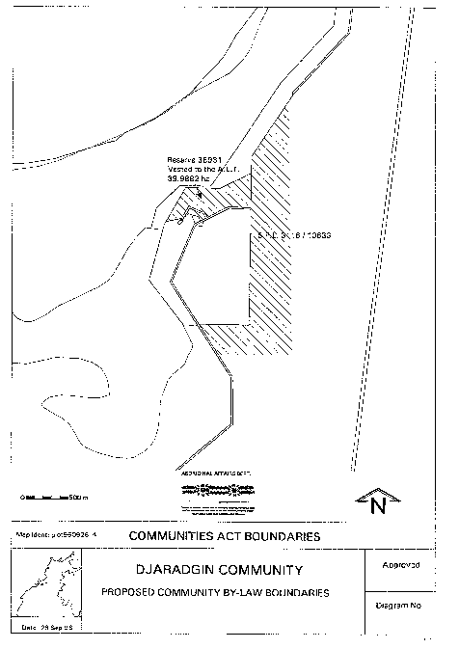
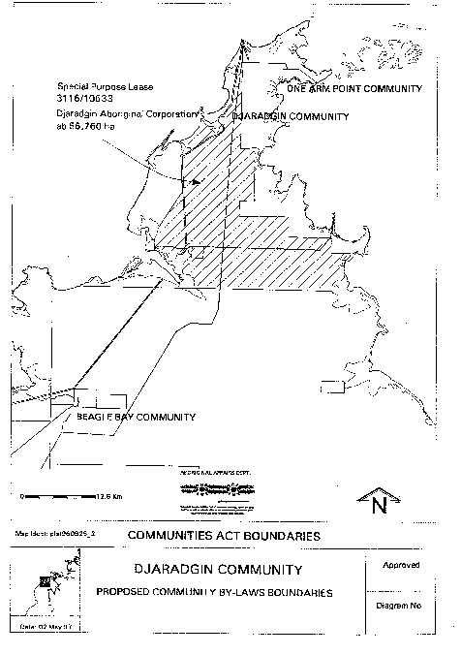
(2) A person must not, while on Community land;
(a) drink alcohol;
(b) supply give alcohol to another person; or
(c) possess alcohol,
without the prior permission of the Council
(3) When deciding whether to grant permission under this by-law the Council must have regard to the welfare of the Community as the paramount consideration.

Part 5 — Miscellaneous

11. Damage to property
A person must not maliciously damage any building, structure, vehicle, planted vegetation or other thing on Community land.

12. Rubbish
A person must not leave rubbish on Community land except in rubbish bins or places set aside by the Council for the dumping of rubbish.

13. Disorderly behaviour
(1) A person must not cause a disturbance to or annoy other people by —
(a) using offensive or abusive language; or
(b) fighting or behaving in an offensive or disorderly manner.
(2) A person must not disrupt a meeting —
(a) of the Council, the Corporation or the Community; or
(b) about community law.
(3) A person must not hinder or prevent the performance by the Council, the Corporation or any of their employees, of their duties.

Part 6 — Enforcement

14. Offences
A person commits an offence against these by-laws if the person —
(a) fails to comply with a by-law; or
(b) fails to comply with a condition imposed by the Council on a permission granted under these bylaws,
unless the person is a member of the Community and is acting in accordance with a custom of the Community.

15. Police powers
(1) A member of the Police Force may take proceedings against any person who commits an offence against these by—laws.
(2) A member of the Police Force may apprehend and remove a person from Community land if —
(a) the person has committed, or is committing, an offence against these by-laws; and
(b) it appears to the member of the Police Force likely that the person will cause injury to other people or damage to property.
(3) A person removed from Community land under sub-bylaw (2) must be released from police custody within 24 hours if not dealt with by a court before then.

16. Penalties
A person who is convicted of an offence against these by-laws —
(a) is liable to a penalty of up to the maximum penalty permitted under the Act to be imposed for a breach of the by-laws; and
(b) may be ordered by the court to pay up to $250 in compensation to the owner of any property that has been damaged as a result of the commission of the offence.

Notes
¹ This is a compilation of the Djarindjin Aboriginal Community By-laws and includes the amendments referred to in the following Table.

Compilation table
Citation | Gazettal | Commencement
Djarindjin Aboriginal Community By-laws | 15 Jul 1997 p. 3661-6 | 15 Jul 1997

Defined terms

[This is a list of terms defined and the provisions where they are defined. The list is not part of the law.]
Defined term Provision(s)
Community 2
Community land 2
Corporation 2
Council 2
member of the Community 2
vehicle 2

