Western Australia

Environmental Protection Act 1986

Environmental Protection (Fibre Reinforced Plastics) Regulations 1998

|  |  |  |
| --- | --- | --- |
|  |  | **Reprinted under the *Reprints Act 1984* as** |
| **at 7 May 2004** |

Western Australia

Environmental Protection (Fibre Reinforced Plastics) Regulations 1998

Contents

1. Citation 1

2. Interpretation 1

3. Use of resins and solvents 2

4. Use of low styrene emission resin 2

5. Control of dust 3

6. Disposal of waste material 3

7. Offence 3

Schedule 1

Test procedure to determine styrene emission rates

Notes

Compilation table 6

Defined terms

|  |  |  |
| --- | --- | --- |
|  | Crest | **Reprinted under the *Reprints Act 1984* as** |
| **at 7 May 2004** |

Western Australia

Environmental Protection Act 1986

Environmental Protection (Fibre Reinforced Plastics) Regulations 1998

##### 1. Citation

These regulations may be cited as the *Environmental Protection (Fibre Reinforced Plastics) Regulations 1998*1.

##### 2. Interpretation

(1) In these regulations —

fibre reinforced plastic means plastic produced using a process in which fibres are used to reinforce a resin which has been pre‑treated with a catalyst;

fibre reinforced plastics manufacturing means the manufacturing of products from fibre reinforced plastic;

operator means a person carrying on fibre reinforced plastics manufacture;

resin means a solid, semi‑solid or liquid organic material which is used as a base in the manufacture of fibre reinforced plastics;

solvent means acetone, ethyl acetate, ethanol or any other chemical used for dissolving other chemicals in the manufacture of fibre reinforced plastics.

(2) In these regulations a reference to the premises in relation to an operator is a reference to the premises at which the operator carries on fibre reinforced plastics manufacturing.

##### 3. Use of resins and solvents

(1) An operator must —

(a) store all resins, solvents and products containing solvents kept on the premises in airtight containers; and

(b) keep those containers sealed except when they are being filled or the contents are being removed.

(2) An operator must not expose to the atmosphere at any time more resin than is necessary for the purpose for which the resin is being used.

(3) An operator must —

(a) keep a supply of absorbent material on the premises;

(b) use that material to immediately mop up any spillage of resin, solvent or a product containing solvent; and

(c) keep any material which has been so used in an airtight container until it is disposed of in accordance with regulation 6.

##### 4. Use of low styrene emission resin

(1) An operator must not use resin other than low styrene emission resin in fibre reinforced plastics manufacturing unless —

(a) a particular application requires certain physical or chemical properties which cannot be achieved using low styrene emission resin;

(b) the resin is a gel coat; or

(c) the resin is being used in a closed moulding process.

(2) In subregulation (1) —

gel coat means an outer layer of resin which is used on fibre reinforced plastic to improve surface properties;

low styrene emission resin means a resin with a maximum emission rate of 20 grams of styrene per square metre of resin per half hour at 23°C, as determined using the method set out in Schedule 1.

##### 5. Control of dust

An operator must ensure that no visible dust created during fibre reinforced plastics manufacturing escapes from the premises.

##### 6. Disposal of waste material

An operator must dispose of all waste produced during fibre reinforced product manufacturing at an appropriate landfill site or waste treatment facility the occupier of which holds a licence under Part V of the Act in respect of that site or facility.

##### 7. Offence

A person who contravenes these regulations commits an offence.

Penalty: $5 000.

[Regulation 7 amended: Gazette 11 Dec 1998 p. 6613.]

[**8.** Omitted under the Reprints Act 1984 s. 7(4)(f).]

Schedule 1

[Regulation 4]

Test procedure to determine styrene emission rates

**Aim**

This test method gives an indication of the rate of styrene loss from a typical Chopped Strand Mat (CSM) contact moulded laminate, with a surface open to the atmosphere.

**Theory**

A single layer of CSM is impregnated with the uncatalysed resin and supported on an accurate direct reading top pan balance in a draught‑free room at 23°C. The loss in weight in grams per square metre is recorded against time.

**Apparatus**

1. Direct reading top pan balance accurate to 0.01 g.

2. Polyethylene terephthalate film (Melinex).

3. Glass fibre chopped strand mat — emulsion bound — 450 g/m2.

4. A draught‑free room of 50 cubic metres minimum volume, controlled at 23°C ± 1°C.

5. Optional shielding as shown in Figure 1.

6. Suitable support platen 300 mm x 300 mm.

7. Glass beaker.

**Method**

1. Set up apparatus in the draught‑free room.

2. Cut and weigh a 250 mm x 250 mm section of CSM.

3. Cut a 300 mm x 300 mm square of Melinex film and mark an area of 250 mm x 250 mm on the back of the film with a marker pen.

4. Adjust the resin temperature to 23°C.

5. Place the Melinex film on the support platen. Pour a quantity of resin equal to 2.0 times the weight of the CSM from the glass beaker onto the film and spread evenly over the marked area.

6. Place the CSM sample into the resin and quickly ensure complete impregnation of the mat by gently pressing with the edge of a spatula. Within one minute, place the lay‑up and the support platen on the balance and note the reading.

7. Record the weight at 2 minutes, 5 minutes, 10 minutes and thereafter at 10 minute intervals for one hour, or longer as required.

8. Repeat the procedure from 2 to 7 twice.

9. From the results, plot a graph of mean cumulative loss in weight against time.

**Items to be reported**

1. Resin identification.

2. CSM identification.

3. Actual atmospheric temperature.

4. Relative humidity.

5. Atmospheric pressure.

6. The amount of styrene (g/m2) emitted during 60 minutes.

**Figure 1**

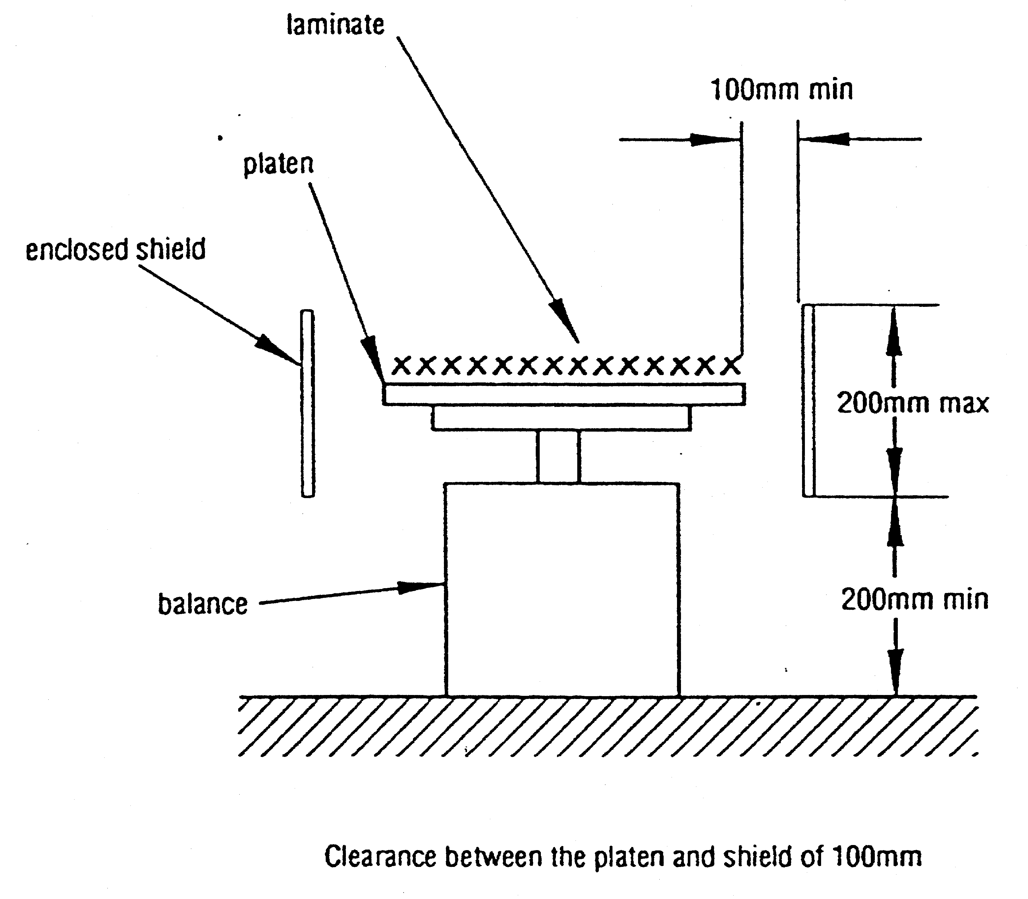

Notes

1 This reprint is a compilation as at 7 May 2004 of the *Environmental Protection (Fibre Reinforced Plastics) Regulations 1998* and includes the amendments made by the other written laws referred to in the following table. The table also contains information about any reprint.

Compilation table

| **Citation** | **Gazettal** | **Commencement** |
| --- | --- | --- |
| *Environmental Protection (Fibre Reinforced Plastics) Regulations 1998* | 17 Mar 1998 p. 1411‑13 | 17 Mar 1998 |
| *Environmental Protection (Miscellaneous Amendments) Regulations 1998* Pt. 6 | 11 Dec 1998 p. 6597-614 | 8 Jan 1999 (see r. 2) |
| **Reprint 1: The *Environmental Protection (Fibre Reinforced Plastics) Regulations 1998* as at 7 May 2004** (includes amendments listed above) | | |

Defined terms

*[This is a list of terms defined and the provisions where they are defined. The list is not part of the law.]*

**Defined term Provision(s)**

fibre reinforced plastic 2(1)

fibre reinforced plastics manufacturing 2(1)

gel coat 4(2)

low styrene emission resin 4(2)

operator 2(1)

resin 2(1)

solvent 2(1)

the premises 2(2)