Western Australia
Optometrists Act 1940

Optometrists Registration Board Rules 1941
These rules were repealed by the Optometrists Act 2005 s. 109 (No. 29 of 2005) as at 20 Apr 2007 (see s. 2 and Gazette 30 Mar 2007 p. 1451).

Western Australia
Optometrists Registration Board Rules 1941
Contents
1. Citation 1
Part 1 — Preliminary
3. Interpretation 2
Part 2 — Election of nominees for appointment to Board
4. Three nominees 3
5. Election dates 3
6. Casual vacancy 3
7. Notice 3
8. Notice of candidates intention 4
9. If candidates equal to vacancies 4
10. If candidates exceed vacancies 4
11. How to vote 4
12. Chairman to determine election result 5
13. Non-receipt does not affect validity of election 5
14. Elected persons 5
Part 3 — Meetings
15. Ordinary meetings 6
16. Special meetings 6
17. Quorum 6
18. Validity of resolutions 6
19. Minutes 6
20. Order of business 7
21. Validity of meetings 7
21A. Attendance fee for chairman and members 7
Part 4 — Registrar
22. The Registrar 9
Part 5 — The Register
23. Form of Register 10
24. Inspection of Register 10
25. Withdrawal of name from Register 10
26. Re-entry of name in Register (section 22) 10
28. Re-entry of name in Register (section 28) 10
Part 6 — Registration of optometrists
30. Evidence of qualification — s. 35(1)(d)(ii) 12
31. Application for registration 12
32. Information to accompany application 12
33. Fees 12
Part 7 — Students and examinations
34. Competency test 14
34A. Syllabus for examinations 14
34B. Preliminary approval by Board 15
34C. Matriculation requirement 15
34D. Study requirements 16
34E. Attendance at lectures 16
34F. Ineligibility due to inadequate attendance 16
35. Course subjects 16
36. Annual examinations 17
37. Supplementary examinations 18
38. Prerequisites for fourth year study 18
39. Satisfactory progress 18
40. Diploma of Optometry 18
41. Conduct of examinations 19
42. Examination fees 19
Part 8 — Licences
43. Optometrists Licence 20
Part 8A — Advertising
43A. Optometrist may advertise services 21
43B. Optometrist not to engage in false or misleading advertising, etc. 21
43C. Board may give directions to optometrists regarding certain matters 22
43D. Failure to comply with Board’s direction may lead to suspension 22
Part 9 — Charges or complaints against optometrists
44. Charges or complaints 23
45. Further particulars, including statutory declaration 23
46. Notice of appointment of investigator 23
Part 10 — Fees and fines
53. Fees 24
54. Fines 24
Part 11 — Miscellaneous
54A. Miscellaneous 25
55. Common Seal 25
56. Forms and Appendices 25
First Appendix
Second Appendix
Notes
Compilation table 37
Provisions that have not come into operation 39

Western Australia
Optometrists Act 1940
Optometrists Registration Board Rules 1941

1. Citation
These rules may be cited as the Optometrists Registration Board Rules 1941 ¹.

[2. Repealed in Gazette 6 Jan 1998 p. 32.]

Part 1 — Preliminary
[Heading inserted in Gazette 26 Oct 1999 p. 5284.]

3. Interpretation
(1) In the construction of these rules section 3 of the Act shall apply.
(2) In these rules, a reference to an optometrist includes a reference to any person, firm or company carrying on, or purporting to carry on, the practice of optometry.
(3) In these rules, where an optometrist is prohibited from any course of action the prohibition extends to prohibit him from authorising, permitting or allowing that course of action to be taken by any other person in his name or on his behalf.
(4) For the purpose of these rules, a person shall be taken to practise optometry if —
(a) he practises optometry personally on his own account;
(b) he employs a person who practises optometry; or
(c) he practises optometry in the employ of another person,
and any firm or company which employs a person who practises optometry shall also be taken to practise optometry.
(5) In these rules, “approved qualifications” means qualifications acceptable to the Board pursuant to the Act and such other qualifications as may be approved by the Board from time to time for the purpose of these rules.
[Rule 3 amended in Gazette 1 Nov 1974 p. 4941.]

Part 2 — Election of nominees for appointment to Board
[Heading inserted in Gazette 26 Oct 1999 p. 5284.]

4. Three nominees
The 3 registered optometrists to be nominated from time to time by the registered optometrists for appointment to the Board shall be determined by election.

5. Election dates
The first election shall be held on the second Thursday in the month of October, 1943, and every election thereafter shall be held on the second Thursday in the month of October in each and every succeeding third year.

6. Casual vacancy
If a casual vacancy occur in the office of any such nominated member, an election shall be held as soon as practicable after such vacancy occurs, to fill the vacancy.
Provided that, if the casual vacancy occur within the period of 60 days before the date fixed by these rules for the holding of the first or any triennal election to select the nominated members, no election need be held to fill such casual vacancy unless the Board shall otherwise direct.

7. Notice
At least 28 days before the date of any election, the Registrar shall advertise once at least in the Government Gazette and once at least in a newspaper published in Perth a notice drawing attention to such election and requiring nominations of candidates to be forwarded to the Registrar not later than 18 days before the date of the election.

8. Notice of candidates intention
Every person desiring and being qualified to become a member of the Board shall, not less than 18 days before the date of an election, forward to the Registrar written notice of his intention to seek election, countersigned by at least 2 persons entitled to vote at such election: such notice to be in the hands of the Registrar by 12 o’clock (noon) on the closing date for nominations.

9. If candidates equal to vacancies
If there be no more candidates than the number of vacancies such candidates shall be declared elected.

10. If candidates exceed vacancies
If there be more candidates than the number of vacancies at any election the Registrar shall, at least 10 days before the date of election, post to each person entitled to vote a ballot paper containing the names and addresses of all candidates and setting out the terms of rule 11, and shall initial each of such papers and, together with such ballot paper, the Registrar shall enclose and post a separate envelope, with the name and address of the Registrar printed thereon.

11. How to vote
(i) The names of the candidates for whom a voter desires to vote shall be left intact and the remaining names scored through with a pen or pencil. If the number of names left intact upon any voting paper be greater or less than the number of members to be elected, or if any mark or writing other than above appear thereon, which in the opinion of the Returning Officer will enable any person to identify the voter, the vote given on and by such paper shall be void and of no effect and shall not be counted by the chairman.
(ii) The voter shall enclose such voting paper in the envelope posted to him by the Registrar, and shall stamp and post the same or deliver the same so that it shall be received by the Registrar not later than 12 o’clock (noon) on the day fixed for holding such election.

12. Chairman to determine election result
(i) All ballot papers shall be opened by the chairman at the office of the Board at 12 o’clock (noon) on the day of election, in the presence of any person entitled to vote who may attend at such time and place, and the candidates receiving the largest number of votes shall be declared elected.
(ii) In the case of an equality of votes the chairman shall give a second or casting vote.

13. Non-receipt does not affect validity of election
The omission by the Registrar to send or post to or the non-receipt of any ballot paper by any person entitled to vote within the time aforesaid, or at all, shall not in any manner invalidate or affect the election.

14. Elected persons
The persons so elected shall be deemed the nominees of the registered optometrists for appointment to the Board by the Governor, and their names and addresses shall be conveyed by the Registrar to the Governor on the day following the day of the election, which last-mentioned date, for the purposes of section 5(5) of the Act, shall be deemed the “prescribed nomination day”.

Part 3 — Meetings
[Heading inserted in Gazette 26 Oct 1999 p. 5284.]

15. Ordinary meetings
Ordinary meetings of the Board shall be held at the office of the Board on the second Thursday in every month, at the hour of 8 p.m., or such other place, date and time as the Board may determine.

16. Special meetings
Special meetings shall be called by the Registrar, whenever requested by the chairman or any 3 members: Provided that 3 clear days’ notice of every such meeting shall be given by the Registrar to the members of the Board.

17. Quorum
If a quorum of members be not present within 15 minutes of the time for which the meeting is convened, it may be adjourned to such time and place as any one or more members present may determine.

18. Validity of resolutions
No resolution arrived at or act, matter, or thing done or authorised by any meeting shall be rescinded or amended at any subsequent meeting, unless notice of such intended rescission or amendment be given in the notices convening the meeting at which such rescission or amendment is proposed.

19. Minutes
Minutes of every meeting shall be kept by the Registrar and such minutes, when signed by the chairman of the same or any subsequent meeting, shall be binding and conclusive evidence for all purposes and before all courts of the proceedings at such meeting.

20. Order of business
The arrangement of the order for business for each ordinary meeting shall be as follows: —
Reading the minutes of the previous meeting.
Confirmation or otherwise of same.
Registration of optometrists.
Ordinary business, including postponed and adjourned matters.
Special business.
Reading of correspondence and reports of committees.
Letters and business arising therefrom.
Production of bank pass book.
Accounts for payment.
Registrar’s statement.
Notices of motion.
Any other business that may be properly brought before the Board.

21. Validity of meetings
The omission to give due notice of a meeting, as hereinbefore provided, to one or more members of the Board, or the non-receipt thereof, shall in no manner affect or prejudice anything done or agreed at such meeting.

21A. Attendance fee for chairman and members
For attendance at each meeting of the Board —
(a) the chairman is to be paid —
(i) if the meeting takes 4 hours or longer, $323.00; or
(ii) if the meeting takes less than 4 hours, $213.00;
and
(b) each other member is to be paid —
(i) if the meeting takes 4 hours or longer, $215.00; or
(ii) if the meeting takes less than 4 hours, $142.00.
[Rule 21A inserted in Gazette 22 Oct 2002 p. 5252.]

Part 4 — Registrar
[Heading inserted in Gazette 26 Oct 1999 p. 5284.]

22. The Registrar
The Registrar shall —
(1) be appointed by the Board and hold the office subject to these rules and during the pleasure of the Board;
(2) discharge duties imposed upon the Registrar by the Act;
(3) be in attendance at his office at such hours and days as the Board may from time to time direct;
(4) consult the chairman on any business requiring attention between the various meetings of the Board and be responsible for the safe custody of all documents and property belonging to the Board;
(5) find security to the satisfaction of the Board in the sum of $500;
(6) present to the Board a monthly statement showing the receipts and expenditure for the past month, and prepare and present to the Board a yearly balance sheet in the month of September in every year;
(7) receive and be responsible for all moneys payable to the Board and shall bank the same within 48 hours of the receipt thereof;
(8) discharge such other duties as the Board from time to time may direct.
[Rule 22 amended by Act No. 113 of 1965 s. 8(1).]

Part 5 — The Register
[Heading inserted in Gazette 26 Oct 1999 p. 5284.]

23. Form of Register
The Register of Optometrists shall be in Form 1 in the First Appendix.

24. Inspection of Register
The Register shall be open to inspection, at the office of the Registrar, during the hours of 2 p.m. and 4 p.m. on Wednesday and Friday of each week, excepting when any of these days falls on a public holiday.

25. Withdrawal of name from Register
Any registered optometrist desirous of having his name withdrawn from the Register shall lodge with the Registrar an application, in writing, according to Form 4 in the First Appendix.

26. Re-entry of name in Register (section 22)
Every person desirous of having his name re-entered in the Register under section 22 of the Act shall make application to the Board in writing, according to Form 5 in the First Appendix and shall lodge such application with the Registrar, together with the sum provided by section 22(3) of the Act, or the sum of $21, whichever is the less, and together with the prescribed re-entry fee.
[Rule 26 amended by Act No. 113 of 1965 s. 8(1).]

[27. Repealed in Gazette 30 Dec 2004 p. 6981.]

28. Re-entry of name in Register (section 28)
Every person desirous of having his name re-entered in the Register under section 28 of the Act shall lodge with the Registrar an application to the Board in writing according to Form 7 in the First Appendix, and shall, when and as often as required, attend in person before the Board and answer verbally or in writing all such questions as may be put to him.
If the application is granted by the Board, the Registrar shall notify the applicant thereof, but the applicant’s name shall not be re-entered until the sum payable under section 28(5) of the Act has been paid, together with the prescribed fee for such re-entry.

[29. Repealed in Gazette 30 Dec 2004 p. 6981.]

Part 6 — Registration of optometrists
[Heading inserted in Gazette 26 Oct 1999 p. 5285.]

30. Evidence of qualification — s. 35(1)(d)(ii)
(1) For the purposes of section 35(1)(d)(ii) of the Act, the following qualifications are prescribed as sufficient to qualify a person for registration under the Act —
(a) a degree in optometry from a school of optometry accredited by the Council;
(b) a certificate of competency in optometry issued by the Council.
(2) In this rule —
“Council” means The Optometry Council (ACN 074 875 111).
[Rule 30 inserted in Gazette 28 Jun 2002 p. 3078.]

31. Application for registration
Every person applying for registration as an optometrist shall apply in writing and make and forward to the Registrar an application according to Form 2 or Form 2A in the First Appendix as the case may require.
[Rule 31 amended in Gazette 4 May 1945 p. 425.]

32. Information to accompany application
Each applicant for registration shall supply in writing to the Board the information and evidence required by the Act and shall, when and as often as required, attend in person before the Board and answer verbally or in writing all such questions as may be put to him.

33. Fees
Every person whose application for registration has been approved and whose name has been entered upon the Register of Optometrists after payment of the fees prescribed by the rules shall be entitled, upon payment of the prescribed fee, to a certificate in Form 3 in the First Appendix.

Part 7 — Students and examinations
[Heading inserted in Gazette 26 Oct 1999 p. 5285.]

34. Competency test
The practical test of competency to practise optometry to be passed by persons seeking registration under section 34(c) of the Act shall be in the following, viz.:
Refraction; History taking and recording; Face and Frame measurements and fitting; Ophthalmoscopy.

34A. Syllabus for examinations
(i) Until otherwise prescribed the test in the work of an optometrist to be passed by persons seeking registration under section 34A(c) of the Optometrists Act 1940, shall be on the following Syllabus: —
Sec. 1. Ophthalmoscopy, Retinoscopy, Keratometry, Perimetry and Scotometry.
Sec. 2. External examination of the eye and its appendages. Recognition of the non-pathological visual apparatus.
Sec. 3. History taking and recording. Refraction.
Sec. 4. Phorometry. Principles and practice of Orthoptics.
Sec. 5. A practical examination in the Clinical practice of Optometry.
(ii) The theoretical and practical tests in optometry to be passed by persons seeking registration under section 34B of the Act shall be the examinations in the subjects covered by the syllabus for third and fourth year students as set out in rule 35. The provisions of rules 36, 37, 41 and 42 shall apply to persons applying under the provisions of section 34B of the Act.
[Rule 34A inserted in Gazette 4 May 1945 p. 424; amended in Gazette 15 Jul 1958 p. 1555.]

34B. Preliminary approval by Board
(1) Every person desiring to qualify for registration as an optometrist through and by means of the course of study and training prescribed by rule 35 must first —
(a) satisfy the Board —
(i) that he has passed the preliminary examination prescribed by rule 34C and
(ii) that he has arranged to be employed by a registered optometrist during the 4 years of the course of study and training prescribed by rule 35. Provided that in the case where no surfacing or fitting facilities are available in the optometrical establishment the student may obtain his first and second years mechanical training at an approved ophthalmic laboratory,
and
(b) be approved by the Board.
(2) The Board may in its discretion approve or refuse to approve any such person or may require him to submit further information or evidence as to his good fame and character and as to the matters set out in paragraph (1)(a).
(3) In rules 34C, 34D and 35, the word “applicant” shall mean a person who has fully complied with paragraph (1).
[Rule 34B inserted in Gazette 19 Sep 1952 p. 2242.]

34C. Matriculation requirement
(1) The prescribed preliminary examination shall be the Matriculation Examination prescribed by the University of Western Australia for persons applying to be admitted to the course for the Degree of Bachelor of Science. If Chemistry has not been taken at the leaving standard, the applicant shall be required to undertake such study of this subject during the first year of the course as the Board may determine.
[Rule 34C inserted in Gazette 19 Sep 1952 p. 2242.]

34D. Study requirements
Every applicant applying under these rules for registration as an optometrist shall complete the course of study and training prescribed in rule 35, and pass the examinations required, before he may be registered.
[Rule 34D inserted in Gazette 19 Sep 1952 p. 2242.]

34E. Attendance at lectures
All students approved by the Board shall subsequently to their approval attend at least 75% of the lectures and demonstrations each year in each subject.
[Rule 34E inserted in Gazette 19 Sep 1952 p. 2242.]

34F. Ineligibility due to inadequate attendance
Any student not complying with the requirements of rule 34E in any year shall not be eligible to sit for the annual examination in that year, unless the Board for good cause shown shall in its discretion waive this condition.
[Rule 34F inserted in Gazette 19 Sep 1952 p. 2242.]

35. Course subjects
(1) Until the Board otherwise provides, it will arrange a course of training in the following subjects: —
Physics IC
Zoology
Chemistry
Psychology I
Optical Dispensing I
General and Practical Optics
Physiology IIB
Anatomy of the Eye and Orbit
Optical Dispensing II
Optometry I
Ocular Physiology
Physiological Optics
Optical Dispensing III
Optometry II
Clinical Optometry I
Ocular Physiology II
Optometry III
Clinical Optometry II
(2) (a) The Board may at its discretion exempt from attendance at any part of the course any applicant who satisfies the Board that he has already undertaken a suitable course of study.
(b) The Board may at its discretion give credit to an applicant for passes at examinations conducted by an approved university or by a recognised examining body.
(3) The Board in its discretion may vary the order in which courses and examinations in the subjects prescribed for the third and fourth years under paragraph (1) shall be taken.
[Rule 35 inserted in Gazette 19 Sep 1952 p. 2242-3; amended in Gazette 11 Sep 1953 p. 1690; 28 Apr 1960 p. 1149-50.]

36. Annual examinations
The annual examination shall be held during the period fixed by the University of Western Australia for its annual examinations. Every person desiring to be examined shall make application to the University of Western Australia in the form required by that University.
[Rule 36 inserted in Gazette 19 Sep 1952 p. 2243.]

37. Supplementary examinations
Any student who has failed to pass the annual examination in any one or more subjects may at the discretion of the University of Western Australia, or the Board, be allowed to submit himself at a supplementary examination to be held during the period fixed by the University for its supplementary examinations immediately following in such subject or subjects.
Application to sit for a supplementary examination must be made to the University of Western Australia in the form required by that University.
[Rule 37 inserted in Gazette 19 Sep 1952 p. 2243.]

38. Prerequisites for fourth year study
No student shall be allowed to proceed to the fourth year of the course until he has passed the examinations for the first, second and third years of the course.
[Rule 38 inserted in Gazette 19 Sep 1952 p. 2243.]

39. Satisfactory progress
Students shall be subject to section 10 of the general regulations for degree courses of the University of Western Australia. Satisfactory progress shall be defined as in the first and second year passes in at least 2 units for which the student has been enrolled, and in subsequent years as determined by the examiners.
[Rule 39 inserted in Gazette 19 Sep 1952 p. 2243.]

40. Diploma of Optometry
Every person who has completed the course of optometry established in conjunction with the University of Western Australia, who has in all respects complied with the Act and rules, and who, after 1 December 1951 has qualified for registration as an optometrist under the Act shall be entitled to a certificate in Form 13 in the First Appendix, and shall on payment of the prescribed diploma fee be eligible to receive the Diploma of Optometry of Western Australia in Form 14 in the First Appendix, and will be entitled to use the affix “Dip. Opt. W.A.”
[Rule 40 inserted in Gazette 19 Sep 1952 p. 2243.]

41. Conduct of examinations
Every examination under these rules shall be conducted by such person or persons in such manner and at such times or places as the Board may from time to time appoint or direct.

42. Examination fees
The respective examination fees payable are as fixed in the Schedule. No fee paid for any examination at which the candidate shall fail to present himself, or which he shall fail to pass to the satisfaction of the Board, shall be available for any subsequent examination, nor shall any such fee be returned.

[42A. Repealed in Gazette 18 Feb 1949 p. 309.]

Part 8 — Licences
[Heading inserted in Gazette 26 Oct 1999 p. 5285.]

43. Optometrists Licence
The Optometrists Licence to be issued under section 36 of the Act shall be in Form 9 in the First Appendix.

Part 8A — Advertising
[Heading inserted in Gazette 26 Oct 1999 p. 5285.]

43A. Optometrist may advertise services
Subject to this Part, an optometrist may advertise his or her services in respect of the practice of optometry in any manner that the optometrist considers appropriate.
[Rule 43A inserted in Gazette 1 Jul 1997 p. 3253.]

43B. Optometrist not to engage in false or misleading advertising, etc.
An optometrist shall not advertise his or her services in respect of the practice of optometry in any way that —
(a) is false in a material particular;
(b) is misleading or deceptive or likely to mislead or deceive;
(c) is likely to affect adversely the reputation of any optometrist, or the standing of optometry in general, in the State;
(d) claims or implies that the optometrist is superior to any other optometrist or to all other optometrists;
(e) contains a testimonial or endorsement in respect of the optometrist;
(f) unless approved by the Board, claims or implies that the optometrist is a specialist, expert or leader in optometry, or an established or experienced optometrist or optician;
(g) refers to any qualification of the optometrist other than a qualification recorded in the register as held by the optometrist;
(h) uses a title or any other information relating to the optometrist other than —
(i) a qualification recorded in the register as held by the optometrist; or
(ii) a title or other information approved by the Board;
or
(i) offers to discount the price of a consultation provided by the optometrist.
[Rule 43B inserted in Gazette 1 Jul 1997 p. 3254.]

43C. Board may give directions to optometrists regarding certain matters
The Board may, by notice in writing, direct an optometrist to vary or discontinue the use of any advertisement of his or her services in respect of the practice of optometry if the Board considers the advertisement to be in breach of rule 43B.
[Rule 43C inserted in Gazette 1 Jul 1997 p. 3254.]

43D. Failure to comply with Board’s direction may lead to suspension
For the purposes of section 26(1)(f) of the Act, the failure by an optometrist to comply immediately with a direction given to the optometrist under rule 43C is a cause or reason upon which or for which suspension may be ordered by the State Administrative Tribunal.
[Rule 43D inserted in Gazette 1 Jul 1997 p. 3254; amended in Gazette 30 Dec 2004 p. 6981.]

Part 9 — Charges or complaints against optometrists
[Heading inserted in Gazette 26 Oct 1999 p. 5285.]

44. Charges or complaints
A charge or complaint against an optometrist shall be made in writing, and shall distinctly state the conduct complained of, give an address in Perth where notices and other communications may be served, and be signed by the complainant or his agent, and lodged with the Registrar.

45. Further particulars, including statutory declaration
The Board may require the complainant to file further particulars of any of the matters complained of.
[Rule 45 amended in Gazette 30 Dec 2004 p. 6981.]

46. Notice of appointment of investigator
If the Board, under section 25A(1) of the Act, appoints a person to investigate a matter relating to an optometrist, the Board shall give or post to the last known place of address of the optometrist a written notice stating that the person has been appointed.
[Rule 46 inserted in Gazette 30 Dec 2004 p. 6982.]

[47-52A. Repealed in Gazette 30 Dec 2004 p. 6982.]

Part 10 — Fees and fines
[Heading inserted in Gazette 26 Oct 1999 p. 5285.]

53. Fees
The fees mentioned in the Second Appendix shall be payable to the Registrar for and in respect of the several matters and proceedings therein set forth.

54. Fines
The fines payable under the proviso to section 37 of the Act shall be $2.10 for each month or part of a month elapsing from the end of the month on which the first unpaid licence fee became payable by the optometrist, but in no case shall the total amount of these fines exceed $21.
[Rule 54 amended in Gazette 9 Jan 1961 p. 61; amended by Act No. 113 of 1965 s. 8(1).]

Part 11 — Miscellaneous
[Heading inserted in Gazette 26 Oct 1999 p. 5286.]

54A. Miscellaneous
The practise of dichotomy between registered optometrists or between a registered optometrist and any other person is prohibited.
[Rule 54A inserted in Gazette 5 Nov 1954 p. 1874.]

55. Common Seal
(i) The Board may adopt a seal as the Common Seal of the Board.
(ii) Such seal shall be kept in the custody of the Registrar and deposited at the Office of the Board.
(iii) Such seal shall be affixed by the Registrar, in the presence of the chairman of the Board, to any writing when authorised by a resolution of the Board and not otherwise.

56. Forms and Appendices
(i) The Appendices to these rules and the Forms and notes thereto contained in the First Appendix shall be deemed part of these rules.
(ii) Any form in the First Appendix may be varied, with the sanction of the Registrar, to meet the circumstances of the case.

First Appendix
Forms
Form 1
Optometrists Act 1940
REGISTER OF OPTOMETRISTS
Name in full
Address
Date of Registration
Qualification for registration
Additional qualifications approved by Board
Date of Certificate of Registration issued
Date Name removed from Register
Reason for removal
Form 2
Optometrists Act 1940
application for registration as an optometrist

STATE OR TERRITORY IN WHICH REGISTRATION IS SOUGHT |  |  |  |  |  |  |  | NAME OF REGISTRATION AUTHORITY WITH WHOM REGISTRATION IS SOUGHT
FAMILY NAME |  |  |  |  | GIVEN NAMES |  |  |  |  |  |  |  |  |  | TITLE: Mr/Mrs/Miss/Dr/Other
PRESENT ADDRESS (for communication during application)

BIRTH DETAILS |  |  |  |  |  |  |  | SEX  Male  Female |  |  |  |  | NATIONALITY
Date |  | Town |  | Country
PRIVATE ADDRESS (to appear on the register) |  |  |  |  |  |  |  | PROFESSIONAL NAME AND ADDRESS (to appear on the register)
* To be advised later, if unknown at the time of application
DECLARATION BY APPLICANT
I solemnly and sincerely declare that I am the person named in the attached documents and that the statements made in this application and in the attached documents are to the best of my knowledge true and correct. I have not been convicted of any criminal offence. I am not an undischarged bankrupt. My name has not been removed from any register of optometrists for any reason relating to my professional conduct.
Signature of applicant ................................................. /20
PROFESSIONAL DETAILS
TRAINING
 |  |  | Place of education |  |  |  | Date commenced |  |  |  | Date completed |  |  | Name of qualification
First optometrical qualification
Other optometrical qualifications
Any additional qualifications
REGISTRATION
Are you at present registered or licensed as an optometrist?  Yes No |  |  |  |  |  |  |  | If ‘Yes’, give name of authority with which you are registered
Are you a member of professional association/s for optometrists?  Yes No |  |  |  |  |  |  |  | If ‘Yes’, give name of association/s
EXPERIENCE SINCE COMPLETION OF TRAINING
Employer’s name and address  (if self-employed, state ‘self’) |  |  |  |  |  | From |  |  | To |  |  | Position held
 | 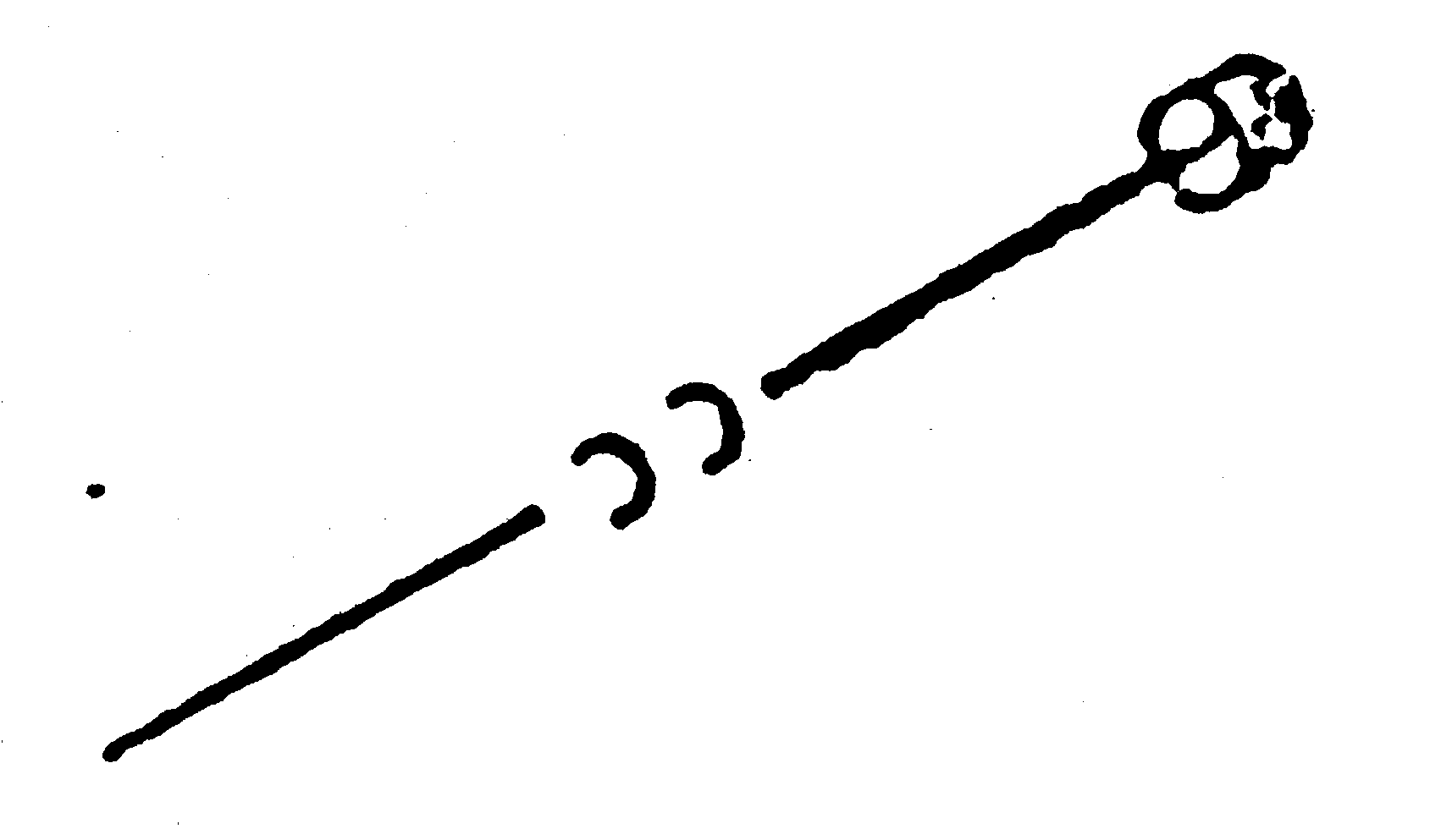IDENTIFICATION  Please attach the following documents to your application:  • originals or photocopies of optometrical certificates  • originals or photocopies of registration certificates or licence/s (where applicable)  • a recent passport sized photograph |  |  |  |  |  |  |  |  | 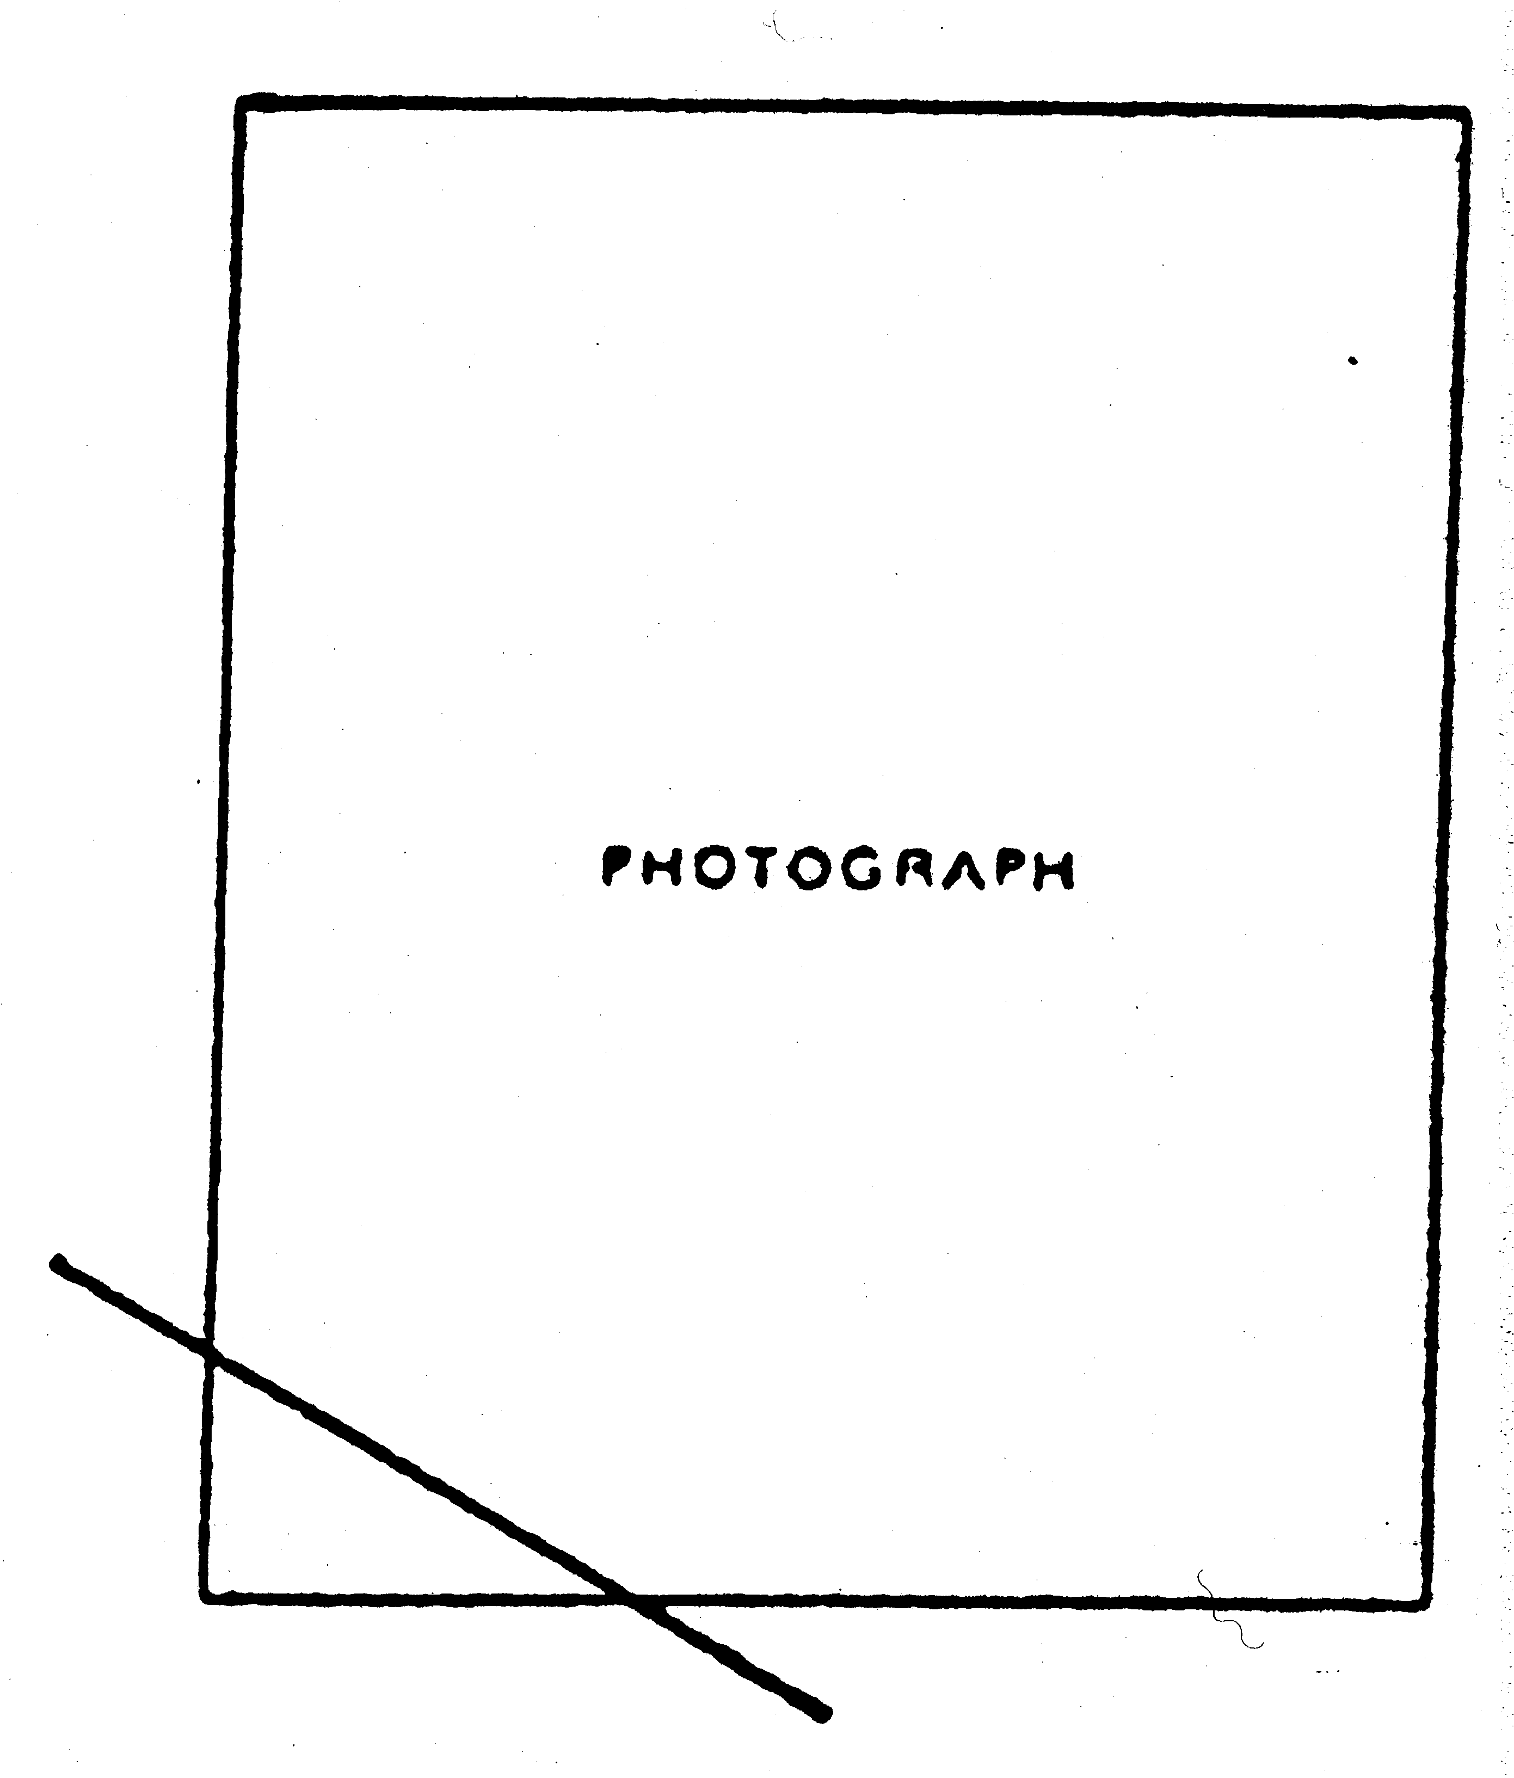

If currently registered, the seal or the stamp of the registration authority must be placed across the corner of the photograph, and the certificate below completed by the registration authority. In the case of applicants not currently registered (including new graduates), the photograph must be endorsed with the stamp or the seal of the school of optometry at which the applicant qualified, or with the stamp or the seal of the previous registration authority, and the certificate below completed by the head of the school of optometry or by the previous registration authority.
CERTIFICATE REGARDING APPLICANT
I, .....................................................................................................certify that:
(BLOCK LETTERS)
the photograph is that of the applicant
the applicant is currently registered
the applicant has not been guilty of professional misconduct
the applicant holds the qualifications claimed
Signature and designation ...........................................................................................................................................................................
Name and address of authority or school ...................................................................................................................................................
......................................................................................................................................................
BACKGROUND AND CHARACTER
The applicant is required to provide the names of 2 character referees from any of the following:
registered or licensed optometrist, head of optometry school, medical or legal practitioner, minister of religion, bank manager, justice of the peace, commissioner for oaths, notary public, serving commissioned officer in the armed services. The applicant must arrange for the character references detailed on the next page to be completed by the referees and forwarded by them directly to the appropriate registration board by airmail.
REFEREES (1) (2)
Name
Address
Designation

application for registration — character reference
You have been named as a referee by ............................................................................................................... who is
an applicant for registration as an optometrist in ..........................................................................................................
(State or Territory)
Please provide a confidential reference about the applicant. This should include details about the applicant on the following matters:
• reputation and standing
• criminal convictions, bankruptcy or professional misconduct, if any
Please state:
• your occupation and position
• how long you have known the applicant
• in what capacity you have known the applicant
• whether you are related to the applicant
You are required to forward this reference directly to the following registration board by airmail:
The Registrar
........................................................................
........................................................................
[Form 2 inserted in Gazette 1 Nov 1974 p. 4944-6.]
[Form 2A deleted in Gazette 1 Nov 1974 p. 4946.]
Form 3
Optometrists Act 1940
CERTIFICATE OF REGISTRATION OF AN OPTOMETRIST
No.
I hereby certify that , of , was registered as an optometrist under the Optometrists Act 1940, on the day of 20 . (See note below.)
Dated the day of 20 .
Registrar,
The Optometrists Registration Board.
Note. — This certificate is evidence of original registration only and is not, nor must it be used as, evidence of the identity of the holder with the person named therein, or that the person named therein at any time remains so registered. A licence must be taken out for every year in which the optometrist desires to practice.
Form 4
Optometrists Act 1940
APPLICATION TO WITHDRAW NAME FROM REGISTER
To the Optometrists Registration Board:
I of
do hereby request you, under section 21 of the Act, to withdraw my name from the Register of Optometrists.
Dated the day of 20 .
Signature of Applicant.
Form 5
Optometrists Act 1940
APPLICATION TO RE-ENTER NAME IN REGISTER UNDER SECTION 22
To the Optometrists Registration Board:
I of
do hereby apply, under section 22 of the Act, to have my name re-entered in the Register of Optometrists.
Dated the day of 20 .
Signature of Applicant.
Note. — This application must be lodged with the Registrar together with the sum provided by section 22(3) of the Act, or the sum of $21, whichever is the less. And together with the prescribed re-entry fee.
[Form 6 deleted in Gazette 30 Dec 2004 p. 6982.]
Form 7
Optometrists Act 1940
APPLICATION TO RE-ENTER NAME IN REGISTER
OR UNDER SECTION 28
To the Optometrists Registration Board:
I of do hereby apply, under section 28 of the Act, to have my name re-entered in the Register of Optometrists for the following reasons, viz.:
Dated the day of 20 .
Signature of Applicant.
Note. — If the application is granted by the Board the applicant will be notified, but the applicant’s name will not be re-entered until the sum payable under section 28(5) of the Act has been paid, together with the prescribed fee for such re-entry.
[Form 8 deleted in Gazette 30 Dec 2004 p. 6982.]
Form 9
Optometrists Act 1940
OPTOMETRISTS LICENCE
No.
(Name in full.) of is hereby licensed, for the period ending 31 December 20 , to practise optometry.
This licence is issued under and subject to the provisions of the Optometrists Act 1940 and the rules and regulations thereunder and in force for the time being, so far as such provisions and rules and regulations are applicable hereto. (See note below.)
Dated the day of 20 .
Registrar,
The Optometrists Registration Board.
Note. — This licence remains operative only until the close of the year stated above. A licence must be taken out for every subsequent year in which the optometrist desires to practise. This licence is not and must not be used as evidence of the identity of the holder with the person named therein.
Form 10
Optometrists Act 1940
SUMMONS TO ATTEND BEFORE THE BOARD
IN THE MATTER OF
To of
You are hereby required to attend before the Optometrists Registration Board at on day the day of 20 , at the hour of in the noon, and so from day to day until the abovementioned matter is heard and determined —
(a) to give evidence in the abovementioned matter, and
(b) also to bring with you and produce at the time and place aforesaid
(Specify documents to be produced.)
Dated the day of 20 .
By order of the Board,
Registrar.
Note. — Attention is drawn to the provisions of section 27(3) of the Act, whereby obedience to this summons may be enforced by the Supreme Court or a Judge thereof on application by the Board.
Strike out (b) if not required.
[Form 10 amended in Gazette 30 Dec 2004 p. 6982.]

[Forms 11 and 12 deleted in Gazette 19 Sep 1952 p. 2243.]
Form 13
Optometrists Act 1940
QUALIFYING CERTIFICATE
No.
I hereby certify that of has qualified himself for registration as an optometrist under the Optometrists Act 1940.
Dated the day of 20 .
Registrar,
The Optometrists Registration Board.

Form 14
THE OPTOMETRISTS REGISTRATION BOARD DIP.OPT.
OF WESTERN AUSTRALIA
In the name of the Board and by authority of same, be it known that ....................................................having fulfilled all the requirements, completed the course of optometry and passed the necessary examinations, has this day been granted the Diploma of Optometry of Western Australia.
In token whereof the Board has authorised the corporate seal of the Board to be affixed.
Dated the ..................................... day of ....................................... 20.........
................................................
Chairman.
................................................
Registrar.
[Form 14 inserted in Gazette 19 Sep 1952 p. 2243.]

Second Appendix
[Heading deleted]
Fees (other than examination fees)
 | $
For registration of an optometrist ........................................................ | 100.00
For certificate of registration (section 19) ........................................... | 5.00
For inspection of Register ................................................................... | 2.00
For re-entry of name of optometrist on the Register ........................... | 20.00
For amendment of Register ................................................................. | 2.00
Annual licence fee of an optometrist ................................................... | 210.00
For certificate that a person has qualified for registration as an optometrist .............................................................................. | 5.00
For Diploma of Optometry of Western Australia ............................... | 10.00
[Heading deleted]
Examination fees
 | $
1. Each annual examination .................................................................. | 10.00
2. Each supplementary examination for each subject .......................... | 10.00
3. Practical test of competency under section 34(c) of the Act ........... | 25.00
[Heading deleted]
Annual permit fee
A person who has been granted permission to dispense in accordance with section 34C of the Act shall pay to the Board, no later than 15 January in each year, a fee of $21.
[Second Appendix inserted in Gazette 12 Mar 1976 p. 733; amended in Gazette 21 Sep 1979 p. 2925; 31 Dec 1980 p. 4424; 19 Dec 1986 p. 4872; 26 Oct 1999 p. 5286; 21 Nov 2000 p. 6325; 8 Apr 2004 p. 1175; 25 Jan 2005 p. 341.]

Notes
¹ This is a compilation of the Optometrists Registration Board Rules 1941 and includes the amendments made by the other written laws referred to in the following table ^{1a}. The table also contains information about any reprint.

Compilation table
Citation | Gazettal | Commencement
Optometrists Registration Board Rules 1941 | 23 May 1941 p. 692-701  (errata 20 Jun 1941 p. 837) | 23 May 1941
Untitled | 4 May 1945 p. 424 | 4 May 1945
Untitled | 4 May 1945 p. 425-6 | 4 May 1945
Untitled | 20 Sep 1946 p. 1172 | 20 Sep 1946
Untitled | 18 Feb 1949 p. 308-9 | 18 Feb 1949
Untitled | 10 Mar 1950 p. 481 | 10 Mar 1950
Untitled | 19 Sep 1952 p. 2242-3 | 19 Sep 1952
Untitled | 6 Mar 1953 p. 460 | 6 Mar 1953
Untitled | 11 Sep 1953 p. 1690 | 11 Sep 1953
Untitled | 5 Nov 1954 p. 1874 | 5 Nov 1954
Untitled | 7 Jan 1958 p. 25 | 7 Jan 1958
Untitled | 15 Jul 1958 p. 1554-5 | 15 Jul 1958
Untitled | 30 Jun 1959 p. 1728 | 30 Jun 1959
Untitled | 28 Apr 1960 p. 1149-50 | 28 Apr 1960
Untitled | 21 Jul 1960 p. 2189-90 | 21 Jul 1960
Untitled | 9 Jan 1961 p. 61 | 9 Jan 1961
Untitled | 3 Nov 1961 p. 3061 | 3 Nov 1961
Decimal Currency Act 1965 assented to 21 Dec 1965 |  | s. 4-9: 4 Feb 1966 (see s. 2(2));  balance: 21 Dec 1965 (see s. 2(1))
Reprint of the Optometrists Registration Board Rules 1941 as at 11 Jul 1966 published in Gazette 15 Jul 1966 p. 1921-36 (includes amendments listed above)
Untitled | 28 Nov 1968 p. 3458-9 | 28 Nov 1968
Optometrists Registration Board Rules (Amendment) Rules 1974 | 1 Nov 1974 p. 4941-6 | 1 Nov 1974
Untitled | 9 May 1975 p. 1300 | 9 May 1975
Untitled | 12 Mar 1976 p. 733 | 12 Mar 1976
Untitled | 21 Sep 1979 p. 2925 | 21 Sep 1979
Optometrists Registration Board Amendment Rules 1980 | 31 Dec 1980 p. 4424 | 1 Jan 1981 (see r. 2)
Optometrists Registration Board Amendment Rules 1986 | 19 Dec 1986 p. 4872 | 1 Jan 1987 (see r. 2)
Optometrists Registration Board Amendment Rules 1993 | 31 Dec 1993 p. 6886-7 | 31 Dec 1993
Optometrists Registration Board Amendment Rules 1997 | 1 Jul 1997 p. 3253-4 | 1 Jul 1997
Optometrists Registration Board Amendment Rules (No. 2) 1997 | 6 Jan 1998 p. 32 | 6 Jan 1998
Optometrists Registration Board Amendment Rules 1999 | 26 Oct 1999 p. 5283-6 | 26 Oct 1999
Optometrists Registration Board Amendment Rules 2000 | 21 Nov 2000 p. 6325 | 21 Nov 2000
Optometrists Registration Board Amendment Rules 2002 | 28 Jun 2002 p. 3078 | 28 Jun 2002
Optometrists Registration Board Amendment Rules (No. 2) 2002 | 22 Oct 2002 p. 5252-3 | 22 Oct 2002
Reprint 2: The Optometrists Registration Board Rules 1941 as at 7 Mar 2003 (includes amendments listed above)
Optometrists Registration Board Amendment Rules 2004 | 8 Apr 2004 p. 1175 | 8 Apr 2004
Optometrists Registration Board Amendment Rules (No. 2) 2004 | 30 Dec 2004 p. 6981-2 | 1 Jan 2005 (see r. 2 and Gazette 31 Dec 2004 p. 7130)
Optometrists Registration Board Amendment Rules (No. 3) 2004 | 25 Jan 2005 p. 341 | 25 Jan 2005
These rules were repealed by the Optometrists Act 2005 s. 109 (No. 29 of 2005) as at 20 Apr 2007 (see s. 2 and Gazette 30 Mar 2007 p. 1451)
^{1a} On the date as at which this compilation was prepared, provisions referred to in the following table had not come into operation and were therefore not included in this compilation. For the text of the provisions see the endnotes referred to in the table.

Provisions that have not come into operation
 | Short title | Number and Year |  | Assent |  |  | Commencement
Optometrists Act 2005 s. 107 ² |  |  | 29 of 2005 |  | 12 Dec 2005 | 20 Apr 2007 (see s. 2 and Gazette 30 Mar 2007 p. 1451)
² On the date as at which this compilation was prepared, the Optometrists Act 2005 s. 107 had not come into operation. It reads as follows:
“
107. Optometrists Registration Board Rules 1941 repealed
The Optometrists Registration Board Rules 1941 are repealed.
”.

Defined terms

[This is a list of terms defined and the provisions where they are defined. The list is not part of the law.]
Defined term Provision(s)
applicant 34B(3)
approved qualifications 3(5)
Council 30(2)

