Western Australia
Country Areas Water Supply Act 1947 2

Country Areas Water Supply By-laws 1957

Reprinted under the Reprints Act 1984 as
at 19 May 2017
Western Australia
Country Areas Water Supply By-laws 1957
Contents
Division 1 — Preliminary
1. Citation, commencement and application 1
1A. Terms used 2
Division 2 — Prevention of pollution in water reserves and catchment areas
2. Application of Division 3
3. Cesspools to be filled in on notice from CEO 4
4. Closets, situation of, removal 4
5. Houses to have approved sanitary conveniences 4
6. Earth closets and privies, construction of 5
6A. Sanitary conveniences, number required in houses and other places 6
6B. Sanitary conveniences to be kept clean 6
7. Closets and urinals to be replaced 7
8. Closets not to cause nuisances 7
9. Nightsoil etc., disposal of 7
10. Manure etc., disposal of near water 8
11. Fertiliser and poisons, use of 8
12. Stables etc., construction of near water 9
13. Stables etc. to be kept clean 9
14. Closets to be disinfected 10
15. Nightsoil to be treated 10
16. Closet pans, procedure for removing and cleaning 10
17. Nightsoil, charges for removal of 11
19A. Pigs, keeping of 12
20. Animals not to be allowed to stray over certain catchment areas 12
21. Abattoirs etc., establishment of 12
22. Carcasses to be removed from near water 13
23. Human burials to be in approved places 13
24. Household refuse, receptacles for 13
25. Household refuse, disposal of 14
26. Refuse etc. not to be deposited in catchment area 14
27. Refuse bins etc., position and cleaning of 14
28. Refuse etc. to be deposited only at approved sites 15
29. Industrial wastes, discharge of 15
30. Polluting activities prohibited 15
31. Bathing prohibited except in approved places 16
32. Powers of entry 16
33. Compliance, CEO to fix time for 16
34. Timber cutting and clearing without permission 17
35. Hunting, shooting and fishing, CEO may restrict 17
36. Camping and picnicking restricted 18
Division 3 — Protection of water supplies and Minister and Corporation property
40. Flora protected 18
Division 7 — Miscellaneous
105. Penalties 20
Schedule 1 — Description of South West Settlement Area
Schedule 2 — Map of South West Settlement Area
Schedule 4 — Mungalup Dam Catchment
Map of Wellington Dam Catchment Area showing Mungalup Dam Catchment
Map of Mungalup Dam Catchment
Notes
Compilation table 28
Defined terms

Reprinted under the Reprints Act 1984 as
at 19 May 2017
Western Australia
Country Areas Water Supply Act 1947 ²
Country Areas Water Supply By-laws 1957

Division 1 — Preliminary
[Heading inserted: Gazette 29 May 2001 p. 2707.]

1. Citation, commencement and application
(1a) These by-laws may be cited as the Country Areas Water Supply By-laws 1957 ¹.
(1) These by-laws shall take effect and have the force of law on and after 1 July 1957, in every catchment area and water reserve constituted under section 9 of the principal Act.
(2) Despite sub-bylaw (1), these by-laws do not apply to —
(a) the Wellington Dam Catchment Area, except for the Mungalup Dam Catchment; or
(b) the Kent River Water Reserve; or
(c) the Warren River Water Reserve, except for those parts of the reserve that are also catchment areas.
(3) The boundaries of the Mungalup Dam Catchment are, for the purposes of sub-bylaw (2) —
(a) defined by reference to the coordinates annexed to the Department of Water Plan WT 6564 titled “Mungalup Dam Catchment” and dated 3/09/2013; and
(b) shown, for information, on the maps in Schedule 4.
Note for this sub-bylaw:
The map referred to in sub-bylaw (3)(a) is available for inspection at the Head Office of the Department of Water and on the Department’s website.
(4) In sub-bylaw (3) —
coordinates means Map Grid of Australia 1994 grid coordinates in Zone 50 of the Universal Transverse Mercator Grid System based on the Geocentric Datum of Australia.
[By-law 1 amended: Gazette 11 Nov 1983 p. 4525; 14 Nov 2013 p. 5033; 15 Nov 2013 p. 5267-8; 8 May 2015 p. 1622.]

1A. Terms used
(1) In these by-laws, unless the context otherwise requires —
Aboriginal customary purpose means —
(a) preparing or consuming food customarily eaten by Aboriginal persons; or
(b) preparing or using medicine customarily used by Aboriginal persons; or
(c) engaging in artistic, ceremonial or other cultural activities customarily engaged in by Aboriginal persons; or
(d) engaging in activities incidental to a purpose stated in paragraph (a), (b) or (c);
feeder means a watercourse, creek, stream or other channel with permanent or intermittent flow whereby water is or can be conveyed to a reservoir;
inspector means an inspector appointed by the Corporation or the CEO for the purposes of these by-laws;
liquid waste means liquid wastes as defined in the Health (Treatment of Sewage and Disposal of Effluent and Liquid Waste) Regulations 1974 regulation 3;
Noongar people means the traditional owners of the lands in the South West Settlement Area;
principal Act means the Country Areas Water Supply Act 1947, as amended;
South West Settlement Area means the area of lands described in Schedule 1 and shown, for information purposes, on the map in Schedule 2;
special provision catchment area means a catchment area within the South West Settlement Area.
(2) In these by-laws, unless the context otherwise requires, words and expressions have the same meanings as in the principal Act.
(3) In these by-laws, unless the context otherwise requires, cesspool, drain, house, land, owner have the same meanings as they have in section 3 of the Health (Miscellaneous Provisions) Act 1911.
[By-law 1A amended: Gazette 22 Dec 1964 p. 4067-8; 15 Dec 1966 p. 3305; 30 Jun 1967 p. 1718; 24 Jul 1968 p. 2111; 8 Nov 1974 p. 5012; 17 Nov 1978 p. 4310-1; 26 Jun 1981 p. 2318; 7 Sep 1984 p. 2873; 22 Nov 1985 p. 4413; 14 Jul 1987 p. 2649; 22 Dec 1989 p. 4627; 29 Dec 1995 p. 6306, 6308-9 and 6310; 25 Aug 1998 p. 4735-6; 16 Jun 2000 p. 2961; 29 May 2001 p. 2705-6; 28 Jun 2004 p. 2390; 23 May 2008 p. 2006; 21 Apr 2011 p. 1472; 14 Nov 2013 p. 5034; 7 Jun 2016 p. 1777-8; 10 Jan 2017 p. 234.]

Division 2 — Prevention of pollution in water reserves and catchment areas
[Heading inserted: Gazette 29 May 2001 p. 2707.]

2. Application of Division
Subject to by-law 1(2), the by-laws in this Division apply to all water reserves and catchment areas constituted for the purpose of the principal or any amending Act.
[By-law 2 amended: Gazette 15 Nov 2013 p. 5268.]

3. Cesspools to be filled in on notice from CEO
All existing cesspools, within the catchment areas shall be cleansed and filled up to the satisfaction of an inspector, within one calendar month after notice, in writing, to that effect has been given by or with the authority of the CEO to the occupier or owner of the premises concerned.
[By-law 3 amended: Gazette 29 Dec 1995 p. 6309; 21 Apr 2011 p. 1472.]

4. Closets, situation of, removal
Closets shall not be constructed within 50 m of high-water mark, or of any well or bore, and any closet situated within 50 m of high-water mark, or of any well or bore, shall within one calendar month of notice to that effect being given to the owner or occupier by the CEO or by an inspector, be taken down and the cesspool, if it exists, cleansed and a fire made therein, after which the cesspool shall be filled up to the satisfaction of the inspector by the owner or occupier of the house to which the closet or cesspool is appurtenant.
[By-law 4 amended: Gazette 29 Dec 1995 p. 6309; 29 May 2001 p. 2706; 21 Apr 2011 p. 1472.]

5. Houses to have approved sanitary conveniences
(1) The owner and occupier of every house within the catchment area shall provide for the use of the occupants of the house —
(a) an earth closet with a sufficient number of pans approved by an inspector; or
(b) septic tanks or other apparatus as may be required or authorised by the CEO.
(2) The closet, septic tanks or authorised apparatus shall be erected in a position as directed by an inspector.
[By-law 5 amended: Gazette 27 Jul 1990 p. 3617; 29 Dec 1995 p. 6309; 21 Apr 2011 p. 1472.]

[5A. Deleted: Gazette 28 Jun 2004 p. 2391.]

6. Earth closets and privies, construction of
No person shall construct or cause to be constructed any earth closet or privy which does not comply with the following conditions:
(a) It shall not be less than —
1.5 m in length, or
1 m in width, or
2 m in height.
(b) It shall not be within 6 m of any house or tank, nor within 15 m of any other water supply, nor within 15 m of the milking shed or milk room of any dairy, and shall be so constructed that the pan may be withdrawn from the rear of the convenience.
(c) The walls shall be of stone, brick, or other material approved by the CEO.
(d) There shall be at least 2 ventilating openings, of 325 cm², in area, one in each of 2 opposite walls, and situated 1.8 m above the floor level.
(e) The roof shall be of galvanised iron, or other impervious material.
(f) The door shall be hung so that there is, when the door is closed, a clear space of at least 8 cm above and below it.
(g) The floor shall be of approved impervious material, and shall have a uniform fall of 1 in 30 from back to front and its upper surface shall be not less than 15 cm above the level of the ground adjoining.
(h) The panstead shall measure 50 cm long by 40 cm wide. It shall be totally enclosed and constructed in a manner to exclude flies.
(i) The under surface of the seat shall be 40 cm above the floor.
(j) A hinged aperture cover shall be provided to the seat.
(k) A service door shall be provided in the rear wall of the convenience through which the pan must be withdrawn.
[By-law 6 amended: Gazette 29 Dec 1995 p. 6309; 29 May 2001 p. 2706-7; 21 Apr 2011 p. 1472.]

6A. Sanitary conveniences, number required in houses and other places
In relation to sanitary conveniences to be provided in connection with houses and public and private places, the following provisions shall apply, that is to say:
(1) Every house, and every public place and every private place shall be provided with not less than one sanitary convenience.
(2) In the case of any house, or public or private place in respect of which the requirements of more than 20 persons have to be provided for, there shall be additional sanitary conveniences in the proportion of one for every 20 persons, or portion of 20: Provided that this requirement shall not apply to public buildings under Part VI of the Health (Miscellaneous Provisions) Act 1911, nor to licensed premises under the provisions of the Licensing Act 1911 ³, nor to factories under the provisions of the Factories and Shops Act 1920 ⁴.
[By-law 6A amended: Gazette 10 Jan 2017 p. 234.]

6B. Sanitary conveniences to be kept clean
(1) The occupier of any premises whereon there is a sanitary convenience shall maintain the convenience in a cleanly condition.
(2) The owner of any premises whereon there is a sanitary convenience shall maintain the convenience in accordance with these by-laws.
(3) Every closet shall be supplied with a sufficient number of receptacles which shall be interchangeable with others in the same district and which shall be of approved size, shape and style, and every pan shall be emptied and cleansed at least once every week or as often as may be required by an inspector.

7. Closets and urinals to be replaced
Closets or urinals already in existence shall, whenever considered necessary by an inspector be removed where directed by the inspector, and the removal or re-erection shall be at the cost of the owner, who shall have the work completed within one calendar month from delivery by the inspector of written notice to the owner requiring this to be done.

8. Closets not to cause nuisances
(1) The owner or occupier of any house within a catchment area shall not permit the contents of any pan used in any closet or urinal to overflow from any cause whatever.
(2) The owner or occupier of any house within the catchment area shall not permit any closet or urinal, or pan appertaining thereto, or used by the occupants of such house to become offensive or a nuisance, and every such owner or occupier, whenever directed, either verbally or in writing by an inspector, shall properly and effectively empty and cleanse the closet, urinal or pan, to the satisfaction of the inspector.

9. Nightsoil etc., disposal of
(1) Nightsoil, refuse and garbage shall be disposed of from time to time as the CEO or an inspector may direct.
(2) Nightsoil, faecal matter or refuse shall not be buried within the catchment area unless written consent thereto has been obtained from the CEO.
(3) Nightsoil, faecal matter or human urine, whether mixed with any other substance or not, or any solution thereof, unless the same has been thoroughly deodorised and disinfected to the satisfaction of an inspector, shall not be placed, deposited, spread or permitted to be placed, deposited or spread in or upon any land or garden within a catchment area, unless written consent thereto has been obtained from the CEO.
[By-law 9 amended: Gazette 29 Dec 1995 p. 6309; 29 May 2001 p. 2706; 21 Apr 2011 p. 1472.]

10. Manure etc., disposal of near water
Refuse, dung, manure or other offensive matter shall not be deposited or be permitted to be deposited within 300 m of high-water mark or of any well or bore.
[By-law 10 amended: Gazette 29 May 2001 p. 2707.]

11. Fertiliser and poisons, use of
(1) The owner or occupier of any house, land or premises situated within a catchment area shall not use without the approval of the CEO —
(a) any artificial manure for agricultural, horticultural, pastoral and sylvicultural purposes; or
(b) any weed killer or any other toxic substance; or
(c) any poison for the destruction of rabbits, dogs, foxes, possums, rats, mice or other vermin.
(2) The CEO may from time to time by notice published in the Government Gazette —
(a) specify substances that may be used within a catchment area without the CEO’s prior approval; or
(b) permit the use within a catchment area of any specified substance or substances in a specified manner or in accordance with a specified method.
(3)(a) Where a notice specifies a substance that may be used without the CEO’s prior approval in accordance with sub-bylaw (2)(a) that substance may be used within the catchment area in question without the approval referred to in sub-bylaw (1).
(b) Where a notice permits the use of any substance in a specified manner or in accordance with a specified method no person shall without the approval of the CEO use the substance within the catchment area in question except in that manner or in accordance with that method.
[By-law 11 amended: Gazette 11 Dec 1959 p. 3026; 29 Dec 1995 p. 6306 and 6309; 29 May 2001 p. 2706; 21 Apr 2011 p. 1470 and 1472.]

12. Stables etc., construction of near water
(1) Buildings of any description shall not be used as or constructed for a stable, cow-shed, goat-shed, sheep-pen, pig-sty or fowl-house, and any animal or bird shall not be housed or yarded within 300 m of high-water mark or of any well or bore or in a position that stormwaters may wash any manure or refuse therefrom into any reservoir or feeder.
(2) Every such structure within the catchment area shall have attached thereto for containing all liquid and solid manure a watertight receptacle approved by an inspector.
(3)(a) Land sloping to a feeder on which any such structure stands shall be excavated to a depth of at least 30 cm and the soil so obtained shall be used as an embankment around the area so excavated.
(b) Such work shall be done by and at the expense of the owner or occupier of such premises.
[By-law 12 amended: Gazette 29 May 2001 p. 2707.]

13. Stables etc. to be kept clean
The owner or occupier of any stable, cow shed, goat-shed, sheep-pen, pig-sty or fowl-house, situated within a catchment area, shall not allow any dung, manure, or other refuse to accumulate in or near such premises, but shall immediately remove or dispose of same in such manner that it cannot pollute any water flowing or which may flow into any reservoir or any feeder or any well or bore and an inspector may by written notice to the owner or occupier order the immediate removal and disposal of any dung, manure, or other refuse from such premises and any person omitting to comply with the notice to the satisfaction of an inspector shall be guilty of an offence against these by-laws, and liable to penalties for breach thereof.

14. Closets to be disinfected
The occupier of every house or premises whether public or private situated on any catchment area, shall when required by the CEO, cause all nightsoil or other matter deposited in any pan in any closet or privy to be thoroughly disinfected in the manner specified by an inspector.
[By-law 14 amended: Gazette 29 Dec 1995 p. 6309; 21 Apr 2011 p. 1472.]

15. Nightsoil to be treated
Every nightman or contractor shall cause the nightsoil removed from any premises to be either rendered inoffensive or treated in a destructor, desiccator or incinerator, or buried in trenches outside the catchment area, or disposed of in a manner approved by an inspector.

16. Closet pans, procedure for removing and cleaning
The mode of removal of each receptacle in each closet shall be as follows:
(a) The nightman shall remove each receptacle and at once cover the same with a suitable tight-fitting lid, and upon every such removal shall carefully place a cleansed pan, of the pattern approved by the CEO or an inspector, in lieu of every pan so removed.
(b) Each receptacle which is so removed from a closet and sealed with a lid as prescribed in the foregoing clause, shall be removed by the nightman in a cart or vehicle of a pattern to be approved by an inspector, and the contents of all such receptacles shall be deposited in such place or places as shall from time to time be fixed by the CEO or an inspector.
(c) After the receptacle has been emptied, it and its lid shall be thoroughly washed, and scrubbed in clean water and then the inside of the receptacle and both sides of the lid shall be thoroughly scrubbed in a disinfecting solution, a separate brush being used, and then wholly immersed in a solution of disinfectant having a germicidal value equal to a 5% solution of pure carbolic acid; or thoroughly cleansed in a steam-tight box or chamber with steam, to be applied to the receptacle and lid for not less than 5 minutes.
(d) The interior surface of every receptacle and the underside of the lids shall, after being thoroughly cleansed, be properly coated with coal tar applied hot, and the coating shall be renewed, whenever necessary, so as to properly protect the whole internal surface of the receptacle and the underside of the lid.
(e) The receptacle shall be emptied and perfectly cleansed as above once per week at least, or so much more frequently as the CEO or inspector may from time to time direct.
[By-law 16 amended: Gazette 29 Dec 1995 p. 6309; 21 Apr 2011 p. 1472.]

17. Nightsoil, charges for removal of
Every nightman is entitled to charge, unless other arrangements be made, and to receive from the occupier of any premises from which any nightsoil, trade or house refuse is removed, such sum or sums of money as are specified in a contract and approved by the CEO, and shall not ask, demand, or receive more than the sums approved.
[By-law 17 amended: Gazette 29 Dec 1995 p. 6309; 21 Apr 2011 p. 1472.]

[18, 19. Deleted: Gazette 29 Dec 1995 p. 6309.]

19A. Pigs, keeping of
The keeping of swine on any portion of a catchment area within 500 m of a reservoir or feeder situate within a catchment area or of a well or bore is hereby forbidden.
[By-law 19A amended: Gazette 29 May 2001 p. 2707.]

20. Animals not to be allowed to stray over certain catchment areas
A person shall not cause or permit horses, cattle, sheep, goats, pigs, ducks, geese, fowls or other species of livestock to stray or depasture over any portion of a catchment area in respect of which area the CEO has by notice in the Government Gazette prohibited the straying or depasturing of horses, cattle, sheep, goats, pigs, ducks, geese, fowls or other species of livestock.
[By-law 20 amended: Gazette 29 Dec 1995 p. 6309; 21 Apr 2011 p. 1472.]

21. Abattoirs etc., establishment of
Abattoirs, slaughterhouses or any trade with offensive waste shall not be established or conducted in any part of the catchment area, except in an area defined in the Schedule to this by-law and set apart for the offensive trades, and unless provision is made for the disposal of all wastes, liquid or otherwise, either outside the catchment area, or in some other manner approved by the CEO.
Schedule
Area; Description
Wellington Dam Catchment — Offensive Trades Waste Area; that piece of land delineated and bordered in red on Public Works Department Plan, W.A. 36033.
[By-law 21 amended: Gazette 25 Jul 1958 p. 1689-90; 29 Dec 1995 p. 6309; 21 Apr 2011 p. 1472.]

22. Carcasses to be removed from near water
In the event of the death or of an accident necessitating the slaughter of any horse, cattle, or sheep, or other animal, the carcase of the animal shall be removed by the owner thereof to a safe distance from high-water mark, or of any well or bore, or any feeder, or to such place as an inspector may direct, and the owner shall immediately thereafter dispose of same by burning to the satisfaction of the inspector, or if the owner cannot be found, the inspector shall destroy it.

23. Human burials to be in approved places
(1) No human body shall be buried in any catchment area except in a place approved by the Minister.
(2) Any human body so buried with the approval of the Minister shall be covered with at least 1.5 m of earth.
[By-law 23 amended: Gazette 29 Dec 1995 p. 6309; 29 May 2001 p. 2707; 21 Apr 2011 p. 1471.]

24. Household refuse, receptacles for
(1) The occupier of every house or premises shall provide and keep in a position approved by an inspector, such and so many receptacles or boxes of the material and of the dimensions as may be required by the CEO or inspector for the temporary deposit of solid house refuse.
(2) The owner or occupier of the house shall regularly collect all refuse or rubbish from the premises, and place the same in receptacles and he shall not permit or suffer the receptacles to overflow or become offensive, and shall, when necessary, or directed by the inspector, thoroughly disinfect the same forthwith.
(3)(a) The owner or occupier of every house or premises in which a receptacle or box is so provided or kept or used, shall cause same to be emptied at least once a week or as often as the inspector may direct.
(b) The owner or occupier of the house or premises shall keep the receptacle or box in good repair, and upon notice from the inspector immediately replace by a new and improved receptacle or box any receptacle or box that the inspector may deem worn out or unfit for use.
[By-law 24 amended: Gazette 29 Dec 1995 p. 6309; 21 Apr 2011 p. 1472.]

25. Household refuse, disposal of
(1) The owner or occupier of any house which is served by a rubbish removal service shall not deposit any rubbish whatsoever upon any catchment area, other than in the place set apart by the CEO or an inspector for such purpose.
(2) Where a house is not served by a rubbish removal service, then the owner or occupier of the house may, subject to the next succeeding by-law, dispose of his own dry house refuse or rubbish by burial: Provided that such rubbish shall be covered by at least 30 cm of clean earth.
[By-law 25 amended: Gazette 29 Dec 1995 p. 6309; 29 May 2001 p. 2707; 21 Apr 2011 p. 1472.]

26. Refuse etc. not to be deposited in catchment area
Rubbish, filth, blood, offal or manure or any slops, soapsuds, urine, water containing urine or other refuse, noisome thing or matter, shall not be deposited or be permitted to be deposited in any part of a catchment area, where it may, in the opinion of an inspector, be carried by stormwater, into any feeder or any well or bore, but every occupier or owner shall provide and maintain proper watertight vehicles or receptacles fitted with close-fitting covers or lids for the purpose of carting or receiving same.

27. Refuse bins etc., position and cleaning of
All such vehicles or receptacles shall be kept in such convenient place to allow of ready removal as may be directed by an inspector, so as not to be a nuisance to any person, and shall be kept in a thoroughly sanitary condition, and removed at least once every week and cleansed and disinfected both inside and out.

28. Refuse etc. to be deposited only at approved sites
Foul or offensive water or other offensive liquid, or refuse, garbage, sweepings, or other offensive matter or thing, shall not be pumped, emptied or swept, thrown, or otherwise discharged or deposited into or upon any street, lane, yard, vacant land, or other place, whether public or private within the district other than the place set apart by the CEO or an inspector for that purpose.
[By-law 28 amended: Gazette 29 Dec 1995 p. 6309; 21 Apr 2011 p. 1472.]

29. Industrial wastes, discharge of
(1) No person shall pump, drain or discharge or permit to be pumped, drained, or discharged, any water or liquid waste from any quarry, mine pit, factory or industrial process upon any catchment area without the written permission of the CEO.
(2) Where any permitted water or liquid waste is so discharged the person so discharging it shall at all times comply with the requirements of the permit.
[By-law 29 amended: Gazette 29 Dec 1995 p. 6309; 21 Apr 2011 p. 1472.]

30. Polluting activities prohibited
No person shall wash clothes or other articles in any watercourse, reservoir, aqueduct, or any waterworks within a catchment area, nor shall any person wash, throw, cause or permit to enter therein any dog or other animal, or throw or convey, or permit to be conveyed or thrown therein any rubbish, dirt, filth, dead animal, or other noisome thing.

31. Bathing prohibited except in approved places
Bathing in any watercourse, reservoir, aqueduct or any waterworks within a catchment area is prohibited except in the places and under the conditions as the CEO may from time to time specify.
[By-law 31 amended: Gazette 29 Dec 1995 p. 6309; 21 Apr 2011 p. 1472.]

32. Powers of entry
(1) It is lawful for an inspector or any assistant acting under the directions of an inspector or other officer authorised by the CEO, at any reasonable hour, with or without notice, to enter any land, house, or premises for the purpose of ascertaining whether any act or thing is being done or permitted or left within that land, or house, or those premises in breach of these by-laws and to remove or cause to be removed anything so done, permitted or left thereon in breach of these by-laws, or to take steps as he may deem necessary for carrying out these provisions.
(2) The cost of removal or other necessary act shall be borne by the owner or occupier of the premises upon which the breach occurs.
[By-law 32 amended: Gazette 29 Dec 1995 p. 6307 and 6309; 21 Apr 2011 p. 1471.]

33. Compliance, CEO to fix time for
Unless otherwise provided for, the time which may elapse between the giving of a notice and the doing of a thing required to be done by any inspector or other authorised officer shall be determined by the CEO according to the nature of each case.
[By-law 33 amended: Gazette 29 Dec 1995 p. 6309; 21 Apr 2011 p. 1472.]

34. Timber cutting and clearing without permission
(1) No person, whether in possession of a timber cutter’s licence or not, shall cut or hew timber or destroy any trees, shrubs or vegetation of any kind or carry out any clearing of any kind, on any catchment area unless authorised so to do by the CEO.
(2) A person does not need to be authorised by the CEO to do an activity referred to in sub-bylaw (1) in a special provision catchment area if the person —
(a) is a member of the Noongar people; and
(b) undertakes the activity for an Aboriginal customary purpose; and
(c) in undertaking the activity does not enter into or upon a reservoir or watercourse.
[By-law 34 amended: Gazette 29 Dec 1995 p. 6309; 21 Apr 2011 p. 1472; 7 Jun 2016 p. 1778.]

35. Hunting, shooting and fishing, CEO may restrict
(1) In this by-law —
hand-held tool does not include —
(a) a firearm or any other device from which an object is discharged; or
(b) a spear, boomerang or any other thing that is propelled from the hand.
(2) The CEO may from time to time prescribe restrictions on hunting, shooting and fishing in the catchment area.
(3) A restriction prescribed under this by-law does not operate to prevent a person from hunting for an invertebrate or egg in a special provision catchment area if the person —
(a) is a member of the Noongar people; and
(b) does so for an Aboriginal customary purpose; and
(c) does so only by hand or with a hand-held tool; and
(d) in doing so does not enter into or upon a reservoir or watercourse; and
(e) in doing so does not allow any hand-held tool to enter into or upon a reservoir or watercourse; and
(f) does not sell the invertebrate or egg.
[By-law 35 amended: Gazette 29 Dec 1995 p. 6309; 21 Apr 2011 p. 1472; 7 Jun 2016 p. 1778-9.]

36. Camping and picnicking restricted
(1) No person, body corporate or association or group of persons shall at any time camp or picnic within 300 m of the high-water mark or of any well or bore or any reservoir or feeder thereto.
(2) The CEO may from time to time by notices erected in a catchment area, further restrict camping and picnicking in the catchment area.
[By-law 36 amended: Gazette 29 Dec 1995 p. 6309; 29 May 2001 p. 2707; 21 Apr 2011 p. 1472.]

Division 3 — Protection of water supplies and Minister and Corporation property
[Heading inserted: Gazette 29 May 2001 p. 2707; amended: Gazette 21 Apr 2011 p. 1471.]

[37-39. Deleted: Gazette 14 Nov 2013 p. 5035.]

40. Flora protected
(1) The removal, plucking or damaging of any wild flower, shrub, bush, tree or other plant growing on any land or reserve under the care, control and management of the Corporation or the Minister, within 800 m of any reservoir or bore is prohibited.
(2) A person does not contravene sub-bylaw (1) by removing, plucking or damaging a wild flower, shrub, bush, tree or other plant in the South West Settlement Area if the person —
(a) is a member of the Noongar people; and
(b) does so for an Aboriginal customary purpose; and
(c) in doing so does not enter into or upon a reservoir or watercourse; and
(d) in doing so does not cause damage to, or adversely affect, any water works.
[By-law 40 amended: Gazette 29 Dec 1995 p. 6307; 29 May 2001 p. 2707; 21 Apr 2011 p. 1471; 7 Jun 2016 p. 1779.]

[41-46. Deleted: Gazette 14 Nov 2013 p. 5035.]
[Division 4: bl. 47-51, 55 and 57 deleted: Gazette 16 Jun 2000 p. 2962;
bl. 52, 54 and 54A deleted: Gazette 14 Nov 2013 p. 5035;
bl. 53 deleted: Gazette 28 Jun 2004 p. 2391;
bl. 56 deleted: Gazette 30 Jun 1960 p. 1953.]
[Division 5: bl. 58 deleted: Gazette 28 Jun 2004 p. 2391;
bl. 58AA deleted: Gazette 25 Aug 1998 p. 4737;
bl. 58A-62 deleted: Gazette 14 Nov 2013 p. 5035.]
[Division 6: bl. 63 and 82 deleted: Gazette 14 Jul 1987 p. 2658;
bl. 64-70, 72-75, 77-80, 83-85 and 87 deleted: Gazette 14 Nov 2013 p. 5035;
bl. 71 deleted: Gazette 26 Apr 2005 p. 1398;
bl. 76 deleted: Gazette 29 Sep 1998 p. 5406;
bl. 81 deleted: Gazette 1 Jul 1977 p. 2011;
bl. 86 deleted: Gazette 22 Dec 1989 p. 4635;
bl. 87A-88 deleted: Gazette 28 Jun 2004 p. 2391.]

Division 7 — Miscellaneous
[Heading inserted: Gazette 29 May 2001 p. 2708.]

[89, 90. Deleted: Gazette 27 Jun 1986 p. 2132.]

[91-94. Deleted: Gazette 22 Dec 1964 p. 4070.]

[95. Deleted: Gazette 14 Nov 2013 p. 5035.]

[95A, 95B Deleted: Gazette 14 Jul 1987 p. 2658.]

[96-101. Deleted: Gazette 14 Nov 2013 p. 5035.]

[102. Deleted: Gazette 14 Jul 1987 p. 2650.]

[103. Deleted: Gazette 22 Dec 1964 p. 4071.]

[104. Deleted: Gazette 27 Jun 1986 p. 2132.]

[104A, 104AA, 104B. Deleted: Gazette 14 Jul 1987 p. 2658.]

[104C. Deleted: Gazette 14 Nov 2013 p. 5035.]

[104D. Deleted: Gazette 19 Jun 2013 p. 2335.]

105. Penalties
(1) A person who contravenes or commits a breach of any provision of these by-laws, whether by act or omission, for which a penalty is not expressly prescribed, is liable, on conviction, to a penalty not exceeding $200, and in the case of a continuing contravention or breach, to a further penalty not exceeding $50 for each day during which the offence continues after notice of the contravention or breach is given by or on behalf of the Corporation or the Minister to that person.
(2) In addition to any penalty provided by these by-laws, any expense, loss or damage incurred by the Corporation or the Minister in consequence of the breach of any by-law shall be paid by the person committing the breach and recoverable in the same manner as compensation may be recovered under section 45(3) of the principal Act.
[By-law 105 amended: Gazette 12 Feb 1960 p. 325; 29 Dec 1995 p. 6308; 29 May 2001 p. 2706; 26 Apr 2005 p. 1398; 21 Apr 2011 p. 1471.]

Schedule 1 — Description of South West Settlement Area
[bl. 1A(1)]
[Heading inserted: Gazette 7 Jun 2016 p. 1780.]
All the lands and waters contained within a line that —
• starts at the intersection of the prolongation westerly of the northern boundary of the Shire of Coorow with the low water mark, being a point on a northern boundary of native title determination application WAD6192/1998 (WC97/71) as accepted for registration on the Register of Native Title Claims on 22 August 1997;
• then continues generally easterly and generally south-easterly along the boundaries of that native title application to the intersection with native title determination application WAD6181/1998 (WC00/7) as accepted for registration on the Register of Native Title Claims on 3 July 2008;
• then continues generally easterly, generally south-easterly and westerly along the boundaries of that native title application to the intersection with native title determination application WAD6286/1998 (WC98/70) as accepted for registration on the Register of Native Title Claims on 29 September 1998;
• then continues generally southerly along the boundaries of that native title application to the intersection with the low water mark;
• then continues generally south-westerly, generally north-westerly and generally northerly along the low water mark back to the starting point,
other than any land or waters the subject of native title determination application WAD6193/1998 (WC97/72-6) as accepted for registration on the Register of Native Title Claims on 12 December 2011.
And all the islands landward of the low water mark that exist within the area contained within a line that —
• starts at the intersection of the prolongation westerly of the northern boundary of the Shire of Coorow with the low water mark;
• then continues generally southerly, generally south-easterly and generally north-easterly along the low water mark to the intersection with longitude 120.465236;
• then continues southerly to the intersection of the 3 nautical mile limit with longitude 120.465236;
• then continues generally south-westerly, generally north-westerly and generally northerly along the 3 nautical mile limit to the prolongation westerly of the northern boundary of the Shire of Coorow;
• then continues easterly along that prolongation back to the starting point.
Notes for this Schedule:
1. The low water mark is sourced from the Spatial Cadastral Database maintained by the Western Australian Land Information Authority as at 29 October 2012.
2. Coordinate references are to Geocentric Datum of Australia 1994 (GDA94) coordinates in decimal degrees.
3. The 3 nautical mile limit is sourced from Australian Maritime Boundaries (AMB), 6th edition, released in February 2006.
[Schedule 1 inserted: Gazette 7 Jun 2016 p. 1780-1.]

Schedule 2 — Map of South West Settlement Area
[bl. 1A(1)]
[Heading inserted: Gazette 7 Jun 2016 p. 1781.]
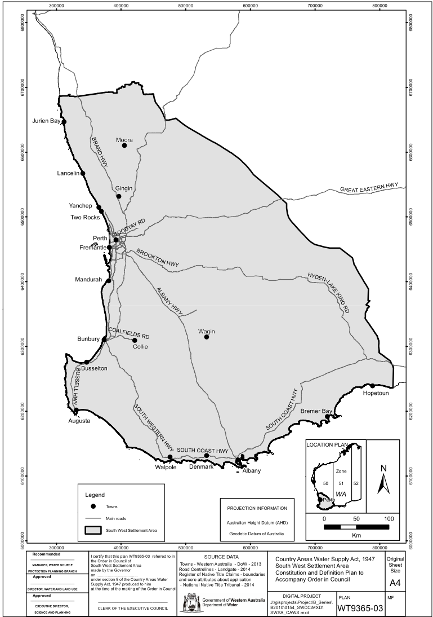
[Schedule 2 inserted: Gazette 7 Jun 2016 p. 1781.]

[Schedule 3 deleted: Gazette 14 Nov 2013 p. 5035.]

Schedule 4 — Mungalup Dam Catchment
[bl. 1(3)]
[Heading inserted: Gazette 15 Nov 2013 p. 5268.]

Map of Wellington Dam Catchment Area showing Mungalup Dam Catchment
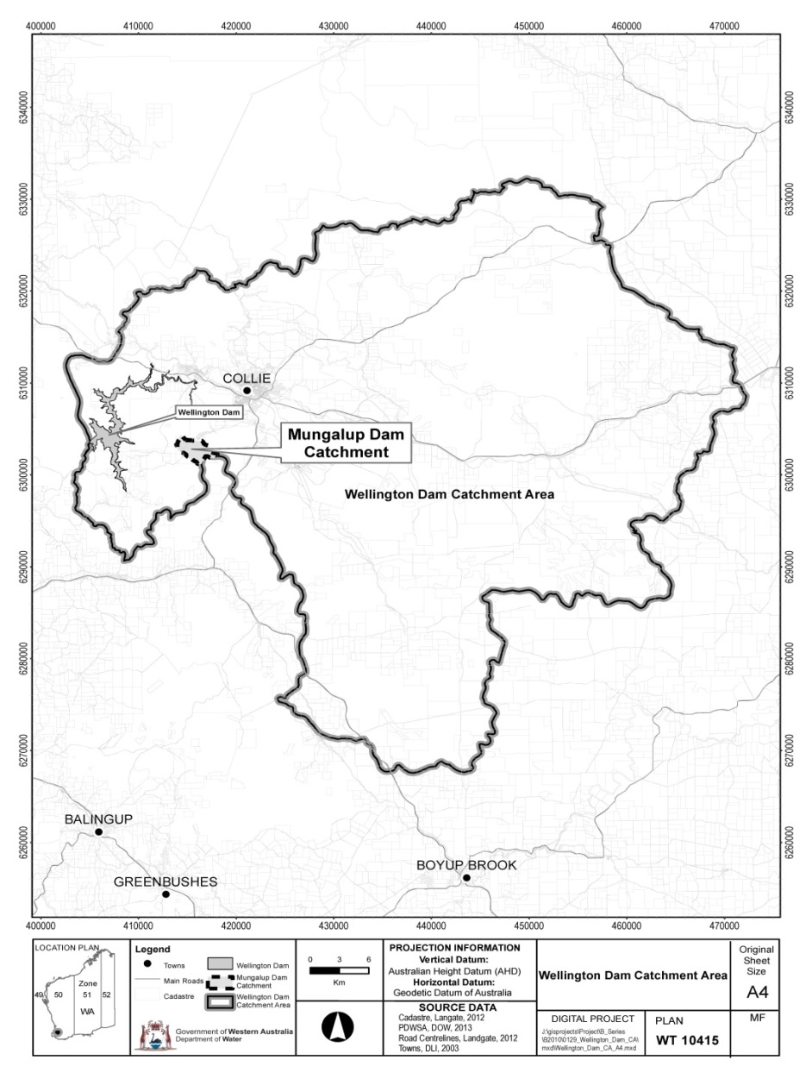

Map of Mungalup Dam Catchment
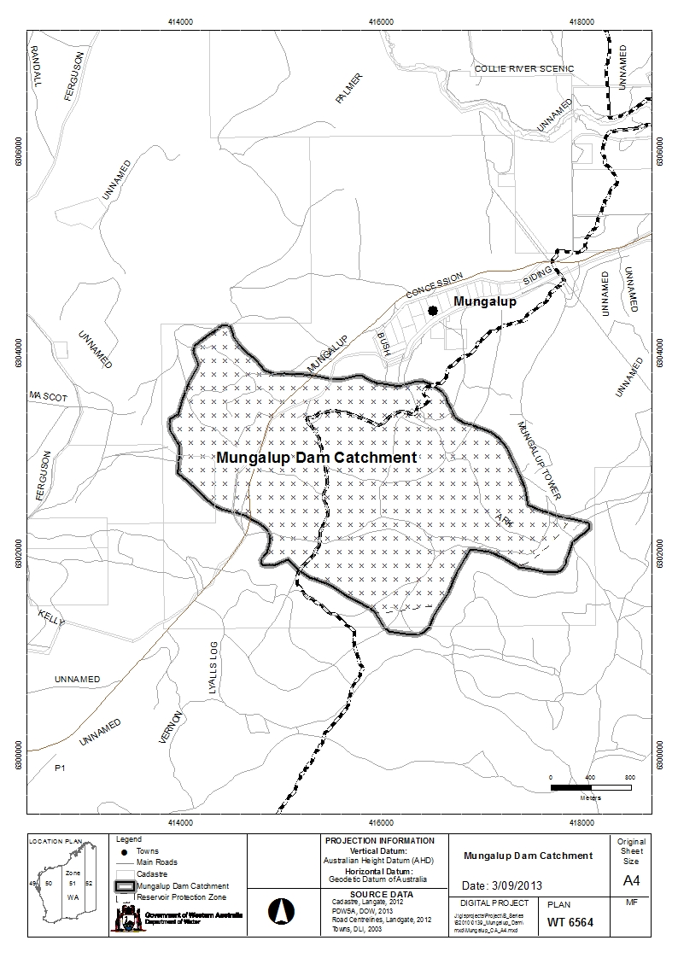
[Schedule 4 inserted: Gazette 15 Nov 2013 p. 5268-9.]

[Schedules 5, 6 deleted: Gazette 14 Jul 1987 p. 2650.]

Notes
¹ This is a compilation of the Country Areas Water Supply By-laws 1957 and includes the amendments made by the other written laws referred to in the following table ⁵. The table also contains information about any reprint.

Compilation table
 | Citation |  | Gazettal |  | Commencement
 | Untitled by-laws ⁶ |  | 20 Jun 1957 p. 1947-78 |  | 1 Jul 1957 (see bl. 1)
 | Untitled by-laws |  | 11 Dec 1959 p. 3025-6 |  | 11 Dec 1959
 | Untitled by-laws |  | 30 Jun 1960 p. 1953 |  | 30 Jun 1960
 | Untitled by-laws |  | 22 Dec 1964 p. 4067-74 |  | 1 Jan 1965
 | Untitled by-laws |  | 26 Jul 1966 p. 2082 |  | 26 Jul 1966
 | Untitled by-laws |  | 15 Dec 1966 p. 3305-6 |  | 15 Dec 1966
 | Untitled by-laws |  | 30 Jun 1967 p. 1718 |  | 1 Jul 1967
 | Untitled by-laws |  | 6 Sep 1967 p. 2213 |  | 6 Sep 1967
 | Reprint authorised 26 Apr 1968 in Gazette 1 May 1968 p. 1219-42 (including amendments listed above)
 | Untitled by-laws |  | 24 Jul 1968  p. 2111 |  | 24 Jul 1968
 | Untitled by-laws |  | 5 Sep 1968 p. 2686 |  | 5 Sep 1968
 | Untitled by-laws |  | 26 Sep 1968 p. 2858 |  | 26 Sep 1968
 | Untitled by-laws |  | 6 Feb 1969 p. 453 |  | 6 Feb 1969
 | Untitled by-laws |  | 9 Feb 1970 p. 376-7 |  | 9 Feb 1970
 | Untitled by-laws |  | 25 Sep 1970 p. 3049-50 |  | 25 Sep 1970
 | Untitled by-laws |  | 4 May 1971  p. 1325 |  | 4 May 1971
 | Untitled by-laws |  | 1 Dec 1972 p. 4593 |  | 1 Dec 1972
 | Untitled by-laws |  | 29 Jun 1973  p. 2510 |  | 29 Jun 1973
 | Untitled by-laws |  | 26 Apr 1974  p. 1394 |  | 26 Apr 1974
 | Untitled by-laws |  | 8 Nov 1974 p. 5012-14 |  | 8 Nov 1974
 | Untitled by-laws |  | 6 Dec 1974 p. 5246-7 |  | 6 Dec 1974
 | Untitled by-laws |  | 21 Mar 1975  p. 964 |  | 21 Mar 1975
 | Untitled by-laws |  | 17 Dec 1976 p. 4995 |  | 17 Dec 1976
 | Untitled by-laws |  | 1 Jul 1977 p. 2011-13 |  | 1 Jul 1977
 | Untitled by-laws |  | 23 Mar 1978  p. 864 |  | 23 Mar 1978
 | Untitled by-laws |  | 30 Jun 1978  p. 2156-9 |  | 30 Jun 1978
 | Untitled by-laws |  | 17 Nov 1978 p. 4310-11 |  | 17 Nov 1978
 | Untitled by-laws |  | 29 Jun 1979 p. 1792-4 |  | 29 Jun 1979
 | Untitled by-laws |  | 27 Jun 1980 p. 1965-7 |  | 1 Jul 1980 (see bl. 2)
 | Country Areas Water Supply Act Amendment By-laws 1981 |  | 26 Jun 1981 p. 2318-20 |  | 1 Jul 1981 (see bl. 2)
 | Country Areas Water Supply Act Amendment By-laws 1982 |  | 25 Jun 1982 p. 2127-9 |  | 1 Jul 1982 (see bl. 2)
 | Country Areas Water Supply Act Amendment By-laws (No. 2) 1982 |  | 20 Aug 1982 p. 3318-19 |  | 20 Aug 1982
 | Country Areas Water Supply Amendment By-laws 1983 |  | 1 Jul 1983 p. 2138-40 |  | 1 Jul 1983 (see bl. 2)
 | Country Areas Water Supply Amendment By-laws (No. 2) 1983 |  | 11 Nov 1983 p. 4525-6 |  | 11 Nov 1983
 | Country Areas Water Supply Amendment By-laws 1984 |  | 29 Jun 1984 p. 1788-90 |  | 29 Jun 1984
 | Country Areas Water Supply Amendment By-laws (No. 2) 1984 |  | 7 Sep 1984 p. 2873 |  | 7 Sep 1984
 | Country Areas Water Supply Amendment By-laws 1985 |  | 22 Feb 1985 p. 690 |  | 22 Feb 1985
 | Country Areas Water Supply Amendment By-laws (No. 2) 1985 |  | 28 Jun 1985 p. 2336-8 |  | 1 Jul 1985 (see bl. 3)
 | Country Areas Water Supply Amendment By-laws (No. 3) 1985 |  | 22 Nov 1985 p. 4413-14 |  | 22 Nov 1985
 | Country Areas Water Supply Amendment By-laws 1986 |  | 27 Jun 1986 p. 2132-4 |  | 27 Jun 1986
 | Country Areas Water Supply Amendment By-laws (No. 2) 1986 |  | 22 Aug 1986 p. 2992 |  | 22 Aug 1986
 | Water Authority Amendment By-laws 1987 bl. 3 and Pt. II |  | 14 Jul 1987 p. 2649-58 (erratum 24 Jul 1987 p. 2841) |  | 14 Jul 1987
 | Water Authority Amendment  By-laws 1988 Pt. 2 |  | 29 Jun 1988 p. 2122-6 |  | 1 Jul 1988 (see bl. 3)
 | Country Areas Water Supply Amendment By-laws 1988 |  | 14 Oct 1988 p. 4172 |  | 14 Oct 1988
 | Country Areas Water Supply Amendment By-laws 1989 |  | 21 Apr 1989 p. 1174 |  | 21 Apr 1989
 | Water Authority Amendment  By-laws 1989 Pt. 2 |  | 29 Jun 1989 p. 1883-91 |  | 1 Jul 1989 (see bl. 3)
 | Country Areas Water Supply Amendment By-laws (No. 2) 1989 |  | 22 Dec 1989 p. 4627-30 |  | 1 Feb 1990 (see bl. 2 and Gazette 5 Jan 1990 p. 38)
 | Country Areas Water Supply Amendment By-laws (No. 3) 1989 |  | 22 Dec 1989 p. 4634-5 |  | 1 Feb 1990 (see bl. 2 and Gazette 5 Jan 1990 p. 38)
 | Water Authority Amendment By-laws 1990 Pt. 2 |  | 29 Jun 1990 p. 3240-8 (errata  6 Jul 1990 p. 3318) |  | 1 Jul 1990 (see bl. 3)
 | Country Areas Water Supply Amendment By-laws 1990 |  | 27 Jul 1990 p. 3617-18 (erratum 10 Aug 1990 p. 3922) |  | 27 Jul 1990
 | Country Areas Water Supply Amendment By-laws (No. 2) 1990 |  | 21 Sep 1990 p. 4952-3 |  | 21 Sep 1990
 | Water Authority Amendment  By-laws 1991 Pt. 2 |  | 28 Jun 1991 p. 3281-9 |  | 1 Jul 1991 (see bl. 3)
 | Country Areas Water Supply Amendment By-laws 1991 |  | 3 Jan 1992 p. 33 |  | 3 Jan 1992
 | Water Authority Amendment  By-laws 1992 Pt. 2 |  | 26 Jun 1992 p. 2832-44 |  | 1 Jul 1992 (see bl. 3)
 | Water Authority Amendment  By-laws (No. 2) 1992 Pt. 4 |  | 31 Dec 1992 p. 6414-17 |  | 1 Jan 1993 (see bl. 2)
 | Country Areas Water Supply Amendment By-laws 1993 |  | 4 May 1993 p. 2327-8 |  | 4 May 1993
 | Water Authority Amendment  By-laws 1993 Pt. 2 ⁷ |  | 1 Jul 1993 p. 3238-50 |  | 1 Jul 1993
 | Water Authority Amendment  By-laws 1994 Pt. 2 ⁷ |  | 29 Jun 1994 p. 3159-70 |  | 1 Jul 1994 (see bl. 2)
 | Water Authority Amendment  By-laws 1995 Pt. 2 ⁷ |  | 30 Jun 1995 p. 2767-76 |  | 1 Jul 1995 (see bl. 2)
 | Country Areas Water Supply Amendment By-laws 1995 |  | 30 Jun 1995 p. 2777 |  | 30 Jun 1995
 | Water Agencies (Amendment and Repeal) By-laws 1995 Pt. 3 |  | 29 Dec 1995 p. 6305-32 |  | 1 Jan 1996 (see bl. 2 and Gazette 29 Dec 1995 p. 6291)
 | Water Agencies Amendment  By-laws 1997 Pt. 2 ⁷ |  | 27 Jun 1997 p. 3204-20 |  | 1 Jul 1997 (see bl. 2)
 | Water Agencies Amendment  By-laws 1998 Pt. 2 ⁷ |  | 26 Jun 1998 p. 3417-21 |  | 1 Jul 1998 (see bl. 2)
 | Country Areas Water Supply Amendment By-laws (No. 2) 1998 |  | 25 Aug 1998 p. 4735-7 |  | 25 Aug 1998
 | Country Areas Water Supply Amendment By-laws 1998 |  | 29 Sep 1998 p. 5406 |  | 29 Sep 1998 (see bl. 2)
 | Water Agencies Amendment  By-laws 1999 Pt. 3 ⁷ |  | 29 Jun 1999 p. 2775-87 |  | 1 Jul 1999 (see bl. 2)
 | Country Areas Water Supply Amendment By-laws 2000 |  | 14 Apr 2000  p. 1893 |  | 14 Apr 2000
 | Country Areas Water Supply Amendment By-laws (No. 2) 2000 |  | 16 Jun 2000  p. 2960-2 |  | 19 Jun 2000 (see bl. 2 and Gazette 16 Jun 2000 p. 2939)
 | Water Agencies Amendment  By-laws 2000 Pt. 3 ⁷ |  | 29 Jun 2000 p. 3365-79 |  | 1 Jul 2000 (see bl. 2)
 | Country Areas Water Supply Amendment By-laws (No. 4) 2000 |  | 29 Sep 2000 p. 5550-1 |  | 29 Sep 2000
 | Country Areas Water Supply Amendment By-laws 2001 |  | 29 May 2001 p. 2705-9 |  | 29 May 2001
 | Water Agencies Amendment By-laws 2001 Pt. 3 ⁷ |  | 29 Jun 2001 p. 3230-42 |  | 1 Jul 2001 (see bl. 2)
Reprint of the Country Areas Water Supply By-laws 1957 as at 3 Aug 2001
(includes amendments listed above)
 | Water Agencies Amendment By-laws 2002 Pt. 2 |  | 1 Jul 2002 p. 3137-53 |  | 1 Jul 2002
 | Water Agencies Amendment By-laws 2003 Pt. 3 ⁷ |  | 27 Jun 2003 p. 2422-32 |  | 1 Jul 2003 (see bl. 2)
 | Country Areas Water Supply Amendment By-laws 2004 |  | 28 Jun 2004 p. 2389-91 |  | 1 Jul 2004 (see bl. 2 and Gazette 28 Jun 2004 p. 2399)
 | Water Agencies Amendment By-laws 2004 Pt. 2 ⁷ |  | 29 Jun 2004 p. 2497-503 |  | 1 Jul 2004 (see bl. 2)
 | Country Areas Water Supply Amendment By-laws 2005 |  | 26 Apr 2005 p. 1397-8 |  | 26 Apr 2005
 | Water Agencies Amendment By-laws 2005 Pt. 3 ⁷ |  | 1 Jul 2005 p. 3009-17 |  | 1 Jul 2005 (see bl. 2)
Reprint 3: The Country Areas Water Supply By-laws 1957 as at 17 Mar 2006
(includes amendments listed above)
 | Water Agencies Amendment By-laws 2006 Pt. 3 ⁷ |  | 30 Jun 2006 p. 2399-412 |  | 1 Jul 2006 (see bl. 2)
 | Water Agencies Amendment By-laws 2007 Pt. 3 ⁷ |  | 29 Jun 2007 p. 3233-44 |  | 1 Jul 2007 (see bl. 2(b))
 | Country Areas Water Supply Amendment By-laws 2008 |  | 23 May 2008 p. 2006-8 |  | bl. 1 and 2: 23 May 2008 (see bl. 2(a));  By-laws other than bl. 1 and 2: 24 May 2008 (see bl. 2(b))
 | Water Agencies Amendment By-laws 2008 Pt. 3 ⁸ |  | 27 Jun 2008 p. 3076-84 |  | 1 Jul 2008 (see bl. 2(b))
 | Country Areas Water Supply Amendment By-laws (No. 3) 2008 |  | 26 Aug 2008 p. 4032 |  | bl. 1 and 2: 26 Aug 2008 (see bl. 2(a));  By-laws other than bl. 1 and 2: 27 Aug 2008 (see bl. 2(b))
Reprint 4: The Country Areas Water Supply By-laws 1957 as at 19 Dec 2008
(includes amendments listed above)
 | Water Agencies Amendment By-laws 2009 Pt. 3 |  | 19 Jun 2009 p. 2393-406 |  | 1 Jul 2009 (see bl. 2(b))
 | Country Areas Water Supply Amendment By-laws 2010 |  | 25 Jun 2010 p. 2884 |  | bl. 1 and 2: 25 Jun 2010 (see bl. 2(a));  By-laws other than bl. 1 and 2: 26 Jun 2010 (see bl. 2(b))
Water Agencies Amendment By-laws 2010 Pt. 3 |  | 25 Jun 2010 p. 2983-96 |  | 1 Jul 2010 (see bl. 2(b))
Country Areas Water Supply Amendment By-laws 2011 |  | 21 Apr 2011 p. 1470-2 |  | bl. 1 and 2: 21 Apr 2011 (see bl. 2(a));  By-laws other than bl. 1 and 2: 22 Apr 2011 (see bl. 2(b))
Water Agencies Amendment By-laws 2011 Pt. 3 |  | 23 Jun 2011 p. 2403-16 |  | 1 Jul 2011 (see bl. 2(b))
Reprint 5: The Country Areas Water Supply By-laws 1957 as at 9 Mar 2012
(includes amendments listed above)
Water Agencies Amendment By-laws 2012 Pt. 3 |  | 20 Jun 2012 p. 2677-92 |  | 1 Jul 2012 (see bl. 2(b))
Water Agencies Amendment By-laws 2013 Pt. 3 |  | 19 Jun 2013 p. 2333-46 |  | 1 Jul 2013 (see bl. 2(b))
Country Areas Water Supply Amendment By-laws 2013 |  | 14 Nov 2013 p. 5033-5 |  | bl. 1 and 2: 14 Nov 2013 (see bl. 2(a));  By-laws other than bl. 1 and 2: 18 Nov 2013 (see bl. 2(b) and Gazette 14 Nov 2013 p. 5027)
Country Areas Water Supply Amendment By-laws (No. 2) 2013 |  | 15 Nov 2013 p. 5267-9 |  | bl. 1 and 2: 15 Nov 2013 (see bl. 2(a));  By-laws other than bl. 1 and 2: 16 Nov 2013 (see bl. 2(b))
Country Areas Water Supply Amendment By-laws 2015 |  | 8 May 2015 p. 1622 |  | bl. 1 and 2: 8 May 2015 (see bl. 2(a));  By-laws other than bl. 1 and 2: 9 May 2015 (see bl. 2(b))
Country Areas Water Supply Amendment By-laws 2016 |  | 7 Jun 2016 p. 1777-81 |  | bl. 1 and 2: 7 Jun 2016 (see bl. 2(a));  By-laws other than bl. 1 and 2: 8 Jun 2016 (see bl. 2(b))
Water By-laws Amendment (Public Health) By-laws 2016 Pt. 2 |  | 10 Jan 2017 p. 233-5 |  | 24 Jan 2017 (see bl. 2(b) and Gazette 10 Jan 2017 p. 165)
Reprint 6: The Country Areas Water Supply By-laws 1957 as at 19 May 2017 (includes amendments listed above)
² These by-laws have effect for the purposes of the Country Areas Water Supply Act 1947 but the formal power to make them is now given by the Water Agencies (Powers) Act 1984 s. 34.
³ Repealed by the Liquor Act 1970, which was repealed by the Liquor Licensing Act 1988, which is now known as the Liquor Control Act 1988.
⁴ Repealed by the Factories and Shops Act 1963, which was repealed by the Industrial Relations Legislation Amendment and Repeal Act 1995.
⁵ These by-laws included headings immediately before various by-laws. Those headings were progressively deleted in Gazette 22 Dec 1964 p. 4070-72, 16 Jun 2000 p. 2962 and 29 May 2001 p. 2708.
⁶ Now known as the Country Areas Water Supply By-laws 1957; citation changed (see note under bl. 1).
⁷ These by-laws contain an application provision concerning fees and charges for a period commencing before, or for a matter or thing done before, the by-laws came into operation.
⁸ The Water Agencies Amendment By-laws 2008 bl. 3 reads as follows:

3. Application
Nothing in these by-laws affects the application after 1 July 2008 of a by-law in force before that day insofar as that by-law relates to a fee or charge for a period commencing before that day or to a fee or charge for any matter or thing done before that day.

Defined terms

[This is a list of terms defined and the provisions where they are defined. The list is not part of the law.]
Defined term Provision(s)
Aboriginal customary purpose 1A(1)
cesspool 1A(3)
coordinates 1(4)
drain 1A(3)
feeder 1A(1)
hand-held tool 35(1)
house 1A(3)
inspector 1A(1)
land 1A(3)
liquid waste 1A(1)
Noongar people 1A(1)
owner 1A(3)
principal Act 1A(1)
South West Settlement Area 1A(1)
special provision catchment area 1A(1)

