Western Australia
Iron Ore Agreements Legislation (Amendment, Termination and Repeals) Act 2011

Western Australia
Iron Ore Agreements Legislation (Amendment, Termination and Repeals) Act 2011
Contents
-Part 1 — Preliminary
1. Short title 3
2. Commencement 3
Part 7 — Port Hedland iron ore processing projects
Division 1 — Termination agreement
22. Ratification and operation of termination agreement 4
Schedule 1 — Termination agreement
Notes
Compilation table 34
Defined terms

Western Australia
Iron Ore Agreements Legislation (Amendment, Termination and Repeals) Act 2011
An Act —
- to amend these Acts —
- the Iron Ore (Mount Newman) Agreement Act 1964;
- the Iron Ore (Mount Goldsworthy) Agreement Act 1964;
- the Iron Ore (Goldsworthy-Nimingarra) Agreement Act 1972;
- the Iron Ore (McCamey’s Monster) Agreement Authorisation Act 1972;
- the Iron Ore (Marillana Creek) Agreement Act 1991;
and
- to ratify an agreement between the State and BHP Billiton Direct Reduced Iron Pty. Ltd. and others that provides for the termination of an agreement made on 16 October 1995 and subsequently varied by an agreement made on 11 April 2000, between the State and BHP Billiton Direct Reduced Iron Pty. Ltd. (under its former name, BHP Direct Reduced Iron Pty. Ltd.);
and
- to repeal these Acts —
- the Iron Ore Beneficiation (BHP) Agreement Act 1996;
- the Iron Ore - Direct Reduced Iron (BHP) Agreement Act 1996;
- the Iron Ore Processing (BHP Minerals) Agreement Act 1994.
The Parliament of Western Australia enacts as follows:

Part 1 — Preliminary

1. Short title
This is the Iron Ore Agreements Legislation (Amendment, Termination and Repeals) Act 2011.

2. Commencement
This Act comes into operation as follows —
(a) Part 1 —on the day on which this Act receives the Royal Assent (assent day);
(b) the rest of the Act — on the day after assent day.

Part 7 — Port Hedland iron ore processing projects

Division 1 — Termination agreement

22. Ratification and operation of termination agreement
(1) In this section —
termination agreement means the agreement a copy of which is set out in Schedule 1.
(2) The termination agreement is ratified.
(3) Without limiting or otherwise affecting the application of the Government Agreements Act 1979, the termination agreement is to operate and take effect despite any other Act or law.

Schedule 1 — Termination agreement
[s. 22]
2011
THE STATE OF WESTERN AUSTRALIA
and
BHP BILLITON DIRECT REDUCED IRON PTY. LTD.
ACN 058 025 960
and
BHP BILLITON MINERALS PTY. LTD.
ACN 008 694 782
MITSUI IRON ORE CORPORATION PTY. LTD.
ACN 050 157 456
ITOCHU MINERALS & ENERGY OF AUSTRALIA PTY. LTD.
ACN 009 256 259
________________________________________________________________
IRON ORE BENEFICIATION (BHP) AGREEMENT 1996
TERMINATION AGREEMENT ________________________________________________________________

[Solicitor's details]
THIS AGREEMENT is made this 7th day of November 2011

BETWEEN

THE HONOURABLE COLIN JAMES BARNETT, MEc., M.L.A., Premier of the State of Western Australia, acting for and on behalf of the said State and its instrumentalities from time to time (hereinafter called “the State”) of the first part,

BHP BILLITON DIRECT REDUCED IRON PTY. LTD. ACN 058 025 960 of Level 17, St Georges Square, 225 St Georges Terrace, Perth, Western Australia (hereinafter called “the Company” in which term shall be included its successors and permitted assigns) of the second part,

BHP BILLITON MINERALS PTY. LTD. ACN 008 694 782 of Level 17, St Georges Square, 225 St Georges Terrace, Perth, Western Australia, MITSUI IRON ORE CORPORATION PTY. LTD. ACN 050 157 456 of Level 16, Exchange Plaza, 2 The Esplanade, Perth, Western Australia and ITOCHU MINERALS & ENERGY OF AUSTRALIA PTY. LTD. ACN 009 256 259 of Level 22, Forrest Centre, 221 St Georges Terrace, Perth, Western Australia (hereinafter called "Joint Venturers" in which term shall be included their successors and permitted assigns) of the third part.

WHEREAS:

A. The State and the Company are the parties to the agreement dated 16 October 1995, which agreement was ratified by the Iron Ore Beneficiation (BHP) Agreement Act 1996 (WA), as varied by an agreement dated 11 April 2000 which was ratified by the Acts Amendment (Iron Ore Agreements) Act 2000. The first mentioned agreement as so varied is referred to in this Agreement as "the Beneficiation Agreement".
B. The State and the Joint Venturers are now the parties to the agreement dated 15 October 1964 approved by and scheduled to the Iron Ore (Mount Goldsworthy) Agreement Act 1964 and which as subsequently added to, varied or amended is referred to in this Agreement as the "Mount Goldsworthy Agreement".
C. The State and the Company wish to terminate the Beneficiation Agreement in the manner and on the terms set out in this Agreement, including the transfer to the Joint Venturers of rights in respect of certain land relating to the Beneficiation Agreement on the terms set out in this Agreement.

NOW THIS AGREEMENT WITNESSES:
1. Definitions
In this Agreement subject to the context:
"Beneficiation Agreement Minister" means the Minister in the Government of the State for the time being responsible for the administration of the Beneficiation Agreement;
"Boodarie GPLs" means the general purpose leases granted under the Mining Act and held by the Company as at the date of this Agreement as described in schedule A and "Boodarie GPL" means as the context requires any or a particular one of them and includes any tenement or title which is a renewal, replacement or successor of or which is granted in lieu of or in substitution for, any of them;
"EP Act" means the Environmental Protection Act 1986 (WA);
"Goldsworthy-Nimingarra Agreement" means the agreement ratified by and scheduled to the Iron Ore (Goldsworthy-Nimingarra) Agreement Act 1972 (WA), as from time to time added to, varied or amended;
"Land Administration Act" means the Land Administration Act 1997 (WA);
"laws relating to native title" means laws applicable from time to time in Western Australia in respect of native title and includes the Native Title Act 1993 (Commonwealth);
"Mining Act" means the Mining Act 1978 (WA);
"Minister" means the Minister in the Government of the State for the time being responsible for the administration of the Act to ratify this Agreement and pending the passing of that Act means the Minister for the time being designated in a notice from the State to the Company and includes the successors in office of the Minister;
"Minister for Mines" means the Minister in the Government of the State for the time being responsible for the administration of the Mining Act;
"Minister for Environment" means the Minister in the Government of the State for the time being responsible for the administration of the EP Act;
"Ministerial Statement" means the Statement That a Proposal May be Implemented (Pursuant to the Provisions of the Environmental Protection Act 1986) number 393 entitled "Hot Briquetted Iron Project, Port Hedland (899) BHP Direct Reduced Iron Pty Ltd" and issued by the then Minister for Environment on 4 September 1995;
"Mount Goldsworthy Agreement Minister" means the Minister in the Government of the State for the time being responsible for the administration of the Mount Goldsworthy Agreement;
"Operative Date" has the meaning given in clause 3(4);
"PEP Agreement" means the agreement ratified by the Pilbara Energy Project Agreement Act 1994 (WA), as from time to time added to, varied or amended;
"PEP Joint Venturers" means the Joint Venturers as defined in the PEP Agreement;
"Port Authorities Act" means the Port Authorities Act 1999 (WA);
"Port Authority" means the Port Hedland Port Authority established by the Port Authorities Act;
"Surrender GPLs" means the general purpose leases granted under the Mining Act and held by the Company as at the date of this Agreement as described in Schedule B; and
"this Agreement", "hereof" and "hereunder" refer to this Agreement, whether in its original form or as from time to time added to, varied or amended;
"Utah Jild lease" means registered lease K693814L of the land the subject of Deposited Plan 59462 being portion of Lot 370 on Deposited Plan 35619, part of the land in Crown Land Title Volume LR3118 Folio 753 granted to the Company by the Port Authority under the Port Authorities Act and pursuant to the Beneficiation Agreement; and
"Water Agreement" means the Water Supply Agreement dated 8 February 2000 between the Water Corporation and BHP Iron Ore Pty Ltd.
2. Interpretation
(1) In this Agreement:
(a) clause headings do not affect interpretation or construction;
(b) words in the singular shall include the plural and words in the plural shall include the singular according to the requirements of the context;
(c) one gender includes the other genders;
(d) a covenant or agreement by more than one person binds, and is enforceable against, those persons jointly and each of them severally;
(e) reference to an Act includes the amendments to that Act for the time being in force and also any Act passed in substitution therefor or in lieu thereof and the regulations for the time being in force thereunder;
(f) reference in this Agreement to any other document includes that document as from time to time added to, varied or amended and notwithstanding any change in the identity of the parties;
(g) reference to a clause or schedule is a reference to a clause or schedule to this Agreement, and a reference to a subclause or paragraph is a reference to the subclause of the clause or paragraph of the clause or subclause as the case may be in, or in relation to, which the reference is made; and
(h) "including" means "including, but not limited to".
(2) Nothing in this Agreement shall be construed to exempt the State or the Company from compliance with or to require the State or the Company to do anything contrary to any law relating to native title or any lawful obligation or requirement imposed on the State or the Company as the case may be pursuant to any law relating to native title. The provisions of this Agreement shall not operate so as to require the State or the Port Authority to grant or vary, or cause to be granted or varied, any lease licence or other right or title until all processes necessary under any laws relating to native title to enable that grant or variation to proceed, have been completed.
(3) Nothing in this Agreement shall be construed to exempt the Company from compliance with any requirement in connection with the protection of the environment arising out of or incidental to its activities under this Agreement that may be made by or under the EP Act.
3. Ratification and operation
(1) The State shall introduce and sponsor a Bill in the State Parliament of Western Australia prior to 31 December 2011 or such later date as may be agreed between the parties hereto to ratify this Agreement. The State shall endeavour to secure the timely passage of such Bill as an Act.
(2) The provisions of this Agreement other than this clause and clauses 1 and 2 will not come into operation until the day after the day on which the Bill referred to in subclause (1) has been passed by the State Parliament of Western Australia and commences to operate as an Act.
(3) If by 30 June 2012 the said Bill has not commenced to operate as an Act then, unless the parties hereto otherwise agree, this Agreement will then cease and determine and no party hereto will have any claim against any other party hereto with respect to any matter or thing arising out of, done, performed, or omitted to be done or performed under this Agreement.
(4) On the day after the day on which the said Bill commences to operate as an Act ("Operative Date") all the provisions of this Agreement will operate and take effect despite any enactment or other law.
4. Termination of Agreement
(1) Subject to subclause (2), the Beneficiation Agreement is hereby terminated with effect on and from the Operative Date and, except as otherwise provided in this Agreement, neither the State nor the Company shall have any claim against the other with respect to any matter or thing in or arising out of the Beneficiation Agreement.
(2) Notwithstanding subclause (1), the Company shall remain liable for any antecedent breach or default under the Beneficiation Agreement and in respect of any indemnity given under the Beneficiation Agreement.
(3) (a) On and from the Operative Date:
(i) for the avoidance of doubt, the holder of the Boodarie GPLs and the Surrender GPLs shall cease to have the benefit of any rights and privileges conferred by the Beneficiation Agreement; and
(ii) each of the Boodarie GPLs is varied by deleting the following condition which it contains:
"The construction and operation of the project and measures to protect the environment being carried out generally in accordance with detailed proposals submitted and approved under Clauses 6 and 7 of the Iron Ore Processing (BHP Minerals) Agreement Act 1994".
(b) The Joint Venturers and the Company acknowledge that the Minister for Environment has given the requisite approval for the purposes of condition 3-1 of the Ministerial Statement and has made the requisite nomination under section 38(7) of the EP Act in respect of the passing of responsibility for the proposal the subject of the Ministerial Statement to the Joint Venturers.
(c) As soon as practicable after the Operative Date, the Company shall make application under the Mining Act to transfer the Boodarie GPLs to the Joint Venturers and the State shall, notwithstanding section 276 of the Duties Act 2008 (WA) and without otherwise affecting the application of that Act, cause the Boodarie GPLs to be transferred to the Joint Venturers and:
(i) upon and from the date such transfers are registered under the Mining Act the Boodarie GPLs shall be held by the Joint Venturers pursuant to the Mount Goldsworthy Agreement for the purposes of the Mount Goldsworthy Agreement; and
(ii) as soon as practicable after the date such transfers are registered under the Mining Act:
(A) the Company shall unconditionally surrender the Surrender GPLs; and
(B) in respect of each Boodarie GPL listed in Schedule C, the Joint Venturers shall unconditionally surrender that portion of the Boodarie GPL described in Schedule C.
Section 114C of the Mining Act applies in respect of any land formerly the subject of a tenement surrendered pursuant to subparagraph (A) or (B) as if the reference in that section to "former holder" includes the Joint Venturers.
(d) Notwithstanding the Mining Act and without limiting the operation of clause 21(1) of the Mount Goldsworthy Agreement, the Minister for Mines, acting with the concurrence of the Mount Goldsworthy Agreement Minister, may on and from the Operative Date from time to time make, vary or cancel such conditions in respect of the Boodarie GPLs as the Minister for Mines considers reasonable.
(e) (i) The Joint Venturers and the Company acknowledge that with the Company's consent plant, facilities and other works have been constructed upon the land the subject of the Boodarie GPLs by other persons, including the PEP Joint Venturers pursuant to proposals approved under the PEP Agreement, and that such plant, facilities and other works continue to be operated by and for the benefit of those other persons or their successors or assigns.
(ii) Upon the request of the Mount Goldsworthy Agreement Minister and subject to the prior transfer of the Boodarie GPLs to the Joint Venturers as referred to in subclause (3)(c), the Company and the Joint Venturers shall:
(A) facilitate the grant under the Land Administration Act of any lease that is reasonably necessary for the plant, facilities or other works identified in Plan C in Schedule D by:
(I) surrendering those portions of the Boodarie GPLs:
(i) described in Schedule D; and
(ii) such further areas as are reasonably required for the operation of the plant, facilities or other works identified in Plan C for which an easement or licence is not reasonably sufficient; and
(II) if reasonably required, on reasonable terms and conditions allowing the relevant third party access to the land the subject of any such lease and (if applicable) consenting to the grant to the relevant third party of an easement or licence under the Land Administration Act; and
(B) facilitate (including if necessary by the Joint Venturers giving their consent where it is requested) the grant under the Land Administration Act of any licences or easements that are reasonably necessary for other plant, facilities and other works referred to in subparagraph (i).
(iii) The Company and the Joint Venturers acknowledge that the State proposes to develop an industrial estate proximate to the land the subject of the Boodarie GPLs and an infrastructure corridor connecting the industrial estate to the Port of Port Hedland along or in the vicinity of the indicative corridor alignment set out in Plan D in Schedule E and the Company and Joint Venturers agree:
(A) to use their best and continuing endeavours to facilitate as soon as practicable the identification of and their agreement to the optimal infrastructure corridor area along or in the vicinity of the indicative corridor alignment having regard to the planned operations of the Joint Venturers in relation to the land the subject of the Boodarie GPLs and the planned requirements of the industrial estate and associated corridor (such agreed area being "the Boodarie Industrial Estate Corridor Area"); and
(B) that upon the request of the Mount Goldsworthy Agreement Minister and subject to the prior transfer of the Boodarie GPLs to the Joint Venturers as referred to in subclause 3(c), the Company and Joint Venturers shall facilitate the establishment and operation of the infrastructure corridor within the Boodarie Industrial Estate Corridor Area including by:
(I) the Joint Venturers surrendering any Boodarie GPLs to the extent that they relate to land within the Boodarie Industrial Estate Corridor Area;
(II) giving their consent (if applicable) to the grant of tenure or other rights for the construction and operation of infrastructure and utilities within the Boodarie Industrial Estate Corridor Area; and
(III) on reasonable terms and conditions facilitating and allowing such crossings for the infrastructure corridor and any future infrastructure and utilities within the Boodarie Industrial Estate Corridor Area that may be required including in relation to the railway and associated facilities currently held pursuant to the Goldsworthy-Nimingarra Agreement,
and the State agrees that immediately after the Joint Venturers surrender the Boodarie GPLs to the extent referred to in subparagraph (I) it shall grant or cause the relevant agency, instrumentality or other authority of the State to grant appropriate and adequate tenure and access rights to the Joint Venturers in respect of any works, installations or facilities of the Joint Venturers located within the Boodarie Industrial Estate Corridor Area and that continue to be required for the purposes of the Mount Goldsworthy Agreement and that such tenure shall be held by the Joint Venturers pursuant to the Mount Goldsworthy Agreement for the purposes of the Mount Goldsworthy Agreement.
(iv) The Joint Venturers further acknowledge that the Boodarie GPLs relate to land that is located proximate to the Port of Port Hedland and of strategic importance and that the State and third parties may in the future wish to construct and operate infrastructure such as roads, railways, conveyors, pipelines, transmission lines and other utilities on such land and to have access to such land for such purposes and in light of this acknowledgment the Joint Venturers shall:
(A) if applicable, give their consent to, or otherwise facilitate the grant by the State or any agency, instrumentality or other authority of the State, of any lease, licence or other title over land the subject of the Boodarie GPLs so long as such grant does not unduly prejudice or interfere with the operations of the Joint Venturers under the Mount Goldsworthy Agreement; and
(B) on reasonable terms and conditions allow access for the construction and operation of such infrastructure.
(v) The State acknowledges that the Joint Venturers plan to develop under the Mount Goldsworthy Agreement a conveyor and associated infrastructure corridor connecting planned stockpile facilities to be located upon the Boodarie GPLs to planned port facilities within the Port of Port Hedland upon the land described in Plan E in Schedule F and the State agrees, subject to and in accordance with any proposals approved or determined in that regard under the Mount Goldsworthy Agreement, to cause the Port Authority to grant from time to time to the Joint Venturers easements under the Port Authorities Act over so much of the described land as the Joint Venturers reasonably require:
(i) at commercial rental; and
(ii) upon such other terms and conditions as approved by the Minister responsible for the Port Authorities Act (acting with the concurrence of the Mount Goldsworthy Agreement Minister) including as to the facilitation and allowance on reasonable terms and conditions of future crossings of the corridor and the future location of infrastructure and utilities within the corridor so long as such crossings, infrastructure or utilities do not unduly prejudice or interfere with the operations of the Joint Venturers under the Mount Goldsworthy Agreement.
The State's obligation under this paragraph (v) shall cease upon the cessation of the State's obligation under clause 8(5)(g) of the Mount Goldsworthy Agreement.
(vi) The Joint Venturers agree to surrender general purpose leases 45/65 and 45/69 (each being a Boodarie GPL) immediately prior to the Port Authority granting to them an easement under the Port Authorities Act in respect of the land the subject of general purpose leases 45/65 and 45/69 (or such lesser area as may be agreed between the Joint Venturers and the Port Authority) and the Joint Venturers acknowledge that such easement shall be:
(i) at commercial rental; and
(ii) upon such other terms and conditions as approved by the Minister responsible for the Port Authorities Act (acting with the concurrence of the Mount Goldsworthy Agreement Minister) including as to the facilitation and allowance on reasonable terms and conditions of future crossings of the land the subject of that easement and the future location of infrastructure and utilities upon that land so long as such crossings, infrastructure or utilities do not unduly prejudice or interfere with the operations of the Joint Venturers under the Mount Goldsworthy Agreement,
and from the date such easement is registered under the Transfer of Land Act 1893 (WA) the easement shall be held by the Joint Venturers pursuant to the Mount Goldsworthy Agreement for the purposes of:
(iii) the Mount Goldsworthy Agreement; and
(iv) performing their obligations (to the extent not then performed) under subclause (5) and the EP Act and the Ministerial Statement generally to the extent such obligations are referable to that land.
(f) The State shall cause an endorsement to be made in the register maintained under section 103F of the Mining Act that the provisions of this subclause apply to the Boodarie GPLs.
(4) (a) On and from the Operative Date and subject to paragraph (b), the Utah Jild lease shall continue in force subject to its terms and conditions and for the avoidance of doubt the holder of the Utah Jild lease shall cease to have the benefit of any rights and privileges conferred by the Beneficiation Agreement.
(b) For the purposes of clause 3.1(b) of the Utah Jild lease the Beneficiation Agreement Minister has approved and the Port Authority has consented to the Company allowing the Joint Venturers to use the land the subject of that lease for the purposes of:
(i) performing their obligations under subclause (5) and the EP Act and the Ministerial Statement generally to the extent such obligations are referable to that land;
(ii) constructing a section of railway in accordance with proposals dated 27 May 2011 and entitled "Project Proposals for Goldsworthy Rail Infrastructure Expansion" submitted by the Joint Venturers under the Mount Goldsworthy Agreement; and
(iii) conducting studies relevant to the formulation and submission of detailed proposals under the Mount Goldsworthy Agreement in respect of that land.
(c) Within 3 months after the Operative Date, the Joint Venturers shall make application to the State for the grant of a lease in respect of the land the subject of the Utah Jild lease (or such lesser area of that land as may be agreed between the Joint Venturers and the Port Authority) and, subject to the prior surrender of the Utah Jild lease by the Company, the State shall cause the Port Authority to grant to the Joint Venturers a lease under the Port Authorities Act of that land:
(i) at commercial rental; and
(ii) upon such other terms and conditions (including as to the assumption by the Joint Venturers of liabilities of the Company under or in relation to the Utah Jild lease) as approved by the Minister responsible for the Port Authorities Act (acting with the concurrence of the Mount Goldsworthy Agreement Minister),
and from the date such lease is registered under the Transfer of Land Act 1893 (WA) the lease shall be held by the Joint Venturers pursuant to the Mount Goldsworthy Agreement for the purposes of:
(iii) the Mount Goldsworthy Agreement; and
(iv) performing their obligations (to the extent not then performed) under subclause (5) and the EP Act and the Ministerial Statement generally to the extent such obligations are referable to that land.
(d) On and from the Operative Date the proposals referred to in subclause (4)(b)(ii) are approved for the purposes of clause 7B(1) of the Mount Goldsworthy Agreement, but only to the extent that they relate to construction of the relevant section of railway.
(5) Upon the transfer of the Boodarie GPLs to the Joint Venturers as referred to in subclause (3)(c), the Joint Venturers shall in accordance with the EP Act, the Ministerial Statement and (to the extent required by the Port Authority) the Utah Jild lease forthwith:
(a) decommission and remove plant, facilities and other works established by the Company upon the land the subject of the Boodarie GPLs and the Utah Jild lease in accordance with and to the extent contemplated by the decommissioning plan prepared in accordance with clause 8 of the Ministerial Statement; and
(b) rehabilitate the land affected by the construction, operation and removal of such works in accordance with and to the extent contemplated by the rehabilitation plan prepared in accordance with clause 8 of the Ministerial Statement.
(6) For the avoidance of doubt, termination of the Beneficiation Agreement effected pursuant to clause 4(1) shall not affect the operation of the Water Agreement.
(7) (a) On and from the Operative Date the Joint Venturers will indemnify and keep indemnified the State and its employees, agents and contractors in respect of all actions, suits, claims, demands or costs of third parties arising out of or in connection with any work carried out by the Company pursuant to the Beneficiation Agreement or relating to its operations under the Beneficiation Agreement or arising out of or in connection with the construction, maintenance or use by the Company or its employees, agents, contractors or assignees of the Company's works or services the subject of the Beneficiation Agreement or the plant, apparatus or equipment installed in connection with the Beneficiation Agreement.
(b) The Joint Venturers will indemnify and keep indemnified the State and its employees, agents and contractors in respect of all actions, suits, claims, demands or costs of third parties arising out of or in connection with any work carried out by the Joint Venturers or their employees, agents, contractors or assignees on or subsequent to the Operative Date in relation to their obligations under clause 4(5) of this Agreement.
(c) The indemnities in paragraphs (a) and (b) shall remain in force for a period ending on the date which is 20 years after:
(i) the date agreed between the State and the Joint Venturers; or
(ii) if the parties fail to agree a date under paragraph (i), the date determined by the State,
as being the date upon which the Joint Venturers have performed their obligations under subclause (5).
(d) The Joint Venturers acknowledge that clause 19 of the Mount Goldsworthy Agreement applies in relation to their use, making available for use or any other activities of the Joint Venturers upon or in relation to the land the subject of any of the Boodarie GPLs, the Utah Jild lease and the lease contemplated by subclause (4)(c) for the purposes of the Mount Goldsworthy Agreement and any tenure and access rights granted to the Joint Venturers as contemplated by subclauses (3)(e)(iii) and (v) for the purposes of the Mount Goldsworthy Agreement.
5. Capacity of Joint Venturers
The Joint Venturers enter into this Agreement in their capacity as the "Joint Venturers" as defined in, and for the purpose of, the Mount Goldsworthy Agreement save that in respect the obligations contained in clause 4(3)(e)(iii) the Joint Venturers accept such obligations also in their capacity as the "Joint Venturers" as defined in, and for the purpose of, the Goldsworthy-Nimingarra Agreement.
SCHEDULE A
Boodarie GPLs
(to be transferred to the Joint Venturers pursuant to clause 4(3)(c))
General Purpose Leases 45/62, 45/63, 45/64, 45/65, 45/66, 45/67, 45/68, 45/69, 45/70, 45/71, 45/72, 45/73, 45/74, 45/75, 45/76, 45/77, 45/78, 45/79, 45/80, 45/81, 45/82, 45/83, 45/84, 45/85, 45/86, 45/87, 45/88, 45/89, 45/90, 45/91, 45/92, 45/93, 45/94, 45/95, 45/96, 45/97, 45/98, 45/99, 45/100, 45/101, 45/102, 45/103, 45/104, 45/105, 45/106, 45/107, 45/108, 45/109, 45/110, 45/111, 45/112, 45/113, 45/114, 45/115, 45/116, 45/117, 45/118, 45/119, 45/120, 45/121, 45/122, 45/123, 45/124, 45/125, 45/126, 45/127, 45/128, 45/129, 45/130, 45/131, 45/132, 45/133, 45/134, 45/135, 45/136, 45/137, 45/138, 45/139, 45/140, 45/141, 45/142, 45/143, 45/144, 45/145, 45/146, 45/147, 45/148, 45/149, 45/150, 45/151, 45/152, 45/153, 45/154, 45/155, 45/156, 45/157, 45/158, 45/159, 45/160, 45/161, 45/162, 45/163, 45/164, 45/165, 45/166, 45/167, 45/168, 45/169, 45/170, 45/171, 45/172, 45/173, 45/174, 45/175, 45/176, 45/177, 45/178, 45/179, 45/180, 45/181, 45/182, 45/183, 45/184, 45/185, 45/186, 45/187, 45/189, 45/190, 45/191, 45/192, 45/193, 45/194, 45/197, 45/198, 45/199, 45/200, 45/220, 45/221, 45/222, 45/223, 45/224, 45/235, 45/236, 45/237, 45/238, 45/239, 45/240, 45/241, 45/242, 45/243, 45/244, 45/245, 45/246, 45/247, 45/248, 45/249, 45/250, 45/251, 45/252, 45/253, 45/254, 45/255, 45/256
SCHEDULE B
Surrender GPLs
(to be surrendered by the Company pursuant to clause 4(3)(c)(ii)(A))

General Purpose Leases, 45/188, 45/195, 45/196, 45/201, 45/202, 45/203, 45/204, 45/205, 45/207, 45/208,45/209, 45/210, 45/211
SCHEDULE C
Portions of Boodarie GPLs to be surrendered pursuant to clause 4(3)(c)(ii)(B)
Boodarie GPL | Portion to be surrendered
G45/181 | That portion of GPL 45/181 shown on Plan "A"
G45/187 | That portion of GPL 45/187 shown on Plan "A"
G45/189 | That portion of GPL 45/189 shown on Plan "A"
G45/190 | That portion of GPL 45/190 shown on Plan "A"
G45/194 | That portion of GPL 45/194 shown on Plan "A"
G45/197 | That portion of GPL 45/197 shown on Plan "A"
G45/198 | That portion of GPL 45/198 shown on Plan "A"
G45/199 | That portion of GPL 45/199 shown on Plan "A"
G45/200 | That portion of GPL 45/200 shown on Plan "A"
G45/241 | That portion of GPL 45/241 shown on Plan "B"
Plan "A"
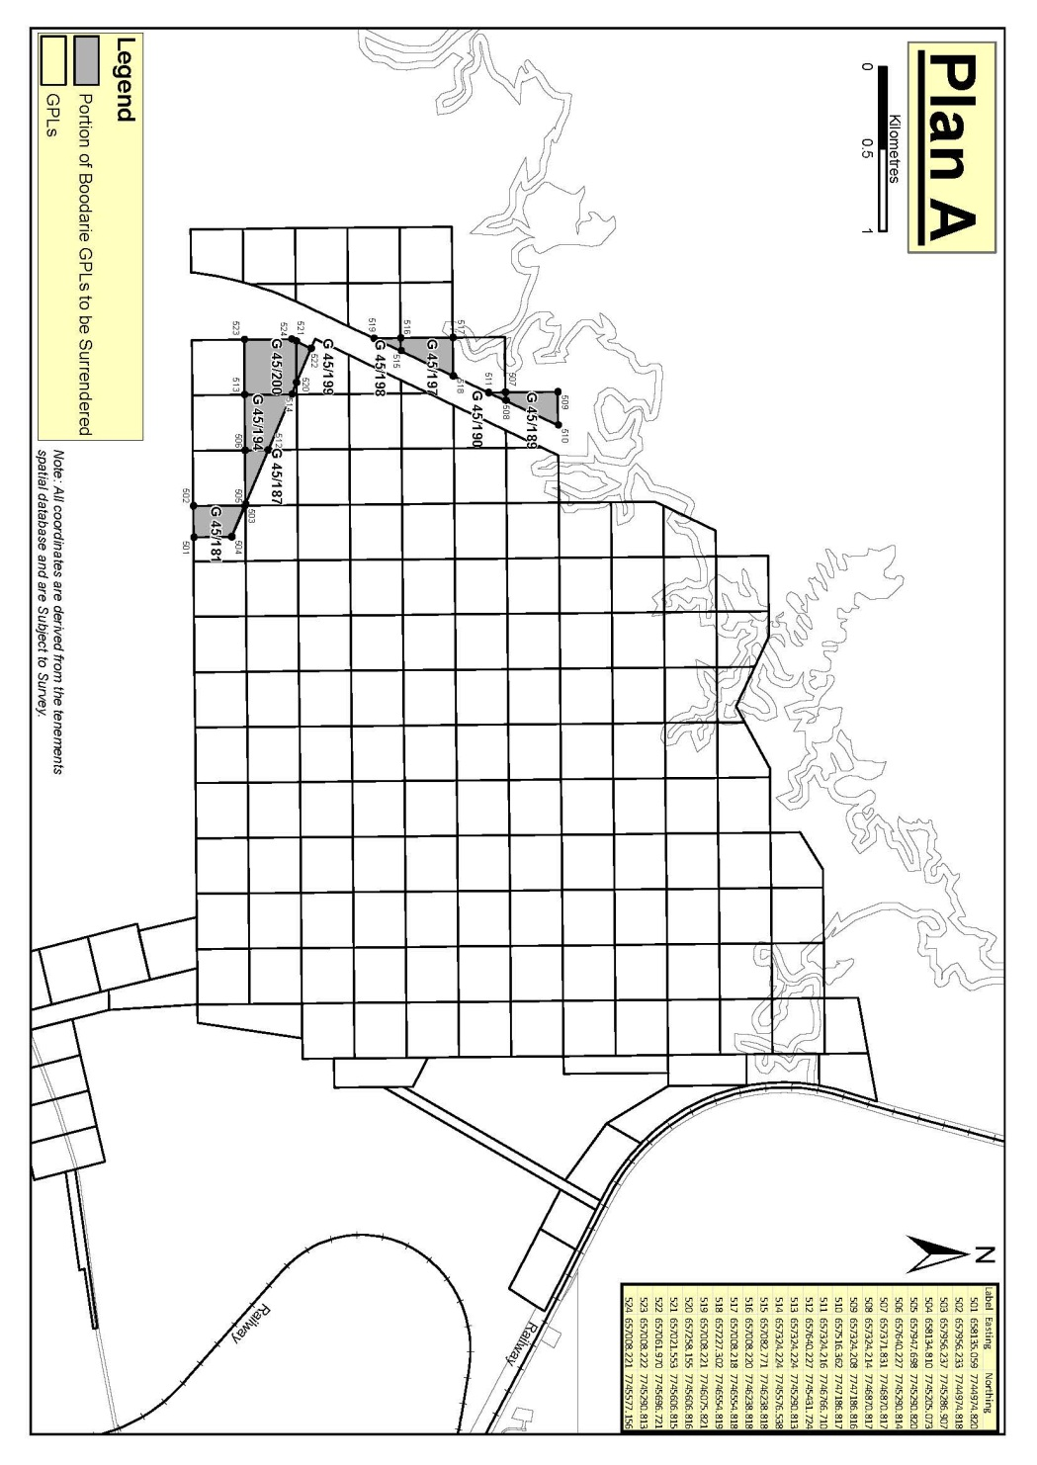
Plan "B"
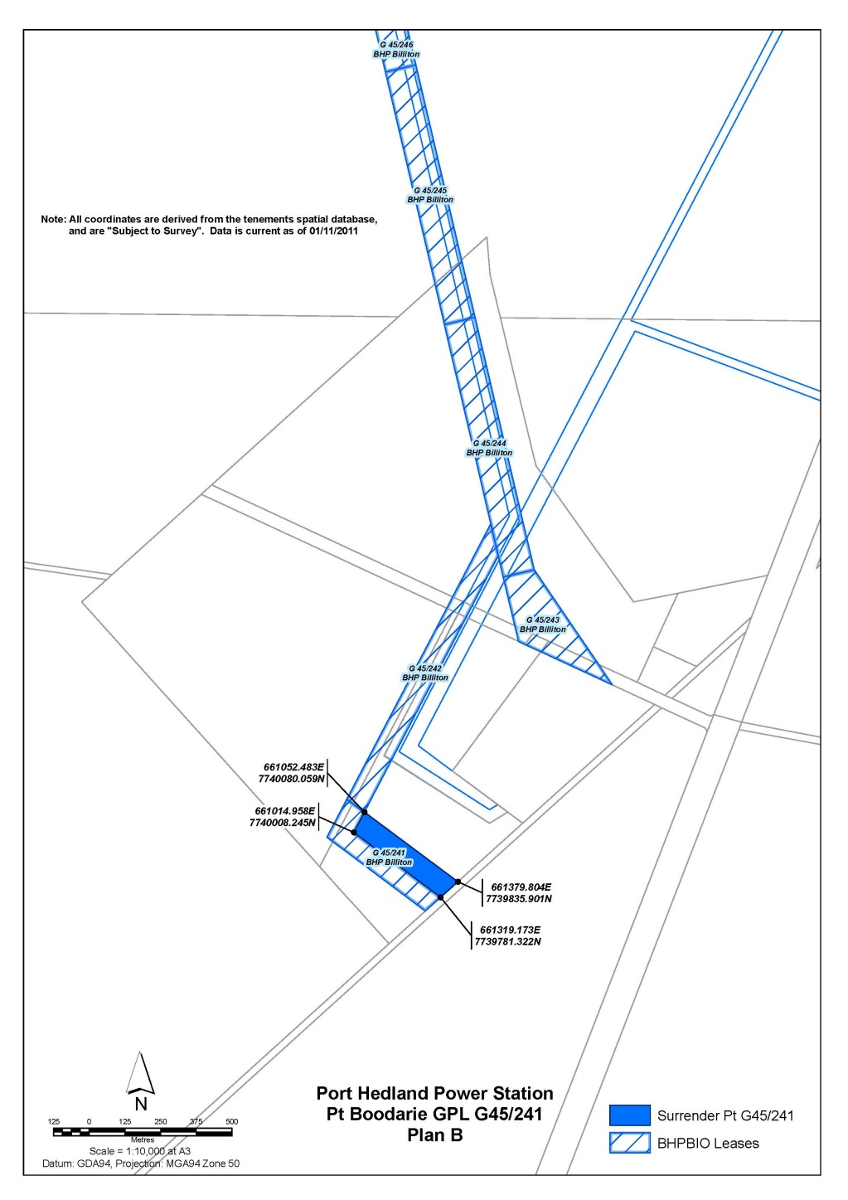
SCHEDULE D
Portions of Boodarie GPLs to be surrendered pursuant to clause 4(3)(e)(ii)(A)(I)(i)
Boodarie GPL | Portion to be surrendered
G45/78 | That portion of GPL 45/78 shown on Plan "C"
G45/79 | That portion of GPL 45/79 shown on Plan "C"
G45/89 | That portion of GPL 45/89 shown on Plan "C"
G45/90 | That portion of GPL 45/90 shown on Plan "C"
G45/102 | That portion of GPL 45/102 shown on Plan "C"
Plan "C"
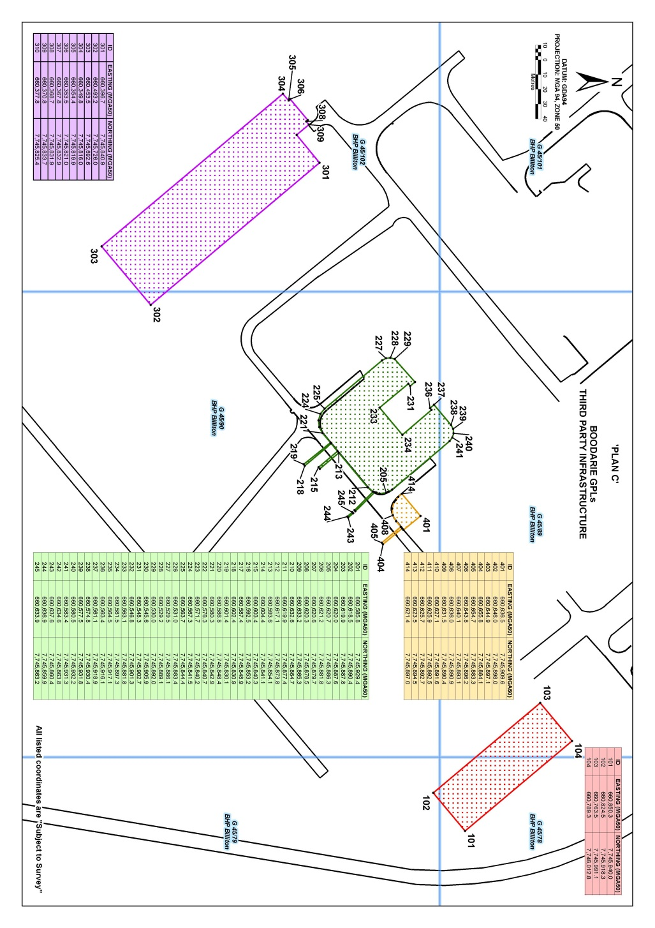
SCHEDULE E
Proposed Boodarie Industrial Estate Corridor – Indicative Corridor Alignment
Plan "D"
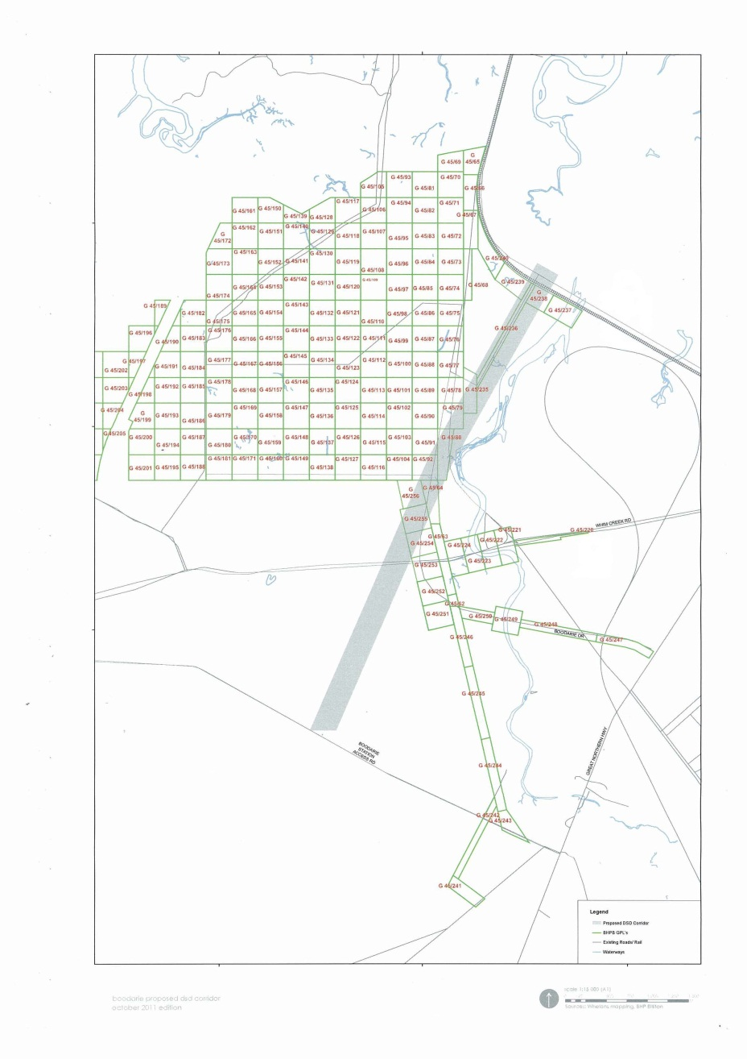
SCHEDULE F
Joint Venturers' planned conveyor and associated infrastructure corridor
Plan "E"
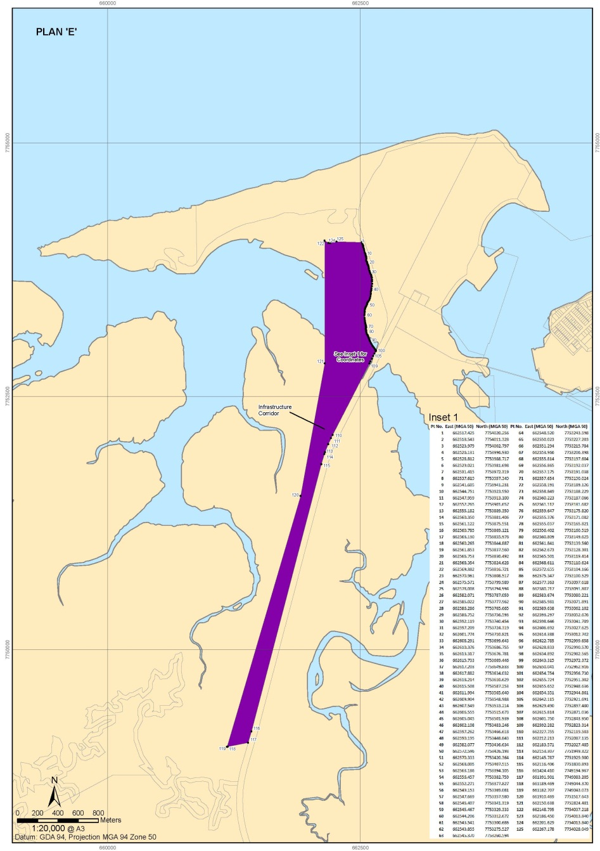
EXECUTED as a deed.

SIGNED by the HONOURABLE )
COLIN JAMES BARNETT )
in the presence of: )

[Signature] |  | [Signature]
Signature of witness
Peter Goodall
Name of witness

EXECUTED by BHP BILLITON DIRECT )
REDUCED IRON PTY. LTD. ACN 058 025 )
960 in accordance with section 127(1) of )
the Corporations Act )

[Signature] |  | [Signature]
Signature of Director |  | Signature of Secretary
Uvashni Raman |  | Robin Lees
Full Name |  | Full Name

EXECUTED by BHP BILLITON )
MINERALS PTY. LTD. ACN 008 694 782 )
in accordance with section 127(1) of )
the Corporations Act )

[Signature] |  | [Signature]
Signature of Director |  | Signature of Secretary
Uvashni Raman |  | Robin Lees
Full Name |  | Full Name

EXECUTED by MITSUI IRON ORE )
CORPORATION PTY. LTD )
ACN 050 157 456 in accordance with section )
127(1) of the Corporations Act )

[Signature] |  | [Signature]
Signature of Director |  | Signature of Secretary
Ryuzo Nakamura |  | Jiahe He
Full Name |  | Full Name

SIGNED by Shuzaburo Tsuchihashi )
as attorney for ITOCHU MINERALS & )
ENERGY OF AUSTRALIA PTY. LTD. )
ACN 009 256 259 under power )
of attorney dated 27 October 2011 )
in the presence of: )

[Signature] |  | [Signature]
Signature of witness |  | Signature of Attorney
Yasushi Fukumura |  | Shuzaburo Tsuchihashi
Name |  | Name

Notes
¹ This is a compilation of the Iron Ore Agreements Legislation (Amendment, Termination and Repeals) Act 2011. The following table contains information about that Act.

Compilation table
Short title | Number and year | Assent | Commencement
Iron Ore Agreements Legislation (Amendment, Termination and Repeals) Act 2011 Pt. 1 and Pt. 7 Div. 1 | 62 of 2011 | 14 Dec 2011 | Pt. 1: 14 Dec 2011 (see s. 2(a));  Pt. 7 Div. 1: 15 Dec 2011 (see s. 2(b))

Defined terms

[This is a list of terms defined and the provisions where they are defined. The list is not part of the law.]
Defined term Provision(s)
assent day 2
termination agreement 22(1)

