Western Australia

Busselton Water Board (Supply of Water to Dunsborough) Act 2009

Western Australia
Busselton Water Board (Supply of Water to Dunsborough) Act 2009
CONTENTS
1. Short title 2
2. Commencement 2
3. Terms used 2
4. Busselton Water Board may supply water to the Water Corporation 2
5. Application of the Water Boards Act 1904 3
Schedule 1 — Dunsborough part of the Dunsborough operating area
Defined Terms

Western Australia

Busselton Water Board (Supply of Water to Dunsborough) Act 2009
No. 31 of 2009
An Act to facilitate the supply of water to the Dunsborough area by —
- enabling the Busselton Water Board to supply water to the Water Corporation; and
- extending the application of the Water Boards Act 1904 in respect of that supply,
and for related purposes.

[Assented to 23 November 2009]

The Parliament of Western Australia enacts as follows:

1. Short title
This is the Busselton Water Board (Supply of Water to Dunsborough) Act 2009.

2. Commencement
This Act comes into operation as follows —
(a) sections 1 and 2 — on the day on which this Act receives the Royal Assent;
(b) the rest of the Act — on the day after that day.

3. Terms used
In this Act —
Board means the Busselton Water Board constituted under the Water Boards Act 1904 for the Busselton Water Area;
Busselton Water Area means the Busselton Water Area constituted under the Water Boards Act 1904;
Corporation means the Water Corporation established by the Water Corporation Act 1995 section 4;
Dunsborough area means that part of the Dunsborough operating area (water supply services) of the Water Corporation’s licence (under the Water Services Licensing Act 1995) shown on the map in Schedule 1.

4. Busselton Water Board may supply water to the Water Corporation
(1) The Board may supply water to the Corporation, on such terms and conditions as are agreed, to facilitate the supply of water to the Dunsborough area.
(2) To the extent to which the Board is not otherwise empowered to do so, the Board may do all things necessary or convenient to be done for or in connection with giving effect to subsection (1).

5. Application of the Water Boards Act 1904
The Water Boards Act 1904 applies to and in relation to the supply of water under section 4 and, for that purpose, the supply is to be taken to be under and for the purposes of that Act.
Schedule 1 — Dunsborough part of the Dunsborough operating area
[s. 3]
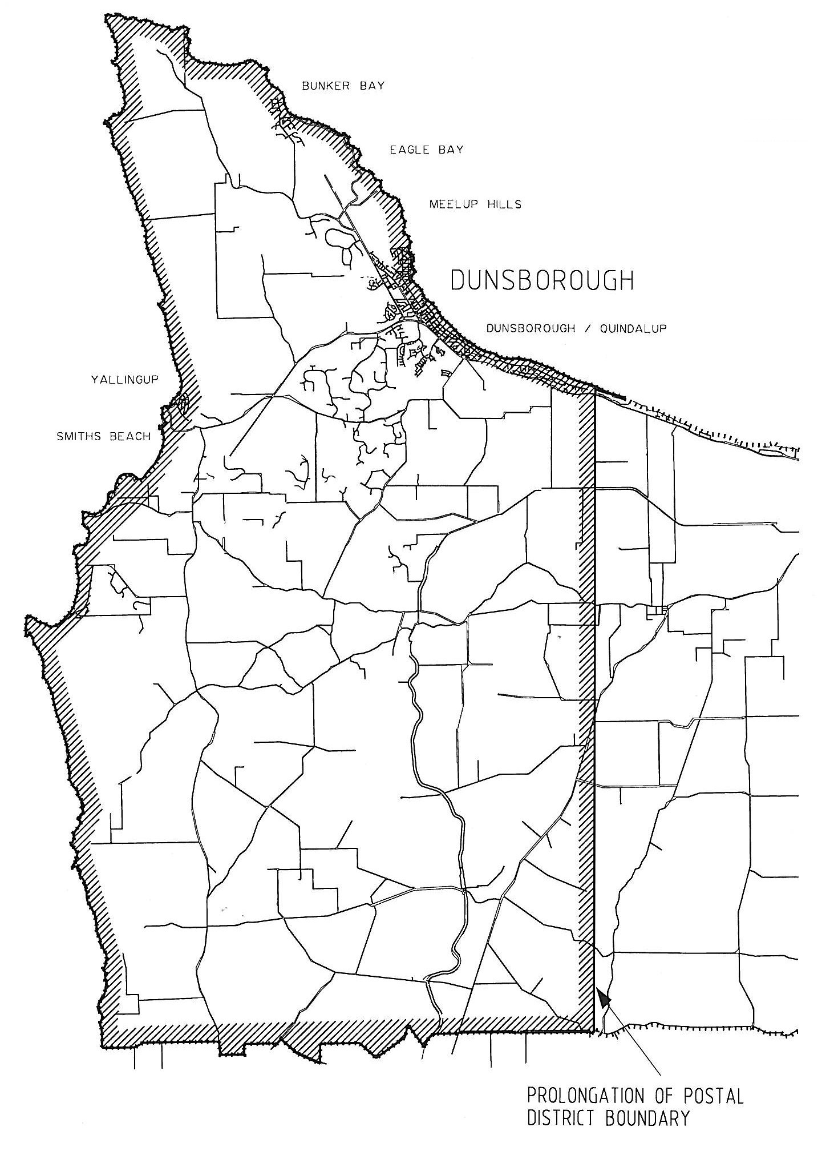
Note: The Dunsborough operating area also includes an area that includes Jarrahwood. That area is not shown on this map.
Defined Terms

[This is a list of terms defined and the provisions where they are defined. The list is not part of the law.]
Defined Term Provision(s)
Board 3
Busselton Water Area 3
Corporation 3
Dunsborough area 3

By Authority: JOHN A. STRIJK, Government Printer

