
Western Australia

Commonwealth Heads of Government Meeting (Special Powers) Regulations 2011
Compare between:
[08 Oct 2011, 00-a0-01] and [22 Oct 2011, 00-b0-01]

Western Australia
Commonwealth Heads of Government Meeting (Special Powers) Act 2011
Commonwealth Heads of Government Meeting (Special Powers) Regulations 2011

1. Citation
These regulations are the Commonwealth Heads of Government Meeting (Special Powers) Regulations 2011.

2. Commencement
These regulations come into operation as follows —
(a) regulations 1 and 2 — on the day on which these regulations are published in the Gazette;
(b) the rest of the regulations — on the day after that day.

3. Application
In Schedule 1, where an area of land is described by reference to a road (however described), the road includes a carriageway, footpath, median strip, traffic island or verge on the road reserve.

4. CHOGM period
For the purposes of the definition of CHOGM period in section 3 of the Act, the period beginning on 20 October 2011 and ending on 4 November 2011 is prescribed.

5. Prohibited items
For the purposes of the definition of prohibited item in section 3 of the Act, the following things or classes of thing are prescribed —
(a) a controlled weapon as defined in the Weapons Act 1999 section 3;
(b) a prohibited weapon as defined in the Weapons Act 1999 section 3;
(c) a firearm as defined in the Firearms Act 1973 section 4;
(d) a dangerous or offensive weapon;
(e) a reptile, insect or other animal capable of causing harm to a person;
(f) all or part of a traffic barrier;
(g) any of the following —
(i) an explosive, including a firework;
(ii) a glass bottle or jar;
(iii) a metal can or tin;
(iv) a projectile;
(v) a hand tool,
capable of being used to harm a person;
(h) any of the following —
(i) a thing capable of emitting a loud sound, including a loud hailer or a horn;
(ii) a thing capable of being used to climb barriers;
(iii) a thing capable of being used to construct a stage, platform, tripod or tower, or a structure similar to a stage, platform, tripod or tower;
(i) a thing capable of being used to disguise or conceal the identity of a person.

6A. Core security area: Big Aussie Barbeque
Under section 6 of the Act, the area of land described in Schedule 1 Division 1A is declared to be a core security area (called the “Big Aussie Barbeque core security area”) for the purposes of the Act for 29 October 2011 between the times of 6 a.m. and 4 p.m.
[Regulation 6A inserted in Gazette 21 Oct 2011 p. 4454.]

6. Core security area: Burswood Entertainment Complex
Under section 6 of the Act, the area of land described in Schedule 1 Division 1 is declared to be a core security area (called the “Burswood Entertainment Complex core security area”) for the purposes of the Act for the period beginning on 24 October 2011 and ending on 27 October 2011.

7. Core security area: Government House
Under section 6 of the Act, the area of land described in Schedule 1 Division 2 is declared to be a core security area (called the “Government House core security area”) for the purposes of the Act for the period beginning on 24 October 2011 and ending on 29 October 2011.

8. Core security area: Hyatt Regency Hotel
Under section 6 of the Act, the area of land described in Schedule 1 Division 3 is declared to be a core security area (called the “Hyatt Regency Hotel core security area”) for the purposes of the Act for the period beginning on 22 October 2011 and ending on 31 October 2011.

9. Core security area: Pan Pacific Perth Hotel
Under section 6 of the Act, the area of land described in Schedule 1 Division 4 is declared to be a core security area (called the “Pan Pacific Perth Hotel core security area”) for the purposes of the Act for the period beginning on 22 October 2011 and ending on 31 October 2011.

10. Core security area: Perth Convention and Exhibition Centre
Under section 6 of the Act, the area of land described in Schedule 1 Division 5 is declared to be a core security area (called the “Perth Convention and Exhibition Centre core security area”) for the purposes of the Act for the period beginning on 22 October 2011 and ending on 31 October 2011.

11. Core security area: State Reception Centre
Under section 6 of the Act, the area of land described in Schedule 1 Division 6 is declared to be a core security area (called the “State Reception Centre core security area”) for the purposes of the Act for the period beginning on 27 October 2011 and ending on 30 October 2011.

12. Core security area: Winthrop Hall
Under section 6 of the Act, the area of land described in Schedule 1 Division 7 is declared to be a core security area (called the “Winthrop Hall core security area”) for the purposes of the Act for 29 October 2011.

13. Core security area: Motorcade Route
Under section 6 of the Act, the area of land described in Schedule 1 Division 8 is declared to be a core security area (called the “Motorcade Route core security area”) for the purposes of the Act for the period beginning on 22 October 2011 and ending on 31 October 2011.

14. Core security area: Motorcade Route Addition
Under section 6 of the Act, the area of land described in Schedule 1 Division 9 is declared to be a core security area (called the “Motorcade Route Addition core security area”) for the period beginning on 29 October 2011 and ending on 30 October 2011.

Schedule 1 — Core security areas
[r. 6, 7, 8, 9, 10, 11, 12, 13 and 14]

Division 1A — Big Aussie Barbeque core security area
[Heading inserted in Gazette 21 Oct 2011 p. 4454.]
(1) The area of land in the City of Perth, City of South Perth and the Town of Victoria Park contained within a line that —
(a) starts at the point on the north eastern side of the Causeway perpendicularly above the high water mark of the north eastern side of the Swan River (the start point); and
(b) then continues in a generally north westerly direction along the north eastern side of the carriageway of the Causeway to the point it becomes Hay Street; and
(c) then continues in a generally northerly direction along the eastern side of the carriageway of Hay Street to the north eastern corner of the intersection of Hay Street and Trinity Avenue; and
(d) then continues in a generally westerly direction along the northern side of that intersection to the western corner of that intersection; and
(e) then continues in a generally southerly direction along the western side of that intersection and the western side of the carriageway of Hay Street to the roundabout at the intersection of Hay Street and Adelaide Terrace; and
(f) then continues around the northern side of the carriageway of the roundabout to the northern side of Adelaide Terrace; and
(g) then continues along the northern side of Adelaide Terrace to the north eastern corner of the intersection of Adelaide Terrace and Erskine Link; and
(h) then continues along the eastern side of Erskine Link to its intersection with the southern side of Hay Street; and
(i) then continues in a generally westerly direction at a right angle to the eastern side of Erskine Link to the western side of Erskine Link; and
(j) then continues along the western side of Erskine Link to the north western corner of its intersection with Adelaide Terrace; and
(k) then continues along the northern side of Adelaide Terrace to the north eastern corner of the intersection of Adelaide Terrace and De Vlamingh Avenue; and
(l) then continues along the eastern side of De Vlamingh Avenue to its intersection with the southern side of Hay Street; and
(m) then continues in a generally westerly direction at a right angle to the eastern side of De Vlamingh Avenue to the western side of De Vlamingh Avenue; and
(n) then continues along the western side of De Vlamingh Avenue to the north western corner of its intersection with Adelaide Terrace; and
(o) then continues along the northern side of Adelaide Terrace to the north eastern corner of the intersection of Adelaide Terrace and Plain Street; and
(p) then continues along the eastern side of Plain Street to its intersection with the southern side of Hay Street; and
(q) then continues in a generally westerly direction at a right angle to the eastern side of Plain Street to the western side of Plain Street; and
(r) then continues along the western side of Plain Street to the north western corner of its intersection with Adelaide Terrace; and
(s) then continues along the northern side of Adelaide Terrace to the north eastern corner of the intersection of Adelaide Terrace and Bennett Street; and
(t) then continues along the eastern side of Bennett Street to its intersection with the southern side of Hay Street; and
(u) then continues in a generally westerly direction at a right angle to the eastern side of Bennett Street to the western side of Bennett Street; and
(v) then continues along the western side of Bennett Street to the north western corner of its intersection with Adelaide Terrace; and
(w) then continues along the northern side of Adelaide Terrace to the north eastern corner of the intersection of Adelaide Terrace and Hill Street; and
(x) then continues along the eastern side of Hill Street to its intersection with the southern side of Hay Street; and
(y) then continues in a generally westerly direction at a right angle to the eastern side of Hill Street to the western side of Hill Street; and
(z) then continues along the western side of Hill Street to the north western corner of its intersection with Adelaide Terrace; and
(aa) then continues along the northern side of Adelaide Terrace to the north eastern corner of the intersection of Adelaide Terrace and Victoria Avenue; and
(bb) then continues along the eastern side of Victoria Avenue to its intersection with the southern side of Hay Street; and
(cc) then continues in a generally westerly direction at a right angle to the eastern side of Victoria Avenue to the western side of Victoria Avenue; and
(dd) then continues along the western side of Victoria Avenue to the north western corner of its intersection with St Georges Terrace; and
(ee) then continues along the northern side of St Georges Terrace to the north eastern corner of the intersection of St Georges Terrace and Irwin Street; and
(ff) then continues along the eastern side of Irwin Street to its intersection with the southern side of Hay Street; and
(gg) then continues in a generally westerly direction at a right angle to the eastern side of Irwin Street to the western side of Irwin Street; and
(hh) then continues along the western side of Irwin Street to the north western corner of its intersection with St Georges Terrace; and
(ii) then continues along the northern side of St Georges Terrace to the north eastern corner of the intersection of St Georges Terrace and Pier Street; and
(jj) then continues along the eastern side of Pier Street to its intersection with the southern side of Hay Street; and
(kk) then continues in a generally westerly direction at a right angle to the eastern side of Pier Street to the western side of Pier Street; and
(ll) then continues along the western side of Pier Street to the north western corner of its intersection with St Georges Terrace; and
(mm) then continues along the northern side of St Georges Terrace to the north eastern corner of the intersection of St Georges Terrace and Cathedral Avenue; and
(nn) then continues along the eastern side of Cathedral Avenue to its intersection with the southern side of Hay Street; and
(oo) then continues in a generally westerly direction at a right angle to the eastern side of Cathedral Avenue to the western side of Cathedral Avenue; and
(pp) then continues along the western side of Cathedral Avenue to the north western corner of its intersection with St Georges Terrace; and
(qq) then continues along the northern side of St Georges Terrace to the north eastern corner of the intersection of St Georges Terrace and Barrack Street; and
(rr) then continues along the eastern side of Barrack Street to its intersection with the southern side of Hay Street; and
(ss) then continues in a generally westerly direction at a right angle to the eastern side of Barrack Street to the western side of Barrack Street; and
(tt) then continues along the western side of Barrack Street to the north western corner of its intersection with St Georges Terrace; and
(uu) then continues along the northern side of St Georges Terrace to the north eastern corner of the intersection of St Georges Terrace and London Court; and
(vv) then continues along the eastern side of London Court to its intersection with the southern side of Hay Street; and
(ww) then continues in a generally westerly direction at a right angle to the eastern side of London Court to the western side of London Court; and
(xx) then continues along the western side of London Court to the north western corner of its intersection with St Georges Terrace; and
(yy) then continues along the northern side of St Georges Terrace to the north eastern corner of the intersection of St Georges Terrace and William Street; and
(zz) then continues along the eastern side of William Street to its intersection with the southern side of Hay Street; and
(aaa) then continues in a generally westerly direction at a right angle to the eastern side of William Street to the western side of William Street; and
(bbb) then continues along the western side of William Street to the north western corner of its intersection with St Georges Terrace; and
(ccc) then continues along the northern side of St Georges Terrace to the north eastern corner of the intersection of St Georges Terrace and King Street; and
(ddd) then continues along the eastern side of King Street to its intersection with the southern side of Hay Street; and
(eee) then continues in a generally westerly direction at a right angle to the eastern side of King Street to the western side of King Street; and
(fff) then continues along the western side of King Street to the north western corner of its intersection with St Georges Terrace; and
(ggg) then continues along the northern side of St Georges Terrace to the north western corner of the intersection of St Georges Terrace and Mill Street; and
(hhh) then continues at a right angle to the northern side of St Georges Terrace in a generally southerly direction to the western side of Mill Street and along the western side of Mill Street to the north western corner of its intersection with Mounts Bay Road; and
(iii) then continues along the northern side of Mounts Bay Road to the north eastern corner of its intersection with Spring Street and then along the eastern side of Spring Street to the south eastern corner of the intersection of Spring Street and Mount Street; and
(jjj) then continues in a generally westerly direction along the southern side of Mount Street and the pedestrian overpass over the Mitchell Freeway to the point perpendicularly above the western side of the Mitchell Freeway; and
(kkk) then continues from a point perpendicularly below that point along the western side of the Mitchell Freeway to and along the western side of the Narrows Bridge in a generally southerly direction to the point on that Bridge perpendicularly above the southern wall of the Swan River; and
(lll) then continues from a point perpendicularly below that point along the southern wall or high water mark, as the case may be, of the Swan River in a generally westerly and southerly direction to its intersection with a straight line projecting in a generally westerly direction from the northern side of Queen Street; and
(mmm) then continues along that line in a generally easterly direction to its intersection with the southern side of the Swan River and then proceeds along the southern wall or high water mark, as the case may be, of the Swan River in a generally easterly direction to the point perpendicularly below the western side of the Causeway; and
(nnn) then continues in a generally southerly direction along the western side of the Causeway and then in a generally southerly and westerly direction along the western side of the carriageway of Shepperton Road, the on ramp from Canning Highway to Shepperton Road and the northern side of the carriageway of Canning Highway to its intersection with a straight line projecting in a generally northerly direction from the western side of Washington Street; and
(ooo) then continues in a generally southerly direction along that line to the southern side of the carriageway of Canning Highway and then continues in a generally easterly direction along that carriageway and the carriageway of the road between Canning Highway and Albany Highway and Shepperton Road; and
(ppp) then continues in a generally southerly direction along the western side of the carriageway of Shepperton Road to the south western corner of the intersection of Shepperton Road and the off ramp from Great Eastern Highway; and
(qqq) then continues in a generally easterly direction across that intersection to the off ramp from Great Eastern Highway and along the southern side of the carriageway of that off ramp and Great Eastern Highway to the south eastern corner of the intersection of Great Eastern Highway and Craig Street; and
(rrr) then continues in a generally northerly direction to the north eastern corner of the intersection of Great Eastern Highway and the eastern side of the eastern carriageway of Resort Drive; and
(sss) then continues in a generally north easterly direction along the south eastern carriageway of Resort Drive to the south western corner of its intersection with Camfield Drive; and
(ttt) then continues in a generally north westerly direction at a right angle to that carriageway of Resort Drive to its intersection with the high water mark of the southern side of the Swan River; and
(uuu) then continues in a generally south westerly direction along the southern wall or high water mark, as the case may be, of the Swan River to a point perpendicularly below the eastern side of the Causeway; and
(vvv) then continues in a generally north westerly direction along the north eastern side of the Causeway to the point of the high water mark of the Swan River on the southern side of Heirisson Island perpendicularly below the eastern side of the Causeway; and
(www) then continues in a generally easterly, northerly and westerly direction along the high water mark of the Swan River on Heirisson Island to a point perpendicularly below the eastern side of the Causeway; and
(xxx) then continues in a generally north westerly direction along the north eastern side of the Causeway to the start point.
(2) For information purposes, the area described above is shown bordered in white on the following map.
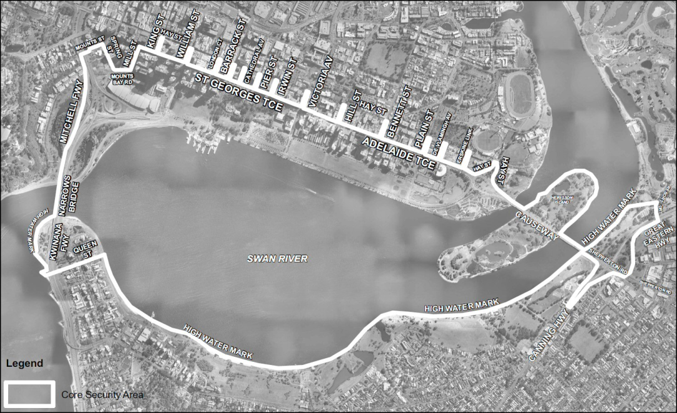
[Division 1A inserted in Gazette 21 Oct 2011 p. 4454-60.]

Division 1 — Burswood Entertainment Complex core security area
(1) The area of land in the Town of Victoria Park contained within a line that —
(a) starts at the north western corner of the fence on the western side of Car Park Number 5 situated on the north western side of the Burswood Entertainment Complex (the start point); and
(b) then continues in a generally south westerly direction along the fence and projected beyond the fence in a straight line to the edge of the lake on the western side of the Burswood Entertainment Complex; and
(c) then continues in a generally southerly direction along the eastern side of the edge of that lake to its intersection with a line projecting westerly from the northern side of the pillars on the northern side of the VIP Villas at a right angle to the eastern side of the VIP Villas; and
(d) then continues in a generally easterly direction along that line to the north eastern corner of the VIP Villas; and
(e) then continues in a generally north easterly direction along the boundary of the Burswood Entertainment complex water park construction site to its intersection with the Burswood Convention Centre; and
(f) then continues in a generally south easterly direction then north easterly direction along the side of the Burswood Convention Centre to its intersection with the Intercontinental Atrium Lobby Lounge; and
(g) then continues in a generally southerly direction along the side of the Intercontinental Atrium Lobby Lounge to its intersection with the Burswood Casino Complex; and
(h) then continues in a generally easterly direction along the northern side of the Burswood Casino Complex building line; and
(i) then continues in a generally southerly and westerly direction along the eastern and southern sides of the Burswood Casino Complex building line; and
(j) then continues along the eastern side of the plant compound wall and beyond, in a straight line, to its intersection with the western side of Bolton Avenue; and
(k) then continues in a generally southerly direction along the western side of Bolton Avenue to its intersection with the north western corner of the roundabout at the intersection of Bolton Avenue and Glenn Place; and
(l) then continues in a generally easterly direction around the northern side of the carriageway of the roundabout to the north eastern side of Bolton Avenue; and
(m) then continues in a generally north, north easterly direction along the eastern side of Bolton Avenue to its intersection with the north eastern corner of Car Park Number 5; and
(n) then continues in a generally westerly direction along the northern boundary of Car Park Number 5 to the start point.
(2) Subclause (1) includes the underground car park, entrances to it, exits from it and any other underground areas below the area of land described in that subclause.
(3) For information purposes, the area described above is shown bordered in white on the following map.

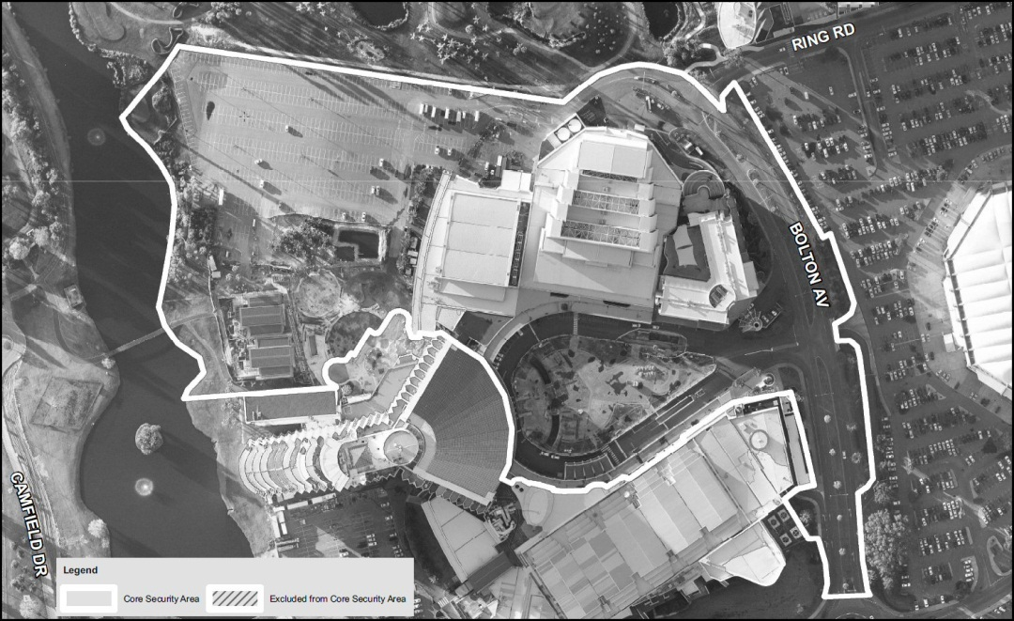

Division 2 — Government House core security area
(1) The area of land in the City of Perth contained within a line that —
(a) starts at the north eastern corner of the intersection of Adelaide Terrace and Victoria Avenue (the start point); and
(b) then continues in a generally westerly direction along the northern side of St Georges Terrace to the north eastern corner of the intersection of St Georges Terrace and Cathedral Avenue; and
(c) then continues in a generally southerly direction at a right angle to the northern side of St Georges Terrace into Stirling Gardens to its intersection with the northern side of the Supreme Court of Western Australia building; and
(d) then continues in a generally easterly direction along the northern side of the Supreme Court of Western Australia building; and
(e) then projects in a straight line beyond the northern side of the Supreme Court of Western Australia building in a generally easterly direction at a right angle to the eastern side of that building until it intersects the structure on the western side of the grounds of Government House; and
(f) then continues in a generally southerly direction along the side of that structure; and
(g) then projects in a straight line beyond that structure at a right angle to the southern side of that structure until it intersects the southern side of the pathway that runs in a generally easterly direction between the Law Library of the Supreme Court of Western Australia and Governors Avenue; and
(h) then continues in a generally easterly direction along the southern side of that pathway until it meets the western side of the intersection of Governors Avenue and Terrace Road; and
(i) then continues in a generally southerly direction along the western side of Governors Avenue to the north western point of the intersection of Governors Avenue and Riverside Drive; and
(j) then continues in a generally easterly direction along Riverside Drive to the north eastern point of the intersection of Governors Avenue and Riverside Drive; and
(k) then continues in a generally northerly direction along the eastern side of Governors Avenue to, and including the south eastern corner of, the intersection of Governors Avenue and Terrace Road; and
(l) then continues in a generally easterly direction along the southern side of Terrace Road to the south western point of the intersection of Terrace Road and Victoria Avenue; and
(m) then continues in a generally northerly direction at a right angle to the southern side of Terrace Road to the northern side of the median strip on Terrace Road; and
(n) then continues in a generally easterly direction along the northern side of that median strip to the median strip on Terrace Road on the eastern side of Victoria Avenue; and
(o) then continues in a generally easterly direction along the median strip on Terrace Road on the eastern side of Victoria Avenue to its intersection with a line projecting south from the eastern side of Victoria Avenue; and
(p) then continues in a generally northerly direction along the eastern side of Victoria Avenue to the start point.
(2) Subclause (1) includes any areas of land to which members of the public have access between St Georges Terrace and the building line of a building on that road and between the eastern side of Victoria Avenue and the building line of a building on that road.
(3) Subclause (1) does not include the area of land on which the following buildings are built —
(a) Council House at 27-29 St Georges Terrace;
(b) Peter Durack Commonwealth Law Courts Building at 1 Victoria Avenue;
(c) Family Court of Western Australia at 150 Terrace Road.
(4) For information purposes, the area described above is shown bordered in white on the following map.

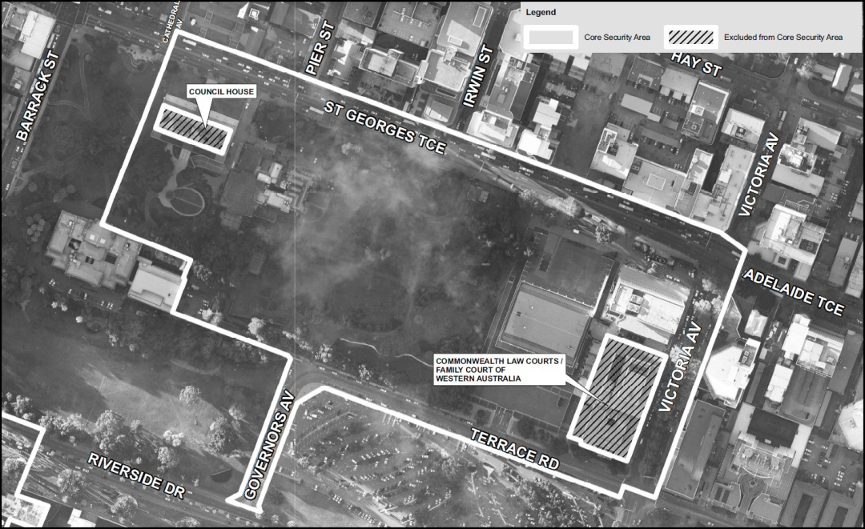

Division 3 — Hyatt Regency Hotel core security area
(1) The area of land in the City of Perth contained within a line that —
(a) starts at the north eastern corner of the intersection of Plain Street and Adelaide Terrace (the start point); and
(b) then continues in a generally westerly direction along the northern side of Adelaide Terrace to its intersection with the western boundary of West Apartments at 128 Adelaide Terrace; and
(c) then continues in a generally southerly direction at a right angle to the northern side of Adelaide Terrace to its intersection with the southern side of Adelaide Terrace; and
(d) then continues in a generally easterly direction along the southern side of Adelaide Terrace to its intersection with the western boundary of the Hyatt Regency Hotel at 99 Adelaide Terrace; and
(e) then continues in a generally southerly direction along the western boundary of the Hyatt Regency Hotel to its intersection with the northern side of Terrace Road; and
(f) then continues in a generally westerly direction along the northern side of Terrace Road to its intersection with the western boundary of Panorama Apartments at 42-52 Terrace Road; and
(g) then continues in a generally southerly direction at a right angle to the northern side of Terrace Road to the southern side of Terrace Road; and
(h) then continues in a generally easterly direction along the southern side of Terrace Road to the south eastern point of the intersection of Terrace Road and Plain Street; and
(i) then continues in a generally northerly direction along the eastern side of Plain Street to the start point.
(2) For information purposes, the area described above is shown bordered in white on the following map.

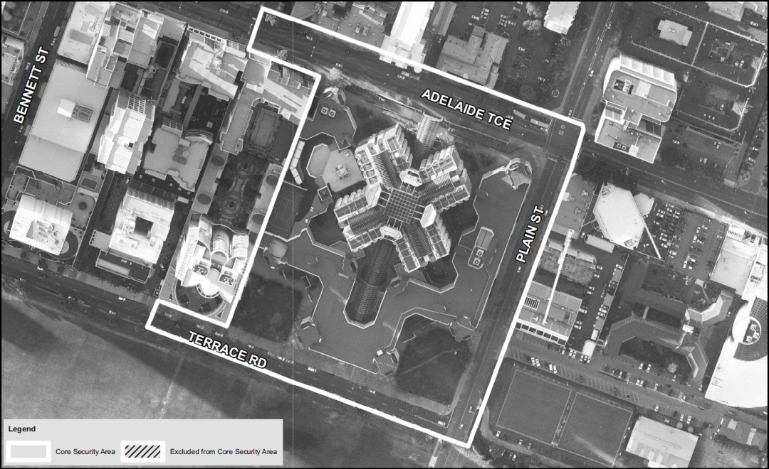

Division 4 — Pan Pacific Perth Hotel core security area
(1) The area of land in the City of Perth contained within a line that —
(a) starts at the south western corner of the intersection of Adelaide Terrace and Burt Way (the start point); and
(b) then continues in a generally northerly direction at a right angle to the southern side of Adelaide Terrace until the northern side of Adelaide Terrace; and
(c) then continues in a generally westerly direction along the northern side of Adelaide Terrace to its intersection with the western boundary of 234 Adelaide Terrace; and
(d) then continues in a generally southerly direction at a right angle to the northern side of Adelaide Terrace until the southern side of Adelaide Terrace; and
(e) then continues in a generally easterly direction along the southern side of Adelaide Terrace to its intersection with the western boundary of the Langley Hotel; and
(f) then continues in a generally southerly direction along the western boundary of the Langley Hotel to its intersection with the southern boundary of the Langley Hotel; and
(g) then continues in a generally easterly direction along the southern boundary of the Langley Hotel to its intersection with the western side of Hill Street; and
(h) then continues in a generally southerly direction along the western side of Hill Street to the north western corner of the intersection of Hill Street and Terrace Road; and
(i) then continues in a generally easterly direction at a right angle to the western side of Hill Street to the north eastern corner of the intersection of Hill Street and Terrace Road; and
(j) then continues in a generally northerly direction along the eastern side of Hill Street to its intersection with the southern boundary of the multistorey car park immediately north of 108 Terrace Road; and
(k) then continues in a generally easterly direction along the southern boundary of that car park to the south eastern corner of that car park; and
(l) then continues in a generally northerly direction along the eastern boundary of that car park until its intersection with the southern boundary of the Pan Pacific Perth Hotel; and
(m) then continues in a generally easterly direction along the southern boundary of the Pan Pacific Perth Hotel to the south eastern corner of the Pan Pacific Perth Hotel; and
(n) then continues in a generally northerly direction along the eastern side of the Pan Pacific Perth Hotel to its intersection with the southern side of Adelaide Terrace; and
(o) then continues in a generally easterly direction along the southern side of Adelaide Terrace to the start point.
(2) For information purposes, the area described above is shown bordered in white on the following map.

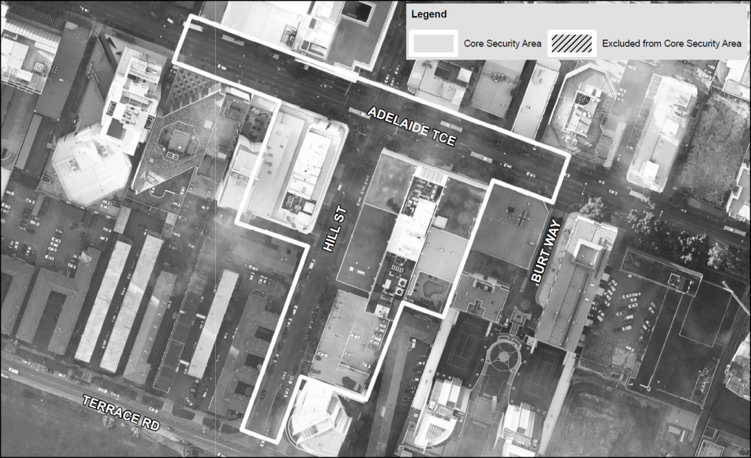

Division 5 — Perth Convention and Exhibition Centre core security area
(1) The area of land in the City of Perth contained within a line that —
(a) starts at the south western corner of The Quadrant Building at the corner of William Street and Mounts Bay Road (the start point); and
(b) then continues in a generally westerly direction along the northern side of Mounts Bay Road to the north western corner of the intersection of Mounts Bay Road and Spring Street; and
(c) then continues in a generally southerly direction along the western side of Spring Street to the south western corner of its intersection with the west bound carriageway of Mounts Bay Road; and
(d) then continues in a generally westerly direction along the southern side of the west bound carriageway of Mounts Bay Road to a point perpendicularly below the eastern side of the Mitchell Freeway off ramp; and
(e) then continues in a generally south easterly direction perpendicularly below the eastern side of the Mitchell Freeway off ramp and then along the eastern and northern side of the Mitchell Freeway off ramp to the point it becomes Riverside Drive; and
(f) then continues in a generally easterly direction along the northern side of Riverside Drive to the north eastern point of the intersection of Riverside Drive and the slip road from William Street to Riverside Drive; and
(g) then continues in a generally northerly direction along the eastern side of that slip road and the eastern side of William Street to the south eastern corner of the intersection of William Street and Mounts Bay Road; and
(h) then continues to the north western corner of the intersection of William Street and Mounts Bay Road; and
(i) then continues in a generally westerly direction to the start point.
(2) The area of land described in subclause (1) includes the pedestrian overpasses above Mounts Bay Road.
(3) For information purposes, the area described above is shown bordered in white on the following map.

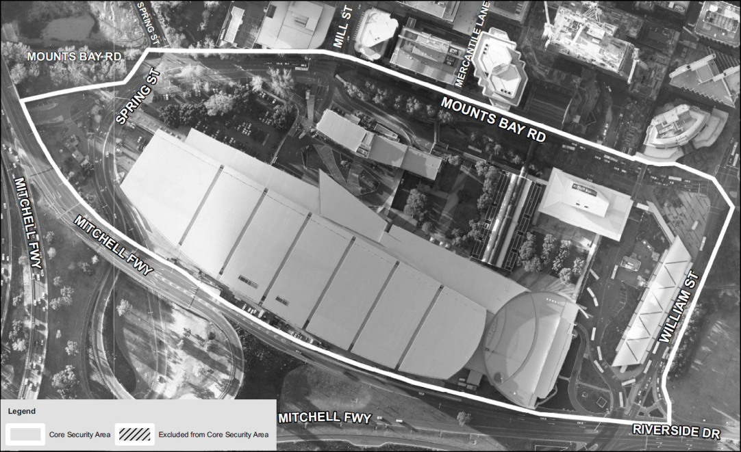

Division 6 — State Reception Centre core security area
(1) The area of land in the City of Perth contained within a line that —
(a) starts at the north western corner of the cyclone fence on the north western corner of the Mount Eliza Reservoir (the start point); and
(b) then continues in a generally south westerly direction along that fence on the north western side of the Mount Eliza Reservoir projecting beyond that fence at a right angle to the fence on the south western side of the Mount Eliza Reservoir to the point where the line intersects with the eastern side of the carriageway of May Drive; and
(c) then continues in a generally south easterly direction along that carriageway to the northern side of the roundabout at the intersection of Wadjuk Way and May Drive; and
(d) then continues around the eastern side of the carriageway of that roundabout to May Drive; and
(e) then continues in a generally south easterly direction along the eastern side of May Drive to its intersection with the northern side of the roundabout at the intersection of May Drive and Lovekin Drive; and
(f) then continues around the eastern side of the carriageway of that roundabout to the point where a line between that point and the centre of the roundabout at the intersection of Mounts Bay Road and Riverside Drive (the tangent line) forms a tangent with that point; and
(g) then continues in a generally south easterly direction along the tangent line to its intersection with the western side of the carriageway of Mounts Bay Road; and
(h) then continues in a generally northerly direction along that carriageway to its intersection with a line projecting from the southern boundary of Kings Tower at 168 Mounts Bay Road at a right angle to the western boundary of Kings Tower; and
(i) then continues in a generally westerly direction along that line to the south western corner of the boundary of Kings Tower; and
(j) then continues in a generally northerly direction along the eastern boundary of Reserve Number 1720 to the point where it intersects a straight line projecting beyond the southern boundary of 2 Bellevue Terrace in a generally easterly direction; and
(k) then continues in a generally westerly direction along that line to its intersection with the footpath on the eastern side of Fraser Avenue; and
(l) then continues in a generally northerly direction along the eastern side of that footpath to its intersection with the southern side of the carriageway of the roundabout at the intersection of Kings Park Road and Fraser Avenue; and
(m) then continues in a generally westerly direction around the southern side of that carriageway to the western side of Fraser Avenue to its intersection with a line parallel to the eastern side of the carriageway of Fraser Avenue and 5 metres west of that carriageway (the parallel line); and
(n) then continues in a generally southerly direction along the parallel line to its intersection with the northern side of the road to the gates in the cyclone fence on the north eastern side of the Mount Eliza Reservoir; and
(o) then continues in a generally south westerly direction along the northern side of that road to those gates; and
(p) then continues in a generally north westerly direction along the fence to the start point.
(2) The area described in subclause (1) includes the western side of the pedestrian overpass north of the roundabout at the intersection of Mounts Bay Road and Riverside Drive immediately above that area.
(3) For information purposes, the area described above is shown bordered in white on the following map.

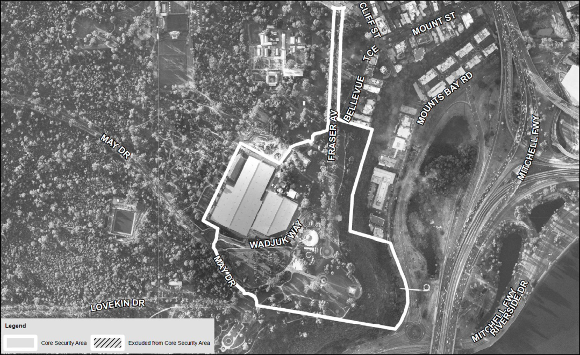

Division 7 — Winthrop Hall core security area
(1) The area of land in the City of Subiaco contained within a line that —
(a) starts at the south western corner of the intersection of Mounts Bay Road and Hackett Drive (the start point); and
(b) then continues in a generally westerly direction along the southern side of Mounts Bay Road and Stirling Highway to the south eastern corner of the intersection of Stirling Highway and Fairway; and
(c) then continues in a generally southerly direction along the eastern side of Fairway to its intersection with a line projecting from the northern side of the University of Western Australia’s Computer Science Building at a right angle to the western side of that building; and
(d) then continues in a generally easterly direction along that line to its intersection with a line projecting from the eastern side of the Lawrence Wilson Art Gallery at a right angle to the southern side of that building; and
(e) then continues in a generally northerly direction along that line to the south eastern corner of the Lawrence Wilson Art Gallery; and
(f) then continues in a generally easterly direction to the north eastern corner of the University of Western Australia’s Geography and Geology Building; and
(g) then continues in a generally southerly direction to the south eastern corner of the University of Western Australia’s Geography and Geology Building; and
(h) then continues in a generally easterly direction to the north western corner of the Arts Building; and
(i) then continues in a generally easterly direction along the northern side of the Arts Building; and
(j) then continues beyond the Arts Building in a generally easterly direction at a right angle to the eastern side of that building to the western side of the footpath on the eastern side of Riley Oval; and
(k) then continues in a generally northerly direction to the south western corner of the intersection of that footpath and the footpath on the northern side of Riley Oval; and
(l) then continues in a generally westerly direction to its intersection with a line projecting southerly from the western side of the Recreation Centre at a right angle to the southern side of the Recreation Centre; and
(m) then continues in a generally northerly direction along that line to the north western corner of the Recreation Centre; and
(n) then continues in a generally easterly direction along a line at a right angle to the western side of the Recreation Centre to its intersection with the western side of Hackett Drive; and
(o) then continues in a generally northerly direction along the western side of Hackett Drive to the start point.
(2) For information purposes, the area described above is shown bordered in white on the following map.

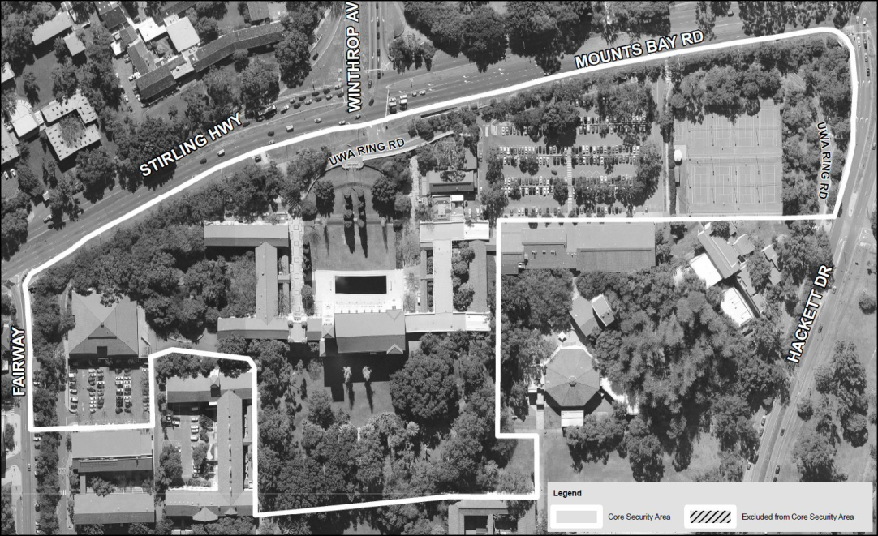

Division 8 — Motorcade Route core security area
(1) The area of land in the City of Perth that comprises the following roads —
(a) Adelaide Terrace;
(b) St Georges Terrace, between Adelaide Terrace and the western side of the intersection with Mount Street and Milligan Street;
(c) Erskine Link, between Adelaide Terrace and Hay Street;
(d) De Vlamingh Avenue, between Adelaide Terrace and Hay Street;
(e) Plain Street, between Terrace Road and Hay Street;
(f) Bennett Street, between Terrace Road and Hay Street;
(g) Terrace Road, between Bennett Street and Plain Street;
(h) Burt Way, between Terrace Road and Adelaide Terrace;
(i) Hill Street, between Terrace Road and Hay Street;
(j) the driveway of the Police and Nurses Credit Society between Adelaide Terrace and Hay Street including the Police and Nurses Credit Society Car Park;
(k) Victoria Avenue, between Terrace Road and Hay Street;
(l) Terrace Road, between Victoria Avenue and Governors Avenue;
(m) Irwin Street, between St Georges Terrace and Hay Street;
(n) Governors Avenue;
(o) Pier Street, between St Georges Terrace and Hay Street;
(p) Cathedral Avenue;
(q) Barrack Street, between Riverside Drive and Hay Street;
(r) The Esplanade, between Barrack Street and William Street;
(s) Sherwood Court, between The Esplanade and St Georges Terrace;
(t) Howard Street, between The Esplanade and St Georges Terrace;
(u) William Street, between Riverside Drive and Hay Street;
(v) Mounts Bay Road, between William Street and Spring Street;
(w) King Street, between St Georges Terrace and Hay Street;
(x) Mercantile Lane, between Mounts Bay Road and St Georges Terrace;
(y) Mill Street, between Mounts Bay Road and St Georges Terrace;
(z) Mount Street, between Spring Street and St Georges Terrace;
(aa) Spring Street, between Mounts Bay Road and Mount Street;
(bb) Milligan Street, between St Georges Terrace and Hay Street;
(cc) Mount Street, between St Georges Terrace and the western side of Spring Street.
(2) The area of land described in subclause (1) includes the following —
(a) laneways on the north and south sides of Adelaide Terrace and St Georges Terrace;
(b) any areas of land to which members of the public have access between a road and the building line of a building on the road;
(c) the pedestrian underpasses that cross under St Georges Terrace;
(d) the pedestrian overpass that crosses over Mercantile Lane.
(3) For information purposes, the area described above is shown hatched on the following map.

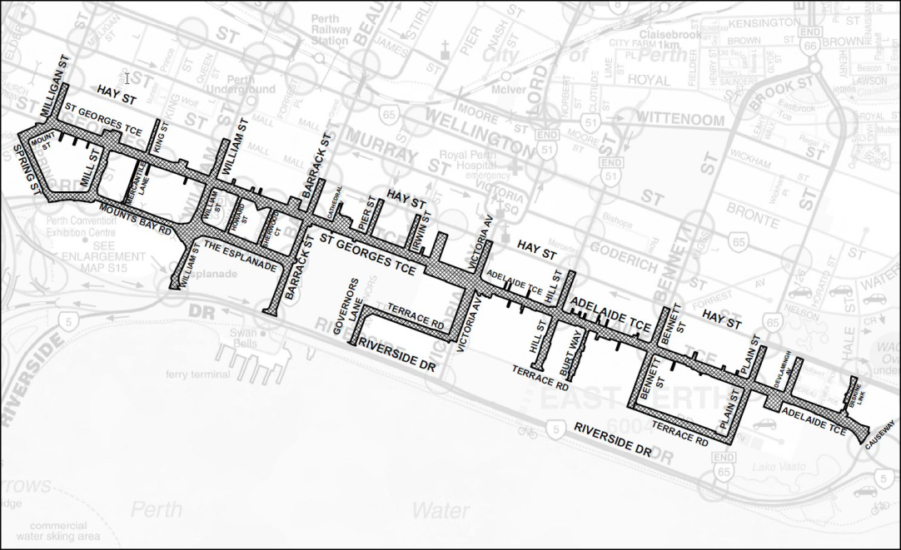

Division 9 — Motorcade Route Addition core security area
(1) The area of land in the City of Perth that comprises the following roads —
(a) St Georges Terrace from the western side of its intersection with Mount Street and Milligan Street to the western end of St Georges Terrace;
(b) Malcolm Street;
(c) Church Row;
(d) the road into Parliament House from Malcolm Street including the median strip, grassed verges and pedestrian walkways which run from Malcolm Street in a generally northerly direction into the grounds of Parliament House;
(e) Harvest Terrace, between Malcolm Street and a line projecting in a generally westerly direction from the northern side of the first road into the grounds of the Parliament House from Harvest Terrace north of Malcolm Street;
(f) Cliff Street between its intersection with Malcolm Street and the northern side of its intersection with Bellevue Terrace and Mount Street;
(g) Kings Park Road between the western end of Malcolm Street and the eastern side of its intersection with Havelock Street.
(2) The area of land described in subclause (1) includes any areas of land to which members of the public have access between a road and the building line of a building on the road.
(3) For information purposes, the area described above is shown hatched on the following map.

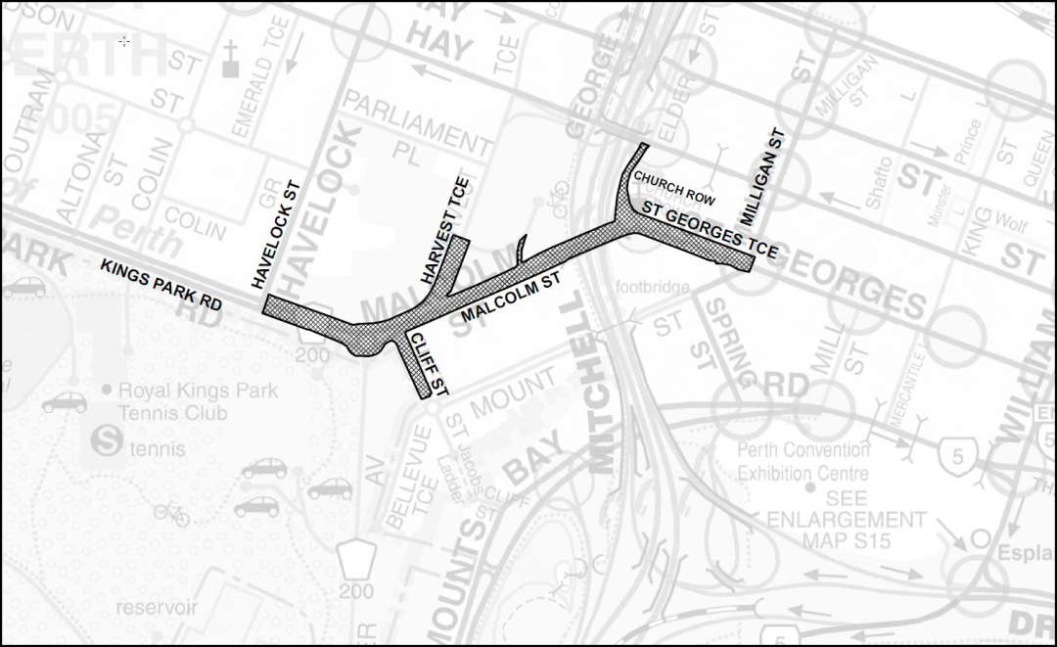

Notes
¹ This is a compilation of the Commonwealth Heads of Government Meeting (Special Powers) Regulations 2011. The following table contains information about those regulations.

Compilation table
Citation | Gazettal | Commencement
Commonwealth Heads of Government Meeting (Special Powers) Regulations 2011 | 7 Oct 2011 p. 4037-63 | r. 1 and 2: 7 Oct 2011 (see r. 2(a));  Regulations other than r. 1 and 2: 8 Oct 2011 (see r. 2(b))
Commonwealth Heads of Government Meeting (Special Powers) Amendment Regulations 2011 | 21 Oct 2011 p. 4453-60 | r. 1 and 2: 21 Oct 2011 (see r. 2(a));  Regulations other than r. 1 and 2: 22 Oct 2011 (see r. 2(b))

