
Western Australia

Retail Trading Hours (Special Trading Precincts and Holiday Resorts) Regulations (No. 2) 2010
Compare between:
[01 Nov 2010, 00-b0-01] and [26 Aug 2012, 00-c0-05]

Western Australia
Retail Trading Hours Act 1987
Retail Trading Hours (Special Trading Precincts and Holiday Resorts) Regulations (No. 2) 2010

1. Citation
These regulations are the Retail Trading Hours (Special Trading Precincts and Holiday Resorts) Regulations (No. 2) 2010.

2. Commencement
These regulations come into operation as follows —
(a) regulations 1 and 2 — on the day on which these regulations are published in the Gazette (gazettal day);
(b) regulations 3 and 6 and Schedule 1 Divisions 1 and 4 — on 1 November 2010;
(c) the rest of the regulations — on the day after gazettal day.

3. Armadale special trading precinct prescribed
The areas of the State described in Schedule 1 Division 1 are prescribed as the Armadale special trading precinct for the purpose of section 12A(4) of the Act.

4. Fremantle special trading precinct prescribed
The area of the State described in Schedule 1 Division 2 is prescribed as the Fremantle special trading precinct for the purpose of section 12A(4) of the Act.

5. Joondalup special trading precinct prescribed
The area of the State described in Schedule 1 Division 3 is prescribed as the Joondalup special trading precinct for the purpose of section 12A(4) of the Act.

6. Midland special trading precinct prescribed
The area of the State described in Schedule 1 Division 4 is prescribed as the Midland special trading precinct for the purpose of section 12A(4) of the Act.

7. Perth special trading precinct prescribed
The area of the State described in Schedule 1 Division 5 is prescribed as the Perth special trading precinct for the purpose of section 12A(4) of the Act.

8. Holiday resorts prescribed
(1) The area of the State described in Schedule 2 Division 1 is prescribed as the Rockingham holiday resort for the purpose of section 12A(4) of the Act.
(2) The area of the State described in Schedule 2 Division 2 is prescribed as the Rottnest Island holiday resort for the purpose of section 12A(4) of the Act.
(3) The area of the State described in Schedule 2 Division 3 is prescribed as the Wanneroo holiday resort for the purpose of section 12A(4) of the Act.

9. Repeal
The Retail Trading Hours (Special Trading Precincts and Holiday Resorts) Regulations 2010 are repealed.

Schedule 1 — Special trading precincts
[r. 3, 4, 5, 6 and 7]

Division 1 — Armadale special trading precinct
(1) That part of the district of Armadale contained within a line that starts where the southern end of Streich Avenue intersects with Armadale Road, then continues in a generally easterly direction along the eastbound lane of Armadale Road to where it intersects with the Albany Highway and the South Western Highway, then continues in a generally south-westerly direction along the south-westbound lane of the South Western Highway to where it intersects with Fourth Road, then continues in a generally north-westerly direction along Fourth Road to where it intersects with Church Avenue, then continues in a generally south-westerly direction along Church Avenue to where it intersects with Hobbs Drive and Commerce Avenue, then continues in a generally north-easterly direction along Commerce Avenue to where it intersects with Forrest Road and Third Road, then continues in a generally north-westerly direction along Forrest Road to where it intersects with Neerigen Street, the continues in a generally north-easterly direction along Neerigen Street to the point on that street that is directly south of Streich Avenue, then continues in a northerly direction directly to the starting point. For information purposes, the prescribed area (including the area described in subclause (3)) is shown below and shaded grey.

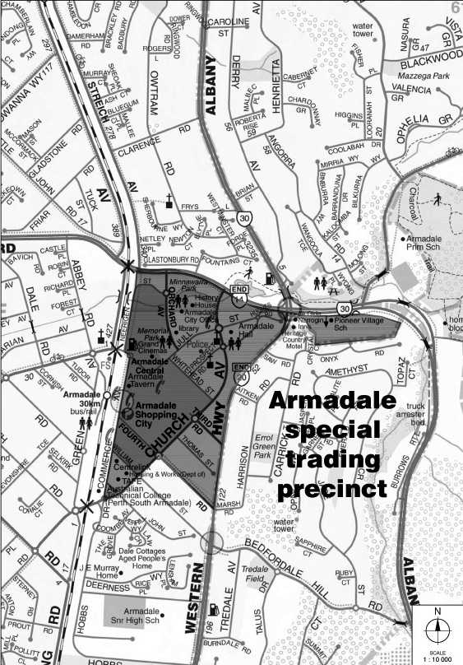

(2) Where the boundary of the area described in subclause (1) follows a road, street or highway, the precinct includes the strip of land that extends outwards for 100 metres from the outer edge of the road, street or highway so that general retail shops that are wholly or partially within that strip of land are within the precinct.
(3) The Armadale special trading precinct includes the area known as the “Pioneer Village” located immediately south-east of where the Albany Highway intersects with Armadale Road and the South Western Highway (Lot 100 on Diagram 77144, being strata plan 10033 held by the Western Australian Land Information Authority established by the Land Information Authority Act 2006 section 5).

Division 2 — Fremantle special trading precinct
That part of the district of Fremantle (as existing at the beginning of 27 March 2010) that is south of the Swan River. For information purposes, the prescribed area is shown below and shaded grey.

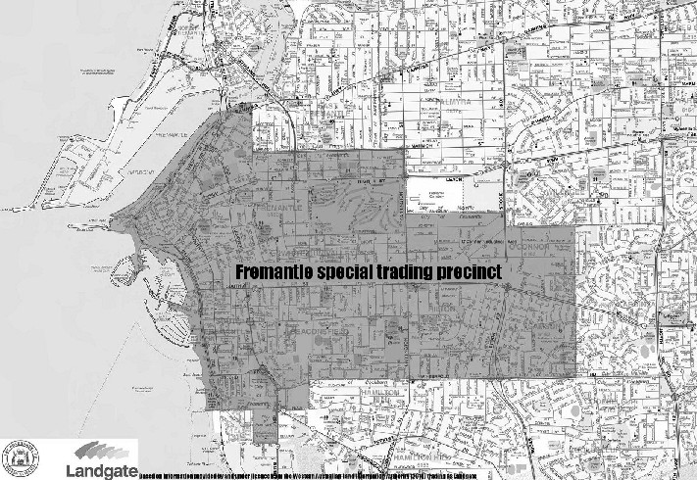

Division 3 — Joondalup special trading precinct
(1) That part of the district of Joondalup contained within a line that starts where Moore Drive begins to cross the northbound lane of the Mitchell Freeway, then continues in a generally easterly direction along Moore Drive to where it intersects with the northbound lane of Joondalup Drive, then continues in a generally northerly direction along the northbound lane of Joondalup Drive to where Joondalup Drive intersects with Lakeside Drive, then continues in a south-easterly then generally southerly direction along the southbound lane of Lakeside Drive to where it intersects with Joondalup Drive, then continues in a generally southerly direction along the southbound lane of Joondalup Drive to where it intersects with Ocean Reef Road, then continues in a westerly direction along the eastbound lane of Ocean Reef Road to where it begins to cross the northbound lane of the Mitchell Freeway, then continues in a north-westerly direction along the northbound lane of the Mitchell Freeway to the starting point. For information purposes, the prescribed area is shown below and shaded grey.

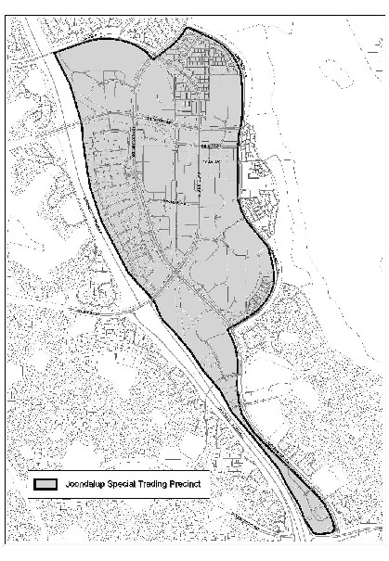

(2) Where the boundary of the area described in subclause (1) follows a road, street or highway, the precinct includes the strip of land that extends outwards for 100 metres from the outer edge of the road, street or highway so that general retail shops that are wholly or partially within that strip of land are within the precinct.

Division 4 — Midland special trading precinct
(1) That part of the district of Midland contained within a line that starts where Morrison Road intersects with the eastbound lane of the Great Eastern Highway, then continues in a generally north-easterly then generally easterly direction along the eastbound lane of Morrison Road to where it intersects with Lloyd Street, then continues in a generally south-westerly direction along the south-westbound lane of Lloyd Street to where it intersects with the Great Eastern Highway, then continues in a generally easterly direction along the eastbound lane of the Great Eastern Highway to where it intersects with the Roe Highway, then continues in a generally south-westerly direction along the south-westbound lane of the Roe Highway to where it begins to cross over Clayton Street, then continues in a generally north-westerly direction along Clayton Street to where it intersects with Irwin Street, then continues in a generally south-westerly direction along Irwin Street to where it intersects with Wildon Street, then continues in a generally north-westerly direction along Wildon Street to where it intersects with Clayton Street, then continues in a generally north-westerly direction along Clayton Street to where it intersects with Military Road, then continues in a generally southerly then generally south-westerly direction along Military Road to where it intersects with the northern boundary of the reserved land known as the Helena River Reserve (as delineated in the Scheme map that is part of the Metropolitan Region Scheme in force under the Planning and Development Act 2005, as that Scheme exists at the beginning of 1 November 2010), then continues in a generally westerly direction along the northern boundary of the Helena River Reserve to where it intersects with Amherst Road, then continues in a generally northerly then generally north-westerly direction along Amherst Road to where it intersects with Morrison Road, then continues in a northerly direction along Morrison Road to the starting point. For information purposes, the prescribed area is shown below and shaded grey.

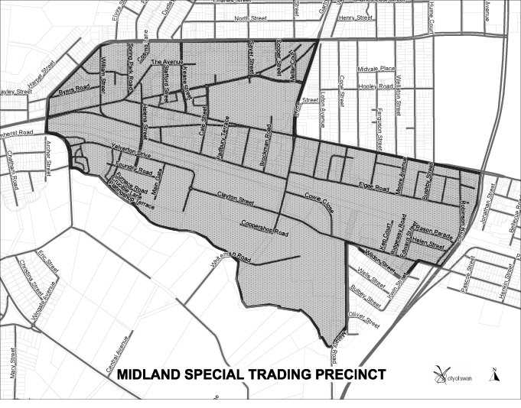

(2) Where the boundary of the area described in subclause (1) follows a road, street or highway, the precinct includes the strip of land that extends outwards for 100 metres from the outer edge of the road, street or highway so that general retail shops that are wholly or partially within that strip of land are within the precinct.

Division 5 — Perth special trading precinct
(1) The area of the State contained within a line that starts at the western end of Bagot Road, Subiaco where it intersects with Railway Road, then continues in a north-easterly direction along Railway Road to where it intersects with Forrest Street, then continues in a northerly direction directly to the southern end of Harborne Street where it intersects with Roydhouse Street, then continues in a northerly direction along Harborne Street to where it intersects with Cambridge Street, then continues in an easterly direction along Cambridge Street to where it intersects with Southport Street, then continues in a generally northerly and north-westerly direction along Southport Street to where the northbound lane intersects with Lake Monger Drive, then continues in an easterly direction along Lake Monger Drive to where it becomes Vincent Street, then continues in an easterly direction along Vincent Street to where it intersects with William Street, then continues in a northerly and then north-easterly direction along William Street to where it intersects with Walcott Street, then (subject to subclause (3)) continues in a generally south-easterly direction along Walcott Street to where it intersects with Lord Street, then continues in an easterly direction directly to the eastern end of Pakenham Street, then continues in a generally easterly then south-easterly direction along Pakenham Street to where it intersects with Joel Terrace, then continues due east to the Swan River, then continues in a generally southerly direction along the western bank of the Swan River to the point where the Perth to Armadale railway line crosses the Swan River immediately to the south of the Graham Farmer Freeway, then continues along the eastbound track of the Perth to Armadale railway line in a generally easterly direction across the Swan River, then continues along that track in a generally south-easterly direction as far as Victoria Park Station and to the point on that track that is directly opposite where the eastern end of Duncan Street intersects with Kitchener Avenue, then continues in a generally south-westerly direction directly to the eastern end of Duncan Street where it intersects with Kitchener Avenue, then continues in a south-westerly direction along Duncan Street to where it intersects with the Albany Highway, then continues in a generally southerly direction along the Albany Highway to where it intersects with McMillan Street, then continues in a south-westerly direction along McMillan Street to where it becomes George Street, then continues in a south-westerly direction along George Street to where it intersects with South Terrace and Hayman Road, then continues in a westerly direction along South Terrace to the western end of South Terrace, then continues in a westerly direction directly to the northbound lane of the Kwinana Freeway, then continues in a generally northerly direction along the northbound lane of the Kwinana Freeway, across the Narrows, to the point on the western bank of the Swan River where it starts to cross over Riverside Drive, then continues in a generally westerly direction along Riverside Drive to where it becomes Mounts Bay Road, then continues generally south-westerly along Mounts Bay Road to where it intersects with Winthrop Avenue, then continues generally northerly then generally north-easterly along Winthrop Avenue until it intersects with Aberdare Road and Thomas Street, then continues generally north-easterly along Thomas Street to where it intersects with Rokeby Road, then continues in a northerly direction along Rokeby Road to where it intersects with Bagot Road, then continues in a westerly direction along Bagot Road to the starting point. For information purposes, the prescribed area is shown below and shaded grey.

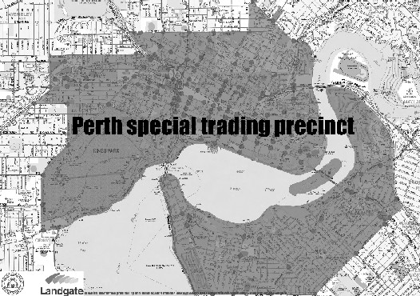

(2) Where the boundary of the area described in subclause (1) follows a road, street or highway, the precinct includes the strip of land that extends outwards for 100 metres from the outer edge of that road, street or highway so that general retail shops that are wholly or partially within that strip of land are within the precinct.
(3) The Perth special trading precinct includes the stretch of Beaufort Street that begins at its intersection with Walcott Street and ends at its intersection with Queens Crescent, and includes the strip of land that extends outwards for 100 metres on either side of that stretch of Beaufort Street so that general retail shops on both sides of that stretch of road and that are wholly or partially within that strip are within the precinct.

Schedule 2 — Holiday resorts
[r. 8]

Division 1 — Rockingham holiday resort
District of Rockingham.

Division 2 — Rottnest Island holiday resort
Rottnest Island.

Division 3 — Wanneroo holiday resort
Localities of Two Rocks and Yanchep.

Notes
¹ This is a compilation of the Retail Trading Hours (Special Trading Precincts and Holiday Resorts) Regulations (No. 2) 2010. The following table contains information about those regulations.

Compilation table
Citation | Gazettal | Commencement
Retail Trading Hours (Special Trading Precincts and Holiday Resorts) Regulations (No. 2) 2010 | 22 Oct 2010 p. 5253-66 | r. 1 and 2: 22 Oct 2010 (see r. 2(a));  Regulations other than r. 1 and 2, r. 3 and 6, Sch. 1 Div. 1 and 4: 23 Oct 2010 (see r. 2(c));  r. 3 and 6, Sch. 1 Div. 1 and 4: 1 Nov 2010 (see. r. 2(b))
These regulations were repealed by the Retail Trading Hours (Holiday Resorts) Regulations 2012 r. 4 as at 26 August 2012 (see Gazette 17 August 2012 p. 3900)

