
Western Australia

Agriculture and Related Resources (Searches for Declared Plants and Animals) Regulations 2003
Compare between:
[05 Feb 2013, 00-c0-01] and [01 May 2013, 00-d0-03]

Western Australia
Agriculture and Related Resources Protection Act 1976
Agriculture and Related Resources (Searches for Declared Plants and Animals) Regulations 2003

1. Citation
These regulations may be cited as the Agriculture and Related Resources (Searches for Declared Plants and Animals) Regulations 2003.

2. Interpretation
(1) In these regulations —
inspector includes an authorised person;
full search means a search in accordance with the relevant full search protocol specified in Schedule 1 Division 2;
prescribed plant means a declared plant that is listed in Schedule 1 Division 1;
search sheet means Form 1 of Schedule 2;
surveillance search means a search in accordance with the relevant surveillance search protocol specified in Schedule 1 Division 3.
(2) For the purposes of these regulations, an inspector reasonably suspects something at a relevant time if he or she, acting in good faith, personally has grounds at the time for suspecting the thing and those grounds (even if they are subsequently found to be false or non-existent), when judged objectively, are reasonable.

3. Notice to carry out full search of private land
(1) An inspector may serve on the owner or the occupier of private land, or on both the owner and the occupier, a notice in writing directing the owner or occupier to conduct a full search of the land for a prescribed plant, if —
(a) the inspector reasonably suspects that the land is infested with a prescribed plant; or
(b) at some time during the previous financial year, the land was infested with a prescribed plant and a full search has not been conducted in the current financial year.
(2) An owner or occupier of private land who has been served with a notice under subregulation (1) and who —
(a) fails to commence to comply with the direction contained in the notice on or before the commencement date specified in the notice; or
(b) fails to fully comply with the direction contained in the notice on or before the completion date specified in the notice,
commits an offence.
Penalty:
(a) for a first offence — $500;
(b) for each subsequent offence — $1 000.
(3) Where the owner and the occupier of private land are both served with a notice under subregulation (1) it is a defence in any proceeding against either of them under subregulation (2)(a) or (b) for the defendant to show that the other has complied with the provisions of that paragraph.

4. Notice to carry out surveillance search of private land
(1) An inspector may serve on the owner or the occupier of private land, or on both the owner and the occupier, a notice in writing requiring the owner or occupier to conduct a surveillance search of the land for a prescribed plant, if —
(a) at some time during the 2 financial years before the previous financial year, the land was infested with a prescribed plant and a surveillance search has not been conducted in the current financial year;
(b) the inspector reasonably suspects that land adjoining the private land is infested with a prescribed plant;
(c) at some time during the previous 3 financial years, land adjoining the private land was infested with a prescribed plant and a surveillance search has not been conducted in the current financial year; or
(d) the circumstances referred to in regulation 3(1) exist, but the inspector is of the opinion that a surveillance search should be conducted instead of a full search.
(2) An owner or occupier of private land who has been served with a notice under subregulation (1) and who —
(a) fails to commence to comply with the direction contained in the notice on or before the commencement date specified in the notice; or
(b) fails to fully comply with the direction contained in the notice on or before the completion date specified in the notice,
commits an offence.
Penalty:
(a) for a first offence — $500;
(b) for each subsequent offence — $1 000.
(3) Where the owner and the occupier of private land are both served with a notice under subregulation (1) it is a defence in any proceeding against either of them under subregulation (2)(a) or (b) for the defendant to show that the other has complied with the provisions of that paragraph.

5. Searches and recovery of costs
(1) Without affecting any proceeding against or liability of any owner or occupier under regulation 3 or 4, if an inspector is of the opinion that neither the owner nor the occupier of private land has complied with the direction contained in a notice served on either or both of them under regulation 3 or 4, the inspector may enter the land to which the notice relates and carry out all or any of the requirements of the direction.
(2) All expenses incurred by an inspector under subregulation (1), together with interest (at the rate at which interest is payable on a judgment debt of the Supreme Court) —
(a) are a debt to the State due by the owner or occupier served with the notice (and if both are served, by them jointly and each of them severally); and
(b) may be sued for and recovered by the Director General on behalf of the State in a court of competent jurisdiction.
[Regulation 5 amended in Gazette 17 Dec 2010 p. 6413.]

6. Records of searches
(1) An owner or occupier who has conducted a search in accordance with a notice under regulation 3 or 4 commits an offence if that owner or occupier fails to keep a record of the search, in the form set out in Schedule 2 Form 1, for a period of 5 years after the search has been conducted.
Penalty:
(a) for a first offence — $500;
(b) for each subsequent offence — $1 000.
(2) If an owner or occupier is requested by an inspector to make a search record available for inspection, the owner or occupier commits an offence if the owner or occupier does not make the record available for inspection by the inspector within 7 working days of the request.
Penalty:
(a) for a first offence — $500;
(b) for each subsequent offence — $1 000.

Schedule 1 — Prescribed plants and search protocols
[r. 2]

Division 1 — Prescribed plants
Skeleton weed (Chondrilla juncea)

Division 2 — Full search protocol
1. Ensure that the land being searched has been free of livestock for at least 6 weeks before the search.
2. Check the land being searched for stubble type and density in order to determine speed and search swath (see clauses 5 and 6).
3. Ensure that the search is conducted using only elevated cab, diesel powered vehicles.
4. If the search is conducted using a search boom ensure that there are at least 3 searchers.
5. Ensure that the speed of a search vehicle is appropriate to the conditions and does not exceed 20 km/h.
6. Ensure that the search swath is appropriate to the conditions and does not exceed —
(a) in the case of a search conducted from inside a vehicle without using a search boom —
(i) if one person is in the vehicle — 5 metres; and
(ii) if 2 or more persons are conducting the search in the vehicle — 15 metres;
and
(b) in the case of a search conducted using a search boom — 20 metres.
Note: Searching at 15 km/h at 20 metre swaths will cover 30 hectares per hour.
7. If plants are found —
(a) stop and search the immediate area on foot;
(b) clearly mark all the plants with drums, spears or steel posts —
(i) in a 20 metre square around each plant; or
(ii) in a 10 metre square around clumps of plants.
8. Clearly mark infestation on map of the land being searched.
9. Record the plant growth stage (ie. rosette, flowering, etc.).
10. If there are any flowering plants, either —
(a) cut and bag the plants; or
(b) treat the plants to prevent the production of viable seed.
11. When the search of the land is complete, move to exit and clean the vehicle.
Note: Where flowering plants have been found in paddock, it is vital that vehicle is thoroughly cleaned.
12. Ensure that plant material from the searched land is not carried into any other land used for agricultural purposes.
13. Record the details of the search by setting out the results of the search on a search sheet.
14. Notify the Department of Agriculture of the search.

Division 3 — Surveillance search protocol
1. Ensure that the land being searched has been free of livestock for at least 6 weeks before the search.
2. Check the land being searched for stubble type and density in order to determine speed and search swath (see clauses 5 and 6).
3. Ensure that the search is conducted using only elevated cab, diesel powered vehicles.
4. If the search is conducted using a search boom ensure that there are at least 3 searchers.
5. Ensure that the speed of a search vehicle is appropriate to the conditions and does not exceed 20 km/h.
6. Ensure that the search swath is appropriate to the conditions and does not exceed —
(a) in the case of a search conducted from inside a vehicle without using a search boom —
(i) if one person is in the vehicle — 15 metres; and
(ii) if 2 or more persons are conducting the search in the vehicle — 30 metres;
Note: Searching with 2 people at 20 km/h with 30 metre swaths will cover 60 hectares per hour.
and
(b) in the case of a search conducted using a search boom — 50 metres.
7. If plants are found —
(a) stop and search the immediate area on foot;
(b) clearly mark all the plants with drums, spears or steel posts —
(i) in a 20 metre square around each plant; or
(ii) in a 10 metre square around clumps of plants.
8. Clearly mark infestation on map of the land being searched.
9. Record the plant growth stage (ie. rosette, flowering, etc.).
10. If there are any flowering plants, either —
(a) cut and bag the plants; or
(b) treat the plants to prevent the production of viable seed.
11. When the search of the land is complete, move to exit and clean the vehicle.
Note: Where flowering plants have been found in paddock, it is vital that vehicle is thoroughly cleaned.
12. Ensure that plant material from the searched land is not carried into any other land used for agricultural purposes.
13. Record the details of the search by setting out the results of the search on a search sheet.
14. Notify the Department of Agriculture of the search.

Schedule 2 — Forms
[r. 2]
Form 1
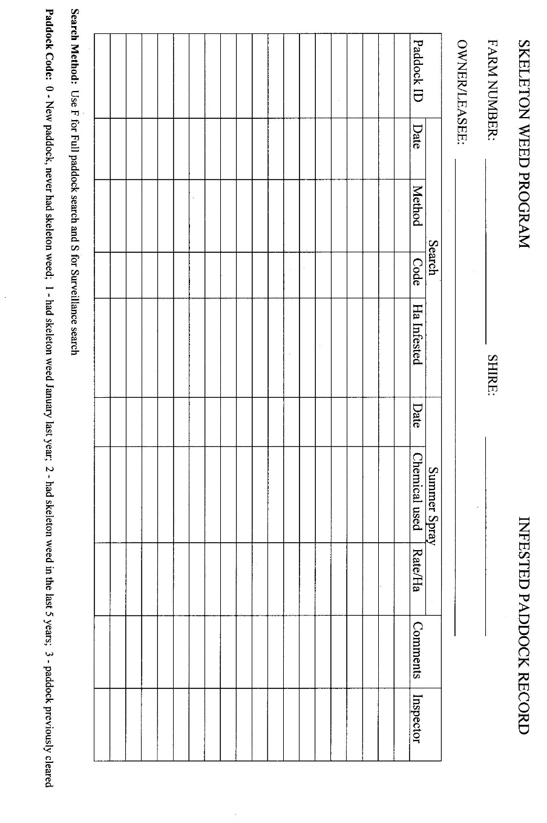

Notes
¹ This is a compilation of the Agriculture and Related Resources (Searches for Declared Plants and Animals) Regulation 2003. The following table contains information about that regulation ².

Compilation table
Citation | Gazettal | Commencement
Agriculture and Related Resources (Searches for Declared Plants and Animals) Regulations 2003 | 7 May 2003 p. 1601-11 | 7 May 2003
Agriculture and Related Resources Protection (Repeals and Amendments) Regulations 2010 Pt. 4 | 17 Dec 2010 p. 6403-32 | 18 Dec 2010 (see r. 2(b) and Gazette 17 Dec 2010 p. 6349)

These regulations were repealed by the Biosecurity and Agriculture Management Regulations 2013 r. 137(b) as at 1 May 2013 (see r. 2(b) and Gazette 5 Feb 2013 p. 823)
² The Biosecurity and Agriculture Management Regulations 2013 r. 138 reads as follows:

138. Fees and expenses
On and from the commencement day —
(a) any fees payable under a regulation repealed under regulation 137 and outstanding on the commencement day are to be regarded as payable under these regulations at the time, and in the manner, in which the fees would have been payable under the repealed regulation and may be recovered accordingly; and
(b) any expenses recoverable under a regulation repealed under regulation 137 and outstanding on the commencement day may be recovered under regulation 128.
Penalty: a fine of $10 000.

