
Western Australia

Government Railways Amendment By-laws 1994
Compare between:
[19 Sep 1997, 00-c0-02] and [29 Sep 2000, 00-d0-05]

GOVERNMENT RAILWAYS ACT 1904
Government Railways Amendment By-laws 1994

1. Citation
These by-laws may be cited as Government Railways Amendment By-laws 1994.

2. By-law 54 Repealed and a by-law substituted
By-law 54 of the Railway By-laws* and the Schedule to that by-law is repealed and the following by-law is substituted —
“
54. Guidance of persons working on or about Government railways
(1) The rules set out in the Schedule to this by-law are to be followed by persons working on or about Government railways on or about Government railways.
(2) To the extent that the rules set out in the Schedule to this by-law impose a duty on a person working on or about Government railways, that person must perform that duty in the circumstances described in those rules.
(3) Where a procedure is set out in the Schedule to this by-law which relates to the safe operation of the rail system, every person working on or about Government railways must follow that procedure when the circumstances arise.
(4) The Commission may —
(a) establish procedures for training persons, other than employees of the Commission, so that persons who complete the training may be accredited by the Commission to work on or about Government railways;
(b) establish different levels of training and accreditation in relation to the performance of different duties;
(c) prohibit persons other than employees of the Commission from working on or about Government railways unless —
(i) those persons are accredited at the level appropriate to the duties they are to perform; or
(ii) the Commission has, in writing, specified that the duties those persons are to perform do not require accreditation; and
(d) cancel or suspend, for any period the Commission considers appropriate, the accreditation of any person.
(5) Penalties for non-compliance with the rules set out in the Schedule to this bylaw are one or more of the disciplinary actions set out in rule 3 of that Schedule.
”.
[By-law 54 amended in Gazette 23 February 1996 pp.679-80.]

Schedule
BOOK OF RULES
SECTION A
GENERAL RULES

1. GLOSSARY AND INTERPRETATION
The following terms and definitions apply: —
TERM | DEFINITION
Accredited Person | Any person who has been accredited in accordance with the procedures established under by-law 54 (4) whose accreditation has not been cancelled or suspended.
Area Manager | The person having management responsibility for the safe and efficient operation of trains, stations and marshalling yards within specified district boundaries.
Assisting Locomotive | A crewed locomotive other than the train locomotive on a train.
Attended Station | A station at which a Station Officer is on duty.
Authorised Speed | The maximum speed laid down in the Working Timetable, subject to any lesser speed shown in a Weekly Notice or Special Train Notice or imposed by warning and caution boards or a permanent speed board.
Block Station | The station at either end of a block section at which equipment is provided to control the movement of trains, and may be attended or unattended.
Block Section | The section of running line extending between two adjoining block stations.
Centralised Traffic Control | A system of remotely controlling the points and signals at a number of interlocked stations, junctions and crossing loops in automatic signalling areas, from a centralised control room or signal box.
Commission Employee | Any person employed by the Commission under a contract of employment.
Construction Engineer | An engineer engaged to be in charge of a Westrail track or infrastructure work site, or section of line upgrading programme.
District Engineer | An engineer having management responsibility for the safety and maintenance of track and infrastructure within specified district boundaries.
Driver | The person in charge of a working locomotive, railcar, road/rail vehicle or self propelled on-track maintenance machine.
Driver’s Assistant | Any employee engaged to assist the Driver in the working of a train and observance of signals.
Employee | A Commission Employee or an Accredited Person who is working on or about Government railways.
Flag Attendant | A person appointed to exhibit hand signals as set out in these rules.
Fulfilled | When applied to train orders means that the order has been complied with fully.
Hand Signal Attendant | A person appointed to exhibit hand signals as set out in these rules.
Head of the Civil Maintenance Branch | The head of that part of the organisation, however designated, responsible for the safety and maintenance of track and infrastructure.
Head of the Operations Branch | The head of a part of the organisation, however designated, having responsibility for the safeworking of train operations.
Interlocked Station | Any station at which the apparatus for working the points and signals is centralised and arranged to prevent conflicting movements. The operation of the points and signals is manually controlled and in addition, on automatic signalling systems, also controlled by track circuits.
Intermediate (or Track) Section Lever | Any division of a block section, the entrance to which is controlled by a fixed signal.
 | Any lever, switch, key, button or other apparatus used to operate signals, points or other interlocking apparatus.
Length Runner | A person having responsibility for regular permanent way inspections to ensure the safety of the line.
Light Locomotive | A locomotive or locomotives coupled without vehicles.
Multi-Coupled Locomotive | Where locomotives are multi-coupled, one crew is in control of, and operating, more than one unit, employees must regard the multi-coupled locomotives, for the purposes of train signalling and operation, as one locomotive.
Lookout | A person appointed by the person in charge of employees working on the line to ensure such employees are aware of the approach of a train or other traffic along the line.
Maintainer | Includes Safeworking Technician, Interlocking Fitter, Line and Signal Maintainer.
Obstruction Situation | A situation in which a train is unable to proceed on a line by reason of an accident, failure, obstruction or other cause.
On-Track Machine | Any power operated, self-propelled, flange wheel mounted maintenance machine or recorder car, excluding locomotives, railcars, road/rail vehicles, and those small machines mentioned in Rule 261 sub-rule (1) of these Rules.
Person-In-Charge | Any person having the control of any part of the Railways.
Proceed | When applied to the aspect of a fixed signal means the caution or clear indication.
Protected Level Crossing | A level crossing equipped with automatic flashing light warning signals with or without bells and half boom gates
Qualified Employee | An employee duly qualified by examination in all aspects of these safeworking Rules and who is authorised to carry out the duties required by these Rules.
Railcar | Self-propelled passenger vehicle.
Relief Train | Is a breakdown or other train, locomotive or locomotives coupled proceeding to clear an obstruction or to assist a disabled train.
Road/Rail Vehicle | A road vehicle specially adapted to travel on rail lines.
Running Line | Is the line which is reserved for the movement of trains as distinct from sidings.
Section Running Time | The train running time between one block station and the next block station in advance.
Shunter | The authorised person in charge of, or engaged in a shunting operation.
Siding | Section of railway, other than defined running lines, used for delivery/receipt of goods, storage of wagons, shunting and marshalling of trains.
Signal Box | Is any place where signal levers or signal control apparatus and the safeworking appliances are located.
Signal Operator | Any employee who is for the time being in charge of the working of signals or safeworking appliances or both.
Station Limits | (a) Within the outer home signal.
 | (b) Within the home signal where an outer home signal is not provided or within the arrival signal.
 | (c) On double line within the starting signal, or facing or trailing points beyond the starting signal, or a shunt set-back signal beyond the starting signal, whichever is furthest from the station concerned.
 | (d) Within the station limits boards where fixed signals do not exist.
Station Officer | The officer for the time being in charge of a station.
Stopping - Place | A place at which there is no apparatus provided to control the movement of trains, and is a stopping place for the setting down or picking up of passengers.
Superior Train Order Station | An attended Train Order Crossing Station protected by fixed signals.
Tail Target | A white target or disc or two red lights attached to the rear of a train.
Track Attendant | Any person employed as a member of a track maintenance gang.
Track Section Time | The train running time between a signal and the next signal in advance.
Track Supervisor | The employee in charge of the track attendants and on-track machines and equipment engaged in the construction, maintenance or upgrading of a section of rail track.
Train | A railcar, or locomotive with or without vehicles attached, and any on-track recorder car or self-propelled maintenance machine which cannot be readily removed from the track.
Train Controller | A qualified employee authorised to regulate and control all movements over prescribed sections of a Railway in accordance with the rules.
Train Locomotive | A locomotive which works a train.
Track Section | Any division of a block section, the entrance to which is controlled by a fixed signal.
Train Examiner | An employee appointed to examine all classes of rollingstock except locomotives, railcars or on-track recorder cars and self-propelled maintenance machines.
Train Order Territory | That portion of railway specified in the Working Timetables or advised through the Weekly Notice or Special Train Notice as being Train Order Territory.
Train Order | An instruction on the prescribed form issued by the Train Controller for the movement of a train or on-track Machine or for closure of a section by a District Engineer.
Train Order Station | A station at which Train Orders may be received and which may or may not be in Train Order Territory.
Train Order Crossing Station | A Train Order Station within or at the start or end of Train Order Territory at which trains may cross pass or run round.
Train Order Non-Crossing Station | A Train Order Station within Train Order Territory at which trains cannot cross, pass or run round.
Train Order Section | That portion of main line between two adjoining Train Order Crossing or Non-Crossing stations.
Unattended Crossing Station | When applied to the single line automatic signalling system means a crossing station where the points and signals are not arranged and operated as an interlocked station.
Westrail | Has the same meaning as “Commission” in the Act.
[Rule 1 amended in Gazette 23 February 1996 p. 680; 19 September 1997 p. 5291.]

2. EMPLOYMENT
(1) Employees must:-
(a) Make SAFETY their first and most important duty.
(b) Attend for duty at the time and place and during the hours required, promptly obey persons placed in authority over them and conform to the Rules, instructions and notices of the Commission issued from time to time.
(c) Notify their immediate supervisor promptly of any change in their private address so that a register of names and addresses can be kept up to date.
(d) Be prompt, civil and obliging, afford every proper facility for the Commission’s business, give correct information, and when asked, their names or service numbers without hesitation.
(e) When on duty be neat and clean in appearance and, where supplied wear uniform, badge and protective clothing and equipment. Staff whose duties compel them to be on or about the railway must wear the high visibility clothing provided.
(f) When required, make restitution for any article provided by the Commission when lost or damaged through improper use by the employee.
(g) Before leaving the service, return their uniform where supplied, and all other articles belonging to the Commission. Until all such articles have been accounted for, the cost of missing articles or articles damaged by improper use or the cost of repairing such damage shall be a debt due by the employee to the Commission. This debt may be deducted from any pay then due or if such pay is insufficient to meet the claims will become a debt recoverable at law.
(2) Employees must not:-
(a) Absent themselves from or exchange duty, or alter appointed hours of attendance without permission of their immediate Supervisor.
(b) Enter any part of railway property not set apart for public use, except in the course of their duties. On completion of these duties they must vacate such property.
(c) Unless in the execution of their duty, ride on a locomotive or in the driving compartment of a railcar or in a brakevan or in any vehicle from which the public are excluded, without the written permission of the person in charge.
(d) Address any communication in connection with their duties or position other than through the person in charge or use an outside influence to press for or achieve their requirements.
(e) Cease duty, where an employee is required to hand over to another employee, until the arrival of the relief employee, or otherwise authorised to do so by the person in charge.
(f) Hand over duty to another employee where the sobriety of that person is in doubt and in such cases, immediately report the matter through the immediate supervisor to the Head of the Branch.
(g) Report for duty under the influence of intoxicating liquor or of any drug that might impair the proper performance of their duties and must not consume intoxicating liquor or any such drug whilst on duty.
(h) Appropriate to their own use, waste or wantonly destroy, any property of or in the possession of the Commission.
(i) Accept gratuities for services rendered.
(j) Except where authorised, take charge of luggage or articles left at the station for the convenience of passengers. Any such luggage or articles must be deposited in the appropriate office.
(k) Except in the course of their duties operate or tamper with any equipment, apparatus or vehicle associated with Westrail operations.

3. DISCIPLINE
(1) Subject to subrule (6), the Commission may at any time —
(a) dismiss a Commission Employee without notice; or
(b) suspend a Commission Employee from duty and, after inquiry, dismiss that Commission Employee without notice; or
(c) suspend a Commission Employee from duty as a disciplinary measure; or
(d) reduce a Commission Employee to a lower grade; or
(e) transfer a Commission Employee without payment of transfer expenses; or
(f) fine a Commission Employee an amount not exceeding $20.00; or
(g) suspend the accreditation of an Accredited Person pending a Commission inquiry; or
(h) suspend the accreditation of an Accredited Person for any period that the Commission considers appropriate as a disciplinary measure; or
(i) cancel the accreditation of an Accredited Person.
(1a) Any of the actions referred to in subrule (1), as applicable to a Commission Employee or an Accredited Person, may be taken by the Commission if the employee concerned —
(a) is under the influence of intoxicants or drugs that might impair the proper performance of the employee’s duties; or
(b) disobeys any lawful order given to the employee or fails to comply with these rules; or
(c) is guilty of misconduct or is negligent in the performance of the employee’s duties; or
(d) is absent from duty without leave; or
(e) is convicted of an offence.
(2) In the circumstances of summary dismissal of a Commission Employee, no salaries or wages shall be paid for any period of suspension from duty or absence without leave prior to such dismissal.
(3) Any Commission Employee who has been continuously employed for three months or more and who has been dismissed, regressed, suspended causing loss of pay, transferred without payment of transfer expenses or fined, may, in the prescribed manner, appeal to the Railway Appeal Board.
(4) Where a Commission Employee is not satisfied by the actions of the immediate supervisor or person in charge, an appeal may be made initially to the Head of the Branch and thereafter through that office to the Commission.
(4a) An Accredited Person whose accreditation has been suspended or cancelled may appeal to the Commission in the manner approved by the Commission, and the Commission must then reconsider whether the suspension or cancellation is appropriate.
(4b) If an appeal under subrule (4a) is not resolved to the satisfaction of both parties within 28 days after the appeal is made, either party may appoint an independent arbitrator, who is acceptable to both parties, to resolve the appeal.
(4c) If the parties cannot agree on the arbitrator to be appointed, either party may request the the president of the Law Society of Western Australia to select an arbitrator and the arbitrator so selected is to be regarded as being acceptable to both parties.
(4d) On an appeal under subrule (4a) both parties must bear their own costs and one half of the costs of any arbitrator appointed under subrule (4b).
(5) A period of two years without a recorded offence will erase any previous detrimental record from a Commission Employee’s personal history card or an Accredited Person’s accreditation record, except;
(a) where the Commission directs otherwise, or
(b) the offence was the subject of a Railway Appeal Board hearing or an appeal to the Commission under subrule (4a).
(6) To the extent that this rule applies to a Commission Employee, it is subject to any relevant award of The Western Australian Industrial Relations Commission or any relevant industrial agreement that may be in force.
[Rule 3 amended in Gazette 23 February 1996 pp.680-82.]

4. DISTRIBUTION AND APPLICATION OF THE BOOK OF RULES, REFERENCE BOOKS AND NOTICES
(1) Every Commission employee shall be supplied with a copy of the General Rules which will have uniform application to all employees except as provided in Rule 5(1)
(2) Every employee who is responsible for the safety of the line or the working of trains, road/rail vehicles and on-track machines must be supplied with and have when on duty a copy of the whole of these Rules.
(3) Every person in charge of a station, depot, office or workshop must be supplied with one copy of the whole of these Rules and these must be kept fully amended and in a convenient place and readily accessible to staff.
(4) Every employee who is responsible for the safety of the line or the working of trains, road/rail vehicles, and on-track machines must be supplied with, and have when on duty, a fully amended copy of the General Appendix to the Book of Rules and the Working Time Table for the appropriate section thereof. One copy of each of these books must be supplied to the person in charge of a station, depot office or workshop and be kept in a convenient place and readily accessible to staff.
(5) The person in charge of a station, depot, yard or sub-depot is responsible for maintaining a General Order Book and a Special Train Notice Book.
(6) A Driver and Driver’s Assistant must peruse the General Order Book and the Special Train Notice Book when signing on duty and carry with them a current Weekly Notice.
[Rule 4 amended in Gazette 23 February 1996 p.682.]

5. GENERAL DUTIES OF ALL STAFF
(1) Except where specific instructions exist to the contrary under By-Law 84 (Workshop Rules,) all employees must comply with these rules and if any infringement occurs which prejudices safe and proper working it must be at once reported to their immediate Supervisor.
(2) Employees must not resort to the use of force in the execution of their duties until all other means of persuasion have failed. Only then should force be used to the degree necessary in the circumstances.
(3) Employees can arrest and detain until handed over to the Police any person who is intoxicated or behaves in an offensive or violent manner to the annoyance of others on the railway. This power is conferred by Section 49 of the Government Railways Act on any officer or servant of the Commission.
(4) Caution must be observed by an employee who detains or gives a person into custody, and no person is to be detained: —
(a) who gives his or her name and address and is able to verify this information, or
(b) whose name and address is known to the employee, or person in charge, or
(c) who is known to any person with whom the person in charge is acquainted.
(5) Unless instructions are issued to the contrary any person trespassing on railway property must be asked to give that person’s name and address, requested to leave the property and warned not to trespass thereon again. If the person refuses to leave that person may be removed from the premises (using only such force as necessary) or if that person refuses both to leave the premises and give that person’s name and address, the offender must be detained and handed over to the Police. In either circumstance a report with the name and address of the offender, if obtained, must be handed to the Person in Charge.
(6) Whereafter a person who has been misbehaving in any way has been warned to desist and does not do so, a request must be made for that person to leave railway premises. The employee when warning the person to desist must issue a warning that further misbehaviour brings with it the possibility of removal and a penalty under the Railway Act or By-Laws. If the person still refuses to desist that person must be removed using only such force as is necessary in the circumstances.
(7) Before a person is removed from any place on the railway the person in charge who orders the removal must ascertain the cause and nature of the complaint and take the names and addresses of the parties complaining.
(8) If police assistance is readily available and is required, the Police Officer should be the person preferring any charges considered necessary.
(9) In any case where there has been a breach of the Government Railways Act or of the By-Laws made thereunder by the Commission, the person in charge must obtain the names and addresses of any persons present when the breach occurred. These must be reported with the name and address of the offending person.
(10) Whenever any person is detained or taken into custody a facsimile or telegram message must at once be sent to the Head of Division stating the person’s name, address and occupation and the nature of the charge. A detailed written report must follow outlining all particulars of the case including when and where the charge is to be heard.
(11) Employees must not permit any persons to travel on the railway unless in possession of a proper ticket or free pass.
(12) Any unclaimed or lost luggage, money or other property found by an employee, whether on duty or not, in any carriage or vehicle or upon any station premises or other part of the railway shall be deemed to belong to the Commission and must at once be delivered to the nearest person in charge. The employee so finding has no claim on the property or to the proceeds if sold.
(13) Any employee must give complete and accurate particulars on any time sheet, time book, attendance book or any other document used for timekeeping or costing purposes. Any falsification or mutilation of a time record or neglect to supply proper information is an offence against these rules.
(14) On a change of duty between employees every circumstance out of the ordinary must be related to the incoming employee with special attention to the position of trains and their running.
(15) Any employee knowing of a fire, flood, accident, damage or any other emergency that may affect the safety of the railways, must take immediate action to protect any approaching train/s and report it as soon as possible.

6. SAFETY
(1) Employees must: —
(a) Work safely to prevent injury both to themselves or to fellow employees.
(b) Within their power, prevent other employees from endangering themselves or other persons by needless or reckless acts.
(c) Observe all safety measures and take all measures to eliminate causes of accidents.
(d) While on duty wear safety footwear and protective clothing where provided and where the occasion requires use protective equipment as directed by the person in charge.
(e) As soon as possible after being injured on duty, inform the person in charge of the circumstances. Unless impracticable, the circumstances should be reported before ceasing duty.

7. MISCELLANEOUS
(1) An employee must not undertake any legal proceedings on behalf of the Commission or on behalf of another employee, nor show nor produce any document or book or copy thereof to any person not connected with the Department; nor directly or indirectly make any communication to any person not entitled thereto, upon any matter affecting the Department, or the business or employees thereof, or relating to the railway service or their own official position; nor act upon any political question or subject whatsoever, without having first obtained authority or instruction from the Head of Branch or from the Commission.
(2) Except with the specific approval of the Commission, no employee under the age of 19 years may be appointed to or otherwise engaged in, any position with Safeworking responsibilities.
(3) An employee must not publicly comment upon the administration of the Western Australian Government Railways, or use for any other purpose other than the discharge of official duties, information gained or received as an employee of the Commission.
(4) Employees attending in their official capacity under a subpoena or order to give evidence for or on behalf of the Department, or to produce papers in any Court, shall do so as part of their official duties. As soon as possible after the receipt of the subpoena the employee must advise the person in charge of the fact and obtain permission to be absent from duty for that purpose. Fees payable will be dealt with under current Departmental instructions in force.
(5) Where an employee volunteers to give evidence before any court hearing in a case in which another employee is involved (but to which the Commission is not a party), permission to do so must be granted provided:
(a) an application is made to the person in charge.
(b) it is at the employee’s own expense and
(c) it is convenient for the Commission.
(6) Each Station Officer and Signal Operator is responsible for keeping the clock or clocks properly regulated to Western Standard Time, or such other time system notified from time to time, and must promptly report any defects. Employees required to use timepieces must have them synchronised with Western Standard Time or other time system notified, at all times.
(7) The twenty-four hour system of time reference will be used for all purposes in connection with the operations of the railway, unless otherwise directed by the Head of the Operations Branch.
(8) It is essential that verbal messages concerning movements of trains or vehicles and matters affecting the safety of the line, be properly understood by all persons involved in the communication.
(a) The persons giving the messages must:-
(i) identify themselves and their location and ensure they are speaking to the correct person.
(ii) satisfy themselves that the message is correctly understood before terminating the conversation.
(b) The persons receiving the messages must: —
(i) identify themselves and establish the identity and location of the person giving the message.
(ii) repeat the message to the sender and satisfy themselves that they correctly understand it before terminating the conversation.

8. SPECIAL AUTHORITY FOR SUSPENSION OF THE RULES
(1) The Head of the Operations Branch may suspend, either generally or over certain specified sections of the railway and for such time as he or she thinks fit, any of the rules relating to the safeworking of trains so as to: —
(a) facilitate the movement of traffic; or
(b) introduce emergency measures
(2) Any suspension of a rule for the purpose mentioned in paragraph (a) of sub-rule (1) of this rule must not be effected until all persons concerned have been advised.
(3) The introduction of any measure under paragraph (b) of sub-rule (1) of this rule shall be effected only for the purposes of meeting exceptional circumstances, and where the observance of these rules would be seriously disadvantageous.
(4) The Head of the Operations Branch may delegate the powers conferred by this rule, for such periods as deemed fit to senior managers whose names must be published at the time of the delegation of authority and thereafter at intervals of not more than 12 months; but a delegate must forthwith report to the Head of the Operations Branch any exercise of the powers so delegated.
(5) The Head of the Operations Branch must, in every case, report to the Commission his or her reasons, or those of a delegate for exercising the power conferred by this rule.

9. DELEGATION OF POWER TO ISSUE PROCEED ORDERS
Wherever in these rules authority is given to an Area Manager to issue proceed orders, the Head of the Operations Branch may delegate such authority to any other officer. This officer’s name must be published in the Weekly Notice at the time of the delegation of authority, and thereafter at intervals of not more than six months, during the continuation of that delegation.

10. FORMS
Reference in these rules to any form is a reference to that form as set forth in the Schedule to the rules.

11. COMMUNICATION OF INFORMATION RELATING TO TRAIN MOVEMENTS
(1) Where in these rules there is a requirement for information relating to train movements to be transmitted or communicated, then transmission may be by radio, telephone, telex, facsimile or computer network, unless otherwise directed.
(2) The persons sending and receiving radio or telephone transmissions must ensure that messages are fully and correctly received by repeating back the information transmitted.

12 TO 19 RESERVED
SECTION B
OPERATING RULES
PART 1
DIVISION 1
FIXED SIGNALS

20. TYPES OF FIXED SIGNALS
(1) Fixed signals are of two types:
(a) Running signals
(b) Shunting signals
(2) Running Signals - Control the movements of trains on running lines and are three aspect colour light signals of two categories:
(a) Semi-automatic
(b) Automatic
(3) Semi-Automatic colour light running signals may be:
(a) Outer Home Signals
(b) Home Signals
(c) Directing Signals
(d) Starting Signals
(e) Departure Signals
(4) Automatic colour light running signals may be:
(a) Approach Signals
(b) Arrival Signals
(c) Intermediate Signals
(5) Shunting Signals:
(a) Shunting signals control the movement of trains:
(i) Between sidings and running lines.
(ii) Between one running line and another.
(iii) For shunting purposes.
(b) Shunting signals are of two categories:
(i) Colour light ground shunting signals with two or three aspects.
(ii) Single aspect shunting signals which exhibit a short range yellow light when placed to proceed.

21. INDICATION OF FIXED SIGNALS (see figures 1 to 44).
(1) The normal indication of fixed signals is stop, except as follows:
SIGNAL | NORMAL ASPECT
Intermediate Signal | Caution or Clear
Approach Signal | Caution
Arrival Signal | Caution
(2) Colour light signals display colour lights by day and night.
(3) Where signals applicable to more than one line are fixed on the same mast or on bracket masts, particulars as to the line to which each signal applies must be shown on the relevant diagram of signalling.
(4) Where a three aspect running signal is in use the indication displayed is either:
(a) Stop - indicated by a red light.
(b) Caution - indicated by a yellow light.
(c) Clear - indicated by a green light.
(5) Three aspect running signals are distinguished by a reflectorised marker plate attached to the mast except as provided in sub-rule 6 of this rule, as follows:
(a) Semi-Automatic — The marker plate is positioned directly below the signal light (See figs 1 and 2) and displays the signal number as shown on the diagram of signalling.
(NOTE: A semi-automatic signal is controlled from a signal box and by the passage of trains).
(b) Automatic — The marker plate is positioned diagonally below and to the right of the signal light (See figs 5 and 6) and displays the signal number based on the kilometreage preceded by the letter “D” for down signal and “U” for up signal.
(NOTE: An automatic signal is controlled only by the passage of trains).
(6) Where two or more three aspect signals are bracketed on the one mast, a marker plate is not displayed (see figs 3 and 4).
(7) Where a shunting signal is in use, the indication displayed is:
(a) Two aspect ground shunting signal (see figs 32 and 34).
(i) Stop indicated by a red light.
(ii) Caution indicated by a yellow light.
(b) Three aspect ground shunting signal (see figs 32 and 33).
(i) Stop indicated by a red light.
(ii) Caution indicated by a yellow light.
(iii) Clear indicated by a green light.
(c) Single aspect shunting signal (see figs 19 to 26).
This single aspect shunting signal is placed on the same mast and below a semi-automatic signal and does not normally show a light. When the shunting signal is placed to Proceed a short range yellow light is displayed.
(8) Where a single aspect shunting signal is placed on the same mast as a departure signal the shunting signal only authorises a movement along a route which diverges from the main line to a siding within station limits.

22 USE AND FUNCTION OF FIXED SIGNALS
Fixed signals apply only to trains approaching in the proper direction.

23. OUTER HOME SIGNAL
Outer home signals are semi- automatic signals placed outside the home signal to extend station limits.

24. HOME SIGNALS
(1) Home signals are semi-automatic signals placed at the entrance to an interlocked block station.
NOTE: The automatic signals placed at the entrance to unattended crossing stations on single line automatic signalling sections are called Arrival Signals (see rule 29).
(2) Home signals must not be passed at stop except:
(a) When shunting signals are provided.
(b) For shunting movements when shunting signal not provided (see rule 62).
(c) When signal is defective (see rule 63).
(d) During Pilotworking (see rule 127).

25. RESERVED

26. DIRECTING SIGNALS
(1) Directing signals are semi-automatic signals used in station limits to direct trains to platforms, sidings or positions to which the signals apply.
(2) A directing signal must not be passed at Stop except:
(a) When shunting signals are provided.
(b) For shunt movements where shunting signals are not provided (see rule 62).
(c) When signal is defective (see rule 63).

27. STARTING SIGNALS
(1) Starting signals are semi-automatic signals which control the entrance of trains into the section ahead except in single line automatic signalling areas.
(2) A starting signal must not be passed at Stop except on:
(a) Single lines in the case of: —
(i) shunting signal provided,
(ii) defective signal (see rule 63),
(iii) Assistance to a disabled train (see rule 132, 135,) or
(iv) Shunt movement when shunting signal not provided (see rule 62); and on,
(b) Double lines in the case of: —
(i) Shunting signal provided,
(ii) Defective signal (see rule 63),
(iii) Pilotworking (see rule 127),
(iv) Assistance to a disabled train (see rule 133) or
(v) Shunt movement when shunting signal not provided (see rule 62).

28. APPROACH SIGNALS
(1) Approach signals are automatic signals and are situated some distance on the approach side of a home or arrival signal.
(2) Approach signals do not divide a block section.
(3) The Driver of a train stopped at a red approach signal must contact the Train Controller and state: —
(a) Train number and description, and
(b) Signal number and section.
(4) The Train Controller must then instruct the Driver to remain at the signal or pass the signal at Stop.
(5) Where a Driver is instructed to pass the approach signal at stop the Driver must proceed cautiously, prepared to find the line obstructed, or a broken or displaced rail.
(6) If the Driver is unable to contact the Train Controller the Driver must wait one minute then pass the signal observing the instruction in sub-rule (5) of this rule.
(7) Approach signals are distinguished by a triangular marker plate on the right hand side of the mast (see figs 7 and 8).

29. ARRIVAL SIGNALS
(1) Arrival signals are automatic signals placed at the entrance to unattended crossing stations in single line automatic signalling areas (see figs 17 and 18).
(2) An illuminated letter “L” visible at short range is displayed to the left of the marker plate when the points are set for the loop.
(3) An illuminated letter “C” visible at short range is displayed vertically below the signal light when the points are set for the loop and:
(a) the loop is unoccupied; and
(b) the facing points at the opposite end of the loop are set for the main; and
(c) any points leading from the loop to sidings are set normal for the loop.
(4) Before entering the loop a Driver must be satisfied that both the “L” and “C” lights are illuminated.
(NOTE: When the points are set for the loop the arrival signal will be at Stop).
(5) When the main line points have been set for the loop but the “L” light is not illuminated, the Driver’s Assistant or qualified employee must examine the points and if found to be correctly set for the safe passage of the train must: —
(a) if the “C” light is illuminated, hand signal the train into the loop.
(b) If the “C” light is not illuminated, contact the Train Controller and if advised there is no opposing train movement hand signal the train into the loop instructing the Driver to proceed cautiously to the Departure Signal being prepared to find the line occupied or points incorrectly set.
(6) If the “C” light is not illuminated and the “L” light is illuminated, the driver must contact the Train Controller who will instruct the Driver, if there is no opposing train movement, to proceed cautiously to the Departure Signal being prepared to find the line occupied or points incorrectly set.
(7) If the Arrival signal is at Stop and the train is required to enter the main line, the Driver’s Assistant or qualified employee must examine, and if necessary correctly set and lock the points for the main line, and should the Arrival signal still fail to exhibit a Proceed indication the Driver must contact the Train Controller.
(8) If there is no opposing train movement the Train Controller must instruct the Driver to pass the Arrival signal at Stop. The Driver must take the train forward cautiously towards the Departure signal prepared to stop short of any obstruction or to find a broken or displaced rail.

30. DEPARTURE SIGNALS
(1) Departure signals are semi-automatic signals and are: —
(a) Placed at the entrance to all single line block sections in automatic signalling areas.
(b) Controlled at interlocked stations by the Signal Operator or Train Controller and by the passage of trains.
(c) Controlled at unattended crossing stations by the passage of trains and an apparatus located at each station.
(2) If the departure signal fails to exhibit a proceed indication at an unattended crossing station the Driver must operate the releasing switch and if the signal still fails to exhibit a Proceed indication, contact the Train Controller.
(3) If a train is detained at a departure signal in an area of Centralised Traffic Control the Driver must immediately contact the Train Controller, and continue to do so at 15 minute intervals if detained..
(4) A train must not be permitted to pass a departure signal at Stop except as provided in the following situations: —
(a) Issue of a Proceed Order (Rule 110).
(b) Pilot Key Working introduced (Rule 117).
(c) Assistance to a disabled train (Rule 134)
(d) Portion of a train left in a section (Rule 132).
(e) Arrow Indicator provided (Rule 33).
(f) Shunting signal provided (Rule 21).
(g) Pilot key lost (Rule 119).
(h) Locomotives changing over at stations not signalled for such purposes (as laid down in General Appendix).
(5) When a Departure Signal has been passed at Stop in accordance with sub-rule 4 of this rule, the Driver must: -
(a) Proceed cautiously being prepared to find the section occupied or obstructed, points wrongly set, a broken or displaced rail until arrival at a further signal.
(b) Stop and examine the points in the track section to which the signal applies to ensure they are correctly set for the passage of the train.
(c) Examine switchlock doors to see they are properly closed.
(d) Approach any protected level crossing in the vicinity of the Departure signal cautiously and ensure the protection is activated before passing over the crossing.
[Rule 30 amended in Gazette 19 September 1997 p. 5291.]

31. INTERMEDIATE SIGNALS
(1) Intermediate Signals are automatic signals used to divide the block section to facilitate the movement of following trains.
(2) Intermediate signals must not be passed at Stop except as follows:
(a) A Driver detained at an Intermediate Signal at Stop must immediately contact the Train Controller and state: —
(i) Train number and description.
(ii) Signal number and section.
(b) The Train Controller must then instruct the Driver to remain at that signal or pass it at Stop according to the circumstances.
(c) Where a Driver is instructed to pass an Intermediate Signal at Stop the Driver must: —
(i) proceed cautiously being prepared to find the section obstructed, points wrongly set, a broken or displaced rail, until arrival at a further signal.
(ii) Stop and examine all points in the track section to which the signal applies to ensure they are correctly set for the passage of the train.
(iii) Examine switchlock doors to ensure they are properly closed.
(3) Where contact cannot be made with the Train Controller, the Driver must wait track section time then proceed in accordance with sub-rule (2)(c) of this rule.
(4) Track section time is the running time to the next signal in advance.

32. SHUNTING SIGNALS
(1) Shunting signals must not be passed at Stop except as follows:
(a) Movements for which the signal does not apply (see Rule 62).
(b) Defective signal.
(2) Where a shunting signal shows a Caution indication, it indicates that the points are set correctly and a train may proceed cautiously as far as the line is clear to the next signal.
(3) Where a shunting signal shows a Clear indication, it indicates the points are set correctly and that the line is clear to the next signal which is showing caution or clear.
(4) A shunting signal, when placed below a running signal, applies when at caution for a shunting move only, onto the line ahead of that running signal.

33. POINT INDICATORS
(1) Point Indicators are connected to and work in conjunction with the points to which they apply solely to indicate the way the points are set.
(2) Where a fixed signal is not provided to govern the movement Drivers, except as provided for in Rule 94, must not proceed through points until verbally or hand signalled to do so.
(3) Point Indicators attached to catch points (fig 48) exhibit a square red reflectorised target when in the normal derail position and a square green reflectorised target when reversed in the running position.
(4) Point Indicators attached to other than catchpoints (fig 47) and except as provided in sub-rule (5) of this rule exhibit a square half red half green reflectorised target. The green is exhibited in the direction for which the points are set.
(5) Point indicators attached to main line points in Train Order Territory exhibit a round reflectorised green target when set in the normal main line position and a round reflectorised red target when in the reverse position (see fig 46), except as provided in sub-rule 9 of this rule.
(6) An illuminated arrow indicator (single or double arrow) (fig 40) and a two aspect colour light indicator (figs 41-44) may be provided at the facing and trailing ends respectively of points which are the termination of interlocking in station yards (see diagram on following page).
(7) When an arrow indicator exhibits a white arrow light in the facing direction or the related colour light indicator exhibits a yellow bar of light in the trailing direction it indicates that the interlocked points are in the normal position. All movements over the interlocked points must be controlled by radio or hand signal by the person shunting.
(8) When the white arrow light in the facing direction is extinguished and the related colour light indicator exhibits a red bar of light all shunting movements over the interlocked points must cease.
(9) An electrically illuminated point indicator is located adjacent to and works in conjunction with the electric point motor attached to self-restoring points and is described as follows: -
(a) The point indicator consists of two triangular shaped indicators mounted one above the other on a single mast. The upper indicator is applicable to trains approaching in the facing direction, while the lower indicator applies to trains approaching in the trailing direction.
(b) The indicators have a matt black finish on both sides with a strip of white reflectorised tape surrounding the outline of the indicator as seen by an approaching train.
(c) Each indicator contains three white lights on -
(i) the upper indicator in the facing direction and
(ii) the lower indicator in the trailing direction.
(d) Only two white lights will be visible at any one time on each indicator and will indicate to an approaching train crew -
(i) two lights in a vertical position - that the points are set and locked for the main line, and
(ii) two lights at a 45 º angle - that the points are set and locked for the loop. (see figs 49-56).
(iii) if only one light or no lights are visible the train must not pass over the points until they have been examined by the Driver’s Assistant who must ensure the points are correctly set for the safe passage of the train.
(e) The indicator lights are approach lit when a train is within approximately 400 metres of the station.
(10) Operating instructions relating to self-restoring points are shown in the General Appendix to the Book of Rules.

34. JUNCTION INDICATORS
(1) A Junction Indicator is mounted above the Running Signal (figs 30-31) with which it is associated and exhibits an indicator for each diverging route in conjunction with a proceed indication on the signal.
(2) A Junction Indicator may be provided with up to six arms fixed at 45 degree intervals. Diverging roads only are indicated. No indication is provided for the non-diverging line.
(3) Each arm of the Junction Indicator contains five lunar white lights. A minimum of three lunar white lights must be illuminated before a Proceed Indication can be displayed on the signal.
(4) A junction indicator when illuminated does not authorise a Driver to pass a signal at Stop. The signal must show Proceed for authority to pass it.

35. ROUTE INDICATORS
(1) A Route Indicator (fig 28) is mounted above or alongside a running signal and exhibits indications in conjunction with a Proceed aspect on that signal.
(2) When illuminated a Route Indicator displays one or two alphanumeric characters in accordance with the designations assigned to each route on the diagram of signalling.
(3) Route Indicators display the characters by means of a matrix of white lights.
(4) A Route Indicator when illuminated does not authorise a Driver to pass a signal at Stop. The signal must show Proceed for authority to pass it.
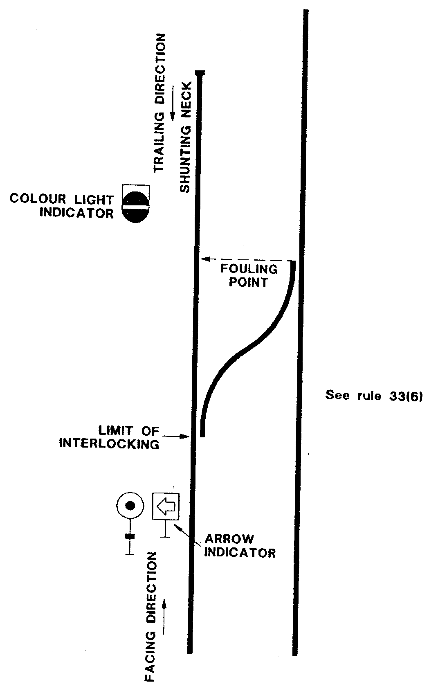

36. STATION LIMITS BOARDS
(1) Station Limits Boards (fig 57) are used to define station limits where fixed signals are not provided.
(2) These boards are located in a position clearly visible to the Driver of an approaching train.
(3) With permission from the Train Controller, shunting is allowed at Train Order crossing stations between the points and the Station Limits Boards without the Driver being in possession of a Train Order for the section.
(4) Except as provided in sub-rule (5) of this rule, Drivers of trains approaching a station where Station Limits Boards are in use must be prepared to stop at the Station Limits Board if the main line beyond such board is occupied; but when the Driver can see all is clear the train may proceed past the Station Limits Board at a speed not exceeding 20 kilometres per hour.
(5) At stations where no crossing is to take place and the train is not required to stop for any reason, the Driver shall proceed past the Station Limits Board at the authorised speed.
DIVISION 2

37. HAND SIGNALS
(1) Any person making hand signals must do so with flags by day and lamps by night and in foggy conditions, but these signals may be given by the use of the arms by day in an emergency or when shunting.
(2) A red flag or red lamp must be exhibited as a signal of Danger-Stop. In the absence of a red flag, the arms raised above the head and by night any lamp waved violently denotes Danger-Stop.
(3) Any person signalling must face the locomotive and signal in such a position that there can be no misunderstanding as to the purpose of the hand signal by the Driver for which the signal is intended. During shunting operations where it is not possible to face the Driver, the person giving the signal must satisfy himself that the Driver can see all hand signals.
(4) Where hand signals are permitted by these rules, the following must be used: —
Signal by Day | Night or Foggy Conditions | Signal Indication
(a) Reg flag | Red lamp or any other light waved violently | Danger Stop
(b) Green flag waved slowly side to side | Green lamp waved slowly side to side | Caution – proceed slowly
(c) Green flag held steadily | Green lamp held steadily at a fixed signal | Permission to a Driver to pass a fixed signal at stop
(e) Red flag held steadily in the hand until the Driver acknowledges the signal then a green flag waved slowly from side to side, given from the main line facing points | Red light held steadily in the hand until the Driver acknowledges the signal, then a green light waved slowly from side to side, given from the main line facing points | Where fixed signals are not provided and train entering the main line is required to Stop, also when a train is required to enter a loop  (see rule 65 sub-rule 2)
(f) Yellow flag waved slowly from side to side  or  yellow flag held steadily | White light waved slowly from side to side | To reduce speed on account of permanent way restrictions (see rule 234)
(5) Shunting Hand Signals are given as follows –
Signal by Day | Night or Foggy Conditions | Signal Indication
(a) The arm waved outwardly from the body | White light waved slowly up and down | Move away from the person giving the signal
(b) The arm waved inwardly across the body | White light waved slowly from side to side across the body | Move towards the person giving the signal
(c) The arm waved outwardly from the body, the other arm in the caution position | Green light waved slowly up and down | Move slowly away from the person giving the signal
(d) The arm waved inwardly across the body, the other arm in the caution position | Green light waved slowly from side to side across the body | Move slowly towards the person giving the signal
(e) One arm extended outward and upward hand closed and moved quickly from the elbow | White light held downwards at arms length and flashed rapidly by wrist movement only | Accelerate speed prepared to stop (i.e. to hit up)
(f) Both arms raised above the head to form an arch and then separated | Green light moved slowly from side to side by wrist movement only | To uncouple
(6) Where the use of arms is permitted by these Rules, the following signals apply:
(a) both arms raised above the head denotes DANGER-STOP. | 
(b) one arm raised above the head denotes CAUTION-MOVE SLOWLY. | 
(c) one arm held in the horizontal position denotes CLEAR-PROCEED. | 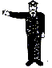
(d) in the case of a person riding in or on a vehicle, either arm waved up and down denotes STOP.
DIVISION 3
SOUND SIGNALS

38. SOUND SIGNALS TO BE GIVEN ON CERTAIN OCCASIONS
(1) Where a train is approaching a pedestrian or vehicular level crossing, whether during shunting operations or otherwise, the Driver must sound the locomotive horn at such a distance from the crossing as to give ample warning of the approach of the train.
(2) Where two trains are approaching any level crossing at or about the same time, the Driver of each train must repeat the warning blasts continuously, until the train has reached the crossing.
(3) A Driver must sound any required blasts distinctly, and with intensity, duration or repetition, proportionate to the distance at which the warning is required to be heard, and the circumstances under which it is being used.
(4) The Driver of a special train run at short notice or a train running in advance of timetable time or of a train running late must sound the horn when approaching all places where a good and distant view cannot be obtained (so as to warn employees working on the line, and others, of the approach of the train).
(5) The following sound signals by means of the locomotive horn may be used by Drivers.
(a) One long whistle denoting - Warning, challenge or approaching a level crossing.
(b) One short whistle denoting Acknowledgement or moving off.
(c) Two short whistles denoting - Setting back.
(d) Three short whistles denoting - Danger-Stop.
(e) Continuous whistling indicates - Assistance required.
DIVISION 4
TRAIN SIGNALS

39. TRAIN SIGNALS
(1) Every train must carry the train signals prescribed by this rule; and tail lights must be lighted between sunset and sunrise, and in foggy weather.
(2) Except as provided in sub-rule 3 of this rule a tail target must be attached to the rear of the last vehicle on every train to show the train is complete.
(3) On single and double lines worked under the rules for Automatic Signalling, light locomotives, empty coaching stock and passenger trains shall not exhibit a white target by day attached to the rear of the last vehicle, but two red lights must be exhibited at night or in foggy weather.
(4) A person upon whom a duty is imposed by these rules must not take a train as having passed or arrived complete, until that person is satisfied that the rear vehicle carrying the tail target is attached to the train.
(5) Where a locomotive is assisting in the rear, the prescribed tail target must be placed at the rear end of that locomotive; and a tail target must not be carried on the vehicle in front of the assisting locomotive.
(6) Except as provided in sub-rule 3 of this rule the Driver of a light locomotive must ensure that it carries, at the rear end, a tail target; and where two or more locomotives coupled together are running light, the Driver of the leading locomotive must ensure that the prescribed tail target is placed at the rear end of the rearmost locomotive.
(7) The headlight of a locomotive or railcar must be on full beam at all times on running lines, except if —
(a) the locomotive or railcar is standing at a station or crossing a second train; and
(b) the locomotive or railcar is clear of the fouling points,
at which time the Driver must extinguish the headlight and exhibit the front white marker light on the side of the locomotive or railcar nearest the clear running line, and the front red light on the side furthest from the clear running line.
(8) The Drivers Assistant must ensure that the proper tail target is securely affixed to the last wagon on the train, is in working order and lit at night and in foggy conditions.
[Rule 39 amended in Gazette 19 September 1997 pp. 5291-2.]
DIVISION 5
DETONATING SIGNALS

40. PURPOSE AND MANNER OF PLACING DETONATING SIGNALS
(1) A Detonating Signal is used for the purpose of attracting the attention of a Driver.
(2) A Driver, Drivers Assistant, Signal Operator, qualified employee in charge of a passenger train, Length Runner, Track Supervisor, Leading Hand or other person in charge of work in connection with a line , must be provided with detonators; and must always have them ready for use, when on duty.
(3) Every person in charge of a station must keep a supply of detonating signals, in a suitable place, known by, and accessible at all times to every authorised person connected with the station.
(4) Each of the persons mentioned in sub-rule (2) and (3) of this rule is held responsible for keeping up the proper supply of detonators.
(5) Where the use of detonators is prescribed by any rule or instruction, the detonators must be used by day and by night, unless otherwise directed, by the Head of the Operations Branch.
(6) Where detonators are required to be used by these rules, the detonators —
(a) shall be placed on every rail of the line to be protected; and
(b) shall be placed so that they are opposite each other on every rail, in order to ensure that they explode simultaneously, and each detonator must be placed as near as possible to the centre of the rail.
(7) Where more than one detonator is used on each rail, they must be placed 20 metres apart.
(8) After fixing the detonators on the rail at the distance prescribed by any rule or instruction, the employee whose duty it is to exhibit the hand signal must stand between the detonators and the obstruction in respect of which he or she is signalling and at least 30 metres from the detonators; and must so exhibit the hand signal that it may be seen by the Driver, immediately after the locomotive or train has exploded the detonators.
(9) All employees in the vicinity of the detonators placed on the rails, other than the flag attendant, must take up positions so that the locomotive will have passed them before exploding the detonators.

41. DUTY OF DRIVERS ON EXPLOSION OF DETONATORS
(1) A Driver must, on hearing —
(a) one detonator, or two detonators twenty metres apart, explode, immediately reduce speed to enable the train to stop at once if required, and must proceed cautiously until a further signal is received.
(b) three detonators twenty metres apart explode, stop the train at once and remain in that position until further directions are received.
(2) If the Driver is not informed of the circumstances, and the reason for the three detonators being on the line is not obvious, the Driver must immediately communicate with the Train Controller or Signal Operator.
(3) In the case of communication failure, the Drivers Assistant must go to the nearest place where he or she is able to communicate with the Train Controller or Signal Operator and report the circumstances and the train which has come to a stand must be treated as an Obstruction Situation and protected in accordance with Rule 131.

42. DETONATORS TO BE HANDLED CAREFULLY
(1) An employee handling detonators must do so carefully (as they may explode if roughly treated); and must ensure that, when required to be stored, they are stored in a dry place.
(2) A person issuing detonators must do so in the order in which they are received; those on hand the longest being always issued first.
(3) Where any detonator fails to explode when a train passes over it, the circumstances must be promptly reported to the Head of the Operations Branch, and the defective detonator disposed of in an approved manner.
(4) Unless instructions to the contrary are issued each employee’s stock of detonators must be tested at intervals of not more than six months to ensure that they are in good condition.
DIVISION 6
WORKING OF POINTS, SIGNALS AND SIGNAL BOXES

43. SIGNALS TO BE OPERATED BY QUALIFIED PERSON ONLY
(1) A signal box must be kept strictly private and the Signal Operator must not allow any unauthorised person to enter the signal box.
(2) At unattended stations which are not interlocked the duty of operating the points and signals must be carried out by the train crew.
(3) A person must not operate the safeworking apparatus in a signal box unless that person holds a Certificate of Competency for the system in operation at that particular station, and has been examined and certified as competent to operate that signal box.
(4) An unauthorised person must not be permitted to operate any safeworking apparatus.

44. CERTAIN POINTS NOT TO BE OPERATED WITHOUT PERMISSION OF THE SIGNAL OPERATOR
A person must not move any points which lead to a running line, or from one running line to another, without the permission of the Signal Operator on duty.

45. SIGNAL OPERATOR LEAVING THE SIGNAL BOX
Where it is necessary for a Signal Operator to leave the signal box, while on duty, for purposes other than train working, the Signal Operator must wherever practicable before leaving inform the Train Controller of the probable duration of the Signal Operator’s absence and must place all signals at STOP and enter in the Train Register Book the time of, and reason for, absence.

46. RELIEF OF SIGNAL OPERATOR
(1) A Signal Operator must change duty at the appointed time only, and a Signal Operator being relieved must inform the relieving Signal Operator as to -
(a) Whether or not the Safeworking Appliances are in good working order;
(b) What trains, if any, are in the sections under their control, or are signalled; and
(c) Any other matter necessary to enable the Relieving Signal Operator to properly discharge his or her duties.
(2) A Relieving Signal Operator before taking over must be satisfied that all information in regard to the matter referred to in sub-rule (1) of this rule, has been received.
(3) A Signal Operator, on arrival on duty and again on leaving must enter the time of arrival or departure as the case may be and his or her signature immediately under the last prior entry in the Train Register Book.
(4) A Signal Operator opening a signal box must, as soon as possible thereafter, ensure that the safeworking appliances are in proper working order.

47. SIGNAL OPERATORS TO CHECK EQUIPMENT
(1) Every Signal Operator must see the points, signals, interlocking, electrical and other apparatus are kept in perfect working order and are promptly returned to normal after use.
(2) In every case where apparatus is defective or is not properly cleaned and oiled, the Signal Operator must immediately report that fact to the Station Officer and to the Track Supervisor, Maintainer or other person in charge of repairs.
(3) Unless instructions are issued to the contrary, points and signals not in daily use must be tested at least once in each week.
(4) Any irregular working, or failure of the proper working of, any fixed signal must immediately be reported, by the person observing the irregularity or failure, to that person’s superior officer.
(5) A Signal Operator must not apply undue force in the operation of levers and before attempting to operate any lever, the Signal Operator must be satisfied himself that conditions are suitable for the intended movement.
(6) Where any track or safeworking appliance is damaged or strained, such conditions must immediately be reported to the Station Officer and to the Track Supervisor or Maintainer and all trains approaching the damaged appliance must be stopped, or, if safe, be allowed to pass slowly over that appliance until the damage has been repaired.
(7) An authorised maintenance employee must certify that the track is in order when repairs to damaged equipment are completed.
(8) An authorised maintenance employee must certify that the safeworking apparatus is in order when repairs to damaged equipment are completed.

48. CATCH POINTS AND SCOTCH BLOCKS TO BE SECURED IN POSITION
Catch points and scotch blocks must be set to secure safety, and, except where movements are required to be made over the line on which they are provided, they must be kept in position and padlocked, to prevent any vehicles escaping on to running lines, except where otherwise provided in the Local Instructions.

49. BALANCED CATCH POINTS TO BE KEPT OPEN, NORMALLY
Balanced catch points must normally be kept open in order to prevent any vehicle running away and where it is necessary for a movement to be made over runaway catch points in the facing direction, care must be taken, to ensure that the points are properly set and secured for the movement.

50. LEVERS AND POINTS TO BE LOCKED OR SECURED
(1) Employees operating points must see that all levers, whether in the normal or reverse position, are secured by the catch being firmly in the notch of the locking frame and must whenever practicable, assure themselves by observation that points have obeyed the lever and are in the proper position.
(2) Facing points, not worked from a locking frame, which lead from a running line, must be padlocked in their normal position.
(3) Points which lead to a running line, and are not worked from a locking frame must be padlocked in their normal position, so that no vehicle or train can foul the path of another.

51. SIGNAL OPERATORS TO OBSERVE THAT SIGNALS OBEY LEVER MOVEMENTS
A Signal Operator operating a signal lever must ensure the signal obeys the lever movements either by direct observation or by the signal indicator light or repeater provided for the purposes.

52. RUNNING LINES NOT TO BE FOULED WITHOUT PERMISSION
(1) Any train or vehicle must not be permitted by any person to foul any running line, without the permission of the Signal Operator or Train Controller.
(2) A line must not be obstructed or occupied until the signals applicable to that line have first been placed at Stop.

53. SIGNAL OPERATORS TO PREVENT TRAINS FROM APPROACHING OBSTRUCTIONS
(1) Should a Signal Operator become aware of any obstruction upon, or defect in a line, the Signal Operator must place and maintain the necessary fixed signals at Stop, and take such other steps as may be possible in the circumstances to prevent any trains approaching the obstruction, until the line is clear and safe.
(2) Where any device is provided which requires to be operated by the Signal Operator to serve as a reminder that certain levers must not be operated, the Signal Operator must make prompt use of that appliance.

54. RESERVED

55. RESERVED

56. DUTIES OF SIGNAL OPERATOR AFTER THE PASSING OF TRAINS
A Signal Operator must, where a signal automatically goes to Stop and it is controlled from the signalbox, return the lever to the normal Stop position.

57. CHANGING A PROCEED SIGNAL TO STOP
After a signal has been placed to Proceed for a train to pass and it is found necessary for that signal to be replaced to Stop before the train passes, the Signal Operator must, before allowing any conflicting movement on the line applicable to the signal or before altering the points, be satisfied that the train has been brought to a stand and that the Driver is aware that the signal is at Stop.

58. DUTIES OF DRIVERS STOPPING AT PROCEED SIGNAL
(1) Where a Driver brings the train to a stand approaching, or about to pass, signals which have been placed at Proceed, the Driver must, before restarting, again observe the indication of the signal.
(2) When unable to proceed for any reason, the Driver must arrange to advise the Signal Operator or Train Controller.

59. DUTIES OF SIGNAL OPERATOR BECOMING AWARE OF OBSTRUCTION
(1) In the event of a Signal Operator becoming aware that livestock on or near the line may cause an obstruction, the Signal Operator must immediately inform the Train Controller who will arrange to have the line cleared. Until it has been ascertained that the line is clear, the Driver of any train proceeding in that section must be informed of the circumstances and instructed to proceed cautiously.
(2) When the possibility of the obstruction has been removed, trains may then be allowed to proceed in the ordinary manner.
[Rule 59 amended in Gazette 23 February 1996 p.682.]

60. DEFECTIVE SIGNALS, POINTS ETC
(1) A signal imperfectly displayed, or the absence of a signal at a place where one is normally shown or the exhibition of a white light or no light where a Red, Yellow or Green ought to be seen must be taken as a Stop signal.
(2) Where a Handsignal Attendant is provided due to a defective signal or points, the attendant must display the handsignal from the defective signal. The Handsignal Attendant must act under the instructions of the Signal Operator.
(3) Where the interlocking is out of order, points must not be set so that the path of one train can cross the path of another.

61. FIXING, REMOVING OR REPAIRING SIGNALS AND POINTS
(1) Unless otherwise provided in these rules, no person other than those authorised may perform any work on the permanent way, points, instruments or signalling appliances.
(2) Before the erection or removal of signals or any other work that may affect the points, signals, track circuits or any other safeworking appliances, prior notice must be given to the Operations Branch to enable special arrangements to be made for working of traffic while the work is carried out, and where necessary a Handsignal Attendant must be appointed for safeworking of trains.
(3) When not in use, running Signals must be distinguished by a white cross fixed to the signal as indicated in fig 27, and shunting signals must be covered.
(4) A new signal must not be brought into use or alterations made to the position or use of an existing signal without the authority of the Head of the Operations Branch.
(5) Where any work is to be carried out on points, signals or other apparatus, the Maintainer must obtain permission from the Signal Operator, who will advise the time at which the work may commence and the time when work must be completed. On completion of work the apparatus must be tested to prove it is in correct working order.
(6) Where repairs to level crossing lights or booms involve disconnection a Handsignal Attendant must attend the protection of the crossing.
DIVISION 7
SIGNALLING IN CONNECTION WITH TRAINS SHUNTING OR RUNNING IN THE WRONG DIRECTION
[Heading amended in Gazette 23 February 1996 p.682.]

62. CERTAIN MOVEMENTS OF TRAINS TO BE SPECIALLY AUTHORISED
(1) Where fixed signals are not provided the movement of trains -
(a) in the wrong direction on any running line.
(b) shunting from one running line to another.
(c) shunting along running lines.
(d) shunting into or out of sidings connected with running lines.
must be authorised either verbally, by radio or by hand signals as occasion may require, and where any such movement has been authorised all conflicting fixed signals must be maintained at Stop.
(2) Any handsignal required under this rule will be given by a Handsignal Attendant acting under instructions of the Signal Operator.
(3) Nothing in this rule authorises any person to permit a train to pass a Departure Signal controlling the movement onto a single line section.
DIVISION 8
DETENTION OF TRAINS AT SEMI AUTOMATIC SIGNALS
ON RUNNING LINES

63. PROCEDURE ON DETENTION OF TRAINS AT SEMI AUTOMATIC SIGNALS
(1) Where a train is detained at a semi automatic running signal (other than a Departure Signal) the Driver must -
(a) immediately contact the Signal Operator or Train Controller and state:
(i) Train number and description.
(ii) Signal number and location.
(2) The Signal Operator or Train Controller must, according to the circumstances instruct the Driver to remain at the signal or pass it at Stop in accordance with these rules.
(3) When directed to remain at the signal the Driver must continue to contact the Signal Operator or Train Controller at intervals of five minutes.
(4) In the event of a Driver being instructed to pass a semi automatic signal at Stop, the Driver must -
(a) Stop and examine the points in the track section to which the signal at Stop applies to ensure they are correctly set for the safe passage of the train and also the doors of switchlocks to see they are properly closed.
(b) Be prepared to stop short of any obstruction or to find a broken or displaced rail until arrival at the next signal in advance even if that signal in advance is at Proceed.
(5) Where a train is detained at a Departure Signal the provisions of Rule 30 apply.
PART 2
DIVISION 1
RULES FOR THE WORKING OF TRAINS BY THE ABSOLUTE BLOCK SYSTEM
GENERAL

64. BLOCK SYSTEM TO BE MAINTAINED
(1) Every person responsible for working trains must maintain the absolute block system, unless special instructions to the contrary are issued by the Head of the Operations Branch.
(2) The absolute block system provides that a train is not permitted to enter a Train Order section or an Automatic Signalling track section until the previous train has passed completely out of such section, except when providing assistance to a disabled train in accordance with these rules.

65. FIXED SIGNALS
(1) A fixed signal must be maintained in the normal position, except when it is necessary to place it to the Proceed position. The person who alters the signal must ensure that -
(a) it is safe to do so.
(b) in the case of a running signal, that the line is clear to the next signal.
(c) that the rules have been complied with.
(2) Except where instructions to the contrary are issued by the Head of the Operations Branch, at a station where a Home or Arrival Signal is not provided, a person signalling a train must do so by flag or hand signal lamp, from the facing points in accordance with Rule 37.
DIVISION 2
SINGLE & DOUBLE LINES OF RAILWAY AUTOMATIC SIGNALLING SYSTEM

66. OBJECT OF AUTOMATIC SIGNALLING
(1) The object of Automatic Signalling on double lines is to facilitate the regular movement of trains by dividing the line between Block stations into track sections, (or intermediate sections) and automatically maintaining the proper space intervals between following trains.
(2) The object of Automatic Signalling on double lines is accomplished by controlling the signal governing the entrance to a section by track circuits in advance of the signal, so that when a train enters the section, the signal is automatically placed and held in the Stop position until the whole of the train has passed under the protection of the next signal in advance.
(3) Where the track controlling an Automatic Signal is unoccupied the signal automatically assumes the Clear or Caution aspect (see diagram next page).
(4) The object of automatic signalling on single lines is to facilitate the regular movement of trains by dividing the line between crossing stations into track (or intermediate) sections and automatically maintaining the proper space interval between following trains and in addition to prevent trains travelling in opposite directions being between two crossing stations at the same time.
(5) The regulation of train movement as mentioned in sub-rule 4 of this rule is effected —
(a) In the case of following trains by electrically securing the signals at Stop, unless the intermediate section ahead of the signal is clear.
(b) In the case of opposing trains, by electrically controlling the fixed signals by the track and the position of the Departure Signal at the opposite end of the section, so that it is not possible for the signals controlling the entrance to the single line section at opposite ends to exhibit the Proceed indication simultaneously.
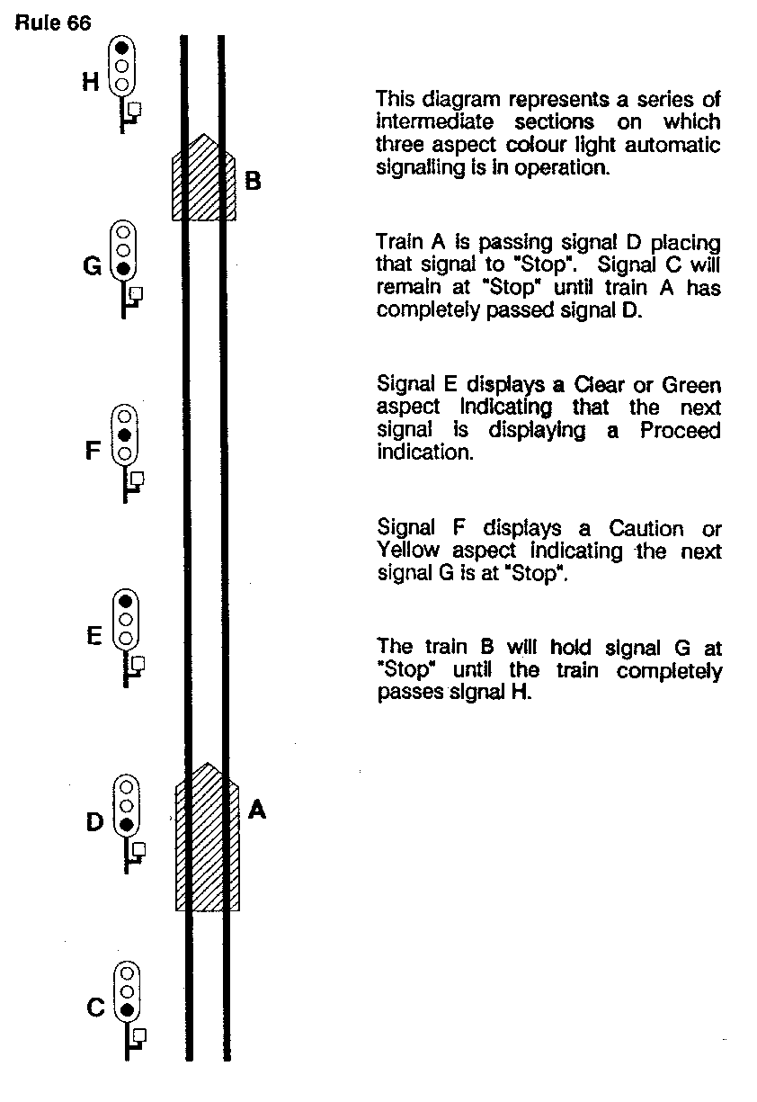
67. The signalling of trains by the automatic signalling system does not relieve any person of the obligation of using hand or detonating signals when necessary.
68. By reason of the risk of its interference with track circuits, a Driver must use sand sparingly, by applying sufficient only to provide adhesion and effective braking. Where heavy sanding is necessary the Driver must advise the Train Controller or Signal Operator.

69. OPERATION OF AUTOMATIC SIGNALLING INSTALLATIONS
(1) Automatic signalling installations may be operated by -
(a) Remote control from a central control point, by means of Centralised Traffic Control and operated by a Train Controller or Signal Operator.
(b) Remote control from an adjacent attended station.
(c) Train crews at unattended crossing stations when a crossing is to be effected.
(d) An interlocked signal box.
(2) In the case of installations worked by remote control or an interlocked signal box the fixed signals are semiautomatic.

70. REPORTS OF FAILURES AND IRREGULARITIES
In the event of any failure or irregularities in the working of the system every employee aware of that occurrence must report it immediately to the Train Controller or Signal Operator.

71. TELEPHONES IN AUTOMATIC SIGNALLING AREAS
Telephones may be provided adjacent to automatic and semi-automatic signals.

72. TRAINS NOT TO MOVE IN THE WRONG DIRECTION
The Driver must not cause or permit a train in automatic signalling territory to set back or otherwise move in the wrong direction in any circumstance other than those set out in rules 75, 133, 134, 187, 192 and 256 of these rules and then only in conformity with those rules.

73. RESERVED

74. RESERVED

75. ELECTRIC SWITCHLOCKS
(1) On single and double line sections in automatic signalling territory, the points leading to intermediate sidings are controlled by electric switchlocks.
(2) The switchlock contains an indicator which indicates the condition of the lock, and a small handle to lock the points. It is provided with a door which is normally kept closed and locked with a standard padlock.
(3) Small white posts marked “A”, “B” and “C” are provided alongside the line in the vicinity of the points to indicate the limits of the track circuits. (see diagram next page).
(4) Where it is necessary to release an electric switchlock, so that a siding can be shunted, the Driver must stop the train with the leading vehicle of that portion of the train to be left on the main line standing on the track circuit opposite the siding, but clear of the points through which the shunt is to be made; that is; on the approach side of post “C”; the rear wheels of the locomotive or last vehicle which is being shunted, after it has moved forward, must stand on the short track circuit immediately beyond the points, between posts “A” and “B”; and the Drivers Assistant, must then open the electric switchlock door and turn the small handle completely over to the left; the points may then be operated as required by means of the points lever.
(5) When the small handle has been turned to the left it must not be turned again until -
(a) shunting has been completed;
(b) the points have been reset for the main line; and
(c) the points lever has been secured by padlock;
and when the operations mentioned in paragraphs (a), (b) and (c) of this sub-rule have been completed, the Drivers Assistant, must turn the small handle in the switchlock completely over to the right, to its normal position, close and lock the door with the standard padlock, and advise the Train Controller or Signal Operator.
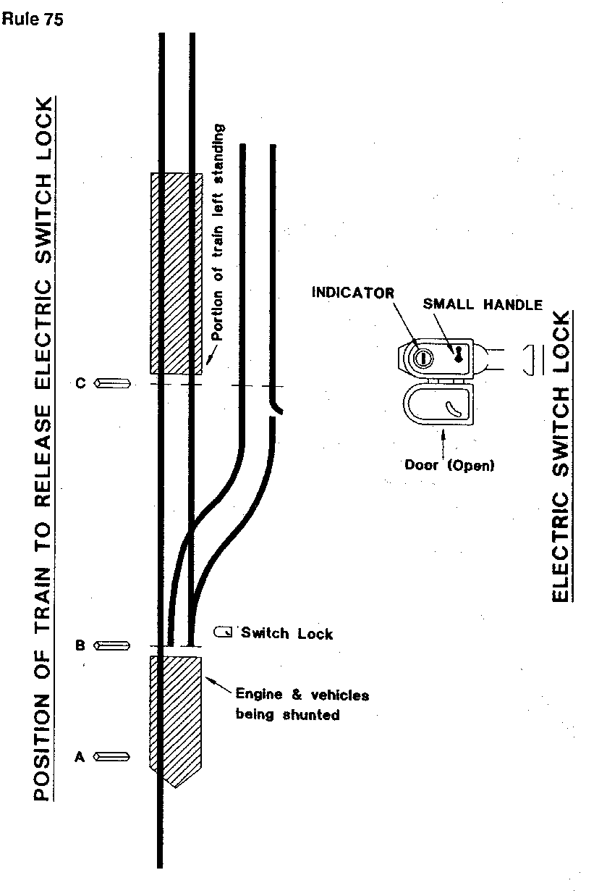
(6) On some types of switchlocks, the hasp for securing the door must be screwed up to ensure the door is tightly closed. If the door is not tightly closed the signal in the rear of the siding will be held in the Stop position and following trains will be delayed.
(7) Where it is required to shunt a train clear of the main line, the Driver must move the whole of the train forward so that the rear wheels of the last vehicle stand on the short track circuit, between posts “A” and “B” and, the Drivers Assistant, must -
(a) operate the switchlock, as provided by sub-rule (4) of this rule.
(b) when the whole of the train is clear of the main line, and well clear of the fouling point as indicated by post “C", restore the points and switchlocks to normal and advise the Train Controller; and
(c) before leaving the area, satisfy himself that all is clear and that it is safe for another train to pass.
(8) Where a train which has been placed in the siding, in accordance with sub-rule (7) of this rule, is required to resume its journey, the Drivers Assistant, must -
(a) obtain permission from the Train Controller before opening the switchlock door.
(b) observe the indicator in the electric switchlock, and, if it shows “free", must unlock and set the points in the prescribed manner, and hand signal the train onto the main line; and
(c) when the train is on the main line, restore the points and switchlock to normal, after which the train may proceed on its journey.
(9) On a section worked by Centralised Traffic Control, and at interlocked stations, when the switchlocks are controlled by the Train Controller or Signal Operator, the person in charge of shunting must request the person in control to release the switchlock when a shunt is required to be made, and advise that person immediately upon the restoration of the points and switchlock to normal. Local instructions apply to the operation of these switchlocks.
(10) Where it is necessary, on a single line, for a train to leave a station, shunt an intermediate switchlocked siding, and return to that station, the Driver before returning, must place the whole of the train in the siding, leaving the main line completely clear; and the Drivers Assistant, must then -
(a) restore the points to normal and properly close the door of the switchlock (this must be done to prove that a following train has not entered the section from the station in the rear); and
(b) when a train is ready to depart on its return journey, operate the switchlock as required by sub-rule (8) of this rule.
[Rule 75 amended in Gazette 23 February 1996 p.682.]

76. WORKING OF UNATTENDED CROSSING STATIONS
(1) The diagrams on the following pages show typical layouts of unattended crossing stations; Fig A being a station with loop only and Fig B being a station with loop and siding.
(2) The facing points at each end of the crossing loop are controlled by a Facing Point Lock Spring Switch Machine which enables the points to be operated in the facing direction by hand lever attached to the machine, while the points may be trailed through for moves from the loop.
(3) The hand lever for operating the points is secured by a standard padlock.
(4) The normal setting of the points is for the main line movements with the hand lever locked in that position.
(5) Where it is necessary for a train to enter the loop, the Driver’s Assistant or qualified employee must set and lock the points for the loop. When the whole of the train has entered the loop inside the opposing Departure signal the points must be reset and locked for the main line.
(6) Two Departure Signal releasing switches, one for the main line and one for the loop are provided in a locked box at each end of the loop adjacent to the loop Departure signal. (see diagram on following page).
(7) A Departure Signal cancel plunger which is locked by a standard padlock, is provided in the Safeworking Annexe at each end of the crossing loop.
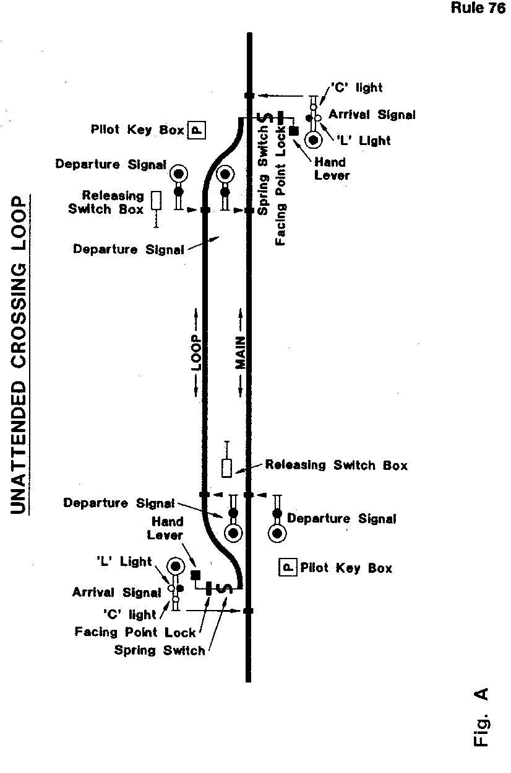
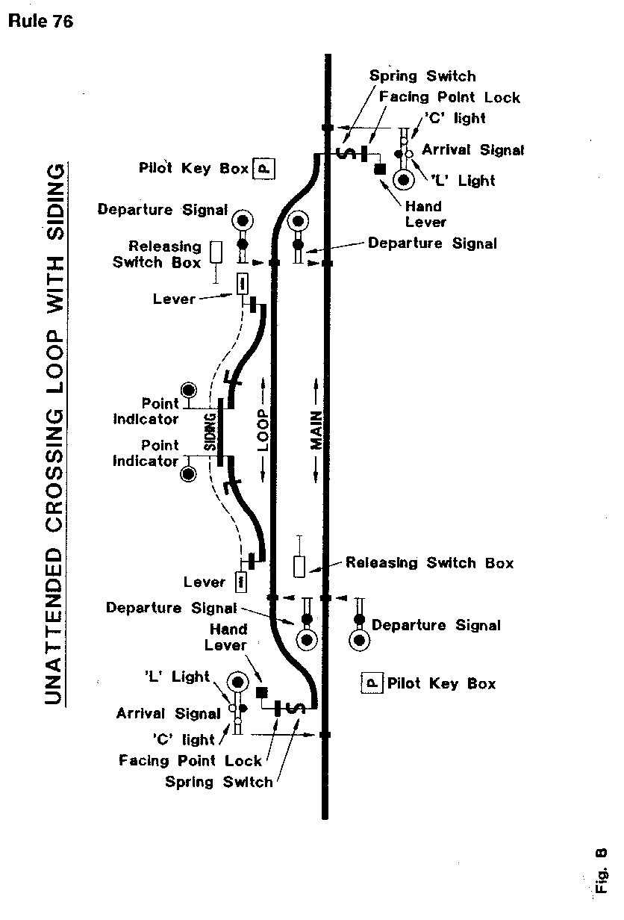
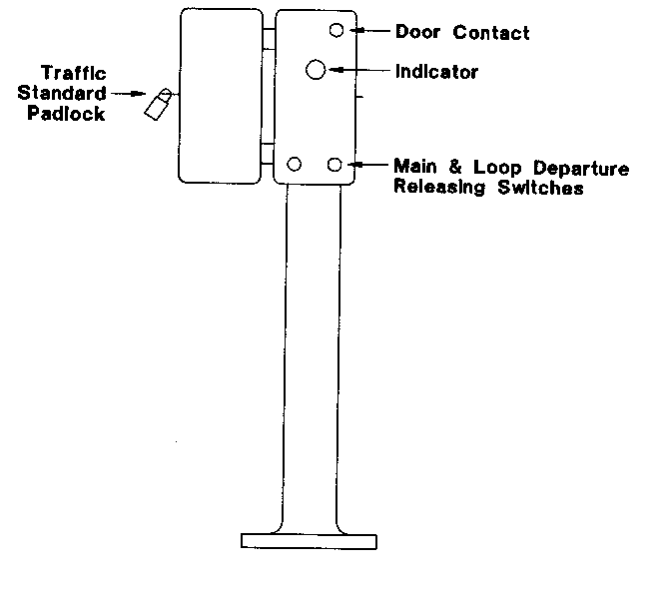
RELEASING-SWITCH BOX
(8) If for any reason it is not possible for a train to depart when the Departure Signal is at Proceed, the Driver must inform the Train Controller. If it is found necessary, the Train Controller will advise the Driver to operate the Departure Signal cancel plunger.
(9) The Departure Signal cancel plunger must only be operated on permission from the Train Controller.
(10) Reserved.
(11) Where two trains are approaching an unattended crossing station from opposite directions at the same time the intermediate signal in rear of the arrival signal will be at Caution although the Arrival Signal may be at Caution or Stop.
(12) When the intermediate signal in the rear of the Arrival Signal is at Caution it indicates that the Arrival Signal is at Stop or that a train is approaching the crossing station from the opposite direction.
(13) The Arrival Signal will be at Caution until the train approaching from the opposite direction has reached a point two to three kilometres from the loop facing points, when the signal will go to Stop.
(14) Where the Arrival Signal is at Stop the Driver must act in accordance with Rule 29 of these Rules.
(15) Where two trains are to cross at an unattended crossing station, the trains must enter the main line or loop as directed by the Train Controller.
(16) When a train which is scheduled to cross another at an unattended crossing station, arrives before the train from the opposite end, it may be found that the Arrival and Departure Signals are at Proceed, in which case the Driver of the first train to arrive must not proceed unless the Train Controller issues an Advice to Driver of Alteration to Scheduled Crossing (Form SW 6) to effect the crossing at a station in advance.
(17) Where a crossing is to be effected and the first train to arrive is required to enter on the main line —
(a) the Driver of that train may enter the main line as far as the Departure Signal, but if the Arrival signal is at Stop the Driver must act in accordance with Rule 29 (7) and (8).
(b) when the train has stopped on the main, the Drivers Assistant or qualified employee must set and lock the points for the opposing train to enter the loop. This action will place the Departure Signal to stop and allow the opposing Departure Signal at the crossing station in advance to exhibit a Proceed indication, if the opposing train has not already left that station.
(c) When the points have been set for the loop the Driver of the opposing train must take the train into the loop.
(d) when the last vehicle has passed inside the loop Departure Signal, the Driver’s Assistant or qualified employee of the train on the main line must reset and lock the points for the main line.
(18) Where a crossing is to be effected and the first train to arrive is to take the loop —
(a) The Driver’s Assistant or qualified employee must set and lock the points for the loop; and
(b) When the “L” and “C” lights are illuminated the Driver must take the train past the Arrival Signal at Stop and enter the loop; and.
(c) When the last vehicle of the train has passed inside the loop Departure Signal, the points must be reset and locked for the main line. This will put the Arrival Signal at Proceed for the opposing train.
(19) RESERVED
(20) A train may be sidetracked at an unattended crossing station for another train to pass, as directed by the Train Controller.
(21) The normal position of a Departure Signal is at Stop.
(22) When a train is standing on the main line at an unattended crossing station, the Departure Signal exhibits a Proceed indication if —
(a) a train is not approaching from the station in advance, and
(b) a train travelling away from the station has cleared the first track section ahead of the Departure Signal, and
(c) the trailing points are in the normal main line position.
(23) When a train is to be despatched from the loop the Departure Signal will be at Stop.
(24) An indicator is provided in the releasing switch box which exhibits a white light when the Departure Signal can be placed at Proceed. When the white light is not illuminated it indicates —
(a) an opposing train is approaching, or
(b) a train travelling in the same direction still occupies the first track section in advance, or
(c) a train approaching from the rear is sufficiently close to the crossing station to place the main line departure signal at Proceed.
(25) Where the indicator is showing a white light the Drivers Assistant or qualified employee must push in the releasing switch for the loop Departure Signal. This will place the signal at Proceed.
(26) If there is no white light exhibited the Train Controller must be contacted immediately.
(27) Because of the provision of Facing Point Lock Spring Switch Machines attached to the loop facing points, trains departing from the loop are permitted to trail through the points to the main line. When the last vehicle of the train has passed through the points they automatically restore for the main line.
(28) If for any reason a train departing from the loop is stopped before the train is clear of the trailable points, the Driver’s Assistant or qualified employee must immediately set and lock the points for the loop before any set back move is undertaken.
(29) The crossing and passing of trains on single line automatic signalling sections between Koolyanobbing and West Kalgoorlie must be effected at the places shown in the Working Time Table or the Special Train Notice Telegram issued from time to time; these are termed “scheduled crossings” and a person must not alter a scheduled crossing or passing place, until an “Advice to Drivers of Alterations to Scheduled Crossing” (Form S.W. 6) has been issued by the Train Controller and has been received by the Driver to whom it is addressed, or by the Signal Operator at West Merredin for down trains or West Kalgoorlie for up trains, in cases where the opposing train has not at that time entered the West Merredin to West Kalgoorlie control area. The information must be repeated back to the Train Controller by the recipient.
(30) The possession of Advice to Drivers of Alteration to Scheduled Crossing does not authorise a Driver to pass a Departure Signal at Stop.
(31) Each Driver must show Form S.W. 6 to the Driver’s Assistant and when two locomotives are attached to the train, the leading Driver must make out the Form S.W. 6 and advise the rear Driver of the altered arrangements.
(32) The Train Controller must not issue Form S.W. 6 to the Driver whose crossing is to be advanced until the Train Controller is aware that the Driver of the opposing train or the Signal Operator at West Merredin or West Kalgoorlie has been issued with a Form S.W. 6 in accordance with Rule 76 (29) and the information repeated back.
(33) Where a form S.W. 6 is issued to the Signal Operator at West Merredin or West Kalgoorlie, in accordance with Rule 76 (29), the Signal Operator must not permit a train for which a Form S.W. 6 has been accepted, to depart from West Merredin or West Kalgoorlie until the Signal Operator has ensured that the Driver is in possession of the original of the Form S.W. 6, and that the Driver’s signature, the time and the date have been endorsed on the bottom of a copy of the Form S.W. 6 (which is to be retained by the Signal Operator for record purposes). If a Signal Operator is relieved for any reason prior to the issue of any current Form S.W. 6 to the Driver, the incoming Signal Operator must initial, and record the time and date of transfer, on all current Forms S.W. 6 still to be issued.
(34) Form S.W. 6 remains in force only until fulfilled, or superseded by a further Form S.W. 6 and when the Form has been fulfilled, the person to whom it was issued must, at once, write the word “fulfilled” across the face of the form and attach it to the Train Journal.
[Rule 76 amended in Gazette 19 September 1997 p. 5292.]
DIVISION 3
TRAIN ORDER SYSTEM

77. DECLARATION OF TRAIN ORDER TERRITORY
(1) The Head of the Operations Branch may declare in writing that a line of railway, or a portion of a line of railway described in the declaration, is train order territory and in that declaration shall state —
(a) that the system of train orders applies to and with respect to the control of train movements in that territory;
(b) the day from which the line or portion of line is to be train order territory (which shall be later in time than the day on which the declaration is published in the Weekly Notice or Special Train Notice telegram in accordance with sub-rule (2)); and
(c) that the line of railway or portion of line shall be train order territory, only until —
(i) the time specified in the declaration; or
(ii) a declaration is made stating that the line or portion of line is no longer train order territory.
(2) A declaration made under sub-rule (1) shall be published in the weekly notice or by Special Train Notice telegram.
(3) A Train Controller is responsible for the issue of Train Orders in such areas of Train Order Territory as specified by the Head of the Operations Branch by written notice to that Train Controller.

78. OBJECT OF THE TRAIN ORDER SYSTEM
(1) Under Train Order Working in Train Order Territory the movement of all trains is governed by Train Orders, authorised by the Train Controller.
(2) The object of the Train Order System is to prevent more than one train being between any two authorised crossing or non-crossing stations at the same time, and to permit the Train Controller for that portion of line to adjust crossings and passings as required.
(3) This is accomplished by the Train Controller.
(a) in the case of following trains ensuring that the preceding train has arrived complete at the end of a Train Order section before a Train Order is issued for a following train.
(b) in the case of opposing trains, not issuing a Train Order for a train to advance into a Train Order section unless the opposing train holds a Train Order which shows the same crossing station for both trains.
(4) A train is not permitted to proceed outside the station limits boards at a train order station unless the Driver is in possession of a train order for the section concerned.

79. ABBREVIATIONS
The following are the only abbreviations which may be used in the issue of Train Orders.
No. for number
LE for light engine
LOCO for locomotive
RC for railcar
PASSGR for passenger
MINS for minutes
KM for kilometre
TM for on-track machine

80. ISSUE OF TRAIN ORDERS BY THE TRAIN CONTROLLER
Train Orders shall be issued by the Train Controller when: —
(a) a train or track machine is to enter a Train Order section or sections.
(b) an unfulfilled Train Order is cancelled by the Train Controller.
(c) the District Engineer requires closure of a section of line.

81. INFORMATION AND INSTRUCTIONS RELATIVE TO THE ISSUE OF TRAIN ORDERS
(1) Train Orders shall contain information or instructions only essential to train movements.
(2) They shall be brief, in the prescribed form and without erasure, alteration or additions written between lines and once issued no information is permitted to be added or deleted except as provided in these Rules.
(3) Letters, words and numerals in Train Orders shall not be surrounded by brackets, circles or other characters.
(4) Approved means of communicating train orders are direct verbal, written, telephone, telex, radio, or through the computer network.
(5) Train Orders will be prepared and issued only by the Train Controller on the prescribed form (SW 17). They will be prepared and issued in order with consecutive serial numbers and can be received only by drivers or at attended stations by qualified employees.
(6) Where there is more than one Driver working a train each Driver shall receive a copy of the Train Order.
(7) A Train Order to be sent to two Drivers shall be transmitted simultaneously to each if practicable.
(8) Trains shall be designated in Train Orders by the train number shown in the Working Timetables or on Special Train Notice Telegrams.
(9) Trains shall be identified in Train Orders by the individual number of the locomotive or railcar being shown on the Train Order.
(10) Where there is more than one locomotive or railcar attached to a train, the leading number only must be shown on the Train Order.
(11) On-track machines shall be identified by the individual number of each track machine.
(12) Train Orders may be issued for travel over an unlimited number of train order sections and, except in the case of on-track machines and a relief locomotive clearing a disabled train from the section, in one direction only.
(13) Train Orders may be issued through and beyond Superior Train Order stations provided such station is within the control of the same Train Controller.
(14) A person to whom a Train Order has been issued and who has received that order shall obey that order.

82. TRAIN WORKING ADVICE
(1) The Train Controller responsible for an area must issue a Train Working Advice on Form S.W.19 to the Driver of each train originating in or entering that area.
(2) Each advice shall include for that Train Controller’s area particulars of any preceding trains which have not terminated, the next following train, and all opposing trains which will operate for the period the train is in that Train Control area.
(3) Details of track machines stabled and locomotives, or trains with locomotives attached, stabled or loading or unloading at an unattended train order crossing station must be shown on the Train Working Advice.
(4) At attended stations, the qualified employee shall obtain the information from the Train Controller.
(5) Where trains originate from an unattended station the Driver shall obtain the information from the Train Controller.

83. PREPARATION OF TRAIN ORDERS BY TRAIN CONTROLLER
(1) Train Orders shall be addressed to those who are to execute them naming the Train Order station or location where they are to be received.
(2) Train Orders for a train or on-track machine shall be addressed to the Driver or employee in charge by name.
(3) The individual identifying number of the leading locomotive or railcar on each train and all on-track machines to be crossed or passed must be shown.
(4) Where the leading locomotive or railcar is attached to or detached from a train enroute the Train Controller must at once be informed. The Train Controller must cancel the existing Train Order for that train, and for any trains travelling on Train Orders which include a crossing or passing with that train, and issue further Train Orders showing the changed locomotive or railcar number.
(5) Train Orders shall be prepared on the prescribed form (SW17) prior to transmission and never from memory or memoranda.

84. TRANSMISSION OF TRAIN ORDERS BY TRAIN CONTROLLER AND REPEATING BACK BY RECIPIENT
(1) In transmitting Train Orders the Train Controller shall state the number of copies required including the original and communicate the serial number of the train order.
(2) Names of stations, or locations, shall first be plainly pronounced and then spelled letter for letter (As an example MOORA becomes - M-O-O-R-A) and shall be printed in block capital letters.
(3) All numbers shall first be plainly pronounced and then spoken numeral for numeral. As an example train 5203 becomes - FIVE-TWO-ZERO-THREE, and the recipient shall repeat the train order in the same manner.
(4) The Train Controller shall acknowledge and underline the Train Order word for word, station or location names letter for letter, and numeral for numeral, as it is being repeated back by the recipient.
(5) When a Train Order has been issued simultaneously to two Drivers as provided for in Rule 81 sub-rule 7, the Train Controller shall acknowledge and underline the Train Order word for word, station or location names letter for letter and numeral for numeral twice to denote the repetition by each Driver.
(6) When the response has been received the Train Controller shall reply “complete", fill in the transmission details and then endorse “complete” on the Train Order Form S.W.17.
(7) In no circumstances is it permissible for a Train Order to be re-written by the recipient after its issue by the Train Controller.

85. RECEIPT OF TRAIN ORDERS AND REPEATING BACK TO TRAIN CONTROLLER
(1) Qualified employees and Drivers receiving Train Orders shall prepare the required number of copies at the one time during transmission using the prescribed form (SW 18).
(2) Copies shall be distributed as follows: —
(a) When received by a qualified employee the original to the Driver; next copy to the Driver of the Assistant Locomotive, where applicable, with the last copy retained and filed in the office in which it was received.
(b) When received by a Driver the original is used as the section authority. Where there is an assistant locomotive a copy is to be handed to this Driver but only where both locomotives and Train Controller are not in radio contact. When in radio contact both Drivers receive the Train Order simultaneously (Rule 81 sub-rule 7).
(3) Train Orders shall be immediately repeated back to the Train Controller by the qualified employee or Driver receiving them.
(4) Once the Driver has received the Train Order, either from a qualified employee or direct from the Train Controller, the Driver must show the Train Order to the Drivers Assistant.
(5) The Drivers Assistant must peruse the contents and when fully understood must sign the Train Order (SW 18) in the space provided.

86. RECEIPT OF TRAIN ORDERS AT ATTENDED AND UNATTENDED STATIONS AND AT LOCATIONS ENROUTE
(1) At attended Train Order stations the qualified employee shall receive Train Orders from the Train Controller.
(2) At unattended Train Order stations the Driver shall receive the Train Orders from the Train Controller.
(3) At locations enroute, the Driver shall receive the Train Orders from the Train Controller. In this instance the Train Controller and Driver must be in direct radio contact and the location will be identified as that kilometreage marker within the Train Order section where transmission of the Train Order first commenced.
(4) When it is necessary to cancel a Train Order partly fulfilled and issue a further Train Order the Driver concerned shall receive the further Train Order direct from the Train Controller and not via a qualified employee.
(5) A Train Order once in effect continues so until either “fulfilled” or “cancelled”.

87. CANCELLATION OF INCORRECTLY PREPARED TRAIN ORDERS
(1) In the event of a Train Order (SW 17) being incorrectly prepared by the Train Controller, this Train Order shall have the word “Cancelled” printed across the face in block letters.
(2) In the event of a Train Order (SW 18) being incorrectly prepared by the recipient this Train Order shall have the word “Cancelled” printed across the face of each copy in block letters and the Train Controller advised when this has been done.
(3) All “Cancelled” Train Orders must be forwarded to the Area Manager promptly.

88. CHECK OF CROSSINGS WITH TRAIN CONTROLLER
(1) After a Train Order which includes a crossing has been repeated back and the Train Controller has acknowledged the correctness of the repetition the qualified employee or the Driver, as the case may be, shall —
(a) obtain advice from the Train Controller as to the whereabouts of the opposing train or trains.
(b) ascertain whether the opposing train or trains have been issued with a Train Order for the intended crossings.
(c) request the Train Controller to check on the stations where crossings are to be effected by repeating the particulars of the Train Orders issued to the opposing train or trains.
(d) if an opposing train has not been issued with a train order including that crossing, request the Train Controller to issue a train order to the Driver of that train with the crossing included as soon as is practicable.
(2) The Train Controller and the recipient must endorse details of information given on the bottom portion of the Train Order. It shall not be necessary for the qualified employee or Driver to prepare a copy of the Train Order issued to the opposing train or trains.
(3) When a Train Order which does not show a crossing is received, the qualified employee or Driver receiving the Train Order shall check with the Train Controller to confirm that no train is to be crossed.

89. DRIVER TO REPORT
(1) The Train Controller shall include in the Train Order any instructions for the Driver to report at such places as are necessary for train working, and, subject to Rule 89 (3), the Driver shall report promptly from those locations.
(2) After the issue of a Train Order, the Train Controller may request a Driver to report at locations in addition to the report locations specified on the Train Order issued, and , subject to rule 89 (3), the Driver shall report promptly from those locations.
(3) When a Driver has been directed to report from a location in accordance with rule 89 (1) or 89 (2) and —
(a) on arrival at the location, the Driver is unable to report to Train Control due to failure of the communications equipment; and
(b) the Driver is in possession of a Train Order to proceed beyond that location,
the Driver may allow the train to proceed in accordance with the Train Order issued and the Driver shall report to Train Control at the first location where operating communications equipment is available.
(4) Before reporting to the Train Controller, the Driver must determine that no unaccounted brake reduction has occurred or other sign on the brake gauges is evident which indicates the train is not complete, and so advise the Train Controller.
[Rule 89 amended in Gazette 19 September 1997 pp.5292-3.]

90. DELIVERY OF TRAIN ORDERS TO DRIVERS
(1) The qualified employee who receives a train order shall ensure it is delivered to the Driver at the earliest opportunity.
(2) At attended Train Order Stations, if the qualified employee who receives Train Orders from the Train Controller for delivery is relieved before delivering the Train Orders to the Drivers concerned the qualified employee shall enter details of the undelivered Train Orders in the hand over book and draw the attention of the incoming employee specially to the undelivered Train Orders.
(3) The incoming qualified employee must acknowledge receipt of the undelivered Train Orders by signing each entry.

91. UNDERSTANDING OF TRAIN ORDERS BEFORE PROCEEDING
(1) A Driver, upon receiving a Train Order, shall not proceed into the Train Order section unless such Train Order is thoroughly understood both by the Driver and the Drivers Assistant (Rule 85 sub-rule 4).
(2) When a Driver is relieved before the completion of a trip the Relief Driver shall not proceed further until any unfulfilled Train Orders are thoroughly understood both by the Relief Driver and the Relief Drivers Assistant.
(3) When satisfied as to the content of the unfulfilled Train Orders both the Relief Driver and the Relief Drivers Assistant must sign the Train Order (SW 18) in the spaces provided.
(4) When a Driver is relieved before the completion of a trip the Train Controller must endorse this fact on the Train Controller’s copy of the relevant Train Order together with the name of the Relief Driver.

92. TRAIN ORDERS FULFILLED AND UNFULFILLED
(1) The Driver must advise the Train Controller when the Train Order has been fulfilled. When a Train Order has been fulfilled the Driver and Train Controller, shall print ‘FULFILLED’, across the face of their respective forms and the Driver attach it to the running statement.
(2) Before advising the Train Controller that a Train Order has been fulfilled, the Driver must determine that no unaccounted brake reduction has occurred or other sign on the brake gauges is evident which indicates the train is not complete.
(3) When it is necessary for the Train Controller to issue a further Train Order in lieu of one previously issued and partly fulfilled the Train Controller and the Driver of each train involved shall print on their original Train Order the words ‘CANCELLED AT OR BEYOND.......’ in block letters.
(4) The Train Controller will then issue a further Train Order to take account of the altered circumstances.
(5) At the completion of each Train Control shift the details of all unfulfilled Train Orders shall be entered in the Train Controllers hand over book by the outgoing Train Controller prior to ceasing duty.
(6) Signatures must be exchanged by the outgoing and incoming Train Controllers as an assurance that full particulars are passed one to the other.

93. CROSSINGS OR PASSINGS ON TRAIN ORDERS
(1) A Train Order shall specify the crossings and passings with other trains but not more than one intermediate crossing or passing shall be shown on a Train Order and not more than one other train shall be involved in that crossing or passing.
(2) If trains are to be crossed or passed at the station at which the Train Order becomes fulfilled those crossings and passings shall also be shown, but crossings and passings at a Superior Train Order station at which the Train Order becomes fulfilled are not to be shown on the Train Order.
(3) A train shall not leave a station at which a crossing has been arranged until the opposing train has arrived complete or the Driver has received a further Train Order from the Train Controller authorising the Driver to do so.
(4) When it is necessary to cancel a partly fulfilled Train Order which includes a crossing and issue a further Train Order, the Train Controller shall not allow a train to proceed beyond the crossing station shown on the original Train Order until the opposing train has been issued with a Train Order for the altered crossing arrangements.
(5) When more than one train proceeding in the same direction is required to cross an opposing train or trains at the same Train Order Crossing station, the Train Controller shall show all trains involved in the crossing on the Train Orders.
(6) At Superior Train Order stations and at attended Train Order crossing stations the qualified employee on duty will arrange the working of trains at that station.
(7) No train may enter an attended train order crossing station until signalled to do so from the facing points by the qualified employee on duty.

94. WORKING OF TRAINS AT UNATTENDED TRAIN ORDER CROSSING STATIONS
(1) Reflectorised indicator boards (figure 58) are located at the approaches to Train Order Crossing stations at a distance of not less than 550 metres from the station limits boards.
(2) Station limits boards are placed at a distance of not less than 50 metres from the outermost set of points fitted with a point indicator.
(3) Where the train order held by the Driver becomes fulfilled at an unattended train order crossing station the Driver shall, after ensuring all is clear in accordance with rule 36(4) of these rules, take the train into the station and after coming to a stand report to the Train Controller for receipt of a further train order. If no crossing, passing or shunting is to take place the train shall enter the station on the main line.
(4) Where the train is not required to stop for the issue of a further Train Order or for any other reason, the Driver shall proceed at authorised speed.
(5) If it is necessary for a train to run in advance of another train and then be bypassed at this type of station this shall be shown on the Train Orders held by each train.
(6) When a crossing or passing is to be made at an unattended train order crossing station, the Train Controller must instruct each Driver on the train orders as to which train must be admitted to the main line and which train to the loop.
(7) If the first train to arrive at an unattended train order crossing station is to be admitted to the loop —
(a) the Driver of such train must after ensuring it is safe to do so pass the Station Limits Board and stop at the facing points.
(b) The Driver’s Assistant or qualified employee, if all is clear and no other train is entering the main line or loop from the other end, must set and lock the points for the loop and hand signal the train into the loop.
(c) The Driver must then move the train into the loop and stop clear of the fouling point at the other end of the loop.
(d) When in clear of the fouling point, the Driver’s Assistant or qualified employee must unless self restoring points are installed reset and lock the points for the main line and rejoin the train.
(e) On arrival of the opposing or passing train the Driver’s Assistant or qualified employee of the train in the loop must hand signal the opposing or passing train into the main line after ensuring the points are correctly set.
(f) After the opposing train has arrived complete and in clear on the main line or the passing train has arrived at the Train Order station ahead the Driver’s Assistant or qualified employee of the train in the loop must, provided the Driver is in possession of a Train Order to proceed into the section ahead, set the points from the loop to main line and hand signal the train from the loop.
(g) The driver must then take the train into the section until clear of the points.
(h) The Driver’s Assistant or qualified employee must unless self restoring points are installed reset and lock the points for the main line and rejoin the train which will continue as directed on the Train Order.
(8) If the first train to arrive at an unattended train order crossing station is admitted to the main line to cross an opposing train —
(a) the Drivers Assistant or qualified employee of the train on the main line must immediately set the facing points for the opposing train to enter the loop and exhibit the hand signal in accordance with rule 37 of these rules;
(b) after the opposing train has arrived in the loop clear of the fouling point the Drivers Assistant or qualified employee of the train on the main line must, unless self-restoring points are installed, reset and lock the points for the main line; and
(c) the Drivers Assistant or qualified employee of the train on the loop must operate the points for the departure of the train on the loop, in accordance with sub-rule 7 of this rule.
(9) If the trains which are to cross at an unattended train order crossing station arrive at or about the same time, both trains must be brought to a stand at the facing points and the train which is to arrive on the loop must be admitted before the opposing train is admitted to the main line.
(10) At an unattended train order crossing station a Driver not in possession of a train order must not permit a train to foul the main line unless granted permission by the Train Controller and —
(a) the Train Controller may only give such permission when no conflicting train movements have been authorised and must not authorise any conflicting train movements until the main line is again clear;
(b) the Driver or Drivers Assistant must notify the Train Controller when the main line is again clear; and
(c) the Train Controller must endorse the train control diagram when permission has been given to foul the main line and when it is again clear.

95. WORKING OF TRAINS AT TRAIN ORDER NON-CROSSING STATIONS
(1) Train Order non-crossing stations are purely to facilitate the movement of following trains. Reflectorised indicator boards (figure 58) are located 550m from the Station Limits Boards.
(2) Station Limits Boards are provided at these stations solely to indicate station limits. No facilities exist at these stations to pass, cross or runround.
(3) Where the Train Order held by the Driver terminates at a Train Order non-crossing station the Driver shall, after proceeding into the station, bring the train to a stand with the last vehicle in clear of the station limits boards and report to the Train Controller for receipt of a further Train Order.
(4) Where the train is not required to stop for the issue of a further Train Order or for any other reason, the Driver shall proceed at authorised speed.

96. WORKING OF BALLAST AND WORK TRAINS
(1) When a ballast or other work train is required to work in Train Order Territory, the Train Controller shall issue a Train Order authorising the movement of the train into the section or sections concerned and the Train Order shall contain instructions as to the time and to which station the train must go in order to clear the section.
(2) Until the Train Controller has received advice that the ballast or work train has arrived complete at the nominated station and the Train Order has been fulfilled or cancelled a further Train Order must not be issued for that section or sections.

97. RECORD OF TRAIN RUNNING
(1) Where a train is in radio contact with the Train Controller, the Driver shall arrange to supply the times of the train through Train Order crossing and non-crossing stations as they occur.
(2) Where a train is not in radio contact with the Train Controller, the Driver’s Assistant shall record the times of the train through the crossing and non-crossing stations and supply these times as directed by the Train Controller.
(3) If a train loses time in a section the Driver shall report to the Train Controller at the first opportunity.
(4) The reporting of trains in accordance with this rule does not authorise the Train Controller to assume a section is clear for a following train and the provisions of rule 89 or rule 92 of these rules must be observed before a further Train Order can be issued.

98. MOVEMENT OF ON-TRACK MACHINES
(1) When one or more On-Track Machines are required to travel through a section, the qualified employee in charge of the machines shall obtain a Train Order for the movement.
(2) If the on-track machines are departing from an attended Train Order station, the Station Officer or qualified employee shall obtain the Train Order for delivery to the employee in charge of the machines.
(3) If it is necessary for on-track machines to cross a train or trains at an unattended Train Order crossing station, the Train Order will show the train or trains to be crossed and whether the machines must take the main line or loop for the crossing.
(4) The employee in charge of the on-track machines shall after obtaining the Train Order, place the machines on track and proceed on the leading machine to the destination shown on the Train Order.
(5) On arrival, the employee in charge shall advise the Train Controller that all the machines have cleared the section and whether they have been stowed or off tracked.
(6) The employee in charge must then print “FULFILLED” in block letters across the Train Order and send it to the Area Manager.
(7) A train order may be issued for on-track machines to proceed to a location in a train order section and return to a train order crossing station.

99. CLOSURE OF SECTIONS
(1) When a section of line is required to be closed in accordance with Rule 256 the District Engineer will issue a telegram closing the section.
(2) On receipt of the telegram the Train Controller must immediately issue a Train Order on form SW.17 addressed to the Train Controller and endorse the Train Control Diagram “section closed”. The Train order must include the names of the stations at each end of the section that is closed to traffic and will continue in effect until the reason for closing the section has been removed and a telegram is received from the District Engineer reopening the closed section for normal traffic.
(3) On receipt of the telegram reopening the section, the Train Controller must then endorse FULFILLED in block letters across the face of the Train Order and endorse the Train Control Diagram “Section Open”. The fulfilled Train order, together with the closing and opening telegrams must be sent to the Area Manager.
(4) Whenever it is necessary to close a section of line in Train Order Territory for the purpose of carrying out works, the worksite in all cases must be protected by the utilisation of trackwork signs as described in rule 240 of these Rules.

100. TEMPORARY FAILURE OF COMMUNICATIONS
(1) When there is temporary interruption of communications between the Train Controller and stations or trains where Train Orders are to be received the qualified employee or Drivers of trains requiring the Train Order must attempt to make contact with the Train Controller through another station or train.
(2) The Train Controller may then issue the Train Order to the station or train in contact for transmission to the qualified employee or Driver requiring the Train Order, in accordance with Rule 85.
(3) The procedure set out for the issuing and repeating back of Train Orders must be carried out.

101. TOTAL FAILURE OF COMMUNICATIONS
(1) When there is a total failure of communications and a Train Order has been fulfilled, the train crew shall decide how best to contact the Train Controller. The Driver’s Assistant or the qualified employee, equipped with a book of Train Order forms (SW 18), will proceed in whichever direction is most expedient and by any means to establish contact with a Train Controller.
(2) The train must not proceed beyond the station at which the Train Order is fulfilled until a further Train Order is received authorising movement beyond that station.
(3) If the issue of Train Orders for a particular Train Order Territory is possible only with the use of on board communication facilities in the locomotive and those on board facilities are inoperative, then the locomotive may not enter that territory.

102 SIDINGS LOCKED BY ANNETT’S KEY
(1) Points giving access between sidings and the running line in Train Order territory are secured by Annett’s lock which can only be unlocked by means of an Annett’s key, and the key cannot be removed from the lock until the points have been placed in the proper position and securely locked for trains to pass upon the running line.
(2) Each locomotive operating in Train Order territory must be provided with an Annett’s key which shall be branded with the locomotive number and must be carried in a conspicuous position in the locomotive cab (so that the Driver will notice if it is missing).
(3) Upon completion of shunting a siding the Driver’s Assistant must so advise the Train Controller, and confirm that the points have been restored to normal and the Annett’s key has been returned to the locomotive. The Train Controller must endorse the control diagram “siding secured” upon confirmation from the Driver’s Assistant.
(4) Upon arrival at the Train Order station at which the Train Order is fulfilled after shunting of a siding, the Driver must —
(a) check that the Annett’s key is on the locomotive; and
(b) endorse the fulfilled Train Order “Annett’s key on locomotive;” and
(c) so advise the Train Controller who must similarly endorse the Train Controller’s copy of the Train Order.
(5) If the Annett’s key is not on the locomotive when the Train Order is fulfilled the Driver must immediately advise the Train Controller, who must —
(a) initiate action to have the missing key recovered; and
(b) if the key is not recovered before the next train is ready to proceed through the section, warn the Driver of such train of the circumstances and instruct the Driver to examine the running line points at the siding previously shunted, before passing over them.
(6) If another train is required to approach a siding which has been shunted by means of an Annett’s key, before the train order has been fulfilled in accordance with sub-rule 4 of this rule, the Driver of such train must be warned and act as laid down in sub-rule 5(b) of this rule.
(7) If an Annett’s key becomes jammed in a lock the Driver must immediately inform the Train Controller, who will advise the Maintainer and warn any train about to traverse the section in which the siding is situated in accordance with sub-rule (5)(b) of this rule.
(8) If an Annett’s key becomes lost and cannot be found the Area Manager must arrange for a replacement key to be provided and if the original Annett’s key is subsequently located it must be forwarded to the Area Manager.
(9) Additional Annett’s keys are provided at attended stations for use by on-track maintenance machines, trains that require an additional key for shunting a particular siding, or for any other reason determined by the Area Manager.
(10) The person in charge of the place where additional Annett’s keys are located must keep the keys secured under lock and key, and provide them to the employee in charge of a track machine or to a Driver’s Assistant only with the permission of the Train Controller.
(11) The additional Annett’s keys must be branded with the name of the place at which they are located, and to which they must be returned after use.
(12) The person in charge of the place where additional Annett’s keys are located must keep a record in a book reserved for the purpose of the issue and return of the Annett’s key.
(13) When an Annett’s key is used in connection with an on-track maintenance machine, the Train Controller must obtain an assurance from the employee in charge of such machine, after operating points secured by an Annett’s lock, that the key has been removed from the lock after use, and endorse the control diagram “siding secured."
(14) When it is necessary to use two Annett’s keys to shunt a particular siding the Train Controller must obtain an assurance from the Driver’s Assistant that both keys have been returned to the locomotive after completion of shunting and the Train Controller must endorse the control diagram accordingly. When the Train Order is fulfilled in these circumstances it must be endorsed “Two Annett’s keys on locomotive” after the Driver has checked that such is the case.

RULES 103 TO 109 RESERVED
PART 3
EMERGENCY WORKING
DIVISION 1
PROCEED ORDERS

110. METHOD OF ISSUING PROCEED ORDER TO PASS A DEPARTURE SIGNAL AT STOP
(1) If a Departure Signal fails to exhibit a Proceed Indication, the Signal Operator or if there is no signal operator at that station the Driver must contact the Train Controller who must ensure all the apparatus has been operated correctly.
(2) If the defect cannot be rectified immediately the Train Controller will direct what action is to be taken.
(3) Where failure of a Departure Signal has occurred when an opposing train is at or approaching the station in advance, and the Departure Signal at that station can be placed to Proceed the Train Controller may advance that opposing train through the section in accordance with these rules, as this procedure may rectify the fault.
(4) If it is inappropriate to advance the opposing train or there is not a train at or approaching the station in advance, the Area Manager may arrange to issue a Proceed Order for the train to pass the failed Departure Signal in the Stop position.
(5) Before issuing a Proceed Order for a train to pass a Departure Signal at Stop, the Area Manager must —
(a) obtain Form “A” (SW 1) from the Signal Operator, or if the station is unattended, from the Driver of the train.
(b) if the half pilot key is missing not issue a Proceed Order.
(c) ensure that there is no train movement that prevents the Departure Signal going to Proceed.
(6) Where the opposing departure signal at the opposite end of the section is controlled by a Signal Operator or Train Controller, that Signal Operator or Train Controller must submit to the Area Manager Form “B” Advice of Opposing Departure Signal (SW2).
(7) Where the opposing departure signal is at an unattended crossing station and is not controlled by a Signal Operator or Train Controller, and trains travelling in the opposite direction will travel through the section to which the failed departure signal applies —
(a) Form “C” (SW3) must be issued to the Driver of the first opposing train —
(i) that has left the last station at which the departure signal is controlled by a Signal Operator or Train Controller; or
(ii) that leaves the last station, at which the departure signal is controlled by a Signal Operator or Train Controller, before the train that required a proceed order has passed out of the section to which the failed departure signal applies; and
(b) if the train that has been issued with the Form “C” is to be by-passed by a following train, the Driver of the following train must also be issued with a Form “C", if the train for which a Proceed Order has been issued has not passed out of the section to which the failed Departure signal applies; and
(c) in these circumstances the Form “C” must be issued to the Driver of the following train before such train is permitted to by-pass the first train.
(8) Where the Signal Operator or Train Controller has forwarded Form “B” in accordance with sub-rule 6 of this rule it is not necessary to issue Form “C”.
(9) Where it is necessary to issue Form “C” to the Driver of an opposing train —
(a) the Area Manager must transmit the particulars of the Form “C” to the Driver of the opposing train;
(b) the Driver must record these particulars on Form “C” and at once repeat them back to the Area Manager, who must if they are correctly repeated back, confirm their correctness and;
(c) the Driver’s Assistant must read the Form “C” and sign it in the place provided.
(10) On receipt of Forms “A", “B” when applicable, and issue of required Forms “C” to opposing trains, the Area Manager may issue a Proceed Order on Form “D” for the Driver of the train to pass the Departure Signal in the Stop position if all requirements of this rule are complied with.
(11) Where the Area Manager issues an authority on Form “D” —
(a) The Area Manager must, where direct communication is available, transmit the particulars of the form to the Signal Operator or Driver who applied for the Proceed Order.
(b) The Signal Operator or Driver must record particulars on the Proceed Order Form “E” (SW 5) and at once repeat them back to the Area Manager who, when they are correctly repeated back, will confirm the authority.
(c) The Signal Operator must remove the original of Form “E” and hand it to the Driver and leave the counterfoil in the book, but
(d) Where the Driver has prepared the Form “E” the Driver must take the original copy of the Proceed Order and use it as the authority to pass the Departure Signal, and
(e) After the Departure Signal has been passed at Stop the Driver must immediately write the word “Cancelled” across the Form “E” and attach it to the running statement.
(12) If the Departure Signal goes to Proceed after the Proceed Order has been issued, the train must not go forward until authority has been received from the Train Controller to cancel the Proceed Order.
(13) A Proceed Order, when issued to pass a Departure Signal at Stop, applies only to that Departure Signal. If any intermediate signals are at Stop they must not be passed except as provided for in rule 31 of these Rules.
(14) If, after the passage of the first train through the section on a Proceed Order, the Departure Signal remains out of order, Pilot Key Working is to be introduced as soon as possible in accordance with Rule 116 of these Rules.
(15) Where direct communication is not possible between the Train Controller and the station requiring the Proceed Order, particulars may be relayed through a convenient station provided all requirements of this rule are complied with.
(16) All forms used in connection with the issue of a Proceed Order must be forwarded to the Operations Manager.

111. UNATTENDED CROSSING STATIONS - DEPARTURE SIGNAL FAILURE
(1) In the event of a Departure Signal failing to exhibit the Proceed indication at an unattended crossing station, the Driver must, in addition to fulfilling the requirements of Rule 110 —
(a) ascertain that the indicator in the releasing switch box is showing a white light; and
(b) operate the releasing switch for the main line or loop whichever is applicable to the line on which the train is standing.
(2) Where the releasing switch fails to operate the applicable Departure Signal, the Driver must immediately contact the Train Controller who will issue instructions on the procedure to be adopted.
(3) Where an opposing train is to be advanced in accordance with Rule 110 (3) the Drivers Assistant, or qualified employee of the train at the unattended crossing station where the Departure Signal has failed, must —
(a) press the cancel plunger for the Departure Signal and
(b) set and lock the facing points for the main or loop whichever is the clear running line for the opposing train.
(4) When a Proceed Order is required for a down train to pass a Departure Signal at “Stop” in the Koolyanobbing-West Kalgoorlie section the Area Manager when completing the lower section of Form “A” must confirm the answers to Item 2 (last opposing train) and Item 3 (next opposing train) with the Signal Operator at West Kalgoorlie and record the name of the Signal Operator at the foot of Form “A”.
DIVISION 2
PILOT KEY WORKING

112. HALF PILOT KEYS
(1) At each end of a single line automatic signalling section a half pilot key is located adjacent to the Departure Signals.
(2) A half pilotkey is housed in a polythene fronted box. To remove a half pilot key the polythene front must be broken and the key turned to “out", then withdrawn.
(3) The half pilot key works in conjunction with the Departure Signals at the end of the section where it is located. When the half pilot key is withdrawn or not turned to “in” the Departure Signals at that end will remain at Stop.
(4) In the event of a half pilot key becoming lost or damaged in such a way that it cannot be effectively inserted in the pilot key box —
(a) the employee discovering the loss or damage must advise the Area Manager and District Electrical Supervisor.
(b) the Area Manager must make special arrangements for working of traffic until such time as a new half pilot key is obtained.
(c) if a lengthy delay is likely to occur before a replacement is obtained, the Head of the Operations Branch may authorise the Maintainer to cut the half pilot key contact out of circuit to enable working under proper signal indication.

113. PILOT KEY WORKING
In the event of failure of the Departure Signal controlling the entrance to a single line automatic signalling section, Pilot Key Working must be introduced, as required by Rule 110 (14).
[Rule 113 amended in Gazette 19 September 1997 p. 5293.]

114. PILOT KEY
(1) A Pilot Key consists of two half pilot keys taken from the Pilot Key boxes located adjacent to the Departure Signals at each end of the section concerned. It is assembled by screwing the two half pilot keys together and the pilot key then shows the names of the stations at each end of the section. (See diagram on following page).
(2) Half pilot keys are arranged in such a manner that it is not possible to screw together those belonging to the Departure Signals of adjoining sections.
(3) When two half pilot keys have been screwed together, the person doing so must —
(a) examine the Pilot Key to ensure it correctly shows the names of the stations at each end of the affected section.
(b) advise the Train Controller when Pilot Key Working is instituted.
(4) A Driver must not accept a Pilot Key that is not properly screwed together or does not display the station names applicable to the affected section.

115. DRIVERS TO BE WARNED OF PILOT KEY WORKING
The Driver of every train approaching a section where Pilot Key Working has been instituted, must be given prior notification on Form SW 13 by the Signal Operator or Train Controller and the Driver must sign for this information, except when it is transmitted to the Driver by telephone or radio in which case the name of the Driver receiving the information is recorded on the issuer’s copy.

116. INSTITUTION OF PILOT KEY WORKING
(1) Where the Departure Signal, at the station where Pilot Key Working is to be instituted, has failed, the Train Controller will arrange issue of a Proceed Order for the first train to pass the Departure Signal at Stop, and the Signal Operator, or Driver if the station is unattended, must remove the half pilot key which the Driver will convey to the other end of the section.
(2) Where the Departure Signal at the station where Pilot Key Working is to be instituted will show a Proceed indication, the train must pass the Departure Signal at Proceed and when the train has passed that Signal the Signal Operator, or Driver when the station is unattended, must remove the half pilot key which the Driver will convey to the other end of the section.
(3) On arrival at the opposite end of the section, the Signal Operator or Driver if the station is unattended, must screw the half pilot key from each end of the section together, place the Pilot Key in the telephone cabinet and advise the Train Controller that Pilot Key Working has been instituted.
(4) Where it is necessary to introduce Pilot Key Working in accordance with sub-rule 1 of this rule and the Pilot Key would be at the wrong end of the section, the Train Controller may delay the introduction of Pilot Key Working to permit following trains to travel on Proceed Orders until necessary to institute Pilot Key Working.
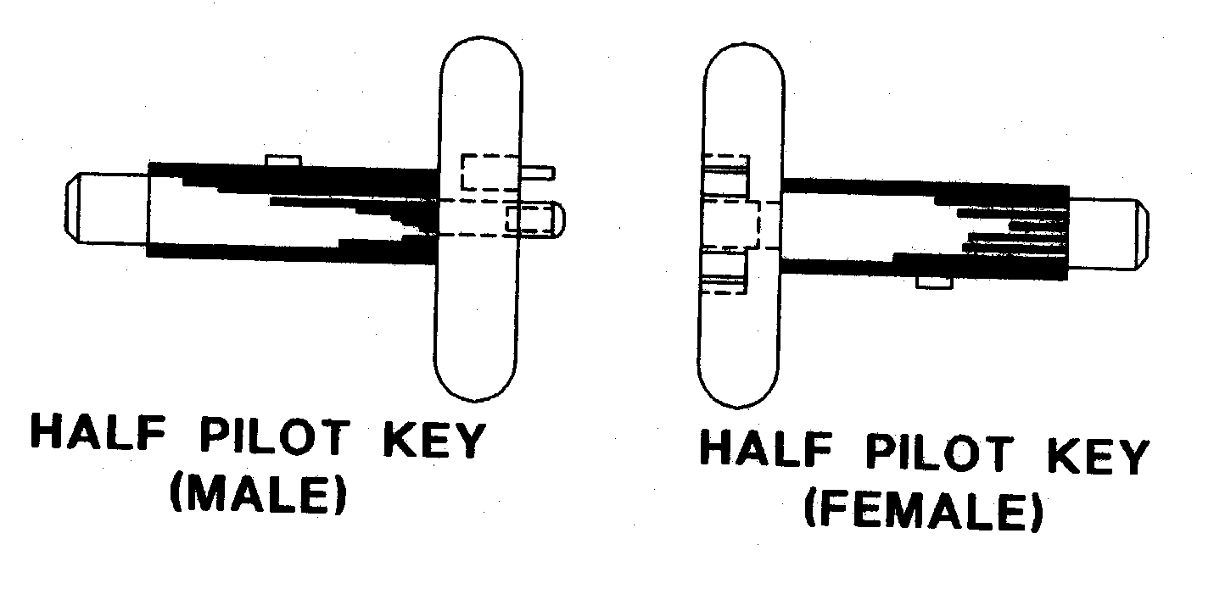
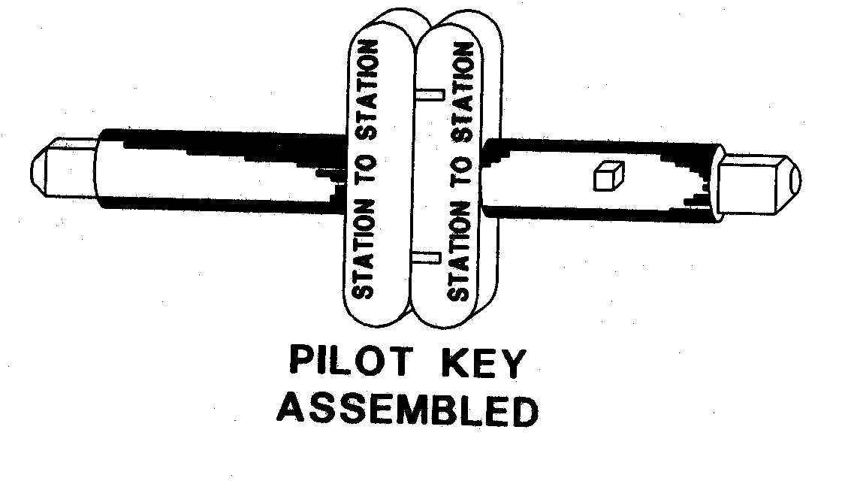

117. PILOT KEY WORKING — METHOD OF OPERATION
(1) When the two half pilot keys have been screwed together, examined and found to be correct, the Train Controller must conduct traffic as provided in this rule.
(2) A train must not be permitted to enter a section under pilot-key working conditions unless the pilot key is at the station from which the train is to enter the section and the previous train has passed completely out of the block section or, where intermediate signals are provided, the track section in advance.
(3) Except as provided by sub-rule 5 of this rule, the Driver of each train that passes into the section must be in possession of the Pilot Key.
(4) Where a train is assisted by a locomotive in the front or rear the Pilot Key must be shown to the Driver of the leading locomotive and carried by the Driver of the rearmost locomotive.
(5) When it is necessary to start two or more trains from one end of the section, before a train has to be started from the opposite end the Signal Operator must —
(a) give the Pilot Key to the Driver of the last train which is to pass over the section before a train has to be started from the other end.
(b) in the case of each train which has to pass over the section without being in possession of the Pilot Key —
(i) if there is only one locomotive on the train, show the Driver the Pilot Key and hand the Driver a Pilot Key Caution Ticket (Form SW 7) properly completed and signed; or
(ii) if there is more than one locomotive on the train, show the Pilot Key and Pilot Key Caution Ticket to the Driver of every locomotive; and after showing the Pilot Key to the Driver of the rearmost locomotive hand the Pilot Key Caution Ticket to that Driver.
(6) A Driver must not accept a Pilot Key Caution Ticket unless the Driver first sights the Pilot Key.
(7) A Pilot Key Caution Ticket applies to a single journey only, to the other end of the section, and on arrival there —
(a) the Driver must immediately give the ticket to the Signal Operator; and
(b) the Signal Operator must write the word “cancelled” across the face of it, and
(c) if the station is unattended the Driver must advise the Train Controller that the train has arrived complete, then write the word “cancelled” across the face of the ticket and attach it to the running statement; and
(d) Before reporting to the Train Controller in accordance with paragraph (c) of this sub-rule, the Driver must determine that no unaccounted brake reduction has occurred or other sign on the brake gauges is evident which indicates the train is not complete, and so advise the Train Controller.
(8) Cancelled Pilot Key Caution Tickets must be forwarded to the Area Manager after normal working has been resumed.
(9) Where, under Pilot Key Working, a train is authorised to pass a Departure Signal in the Stop position, this authority applies to the Departure Signal only, and if any intermediate signals are at stop they can only be passed as provided in Rule 31.

118. PILOT KEY NOT TO BE OVERCARRIED
(1) A Driver must not carry a Pilot Key beyond the station to which it applies.
(2) If the Pilot Key is overcarried it must be returned to the correct station under cover.

119. PILOT KEY LOST
(1) In the event of a Pilot Key becoming lost the Head of the Operations Branch may make special arrangements for working of traffic, by the temporary introduction of the Train Order System, in accordance with rule 77 of these rules.
(2) If the lost pilot key is subsequently found it must be delivered to the nearest Station Officer who will advise the Area Manager.

120. SIGNAL OPERATOR CHANGED DURING PILOT KEY WORKING
Where a Signal Operator is changed while Pilot Key Working is in force, the outgoing Signal Operator must advise the incoming Signal Operator of the arrangements in force.

121. TRAIN CONTROLLER TO BE ADVISED OF MOVEMENT OF TRAINS
The Train Controller must be informed of the arrival and departure times of every train travelling on a pilot key or pilot key caution ticket —
(a) at attended stations by the Signal Operator; or
(b) at unattended stations by the Driver.

122. RESERVED

123. CANCELLATION OF PILOT KEY WORKING
(1) When the condition which made the institution of Pilot Key Working necessary has been remedied and normal working can be resumed —
(a) the Train Controller will instruct the Signal Operator at the station where Pilot Key Working is to be cancelled, or the Driver of the train which is to resume normal working, to —
(i) unscrew the pilot key, and
(ii) place the appropriate half pilot key in the pilot key box and turn it to “IN” at that end of the section.
(b) The Driver must then take the other half pilot key to the opposite end of the section.
(2) The train that is to resume normal working must not be permitted to depart until the Departure Signal is at Proceed.
(3) When the train, that is resuming normal working, has arrived at the opposite end of the section the Signal Operator, or Driver if the station is unattended, must replace the half pilot key in the pilot key box and turn it to “IN” and report to the Train Controller. Normal working may then be resumed.
(4) In order to avoid delays to trains, and if convenient, after the condition which made pilot key working necessary has been remedied, the Train Controller may instruct the Maintainer to replace the half pilot keys in their respective boxes and turn them to “IN”.
DIVISION 3
PILOTWORKING
DOUBLE LINE AUTOMATIC SIGNALLING

124. PILOTWORKING TO BE INSTITUTED IN CERTAIN CIRCUMSTANCES
(1) Pilot Working must be instituted on double line sections when during repairs or a period of prolonged obstruction on one line, it is necessary to run trains over a single line.
(2) Single line working must be confined to the shortest possible section with fixed signals and a crossover available at each end of that section.

125. INSTITUTION OF PILOTWORKING
(1) Stations at each end of the section must be manned by a Station Officer qualified in safeworking, and provided with a Train Register Book, in which all trains must be recorded.
(2) The Train Controller will direct who shall institute pilotworking.
NOTE: It will be found to be quicker for Pilotworking to be instituted from the end where the proper running line is clear and may be used by the Pilot to deliver the forms by train if one is available.
(3) The Station Officer instituting Pilotworking must appoint a competent person qualified in Safeworking to act as Pilot, but if a qualified Pilot is not available, the appointed Pilot will work under the direction of the Station Officer at each end of the section.
(4) The “PILOT” armband must be worn by the Pilot on the upper arm. The armband is red with the word “PILOT” in white lettering on it. Where an armband is not available the Pilot must wear a red flag around the upper arm.
(5) The Station Officer of the station where Pilotworking is instituted and no other, may cancel Pilotworking or arrange relief of a Pilot.
(6) The Station Officer instituting Pilotworking must prepare and sign a sufficient number of “instituting pilotworking” forms (Form SW 8) for delivery to every employee concerned. Each form must also be signed by the Pilot.
(7) The Station Officer who institutes Pilot Working must retain one form and hand one form to the Pilot and one to the Signal Operator if a signal box is located at that station; and the Signal Operator must sign the form held by the Pilot. The remainder of the forms are given to the Pilot for delivery to every employee concerned.
(8) If the Signal Operator is at a remote location —
(a) the Pilot must transmit the details of the Pilotworking form to the Signal Operator by telephone or radio.
(b) The Signal Operator is required to repeat back details of the form by telephone or radio.
(c) The Pilot then inserts the name of the Signal Operator on the Pilot form.
(9) The Pilot must proceed as quickly as possible to the other end of the section, using the best means available, but the Pilot may use a train to deliver the forms only if the train is able to proceed to the other end of the section along the proper running line. If a road vehicle is used it must travel adjacent to the line so that the Pilot can ensure that the line to be used for the passage of trains is unoccupied.
(10) The Pilot must deliver one form to any Person in Charge enroute and the Signal Operator and Station Officer at the station at the other end of the section.
(11) Except in the case of a remote Signal Operator (sub rule 8 above) every employee receiving a Pilotworking form must sign the form held by the Pilot.
(12) The Station Officer instituting Pilotworking must ensure that every level crossing with flashing lights or flashing lights & half boomgates is protected by a Hand Signal Attendant unless otherwise authorised by the Head of the Operations Branch.
(13) The Pilot must, when proceeding through the section to deliver the forms, inform any persons at work on the line, that single line working is about to be commenced and which line is to be used.

126. PROTECTION OF OBSTRUCTED LINE
(1) The Station Officer at each end of the single line section must ensure that three detonators are placed on each rail twenty metres apart with a red flag or red light at night at the entrance to the obstructed line. (See diagram on following page).
(2) The Driver of every train approaching a section that is being worked by Pilotworking must be notified that such working is in force by the Signal Operator or Train Controller issuing advice on Form SW 13. The Driver’s signature is to be obtained on the butt of the form but if the information is given by radio the butt is to be endorsed accordingly.
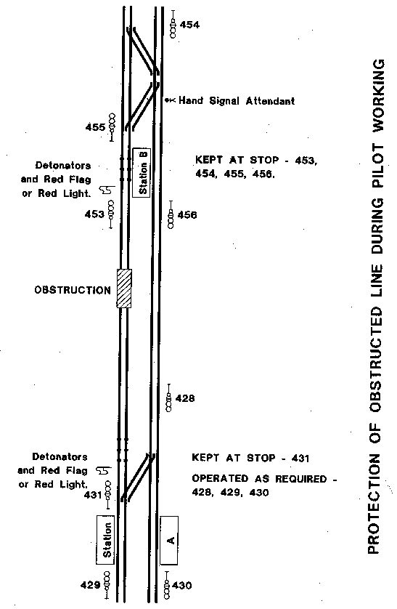

127. WORKING OF TRAINS UNDER PILOTWORKING
(1) Except for a train being used by the Pilot to deliver Pilotworking forms, a Signal Operator must not permit a train to enter a section over which Pilotworking is being instituted until all necessary forms have been delivered and signed.
(2) Advice of completion of delivery will be given to the Signal Operator by the Station Officer at the station from where the first train is expected to depart.
(3) Trains may be allowed to enter the section when the following requirements are met: —
(a) The Pilot must inform the Driver and Driver’s Assistant that Pilotworking is in force, the section involved and on which line (up or down) it is operating;
(b) The Driver of each train, before entering the section, must check all details on the Pilot’s Pilotworking form;
(c) The Pilot must obtain the Signal Operator’s permission for the train to enter the section and the Pilot must be in attendance to start the train personally;
(d) The Pilot must accompany each train through the section except as provided in paragraph (g) of this sub-rule;
(e) Where a train has an assisting locomotive the Pilot must show the Driver of the leading locomotive the Pilotworking form and travel on the rear locomotive;
(f) "Line clear” has been received from the station in advance or where it is known the first track section is clear (in order to maintain the absolute block system);
(g) Where it is necessary to start two or more trains from one end of a section under the Pilot’s control, before a train has to be started from the other end, the Pilot must issue a Pilot Caution Ticket properly completed, to the Driver of each train not accompanied by the Pilot (see Form SW 12). The Pilot must be in attendance to start those trains and accompany the last train;
(h) When a train with an assisting Locomotive is to travel on a Pilot’s Caution Ticket the Pilotworking form and Pilot’s Caution Ticket must be shown to both Drivers and the Ticket must be carried by the Driver of the rear locomotive.
(4) A Pilot’s Caution Ticket applies to a single journey only and on arrival at the other end of the section, if the train is complete, the Pilot’s Caution Ticket must be handed to the Station Officer or Signal Operator who must write the word “CANCELLED” across the face of it and send it to the Area Manager when ordinary working is resumed.
(5) The signal controlling the entrance to the pilotworking section must be kept at stop. A Driver must not pass this signal until directed by the Pilot, who must obtain permission from the Signal Operator.
(6) Where a train is required to move through points not signalled, the Station Officer must arrange for a Handsignal Attendant to be positioned at those points to display handsignals as required.
(7) Intermediate signals apply only to trains travelling in the proper direction, and may only be passed at Stop as provided in Rule 31.
(8) Where there is a switchlock in the section, the switchlock must be locked with a special padlock and the key held by the Pilot and If a train is required to shunt at that switchlocked siding the train must be accompanied by the Pilot.
(9) A Driver when working a train over the pilot section must proceed cautiously, make frequent use of the horn and between sunset and sunrise or in foggy weather exhibit two red lights on the front of the locomotive.
(10) In order to facilitate movement of trains in the direction that Automatic Signals do not apply the Area Manager may introduce the following working; and if so the Area Manager must:
(a) Appoint an employee qualified in safeworking to act as Handsignal Attendant at an intermediate signal;
(b) instruct the Handsignal Attendant in the duties;
(c) equip the Handsignal Attendant with Pilotworking form, hand lamp, red and green flags, 36 detonators, Train Register Book, and radio in working order or telephone;
(d) place the Handsignal Attendant in a position where Drivers of trains moving in the direction of the Handsignal Attendant’s control can see the Handsignal Attendant at a distance of at least 365 metres;
(e) not appoint more than one Handsignal Attendant in the section;
(f) ensure that absolute block is maintained between the Handsignal Attendant and both rear and advance stations, and that trains are not permitted to enter either portion of the divided section until line clear has been obtained by radio or telephone;
(g) advise the Pilot and enter on the Pilotworking form held by the Pilot the location of the Handsignal Attendant;
(h) ensure the location of the Handsignal Attendant is entered in the Train Register Book at both ends of the section;
(11) The Handsignal Attendant must —
(a) if on arrival at the intermediate place finds the communications out of order, return to the station and report the circumstances;
(b) remain in constant attendance at the telephone or radio to give Line Clear and Train Arrival to the rear station and receive Line Clear and Train arrival from the advance station;
(c) after giving Line Clear to the rear station place and keep three detonators, fixed twenty metres apart, on all rails of the line for which that person is signalling and exhibit a stop handsignal to the Driver of any approaching train;
(d) when that person has received Line Clear from the advance station, remove the detonators from all rails and exhibit a Clear handsignal to the Driver of the train;
(e) keep a record of all train movements in the direction of that person’s control in the Train Register Book until Pilotworking is cancelled.
(12) The Pilot must warn all Drivers of the location of and to obey handsignals exhibited by the intermediate Handsignal Attendant.

128. RELIEF OF PILOT
(1) Where it is necessary to relieve a Pilot —
(a) the Station Officer at the station where the pilotworking was originally instituted, must prepare and, in the presence of the Pilot, hand to the relief Pilot —
(i) fresh Pilotworking forms (SW 8) showing the name of the relief Pilot; and
(ii) an equivalent number of Relief of Pilot forms (SW9).
(b) as soon as the fresh forms have been handed to the relief Pilot, the Pilot that has been relieved must immediately remove the red armband and relinquish all duties as Pilot.
(2) The relief Pilot must —
(a) deliver one of the new Pilotworking forms and Relief of Pilot form to each person in possession of a Pilotworking form and obtain necessary signatures on the form held by the Relief Pilot;
(b) transmit details of the new Pilotworking form and Relief of Pilot form to the remote Signal Operator if applicable, obtain acknowledgement and insert the Signal Operators name on the forms;
(c) withdraw the superseded Pilotworking forms and deliver them to the Station Officer where Pilotworking was instituted;
(3) The Station Officer receiving the superseded forms must cancel them by writing across the face of each one —
Withdrawn. Pilot relieved: Name, Time and Date;
and any remote Signal Operator must do likewise on the Signal Operator’s superseded Pilotworking form.
(4) The Pilot who has been relieved must not ride on any locomotive or in the driving cab of a railcar unless that person resumes duty as Pilot.
(5) Where a Station Officer or Signal Operator is relieved during Pilotworking the person coming on duty must be advised by the outgoing person of the arrangements in force and the name of the Pilot . Before taking charge of the station or signal box, the person coming on duty must sign the form held by the Pilot or in the case of a remote Signal Operator being relieved the Signal Operator coming on duty must read the Pilotworking form (SW8) and advise his or her name to the Pilot who must record the name on the form held by the Pilot.

129. CANCELLATION OF PILOTWORKING
(1) When the condition which required the institution of Pilotworking has been rectified and normal working is to be resumed —
(a) The Station Officer at the station where Pilotworking was instituted must make out the necessary Cancellation Orders (See form SW 10);
(b) The Pilot must deliver a Cancellation Order to every person who received a Pilotworking form and must collect and cancel every Pilotworking form by writing the word “CANCELLED” with the time and date across the face of it; but
(c) Where a remote Signal Operator is involved the Pilot must transmit details of the Cancellation Order by radio or telephone to the remote Signal Operator who must then write “CANCELLED,” with time and date, across the Pilotworking form; and the Pilot must insert the Signal Operator’s name on the cancellation order.
(d) When the Station Officer at the opposite end of the section to which the Pilotworking was instituted has received a Cancellation Order and the Pilotworking form has been collected and cancelled, that person must —
(i) check the Pilot’s form and verify that all forms issued have been cancelled, then;
(ii) advise the Signal Operator for the station where Pilotworking was instituted by special telegram (see form SW 11) that ordinary working may be resumed.
(2) The Pilot when making the last trip under single line conditions must notify all employees in the section that double line working is to be resumed.
(3) The Pilot must return all cancelled pilotworking forms to the Station Officer where it was instituted.
(4) All forms used in connection with the Pilotworking must be sent with a full report to the Area Manager.
(5) The Station Officer at each end of the section must remove the detonators and red flag or light when the pilotworking is cancelled.
DIVISION 4
TRAINS STOPPED BY FAILURE, ACCIDENT,
OBSTRUCTION OR OTHER CAUSE
ALL SAFEWORKING SYSTEMS

130. SECURING OF A TRAIN ON A RUNNING LINE
Whenever it is necessary to leave a train or portion of a train on a running line for any reason, that train or portion of train must be secured by application of a sufficient number of effective handbrakes or sprags as shown in the automatic air and vacuum brake instructions in the General Appendix, in addition to a full continuous brake application.

131. METHOD OF CARRYING OUT PROTECTION OF A TRAIN — ALL SAFEWORKING SYSTEMS
(1) Protection of a train in a block section must be carried out by the use of hand signals, detonators and where applicable by use of a Track Circuit Shorting Out Device, except as provided in sub-rule 13 of this Rule.
(2) Where there are adjacent lines to an obstruction, unless the Driver can ascertain that the adjacent lines are not fouled, the Driver must immediately protect the adjacent lines in the direction from which traffic may approach —
(a) in automatic signalling territory by placing a Track Circuit Shorting Out Device on those lines; and
(b) whether in automatic signalling territory or not by placing detonators on those lines in accordance with this rule.
(3) Except as otherwise provided in these rules detonators must be placed on all rails of all the lines obstructed as follows —
(a) 3 detonators on each rail 20 metres apart 500 metres from the obstruction;
(b) 2 detonators on each rail 20 metres apart 1500 metres from the obstruction;
(c) 1 detonator on each rail 2000 metres from the obstruction;
(d) detonators must be attached to rails in accordance with rule 40 of these Rules.
(4) The person carrying out the protection of the train or obstruction must exhibit a Stop hand signal whilst proceeding to place the detonators on the line and when the protection is complete the person may then return to the obstruction.
(5) After sunset or during foggy weather a red light must be placed on the leading vehicle of the obstruction in the direction the detonators are placed, except as provided in Rule 132 (5)(c).
(6) In the event of a train approaching on an obstructed line before detonators have been laid down, as required by this rule, 3 detonators must immediately be placed on the line affected, as far as possible from the obstruction, and a Stop hand signal must be exhibited.
(7) Where the person carrying out the protection of a train or obstruction arrives at an interlocked station within the distances required by this rule, that person must —
(a) place 3 detonators on all rails 20 metres apart on the obstructed line or lines, in such a position that any train entering the obstructed section must pass over the detonators; and
(b) advise the Signal Operator or Train Controller of the circumstances who must place and maintain the fixed signals at Stop to protect the obstructed line or lines; and
(c) having done so return to the obstruction.
(8) Where the distance for placing of detonators lies within a tunnel or cutting, the person carrying out the protection, before entering the tunnel or cutting must place the required number of detonators on the line at the end of the tunnel or cutting closest to the obstruction, in addition to all other requirements.
(9) Where a second train comes up before protection of the first train is completed —
(a) the Driver’s Assistant of the second train must protect that train in accordance with these rules.
(b) the Driver’s Assistant of the first train, having been assured that the Driver’s Assistant of the second train has gone back with the necessary signals to protect that train may then remove all unexploded detonators and rejoin the first train and;
(c) for any subsequent trains that come up the same procedure applies so that the Driver’s Assistant of the last train provides protection of the whole.
(10) Any train stopped at an intermediate signal must be protected according to the circumstances laid down in Rules 133(1) and 134(1), except when the train has been stopped due to failure of the signal and permission has been given to pass the signal at Stop, or where a Driver is waiting track section time in accordance with Rule 31.
(11) When the obstruction is about to be cleared the Driver must ensure the Driver’s Assistant removes the 3 detonators placed at 500 metres from the obstruction.
(12) The Signal Operator must stop the first train to enter the section after an obstruction has been removed and advise the Driver of the circumstances.
(13) In the suburban electrified territory, unless the Driver or Driver’s Assistant can determine that fallen overhead line wires are not close to or in contact with the rails, such rails must not be touched and a Track Circuit Shorting Out Device or detonators must not be used for protection of an obstruction situation, but a Stop hand signal must be exhibited by the person proceeding to protect the obstruction and that person must remain at 2000 metres from the obstruction and continue to exhibit the Stop hand signal until the requirement to do so has ceased.
(14) Where the distance for the placing of detonators in accordance with this rule, other than Rule 131 (6), falls within 50 metres of any pedestrian or road crossing, or platform, then the person carrying out the protection shall extend the distance for placing the detonators to a distance of 50 metres beyond any pedestrian or road crossing, or platform.
(15) Any reference in these rules to a distance from a disabled train for the placing of detonators, exhibiting a hand signal, or meeting a relief train means —
(a) in the case of in the rear of the train, the distance from the last vehicle; and
(b) in the case of in advance of the train, the distance from the leading vehicle of the disabled train.
[Rule 131 amended in Gazette 19 September 1997 p. 5293.]

132. PORTION OF A TRAIN LEFT IN A SECTION — ALL SAFEWORKING SYSTEMS
(1) When portion of a train is left in the section due to inability of the locomotive to take the whole train forward and it becomes necessary to divide the load and return for the rear portion from the station in advance, the Driver must retain the section authority when in possession of such until the whole of the train is removed from the section.
(2) Where communication is available the Driver must advise the Train Controller of the circumstances.
(3) In automatic signalling territory (excluding the fully automatic signal section of line between Koolyanobbing East and West Kalgoorlie) and where —
(a) no passenger train is involved;
(b) communications are available between the Train Controller and the Driver of the failed train;
(c) no other train or vehicle has entered the block section from the rear; and
(d) the signal controlling the entrance to the block section from the rear has been placed to Stop, and blocking facilities have been applied to the signal,
the Train Controller may advise the Driver that protection in the rear in accordance with Rule 131 is not necessary, and the Train Controller must endorse the control diagram accordingly.
(4) In train order territory the Train Controller may, if no passenger train is involved and provided there is not and will not be an approaching train at the station in the rear during the time reasonably expected to be required to remove the rear portion of the train from the section, advise the Driver that protection in the rear in accordance with Rule 131 is not necessary; and the Train Controller must endorse the control diagram accordingly.
(5) The Drivers Assistant must —
(a) unless otherwise instructed by the Train Controller, protect the rear of the train in accordance with rule 131;
(b) secure the portion left in section in accordance with rule 130;
(c) uncouple the rear portion and after sunset or during foggy weather place a light on the leading vehicle of the rear portion as follows: —
(i) in areas where there are adjacent lines a white light;
(ii) on single lines a red light.
(6) Where the train is assisted by a locomotive in the rear the Driver of the leading locomotive must obtain a Drivers Order for assistance (SW 15) from the rear Driver, with an assurance the locomotive will not be moved until the leading locomotive returns.
(7) The Driver must, as soon as possible, move the front portion of the train sufficiently forward to allow the Driver’s Assistant, by day or night, to place 2 detonators on all rails 20 metres apart 200 metres in advance of the rear portion.
(8) The Driver’s Assistant must —
(a) take a written note of the number of the last vehicle of the front portion of the train, so as a check can be made that the front portion is complete on arrival at the station in advance.
(b) accompany the front portion of the divided train and;
(c) ensure a tail target is not carried on the front portion.
(9) The front portion must be taken to the first place where it can be stowed, and —
(a) the Driver must obtain permission from the Train Controller or Signal Operator to return for the rear portion.
(b) on single line automatic signalling, the Driver must —
(i) immediately on arrival at the station in advance remove the half pilot key from the Departure Signal controlling the entrance to the section where the rear portion is located and retain possession of it until the whole of the train is cleared from the section; and
(ii) obtain permission from the Train Controller or Signal Operator to pass the Departure Signal at Stop when returning for the rear portion.
(c) in train order territory —
(i) Where the Train Order provides for a crossing at the station to which the first portion is taken and the train to be crossed is met at that station on arrival of the first portion, the Driver of the divided train must stop at the facing points and inform the Driver of the train to be crossed of the circumstances.
(ii) The Train Order held by the Driver remains in effect until the complete train is cleared from the section by the train locomotive and will then continue in effect until “fulfilled” or “cancelled”.
(iii) Should the train locomotive fail on arrival at the station in advance with the first portion of the train, or for any other reason, the Train Controller may authorise another locomotive to remove the second portion from the section by cancellation of the Train Order held by the Driver of the failed locomotive and the issue of a Train Order to the relief locomotive, authorising removal of the rear portion of the failed train from the section. The kilometreage at which the rear portion is located must be shown on the Train Order and the Driver’s Assistant of the failed locomotive must accompany the relief locomotive until the rear portion of the disabled train is cleared from the section.
(10) When due to derailment or other cause the train cannot be cleared from the section the Driver must ensure the train is protected in both directions in accordance with rule 131.
[Rule 132 amended in Gazette 19 September 1997 p. 5293.]

133. TRAIN BROUGHT TO A STAND ON A RUNNING LINE AUTOMATIC SIGNALLING SYSTEM — DOUBLE LINE
(1) In the event of a train coming to a stand in a double line automatic signalling section because of accident, failure, or any other cause, the Driver must —
(a) immediately protect any adjacent line that is fouled in accordance with Rule 131; and
(b) arrange for —
(i) a qualified person to protect the rear of the failed train in accordance with Rule 131 (if the train is in the electrified urban rail system); or
(ii) the Driver’s Assistant to protect the rear of the train in accordance with Rule 131, unless otherwise authorised by the Head of Operations Branch (if the train is in territory other than the electrified urban rail system).
(1A) Where a person carrying out protection of a train in accordance with Rule 133 (1) arrives at a signal applicable to the line occupied by the failed train and that signal is displaying a Stop indication, then the person shall —
(a) place 3 detonators on each line in such a position that any train entering the obstructed section must pass over the detonators; and
(b) remain at the location until the arrival of a relief train and then accompany the relief train to the failed train.
(2) The Driver must communicate with the Train Controller and if assistance is required because of locomotive failure, request such assistance on a Driver’s Order for Assistance (Form SW 15), transmitted by radio or telephone, except as provided in sub-rule 16 of this rule.
(3) The Train Controller must inform the Driver from which end of the section the relief train will be provided and request the Driver to arrange protection of the disabled train in accordance with sub-rule 4 of this rule.
(4) The Driver’s Assistant must place 3 detonators, if not already placed, 20 metres apart on each rail 500 metres from the disabled train in the direction from which the relief train is to approach (Note: In the rear of the disabled train the 3 detonators should already have been placed at 500 metres in accordance with sub-rule 1(b) of this Rule).
(5) The Driver’s Assistant of the disabled train must wait at the location of the 3 detonators for the relief train and exhibit a Stop handsignal until the relief train arrives and then join that train.
(6) When proceeding to provide protection and wait for the relief train, the Driver’s Assistant must take the Driver’s Order for Assistance but if a Pilot is accompanying the train, the Pilot must provide the protection and wait for the relief train, and take the Driver’s Order for Assistance.
(7) The Train Controller must, after ascertaining that the Driver’s Assistant or Pilot has gone to meet the relief train, transmit to the Driver of the relief train authority to proceed into the obstructed section on an Authority for Relief Locomotive to Enter Section (Form SW 16) except as provided in sub-rule 16 of this rule.
(8) The Driver of the relief train before passing any signals at stop must obtain permission from the Signal Operator or Train Controller.
(9) The Driver of the relief train must not proceed beyond the location shown on the form SW16 at which the Driver’s Assistant or Pilot is to be met, until that person has joined the relief train with the Driver’s Order for Assistance, as authority for the relief train Driver to move to the obstruction.
(10) The Driver of the relief train must retain the Driver’s Order for Assistance and the Authority for Relief Locomotive to Enter Section until the whole of the disabled train has been removed from the section, at which time the Driver of the relief train must cancel the forms and attach them to the running statement.
(11) When a Driver issues a Driver’s Order for Assistance, that Driver must not allow the train to be moved until such time as the Driver’s Assistant or Pilot has returned with the relief train, or the Order for Assistance has been cancelled by that Driver with the Train Controller’s approval, in which case the Train Controller’s copy must also be cancelled.
(12) Where it is necessary to remove a train or portion of a train, from a section in the wrong direction —
(a) A Signal Operator’s Wrong Direction Order (Form SW 14) must be obtained at the block station in the rear by the Driver’s Assistant from the Signal Operator or Train Controller, and such order must be obtained by radio or telephone.
(b) The Driver of the disabled train must not allow the train to be moved in the wrong direction without sighting the Signal Operator’s Wrong Direction Order.
(c) When it is necessary for a Drivers Assistant to proceed to the block station in the rear to obtain a Signal Operator’s wrong direction order, the Drivers Assistant must travel adjacent to the line to ensure that no train has entered the section behind the disabled train.
(13) In case of failure of communication between the train and the Train Controller the Driver or Driver’s Assistant or Pilot must take the Driver’s Order for Assistance to the nearest place where communication is available and the Train Controller must advise that person in accordance with sub-rule 3 of this rule.
(14) If assistance is obtained from the rear and one or more following trains have entered the section behind the disabled train —
(a) the locomotive of the following train must if necessary, be detached and when given the Driver’s Order for Assistance the Driver of the relief train must move the locomotive to the scene of the obstruction, and propel the disabled train to the station in advance.
(b) and if the whole or part of the relief train is left in the section while the disabled train is being removed from the section, the driver of the relief train may return for the remainder of the train on permission of the Train Controller, and the provisions of Rule 132 apply.
(c) and the train nearest to the disabled train is unable to assist but the second following train can assist,
(i) each of the following trains must return to the rear station after obtaining a Signal Operator’s Wrong Direction Order as shown in sub-rule (12) of this rule. The Drivers must exercise extreme care when propelling from the section and a safe interval maintained by the Train Controller between each train, by not permitting a train to move in the wrong direction until the train behind it has returned complete to the station in the rear,.
(ii) the Driver of the train immediately following the disabled train must advise the Train Controller when the section is clear to the disabled train; and
(iii) the Train Controller will then issue the Authority for Relief Locomotive to Enter Section to the Driver of the relief train.
(15) Where a portion of a train is left in a section without the train crew being aware of the fact, the Train Controller on receiving advice must —
(a) ascertain the location of the rear portion;
(b) arrange securing and protection of the obstruction; and
(c) arrange clearance of the obstruction.
(16) In the event of failure of a suburban electric train —
(a) the Driver’s Order for Assistance form and the Authority for Relief Locomotive to Enter Section form need not be used for assistance from the rear;
(b) subject to Rule 133 (17), a relief train may enter the obstructed track section on the verbal authority of the Train Controller; who must advise the Driver the location of the disabled train; and
(c) the Driver must take the relief train cautiously towards the disabled train.
(17) In the urban electrified rail system where assistance is being provided to a failed train from the rear, if —
(a) it is between sunrise and sunset;
(b) the failed train is clearly visible from the signal controlling entry to the occupied track section; and
(c) communications have been established between the Driver of the failed train and the Driver of the relief train,
Rules 133 (1) (b) and 133 (1A) do not apply.
(NOTE: The failed electric train must be protected in the manner set out in Rules 133 (1) and 133 (1A) unless specifically exempted by another part of Rule 133.)
[Rule 133 amended in Gazette 19 September 1997 p. 5294.]

134. TRAIN BROUGHT TO A STAND ON A RUNNING LINE AUTOMATIC SIGNALLING SYSTEM SINGLE LINE
(1) In the event of a train coming to a stand in a single line automatic signalling section because of accident, failure or any other cause, the Driver must —
(a) immediately protect any adjacent line that is fouled in accordance with rule 131; and
(b) arrange for the Driver’s Assistant to protect the rear of the train as laid down in rule 131, unless otherwise authorised by the Head of the Operations Branch.
(2) The Driver must communicate with the Train Controller and if assistance is required because of locomotive failure request such assistance on a Driver’s Order for Assistance (Form SW 15), transmitted by radio or telephone.
(3) The Train Controller must inform the Driver from which end of the section the relief train will be provided and request the Driver to arrange protection of the disabled train in accordance with sub-rule 4 of this rule.
(4) The Driver’s Assistant must place 3 detonators, if not already placed, 20 metres apart on each rail 500 metres from the disabled train in the direction from which the relief train is to approach. (Note: In the rear of the disabled train the 3 detonators should already have been placed at 500 metres in accordance with sub-rule 1(b) of this Rule).
(5) The Driver’s Assistant from the disabled train must wait at the location of the 3 detonators for the approach of the relief train and exhibit a Stop hand signal until the relief train arrives and then join that train.
(6) When proceeding to provide protection and wait for the relief train, the Driver’s Assistant must take the Driver’s Order for Assistance.
(7) The Train Controller must, after ascertaining that the Driver’s Assistant has gone to meet the relief train, transmit to the Driver of the relief train authority to proceed into the obstructed section on an Authority for Relief Locomotive to Enter Section Form (SW 16).
(8) The Driver of the relief train before passing any signals at stop must obtain permission from the Signal Operator or Train Controller.
(9) The Driver of the relief train must not proceed beyond the location shown on the form SW16 at which the Driver’s Assistant is to be met, until that person has joined the relief train with the Driver’s Order for Assistance, as authority for the relief train Driver to move to the obstruction.
(10) The Driver of the relief train must retain the Driver’s Order for Assistance and the Authority for Relief Locomotive to Enter Section until the whole of the disabled train has been removed from the section, at which time the Driver of the relief train must cancel the forms and attach them to the running statement.
(11) When a Driver issues a Driver’s Order for Assistance, that Driver must not allow the train to be moved until such time as the Driver’s Assistant has returned with the relief train, or the Order for Assistance has been cancelled by that Driver with the Train Controller’s approval, in which case the Train Controller’s copy must also be cancelled.
(12) In the case of failure of communication between the train and the Train Controller the Driver or Driver’s Assistant must take the Driver’s Order for Assistance to the nearest place where communication is available and the Train Controller must advise that person in accordance with sub-rule 3 of this rule.
(13) Where it is necessary to remove the disabled train to the station in the rear —
(a) if the relief train is provided from the station in the rear the Driver of the relief train must withdraw the half pilot key for the obstructed section before leaving that station, and retain it until the whole of the disabled train has been removed from the section.
(b) if the relief train is supplied from the station in advance, before the train is moved, the half pilot key for the obstructed section must be obtained by the Driver’s Assistant of the disabled train from the station in the rear, and handed to the Driver of the relief train who must retain it until the disabled train is completely cleared from the section.
(14) If the relief train is provided from the station in advance and the disabled train is to be removed to that station, the Driver of the relief train must remove the half pilot key applicable to the obstructed section before leaving the station in advance and retain possession of the half pilot key until the whole of the disabled train has been removed from the section.
(15) Where a train is assisted by a locomotive in the rear and the train locomotive becomes disabled so that it cannot be moved forward —
(a) the Driver of the assistant locomotive in the rear must send the Driver’s Assistant to the station in the rear to obtain the half pilot key applicable to the obstructed section; and
(b) when in possession of the half pilot key the Driver can remove the train to the station in the rear and must retain the half pilot key until the whole of the train is cleared from the section
(16) If assistance is obtained from the rear and one or more following trains have entered the section behind the disabled train —
(a) the locomotive of the following train must, if necessary, be detached and when given the Driver’s Order for Assistance the Driver of the relief train must move the locomotive to the disabled train and propel the disabled train to the station in advance.
(b) and if the whole or part of the relief train is left in the section while the disabled train is being removed from the section, the driver of the relief train must remove and retain the half pilot key applicable to the obstructed section upon arrival at the station in advance and contact the Train Controller for permission to return to the train, and the provisions of Rule 132 apply.
(c) and the train nearest to the disabled train is unable to assist but the second following train can assist, each of the following trains must return to the rear station upon permission from the Train Controller
(i) after the half pilot key at the rear station applicable to the obstructed section has been removed by the Driver’s Assistant of the disabled train and;
(ii) it has been shown to each of the Drivers of the following trains who must propel to the rear station, and the Train Controller must maintain a safe interval between trains by not permitting a train to move in the wrong direction until the train behind it has returned complete to the station in the rear; and
(iii) The half pilot key must be carried on the last train from the section and the Driver must advise the Train Controller when the section is clear to the disabled train.
(iv) The Train Controller will then issue the Authority for Relief Locomotive to Enter Section to the Driver of the relief train, and
(v) If the disabled train is to be propelled to the station in advance the half pilot key is to be replaced in the pilot key box.
(17) Whenever a train becomes disabled during pilot-key working and —
(a) the Driver of the disabled train is in possession of the pilot-key, the Driver’s Assistant must take the pilot-key (with the Order for Assistance) when proceeding to meet the relief train and must hand the pilot-key (with the Order for Assistance) to the Driver of the relief train who must retain it until the disabled train has been cleared from the section.
(b) the Driver of the disabled train is in possession of a pilot-key caution ticket, the disabled train must be removed only to the station in advance, unless the driver of the relief train has possession of the pilot-key which must be retained until the disabled train has been cleared from the section.
(18) Whenever it is necessary to proceed to the rear station to obtain the half pilot key or pilot key the Drivers Assistant from the disabled train must travel adjacent to the line in order to meet any trains that have entered the section behind the disabled train.
(19) Where a portion of a train is left in a section without the train crew being aware of the fact, the Train Controller on receiving advice must —
(a) ascertain the location of the rear portion.
(b) arrange securing and protection of the obstruction and;
(c) arrange clearance of the obstruction.
(20) Whenever, because of accident or any other cause, it is necessary for a train to return in the wrong direction to the block station in the rear, the Drivers Assistant must firstly obtain the half pilot key applicable to the obstructed section from the station in the rear, return with the half pilot key to the train and hand it to the Driver who must retain the half pilot key until the train has completely cleared the section.

135. TRAIN BROUGHT TO A STAND ON A RUNNING LINE TRAIN ORDER SYSTEM
(1) In the event of a train coming to a stand in a Train Order section because of accident, failure or any other cause, the Driver must —
(a) immediately protect any adjacent line that is fouled, in accordance with Rule 131; and
(b) arrange for the train to be protected in both directions, unless otherwise authorised by the Head of the Operations branch, and except when the locomotive is required to return from the station in advance for the rear portion of the train as laid down in Rule 132.
(2) When a relief locomotive is required to remove a train disabled within a section, the Driver of the disabled train must contact the Train Controller and advise the circumstances.
(3) The Train Controller must inform the Driver from which end of the section the relief train will be provided, and the Driver’s Assistant must wait for the relief locomotive at the location of the 3 detonators placed on the line in accordance with Rule 131, exhibit a stop hand signal until the relief train arrives, and then join that train.
(4) On being advised that a relief locomotive is required, the Train Controller will cancel the Train Order held by the Driver of the disabled train and authorise the relief locomotive to proceed into the section to the disabled train by issue of a further Train Order, which must show clearly the location of the disabled train.
(5) The Driver of the relief locomotive must arrange removal of the disabled train from the section in accordance with directions given on the Train Order, a copy of which is to be shown to the Driver of the disabled train.
(6) Where direct communication with the Train Controller is unavailable the Driver or Driver’s Assistant shall take the Train Order and proceed to a place where contact can be made with the Train Controller for cancellation of the Train Order and for arrangements to be made for a relief train.

136. FAILURE OF TRAIN WITHOUT DRIVER’S ASSISTANT
Where any disabled train is operated without a Driver’s Assistant and there is a requirement for the Driver’s Assistant to perform any duty under rules 130 to 135 inclusive, then that duty will be carried out by the qualified employee accompanying the train or one nominated by the Train Controller, or in non-electrified territory, by the Driver after compliance with Rule 130.
[Rule 136 amended in Gazette 19 September 1997 p. 5294.]

RULE 137 TO 140 SPARE

141. PRECAUTIONS TO BE OBSERVED FOR TRAINS MOVING OR PROPELLING IN WRONG DIRECTION
(1) When moving in the wrong direction a Driver must —
(a) proceed cautiously;
(b) make frequent use of the locomotive horn;
(c) maintain a sharp look-out for any permanent way or other employees who may be working in the section;
(d) on double lines unless otherwise directed by the Head of the Operations Branch not pass over level crossings that are protected by automatic warning devices, until such time as the crossing has been protected by a Flag Attendant or the Driver’s Assistant.
(2) Where a train is being propelled, the Driver must ensure that an employee rides on or precedes the leading vehicle to communicate with the Driver as may be necessary; and who must maintain a sharp look out for any permanent way or other employees who may be working in the section.

142. TRAIN ON FIRE
Where any vehicle of a train is on fire the Driver must stop the train, and the crew must —
(a) attend to the safety of any passengers;
(b) protect the train in the manner prescribed in these rules;
(c) endeavour to extinguish the fire;
(d) when it is not possible to extinguish the fire secure the portion of the train in the rear of the burning vehicle and when safe to do so, isolate the burning vehicle.

143. PROLONGED OBSTRUCTION
(1) On double lines where one line only is obstructed, single line working must be instituted by the introduction of Pilot Working.
(2) If both lines are obstructed traffic will be worked in accordance with instructions issued by the Head of the Operations Branch.

144. TRAIN PARTED IN ANY BLOCK SECTION
(1) Where a train has parted in any block section, before setting back for the rear portion the Driver must —
(a) ascertain where the rear portion of the train is located;
(b) ensure that it is a safe operation to re-couple the train;
(c) proceed cautiously and if it is necessary to pass over points worked from a signal box, the Driver must obtain permission from the Signal Operator concerned for the movement over those points, and
(d) observe the provisions of Rule 141 (2).
PART 4
DIVISION 1
CONTROL AND WORKING OF STATIONS

145. WORKING OF STATIONS GENERALLY
(1) A Station Officer is responsible for —
(a) the general working of the station being carried out in strict accordance with these rules, and the instructions and orders issued from time to time, and as far as practicable, giving personal attention to shunting, signalling and all other operations affecting the safety of the railway; and
(b) the efficient discharge of duties by all employees under the Station Officer’s charge.

146. TRAINS NOT TO BE STARTED UNTIL IN PROPER CONDITION
(1) Where a Train Examiner is stationed the Station Officer must, before starting a passenger or freight train, unless there are special instructions to the contrary, be satisfied that the examination of the train has been completed, and that, as far as the Train Examiner is concerned the train is in a proper condition and safe to proceed.
(2) Where there is no Train Examiner the Driver must arrange to have remedied any defect which might interfere with the safe running of the vehicles and remove any defective vehicles from the train.

147. PROTECTION OF EMPLOYEES WORKING ON OR UNDER VEHICLES
(1) Employees engaged in repairing or lifting a wagon on any line or siding must, before commencing such work, advise the person in charge of shunting operations that they are about to do so.
(2) Where practicable, wagons must be repaired or lifted on a line set apart for the purpose and at major depots the wagon repair sidings are locked with a special lock and the key held by the Senior Examiner who is responsible for the security of the siding.
(3) The employee engaged in work on any wagons must exhibit a red disc with the words NOT TO BE MOVED painted in white, or in the absence of a disc a red flag at both ends of the wagons undergoing repairs and wagons on either side of the defective wagons must be securely braked and chocked.
(4) Where a red disc or red flag has been positioned for protection of employees working on vehicles —
(a) a person must not move those vehicles nor shunt others against them, and
(b) the protection must not be removed until the work is completed and all employees are clear of the wagons.
(5) The person in charge of the work must remove the chocks and the red disc or flags.
(6) Where a locomotive or vehicle attached to a train requires attention, the employee required to work on or under it must personally notify the Driver before commencing work.
(7) If a Train Examiner finds it necessary to place a red “NOT TO GO” card on a vehicle marshalled on a train ready to depart, the Train Examiner must immediately advise the Driver and person in charge of shunting and the red card must clearly show the nature of the defects.
(8) An unauthorised person must not remove a Red or Green card from a vehicle.
(9) Following the derailment of any vehicle a Train Examiner or other authorised employee must certify it as fit for traffic, before it can be used.

148. PROTECTION OF TRAINS AGAINST CRANES OR OTHER LIFTING MACHINES
(1) Where a crane jib or any other portion of it obstructs or fouls or is likely to foul any line in use for traffic, or where by any possibility, during the loading or unloading of any articles of great size or length a running line may be fouled, the operator must —
(a) obtain the sanction of the Station Officer or Signal Operator before commencing the work;
(b) arrange where necessary, protection of the work in accordance with rule 131.
(2) Lifting machines must be locked or otherwise secured when not in use.

149. RESERVED

150. ACCIDENTS OR OBSTRUCTION TO RUNNING LINES TO BE REPORTED
(1) Where an accident or obstruction occurs that affects the working of any running line, the employee concerned must ensure that it is immediately reported to the Signal Operator and Train Controller controlling the section;
(2) Where any vehicle, train or portion of a train runs back or proceeds in the wrong direction on a running line the Signal Operator must —
(a) place all signals applicable to that line at Stop;
(b) at once inform the Train Controller; and
(c) the Train Controller must —
(i) stop all trains running on that line;
(ii) take any action that may be necessary such as diverting the vehicles to another line or into a siding;
(iii) stop any train going in the same direction on adjacent lines and advise the driver of the circumstances with instructions to proceed cautiously.
(iv) arrange for the runaway vehicles to be cleared from the section.
(3) Where any vehicle, train or portion of a train runs away in the proper direction on the right running line the Signal Operator must —
(a) at once inform the Train Controller; and
(b) The Train Controller must —
(i) stop any train travelling in the opposite direction until it has been ascertained that the line on which it will run is not obstructed;
(ii) arrange for the line on which the runaway train is running to be cleared;
(iii) take any action that may be necessary to divert the runaway train to another line or siding.

151. BUFFER STOPS ON DEAD END LINES
At terminal stations where there are dead end lines, after sunset and in fog a red light must be placed on the buffer stop or on any vehicle on that line.
DIVISION 2
WORKING OF LEVEL CROSSINGS

152. PROTECTION OF LEVEL CROSSINGS
(1) Where a vehicle is being propelled or shunted over a level crossing not provided with flashing light warning signals or flashing light warning signals with half boomgates the Shunter must precede the train which must be restricted to a speed of 6 kilometres per hour.
(2) Where a train moving in the wrong direction on a double line section is required to pass over a level crossing protected by flashing light warning signals or flashing light warning signals with half boomgates a Flag Attendant must be provided unless instructions to the contrary are issued by the Head of the Operations Branch.
(3) Where a train is required to pass at Stop a fixed signal located close to a protected level crossing, the Driver must not take the train over the crossing until the protection is activated and road traffic has stopped.

153. FAULTS IN WARNING SIGNALS AT PROTECTED CROSSINGS
(1) When passing a level crossing protected by warning signals the train crew must observe the working of those warning devices and any defect noticed must be reported to the Train Controller.
(2) Every employee who notices a defect in the working of any flashing light warning signals or half boomgates must immediately report the fact to the Train Controller.
(3) The Train Controller, receiving a report of defective warning signals must immediately advise the maintainer and arrange protection of the crossing by a Flag Attendant until the fault is repaired.
DIVISION 3
SHUNTING

154. DRIVERS TO WORK TO SIGNALS OF SHUNTERS
(1) During shunting operations a Driver —
(a) must only work to the signals given by the Shunter.
(b) notwithstanding that the fixed signals may have been placed at Proceed must not move the train until the Shunter has given a signal to do so.
(c) must immediately bring the locomotive to a stand if sight of the signal is lost or if shunting by radio and contact is lost between the Shunter and the Driver.
(2) A person giving hand signals must do so in such a way as to avoid the signals being taken by any Driver other than the one for whom they are intended and to avoid confusion verbal instructions must be given if possible.
(3) Where a train is being propelled a Shunter must ride on or precede the leading vehicle and in the event of the Driver being unable to see the Shunter or the Shunter is out of radio contact, one or more Shunters must be positioned to repeat any signals.
(4) Where the Driver is unable to see a fixed signal applying to a shunt move the Shunter must observe the signal indication and when placed at Proceed, exhibit a clear hand signal to the Driver or advise the Driver by radio and must receive acknowledgement before giving a signal to continue shunting.

155. RESTRICTIONS ON LOOSE SHUNTING
(1) A vehicle must not be loose shunted (that is, shunted without remaining attached to the locomotive) into sidings or upon running lines, unless it is accompanied for a sufficient distance by a competent person prepared to apply handbrakes to ensure the vehicle is brought to a stand in the required place, or to prevent it colliding violently with other vehicles, or buffer stops or fouling other lines or running away on a falling gradient.
(2) Loose shunting of a vehicle is not permitted —
(a) into a loading dock, freight shed, passenger platform or loading ramp unless brakes can be applied without risk of injury to the Shunter;
(b) against a passenger train or a vehicle containing passengers;
(c) against a rail tank car containing any liquid or a vehicle loaded with containers of any liquid.
(3) Loose shunting of a rail tank car containing any liquid or a wagon loaded with containers of any liquid is not permitted.

156. VEHICLES NOT TO BE LEFT FOUL OF LEVEL CROSSINGS
A person must not leave a vehicle standing foul of a level crossing.

157. RESPONSIBILITIES OF PERSON IN CHARGE OF SHUNTING
(1) A Shunter is responsible for ensuring that —
(a) trains or vehicles are clear of all points that may require to be moved and that scotchblocks are removed as required;
(b) vehicles placed in sidings are properly secured to prevent their moving, fouling other lines, being blown out or otherwise escaping on to a running line by application of at least one third of the effective handbrakes;
(c) on completion of shunting operations.
(i) every train or vehicle is left clear of any running lines and within catchpoints, derailers or scotchblocks;
(ii) points are left in their normal position and locked if so required;
(iii) scotchblocks, where provided are placed across the rails and locked in position unless otherwise laid down in the local instructions; and
(iv) a vehicle is not left on any running line, through inadvertence;
(d) all points are in their correct position and properly closed for any movement about to be made over them, before giving the Driver the signal to move;
(e) hand points are not trailed through, when they are set in the wrong direction for the move about to be made.
(f) balanced self-acting points are correctly set and held by hand, when reversed, for movements in either direction; and
(g) any points which are motor operated or connected to a lever frame or interlocking machine are not, in any circumstances, trailed through.
(2) Drivers, Shunters and Drivers’ Assistants and others controlling the movement of trains or vehicles over points are equally responsible for ensuring compliance with paragraph (g) of sub-rule 1.
(3) Where a movement is over points worked, bolted or locked from a signal box or ground frame, and a fixed signal is not provided for the movement, the Shunter, must —
(a) receive an intimation verbally or by hand signal or other authorised means, from the Signal Operator, or person working the ground frame, that the movement may be made; and
(b) as far as practicable, ensure that the points are in their correct position, before instructing the Driver to move.
(4) Before any vehicle is shunted into a siding —
(a) the Shunter must ascertain the position of any vehicles in the siding, and signal the Driver accordingly (so as to avoid undue impact with those vehicles or the buffer-stops);
(b) where the view of the line is obstructed by any building or other cause, the Shunter must precede the vehicles on foot, and be satisfied that the line is clear.
(5) The Shunter must ensure that a vehicle standing in a siding is properly secured and left sufficiently clear of the fouling points of any adjoining sidings or lines, to permit shunting operations to be carried on without risk of collision between that vehicle and any vehicle that is being shunted on adjoining sidings or lines, or risk of injury to the staff conducting the operations.
[Rule 157 amended in Gazette 23 February 1996 p.682.]

158. SHUNTING INTO LOADING OR UNLOADING ROADS
The Shunter must, before a vehicle is moved in or shunted into a siding used for loading and unloading traffic or for repairing vehicles or a freight shed or other building where other vehicles are standing —
(a) remove any scotchblocks necessary for the shunt;
(b) if any other vehicles are likely to be moved by the shunting operations —
(i) warn any employee or other person who may be engaged in, about or between vehicles and;
(ii) direct any person who may be loading or unloading not to remain in or near to vehicles which are likely to be moved by shunting operations;
(c) be satisfied that no road vehicle is foul of any of the lines on which shunting operations are about to be performed;
(d) ensure that the contents are not left in such a condition that would result in their damage when the vehicles are moved; and
(e) ensure that shed doors are fully open and secured by the catches provided, that all is clear, and that all wagon doors are properly secured before shunting.

159. LOCOMOTIVES MOVING IN SHUNTING YARDS TO BE ACCOMPANIED BY SHUNTER
(1) Except where instructions to the contrary are issued by the Head of the Operations Branch a Shunter or other person deputed for the duty must accompany a train or locomotive moving in a shunting yard.
(2) Where a locomotive is not accompanied by a shunter, the Driver must when a fixed signal does not control the move, see that all points are correctly set before passing over them.
(3) Where a train has set back through a crossover or into a siding or loop the Driver must ensure that the train is clear of the points near the locomotive when there is no Shunter present.

160. VEHICLES TO BE SECURED DURING SHUNTING
When shunting wagons at any place on a running line, the Shunter must, if leaving any part of a train on the running line see that a sufficient number of vehicle handbrakes are applied to eliminate any possibility of vehicles running away, see Rule 130 of these Rules.

161. VEHICLES LEFT ON RUNNING LINES
(1) Where a vehicle is detached and left on any running line at an interlocked station,
(a) the person doing so must first obtain the Signal Operator’s permission (in order that the Signal Operator may keep the necessary fixed Signals at Stop); and
(b) the person in charge of shunting must ensure the detached vehicles are properly secured see Rule 130 and red lights are attached to each end of the vehicles.
(2) A Signal Operator must keep a good look-out and must, where any vehicle has been detached from a train and left on any running line, take the necessary steps to protect it.
(3) A train or portion of a train must not be stowed on a running line at a crossing station unless such line is provided with catchpoints or scotch blocks, except in an emergency, in which case the Train Controller must —
(a) be assured that handbrakes are applied in accordance with Rule 130; and
(b) issue a special train notice telegram for the information of train crews.
(4) Where a train or portion of a train with locomotive attached is stowed on any running line at night or in foggy weather a red light must be exhibited at each end of the train.

162. SHUNTING OF PASSENGER TRAINS
(1) A vehicle must where practicable, be attached to or detached from a passenger train, without the train being moved.
(2) Before any vehicle containing a passenger is shunted over points, the Shunter must take particular care to ensure the points are securely set for the line on which the vehicle is required to run and that the line is clear and properly protected.
(3) Where a vehicle is being moved by a locomotive for the purpose of being attached to or detached from a passenger train the Shunter must ensure that the continuous brake pipes are connected so that the brakes are available during shunting.

163. PRECAUTIONS TO BE TAKEN WHEN SHUNTING CRANES
Where it is necessary to move a crane in a station yard or to place on a train, the Shunter must ensure that the jib and balance box are in the proper position and securely fastened and that the crane does not foul any structure or overhead wire whilst being moved.

RULES 164 TO 170 RESERVED.
PART 5
WORKING OF TRAINS
DIVISION 1
DUTIES OF OPERATIONAL STAFF

171. TRAIN AN UNUSUALLY LONG TIME IN THE SECTION
(1) Whenever it appears that a train is an unusually long time in a section, the Train Controller must take action to ascertain the cause and advise the Area Manager who will arrange where necessary to institute emergency procedures.

172. TRAINS TO BE CLOSELY EXAMINED
(1) Every employee must, as far as practicable, closely examine each train as it passes, and must where any train signals are not properly displayed or anything unusual, such as signals of alarm by a passenger, insecure loads, vehicles on fire or derailed, hot axle box or equipment dragging or a train divided is observed, endeavour to stop the train and in any event report the incident to the Train Controller.
(2) At crossing stations the Driver, from the cab of the locomotive, and the Driver’s Assistant, from the ground on the opposite side to the Driver, shall carry out a visual roll by inspection of any passing train and in the event of observing anything unusual, as listed in subrule (1) of this rule, endeavour to stop the train and advise the Train Controller.
(3) The crew of the passing or crossing train must ensure that the stationary train is complete with tail target, except as provided in sub-rule 3 of rule 39 of these rules and if not, stop their train and establish the reason.
(4) Where available radio is to be used to expedite enquiries.
(5) Where it is not possible to stop a train as required by this rule the Train Controller must have the train stopped as soon as practicable to have any defect remedied.
(6) Where there is any reason to believe that the permanent way has been damaged or fouled, a Signal Operator must not allow a train to enter that section until the line has been examined and certified fit for the safe passage of trains.
(7) In the event of any employee observing any vehicle running away, the employee must —
(a) endeavour to stop it;
(b) if able to stop it, protect the obstruction with hand signals and detonators in accordance with these rules;
(c) advise the Train Controller and take action to stop approaching trains where possible.

173. DUTIES OF DRIVERS
A Driver must —
(a) be with the locomotive or railcar at such times as may be required and, unless otherwise directed, be satisfied that the locomotive or railcar is in proper working order;
(b) have a watch, all the necessary keys and Safeworking forms, and on the locomotive two red flags and one green flag, not less than thirty-six detonators, a hand signal lamp, a tail target and such other articles as may be ordered;
(c) before moving a railcar or locomotive, whatever the circumstances, sound the horn to give notice;
(d) keep a good look out, at all times while the locomotive is in motion;
(e) carefully observe all signals and where, from fog or any other cause, fixed signals are not as visible as usual, reduce speed and use every possible precaution, especially in approaching stations and junctions, so that the train can be brought to a stand in the event of the signals being at Stop;
(f) where working ballast trains with employees in the wagons, sound the horn before reducing speed preparatory to stopping;
(g) not sound the horn unnecessarily, especially when attached to, or near a passenger train;
(h) where required by an authorised officer to do anything which may appear unreasonable or in excess of the Driver’s duties, carry out those instructions, unless they endanger the safety of the train or require the violation of the rules, and thereupon report the fact to the Driver’s immediate Superior Officer;
(i) ensure that the Driver’s Assistant performs duties properly and, when working a “Driver-only” train, carry out the duties that would normally be carried out by the Driver’s Assistant under these rules, unless otherwise directed by the Train Controller;
(j) when not acquainted with any portion of the line over which the train has to run, obtain the services of a qualified employee who has driven over that line as guide;
(k) not move the train forward towards the next signal after station work is completed, until that signal is placed to Proceed, except when specially ordered to do so by the Station Officer or Train Controller;
(l) not enter upon, set back from, or cross, any running line with the train, without the permission of the Signal Operator and not then, until the proper signals, where provided, are exhibited for the protection of the operation;
(m) before starting the train, see that the proper destination signs (where provided), discs and lights are exhibited on the locomotive or railcar and are in good order and alight when necessary;
(n) regulate the running of the train or railcar as accurately as practicable, so as to avoid extreme speed or loss of time;
(o) as far as practicable, have the Driver’s Assistant disengaged when approaching or passing stations, signal boxes or level crossings so that the Driver’s Assistant, also, may keep a good look out for signals;
(p) when approaching a signal box, challenge with the prescribed blast on the locomotive horn if the signals are at Stop; or contact Signal Operator by radio;
(q) watch out for hand signals, when passing signal boxes or stations;
(r) observe the speed limits and restrictions laid down from time to time in the Working Timetables Book and in any notice; and also take care that normal speed is not resumed until the whole of the train has passed over the point of restriction;
(s) ensure the steady passage of the whole train when passing over points and crossings;
(t) start the train carefully, and pass along the proper line, which, in the case of a double line, is the left hand side of the permanent way, in the direction in which the train is travelling;
(u) stop the train with care, paying particular attention to the state of the weather and the condition of the rails, as well as to the length and weight of the train, and to the brake power available; all of which circumstances must receive due consideration in determining when to shut off power and when to apply the brake;
(v) carefully approach all stations at which the train is required to stop; not stop short of or over-run the platform;
(w) when working a passenger train which is stopped at signals at a station platform where it is not booked to stop, ignore the placing of the signal to Proceed until the Driver receives the signal to start from the qualified employee, where provided;
(x) be satisfied when a signal is placed to Proceed that it refers to the line that the Driver is on and to that on which the train is to run;
(y) not move towards a signal that applies to more than one siding, where more than one locomotive or train is in the sidings at the time, until a proper understanding as to procedure has been reached between all Drivers; and, whilst waiting for the signal to be placed to Proceed, not allow the train to foul any other line, if that is practicable;
(z) While approaching or passing a station, sound the horn should another train be approaching, stopping, or leaving, or should shunting operations be in progress on an adjacent line; and also sound the horn to caution employees on or near the line on which a train is running and sound the horn when entering and passing through tunnels and deep cuttings situated on curves;
(aa) reduce to 20 kilometres per hour or such other speed as may be prescribed by these rules, over the portion of line protected if a Caution hand signal is exhibited;
(bb) on bringing a locomotive or railcar to a stand, take care that the locomotive or railcar does not stand foul of the points or crossings of any other running line;
(cc) ensure that every locomotive, equipped with NCDA couplings, attached to a train has the buffer heads screwed together tightly, by means of the tightening screws where provided;
(dd) promptly afford such assistance with the locomotive as may be required for the formation, arrangement and dispatch of the train;,
(ee) when shunting, ensure the person performing the shunting operation is in position for the purposes of shunting before moving the train;
(ff) before booking off duty, enter in the book or books provided for the purpose any repairs to the locomotive, or railcar that may be required, and also submit a report on any circumstances that are required to be brought under notice;
(gg) where operating a light locomotive, unaccompanied by a Shunter, be satisfied that the points are in the proper position;
(hh) not allow any vehicle attached to the train to travel when the Driver considers it is unsafe; and
(ii) not sand when passing over points, and elsewhere only sand sufficiently to obtain traction.
[Rule 173 amended in Gazette 23 February 1996 p.682; 19 September 1997 p. 5295.]

174. DUTIES OF DRIVERS AND DRIVER’S ASSISTANTS
A Driver and a Driver’s Assistant must —
(a) except when shunting, working a “Driver-only” train or where otherwise provided by these rules, not permit any locomotive to be in motion on any running line unless both are upon it;
(b) when on duty, not leave their locomotive, except as directed in these rules, or where special instructions to the contrary are issued, unless a qualified person is left in charge of it, or the locomotive is in a siding and out of gear, with the handbrake hard on, or the locomotive is shut down and control keys removed;
(c) before commencing their day’s work and also before running additional trips, where practicable, ascertain, from the notices posted for their guidance, whether there is anything requiring their special attention on those parts of the line over which they have to travel; and also examine all special train notices at pooling stations or depots where they may remain for a time, and, where practicable, before going off duty, ascertain the time at which they are again required to be on duty;
(d) pay immediate attention to and obey all signals, whether the cause of the signal being shown is known to them or not;
(e) be vigilant and cautious and not trust entirely to signals;
(f) promptly obey the instructions of Station Officers and Train Controllers;
(g) frequently during the journey, especially when passing stations or signal boxes, look back to see that the whole of the train is following in a safe and proper manner; and watch out for any hand signals that may be exhibited.
(h) on approaching a signal, in order to obtain a cross check, call out to each other the aspect of the signal in relation to their train;
(i) where the aspect of the signal is visible only to one of them, that person shall immediately advise the other of the aspect of the signal.
(j) when a person exhibiting a hand signal disappears from sight, act as if a Stop signal was being exhibited; and
(k) where communications are being carried out by radio, and contact is lost with the Shunter or other person in charge, act as if a Stop signal had been exhibited.
[Rule 174 amended in Gazette 19 September 1997 p. 5295.]

175. DUTIES OF A DRIVER’S ASSISTANT
A Driver’s Assistant must —
(a) in all instances be under the direction of the Driver;
(b) when not necessarily otherwise engaged, observe and obey all signals and keep a good look out while the locomotive is in motion;
(c) see that the proper tail target is exhibited and placed on the rear vehicle of the train;
(d) ensure that the continuous brake and other couplings between vehicles are properly connected after shunting and before allowing the train to start again;
(e) at unattended sidings, stations or platforms properly secure points and scotchblocks and secure vehicles left in the sidings.
(f) carefully examine the loading of the vehicles on the train and of any that may be attached on the way and, where any vehicle becomes unsafe from the shifting or disarrangement of the load, at once have the load adjusted or the vehicle removed from the train;
(g) report all irregularities;
(h) before leaving sidings and other places, carefully examine the doors of vehicles to see that they are properly secured by the fastenings provided for the purpose; and
(i) see that wagons detached enroute are placed at the most suitable point for loading or discharge; and wagons already in the sidings are left in an accessible place.

RULE 176 RESERVED

RULE 177 RESERVED

178. MOVEMENT OF TRAINS OVER RUNAWAY CATCHPOINTS OR TRAILABLE POINTS
(1) Unless absolutely necessary, a Driver must not bring a train to a stand over balanced catchpoints or trailable points.
(2) Where a train is brought to a stand on, or immediately ahead of, balanced catchpoints or trailable points, the Driver must not move the train in either direction, until satisfied, that it is safe to do so.

179. INCAPACITATED DRIVERS OR DRIVER’S ASSISTANT
(1) In the event of either a Driver or Driver’s Assistant becoming incapacitated whilst on duty, the other of them must, where telephone or radio communication is available immediately consult with the Train Controller or other Senior Officer, otherwise take the train to the nearest station in advance, and there consult with the Train Controller or Senior Officer as to the condition of the incapacitated Driver or Driver’s Assistant and the working of the train during the remainder of the journey.
(2) Where the Driver becomes incapacitated whilst on duty and the Driver’s Assistant is not qualified to drive, the train must not be moved and the Driver’s Assistant must communicate with the Train Controller by any means available.
(3) Where the Driver or Driver’s Assistant becomes incapacitated before a train leaves a station, the train must not be permitted to depart, without the authority of the Train Controller, whose attention must be directed to the condition of the employee concerned.
(4) In the case of a Driver of a railcar being, from any cause, incapacitated during the journey, any employee aware of the circumstances must communicate with the Train Controller.

180. LOCOMOTIVES AND RAILCARS FITTED WITH VIGILANCE EQUIPMENT
In the operation of a railcar or locomotive, on which a vigilance system is fitted, a person must not handle the device except in the approved manner, and must not use any method of operating the device that impairs its unrestricted operation.

181. LOCOMOTIVES OPERATED IN MULTIPLE
Where locomotives are being operated in multiple, (i.e., where one crew is in control of, and operating, more than one unit) employees must regard the multiple unit for the purposes of train signalling and operation as one locomotive.
[Rule 181 amended in Gazette 23 February 1996 p.682.]

182. ASSISTING LOCOMOTIVES NOT TO LEAVE TRAIN
(1) Where one or more locomotives are employed to assist a train in the rear, they must not be permitted to leave the train, except at a block station.
(2) Where a train is assisted by a locomotive in the rear, the Driver’s Assistant of the rear locomotive must —
(a) remove the tail target from the rear vehicle;
(b) when the assisting locomotive leaves the train, replace the tail target.
(3) When the Driver of the locomotive in front is ready to start and the necessary fixed signal has been exhibited, the Driver must advise the Driver in the rear of the train by radio and, until this has been done, the Drivers must not move either the train locomotive or the assisting locomotive.

183. LOCOMOTIVES NOT TO BE UNCOUPLED
Where two or more locomotives are employed to draw a train, a person must not uncouple them, unless authorised by the Area Manager, other than at a block station.

184. LIGHT LOCOMOTIVES PASSING AT SAME TIME THROUGH A BLOCK SECTION
Where two or more light locomotives have to pass at the same time through a block section, the Drivers must ensure —
(a) that the locomotives are coupled together before entering that section;
(b) that the continuous brake pipes are coupled; and
(c) that the locomotives are not uncoupled, except at a block station or when authorised by the Area Manager.

185. DRIVERS TO COMMUNICATE WITH SIGNAL OPERATORS
Where it is necessary to detach one locomotive from another on any running line, the Driver of each locomotive requiring to be detached must, unless instructions are issued to the contrary, before uncoupling, communicate with the Signal Operator and advise what is about to be done and in what direction the uncoupled locomotive or locomotives are required to proceed.

186. DRIVERS TO EXERCISE SPECIAL CARE
Drivers must exercise special care, in starting or stopping a train, to prevent the breaking of couplings.

187. PASSENGER TRAIN OVER-RUNNING PLATFORM
(1) In the event of a passenger train over-running, or stopping short of the platform or stopping place where a stop is required —
(a) the Driver must not move the train back unless a qualified employee is present and instructs the Driver to do so;
(b) the Driver must not draw the train forward until instructed by a qualified employee to do so, or in the absence of a qualified employee, when the Driver determines it is safe to do so;
(c) the Station Officer, or other qualified employee must, at once, take steps to prevent passengers leaving the carriages that are not at the platform;
(d) as soon as the qualified employee is satisfied that all doors are closed, and that no passengers are entering or leaving the train, the Driver must be instructed to set back or draw up to the platform, as may be required; and
(e) the Driver must sound the horn before moving the train.
(2) In the event of the whole of a train running past the platform or stopping place, the qualified employee must not give instructions to the Driver to set the train back, without the authority of the Train Controller.
(3) The Driver must not allow any part of the train to set back behind the signal in the rear nor over any level or pedestrian crossing, unless such crossing is protected by a qualified employee.
[Rule 187 amended in Gazette 23 February 1996 p.682.]

188. TIMES AND SIGNALS FOR STARTING TRAINS
(1) A passenger train must not be permitted to depart before the time stated in the Working Timetable.
(2) Trains other than Passenger Trains may be run before the times specified in the Working Timetable when so directed by the Train Controller.
(3) The qualified employee’s signal —
(a) for starting a train must be a Green flag by day, and a Green light by night, after an intimation has been given by the Station Officer that all is right for the train to proceed;
(b) that the qualified employee has rejoined the train must be the exhibition of a Green flag by day, and a Green light by night.
(c) for starting a train or that the qualified employee has rejoined the train may be given by radio or by a system of bells to the Driver.
(4) A Driver must acknowledge the signal under sub-rule (3) of this rule, by a short blast on the locomotive horn or by Radio Communications.
(5) A Station Officer signalling that all is right for a train to proceed must do so by hand signal by day, and at night by a hand lamp, showing a White light, held steadily above the head.
(6) Where any train working with a qualified employee is stopped for any cause, the Driver must not start again until the Driver has received hand or bell signals or radio communication, from that employee, to signify approval to proceed.

189. DRIVERS TO SEE THAT CORRECT FIXED SIGNAL IS PLACED TO PROCEED
Where a train is about to leave a station, siding or platform and the Driver has been signalled to start the train, the Driver must see that the correct fixed signal is at Proceed and observe that the line ahead is clear before starting the train and the Driver’s Assistant must look back to see that the whole of the train is following safely and to receive any signal that may be given.

190. CARRIAGES AND WAGONS TO BE PROPERLY COUPLED
Employees must couple the passenger carriages and wagons on all trains properly by the use of the centre coupling and continuous brake and must place the bridle (where provided) over the drag hook.

191. PRECEDENCE OF TRAINS
The Train Controller will determine precedence of trains.

192. DRIVERS NOT TO PROPEL ANY VEHICLE UPON A RUNNING LINE
(1) A Driver must not use the locomotive or railcar to propel any vehicle upon any running line, except as follows —
(a) where within station limits or shunting outside station limits on a running line, for station work, in accordance with these rules;
(b) where specially authorised by the Head of the Operations Branch.
(c) where authorised by the Head of the Civil Maintenance Branch in a section that has been closed by the District Engineer.
(d) under special regulations, where assisting on rising grades;
(e) where a train, or a portion of a train, is left upon any running line and the locomotive crosses behind it;
(f) where, owing to mishap, a train has to return in the wrong direction, to the station in the rear;
(g) in the case of a locomotive or railcar being disabled, a following locomotive or railcar may push the train slowly to the next siding or crossover road at either of which points the pushing locomotive or railcar must, if practicable, be transferred to the front;
(h) where the line is blocked and trains are being worked to the point of obstruction, on one or both sides;
(i) in the case of ballast and breakdown trains, where the line is obstructed and it is necessary for the purpose of clearing the line to push the train between any block stations, and authority cannot be promptly obtained;
(j) where required to assist in starting a train from a station;
(k) where a railcar is being operated from the controls installed in the driving compartment of a non-powered vehicle, in which case the railcar may be used to propel that vehicle on any running line if the driving compartment is at the front of the train;
(l) where a passenger train over-runs a platform or stopping place as provided for in rule 187; and
(m) where a train has parted in the section.
(2) Where locomotives are to propel vehicles on running lines, in accordance with the provisions of sub-rule (1) of this rule —
(a) the person in charge at the station from which arrangements are made to propel the train, and the Driver of the train which is being propelled, must be satisfied that effective precautions are taken to prevent vehicles breaking away when descending gradients;
(b) the Driver’s Assistant or other employee must ride on or precede the leading vehicle, giving the Driver such signals as may be necessary; and
(c) the Driver must —
(i) keep a sharp look out ahead, so as to be prepared to act on any signal given by the Driver’s Assistant or other employee; and
(ii) sound the horn freely, when entering cuttings or tunnels where view of the line is obstructed, and when approaching level crossings, to warn employees and others of the approaching train.

193. VEHICLES DETACHED FROM PASSENGER TRAINS TO BE PROPERLY SECURED
Where any vehicle has been detached from a passenger train, the person detaching the vehicle must see that the vehicle is secured to prevent it moving, by use of handbrakes or sprags.

194. BRAKING OF DETACHED VEHICLES
An employee must not rely upon the continuous brake to secure any vehicle, after the vehicle has been detached from a locomotive, railcar, or train.

195. PRECAUTIONS BEFORE LOCOMOTIVES ARE DETACHED FROM TRAINS
Where a train has been brought to a stand on a running line and it is necessary for the locomotive to be detached from the train, the Driver’s Assistant or Shunter must before the locomotive is detached —
(a) apply sufficient effective handbrakes or sprags to the train; in accordance with Rule 130; and
(b) ensure the Driver has applied the continuous brake to that part of the train left standing on the running line in addition to the application of the handbrakes as in (a) above.

196. RESERVED

197. DRIVERS TO REPORT IRREGULARITIES OR OBSTRUCTIONS
(1) In the event of a Driver observing any irregularity or defect in the working of signals, works, permanent way or telephone line, the Driver must report the matter to the Train Controller at the earliest opportunity or give the information to Track Attendants.
(2) Where a Driver observes any obstruction or anything wrong on lines adjacent to the train the Driver must report, by radio where possible, to any approaching trains and the Train Controller and where practicable place detonators on the adjacent lines.
(3) The Driver must submit a written report of any circumstances mentioned in this rule.

198. FIRES TO BE REPORTED
A Driver observing a fire by the side of the line or on any adjoining land must inform the Train Controller and any nearby Track Attendant.

199. FAULTS IN RUNNING OF PASSENGER CARRIAGES
In the event of a complaint being made as to the running of any passenger carriage the qualified employee must —
(a) inform the Driver, Station Officer or Train Examiner;
(b) where there is reason to suspect a dangerous situation will arise before it can be inspected, have it detached from the train; and
(c) make a special report quoting the number and class of the vehicle.

200 to 210 RESERVED.
SECTION C
PERMANENT WAY AND WORKS RULES
PART 1
RULES FOR THE USE OF ROAD/RAIL VEHICLES

211. ROAD/RAIL VEHICLES
(1) A road/rail vehicle is a road vehicle specially adapted to travel on rail lines.
(2) For operation of on-track maintenance machines, and recorder cars - see rules 261 to 263.

212. PRECAUTIONS IN USE OF ROAD/RAIL VEHICLES
An employee in charge of a road/rail vehicle must exercise the greatest possible vigilance and take all reasonable precautions in the use of the vehicle, to protect persons and machine from accident or collision with trains or other vehicles, or road vehicles at level crossings.

213. ROAD/RAIL VEHICLES NOT TO BE PLACED ON LINE WITHOUT APPROVAL
A person must not place a road/rail vehicle on the line nor take a road/rail vehicle into any section —
(a) at attended block stations until —
(i) the approval of the person in charge of safeworking has been obtained;
(ii) a Road/Rail Vehicle Driver’s Advice Form with information regarding trains and other road/rail vehicles has been obtained (see rule 227).
(b) at other than attended block stations until —
(i) the approval of the Train Controller has been obtained; and
(ii) a Road/Rail Vehicle Driver’s Advice Form with information regarding trains and other road/rail vehicles has been obtained (see Rule 227).

214. EMPLOYEES TO NOTIFY SIGNAL OPERATOR/TRAIN CONTROLLER
(1) A road/rail vehicle driver must notify the Signal Operator or Train Controller when the Driver has cleared a section as directed by the Train Controller or off tracked the road/rail vehicle.
(2) The Signal Operator or Train Controller must then endorse the train register book or train control diagram that the road/rail vehicle has cleared the section.

215. RESPONSIBILITIES OF DRIVERS OF ROAD/RAIL VEHICLES
(1) Every employee in charge of a road/rail vehicle must —
(a) be thoroughly acquainted with the ordinary running of trains;
(b) before setting out, become conversant with any special train notices concerning the running of special trains for that day;
(c) carry a watch showing correct time;
(d) carry a current Working Timetable for the sections of travel and a current Weekly Notice or Weekly Notice supplement; and
(e) carry the items detailed in Rule 245 of these Rules.

216. DUTIES OF DRIVERS OF ROAD/RAIL VEHICLES
The driver of a road rail vehicle must —
(a) approach points, or curves where the view is obstructed, at slow speeds;
(b) where the view is restricted, be able to stop in a distance which is half the clear view ahead;
(c) when approaching level crossings, reduce the speed of the road/rail vehicle sufficiently to enable the machine to be stopped short of any obstruction on the crossing;
(d) not proceed over a level crossing in the face of an approaching road vehicle;
(e) keep a good look out, when approaching crossing stations on single lines of railway in case a train is shunting outside station limits;
(f) when passing over points and crossings or roadways ensure that the speed of the road/rail vehicle does not exceed 10km/h;
(g) ensure that when travelling on track at all times the headlights, tail lights and, roof mounted amber rotating light are switched on and operating correctly; and
(h) if the road/rail vehicle is removed from the track, switch off the amber rotating light.

217. ROAD/RAIL VEHICLES TO BE REMOVED FROM LINE TEN MINUTES BEFORE A TRAIN IS DUE
An employee in charge of a road/rail vehicle —
(a) must in every case, ensure that the vehicle is removed from the line at least ten minutes before a train is due and;
(b) is in all situations responsible for keeping the vehicle clear of train movements.

218. ROAD/RAIL VEHICLES TO BE LEFT CLEAR OF RUNNING LINES
(1) An employee in charge of a road/rail vehicle must ensure that —
(a) the road/rail vehicle is not left standing unattended on a running line, but is removed to full clearance of three metres from the nearest running rail;
(b) the vehicle is not left standing where it is liable to move and foul any running line.

219. UNATTENDED ROAD/RAIL VEHICLES TO BE LOCKED
An employee in charge of a road/rail vehicle must ensure it is secured against unauthorised use when left unattended clear of the line.

220. ROAD/RAIL VEHICLES TRAVELLING TOGETHER OR BEHIND TRAINS
(1) A person must not attach a road/rail vehicle to a train.
(2) Where two road/rail vehicles are travelling in the same direction on the same line the employees in charge must maintain a minimum distance of 200 metres between the vehicles, unless the vehicles are coupled together by a rigid coupling of less than one metre in length.
(3) An employee in charge of a road/rail vehicle must not permit that vehicle to follow a train within a distance of 200 metres.
(4) Special care is to be taken when road rail vehicles are following trains over level crossings, in particular those protected by flashing lights and half boomgates.

221. ROAD/RAIL VEHICLES TO BE PROTECTED
When a road/rail vehicle fails or causes an obstruction for any reason it must be protected in accordance with rule 131.

222. ROAD/RAIL VEHICLES ON DOUBLE LINES
Where a road/rail vehicle is used on double line the employee in charge of the vehicle must run it on the line used by trains travelling in the same direction.

223. ROAD/RAIL VEHICLES OPERATING IN TRACK CIRCUITED AREA
A person must not run a road/rail vehicle, which does not have insulated axles, on a track circuited section.

224. ROAD/RAIL VEHICLES TO BE EXAMINED
The person in charge must ensure that road/rail vehicles at stations, depots and other locations are maintained and tested under operating conditions to ensure they are in proper order for use.

225. RESERVED

226. RESERVED

227. ROAD/RAIL VEHICLE DRIVERS ADVICE FORM
(1) The Road/Rail Vehicle Drivers Advice Form (SW 20)is made out by the Train Controller or Signal Operator and the road/rail vehicle driver.
(2) At attended stations the information must be obtained from the Signal Operator at that station. Where a station is unattended, the information must be obtained by telephone or radio from the Train Controller or Signal Operator in charge of the section.
(3) Where it is necessary to obtain the information by telephone or radio the Driver of the road/rail vehicle must record details of all information received on the Road Rail Vehicle Driver’s Advice Form and repeat the information back to the person from whom received.
(4) The Driver of the road/rail vehicle will record the name of the Train Controller or Signal Operator, the time, date and number of the Road Rail Vehicle Driver’s Advice Form prepared by the Train Controller or Signal Operator.
(5) The road/rail vehicle must not move into the section until the applicable points have been set and the Driver has received verbal approval to proceed.
(6) When it is necessary to give information by telephone or radio the Train Controller or Signal Operator must prepare a Road Rail Vehicle Driver’s Advice Form on which is recorded all information given to the Driver, also the time, date, gauge of the road/rail vehicle and name of the Driver.
(7) On all occasions when the Driver of any road/rail vehicle in dual gauge territory communicates with the Train Controller or Signal Operator the Driver must indicate to that person the gauge of the road/rail vehicle.
(8) In Centralised Traffic Control Territory the Signal Operator or Train Controller, may issue a Road/Rail Vehicle Driver’s Advice Form for travel over the entire line under control.
(9) When a Road/Rail Vehicle Driver’s Advice Form is issued for travel over more than one block section the Driver of the road/rail vehicle must contact the Signal Operator or Train Controller at each block station, or intermediate point where necessary, where, if there is no variation to the information already on the form, direction may be given to proceed towards the next block station. When the Driver of any road/rail vehicle is instructed to proceed to the next point without obtaining a new form the Driver must complete in the space provided on the form, the name of the departure station, name of the Signal Operator or Train Controller and the time. In the event of any variation to the movement of trains or road/rail vehicles a new Road/Rail Vehicle Driver’s Advice Form must be issued.
(10) When a road/rail vehicle has been permitted to leave a station the Signal Operator and Train Controller must affix to the control panel (where provided) an indication showing that a road/rail vehicle is in the section, and the movement of the vehicle must be recorded in the train register book in red ink and on the train control diagram.
(11) The Signal Operator at the station at the opposite end of the section must be advised of the circumstances by the Train Controller, whenever a road/rail vehicle enters the section.
(12) Under no circumstances is a train or road/rail vehicle travelling in the opposite direction on single line permitted to enter a section where a road/rail vehicle is already operating and its driver is unaware of such approaching train or road/rail vehicle.
(13) In Centralised Traffic Control territory when a Train Controller has given authority for a road/rail vehicle to enter a section, such movement must be protected by the Train Controller making use of blocking facilities. The person in charge of a road/rail vehicle shall obtain confirmation from the Train Controller that blocking facilities have been applied to the signals of the proposed route before entering the section. Such blocking facilities shall be removed by the Train Controller once the road/rail vehicle Driver has communicated to the Train Controller that the road/rail vehicle is clear of the running line.

228. WARNING TO DRIVER
(1) A Warning to Driver Form (SW21) must be issued by the Train Controller or Signal Operator when it is necessary to allow a train or road/rail vehicle to enter a section where —
(a) a road/rail vehicle is operating in the same direction and its driver is not aware of the approaching train or road/rail vehicle;
(b) Track Attendants are working and are not aware of the approaching train or road/rail vehicle;
(c) any train is running 10 minutes or more earlier than the time shown on the Train Information Form (SW22) or road/rail vehicle Driver’s Advice Form (SW20) at any time that Track Attendants are known to be working or a road/rail vehicle is in the section.
(2) The Warning to Driver form is issued to the Driver of the approaching train or road/rail vehicle before being permitted to enter the section in which the track attendants are working or the road/rail vehicle is operating.
(3) The Warning to Driver Form may be transmitted by radio, and in this case, the bottom part of the form must be completed.
(4) The Train Controller or Signal Operator and the Driver must exchange form numbers, which are to be entered in the space provided.
(5) The Warning to Driver Form must be prepared in duplicate (except when transmitted by radio or telephone) signed by the issuer and driver. The original is handed to the Driver and the duplicate is retained as a record.

229 AND 230 RESERVED
PART 2
PERMANENT WAY AND WORKS

231. EMPLOYEES ENGAGED ON PERMANENT WAY OR WORKS AFFECTING RUNNING LINES TO HAVE EMPLOYEE IN CHARGE
(1) Every gang of track attendants or workers engaged on works affecting the running lines must have a Track Supervisor or other employee qualified in safeworking in charge of it, and the Inspector or Supervisor must ensure that every employee in charge of workers is provided with complete train running information for the section where work will take place and a copy of the Weekly Notice and any other notices of working arrangements and also that every employee in charge, leading hand or leading track attendant has access to a copy of the whole of these rules and of the General Appendix.
(2) Every employee in charge of workers engaged on or near the permanent way must, before commencing duty each day, obtain train running details on a Train Information Form in accordance with Rule 258 of these rules.
(3) Every employee in charge of workers must be satisfied that everyone under that person’s control understands the rules, so far as they relate to their duties.
(4) Every employee in charge must ensure that the gang copies of the Rules and General Appendix are kept amended as necessary.

232. RULES TO BE OBSERVED
Inspectors and Supervisors must see that all rules are observed and report any departure from them to the District Engineer.

233. APPOINTMENT OF LOOKOUT
(1) When work is to be carried out on or near running lines and the workers are in danger of being struck, the employee in charge must appoint one or more persons expressly to maintain a good look out and to give warning of approaching trains. Where gangs are employed on single lines or where on double lines there is a risk of fouling both mains, the employee in charge must arrange for warning to be provided in both directions.
(2) The employee in charge must ensure that the appointed Lookout is competent to act in the position and is instructed in the requirement of the duties.
(3) The employee in charge must nominate the most suitable position for a Lookout and ensure that the lookout maintains that position and is properly equipped.
(4) When there is a risk that the Lookout warning may not be heard by the persons engaged on the work, due to excessive noise from mechanical plant, working in cuttings or tunnels, the employee in charge must appoint sufficient Lookouts to ensure warning of approaching trains is conveyed to the workers.
(5) Where, of necessity, persons are working during fog, the employee in charge must post a Lookout equipped with radio 1500 metres in each direction from the worksite to give warning of approaching trains to a Lookout at the worksite, in addition to other provisions of this Rule.
(6) Where more than one gang of workers is concentrated in a particular area, the employees in charge of each gang must confer and appoint a Lookout common to all gangs. The Lookout must be advised of the additional persons for whom the Lookout is responsible and stationed where the Lookout may readily see any approaching train and maintain effective protection of all gangs.
(7) Lookouts need not be appointed when —
(a) an authorised apparatus is provided for the purpose of giving warning; and
(b) when the section is closed.
(8) While carrying out duties of lookout, the Lookout must —
(a) wear high visibility clothing provided;
(b) be provided with a whistle or air horn;
(9) The Lookout must be stationed in the position nominated by the employee in charge, must maintain a good lookout and give warning of approaching trains. The Lookout must not leave the post, nor allow attention to be distracted while the workers the Lookout is protecting continue to work unless properly relieved by the employee in charge, when the Lookout must transfer the lookout equipment to the relief.
(10) The warning given by the Lookout must be acknowledged by all the persons the Lookout is protecting each raising an arm and moving clear of all lines. If acknowledgement is not immediate the warning must be repeated, until acknowledged.
(11) Should the Lookout consider that adequate protection to any particular persons cannot be given because they are moving too far away, or for any other reason, the Lookout must sound a warning and when all persons are clear of the lines advise the employee in charge the Lookout can no longer be responsible for their protection.

234. ARTICLES TO BE CARRIED BY GANGS WORKING ON OR ADJACENT TO THE PERMANENT WAY
(1) Every gang of employees working on or adjacent to the running lines must be supplied by the Inspector or Supervisor with —
(a) Three red and three yellow flags;
(b) three hand signal lamps;
(c) at least thirty-six detonators; and
(d) a whistle or air horn.
(2) Each employee in charge of a gang will be held responsible for having the signals in working order and ready for use; the flags for use by day and the hand lamps for use during fog and hours of darkness and the detonators for use by day and by night as described in rule 40 of these Rules.
(3) The table of hand signals to be used by gangs is as follows —
Signal by day |  | Night or Foggy  conditions | Indication
(a)  (b)  (c) | Red flag or arms above head  Yellow flag waved slowly side to side  Yellow flag held steadily | Red light or any other light waved violently  White light waved slowly side to side  For use only during daylight hours | Danger - Stop - used to stop a train  To reduce train speed to 20 km/h over the portion of line under protection  To reduce train speed to 40 km/h over portion of line under protection

235. WORKERS NOT TO USE FIXED SIGNALS, EXCEPT IN EMERGENCY
Track Supervisors, Track Attendants or other employees must not, except in case of emergency or as provided for in Rules 236(4) and 239 of these rules, use fixed signals for protection, but must use their own signals for their own purposes.

236. PROTECTION OF TRACKWORKS
(1) Before any trolley conveying material or any other obstruction is placed on the line, or in the event of a ballast or other work train requiring to stop or move so slowly as to be in danger of being overtaken and before a rail is taken out, or for any cause the line is unsafe the employee in charge must appoint a competent Flag Attendant who must —
(a) place detonators on the line as follows —
(i) three detonators on every rail 20 metres apart, 500 metres from the obstruction;
(ii) two detonators on every rail 20 metres apart, 1500 metres from the obstruction; and
(iii) one detonator on every rail, 2000 metres from the obstruction;
(iv) in the event of the distance of 500 metres falling in a tunnel or cutting or in any position where the Driver of an approaching train is unable to obtain a distant view of the stop hand signal, then the Flag Attendant must place 3 detonators on every rail 20 metres apart at the end of the tunnel or cutting furthest from the obstruction where the Driver has a distant view of the Flag Attendant;
(v) where the distance for the placing of detonators in accordance with this sub-rule falls within 50 metres of any pedestrian or road crossing, or platform, then the person carrying out the protection shall extend the distance for placing the detonators to a distance of 50 metres beyond any pedestrian or road crossing, or platform; and
(b) advise the employee in charge when protection is complete and stand at 500 metres from the obstruction and exhibit a stop hand signal to any approaching train until the employee in charge indicates that the line is clear and that detonators may be removed.
(2) The employee in charge must not order removal of the detonators until the obstruction is cleared from the line, and the line is safe.
(3) Where the obstruction occurs or unsafe situation arises on a single line the employee in charge must arrange to provide protection in both directions.
(4) In the event of the Flag Attendant appointed to place detonators and exhibit a stop hand signal arriving at a signal at an interlocked station before reaching the prescribed distance, the Flag Attendant need not go back any further, but must —
(a) request the Signal Operator controlling the signal to keep that signal at stop to protect the line about to be obstructed;
(b) place 3 detonators on each rail 20 metres apart on the obstructed line or lines so that any train entering the obstructed section must pass over the detonators;
(c) remain at the signal until advised by the employee in charge of the works that the line is clear and that detonators may be removed; and
(d) advise the Signal Operator when the line is clear and that the signal may be placed at Proceed.
(5) The Signal Operator using blocking facilities must not allow any train to pass the signal controlling the entrance to the obstructed section until advised by the Flag Attendant that the line is clear.
(6) Trackwork signs may be used for the protection of obstructions and track works, in lieu of Flag Attendants, on single lines as laid down in Rule 240 of these rules.
(7) Where a section of line is closed by the District Engineer —
(a) in automatic signalling single line territory it is not necessary to protect the obstruction with Flag Attendant and detonators, provided the half-pilot keys have been removed from the departure signals at both ends of the closed section;
(b) in automatic signalling double line territory protection by use of Flag Attendant and detonators must be provided at the interlocked station in the rear in accordance with sub-rule 4 of this rule;
(c) In Train Order territory the obstruction must be protected by the use of track work signs, as laid down in Rule 240 of these rules.
(8) Track Closed Warning Devices may be used for protection of obstructions and trackwork, instead of Flag Attendants and detonators, on double line automatic signalled lines as set out in Rule 237.
[Rule 236 amended in Gazette 19 September 1997 p. 5295.]

237. UTILISATION OF TRACK CLOSED WARNING DEVICES ON DOUBLE LINE AUTOMATIC SIGNALLED SECTIONS INSTEAD OF FLAG ATTENDANTS AND DETONATORS
(1) The use of Track Closed Warning Devices is permitted instead of Flag Attendants and detonators (see Rule 236 (8)) on double line automatic signalled sections.
(2) A Track Closed Warning Device shall —
(a) be made of metal construction with a tripod support arrangement that facilitates the locking of the legs into different gauge tracks;
(b) include a headboard which shall —
(i) be a minimum of 30 cm high by 90 cm wide;
(ii) have a red reflectorised face board equipped with two red lights; and
(iii) be between 1.6 and 2 metres above the head of the rail when fixed to any track,
and
(c) be insulated so as not to activate signals, or pedestrian or road crossing warning devices.
[See diagram 237A]
(3) A person shall not use a Track Closed Warning Device for the protection of obstructions or track works unless the section has been closed to traffic by the District Engineer responsible for the section of line.
(4) Where an obstruction or track work within double line automatic signalled territory obstructs more than one line, then all obstructed lines shall be protected in accordance with the rules.
(5) Track Closed Warning Devices may be used to protect obstructions or track works on double line automatic signalled territory within a closed section in accordance with the conditions and procedures set out in Rule 237 (6) [Installation] and Rule 237 (7) [Removal].
(6) The following conditions and procedures for installing a Track Closed Warning Device are to be carried out before any work commences on a closed section of track —
(a) the Track Supervisor shall confirm with the Train Controller that the District Engineer responsible for the section has closed the track;
(b) the Track Supervisor shall apply to the Train Controller, using Form S.W. 24 Part A, for approval to install one or more Track Closed Warning Devices for the protection of the specified closed section of line;
(c) the Train Controller shall place the signal or signals controlling entry to the closed section at Stop and maintain the Stop indication, with blocking facilities until the resumption of normal working has been approved in accordance with Rule 237 (7);
(d) if the Train Controller approves the application to install the Track Closed Warning Devices, the Train Controller shall complete Form S.W. 24 Part B and transmit the contents of Part B of that Form to the Track Supervisor;
(e) on receiving the transmission of Form S.W. 24 Part B, the Track Supervisor shall repeat the details of the transmission back to the Train Controller;
(f) the Track Supervisor shall carry out a physical examination of the signals controlling the entry to the closed section of track, and confirm that a Stop indication is being displayed;
(g) the Track Supervisor shall ensure that the Track Closed Warning Devices are installed and locked into position between the obstruction or track works and the signal(s) controlling the entry to the closed section, at a distance of 30 metres from those signals.
[See diagram 237B]
(7) The following conditions and procedures for removing a Track Closed Warning Device are to be carried out before any closed section of track that is protected by a device is opened to normal traffic —
(a) the Track Supervisor shall verify that all work within the closed section has ceased and the section is safe for normal traffic;
(b) the track Supervisor shall arrange for, and verify that, all Track Closed Warning Device(s) have been removed from the closed section;
(c) the Track Supervisor shall certify that the all Track Closed Warning Devices have been removed from the closed section and that the track is safe for normal traffic, by completing Form 24 Part C and transmitting the contents of the form to the Train Controller;
(d) both the Train Controller and the Track Supervisor shall record the time and date that the authority was cancelled in the area provided on Form S.W. 24 Part C;
(e) the Train Controller shall remove the signal blocking facilities;
(f) the District Engineer shall open the section to normal traffic.
[Rule 237 inserted in Gazette 19 September 1997 pp. 5295-7.]
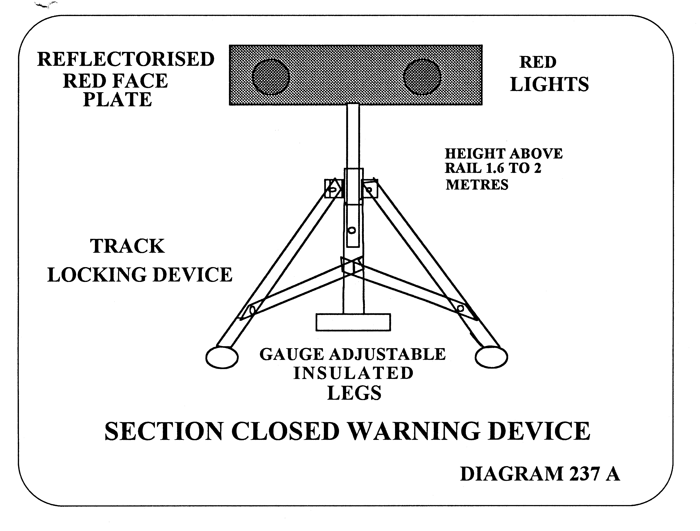
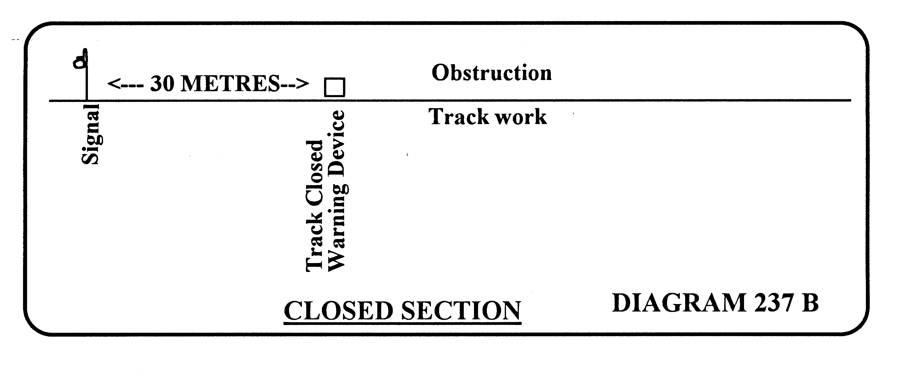

238. PRECAUTIONS WHEN REPAIRING THE LINE AND REDUCED SPEED IS NECESSARY
(1) Where it is necessary for a train to travel at reduced speed because of track maintenance work or for any other cause, the employee in charge of the work must —
(a) send a person back to place 2 detonators on every rail 20 metres apart at 1500 metres from the work area and one detonator on every rail at 2000 metres from the work area; and
(b) locate a Flag Attendant at 1500 metres to exhibit a yellow hand signal as shown in rule 234(3) for an approaching train to proceed through the work site at a reduced speed,
but, where the distance for the placing of detonators in accordance with paragraph (a) falls within 50 metres of any road crossing, pedestrian crossing or platform, then the person carrying out the protection shall extend the distance for placing the detonators to a distance of 50 metres beyond any road crossing, pedestrian crossing or platform.
(2) Where the necessity for trains to travel at reduced speed continues for a lengthy period —
(a) the Head of the Operations Branch may dispense with the placing of detonators and provision of a hand signal as described in sub-rule (1) of this rule; and in this case must ensure that special permanent way “Warning” boards and “Caution” boards are fixed not less than 1 500 metres and 20 metres respectively, from the place to be protected, in both directions on single lines and on double line when both up and down mains are affected; (See diagram on following page); and the boards must remain in place until the need for the speed restriction no longer exists; and
PLACING OF WARNING CAUTION and TERMINATING BOARDS
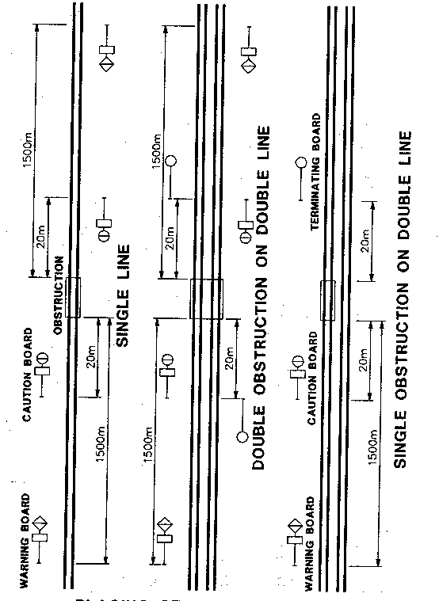
WARNING, CAUTION & TERMINATION BOARDS
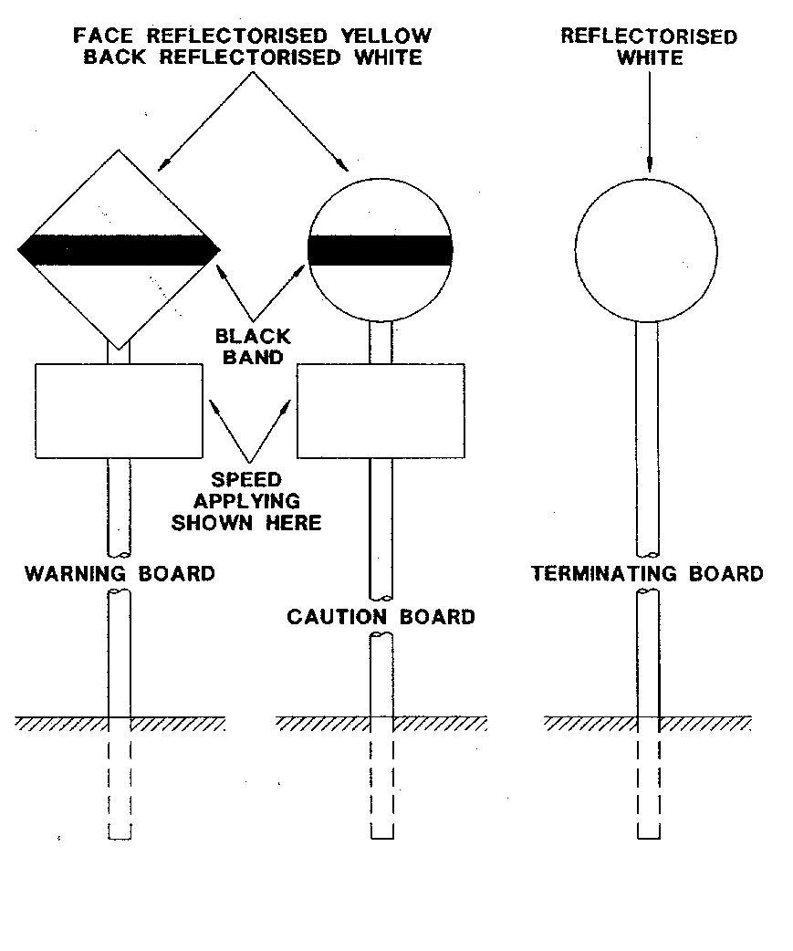
(b) where “Warning” boards and “Caution” boards are used —
(i) they must be exhibited in such a position as to be clearly seen by Drivers;
(ii) speed boards, indicating the maximum speed applicable between “Caution” board and terminating board must be affixed to both the “Warning” and “Caution” boards; (See diagram on previous page).
(iii) on double lines a terminating board similar in size and shape to a “Caution” board, but painted white, must be erected 20 metres past the point being protected, to indicate where the speed restriction terminates;
(iv) on single lines, the “Caution” board facing in the opposite direction indicates where the speed restriction terminates.
(3) A Driver must not increase speed until the whole of the train has passed beyond the limits of a restriction under this rule.
(4) Permanent Way Warning and Caution Boards must only be brought into use after due notice has been given in the Weekly Notice or other notice, indicating the position of those boards, and the places to which they refer.
(5) In the case of permanent speed restrictions, the printed directions in the Working Timetable are a sufficient warning to Drivers.
(6) The employee in charge must keep the distances between “Caution” boards to a minimum and when necessary must move them to suit the work area as it progresses.
[Regulation 238 amended in Gazette 19 September 1997 p. 5297.]

239. PROTECTION OF WORKS WITHIN STATION LIMITS
(1) Where it is necessary to protect the line as described in rules 236 and 238 of these rules within the limits of any station or junction —
(a) the employee in charge must first advise the Signal Operator or Train Controller;
(b) the Signal Operator using blocking facilities must keep the signals applying to the line about to be obstructed at Stop until advised by the employee in charge that the line is again clear and safe for traffic; and
(c) the employee in charge must also protect the operations in accordance with rules 236 and 238 of these rules.

240. UTILISATION OF TRACKWORK SIGNS IN LIEU OF FLAG ATTENDANTS FOR PROTECTION OF TRACKWORKS ON SINGLE LINES
(1) The use of trackwork signs is permitted in lieu of Flag Attendants see Rule 236 on single lines of railway only.
(2) Trackwork signs must not be used for the protection of on-track machines, except in Train Order territory when the section is closed by the District Engineer for the purpose of carrying out works.
(3) Trackwork signs and detonators must be used to afford protection and their description and location are as follow —
(a) Stop Sign. Rectangular board, 70cm x 40cm. Red reflectorised background, black lettering, placed 200 metres on the approach side of the obstruction with three detonators on every rail placed 20 metres apart and 100 metres on the approach to the Stop Sign (see diagram on following page).
(b) Work Sign. Rectangular board, 70cm x 40cm. Yellow reflectorised background, black human stick emblem, placed 1400 metres on the approach to the obstruction, with two detonators on every rail placed 20 metres apart and 100 metres on the approach to the Work Sign (see diagram on following page).
(c) One detonator must be placed on each rail at 2000 metres from the obstruction.
(4) Protection is to be provided similarly on each side of the obstruction on the line.
(5) The employee in charge of works must advise the Train Controller before placing the signs.
(6) In the event of the detonators being exploded and the obstruction still exists, the detonators must be renewed immediately.
(7) The employee in charge of the civil operations is to nominate an employee who must meet each train at the Stop Sign and exhibit a hand signal or pilot the train if necessary.
(8) The Driver of an approaching train must, on arrival at the Work Sign, reduce the speed of the train and be prepared to bring the train to a stand at the Stop sign.
(9) The train must remain stationary at the Stop Sign until given permission to proceed. In the event of an employee not being in attendance at the Stop Sign the Driver must send the Driver’s Assistant forward to investigate the situation who must then report back to the Driver accordingly.
(10) The work site must not exceed 200 metres from the Stop Sign applicable to an approaching train.
(11) The employee in charge of the Civil operations must arrange for the resiting of the Work and Stop Signs as often as necessary in order to comply with subrule (10) of this rule.
(12) When the work is completed for the day the employee in charge must advise the Train Controller that work has ceased and the line is unobstructed and all trackwork signs have been removed.

241. TIMES FOR EFFECTING REPAIRS
The times for effecting repairs, which involve the stopping of trains must where possible be so selected as to interfere as little as possible with the passage of traffic.

242. ORDERS RELATING TO TIME OF RUNNING BALLAST TRAINS
A person in charge of a ballast train must obey the orders of Station Officers, Inspectors, Train Controllers and Signal Operators in so far as those orders relate to the time of the train running on the line.

243. RESERVED
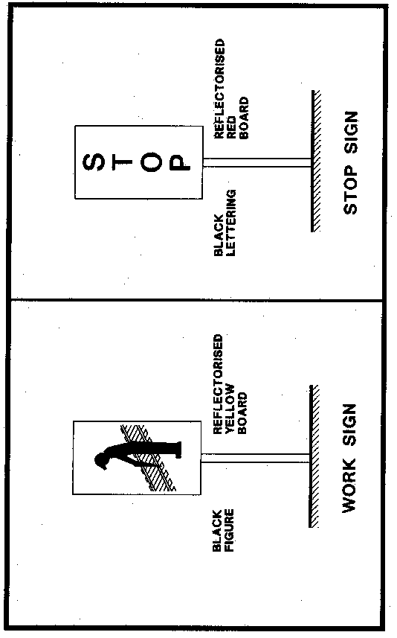
LOCATION OF TRACKWORK SIGNS IN LIEU OF FLAG ATTENDANT
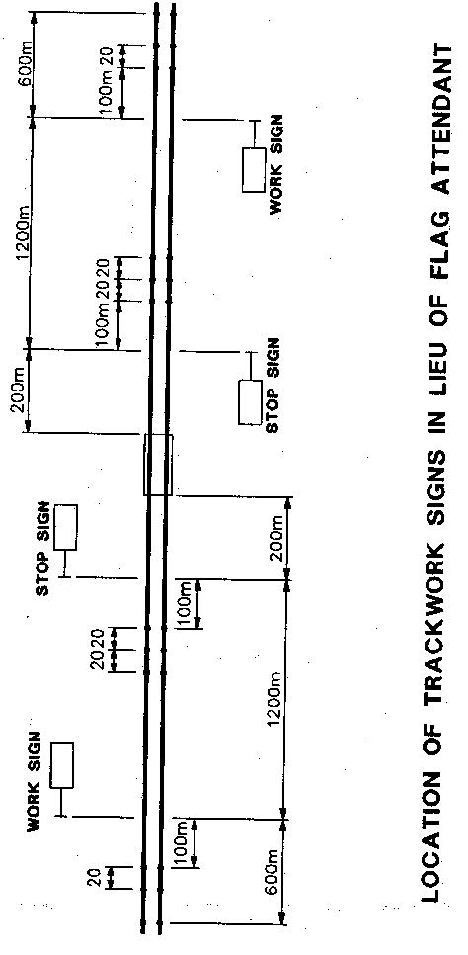

244. ACCIDENTS TO TRAINS OR FAILURE OF WORKS AFFECTING SAFETY OF LINE
(1) In the case of any accident to a train or failure of any part of the works affecting the safety of the line, the employees concerned must —
(a) immediately protect the section of the line affected in accordance with rule 236.
(b) inform the Train Controller where the accident or failure has occurred; and
(c) advise the District Engineer or Inspector of Permanent Way.
(2) Any accident involving personal injury must be reported immediately to the District Engineer.

245. ARTICLES TO BE CARRIED BY LENGTH RUNNERS
(1) Every Length Runner or other employee using a road/rail vehicle to examine the line, must carry —
(a) one red and one yellow flag;
(b) at least 36 detonators;
(c) Road/Rail Vehicle Driver’s Advice Forms (SW20);
(d) Warning to Driver Forms (SW21).
(2) A walking Length Runner must carry one red and one yellow flag and 12 detonators.

246. BLASTING NOT PERMITTED WITHOUT AUTHORITY
A person must not permit blasting on the railway reserve without the authority of the District Engineer.

247. SAFETY OF WAY AND WORKS DURING ADVERSE WEATHER CONDITIONS
(1) Inspectors in charge of lines or any works connected with them, Track Supervisors and Length Runners must use extreme vigilance as to the safety of the line and works during wet weather, thunderstorms, when floods may be expected, or extreme heat conditions.
(2) Inspectors, Track Supervisors and if necessary, other employees, must be on duty so long as floods may be expected, and must inspect every doubtful part of their length, before the passing of any train, in sufficient time to stop it when necessary, and the inspection must be continued until all danger from flood or slip is past.
(3) A Track Supervisor must report to the Inspector from time to time the height of floods, mark the level of floods and at once report any damage to culverts, bridges and other structures.

248. UNCONTROLLED FIRES
In the event of any uncontrolled fire occurring on or near the line —
(a) the employees working on the line must, as soon as they can safely leave that portion of line on which they are working, take immediate measures for putting the fire out;
(b) where damage is caused to departmental structures or to private property adjoining the railway the circumstances must be reported with all details on the form provided.

249. DUTIES OF TRACK SUPERVISORS
(1) A Track Supervisor must —
(a) keep all tools, implements and detonators, when not in use, locked away in a building or boxes;
(b) ensure the safety of the line by replacing all faulty rails, fastenings and sleepers promptly with sound materials;
(c) keep tools, equipment and material at least 3 metres from the nearest rail; and
(d) except where an authorised apparatus is provided to give warning of trains, arrange for off-track mechanical plant within 3 metres of a rail to be protected in accordance with rule 233(1) of these rules.
(2) Any case in which a driver disregards a signal or warning device must be reported to the Inspector of Permanent Way, and District Engineer.

250. MATERIALS FOUND ON LINE TO BE COLLECTED
(1) Each Track Supervisor must ensure that any equipment, other materials or goods found on the line are collected and conveyed to the nearest attended station promptly.
(2) A person must not sell or in any way dispose of sleepers, timber or material of any description without the authority of the District Engineer.

251. EMPLOYEES NOT TO REMAIN ON RUNNING LINES WHEN TRAINS APPROACHING
(1) When a train is approaching, Track Attendants and other employees at work on the permanent way must not remain on any running lines, nor between them, if the space is less than 4 metres between the inner rails of the two lines, but must at once move clear of all lines unless they can distinctly see that they are in a position of safety, and are in no danger from another train approaching them unobserved; and the employees must stop in the positions of safety until the train has cleared a sufficient distance to enable them to see that no train is approaching on other adjacent lines before they re-cross the rails.
(2) Where circumstances compel employees to remain in the space between trains passing on adjoining lines, they must lie down.
(3) Where employees are working in a tunnel —
(a) when trains are approaching in both directions on double lines they must, if unable to reach a recess in the walls lie down either in the space between the two running lines or between the line and the side of the tunnel until the trains have passed, and on single lines if unable to reach a recess lie down between the line and the side of the tunnel until the train has passed;
(b) every employee must become acquainted with the width of space in order that the place which affords greatest safety may be selected.
(4) Drivers must sound the locomotive or railcar horn before entering and while passing through tunnels.

252. PERSONS ON BALLAST TRAINS TO BE WARNED BEFORE MOVING
(1) Where a ballast train has to be moved while persons are in the wagons —
(a) the Track Supervisor must arrange to warn the persons;
(b) the Driver must sound the locomotive horn (one short blast) before wagons are moved; and
(c) the Driver must sound the locomotive horn (three short blasts) before reducing speed, preparatory to stopping.

253. DRIVERS TO BE INFORMED OF OPEN DOORS
Any employee noticing doors of wagons open or chains or lashings hanging loose, or any loading in an unsafe position on an approaching train must draw the attention of the Driver to the fact by hand signal or radio and if unable to advise the Driver must inform the Train Controller.

254. PERMANENT WAY AND ROADS IN YARDS TO BE LEFT IN SAFE CONDITION
Except in cases where it is unavoidable, a Track Supervisor must ensure that any tracks in station yards which have been opened out during the day for the purpose of repairs are filled in and ballast levelled off before leaving the area (so that shunters and others will not be exposed to unnecessary danger); and where this cannot be done, notify the Operations Branch employee in charge.

255. CLEARANCES MUST BE MAINTAINED
(1) When a line is lifted or slewed through sheds, over bridges, alongside platforms, structures, under contact wires or alongside other lines, the clearances shown on the Diagram of Clearance must be maintained.
(2) In electrified territory the authority of the engineer in charge of the overhead line must be obtained prior to lifting or slewing the line beyond laid down tolerances.

256. SECTIONS UNFIT FOR ORDINARY TRAFFIC
(1) Where any section of railway is rendered unfit for ordinary traffic through washaways or other exceptional cause, or because repair or maintenance work is to be undertaken, the District Engineer may close the section by means of a telegram.
(2) Immediately on receipt of notice of closure the Train Controller must —
(a) on single line automatic signalling sections, arrange removal of the half pilot keys from each end of the affected section by a qualified employee who must retain possession of them until the section is re-opened;
(b) on double line automatic signalling sections, arrange to have blocking facilities applied to the starting signals which must be kept at Stop; and ensure 3 detonators are placed on every line 20 metres apart at the entrance to the section as laid down in Rule 236(4) of these Rules;
(c) in Train Order Territory issue a Train Order to the Train Controller for the section affected in accordance with rule 99 of these rules.
(3) Any train required for ballast or other work in the closed section must operate under instructions of the Track Supervisor in charge of the work, and no other trains are to enter the closed section.
(4) As soon as the line is fit for traffic and all work trains clear of the section, the District Engineer must send a telegram to re-open the section for working of traffic in accordance with the rules governing safeworking.
(5) On receipt of notice that the section is open the Train Controller must —
(a) arrange replacement of half pilot keys; or
(b) arrange removal of blocking facilities and detonators; or
(c) endorse the Train Order “Fulfilled”.

257. RESERVED.

258. TRAIN INFORMATION FORMS
(1) All employees, or employees in charge of groups of workers, who require to occupy any running line, or who are required to work so close to any running line as to be in danger from passing trains, or who by the nature of that work may obstruct or endanger passing trains must obtain up to date train running information on the prescribed train information form. (SW 23).
(2) Possession of a train information form does not constitute authority to occupy a running line, and authority to occupy a running line must first be obtained from the Train Controller, or Signal Operator in charge of Safeworking for the section concerned.
(3) Inspectorial staff and other personnel such as small inspection and survey parties, of four or less employees, who are required to enter upon a running line or work in close proximity to a running line, but who by virtue of the nature of their work do not present a danger or obstruction to passing trains, do not require possession of a train information form.
(4) Employees as described in sub-rule 3, must be constantly alert to danger, and must be prepared to expect the passage of a train at any moment while working in close proximity to the running line.
(5) Larger groups comprising more than four employees who require to enter upon the running line or work in close proximity to a running line but who by virtue of the nature of their work do not present a danger or obstruction to passing trains must be accompanied by a lookout in possession of a train information form who must maintain a constant look out and ensure the running line is clear for the passage of trains. Special care must be taken when occupying both lines in double line sections, and if necessary, a separate lookout should be provided for the protection of each line.
(6) The requirement to obtain up to date train running information shall apply whether occupancy of the running line is inside or outside station limits.
(7) Train information must be obtained on the prescribed form from the Train Controller or Signal Operator in control of the section concerned and must be obtained by telephone, radio, application in person, or where provided, by facsimile transmission.
(8) Where the train information form is obtained by the facsimile machine, acknowledgement by the recipient to the sender is not required, however, employees receiving train running information in this manner must take particular notice of the numbers (1) to (11) printed on the left hand margin of the form and ensure that every line has been correctly received during the transmission.
(9) Except in the case of the metropolitan electrified Area, the train information form must include details of all trains which run on any section between 0600 hours and 1800 hours Monday to Friday of each week. Where work is to take place outside these hours, details of all trains running during the proposed work period must be shown on the train information form.
(10) In the metropolitan electrified area details of the suburban passenger train services are contained in Working Timetable Book No 2 and will not be shown on the train information form however, every employee or employee in charge of a group of employees when requiring train running information must have in their possession an up to date copy of Working Timetable Book No 2. All special and tabled trains not included in Working Timetable Book No 2 and ANY train running 10 minutes or more before or 30 minutes or more later than tabled must be shown on the train information form.
11. The information shown on the train information form must be updated at intervals of not more than three hours or as often as directed by the Train Controller, or Signal Operator in charge of Safeworking for the section concerned. In the case of Track Supervisors and other track employees, train running information must be obtained: —
(a) On commencing duty.
(b) At 1030 hours.
(c) Prior to commencing work after the lunch break.
(12) On arrival at the worksite and before occupation of the running line, the employee in charge of the work must communicate with the Train Controller, or Signal Operator in charge of Safeworking for the section where occupation is required and verify that the details shown on the train information form are current, and permission is granted for work to commence.
(13) In isolated areas, where direct communication would not be available with the Train Controller, or Signal Operator from the worksite, approval to occupy the track may be obtained from the nearest station or siding where suitable communication facilities are available.
(14) The Train Controller, or Signal Operator when giving authority to occupy the running lines must advise the employee in charge of the work as to the exact time that occupation must be terminated and the running lines cleared for the normal passage of trains.
(15) All employees must strictly obey the time allocated for completion of the work to avoid delays to trains, however, where circumstances dictate that work will not be completed within the time allocated and an extension is required, the employee in charge of the work must contact the Train Controller, or Signal Operator as soon as a delay becomes evident and request an extension to complete the work.
(16) On completion of work, the employee in charge must contact the Train Controller, or Signal Operator and advise that work is complete for the day or that work is to continue at the same or a new location.
(17) On arrival at a new location the employee in charge must carry out the instructions as indicated in sub-rule 12 or 13 of this rule.
(18) When work is to be carried out outside the recognised working hours it will be the responsibility of the Track Supervisor, or employee in charge, to obtain a train information form.
(19) There are two train information forms, viz: —
(a) form A (SW 22).
(b) form B (SW 23).
(20) Train information form “A” is consecutively numbered in the top right hand corner of the form with an original only and is completed by the Train Controller who compiles the information and prepares the form.
(21) Train information form “B” is not numbered, and is compiled by employees requesting train running information with an original, and as many copies as required.
(22) When preparing train information form “B", sufficient copies should be compiled to enable one copy to remain on file at the Depot or Station for perusal by Inspectors.
(23) Except in the case of facsimile transmission where acknowledgement is not required, the person receiving the train information form “B” must acknowledge its receipt by repeating the information word for word and numeral for numeral back to the sender.
(24) Down trains are to be grouped separately from up trains.

259. RESERVED

260. RESERVED
PART 3
RULES FOR ON TRACK MAINTENANCE MACHINES
AND RECORDER CARS

261. ON TRACK MAINTENANCE MACHINES, AND RECORDER CARS — SIGNALLING OF
(1) Rules 261 to 263 do not apply to small machines placed on and off track by hand or lifting equipment on site, such as resleepering plant.
(2) For the operation of road/rail vehicles see rules 211 to 227 of these rules.
(3) Prior notice must be given in the Weekly Notice or by Special Train Notice Telegram when on track maintenance machines or recorder cars are to run or work on a running line.
(4) Before an on-track maintenance machine or recorder car is placed on the running line the employee in charge of the machine or car must obtain the permission of the Train Controller or Signal Operator. When the machine or car is again clear of the running line the employee in charge must so inform the Train Controller or Signal Operator.
(5) The amber rotating light on vehicles and machines so equipped must be operating whenever the vehicle or machine is occupying the running line.
(6) Before these machines or vehicles pass over level crossings —
(a) if the crossing is protected by automatic warning devices, the crossing must be protected by a Flag Attendant or the warning device must be activated manually; and
(b) at all other level crossings the machines or vehicles must reduce speed sufficiently to enable them to be stopped short of any obstruction and must not proceed over the level crossing in the face of an approaching road vehicle.
(7) If the employee in charge of the machine or vehicle is unfamiliar with the signalling at an interlocked station such person must be piloted by an employee who is familiar with the signalling.
(8) These machines or vehicles cannot be admitted to sidings controlled by a fully automatic switchlock.
(9) Where it is necessary for two or three on track maintenance machines to travel through a section together —
(a) a minimum distance of 200 metres and a maximum distance of 400 metres must be maintained between machines;
(b) a qualified employee must ride on the leading machine and maintain radio contact with the following machines;
(c) the driver of each machine shall be responsible for maintaining a safe distance between that machine and the one ahead, and ensuring the instructions for level crossings are obeyed;
(d) not more than three machines may travel in this manner together;
(e) the qualified employee must ensure that ALL machines are clear of the running line before advising the Signal Operator or Train Controller.

262. ON TRACK MAINTENANCE MACHINES, AND RECORDER CARS PROCEEDING THROUGH SECTION WITHOUT STOPPING FOR WORK ENROUTE
(1) When an on-track maintenance machine or recorder car is to proceed through a section without stopping for work enroute it must —
(a) be accompanied by an employee qualified in the safeworking system for the section concerned and who will be in charge of the machine or vehicle for safeworking purposes, and
(b) have the authority for the section, and
(c) be equipped with a portable telephone and radio, flags, disc, detonators and applicable safeworking forms.
(2) On double line automatic signalling sections the employee in charge of the vehicle or machine must report its arrival and departure to the Train Controller or Signal Operator from each interlocked station and shall proceed on signal indication. The Train Controller or Signal Operator must apply “blocking” facilities to maintain absolute block behind the vehicle or machine, between interlocked stations, and ensure home and starting signals are placed at Stop behind it.
(3) On single line automatic signalling sections operated by Centralised Traffic Control the employee in charge of the vehicle or machine must report its arrival and departure to the Train Controller or Signal Operator from each interlocked station or junction, and shall proceed on signal indication. The Train Controller or Signal Operator must apply “blocking” facilities to ensure no train is permitted to enter the section from either end until the vehicle or machine has passed out of the section, and must ensure home and departure signals are placed at Stop behind it.
(4) The employee in charge of the vehicle or machine must report “arrival” at interlocked stations after passing the home signal and must report “departure” after passing the departure signal or starting signal, so that the Signal Operator or Train Controller can restore such signal to stop. The Signal Operator or Train Controller may place the home signal to proceed for a following train to enter the station after receiving advice that the machine or vehicle has passed the departure or starting signal and the Signal Operator or Train Controller has restored such signal to stop.
(5) Where signals are approach-lit and do not exhibit an aspect to the machine or vehicle the Train Controller or Signal Operator must advise the employee in charge of the machine or vehicle of the aspect that should be displayed.
(6) In the event of signal failure which prevents the departure signal exhibiting a proceed aspect, or in the case of an approach lit departure signal a proceed aspect is not indicated on the Centralised Traffic Control panel or screen, the employee in charge of the machine or vehicle must be in possession of a proceed order or the pilot key in order to traverse the section.
(7) On the single line automatic signalling sections not operated by Centralised Traffic Control the section concerned must be closed and the half-pilot keys removed from the relevant departure signals at both ends of the section prior to passage of the machine or vehicle.
(8) To facilitate passage of the machine or vehicle through two or more consecutive sections the Area Manager, provided there are no trains in the sections concerned, may authorise the removal of the half-pilot key from the relevant departure signal at the station from which the machine or vehicle commences its movement, or from a convenient station in the rear of the commencing station, again provided there is no train in those sections and the halfpilot key from the opposing departure signal at the station at which the machine or vehicle terminates its movement. In these circumstances the half-pilot keys at stations enroute are not removed.

263. ON TRACK MAINTENANCE MACHINES AND RECORDER CARS STOPPING FOR WORK IN A SECTION
(1) When an on-track maintenance machine or recorder car is required to stop for work enroute the Construction Engineer or District Engineer must ensure that the machine or vehicle is properly protected by one of the following methods:
(a) closure of the section, or
(b) use of Flag Attendants and detonators in accordance with Rule 236 of these rules; or
(c) by use of an employee in charge of the machine who is qualified in the safeworking system for the section concerned and who is in possession of a train order or the pilot-key for the section.
(2) The Construction or District Engineer must confer with the Operations Manager or Area Manager in determining the method to be adopted for protection of the vehicle or machine.
(3) The Construction or District Engineer is the person responsible for ensuring that the protection is adequate and properly maintained on every occasion.
(4) Whenever a machine or vehicle referred to in this rule is occupying a running line within station limits (unless simply passing through a station enroute) the person in charge of the machine must ensure that protection is provided in accordance with Rule 239 of these Rules.
(5) When a pilot key is required, in accordance with sub-rule (1)(c) of this rule, the person obtaining the half pilot keys from each end of the section must obtain the Train Controller’s permission before withdrawing the half pilot-keys and must travel adjacent to the line to ensure no trains have entered the section.
SECTION D

PART 1

DIAGRAMS OF SIGNALS

AND INDICATORS

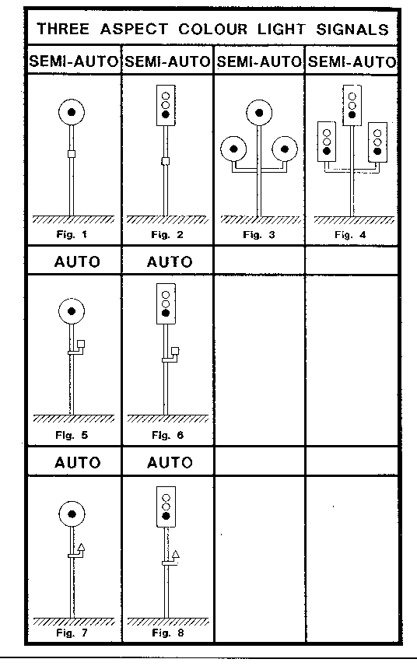
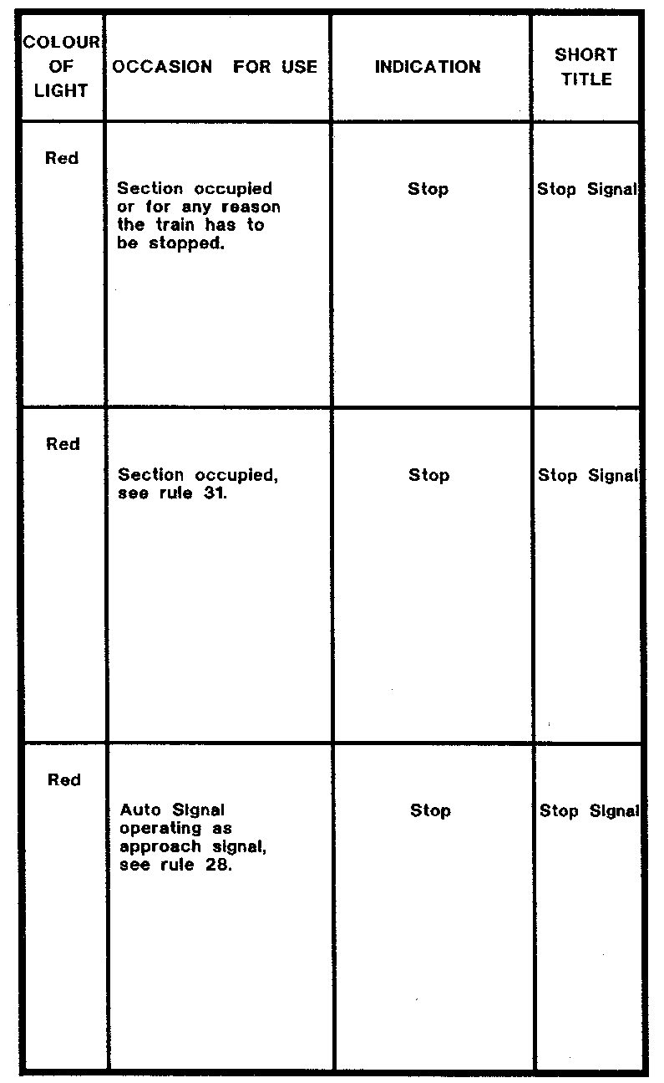
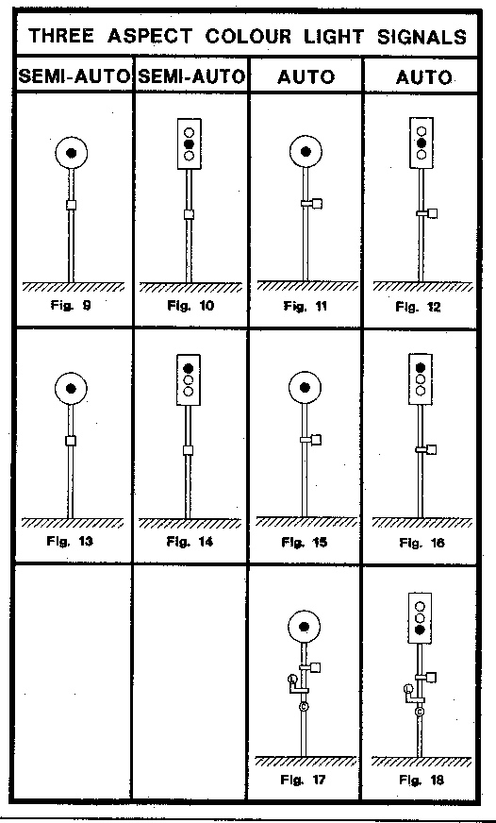
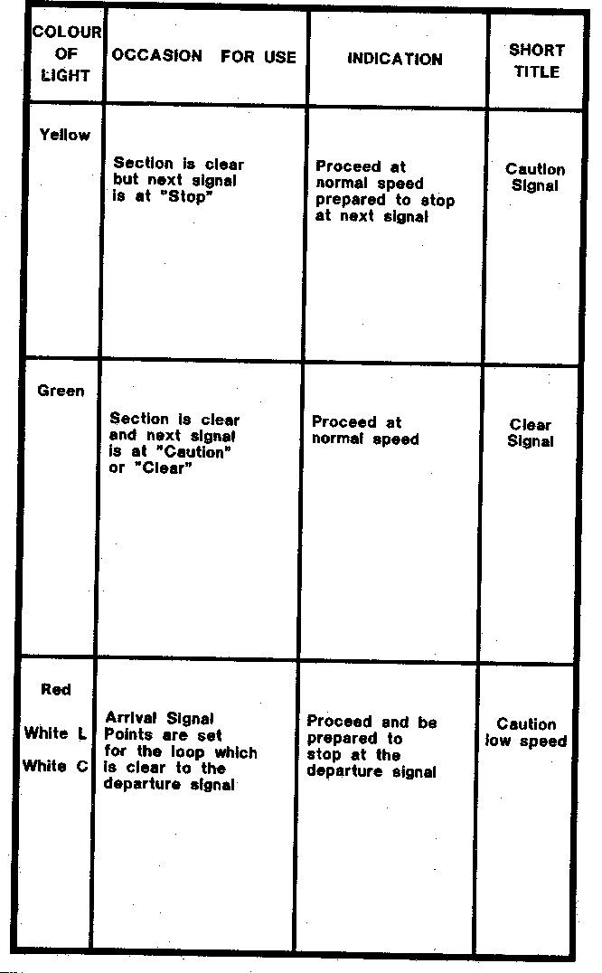
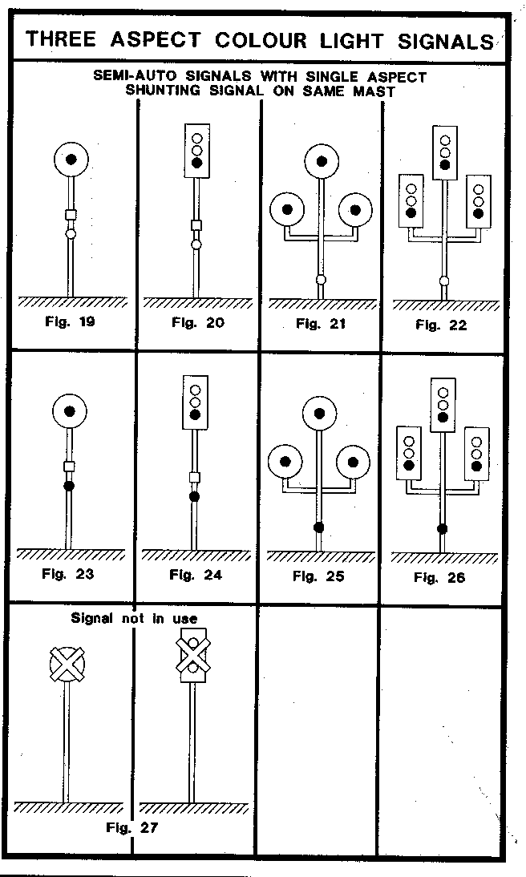
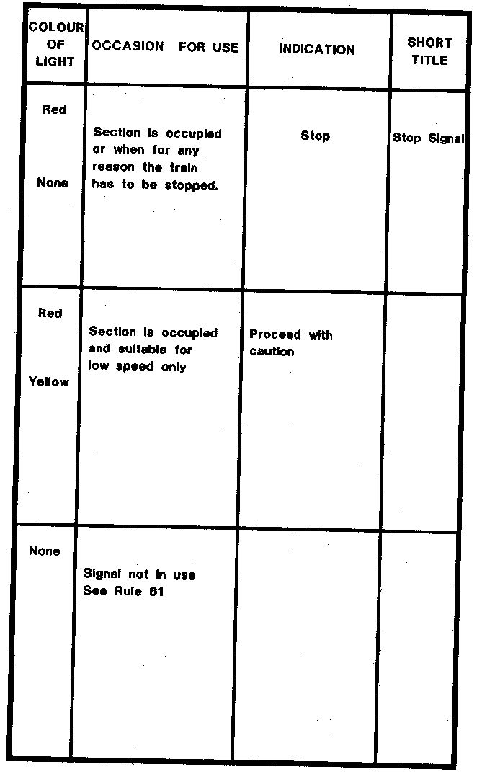
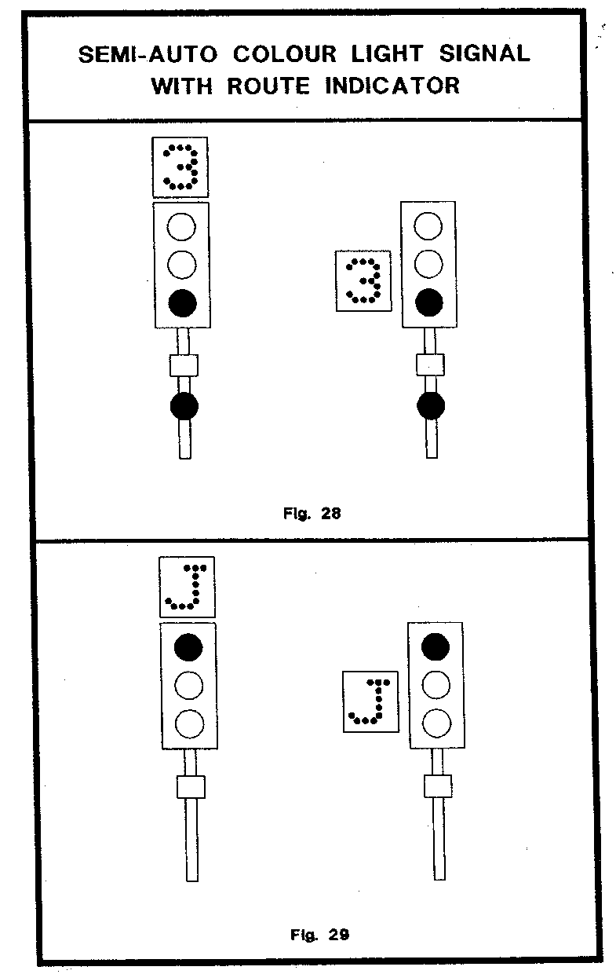
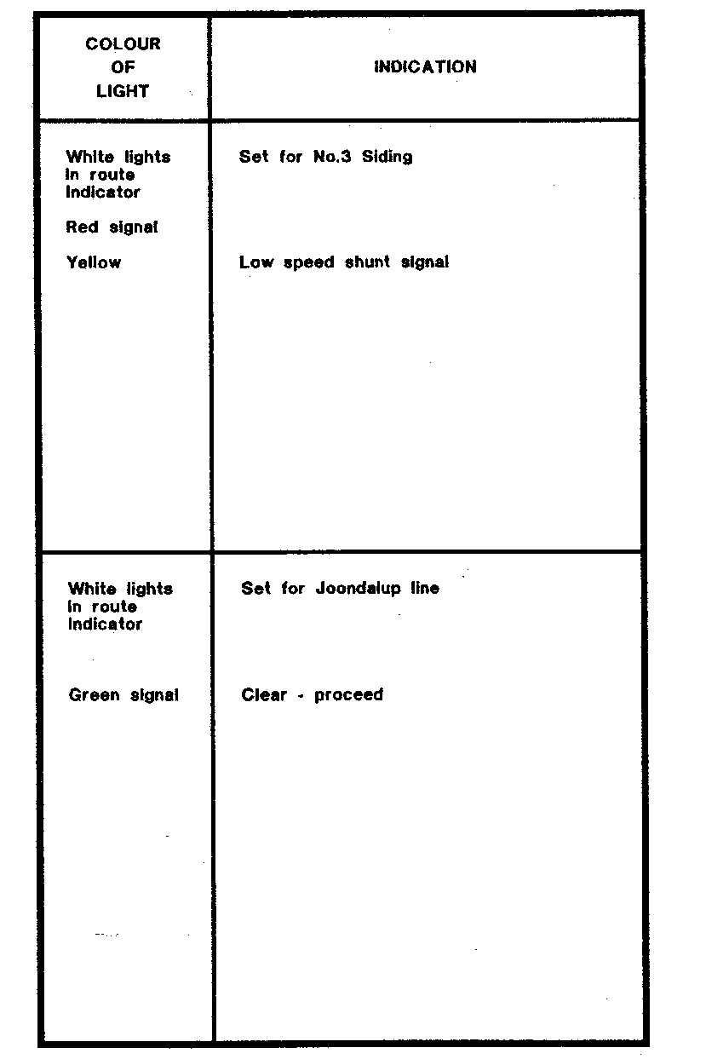
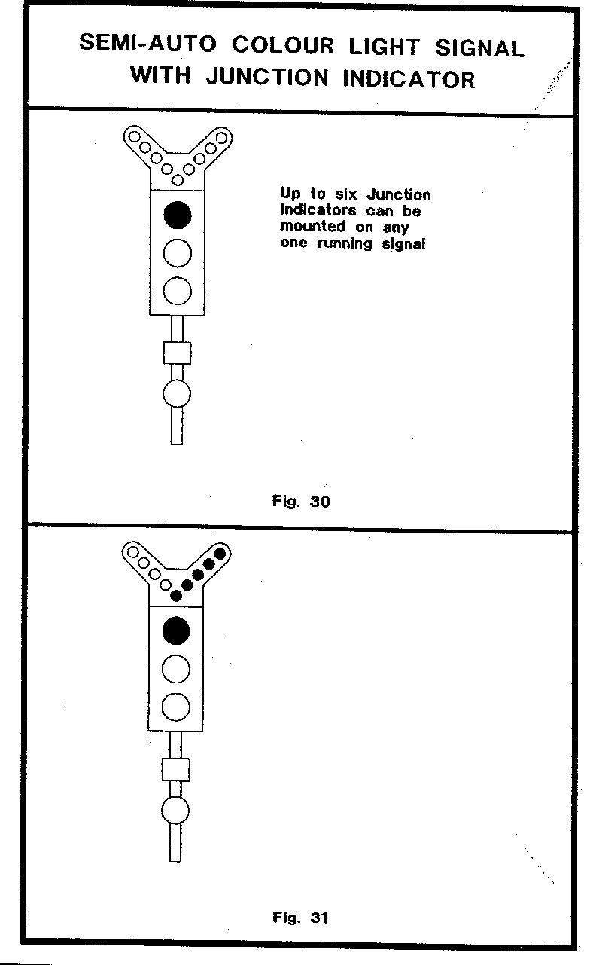
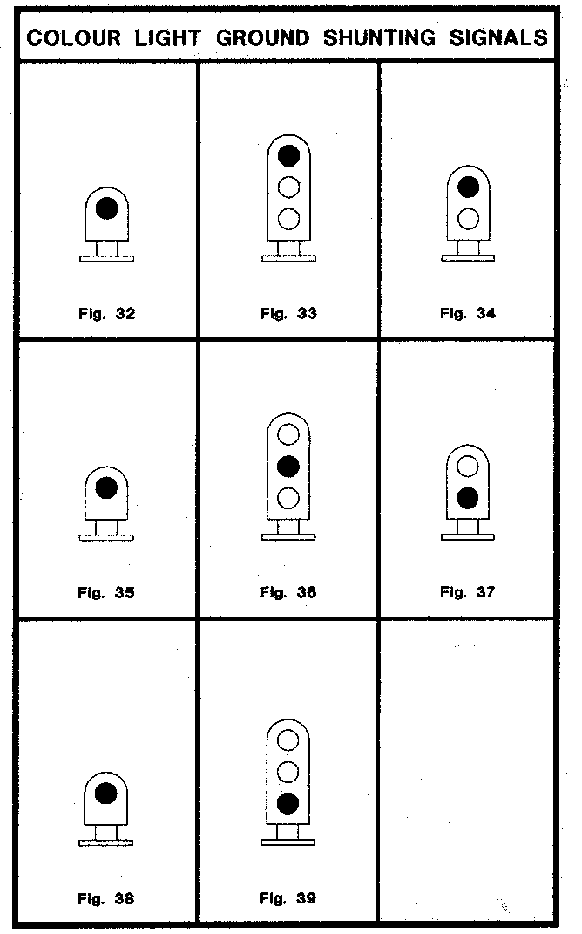
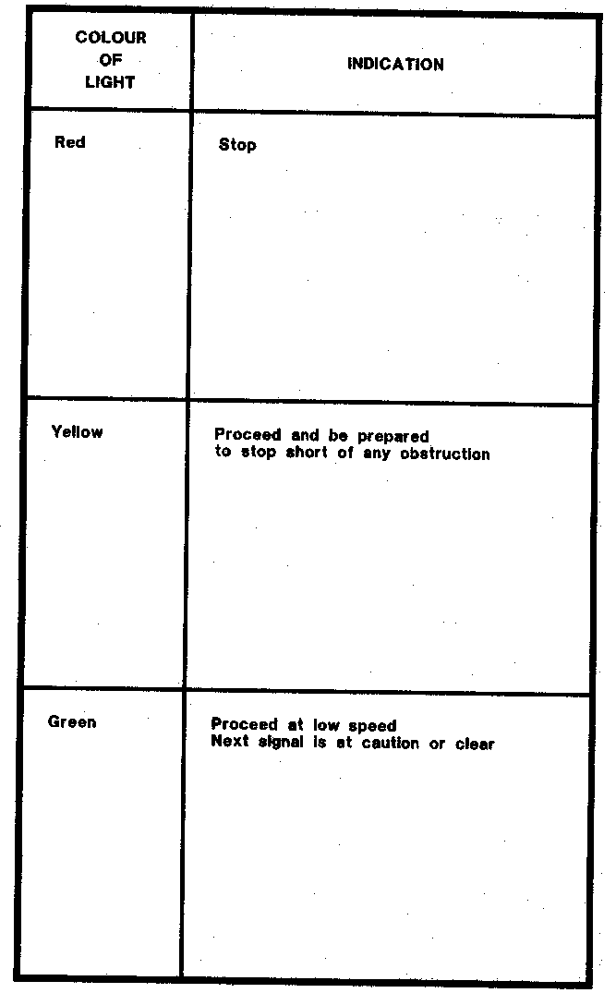
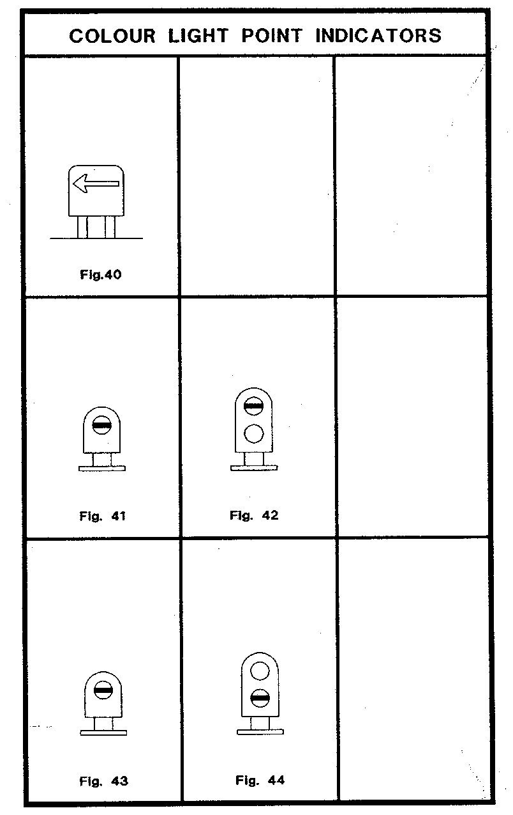
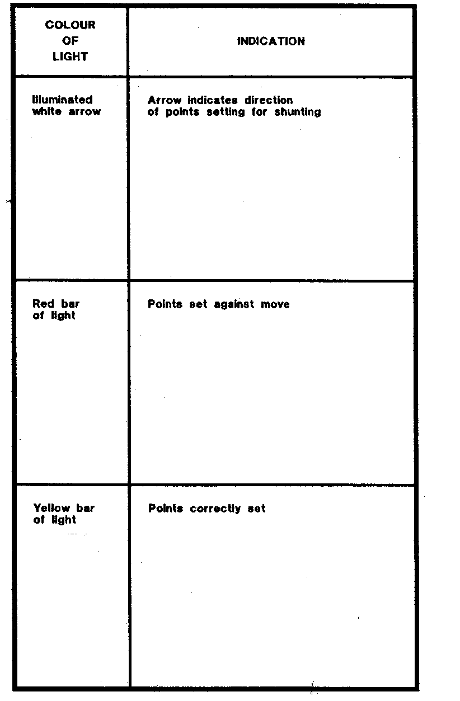
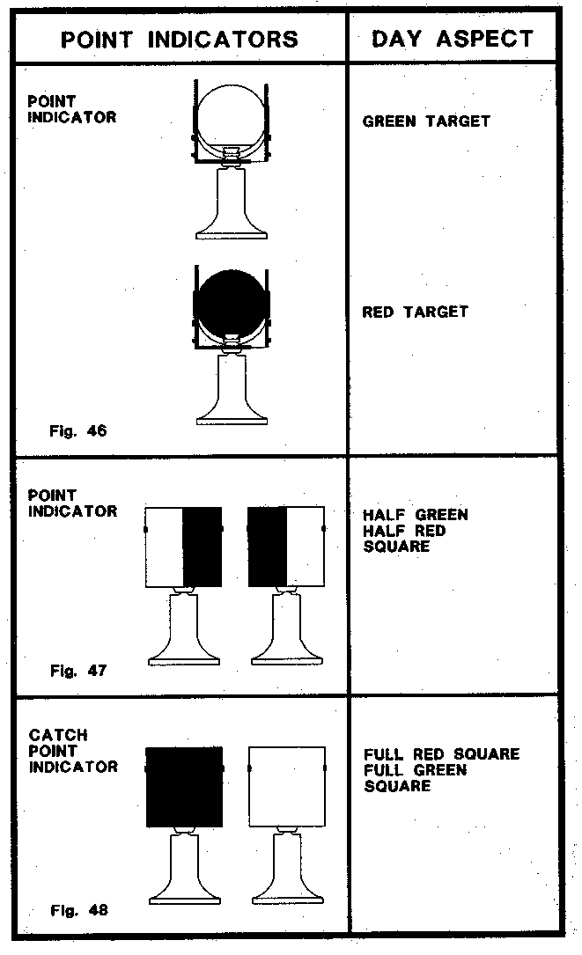
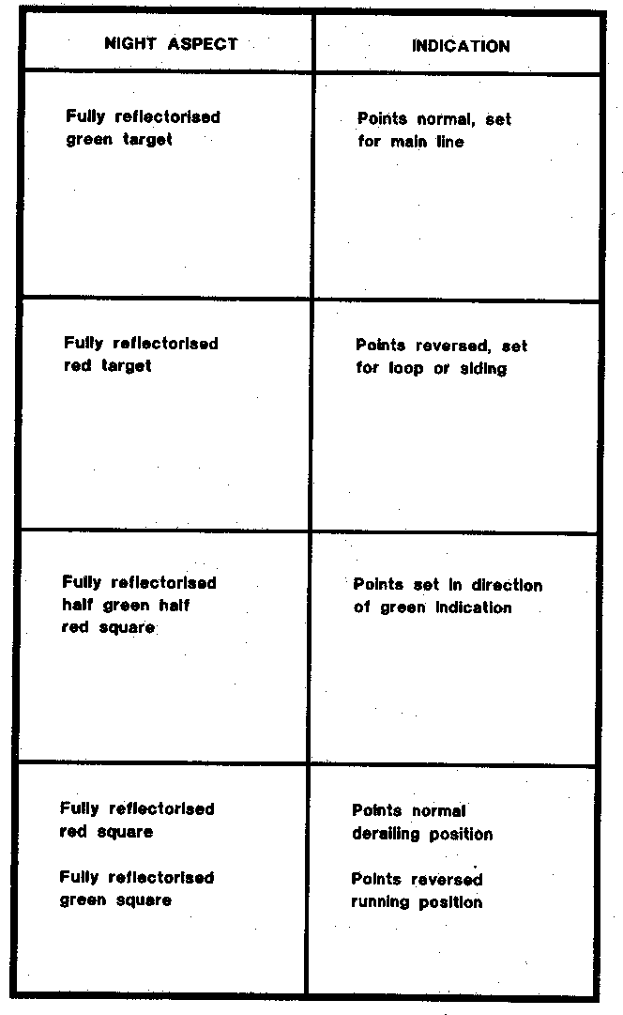
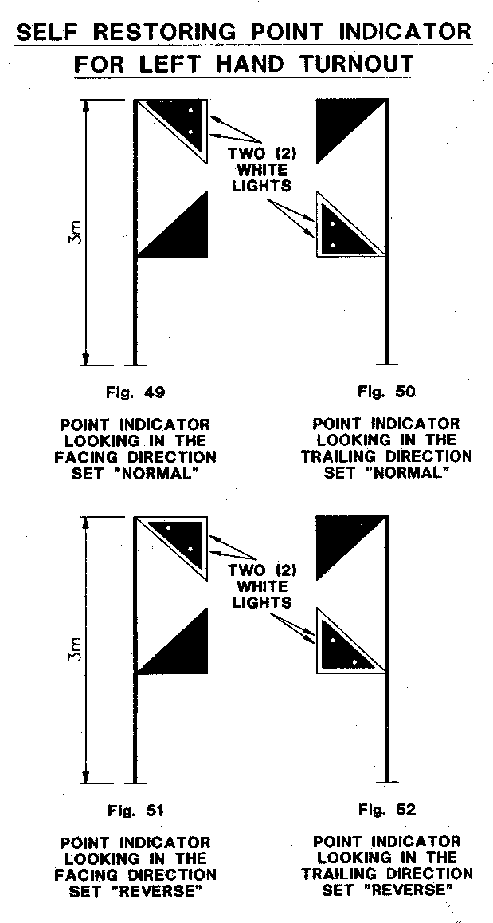
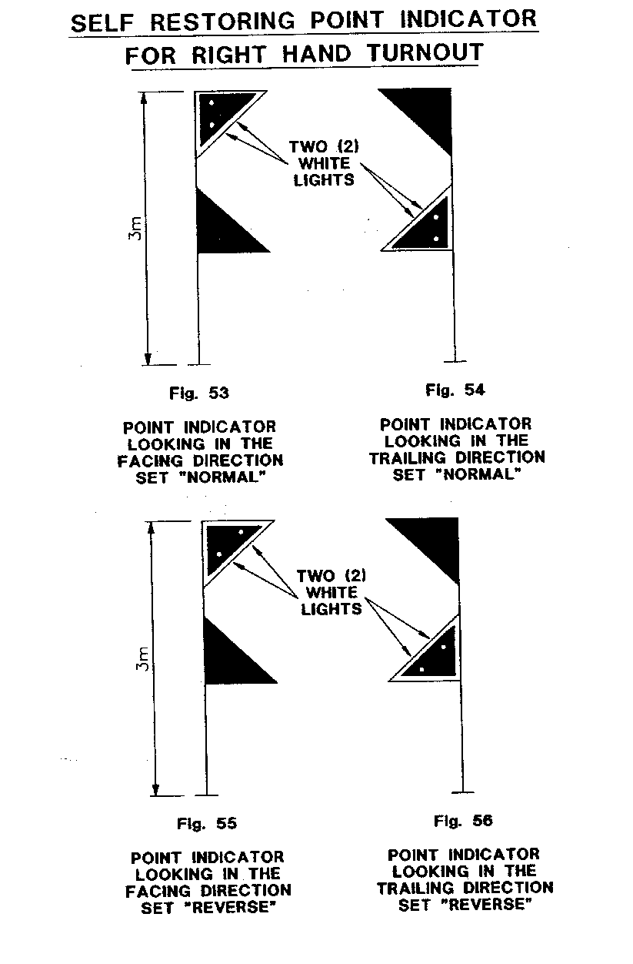
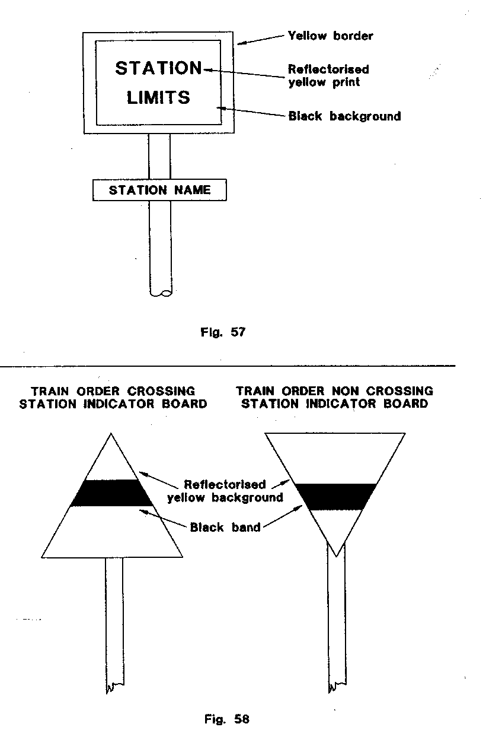
THE SCHEDULE

SECTION D

PART 2

SAFEWORKING FORMS

Form S.W.1 S.W.1
Western Australian Government Railways.
Single Line Automatic Signalling System.
(Form referred to in Rule 110 of the Book of Rules.)
FORM A
From *Signal Operator/Driver Train No.. . . . . . . . . . at . . . . . . . . . station.
To Area Manager . . . . . . . . . . . . . . . . . . . . . . . . . . . . . . . . . . . . . . . . . .
Up *-------- Train No. . . . Loco No. . . . . . is at/approaching * . . . . . . . station
Down
Up *
and --------------- departure signal No. . . . . . . . at . . . . . . . . . . . . . station
Down
will not exhibit the Proceed indication.
The following apparatus applying to the system of single line automatic signalling in operation at this Station has been examined: —
Track indicator shows . . . . . . . . . . . . . . | *occupied/clear
Points properly set . . . . . . . . . . . . . . . . . | *yes/no
Signal lever correctly operated . . . . . . . . | *yes/no
Releasing switch correctly operated . . . . | *yes/no
Motor points crank handle in switch . . . | *yes/no
Motor points crank handle aperture closed and locked . . . . . . . . . . . . . . . . . . | *yes/no
Half Pilot Key in case and turned to "In" | *yes/no
Please issue a Proceed Order for Driver of Train No. . . . . . . . . . . . . .
Loco No. . . . . . . . .
Up *
to pass ---------- departure signal No. . . . . . at . . . . . . . . . . . . . . . . . . . . . Station
Down
in the Stop position.
Time . . . . . . . . . . . . . . . hours
Date . . . . . . . . . . . . . . . 19 . . . . . . .
. . . . . . . . . . . . . . . . . . . . . . . . . . . . . .
* Signal Operator/Driver
* Strike out as necessary.
Information as applicable to be supplied by the Train Controller or the Signal Operator in Charge of a Remote Control System.
(1) Is there a train movement that prevents the signal being cleared?
. . . . . . . . . . . . . . . *yes/no
(2) The last opposing train in the section was No. . . . . . . . . . . . . . . . which left . . . . . . . . . . . . . . . Station at . . . . . . .hours on . . . . . . . . . . . . . . . 19 . . . . . . and arrived at . . . . . . . . . . . . . . . Station at . . . . . . . . . . . .
hours on . . . . . . . . . . . . . . . 19 . . . . . . . .
(3) The next opposing train is No. . . . . . . and it is now at or approaching . . . . . . . . . . . . . . . station.
(4) Has the Driver of this train been issued with Form C if required?
. . . . . . . . . . . . . . . (Form “C” No. . . . . . . . . )
(5) The last train through the section was No. . . . . . . . and it is now at or approaching . . . . . . . . . . . . . . .
(6) Has the last train through the section been checked as complete?
. . . . . . . . . . . . . . . *yes/no
(7) What does illuminated Track Diagram show for the section concerned
. . . . . . . . . . . . . . . . . . . . . . . . . . . . . . . . . . . . . . . . . . . . . . . . . . . . . . .
(8) Did the previous train shunt a switchlocked siding . . . . . . . . . . . . . . . *yes/no
(9) On what line is the train standing? . . . . . . . . . . . . . . . *main/loop/other
(10) What points indication shows? . . . . . . . . . . . . . . . . . . . . . . . . . . . . . . *none/normal/reverse/flashing
(11) Have other departure signals in the same direction been tested?
. . . . . . . . . . . . . . . *yes/no
Result of test . . . . . . . . . . . . . . . . . . . . . . . . . . . . . . . . . . . . . . . . . . . .
(12) Has the departure signal at the opposite end of the section been tested?
. . . . . . . . . . . . . . . *yes/no
Result . . . . . . . . . . . . . . . . . . . . . . . . . . . . . . . . . . . . . . . . . . . . . . . . .
(13) If (10) suggests a points failure have local Staff or Driver operated the points by hand to attempt to clear? . . . . . . . . . . . . . . . *yes/no
(14) Have approach lock releases been operated as necessary?
. . . . . . . . . . . . . . . *yes/no
(15) Items (2) & (3) must be checked with Signal Operator West Kalgoorlie for down trains requiring a proceed order between Koolyanobbing and West Kalgoorlie.
. . . . . . . . . . . . . . . . . . . . . . . . . . . . . . . . . . . . . . . . . . . .
TRAIN CONTROLLER SIGNAL OPERATOR
_______________

* Strike out where not applicable.
_______________

Form S.W.2. S.W.2.
Western Australian Government Railways.
Single Line Automatic Signalling System.
(Form Referred to in Rule 110 of the Book of Rules.)
FORM B - ADVICE OF OPPOSING DEPARTURE SIGNAL.
From *Signal Operator/Train Controller at . . . . . . . . . . . . . . . . . . . . . . . . . . .
To Area Manager at . . . . . . . . . . . . . . . . . . . . . . . . . . . . . . . . . . . . . . . . . . . . .
Up *
Advice has been received that --------- Departure signal No. . . . . . . . . . . . . . . .
Down
at . . . . . . . . . . . . . . . will not exhibit the Proceed indication for train
No . . . . . . . .
The opposing Departure signal at ** . . . . . . . . . . . . . . . . . . . . . . . . . . . . . . . .
will be maintained at Stop, and no train or locomotive will be
permitted to foul the ** . . . . . . . . . . . . . . . . . . . . . . . . . . . . . . . . . . . . . . . . . .
to . . . . . . . . . . . . . . . section until the arrival of No . . . . . . . . . . . . . . . . . . . .
at ** . . . . . . . . . . . . . . . Station.
. . . . . . . . . . . . . . . . . . . . . . . . . . .
*Signal Operator/Train Controller
Time . . . . . . . . . . . . . . . hours
Date . . . . . . . . . . . . . . . 19 . . . . . .
* Strike out where not applicable.
** Here insert station at opposite end of section to which the failed departure signal applies.
_______________

Form S.W.3. S.W.3.
Western Australian Government Railways.
Single Line Automatic Signalling System.
(Form Referred to in Rule 110 of the Book of Rules.)
FORM C
(Serial No.........)
From Area Manager at . . . . . . . . . . . . . . . . . . . . . . . . . . . . . . . . . . . . . . . . . .
To Driver Train No. . . . . . . . . . . Loco No. . . . . . . . . . at . . . . . . . . . . . . . . . station
You are hereby notified that Train No. . . . . . . . . . . . . . . has been */will be *
authorised to pass Up * departure signal No.. . . . . . . . . . at . . . . . . . . . . . . .
---------
Down *
in the Stop position and you must not proceed beyond ** . . . . . . . . . . . . . . . . .
until the crossing with Train No. . . . . . . . . . . . . Locomotive No. . . . . . . . . . . .
has been effected.
Time . . . . . . . . . . . . . . .. . . . . . . . . . . . . . . . . . . . . . .
Area Manager
per Train Controller . . . . . . . . . . . . . . .
Noted by: —
Driver’s Assistant . . . . . . . . . . . . . . .
Repeated Back Time . . . . . . . . . . . . . . . by Driver . . . . . . . . . . . . . . .
* Strike out where not applicable.
** Here insert station at opposite end of section to which failed departure signal applies.
A supply of these forms must be kept by each driver.

_______________

Form S.W.4. S.W.4.
Western Australian Government Railways.
Single Line Automatic Signalling System.
(Form referred to in Rule 110 of the Book of Rules.)
FORM D. — PROCEED ORDER
Authority to pass the Departure signal in the Stop Position.
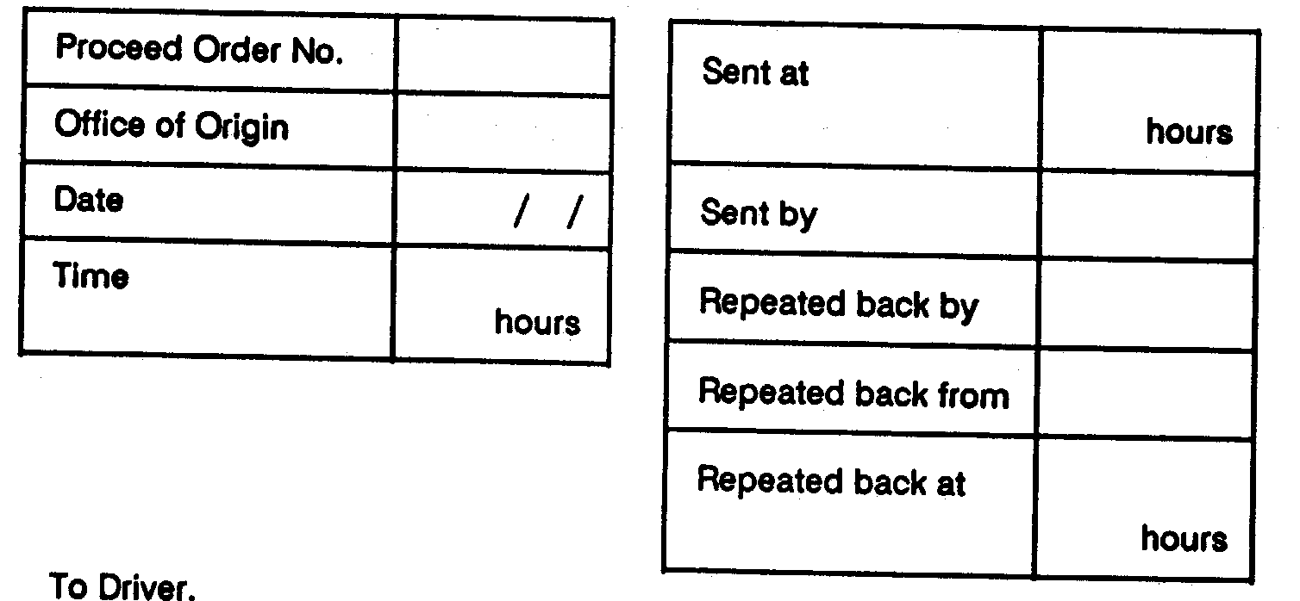
To Driver.
Train No. . . . . . . . . . Loco No. . . . . . . . . . . . . . at . . . . . . . . . . . . . . . . . . . . . .
Today . . . . . . . . . . . . . . . day . . . . . . . . . . . . . . . 19. . . . . . .
Train No. . . . . . . . . . . . Loco No. . . . . . . . . . is authorised to pass the * . . . . .
departure signal No . . . . . . . . . . . at . . . . . . . . . . . . . . . in the Stop position
. . . . . . . . . . . . . . . . . . . . . .
Area Manager.
Per . . . . . . . . . . . . . . . . . . . . . . .
Train Controller.
* Here insert Up or Down as the case may be.

_______________

Form S.W.5 (E Pink).
S.W.5.
Western Australian Government Railways.
Single Line Automatic Signalling System.
(Form referred to in Rule 110 of the Book of Rules)
FORM E. — PROCEED ORDER
AUTHORITY TO PASS THE DEPARTURE SIGNAL IN THE STOP
POSITION
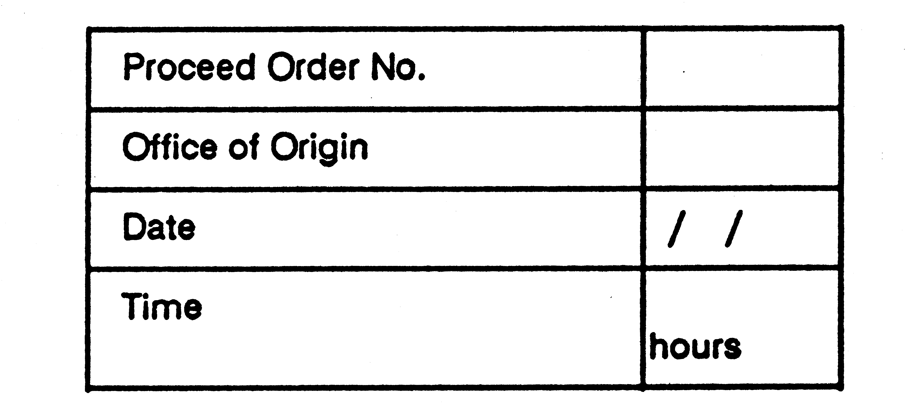
To Driver.
Train No. . . . . . . . . . . . . . . Loco No.. . . . . . . . . . . . . . at . . . . . . . . . . . . . .
Today. . . . . . . . . . . . . . day . . . . . . . . . . . . . . 19 . . . . . . . No . . . . . . . . . . .
is authorised to pass the *. . . . . . . . . . . . . . Departure signal No . . . . . . . . . . at . . . . . . . . . . . . . . . . . . . . . in the Stop position.
Note - The train must travel cautiously, the Driver being prepared to find the section obstructed, points wrongly set, or a broken or displaced rail. The engine headlight must be lighted when visibility is bad.
. . . . . . . . . . . . . . . . . . . . . . . . .
Area Manager.
(Original to be handed to Driver, duplicate to remain in book.)
Immediately after the Departure signal quoted above has been passed in the Stop position the Driver must write “Cancelled” across this Proceed Order and attach it to his daily running statement.
* Here insert Up of Down as the case may be.

_______________

Form S.W.5 (carbon)
S.W.5. (Carbon)
Western Australian Government Railways.
Carbon of Form E.
(To be left in book.)

NOT TO BE USED AS AN AUTHORITY TO ENTER THE SECTION

_______________
Form S.W.6.
S.W.6.
Western Australian Government Railways.
Single Line Automatic Signalling System.
(Form referred to in Rule 76 of the Book of Rules.)
ADVICE TO DRIVERS OF ALTERATION TO SCHEDULED CROSSING.
From Train Controller at . . . . . . . . . . . . . . . . . . . . . . . . . . . . station.
To the Driver Train No. . . . . . . . . . . . . . . Loco No. . . . . . . . . . . . . . . . . . . . . .
at . . . . . . . . . . . . . . . station.
The information contained on this advice form must also be communicated to the driver of assistant locomotive where applicable.
NOTE: — You will now cross Train No. . . . . . . . . . . . . . . Loco No. . . . . . . . . .
at . . . . . . . . . . . . . . station.
Instructions . . . . . . . . . . . . . . . . . . . . . . . . . . . . . . . . . . . . . . . . . . . . . . . . .
. . . . . . . . . . . . . . . . . . . . . . . . . . . . . . . . . . . . . . . . . . . . . . . . .
=========================================================
Train Controller . . . . . . . . . . . . . . . . . . . . . . Date . . . . . . . . . . . . . . 19 . . . . .
Received by . . . . . . . . . . . . . . . . . . . . . . . . . . . . Time . . . . . . . . . . . . . . . . . . .
Repeated back by . . . . . . . . . . . . . . . . . . . . . . . . . . Time . . . . . . . . . . . . . . . .
=========================================================
NOTE:- This does NOT authorise the passing of departure signals at stop.

_______________

Form S.W.7. S.W.7.

[Butt]  Western Australian  Government  Railways | Western Australian Government Railways.  Single Line Automatic Signalling  System.  (Form referred to in Rule 117 of  the Book of Rules.)
Ticket No. . . . . . . . . . . . . . . . . . . .  Train No. . . . . . . . . . . . . . . . . . . . .  Loco No . . . . . . . . . . . . . . . . . . . . .  From . . . . . . . . . . . . . . . . . . . . . . . .  To . . . . . . . . . . . . . . . . . . . . . . . . . . | PILOT KEY CAUTION TICKET.  Ticket No. . . . . . . . . . . . . . . .  To the Driver of Train No. . . . . . . .  Loco No. . . . . . . . . . . . . . . .  You are authorised to proceed from . .  to . . . . . . . . . . . . . . .
. . . . . . . . . . . . . .  Signal Operator | The last train that left here was No.. . .  hours and arrived *  at . . . . .--------------------------  hours has not yet reported in *
Date . . . . . . . . . . . . . . . 19 . . . . .  I have seen the complete Pilot Key for the section.  * I note that the last train to leave here has not yet reported at . . . . . .  . . . . . . . . . . . . . . . . . .  Driver | The Driver must see the complete Pilot Key for the section before accepting this ticket.  . . . . . . . . . . . . . . . . . . . . .  Signal Operator  Date . . . . . . . . . . . . . . . 19 . . . . .
* Strike out if not required. | * Strike out whichever is not applicable.
 | [ Reverse ]
 | The Pilot Key Caution Ticket will apply only to a single journey to the other end of the section, where it must be given up by the Driver to the Signal Operator, who must cancel the ticket by writing the word “Cancelled” across the face of it, and forward it to the Area Manager.
Form S.W. 8.
S.W.8.
Western Australian Government Railways.
INSTITUTING PILOT WORKING.
(Form referred to in Rule 125 of the Book of Rules.)
. . . . . . . . . . . . . . Station. . . . . . . . . . . . . . . . 19. . . . . .
. . . . . . . . . . . . . . hours
To . . . . . . . . . . . . . . . . . . . . . . . . . at . . . . . . . . . . . . . . . . . . . . . . . . . . . . . . .
Owing to the line being blocked between . . . . . . . . . . . . . . . . . . . . . . . . . . . . .
. . . . . . . . . . . . . . . . . . . . . . . . . . . . . . and . . . . . . . . . . . . . . . . . . . . . . . all traffic will pass between . . . . . . . . . . . . . . .
and . . . . . . . . . . . . . . . . . on the ** . . . . . . . . . . . . . . . main line in charge of . . . . . . . . . . . . . . . . . . . . . . . . . . . . . . who will act as Pilot.
No train is to be allowed to pass into this section unless the Pilot is present and gives permission.
The Driver of each train must read this form before entering the section.
This order must remain in force until cancelled by the Person-in-Charge for the time being at the Station where Pilotworking was instituted.
Catch points exist at . . . . . . . . . . . . . . . kilometreage.
(Delete if no catch points exist.)
. . . . . . . . . . . . . . . . . . . . .
Station Officer.
Noted by ‡. . . . . . . . . . . . . . . . . . . . . at . . . . . . . . . . . . . . . . . . . . . . . . hours
“ ” ‡. . . . . . . . . . . . . . . . . . . . . at . . . . . . . . . . . . . . . . . . . . . . . . hours
“ ” ‡. . . . . . . . . . . . . . . . . . . . . at . . . . . . . . . . . . . . . . . . . . . . . . hours
“ ” ‡. . . . . . . . . . . . . . . . . . . . . at . . . . . . . . . . . . . . . . . . . . . . . . hours
“ ” ‡. . . . . . . . . . . . . . . . . . . . . at . . . . . . . . . . . . . . . . . . . . . . . . hours
“ ” ‡. . . . . . . . . . . . . . . . . . . . . at . . . . . . . . . . . . . . . . . . . . . . . . hours
“ ” ‡. . . . . . . . . . . . . . . . . . . . . at . . . . . . . . . . . . . . . . . . . . . . . . hours
“ ” ‡. . . . . . . . . . . . . . . . . . . . . at . . . . . . . . . . . . . . . . . . . . . . . . hours
. . . . . . . . . . . . . . . . . . . . . . . . . . . . .
Pilot.
** Insert here “Up” or “Down” as the case may be.
* These signatures must be made on the copy held by the Pilot.
To be completed when transmitted to remote Signal Operator:
Time Transmitted . . . . . . . . . . . . . . . Time acknowledged . . . . . . . . . . . . . . .
Name of Signal Operator . . . . . . . . . . . . . . . . . . . . . . . . . . . . . . . . . . . . . . . . . . . . . . . . . . . . . . . .
_______________

Forms S.W. 9 and 10 S.W.9.
Western Australian Government Railways.
RELIEF OF PILOT.
(From referred to in Rule 128 of the Book of Rules.)
. . . . . . . . . . . . . . . Station.
. . . . . . . . . . . . . . . 19 . . . . . .
* To . . . . . . . . . . . . . . . at . . . . . . . . . . . . . . . Pilot . . . . . . . . . . . . . . . appointed to work between . . . . . . . . . . . . . . . and . . . . . . . . . . . . . . . is now being relieved; new forms are being issued and . . . . . . . . . . . . . . . appointed as pilot.
. . . . . . . . . . . . . . . . . . . . . . .
Station Officer
* Each person who receives a pilotworking form must also be handed a copy of this order.
To be completed when transmitted to remote Signal Operator:
Time Transmitted . . . . . . . . . . . . . . . Time acknowledged . . . . . . . . . . . . . . .
Name of Signal Operator . . . . . . . . . . . . . . . . . . . . . . . . . . . . . .
_______________

S.W.10.
Western Australian Government Railways.
PILOTWORKING CANCELLATION ORDER.
(Form referred to in Rule 129 of the Book of Rules.)
. . . . . . . . . . . . . . . Station.
. . . . . . . . . . . . . . . 19 . . . . .
* To . . . . . . . . . . . . . . .
Pilotworking arrangements made at . . . . . . . . . . . . . . . on . . . . . . . . . . . . . . . 19 . . . . . . for the line between . . . . . . . . . . . . . . . and . . . . . . . . . . . . . . . are hereby cancelled, and ordinary working will be resumed.
. . . . . . . . . . . . . . . . . . . . . . . . . .
Station Officer
* Each person who receives a form instituting pilotworking must also be handed a copy of this order.
To be completed when transmitted to remote Signal Operator:
Time Transmitted . . . . . . . . . . . . . . . Time acknowledged . . . . . . . . . . . . . . .
Name of Signal Operator . . . . . . . . . . . . . . . . . . . . . . . . . . . . . .
_______________

Form S.W.11
S.W.11.
Western Australian Government Railways.
Telegram.
RESUMPTION OF ORDINARY WORKING.
(Form referred to in Rule 129 of the Book of Rules.)
. . . . . . . . . . . . . . . Station.
. . . . . . . . . . . . . . . 19 . . . . .
To Signal Operator at . . . . . . . . . . . . . . . . . . . . . . . . . . . . . . . . . . . . . . . . . . . . .
Train No . . . . . . . . . . . . . . . Loco No. . . . . . . . . . . . . . . . accompanied by the Pilot arrived here at . . . . . . . . . . . . . . . hours.
I have received my cancellation order. All pilotworking forms issued have been cancelled by the Pilot. I have checked these against the notation on the Pilot’s form.
Normal working may be resumed.
. . . . . . . . . . . . . . . . . . . . .
Station Officer.
Time . . . . . . . . . . . . . . . hours
Date . . . . . . . . . . . . . . . 19 . . . . . .
Received by . . . . . . . . . . . . . . . . . . . . . . . .
Signal Operator.
Time . . . . . . . . . . . . . . . hours
_______________

Forms S.W.12 (BLUE) S.W.12.

[Butt]  Western Australian  Government  Railways | Western Australian Government Railways.  PILOT’S CAUTION TICKET  (Form referred to in Rule 127 of  the Book of Rules.)
Ticket No. . . . . . . . . . . . . . . . . . . .  Train No. . . . . . . . . . . . . . . . . . . . . Loco No . . . . . . . . . . . . . . . . . . . . . From . . . . . . . . . . . . . . . . . . . . . . . . To . . . . . . . . . . . . . . . . . . . . . . . . . . | Ticket No. . . . . . . . . . . . . . . .  To the Driver of Train No. . . . . . . . . . Loco No. . . . . . . . . . . . . . . .  You are authorised to proceed from . .  to . . . . . . . . . . . . . . .
. . . . . . . . . . . . . . .  Pilot | The last train that left here was No.. . .  hours and arrived *  at . . . . .-----------------------------------  hours has not yet reported in *
Date . . . . . . . . . . . . . . . 19 . . . . .  I have read the form held by the Pilot.  * I note that the last train to leave here has not yet reported at . . . . . .  . . . . . . . . . . . . . . . . . .  Driver | The Driver must see the complete Pilot-working form held by the Pilot before accepting this ticket.  . . . . . . . . . . . . . . . . . . . . . . .  Pilot  Date . . . . . . . . . . . . . . . 19 . . . . .
* Strike out if not required. | * Strike out whichever is not applicable.
 | [ Reverse ]
 | The Pilot Caution Ticket will apply only to a single journey to the other end of the section, where it must be given up by the Driver to the Signal Operator, who must cancel the ticket by writing the word “Cancelled” across the face of it, and forward it to the Area Manager.
Forms S.W.13
S.W.13.

[Butt]  Western Australian  Government Railways | Western Australian Government Railways.  (Form referred to in Rules 115 and 126 of the Book of Rules.)
 | NOTICE TO DRIVER THAT PILOT WORKING OR PILOT KEY WORKING IS IN FORCE
Received notice that | To Driver of Train No. . . .Loco No . .  You are hereby notified that —
Pilot Working* is in  Pilot Key Working  force between . . . . . . . . . . . . . . . . .  and . . . . . . . . . . . . . . . . . . . . . | Pilot Working*  Pilot Key Working  is in force between . . . . . . . . . . . . . . . and . . . . . . . . . . . . . . .
. . . . . . . . . . . . . . . . . .  Driver  Date . . . . . . . . . . . . . . . 19 . . . . .  Time . . . . . . . . . . . . . . . hours | . . . . . . . . . . . . . . . . . .  (Signature)  Date . . . . . . . . . . . . . . . 19 . . . . .  Time . . . . . . . . . . . . . . . hours
* Strike out as necessary | * Strike out as necessary

_______________

Forms S.W.14 (YELLOW)
S.W.14.
Western Australian Government Railways.
SIGNAL OPERATOR’S WRONG DIRECTION ORDER.
Form referred to in the Book of Rules:
Rules 133 Automatic Signalling System. Double Line.
To Driver of locomotive No. . . . . . . . . . . . . . . . working train No. . . . . . . . . . .
You are authorised to return with your train to . . . . . . . . . . . . . . .
. . . . . . . . . . . . . . . . . . . . .
Signal Operator/Train Controller.
at. . . . . . . . . . . . . . . .
Time . . . . . . . . . . . . . . . hours
Date . . . . . . . . . . . . . . . 19 . . . . . .
_______________

Form S.W.15 (Green)
S.W.15.
Western Australian Government Railways.
DRIVER’S ORDER FOR ASSISTANCE.
Form referred to in the Book of Rules:
Rules 132, 133, 134 Automatic Signalling System.
(A supply of these forms must be kept by each Driver.)
To the Train Controller at . . . . . . . . . . . . . . . . . . . . . . . . . . . . . . . . . . . . . . . .
Allow a relief train to proceed to my train which is stationary at . . . . . . . . . . . . . . . kilometreage, between . . . . . . . . . . . . . . . and . . . . . . . . . . . . . . .
I will not move my locomotive in any direction until the arrival of the relief train.
Reasons for requiring assistance . . . . . . . . . . . . . . . . . . . . . . . . . . . . . . . . . . .
. . . . . . . . . . . . . . . . . . . . . . . . . . . . . . . . . . . . . . . . . . . . . . . . . . . . . . . . . . . . .
Tonnage, including disabled locomotive . . . . . . . . . . . . . . . . . . . . . . . . . . . .
. . . . . . . . . . . . . . . . . . . . . . . . . . . . . . . . . . . . . . . . . . . . . . . . . . . . . . . . . . . . .
. . . . . . . . . . . . . . . . . . . . . . . . . . . . . .
Driver.
Train No. . . . . . . . . . . . . . . . Loco.No. . . . . . . . . . . . . . . .
Time . . . . . . . . . . . . . . . hours
Date . . . . . . . . . . . . . . . 19 . . . . . .
_______________

Form S.W.16
S.W.16.
Western Australian Government Railways.
AUTHORITY FOR RELIEF LOCOMOTIVE TO ENTER SECTION
Form referred to in rules 133 and 134 of the Book of Rules:
Automatic Signalling System (Single and Double Line)
To the Driver of locomotive No. . . . . . . . . . . . . . . . at . . . . . . . . . . . . . . .
Train No. . . . . . . . . . . . . . . . Locomotive No . . . . . . . . . . . . . . . has failed at . . . . . . . . . km, and an assurance has been received that the Driver will not move his train or locomotive until your relief locomotive has been coupled to the disabled train.
Your locomotive No. . . . . . . . . . . . . . . . is to be used to remove the disabled . . . . . . . . . . . . . . . train No. . . . . . . . . . . . . . . . locomotive No. . . . . . . . . . . . . . . . from the . . . . . . . . .km to . . . . . . . . . . . station.
You are authorised to enter the . . . . . . . . . . . . . . . to . . . . . . . . . . . . . . . . . . . . . .
section and proceed cautiously to the . . . . . . . . . km from where you will be piloted to the disabled train.
You must obtain from the Driver’s Assistant or qualified employee of the disabled train, the Driver’s Order for Assistance. The Driver’s Assistant or qualified employee must accompany you from the . . . . . . . . . . . . . . km to the disabled train. Be prepared to stop short of any obstruction and obey any handsignal.
*You must take with you the half pilot key*/pilot key*.
This authority is to be retained by you until the disabled train has been removed from the section when you must write the word cancelled on it and attach it to your train journal.

Issued by . . . . . . . . . . . . . . . . . . . . . . . . . . . . . . . . . . . . . Train Controller at . . . . . . . . . . . . . . . station, . . . . . . . . . . . . . . . hours, date . . . . . . . . . . . . . . .
Repeated back by . . . . . . . . . . . . . . . . . . . . . . . . . . . . . . *Signal Operator/Driver
*locomotive No. . . . . . . . . . . . . . . . from . . . . . . . . . . . . . . . station, . . . . . . . . . . . . . . . hours, date . . . . . . . . . . . . . . . . . . . . . . . . . . . . . . .
* Delete as necessary.
_______________

Form S.W.17.
S.W.17.
Western Australian Government Railways
TRAIN ORDER SYSTEM
(FORM REFERRED TO IN RULES 81 TO 87 OF THE BOOK OF RULES)
TRAIN ORDER (ISSUE)
TRAIN ORDER NO (SERIAL NO) . . . . . . . . . . . . . DATE . . . . . . .. . . . 19 . . ..
TO DRIVER . . . . . . . . . . . . . . . . . . . . . . . . . . . . . . TRAIN NO . . . . . . . . . . . . .
*LOCOMOTIVE/RAILCAR NO . . . . . . . . . . . . . . . . . . . . . . . . . . . . . . . . . . . . .
AT . . . . . . . . . . . . . . . . . . . . . . . . . . . . . . *STATION/LOCATION

TRANSMITTED TO . . . . . . . . . . . . . . . . . . . . . . . . . . . . . . *STATION/LOCATION
AT . . . . . . . . . . . . . . . HOURS
TRAIN CONTROLLER . . . . . . . . . . . . . . . . . .
REPEATED FROM . . . . . . . . . . . . . . . . . . . . . . . . . . . . . . *STATION/LOCATION
AT . . . . . . . . . . . . . . . HOURS BY *DRIVER/QUALIFIED EMPLOYEE
DATE . . . . . . . . . . . . . . . 19 . . . . . .. . . . . . . . . . . . . . . . . . . . . . . . . . . . . .
Train Order No. . . . . . . . . . . . . . . . has been issued to train No. . . . . . . . . . . . . . . . to *cross/pass train No. . . . . . . . . . . . . . . . at . . . . . . . . . . . . . . . station.
Train Order No. . . . . . . . . . . . . . . . has been issued to train No. . . . . . . . . . . . . . . . to *cross/pass train No. . . . . . . . . . . . . . . . at . . . . . . . . . . . . . . . station.
Train No . . . . . . . . . . . . . . . has not yet been issued with a train order containing advice of the above crossing or passing.
Relief Driver 1 . . . . . . . . . . . . . . . , 2 . . . . . . . . . . . . . . . 3 . . . . . . . . . . . . . . .
* Delete as necessary
_______________

Form S.W.18.
S.W.18.
Western Australian Government Railways.
TRAIN ORDER SYSTEM
(FORM REFERRED TO IN RULES 81 TO 87 OF THE BOOK OF RULES)
TRAIN ORDER (RECEIPT)
TRAIN ORDER NO . . . . . . . . . . . . . . . . . . . . . . . . DATE . . . . . . . . . . . . . 19
TO DRIVER . . . . . . . . . . . . . . . . . . . . . . . . . . . . . . TRAIN NO . . . . . . . . . . . . .
*LOCOMOTIVE/RAILCAR NO . . . . . . . . . . . . . . . . . . . . . . . . . . . . . . . . . . . . .
AT . . . . . . . . . . . . . . . . . . . . . . . . . . . . . . *STATION/LOCATION

TRANSMITTED TO . . . . . . . . . . . . . . . . . . . . . . . . . . *STATION/LOCATION
AT . . . . . . . . . . . . . . . HOURS
TRAIN CONTROLLER . . . . . . . . . . . . . . . . . .
REPEATED FROM . . . . . . . . . . . . . . . . . . . . . . . . . . . *STATION/LOCATION
AT . . . . . . . . . . . . . . . HOURS ___________________________________
DATE . . . . . . . . . . . . . . . 19 . . . BY *DRIVER/QUALIFIED EMPLOYEE
Train Order No. . . . . . . . . . . . . . . . has been issued to train No. . . . . . . . . . . . . . to *cross/pass train No. . . . . . . . . . . . . . . . at . . . . . . . . . . . . . . . station.
Train Order No. . . . . . . . . . . . . . . . has been issued to train No . . . . . . . . . . . . . . to *cross/pass train No. . . . . . . . . . . . . . . . at . . . . . . . . . . . . . . . station.
Train No . . . . . . . . . . . . . . . has not yet been issued with a train order containing advice of the above crossing or passing.
The directions contained in this Train Order are fully understood
. . . . . . . . . . . . . . . Driver Assistant
. . . . . . . . . . . . . . . Relief Drivers Assistant . . . . . . . . . . . . . . . Relief Driver
. . . . . . . . . . . . . . . Relief Drivers Assistant . . . . . . . . . . . . . . . Relief Driver
. . . . . . . . . . . . . . . Relief Drivers Assistant . . . . . . . . . . . . . . . Relief Driver
* Delete as necessary
_______________

Form S.W.19.
S.W.19.
Western Australian Government Railways.
TRAIN ORDER SYSTEM
Train Working Advice (Rule 82)
To: —
Driver of Train No . . . . . . . . . . . . . . . . . . . . . . . . . . . . . . . . . . . . . . . . . . . . . . . . .
Locomotive No . . . . . . . . . . . . . . . . . . . . . . . . . . . . . . Date . . . . . . . . . . . . . . .
At . . . . . . . . . . . . . . . . . . . . . . . . . . . . . . . . . . . . . . . . . . . . . . . . . Time . . . . . . . .
Details of trains expected to be operating between . . . . . . . . . . . . . . . . . . . . . . . .
and . . . . . . . . . . . . . . . . . . . . . . . . . during the passage of your train between those points, and the latest advice on their positions are shown below: —
OPPOSING TRAINS
No . . . . . . . *Departed/*Expected Depart . . . . . . . . . . . . . at . . . . . . . . . .(Time)
No . . . . . . . *Departed/*Expected Depart . . . . . . . . . .. . . . at . . . . . . . . . .(Time)
No . . . . . . . *Departed/*Expected Depart . . . . . . . . . . . . . at . . . . . . . . . . (Time)
No . . . . . . . *Departed/*Expected Depart . . . . . . . . . . . . . at . . . . . . . . . .(Time)
PRECEDING TRAINS
No . . . . . . . Last Reported Arriving . . . . . . . . . . . . . at . . . . . . . . . . . . . .(Time)
No . . . . . . . Last Reported Arriving . . . . . . . . . .. . . . at . . . . . . . . . . . . . . (Time)
No . . . . . . . Last Reported Arriving . . . . . . . . . . . . . . . at . . . . . . . . . . . . .(Time)
FOLLOWING TRAIN
No . . . . . . . Expected Depart . . . . . . . . . . . . . . . at . . . . . . . . . . . . . . . (Time)
_______________
. . . . . . . . . . . . . . . . . . . . . . . . . . . . . . . . . . . . . . . . . . . . . . . . . . . . . . . . . . . . . . . .
. . . . . . . . . . . . . . . . . . . . . . . . . . . . . . . . . . . . . . . . . . . . . . . . . . . . . . . . . . . . . . . .
. . . . . . . . . . . . . . . . . . . . . . . . . . . . . . . . . . . . . . . . . . . . . . . . . . . . . . . . . . . . . . . .
. . . . . . . . . . . . . . . . . . . . . . . . . . . . . . . . . . . . . . . . . . . . . . . . . . . . . . . . . . . . . . . .
*Delete words not required.
. . . . . . . . . . . . . . . . . . . . . . . . .
Train Controller
This form shall be handed to relief driver when changing over and subsequently be attached to the Train Journal on completion of trip.
_______________

Form S.W.20.
S.W.20.
Western Australian Government Railways (Serial No. . . . . . . . )
ROAD/RAIL VEHICLE — DRIVER’S ADVICE FORM (Rule 227)
Issued at . . . . . . . . . . . . . . station/ . . . . . . . . . . . . . . /19 . . . . . . . . . . . . . . Hours
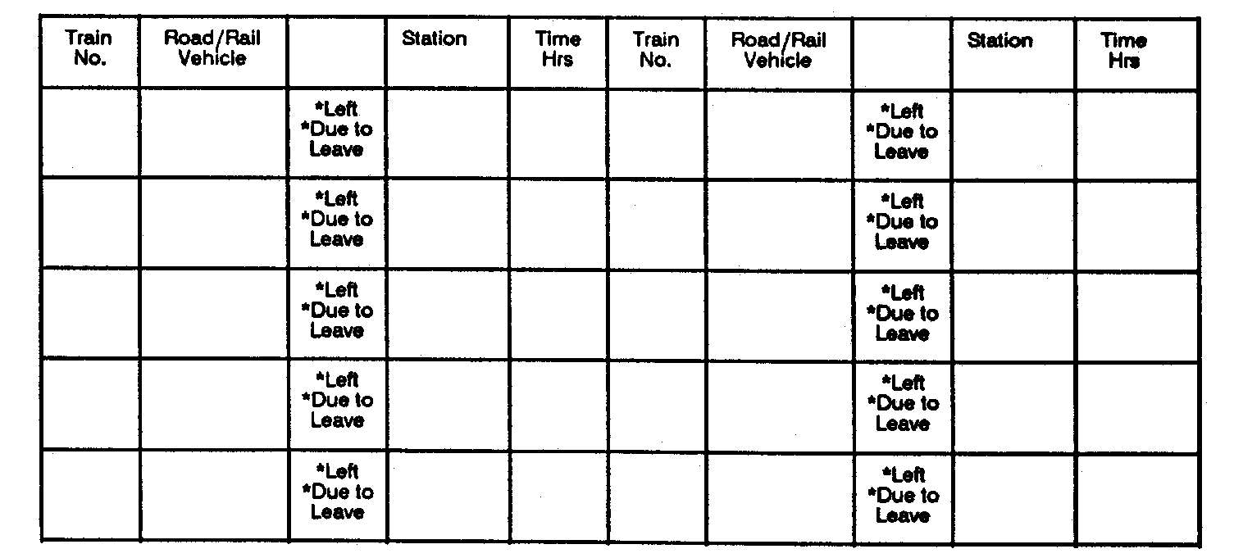
ADVISED NO ALTERATION TO INFORMATION SHOWN ON FORM AND GIVEN
PERMISSION TO PROCEED BY *TRAIN CONTROLLER AT STATION LISTED BELOW
*SIGNAL OPERATOR
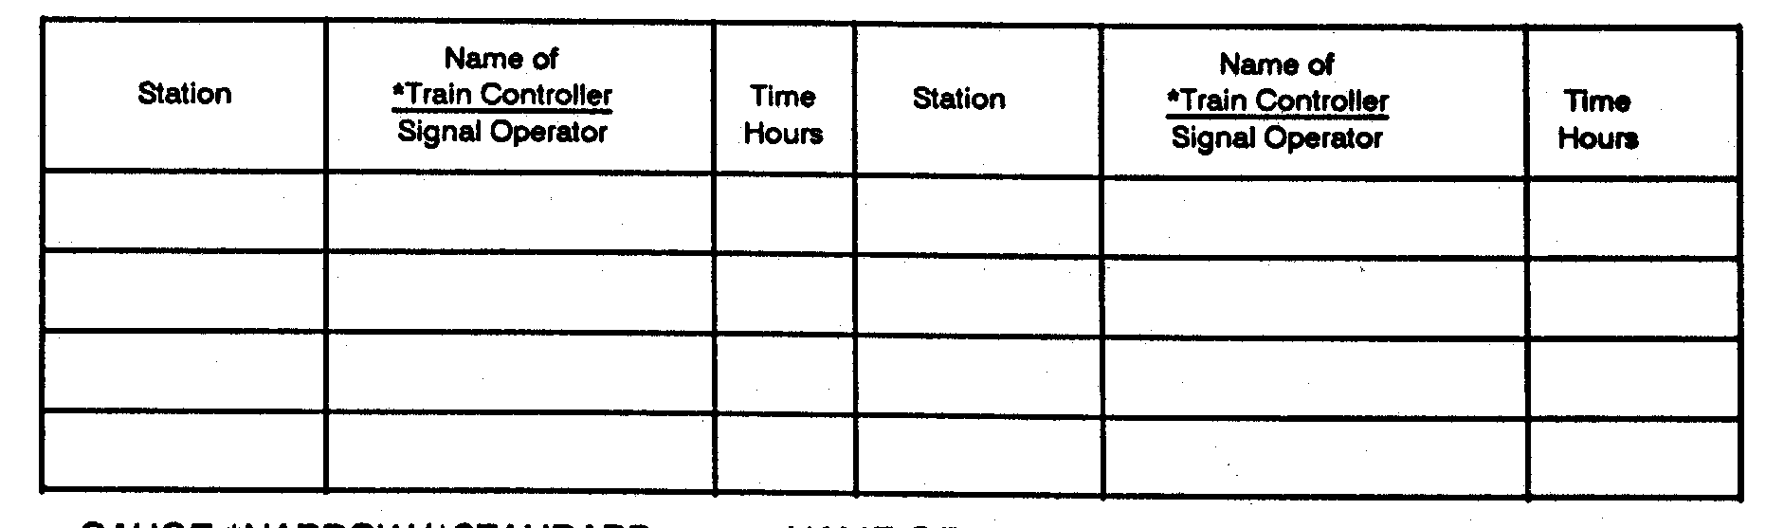

GAUGE *NARROW/*STANDARD
NAME OF *TRAIN CONTROLLER . . . . . . . . . . . . . . . . .
SIGNAL OPERATOR
NAME OF *ROAD/RAIL VEHICLE/
DRIVER . . . . . . . . . . . . . . . . . . . . . . . . . . . . . . . . . . . . . . . .
Signature of *Train Controller/*Signal Operator . . . . . . . . . . . . . . . . . . . . . . .
Signature *Road/Rail Vehicle - Driver . . . . . . . . . . . . . . . . . . . . . . . . . . . . . . .
*Delete as necessary
=========================================================
TO BE COMPLETED WHEN ADVICE OBTAINED BY TELEPHONE OR
RADIO
*TRAIN CONTROLLER’S/*SIGNAL OPERATOR’S
*ROAD/RAIL VEHICLE - DRIVER’S ADVICE FORM NO. . . . . . . . . . . . . . . .
DATE . . . . . . . / . . . . . . . . /19. . . . . . . . . . . . . . . . . . . . . HOURS
TIME REPEATED BACK . . . . . . . . . . . . . . . HOURS
_______________

Form S.W.21.
S.W.21.
WESTERN AUSTRALIAN GOVERNMENT RAILWAYS COMMISSION (Rule 227 and 228)
WARNING TO DRIVER (Serial No..........)
. . . . . . . . . . . . . . . Office of Origin
. . . . . . . . . . . . . . . Date
. . . . . . . . . . . . . . . Hours
To the Driver of * Train No. . . . . . . . . . . . . . . . From . . . . . . . . . . . . . . .
* Road/Rail Vehicle . . . . . . . . . . . . . . . To . . . . . . . . . . . . . . . .
Departing at . . . . . . . . .
Between . . . . . . . . . . . . . . . . . . . . . . . and . . . . . . . . . . . . . . . . . . . . . . . . . . .
you must be specially on the alert when you have not a clear view of the line ahead, to avoid running into Track Attendants or road/rail vehicles and employees working in the section (locomotive Drivers to frequently sound klaxon) as: —
* Your train is running 10 min. or more earlier than timetable time,
or
* Insufficient or no notice has been issued for your train,
and
An employee is * Travelling on a road/rail vehicle.
* Working in the section.
* Train
and is not aware of the running of your * Road/Rail Vehicle
Signature of Signal Operator. . . . . . . . . . . . . . . .
Signature of Driver . . . . . . . . . . . . . . .
TO BE COMPLETED WHEN “WARNING TO DRIVER” FORM
TRANSMITTED BY RADIO.
Signal Operator’s
Driver’s Form No. . . . . . . . . . . . Date . . . . . . . . . . . Hours . . . . . . . . . .
Time Repeated Name of Signal Operator . . . . . . . . . . . . . . .
Back . . . . . . . . Hours Name of Driver . . . . . . . . . . . . . . . . . . . . . . . . . .
* Strike out as required.
_______________

FORM A S.W.22
TRAIN INFORMATION FORM
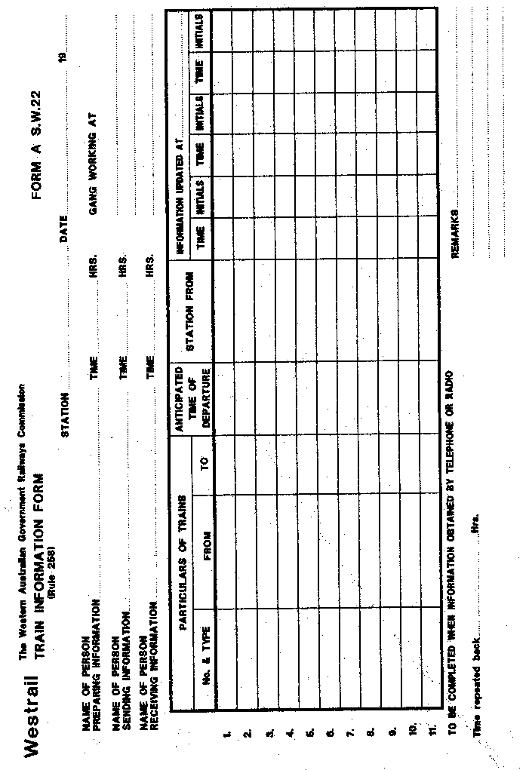
_______________

FORM A S.W.23
TRAIN INFORMATION FORM
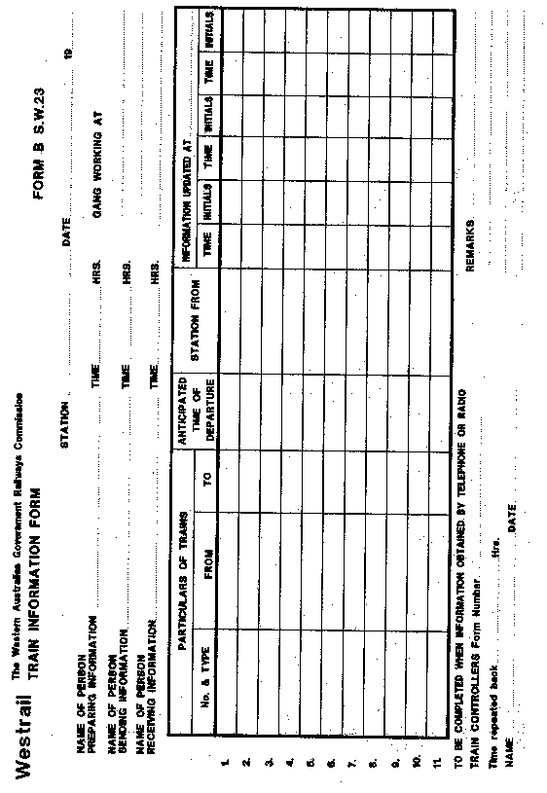
_______________
S.W. 24
APPLICATION FOR AUTHORITY TO INSTALL A CLOSED SECTION
WARNING DEVICE ON TRACK
PART A
To Train Controller at ............................ Date ...................... Time .....................
Authority to install a Closed Section Warning Device(s) is requested for the section of line between ....................... and ......................... on the following running lines: .............................................. ............................................................
.............................................. ............................................................
in accordance with Rules 236 and 237.
.............................. ................................ . .................................
Track Supervisor Accreditation Category Track Access Permit Number
Part B
Authority Number ..............
From Train Controller......................................
To Track Supervisor ......................................
The section of line between ....................... and ......................... has been closed to traffic by the District Engineer ...................................... at ............... hours on the ..... /.... / .... and authority to install a Section Closed Warning Device on the above specified lines is approved at ............... hours on the ..... /.... / .... .
Signal number(s) ........ ........ ........ controlling access to above specified lines have been secured in the STOP indication by a locking device and will be maintained in that condition until this authority has been cancelled.
......................................
Train Controller
Part C
Track Supervisor .............................. To Train Controller ....................................
Section Closed Warning Devices installed at the following locations:
.................................................................. ..................................................................
.................................................................. ..................................................................
have been removed from the track and the track is now safe for normal operations.
Track Supervisor ................................................ Time ............ Date ....................
Authority Number ............................ cancelled at ............ hours on ..... /.... / ....
Train Controller ....................................
[Schedule amended in Gazette 23 February 1996 p. 679; 19 September 1997 p. 5298.]

Notes
^{1.} This is a compilation of Government Railways Amendment By-laws 1994 and includes the amendments referred to in the following Table.

Compilation table
Citation | Gazettal | Commencement
Government Railways Amendment By-laws 1994 | 5 Dec 1994 pp.6393-626 | 5 Dec 1994
Government Railways Amendment By-laws 1995 | 23 Feb 1996 pp.679-83 | 23 Feb 1996
Government Railways Amendment By-laws 1997 | 19 Sep 1997 pp.5290-8 | 19 Sep 1997
These by-laws were repealed by the Government Railways Amendment By-laws 2000 bl. 2 as at 29 Sep 2000 (see Gazette 29 Sep 2000 p. 5550)

