
Western Australia

Land Tax Assessment Regulations 1976
Compare between:
[31 Jul 2001, 01-o0-03] and [01 Jul 2003, 01-p0-08]

Western Australia
Land Tax Assessment Act 1976
Land Tax Assessment Regulations 1976

1. Citation
These regulations may be cited as the Land Tax Assessment Regulations 1976 ¹.
[Regulation 1 inserted in Gazette 28 October 1983 p.4361.]

2. Interpretation
In these regulations, unless the contrary intention appears —
“the Act” means the Land Tax Assessment Act 1976.
[3. Repealed in Gazette 24 July 1998 p.3910.]

4. Fee for certificate (section 48(1))
For a certificate showing if there is any assessed land tax charged on land, pursuant to section 48(1) of the Act, the Commissioner shall charge —
(a) if the request for the certificate was made electronically through the Electronic Advice of Sale computer system operated by the Department of Land Administration and the State Revenue Department, a fee of $30; or
(b) in any other case, a fee of $50.
[Regulation 4 inserted in Gazette 28 October 1983 p.4361; amended in Gazette 15 August 1986 p.2928; 30 June 1989 p.1895; 13 May 1997 pp.2339-40; 31 July 2001 p. 3919.]

5. Prescription of Commissioner as State taxation officer
The Commissioner is prescribed as a State taxation officer for the purposes of Part 111A of the Taxation Administration Act 1953 of the Commonwealth.
[Regulation 5 inserted in Gazette 27 March 1986 p.1303.]

6. Payment of land tax where notice of assessment issued
(1) In this regulation unless the contrary intention appears —
“additional tax” means additional tax assessed under section 25 of the Act;
“arrears” (“Ar” in the formulas) means the sum, as at the time a relevant assessment is issued, of —
(a) any land tax shown on a notice of assessment, or notice of amended assessment, issued in a year of assessment prior to the year of assessment in which the relevant assessment is issued, and due and payable;
(b) any unpaid additional tax;
(c) any interest assessed under section 38(3) of the Act and unpaid;
(d) any penalty assessed under section 39 of the Act and unpaid;
(e) any charge imposed under subregulation (5) or (6) and unpaid; and
(f) any law costs referred to in the definition of “land tax” in section 5(1) of the Act and unpaid;
“assessed amount” means the total amount of land tax (including arrears) shown on a relevant assessment as payable under the Act;
“discountable amount” (“DA” in the formulas) means any land tax (but not additional tax, interest, penalties, charges or law costs) shown on a relevant assessment but not shown on a notice of assessment, or notice of amended assessment, issued in a year of assessment prior to the year of assessment in which the relevant assessment is issued;
“residual amount” (“RA” in the formulas) means the assessed amount less arrears and less the discountable amount;
“relevant assessment” means a notice of assessment, or a notice of amended assessment, issued by the Commissioner after the coming into operation of this regulation.
(2) A taxpayer may discharge a liability to pay an assessed amount by paying in accordance with one of the 3 options in subregulations (3), (4) and (5).
(3) A taxpayer may discharge a liability to pay an assessed amount by making one payment, within 45 days after the service by post of the relevant assessment, of the amount calculated according to the following formula:
Amount payable = Ar + RA + 0.97DA.
(In this regulation referred to as “option 1”.)
(4) A taxpayer may discharge a liability to pay an assessed amount by making 2 payments as follows:
(a) A first payment, to be made within 45 days after the service by post of the relevant assessment, of an amount calculated according to the following formula:
First payment = 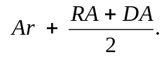
(b) A second payment, to be made within 110 days after the service by post of the relevant assessment, of an amount calculated according to the following formula:
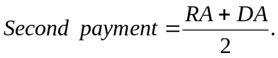
(In this regulation referred to as “option 2”.)
(5) A taxpayer may discharge a liability to pay an assessed amount by making 3 payments as follows:
(a) A first payment, to be made within 45 days after the service by post of the relevant assessment, of an amount calculated according to the following formula:
First payment = 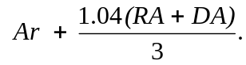
(b) A second payment, to be made within 110 days after the service by post of the relevant assessment, of an amount calculated according to the following formula:
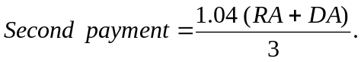
(c) A third payment, to be made within 175 days after the service by post of the relevant assessment, of an amount calculated according to the following formula:
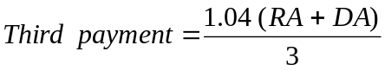.
(In this regulation referred to as “option 3”.)
(6) If the sum of payments made by a taxpayer within 45 days after the service by post of a relevant assessment (“the sum paid”) is less than the amount payable under option 1 but greater than —
(a) the first payment under option 2, then the sum paid shall be deducted by the Commissioner from the assessed amount and the remainder shall be paid by the taxpayer when the second payment under option 2 would otherwise have been payable;
(b) the first payment under option 3 but less than the first payment under option 2, then the sum paid shall be deducted by the Commissioner from the assessed amount and the remainder, plus a charge of 4% of the sum of the discountable amount and the residual amount, shall be divided into 2 equal amounts —
(i) the first to be paid by the taxpayer when the second payment under option 3 would otherwise have been payable; and
(ii) the second to be paid by the taxpayer when the third payment under option 3 would otherwise have been payable.
(7) If —
(a) the sum of payments made by a taxpayer within 45 days after the service by post of a relevant assessment is less than the first payment under option 3; or
(b) the taxpayer fails to make a payment when it is due,
the amount of land tax remaining unpaid at that time becomes due and payable immediately and section 39 of the Act applies accordingly.
(8) The amounts to be paid under subregulation (4), (5) or (6)(b), are each to be a multiple of 5 cents and, where that results in the amounts being unequal, the first payment shall be the greater amount.
[Regulation 6 inserted in Gazette 10 December 1993 pp.6612-4.]

7. Prescribed rate of interest for section 37B of the Act
The prescribed rate of interest for the purposes of section 37B(2)(b) of the Act is 6% per annum.
[Regulation 7 inserted in Gazette 16 December 1994 p.6844; amended in Gazette 28 November 1997 p.7031.]

8. Excluded public statutory authorities
The following public statutory authorities are excluded from the definition of “public statutory authority” in section 5(1) of the Act —
(a) the Electricity Corporation established by section 4 of the Electricity Corporation Act 1994;
(b) the Gas Corporation established by section 4 of the Gas Corporation Act 1994;
(c) the Water Corporation established by section 4 of the Water Corporation Act 1995;
(d) the Albany Port Authority established by section 4 of the Port Authorities Act 1999;
(da) the Broome Port Authority established by section 4 of the Port Authorities Act 1999;
(e) the Bunbury Port Authority established by section 4 of the Port Authorities Act 1999;
(f) the Dampier Port Authority established by section 4 of the Port Authorities Act 1999;
(g) the Esperance Port Authority established by section 4 of the Port Authorities Act 1999;
(h) the Fremantle Port Authority established by section 4 of the Port Authorities Act 1999;
(i) the Geraldton Port Authority established by section 4 of the Port Authorities Act 1999; and
(j) the Port Hedland Port Authority established by section 4 of the Port Authorities Act 1999.
[Regulation 8 inserted in Gazette 17 May 1996 p.2113; amended in Gazette 26 November 1999 p.5911; 14 April 2000 p.1893.]

9. Inner city area prescribed for section 23AB of the Act
For the purposes of the definition of “inner city area” in section 23AB(1) of the Act, the portion of the State delineated and indicated by dots on the plan reproduced in Schedule 1 is the inner city area.
[Regulation 9 inserted in Gazette 24 July 1998 p.3910.]

Schedule 1 — Inner city area
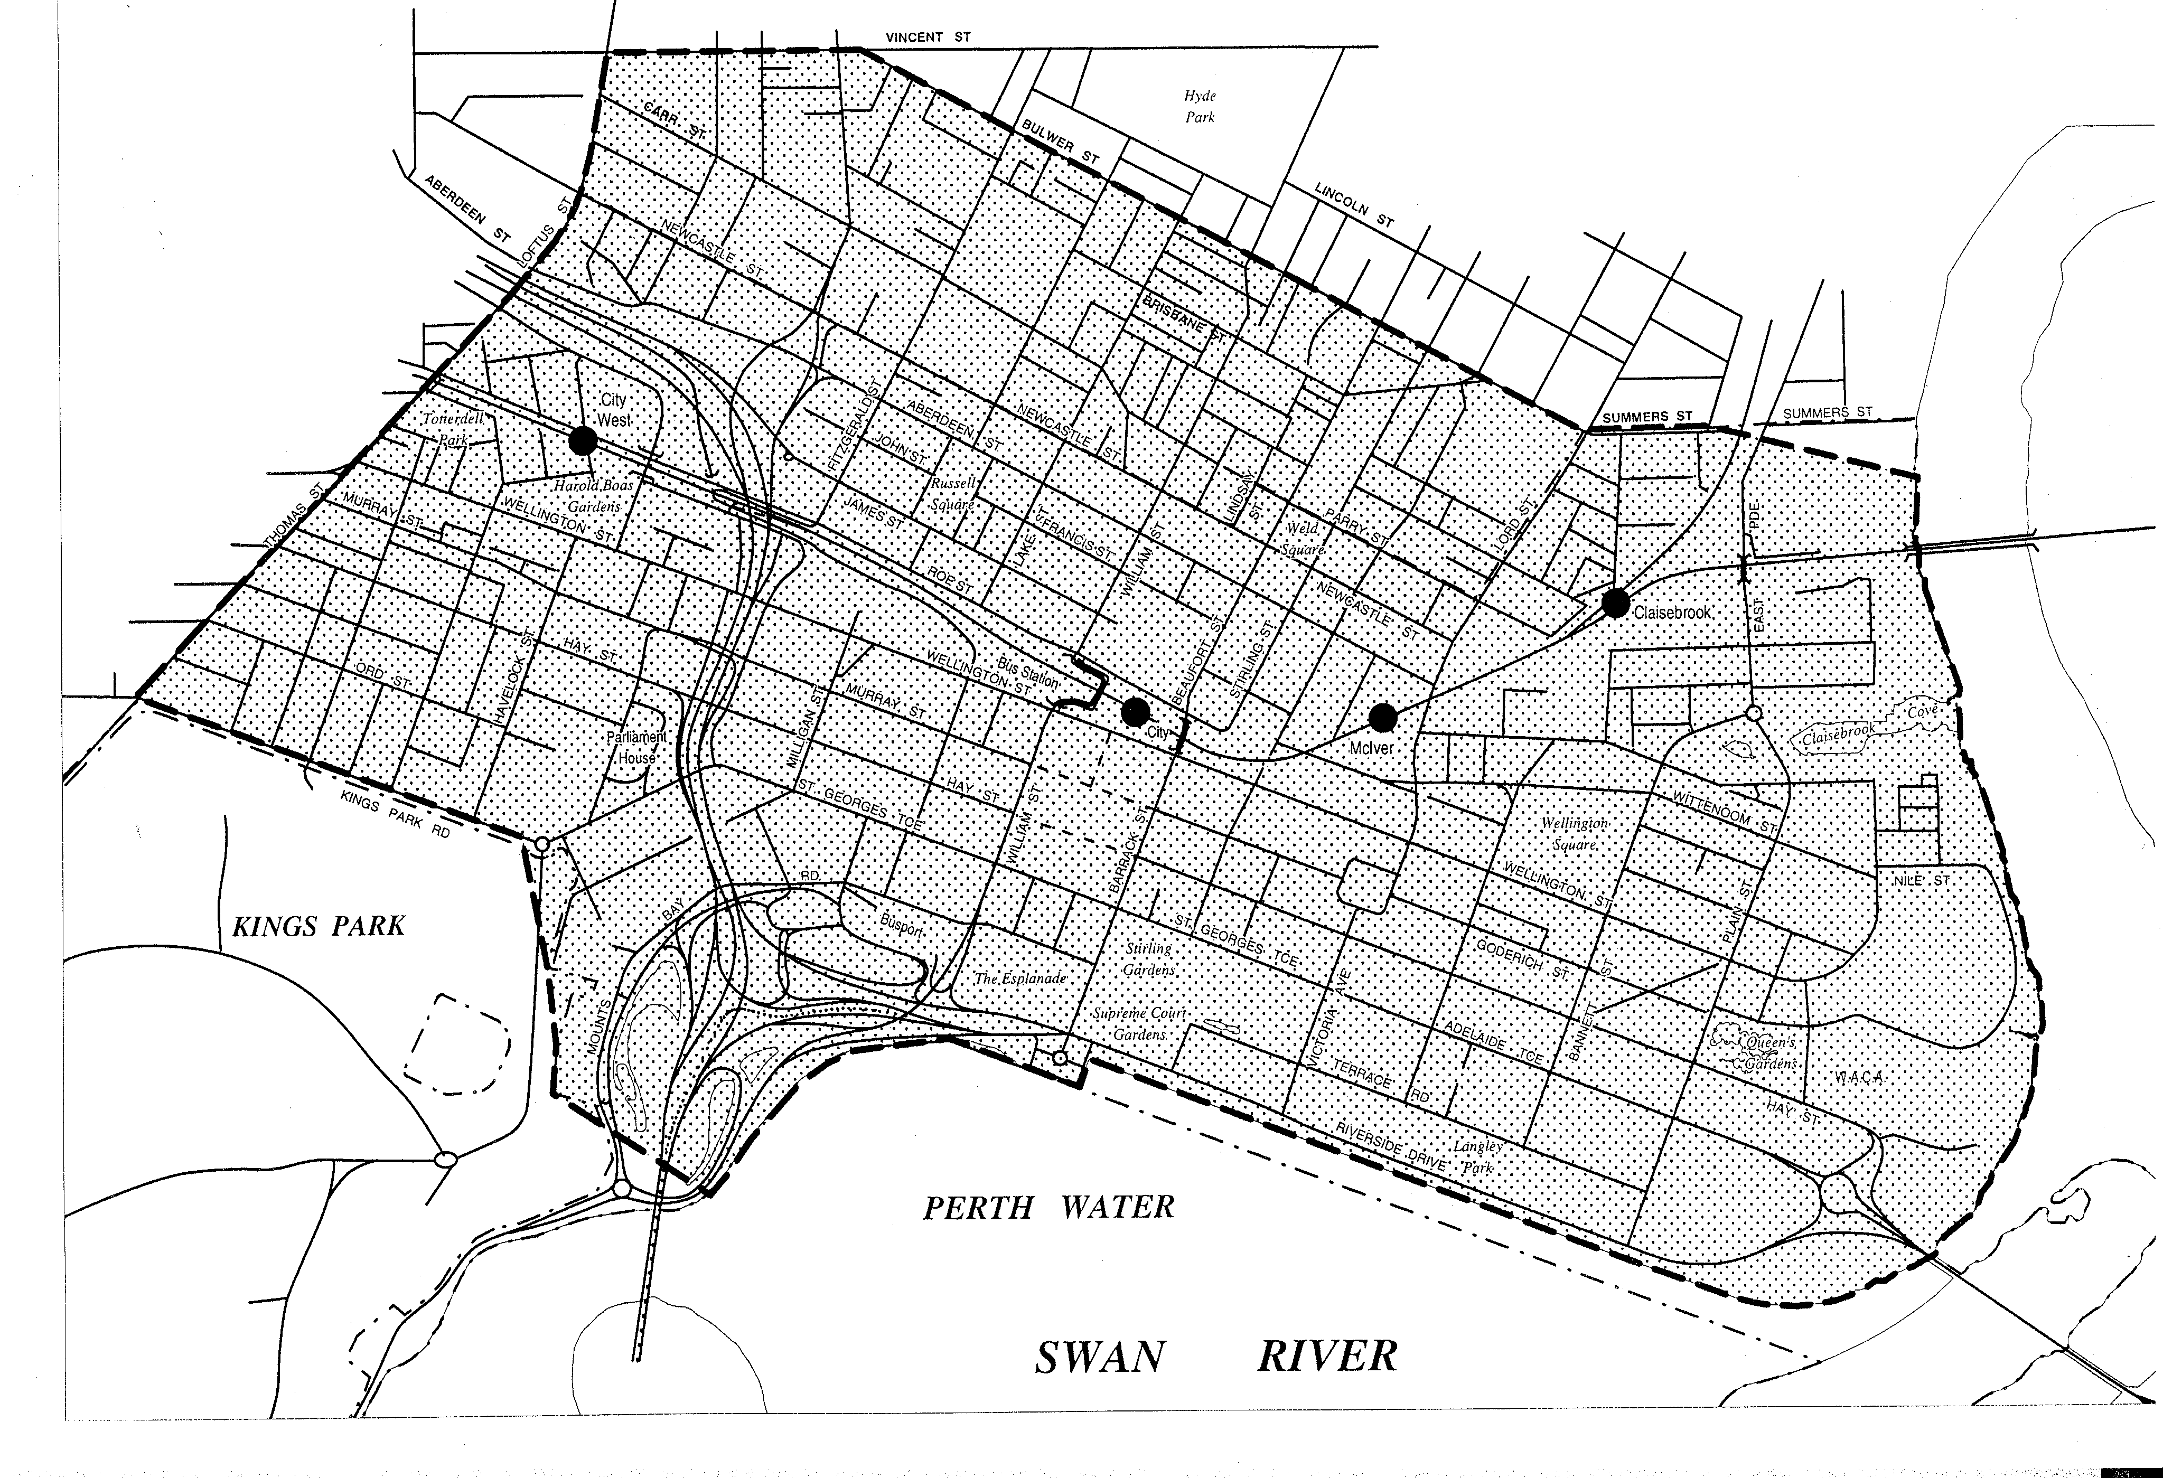
[Schedule 1 inserted in Gazette 24 July 1998 p.3911.]

Notes
¹ This is a compilation of the Land Tax Assessment Regulations 1976 and includes the amendments effected by the other regulations referred to in the following Table ^{2, 3}.

Compilation table
Citation | Gazettal | Commencement
Land Tax Assessment Regulations 1976 | 10 Sep 1976 p. 3343 | 10 Sep1976
Land Tax Assessment Regulations 1983 | 28 Oct 1983 p. 4361 | 1 Jan 1984 (see r. 2)
Land Tax Assessment Regulations 1986 | 27 Mar 1986 p. 1303 | 27 Mar 1986
Land Tax Assessment Regulations (No. 2) 1986 | 15 Aug 1986 p. 2928 | 1 Oct 1986 (see r. 2)
Land Tax Assessment Regulations 1989 | 30 Jun 1989 p. 1895 | 1 Jul 1989 (see r. 2)
Land Tax Assessment Amendment Regulations 1993 | 10 Dec 1993 p. 6612-4 | 10 Dec 1993
Land Tax Assessment Amendment Regulations 1994 | 16 Dec 1994 p. 6844 | 16 Dec 1994
Land Tax Assessment Amendment Regulations 1995 | 23 Jun 1995 p. 2509 | 23 Jun 1995
Land Tax Assessment Amendment Regulations 1996 | 17 May 1996 p. 2113 | 17 May 1996
Land Tax Assessment Amendment Regulations 1997 | 13 May 1997 p. 2339-40 | 1 Jul 1997 (see r. 2)
Land Tax Assessment Amendment Regulations (No. 2) 1997 | 28 Nov 1997 p. 7030-31 | 28 Nov 1997
Land Tax Assessment Amendment Regulations 1998 | 24 Jul 1998 p. 3910-11 | 1 Jul 1998 (see r. 2)
Land Tax Assessment Amendment Regulations 1999 | 26 Nov 1999 p. 5911 | 26 Nov 1999
Land Tax Assessment Amendment Regulations 2000 | 14 Apr 2000 p. 1892-3 | 14 Apr 2000
Land Tax Assessment Amendment Regulations 2001 | 31 Jul 2001  p. 3918-19 | 31 Jul 2001
These regulations were repealed by the Land Tax Assessment Regulations 2003 r. 14(1) as at 1 Jul 2003 (see s. 2 and Gazette 27 June 2003 p. 2413)
² Under the Commonwealth Places (Mirror Taxes Administration) Act 1999 s. 7 this Act is to be read and construed with any modifications referred to in subsection (1) of that section and, in particular, with the modifications set out in the Commonwealth Places (Mirror Taxes Administration) Regulations 2002. Pt. 1 and Pt. 4 Div. 3 of those regulations read as follows:
“
Part 1 — Preliminary
1. Citation
These regulations may be cited as the Commonwealth Places (Mirror Taxes Administration) Regulations 2002.
2. Commencement
(1) These regulations do not have effect unless an arrangement is in operation under section 5 of the Act.
(2) When such an arrangement is in operation, these regulations and the modifications they prescribe are deemed to have taken effect on 6 October 1997.
(3) If a State taxing law was repealed before these regulations take effect then, despite the repeal, when these regulations are deemed under subsection (2) to have taken effect, the repealed law is deemed to have been modified, in accordance with these regulations, on 6 October 1997.
3. Modification of State taxing laws
(1) In its operation as an applied WA law, the Act is modified by omitting section 7.
(2) For the purposes of section 7(2) of the Act, each State taxing law is taken to be modified to the extent necessary to give effect to subregulation (3).
(3) If —
(a) a State taxing law applies, or could apply, to any extent, to or in relation to an event, state of affairs or transaction, and the corresponding applied law also applies, or could apply, to any extent, to or in relation to the same event, state of affairs or transaction;
(b) a person is required or permitted, or could be required or permitted, to take an action under both the State taxing law and the corresponding applied law in relation to the event, state of affairs or transaction;
(c) the person has taken the action in accordance with the corresponding applied law; and
(d) the Commissioner has enough information about the event, state of affairs or transaction to carry out his or her functions in relation to it under the State taxing law or the corresponding applied law or both, as the case requires,
then —
(e) the person is not required to take the action under the State taxing law; and
(f) the Commissioner may carry out his or her functions in relation to the event, state of affairs or transaction as if the person had taken whatever action is required or permitted under the State taxing law in relation to the event, state of affairs or transaction.
(4) The particular modifications set out in these regulations of certain State taxing laws have effect for the purposes of section 7(2) of the Act.
Part 4 — Land tax
Division 3 — The Land Tax Assessment Regulations 1976
40. Modification of the Land Tax Assessment Regulations 1976
This Division sets out modifications of the Land Tax Assessment Regulations 1976*.
[* Reprinted as at 26 November 1999.
For amendments to 14 November 2002 see 2001 Index to Legislation of Western Australia, Table 4, p. 186.]
41. Regulation 3 inserted
After regulation 2 the following regulation is inserted —
“
3. Application of regulations in non-Commonwealth places
(1) In these regulations, unless the contrary intention appears —
(a) a reference to these regulations is to be read as a reference to these regulations in their application as a law of Western Australia;
(b) a reference to the Act is to be read as a reference to the Act in its application as a law of Western Australia; and
(c) a reference to the Land Tax Assessment Act 1976 is to be read as a reference to that Act in its application as a law of Western Australia.
(2) These regulations are to be read with the applied Land Tax Assessment Regulations as a single body of law.
(3) In these regulations —
“applied Land Tax Assessment Regulations” means the Land Tax Assessment Regulations 1976 of Western Australia in their application as a law of the Commonwealth in or in relation to Commonwealth places in Western Australia in accordance with the Commonwealth Mirror Taxes Act.
”.
”
³ Under the Commonwealth Places (Mirror Taxes Administration) Act 1999 s. 8(2) of the Commonwealth, this Act is to be read and construed with any modifications referred to in subsection (1) of that section and, in particular, with the modifications set out in the Commonwealth Places (Mirror Taxes) (Modification of Applied Laws (WA)) Notice 2002. Pt. 1 and Pt. 4 Div. 3 of that notice read as follows:
“
Part 1 — Preliminary
1. Citation
This notice may be cited as the Commonwealth Places (Mirror Taxes) (Modification of Applied Laws (WA)) Notice 2002.
2. Commencement
(1) This notice does not have effect unless an arrangement is in operation under section 9 of the Commonwealth Places Mirror Taxes Act in relation to Western Australia.
(2) When such an arrangement is in operation, this notice and the modifications it prescribes are deemed to have taken effect on 6 October 1997.
(3) If an applied WA law was repealed before this notice takes effect then, despite the repeal, when this notice is deemed under subsection (2) to have taken effect, the repealed law is deemed to have been modified on 6 October 1997 as set out in this notice.
3. Definitions
In this notice —
“applied WA law” means the provisions of a State taxing law of Western Australia that apply or are taken to have applied in relation to Commonwealth places in Western Australia in accordance with the Commonwealth Mirror Taxes Act;
“Commonwealth Mirror Taxes Act” means the Commonwealth Places (Mirror Taxes) Act 1998 of the Commonwealth;
“WA taxing law” means a State taxing law of Western Australia.
4. Modification of applied WA laws
(1) For the purposes of section 8 of the Commonwealth Mirror Taxes Act, each applied WA law is taken to be modified to the extent necessary to give effect to subregulation (2).
(2) If —
(a) an applied WA law applies, or could apply, to any extent, to or in relation to an event, state of affairs or transaction, and the corresponding State taxing law also applies, or could apply, to any extent, to or in relation to the same event, state of affairs or transaction;
(b) a person is required or permitted, or could be required or permitted, to take an action under both the applied WA law and the corresponding State taxing law in relation to the event, state of affairs or transaction;
(c) the person has taken the action in accordance with the corresponding State taxing law; and
(d) the Commissioner has enough information about the event, state of affairs or transaction to carry out his or her functions in relation to it under the applied WA law or the corresponding State taxing law or both, as the case requires,
then —
(e) the person is not required to take the action under the applied WA law; and
(f) the Commissioner may carry out his or her functions in relation to the event, state of affairs or transaction as if the person had taken whatever action is required or permitted under the applied WA law in relation to the event, state of affairs or transaction.
(3) The particular modifications set out in this notice of certain applied WA laws have effect for the purposes of section 8 of the Commonwealth Mirror Taxes Act.
Part 4 — Land tax
Division 3 — The applied Land Tax Assessment Regulations 1976
58. Modification of the applied regulations
This Division sets out modifications of the Land Tax Assessment Regulations 1976* of Western Australia.
[* Reprinted 26 November 1999.
For amendments to 9 December 2002 see 2001 Index to Legislation of Western Australia, Table 4, p. 186.]
59. Regulation 3 inserted
After regulation 2 the following regulation is inserted —
“
3. Application of regulations in Commonwealth places
(1) In these regulations —
(a) a reference to these regulations is to be read as a reference to these regulations in their application as a law of the Commonwealth in or in relation to Commonwealth places in Western Australia in accordance with the Commonwealth Mirror Taxes Act;
(b) a reference to the Act is to be read as a reference to the Act in its application as a law of the Commonwealth in or in relation to Commonwealth places in Western Australia in accordance with the Commonwealth Mirror Taxes Act;
(c) a reference to the Department of Land Administration is to be read as a reference to the Department of the State of Western Australia of that name;
(d) a reference to the State Revenue Department is to be read as a reference to the Office of State Revenue of the Department of Treasury and Finance of Western Australia; and
(e) a reference to the State is a reference to the State of Western Australia.
(2) These regulations are to be read with the corresponding Land Tax Assessment Regulations as a single body of law.
(3) In addition to being modified as prescribed by the Commonwealth Places (Mirror Taxes) (Modification of Applied Laws (WA)) Notice 2002, these regulations are deemed to be further modified to any extent that is necessary or convenient to enable these regulations to operate effectively as a law of the Commonwealth.
(4) In these regulations —
“corresponding Land Tax Assessment Regulations” means the Land Tax Assessment Regulations 1976 of Western Australia in their application as a law of Western Australia.
”.

