
Western Australia

Land Tax Assessment Regulations 2003
Compare between:
[01 Jul 2003, 00-a0-05] and [01 Apr 2006, 00-b0-03]

Western Australia
Land Tax Assessment Act 2002
Taxation Administration Act 2003
Land Tax Assessment Regulations 2003

1. Citation
These regulations may be cited as the Land Tax Assessment Regulations 2003.

2. Commencement and application
(1) These regulations come into operation on the day on which the Taxation Administration Act 2003 comes into operation.
(2) These regulations apply —
(a) to land tax that is assessed for an assessment year that ends after the day referred to in subregulation (1); and
(b) for the purposes of paragraph (a) of the definition of “arrears” in regulation 3(1) — to land tax, as defined in the Land Tax Assessment Act 1976 section 5(1), that is payable in respect of an assessment year that ends before that day.

3. Definitions and abbreviations
(1) In these regulations —
“arrears” means the sum, as at the date an assessment notice (the “relevant assessment notice”) is issued, of —
(a) any land tax that is due and payable and shown on an assessment notice issued in an assessment year before the assessment year in which the relevant assessment notice is issued;
(b) any penalty tax under the Taxation Administration Act 2003 section 26 or 27 that is due and payable in relation to land tax;
(c) any interest under the Taxation Administration Act 2003 section 47 that is due and payable in relation to land tax;
(d) any legal costs or costs, as referred to in the Taxation Administration Act 2003 section 62(a) or (b), that are incurred by the Commissioner and due and payable in relation to land tax; and
(e) any charge due and payable under regulation 8 or 9;
“assessed amount” means the total amount of land tax and arrears due and payable and shown on an assessment notice;
“discountable amount” means the amount of land tax (not including arrears) due and payable and shown on an assessment notice (the “relevant assessment notice”) but not shown on an assessment notice issued in an assessment year before the assessment year in which the relevant assessment notice is issued;
“option 1” means the option for discharging a liability to pay an assessed amount set out in regulation 6;
“option 2” means the option for discharging a liability to pay an assessed amount set out in regulation 7;
“option 3” means the option for discharging a liability to pay an assessed amount set out in regulation 8;
“residual amount” means the assessed amount less —
(a) arrears; and
(b) the discountable amount.
(2) In these regulations, the following abbreviations are used —
“A” for arrears;
“DA” for discountable amount;
“RA” for residual amount.

4. Tax payment arrangements not affected
Nothing in these regulations affects the payment of land tax under a tax payment arrangement.

5. Taxpayer’s options in discharging liability to pay assessed amount
A taxpayer may discharge a liability to pay an assessed amount by paying in accordance with regulation 6, 7, 8 or 9.

6. Paying assessed amount in one discounted payment (option 1)
A taxpayer may discharge a liability to pay an assessed amount by making one payment of the amount, due and payable within 49 days after the date of the assessment notice, calculated using the formula —

7. Paying assessed amount in 2 instalments (option 2)
(1) A taxpayer may discharge a liability to pay an assessed amount by paying in 2 instalments.
(2) The first instalment is due and payable within 49 days after the date of the assessment notice and is the amount calculated using the formula —
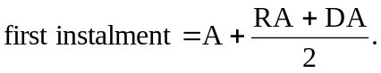
(3) The second instalment is due and payable within 110 days after the date of the assessment notice and is the amount calculated using the formula —
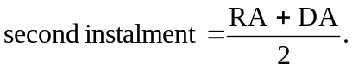

8. Paying assessed amount in 3 instalments (option 3)
(1) A taxpayer may discharge a liability to pay an assessed amount by paying in 3 instalments that, in accordance with the formulas set out in subregulations (2), (3) and (4), include a charge of 4% of (RA + DA).
(2) The first instalment is due and payable within 49 days after the date of the assessment notice and is the amount calculated using the formula —
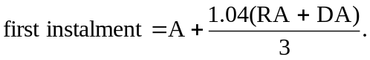
(3) The second instalment is due and payable within 110 days after the date of the assessment notice and is the amount calculated using the formula —
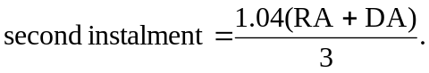
(4) The third instalment is due and payable within 175 days after the date of the assessment notice and is the amount calculated using the formula —
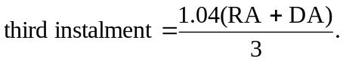

9. Other arrangements for paying assessed amount
(1) If the amount of land tax paid within 49 days after the date of the assessment notice (the “amount paid”) is —
(a) less than the amount payable under option 1; and
(b) more than the first instalment payable under option 2,
the Commissioner is to deduct the amount paid from the assessed amount, and the remaining amount is due and payable by the taxpayer within 110 days after the date of the assessment notice.
(2) If the amount of land tax paid within 49 days after the date of the assessment notice (the “amount paid”) is —
(a) less than the first instalment payable under option 2; and
(b) more than the first instalment payable under option 3,
the Commissioner is to deduct the amount paid from the assessed amount, and the remaining amount, plus a charge of 4% of (RA + DA), is to be divided into 2 equal instalments.
(3) The first of those instalments is due and payable by the taxpayer within 110 days after the date of the assessment notice.
(4) The second of those instalments is due and payable by the taxpayer within 175 days after the date of the assessment notice.

10. Instalments to be multiples of 5 cents
(1) Amounts payable as instalments under regulation 7, 8 or 9 are to be multiples of 5 cents.
(2) If the application of subregulation (1) results in unequal instalments being payable that would have been equal instalments if not for the application of that subregulation, the first of those instalments is to be the greater or greatest amount, as the case requires.

11. When full amount of land tax becomes due and payable
If —
(a) the amount of land tax paid within 49 days after the date of the assessment notice is less than the first instalment due and payable under option 3; or
(b) an instalment under these regulations is not paid when it is due and payable,
the full amount of unpaid land tax is immediately due and payable by the taxpayer.

12. Taxable authorities
(1) For the purposes of paragraph (b) of the definition of “taxable authority” in clause 1 of the Glossary at the end of the Land Tax Assessment Act 2002, the bodies to which this subregulation applies are prescribed.
(2) Subregulation (1) applies to —
(a) the Electricity Generation Corporation established by the Electricity Corporations Act 2005 section 4(1)(a);
(aa) the Electricity Networks Corporation established by the Electricity Corporations Act 2005 section 4(1)(b);
(ab) the Electricity Retail Corporation established by the Electricity Corporations Act 2005 section 4(1)(c);
(ac) the Regional Power Corporation established by the Electricity Corporations Act 2005 section 4(1)(d);
(b) the Water Corporation established by the Water Corporation Act 1995 section 4;
(c) the Western Australian Land Authority established by the Western Australian Land Authority Act 1992 section 5;
(d) the Albany Port Authority established by the Port Authorities Act 1999 section 4;
(e) the Broome Port Authority established by the Port Authorities Act 1999 section 4;
(f) the Bunbury Port Authority established by the Port Authorities Act 1999 section 4;
(g) the Dampier Port Authority established by the Port Authorities Act 1999 section 4;
(h) the Esperance Port Authority established by the Port Authorities Act 1999 section 4;
(i) the Fremantle Port Authority established by the Port Authorities Act 1999 section 4;
(j) the Geraldton Port Authority established by the Port Authorities Act 1999 section 4; and
(k) the Port Hedland Port Authority established by the Port Authorities Act 1999 section 4.
[Regulation 12 amended in Gazette 31 Mar 2006 p. 1350-1.]

13. Inner city area
For the purposes of the Land Tax Assessment Act 2002 section 28(2)(a), the area of the State that corresponds to the shaded area on the plan set out in Schedule 1 is an inner city area.

14. Repeal and savings
(1) The Land Tax Assessment Regulations 1976 are repealed.
(2) Despite subregulation (1) and subject to regulation 2(2)(b), the Land Tax Assessment Regulations 1976 continue to apply to land tax, as defined in the Land Tax Assessment Act 1976 section 5(1), that is payable in respect of an assessment year that ends before the day referred to in regulation 2(1).

Schedule 1 — Inner city area
[r. 13]
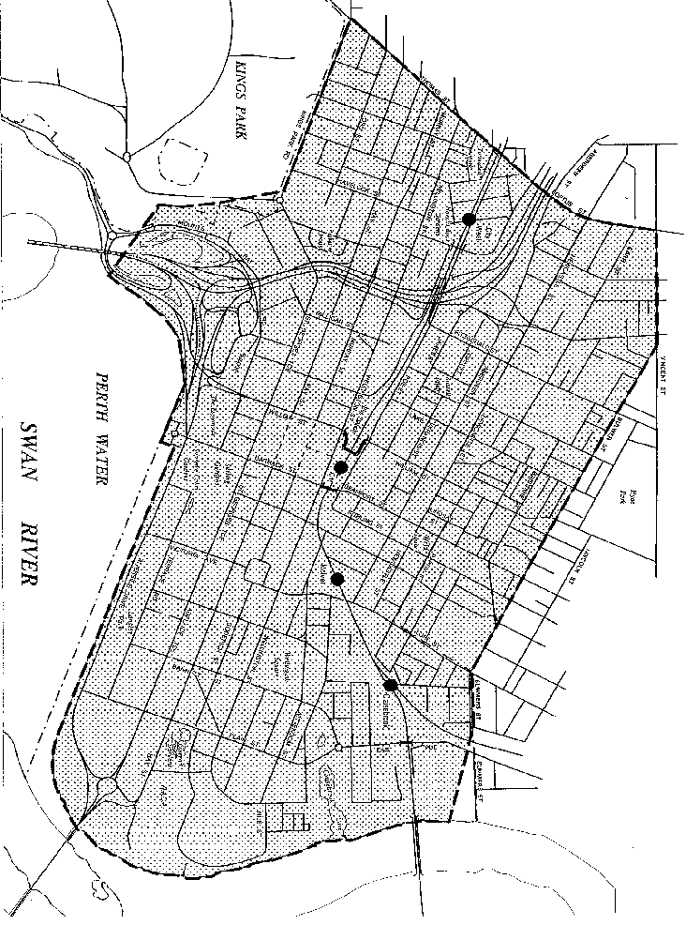

Notes
¹ This is a compilation of the Land Tax Assessment Regulations 2003 and includes the amendments made by the other written laws referred to in the following table.

Compilation table
Citation | Gazettal | Commencement
Land Tax Assessment Regulations 2003 | 27 Jun 2003 p. 2409-14 | 1 Jul 2003 (see r. 2(1) and Gazette 27 Jun 2003 p. 2383)
Electricity Corporations (Consequential Amendments) Regulations 2006 r. 82 | 31 Mar 2006 p. 1299-57 | 1 Apr 2006 (see r. 2)

