Western Australia
Metropolitan Region Scheme (Fremantle) Act 1994

Western Australia
Metropolitan Region Scheme (Fremantle) Act 1994
CONTENTS
-1. Short title 1
2. Commencement 1
3. Interpretation 1
4. Amendment to Metropolitan Region Scheme 2
5. Effect of amendment 2
6. Inspection of Plan 2
Schedule
Notes
Compilation table 4
Provisions that have not come into operation 4

Western Australia
Metropolitan Region Scheme (Fremantle) Act 1994
An Act to amend the Metropolitan Region Scheme to reinstate certain areas of the City of Fremantle as a Controlled Access Highway Reservation.
[Assented to 22 September 1994.]
The Parliament of Western Australia enacts as follows:

1. Short title
This Act may be cited as the Metropolitan Region Scheme (Fremantle) Act 1994.

2. Commencement
This Act comes into operation on the day on which it receives the Royal Assent.

3. Interpretation
In this Act —
“Commission” and “Metropolitan Region Scheme” have the same meanings as they have in the Metropolitan Region Town Planning Scheme Act 1959;
“Plan” means Plan No. 4.1244 held by the Commission, a reproduction of which is shown in the Schedule.

4. Amendment to Metropolitan Region Scheme
The Metropolitan Region Scheme is amended by cancelling the Urban Zone classification of those portions of land shown stippled on the Plan and reserving those portions of land as a Controlled Access Highway.

5. Effect of amendment
(1) The amendment to the Scheme effected by section 4 has effect as though the provision were enacted by the Metropolitan Region Town Planning Scheme Act 1959.
(2) Nothing in this Act affects the operation of the Metropolitan Region Town Planning Scheme Act 1959 with respect to amendments to the Scheme as amended by this Act.

6. Inspection of Plan
The Plan is open for public inspection during ordinary business hours at the office of the Department of Planning and Urban Development.

Schedule
[Section 3]
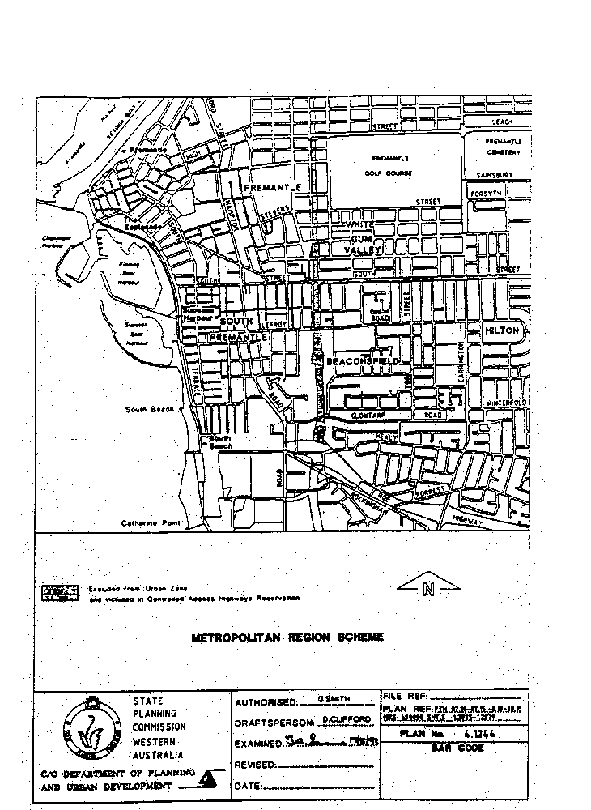

Notes
¹ This is a compilation of the Metropolitan Region Scheme (Fremantle) Act 1994. The following table contains information about that Act ^{1a}.

Compilation table
Short title | Number and year | Assent | Commencement
Metropolitan Region Scheme (Fremantle) Act 1994 | 44 of 1994 | 22 Sep 1994 | 22 Sep 1994
^{1a} On the date as at which this compilation was prepared, provisions referred to in the following table had not come into operation and were therefore not included in this compilation. For the text of the provisions see the endnotes referred to in the table.

Provisions that have not come into operation
Short title | Number and Year |  | Assent |  | Commencement
Planning and Development (Consequential and Transitional Provisions) Act 2005 s. 15 ² |  | 38 of 2005 |  | 12 Dec 2005 | To be proclaimed (see s. 2)
² On the date as at which this compilation was prepared, the Planning and Development (Consequential and Transitional Provisions) Act 2005 s. 15, which gives effect to Sch. 2, had not come into operation. It reads as follows:
“
15. Acts in Schedule 2 amended
The Acts mentioned in Schedule 2 are amended as set out in that Schedule.
”.
Schedule 2, cl. 39 reads as follows:
“
Schedule 2 — Consequential amendments
[s. 15]
39. Metropolitan Region Scheme (Fremantle) Act 1994
(1) Section 3 is amended by deleting “the Metropolitan Region Town Planning Scheme Act 1959” and inserting instead —
“ the Planning and Development Act 2005 ”.
(2) Section 5(2) is amended by deleting “the Metropolitan Region Town Planning Scheme Act 1959” and inserting instead —
“ the Planning and Development Act 2005 ”.
”.

