
Western Australia

Metropolitan Region Scheme (Fremantle) Act 1994

Western Australia
Metropolitan Region Scheme (Fremantle) Act 1994
Contents
1. Short title 1
2. Commencement 1
3. Interpretation 1
4. Amendment to Metropolitan Region Scheme 2
5. Effect of amendment 2
6. Inspection of Plan 2
Schedule
Notes
Compilation table 4
Defined terms

Western Australia
Metropolitan Region Scheme (Fremantle) Act 1994
An Act to amend the Metropolitan Region Scheme to reinstate certain areas of the City of Fremantle as a Controlled Access Highway Reservation.
[Assented to 22 September 1994.]
The Parliament of Western Australia enacts as follows:

1. Short title
This Act may be cited as the Metropolitan Region Scheme (Fremantle) Act 1994.

2. Commencement
This Act comes into operation on the day on which it receives the Royal Assent.

3. Interpretation
In this Act —
Commission and Metropolitan Region Scheme have the same meanings as they have in the Planning and Development Act 2005;
Plan means Plan No. 4.1244 held by the Commission, a reproduction of which is shown in the Schedule.
[Section 3 amended: No. 38 of 2005 s. 15.]

4. Amendment to Metropolitan Region Scheme
The Metropolitan Region Scheme is amended by cancelling the Urban Zone classification of those portions of land shown stippled on the Plan and reserving those portions of land as a Controlled Access Highway.

5. Effect of amendment
(1) The amendment to the Scheme effected by section 4 has effect as though the provision were enacted by the Metropolitan Region Town Planning Scheme Act 1959.
(2) Nothing in this Act affects the operation of the Planning and Development Act 2005 with respect to amendments to the Scheme as amended by this Act.
[Section 5 amended: No. 38 of 2005 s. 15.]

6. Inspection of Plan
The Plan is open for public inspection during ordinary business hours at the office of the Department of Planning and Urban Development.

Schedule
[Section 3]
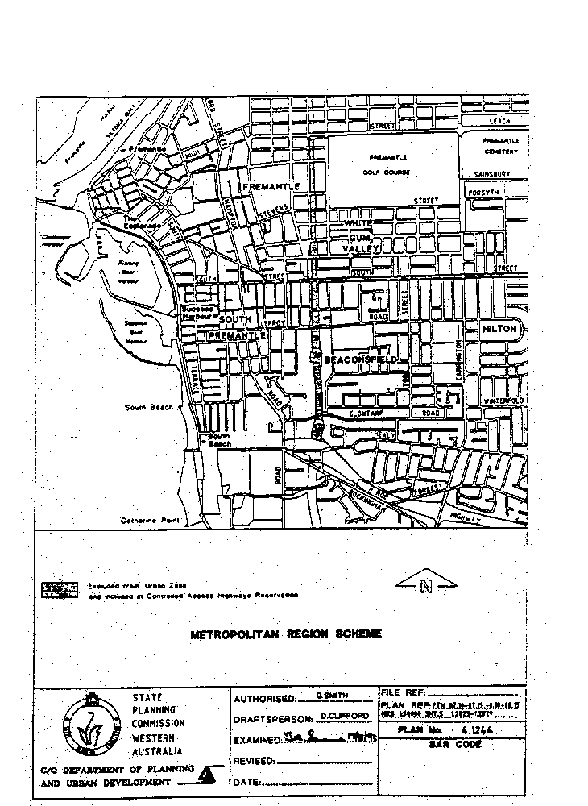

Notes
¹ This is a compilation of the Metropolitan Region Scheme (Fremantle) Act 1994 and includes the amendments made by the other written laws referred to in the following table.

Compilation table
Short title | Number and year | Assent | Commencement
Metropolitan Region Scheme (Fremantle) Act 1994 | 44 of 1994 | 22 Sep 1994 | 22 Sep 1994
Planning and Development (Consequential and Transitional Provisions) Act 2005 s. 15 | 38 of 2005 | 12 Dec 2005 | 9 Apr 2006 (see s. 2 and Gazette 21 Mar 2006 p. 1078)

Defined terms

[This is a list of terms defined and the provisions where they are defined. The list is not part of the law.]
Defined term Provision(s)
Commission 3
Metropolitan Region Scheme 3
Plan 3

