
Western Australia
Retail Trading Hours Act 1987
Retail Trading Hours (Tourism Precincts and Holiday Resorts) Regulations 2007

Western Australia
Retail Trading Hours (Tourism Precincts and Holiday Resorts) Regulations 2007
CONTENTS
-1. Citation 1
2. Commencement 1
3. Fremantle tourism precinct prescribed 1
4. Perth tourism precinct prescribed 1
5. Holiday resorts prescribed 2
Schedule 1 — Tourism precincts
Division 1 — Fremantle tourism precinct
Division 2 — Perth tourism precinct
Schedule 2 — Holiday resorts
Division 1 — Rockingham holiday resort
Division 2 — Rottnest Island holiday resort
Division 3 — Wanneroo holiday resort
Notes
Compilation table 7

Western Australia
Retail Trading Hours Act 1987
Retail Trading Hours (Tourism Precincts and Holiday Resorts) Regulations 2007

1. Citation
These regulations are the Retail Trading Hours (Tourism Precincts and Holiday Resorts) Regulations 2007.

2. Commencement
These regulations come into operation on the day on which the Retail Shops and Fair Trading Legislation Amendment Act 2006* section 9 comes into operation.
[* Act No. 47 of 2006.]

3. Fremantle tourism precinct prescribed
The area of the State described in Schedule 1 Division 1 is prescribed as the Fremantle tourism precinct for the purpose of section 12A(4) of the Act.
[Regulation 3 amended in Gazette 26 Mar 2010 p. 1134.]

4. Perth tourism precinct prescribed
The area of the State described in Schedule 1 Division 2 is prescribed as the Perth tourism precinct for the purpose of section 12A(4) of the Act.
[Regulation 4 inserted in Gazette 24 Nov 2009 p. 4733; amended in Gazette 26 Mar 2010 p. 1134.]

5. Holiday resorts prescribed
(1) The area of the State described in Schedule 2 Division 1 is prescribed as the Rockingham holiday resort for the purpose of section 12A(4) of the Act.
(2) The area of the State described in Schedule 2 Division 2 is prescribed as the Rottnest Island holiday resort for the purpose of section 12A(4) of the Act.
(3) The area of the State described in Schedule 2 Division 3 is prescribed as the Wanneroo holiday resort for the purpose of section 12A(4) of the Act.

Schedule 1 — Tourism precincts
[r. 3 & 4]

Division 1 — Fremantle tourism precinct
[Heading inserted in Gazette 26 Mar 2010 p. 1134.]
That part of the district of Fremantle (as existing at the commencement of the Retail Trading Hours (Tourism Precincts and Holiday Resorts) Amendment Regulations 2010 regulation 6) that is south of the Swan River. For information purposes, the prescribed area is shown below and shaded grey.
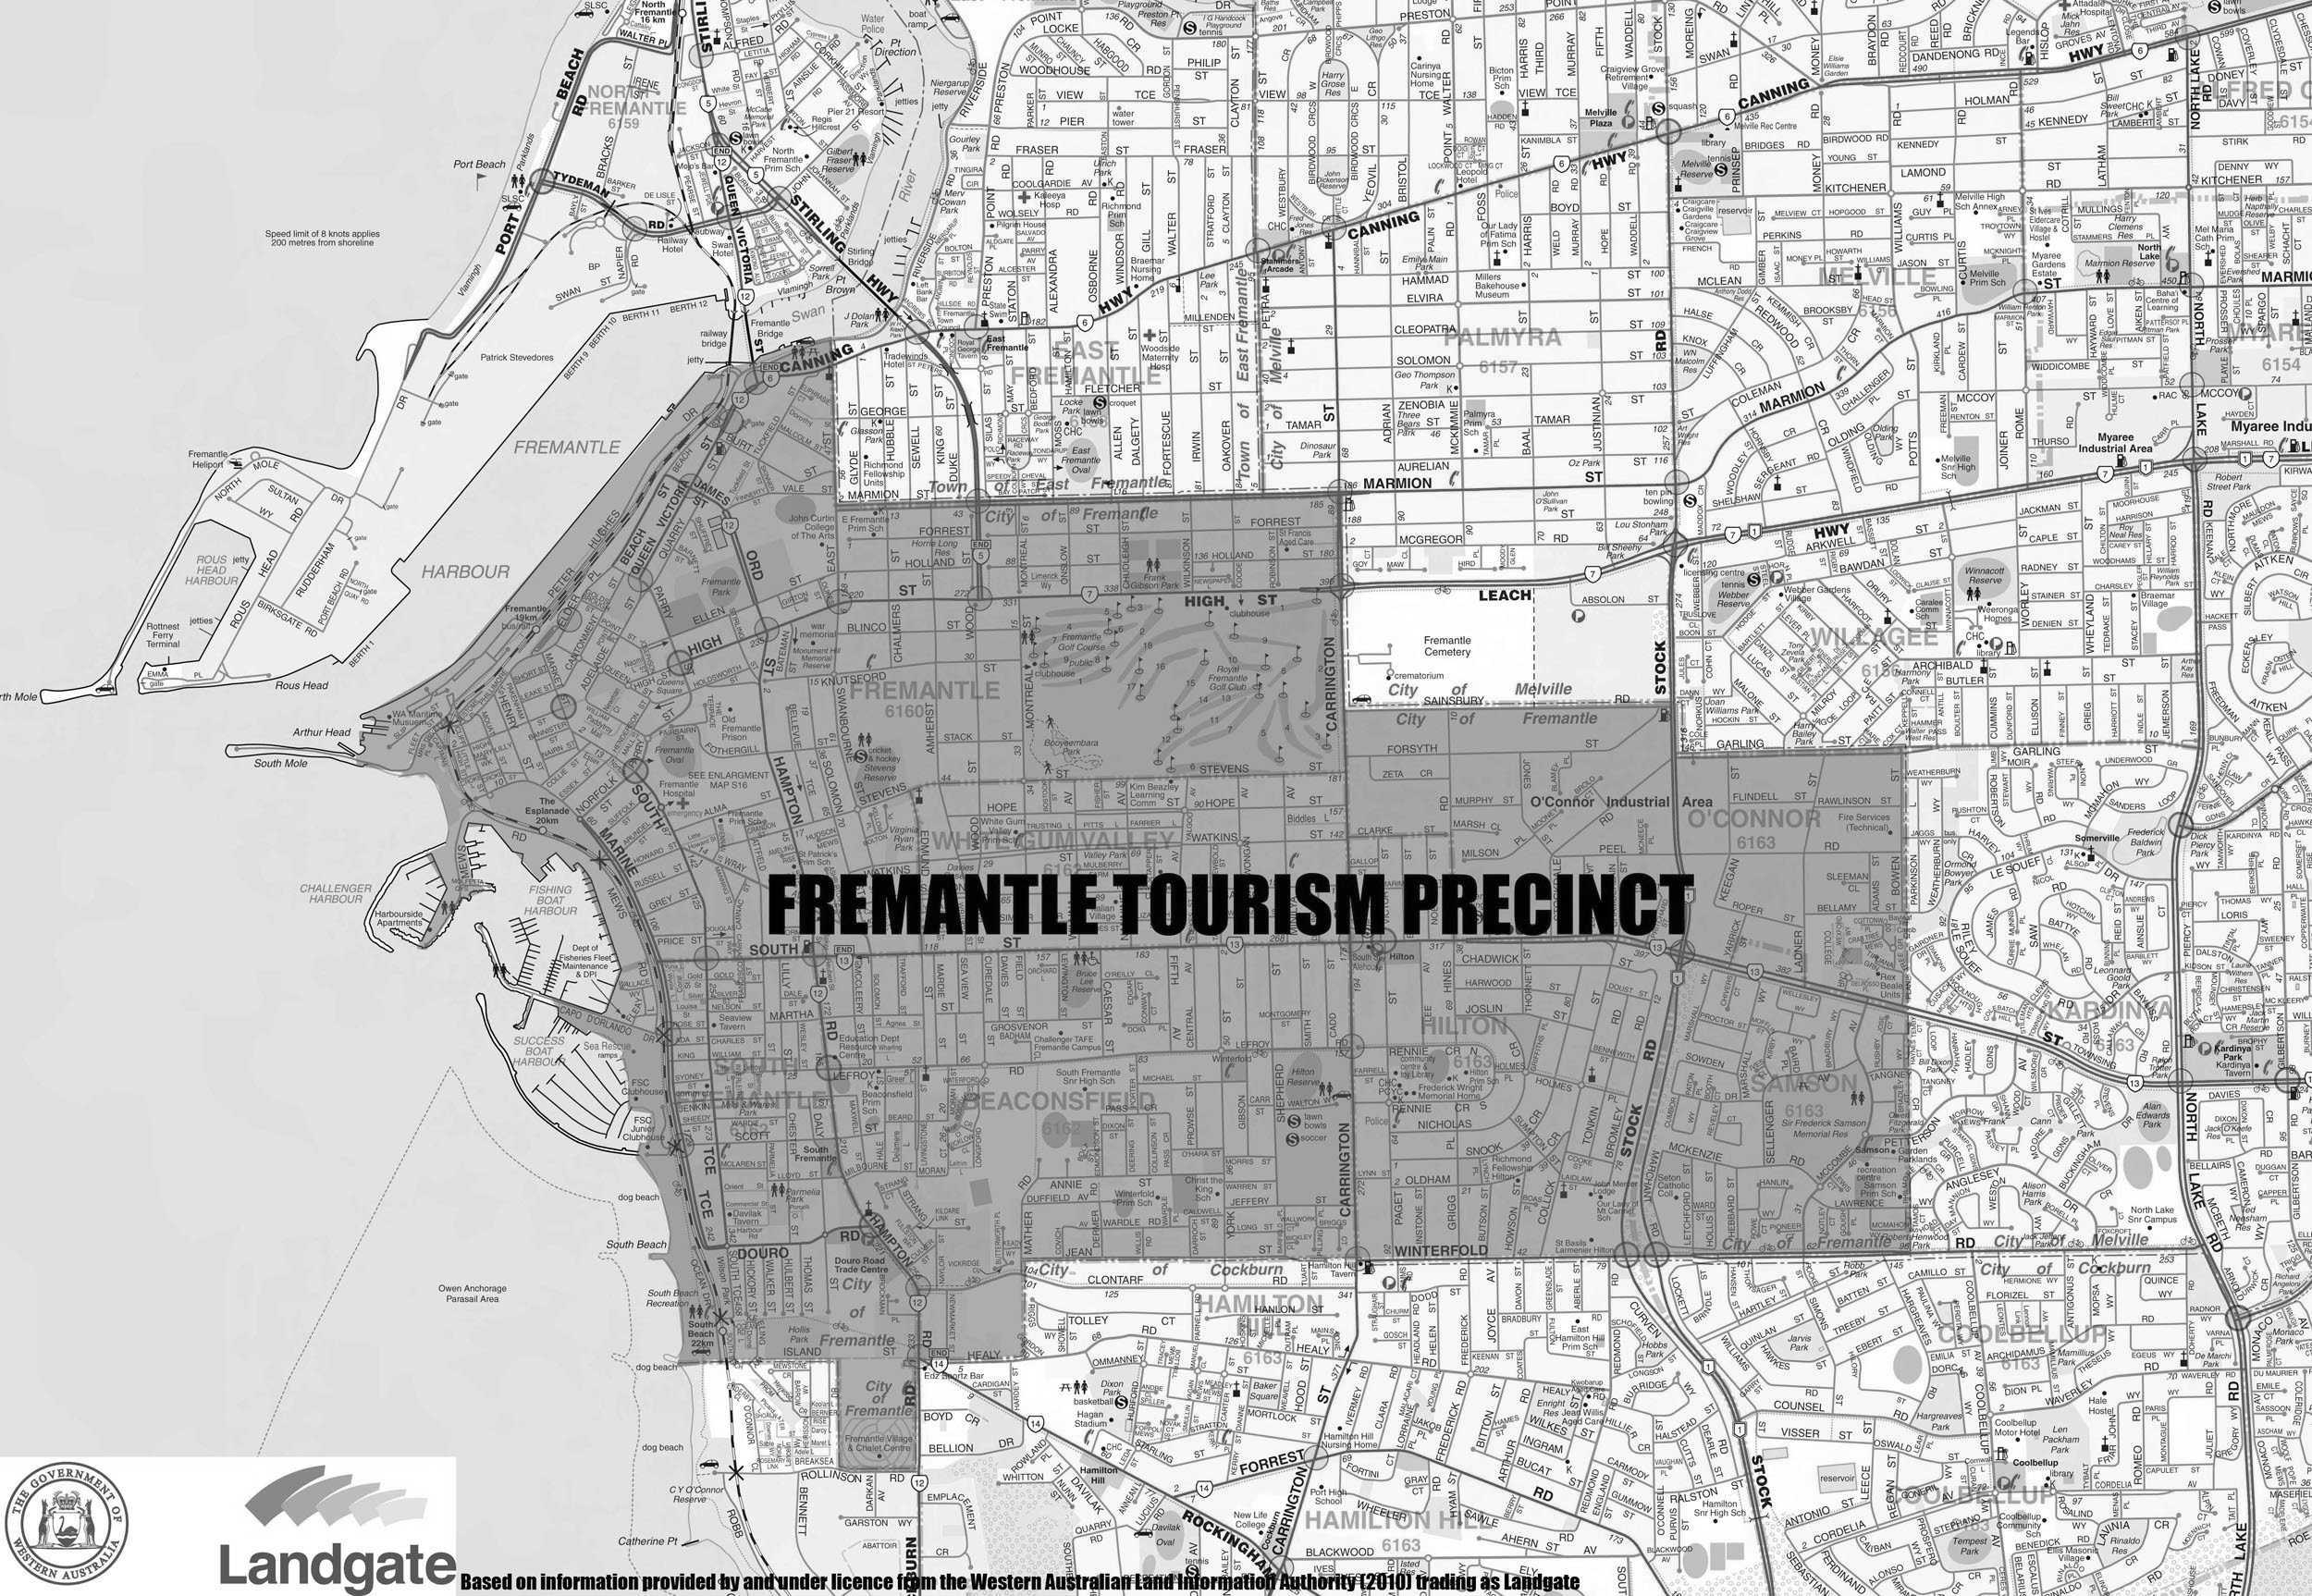
[Division 1 inserted in Gazette 26 Mar 2010 p. 1134-5.]

Division 2 — Perth tourism precinct
[Heading inserted in Gazette 24 Nov 2009 p. 4734.]
(1) The area of the State contained within a line that starts at the western end of Bagot Road, Subiaco where it intersects with Railway Road, then continues in a north-easterly direction along Railway Road to where it intersects with Forrest Street, then continues in a northerly direction directly to the southern end of Harborne Street where it intersects with Roydhouse Street, then continues in a northerly direction along Harborne Street to where it intersects with Cambridge Street, then continues in an easterly direction along Cambridge Street to where it intersects with Southport Street, then continues in a generally northerly and north-westerly direction along Southport Street to where the northbound lane intersects with Lake Monger Drive, then continues in an easterly direction along Lake Monger Drive to where it becomes Vincent Street, then continues in an easterly direction along Vincent Street to where it intersects with William Street, then continues in a northerly and then north-easterly direction along William Street to where it intersects with Walcott Street, then (subject to subclause (3)) continues in a generally south-easterly direction along Walcott Street to where it intersects with Lord Street, then continues in an easterly direction directly to the eastern end of Pakenham Street, then continues in a generally easterly then south-easterly direction along Pakenham Street to where it intersects with Joel Terrace, then continues due east to the Swan River, then continues in a generally southerly direction along the western bank of the Swan River to the point where the Perth to Armadale railway line crosses the Swan River immediately to the south of the Graham Farmer Freeway, then continues along the eastbound track of the Perth to Armadale railway line in a generally easterly direction across the Swan River, then continues along that track in a generally south-easterly direction as far as Victoria Park Station and to the point on that track that is directly opposite where the eastern end of Duncan Street intersects with Kitchener Avenue, then continues in a generally south-westerly direction directly to the eastern end of Duncan Street where it intersects with Kitchener Avenue, then continues in a south-westerly direction along Duncan Street to where it intersects with the Albany Highway, then continues in a generally southerly direction along the Albany Highway to where it intersects with McMillan Street, then continues in a south-westerly direction along McMillan Street to where it becomes George Street, then continues in a south-westerly direction along George Street to where it intersects with South Terrace and Hayman Road, then continues in a westerly direction along South Terrace to the western end of South Terrace, then continues in a westerly direction directly to the northbound lane of the Kwinana Freeway, then continues in a generally northerly direction along the northbound lane of the Kwinana Freeway, across the Narrows, to the point on the western bank of the Swan River where it starts to cross over Riverside Drive, then continues in a generally westerly direction along Riverside Drive to where it becomes Mounts Bay Road, then continues generally south-westerly along Mounts Bay Road to where it intersects with Winthrop Avenue, then continues generally northerly then generally north-easterly along Winthrop Avenue until it intersects with Aberdare Road and Thomas Street, then continues generally north-easterly along Thomas Street to where it intersects with Rokeby Road, then continues in a northerly direction along Rokeby Road to where it intersects with Bagot Road, then continues in a westerly direction along Bagot Road to the starting point.
(2) Where the boundary of the area described in subclause (1) follows a road, street or highway, the precinct includes the strip of land that extends outwards for 100 metres from the outer edge of that road, street or highway so that general retail shops that are wholly or partially within that strip of land are within the precinct.
(3) The Perth tourism precinct includes the stretch of Beaufort Street that begins at its intersection with Walcott Street and ends at its intersection with Queens Crescent, and includes the strip of land that extends outwards for 100 metres on either side of that stretch of Beaufort Street so that general retail shops on both sides of that stretch of road and that are wholly or partially within that strip are within the precinct.
[Division 2 inserted in Gazette 24 Nov 2009 p. 4734-5.]

Schedule 2 — Holiday resorts
[r. 5]

Division 1 — Rockingham holiday resort
City of Rockingham.

Division 2 — Rottnest Island holiday resort
Rottnest Island.

Division 3 — Wanneroo holiday resort
Localities of Two Rocks and Yanchep.

Notes
¹ This is a compilation of the Retail Trading Hours (Tourism Precincts and Holiday Resorts) Regulations 2007 and includes the amendments made by the other written laws referred to in the following table.

Compilation table
Citation | Gazettal | Commencement
Retail Trading Hours (Tourism Precincts and Holiday Resorts) Regulations 2007 | 11 May 2007 p. 2019-25 | 11 May 2007 (see r. 2 and Gazette 11 May 2007 p. 2017)
Retail Trading Hours (Tourism Precincts and Holiday Resorts) Amendment Regulations 2009 | 14 Jul 2009 p. 2811-12 | r. 1 and 2: 14 Jul 2009 (see r. 2(a));  Regulations other than r. 1 and 2: 15 Jul 2009 (see r. 2(b))
Retail Trading Hours (Tourism Precincts and Holiday Resorts) Amendment Regulations (No. 2) 2009 | 24 Nov 2009 p. 4733-5 | r. 1 and 2: 24 Nov 2009 (see r. 2(a));  Regulations other than r. 1 and 2: 1 Jan 2010 (see r. 2(b))
Retail Trading Hours (Tourism Precincts and Holiday Resorts) Amendment Regulations 2010 | 26 Mar 2010 p. 1134-5 | r. 1 and 2: 26 Mar 2010 (see r. 2(a));  Regulations other than r. 1 and 2: 27 Mar 2010 (see r. 2(b))

