
Western Australia
Subiaco Redevelopment Act 1994

Subiaco Redevelopment (Subtracted Area - Stage 2) Regulations 2006
These regulations expired as at 17 Nov 2010 (see r. 7(2)).

Western Australia
Subiaco Redevelopment (Subtracted Area - Stage 2) Regulations 2006
Contents
1. Citation 1
2. Commencement 1
3. Schedule 1 to the Act replaced 1
Schedule 1
Redevelopment Area
4. Minister may amend planning schemes 3
5. Transitional matters to do with City of Subiaco Town Planning Scheme No. 4 3
6. Other transitional matters 5
7. Expiry of regulations 5
Schedule 1 — Adopted policies and manuals
Notes
Compilation table 7

Western Australia
Subiaco Redevelopment Act 1994
Subiaco Redevelopment (Subtracted Area - Stage 2) Regulations 2006

1. Citation
These regulations are the Subiaco Redevelopment (Subtracted Area - Stage 2) Regulations 2006.

2. Commencement
These regulations come into operation on the day on which they are published in the Gazette.

3. Schedule 1 to the Act replaced
(1) In this regulation —
Schedule 1 means the Subiaco Redevelopment Act 1994* Schedule 1.
[* Reprint2 as at 2 June 2006.]
(2) When an order under regulation 4 takes effect, Schedule 1 is repealed and the following Schedule is inserted instead —
“
Schedule 1
[Section 4]
Redevelopment Area
All of the land outlined by a broken black and white line on Plan No. 3.1786/2 held at the office of the Authority. For guidance, the redevelopment area is indicated in the following representation of Plan No. 3.1786/2 —
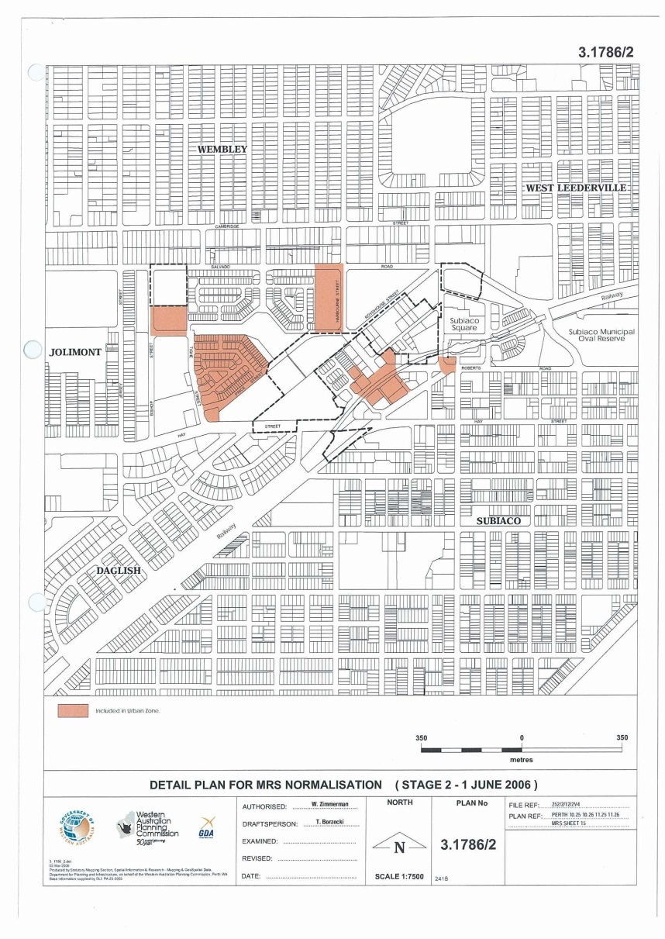
”.

4. Minister may amend planning schemes
(1) The Minister may, by order published in the Gazette, amend the Metropolitan Region Scheme or the City of Subiaco Town Planning Scheme No. 4 to provide for —
(a) land in the subtracted area to be included in the area to which that scheme applies; and
(b) the land to have a reservation or zoning under that scheme the same as, or similar to, that which applied to the land immediately before it ceased to be in the redevelopment area.
(2) In subregulation (1) —
subtracted area means the area to be subtracted from the redevelopment area by regulation 3.
(3) An order takes effect at the beginning of the day after the day on which it is published in the Gazette.

5. Transitional matters to do with City of Subiaco Town Planning Scheme No. 4
(1) This regulation applies in relation to land included under regulation 4(1) in the area to which the City Scheme applies, but only to the extent that the City Scheme has not been amended to expressly exclude the application of this regulation.
(2) The provisions of the Redevelopment Scheme that applied in relation to the land before it was included in the area to which the City Scheme applies continue to apply in relation to that land as if they were a part of the City Scheme but with —
(a) references to the Authority being read as references to the City of Subiaco; and
(b) any other modifications necessary to enable the provisions to apply as if they were a part of the City Scheme administered by the City of Subiaco.
(3) Provisions of the Redevelopment Scheme that are listed in the Table to this subregulation do not continue to apply under subregulation (2).
Table
cl. 1 to 4 | cl. 34
cl. 6(e) | cl. 37
cl. 10 to 14 | cl. 39
cl. 16 | cl. 50 to 68
cl. 17 to 24 | Sch. 2 to 5
cl. 26 | App. 2
cl. 29 to 31
(4) Provisions applying under subregulation (2) prevail to the extent of any inconsistency with another provision of the City Scheme.
(5) The General Planning Policies, Precinct Planning Policies and Design Manuals adopted under the Redevelopment Scheme and listed in Schedule 1 of these regulations are to be treated as if —
(a) they were policies prepared under the provisions applying under subregulation (2); and
(b) to the extent of any inconsistency with any other provision of the City Scheme, they prevailed over that provision.
(6) In this regulation —
City Scheme means the City of Subiaco Town Planning Scheme No. 4;
Redevelopment Scheme means the redevelopment scheme in force under Part 4 of the Act immediately before an order under regulation 4 takes effect.

6. Other transitional matters
When an order under regulation 4 takes effect, the effect, if any, of a decision previously made by the Authority about a development application or approval continues.

7. Expiry of regulations
(1) These regulations expire if the Minister has made an order under regulation 4(1) but there is no longer any land in relation to which regulation 5 applies, unless these regulations have already expired under subregulation (2).
(2) These regulations expire at the end of the period of 4 years commencing on the day on which they come into operation, unless they have already expired under subregulation (1).
(3) The expiry of these regulations does not affect the amendment made by regulation 3(2) nor an amendment made by an order under regulation 4(1).

Schedule 1 — Adopted policies and manuals
[r. 5(5)]
General Planning Policies
Planning Policy 1.1 | The Redevelopment Area
Planning Policy 1.2 | Neighbourhood design
Planning Policy 1.3 | Land Uses in the Project Area
Planning Policy 1.4 | Residential Development
Planning Policy 1.5 | Subdivision Design
Planning Policy 1.6 | Environmental Assessment
Planning Policy 1.7 | Resource Efficiency
Planning Policy 1.8 | The Urban Landscape
Planning Policy 1.9 | Movement
Planning Policy 1.10 | Car Parking
Planning Policy 1.11 | Heritage
Planning Policy 1.12 | Public Art
Planning Policy 1.13 | Safety
Planning Policy 1.14 | Signage
Planning Policy 1.15 | Roof Mounted Structures
Precinct Planning Policies
Planning Policy 2.1 | Precinct 1 — Station
Planning Policy 2.2 | Precinct 2 — Roydhouse
Planning Policy 2.3 | Precinct 3 — Centro Place
Planning Policy 2.4 | Precinct 4 — Salvado
Planning Policy 2.5 | Precinct 5 — Bishop Street
Planning Policy 2.6 | Precinct 6 — Greenway
Planning Policy 2.7 | Precinct 7 — Price Street
Design Manual
Subiaco Redevelopment Residential Design Manual | November 1996

Notes
¹ This is a compilation of the Subiaco Redevelopment (Subtracted Area - Stage 2) Regulations 2006. The following table contains information about those regulations.

Compilation table
Citation | Gazettal | Commencement
Subiaco Redevelopment (Subtracted Area - Stage 2) Regulations 2006 | 17 Nov 2006 p. 4764-8 | 17 Nov 2006 (see r. 2)
These regulations expired as at 17 Nov 2010 (see r. 7(2))

Defined terms

[This is a list of terms defined and the provisions where they are defined. The list is not part of the law.]
Defined term Provision(s)
City Scheme 5(6)
Redevelopment Scheme 5(6)
Schedule 1 3(1)
subtracted area 4(2)

