Western Australia
Swan Valley Planning Act 1995

Western Australia
Swan Valley Planning Act 1995
CONTENTS
-Part 1 — Preliminary
1. Short title 2
2. Commencement 2
3. Interpretation 2
Part 2 — Delineation of planning areas in Swan Valley
4. Areas A, B, C and D 4
5. Areas may be varied 5
Part 3 — Planning objectives for the Swan Valley
6. General planning objectives 6
7. Planning objectives for Area A 6
8. Planning objectives for Area B 6
9. Planning objectives for Area C 7
10. Planning objectives for Area D 8
Part 4 — Swan Valley Planning Committee
Division 1 — Committee established, and functions
11. Swan Valley Planning Committee 10
12. Nominations 11
13. Functions 11
14. Objectives 12
15. Referral to Committee of development applications under the Shire of Swan town planning scheme 12
16. Evidence of advice or submission 13
17. Staff and facilities 13
Division 2 — Provisions relating to Committee and its members
18. Constitution and proceedings 14
19. Remuneration and expenses of members 14
20. Protection of members 14
22. Particular duties of members 14
Part 5 — General
23. Minister may require Shire to prepare guidelines 16
24. Advice and reports to be open for inspection 16
25. Regulations 17
26. Review of Act 17
Schedule 1
1. Term of office 18
2. Resignation, termination, etc. 18
3. Temporary members 18
4. Deputy chairperson 19
5. Meetings 19
6. Sub-committees 20
7. Resolution may be passed without meeting 20
8. Leave of absence 20
9. Committee to determine own procedures 20
Notes
Compilation table 21

Western Australia
Swan Valley Planning Act 1995
An Act to establish a committee to advise on land use planning and land development in the area known as the Swan Valley, and to prescribe planning and development objectives for the various parts of that area.

Part 1 — Preliminary

1. Short title
This Act may be cited as the Swan Valley Planning Act 1995 ¹.

2. Commencement
The provisions of this Act come into operation on such day as is, or days as are respectively, fixed by proclamation ¹.

3. Interpretation
In this Act, unless the contrary intention appears —
“appointed member” means a member other than an ex officio member;
“Area A”, “Area B”, “Area C” and “Area D” mean the areas referred to as such in section 4;
“Commission” means the Western Australian Planning Commission established under the Planning and Development Act 2005;
“Committee” means the Swan Valley Planning Committee;
“development” means the development or use of any land, including —
(a) any demolition, erection, construction, alteration of or addition to any building or structure on the land and the carrying out on the land of any excavation or other works; and
(b) in the case of a place to which a Conservation Order made under section 59 of the Heritage of Western Australia Act 1990 applies, any act or thing that —
(i) is likely to change the character of that place or the external appearance of any building; or
(ii) would constitute an irreversible alteration of the fabric of any building;
“ex officio member” means a member referred to in section 11(2)(b) or (c);
“land” includes waters and land covered by water whether continuously or otherwise;
“local planning scheme” means the local planning scheme for the time being in force under the Planning and Development Act 2005 for the local government district of Swan;
“member” means a member of the Committee;
“Swan Valley” means all of the land comprised in Area A, Area B, Area C and Area D;
“Swan Valley Planning Committee” means the Committee established by section 11(1).
[Section 3 amended by No. 14 of 1996 s. 4; No. 38 of 2005 s. 15.]

Part 2 — Delineation of planning areas in Swan Valley

4. Areas A, B, C and D
(1) Area A, Area B, Area C and Area D comprise all of the land in the areas respectively shown as Area A, Area B, Area C and Area D on the plan of the Swan Valley held at the office of the Commission, that plan being certified by the Minister as being the plan prepared to define those Areas for the purposes of this Act.
(2) For guidance, Area A, Area B, Area C and Area D are indicated in the following representation of the plan referred to in subsection (1).
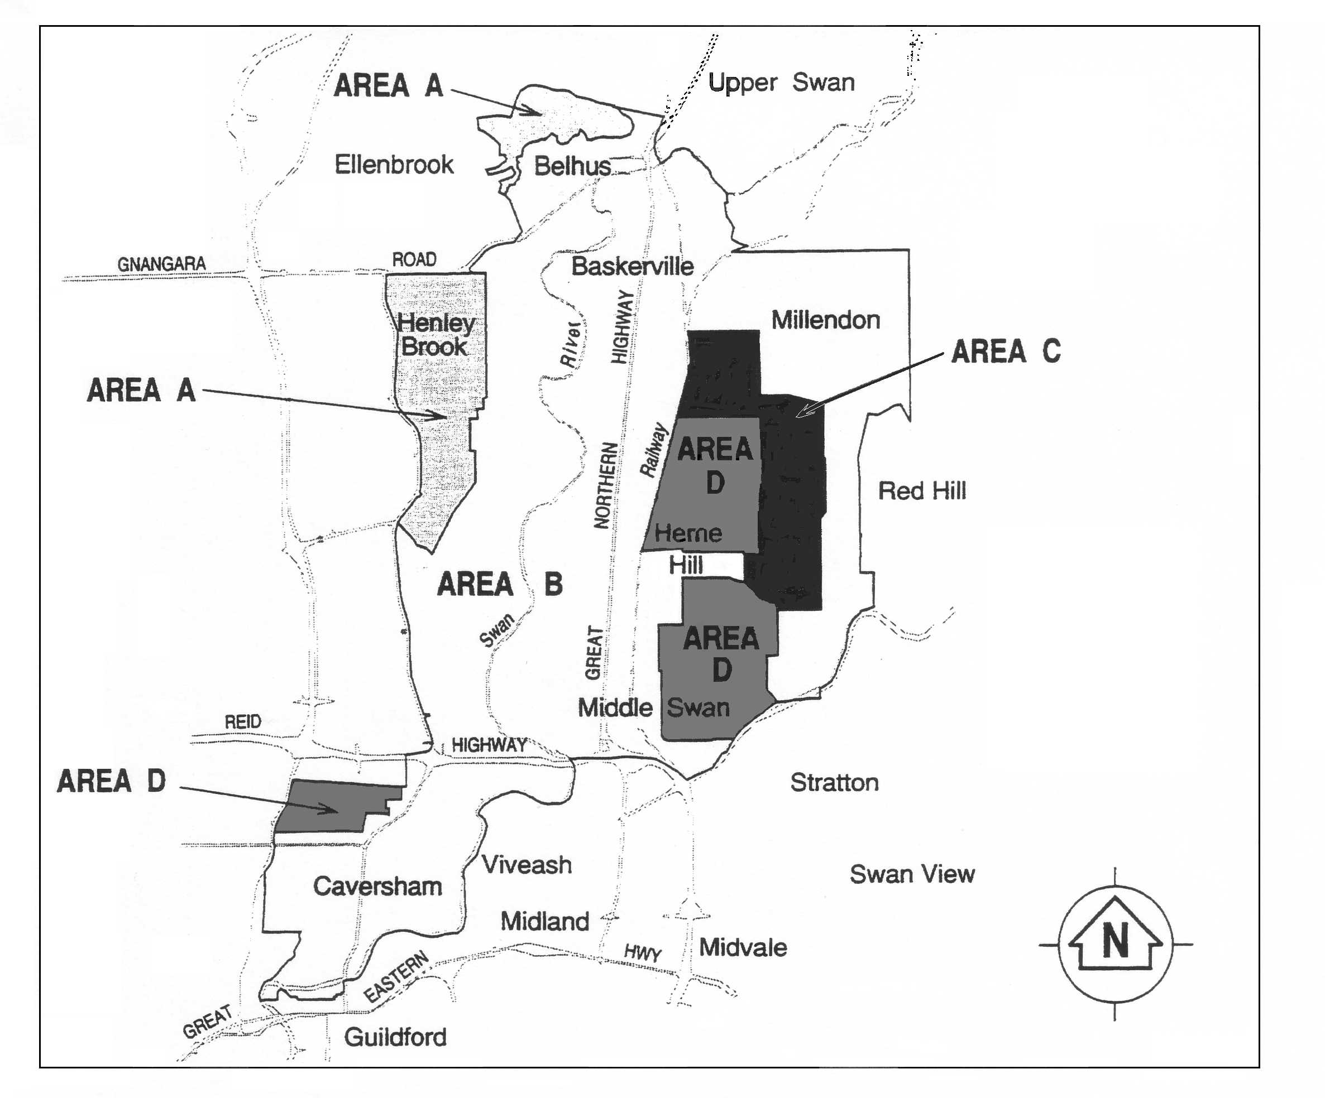

5. Areas may be varied
(1) Regulations may be made under section 25 to vary the plan referred to in section 4(1) by adding to Area A, Area B, Area C or Area D any land that is contiguous to that Area or by subtracting any land from Area A, Area B, Area C or Area D.
(2) When regulations are made for the purpose of subsection (1) those regulations may delete section 4(2) and substitute a new subsection for it.
(3) Before any regulations are made for the purpose of subsection (1) the Minister is to —
(a) consult with the Swan Valley Planning Committee and the Shire of Swan; and
(b) cause public notification of the proposed regulations to be given by the publication —
(i) in the Gazette;
(ii) in 2 issues of a daily newspaper circulating throughout the State and in 2 issues of a community newspaper with a circulation local to the Swan Valley; and
(iii) at the offices of the Commission,
of a notice specifying the places at which a copy of the proposed regulations may be inspected or obtained and stating that written submissions on those proposed regulations may be made by any person within a period of 3 months after the day of publication of the notice in the Gazette by delivering or posting those submissions to the address stated in the notice.
(4) In any proceedings, a plan purporting to be a copy of a plan referred to in section 4 showing the boundaries or any boundary of any area is evidence of those boundaries or that boundary.
(5) The regulations may make such transitional provisions as may be required in connection with any variation of an Area.
[Section 5 amended by No. 14 of 1996 s. 4.]

Part 3 — Planning objectives for the Swan Valley

6. General planning objectives
The general planning objectives for the Swan Valley are the encouragement of the traditional agricultural and other productive uses of the area, the protection of the environment and the character of the area, the reduction of nutrient levels in the Swan River and the promotion of tourism.

7. Planning objectives for Area A
The planning objectives for any proposed development in Area A are as follows —
1. The maintenance of the rural character of the area.
2. The encouragement of viticulture, horticulture, hobby farming, and rural activities compatible with rural residential uses in the area.
3. The encouragement of tourism.
4. Due consideration of building setbacks, retention of vegetation, suitable building materials and suitable boundary fencing in the design of rural residential developments.
5. The avoidance of overstocking, of clearing of natural vegetation, of activities causing pollution or degradation of the environment and of any other land management practices detrimental to the amenity of the area.
6. The subdivision of rural land only when it is consistent with the objectives set out in this section or the size of the proposed lots is not substantially different from prevailing lot sizes in the area.

8. Planning objectives for Area B
The planning objectives for any proposed development in Area B are as follows —
1. The protection of viticulture.
2. The provision of water for viticulture and horticulture and the discouragement of other activities that have high water demands.
3. The encouragement of tourist facilities provided that they do not detract from the rural character of the area.
4. The encouragement of traditional activities of the Swan Valley and industries associated with viticulture, horticulture and cottage industry.
5. The limited expansion of the existing retail and community facilities at Herne Hill, Caversham and West Swan.
6. The compatibility of design, siting and landscaping with the character of the area.
7. The discouragement of uses that are incompatible with the rural character and traditional agricultural activities of the area.
8. The extraction of basic raw materials so far as it is compatible with the character and amenity of the area and subject to the rehabilitation of the affected land.
9. The subdivision into lots of less than 4 hectares only where this is consistent with the objectives set out in this section.
10. The avoidance of overstocking, of activities causing pollution or degradation of the environment and of any other land management practices detrimental to the amenity of the area.

9. Planning objectives for Area C
The planning objectives for any proposed development in Area C are as follows —
1. The maintenance of the rural character of the area.
2. The encouragement of viticulture and horticulture.
3. The establishment of a wide range of rural activities compatible with the rural character of the area.
4. The encouragement of revegetation.
5. Due consideration of building setbacks, retention of vegetation, suitable building materials and suitable boundary fencing in the design of rural residential developments.
6. The avoidance of overstocking, of clearing of natural vegetation, of activities causing pollution or degradation of the environment and of any other land management practices detrimental to the amenity of the area.
7. The subdivision into lots of less than 4 hectares only where this is consistent with the objectives set out in this section.

10. Planning objectives for Area D
The planning objectives for any proposed development in Area D are as follows —
1. The establishment of villages in a rural setting.
2. The encouragement of a range in residential lot sizes from 2 000 m² to 4 000 m².
3. The provision of utility and infrastructure services and of amenities (including tourist facilities) which complement and support rural villages.
4. Due consideration of wetlands, natural drainage, soil types, remnant vegetation and the need for revegetation.
5. The prevention of detrimental impact on —
(a) rural activities in Areas B and C; and
(b) nutrient levels in the Swan River.
6. Due consideration of building design, building materials, and landscaping.
7. Due consideration of materials used for fencing the boundary of a rural village.
8. The subdivision into residential lots of less than 2 000 m² only where this is consistent with the objectives set out in this section.
9. Due consideration of alternative reticulated systems to deep sewerage treatment that are consistent with the objectives of this section.

Part 4 — Swan Valley Planning Committee

Division 1 — Committee established, and functions

11. Swan Valley Planning Committee
(1) There is established a committee called the Swan Valley Planning Committee.
(2) The Committee consists of —
(a) a person with appropriate qualifications and experience appointed by the Minister to be the chairperson;
(b) the person who is for the time being the president or acting president of the Shire of Swan, ex officio, or his or her nominee;
(c) the chairperson or acting chairperson for the time being of the Commission, ex officio, or his or her nominee;
(d) 4 persons appointed by the Minister each being appointed from a panel of 3 names submitted by each of the following bodies —
(i) the Midland and Districts Chamber of Commerce and Industries;
(ii) the Grape Growers Association of W.A. (Inc);
(iii) the Swan Valley and Regional Winemakers Association; and
(iv) the Swan Valley Tourism Council (Inc);
and
(e) not more than 3 other persons appointed by the Minister of whom —
(i) one is to be a person who is a resident of the Swan Valley; and
(ii) one is to be a person who in the opinion of the Minister is suitable to represent Aboriginal interests in that area.

12. Nominations
(1) Whenever an appointment is required to be made under section 11(2)(d) the Minister is to request the relevant body to submit to him or her the names of 3 persons that the body considers to be suitable for appointment.
(2) If a body fails to comply with the request within 30 days after it is made, the Minister may make the appointment at his or her discretion.

13. Functions
(1) The functions of the Committee are —
(a) to provide advice in accordance with —
(i) section 15(2);
(ii) sections 40, 47, 78 and 134 of the Planning and Development Act 2005; and
(iii) clause 30B of the Metropolitan Region Scheme as defined in the Planning and Development Act 2005;
(b) to make submissions under section 53(2) of the Swan River Trust Act 1988;
(c) to provide advice to a public authority on any matter relating to the Swan Valley that is referred to it by that public authority;
(d) where a public authority has power to carry out remedial or improvement works on land in the Swan Valley or to provide funds for such works, at the request of the public authority to provide advice to it as to the exercise of that power;
(e) where a public authority has power to enter into agreements as to the management of private land in the Swan Valley by the owner or occupier, at the request of the public authority to provide advice to it as to the exercise of that power; and
(f) to provide advice to the Shire of Swan on ways of introducing differential rating in the Swan Valley in order to encourage viticulture and any other activity in keeping with the objectives for the area.
(2) In subsection (1) “public authority” includes the Shire of Swan.
[Section 13 amended by No. 14 of 1996 s. 4; No. 38 of 2005 s. 15.]

14. Objectives
In providing the advice referred to in section 13(1)(a) or making a submission referred to in section 13(1)(b) in respect of any planning or development proposal the Committee is to seek to ensure that the proposal is consistent with the objectives set out in section 7, 8, 9 or 10 that apply to that proposal.

15. Referral to Committee of development applications under the Shire of Swan town planning scheme
(1) Where an application is made to the Shire of Swan under the local planning scheme for development approval relating to land in the Swan Valley the Shire of Swan, unless subsection (5) applies, is to give full particulars of the application to the Swan Valley Planning Committee.
(2) The Committee, within 42 days after the day on which it receives particulars of an application or within such longer period as the Shire of Swan allows, is to give to the Shire of Swan its advice in writing on how the application should be determined, including any conditions to which any approval should be made subject.
(3) If the Committee fails to give its advice within the time allowed under subsection (2), it shall be taken to have no advice to give on the application.
(4) The Shire of Swan is to have due regard to the advice of the Committee but may determine the application otherwise than in accordance with that advice.
(5) The Committee may determine that any particular class or description of applications for development approval need not be referred to the Committee for advice under this section and is to notify the Shire of Swan of any such determination.
(6) This section has effect despite anything in the local planning scheme.
(7) Subsection (1) does not apply to any application for development approval made before the commencement of this section.
[Section 15 amended by No. 14 of 1996 s. 4; No. 38 of 2005 s. 15.]

16. Evidence of advice or submission
(1) A statement setting out the advice of the Committee or a submission made by the Committee is sufficient evidence of that advice or that submission if it is signed on behalf of the Committee —
(a) by the chairperson; or
(b) by some other person authorised by the Committee to sign the statement.
(2) A statement purporting to be signed by the chairperson or a person referred to in subsection (1)(b) is to be presumed to be duly signed until the contrary is shown.

17. Staff and facilities
(1) The Committee may, by arrangement made between it and the Department, on such terms and conditions as are agreed, make use either full-time or part-time of the services of any officer or employee of the Department and of any facilities of the Commission.
(2) In subsection (1) “Department” means the department principally assisting the Minister in the administration of the Planning and Development Act 2005.
[Section 17 amended by No. 38 of 2005 s. 15.]

Division 2 — Provisions relating to Committee and its members

18. Constitution and proceedings
The provisions of Schedule 1 have effect with respect to the constitution and proceedings of the Committee.

19. Remuneration and expenses of members
A member is to be paid such remuneration and travelling and other allowances as are determined in his or her case by the Minister on the recommendation of the Minister for Public Sector Management.

20. Protection of members
A member is not personally liable for any act done or omitted to be done in good faith by the Committee in the performance of any function under this Act.

[21. Repealed by No. 14 of 1996 s. 4.]

22. Particular duties of members
(1) A member must at all times act honestly and diligently in performing his or her functions under this Act.
(2) If a matter is before a meeting for consideration and a member present at the meeting has a direct or indirect pecuniary interest in the matter, the member must disclose to the other members present at the meeting, as soon as possible after the relevant facts have come to his or her knowledge, that he or she has an interest, and —
(a) the disclosure is to be recorded in the minutes of the meeting; and
(b) the member must not subsequently be present during any consideration or discussion of, and is not to vote on any determination of, the matter.
(3) A member must not disclose any information acquired by virtue of the performance of any function under this Act unless the disclosure is made in connection with the carrying out of this Act or under a legal duty.
(4) A member must not make use of any information acquired by virtue of the performance of his or her functions to gain, directly or indirectly, an improper advantage for himself or herself or to cause detriment to any person.
(5) A member who commits a breach of any provision of this section —
(a) is liable to the Crown for any profit made by him or her as a result of the breach of that provision; and
(b) commits an offence and is liable to a fine of $10 000.
(6) This section is in addition to and not in derogation of any other law relating to the duty or liability of the holder of a public office.

Part 5 — General

23. Minister may require Shire to prepare guidelines
(1) The Shire of Swan is to amend the local planning scheme to include guidelines relating to —
(a) the subdivision of land;
(b) the provision of infrastructure; and
(c) the carrying out of development generally,
in Area A, Area B, Area C or Area D in accordance with the objectives set out in section 7, 8, 9 or 10.
(2) For the purposes of ensuring that subsection (1) is complied with the Minister may exercise the powers in section 212 of the Planning and Development Act 2005 as if —
(a) subsection (1) of this section were the relevant provision referred to in section 212(1) of that Act; and
(b) references to a local planning scheme were references to an amendment to the local planning scheme referred to in subsection (1) of this section,
and section 213 of the Planning and Development Act 2005 applies accordingly.
[Section 23 amended by No. 14 of 1996 s. 4; No. 38 of 2005 s. 15.]

24. Advice and reports to be open for inspection
(1) The Committee is to cause a separate record to be kept of any advice given or report made by it in the performance of its functions.
(2) The record referred to in subsection (1) is to be available for inspection by members of the public during normal office hours on payment of the prescribed fee.

25. Regulations
The Governor may make regulations prescribing all matters that are required or permitted by this Act to be prescribed, or are necessary or convenient to be prescribed, for giving effect to the purposes of this Act.

26. Review of Act
(1) The Minister is to carry out a review of the operation and effectiveness of this Act as soon as is practicable after the expiration of 5 years from its commencement, and in the course of that review the Minister is to consider and have regard to —
(a) the effectiveness of the operations of the Committee;
(b) the need for the continuation of the functions of the Committee; and
(c) any other matters that appear to the Minister to be relevant to the operation and effectiveness of this Act.
(2) The Minister is to prepare a report based on the review made under subsection (1) and, as soon as is practicable after the report is prepared, cause it to be laid before each House of Parliament.

[27. Omitted under the Reprints Act 1984 s. 7(4)(e).]

Schedule 1
[Section 18]
Provisions as to constitution and proceedings of the Committee
1. Term of office
(1) Except as otherwise provided by this Act, an appointed member holds office for the term, not exceeding 3 years, that is specified in the instrument of his or her appointment, but may from time to time be re-appointed.
(2) Unless his or her office becomes vacant under clause 2, an appointed member continues in office until his or her successor comes into office, despite the fact that the term for which the member was appointed has expired.
2. Resignation, termination, etc.
(1) The office of an appointed member becomes vacant if —
(a) he or she resigns the office by written notice addressed to the Minister;
(b) he or she is an undischarged bankrupt or a person whose property is subject to an order or arrangement under the laws relating to bankruptcy; or
(c) his or her appointment is terminated by the Minister.
(2) The Minister may at his or her discretion terminate the appointment of an appointed member at any time.
3. Temporary members
(1) If an appointed member other than the chairperson is unable to act by reason of sickness, absence or other cause, the Minister may appoint another person to act temporarily in his or her place and, while so acting according to the tenor of his or her appointment, that other person is deemed to be a member.
(2) If an appointed member is the deputy chairperson and is performing the functions of the chairperson, the Minister may, under subclause (1), appoint another person to act in his or her place as member.
(3) No act or omission of a person acting in place of another under this clause is to be questioned on the ground that the occasion for his or her appointment or acting had not arisen or had ceased.
(4) The appointment of a person as a temporary member may be terminated at any time by the Minister.
4. Deputy chairperson
(1) The Minister is to appoint a member to be the deputy chairperson of the Committee.
(2) The office of deputy chairperson becomes vacant if —
(a) the person holding the office resigns the office by notice in writing to the Minister;
(b) the person holding the office ceases to be a member; or
(c) the Minister declares the office to be vacant.
(3) During any vacancy in the office of chairperson, or while he or she is unable to act by reason of sickness, absence or other cause, the deputy chairperson is to perform the functions of the chairperson.
(4) No act or omission of the deputy chairperson acting as the chairperson is to be questioned on the ground that the occasion for his or her so acting had not arisen or had ceased.
5. Meetings
(1) The first meeting of the Committee is to be convened by the chairperson and subsequently, subject to subclause (2), meetings are to be held at the times and places that the Committee determines.
(2) A special meeting of the Committee may at any time be convened by the chairperson.
(3) The chairperson is to preside at all meetings of the Committee at which he or she is present.
(4) If both the chairperson and the deputy chairperson are absent from a meeting the members present are to appoint one of their number to preside.
(5) A quorum for a meeting of the Committee is 5 members.
(6) At any meeting of the Committee the chairperson, deputy chairperson or other person presiding is to have a deliberative vote and, in the case of an equality of votes, is also to have a casting vote.
(7) The Committee is to cause accurate minutes to be kept of the proceedings at its meetings.
6. Sub-committees
The Committee may from time to time appoint sub-committees of members, or members and other persons, as it thinks fit, and may discharge or alter any sub-committee so appointed.
7. Resolution may be passed without meeting
A resolution in writing signed or assented to by each member by letter or facsimile transmission is as valid and effectual as if it had been passed at a meeting of the Committee.
8. Leave of absence
The Committee may grant leave of absence to a member on the terms and conditions that the Committee thinks fit.
9. Committee to determine own procedures
Subject to this Act, the Committee is to determine its own procedures.
[Schedule 2 omitted under the Reprints Act 1984 s. 7(4)(e).]

Notes
¹ This is a compilation of the Swan Valley Planning Act 1995 and includes the amendments made by the other written laws referred to in the following table ^{1a}. The table also contains information about any reprint.

Compilation table
Short title | Number and year | Assent | Commencement
Swan Valley Planning Act 1995 | 31 of 1995 | 18 Sep 1995 | 25 Nov 1995 (see s. 2 and Gazette 24 Nov 1995 p. 5389)
Local Government (Consequential Amendments) Act 1996 s. 4 | 14 of 1996 | 28 Jun 1996 | 1 Jul 1996 (see s. 2)
Reprint 1: The Swan Valley Planning Act 1995 as at 12 Sep 2003 (includes amendments listed above)
Planning and Development (Consequential and Transitional Provisions) Act 2005 s. 15 | 38 of 2005 | 12 Dec 2005 | 9 Apr 2006 (see s. 2 and Gazette 21 Mar 2006 p. 1078)

