Western Australia
Water Agencies (Powers) Act 1984
Water Agencies (Water Use) By-laws 2010

Western Australia
Water Agencies (Water Use) By-laws 2010
CONTENTS
-Part 1 — Preliminary
1. Citation 1
2. Commencement 1
3. Terms used 1
Part 2 — Water restrictions
Division 1 — Restrictions
4. Use of water restricted 4
5. Stage of restrictions applicable to Area 1 4
6. Stage of restrictions applicable to Area 2 4
7. Stage of restrictions applicable to Area 3 5
8. Stage of restrictions applicable to Area 4 5
9. Use of scheme water in Halls Creek 5
10AA. Use of scheme water in Area 2 to 31 October 2012 6
10A. Use of scheme water in Area 4 from 1 December 2010 to 31 May 2011 8
Division 2 — Exemptions
10. Licensees under Rights in Water and Irrigation Act 1914 section 5C 11
11. Shared domestic bores 11
12. Installation, repair or testing reticulation systems 11
13. Vertimowing or applying fertilisers or wetting agents 12
14. Market gardens or plant nurseries 12
15. Caravan park or camping ground sites 12
16. Maintenance of birds in aviaries 12
17. Fire fighting 12
Part 3 — Scheme water efficiency management plans
Division 1 — General
18. Terms used 14
19. Extensions of time 14
Division 2 — Preparation, submission and approval of scheme water efficiency management plans
20. Initial preparation and submission of scheme water efficiency management plan 15
21. Approvals, requests for further information and requests for amendments 16
22. Persons may submit revised plans for approval at any time 17
Division 3 — After approval of scheme water efficiency management plans
23. Application 17
24. Period of approval of scheme water efficiency management plan 17
25. Compliance with scheme water efficiency management plans 18
26. Persons to submit revised scheme water efficiency management plans before end of approval period 18
27. Scheme water supplier may require revised scheme water efficiency management plans 19
28. Scheme water supplier may revoke approval of scheme water efficiency management plan 19
29. Annual reports on scheme water efficiency management plans 20
Part 4 — Repeal, saving and transitional
30. Repeal 22
31. Saving and transitional provisions for the Water Agencies (Water Use) By-laws 2007 22
Schedule 1 — Maps showing Areas 1, 2, 3 and 4
Schedule 2 — Stages of restrictions
1. Stage 1 25
2. Stage 2 25
3. Stage 3 26
4. Stage 4 27
5. Stage 5 28
6. Stage 6 29
7. Stage 7 30
Schedule 3 — Specified days for watering by reticulation
Division 1 — Specified days for Schedule 2 clauses 3(1)(a), 4(2)(a), 5(2)(a) and 6(2)(a)
Division 2 — Specified days for Schedule 2 clause 4(1)(a)
Division 3 — Specified days for Schedule 2 clause 5(1)(a)
Schedule 4 — Maps of certain scheme water areas
Notes
Compilation table 40
Defined Terms

Western Australia
Water Agencies (Powers) Act 1984
Water Agencies (Water Use) By-laws 2010

Part 1 — Preliminary

1. Citation
These by-laws are the Water Agencies (Water Use) By-laws 2010.

2. Commencement
These by-laws come into operation as follows —
(a) by-laws 1 and 2 — on the day on which these by-laws are published in the Gazette;
(b) the rest of the by-laws — on 1 April 2010.

3. Terms used
In these by-laws, unless the contrary intention appears —
Area means Area 1, Area 2, Area 3 or Area 4;
Area 1 means that part of the State that is north of the line —
(a) starting at latitude - 27.428° and longitude 114.063°; and
(b) extending to latitude - 30.117° and longitude 117.081°; and
(c) extending to latitude - 30.117° and longitude 128.993°,
as illustrated for information purposes on the maps shown in Schedule 1;
Area 2 means that part of the State that is south of the line —
(a) starting at latitude - 27.428° and longitude 114.063°; and
(b) extending to latitude - 30.117° and longitude 117.081°; and
(c) extending to latitude - 30.117° and longitude 128.993°,
except Area 3 or Area 4, as illustrated for information purposes on the maps shown in Schedule 1;
Area 3 means the local government districts of Bayswater, Mandurah, Murray, Joondalup, Wanneroo, Swan, Perth, Canning, Belmont, Vincent, Kwinana, Rockingham, Cockburn, Armadale, Gosnells, Peppermint Grove, Stirling, Fremantle, Claremont, Subiaco, Cottesloe, East Fremantle, Victoria Park, South Perth, Mundaring, Kalamunda, Melville, Serpentine-Jarrahdale, Nedlands, Mosman Park, Bassendean and Cambridge, as illustrated for information purposes on the maps shown in Schedule 1;
Area 4 means the local government districts of Dardanup, Bunbury, Cranbrook, Donnybrook-Balingup, Collie, Capel, Busselton, Nannup, Augusta-Margaret River, Albany, Boyup Brook, Manjimup, Bridgetown-Greenbushes, Waroona, Harvey, Plantagenet and Denmark, as illustrated for information purposes on the maps shown in Schedule 1;
domestic bore means a non-artesian well as defined in the Rights in Water and Irrigation Act 1914 section 2(1) from which the only water that can be taken is from the water table aquifer;
domestic bore water means water taken from a domestic bore;
evening period means the period after 6.00 p.m.;
garden does not include any indoor plants or plants growing inside a glasshouse;
high pressure water cleaner means a cleaning device that uses pressurised water flowing at a rate of not more than 6 L per minute;
lawn does not include a grass-covered sporting ground;
morning period means the period before 9.00 a.m.;
relevant property, in relation to the watering of a lawn, garden or grass-covered sporting ground, means the property on which the lawn, garden or grass-covered sporting ground is located;
scheme water means water supplied by scheme water supplier;
scheme water supplier means —
(a) the Corporation; or
(b) a water board as defined in the Water Boards Act 1904 section 3(1);
stage of restrictions means a stage of restrictions set out in Schedule 2;
synthetic sporting ground means a sporting ground that has a synthetic surface designed to be used after watering;
water means —
(a) scheme water; or
(b) domestic bore water;
week means a period of seven successive days beginning with Sunday.
[By-law 3 amended in Gazette 30 Nov 2010 p. 6016.]

Part 2 — Water restrictions

Division 1 — Restrictions

4. Use of water restricted
(1) In this by-law —
written approval means written approval from —
(a) in relation to scheme water — the scheme water supplier; and
(b) in relation to domestic bore water — the chief executive officer of the department of the Public Service principally assisting in the administration of the Act.
(2) A person must not, without written approval, use water in contravention of the stage of restrictions applicable under these by-laws.
Penalty: a fine of $500.
[By-law 4 amended in Gazette 28 Sep 2010 p. 5063.]

5. Stage of restrictions applicable to Area 1
(1) Subject to by-law 9, the stage of restrictions that applies in relation to the use of scheme water in Area 1 is stage 2.
(2) The stage of restrictions that applies in relation to the use of domestic bore water in Area 1 is stage 1.
[By-law 5 amended in Gazette 28 Sep 2010 p. 5063.]

6. Stage of restrictions applicable to Area 2
(1) Subject to by-law 10AA, the stage of restrictions that applies in relation to the use of scheme water in Area 2 is stage 4.
(2) The stage of restrictions that applies in relation to the use of domestic bore water in Area 2 is stage 1.
[By-law 6 amended in Gazette 28 Sep 2010 p. 5064; 8 Mar 2011 p. 801.]

7. Stage of restrictions applicable to Area 3
(1) The stage of restrictions that applies in relation to the use of scheme water in Area 3 is —
(a) from 1 June to 31 August in a particular year — stage 6; and
(b) at any other time of the year — stage 4.
(2) The stage of restrictions that applies in relation to the use of domestic bore water in Area 3 is —
(a) from 1 June to 31 August in a particular year — stage 6; and
(b) at any other time of the year — stage 3.
[By-law 7 amended in Gazette 28 Sep 2010 p. 5064; 30 Nov 2010 p. 6016.]

8. Stage of restrictions applicable to Area 4
(1) Subject to by-law 10A, the stage of restrictions that applies in relation to the use of scheme water in Area 4 is —
(a) from 1 June to 31 August in a particular year — stage 6; and
(b) at any other time of the year — stage 4.
(2) The stage of restrictions that applies in relation to the use of domestic bore water in Area 4 is —
(a) from 1 June to 31 August in a particular year — stage 6; and
(b) at any other time of the year — stage 1.
[By-law 8 amended in Gazette 28 Sep 2010 p. 5064.]

9. Use of scheme water in Halls Creek
The stage of restrictions that applies in relation to the use of scheme water in the local government district of Halls Creek is stage 4.
[By-law 9 inserted in Gazette 28 Sep 2010 p. 5064.]

10AA. Use of scheme water in Area 2 to 31 October 2012
(1) In this by-law —
commencement day means the day on which the Water Agencies (Water Use) Amendment By-laws (No. 2) 2011, other than by-laws 1 and 2, come into operation;
coordinate means a Map Grid of Australia (Geocentric Datum of Australia 1994) coordinate for zone 50.
(2) This by-law applies from commencement day to 31 October 2012.
(3) The stage of restrictions that applies in relation to the use of scheme water in the following areas is stage 5 —
(a) the Grass Patch scheme water area;
(b) the Salmon Gums scheme water area.
(4) The Grass Patch scheme water area is the area (around Grass Patch) defined by boundaries joining the coordinates in the Table sequentially.
Table
Point No. | Easting | Northing
1 | 379155 | 6323550
2 | 381035 | 6323550
3 | 381035 | 6322270
4 | 379155 | 6322270
5 | 379155 | 6323550
(5) The Salmon Gums scheme water area is the area (around Salmon Gums) defined by boundaries joining the coordinates in the Table sequentially.
Table
 | Point No. |  | Easting |  | Northing
1 |  | 371210 |  | 6351320
2 |  | 372280 |  | 6352570
3 |  | 373820 |  | 6349485
4 |  | 373820 |  | 6349380
5 |  | 373320 |  | 6349590
6 |  | 371180 |  | 6349570
7 |  | 371210 |  | 6351320
(6) Each scheme water area is shown on the appropriate map in Schedule 4 and a copy of each map is available for inspection at —
(a) the Department of Water, 168 St Georges Terrace, Perth; and
(b) the Shire of Esperance, Administration Centre, Windich Street, Esperance; and
(c) the Water Corporation, 629 Newcastle Street, Leederville or corner of Harbour Road and Sim Street, Esperance.
[By-law 10AA inserted in Gazette 8 Mar 2011 p. 802-3; amended in Gazette 18 Nov 2011 p. 4819.]

10A. Use of scheme water in Area 4 from 1 December 2010 to 31 May 2011
(1) In this by-law —
coordinate means a Map Grid of Australia (Geocentric Datum of Australia 1994) coordinate for zone 50.
(2) This by-law applies from 1 December 2010 to 31 May 2011.
(3) The stage of restrictions that applies in relation to the use of scheme water in the following areas is stage 5 —
(a) the Balingup scheme water area;
(b) the Greenbushes scheme water area;
(c) the Kirup scheme water area;
(d) the Mullalyup scheme water area.
(4) The Balingup scheme water area is the area (around Balingup) defined by boundaries joining the coordinates in the Table sequentially.
Table
Point No. | Easting | Northing
1 | 404138.56 | 6262147.91
2 | 407338.58 | 6262147.90
3 | 407338.58 | 6260147.91
4 | 404138.56 | 6260147.89
5 | 404138.56 | 6262147.91
(5) The Greenbushes scheme water area is the area (around Greenbushes) defined by boundaries joining the coordinates in the Table sequentially.
Table
Point No. | Easting | Northing
1 | 412138.58 | 6259147.88
2 | 413738.59 | 6259147.87
3 | 413738.62 | 6253147.90
4 | 412138.64 | 6253147.91
5 | 412138.61 | 6255147.90
6 | 410538.61 | 6255147.91
7 | 410538.59 | 6258147.91
8 | 412138.60 | 6258147.89
9 | 412138.58 | 6259147.88
(6) The Kirup scheme water area is the area (around Kirup) defined by boundaries joining the coordinates in the Table sequentially.
Table
Point No. | Easting | Northing
1 | 396138.54 | 6270147.99
2 | 399338.57 | 6270147.99
3 | 399338.54 | 6266147.95
4 | 396138.50 | 6266147.95
5 | 396138.54 | 6270147.99
(7) The Mullalyup scheme water area is the area (around Mullalyup) defined by boundaries joining the coordinates in the Table sequentially.
Table
Point No. | Easting | Northing
1 | 399338.55 | 6268147.97
2 | 404138.58 | 6268147.96
3 | 404138.57 | 6265147.93
4 | 399338.53 | 6265147.94
5 | 399338.55 | 6268147.97
(8) Each scheme water area is shown on the appropriate map in Schedule 4 and a copy of each map is available for inspection at —
(a) the Department of Water, 168 St Georges Terrace, Perth or 35-39 McCombe Road, Bunbury; and
(b) the Water Corporation, 629 Newcastle Street Leederville or Level 3, 61 Victoria Street, Bunbury.
[By-law 10A inserted in Gazette 30 Nov 2010 p. 6017-19.]

Division 2 — Exemptions

10. Licensees under Rights in Water and Irrigation Act 1914 section 5C
A person does not commit an offence under by-law 4 if the person uses water in accordance with a licence under the Rights in Water and Irrigation Act 1914 section 5C.

11. Shared domestic bores
(1) This by-law applies to a person using domestic bore water to water a lawn or garden by reticulation in circumstances where —
(a) a stage of restrictions prohibits the use of the water except on a day or days of the month determined by reference to the street number or, where there is no street number, the lot number of the relevant property; and
(b) the domestic bore is located on property with a different street or lot number (the other property).
(2) The person does not contravene the stage of restrictions only because, in any particular week —
(a) the person uses the water on days determined by reference to the street number or, where there is no street number, the lot number of the other property; and
(b) the person does not use the water on any other day.

12. Installation, repair or testing reticulation systems
(1) A person does not commit an offence under by-law 4 if the person operates a reticulation system using domestic bore water to the minimum extent necessary while the reticulation system is being installed, maintained, tested or repaired.
(2) A person does not commit an offence under by-law 4 if, in the course of the person’s occupation in the turf, garden or landscaping industries, the person operates a reticulation system using either scheme water or domestic bore water to the minimum extent necessary while the reticulation system is being installed, maintained, tested or repaired.

13. Vertimowing or applying fertilisers or wetting agents
(1) This by-law applies to the use of water in an Area unless the stage of restrictions designated stage 7 applies to that Area.
(2) A person does not commit an offence under by-law 4 if, in the course of the person’s occupation in the turf, garden or landscaping industries, the person waters a lawn, garden or grass-covered sporting ground immediately after —
(a) vertimowing; or
(b) the application of a fertiliser or wetting agent.

14. Market gardens or plant nurseries
A person does not commit an offence under by-law 4 if the person waters a market garden or plant nursery to the minimum extent necessary to ensure the viable operation of the market garden or plant nursery.

15. Caravan park or camping ground sites
A person does not commit an offence under by-law 4 if the person waters a site as defined in the Caravan Parks and Camping Grounds Act 1995 section 5(1) immediately after the site has been vacated by an occupier.

16. Maintenance of birds in aviaries
A person does not commit an offence under by-law 4 if the person waters a aviary to the minimum extent necessary to maintain the birds in that aviary.

17. Fire fighting
A person does not commit an offence under by-law 4 if the person uses water to the minimum extent necessary for fire fighting or training for fire fighting.

Part 3 — Scheme water efficiency management plans

Division 1 — General

18. Terms used
In this Part —
approved means approved by the scheme water supplier;
consumption year has the meaning given in the Water Agencies (Charges) By-laws 1987 by-law 2(1);
non-residential lot means a lot as defined in section 41GA(5) of the Act, except a habitable lot as defined in that section;
scheme water efficiency management plan, in relation to a non-residential lot, means a plan for ensuring that water supplied to the lot is used as efficiently as practicable, prepared in the approved form and containing —
(a) the full name and address of each owner and occupier of the lot; and
(b) a description of the nature of any business or other work being conducted on the lot; and
(c) details of the measures comprising the plan, including proposed timeframes for implementing each of those measures; and
(d) the estimated savings in water use under the plan; and
(e) the substance of the most recent report under by-law 29 (if any) prepared in relation to the lot; and
(f) such other information as the scheme water supplier reasonably requires, as specified in any notice under by-law 20(2), 21(2) or 27(1);
water means scheme water.

19. Extensions of time
(1) Where under this Part —
(a) it is an offence for a person to fail to do something within a specified period; and
(b) in a particular case it is not practicable for the person to do the thing within that period,
the person may, before the end of the period, make a written application to the scheme water supplier to extend that period.
(2) The scheme water supplier may, on an application under sub-bylaw (1) extend the period.
(3) The person does not commit the offence if the person does the thing within the extended period.

Division 2 — Preparation, submission and approval of scheme water efficiency management plans

20. Initial preparation and submission of scheme water efficiency management plan
(1) This by-law applies to an owner or occupier of a non-residential lot in a particular consumption year unless —
(a) the lot was supplied with less than 20 ML of water in the consumption year immediately before that year; or
(b) the owner or occupier has submitted to the scheme water supplier a scheme water efficiency management plan, the approval of which —
(i) is being considered under by-law 21; or
(ii) has been given and remains in force under by-law 24.
(2) The scheme water supplier may, by notice in writing, require the owner or occupier to prepare and submit for approval to the scheme water supplier a scheme water efficiency management plan.
(3) A person who is served with a notice under sub-bylaw (2) must prepare the scheme water efficiency management plan and submit it for approval to the scheme water supplier within 90 days after the notice is served on the person.
Penalty: a fine of $2 000.

21. Approvals, requests for further information and requests for amendments
(1) This by-law applies when the scheme water supplier receives from a person —
(a) a scheme water efficiency management plan prepared and submitted under sub-bylaw (4) or by-law 20(3), 22, 26 or 27(3); or
(b) further information provided under sub-bylaw (3).
(2) The scheme water supplier must, by notice in writing served on the person within 60 days after the plan is received by the scheme water supplier —
(a) approve the plan in the form most recently submitted; or
(b) request further information from the person relating to the plan, including the person’s comments on any specific amendments to the plan the scheme water supplier considers might be necessary; or
(c) request an amended scheme water efficiency management plan in accordance with any instructions specified in the notice; or
(d) if, while the scheme water supplier is considering the plan, a subsequent revised scheme water efficiency management plan is submitted to the scheme water supplier under by-law 22, do anything referred to in paragraph (a), (b) or (c) in relation to the revised plan.
(3) A person who is served with a notice under sub-bylaw (2)(b) must provide the further information within 30 days after the notice is served on the person.
Penalty: a fine of $2 000.
(4) A person who is served with a notice under sub-bylaw (2)(c) must prepare the amended scheme water efficiency management plan and submit it for approval to the scheme water supplier within 60 days after the notice is served on the person.
Penalty: a fine of $2 000.

22. Persons may submit revised plans for approval at any time
A person who has submitted a scheme water efficiency management plan for approval to the scheme water supplier under this Part may, at any time after that submission (whether or not the plan has been approved), prepare a revised scheme water efficiency management plan and submit it for approval to the scheme water supplier.

Division 3 — After approval of scheme water efficiency management plans

23. Application
This Division applies where a person has submitted a scheme water efficiency management plan under by-law 20(3), 21(4), 22, 26 or 27(3) and the plan has been approved.

24. Period of approval of scheme water efficiency management plan
The approval remains in force on and from the day the approval was given until —
(a) the person ceases to be an owner or occupier of the lot; or
(b) the approval is revoked under by-law 28; or
(c) a revised scheme water efficiency management plan is submitted by the person under by-law 22, 26 or 27(3) and is approved; or
(d) a period of 5 years expires,
whichever occurs first.

25. Compliance with scheme water efficiency management plans
(1) The person must comply with the scheme water efficiency management plan during the period that the approval remains in force under by-law 24.
Penalty: a fine of $2 000.
(2) If the scheme water supplier reasonably suspects that the person has not complied, or is not complying, with the plan during the period that the approval remains in force under by-law 24, the scheme water supplier may, by notice in writing, require the person to provide a written report on the person’s implementation of the plan.
(3) A person who is served with a notice under sub-bylaw (2) must prepare the report in an approved form and submit it to the scheme water supplier within 30 days after the notice is served on the person.
Penalty: a fine of $2 000.

26. Persons to submit revised scheme water efficiency management plans before end of approval period
(1) Except as provided in sub-bylaw (2), the person must, at least 90 days before the end of the period that the approval remains in force under by-law 24, prepare and submit for approval to the scheme water supplier a revised scheme water efficiency management plan.
Penalty: a fine of $2 000.
(2) Sub-bylaw (1) does not apply to the person if —
(a) the lot was supplied with less than 20 ML of water in the consumption year immediately before the consumption year in which the approval is due to expire; and
(b) the person has submitted to the scheme water supplier a written notice in an approved form —
(i) confirming the circumstances in paragraph (a); and
(ii) stating that the person does not intend to use 20 ML or more of water in the consumption year in which the approval is due to expire.

27. Scheme water supplier may require revised scheme water efficiency management plans
(1) In addition to by-law 26, the scheme water supplier may, by notice in writing at any time during the period that the approval remains in force under by-law 24, require the person to prepare and submit for approval to the scheme water supplier a revised scheme water efficiency management plan if —
(a) there has been a significant change in —
(i) the use of water supplied to the lot; or
(ii) the quantity of water available for supply to the lot,
since the approval was given; or
(b) otherwise where the scheme water supplier thinks it is necessary on the basis of a report under by-law 29.
(2) The notice may specify measures to be included in the revised plan, including timeframes for implementing each of those measures.
(3) A person who is served with a notice under sub-bylaw (1) must prepare the revised plan and submit it for approval to the scheme water supplier within 60 days after the notice is served on the person.
Penalty: a fine of $2 000.

28. Scheme water supplier may revoke approval of scheme water efficiency management plan
(1) The person may, in an approved form, make an application for the scheme water supplier to revoke the scheme water supplier’s approval of the scheme water efficiency management plan.
(2) On an application under sub-bylaw (1) the scheme water supplier may revoke its approval if the scheme water supplier is satisfied that —
(a) the lot was supplied with less than 20 ML of water in the consumption year immediately before the consumption year in which the application was made; and
(b) the person does not intend to use 20 ML or more of water in the consumption year in which the application was made.

29. Annual reports on scheme water efficiency management plans
(1) During the period that the approval remains in force under by-law 24 the person must, within 30 days after each anniversary of the approval, prepare and submit to the scheme water supplier a report on the efficacy of the scheme water efficiency management plan.
Penalty: a fine of $2 000.
(2) The report must be in an approved form and must —
(a) compare the use of water supplied to the property during the period to which the report relates against the estimated savings in water use under the plan for that period; and
(b) contain such other information relating to the efficacy of the plan as the scheme water supplier reasonably requires, as specified in —
(i) any notice under by-law 20(2), 21(2) or 27(1); or
(ii) any other written notice served on the person for the purposes of this paragraph.
(3) The scheme water supplier may, by notice in writing served on the person within 90 days after the report is received by the scheme water supplier, request such further information from the person relating to the efficacy of the plan as the scheme water supplier reasonably requires.
(4) A person who is served with a notice under sub-bylaw (3) must provide the information in an approved form and submit it to the scheme water supplier within 30 days after the notice is served on the person.
Penalty: a fine of $2 000.

Part 4 — Repeal, saving and transitional

30. Repeal
The Water Agencies (Water Use) By-laws 2007 are repealed.

31. Saving and transitional provisions for the Water Agencies (Water Use) By-laws 2007
(1) In this by-law —
commencement day means the day on which these by-laws, other than by-laws 1 and 2, come into operation;
former plan means a water efficiency management plan submitted and approved under the Water Agencies (Water Use) By-laws 2007 Part 3;
restriction notice means a notice under by-law 9;
specified day, in a restriction notice, means the day from which a stage of restrictions applies under the notice.
(2) Despite by-law 9(2), the specified day in the first restriction notice made in relation to an Area may be a day that is the later of —
(a) 1 April 2010; or
(b) the day of the publication of the notice in the Gazette.
(3) A former plan is, on and after the commencement day, to be taken to be a scheme water efficiency management plan submitted and approved under Part 3.

Schedule 1 — Maps showing Areas 1, 2, 3 and 4
[bl. 3]
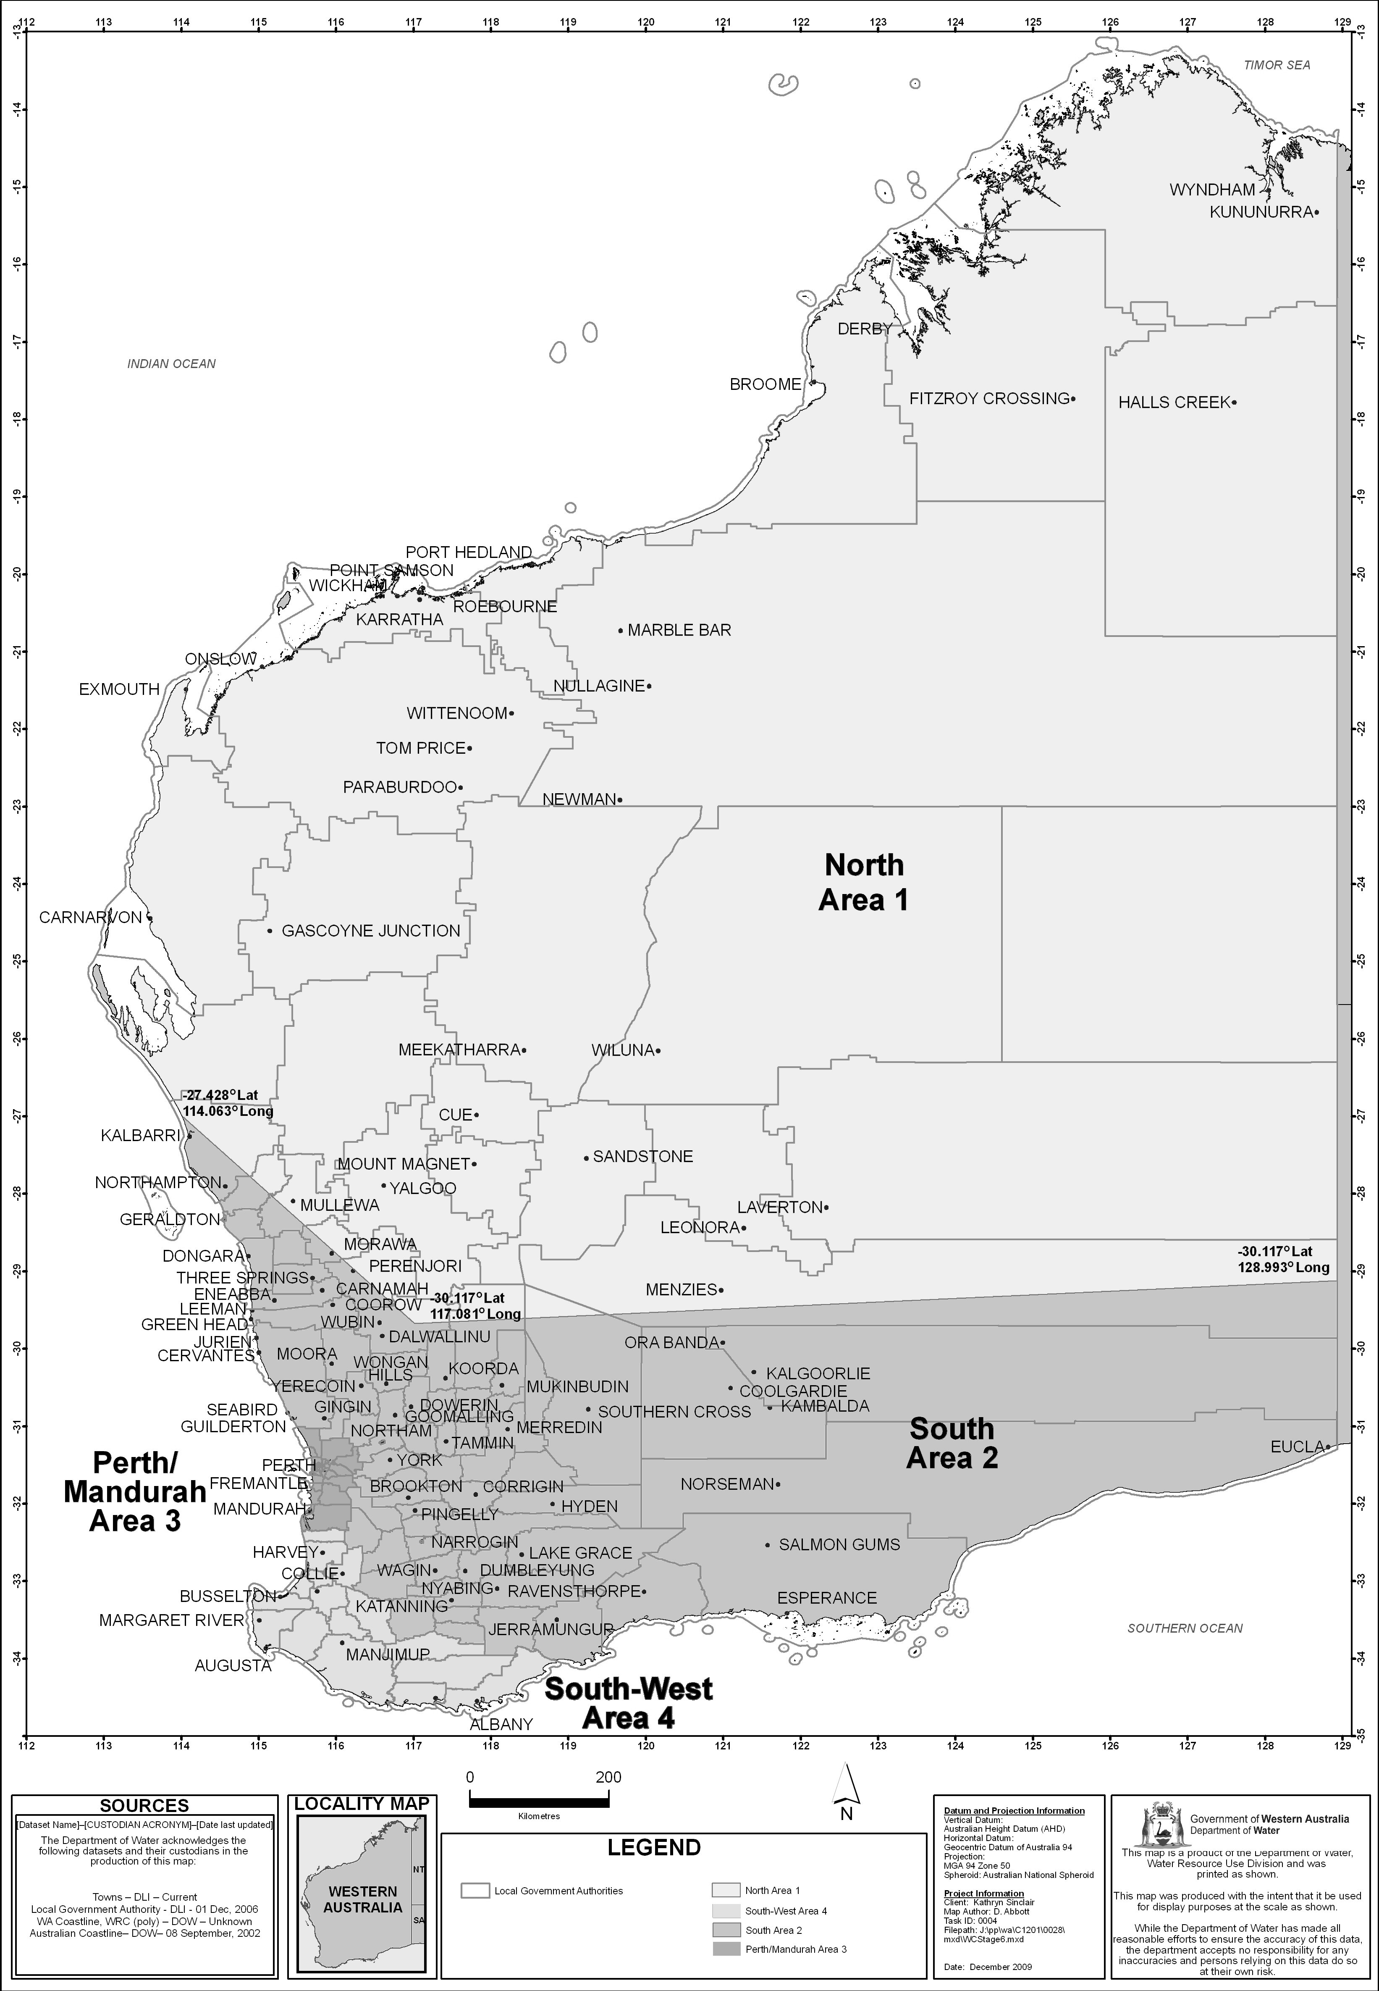
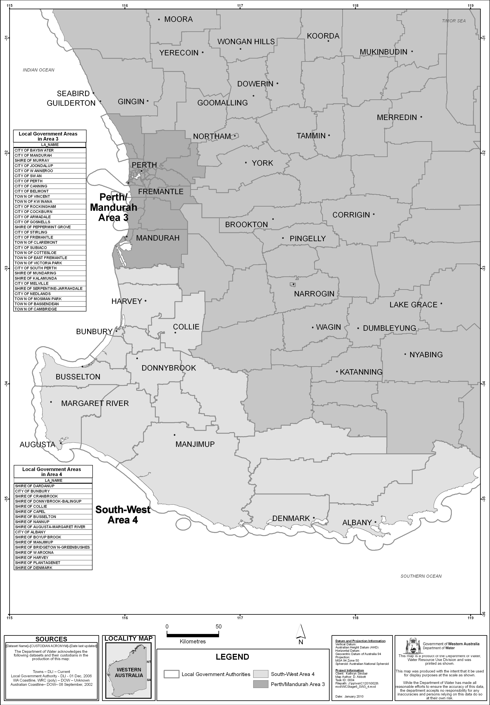

Schedule 2 — Stages of restrictions
[bl. 3]

1. Stage 1
(1) A person must not water a lawn, garden or grass-covered sporting ground except by —
(a) reticulation during either, but not both, the morning period or the evening period on a particular day; or
(b) a handheld hose with one outlet; or
(c) a handheld watering can.
(2) A person must not water a synthetic sporting ground except for 10 minutes or less before a sport is played or practised on the sporting ground.

2. Stage 2
(1) A person must not water a lawn, garden or grass-covered sporting ground except by —
(a) reticulation during either, but not both, the morning period or the evening period —
(i) on any even numbered day of the month if the relevant property has an even street number or, where there is no street number, an even lot number; or
(ii) on any odd numbered day of the month if the relevant property has an odd street number or, where there is no street number, an odd lot number;
or
(b) a handheld hose with one outlet; or
(c) a handheld watering can.
(2) A person must not spray a building, building site, demolition site (including vacant land resulting from a demolition), path, paved area or road except —
(a) with —
(i) a high pressure water cleaner; or
(ii) a handheld hose with one outlet,
to the minimum extent necessary for the cleaning of the building, building site, demolition site (including vacant land resulting from a demolition), path, paved area or road so as to avoid a threat to public health or safety; or
(b) with a handheld hose with one outlet to the minimum extent necessary for purposes related to the construction, demolition or repair of the building, path, paved area or road.
(3) A person must not water a synthetic sporting ground except for 10 minutes or less before a sport is played or practised on the sporting ground.

3. Stage 3
(1) A person must not water a lawn, garden or grass-covered sporting ground except by —
(a) reticulation during either, but not both, the morning period or the evening period on one or more of 3 days of the week specified in relation to the relevant property in Schedule 3 Division 1; or
(b) a handheld hose with one outlet; or
(c) a handheld watering can.
(2) A person must not spray a building, building site, demolition site (including vacant land resulting from a demolition), path, paved area or road except —
(a) with —
(i) a high pressure water cleaner; or
(ii) a handheld hose with one outlet,
to the minimum extent necessary for the cleaning of the building, building site, demolition site (including vacant land resulting from a demolition), path, paved area or road so as to avoid a threat to public health or safety; or
(b) with a handheld hose with one outlet to the minimum extent necessary for purposes related to the construction, demolition or repair of the building, path, paved area or road.
(3) A person must not water a synthetic sporting ground except for 10 minutes or less before a sport is played or practised on the sporting ground.

4. Stage 4
(1) A person must not water a lawn or garden except by —
(a) reticulation during either, but not both, the morning period or the evening period on one or both of 2 days of the week specified in relation to the relevant property in Schedule 3 Division 2; or
(b) a handheld hose with one outlet; or
(c) a handheld watering can.
(2) A person must not water a grass-covered sporting ground except by —
(a) reticulation during either, but not both, the morning period or the evening period on one or more of 3 days of the week specified in relation to the relevant property in Schedule 3 Division 1; or
(b) a handheld hose with one outlet; or
(c) a handheld watering can.
(3) A person must not spray a building, building site, demolition site (including vacant land resulting from a demolition), path, paved area or road except —
(a) with —
(i) a high pressure water cleaner; or
(ii) a handheld hose with one outlet,
to the minimum extent necessary for the cleaning of the building, building site, demolition site (including vacant land resulting from a demolition), path, paved area or road so as to avoid a threat to public health or safety; or
(b) with a handheld hose with one outlet to the minimum extent necessary for purposes related to the construction, demolition or repair of the building, path, paved area or road.
(4) A person must not water a synthetic sporting ground except for 10 minutes or less before a sport is played or practised on the sporting ground.

5. Stage 5
(1) A person must not water a lawn or garden except by —
(a) reticulation during either, but not both, the morning period or the evening period on one day of the week specified in relation to the relevant property in Schedule 3 Division 3; or
(b) a handheld hose with one outlet; or
(c) a handheld watering can.
(2) A person must not water a grass-covered sporting ground except by —
(a) reticulation during either, but not both, the morning period or the evening period on one or more of 3 days of the week specified in relation to the relevant property in Schedule 3 Division 1; or
(b) a handheld hose with one outlet; or
(c) a handheld watering can.
(3) A person must not spray a building, building site, demolition site (including vacant land resulting from a demolition), path, paved area or road except —
(a) with —
(i) a high pressure water cleaner; or
(ii) a handheld hose with one outlet,
to the minimum extent necessary for the cleaning of the building, building site, demolition site (including vacant land resulting from a demolition), path, paved area or road so as to avoid a threat to public health or safety; or
(b) with a handheld hose with one outlet to the minimum extent necessary for purposes related to the construction, demolition or repair of the building, path, paved area or road.
(4) A person must not water a synthetic sporting ground except for 10 minutes or less before a sport is played or practised on the sporting ground.

6. Stage 6
(1) A person must not water a lawn or garden except by —
(a) a handheld hose with one outlet; or
(b) a handheld watering can.
(2) A person must not water a grass-covered sporting ground except by —
(a) reticulation during either, but not both, the morning period or the evening period on one or more of 3 days of the week specified in relation to the relevant property in Schedule 3 Division 1; or
(b) a handheld hose with one outlet; or
(c) a handheld watering can.
(3) A person must not spray a building, building site, demolition site (including vacant land resulting from a demolition), path, paved area or road except —
(a) with —
(i) a high pressure water cleaner; or
(ii) a handheld hose with one outlet,
to the minimum extent necessary for the cleaning of the building, building site, demolition site (including vacant land resulting from a demolition), path, paved area or road so as to avoid a threat to public health or safety; or
(b) with a handheld hose with one outlet to the minimum extent necessary for purposes related to the construction, demolition or repair of the building, path, paved area or road.
(4) A person must not fill a swimming pool except —
(a) to replace water lost from the pool through evaporation or ordinary use; and
(b) to the minimum extent necessary for the proper functioning of the pool.
(5) A person must not water a synthetic sporting ground except for 10 minutes or less before a sport is played or practised on the sporting ground.

7. Stage 7
(1) A person must not water a lawn, garden, grass-covered sporting ground or synthetic sporting ground except by a handheld watering can.
(2) A person must not spray a building, building site, demolition site (including vacant land resulting from a demolition), path, paved area or road except —
(a) with —
(i) a high pressure water cleaner; or
(ii) a handheld hose with one outlet,
to the minimum extent necessary for the cleaning of the building, building site, demolition site (including vacant land resulting from a demolition), path, paved area or road so as to avoid a threat to public health or safety; or
(b) with a handheld hose with one outlet to the minimum extent necessary for purposes related to the construction, demolition or repair of the building, path, paved area or road.
(3) A person must not fill a swimming pool.
(4) A person must not wash a motor vehicle except —
(a) to the minimum extent necessary to enable the vehicle to be driven safely; and
(b) by using a bucket of water and a cloth.

Schedule 3 — Specified days for watering by reticulation
[bl. 3, 6, Sch. 2 cl. 3, 4, 5 and 6]

Division 1 — Specified days for Schedule 2 clauses 3(1)(a), 4(2)(a), 5(2)(a) and 6(2)(a)
Last digit of property’s street number or, where there is no street number, lot number | Days for watering by reticulation
1 | Monday, Wednesday and Saturday
2 | Sunday, Tuesday and Thursday
3 | Monday, Wednesday and Friday
4 | Tuesday, Thursday and Saturday
5 | Sunday, Wednesday and Friday
6 | Monday, Thursday and Saturday
7 | Sunday, Tuesday and Friday
8 | Monday, Wednesday and Saturday
9 | Sunday, Tuesday and Thursday
0 | Monday, Wednesday and Friday

Division 2 — Specified days for Schedule 2 clause 4(1)(a)
Last digit of property’s street number or, where there is no street number, lot number | Days for watering by reticulation
1 | Wednesday and Saturday
2 | Sunday and Thursday
3 | Monday and Friday
4 | Tuesday and Saturday
5 | Sunday and Wednesday
6 | Monday and Thursday
7 | Tuesday and Friday
8 | Wednesday and Saturday
9 | Sunday and Thursday
0 | Monday and Friday

Division 3 — Specified days for Schedule 2 clause 5(1)(a)

Last digit of property’s street number or, where there is no street number, lot number | Day for watering by reticulation
1 | Wednesday
2 | Thursday
3 | Friday
4 | Saturday
5 | Sunday
6 | Monday
7 | Tuesday
8 | Wednesday
9 | Thursday
0 | Friday
[Division 3 amended in Gazette 28 Sep 2010 p. 5065.]

Schedule 4 — Maps of certain scheme water areas
[bl. 10AA(6) and 10A(8)]
[Heading inserted in Gazette 30 Nov 2010 p. 6019; amended in Gazette 8 Mar 2011 p. 803.]
Map 1 — the Balingup scheme water area
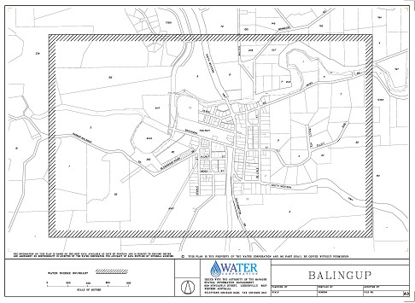
Note: This map is for information only.
Map 2 — the Greenbushes scheme water area
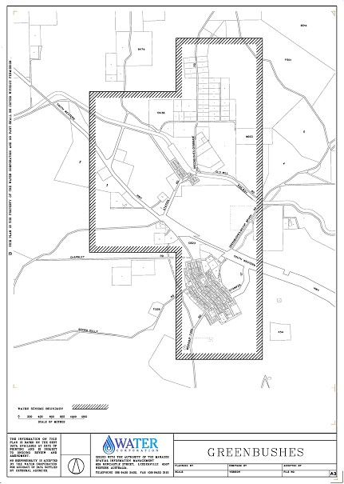
Note: This map is for information only.
Map 3A — the Grass Patch scheme water area
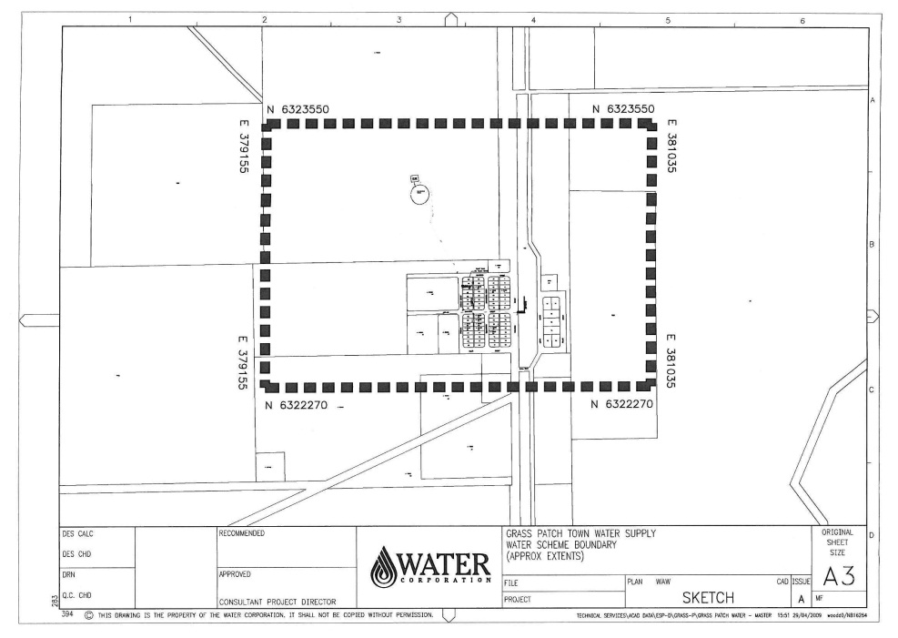
Note: This map is for information only.
Map 3 — the Kirup scheme water area
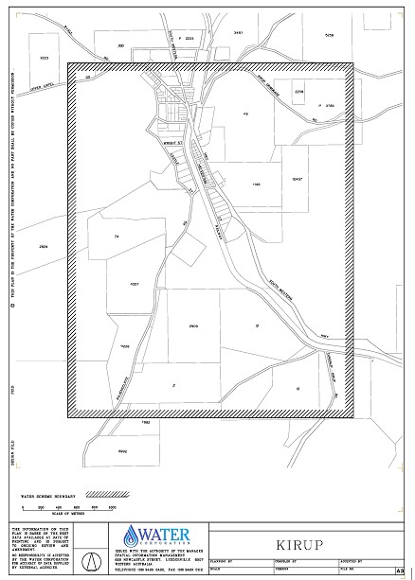
Note: This map is for information only.
Map 4 — the Mullalyup scheme water area
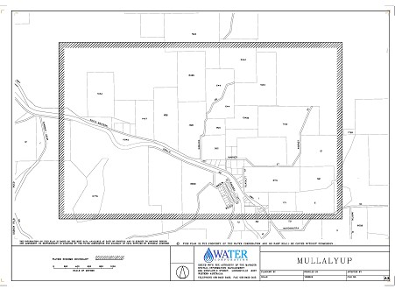
Note: This map is for information only.
Map 5 — the Salmon Gums scheme water area
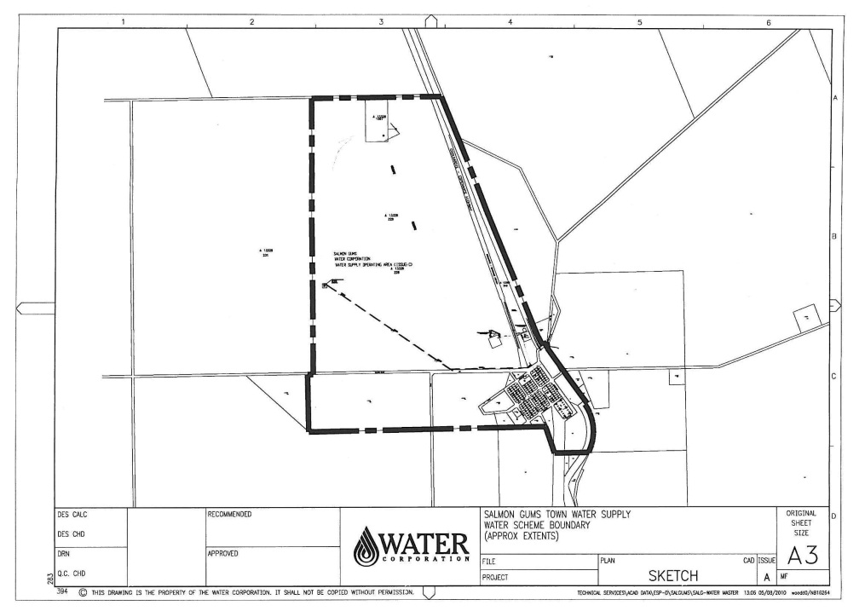
Note: This map is for information only.
[Schedule 4 inserted in Gazette 30 Nov 2010 p. 6019-22; amended in Gazette 8 Mar 2011 p. 803-4.]

Notes
¹ This is a compilation of the Water Agencies (Water Use) By-laws 2010 and includes the amendments made by the other written laws referred to in the following table.

Compilation table
Citation | Gazettal | Commencement
Water Agencies (Water Use) By-laws 2010 | 16 Mar 2010 p. 999-1031 | bl. 1 and 2: 16 Mar 2010 (see bl. 2(a));  By-laws other than bl. 1 and 2: 1 Apr 2010 (see bl. 2(b))
Water Agencies (Water Use) Amendment By-laws 2010 | 28 Sep 2010 p. 5063-5 | bl. 1 and 2: 28 Sep 2010 (see bl. 2(a));  By-laws other than bl. 1 and 2: 1 Oct 2010 (see bl. 2(b))
Water Agencies (Water Use) Amendment By-laws (No. 2) 2010 | 30 Nov 2010 p. 6016-22 | bl. 1 and 2: 30 Nov 2010 (see bl. 2(a));  By-laws other than bl. 1 and 2: 1 Dec 2010 (see bl. 2(b))
Water Agencies (Water Use) Amendment By-laws 2011 | 8 Mar 2011 p. 801-4 | bl. 1 and 2: 8 Mar 2011 (see bl. 2(a));  By-laws other than bl. 1 and 2: 9 Mar 2011 (see bl. 2(b))
Water Agencies (Water Use) Amendment By-laws (No. 2) 2011 | 18 Nov 2011 p. 4818-19 | bl. 1 and 2: 18 Nov 2011 (see bl. 2(a));  By-laws other than bl. 1 and 2: 19 Nov 2011 (see bl. 2(b))

Defined Terms

[This is a list of terms defined and the provisions where they are defined. The list is not part of the law.]
Defined Term Provision(s)
approved 18
Area 3
Area 1 3
Area 2 3
Area 3 3
Area 4 3
commencement day 10AA(1), 31(1)
consumption year 18
coordinate 10AA(1), 10A(1)
domestic bore 3
domestic bore water 3
evening period 3
former plan 31(1)
garden 3
high pressure water cleaner 3
lawn 3
morning period 3
non-residential lot 18
other property 11(1)
relevant property 3
restriction notice 31(1)
scheme water 3
scheme water efficiency management plan 18
scheme water supplier 3
specified day 31(1)
stage of restrictions 3
synthetic sporting ground 3
water 3, 18
week 3
written approval 4(1)

