
Western Australia
Water Agencies (Powers) Act 1984

Water Agencies (Water Use) By-laws 2010
Reprint 1: The by-laws as at 5 April 2013
Guide for using this reprint
What the reprint includes
Endnotes, Compilation table, and Table of provisions that have not come into operation
1. Details about the original by-laws and legislation that has amended its text are shown in the Compilation table in endnote 1, at the back of the reprint. The table also shows any previous reprint.
2. Transitional, savings, modifying or other provisions identified in the Compilation table may be important. The table may refer to another endnote setting out the text of these provisions in full.
3. A table of provisions that have not come into operation, to be found in endnote 1a if it is needed, lists any provisions of the by-laws being reprinted that have not come into operation and any amendments that have not come into operation. The full text is set out in another endnote that is referred to in the table.
Notes amongst text (italicised and within square brackets)
1. If the reprint includes a by-law that was inserted, or has been amended, since the by-laws being reprinted were made, editorial notes at the foot of the
by-law give some history of how the by-law came to be as it is. If the by-law replaced an earlier by-law, no history of the earlier by-law is given (the full history of the by-laws is in the Compilation table).
Notes of this kind may also be at the foot of Schedules or headings.
2. The other kind of editorial note shows something has been —
- removed (because it was repealed or deleted from the law); or
- omitted under the Reprints Act 1984 s. 7(4) (because, although still technically part of the text, it no longer has any effect).
The text of anything removed or omitted can be found in an earlier reprint (if there is one) or one of the written laws identified in the Compilation table.

Reprint numbering and date
1. The reprint number (in the footer of each page of the document) shows how many times the by-laws have been reprinted. For example, numbering a reprint as “Reprint 3” would mean that the reprint was the 3rd reprint since the by-laws were published. Reprint numbering was implemented as from 1 January 2003.
2. The information in the reprint is current on the date shown as the date as at which the by-laws are reprinted. That date is not the date when the reprint was published by the State Law Publisher and it is probably not the date when the most recent amendment had effect.

Reprinted under the Reprints Act 1984 as
at 5 April 2013
Western Australia
Water Agencies (Water Use) By-laws 2010
Contents
-Part 1 — Preliminary
1. Citation 1
2. Commencement 1
3. Terms used 1
Part 2 — Water restrictions
Division 1 — Restrictions
4. Contravening restrictions, offence 4
5. Area 1’s restrictions 4
6. Area 2’s restrictions 4
7. Area 3’s restrictions 5
8. Area 4’s restrictions 5
9. Halls Creek district, restrictions 5
10AA. Grass Patch and Salmon Gums, restrictions for until 31 Oct 2012 6
10A. Manjimup, restrictions for during 1 Sep to 30 Nov 2012 8
Division 2 — Exemptions
10. Rights in Water and Irrigation Act 1914 s. 5C, use of water under is exempt 9
11. Domestic bore on other property, using water from 9
12. Installing etc. reticulation system, using water for 10
13. Vertimowing, fertilising etc. by commercial operator, watering after 10
14. Market garden or plant nursery, watering of 10
15. Caravan park site etc., watering of after vacation of 10
16. Aviary, water for birds in 11
17. Fire fighting, using water for 11
Part 3 — Scheme water efficiency management plans
Division 1 — General
18. Terms used 12
19. Extension of time, application for and grant of 13
Division 2 — Preparation, submission and approval of scheme water efficiency management plans
20. Supplier may require certain owners etc. to submit plan 13
21. Supplier’s functions on receiving plan 14
22. Revised plan may be submitted at any time 15
Division 3 — After approval of scheme water efficiency management plans
23. Application of this Division 15
24. Approval of plan, duration of 15
25. Approved plan to be complied with etc. 16
26. Revised plan to be submitted before end of approved plan in some cases 16
27. Supplier may require revised plan to be submitted in some cases 17
28. Revocation of approval of plan, application for etc. 17
29. Annual report on plan to be given to supplier 18
Part 4 — Repeal, saving and transitional
30. Repeal 20
31. Water Agencies (Water Use) By-laws 2007, provisions for 20
Schedule 1 — Maps showing Areas 1, 2, 3 and 4
Schedule 2 — Stages of restrictions
1. Stage 1 23
2. Stage 2 23
3. Stage 3 24
4. Stage 4 25
5. Stage 5 26
6. Stage 6 27
7. Stage 7 28
Schedule 3 — Specified days for watering by reticulation
Division 1 — Specified days for Schedule 2 clauses 3(1)(a), 4(2)(a), 5(2)(a) and 6(2)(a)
Division 2 — Specified days for Schedule 2 clause 4(1)(a)
Division 3 — Specified days for Schedule 2 clause 5(1)(a)
Schedule 4 — Maps of certain scheme water areas
Notes
Compilation table 34
Defined terms

 |  | Reprinted under the Reprints Act 1984 as
 |  | at 5 April 2013
Western Australia
Water Agencies (Powers) Act 1984
Water Agencies (Water Use) By-laws 2010

Part 1 — Preliminary

1. Citation
These by-laws are the Water Agencies (Water Use) By-laws 2010 ¹.

2. Commencement
These by-laws come into operation as follows —
(a) by-laws 1 and 2 — on the day on which these by-laws are published in the Gazette ¹;
(b) the rest of the by-laws — on 1 April 2010.

3. Terms used
In these by-laws, unless the contrary intention appears —
Area means Area 1, Area 2, Area 3 or Area 4;
Area 1 means that part of the State that is north of the line —
(a) starting at latitude - 27.428° and longitude 114.063°; and
(b) extending to latitude - 30.117° and longitude 117.081°; and
(c) extending to latitude - 30.117° and longitude 128.993°,
as illustrated for information purposes on the maps shown in Schedule 1;
Area 2 means that part of the State that is south of the line —
(a) starting at latitude - 27.428° and longitude 114.063°; and
(b) extending to latitude - 30.117° and longitude 117.081°; and
(c) extending to latitude - 30.117° and longitude 128.993°,
except Area 3 or Area 4, as illustrated for information purposes on the maps shown in Schedule 1;
Area 3 means the local government districts of Bayswater, Mandurah, Murray, Joondalup, Wanneroo, Swan, Perth, Canning, Belmont, Vincent, Kwinana, Rockingham, Cockburn, Armadale, Gosnells, Peppermint Grove, Stirling, Fremantle, Claremont, Subiaco, Cottesloe, East Fremantle, Victoria Park, South Perth, Mundaring, Kalamunda, Melville, Serpentine-Jarrahdale, Nedlands, Mosman Park, Bassendean and Cambridge, as illustrated for information purposes on the maps shown in Schedule 1;
Area 4 means the local government districts of Dardanup, Bunbury, Cranbrook, Donnybrook-Balingup, Collie, Capel, Busselton, Nannup, Augusta-Margaret River, Albany, Boyup Brook, Manjimup, Bridgetown-Greenbushes, Waroona, Harvey, Plantagenet and Denmark, as illustrated for information purposes on the maps shown in Schedule 1;
domestic bore means a non-artesian well as defined in the Rights in Water and Irrigation Act 1914 section 2(1) from which the only water that can be taken is from the water table aquifer;
domestic bore water means water taken from a domestic bore;
evening period means the period after 6.00 p.m.;
garden does not include any indoor plants or plants growing inside a glasshouse;
high pressure water cleaner means a cleaning device that uses pressurised water flowing at a rate of not more than 6 L per minute;
lawn does not include a grass-covered sporting ground;
morning period means the period before 9.00 a.m.;
relevant property, in relation to the watering of a lawn, garden or grass-covered sporting ground, means the property on which the lawn, garden or grass-covered sporting ground is located;
scheme water means water supplied by scheme water supplier;
scheme water supplier means —
(a) the Corporation; or
(b) a water board as defined in the Water Boards Act 1904 section 3(1);
stage of restrictions means a stage of restrictions set out in Schedule 2;
synthetic sporting ground means a sporting ground that has a synthetic surface designed to be used after watering;
water means —
(a) scheme water; or
(b) domestic bore water;
week means a period of 7 successive days beginning with Sunday.
[By-law 3 amended in Gazette 30 Nov 2010 p. 6016.]

Part 2 — Water restrictions

Division 1 — Restrictions

4. Contravening restrictions, offence
(1) In this by-law —
written approval means written approval from —
(a) in relation to scheme water — the scheme water supplier; and
(b) in relation to domestic bore water — the chief executive officer of the department of the Public Service principally assisting in the administration of the Act.
(2) A person must not, without written approval, use water in contravention of the stage of restrictions applicable under these by-laws.
Penalty: a fine of $500.
[By-law 4 amended in Gazette 28 Sep 2010 p. 5063.]

5. Area 1’s restrictions
(1) Subject to by-law 9, the stage of restrictions that applies in relation to the use of scheme water in Area 1 is stage 2.
(2) The stage of restrictions that applies in relation to the use of domestic bore water in Area 1 is stage 1.
[By-law 5 amended in Gazette 28 Sep 2010 p. 5063.]

6. Area 2’s restrictions
(1) Subject to by-law 10AA, the stage of restrictions that applies in relation to the use of scheme water in Area 2 is stage 4.
(2) The stage of restrictions that applies in relation to the use of domestic bore water in Area 2 is stage 1.
[By-law 6 amended in Gazette 28 Sep 2010 p. 5064; 8 Mar 2011 p. 801.]

7. Area 3’s restrictions
(1) The stage of restrictions that applies in relation to the use of scheme water in Area 3 is —
(a) from 1 June to 31 August in a particular year — stage 6; and
(b) at any other time of the year — stage 4.
(2) The stage of restrictions that applies in relation to the use of domestic bore water in Area 3 is —
(a) from 1 June to 31 August in a particular year — stage 6; and
(b) at any other time of the year — stage 3.
[By-law 7 amended in Gazette 28 Sep 2010 p. 5064; 30 Nov 2010 p. 6016.]

8. Area 4’s restrictions
(1) Subject to by-law 10A, the stage of restrictions that applies in relation to the use of scheme water in Area 4 is —
(a) from 1 June to 31 August in a particular year — stage 6; and
(b) at any other time of the year — stage 4.
(2) The stage of restrictions that applies in relation to the use of domestic bore water in Area 4 is —
(a) from 1 June to 31 August in a particular year — stage 6; and
(b) at any other time of the year — stage 1.
[By-law 8 amended in Gazette 28 Sep 2010 p. 5064.]

9. Halls Creek district, restrictions
The stage of restrictions that applies in relation to the use of scheme water in the local government district of Halls Creek is stage 4.
[By-law 9 inserted in Gazette 28 Sep 2010 p. 5064.]

10AA. Grass Patch and Salmon Gums, restrictions for until 31 Oct 2012
(1) In this by-law —
commencement day means the day on which the Water Agencies (Water Use) Amendment By-laws (No. 2) 2011, other than by-laws 1 and 2, come into operation ¹;
coordinate means a Map Grid of Australia (Geocentric Datum of Australia 1994) coordinate for zone 50.
(2) This by-law applies from commencement day to 31 October 2012.
(3) The stage of restrictions that applies in relation to the use of scheme water in the following areas is stage 5 —
(a) the Grass Patch scheme water area;
(b) the Salmon Gums scheme water area.
(4) The Grass Patch scheme water area is the area (around Grass Patch) defined by boundaries joining the coordinates in the Table sequentially.
Table
Point No. | Easting | Northing
1 | 379155 | 6323550
2 | 381035 | 6323550
3 | 381035 | 6322270
4 | 379155 | 6322270
5 | 379155 | 6323550
(5) The Salmon Gums scheme water area is the area (around Salmon Gums) defined by boundaries joining the coordinates in the Table sequentially.
Table
 | Point No. |  | Easting |  | Northing
1 |  | 371210 |  | 6351320
2 |  | 372280 |  | 6352570
3 |  | 373820 |  | 6349485
4 |  | 373820 |  | 6349380
5 |  | 373320 |  | 6349590
6 |  | 371180 |  | 6349570
7 |  | 371210 |  | 6351320
(6) Each scheme water area is shown on the appropriate map in Schedule 4 and a copy of each map is available for inspection at —
(a) the Department of Water, 168 St Georges Terrace, Perth; and
(b) the Shire of Esperance, Administration Centre, Windich Street, Esperance; and
(c) the Water Corporation, 629 Newcastle Street, Leederville or corner of Harbour Road and Sim Street, Esperance.
[By-law 10AA inserted in Gazette 8 Mar 2011 p. 802-3; amended in Gazette 18 Nov 2011 p. 4819.]

10A. Manjimup, restrictions for during 1 Sep to 30 Nov 2012
(1) In this by-law —
coordinate means a Map Grid of Australia (Geocentric Datum of Australia 1994) coordinate for zone 50.
(2) This by-law applies from 1 September to 30 November 2012.
(3) The stage of restrictions that applies in relation to the use of scheme water in the Manjimup scheme water area is stage 6.
(4) The Manjimup scheme water area is the area (around Manjimup) defined by boundaries joining the coordinates in the Table sequentially.
Table
Point No. | Easting | Northing
1 | 423568.46 | 6213447.39
2 | 423622.84 | 6206716.95
3 | 416294.83 | 6206659.15
4 | 416310.55 | 6204688.22
5 | 412430.10 | 6204651.65
6 | 412403.71 | 6207436.43
7 | 415077.14 | 6207463.02
8 | 415026.25 | 6213371.91
9 | 423568.46 | 6213447.39
(5) The Manjimup scheme water area is shown on the appropriate map in Schedule 4 and a copy of this map is available for inspection at —
(a) the Department of Water, 168 St Georges Terrace, Perth or 35-39 McCombe Road, Bunbury; and
(b) the Water Corporation, 629 Newcastle Street, Leederville or Level 3, 61 Victoria Street, Bunbury.
[By-law 10A inserted in Gazette 24 Aug 2012 p. 3961-2.]

Division 2 — Exemptions

10. Rights in Water and Irrigation Act 1914 s. 5C, use of water under is exempt
A person does not commit an offence under by-law 4 if the person uses water in accordance with a licence under the Rights in Water and Irrigation Act 1914 section 5C.

11. Domestic bore on other property, using water from
(1) This by-law applies to a person using domestic bore water to water a lawn or garden by reticulation in circumstances where —
(a) a stage of restrictions prohibits the use of the water except on a day or days of the month determined by reference to the street number or, where there is no street number, the lot number of the relevant property; and
(b) the domestic bore is located on property with a different street or lot number (the other property).
(2) The person does not contravene the stage of restrictions only because, in any particular week —
(a) the person uses the water on days determined by reference to the street number or, where there is no street number, the lot number of the other property; and
(b) the person does not use the water on any other day.

12. Installing etc. reticulation system, using water for
(1) A person does not commit an offence under by-law 4 if the person operates a reticulation system using domestic bore water to the minimum extent necessary while the reticulation system is being installed, maintained, tested or repaired.
(2) A person does not commit an offence under by-law 4 if, in the course of the person’s occupation in the turf, garden or landscaping industries, the person operates a reticulation system using either scheme water or domestic bore water to the minimum extent necessary while the reticulation system is being installed, maintained, tested or repaired.

13. Vertimowing, fertilising etc. by commercial operator, watering after
(1) This by-law applies to the use of water in an Area unless the stage of restrictions designated stage 7 applies to that Area.
(2) A person does not commit an offence under by-law 4 if, in the course of the person’s occupation in the turf, garden or landscaping industries, the person waters a lawn, garden or grass-covered sporting ground immediately after —
(a) vertimowing; or
(b) the application of a fertiliser or wetting agent.

14. Market garden or plant nursery, watering of
A person does not commit an offence under by-law 4 if the person waters a market garden or plant nursery to the minimum extent necessary to ensure the viable operation of the market garden or plant nursery.

15. Caravan park site etc., watering of after vacation of
A person does not commit an offence under by-law 4 if the person waters a site as defined in the Caravan Parks and Camping Grounds Act 1995 section 5(1) immediately after the site has been vacated by an occupier.

16. Aviary, water for birds in
A person does not commit an offence under by-law 4 if the person waters an aviary to the minimum extent necessary to maintain the birds in that aviary.

17. Fire fighting, using water for
A person does not commit an offence under by-law 4 if the person uses water to the minimum extent necessary for fire fighting or training for fire fighting.

Part 3 — Scheme water efficiency management plans

Division 1 — General

18. Terms used
In this Part —
approved means approved by the scheme water supplier;
consumption year has the meaning given in the Water Agencies (Charges) By-laws 1987 by-law 2(1);
non-residential lot means a lot as defined in section 41GA(5) of the Act, except a habitable lot as defined in that section;
scheme water efficiency management plan, in relation to a non-residential lot, means a plan for ensuring that water supplied to the lot is used as efficiently as practicable, prepared in the approved form and containing —
(a) the full name and address of each owner and occupier of the lot; and
(b) a description of the nature of any business or other work being conducted on the lot; and
(c) details of the measures comprising the plan, including proposed timeframes for implementing each of those measures; and
(d) the estimated savings in water use under the plan; and
(e) the substance of the most recent report under by-law 29 (if any) prepared in relation to the lot; and
(f) such other information as the scheme water supplier reasonably requires, as specified in any notice under by-law 20(2), 21(2) or 27(1);
water means scheme water.

19. Extension of time, application for and grant of
(1) Where under this Part —
(a) it is an offence for a person to fail to do something within a specified period; and
(b) in a particular case it is not practicable for the person to do the thing within that period,
the person may, before the end of the period, make a written application to the scheme water supplier to extend that period.
(2) The scheme water supplier may, on an application under sub-bylaw (1) extend the period.
(3) The person does not commit the offence if the person does the thing within the extended period.

Division 2 — Preparation, submission and approval of scheme water efficiency management plans

20. Supplier may require certain owners etc. to submit plan
(1) This by-law applies to an owner or occupier of a non-residential lot in a particular consumption year unless —
(a) the lot was supplied with less than 20 ML of water in the consumption year immediately before that year; or
(b) the owner or occupier has submitted to the scheme water supplier a scheme water efficiency management plan, the approval of which —
(i) is being considered under by-law 21; or
(ii) has been given and remains in force under by-law 24.
(2) The scheme water supplier may, by notice in writing, require the owner or occupier to prepare and submit for approval to the scheme water supplier a scheme water efficiency management plan.
(3) A person who is served with a notice under sub-bylaw (2) must prepare the scheme water efficiency management plan and submit it for approval to the scheme water supplier within 90 days after the notice is served on the person.
Penalty: a fine of $2 000.

21. Supplier’s functions on receiving plan
(1) This by-law applies when the scheme water supplier receives from a person —
(a) a scheme water efficiency management plan prepared and submitted under sub-bylaw (4) or by-law 20(3), 22, 26 or 27(3); or
(b) further information provided under sub-bylaw (3).
(2) The scheme water supplier must, by notice in writing served on the person within 60 days after the plan is received by the scheme water supplier —
(a) approve the plan in the form most recently submitted; or
(b) request further information from the person relating to the plan, including the person’s comments on any specific amendments to the plan the scheme water supplier considers might be necessary; or
(c) request an amended scheme water efficiency management plan in accordance with any instructions specified in the notice; or
(d) if, while the scheme water supplier is considering the plan, a subsequent revised scheme water efficiency management plan is submitted to the scheme water supplier under by-law 22, do anything referred to in paragraph (a), (b) or (c) in relation to the revised plan.
(3) A person who is served with a notice under sub-bylaw (2)(b) must provide the further information within 30 days after the notice is served on the person.
Penalty: a fine of $2 000.
(4) A person who is served with a notice under sub-bylaw (2)(c) must prepare the amended scheme water efficiency management plan and submit it for approval to the scheme water supplier within 60 days after the notice is served on the person.
Penalty: a fine of $2 000.

22. Revised plan may be submitted at any time
A person who has submitted a scheme water efficiency management plan for approval to the scheme water supplier under this Part may, at any time after that submission (whether or not the plan has been approved), prepare a revised scheme water efficiency management plan and submit it for approval to the scheme water supplier.

Division 3 — After approval of scheme water efficiency management plans

23. Application of this Division
This Division applies where a person has submitted a scheme water efficiency management plan under by-law 20(3), 21(4), 22, 26 or 27(3) and the plan has been approved.

24. Approval of plan, duration of
The approval remains in force on and from the day the approval was given until —
(a) the person ceases to be an owner or occupier of the lot; or
(b) the approval is revoked under by-law 28; or
(c) a revised scheme water efficiency management plan is submitted by the person under by-law 22, 26 or 27(3) and is approved; or
(d) a period of 5 years expires,
whichever occurs first.

25. Approved plan to be complied with etc.
(1) The person must comply with the scheme water efficiency management plan during the period that the approval remains in force under by-law 24.
Penalty: a fine of $2 000.
(2) If the scheme water supplier reasonably suspects that the person has not complied, or is not complying, with the plan during the period that the approval remains in force under by-law 24, the scheme water supplier may, by notice in writing, require the person to provide a written report on the person’s implementation of the plan.
(3) A person who is served with a notice under sub-bylaw (2) must prepare the report in an approved form and submit it to the scheme water supplier within 30 days after the notice is served on the person.
Penalty: a fine of $2 000.

26. Revised plan to be submitted before end of approved plan in some cases
(1) Except as provided in sub-bylaw (2), the person must, at least 90 days before the end of the period that the approval remains in force under by-law 24, prepare and submit for approval to the scheme water supplier a revised scheme water efficiency management plan.
Penalty: a fine of $2 000.
(2) Sub-bylaw (1) does not apply to the person if —
(a) the lot was supplied with less than 20 ML of water in the consumption year immediately before the consumption year in which the approval is due to expire; and
(b) the person has submitted to the scheme water supplier a written notice in an approved form —
(i) confirming the circumstances in paragraph (a); and
(ii) stating that the person does not intend to use 20 ML or more of water in the consumption year in which the approval is due to expire.

27. Supplier may require revised plan to be submitted in some cases
(1) In addition to by-law 26, the scheme water supplier may, by notice in writing at any time during the period that the approval remains in force under by-law 24, require the person to prepare and submit for approval to the scheme water supplier a revised scheme water efficiency management plan if —
(a) there has been a significant change in —
(i) the use of water supplied to the lot; or
(ii) the quantity of water available for supply to the lot,
since the approval was given; or
(b) otherwise where the scheme water supplier thinks it is necessary on the basis of a report under by-law 29.
(2) The notice may specify measures to be included in the revised plan, including timeframes for implementing each of those measures.
(3) A person who is served with a notice under sub-bylaw (1) must prepare the revised plan and submit it for approval to the scheme water supplier within 60 days after the notice is served on the person.
Penalty: a fine of $2 000.

28. Revocation of approval of plan, application for etc.
(1) The person may, in an approved form, make an application for the scheme water supplier to revoke the scheme water supplier’s approval of the scheme water efficiency management plan.
(2) On an application under sub-bylaw (1) the scheme water supplier may revoke its approval if the scheme water supplier is satisfied that —
(a) the lot was supplied with less than 20 ML of water in the consumption year immediately before the consumption year in which the application was made; and
(b) the person does not intend to use 20 ML or more of water in the consumption year in which the application was made.

29. Annual report on plan to be given to supplier
(1) During the period that the approval remains in force under by-law 24 the person must, within 30 days after each anniversary of the approval, prepare and submit to the scheme water supplier a report on the efficacy of the scheme water efficiency management plan.
Penalty: a fine of $2 000.
(2) The report must be in an approved form and must —
(a) compare the use of water supplied to the property during the period to which the report relates against the estimated savings in water use under the plan for that period; and
(b) contain such other information relating to the efficacy of the plan as the scheme water supplier reasonably requires, as specified in —
(i) any notice under by-law 20(2), 21(2) or 27(1); or
(ii) any other written notice served on the person for the purposes of this paragraph.
(3) The scheme water supplier may, by notice in writing served on the person within 90 days after the report is received by the scheme water supplier, request such further information from the person relating to the efficacy of the plan as the scheme water supplier reasonably requires.
(4) A person who is served with a notice under sub-bylaw (3) must provide the information in an approved form and submit it to the scheme water supplier within 30 days after the notice is served on the person.
Penalty: a fine of $2 000.

Part 4 — Repeal, saving and transitional

30. Repeal
The Water Agencies (Water Use) By-laws 2007 are repealed.

31. Water Agencies (Water Use) By-laws 2007, provisions for
(1) In this by-law —
commencement day means the day on which these by-laws, other than by-laws 1 and 2, come into operation;
former plan means a water efficiency management plan submitted and approved under the Water Agencies (Water Use) By-laws 2007 Part 3;
restriction notice means a notice under by-law 9;
specified day, in a restriction notice, means the day from which a stage of restrictions applies under the notice.
(2) Despite by-law 9(2), the specified day in the first restriction notice made in relation to an Area may be a day that is the later of —
(a) 1 April 2010; or
(b) the day of the publication of the notice in the Gazette.
(3) A former plan is, on and after the commencement day, to be taken to be a scheme water efficiency management plan submitted and approved under Part 3.

Schedule 1 — Maps showing Areas 1, 2, 3 and 4
[bl. 3]
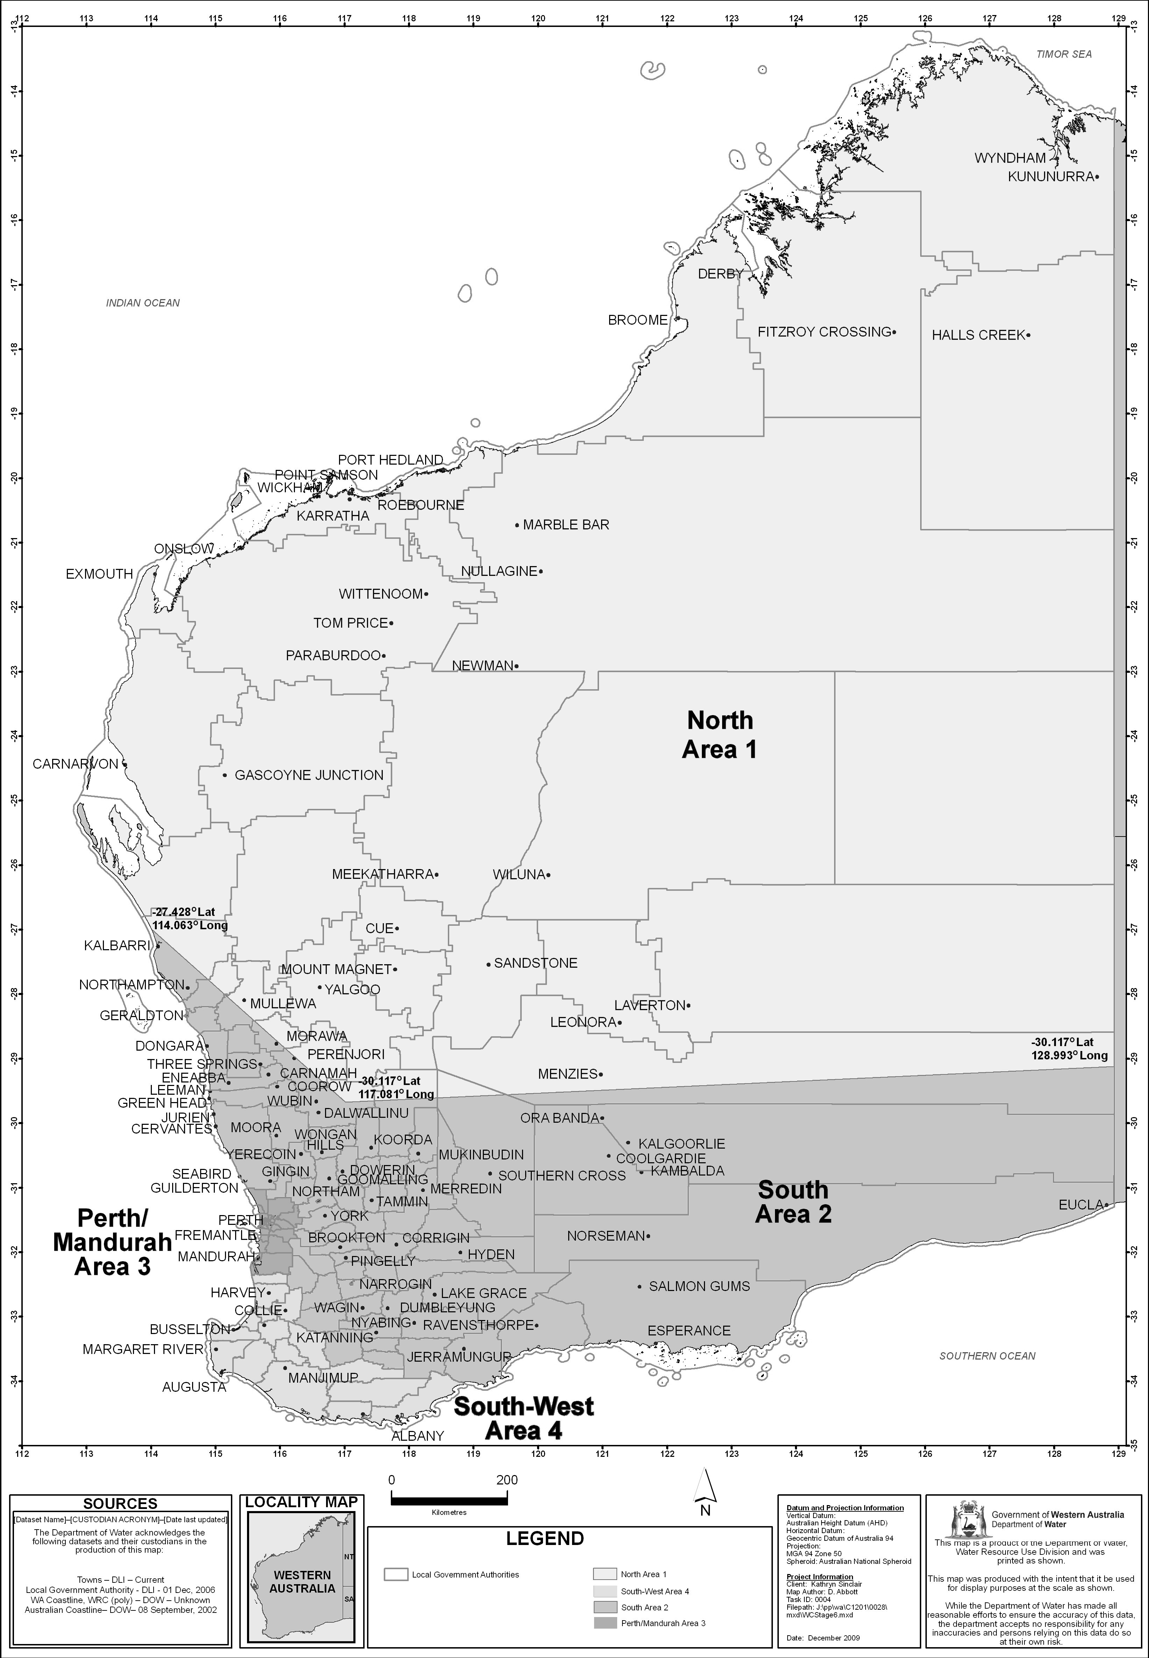
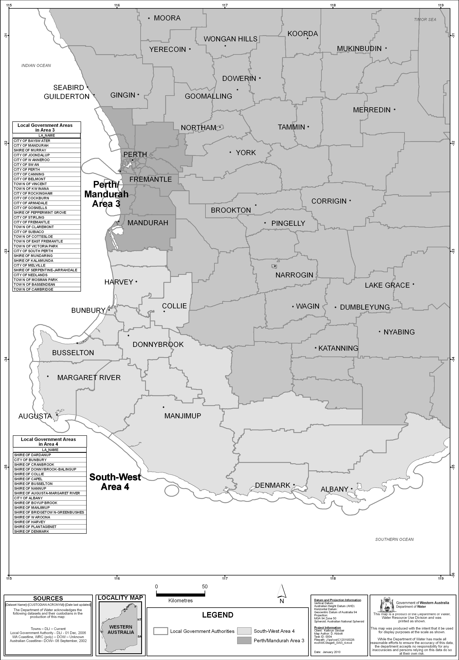

Schedule 2 — Stages of restrictions
[bl. 3]

1. Stage 1
(1) A person must not water a lawn, garden or grass-covered sporting ground except by —
(a) reticulation during either, but not both, the morning period or the evening period on a particular day; or
(b) a handheld hose with one outlet; or
(c) a handheld watering can.
(2) A person must not water a synthetic sporting ground except for 10 minutes or less before a sport is played or practised on the sporting ground.

2. Stage 2
(1) A person must not water a lawn, garden or grass-covered sporting ground except by —
(a) reticulation during either, but not both, the morning period or the evening period —
(i) on any even numbered day of the month if the relevant property has an even street number or, where there is no street number, an even lot number; or
(ii) on any odd numbered day of the month if the relevant property has an odd street number or, where there is no street number, an odd lot number;
or
(b) a handheld hose with one outlet; or
(c) a handheld watering can.
(2) A person must not spray a building, building site, demolition site (including vacant land resulting from a demolition), path, paved area or road except —
(a) with —
(i) a high pressure water cleaner; or
(ii) a handheld hose with one outlet,
to the minimum extent necessary for the cleaning of the building, building site, demolition site (including vacant land resulting from a demolition), path, paved area or road so as to avoid a threat to public health or safety; or
(b) with a handheld hose with one outlet to the minimum extent necessary for purposes related to the construction, demolition or repair of the building, path, paved area or road.
(3) A person must not water a synthetic sporting ground except for 10 minutes or less before a sport is played or practised on the sporting ground.

3. Stage 3
(1) A person must not water a lawn, garden or grass-covered sporting ground except by —
(a) reticulation during either, but not both, the morning period or the evening period on one or more of 3 days of the week specified in relation to the relevant property in Schedule 3 Division 1; or
(b) a handheld hose with one outlet; or
(c) a handheld watering can.
(2) A person must not spray a building, building site, demolition site (including vacant land resulting from a demolition), path, paved area or road except —
(a) with —
(i) a high pressure water cleaner; or
(ii) a handheld hose with one outlet,
to the minimum extent necessary for the cleaning of the building, building site, demolition site (including vacant land resulting from a demolition), path, paved area or road so as to avoid a threat to public health or safety; or
(b) with a handheld hose with one outlet to the minimum extent necessary for purposes related to the construction, demolition or repair of the building, path, paved area or road.
(3) A person must not water a synthetic sporting ground except for 10 minutes or less before a sport is played or practised on the sporting ground.

4. Stage 4
(1) A person must not water a lawn or garden except by —
(a) reticulation during either, but not both, the morning period or the evening period on one or both of 2 days of the week specified in relation to the relevant property in Schedule 3 Division 2; or
(b) a handheld hose with one outlet; or
(c) a handheld watering can.
(2) A person must not water a grass-covered sporting ground except by —
(a) reticulation during either, but not both, the morning period or the evening period on one or more of 3 days of the week specified in relation to the relevant property in Schedule 3 Division 1; or
(b) a handheld hose with one outlet; or
(c) a handheld watering can.
(3) A person must not spray a building, building site, demolition site (including vacant land resulting from a demolition), path, paved area or road except —
(a) with —
(i) a high pressure water cleaner; or
(ii) a handheld hose with one outlet,
to the minimum extent necessary for the cleaning of the building, building site, demolition site (including vacant land resulting from a demolition), path, paved area or road so as to avoid a threat to public health or safety; or
(b) with a handheld hose with one outlet to the minimum extent necessary for purposes related to the construction, demolition or repair of the building, path, paved area or road.
(4) A person must not water a synthetic sporting ground except for 10 minutes or less before a sport is played or practised on the sporting ground.

5. Stage 5
(1) A person must not water a lawn or garden except by —
(a) reticulation during either, but not both, the morning period or the evening period on one day of the week specified in relation to the relevant property in Schedule 3 Division 3; or
(b) a handheld hose with one outlet; or
(c) a handheld watering can.
(2) A person must not water a grass-covered sporting ground except by —
(a) reticulation during either, but not both, the morning period or the evening period on one or more of 3 days of the week specified in relation to the relevant property in Schedule 3 Division 1; or
(b) a handheld hose with one outlet; or
(c) a handheld watering can.
(3) A person must not spray a building, building site, demolition site (including vacant land resulting from a demolition), path, paved area or road except —
(a) with —
(i) a high pressure water cleaner; or
(ii) a handheld hose with one outlet,
to the minimum extent necessary for the cleaning of the building, building site, demolition site (including vacant land resulting from a demolition), path, paved area or road so as to avoid a threat to public health or safety; or
(b) with a handheld hose with one outlet to the minimum extent necessary for purposes related to the construction, demolition or repair of the building, path, paved area or road.
(4) A person must not water a synthetic sporting ground except for 10 minutes or less before a sport is played or practised on the sporting ground.

6. Stage 6
(1) A person must not water a lawn or garden except by —
(a) a handheld hose with one outlet; or
(b) a handheld watering can.
(2) A person must not water a grass-covered sporting ground except by —
(a) reticulation during either, but not both, the morning period or the evening period on one or more of 3 days of the week specified in relation to the relevant property in Schedule 3 Division 1; or
(b) a handheld hose with one outlet; or
(c) a handheld watering can.
(3) A person must not spray a building, building site, demolition site (including vacant land resulting from a demolition), path, paved area or road except —
(a) with —
(i) a high pressure water cleaner; or
(ii) a handheld hose with one outlet,
to the minimum extent necessary for the cleaning of the building, building site, demolition site (including vacant land resulting from a demolition), path, paved area or road so as to avoid a threat to public health or safety; or
(b) with a handheld hose with one outlet to the minimum extent necessary for purposes related to the construction, demolition or repair of the building, path, paved area or road.
(4) A person must not fill a swimming pool except —
(a) to replace water lost from the pool through evaporation or ordinary use; and
(b) to the minimum extent necessary for the proper functioning of the pool.
(5) A person must not water a synthetic sporting ground except for 10 minutes or less before a sport is played or practised on the sporting ground.

7. Stage 7
(1) A person must not water a lawn, garden, grass-covered sporting ground or synthetic sporting ground except by a handheld watering can.
(2) A person must not spray a building, building site, demolition site (including vacant land resulting from a demolition), path, paved area or road except —
(a) with —
(i) a high pressure water cleaner; or
(ii) a handheld hose with one outlet,
to the minimum extent necessary for the cleaning of the building, building site, demolition site (including vacant land resulting from a demolition), path, paved area or road so as to avoid a threat to public health or safety; or
(b) with a handheld hose with one outlet to the minimum extent necessary for purposes related to the construction, demolition or repair of the building, path, paved area or road.
(3) A person must not fill a swimming pool.
(4) A person must not wash a motor vehicle except —
(a) to the minimum extent necessary to enable the vehicle to be driven safely; and
(b) by using a bucket of water and a cloth.

Schedule 3 — Specified days for watering by reticulation
[bl. 3, 6, Sch. 2 cl. 3, 4, 5 and 6]

Division 1 — Specified days for Schedule 2 clauses 3(1)(a), 4(2)(a), 5(2)(a) and 6(2)(a)
Last digit of property’s street number or, where there is no street number, lot number | Days for watering by reticulation
1 | Monday, Wednesday and Saturday
2 | Sunday, Tuesday and Thursday
3 | Monday, Wednesday and Friday
4 | Tuesday, Thursday and Saturday
5 | Sunday, Wednesday and Friday
6 | Monday, Thursday and Saturday
7 | Sunday, Tuesday and Friday
8 | Monday, Wednesday and Saturday
9 | Sunday, Tuesday and Thursday
0 | Monday, Wednesday and Friday

Division 2 — Specified days for Schedule 2 clause 4(1)(a)
Last digit of property’s street number or, where there is no street number, lot number | Days for watering by reticulation
1 | Wednesday and Saturday
2 | Sunday and Thursday
3 | Monday and Friday
4 | Tuesday and Saturday
5 | Sunday and Wednesday
6 | Monday and Thursday
7 | Tuesday and Friday
8 | Wednesday and Saturday
9 | Sunday and Thursday
0 | Monday and Friday

Division 3 — Specified days for Schedule 2 clause 5(1)(a)
Last digit of property’s street number or, where there is no street number, lot number |  | Day for watering by reticulation
1 |  | Wednesday
2 |  | Thursday
3 |  | Friday
4 |  | Saturday
5 |  | Sunday
6 |  | Monday
7 |  | Tuesday
 | 8 | Wednesday
 | 9 | Thursday
 | 0 | Friday
[Division 3 amended in Gazette 28 Sep 2010 p. 5065.]

Schedule 4 — Maps of certain scheme water areas
[bl. 10AA(6) and 10A(5)]
[Heading inserted in Gazette 24 Aug 2012 p. 3962.]
Map 1 — the Grass Patch scheme water area
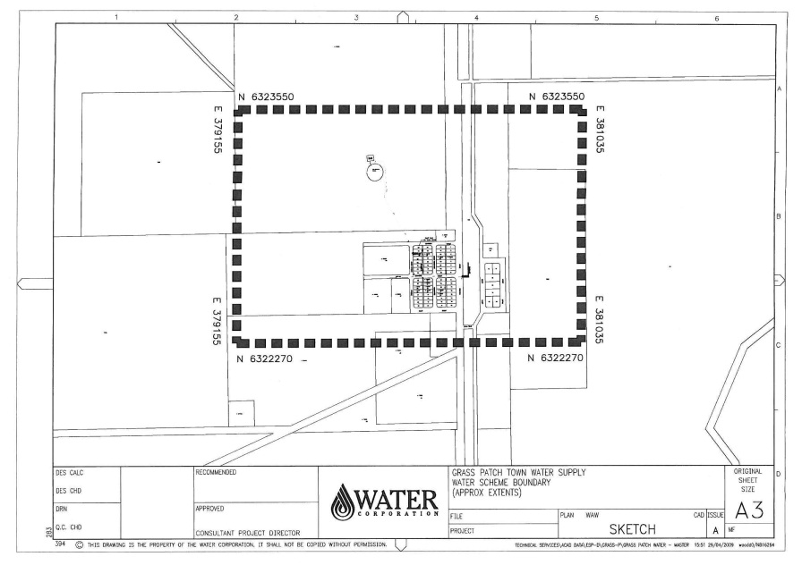
Note: This map is for information only.
Map 2 — the Manjimup scheme water area
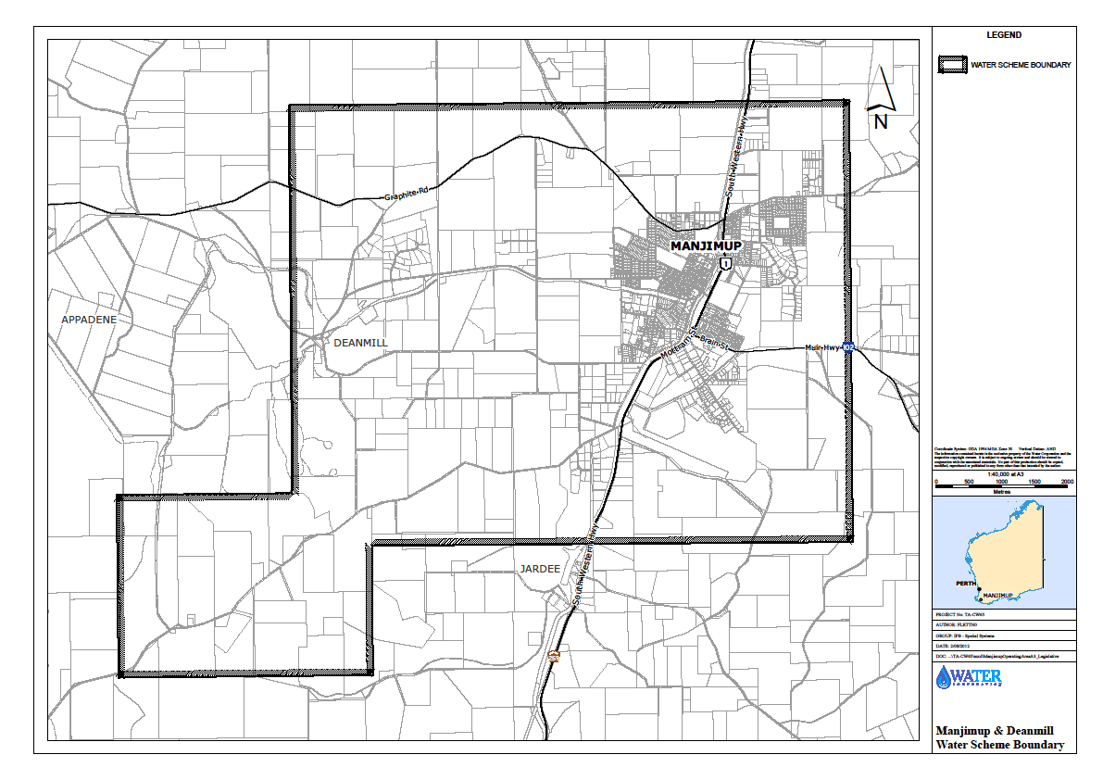
Note: This map is for information only.
Map 3 — the Salmon Gums scheme water area
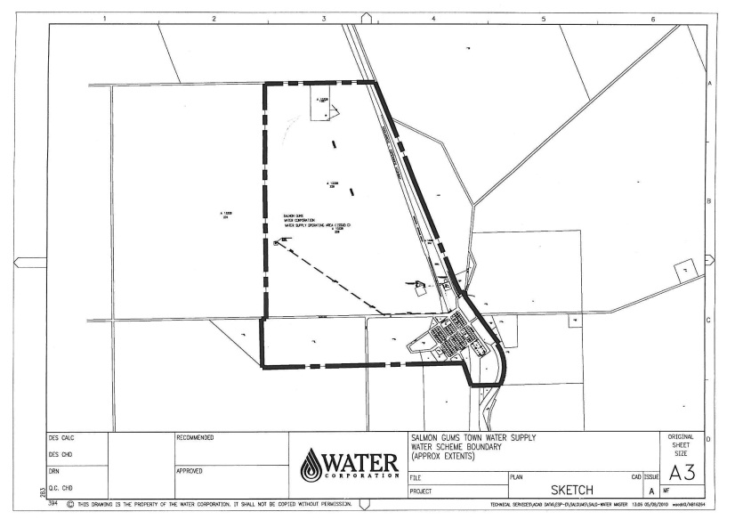
Note: This map is for information only.
[Schedule 4 inserted in Gazette 24 Aug 2012 p. 3962-3.]

Notes
¹ This reprint is a compilation as at 5 April 2013 of the Water Agencies (Water Use) By-laws 2010 and includes the amendments made by the other written laws referred to in the following table. The table also contains information about any reprint.

Compilation table
Citation | Gazettal | Commencement
Water Agencies (Water Use) By-laws 2010 | 16 Mar 2010 p. 999-1031 | bl. 1 and 2: 16 Mar 2010 (see bl. 2(a));  By-laws other than bl. 1 and 2: 1 Apr 2010 (see bl. 2(b))
Water Agencies (Water Use) Amendment By-laws 2010 | 28 Sep 2010 p. 5063-5 | bl. 1 and 2: 28 Sep 2010 (see bl. 2(a));  By-laws other than bl. 1 and 2: 1 Oct 2010 (see bl. 2(b))
Water Agencies (Water Use) Amendment By-laws (No. 2) 2010 | 30 Nov 2010 p. 6016-22 | bl. 1 and 2: 30 Nov 2010 (see bl. 2(a));  By-laws other than bl. 1 and 2: 1 Dec 2010 (see bl. 2(b))
Water Agencies (Water Use) Amendment By-laws 2011 | 8 Mar 2011 p. 801-4 | bl. 1 and 2: 8 Mar 2011 (see bl. 2(a));  By-laws other than bl. 1 and 2: 9 Mar 2011 (see bl. 2(b))
Water Agencies (Water Use) Amendment By-laws (No. 2) 2011 | 18 Nov 2011 p. 4818-19 | bl. 1 and 2: 18 Nov 2011 (see bl. 2(a));  By-laws other than bl. 1 and 2: 19 Nov 2011 (see bl. 2(b))
Water Agencies (Water Use) Amendment By-laws 2012 | 24 Aug 2012 p. 3961-3 | bl. 1 and 2: 24 Aug 2012 (see bl. 2(a));  By-laws other than bl. 1 and 2: 25 Aug 2012 (see bl. 2(b))
Reprint 1: The Water Agencies (Water Use) By-laws 2010 as at 5 Apr 2013
(includes amendments listed above)

Defined terms

[This is a list of terms defined and the provisions where they are defined. The list is not part of the law.]
Defined term Provision(s)
approved 18
Area 3
Area 1 3
Area 2 3
Area 3 3
Area 4 3
commencement day 10AA(1), 31(1)
consumption year 18
coordinate 10AA(1), 10A(1)
domestic bore 3
domestic bore water 3
evening period 3
former plan 31(1)
garden 3
high pressure water cleaner 3
lawn 3
morning period 3
non-residential lot 18
other property 11(1)(b)
relevant property 3
restriction notice 31(1)
scheme water 3
scheme water efficiency management plan 18
scheme water supplier 3
specified day 31(1)
stage of restrictions 3
synthetic sporting ground 3
water 3, 18
week 3
written approval 4(1)

By Authority: JOHN A. STRIJK, Government Printer

