
Western Australia

Special Lease (Gypsum) Act 1918
This Act was repealed by the Statutes (Repeals) Act 2014 s. 3 (No. 32 of 2014) as at 4 Dec 2014 (see s. 2(b)).

Western Australia
Special Lease (Gypsum) Act 1918
Contents
1. Short title 1
2. Authority to grant lease 1
The Schedule
Notes
Compilation table 7

Western Australia
Special Lease (Gypsum) Act 1918
An Act to enable a Special Lease to be granted under the Land Act 1898, of 5,000 acres of land situated near Dukin, in the South-West Division of the State.
[Assented to 13 June 1918.]
Whereas the Western Australian Plaster of Paris and Gysum Company, Limited, a Company duly incorporated and registered in the State of Western Australia, having its registered office at No. 98 Raglan Road, North Perth, and carrying on business in western Australia, is desirous of obtaining a lease of five thousand acres of land, situated near Dukin, Western Australia, containing gypsum deposits for the purpose of manufacturing plaster of Paris and manure: And whereas it is expedient to grant the Company the said land: Be it therefore enacted by the King’s Most Excellent Majesty, by and with the advice and consent of the Legislative Council and Legislative Assembly, in this present Parliament assembled, and by the authority of the same, as follows: —

1. Short title
This Act may be cited as the Special Lease (Gypsum) Act 1918.

2. Authority to grant lease
Notwithstanding anything contained in the Land Act to the contrary, the Governor may, in the name and on behalf of His Majesty, grant to the Western Australian Plaster of Paris and Gypsum Company, Limited, a special lease of the land described in the draft lease set forth in the schedule to this Act for the term, at the rent, and subject to the covenants and conditions therein stated: Provided, however, that any variation in the form of said draft lease, not being matters of substance, shall not affect the validity of the lease.

The Schedule
DRAFT LEASE
Lease No. Division No.
GEORGE THE FIFTH, by the Grace of God, of the United Kingdom of Great Britain and Ireland, and of the British Dominions beyond the Seas, King, Defender of the Faith, Emperor of India: To all to whom these presents shall come, Greeting
Know ye that we of Our Special Grace and in consideration of the rent hereinafter reserved and to be paid by Western Australian Plaster of Paris and Gypsum Company, Limited, a Company duly incorporated and registered in the State of (Western Australia, and having its registered office at 25 Raglan Road, North Perth, Western Australia, its Liquidators, Successors, and Assigns (hereinafter called and referred to as the lessee) and of the conditions hereinafter expressed and to be observed and performed by the lessee, do by these presents demise and lease to the lessee all that land being portion of the bed of the Cowcowing Lakes, to a depth of 200 feet, situated at Avon Location 16454, near Dukin, in this State, and containing approximately 5,000 acres, as the same is delineated in the plan drawn hereon and coloured blue: To have and to hold the premises hereby demised, subject to the powers, reservations, and conditions herein and in the Land Act 1898, and its amendments contained: And with all the rights, powers, and privileges conferred by the said Act as are applicable hereto, unto the lessee for the term of twenty-one years, to be computed from the
day of One thousand nine hundred and eighteen, for the special purpose of working the gypsum deposits on the demised premises, and for the manufacture of plaster of Paris from the said gypsum deposits, and/or the manufacture of manure from the said gypsum deposits. Yielding and paying therefor during the said term unto Us, Our Heirs, and Successors, the yearly rent of Ten Pounds without deduction, by equal payments half-yearly, in advance on or before the first day of March, and the first day of September, in every year, and also yielding to Us, Our Heirs, and Successors, by the way of further rent, a royalty of one shilling per ton of all plaster of Paris and/or manure manufactured, being the product of the said Lease, such rent and royalty to be paid to our Minister for Lands of our said State. Provided that this lease is granted and shall be held on the condition that no worker or other person shall be employed by the Lessee on the demised land unless such worker or person is a natural born or naturalised British subject.
Provided that this Lease is granted subject to the observance and performance by the Lessee of the following conditions. That the Lessee
(a) Shall commence operations forthwith and continue the same during the term of the lease.
(b) Shall continuously employ not less than two workmen on the lease during the first year of the term, and not less than five men during the remainder of the term.
(c) Shall perform such labour conditions by the employment of only natural born or naturalised British subjects.
(d) Shall render to Our Minister for Lands to his satisfaction, and if so required by him in a prescribed form, half-yearly returns in writing of all plaster of Paris and/or manure manufactured, and the produce of the said Lease, and shall pay to our Minister for Lands with each return the said royalty of one shilling per ton;
with power to the Minister for Lands or any officer appointed by him to inspect the books of account or records of the Lessee from time to time, and to take extracts therefrom.
(e) Shall pay the proper survey fees in respect of the demised land.
Provided, nevertheless, that it shall at all times be lawful for Us, Our Heirs and Successors, or for any person or persons acting in that behalf by Our or Their authority, to resume and enter upon possession of any part of the said lands which it may at any time by Us, Our Heirs and Successors, be deemed necessary to resume for roads, tramways, railways, railway stations, bridges, canals, towing paths, harbour or river improvement works, drainage or irrigation works, quarries, and generally for any other works or purposes of public use, utility, or convenience, and for the purpose of exercising the power of search for minerals and gems hereinafter reserved, and such land so resumed to hold to Us, Our Heirs and Successors, as of Our or Their former estates, without making to the said Lessee, its Successors and Assigns, any compensation in respect thereof; so, nevertheless, that the lands so to be resumed shall not exceed one-twentieth part of the whole of the lands aforesaid, and that no such resumption be made of any part of the said lands upon which any buildings may have been erected, or which may be enclosed and in use as gardens or otherwise for the more convenient occupation of any such buildings without compensation: Provided also that it shall be lawful at all times for Us, Our Heirs and Successors, or for any person or persons acting in that behalf by Our or Their authority to cut and take away any such indigenous timber and to search and dig for and carry away any stones or other materials which may be required for making or keeping in repair any roads, tramways, railways, railway stations, bridges, canals, towing paths, harbour works, break-waters, river improvements, drainage, or irrigation works, and generally for any other works or purposes of public use, utility, or convenience, without making to the Lessee, its Successors or Assigns, any compensation in respect thereof, and We do hereby save and reserve to Us, Our Heirs and Successors, all mines of gold, silver, copper, tin, or other metals, and all gems and precious stones, and coal or mineral oil in and under the said land, with full liberty at all times to search and dig for and carry away the same, and for that purpose enter upon the said land or any part thereof: Provided also that if the said Lessee shall, during the term hereby created, at any time make default in payment of the rent or royalty hereby reserved, or shall fail or cease to use, hold, and enjoy the said land for the said special purpose, or shall fail or neglect to duly observe and perform the said conditions or any of them to the satisfaction of Our Minister for Lands, it shall thereupon be lawful for Us, Our Heirs and Successors, into and upon the said demised premises, or any part thereof, in the name of the whole to re-enter and the same to have again, re-possess, and enjoy as if this deed-poll had never been executed, without making any compensation to the said Lessees.
PLAN REFERRED TO
Subject to Survey
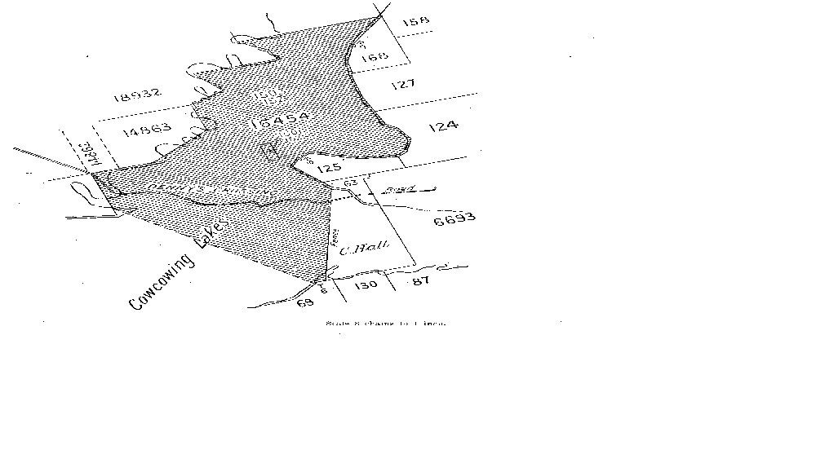
IN WITNESS where We have caused Our said Minister for Lands to affix hereto his seal and set his hand this day of 1918.
By order of THE MINISTER FOR LANDS.

Notes
^{1.} This is a compilation of the Special Lease (Gypsum) Act 1918 and includes all amendments effected by the other Acts referred to in the following Table.

Compilation table
Short title | Number and year | Assent | Commencement
Special Lease (Gypsum) Act 1918 | Private Act | 13 Jun 1918 | 13 Jun 1918
This Act was repealed by the Statutes (Repeals) Act 2014 s. 3 (No. 32 of 2014) as at 4 Dec 2014 (see s. 2(b))

