
Western Australia
Metropolitan Redevelopment Authority Act 2011

Metropolitan Redevelopment Authority Regulations 2011

Western Australia
Metropolitan Redevelopment Authority Regulations 2011
Contents
Part 1 — Preliminary
1. Citation 1
2. Commencement 1
3. Terms used 1
Part 2 — Works, acts and activities that do not constitute development
4. Effect of exclusions in relation to heritage places 3
5. Minor and temporary works, acts and activities 4
6. Subdivision works 5
7. Home occupations 6
8. Certain works, acts and activities by Authority 7
9. Certain buildings and related works 8
Part 3 — Redevelopment areas
10. Armadale redevelopment area 10
11. Central Perth redevelopment area 10
12. Midland redevelopment area 10
13. Subiaco redevelopment area 11
14A. Scarborough redevelopment area 11
14. Redevelopment area objectives: s. 30(5)(c) 12
Part 4 — Development applications
15. Criteria for determining whether development application is standard or major application: s. 63(1) 13
16. Development application 13
17. Plans to accompany development application 13
18. Statements to accompany development application 15
19. Other material to accompany development application 16
20. Electronic lodgment under regulation 17, 18 or 19 16
21. Authority may request additional information 16
22. Amending development approval on application 16
23. Review of Authority’s decision by SAT 18
Part 5 — Functions of Authority
24. Delegation: s. 14 19
25. Value of land acquired or disposed of: s. 18 19
26. Business plans: s. 113 19
27. Operational plans: s. 113 20
Part 6 — Fees and charges
Division 1 — General
28. Terms used 22
29. Fees for certain services 22
30. Fees relating to structure plans and scheme amendments etc. 22
31. Additional costs and expenses payable by applicants 24
32. Itemised account to be provided on request 25
33. Dispute as to amount payable 25
34. Authority may waive or refund fee 25
Division 2 — Fees Arbitration Panels
35. Fees Arbitration Panels 25
36. Panel meetings 26
37. Decisions of a Panel 26
Part 7 — Miscellaneous
38. Closely associated persons: s. 95 27
39. Offences 27
Schedule 1 — Armadale redevelopment area
Schedule 2 — Central Perth redevelopment area
Schedule 3 — Midland redevelopment area
Schedule 4 — Subiaco redevelopment area
Schedule 5A — Scarborough redevelopment area
Schedule 5 — Fees
Notes
Compilation table 35
Defined terms

Western Australia
Metropolitan Redevelopment Authority Act 2011
Metropolitan Redevelopment Authority Regulations 2011

Part 1 — Preliminary

1. Citation
These regulations are the Metropolitan Redevelopment Authority Regulations 2011 ¹.

2. Commencement
These regulations come into operation as follows —
(a) regulations 1 and 2 — on the day on which these regulations are published in the Gazette;
(b) the rest of the regulations — on the day on which the Metropolitan Redevelopment Authority Act 2011 section 4 comes into operation.

3. Terms used
In these regulations —
Armadale redevelopment area means the land referred to in regulation 10(2);
Central Perth redevelopment area means the land described in regulation 11(2);
Midland redevelopment area means the land described in regulation 12(2);
section means a section of the Act;
Subiaco redevelopment area means the land described in regulation 13(2);
utility services means drainage, electricity, sewerage, water, gas and telecommunications supply services.

Part 2 — Works, acts and activities that do not constitute development

4. Effect of exclusions in relation to heritage places
(1) In this regulation —
heritage area means an area that is listed on a heritage inventory;
Heritage Council means the Heritage Council of Western Australia established under the Heritage of Western Australia Act 1990 section 5;
heritage inventory means an inventory of heritage places and heritage areas prepared by the Authority under a redevelopment scheme;
heritage place means land, or a building or other structure, that is —
(a) identified as a heritage place in a redevelopment scheme or in a plan, strategy or other instrument relating to heritage prepared and adopted under a redevelopment scheme; or
(b) located within a heritage area; or
(c) listed on the Register of Heritage Places;
Register of Heritage Places means the Register established under the Heritage of Western Australia Act 1990 section 46.
(2) A declaration under regulation 5, 8 or 9 that any work, act or activity does not constitute development does not include any work, act or activity carried out in, or in relation to, a heritage place unless subregulation (3) applies to that work, act or activity.
(3) This subregulation applies to any work, act or activity —
(a) that is of the kind referred to in regulation 5(a), (b), (c) or (d); or
(b) that —
(i) is of the kind referred to in regulation 5(e), (f), (g), (h) or (i), 8(2) or 9(2), (3) or (4); and
(ii) is carried out by or on behalf of the Authority in accordance with a conservation plan, or other arrangement relating to the conservation of the heritage place, prepared by the Authority in consultation with the Heritage Council.

5. Minor and temporary works, acts and activities
The following works, acts and activities do not constitute development in a redevelopment area for the purposes of the definition of development in section 3 —
(a) the erection of a traffic control sign or device by a public authority or a local government;
(b) the erection of a sign within a building (other than one that is attached to the inside of a window);
(c) the carrying out of maintenance or repair work by a public authority, utility services provider or local government, other than construction of a new building or structure;
(d) the carrying out by a local government, after consultation with the Authority, of —
(i) the construction of a new building or structure associated with roads, such as a bus shelter, public seating and lighting; or
(ii) any other work, act or activity associated with roads, such as paving, kerbing and landscaping;
(e) minor filling, excavation or recontouring of land, or the construction of a retaining wall, if the cumulative change in the natural ground level over the 5 years before the completion of the work as a result of filling, excavation or recontouring of land, or the construction of the retaining wall, is no more than 0.5 m, which change is to include any sand pad or site works associated with building;
(f) the carrying out of work inside a building that is not related to a change of use of any part of the building and does not alter its external appearance;
(g) the carrying out of work for the maintenance of a building or structure where that work involves the replacement of materials by similar materials and does not materially affect the external appearance of the building or structure;
(h) the erection, for the duration of construction work approved by the Authority, of a temporary building, structure or sign necessary for the construction work;
(i) the erection, for the duration of a public event authorised or approved by the Authority, of a temporary building, structure or sign associated with the event;
(j) the location of a single vehicle or single stall on public land, selling food or other items or providing a community service, for less than 24 consecutive hours in any period of 4 weeks, including any change in the use of the land necessary to permit the vehicle or stall to be used on the land.

6. Subdivision works
(1) In this regulation —
subdivision works means works for the purpose of enabling the subdivision of land and includes, to the extent necessary for the subdivision, the following —
(a) site works, including remediation;
(b) road works;
(c) the provision of utility services.
(2) The following works, acts and activities do not constitute development in a redevelopment area for the purposes of the definition of development in section 3 —
(a) the carrying out of subdivision works by the Authority if the works are necessary or desirable for compliance by the Authority with the conditions attached to the approval of the subdivision;
(b) the carrying out of subdivision works by a person other than the Authority if —
(i) the works are —
(I) necessary for compliance by the person with the conditions attached to the approval of the subdivision; or
(II) in the opinion of the Authority, desirable for compliance by the person with the conditions attached to the approval of the subdivision;
and
(ii) the works are not carried out on land that is in a costs contribution area under a redevelopment scheme.

7. Home occupations
(1) In this regulation —
home occupation means any work, act or activity that meets the following criteria —
(a) it is an occupation carried out in a dwelling or on land around a dwelling by an occupier of the dwelling;
(b) it is not likely to adversely affect the amenity of the neighbourhood;
(c) it does not involve the sale or hire of goods of any nature from, or display of goods of any nature at, the dwelling;
(d) in relation to vehicles and parking, it does not —
(i) require a greater number of parking facilities than the number permitted for a single dwelling under the applicable redevelopment scheme; or
(ii) result in an increase in traffic volume in the neighbourhood;
(e) it does not involve the use of a utility service of greater capacity than normally required in the planning zone in which the use is carried out;
(f) it does not —
(i) involve the employment of more than 2 persons who are not members of the occupier’s household; or
(ii) occupy an area greater than 50 m²; or
(iii) require the presence or use of a motor vehicle of more than 3 tonnes tare weight; or
(iv) require provision for the fuelling, repair or maintenance of motor vehicles.
(2) A home occupation does not constitute development in a redevelopment area for the purposes of the definition of development in section 3.

8. Certain works, acts and activities by Authority
(1) In this regulation —
public work has the meaning given in the Public Works Act 1902 section 2.
(2) The following works, acts and activities do not constitute development in a redevelopment area for the purposes of the definition of development in section 3 —
(a) the use by the Authority of any land held by the Authority or Crown land, if that use is not prohibited under the relevant redevelopment scheme;
(b) a public work carried out by the Authority on land held by the Authority or Crown land, if the value of the work, as estimated by the Authority, is less than $1 million.

9. Certain buildings and related works
(1) A declaration under this regulation that any work, act or activity does not constitute development does not include any work, act or activity that —
(a) requires the exercise of a discretion under a redevelopment scheme; or
(b) is carried out in the development control area as defined in the Swan and Canning Rivers Management Act 2006 section 3(1).
(2) The following works, acts and activities do not constitute development in the Armadale redevelopment area for the purposes of the definition of development in section 3 —
(a) the erection of a single dwelling on a lot with an area greater than 350 m², if the dwelling complies with the redevelopment scheme for that redevelopment area;
(b) the erection of an outbuilding to a dwelling, if the outbuilding is less than 60 m² in floor area.
(3) The following works, acts and activities do not constitute development in the Armadale redevelopment area or Midland redevelopment area for the purposes of the definition of development in section 3 —
(a) the erection of a single storey extension at the side or rear of a dwelling;
(b) the erection of solar panels on the roof of a building, if the panels are affixed at the same pitch as the roof;
(c) the erection of rain water tanks at the side or rear of a dwelling;
(d) the erection at the side or rear of a dwelling of residential add-ons, such as shade sails and patios;
(e) the erection, maintenance or alteration of a boundary fence or wall, other than a fence or wall within the front setback of a lot;
(f) the demolition or removal of a minor or ancillary structure, such as a patio, pergola, carport, fence, shed, store room or similar structure, but not including a retaining wall that exceeds 0.5 m in height;
(g) the construction of a swimming pool associated with a dwelling.
(4) The following works, acts and activities do not constitute development in the Central Perth redevelopment area or Subiaco redevelopment area for the purposes of the definition of development in section 3 —
(a) the erection of structures that are additional to an existing building, and any ancillary works, if the erection of the structures, and any ancillary works, are carried out in accordance with an applicable policy published by the Authority;
(b) the demolition or removal of a minor or ancillary structure, such as a patio, pergola, carport, fence, shed, store room or similar structure, but not including a retaining wall that exceeds 0.5 m in height;
(c) the construction of a swimming pool associated with a dwelling.

Part 3 — Redevelopment areas

10. Armadale redevelopment area
(1) In this regulation —
relevant plan means the plan entitled “Armadale redevelopment area” held at the office of the Authority, that plan being certified by the Minister as the plan prepared for the purpose of defining the Armadale redevelopment area.
(2) All of the land in the area outlined in bold on the relevant plan is declared to be a redevelopment area.
(3) The name of the redevelopment area is the Armadale redevelopment area.
(4) For guidance, a plan depicting the Armadale redevelopment area is set out in Schedule 1.

11. Central Perth redevelopment area
(1) In this regulation —
relevant plan means the plan entitled “Central Perth redevelopment area” held at the office of the Authority, that plan being certified by the Minister as the plan prepared for the purpose of defining the Central Perth redevelopment area.
(2) All of the land in the area outlined in bold on the relevant plan is declared to be a redevelopment area.
(3) The name of the redevelopment area is the Central Perth redevelopment area.
(4) For guidance, a plan depicting the Central Perth redevelopment area is set out in Schedule 2.

12. Midland redevelopment area
(1) In this regulation —
relevant plan means the plan entitled “Midland redevelopment area 2014” held at the office of the Authority, that plan being certified by the Minister as the plan prepared for the purpose of defining the Midland redevelopment area.
(2) All of the land in the area outlined in bold on the relevant plan is declared to be a redevelopment area.
(3) The name of the redevelopment area is the Midland redevelopment area.
(4) For guidance, a plan depicting the Midland redevelopment area is set out in Schedule 3.
[Regulation 12 amended in Gazette 16 Dec 2014 p. 4763.]

13. Subiaco redevelopment area
(1) In this regulation —
relevant plan means the plan entitled “Subiaco redevelopment area” held at the office of the Authority, that plan being certified by the Minister as the plan prepared for the purpose of defining the Subiaco redevelopment area.
(2) All of the land in the area outlined in bold on the relevant plan is declared to be a redevelopment area.
(3) The name of the redevelopment area is the Subiaco redevelopment area.
(4) For guidance, a plan depicting the Subiaco redevelopment area is set out in Schedule 4.

14A. Scarborough redevelopment area
(1) In this regulation —
relevant plan means the plan entitled “Scarborough redevelopment area” held at the office of the Authority, that plan being certified by the Minister as the plan prepared for the purpose of defining the Scarborough redevelopment area.
(2) All of the land in the area outlined in bold on the relevant plan is declared to be a redevelopment area.
(3) The name of the redevelopment area is the Scarborough redevelopment area.
(4) For guidance, a plan depicting the Scarborough redevelopment area is set out in Schedule 5A.
[Regulation 14A inserted in Gazette 30 Aug 2013 p. 4102.]

14. Redevelopment area objectives: s. 30(5)(c)
The objectives of each redevelopment area are as follows —
(a) to build a sense of place by supporting high-quality urban design, heritage protection, public art and cultural activities that respond to Perth’s environment, climate and lifestyle;
(b) to promote economic wellbeing by supporting, where appropriate, development that facilitates investment and provides opportunity for local businesses and emerging industries to satisfy market demand;
(c) to promote urban efficiency through infrastructure and buildings, the mix of land use and facilitating a critical mass of population and employment;
(d) to enhance connectivity and reduce the need to travel by supporting development aimed at well-designed places that support walking, cycling and public transit;
(e) to promote social inclusion by encouraging, where appropriate, a diverse range of housing and by supporting community infrastructure and activities and opportunities for visitors and residents to socialise;
(f) to enhance environmental integrity by encouraging ecologically sustainable design, resource efficiency, recycling, renewable energy and protection of the local ecology.

Part 4 — Development applications

15. Criteria for determining whether development application is standard or major application: s. 63(1)
(1) For the purposes of section 63(1), a standard application is a development application that, in the opinion of the Authority, has an estimated cost of less than $7 million.
(2) For the purposes of section 63(1), a major application is a development application that, in the opinion of the Authority, has an estimated cost of $7 million or more.

16. Development application
A development application must be —
(a) made in the form approved by the chief executive officer; and
(b) accompanied by the relevant fee set out in Schedule 5 item 1 or 2.

17. Plans to accompany development application
(1) Except as stated in regulation 20, every development application must be accompanied by at least 4 sets of the following plans —
(a) one or more plans showing, in relation to the land on which the development is proposed (the site), the following —
(i) the location and existing and proposed use of existing buildings;
(ii) the location, design and use of any building proposed to be erected or demolished;
(iii) existing and proposed means of access for pedestrians and vehicles to and from the site;
(iv) the location, design and dimensions of all car parking spaces proposed to be provided, together with access details and any specific allocation of parking (such as disabled parking and loading zones);
(v) the location and dimensions of any area proposed to be provided for the loading and unloading of vehicles and the means of access to and from those areas;
(vi) the location of any existing trees and other vegetation;
(vii) the location of any areas proposed to be landscaped and the nature and extent of the proposed landscaping;
(b) a site plan, relevant floor plans, cross-sections, elevations and details (including materials and finishes) of any building proposed to be erected or altered and of any building proposed to be retained;
(c) a plan showing details of any proposed signage or advertising structures, including size, location and any illumination.
(2) The plans must —
(a) be clearly legible; and
(b) be drawn to a scale commensurate to the development proposed and to a standard scale; and
(c) include all relevant dimensions, including —
(i) the overall size of the proposed development; and
(ii) setbacks to boundaries; and
(iii) existing and proposed lot boundaries.
(3) All measurements used on the plans must be metric.
(4) If the plans are lodged electronically —
(a) they must be capable of being reproduced in black and white; or
(b) if paragraph (a) is not complied with, a version of the plans must also be lodged that is capable of being reproduced in black and white.
(5) If the plans are not lodged electronically, at least one set of the plans must be drawn to scale at an A3 size capable of being copied in black and white.

18. Statements to accompany development application
(1) In this regulation —
heritage area has the meaning given in regulation 4(1);
Register of Heritage Places has the meaning given in regulation 4(1);
statement includes a document that includes a plan or drawing.
(2) Except as stated in regulation 20, every development application must be accompanied by at least 4 sets of the following statements —
(a) a statement about the effect of the proposed development on the appearance of streets, vegetation and buildings accompanied by —
(i) if the application relates to a proposed building with more than 2 storeys (other than a single dwelling) — a perspective drawing indicating that effect and a streetscape analysis; or
(ii) if the application relates to a proposed building to be located in a heritage area — a streetscape analysis;
(b) a statement about any effect of the proposed development on views, privacy and overshadowing;
(c) a statement about the proposed use and operation of the proposed development;
(d) a statement about any effect the proposed development may have on transport networks, such as public transport, vehicle, bicycle and pedestrian networks;
(e) if the proposed development does not comply with any requirement of the applicable redevelopment scheme — a statement of the reasons for that failure to comply;
(f) if the proposed development relates to a place entered in the Register of Heritage Places — a statement about the effect of the proposed development on the heritage values of the place.

19. Other material to accompany development application
Except as stated in regulation 20, every development application must be accompanied by —
(a) a copy of the certificate of title for the land on which the development is proposed; and
(b) 4 sets of any further information or material required by the approved form.

20. Electronic lodgment under regulation 17, 18 or 19
If a development application and one set of anything the application is required to be accompanied by under regulation 17(1), 18(2) or 19 are lodged electronically, no other sets of plans, statements, further information or material are required to accompany the application unless regulation 17(4)(b) applies.

21. Authority may request additional information
After a development application is given to the Authority, the Authority may request the applicant to give it further plans or information in relation to matters specified in the request in order to enable it to decide the application.

22. Amending development approval on application
(1) A person to whom a development approval has been issued by the Authority may apply to the Authority to do any or all of the following —
(a) to amend the approval so as to extend the period within which any development approved must be substantially commenced;
(b) to amend or delete any condition to which the approval is subject;
(c) to amend an aspect of the development approved that, if amended, would not substantially change the development approved.
(2) The application must be —
(a) made in the approved form; and
(b) accompanied by any information or supporting material required by the approved form; and
(c) accompanied by the fee set out in Schedule 5 item 3.
(3) The Authority may give written notice of the particulars of an application under subregulation (1) to any person mentioned in section 64(1) and have regard to any submissions made by the person.
(4) In considering an application under subregulation (1), the Authority must have regard to the matters mentioned in section 66(1).
(5) The Authority may decide an application under subregulation (1) by —
(a) approving the application with or without conditions; or
(b) refusing the application.
(6) The Authority must decide the application within 90 days after the application is made.
(7) The Authority must give written notice of any decision under this regulation to the applicant and to any person mentioned in section 64(1)(a) or as it otherwise thinks fit.
(8) The decision takes effect on the day on which written notice of it is given to the applicant.
(9) A decision under this regulation in relation to a development approval does not extend the period decided under section 66(3) in respect of the development approval unless that is a specific term of the decision.
(10) This regulation applies in relation to a development approval under section 60 as if any reference in this regulation to the Authority were a reference to the Minister.

23. Review of Authority’s decision by SAT
(1) An applicant under regulation 22 may apply to the State Administrative Tribunal for a review, in accordance with the PAD Act Part 14, of a decision of the Authority made under that regulation.
(2) For the purposes of subregulation (1), a failure by the Authority to decide an application under regulation 22 within 90 days after the application is made is to be taken to be a decision of the Authority to refuse the application.

Part 5 — Functions of Authority

24. Delegation: s. 14
Each of the following persons is prescribed for the purposes of section 14(1)(c) as a person to whom the Authority can delegate a power or duty —
(a) a member of the Authority;
(b) a member of an LRC;
(c) a staff member who is the holder for the time being of an office in the Authority specified in the instrument of delegation;
(d) the chief executive officer of a local government;
(e) the chief executive officer of the department principally assisting in the administration of the PAD Act;
(f) the chairperson of the WAPC.

25. Value of land acquired or disposed of: s. 18
For the purposes of section 18(2), the amount prescribed is $5 million.

26. Business plans: s. 113
(1) In this regulation —
Australian Accounting Standards means the standards issued by the Australian Accounting Standards Board;
business plan includes a draft business plan prepared under section 113(3).
(2) A business plan is to cover a forecast period of 4 financial years.
(3) A business plan must specify the following —
(a) the objectives of the Authority for the forecast period, including economic, financial and social objectives, and descriptions of how those objectives are to be achieved during that period;
(b) the Authority’s financial forecasts for each financial year of the forecast period, set out in the form of financial statements prepared in accordance with applicable Australian Accounting Standards, and details of, including the reasons for, any significant variation from the Authority’s financial forecasts in a previously approved business plan;
(c) the proposed asset investment expenditure and funding requirements for each financial year of the forecast period, including the source of the Authority’s funds in that period;
(d) for each redevelopment project being, or proposed to be, undertaken by the Authority —
(i) a description of the project’s nature and scope;
(ii) details of the costs and funding over the life of the project;
(iii) milestones and objectives to be achieved;
(e) confirmation by the Authority that it has complied with any relevant Government policy in the preparation of the business plan;
(f) any other matters required by a written direction given to the Authority by the Minister or as are agreed by the Minister and the Authority;
(g) any other matters required by a written direction given to the Authority by the Treasurer for the purposes of the most recent State budget.

27. Operational plans: s. 113
(1) In this regulation —
operational plan includes a draft operational plan prepared under section 113(3).
(2) An operational plan is to cover a period of one financial year.
(3) An operational plan must specify the following —
(a) an outline of the Authority’s specific objectives for the year, including economic, financial and social objectives;
(b) an outline of the Authority’s major planned achievements for the year;
(c) the business and service performance targets, and any other measures or indicators, by which the Authority’s performance in relation to its objectives and achievements may be measured;
(d) any other matters required by a written direction given to the Authority by the Minister or as are agreed by the Minister and the Authority.
(4) The Minister must, within 14 days after approving a draft operational plan under section 113(7), cause a copy of it to be laid before each House of Parliament or dealt with under section 132.
(5) The Authority may request the Minister to delete from a copy of an operational plan that is to be laid before Parliament a matter that is of a commercially sensitive nature, and the Minister may, despite subregulation (4), comply with the request.

Part 6 — Fees and charges

Division 1 — General

28. Terms used
In this Division —
applicant includes a person making a request;
fee includes a charge;
Panel means a Fees Arbitration Panel appointed under regulation 35;
structure plan means a plan, however described in a redevelopment scheme, for the coordination of subdivision and development.

29. Fees for certain services
(1) The Authority may impose a fee listed in Schedule 5 for the corresponding service provided by the Authority described in that Schedule.
(2) A fee listed in Schedule 5 must be paid by the applicant when applying for or requesting the corresponding service described in that Schedule.

30. Fees relating to structure plans and scheme amendments etc.
(1) The Authority may impose a fee for a service provided by the Authority arising from a request for —
(a) the adoption or amendment of a structure plan provided by the applicant; or
(b) the preparation or adoption of an amendment to a redevelopment scheme; or
(c) the approval or assessment of a plan, diagram or other document in connection with a development approval or subdivision approval or a requirement of a redevelopment scheme.
(2) When the Authority receives a request referred to in subregulation (1), the Authority must give the applicant an estimate, in the form approved by the chief executive officer, of —
(a) the hours that staff members will spend dealing with the request; and
(b) the total fee, calculated in accordance with that form, that the Authority will impose for dealing with that request.
(3) In an estimate given under subregulation (2), the hourly rates for staff members must be decided by the Authority but must not exceed —
(a) for the person in charge of planning at the Authority, $83.00 per hour; or
(b) for a senior planner or manager, $63.00 per hour; or
(c) for a planning officer, environmental health officer or other officer with qualifications relevant to the request, $34.70 per hour; or
(d) for a secretary or administrative officer, $28.40 per hour.
(4) The Authority may reduce the estimated total fee specified in an estimate given under subregulation (2).
(5) The Authority may refuse to deal with a request referred to in subregulation (1) until —
(a) the estimated total fee specified in the estimate given under subregulation (2) is paid; or
(b) if that fee is reduced under subregulation (4), the reduced fee is paid.
(6) If the Authority —
(a) decides not to implement the adoption or amendment of a structure plan or the adoption of an amendment to a redevelopment scheme; or
(b) decides to discontinue the adoption or amendment of a structure plan or the adoption of an amendment to a redevelopment scheme,
any amount paid by the applicant to the Authority for the adoption or amendment and not expended by the Authority on the provision of that service must be refunded to the applicant.

31. Additional costs and expenses payable by applicants
(1) The following costs and expenses, if incurred by the Authority in providing a service described in Schedule 5 items 1 to 7 or referred to in regulation 30, are payable by the applicant in addition to the fee for the provision of the service —
(a) costs and expenses of advertising the application and advertising matters related to the application;
(b) costs and expenses of any specific assessment, such as an environmental assessment, required in relation to the application;
(c) costs and expenses of consultation procedures required in relation to the application;
(d) costs and expenses of technical resources and equipment, such as computer modelling, required in relation to the application;
(e) costs and expenses of specialist advice, such as advice in relation to heritage matters, required in relation to the application.
(2) The Authority, in an account given to the applicant, may —
(a) require the applicant to pay the costs and expenses referred to in subregulation (1) that the Authority estimates it will incur; or
(b) require the applicant to pay the actual costs and expenses referred to in subregulation (1) after they have been incurred.
(3) Any amount paid in advance by an applicant to the Authority for estimated costs or expenses referred to in subregulation (1) that are not incurred by the Authority must be refunded to the applicant on the completion of the service.

32. Itemised account to be provided on request
If an applicant so requests, the Authority must give the applicant an itemised account of any fee the Authority has imposed on the applicant under regulation 30 or 31.

33. Dispute as to amount payable
(1) If a dispute arises as to an amount payable for or in relation to a service to be provided by the Authority arising from a request referred to in regulation 30(1), the dispute may be referred in writing by the Authority or applicant to a Panel for its decision.
(2) The referral of a dispute to a Panel does not affect the provision of the service for or in relation to which the fee is payable or the requirement to pay that fee, but the Panel may order the Authority to refund any part of the fee paid.
(3) A Panel’s decision on a dispute is final.

34. Authority may waive or refund fee
The Authority may waive or refund, in whole or in part, the payment of a fee imposed under this Division.

Division 2 — Fees Arbitration Panels

35. Fees Arbitration Panels
(1) A Fees Arbitration Panel consists of the following members appointed by the Minister —
(a) an officer of the department principally assisting in the administration of the Planning and Development Act 2005 nominated by the chief executive officer of that department;
(b) a person nominated by the Western Australian Local Government Association constituted under the Local Government Act 1995 section 9.58;
(c) a person selected by the Minister as a representative of the development industry.
(2) The Minister must appoint one of the members as chairperson of the Panel.
(3) The function of a Panel is to determine a dispute referred to it under regulation 33.

36. Panel meetings
(1) A Panel may hold a meeting to decide a dispute referred to it.
(2) A Panel may invite a person to be present at a meeting of the Panel to advise or inform, or make a submission to, the Panel.
(3) The applicant, or a representative of the applicant, and a representative of the Authority are entitled to be present whenever a person invited under subregulation (2) is present at a meeting of the Panel.

37. Decisions of a Panel
(1) A Panel member, including the chairperson, has a single vote on a decision to be made by the Panel.
(2) A matter that is to be decided by a Panel must be decided by a majority of votes.
(3) A decision is a valid decision of the Panel even though it is not made at a meeting of the Panel, if each member of the Panel agrees in writing to the proposed decision.

Part 7 — Miscellaneous

38. Closely associated persons: s. 95
(1) The amount prescribed for the purposes of section 95(1)(d)(ii)(I) is $10 000.
(2) The percentage prescribed for the purposes of section 95(1)(d)(ii)(II) is 1%.
(3) The prescribed manner of calculating the values of shares for the purposes of the definition of value in section 95(2) is —
(a) the closing share price of the shares on the ASX on the last trading day of the financial year; or
(b) the nominal value of the shares, if the shares were not listed on the ASX on the last trading day of the financial year.

39. Offences
(1) A person must not, in connection with a development application, make a statement or give any information the person knows to be false in a material particular.
Penalty: a fine of $1 000.
(2) A person must not, in connection with a development application, omit to supply to the Authority any information or particulars the person knows to be relevant to the application.
Penalty: a fine of $1 000.

Schedule 1 — Armadale redevelopment area
[r. 10(4)]
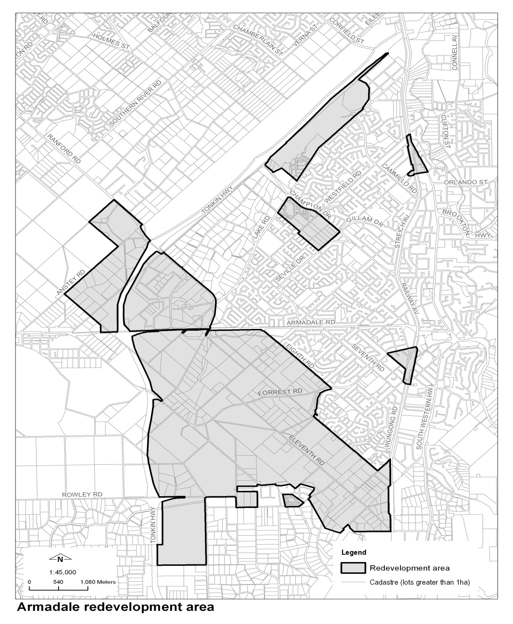

Schedule 2 — Central Perth redevelopment area
[r. 11(4)]
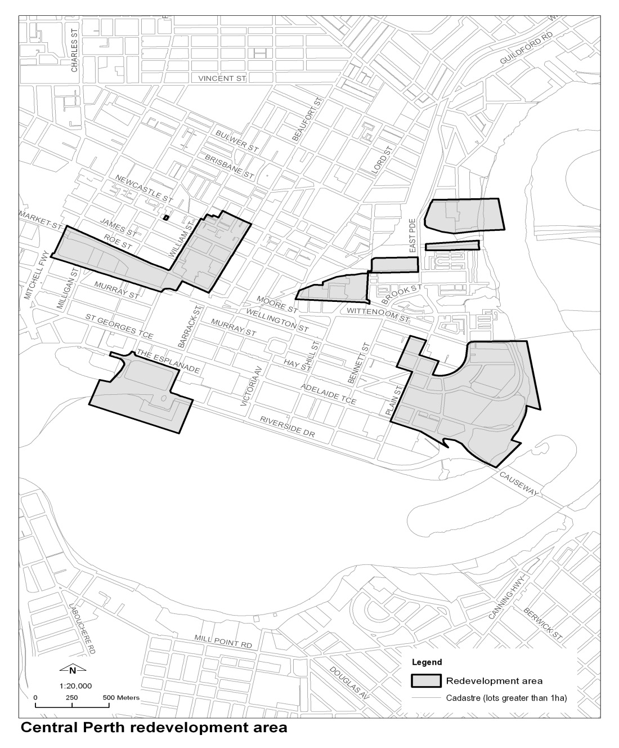

Schedule 3 — Midland redevelopment area
[r. 12(4)]
[Heading inserted in Gazette 16 Dec 2014 p. 4763.]
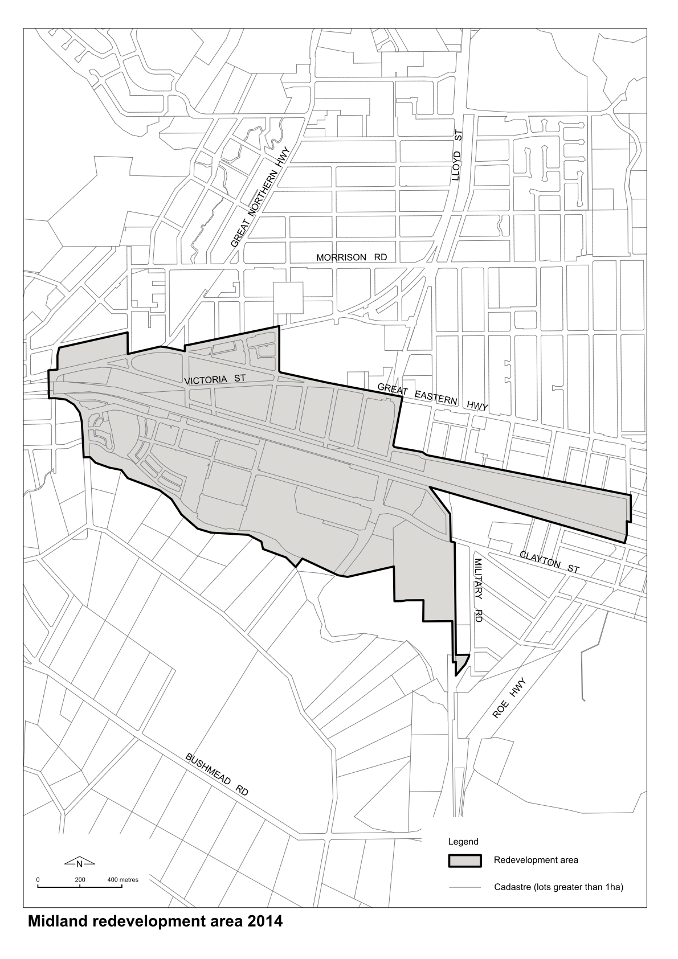
[Schedule 3 inserted in Gazette 16 Dec 2014 p. 4763.]

Schedule 4 — Subiaco redevelopment area
[r. 13(4)]
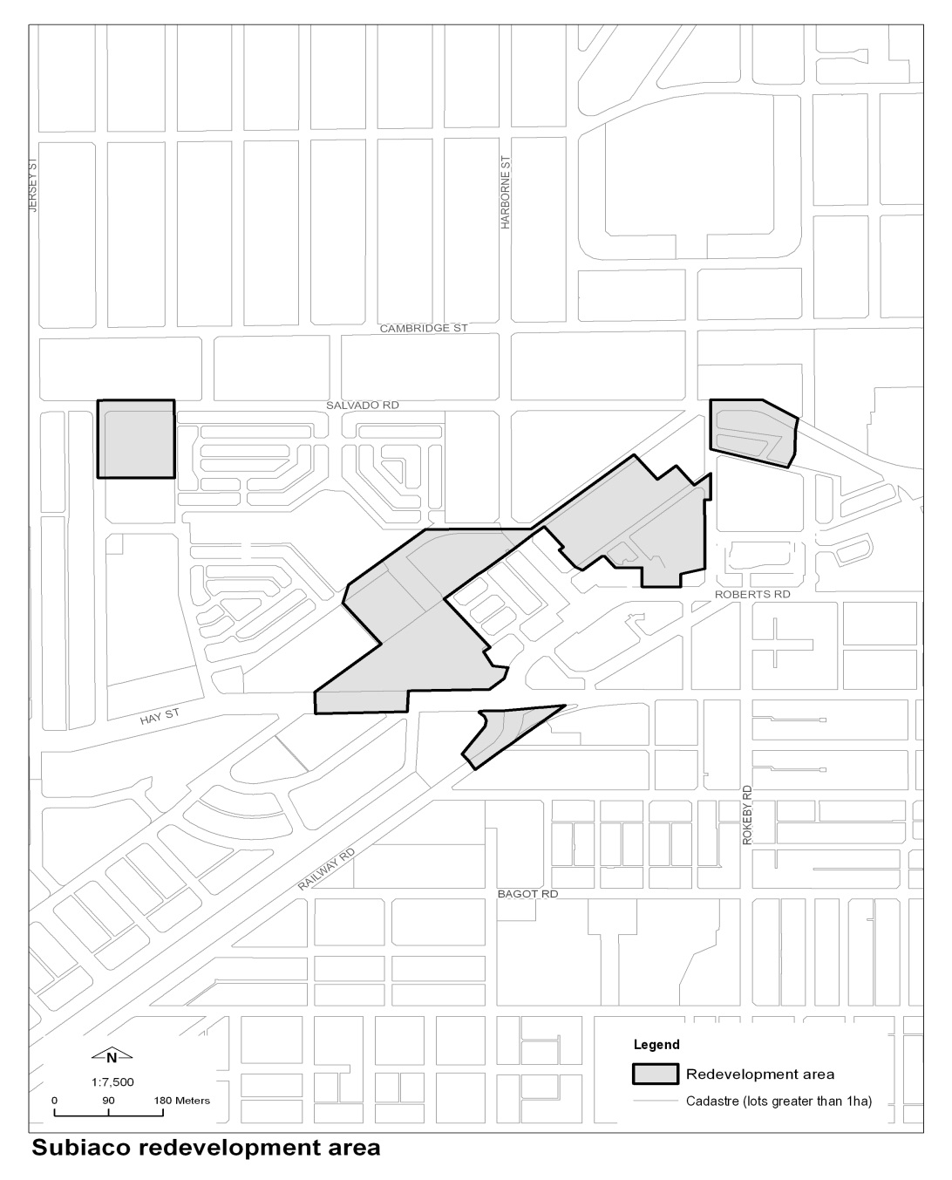

Schedule 5A — Scarborough redevelopment area
[r. 14A(4)]
[Heading inserted in Gazette 30 Aug 2013 p. 4103.]
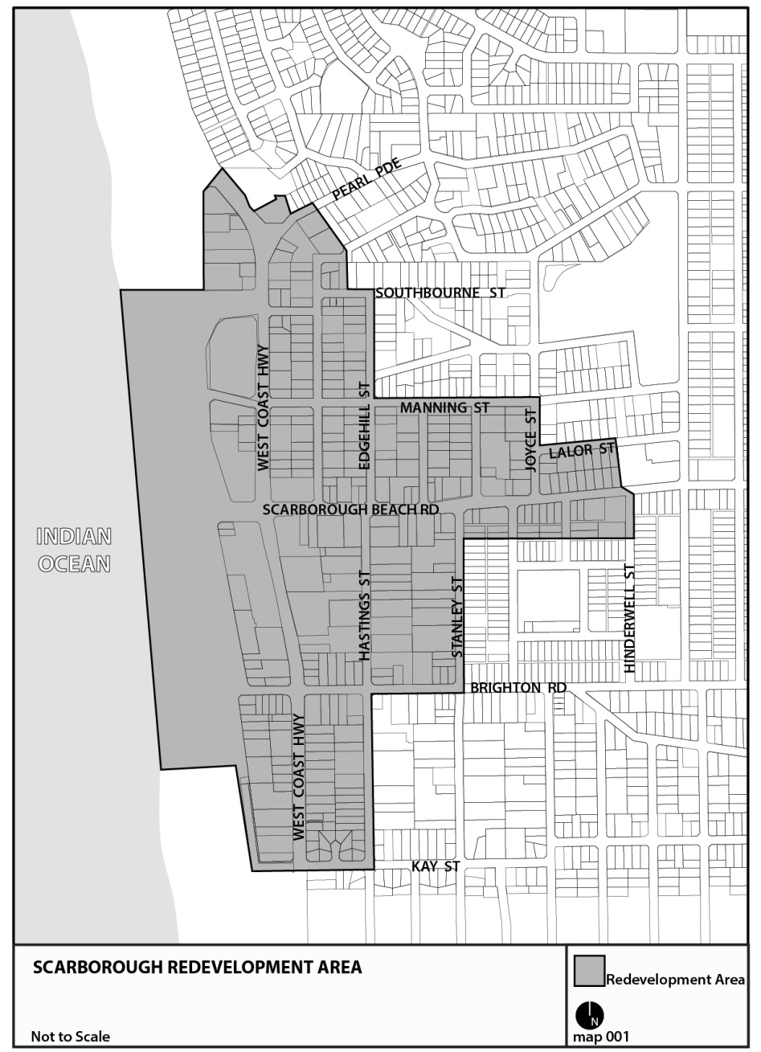
[Schedule 5A inserted in Gazette 30 Aug 2013 p. 4103.]

Schedule 5 — Fees
[r. 16, 22 and 29]

Item | Service | Fee
1. | Determining a development application where the development has not commenced or been carried out and the estimated cost of the development is —
 | (a) not more than $50 000 | $139
 | (b) more than $50 000 but not more than $500 000 | 0.32% of the estimated cost of development
 | (c) more than $500 000 but not more than $2.5 million | $1 600 + 0.257% for every $1 in excess of $500 000
 | (d) more than $2.5 million but not more than $5 million | $6 740 + 0.206% for every $1 in excess of $2.5 million
 | (e) more than $5 million but not more than $21.5 million | $11 890 + 0.123% for every $1 in excess of $5 million
 | (f) more than $21.5 million | $32 185
2. | Determining a development application where the development has commenced or been carried out | The fee in item 1 plus, by way of penalty, twice that fee
3. | Determining an application under r. 22 to amend a development approval | $150 or 10% of the fee paid for the development application under r. 16, whichever is the greater amount
4. | Providing a subdivision clearance for —
 | (a) not more than 5 lots | $69 per lot
 | (b) more than 5 lots but not more than 195 lots | $69 per lot for the first 5 lots and then $35 per lot
 | (c) more than 195 lots | $6 959
5. | Determining an application for a change of use or for an alteration or extension or change of a non-conforming use to which item 1 does not apply, where the change or the alteration, extension or change has not commenced or been carried out | $278
6. | Determining an application for a change of use or for an alteration or extension or change of a non-conforming use to which item 2 does not apply, where the change or the alteration, extension or change has commenced or been carried out | The fee in item 5 plus, by way of penalty, twice that fee
7. | Providing a zoning certificate | $69
8. | Providing a copy (except in an electronic format) of a draft redevelopment scheme, a redevelopment scheme or a policy made by the Authority for the purposes of a redevelopment scheme | 30 cents per page
9. | Replying to a property settlement questionnaire | $69
10. | Providing written planning advice | $69

Notes
¹ This is a compilation of the Metropolitan Redevelopment Authority Regulations 2011 and includes the amendments made by the other written laws referred to in the following table.

Compilation table
Citation | Gazettal | Commencement
Metropolitan Redevelopment Authority Regulations 2011 | 30 Dec 2011 p. 5475-514 | r. 1 and 2: 30 Dec 2011 (see r. 2(a));  Regulations other than r. 1 and 2: 31 Dec 2011 (see r. 2(b) and Gazette 30 Dec 2011 p. 5573)
Metropolitan Redevelopment Authority Amendment Regulations 2013 | 30 Aug 2013 p. 4102-3 | r. 1 and 2: 30 Aug 2013 (see r. 2(a));  Regulations other than r. 1 and 2: 31 Aug 2013 (see r. 2(b))
Metropolitan Redevelopment Authority Amendment Regulations 2014 | 16 Dec 2014 p. 4762-3 | r. 1 and 2: 16 Dec 2014 (see r. 2(a));  Regulations other than r. 1 and 2: 17 Dec 2014 (see r. 2(b))

Defined terms

[This is a list of terms defined and the provisions where they are defined. The list is not part of the law.]
Defined term Provision(s)
applicant 28
Armadale redevelopment area 3
Australian Accounting Standards 26(1)
business plan 26(1)
Central Perth redevelopment area 3
fee 28
heritage area 4(1), 18(1)
Heritage Council 4(1)
heritage inventory 4(1)
heritage place 4(1)
home occupation 7(1)
Midland redevelopment area 3
operational plan 27(1)
Panel 28
public work 8(1)
Register of Heritage Places 4(1), 18(1)
relevant plan 10(1), 11(1), 12(1), 13(1), 14A(1)
section 3
site 17(1)
statement 18(1)
structure plan 28
subdivision works 6(1)
Subiaco redevelopment area 3
utility services 3

