
Western Australia
East Perth Redevelopment Act 1991

East Perth Redevelopment (Subtracted Area) Regulations 2002
These regulations expired on 25 Jan 2007 (see r. 7).

Western Australia
East Perth Redevelopment (Subtracted Area) Regulations 2002
Contents
1. Citation 1
2. Commencement 1
3. Schedule 1 to the Act replaced 1
Schedule 1
Redevelopment area
4. Minister may amend planning schemes 3
5. Transitional matters to do with City of Perth City Planning Scheme 3
6. Other transitional matters 4
7. Expiry of regulations 5
Schedule 1 — Adopted Policies and Guidelines
Notes
Compilation table 8
Defined terms

Western Australia
East Perth Redevelopment Act 1991
East Perth Redevelopment (Subtracted Area) Regulations 2002

1. Citation
These regulations may be cited as the East Perth Redevelopment (Subtracted Area) Regulations 2002.

2. Commencement
These regulations come into operation on the day on which they are published in the Gazette.

3. Schedule 1 to the Act replaced
(1) In this regulation —
“Schedule 1” means the East Perth Redevelopment Act 1991* Schedule 1.
[* Reprinted 27 August 1999.
For subsequent amendments see 2000 Index to Legislation of Western Australia, Table 1, p. 1-125.]
(2) When an order under regulation 4 takes effect, Schedule 1 is repealed and the following Schedule is inserted instead —
“
Schedule 1
[Section 4]
Redevelopment area
All of the land and waters in the area described as the redevelopment area on Plan No. 2 held at the office of the Authority, that plan being certified by the Minister as being the plan prepared for the purpose of defining the redevelopment area.
For guidance, the redevelopment area is indicated in the following representation of Plan No. 2.
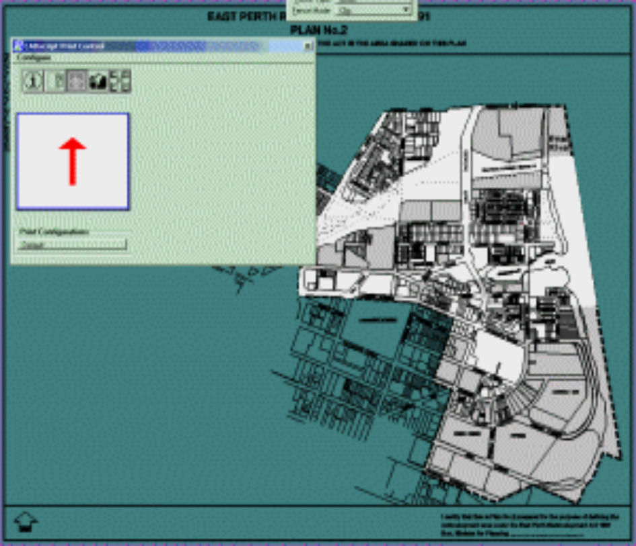
”.

4. Minister may amend planning schemes
(1) The Minister may, by order published in the Gazette, amend the Metropolitan Region Scheme or the City of Perth City Planning Scheme to provide for —
(a) land in the subtracted area to be included in the area to which that scheme applies; and
(b) the land to have a reservation or zoning under that scheme the same as or similar to that which applied to the land immediately before it ceased to be in the redevelopment area.
(2) In subregulation (1) —
“subtracted area” means the area to be subtracted from the redevelopment area by regulation 3.
(3) The order takes effect at the beginning of the day after the day on which it is published in the Gazette.

5. Transitional matters to do with City of Perth City Planning Scheme
(1) This regulation applies in relation to land included under regulation 4(1) in the area to which the City Scheme applies, but only to the extent that the City Scheme has not been amended to expressly exclude the application of this regulation.
(2) The provisions of the Redevelopment Scheme that applied in relation to the land before it was included in the area to which the City Scheme applies continue to apply in relation to that land as if they were a part of the City Scheme but with —
(a) references to the Authority being read as references to the City of Perth;
(b) the reference in clause 4.6.4(g) to “a Special Fund in the East Perth Redevelopment Authority Account” being read as a reference to “a Special Fund”; and
(c) any other modifications necessary to enable the provisions to apply as if they were a part of the City Scheme administered by the City of Perth.
(3) Provisions of the Redevelopment Scheme that are listed in the Table to this subregulation do not continue to apply under subregulation (2).
Table
clauses 1.1 to 1.6 | clauses 3.2 to 3.12
clause 2.23 | clause 3.16
clauses 2.25 to 2.27 | clause 4.8
(4) Provisions applying under subregulation (2) prevail to the extent of any inconsistency with another provision of the City Scheme.
(5) The General Planning Policies, Precinct Planning Policies, and Design Guidelines adopted under the Act and listed in Schedule 1 are to be treated as if —
(a) they were Policies prepared under the provisions applying under subregulation (2); and
(b) to the extent of any inconsistency with any other provision of the City Scheme, they prevailed over that provision.
(6) In this regulation —
“the City Scheme” means the City of Perth City Planning Scheme;
“the Redevelopment Scheme” means the redevelopment scheme in force under Part 4 of the Act immediately before an order under regulation 4 takes effect.

6. Other transitional matters
When an order under regulation 4 takes effect, the effect, if any, of a decision previously made by the Authority about a development application or approval continues.

7. Expiry of regulations
(1) These regulations expire if the Minister has made an order under regulation 4(1) but there is no longer any land in relation to which regulation 5 applies, unless these regulations have already expired under subregulation (2).
(2) These regulations expire at the end of the period of 5 years commencing on the day on which they come into operation, unless they have already expired under subregulation (1).
(3) The expiry of these regulations does not affect the amendment made by regulation 3(2) nor an amendment made by an order under regulation 4(1).
[Regulation 7 amended in Gazette 23 Jan 2004 p. 307.]

Schedule 1 — Adopted Policies and Guidelines
[r. 5(5)]
General Planning Policies
Planning Policy 1.2 | The Urban Village
Planning Policy 1.4 | Residential Development
Planning Policy 1.5 | Urban Design
Planning Policy 1.6 | Energy Conservation
Planning Policy 1.7 | Landscaping
Planning Policy 1.8 | Open Space
Planning Policy 1.9 | Car Parking
Planning Policy 1.10 | Transport
Planning Policy 1.11 | Public Art
Planning Policy 1.12 | Community and Cultural Facilities
Planning Policy 1.13 | Home Occupation
Planning Policy 1.14 | Security
Planning Policy 1.15 | Advertising Signs
Planning Policy 1.16 | Heritage
Planning Policy 1.17 | Industrial Uses in East Perth
Planning Policy 1.18 | Television Antennae and Satellite and Microwave Dishes
Precinct Planning Policies
Planning Policy 2.1 | Precinct 1: Claisebrook Inlet
Planning Policy 2.2 | Precinct 2: Constitution Street
Planning Policy 2.3 | Precinct 3: Royal Street Central
Planning Policy 2.4 | Precinct 4: Silver City
Planning Policy 2.6 | Precinct 6: Boans
Planning Policy 2.7 | Precinct 7: East Parade
Planning Policy 2.8 | Precinct 8: Belvidere
Planning Policy 2.9 | Precinct 9: Brown Street
Planning Policy 2.10 | Precinct 10: Riverbank
Planning Policy 2.11 | Precinct 11: Cemeteries
Planning Policy 2.12 | Precinct 12: Waterloo
Planning Policy 2.13 | Precinct 13: Plain Street
Planning Policy 2.15 | Precinct 15: Claisebrook Road North
Planning Policy 2.16 | Precinct 16: Transport Corridor
Design Guidelines
Constitution Hill | adopted 23 May 1994
Lot 221 Royal Street (Regal Place) | adopted 22 July 1996
Gasworks Subdivision Sector 10B (Belvidere) | adopted 23 September 1996
Lots 209, 211 and 212 Eastbrook Subdivision | adopted 23 September 1996
Sectors 1 and 2 – Haig Park and South Cove | adopted 24 February 1997
Lots 161 and 162 Quayside | adopted 26 February 1997
The Quadrant Site, Sector 6 | adopted 26 February 1997
Sector 34 Perth Aboriginal Medical Service Site between Wittenoom and Royal Streets | adopted 28 April 1997
Lot 201 Plain Street | adopted 26 May 1997
Glyde Street Substation Design Guidelines | adopted 26 May 1997
Lot 201 Plain Street | adopted 23 June 1997
East Perth Primary School | adopted 25 August 1997
Sector 25 – Claisebrook Road | adopted 25 August 1997
Lots 73, 75 and 76 Royal Street | adopted 25 August 1997
Lots 37 to 44 Belvidere (Sector 10) Design Guidelines for resubdivided land | adopted 24 November 1997

Notes
¹ This is a compilation of the East Perth Redevelopment (Subtracted Area) Regulations 2002 and includes the amendments made by the other written laws referred to in the following table.

Compilation table
Citation | Gazettal | Commencement
East Perth Redevelopment (Subtracted Area) Regulations 2002 | 25 Jan 2002 p. 463-71 | 25 Jan 2002 (see r. 2)
East Perth Redevelopment (Subtracted Area) Amendment Regulations 2003 | 23 Jan 2004 p. 306-7 | 23 Jan 2004
These regulations expired on 25 Jan 2007 (see r. 7)

Defined terms

[This is a list of terms defined and the provisions where they are defined. The list is not part of the law.]
Defined term Provision(s)
Schedule 1 3(1)
subtracted area 4(2)
the City Scheme 5(6)
the Redevelopment Scheme 5(6)

