
Western Australia
Land Tax Assessment Act 2002
Taxation Administration Act 2003

Land Tax Assessment Regulations 2003

Reprinted under the Reprints Act 1984 as
at 7 April 2017
Western Australia
Land Tax Assessment Regulations 2003
Contents
1. Citation 1
2. Commencement and application 1
3. Terms and abbreviations used 2
4. Tax payment arrangements not affected 3
5. Taxpayer’s options in discharging liability to pay assessed amount 3
6. Paying assessed amount in one discounted payment (option 1) 3
7. Paying assessed amount in 2 instalments (option 2) 3
8. Paying assessed amount in 3 instalments (option 3) 4
9. Other arrangements for paying assessed amount 5
10A. Incorrect payment of assessed amount 6
10. Instalments to be multiples of 5 cents 7
11. When full amount of land tax becomes due and payable 7
12. Taxable authorities 7
13A. Taxable value: prescribed percentage 9
13. Inner city area 9
14. Repeal and savings 9
Schedule 1 — Inner city area
Notes
Compilation table 11
Defined terms

 |  | Reprinted under the Reprints Act 1984 as
 |  | at 7 April 2017
Western Australia
Land Tax Assessment Act 2002
Taxation Administration Act 2003
Land Tax Assessment Regulations 2003

1. Citation
These regulations may be cited as the Land Tax Assessment Regulations 2003 ¹.

2. Commencement and application
(1) These regulations come into operation on the day on which the Taxation Administration Act 2003 comes into operation ¹.
(2) These regulations apply —
(a) to land tax that is assessed for an assessment year that ends after the day referred to in subregulation (1); and
(b) for the purposes of paragraph (a) of the definition of “arrears” in regulation 3(1) — to land tax, as defined in the Land Tax Assessment Act 1976 ² section 5(1), that is payable in respect of an assessment year that ends before that day.

3. Terms and abbreviations used
(1) In these regulations —
arrears means the sum, as at the date an assessment notice (the relevant assessment notice) is issued, of —
(a) any land tax that is due and payable and shown on an assessment notice issued in an assessment year before the assessment year in which the relevant assessment notice is issued; and
(b) any penalty tax under the Taxation Administration Act 2003 section 26 or 27 that is due and payable in relation to land tax; and
(c) any interest under the Taxation Administration Act 2003 section 47 that is due and payable in relation to land tax; and
(d) any legal costs or costs, as referred to in the Taxation Administration Act 2003 section 62(a) or (b), that are incurred by the Commissioner and due and payable in relation to land tax; and
(e) any charge due and payable under regulation 8 or 9;
assessed amount means the total amount of land tax and arrears due and payable and shown on an assessment notice;
discountable amount means the amount of land tax (not including arrears) due and payable and shown on an assessment notice (the relevant assessment notice) but not shown on an assessment notice issued in an assessment year before the assessment year in which the relevant assessment notice is issued;
option 1 means the option for discharging a liability to pay an assessed amount set out in regulation 6;
option 2 means the option for discharging a liability to pay an assessed amount set out in regulation 7;
option 3 means the option for discharging a liability to pay an assessed amount set out in regulation 8;
residual amount means the assessed amount less —
(a) arrears; and
(b) the discountable amount.
(2) In these regulations, the following abbreviations are used —
A for arrears;
DA for discountable amount;
RA for residual amount.

4. Tax payment arrangements not affected
Nothing in these regulations affects the payment of land tax under a tax payment arrangement.

5. Taxpayer’s options in discharging liability to pay assessed amount
A taxpayer may discharge a liability to pay an assessed amount by paying in accordance with regulation 6, 7, 8 or 9.

6. Paying assessed amount in one discounted payment (option 1)
A taxpayer may discharge a liability to pay an assessed amount by making one payment of the amount, due and payable within 49 days after the date of the assessment notice, calculated using the formula —

7. Paying assessed amount in 2 instalments (option 2)
(1) A taxpayer may discharge a liability to pay an assessed amount by paying in 2 instalments.
(2) The first instalment is due and payable within 49 days after the date of the assessment notice and is the amount calculated using the formula —
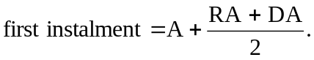
(3) The second instalment is due and payable within 175 days after the date of the assessment notice and is the amount calculated using the formula —
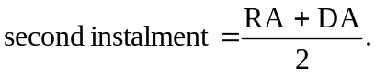
[Regulation 7 amended in Gazette 17 Nov 2009 p. 4633.]

8. Paying assessed amount in 3 instalments (option 3)
(1) A taxpayer may discharge a liability to pay an assessed amount by paying in 3 instalments that, in accordance with the formulas set out in subregulations (2), (3) and (4), include a charge of 2% of (RA + DA).
(2) The first instalment is due and payable within 49 days after the date of the assessment notice and is the amount calculated using the formula —
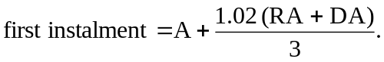
(3) The second instalment is due and payable within 175 days after the date of the assessment notice and is the amount calculated using the formula —
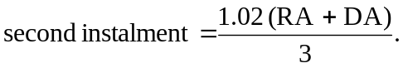
(4) The third instalment is due and payable within 240 days after the date of the assessment notice and is the amount calculated using the formula —
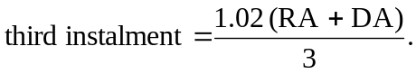
[Regulation 8 amended in Gazette 17 Nov 2009 p. 4633.]

9. Other arrangements for paying assessed amount
(1) If the amount of land tax paid within 49 days after the date of the assessment notice (the amount paid) is —
(a) less than the amount payable under option 1; and
(b) more than the first instalment payable under option 2,
the Commissioner is to deduct the amount paid from the assessed amount, and the remaining amount is due and payable by the taxpayer within 175 days after the date of the assessment notice.
(2) If the amount of land tax paid within 49 days after the date of the assessment notice (the amount paid) is —
(a) less than the first instalment payable under option 2; and
(b) more than the first instalment payable under option 3,
the Commissioner is to deduct the amount paid from the assessed amount, and the remaining amount, plus a charge of 2% of (RA + DA), is to be divided into 2 equal instalments.
(3) The first of those instalments is due and payable by the taxpayer within 175 days after the date of the assessment notice.
(4) The second of those instalments is due and payable by the taxpayer within 240 days after the date of the assessment notice.
[Regulation 9 amended in Gazette 17 Nov 2009 p. 4633-4.]

10A. Incorrect payment of assessed amount
(1) In this regulation —
incorrect payment means a payment to discharge a liability to pay an assessed amount that is not in accordance with regulation 6, 7, 8 or 9 where —
(a) the Commissioner is satisfied that it is clear from the circumstances in which the payment is made that the payment was intended to be an amount or instalment due and payable under regulation 6, 7(2), 8(2) or (3) or 9(3) (the relevant provision); and
(b) the payment was received by the Commissioner within 7 days after the amount or instalment was due and payable under the relevant provision.
(2) If this subregulation applies in respect of an incorrect payment —
(a) the payment —
(i) is to be taken to have been made under the relevant provision; and
(ii) so far as is practicable, the relevant provision applies in respect of the payment;
and
(b) regulations 9(1) and (2) and 11 do not apply in respect of the payment.
(3) Subregulation (2) applies in respect of an incorrect payment —
(a) if the payment is equal to or more than the amount or instalment due under the relevant provision; or
(b) if —
(i) the payment is less than the amount or instalment due under the relevant provision; and
(ii) the amount of the shortfall has been paid by the taxpayer immediately in accordance with subregulation (4).
(4) If an incorrect payment is less than the amount or instalment due under the relevant provision the Commissioner is to deduct the amount of the payment from that amount or instalment and the amount of the shortfall is immediately due and payable by the taxpayer.
[Regulation 10A inserted in Gazette 18 Sep 2015 p. 3814-15.]

10. Instalments to be multiples of 5 cents
(1) Amounts payable as instalments under regulation 7, 8 or 9 are to be multiples of 5 cents.
(2) If the application of subregulation (1) results in unequal instalments being payable that would have been equal instalments if not for the application of that subregulation, the first of those instalments is to be the greater or greatest amount, as the case requires.

11. When full amount of land tax becomes due and payable
If —
(a) the amount of land tax paid within 49 days after the date of the assessment notice is less than the first instalment due and payable under option 3; or
(b) an instalment under these regulations is not paid when it is due and payable,
the full amount of unpaid land tax is immediately due and payable by the taxpayer.

12. Taxable authorities
(1) For the purposes of paragraph (b) of the definition of “taxable authority” in clause 1 of the Glossary at the end of the Land Tax Assessment Act 2002, the bodies to which this subregulation applies are prescribed.
(2) Subregulation (1) applies to the following bodies —
(a) the Electricity Generation and Retail Corporation established by the Electricity Corporations Act 2005 section 4(1)(a);
(aa) the Electricity Networks Corporation established by the Electricity Corporations Act 2005 section 4(1)(b);
[(ab) deleted]
(ac) the Regional Power Corporation established by the Electricity Corporations Act 2005 section 4(1)(d);
(b) the Water Corporation established by the Water Corporations Act 1995 section 4(1);
(ca) the Bunbury Water Corporation established by the Water Corporations Act 1995 section 4(2);
(cb) the Busselton Water Corporation established by the Water Corporations Act 1995 section 4(3);
(c) the Western Australian Land Authority established by the Western Australian Land Authority Act 1992 section 5;
[(d)-(f) deleted]
(g) the Fremantle Port Authority established by the Port Authorities Act 1999 section 4;
(h) the Kimberley Ports Authority established by the Port Authorities Act 1999 section 4;
(i) the Mid West Ports Authority established by the Port Authorities Act 1999 section 4;
(j) the Pilbara Ports Authority established by the Port Authorities Act 1999 section 4;
(k) the Southern Ports Authority established by the Port Authorities Act 1999 section 4;
(l) the Western Australian Land Information Authority established by the Land Information Authority Act 2006 section 5;
(m) the Chemistry Centre (WA) established by the Chemistry Centre (WA) Act 2007 section 4;
(n) the Insurance Commission of Western Australia continued under the Insurance Commission of Western Australia Act 1986 section 4.
[Regulation 12 amended in Gazette 31 Mar 2006 p. 1350-1; 20 Mar 2007 p. 1049; 4 Sep 2007 p. 4522; 30 May 2008 p. 2088; 27 Dec 2013 p. 6478; 30 Jun 2014 p. 2425-6; 19 Sep 2014 p. 3340; 18 Sep 2015 p. 3815.]

13A. Taxable value: prescribed percentage
The percentages prescribed for the purposes of clause 6(4) of the Glossary at the end of the Land Tax Assessment Act 2002 are as follows —
(a) under paragraph (a) — 150% for a financial year;
(b) under paragraph (b) —
(i) 150% for the financial year 2009/10;
(ii) 150% for a financial year after 2009/10.
[Regulation 13A inserted in Gazette 17 Nov 2009 p. 4634.]

13. Inner city area
For the purposes of the Land Tax Assessment Act 2002 section 28(2)(a), the area of the State that corresponds to the shaded area on the plan set out in Schedule 1 is an inner city area.

14. Repeal and savings
(1) The Land Tax Assessment Regulations 1976 are repealed.
(2) Despite subregulation (1) and subject to regulation 2(2)(b), the Land Tax Assessment Regulations 1976 continue to apply to land tax, as defined in the Land Tax Assessment Act 1976 ² section 5(1), that is payable in respect of an assessment year that ends before the day referred to in regulation 2(1).

Schedule 1 — Inner city area
[r. 13]
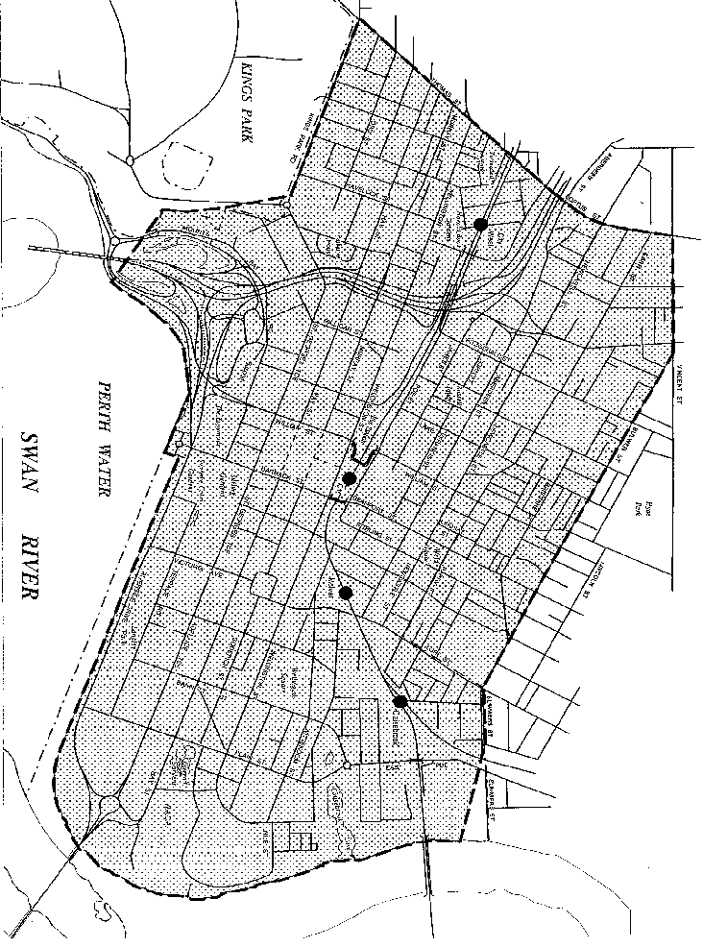

Notes
¹ This reprint is a compilation as at 7 April 2017 of the Land Tax Assessment Regulations 2003 and includes the amendments made by the other written laws referred to in the following table ^{3, 4}. The table also contains information about any reprint.

Compilation table
Citation | Gazettal | Commencement
Land Tax Assessment Regulations 2003 | 27 Jun 2003 p. 2409-14 | 1 Jul 2003 (see r. 2(1) and Gazette 27 Jun 2003 p. 2383)
Electricity Corporations (Consequential Amendments) Regulations 2006 r. 82 | 31 Mar 2006 p. 1299-357 | 1 Apr 2006 (see r. 2)
Land Tax Assessment Amendment Regulations 2007 | 20 Mar 2007 p. 1049 | 20 Mar 2007
Land Tax Assessment Amendment Regulations (No. 2) 2007 | 4 Sep 2007 p. 4521-2 | r. 1 and 2: 4 Sep 2007 (see r. 2(a));  Regulations other than r. 1 and 2: 5 Sep 2007 (see r. 2(b))
Land Tax Assessment Amendment Regulations 2008 | 30 May 2008 p. 2088 | r. 1 and 2: 30 May 2008 (see r. 2(a));  Regulations other than r. 1 and 2: 31 May 2008 (see r. 2(b))
Reprint 1: The Land Tax Assessment Regulations 2003 as at 5 Sep 2008 (includes amendments listed above)
Land Tax Assessment Amendment Regulations 2009 | 17 Nov 2009 p. 4632-4 | r. 7: 1 Jul 2009 (see r. 2(b));  r. 1 and 2: 17 Nov 2009 (see r. 2(a));  Regulations other than r. 1, 2 and 7: 18 Nov 2009 (see r. 2(c))
Electricity Corporations (Consequential Amendments) Regulations 2013 r. 13 | 27 Dec 2013 p. 6469-79 | 1 Jan 2014 (see r. 2(c) and Gazette 27 Dec 2013 p. 6465)
Land Tax Assessment Amendment Regulations 2014 | 30 Jun 2014 p. 2425-6 | r. 1 and 2: 30 Jun 2014 (see r. 2(a));  Regulations other than r. 1 and 2: 1 Jul 2014 (see r. 2(b)(i))
Land Tax Assessment Amendment Regulations (No. 2) 2014 | 19 Sep 2014 p. 3340 | r. 1 and 2: 19 Sep 2014 (see r. 2(a));  Regulations other than r. 1 and 2: 1 Oct 2014 (see r. 2(b)(i))
Land Tax Assessment Amendment Regulations 2015 | 18 Sep 2015 p. 3813-15 | r. 1 and 2: 18 Sep 2015 (see r. 2(a));  Regulations other than r. 1 and 2: 19 Sep 2015 (see r. 2(b))
Reprint 2: The Land Tax Assessment Regulations 2003 as at 7 Apr 2017 (includes amendments listed above)
² Repealed by the Taxation Administration (Consequential Provisions) Act 2002 s. 5(d).
³ Under the Commonwealth Places (Mirror Taxes Administration) Act 1999 s. 7 these regulations are to be read and construed with any modifications referred to in subsection (1) of that section and, in particular, with the modifications set out in the Commonwealth Places (Mirror Taxes Administration) Regulations 2007. Regulations 1-4 and Pt. 3 Div. 3 of those regulations read as follows:

1. Citation
These regulations are the Commonwealth Places (Mirror Taxes Administration) Regulations 2007.
2. Commencement
These regulations come into operation on the day on which the Commonwealth Places (Mirror Taxes) (Modification of Applied Laws (WA)) Notice 2007 comes into operation.
3. When certain modifications have effect
(1) Subject to this regulation, the modifications prescribed in Part 3, Part 5, Part 6 Division 2 and Part 7 have effect on and from 1 July 2003.
(2) The modifications prescribed in Part 4 have effect on and from 9 April 2006 and prevail over the modifications in the Commonwealth Places (Mirror Taxes Administration) Regulations 2002 Part 5 to the extent of any inconsistency.
(3) The modifications prescribed in Part 2 have effect on and from 1 July 2008.
(4) The modification in regulation 29 has effect on and from 25 June 2010.
(5) The modifications in regulation 47 have effect on and from 1 July 2008.
Note for this regulation:
Modifications prescribed for the purposes of section 7(2) of the Act may be expressed to take effect from a date that is earlier than the date on which the modifications are published in the Gazette, see section 7(3) of the Act.
4. Modification of State taxing laws
(1) For the purposes of section 7(2) of the Act, each State taxing law is taken to be modified to the extent necessary to give effect to subregulation (2).
(2) If —
(a) a State taxing law applies, or could apply, to any extent, to or in relation to an event, state of affairs or transaction, and the corresponding applied law also applies, or could apply, to any extent, to or in relation to the same event, state of affairs or transaction; and
(b) a person is required or permitted, or could be required or permitted, to take an action under both the State taxing law and the corresponding applied law in relation to the event, state of affairs or transaction; and
(c) the person has taken the action in accordance with the corresponding applied law; and
(d) the Commissioner of State Revenue has sufficient information about the event, state of affairs or transaction to carry out his or her functions in relation to it under the State taxing law or the corresponding applied law or both, as the case requires,
then —
(e) the person is not required to take the action under the State taxing law; and
(f) the Commissioner may carry out his or her functions in relation to the event, state of affairs or transaction as if the person had taken whatever action is required or permitted under the State taxing law in relation to the event, state of affairs or transaction.
(3) The particular modifications set out in these regulations of certain State taxing laws have effect for the purposes of section 7(2) of the Act.
Note for this regulation:
If a modification is to replace or insert a numbered provision, the new provision is identified by the superscript 1M appearing after the provision number. If a modification is to replace or insert a definition, the new definition is identified by the superscript 1M appearing after the defined term.
Part 3 — Land tax
Division 3 — The Land Tax Assessment Regulations 2003
19. Modification of the Land Tax Assessment Regulations 2003
This Division sets out modifications of the Land Tax Assessment Regulations 2003 in their application as a law of Western Australia.
20. Regulation 3A inserted
After regulation 3 the following regulation is inserted —

3A. Application of regulations in non-Commonwealth places
(1) In this regulation —
applied Land Tax Assessment Regulations means the Land Tax Assessment Regulations 2003 of Western Australia in their application as a law of the Commonwealth in or in relation to Commonwealth places in Western Australia in accordance with the Commonwealth Act.
(2) In these regulations, unless the contrary intention appears —
(a) a reference to these regulations is to be read as a reference to these regulations in their application as a law of Western Australia; and
(b) a reference to the Act is to be read as a reference to the Act in its application as a law of Western Australia; and
(c) a reference to the Land Tax Assessment Act 2002 is to be read as a reference to that Act in its application as a law of Western Australia; and
(d) a reference to the Land Tax Assessment Act 1976 is to be read as a reference to that Act in its application, before 1 July 2003, as a law of Western Australia; and
(e) a reference to the Land Tax Assessment Regulations 1976 is to be read as a reference to those regulations in their application, before 1 July 2003, as a law of Western Australia.
(3) These regulations are to be read with the applied Land Tax Assessment Regulations as a single body of law.

⁴ Under the Commonwealth Places (Mirror Taxes) Act 1998 (Commonwealth) s. 8(2) these regulations are to be read and construed with any modifications referred to in subsection (1) of that section and, in particular, with the modifications set out in the Commonwealth Places (Mirror Taxes) (Modification of Applied Laws (WA)) Notice 2007. Clauses 1-5 and Pt. 3 Div. 3 of that notice read as follows:

1. Citation
This notice is the Commonwealth Places (Mirror Taxes) (Modification of Applied Laws (WA)) Notice 2007.
2. Commencement
This notice comes into operation on the day after the day on which it is registered under the Legislative Instruments Act 2003 of the Commonwealth.
3. When certain modifications have effect
(1) Subject to this regulation, the modifications prescribed in Part 3, Part 5, Part 6 Division 2 and Part 7 have effect on and from 1 July 2003.
(2) The modifications prescribed in Part 4 have effect on and from 9 April 2006 and prevail over the modifications in the Commonwealth Places (Mirror Taxes) (Modification of Applied Laws (WA)) Notice 2002 Part 5 to the extent of any inconsistency.
(3) The modifications prescribed in Part 2 have effect on and from 1 July 2008.
(4) The modification prescribed in clause 30 has effect on and from 25 June 2010.
(5) The modifications prescribed in clause 51 have effect on and from 1 July 2008.
Note: Modifications prescribed in a notice under section 8 of the Act may be expressed to take effect from a date that is earlier than the date on which the modifications are published in the Commonwealth of Australia Gazette, see section 8(5) of the Act.
4. Definitions
In this notice —
applied WA law means the provisions of a State taxing law of Western Australia that apply or are taken to have applied in relation to Commonwealth places in Western Australia in accordance with the Commonwealth Mirror Taxes Act;
Commissioner of State Revenue means the Commissioner of State Revenue of Western Australia appointed in accordance with the Taxation Administration Act 2003 section 6 of Western Australia;
Commonwealth Mirror Taxes Act means the Commonwealth Places (Mirror Taxes) Act 1998 of the Commonwealth.
5. Modification of applied WA laws
(1) For the purposes of the Commonwealth Mirror Taxes Act section 8, each applied WA law is taken to be modified to the extent necessary to give effect to subclause (2).
(2) If —
(a) an applied WA law applies, or could apply, to any extent, to or in relation to an event, state of affairs or transaction, and the corresponding State taxing law also applies, or could apply, to any extent, to or in relation to the same event, state of affairs or transaction; and
(b) a person is required or permitted, or could be required or permitted, to take an action under both the applied WA law and the corresponding State taxing law in relation to the event, state of affairs or transaction; and
(c) the person has taken the action in accordance with the corresponding State taxing law; and
(d) the Commissioner of State Revenue has sufficient information about the event, state of affairs or transaction to carry out his or her functions in relation to it under the applied WA law or the corresponding State taxing law or both, as the case requires,
then —
(e) the person is not required to take the action under the applied WA law; and
(f) the Commissioner may carry out his or her functions in relation to the event, state of affairs or transaction as if the person had taken whatever action is required or permitted under the applied WA law in relation to the event, state of affairs or transaction.
(3) The particular modifications set out in this notice of certain applied WA laws have effect for the purposes of the Commonwealth Mirror Taxes Act section 8.
Note: If a modification is to replace or insert a numbered provision, the new provision is identified by the superscript 1MC appearing after the provision number. If a modification is to replace or insert a definition, the new definition is identified by the superscript 1MC appearing after the defined item.
Part 3 — Land tax
Division 3 — The applied Land Tax Assessment Regulations 2003
20. Modification of the applied Land Tax Assessment Regulations 2003
This Division sets out modifications of the Land Tax Assessment Regulations 2003 of Western Australia in their application as a law of the Commonwealth in or in relation to Commonwealth places in Western Australia.
21. Regulation 3A inserted
After regulation 3 the following regulation is inserted —

3A. Application of regulations in Commonwealth places
(1) In this regulation —
corresponding Land Tax Assessment Regulations means the Land Tax Assessment Regulations 2003 of Western Australia in their application as a law of Western Australia.
(2) In these regulations —
(a) a reference to these regulations is to be read as a reference to these regulations in their application as a law of the Commonwealth in or in relation to Commonwealth places in Western Australia in accordance with the Commonwealth Mirror Taxes Act; and
(b) a reference to the Act or the Land Tax Assessment Act 2002 is to be read as a reference to the Land Tax Assessment Act 2002 of Western Australia in its application as a law of the Commonwealth in or in relation to Commonwealth places in Western Australia in accordance with the Commonwealth Mirror Taxes Act; and
(c) a reference to the Land Tax Assessment Act 1976 is to be read as a reference to that Act in its application, before 1 July 2003, as a law of the Commonwealth in or in relation to Commonwealth places in Western Australia in accordance with the Commonwealth Mirror Taxes Act; and
(d) a reference to the Land Tax Assessment Regulations 1976 is to be read as a reference to those regulations in their application, before 1 July 2003, as a law of the Commonwealth in or in relation to Commonwealth places in Western Australia in accordance with the Commonwealth Mirror Taxes Act.
(3) These regulations are to be read with the corresponding Land Tax Assessment Regulations as a single body of law.
(4) In addition to being modified as prescribed by the Commonwealth Places (Mirror Taxes) (Modification of Applied Laws (WA)) Notice 2007, these regulations are deemed to be further modified to any extent that is necessary or convenient to enable these regulations to operate effectively as a law of the Commonwealth.

Defined terms

[This is a list of terms defined and the provisions where they are defined. The list is not part of the law.]
Defined term Provision(s)
A 3(2)
amount paid 9(1) and (2)
arrears 3(1)
assessed amount 3(1)
DA 3(2)
discountable amount 3(1)
incorrect payment 10A(1)
option 1 3(1)
option 2 3(1)
option 3 3(1)
RA 3(2)
relevant assessment notice 3(1)
relevant provision 10A(1)(a)
residual amount 3(1)

