
Western Australia
Health (Miscellaneous Provisions) Act 1911

Health (Notifications by Midwives) Regulations 1994
Reprint 2: The regulations as at 22 September 2017
Guide for using this reprint
What the reprint includes
Regulations as published
legislative amendments
changes under the
Reprints Act 1984
this reprint
Endnotes, Compilation table, and Table of provisions that have not come into operation
1. Details about the original regulations and legislation that has amended its text are shown in the Compilation table in endnote 1, at the back of the reprint. The table also shows any previous reprint.
2. Transitional, savings, modifying or other provisions identified in the Compilation table may be important. The table may refer to another endnote setting out the text of these provisions in full.
3. A table of provisions that have not come into operation, to be found in endnote 1a if it is needed, lists any provisions of the regulations being reprinted that have not come into operation and any amendments that have not come into operation. The full text is set out in another endnote that is referred to in the table.
Notes amongst text (italicised and within square brackets)
1. If the reprint includes a regulation that was inserted, or has been amended, since the regulations being reprinted were made, editorial notes at the foot of the regulation give some history of how the regulation came to be as it is. If the regulation replaced an earlier regulation, no history of the earlier regulation is given (the full history of the regulations is in the Compilation table).
Notes of this kind may also be at the foot of Schedules or headings.
2. The other kind of editorial note shows something has been —
- removed (because it was repealed or deleted from the law); or
- omitted under the Reprints Act 1984 s. 7(4) (because, although still technically part of the text, it no longer has any effect).
The text of anything removed or omitted can be found in an earlier reprint (if there is one) or one of the written laws identified in the Compilation table.
Reprint numbering and date
1. The reprint number (in the footer of each page of the document) shows how many times the regulations have been reprinted. For example, numbering a reprint as “Reprint 3” would mean that the reprint was the 3rd reprint since the regulations were published. Reprint numbering was implemented as from 1 January 2003.
2. The information in the reprint is current on the date shown as the date as at which the regulations are reprinted. That date is not the date when the reprint was published by the State Law Publisher and it is probably not the date when the most recent amendment had effect.

Reprinted under the Reprints Act 1984 as
at 22 September 2017
Western Australia
Health (Notifications by Midwives) Regulations 1994
Contents
1. Citation 1
3. Notification of private practice as midwife 1
4. Notification of case or delivery attended 1
Schedule
Notes
Compilation table 6

 |  | Reprinted under the Reprints Act 1984 as
 |  | at 22 September 2017
Western Australia
Health (Miscellaneous Provisions) Act 1911
Health (Notifications by Midwives) Regulations 1994

1. Citation
These regulations may be cited as the Health (Notifications by Midwives) Regulations 1994 ¹.

[2. Omitted under the Reprints Act 1984 s. 7(4)(f).]

3. Notification of private practice as midwife
A midwife is not to enter into private practice as a midwife unless he or she has notified the Chief Health Officer of his or her intention to do so in the form of Form 1 in the Schedule.
[Regulation 3 amended in Gazette 10 Jan 2017 p. 270.]

4. Notification of case or delivery attended
For the purposes of —
(a) section 335(1) of the Act, the report required to be furnished of a case attended by a midwife, whether of living, premature or full term birth, or stillbirth, or abortion; and
(b) section 335(5)(b) of the Act, the notice required to be furnished of a delivery attended by a midwife,
is to be in the form of Form 2 in the Schedule.
[Regulation 4 amended in Gazette 14 Dec 2012 p. 6200.]

Schedule
Form 1
[r. 3]
HEALTH (MISCELLANEOUS PROVISIONS) ACT 1911
HEALTH (NOTIFICATIONS BY MIDWIVES) REGULATIONS 1994
NOTIFICATION OF INTENTION TO ENTER INTO PRIVATE PRACTICE AS A MIDWIFE
CHIEF HEALTH OFFICER
I intend to enter into private practice as a midwife on ____/____/____
PERSONAL PARTICULARS
Full Name: ______________________________________________________
Date of Birth: ______/______/______
Telephone Numbers (*Business or *Private):
(Tel) ____________ (Mob) ____________
Address (*Business or *Private): _____________________________________
_____________________________
Suburb: _________________ Postcode: ____________
Australian Health Practitioner Regulation Agency Midwifery Registration Number: NMW________________________
Professional Indemnity Insurance Provider: _____________________________
Signature: ___________________
Date: ____/____/____
* Delete if not applicable
[Form 1 inserted in Gazette 14 Dec 2012 p. 6200; amended in Gazette 10 Jan 2017 p. 270.]
Form 2
[r. 4]
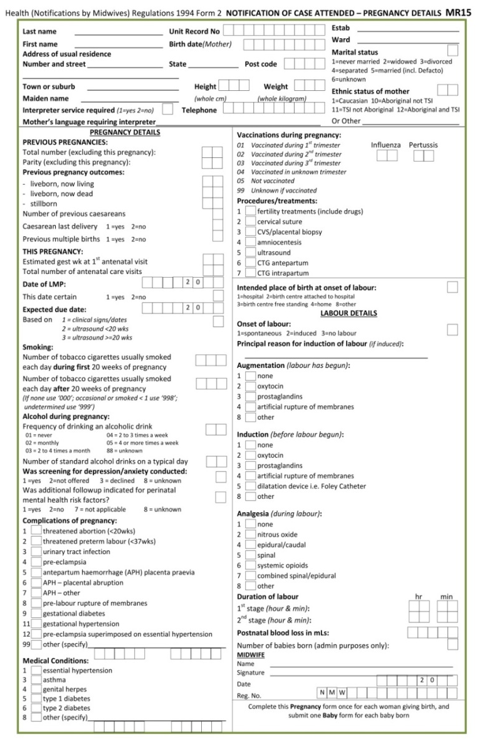
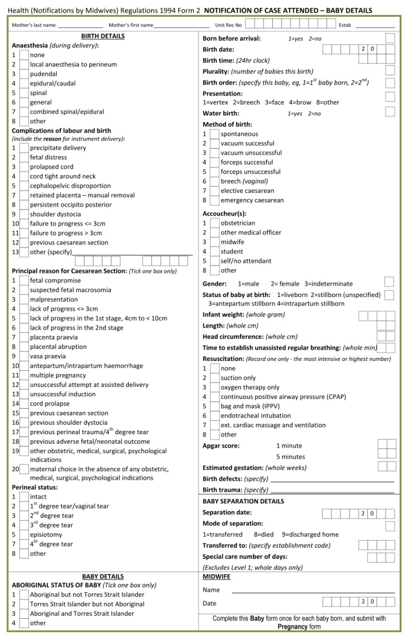
[Form 2 inserted in Gazette 16 May 2017 p. 2490-1.]

Notes
¹ This reprint is a compilation as at 22 September 2017 of the Health (Notifications by Midwives) Regulations 1994 and includes the amendments made by the other written laws referred to in the following table. The table also contains information about any reprint.

Compilation table
Citation | Gazettal | Commencement
Health (Notifications by Midwives) Regulations 1994 | 28 Jan 1994 p. 283-5 | 28 Jan 1994
Reprint 1: The Health (Notifications by Midwives) Regulations 1994 as at 11 Jun 2004
Health (Notifications by Midwives) Amendment Regulations 2011 | 1 Apr 2011 p. 1178 | r. 1 and 2: 1 Apr 2011 (see r. 2(a));  Regulations other than r. 1 and 2: 2 Apr 2011 (see r. 2(b))
Health (Notifications by Midwives) Amendment Regulations (No. 2) 2011 | 30 Dec 2011 p. 5577-8 | r. 1 and 2: 30 Dec 2011 (see r. 2(a));  Regulations other than r. 1 and 2: 31 Dec 2011 (see r. 2(b))
Health (Notifications by Midwives) Amendment Regulations 2012 | 14 Dec 2012 p. 6199-201 | r. 1 and 2: 14 Dec 2012 (see r. 2(a));  Regulations other than r. 1 and 2: 1 Jan 2013 (see r. 2(b))
Health (Notifications by Midwives) Amendment Regulations 2014 | 24 Apr 2014 p. 1143-5 | r. 1 and 2: 24 Apr 2014 (see r. 2(a));  Regulations other than r. 1 and 2: 1 Jul 2014 (see r. 2(b))
Health (Notifications by Midwives) Amendment Regulations 2016 | 3 May 2016 p. 1356-8 | r. 1 and 2: 3 May 2016 (see r. 2(a));  Regulations other than r. 1 and 2: 1 Jul 2016 (see r. 2(b))
Health Regulations Amendment (Public Health) Regulations 2016 Pt. 17 | 10 Jan 2017 p. 237-308 | 24 Jan 2017 (see r. 2(b) and Gazette 10 Jan 2017 p. 165)
Health (Notifications by Midwives) Amendment Regulations 2017 | 16 May 2017 p. 2489-91 | r. 1 and 2: 16 May 2017 (see r. 2(a));  Regulations other than r. 1 and 2: 1 Jul 2017 (see r. 2(b))
Reprint 2: The Health (Notifications by Midwives) Regulations 1994 as at 22 Sep 2017 (includes amendments listed above)

By Authority: KEVIN J. McRAE, Government Printer

