
Western Australia
Western Australian Products Symbol Act 1972

Products Symbol Regulations 1980

Western Australia
Products Symbol Regulations 1980
Contents
1. Citation 1
2. Interpretation 1
3. Certificate of appointment 1
Schedule
Notes
Compilation table 3
Defined terms

Western Australia
Western Australian Products Symbol Act 1972
Products Symbol Regulations 1980

1. Citation
These regulations may be cited as the Products Symbol Regulations 1980 ¹.

2. Interpretation
In these regulations unless the contrary intention appears —
the Act means the Western Australian Products Symbol Act 1972.

3. Certificate of appointment
(1) Every person appointed to be an inspector under section 7 of the Act shall be furnished with a certificate evidencing his appointment, in the form of Form 1 in the Schedule to these regulations.
(2) The certificate referred to in subregulation (1) shall carry a photograph of the appointee and be signed by the appointee and the Minister.

Schedule
Form 1


Western Australian Products Symbol Act 1972
CERTIFICATE OF APPOINTMENT
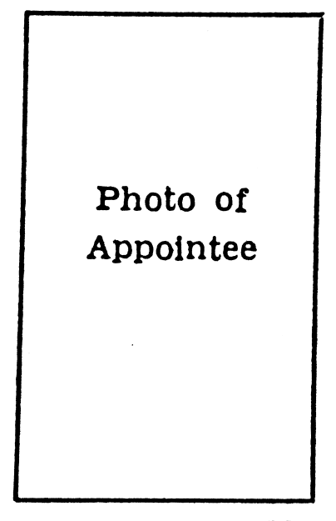 | This is to certify that ……………………………  the holder of this Certificate of Appointment is appointed as an Inspector pursuant to section 7 of the Western Australian Products Symbol Act 1972, and is authorised to carry out the requirements of the Act within Western Australia.  …………………………………..  Signature of Appointee.  ………………………………….  Signature, Minister for Industrial  Development and Commerce ².

Notes
¹ This is a compilation of the Products Symbol Regulations 1980. There have been no amendments to the regulations.

Compilation table
Citation | Gazettal | Commencement
Products Symbol Regulations 1980 | 4 Jul 1980 p. 2257 | 4 Jul 1980
² The designation of Ministers may be altered by the Governor under the Alteration of Statutory Designations Act 1974. At the time of this reprint the former Minister for Industrial Development and Commerce is known as the Minister for Commerce and Trade.

Defined terms

[This is a list of terms defined and the provisions where they are defined. The list is not part of the law.]
Defined term Provision(s)
the Act 2

