Western Australia
Retail Trading Hours (Tourism Precincts and Holiday Resorts) Regulations 2007

Western Australia
Retail Trading Hours (Tourism Precincts and Holiday Resorts) Regulations 2007
CONTENTS
-1. Citation 1
2. Commencement 1
3. Fremantle tourism precinct prescribed 1
4. Perth tourism precinct prescribed 1
5. Holiday resorts prescribed 2
Schedule 1 — Tourism precincts
Division 1 — Fremantle tourism precinct
Division 2 — General Perth tourism precinct
Schedule 2 — Holiday resorts
Division 1 — Rockingham holiday resort
Division 2 — Rottnest Island holiday resort
Division 3 — Wanneroo holiday resort
Notes
Compilation table 6

Western Australia
Retail Trading Hours Act 1987
Retail Trading Hours (Tourism Precincts and Holiday Resorts) Regulations 2007

1. Citation
These regulations are the Retail Trading Hours (Tourism Precincts and Holiday Resorts) Regulations 2007.

2. Commencement
These regulations come into operation on the day on which the Retail Shops and Fair Trading Legislation Amendment Act 2006* section 9 comes into operation.
[* Act No. 47 of 2006.]

3. Fremantle tourism precinct prescribed
The area of the State described in Schedule 1 Division 1 is prescribed as falling within the Fremantle tourism precinct for the purpose of section 12A(4) of the Act.

4. Perth tourism precinct prescribed
(1) The area of the State described in Schedule 1 Division 2 is prescribed as falling within the Perth tourism precinct for the purpose of section 12A(4) of the Act.
(2) The following specific areas of the State are prescribed as falling within the Perth tourism precinct for the purpose of section 12A(4) of the Act —
(a) the retail complex known as “City West” (located at the corner of Sunderland Street and Railway Road, West Perth);
(b) the retail complex known as “Harbour Town” (located at 840 Wellington Street, West Perth);
(c) the area south of, and adjacent to the shaded area in clause 1 bounded by the Mitchell Freeway along to the Narrows bridge, encompassing the foreshore, Busport, Convention Centre and other retail shops within that area.

5. Holiday resorts prescribed
(1) The area of the State described in Schedule 2 Division 1 is prescribed as the Rockingham holiday resort for the purpose of section 12A(4) of the Act.
(2) The area of the State described in Schedule 2 Division 2 is prescribed as the Rottnest Island holiday resort for the purpose of section 12A(4) of the Act.
(3) The area of the State described in Schedule 2 Division 3 is prescribed as the Wanneroo holiday resort for the purpose of section 12A(4) of the Act.

Schedule 1 — Tourism precincts
[r. 3 & 4]

Division 1 — Fremantle tourism precinct
The portion of the State delineated in black and bordered red on “Department of Land Administration Miscellaneous Diagram No. 504” held by the Western Australian Land Information Authority (a representation of which is reproduced below and shaded grey).
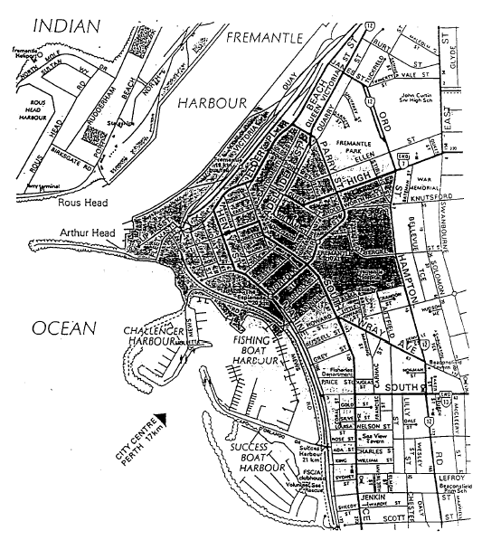

Division 2 — General Perth tourism precinct
The portion of the State delineated in black and bordered red on “Department of Land Administration Miscellaneous Diagram No. 599” held by the Western Australian Land Information Authority (a representation of which is reproduced below and shaded grey).
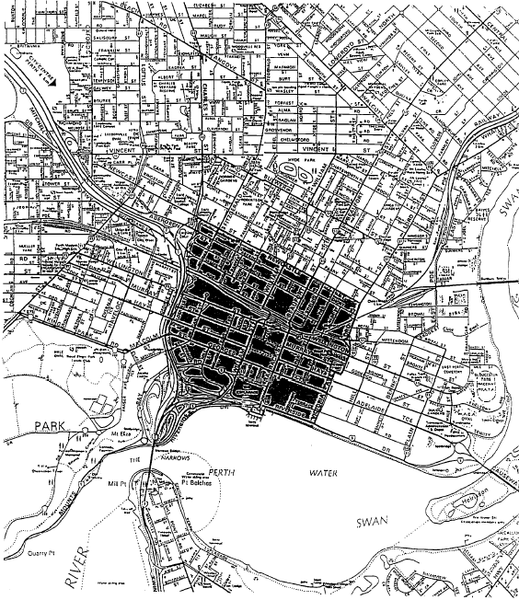

Schedule 2 — Holiday resorts
[r. 5]

Division 1 — Rockingham holiday resort
City of Rockingham.

Division 2 — Rottnest Island holiday resort
Rottnest Island.

Division 3 — Wanneroo holiday resort
Localities of Two Rocks and Yanchep.

Notes
¹ This is a compilation of the Retail Trading Hours (Tourism Precincts and Holiday Resorts) Regulations 2007. The following table contains information about those regulations.

Compilation table
Citation | Gazettal | Commencement
Retail Trading Hours (Tourism Precincts and Holiday Resorts) Regulations 2007 | 11 May 2007 p. 2019-25 | 11 May 2007 (see r. 2 and Gazette 11 May 2007 p. 2017)

