
Western Australia
Land Tax Assessment Act 2002
Taxation Administration Act 2003

Land Tax Assessment Regulations 2003

Western Australia
Land Tax Assessment Regulations 2003
Contents
1. Citation 1
2. Commencement and application 1
3. Terms and abbreviations used 1
4. Tax payment arrangements not affected 3
5. Taxpayer’s options in discharging liability to pay assessed amount 3
6. Paying assessed amount in one discounted payment (option 1) 3
7. Paying assessed amount in 2 instalments (option 2) 3
8. Paying assessed amount in 3 instalments (option 3) 4
9. Other arrangements for paying assessed amount 5
10A. Incorrect payment of assessed amount 6
10. Instalments to be multiples of 5 cents 7
11. When full amount of land tax becomes due and payable 7
12. Taxable authorities 7
12AA. Circumstances in which subdivision does not cause parent lot to cease being a lot 9
12A. Taxable value: prescribed percentage 9
13. Inner city area 9
13A. Land used for production-based agistment is used for primary production (s. 30A(1)(e)) 10
14. Repeal and savings 11
Schedule 1 — Inner city area
Notes
Compilation table 13
Other notes 14
Defined terms

Western Australia
Land Tax Assessment Act 2002
Taxation Administration Act 2003
Land Tax Assessment Regulations 2003

1. Citation
These regulations may be cited as the Land Tax Assessment Regulations 2003.

2. Commencement and application
(1) These regulations come into operation on the day on which the Taxation Administration Act 2003 comes into operation.
(2) These regulations apply —
(a) to land tax that is assessed for an assessment year that ends after the day referred to in subregulation (1); and
(b) for the purposes of paragraph (a) of the definition of “arrears” in regulation 3(1) — to land tax, as defined in the Land Tax Assessment Act 1976 ¹ section 5(1), that is payable in respect of an assessment year that ends before that day.

3. Terms and abbreviations used
(1) In these regulations —
arrears means the sum, as at the date an assessment notice (the relevant assessment notice) is issued, of —
(a) any land tax that is due and payable and shown on an assessment notice issued in an assessment year before the assessment year in which the relevant assessment notice is issued; and
(b) any penalty tax under the Taxation Administration Act 2003 section 26 or 27 that is due and payable in relation to land tax; and
(c) any interest under the Taxation Administration Act 2003 section 47 that is due and payable in relation to land tax; and
(d) any legal costs or costs, as referred to in the Taxation Administration Act 2003 section 62(a), (b) or (ba), that are incurred by the Commissioner and due and payable in relation to land tax; and
(e) any charge due and payable under regulation 8 or 9;
assessed amount means the total amount of land tax and arrears due and payable and shown on an assessment notice;
discountable amount means the amount of land tax (not including arrears) due and payable and shown on an assessment notice (the relevant assessment notice) but not shown on an assessment notice issued in an assessment year before the assessment year in which the relevant assessment notice is issued;
option 1 means the option for discharging a liability to pay an assessed amount set out in regulation 6;
option 2 means the option for discharging a liability to pay an assessed amount set out in regulation 7;
option 3 means the option for discharging a liability to pay an assessed amount set out in regulation 8;
residual amount means the assessed amount less —
(a) arrears; and
(b) the discountable amount.
(2) In these regulations, the following abbreviations are used —
A for arrears;
DA for discountable amount;
RA for residual amount.
[Regulation 3 amended: Gazette 13 Aug 2019 p. 3041.]

[3A.^{1M} Modification, to insert regulation 3A, to have effect under the Commonwealth Places (Mirror Taxes Administration) Act 1999 s. 7, see Commonwealth Places (Mirror Taxes Administration) Regulations 2007 r. 20 and endnote 1M.]

[3A.^{1MC} Modification, to insert regulation 3A, to have effect under the Commonwealth Places (Mirror Taxes) Act 1998 (Commonwealth) s. 8, see Commonwealth Places (Mirror Taxes) (Modification of Applied Laws (WA)) Notice 2007 cl. 21 and endnote 1MC.]

4. Tax payment arrangements not affected
Nothing in these regulations affects the payment of land tax under a tax payment arrangement.

5. Taxpayer’s options in discharging liability to pay assessed amount
A taxpayer may discharge a liability to pay an assessed amount by paying in accordance with regulation 6, 7, 8 or 9.

6. Paying assessed amount in one discounted payment (option 1)
A taxpayer may discharge a liability to pay an assessed amount by making one payment of the amount, due and payable within 49 days after the date of the assessment notice, calculated using the formula —

7. Paying assessed amount in 2 instalments (option 2)
(1) A taxpayer may discharge a liability to pay an assessed amount by paying in 2 instalments.
(2) The first instalment is due and payable within 49 days after the date of the assessment notice and is the amount calculated using the formula —
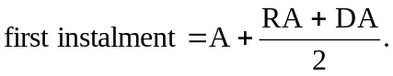
(3) The second instalment is due and payable within 175 days after the date of the assessment notice and is the amount calculated using the formula —
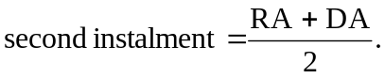
[Regulation 7 amended: Gazette 17 Nov 2009 p. 4633.]

8. Paying assessed amount in 3 instalments (option 3)
(1) A taxpayer may discharge a liability to pay an assessed amount by paying in 3 instalments that, in accordance with the formulas set out in subregulations (2), (3) and (4), include a charge of 2% of (RA + DA).
(2) The first instalment is due and payable within 49 days after the date of the assessment notice and is the amount calculated using the formula —
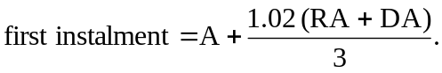
(3) The second instalment is due and payable within 175 days after the date of the assessment notice and is the amount calculated using the formula —
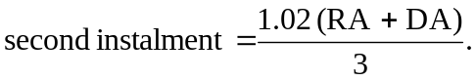
(4) The third instalment is due and payable within 240 days after the date of the assessment notice and is the amount calculated using the formula —
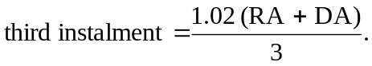
[Regulation 8 amended: Gazette 17 Nov 2009 p. 4633.]

9. Other arrangements for paying assessed amount
(1) If the amount of land tax paid within 49 days after the date of the assessment notice (the amount paid) is —
(a) less than the amount payable under option 1; and
(b) more than the first instalment payable under option 2,
the Commissioner is to deduct the amount paid from the assessed amount, and the remaining amount is due and payable by the taxpayer within 175 days after the date of the assessment notice.
(2) If the amount of land tax paid within 49 days after the date of the assessment notice (the amount paid) is —
(a) less than the first instalment payable under option 2; and
(b) more than the first instalment payable under option 3,
the Commissioner is to deduct the amount paid from the assessed amount, and the remaining amount, plus a charge of 2% of (RA + DA), is to be divided into 2 equal instalments.
(3) The first of those instalments is due and payable by the taxpayer within 175 days after the date of the assessment notice.
(4) The second of those instalments is due and payable by the taxpayer within 240 days after the date of the assessment notice.
[Regulation 9 amended: Gazette 17 Nov 2009 p. 4633-4.]

10A. Incorrect payment of assessed amount
(1) In this regulation —
incorrect payment means a payment to discharge a liability to pay an assessed amount that is not in accordance with regulation 6, 7, 8 or 9 where —
(a) the Commissioner is satisfied that it is clear from the circumstances in which the payment is made that the payment was intended to be an amount or instalment due and payable under regulation 6, 7(2), 8(2) or (3) or 9(3) (the relevant provision); and
(b) the payment was received by the Commissioner within 7 days after the amount or instalment was due and payable under the relevant provision.
(2) If this subregulation applies in respect of an incorrect payment —
(a) the payment —
(i) is to be taken to have been made under the relevant provision; and
(ii) so far as is practicable, the relevant provision applies in respect of the payment;
and
(b) regulations 9(1) and (2) and 11 do not apply in respect of the payment.
(3) Subregulation (2) applies in respect of an incorrect payment —
(a) if the payment is equal to or more than the amount or instalment due under the relevant provision; or
(b) if —
(i) the payment is less than the amount or instalment due under the relevant provision; and
(ii) the amount of the shortfall has been paid by the taxpayer immediately in accordance with subregulation (4).
(4) If an incorrect payment is less than the amount or instalment due under the relevant provision the Commissioner is to deduct the amount of the payment from that amount or instalment and the amount of the shortfall is immediately due and payable by the taxpayer.
[Regulation 10A inserted: Gazette 18 Sep 2015 p. 3814-15.]

10. Instalments to be multiples of 5 cents
(1) Amounts payable as instalments under regulation 7, 8 or 9 are to be multiples of 5 cents.
(2) If the application of subregulation (1) results in unequal instalments being payable that would have been equal instalments if not for the application of that subregulation, the first of those instalments is to be the greater or greatest amount, as the case requires.

11. When full amount of land tax becomes due and payable
If —
(a) the amount of land tax paid within 49 days after the date of the assessment notice is less than the first instalment due and payable under option 3; or
(b) an instalment under these regulations is not paid when it is due and payable,
the full amount of unpaid land tax is immediately due and payable by the taxpayer.

12. Taxable authorities
(1) For the purposes of paragraph (b) of the definition of “taxable authority” in clause 1 of the Glossary at the end of the Land Tax Assessment Act 2002, the bodies to which this subregulation applies are prescribed.
(2) Subregulation (1) applies to the following bodies —
(a) the Electricity Generation and Retail Corporation established by the Electricity Corporations Act 2005 section 4(1)(a);
(aa) the Electricity Networks Corporation established by the Electricity Corporations Act 2005 section 4(1)(b);
[(ab) deleted]
(ac) the Regional Power Corporation established by the Electricity Corporations Act 2005 section 4(1)(d);
(b) the Water Corporation established by the Water Corporations Act 1995 section 4(1);
(ca) the Bunbury Water Corporation established by the Water Corporations Act 1995 section 4(2);
(cb) the Busselton Water Corporation established by the Water Corporations Act 1995 section 4(3);
(c) the Western Australian Land Authority established by the Western Australian Land Authority Act 1992 section 5;
[(d)-(f) deleted]
(g) the Fremantle Port Authority established by the Port Authorities Act 1999 section 4;
(h) the Kimberley Ports Authority established by the Port Authorities Act 1999 section 4;
(i) the Mid West Ports Authority established by the Port Authorities Act 1999 section 4;
(j) the Pilbara Ports Authority established by the Port Authorities Act 1999 section 4;
(k) the Southern Ports Authority established by the Port Authorities Act 1999 section 4;
(l) the Western Australian Land Information Authority established by the Land Information Authority Act 2006 section 5;
(m) the Chemistry Centre (WA) established by the Chemistry Centre (WA) Act 2007 section 4;
(n) the Insurance Commission of Western Australia continued under the Insurance Commission of Western Australia Act 1986 section 4.
[Regulation 12 amended: Gazette 31 Mar 2006 p. 1350-1; 20 Mar 2007 p. 1049; 4 Sep 2007 p. 4522; 30 May 2008 p. 2088; 27 Dec 2013 p. 6478; 30 Jun 2014 p. 2425-6; 19 Sep 2014 p. 3340; 18 Sep 2015 p. 3815.]

12AA. Circumstances in which subdivision does not cause parent lot to cease being a lot
For the purposes of the Land Tax Assessment Act 2002 Glossary clause 2(2B), clause 2(2) of that Glossary does not apply to a subdivision of land that is the subject of a leasehold scheme to be registered under the Strata Titles Act 1985.
[Regulation 12AA inserted: Gazette 13 Aug 2019 p. 3042.]

12A. Taxable value: prescribed percentage
The percentages prescribed for the purposes of clause 6(4) of the Glossary at the end of the Land Tax Assessment Act 2002 are as follows —
(a) under paragraph (a) — 150% for a financial year;
(b) under paragraph (b) —
(i) 150% for the financial year 2009/10;
(ii) 150% for a financial year after 2009/10.
[Regulation 12A inserted as regulation 13A: Gazette 17 Nov 2009 p. 4634; renumbered as 12A: Gazette 12 Jun 2018 p. 1898.]

13. Inner city area
For the purposes of the Land Tax Assessment Act 2002 section 28(2)(a), the area of the State that corresponds to the shaded area on the plan set out in Schedule 1 is an inner city area.

13A. Land used for production-based agistment is used for primary production (s. 30A(1)(e))
(1) In this regulation —
section means a section of the Land Tax Assessment Act 2002.
(2) Land used for production-based agistment is prescribed for the purposes of section 30A(1).
(3) Land is used for production-based agistment if —
(a) the land is used for the purpose of rearing living creatures in accordance with an agistment arrangement provided for in a contract, or agreement, that is in writing; and
(b) the agistment arrangement provided for in the contract or agreement is limited to agistment of the living creatures for a purpose referred to in section 30A(1)(b)(ii) or (iii); and
(c) the contract or agreement is made between —
(i) a person who may lawfully use the land for the purpose referred to in paragraph (a); and
(ii) a person to whom subparagraph (i) does not apply who owns the living creatures.
(4) This regulation applies to the assessment year that began on 1 July 2014 and each subsequent assessment year.
[Regulation 13A inserted: Gazette 12 Jun 2018 p. 1898-9; amended: Gazette 13 Aug 2019 p. 3042.]

14. Repeal and savings
(1) The Land Tax Assessment Regulations 1976 are repealed.
(2) Despite subregulation (1) and subject to regulation 2(2)(b), the Land Tax Assessment Regulations 1976 continue to apply to land tax, as defined in the Land Tax Assessment Act 1976 ¹ section 5(1), that is payable in respect of an assessment year that ends before the day referred to in regulation 2(1).

Schedule 1 — Inner city area
[r. 13]
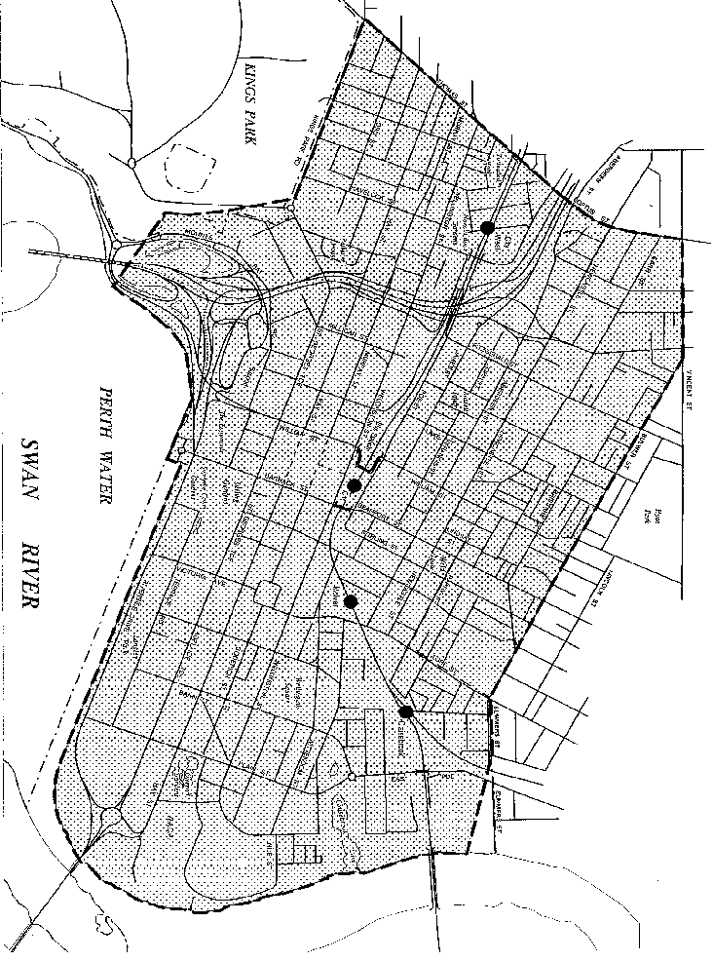

Notes
This is a compilation of the Land Tax Assessment Regulations 2003 and includes amendments made by other written laws. For provisions that have come into operation, and for information about any reprints, see the compilation table.

Compilation table
Citation | Published | Commencement
Land Tax Assessment Regulations 2003 | 27 Jun 2003 p. 2409-14 | 1 Jul 2003 (see r. 2(1) and Gazette 27 Jun 2003 p. 2383)
Electricity Corporations (Consequential Amendments) Regulations 2006 r. 82 | 31 Mar 2006 p. 1299-357 | 1 Apr 2006 (see r. 2)
Land Tax Assessment Amendment Regulations 2007 | 20 Mar 2007 p. 1049 | 20 Mar 2007
Land Tax Assessment Amendment Regulations (No. 2) 2007 | 4 Sep 2007 p. 4521-2 | r. 1 and 2: 4 Sep 2007 (see r. 2(a));  Regulations other than r. 1 and 2: 5 Sep 2007 (see r. 2(b))
Land Tax Assessment Amendment Regulations 2008 | 30 May 2008 p. 2088 | r. 1 and 2: 30 May 2008 (see r. 2(a));  Regulations other than r. 1 and 2: 31 May 2008 (see r. 2(b))
Reprint 1: The Land Tax Assessment Regulations 2003 as at 5 Sep 2008 (includes amendments listed above)
Land Tax Assessment Amendment Regulations 2009 | 17 Nov 2009 p. 4632-4 | r. 7: 1 Jul 2009 (see r. 2(b));  r. 1 and 2: 17 Nov 2009 (see r. 2(a));  Regulations other than r. 1, 2 and 7: 18 Nov 2009 (see r. 2(c))
Electricity Corporations (Consequential Amendments) Regulations 2013 r. 13 | 27 Dec 2013 p. 6469-79 | 1 Jan 2014 (see r. 2(c) and Gazette 27 Dec 2013 p. 6465)
Land Tax Assessment Amendment Regulations 2014 | 30 Jun 2014 p. 2425-6 | r. 1 and 2: 30 Jun 2014 (see r. 2(a));  Regulations other than r. 1 and 2: 1 Jul 2014 (see r. 2(b)(i))
Land Tax Assessment Amendment Regulations (No. 2) 2014 | 19 Sep 2014 p. 3340 | r. 1 and 2: 19 Sep 2014 (see r. 2(a));  Regulations other than r. 1 and 2: 1 Oct 2014 (see r. 2(b)(i))
Land Tax Assessment Amendment Regulations 2015 | 18 Sep 2015 p. 3813-15 | r. 1 and 2: 18 Sep 2015 (see r. 2(a));  Regulations other than r. 1 and 2: 19 Sep 2015 (see r. 2(b))
Reprint 2: The Land Tax Assessment Regulations 2003 as at 7 Apr 2017 (includes amendments listed above)
Land Tax Assessment Amendment Regulations 2018 | 12 Jun 2018 p. 1898-9 | r. 1 and 2: 12 Jun 2018 (see r. 2(a));  Regulations other than r. 1 and 2: 13 Jun 2018 (see r. 2(b))
Finance Regulations Amendment Regulations 2019 Pt. 2 | 13 Aug 2019 p. 3041-3 | Pt. 2 (other than r. 5): 14 Aug 2019 (see r. 2(c));  r. 5: 1 May 2020 (see r. 2(b) and SL 2020/39 cl. 2)

Other notes
^{1M} Under the Commonwealth Places (Mirror Taxes Administration) Act 1999 s. 7, modifications to State taxing laws may be prescribed. Modifications are prescribed in the Commonwealth Places (Mirror Taxes Administration) Regulations 2007 Pt. 3 Div. 3.
If a modification is to:
- replace or insert a numbered provision, the new provision is identified by the superscript 1M appearing after the provision number;
- amend a numbered provision, the amended provision is identified by the superscript 1M appearing after the provision number.
^{1MC} Under the Commonwealth Places (Mirror Taxes) Act 1998 (Commonwealth) s. 8, modifications to State taxing laws, in their application as Commonwealth laws in Commonwealth places in Western Australia, may be prescribed. Modifications are prescribed in the Commonwealth Places (Mirror Taxes) (Modifications of Applied Laws (WA)) Notice 2007 (Commonwealth) Pt. 3 Div. 3.
If a modification is to:
- replace or insert a numbered provision, the new provision is identified by the superscript 1MC appearing after the provision number;
- amend a numbered provision, the amended provision is identified by the superscript 1MC appearing after the provision number.
¹ Repealed by the Taxation Administration (Consequential Provisions) Act 2002 s. 5(d).

Defined terms

[This is a list of terms defined and the provisions where they are defined. The list is not part of the law.]
Defined term Provision(s)
A 3(2)
amount paid 9(1) and (2)
arrears 3(1)
assessed amount 3(1)
DA 3(2)
discountable amount 3(1)
incorrect payment 10A(1)
option 1 3(1)
option 2 3(1)
option 3 3(1)
RA 3(2)
relevant assessment notice 3(1)
relevant provision 10A(1)(a)
residual amount 3(1)

