
Western Australia

Misuse of Drugs Amendment Act 2023

Western Australia
Misuse of Drugs Amendment Act 2023
Contents
Part 1 — Preliminary
1. Short title 2
2. Commencement 2
3. Act amended 2
Part 2 — Amendments commencing on day after Royal Assent
4. Section 3 amended 3
5. Section 20A amended 4
6. Part 4B inserted 4
Part 4B — Border Search Areas
Division 1 — Preliminary
20M. Terms used 4
20N. Border Search Area (BSA) 4
Division 2 — Ancillary provisions in relation to exercising powers in Division 3
20O. Other written laws 7
20P. Assistance when exercising powers under Division 3 7
20Q. Use of force 7
Division 3 — Powers of authorised officers in public place in BSA
20R. Authorised officers and BSA authorisations 8
20S. Exercise of powers under Division 9
20T. Powers of authorised officers in relation to persons 9
20U. Powers of authorised officers in relation to vehicles 10
Division 4 — Offences
20V. Application of section 29 to exercise of powers conferred by or under this Part 12
20W. Failure to comply with requirement of authorised officer 12
Division 5 — Reporting, oversight and review
20X. Commissioner’s reports 12
20Y. Annual report by Corruption and Crime Commission 13
20Z. Inspection of records by Corruption and Crime Commission 14
20ZA. Review of Part 16
7. Section 23 amended 16
8. Section 34 amended 17
9. Section 42 amended 17
10. Schedule 6A inserted 18
Schedule 6A — Border Search Areas
Division 1 — Descriptions of BSAs
Division 2 — Plans of BSAs
1. Broome Port 42
2. Broome Airport 42
3. Port of Port Hedland 44
4. Port Hedland International Airport 45
5. Port of Dampier 45
6. Port of Ashburton (Onslow) 46
7. Port of Geraldton 47
8. Perth Airport 48
9. Fremantle Port (Inner Harbour) 49
10. Fremantle Port (Outer Harbour) 51
11. Jandakot Airport 55
12. Wyndham Port 55
13. Bunbury Port 56
14. Busselton Airport 57
15. Albany Port 58
16. Esperance Port 58
17. Eyre Highway, Eucla (WA/SA border) 59
18. Victoria Highway near Kununurra (WA/NT border) 60
19. Tanami Road (WA/NT border) 60
20. Duncan Road (WA/NT border) 61
21. Great Central Road (WA/NT border) 61
22. Rawlinna Rail Siding 62
Part 3 — Amendments commencing 5 years after Royal Assent
11. Section 3 amended 63
12. Section 20A amended 63
13. Part 4B deleted 64
14. Section 23 amended 64
15. Section 34 amended 64
16. Section 42 amended 64
17. Schedule 6A deleted 64

Western Australia
Misuse of Drugs Amendment Act 2023
No. 16 of 2023
An Act to amend the Misuse of Drugs Act 1981.
[Assented to 26 June 2023]
The Parliament of Western Australia enacts as follows:

Part 1 — Preliminary

1. Short title
This is the Misuse of Drugs Amendment Act 2023.

2. Commencement
This Act comes into operation as follows —
(a) Part 1 — on the day on which this Act receives the Royal Assent (assent day);
(b) Part 2 — on the day after assent day;
(c) the rest of the Act — on the day after the period of 5 years beginning on the day after assent day.

3. Act amended
This Act amends the Misuse of Drugs Act 1981.

Part 2 — Amendments commencing on day after Royal Assent

4. Section 3 amended
In section 3(1) insert in alphabetical order:

Border Search Area (BSA) has the meaning given in section 20N(1);
controlled precursor means a category 1 item or a category 2 item;
drug detection device means an electronic device, or a system that uses or involves an electronic device, of a type approved by the Commissioner for the purpose of detecting the presence of any of the following —
(a) a prohibited drug;
(b) a prohibited plant;
(c) a controlled precursor;
drug detection dog means a dog trained to detect the presence of any of the following —
(a) a prohibited drug;
(b) a prohibited plant;
(c) a controlled precursor;
preliminary drug detection test means —
(a) leading or otherwise placing a drug detection dog in the vicinity of a person or property; or
(b) using a drug detection device in relation to a person or property;

5. Section 20A amended
In section 20A delete the definitions of:
controlled precursor
drug detection device
drug detection dog
preliminary drug detection test

6. Part 4B inserted
After section 20L insert:

Part 4B — Border Search Areas
Division 1 — Preliminary
20M. Terms used
In this Part —
authorised officer has the meaning given in section 20R(1);
Corruption and Crime Commission means the Corruption and Crime Commission established under the Corruption, Crime and Misconduct Act 2003;
public place has the meaning given in the Criminal Investigation Act 2006 section 3(1).
20N. Border Search Area (BSA)
(1) For the purposes of this Act, a Border Search Area (BSA) is an area —
(a) described in Schedule 6A Division 1; and
(b) shown for information purposes in a plan in Schedule 6A Division 2.
(2) The power in section 42(1A)(a) cannot be exercised in relation to Schedule 6A to modify a BSA except on the recommendation of the Minister.
(3) The Minister cannot make the recommendation under subsection (2) unless —
(a) the Minister has the approval of the Attorney General to make the recommendation; and
(b) the Minister is satisfied of the matters referred to in subsection (4).
(4) The Minister must be satisfied that —
(a) the modification is necessary for the ongoing effectiveness of the BSA in reducing the transport into the State of any of the following —
(i) a prohibited drug;
(ii) a prohibited plant;
(iii) a controlled precursor;
and
(b) the proposed modified BSA —
(i) is not larger than is reasonably necessary for the effective exercise of the powers in Division 3; and
(ii) in any event, does not exceed 5 km² in area.
(5) The Minister can be satisfied of the matters referred to in subsection (4) only after consultation with each of the following —
(a) the Minister responsible for the administration of the Local Government Act 1995;
(b) the Minister responsible for the administration of the Port Authorities Act 1999;
(c) the Minister responsible for the administration of the Transport Co-ordination Act 1966.
(6) The power in section 42(1A)(b) cannot be exercised in relation to Schedule 6A to establish a new BSA except on the recommendation of the Minister.
(7) The Minister cannot make the recommendation under subsection (6) unless —
(a) the Minister has the approval of the Attorney General to make the recommendation; and
(b) the Minister is satisfied of the matters referred to in subsection (8).
(8) The Minister must be satisfied that —
(a) there are reasonable grounds to suspect that the area comprising the proposed new BSA is being, or is likely to be, used for the transport into the State of any of the following —
(i) a prohibited drug;
(ii) a prohibited plant;
(iii) a controlled precursor;
and
(b) the proposed new BSA —
(i) is not larger than is reasonably necessary for the effective exercise of the powers in Division 3; and
(ii) in any event, does not exceed 5 km² in area.
(9) The Minister can be satisfied of the matters referred to in subsection (8) only after consultation with each of the following —
(a) the Minister responsible for the administration of the Local Government Act 1995;
(b) the Minister responsible for the administration of the Port Authorities Act 1999;
(c) the Minister responsible for the administration of the Transport Co-ordination Act 1966.
Division 2 — Ancillary provisions in relation to exercising powers in Division 3
20O. Other written laws
Unless the contrary intention appears in this Act or another written law —
(a) this Part does not affect the operation of any other written law; and
(b) the powers in Division 3 are in addition to, and not in derogation of, the powers conferred on police officers by Part 4A or V or any other written law.
20P. Assistance when exercising powers under Division 3
(1) An authorised officer may authorise as many other persons to assist in exercising a power under Division 3 as are reasonably necessary in the circumstances.
(2) If an authorised officer authorises other persons to assist in the exercise of powers under Division 3, the Criminal Investigation Act 2006 section 15, with any necessary changes, applies to and in relation to the exercise of powers by, or the assistance of, that person.
20Q. Use of force
When exercising a power under Division 3, a person may use such force as is reasonably necessary and with such assistance as the person considers necessary —
(a) to exercise the power; and
(b) to overcome any resistance to exercising the power that is offered, or that the person exercising the power reasonably suspects will be offered, by any person.
Division 3 — Powers of authorised officers in public place in BSA
20R. Authorised officers and BSA authorisations
(1) A police officer of or above the rank of inspector (an issuing officer) may, by notice in writing (a BSA authorisation), authorise another police officer (an authorised officer) to exercise the powers under this Division.
(2) Except as provided in subsection (4), a BSA authorisation has effect for a period stated in the notice, being a period no longer than 28 days after the notice is issued.
(3) If the issuing officer is of the rank of inspector, the BSA authorisation must, within 24 hours after it is issued, be ratified in writing by a police officer of or above the rank of superintendent.
(4) A BSA authorisation referred to in subsection (3) ceases to have effect 24 hours after it is issued if it is not ratified in accordance with that subsection.
(5) A BSA authorisation must —
(a) contain any directions approved by the Commissioner relating to the exercise of powers under this Division; and
(b) otherwise be in a form approved by the Commissioner.
(6) A BSA authorisation may be revoked or varied by the issuing officer or another police officer of or above the rank of superintendent.
20S. Exercise of powers under Division
(1) Except as provided in subsection (2), the powers under this Division may be exercised in relation to a person or vehicle that is in a public place in a BSA.
(2) The powers under this Division cannot be exercised in relation to a person participating in, or a vehicle being used primarily for, any of the following —
(a) industrial action;
(b) a political protest or demonstration;
(c) a religious or cultural activity;
(d) an educational activity;
(e) the seeking or provision of medical or emergency services;
(f) an activity prescribed by the regulations.
20T. Powers of authorised officers in relation to persons
(1) An authorised officer may do a preliminary drug detection test on a person.
(2) An authorised officer who wishes to do a preliminary drug detection test on a person under subsection (1) may detain the person for a reasonable period in order to do the test.
(3) An authorised officer has reasonable grounds to suspect that any thing referred to in section 23(1)(a), (b) or (c) is in the possession of a person if a preliminary drug detection test indicates the detection of any of the following on the person —
(a) a prohibited drug;
(b) a prohibited plant;
(c) a controlled precursor.
(4) Section 25 applies as if the reference in subsection (1) of that section to a police officer exercising the powers conferred by section 22 or 23 included a reference to an authorised officer exercising the powers conferred by subsections (1) and (2) of this section.
(5) Section 26 applies as if —
(a) the reference in subsection (1)(a)(i) and (ii) of that section to a dangerous substance included a reference to a controlled precursor; and
(b) the reference in subsection (1) of that section to the exercise of the powers conferred by section 22 or 23 included a reference to the exercise of the powers conferred by subsections (1) and (2) of this section.
20U. Powers of authorised officers in relation to vehicles
(1) In this section —
search includes doing a preliminary drug detection test.
(2) An authorised officer may do 1 or more of the following in relation to a vehicle —
(a) require the driver of the vehicle to stop the vehicle;
(b) enter and search any part of the vehicle;
(c) detain the vehicle for a reasonable period in order to search the vehicle;
(d) move the vehicle to a public place in the relevant BSA suitable to search the vehicle;
(e) require the driver, or a passenger, of the vehicle to open any part of the vehicle;
(f) require the driver, or a passenger, of the vehicle not to leave, or to remain in, the vehicle;
(g) take any action that is reasonably necessary in order to search the vehicle.
(3) An authorised officer has reasonable grounds to suspect that any thing referred to in section 23(1)(a), (b) or (c) is in the possession of a person if a preliminary drug detection test in relation to a vehicle in which the person is, or was, the driver or a passenger, indicates the detection of any of the following —
(a) a prohibited drug;
(b) a prohibited plant;
(c) a controlled precursor.
(4) Section 25 applies as if the reference in subsection (1) of that section to a police officer exercising the powers conferred by section 22 or 23 included a reference to an authorised officer exercising the powers conferred by subsection (2) of this section.
(5) Section 26 applies as if —
(a) the reference in subsection (1)(a)(i) and (ii) of that section to a dangerous substance included a reference to a controlled precursor; and
(b) the reference in subsection (1) of that section to the exercise of the powers conferred by section 22 or 23 included a reference to the exercise of the powers conferred by subsection (2) of this section.
Division 4 — Offences
20V. Application of section 29 to exercise of powers conferred by or under this Part
Section 29 applies as if the references in paragraphs (a) and (b) of that section to a police officer acting in the exercise of the powers conferred on the police officer by or under Part V or a person assisting a police officer so acting included a reference to an authorised officer acting in the exercise of the powers conferred by section 20T(1) or 20U(2) or a person assisting the authorised officer under section 20P.
20W. Failure to comply with requirement of authorised officer
A person who fails to comply, without reasonable excuse, with a requirement of an authorised officer in the exercise of powers conferred on that authorised officer under section 20U(2)(a), (e) or (f) commits a simple offence.
Division 5 — Reporting, oversight and review
20X. Commissioner’s reports
(1) As soon as practicable after 30 June and 31 December in each year, the Commissioner must submit a report to the Corruption and Crime Commission setting out the details required by subsection (2) in relation to the exercise of powers under Division 3 during the previous 6 months.
(2) The report must include all of the following details —
(a) the number of preliminary drug detection tests carried out in each BSA under section 20T(1);
(b) the number and nature of seizures under section 25 by virtue of sections 20T(4) and 20U(4);
(c) the number of searches carried out in each BSA under section 20U(2);
(d) the number of searches carried out in each BSA under section 23(1) by virtue of sections 20T(3) and 20U(3);
(e) the number and nature of seizures under section 26 by virtue of sections 20T(5) and 20U(5);
(f) the number and nature of arrests and charges resulting from the exercise of the powers conferred by sections 20T and 20U and the results of prosecutions of those charges.
(3) The Corruption and Crime Commission may require the Commissioner to provide additional information in relation to any exercise of a power under Division 3 to which a report relates.
20Y. Annual report by Corruption and Crime Commission
(1) The Corruption and Crime Commission must, as soon as practicable after 30 June in each year, prepare a report of the exercise of powers under Division 3 for the preceding 12 months and give a copy of the report to the Minister and the Commissioner.
(2) The Commissioner must advise the Minister of any information in the report that, in the Commissioner’s opinion, should be excluded from the report before the report is laid before each House of Parliament because the information, if made public, could reasonably be expected to —
(a) endanger a person’s safety; or
(b) prejudice an investigation or prosecution; or
(c) compromise any operational activities or methodologies of the Police Force.
(3) The Minister must —
(a) exclude information from the report if satisfied on the advice of the Commissioner of any of the grounds set out in subsection (2); and
(b) insert a statement to the effect that information has been excluded from the report under paragraph (a).
(4) The Minister is to cause a copy of the report to be laid before each House of Parliament within 15 sitting days from the day on which the report is received by the Minister.
(5) The report must include comments on the comprehensiveness and adequacy of reports provided to the Corruption and Crime Commission by the Commissioner.
20Z. Inspection of records by Corruption and Crime Commission
(1) In this section —
Department means the department of the Public Service principally assisting in the administration of the Police Act 1892;
officer, of the Department, means a person employed or engaged by the Department.
(2) The Corruption and Crime Commission must, from time to time and at least once every 12 months, inspect the records of the Commissioner to determine the extent of compliance with this Part by the Police Force and police officers.
(3) For the purposes of an inspection under this section, the Corruption and Crime Commission —
(a) after notifying the Commissioner, may enter at any reasonable time premises occupied by the Police Force or Department; and
(b) is entitled to have full and free access at all reasonable times to all records of the Police Force and Department that are relevant to the inspection; and
(c) may require a police officer or officer of the Department to give the Corruption and Crime Commission any information that the Corruption and Crime Commission considers necessary, being information that is in the officer’s possession, or to which the officer has access, and that is relevant to the inspection.
(4) The Corruption and Crime Commission may delegate to an officer of the Commission (as defined in the Corruption, Crime and Misconduct Act 2003 section 3(1)) a power or duty of the Corruption and Crime Commission under this section and, for that purpose, the Corruption, Crime and Misconduct Act 2003 section 185(3) to (6) apply as if the delegation were a delegation under section 185 of that Act.
(5) The Commissioner must ensure that police officers or officers of the Department give the Corruption and Crime Commission any assistance the Corruption and Crime Commission reasonably requires to enable the Corruption and Crime Commission to perform or exercise functions under this section.
20ZA. Review of Part
(1) The Minister must review the operation and effectiveness of this Part, and prepare a report based on the review, as soon as practicable after the 3rd anniversary of the day on which the Misuse of Drugs Amendment Act 2023 Part 2 comes into operation.
(2) The Minister must cause the report to be laid before each House of Parliament as soon as practicable after it is prepared, but not later than 12 months after the 3rd anniversary.

7. Section 23 amended
(1) In section 23(1):
(a) delete “he” and insert:

the officer

(b) delete “him” and insert:

the person

(c) delete “his” and insert:

the person’s

(2) After section 23(1) insert:

(1A) In relation to a search of a person under subsection (1) conducted by a police officer exercising the powers conferred by section 20T or 20U —
(a) subsections (2), (3) and (4) do not apply; and
(b) the Criminal Investigation Act 2006 sections 70(2) and (3) and 71(2) apply as if the police officer were authorised under that Act to conduct a basic search of the person.
(1B) Nothing in subsection (1A)(b) limits the operation of the Criminal Investigation Act 2006 Part 8 Division 3.

(3) In section 23(2) and (4) delete “shall” and insert:

must

8. Section 34 amended
In section 34(1)(d) after “20J,” insert:

20W,

9. Section 42 amended
(1) After section 42(1) insert:

(1A) The Governor may from time to time by Order in Council published in the Gazette amend Schedule 6A —
(a) subject to section 20N(2) and (3), to modify a BSA; or
(b) subject to section 20N(6) and (7), to establish a new BSA.

(2) In section 42(2) delete “subsection (1),” and insert:

subsection (1) or (1A),

(3) In section 42(3), (4) and (5) delete “subsection (1)” and insert:

subsection (1) or (1A)

10. Schedule 6A inserted
After Schedule VI insert:

Schedule 6A — Border Search Areas
[s. 20N]
Division 1 — Descriptions of BSAs
Item | BSA | Description
1. | Broome Port | The area bounded by a line connecting the following Geocentric Datum of Australia 2020 (GDA2020) coordinates —  18.003261°S 122.212471°E  18.003090°S 122.212433°E  18.003451°S 122.211361°E  18.002760°S 122.208298°E  18.001921°S 122.208732°E  18.001667°S 122.209716°E  18.001137°S 122.210114°E  18.000854°S 122.209552°E  18.001377°S 122.208796°E  18.001982°S 122.208287°E  18.001683°S 122.207736°E  18.002306°S 122.206980°E  18.002861°S 122.207741°E  18.003250°S 122.209108°E  18.004218°S 122.210799°E  18.003261°S 122.212471°E
2. | Broome Airport  Zone 1 | The area bounded by a line connecting the following Geocentric Datum of Australia 2020 (GDA2020) coordinates —  17.954394°S 122.233479°E  17.954606°S 122.234555°E  17.953872°S 122.234761°E  17.953919°S 122.234948°E  17.953314°S 122.235085°E  17.953195°S 122.235197°E  17.953225°S 122.235599°E  17.952628°S 122.235768°E  17.952405°S 122.234863°E  17.952543°S 122.234815°E  17.952442°S 122.234397°E  17.952563°S 122.234098°E  17.952823°S 122.234028°E  17.952786°S 122.233892°E  17.954394°S 122.233479°E
 | Broome Airport  Zone 2 | The area bounded by a line connecting the following Geocentric Datum of Australia 2020 (GDA2020) coordinates —  17.948232°S 122.236649°E  17.948025°S 122.236539°E  17.948463°S 122.235552°E  17.948327°S 122.234852°E  17.947461°S 122.233985°E  17.946095°S 122.228801°E  17.944638°S 122.228795°E  17.944626°S 122.228370°E  17.946400°S 122.228331°E  17.947779°S 122.233572°E  17.948494°S 122.234382°E  17.948810°S 122.235587°E  17.948232°S 122.236649°E
3. | Port of Port Hedland  Zone 1 | The area bounded by a line connecting the following Geocentric Datum of Australia 2020 (GDA2020) coordinates —  20.315172°S 118.580940°E  20.314856°S 118.580885°E  20.315135°S 118.578290°E  20.314359°S 118.578168°E  20.314405°S 118.577878°E  20.315166°S 118.578008°E  20.315241°S 118.577432°E  20.315369°S 118.577124°E  20.315682°S 118.577260°E  20.315582°S 118.577518°E  20.315172°S 118.580940°E
 | Port of Port Hedland  Zone 2 | The area bounded by a line connecting the following Geocentric Datum of Australia 2020 (GDA2020) coordinates —  20.374544°S 118.572507°E  20.373982°S 118.572790°E  20.369228°S 118.563972°E  20.370218°S 118.563539°E  20.374544°S 118.572507°E
4. | Port Hedland International Airport | The area bounded by a line connecting the following Geocentric Datum of Australia 2020 (GDA2020) coordinates —  20.377985°S 118.630928°E  20.378086°S 118.632738°E  20.376182°S 118.632819°E  20.376125°S 118.631389°E  20.374573°S 118.631440°E  20.374560°S 118.631285°E  20.376305°S 118.631006°E  20.377985°S 118.630928°E  but excluding the area bounded by a line connecting the following Geocentric Datum of Australia 2020 (GDA2020) coordinates —  20.377122°S 118.631327°E  20.377177°S 118.632502°E  20.376297°S 118.632539°E  20.376251°S 118.631352°E  20.377122°S 118.631327°E
5. | Port of Dampier | The area bounded by a line connecting the following Geocentric Datum of Australia 2020 (GDA2020) coordinates —  20.690025°S 116.735680°E  20.689844°S 116.736045°E  20.687813°S 116.735131°E  20.687321°S 116.736293°E  20.686538°S 116.736161°E  20.684838°S 116.739973°E  20.681257°S 116.743651°E  20.679962°S 116.742873°E  20.681433°S 116.740057°E  20.683285°S 116.741232°E  20.684638°S 116.739799°E  20.686883°S 116.734736°E  20.684600°S 116.733663°E  20.684785°S 116.733201°E  20.690025°S 116.735680°E
6. | Port of Ashburton (Onslow) | The area bounded by a line connecting the following Geocentric Datum of Australia 2020 (GDA2020) coordinates —  21.710200°S 114.999698°E  21.710171°S 115.000097°E  21.708865°S 115.000214°E  21.707592°S 115.001300°E  21.707048°S 115.000563°E  21.707886°S 114.999809°E  21.707454°S 114.998149°E  21.707347°S 114.998178°E  21.707181°S 114.997529°E  21.707686°S 114.997381°E  21.707477°S 114.996550°E  21.708698°S 114.996185°E  21.708697°S 114.997267°E  21.708035°S 114.997465°E  21.708635°S 114.999630°E  21.710200°S 114.999698°E
7. | Port of Geraldton  Zone 1 | The area bounded by a line connecting the following Geocentric Datum of Australia 2020 (GDA2020) coordinates —  28.775458°S 114.587729°E  28.775477°S 114.588308°E  28.774067°S 114.588337°E  28.773589°S 114.587855°E  28.773589°S 114.587726°E  28.775458°S 114.587729°E
 | Port of Geraldton  Zone 2 | The area bounded by a line connecting the following Geocentric Datum of Australia 2020 (GDA2020) coordinates —  28.776934°S 114.588058°E  28.777106°S 114.588057°E  28.777023°S 114.590086°E  28.776664°S 114.590521°E  28.776662°S 114.591501°E  28.775913°S 114.591492°E  28.775899°S 114.590427°E  28.776537°S 114.590418°E  28.776607°S 114.590079°E  28.776891°S 114.589622°E  28.776934°S 114.588058°E
8. | Perth Airport  Zone 1 | The area bounded by a line connecting the following Geocentric Datum of Australia 2020 (GDA2020) coordinates —  31.936464°S 115.955439°E  31.936415°S 115.955855°E  31.935402°S 115.955781°E  31.935143°S 115.957320°E  31.935829°S 115.957448°E  31.935676°S 115.958625°E  31.935998°S 115.959269°E  31.934709°S 115.960117°E  31.932332°S 115.960841°E  31.932154°S 115.960609°E  31.932304°S 115.960435°E  31.931471°S 115.959421°E  31.931719°S 115.959124°E  31.930849°S 115.958146°E  31.931047°S 115.957914°E  31.931888°S 115.958898°E  31.933035°S 115.957762°E  31.933441°S 115.956292°E  31.932430°S 115.955153°E  31.932459°S 115.954867°E  31.933842°S 115.954353°E  31.935443°S 115.954593°E  31.936464°S 115.955439°E  but excluding the area bounded by a line connecting the following Geocentric Datum of Australia 2020 (GDA2020) coordinates —  31.934658°S 115.955572°E  31.935123°S 115.955823°E  31.934610°S 115.959036°E  31.934682°S 115.959607°E  31.932619°S 115.960207°E  31.932319°S 115.959978°E  31.932188°S 115.959502°E  31.932320°S 115.959061°E  31.933433°S 115.957759°E  31.933577°S 115.957755°E  31.934065°S 115.955690°E  31.934658°S 115.955572°E  and also excluding the area bounded by a line connecting the following Geocentric Datum of Australia 2020 (GDA2020) coordinates —  31.935060°S 115.957563°E  31.934866°S 115.959044°E  31.934942°S 115.959487°E  31.935615°S 115.959055°E  31.935518°S 115.958728°E  31.935642°S 115.957676°E  31.935060°S 115.957563°E
 | Perth Airport  Zone 2 | The area bounded by a line connecting the following Geocentric Datum of Australia 2020 (GDA2020) coordinates —  31.946951°S 115.971608°E  31.947904°S 115.976044°E  31.942743°S 115.977515°E  31.941771°S 115.976408°E  31.941389°S 115.975642°E  31.941371°S 115.974643°E  31.941803°S 115.973539°E  31.942620°S 115.972895°E  31.942400°S 115.972385°E  31.943717°S 115.972022°E  31.943816°S 115.972485°E  31.946951°S 115.971608°E  but excluding the area bounded by a line connecting the following Geocentric Datum of Australia 2020 (GDA2020) coordinates —  31.945692°S 115.974728°E  31.944265°S 115.976445°E  31.944324°S 115.976779°E  31.947583°S 115.975823°E  31.947250°S 115.974241°E  31.945692°S 115.974728°E  and also excluding the area bounded by a line connecting the following Geocentric Datum of Australia 2020 (GDA2020) coordinates —  31.945311°S 115.974177°E  31.945407°S 115.974798°E  31.944270°S 115.976228°E  31.943616°S 115.976671°E  31.943073°S 115.976674°E  31.942214°S 115.976292°E  31.941767°S 115.975552°E  31.941870°S 115.974380°E  31.942498°S 115.973502°E  31.943553°S 115.973366°E  31.944517°S 115.973691°E  31.945311°S 115.974177°E
 | Perth Airport  Zone 3 | The area bounded by a line connecting the following Geocentric Datum of Australia 2020 (GDA2020) coordinates —  31.937351°S 115.957803°E  31.937352°S 115.958140°E  31.935919°S 115.959111°E  31.935840°S 115.958950°E  31.936176°S 115.958724°E  31.936151°S 115.958675°E  31.936860°S 115.958197°E  31.936514°S 115.957393°E  31.939099°S 115.952240°E  31.939385°S 115.952435°E  31.936838°S 115.957417°E  31.937351°S 115.957803°E
9. | Fremantle Port (Inner Harbour)  Zone 1 | The area bounded by a line connecting the following Geocentric Datum of Australia 2020 (GDA2020) coordinates —  32.047839°S 115.748680°E  32.047358°S 115.748044°E  32.048656°S 115.746780°E  32.049147°S 115.747456°E  32.047839°S 115.748680°E
 | Fremantle Port (Inner Harbour)  Zone 2 | The area bounded by a line connecting the following Geocentric Datum of Australia 2020 (GDA2020) coordinates —  32.042445°S 115.753725°E  32.042168°S 115.753753°E  32.042276°S 115.753342°E  32.043306°S 115.753003°E  32.043387°S 115.753186°E  32.042445°S 115.753725°E
 | Fremantle Port (Inner Harbour)  Zone 3 | The area bounded by a line connecting the following Geocentric Datum of Australia 2020 (GDA2020) coordinates —  32.037569°S 115.749676°E  32.036639°S 115.748323°E  32.036908°S 115.747458°E  32.037197°S 115.747632°E  32.037165°S 115.748368°E  32.037567°S 115.748929°E  32.038801°S 115.749250°E  32.038720°S 115.749687°E  32.037569°S 115.749676°E
 | Fremantle Port (Inner Harbour)  Zone 4 | The area bounded by a line connecting the following Geocentric Datum of Australia 2020 (GDA2020) coordinates —  32.038663°S 115.743898°E  32.038823°S 115.744296°E  32.036583°S 115.745436°E  32.036454°S 115.745013°E  32.038663°S 115.743898°E
10. | Fremantle Port (Outer Harbour)  Zone 1 | The area bounded by a line connecting the following Geocentric Datum of Australia 2020 (GDA2020) coordinates —  32.258044°S 115.751293°E  32.257867°S 115.751028°E  32.258336°S 115.750540°E  32.258410°S 115.750650°E  32.258685°S 115.750373°E  32.258801°S 115.750534°E  32.258044°S 115.751293°E
 | Fremantle Port (Outer Harbour)  Zone 2 | The area bounded by a line connecting the following Geocentric Datum of Australia 2020 (GDA2020) coordinates —  32.242937°S 115.763466°E  32.242624°S 115.763499°E  32.242126°S 115.761205°E  32.242266°S 115.761169°E  32.242688°S 115.762864°E  32.242915°S 115.762919°E  32.243068°S 115.763200°E  32.242937°S 115.763466°E
 | Fremantle Port (Outer Harbour)  Zone 3 | The area bounded by a line connecting the following Geocentric Datum of Australia 2020 (GDA2020) coordinates —  32.226675°S 115.776900°E  32.226575°S 115.777040°E  32.225461°S 115.776404°E  32.225117°S 115.776399°E  32.225119°S 115.776136°E  32.225927°S 115.776127°E  32.225930°S 115.776309°E  32.226675°S 115.776900°E
 | Fremantle Port (Outer Harbour)  Zone 4 | The area bounded by a line connecting the following Geocentric Datum of Australia 2020 (GDA2020) coordinates —  32.209989°S 115.770799°E  32.209546°S 115.770890°E  32.208711°S 115.771308°E  32.208629°S 115.771115°E  32.209081°S 115.770691°E  32.209190°S 115.770238°E  32.209499°S 115.770314°E  32.209500°S 115.770588°E  32.209921°S 115.770482°E  32.209989°S 115.770799°E
 | Fremantle Port (Outer Harbour)  Zone 5 | The area bounded by a line connecting the following Geocentric Datum of Australia 2020 (GDA2020) coordinates —  32.189416°S 115.777709°E  32.189384°S 115.777916°E  32.188502°S 115.777894°E  32.187758°S 115.778263°E  32.187135°S 115.779271°E  32.186950°S 115.779112°E  32.187231°S 115.778585°E  32.186644°S 115.777444°E  32.186616°S 115.776234°E  32.186863°S 115.776244°E  32.186894°S 115.777391°E  32.187517°S 115.778199°E  32.188193°S 115.777478°E  32.189416°S 115.777709°E
 | Fremantle Port (Outer Harbour)  Zone 6 | The area bounded by a line connecting the following Geocentric Datum of Australia 2020 (GDA2020) coordinates —  32.189578°S 115.775523°E  32.189583°S 115.775737°E  32.189122°S 115.775807°E  32.188616°S 115.776225°E  32.188577°S 115.775992°E  32.189054°S 115.775606°E  32.189578°S 115.775523°E
 | Fremantle Port (Outer Harbour)  Zone 7 | The area bounded by a line connecting the following Geocentric Datum of Australia 2020 (GDA2020) coordinates —  32.198961°S 115.779122°E  32.198977°S 115.779492°E  32.198346°S 115.779538°E  32.197688°S 115.779396°E  32.197752°S 115.779121°E  32.198202°S 115.779175°E  32.198961°S 115.779122°E
11. | Jandakot Airport | The area bounded by a line connecting the following Geocentric Datum of Australia 2020 (GDA2020) coordinates —  32.094212°S 115.878021°E  32.094402°S 115.878275°E  32.091818°S 115.880700°E  32.091528°S 115.880339°E  32.091922°S 115.879448°E  32.091870°S 115.876605°E  32.091620°S 115.876525°E  32.091602°S 115.876254°E  32.091839°S 115.876209°E  32.091823°S 115.875791°E  32.092134°S 115.875748°E  32.092300°S 115.876295°E  32.094078°S 115.875020°E  32.094204°S 115.875257°E  32.092224°S 115.876890°E  32.092220°S 115.879344°E  32.092702°S 115.879297°E  32.094212°S 115.878021°E
12. | Wyndham Port | The area bounded by a line connecting the following Geocentric Datum of Australia 2020 (GDA2020) coordinates —  15.457087°S 128.103471°E  15.457135°S 128.103676°E  15.454733°S 128.105741°E  15.454466°S 128.104283°E  15.457087°S 128.103471°E
13. | Bunbury Port  Zone 1 | The area bounded by a line connecting the following Geocentric Datum of Australia 2020 (GDA2020) coordinates —  33.311212°S 115.637019°E  33.311523°S 115.638459°E  33.310275°S 115.639139°E  33.309142°S 115.637925°E  33.310777°S 115.636420°E  33.313722°S 115.635657°E  33.313832°S 115.636421°E  33.311212°S 115.637019°E
 | Bunbury Port  Zone 2 | The area bounded by a line connecting the following Geocentric Datum of Australia 2020 (GDA2020) coordinates —  33.331152°S 115.667251°E  33.330890°S 115.667820°E  33.329864°S 115.667414°E  33.324203°S 115.673767°E  33.323919°S 115.673410°E  33.327822°S 115.668995°E  33.329004°S 115.663743°E  33.329708°S 115.663708°E  33.329824°S 115.666710°E  33.331152°S 115.667251°E
 | Bunbury Port  Zone 3 | The area bounded by a line connecting the following Geocentric Datum of Australia 2020 (GDA2020) coordinates —  33.321117°S 115.650779°E  33.321331°S 115.652125°E  33.320277°S 115.652126°E  33.320490°S 115.651119°E  33.320799°S 115.651155°E  33.320775°S 115.650854°E  33.321117°S 115.650779°E
14. | Busselton Airport | The area bounded by a line connecting the following Geocentric Datum of Australia 2020 (GDA2020) coordinates —  33.690023°S 115.389899°E  33.695762°S 115.392592°E  33.687898°S 115.396939°E  33.688091°S 115.397463°E  33.685223°S 115.398968°E  33.684316°S 115.396741°E  33.689542°S 115.391356°E  33.690023°S 115.389899°E
15. | Albany Port | The area bounded by a line connecting the following Geocentric Datum of Australia 2020 (GDA2020) coordinates —  35.033710°S 117.895011°E  35.033063°S 117.895346°E  35.030881°S 117.890339°E  35.030443°S 117.889809°E  35.030588°S 117.889601°E  35.031025°S 117.889670°E  35.031714°S 117.890992°E  35.031570°S 117.891091°E  35.032435°S 117.893027°E  35.033245°S 117.893815°E  35.033710°S 117.895011°E
16. | Esperance Port  Zone 1 | The area bounded by a line connecting the following Geocentric Datum of Australia 2020 (GDA2020) coordinates —  33.869912°S 121.892980°E  33.869925°S 121.893893°E  33.869779°S 121.893903°E  33.869773°S 121.893468°E  33.869072°S 121.893952°E  33.869196°S 121.894198°E  33.868860°S 121.894420°E  33.868194°S 121.894404°E  33.868211°S 121.893783°E  33.868819°S 121.893793°E  33.868817°S 121.892663°E  33.868951°S 121.892667°E  33.868947°S 121.893816°E  33.869751°S 121.893302°E  33.869753°S 121.892978°E  33.869912°S 121.892980°E
 | Esperance Port  Zone 2 | The area bounded by a line connecting the following Geocentric Datum of Australia 2020 (GDA2020) coordinates —  33.875828°S 121.899520°E  33.875688°S 121.899665°E  33.874465°S 121.898185°E  33.874651°S 121.897952°E  33.875236°S 121.898719°E  33.875910°S 121.899000°E  33.875649°S 121.899293°E  33.875828°S 121.899520°E
17. | Eyre Highway, Eucla (WA/SA border) | The area bounded by a line connecting the following Geocentric Datum of Australia 2020 (GDA2020) coordinates —  31.641092°S 129.001961°E  31.636129°S 129.001947°E  31.641512°S 128.990907°E  31.644445°S 128.992598°E  31.641092°S 129.001961°E
18. | Victoria Highway near Kununurra (WA/NT border) | The area bounded by a line connecting the following Geocentric Datum of Australia 2020 (GDA2020) coordinates —  15.982567°S 129.000434°E  15.980833°S 129.000403°E  15.981386°S 128.995436°E  15.983490°S 128.991532°E  15.983848°S 128.991686°E  15.982567°S 129.000434°E
19. | Tanami Road (WA/NT border) | The area bounded by a line connecting the following Geocentric Datum of Australia 2020 (GDA2020) coordinates —  19.878631°S 128.200033°E  19.880070°S 128.199346°E  19.883877°S 128.200062°E  19.884429°S 128.201664°E  19.885895°S 128.218057°E  19.884025°S 128.218744°E  19.878631°S 128.200033°E
20. | Duncan Road (WA/NT border) | The area bounded by a line connecting the following Geocentric Datum of Australia 2020 (GDA2020) coordinates —  18.049033°S 128.888510°E  18.049876°S 128.889096°E  18.044925°S 128.898180°E  18.044035°S 128.898064°E  18.044452°S 128.893729°E  18.039131°S 128.892673°E  18.039172°S 128.891528°E  18.046041°S 128.892115°E  18.049033°S 128.888510°E
21. | Great Central Road (WA/NT border) | The area bounded by a line connecting the following Geocentric Datum of Australia 2020 (GDA2020) coordinates —  25.059389°S 128.321413°E  25.056843°S 128.322064°E  25.052294°S 128.301846°E  25.054551°S 128.301248°E  25.059389°S 128.321413°E
22. | Rawlinna Rail Siding | The area bounded by a line connecting the following Geocentric Datum of Australia 2020 (GDA2020) coordinates —  31.007942°S 125.329615°E  31.009229°S 125.329565°E  31.009333°S 125.340687°E  31.008027°S 125.340723°E  31.007942°S 125.329615°E
Division 2 — Plans of BSAs
1. Broome Port
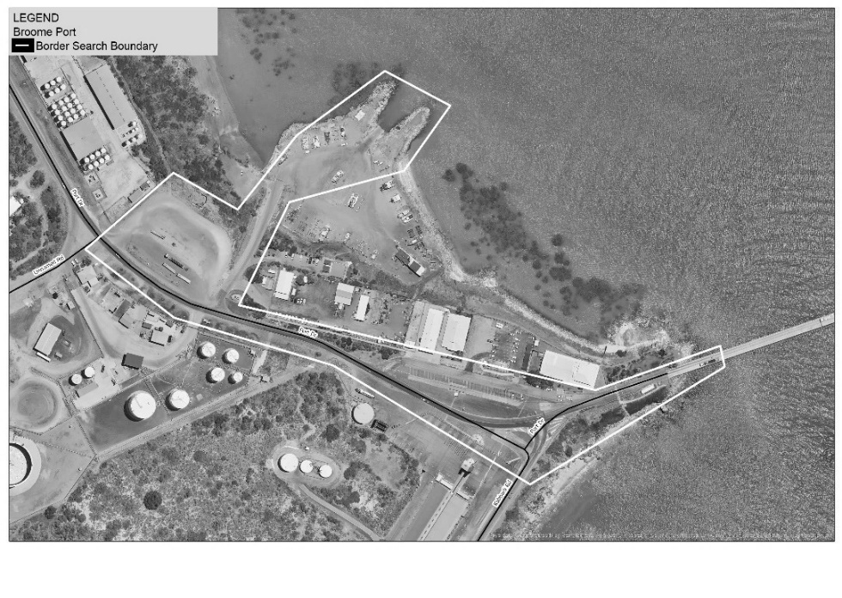
2. Broome Airport
Zone 1
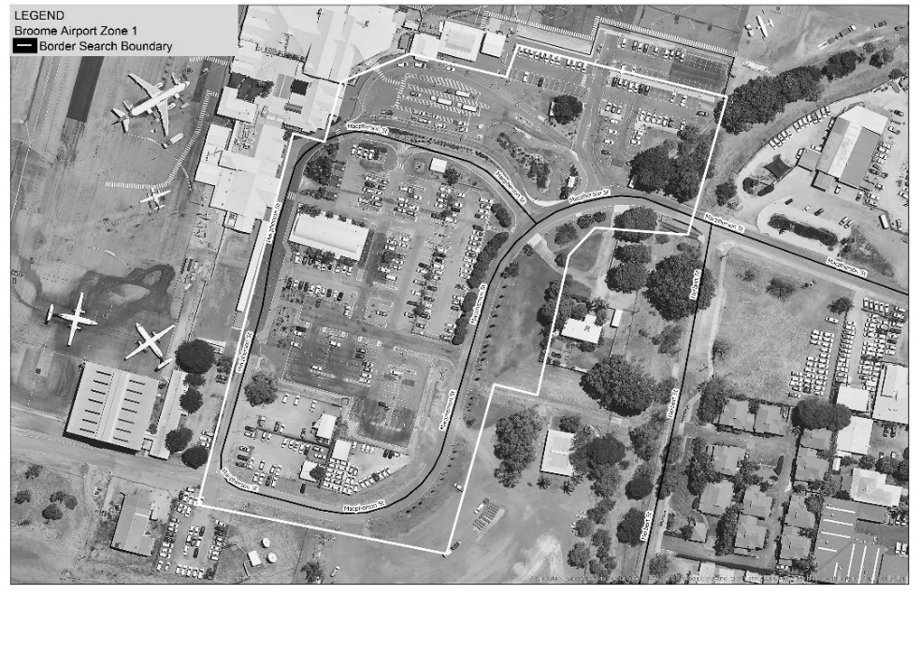
Zone 2
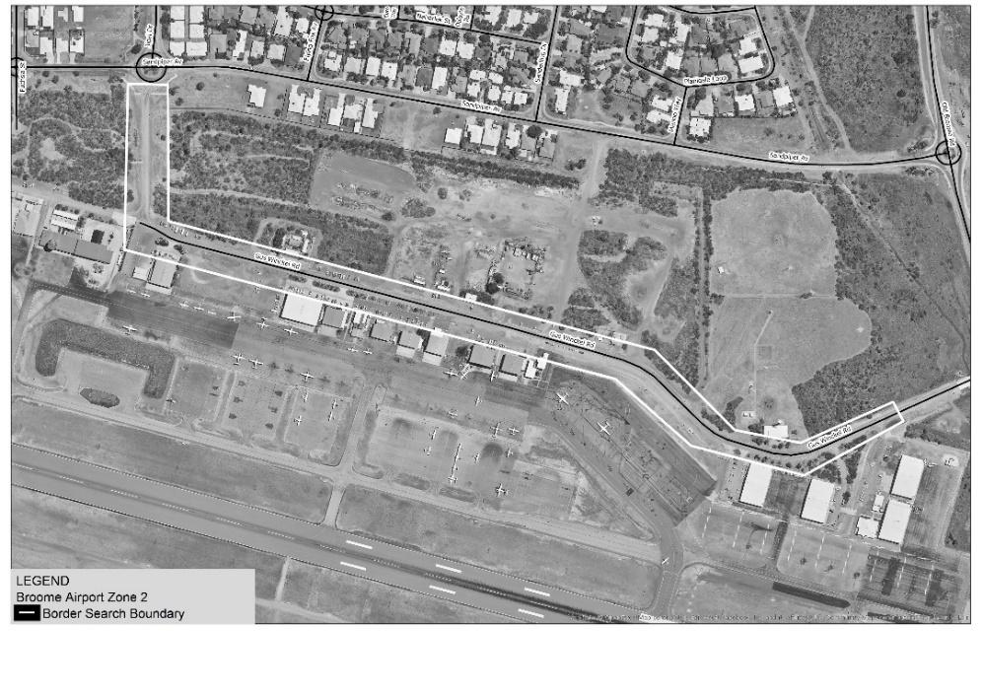
3. Port of Port Hedland
Zone 1
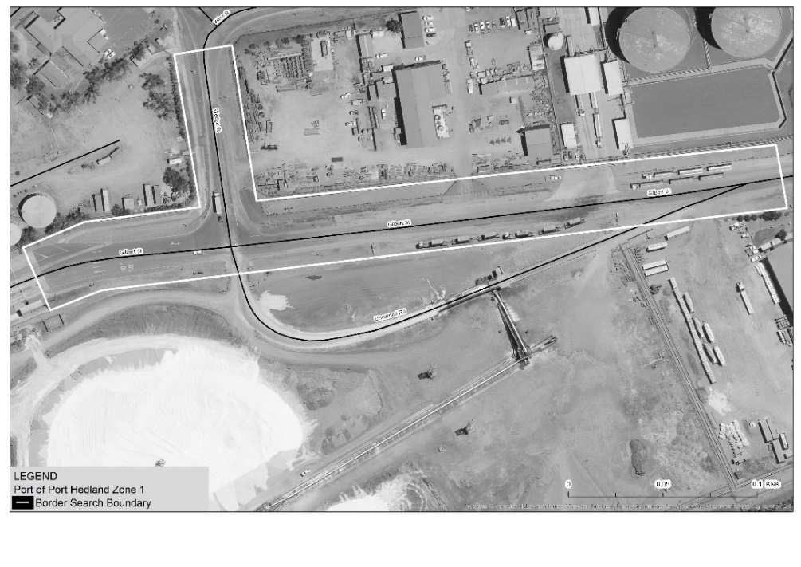
Zone 2
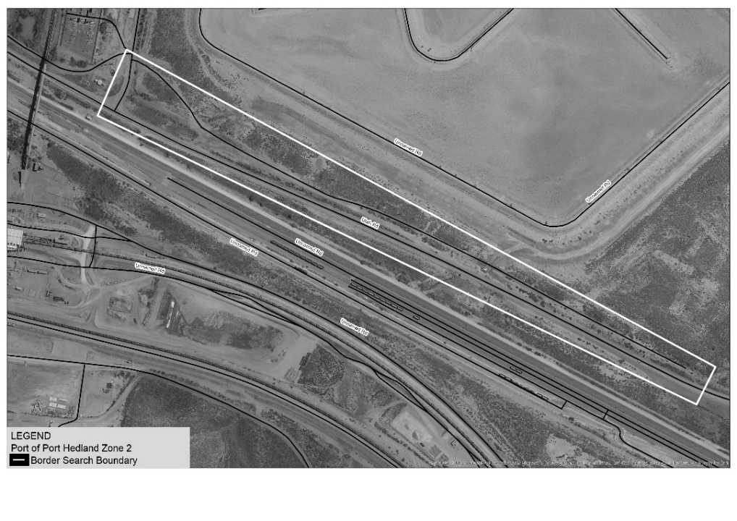
4. Port Hedland International Airport
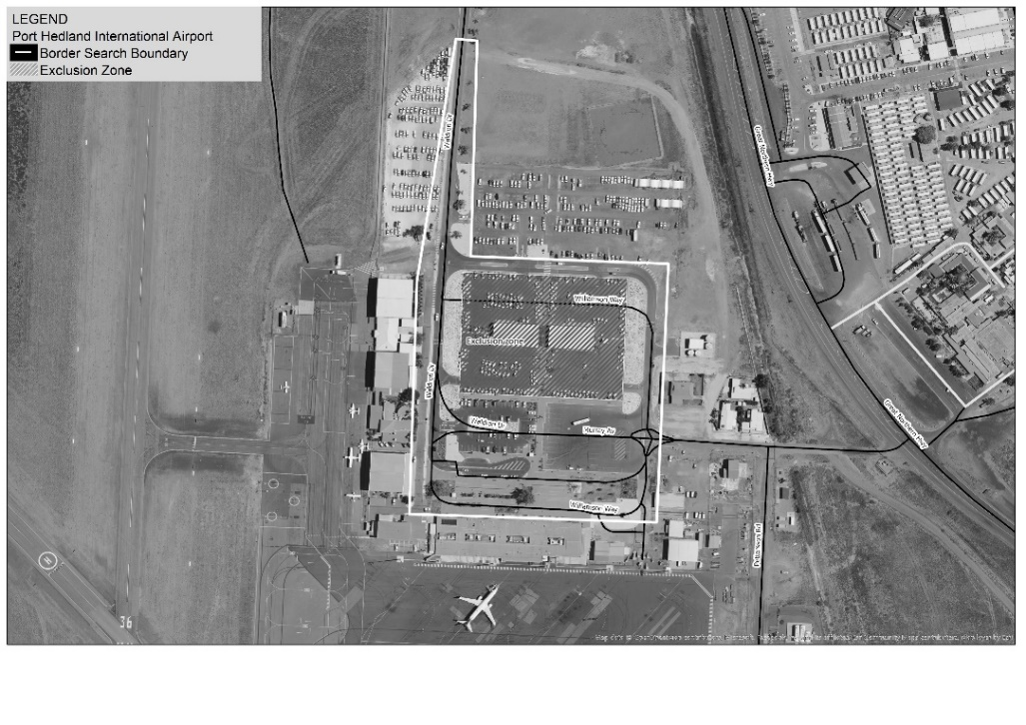
5. Port of Dampier
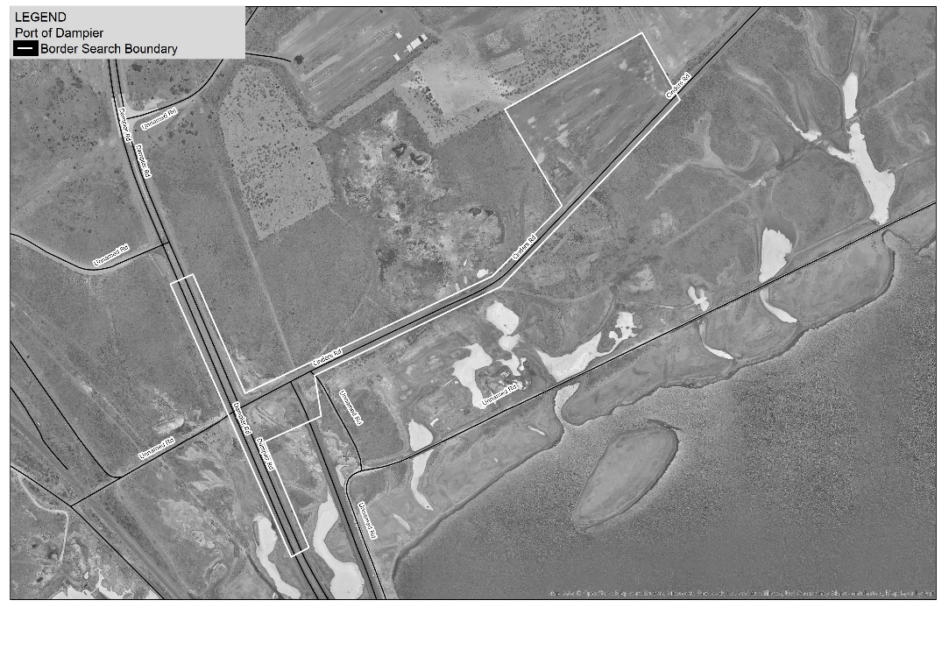
6. Port of Ashburton (Onslow)
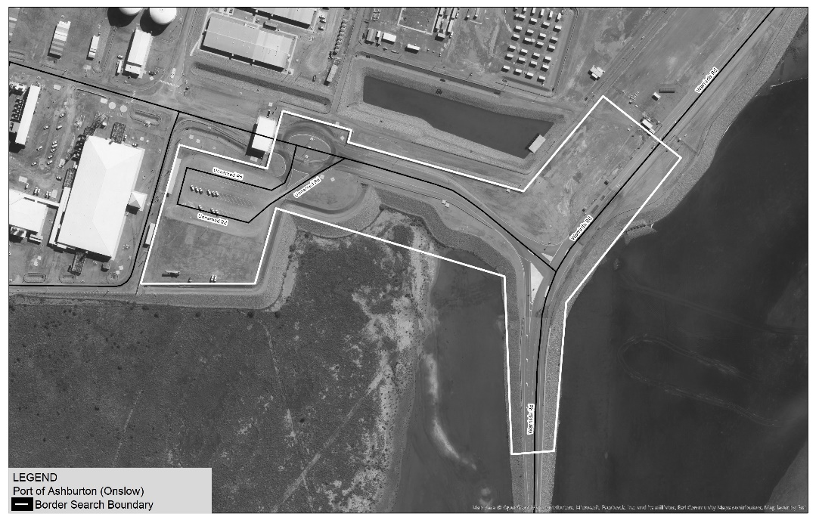
7. Port of Geraldton
Zone 1
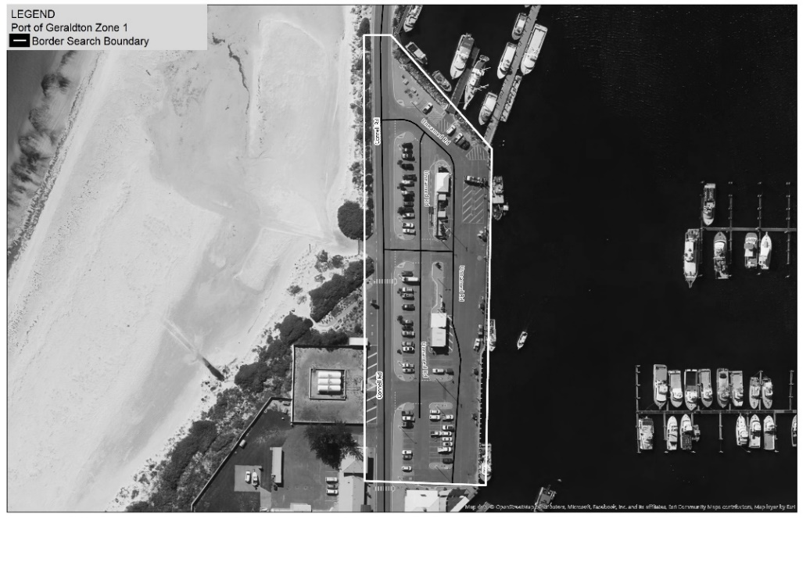
Zone 2
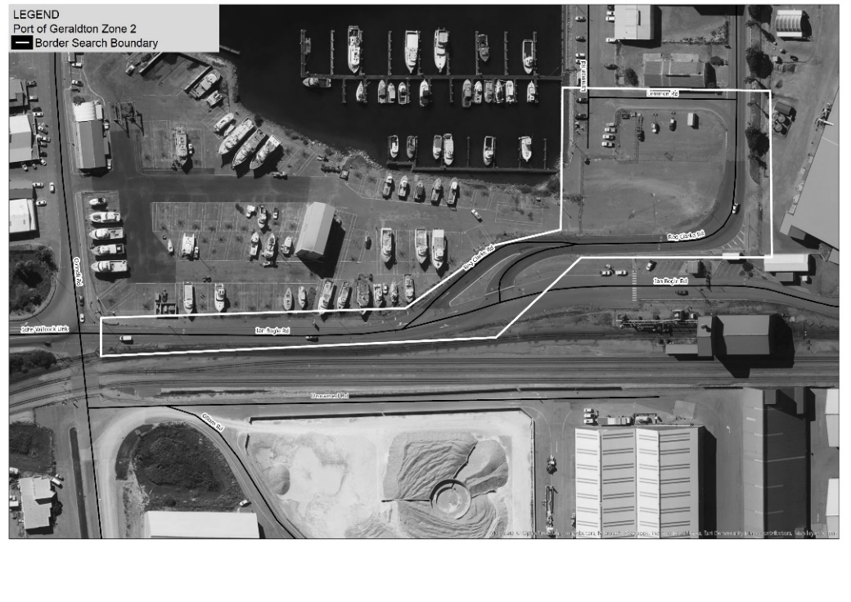
8. Perth Airport
Zone 1
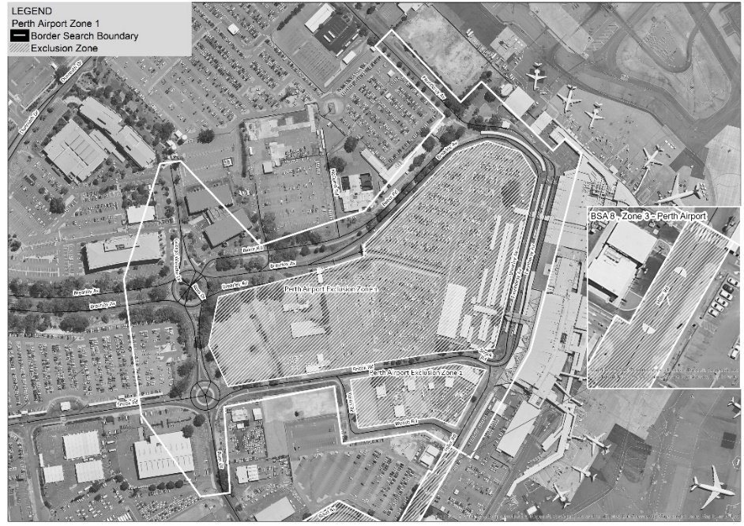
Zone 2
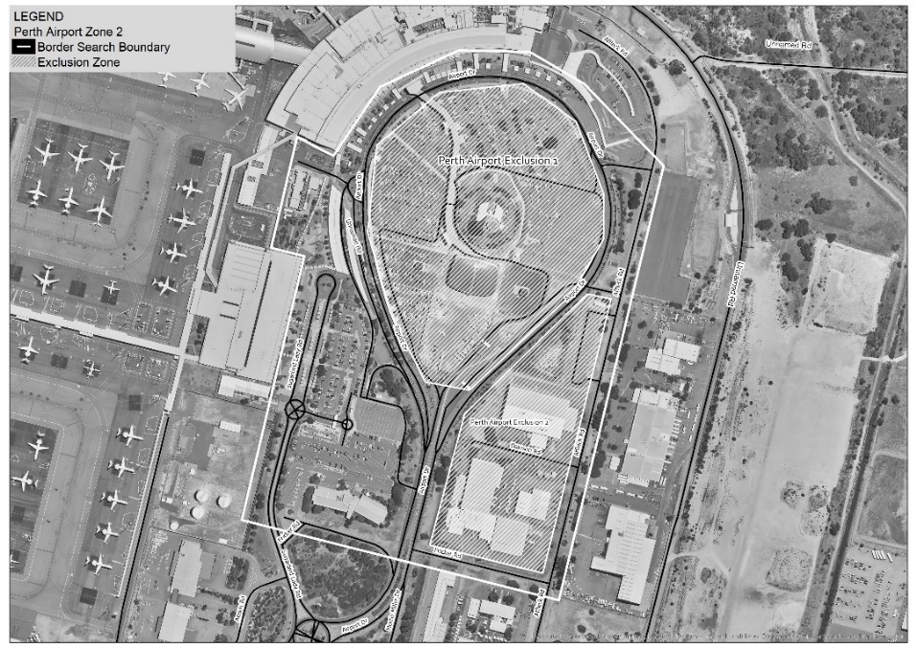
Zone 3
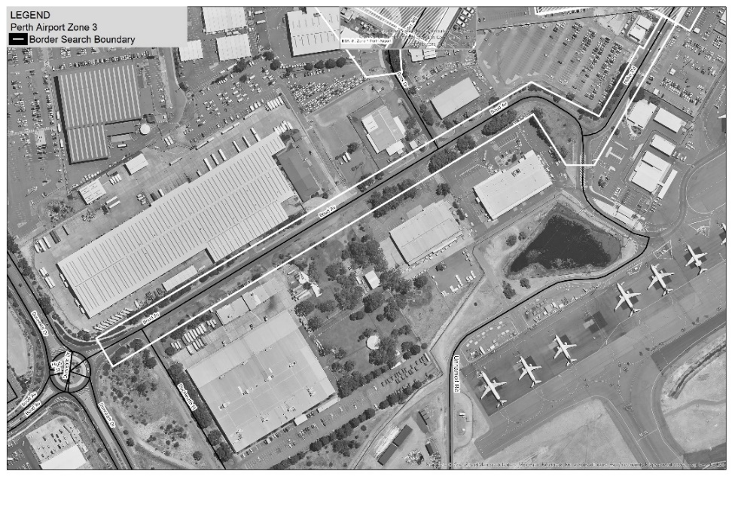
9. Fremantle Port (Inner Harbour)
Zone 1
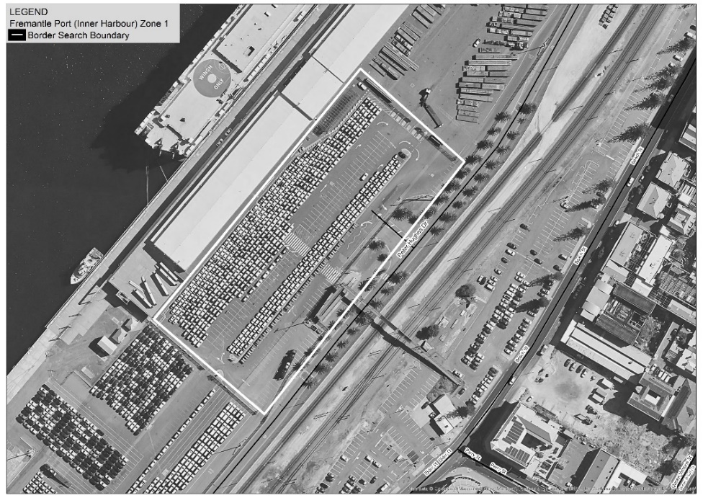
Zone 2
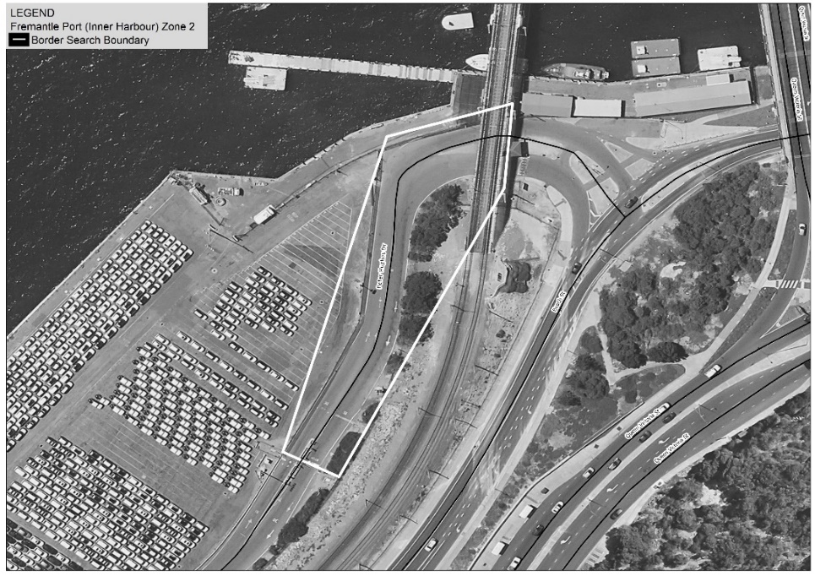
Zone 3
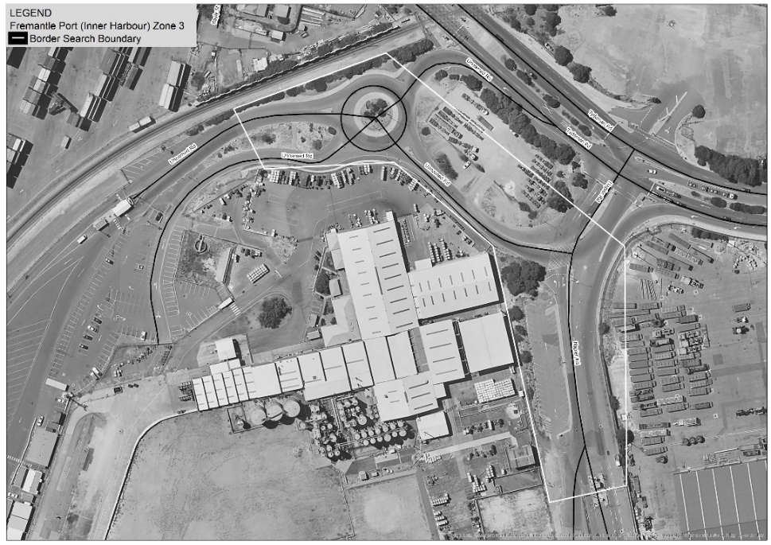
Zone 4
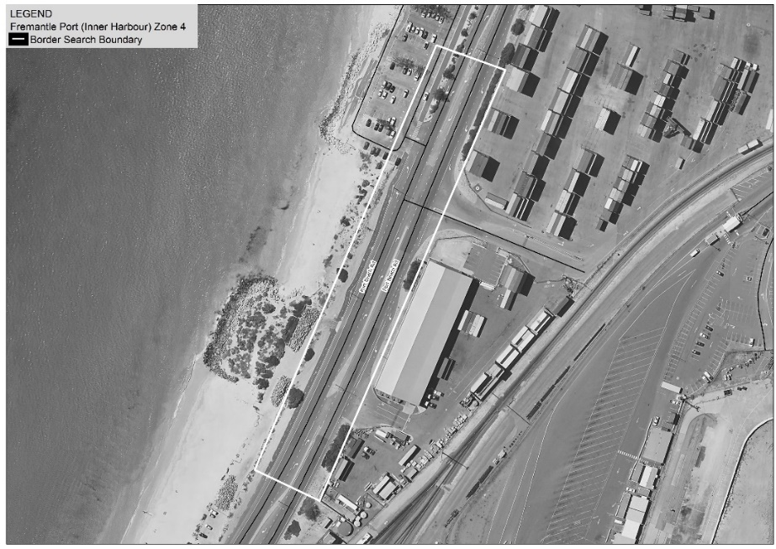
10. Fremantle Port (Outer Harbour)
Zone 1
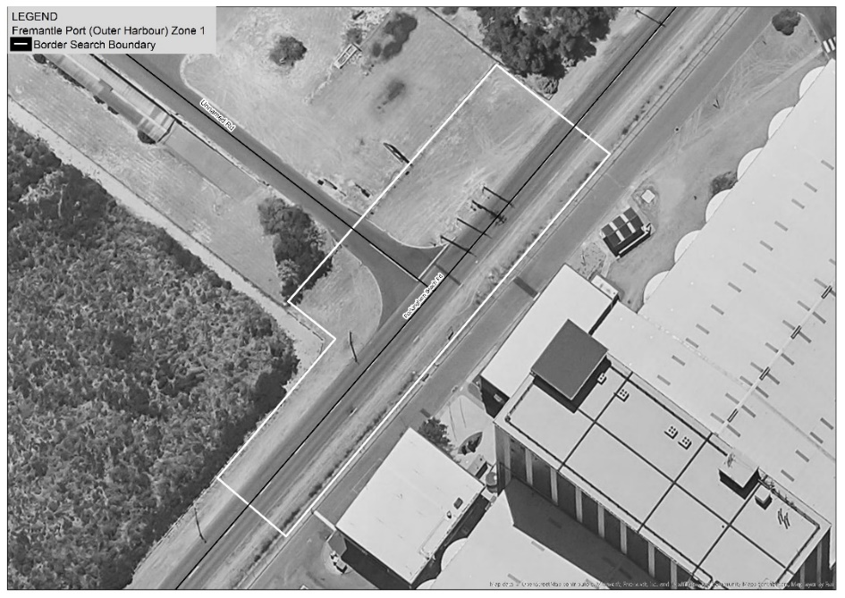
Zone 2
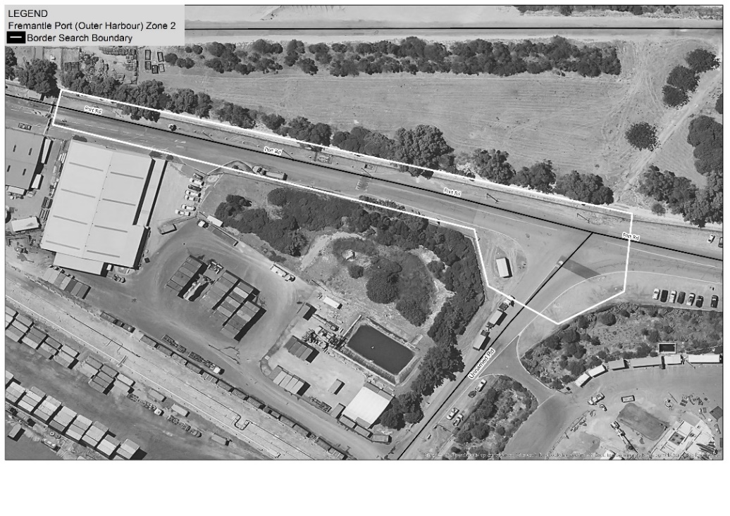
Zone 3
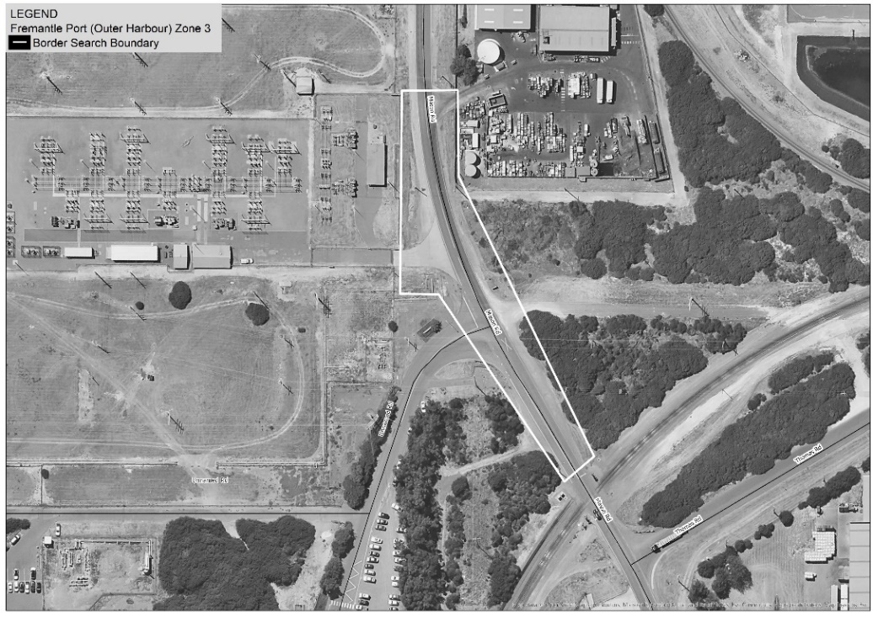
Zone 4
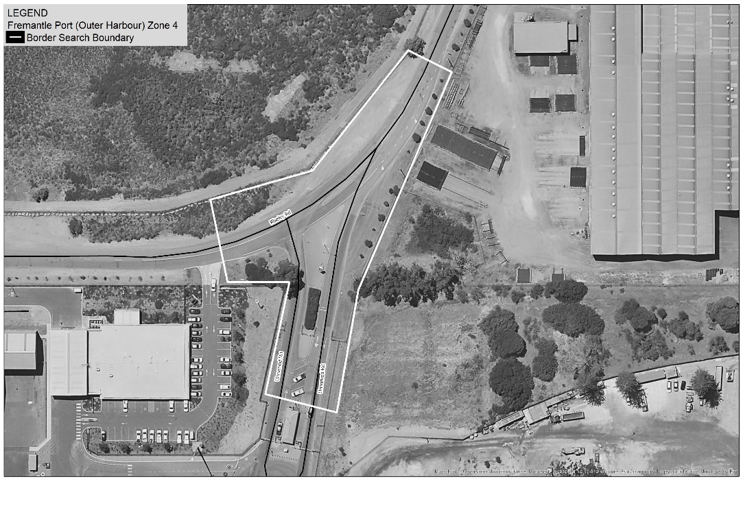
Zone 5
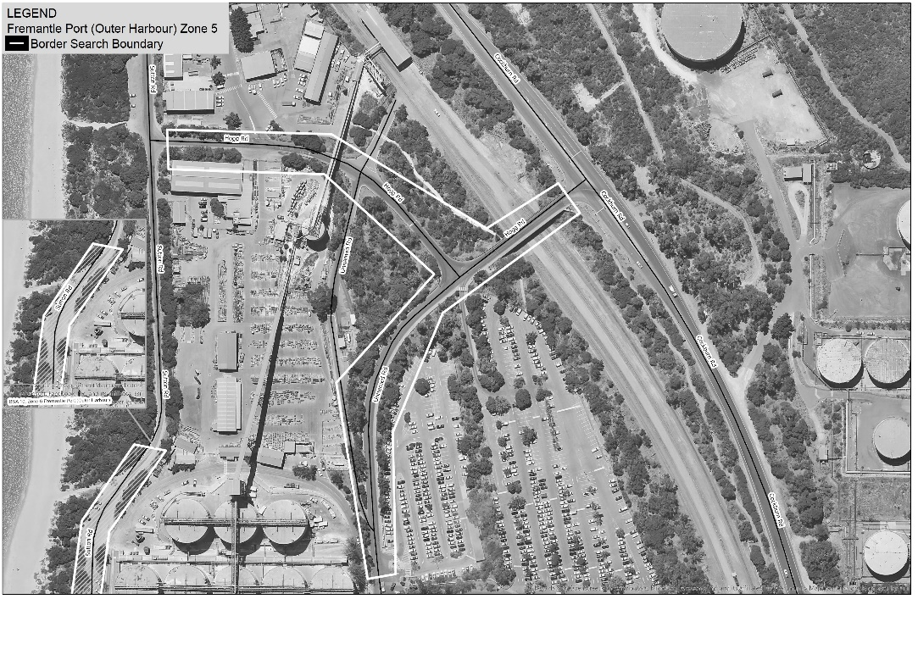
Zone 6
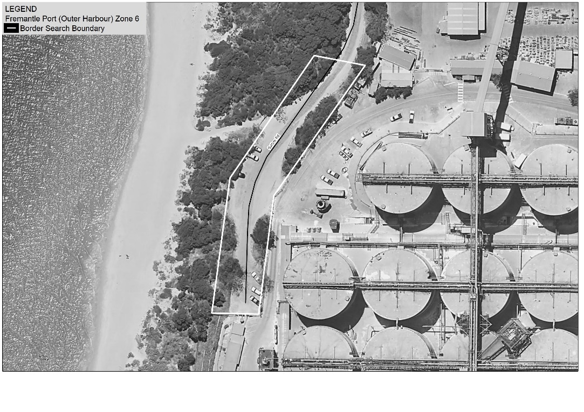
Zone 7
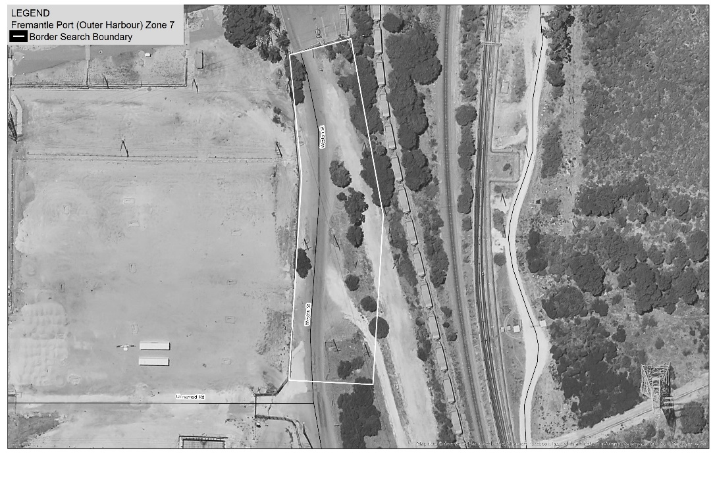
11. Jandakot Airport
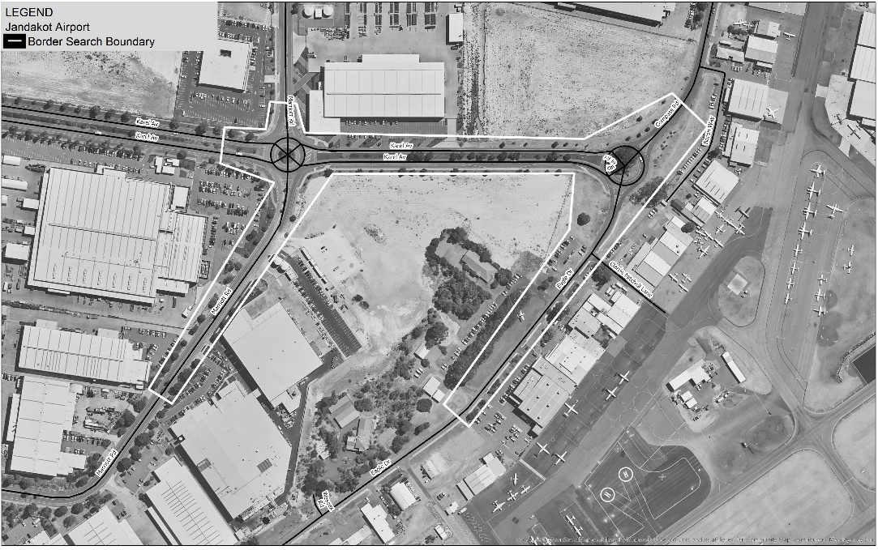
12. Wyndham Port
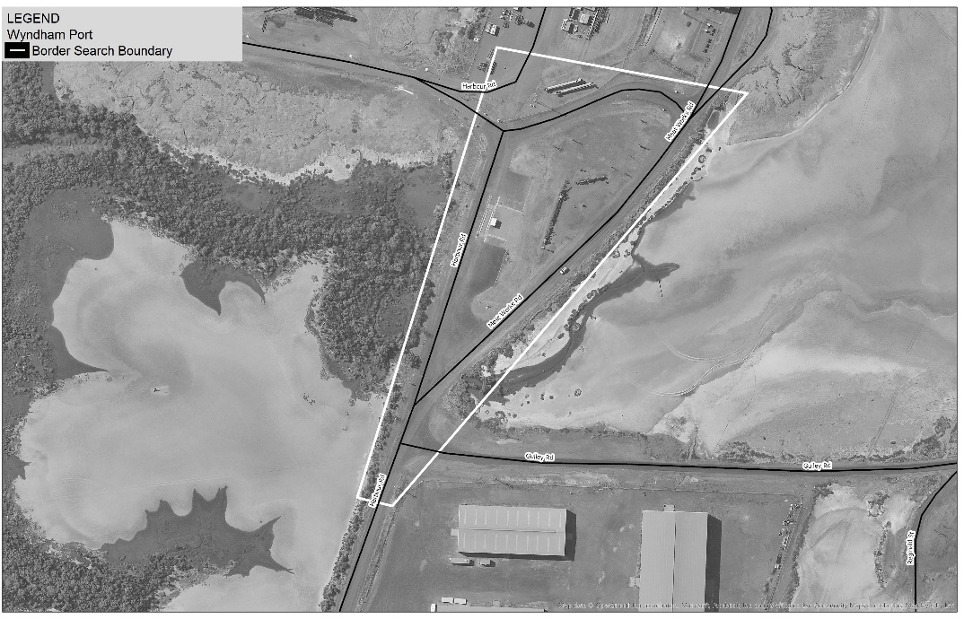
13. Bunbury Port
Zone 1
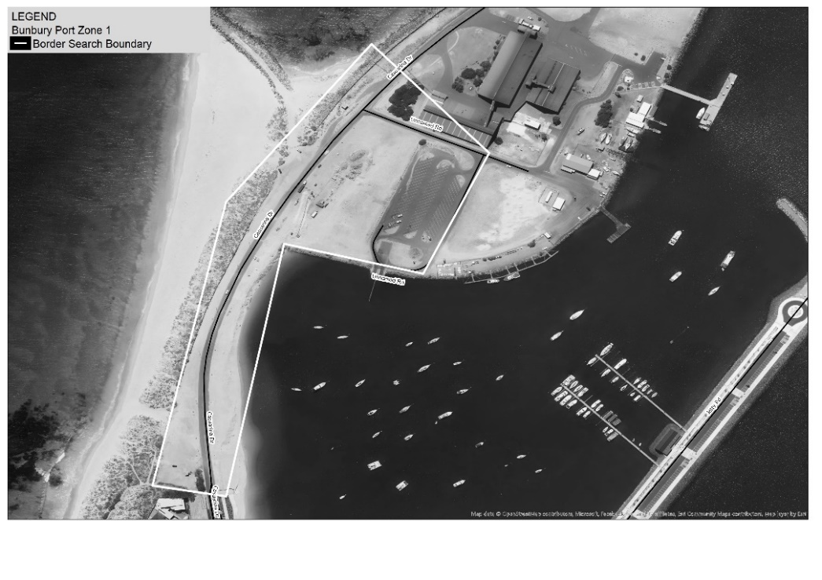
Zone 2
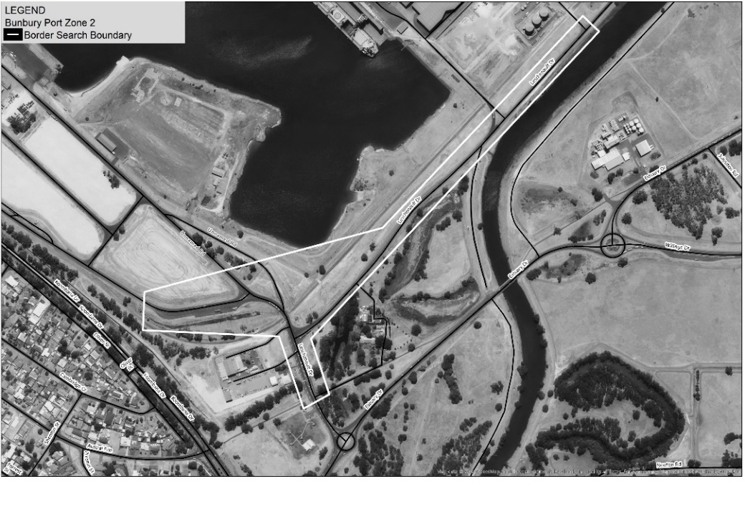
Zone 3
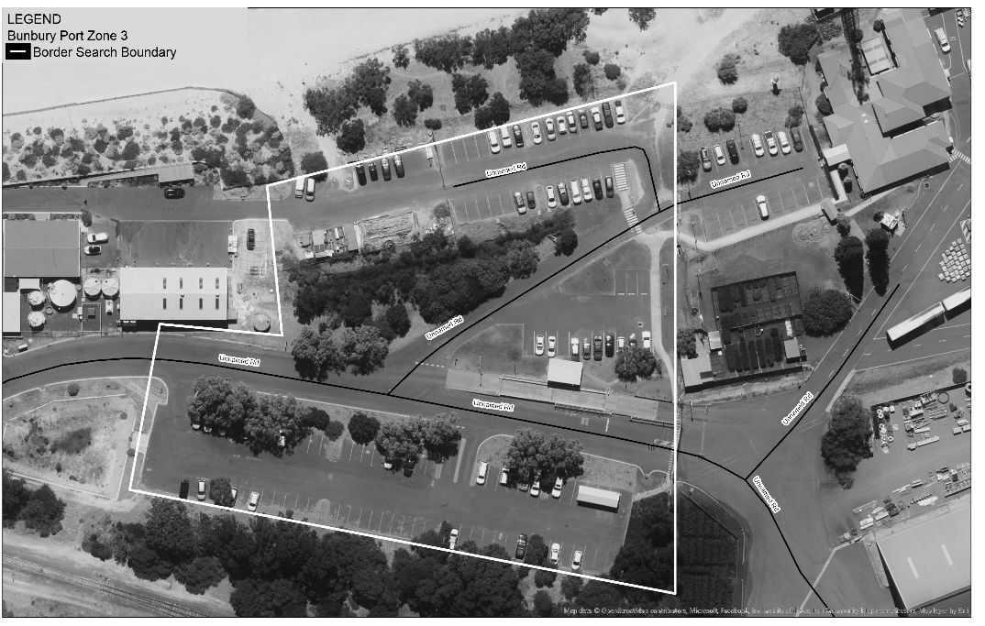
14. Busselton Airport
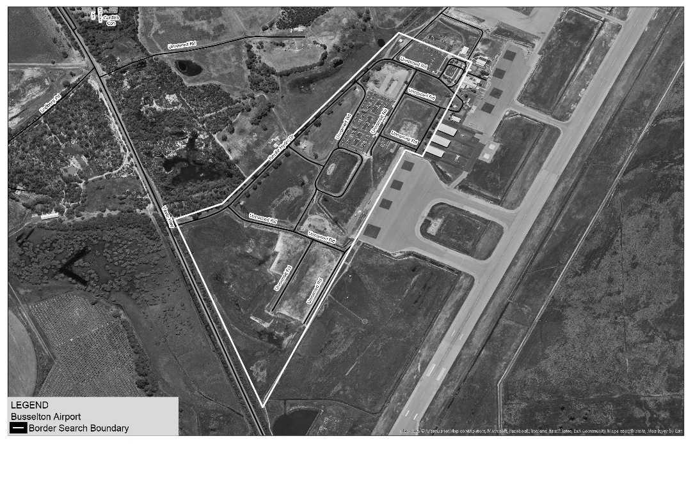
15. Albany Port
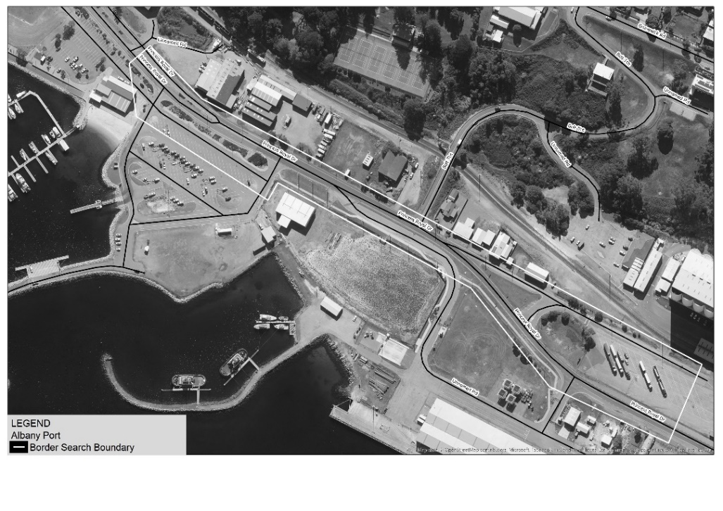
16. Esperance Port
Zone 1
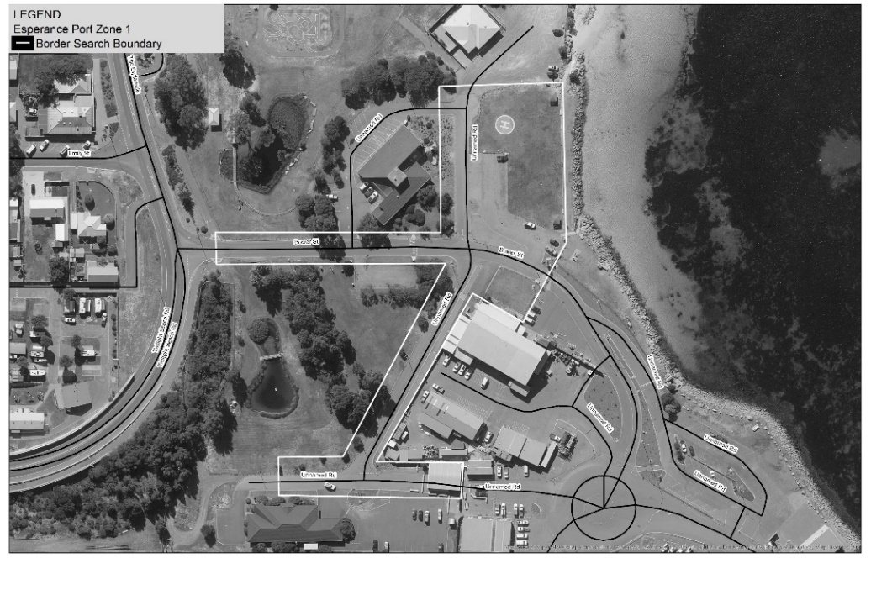
Zone 2
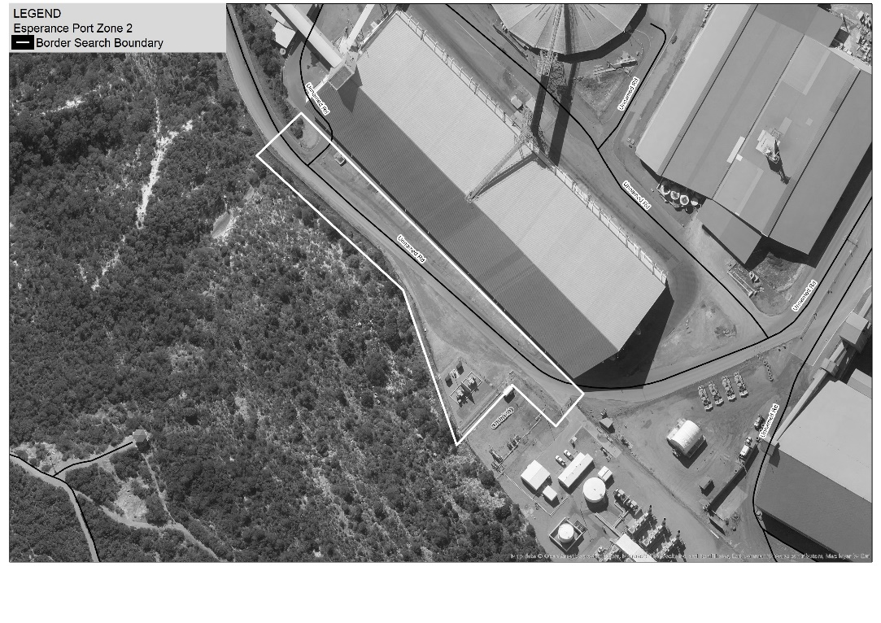
17. Eyre Highway, Eucla (WA/SA border)
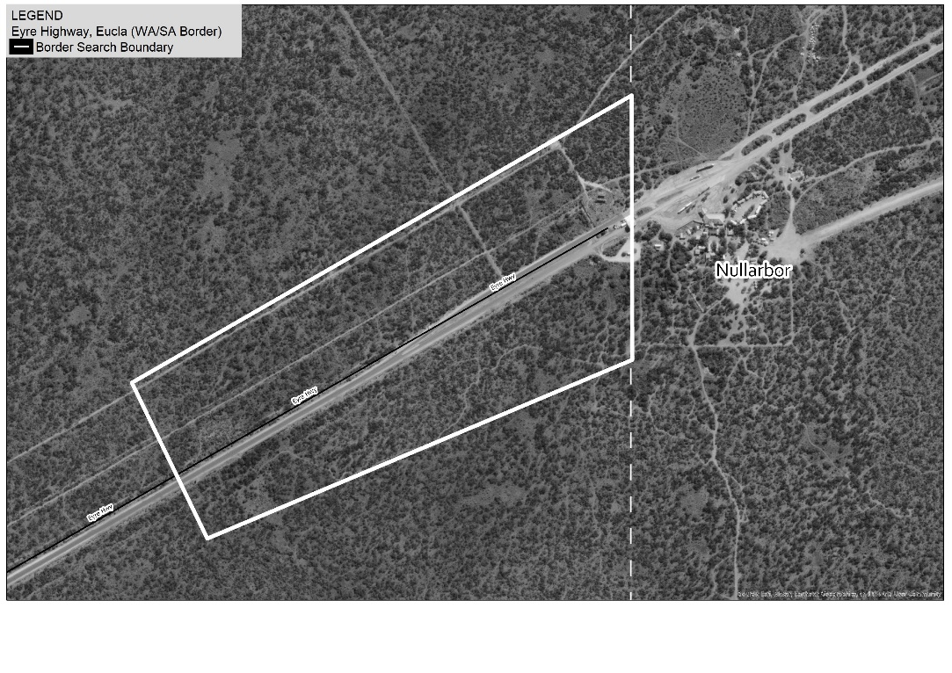
18. Victoria Highway near Kununurra (WA/NT border)
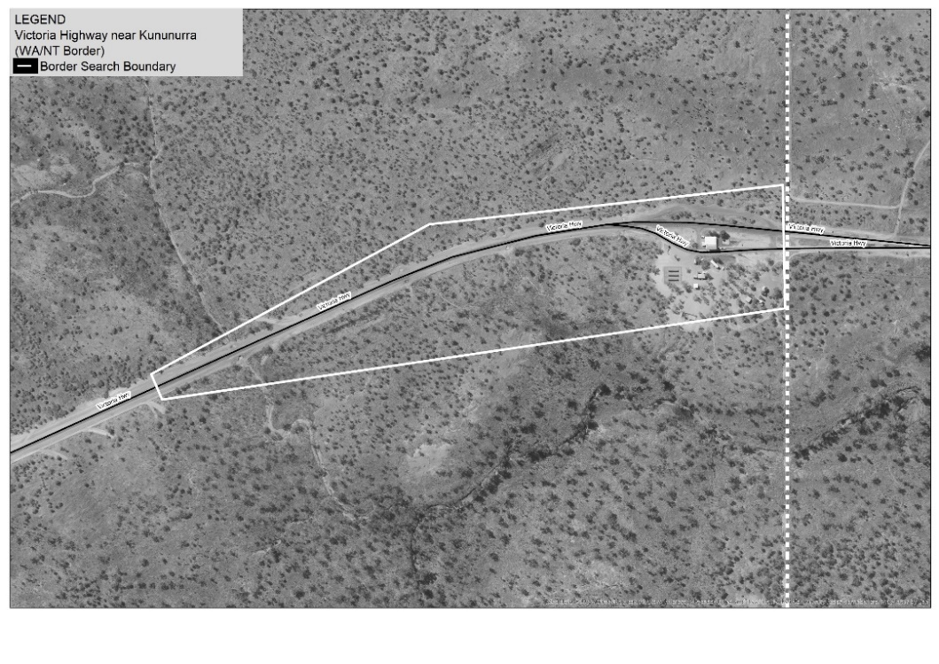
19. Tanami Road (WA/NT border)
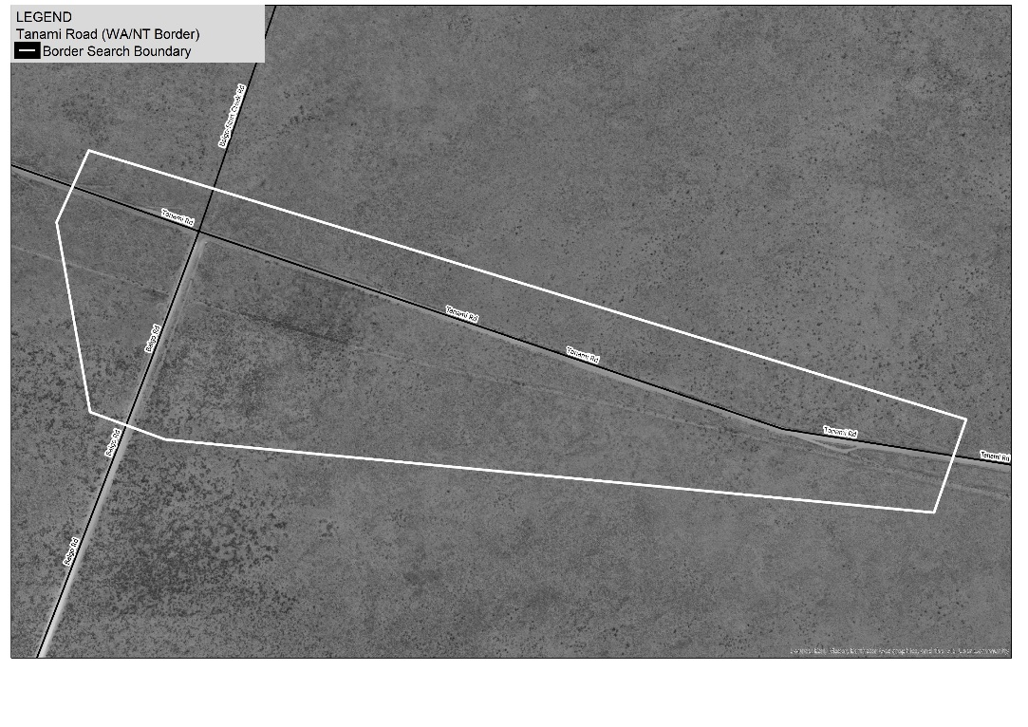
20. Duncan Road (WA/NT border)
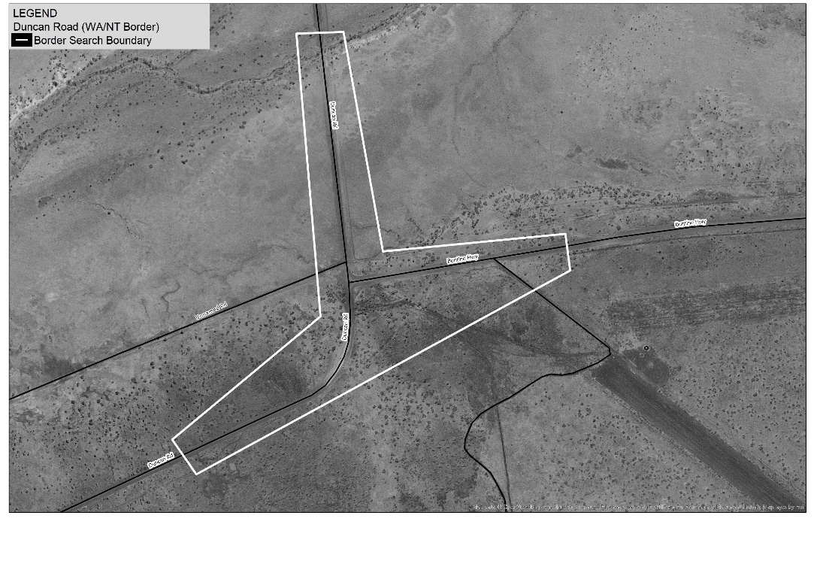
21. Great Central Road (WA/NT border)
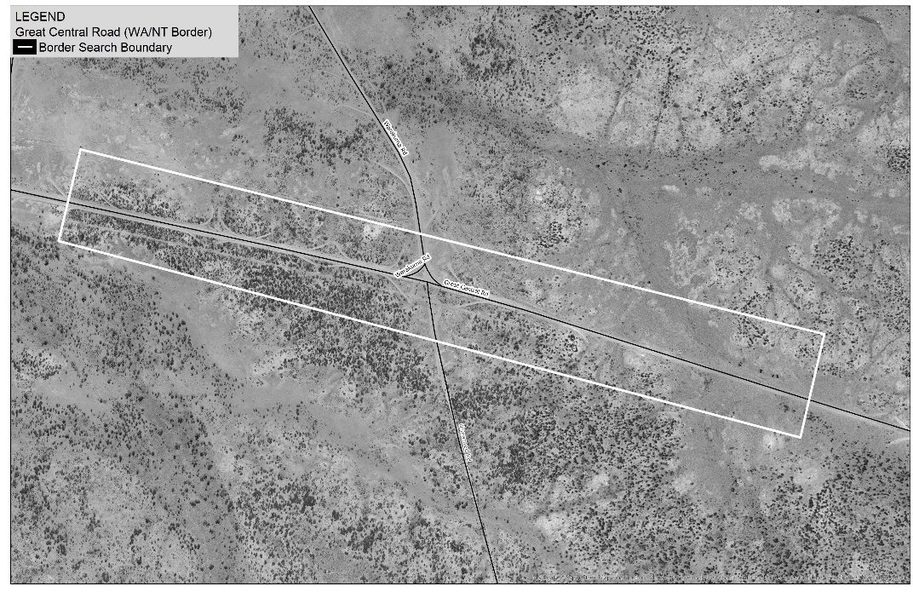
22. Rawlinna Rail Siding
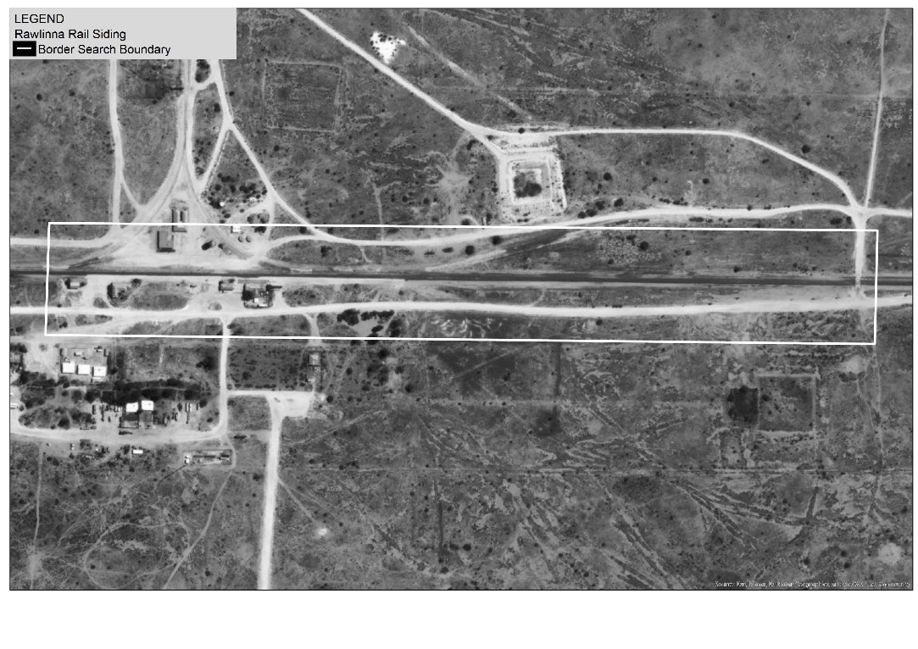

Part 3 — Amendments commencing 5 years after Royal Assent

11. Section 3 amended
In section 3(1) delete the definitions of:
Border Search Area (BSA)
controlled precursor
drug detection device
drug detection dog
preliminary drug detection test

12. Section 20A amended
In section 20A insert in alphabetical order:

controlled precursor means a category 1 item or a category 2 item;
drug detection device means an electronic device, or a system that uses or involves an electronic device, of a type approved by the Commissioner for the purpose of detecting the presence of any of the following —
(a) a prohibited drug;
(b) a prohibited plant;
(c) a controlled precursor;
drug detection dog means a dog trained to detect the presence of any of the following —
(a) a prohibited drug;
(b) a prohibited plant;
(c) a controlled precursor;
preliminary drug detection test means —
(a) leading or otherwise placing a drug detection dog in the vicinity of a person or property; or
(b) using a drug detection device in relation to a person or property;

13. Part 4B deleted
Delete Part 4B.

14. Section 23 amended
Delete section 23(1A) and (1B).

15. Section 34 amended
In section 34(1)(d) delete “20W,”.

16. Section 42 amended
(1) Delete section 42(1A).
(2) In section 42(2) delete “subsection (1) or (1A),” and insert:

subsection (1),

(3) In section 42(3), (4) and (5) delete “subsection (1) or (1A)” and insert:

subsection (1)

17. Schedule 6A deleted
Delete Schedule 6A.


© State of Western Australia 2023.
This work is licensed under a Creative Commons Attribution 4.0 International Licence (CC BY 4.0). To view relevant information and for a link to a copy of the licence, visit www.legislation.wa.gov.au.
Attribute work as: © State of Western Australia 2023.
By Authority: GEOFF O. LAWN, Government Printer

