
Western Australia
Metropolitan Water Supply, Sewerage, and Drainage Act 1909 1

Metropolitan Water Supply, Sewerage and Drainage By-laws 1981

Western Australia
Metropolitan Water Supply, Sewerage and Drainage By-laws 1981
Contents
Preliminary and definitions
1.0 Citation 1
1.1 Terms used 1
4.0 Protection of catchment areas and water reserves
4.1 Object of this Part 5
4.2 Application of this Part 5
4.3 Catchment areas etc., protection of 6
4.4 Sewage, liquid waste and solid refuse 7
4.5 Animals and birds 8
4.6 Manure, fertilizers, chemicals, petrol etc. 9
4.7 Clearing, road construction, vehicles etc. 11
4.8 Development, mining, offensive trades etc. 11
4.9 Remedying damage etc., CEO’s powers for 12
4.10 Signs; rangers’ powers 12
4.11 Designated camping sites for Noongar people 13
4.12 Customary hunting by Noongar people 14
4.13 Noongar people lighting fires for customary purposes 15
4.14 Entry to registered Aboriginal places by Noongar people 15
5.0 Protection of public water supply areas and underground water pollution control areas
5.1 Object of this Part; CEO may erect signs 17
5.3 Causing flooding of wells etc. 17
5.4 Pollution areas, production wells etc., protection of 17
5.5 Pollution areas, development and storing petrol etc. in 19
5.6 Priority source protection areas, control of certain developments in 23
31.0 Offences and penalties
31.4 Penalties 33
Schedule 1 — Description of South West Settlement Area
Schedule 2 — Map of South West Settlement Area
Notes
Compilation table 37
Other notes 43
Defined terms

Western Australia
Metropolitan Water Supply, Sewerage, and Drainage Act 1909 ¹
Metropolitan Water Supply, Sewerage and Drainage By-laws 1981

Preliminary and definitions

1.0 Citation
These by-laws may be cited as the Metropolitan Water Supply, Sewerage and Drainage By-laws 1981 and shall come into operation on 1 March 1981.

1.1 Terms used
In these by-laws, unless the context otherwise requires —
Aboriginal customary purpose means —
(a) preparing or consuming food customarily eaten by Aboriginal persons; or
(b) preparing or using medicine customarily used by Aboriginal persons; or
(c) engaging in artistic, ceremonial or other cultural activities customarily engaged in by Aboriginal persons; or
(d) engaging in activities incidental to a purpose stated in paragraph (a), (b) or (c);
Act means the Metropolitan Water Supply, Sewerage, and Drainage Act 1909 ¹, as amended from time to time;
bore, diameter or size, in reference to —
(a) any pipe of copper or brass, means the external diameter of the pipe; and
(b) any pipe of any other material, means the internal diameter of the pipe;
Corporation means the Water Corporation established by the Water Corporations Act 1995 section 4(1);
Dangerous Goods Storage Regulations means the Dangerous Goods Safety (Storage and Handling of Non-explosives) Regulations 2007;
designated camping site means an area designated under by-law 4.11.2 to be a camping site for the Noongar people;
domestic sewage means all faecal matter, urine, household slops and household liquid refuse;
feeder means any water course, creek, stream or other channel with either perennial or intermittent flow whereby water can be conveyed to any reservoir;
ground means the surface of the earth, soil, or rock which conform to the established finished grade at a specific location after all excavations have been thoroughly backfilled or otherwise closed and after all surface treatment at said location has been completed;
high-water mark means the level of full supply of any reservoir or feeder thereto;
industrial waste means the liquid, solid or gaseous refuse from any business, industry, warehouse or manufacturing premises other than domestic sewage, stormwater, or unpolluted water;
liquid waste means liquid wastes as defined in the Health (Treatment of Sewage and Disposal of Effluent and Liquid Waste) Regulations 1974 regulation 3;
Noongar people means the traditional owners of the lands in the South West Settlement Area;
observation well means a well constructed for the purposes of observing the depth to the ground water from the top of the well, and for obtaining samples of the ground water;
pesticides means a substance or compound used or intended for use for agricultural, pastoral, horticultural, domestic, or industrial purposes for controlling, destroying or preventing the growth and development of any fungus, virus, insect, mite, mollusc, nematode, plant or animal and includes all admixtures containing any proportion of any one or more of them;
petroleum product has the meaning given in the Dangerous Goods Storage Regulations regulation 4;
production well means a well owned and operated by the Corporation and from which groundwater is extracted for the provision of a public water supply;
registered Aboriginal place means an Aboriginal place (as defined in paragraph (b)(i) of the definition of Aboriginal cultural heritage in the Aboriginal Cultural Heritage Act 2021 section 12) about which information is contained on the ACH Directory (as defined in section 11 of that Act);
South West Settlement Area means the area of lands described in Schedule 1 and shown, for information purposes, on the map in Schedule 2;
special provision catchment area means a catchment area, or water reserve from which water can flow into an existing reservoir, within the South West Settlement Area;
underground storage or handling system means an underground storage or handling system as defined in the Dangerous Goods Storage Regulations regulation 4;
underground water means all water that is below the surface of the ground, whether or not flowing or in defined channels;
works has the meaning given in the Water Agencies (Powers) Act 1984 section 3(1).
[By-law 1.1 amended: Gazette 24 Dec 1982 p. 4924-5; 29 Jun 1989 p. 1888; 21 Sep 1990 p. 4952; 29 Dec 1995 p. 6319-20 and 6324; 4 Feb 1997 p. 713; 25 Aug 1998 p. 4724-5; 16 Jun 2000 p. 2959; 28 Jun 2004 p. 2373-4; 13 Apr 2007 p. 1686; 23 May 2008 p. 2009; 21 Apr 2011 p. 1473; 14 Nov 2013 p. 5053-5; 7 Jun 2016 p. 1782-3; SL 2023/54 bl. 4.]

[1.2-1.4 Deleted: Gazette 28 Jun 2004 p. 2374.]

[2.0 Deleted: Gazette 14 Nov 2013 p. 5055]

[3.0 Deleted: Gazette 14 Nov 2013 p. 5055.]

4.0 Protection of catchment areas and water reserves

4.1 Object of this Part
4.1.1 The by-laws contained in this Part are intended to —
(a) prevent any deterioration of the quality of water collected from the Minister’s catchment areas and water reserves by way of increased bacteriological or chemical contamination, increased turbidity, or increased level of nutrients necessary to the growth of undesirable aquatic flora;
(b) control and manage existing and future development within the catchments and water reserves that could adversely affect water quality;
(c) regulate the behaviour of persons entering the catchment areas.
4.1.2 Attention is drawn to by-law 31.4 regarding penalties that may be imposed for breaches of these by-laws.
[By-law 4.1 amended: Gazette 29 Dec 1995 p. 6321 and 6326; 21 Apr 2011 p. 1475.]

4.2 Application of this Part
4.2.1 The by-laws in this Part apply to water reserves and catchment areas constituted under the Act and within which surface or sub-surface water may be collected into an open storage reservoir before distribution to consumers.
4.2.2 In this Part —
4.2.2.1 All by-laws applicable to a catchment area shall apply equally to any part of a water reserve from which water can flow into an existing storage reservoir.
4.2.2.2 Prohibited zone means that part of a catchment area which lies —
(a) upstream of a dam; and
(b) within 2 km of the top water level of any reservoir in which water is or can be stored.
4.2.2.3 Public road means a road or street as defined in the Local Government Act.
[By-law 4.2 amended: Gazette 29 Dec 1995 p. 6321.]

4.3 Catchment areas etc., protection of
4.3.1 No person shall throw, deposit, discharge or leave or cause, permit or suffer to be thrown, deposited, discharged or left into or upon a catchment area or water reserve any chemical, radioactive material, litter, rubbish, offal, dung, dead animal or any noisome, noxious or polluting liquid substance, matter, or thing which is likely to pollute the catchment area or water reserve or any reservoir or watercourse in the catchment area, or which is likely to affect purity of the water.
4.3.2 No person shall swim, bathe, or have any bodily contact with the water or wash any clothes or other articles in any stream, reservoir, aqueduct or other water works within a catchment area.
4.3.3 No person shall in or upon any watercourse, lake, reservoir, aqueduct or other water works in a catchment area set afloat, sail, propel or cause to be propelled any craft or vessel, without express permission in writing from the CEO and subject to any conditions that it may deem necessary.
4.3.4 Subject to by-laws 4.11.5, 4.12.2 and 4.12.3, no person shall camp, or shoot, trap or hunt any game or catch, or attempt to catch, any fish or marron within a catchment area, without specific permission in writing from the CEO to which it may attach any conditions that it deems necessary.
4.3.5 Subject to by-law 4.13 —
(a) no person is to light a fire on Crown land in a prohibited zone on a catchment area except in the fire places provided at authorised picnic sites unless with the written approval of the CEO; and
(b) any person lighting fires at other places on a catchment area must comply with all requirements of the Bush Fires Act 1954 or restrictions promulgated under that Act.
4.3.6 Subject to by-law 4.14, no unauthorised person shall enter Crown land within a prohibited zone on any catchment area except for the purposes of —
(a) travelling through the prohibited area on public roads; or
(b) travelling along private roads constructed by the State and which are open for public use; or
(c) picnicking within designated picnic sites provided and serviced by the State.
4.3.7 No picnic area or amenity to encourage picnicking or public recreation is to be established in any catchment area or water reserve without the written approval of the Minister.
[By-law 4.3 amended: Gazette 29 Dec 1995 p. 6321 and 6325; 21 Apr 2011 p. 1475 and 1482; 7 Jun 2016 p. 1783.]

4.4 Sewage, liquid waste and solid refuse
4.4.1 No person shall permit the water of any property sewer or any filthy or polluted water discharging from premises occupied by him or under his control, to run, flow, or be brought into any reservoir or watercourse in any catchment area or water reserve.
4.4.2 Disposal of domestic sewage on catchment areas and water reserves.
4.4.2.1 All domestic sewage and liquid waste shall be treated and disposed of in accordance with the Health (Treatment of Sewage and Disposal of Effluent and Liquid Waste) Regulations 1974.
4.4.2.2 Prior approval in writing must be obtained from the CEO before a bacteriolytic treatment plant is installed within a prohibited zone or within 100 m of the centre line of any watercourse.
4.4.2.3 Any liquid waste not processed through a bacteriolytic treatment plant, or not capable of treatment in such a plant shall be stored in watertight tanks or receptacles (which shall be maintained in good condition) and periodically removed from the catchment area by a liquid waste removal contractor approved by the appropriate Local Health Authority, and by the CEO.
4.4.3 The occupier of every house or premises shall provide and maintain in good condition a sufficient number of receptacles or boxes to contain all solid refuse, and the contents of these receptacles or boxes shall be removed from the catchment area at least once every week.
[By-law 4.4 amended: Gazette 24 Dec 1982 p. 4926; 29 Dec 1995 p. 6325; 26 Jun 1998 p. 3420; 21 Apr 2011 p. 1475 and 1482.]

4.5 Animals and birds
4.5.1 The owner or person in charge of any animals or birds shall not cause or permit any dog, horse, goat, cattle, sheep, pig, duck, geese or fowls or other species of livestock to enter or remain on any portion of a catchment area.
4.5.2 The occupier or owner of any land within a catchment area shall not raise or graze livestock without approval of the CEO.
4.5.3 No person shall ride a horse or any other animal on any of the Minister’s catchment areas (except along public roads) without the written permission of the CEO.
4.5.4 Any animal or bird found straying within a catchment area may be —
(a) driven away or otherwise removed from such lands; or
(b) sold; or
(c) destroyed; or
(d) otherwise disposed of,
by any officer or person authorised by the CEO without incurring any liability on the part of the State to recompense the owner for the loss.
4.5.5 Subject to by-laws 4.12.2 and 4.12.3, no person shall slaughter any animal or bird in a catchment area without the permission of the CEO.
4.5.6 The owner of any animal or bird which dies upon any part of a catchment area or the person under whose charge the animal was at or immediately before the time of its death, shall forthwith upon knowing or being informed of the death of the animal or bird remove its body or carcass from the catchment area or bury the same so that all parts of the carcass are not less than 300 mm below the normal surface and restore the ground at least to its original level except that no animal or bird shall be buried within a prohibited zone or within 100 m of the centre line of any watercourse.
[By-law 4.5 amended: Gazette 29 Dec 1995 p. 6325-6; 21 Apr 2011 p. 1476 and 1482; 7 Jun 2016 p. 1783.]

4.6 Manure, fertilizers, chemicals, petrol etc.
4.6.1 The occupier or owner of any house, land or premises situated within a catchment area shall not store or use any animal manure or fertilizer without written permission of the CEO.
4.6.2 No person shall lay, place or use upon any part of the catchment area any poison, pesticide, insecticide, herbicide or other dangerous substances without written permission of the CEO and then they shall be applied in the manner required by the Health (Pesticides) Regulations 2011.
4.6.3 All persons storing, laying, placing or using any explosive or dangerous goods on a catchment area shall comply with the requirements of the Dangerous Goods Safety Act 2004.
4.6.4 No toxic, dangerous chemicals or radioactive materials are to be stored on the catchment areas without the prior written approval of the CEO.
4.6.5 Storage of Petroleum Products on Catchment Areas and Water Reserves
4.6.5.1 A person storing or handling petroleum products is to ensure that —
(a) the petroleum products are stored and handled in accordance with the Dangerous Goods Storage Regulations; and
(b) no underground storage or handling system is situated within a prohibited zone or within 100 m of the centre line of any watercourse; and
(c) no underground storage or handling system is constructed without the prior written approval of the CEO; and
(d) each underground storage or handling system is designed, installed, operated and maintained so that it does not leak; and
(e) any conditions set out in a written notice given to the person by the CEO are complied with.
4.6.5.2 A person storing petroleum products on premises that are not the subject of a licence granted under the Dangerous Goods Storage Regulations regulation 32 is to —
(a) take all precautions necessary to prevent spillage of petroleum products onto the ground; and
(b) comply with any requirement of the CEO to install containment structures on the premises.
[By-law 4.6 amended: Gazette 29 Dec 1995 p. 6321 and 6325; 18 Mar 2011 p. 928; 21 Apr 2011 p. 1476-7.]

4.7 Clearing, road construction, vehicles etc.
4.7.1 No person shall clear any portion of the catchment area or commence any excavation or any construction, alteration or diversion of roads in the catchment area without the prior written approval of the CEO.
4.7.2 No person shall drive a vehicle on any part of a catchment area other than a road or track which has a graded, gravelled, sealed, primed or other prepared surface without written approval of the CEO.
4.7.3 No person or organisation shall conduct a vehicle rally or race on a catchment area without the prior written approval of the CEO.
[By-law 4.7 amended: Gazette 29 Dec 1995 p. 6325 and 6326; 21 Apr 2011 p. 1477-8.]

4.8 Development, mining, offensive trades etc.
4.8.1 No person shall commence, carry out, change or expand any agricultural, industrial, commercial, quarrying or mining development in a catchment area without the written approval of the CEO.
4.8.2 No person is to establish or carry on an offensive trade as defined in the Health (Miscellaneous Provisions) Act 1911 on a catchment area or water reserve without the written approval of the CEO.
4.8.3 No person shall commence or proceed with the erection of a building or structure of any kind or any alterations or additions to a building or structure on a catchment area or water reserve without the written approval of the CEO.
4.8.4 The occupier or owner of premises in a catchment area shall maintain those premises at all times to the standards required by the Health (Miscellaneous Provisions) Act 1911 or the relevant regulations made under that Act.
[By-law 4.8 amended: Gazette 29 Dec 1995 p. 6325-6; 21 Apr 2011 p. 1478; 10 Jan 2017 p. 235.]

4.9 Remedying damage etc., CEO’s powers for
4.9.1 If any person commits an offence under Part 4, the CEO, upon discovery of that offence, may serve notice on the offending person to restore any damage, remove any cause of pollution, or dismantle any building carried out in contravention of these by-laws by a nominated date.
4.9.2 A person who fails to comply with a notice served on that person under this by-law commits an offence.
[By-law 4.9 amended: Gazette 29 Dec 1995 p. 6325-6; 21 Apr 2011 p. 1478-9.]

4.10 Signs; rangers’ powers
4.10.1 The CEO may erect signs at any position in the catchment areas or water reserves that it considers necessary to control the activities of persons or movement of vehicles entering onto or moving across the catchment areas or water reserves.
4.10.2 Any person driving or taking a vehicle, trailer, or item of mobile equipment onto or across a catchment area shall comply with all signs erected to control the speed, movement or parking of vehicles, trailers or mobile equipment.
4.10.3 Powers of a Ranger
4.10.3.1 Rangers and other persons authorised by the CEO are empowered to demand the name and address of any person committing or reasonably suspected of committing an offence against the Act or these by-laws relating to catchment areas and water reserves.
4.10.3.2 Any person who refuses to give, or gives a false name or address when such is requested by a Ranger or other authorised person is deemed to commit an offence under these by-laws.
[By-law 4.10 amended: Gazette 29 Dec 1995 p. 6321 and 6325-6; 21 Apr 2011 p. 1482.]

4.11 Designated camping sites for Noongar people
4.11.1 In this by-law —
CALM Act land means land to which the Conservation and Land Management Act 1984 applies under section 5 of that Act;
CALM Act Minister means the Minister to whom the administration of the Conservation and Land Management Act 1984 is for the time being committed by the Governor;
wellhead protection zone —
(a) within a pollution area — has the meaning given in by-law 5.6.1; and
(b) within a water reserve — means an area identified as a wellhead protection zone in the drinking water source protection plan for the water reserve published on the Department’s website.
4.11.2 Subject to by-law 4.11.3, the Minister may, by notice published in the Gazette, designate all or part of a special provision catchment area to be a camping site for the Noongar people.
4.11.3 The Minister must not —
(a) designate CALM Act land to be a camping site under this by-law without the written consent of the CALM Act Minister; or
(b) designate a prohibited zone to be a camping site under this by-law; or
(c) designate a wellhead protection zone within a pollution area or within a water reserve to be a camping site under this by-law.
4.11.4 The CEO must ensure that sufficient signs are erected and maintained in the vicinity of a designated camping site indicating that the area is a designated camping site for the Noongar people.
4.11.5 A person does not breach by-law 4.3.4 by camping in a special provision catchment area if the person —
(a) is a member of the Noongar people; and
(b) camps in a designated camping site.
[By-law 4.11 inserted: Gazette 7 Jun 2016 p. 1783-4.]

4.12 Customary hunting by Noongar people
4.12.1 In this by-law —
hand-held tool does not include —
(a) a firearm or any other device from which an object is discharged; or
(b) a spear, boomerang or any other thing that is propelled from the hand;
take means trap, hunt or slaughter.
4.12.2 A person does not breach by-law 4.3.4 or 4.5.5 by taking an invertebrate or egg, as the case may be, in a prohibited zone in a special provision catchment area if the person —
(a) is a member of the Noongar people; and
(b) does so at a registered Aboriginal place; and
(c) does so for an Aboriginal customary purpose; and
(d) does so only by hand or with a hand-held tool; and
(e) in doing so does not enter into or upon a stream, reservoir or watercourse; and
(f) in doing so does not allow a hand-held tool to enter into a stream, reservoir or watercourse; and
(g) does not sell the invertebrate or egg.
4.12.3 A person does not breach by-law 4.3.4 or 4.5.5 by taking an invertebrate or egg, as the case may be, in a special provision catchment area, other than in a prohibited zone in that area, if the person —
(a) is a member of the Noongar people; and
(b) does so for an Aboriginal customary purpose; and
(c) does so only by hand or with a hand-held tool; and
(d) in doing so does not enter into or upon a stream, reservoir or watercourse; and
(e) in doing so does not allow a hand-held tool to enter into a stream, reservoir or watercourse; and
(f) does not sell the invertebrate or egg.
[By-law 4.12 inserted: Gazette 7 Jun 2016 p. 1784-5; amended: SL 2023/54 bl. 5.]

4.13 Noongar people lighting fires for customary purposes
A person does not need approval under by-law 4.3.5(a) to light a fire on Crown land in a prohibited zone on a special provision catchment area if the person —
(a) is a member of the Noongar people; and
(b) does so at a registered Aboriginal place; and
(c) does so for an Aboriginal customary purpose; and
(d) in doing so does not enter into or upon a stream, reservoir or watercourse.
[By-law 4.13 inserted: Gazette 7 Jun 2016 p. 1785; amended: SL 2023/54 bl. 6.]

4.14 Entry to registered Aboriginal places by Noongar people
A person who enters Crown land within a prohibited zone on a special provision catchment area does not breach by-law 4.3.6 if —
(a) the person is a member of the Noongar people; and
(b) the person is travelling directly to or from, or is at, a registered Aboriginal place within the prohibited zone; and
(c) while on the land, the person does not enter into or upon a stream, watercourse or reservoir.
[By-law 4.14 inserted: Gazette 7 Jun 2016 p. 1785-6; amended: SL 2023/54 bl. 7.]

5.0 Protection of public water supply areas and underground water pollution control areas

5.1 Object of this Part; CEO may erect signs
5.1.1 The objectives of the by-laws in Part 5 are —
[(a) deleted]
(b) to protect the Minister’s production and observation wells from damage or pollution;
(c) to prevent contamination of underground water in the pollution control areas;
(d) to control development over the areas so as to prevent or inhibit contamination.
5.1.2 Penalties for breaches of any by-laws in Part 5 shall be as set out in section 57B(4) of the Act.
5.1.3 The CEO may erect signs and notice boards in any pollution area for the exhibition of any by-law, rule, regulation or notice.
[By-law 5.1 amended: Gazette 29 Dec 1995 p. 6325-6; 21 Apr 2011 p. 1479 and 1482; 14 Nov 2013 p. 5055.]

[5.2 Deleted: Gazette 14 Nov 2013 p. 5055.]

5.3 Causing flooding of wells etc.
5.3.1 A person shall not construct, alter or obstruct any watercourse, or drainage assets in a manner that causes the flooding of any well or observation well.
[By-law 5.3 amended: Gazette 14 Nov 2013 p. 5056.]

5.4 Pollution areas, production wells etc., protection of
5.4.1 In a pollution area the use, storage and transport of pesticides, the disposal of pesticide containers and the disposal of spilled pesticides shall be in compliance with the Health (Pesticides) Regulations 2011.
5.4.2 In a pollution area a person shall not store animal manures or sewage sludges within 100 m of a production well except with the approval of the CEO.
5.4.3 In a pollution area a person shall not carry out the burial or disposal of animal or poultry carcasses, blood offal, or other refuse products in excess of 2 t, unless prior approval has been obtained from the CEO.
5.4.4 In a pollution area a person shall not yard or house an animal within 30 m of a production well.
5.4.5 In a pollution area installation or operation of septic tanks, leach drains, soakwells and other apparatus for the disposal of liquid waste shall be carried out in conformity with the Health (Treatment of Sewage and Disposal of Effluent and Liquid Waste) Regulations 1974 as amended from time to time and where the site is within 100 m of a production well a person shall obtain prior consent for the installation or operation from the CEO who may impose further conditions and restrictions as to the siting, construction or operation of the apparatus, in which event the State shall meet any consequential extra cost incurred in the initial construction of the apparatus.
5.4.6 In a pollution area or a part of a pollution area a person shall not dispose of or discharge onto or into the ground, or into any lake, swamp or drain industrial wastes, chemicals, radioactive material, petroleum or petroleum products, polluted water, or refuse unless that person has been granted permission in writing by the CEO to do so.
5.4.7 A person shall not discharge into any well or observation well any chemical, industrial waste, treated or untreated sewage, effluent or other matter which in the opinion of the CEO may pollute the underground water.
5.4.8A A person shall not place any chemical or other substance that is capable of polluting underground water, down a well during the course of its construction, redevelopment, maintenance or operation without prior approval of the CEO.
5.4.8 The holder of a permit referred to in by-law 5.5.2, shall notify the CEO and the Corporation immediately any spillage occurs that might pollute the groundwater, either directly or indirectly, and where that spillage occurs.
5.4.9 Any person spilling, or being aware of any leakage of, any petroleum product in a pollution area shall notify the CEO and the Corporation immediately of that occurrence.
[By-law 5.4 amended: Gazette 24 Dec 1982 p. 4926; 29 Dec 1995 p. 6322 and 6325-6; 26 Jun 1998 p. 3420; 18 Mar 2011 p. 928; 21 Apr 2011 p. 1479-80 and 1482; 14 Nov 2013 p. 5056.]

5.5 Pollution areas, development and storing petrol etc. in
5.5.1 A person shall not establish an offensive trade in accordance with the provisions of the Health (Miscellaneous Provisions) Act 1911, in a pollution area, unless they have obtained the consent of the Minister to do so, and unless they comply with any conditions which the Minister may impose in relation to the establishment of that offensive trade.
5.5.2 The establishment or operation of any premises for the storage, packaging, formulating, processing, manufacturing, sale, testing or use of chemicals or other substances liable to pollute underground water in a pollution area shall be subject to the following terms, provisions and conditions —
(a) application shall be made to the Minister in writing for a permit to operate existing or proposed premises and the application shall set out —
(i) the process or processes of manufacture, packaging, storage, formulating, testing, or use of all raw materials and fuels, intermediate products and final products including waste material and effluents whether gaseous, liquid or solid;
(ii) the quantities of raw materials, and fuels used and the intermediate and final products, waste materials, effluents, being or proposed to be produced;
(iii) the methods proposed to treat and dispose of any wastes, by-products and effluents, including stormwater and wash down water where this may be or could become polluted;
(iv) plans and procedures proposed to prevent pollution of underground water, including emergency plans and procedures for contingencies such as accidental spillage or malfunction of any manufacturing, storage, transport or treatment process or system, both on and off the premises where this is applicable;
(v) such other information required by the Minister to assess the pollution risk to underground water and to assist with measures to prevent pollution;
(b) upon receipt of the permit for the operation of the premises the applicant shall enter into a written agreement with the Minister to comply with the conditions of the permit which may where so required include conditions that where at any time in the opinion of the Minister —
(i) the occupier is not fully and faithfully performing and observing the terms, provisions and conditions of the permit or any by-law; or
(ii) the raw materials, intermediate products and final products, wastes, effluents, fuels or any other substances are not in compliance with the terms, provisions or conditions of the permit; or
(iii) the apparatus, the subject of the permit is not in efficient working order; or
(iv) pollution of the groundwater may be occurring or about to occur; or
(v) any other breach of the agreement has been made,
the Minister may serve a notice in writing upon the occupier of the property, by delivering it or posting it addressed to him at the property, specifying the matter or matters in respect of which a breach has taken place, or as to which the occupier is in default, or concerning which there is any complaint by the Minister, and the notice shall require the occupier to make good the same in all things to the satisfaction of the Minister, within a period to be stated therein, from the date of service thereof in a manner so specified, and the notice shall also state that the Minister is at liberty to terminate and put an end to the permit;
(c) the occupier shall notify the Minister in writing of his desire to make any alteration which shall in any way affect the nature and quantity of the raw materials, fuels, intermediate and final products, wastes and effluents, or the apparatus plans and procedures the subject of the permit, and which may affect the risk of pollution to underground water, and shall not make such an alteration without prior approval in writing from the Minister;
(d) the person to whom the permit is granted shall notify the Minister in writing of any change of ownership or occupancy of the property, at least 14 days prior to the change;
(e) the permit shall not be assigned or transferred, unless the consent of the Minister in writing has been first obtained;
(f) the Minister may require the owner or occupier of any premises the subject of a permit from the Minister to install sample collection apparatus, measuring equipment and observation wells in the ground for the purpose of measuring the depth to the ground water and for obtaining samples of ground water, or for any other purpose;
(g) an officer authorised by the CEO shall be at liberty at any time and from time to time to enter upon the property and every part thereof and to take samples or measurements and otherwise to inspect the apparatus stored or situated on the property.
5.5.3 Where the requirements of a notice referred to in by-law 5.5.2(b) have not been complied with on the expiration of the period mentioned therein, the permit shall automatically terminate, and an officer authorised by the CEO may enter upon the property, and at the expense of the occupier disconnect or stop the apparatus used and take such other action as may be deemed necessary to prevent or stop pollution of groundwater that may be occurring or which might occur, and the occupier shall not be entitled to compensation in connection therewith.
5.5.4 A person storing or handling petroleum products or flammable liquids in a pollution area is to ensure that —
(a) the petroleum products or flammable liquids are stored and handled in accordance with the Dangerous Goods Storage Regulations; and
(b) no underground storage or handling system is situated within a prohibited zone or within 100 m of a production well; and
(c) no underground storage or handling system is constructed without the prior written approval of the CEO; and
(d) each underground storage or handling system is designed, installed, operated and maintained so that it does not leak; and
(e) no flammable liquid is stored without the prior written approval of the CEO; and
(e) any conditions set out in a written notice given to the person by the CEO are complied with.
5.5.5 A person storing petroleum products in a pollution area on premises that are not the subject of a licence granted under the Dangerous Goods Storage Regulations regulation 32 is to —
(a) take all precautions necessary to prevent spillage of petroleum products onto the ground; and
(b) comply with any requirement of the CEO to install containment structures on the premises.
[By-law 5.5 amended: Gazette 24 Dec 1982 p. 4926; 29 Dec 1995 p. 6322 and 6325-6; 21 Apr 2011 p. 1480-1; 10 Jan 2017 p. 235.]

5.6 Priority source protection areas, control of certain developments in
5.6.1 In this by-law and by-laws 5.6.2, 5.6.3, 5.6.4, 5.6.5, 5.6.6, 5.6.7 and 5.6.8 —
automotive business premises means premises associated with the repair, maintenance or servicing of motor vehicles and includes premises that are to be used as or by any of the following —
(a) an automotive maintenance and repair shop or premises where motor vehicle parts are installed; or
(b) a motor vehicle detailer, a car wash establishment, a motor vehicle wrecker or a vehicle depot; or
(c) a workshop for construction, mining and earthmoving equipment; or
(d) a wholesaler or retailer of fuels and oils;
bulk liquid storage tank system means any tank, whether or not mobile, having a capacity of or greater than 250 L, and includes the pipework fittings and filling and dispensing apparatus associated with the tank, but does not include a tank that is part of any apparatus for the bacteriolytic treatment of sewage or that contains unpolluted water;
elevated storage tank system means a bulk liquid storage tank system in which no portion of the tank is on or below the ground;
establish, in relation to a mobile bulk liquid storage tank system, includes placing that storage tank system at a location where it will operate for a purpose other than the delivery to, or collection from, another bulk liquid storage tank system;
ground storage tank system means a bulk liquid storage tank system in which any portion of the tank is on or below the ground;
owner has the meaning given in the Local Government Act 1995 section 1.4;
plans means the plans showing the locations of pollution areas, priority 1, 2 and 3 source protection areas, wellheads and wellhead protection zones, copies of which are available for public inspection at the offices of the Department, and representations of which are set out in the Schedule after by-law 5.6.8;
priority 1 source protection area, priority 2 source protection area and priority 3 source protection area mean the portions of pollution areas designated, respectively, “P1”, “P2” and “P3” on the plans;
tank includes all the tanks that are connected in, or otherwise form part of, the same bulk liquid storage tank system;
unpolluted water means water that, if released from storage, would not contaminate groundwater or other water resources;
wellhead means a well, or the location of a proposed well, identified on the plans by its name adjacent to a black circle;
wellhead protection zone means that area within a pollution area that surrounds a wellhead, the extent of which is identified on the plans.
5.6.2 Regardless of any other provision of these by-laws, a person shall not establish within a priority 1 or a priority 2 source protection area —
(a) a ground storage tank system; or
(b) any automotive business premises; or
(c) an elevated storage tank system inside a wellhead protection zone.
5.6.3 A person shall not establish, or increase the capacity of, an elevated storage tank system within a priority 1 or priority 2 source protection area unless —
(a) the person has applied for a permit under by-law 5.6.4; and
(b) the Minister has issued a permit authorising the establishment, or increase in capacity, of the storage tank system; and
(c) the person complies with the terms and conditions of the permit.
5.6.4 An application for a permit to establish, or increase the capacity of, an elevated storage tank system on land within a priority 1 or priority 2 source protection area shall be made —
(a) in writing to the Minister; and
(b) by the owner of the land or, if the owner is not the occupier, by the occupier of the land.
5.6.5 The Minister may only issue a permit applied for under by-law 5.6.4 —
(a) for an elevated storage tank system that, including any proposed increase in capacity, does not exceed 5 000 L, unless the Minister is satisfied that there are special circumstances relevant to the issue of that permit; and
(b) if, regardless of the present or proposed capacity of the elevated storage tank system the subject of the application, the Minister is satisfied that there is no undue risk that the purity of underground water in the source protection area in which the storage tank system is to be established, or increased in capacity, will be affected detrimentally, either directly or indirectly, by the establishment, or increase in capacity, of that storage tank system.
5.6.6 By-laws 5.5.2 (other than paragraph (a)) and 5.5.3, as they relate to permits, apply, to the extent that they are applicable and with appropriate modifications, to a permit applied for under by-law 5.6.4.
5.6.7 The CEO, by notice in writing served on a person who, in contravention of by-law 5.6.2 or 5.6.3, as the case may be —
(a) has established, or increased the capacity of, a storage tank system; or
(b) has established any automotive business premises,
may direct that person within such period, being not less than 21 days after the service of the notice, as specified in the notice, to dismantle and remove the storage tank system or the business premises.
5.6.8 If a person fails to comply with a notice served on that person under by-law 5.6.7 —
(a) the person commits an offence; and
(b) an officer authorised by the CEO may dismantle and remove the storage tank system or the business premises the subject of the offence.
[By-law 5.6 inserted: Gazette 31 Dec 1992 p. 6418-21; amended: Gazette 30 Jul 1993 p. 4165; 29 Dec 1995 p. 6322 and 6327; 21 Apr 2011 p. 1481 and 1482.]
Schedule
[bl. 5.6.1]
Locations of Priority Source Protection Areas,
Wellheads and Wellhead Protection Zones
[Heading inserted: Gazette 31 Dec 1992 p. 6420.]

[Plan 1 deleted: Gazette 28 Mar 2008 p. 920.]
Plan 2 — Gnangara Underground Water Pollution Control Area
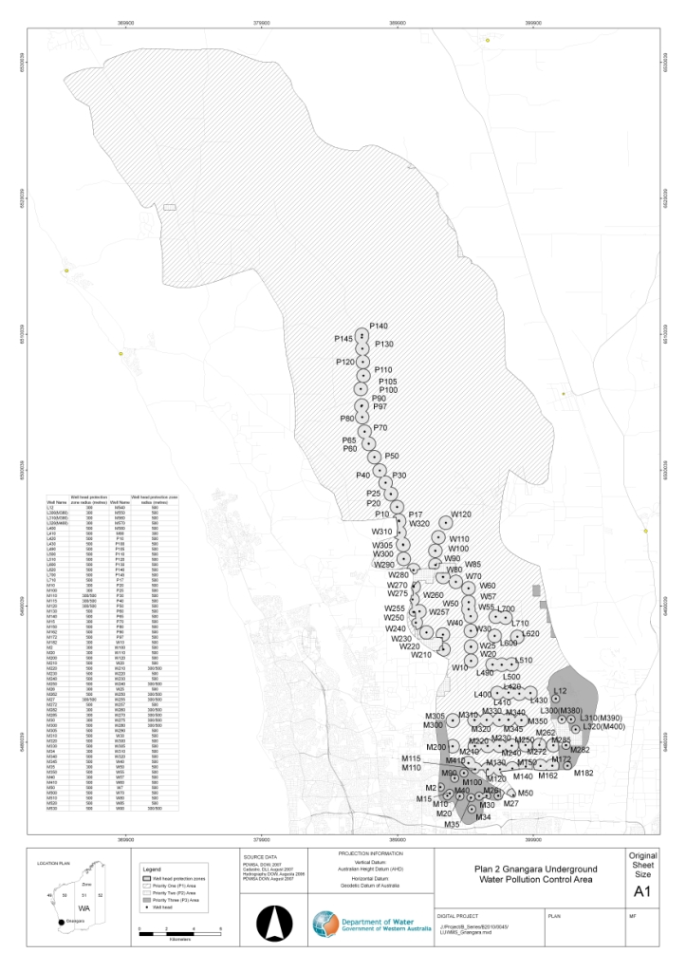
[Plan 2 inserted: Gazette 28 Mar 2008 p. 920.]
[Plan 3 deleted: Gazette 28 Mar 2008 p. 920.]
Plan 4 — Jandakot Underground Water Pollution Control Area
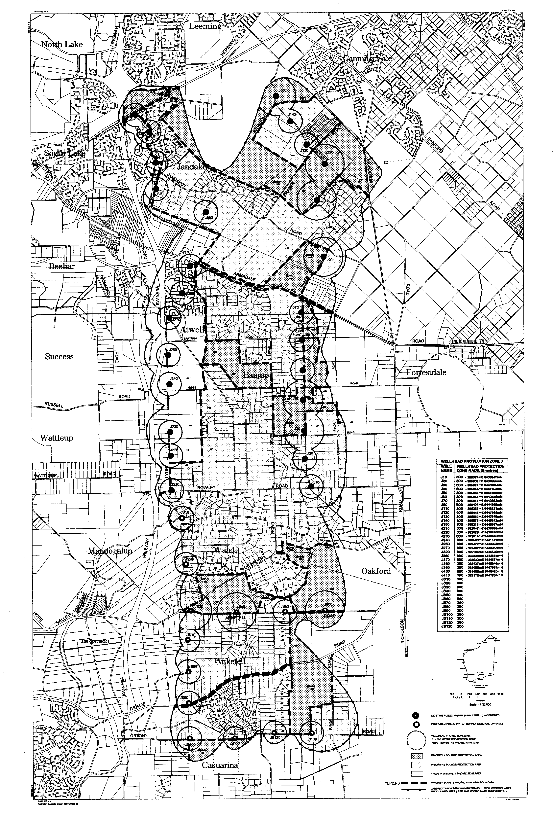
[Plan 4 inserted: Gazette 31 Dec 1992 p. 6423; amended: Gazette 1 Sep 2000 p. 5021.]
Plan 5 — Locations of Underground Water Pollution Control Areas
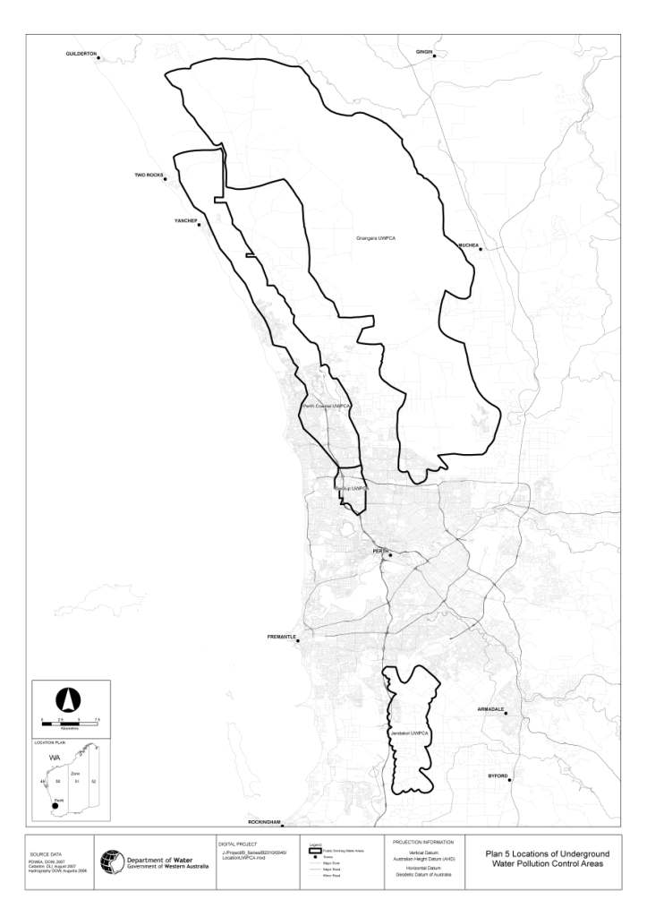
[Plan 5 inserted: Gazette 28 Mar 2008 p. 921.]

[6.0. Deleted: Gazette 14 Nov 2013 p. 5056.]

[7.0. Deleted: Gazette 28 Jun 2004 p. 2375.]

[8.0: bl. 8.2-8.9 deleted: Gazette 25 Aug 1998 p. 4730;
bl. 8.1 deleted: Gazette 28 Jun 2004 p. 2375.]

[9.0. Deleted: Gazette 25 Aug 1998 p. 4730.]

[10.0: bl. 10.3-10.11 deleted: Gazette 4 May 1993 p. 2329;
bl. 10.1-10.2 deleted: Gazette 25 Aug 1998 p. 4730.]

[11.0: bl. 11.1, 11.2 deleted: Gazette 14 Nov 2013 p. 5056;
bl. 11.3-11.5 deleted: Gazette 25 Aug 1998 p. 4730.]

[12.0: bl. 12.1 and 12.5 and Figure 12.1 deleted: Gazette 14 Nov 2013 p. 5056;
bl. 12.2-12.4 deleted: Gazette 28 Jun 2004 p. 2375.]

[13.0: bl. 13.1.1-13.1.3 and 13.2 deleted: Gazette 25 Aug 1998 p. 4731:
bl. 13.1.4. deleted: Gazette 14 Nov 2013 p. 5056.]

[14.0: bl. 14.1, 14.3, 14.5, 14.6 deleted: Gazette 25 Aug 1998 p. 4731;
bl. 14.2, 14.4 deleted: Gazette 28 Jun 2004 p. 2375.]

[15.0: bl. 15.5 deleted: Gazette 25 Aug 1998 p. 4731:
bl. 15.6 and 15.7 deleted: Gazette 28 Jun 1985 p. 2349;
balance deleted: Gazette 14 Nov 2013 p. 5056.]

[16.0. Deleted: Gazette 28 Jun 2004 p. 2375.]

[17.0: bl. 17.1, 17.2, 17.4 deleted: Gazette 25 Aug 1998 p. 4734;
bl. 17.3 deleted: Gazette 22 Dec 1989 p. 4631.]

[18.0: bl. 18.1 deleted: Gazette 25 Aug 1998 p. 4734;
bl. 18.2, 18.3 deleted: Gazette 28 Jun 2004 p. 2375;
bl. 18.4-18.19, 18.21, 18.22, 18.24 and 18.25 deleted: Gazette 25 Aug 1998 p. 4734;
bl. 18.20 deleted: Gazette 28 Jun 2004 p. 2375;
bl. 18.23 deleted: Gazette 14 Nov 2013 p. 5056.]

[19.0: bl. 19.1, 19.2, 19.4-19.8 deleted: Gazette 25 Aug 1998 p. 4734;
bl. 19.3 deleted: Gazette 28 Jun 2004 p. 2375.]

[20.0-24.0. Deleted: Gazette 25 Aug 1998 p. 4734.]

[25.0: bl. 25.1-25.6, 25.8-25.15 deleted: Gazette 25 Aug 1998 p. 4734;
bl. 25.7 deleted: Gazette 28 Jun 2004 p. 2376.]

[26.0: bl. 26.1-26.3 deleted: Gazette 25 Aug 1998 p. 3734;
bl. 26.4 deleted: Gazette 28 Jun 2004 p. 2376.]

[27.0, 28.0 deleted: Gazette 14 Nov 2013 p. 5056.]

[29.0. Deleted: Gazette 18 Jun 1982 p. 2023.]

[30.0. bl. 30.1-30.8, 30.10-30.14, 30.17 and 30.18 deleted: Gazette 16 Jun 2000 p. 2960;
bl. 30.15 Deleted: Gazette 22 Dec 1989 p. 4638;
balance deleted: Gazette 14 Nov 2013 p. 5056.]

31.0 Offences and penalties

[31.1-31.3 Deleted: Gazette 14 Nov 2013 p. 5056.]

31.4 Penalties
31.4.1 A person committing a breach of any of the provisions of these by-laws, to which no specific penalty is attached shall be liable on summary conviction to a penalty not exceeding $200.00 and in addition may be ordered to pay any expense incurred by the State in consequence of such breach.
31.4.2 In the case of a continuing breach the offender shall be liable in addition to the fine and payment of expenses to a daily penalty not exceeding $50.00 for each day the breach continues after notice thereof has been given by or on behalf of the Minister or the CEO to the offender.
[By-law 31.4 amended: Gazette 24 Dec 1982 p. 4930; 29 Dec 1995 p. 6326; 26 Apr 2005 p. 1397; 21 Apr 2011 p. 1481; 14 Nov 2013 p. 5057.]

[31.5-31.6 Deleted: Gazette 14 Nov 2013 p. 5057.]

[32.0. Deleted: Gazette 14 Nov 2013 p. 5057.]

[33.0. Omitted under the Reprints Act 1984 s. 7(4)(f).]

[Schedule A deleted: Gazette 18 Jun 1982 p. 2023.]

[Schedule B-D deleted: Gazette 14 Nov 2013 p. 5057.]

Schedule 1 — Description of South West Settlement Area
[bl. 1.1]
[Heading inserted: Gazette 7 Jun 2016 p. 1787.]
All the lands and waters contained within a line that —
• starts at the intersection of the prolongation westerly of the northern boundary of the Shire of Coorow with the low water mark, being a point on a northern boundary of native title determination application WAD6192/1998 (WC97/71) as accepted for registration on the Register of Native Title Claims on 22 August 1997;
• then continues generally easterly and generally south-easterly along the boundaries of that native title application to the intersection with native title determination application WAD6181/1998 (WC00/7) as accepted for registration on the Register of Native Title Claims on 3 July 2008;
• then continues generally easterly, generally south-easterly and westerly along the boundaries of that native title application to the intersection with native title determination application WAD6286/1998 (WC98/70) as accepted for registration on the Register of Native Title Claims on 29 September 1998;
• then continues generally southerly along the boundaries of that native title application to the intersection with the low water mark;
• then continues generally south-westerly, generally north-westerly and generally northerly along the low water mark back to the starting point,
other than any land or waters the subject of native title determination application WAD6193/1998 (WC97/72-6) as accepted for registration on the Register of Native Title Claims on 12 December 2011.
And all the islands landward of the low water mark that exist within the area contained within a line that —
• starts at the intersection of the prolongation westerly of the northern boundary of the Shire of Coorow with the low water mark;
• then continues generally southerly, generally south-easterly and generally north-easterly along the low water mark to the intersection with longitude 120.465236;
• then continues southerly to the intersection of the 3 nautical mile limit with longitude 120.465236;
• then continues generally south-westerly, generally north-westerly and generally northerly along the 3 nautical mile limit to the prolongation westerly of the northern boundary of the Shire of Coorow;
• then continues easterly along that prolongation back to the starting point.
Notes for this Schedule:
1. The low water mark is sourced from the Spatial Cadastral Database maintained by the Western Australian Land Information Authority as at 29 October 2012.
2. Coordinate references are to Geocentric Datum of Australia 1994 (GDA94) coordinates in decimal degrees.
3. The 3 nautical mile limit is sourced from Australian Maritime Boundaries (AMB), 6th edition, released in February 2006.
[Schedule 1 inserted: Gazette 7 Jun 2016 p. 1786-7.]

Schedule 2 — Map of South West Settlement Area
[bl. 1.1]
[Heading inserted: Gazette 7 Jun 2016 p. 1787.]
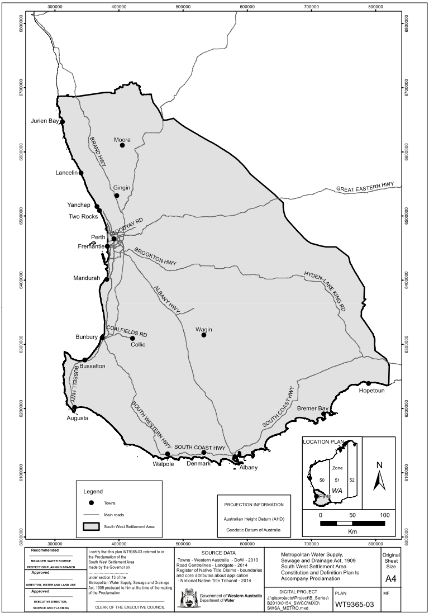
[Schedule 2 inserted: Gazette 7 Jun 2016 p. 1787.]

Notes
This is a compilation of the Metropolitan Water Supply, Sewerage and Drainage By-laws 1981 and includes amendments made by other written laws. For provisions that have come into operation, and for information about any reprints, see the compilation table.

Compilation table
Citation | Published |  | Commencement
Metropolitan Water Supply, Sewerage and Drainage By-laws 1981 |  | 22 Jan 1981 p. 165-384  (corrigendum 30 Jan 1981 p. 488) |  | 1 Mar 1981 (see bl. 1.0)
Metropolitan Water Supply, Sewerage and Drainage Board By-laws No. 1 of 1981 |  | 20 Feb 1981 p. 773 |  | 1 Mar 1981 (see bl. 2)
Metropolitan Water Supply, Sewerage and Drainage Amendment By-laws (No. 3) 1981 |  | 26 Jun 1981 p. 2326-7 |  | 1 Jul 1981 (see bl. 2)
Metropolitan Water Supply, Sewerage and Drainage Board Amendment By-laws No. 2 of 1981 |  | 31 Jul 1981 p. 3169-73 |  | 31 Jul 1981
Metropolitan Water Supply, Sewerage and Drainage Board Amendment By-laws 1982 |  | 26 Mar 1982 p. 1088 |  | 1 Jul 1982 (see bl. 2)
Metropolitan Water Supply, Sewerage and Drainage Amendment By-laws (No. 2) 1982 |  | 18 Jun 1982 p. 2022-3 |  | 1 Jul 1982 (see bl. 2)
Metropolitan Water Supply, Sewerage, and Drainage Amendment By-laws (No. 3) 1982 |  | 24 Dec 1982 p. 4924-30  (corrigendum 4 Feb 1983 p. 425) |  | 31 Dec 1982 (see bl. 2 and Gazette 31 Dec 1982 p. 4969)
Metropolitan Water Supply, Sewerage, and Drainage Amendment By-laws 1983 |  | 24 Jun 1983 p. 2007-8 |  | 1 Jul 1983 (see bl. 2)
Metropolitan Water Supply, Sewerage, and Drainage Amendment By-laws 1984 |  | 6 Apr 1984 p. 978 |  | 1 Jul 1984 (see bl. 2)
Metropolitan Water Supply, Sewerage and Drainage Amendment By-laws (No. 2) 1984 |  | 29 Jun 1984 p. 1812-13 |  | 1 Jul 1984 (see bl. 3)
Metropolitan Water Supply, Sewerage and Drainage Amendment By-laws (No. 2) 1985 |  | 8 Mar 1985 p. 907 |  | By-laws other than bl. 5: 8 Mar 1985 (see bl. 2(1));  bl. 5: 1 Jul 1985 (see bl. 2(2))
Metropolitan Water Supply, Sewerage and Drainage Amendment By-laws (No. 3) 1985 |  | 28 Jun 1985 p. 2348-9 |  | 1 Jul 1985 (see bl. 2)
Metropolitan Water Supply, Sewerage and Drainage Amendment By-laws 1985 |  | 28 Jun 1985 p. 2349-51 |  | 28 Jun 1985
Metropolitan Water Supply, Sewerage and Drainage Amendment By-laws 1986 |  | 27 Jun 1986 p. 2131-2 |  | 1 Jul 1986 (see bl. 2)
Reprint of the Metropolitan Water Supply, Sewerage and Drainage By-laws 1981 as at 7 Nov 1986 (includes amendments listed above)
Water Authority Amendment By-laws 1987 Pt. V ² |  | 14 Jul 1987 p. 2649-58 |  | 14 Jul 1987
Metropolitan Water Supply, Sewerage and Drainage Amendment By-laws 1988 |  | 19 Feb 1988 p. 551-2 |  | 19 Feb 1988
Metropolitan Water Supply, Sewerage and Drainage Amendment By-laws (No. 3) 1988 |  | 29 Jun 1988 p. 2126-7 |  | 1 Jul 1988 (see bl. 2)
Metropolitan Water Supply, Sewerage and Drainage Amendment By-laws (No. 2) 1988 |  | 14 Oct 1988 p. 4173-4 |  | 14 Oct 1988
Metropolitan Water Supply, Sewerage and Drainage Amendment By-laws 1989 |  | 21 Apr 1989 p. 1174-5  (erratum 19 May 1989 p. 1499) |  | 21 Apr 1989
Metropolitan Water Supply, Sewerage and Drainage Amendment By-laws (No. 3) 1989 |  | 12 May 1989 p. 1445-6 |  | 12 May 1989
Water Authority Amendment By-laws 1989 Pt. 5 ² |  | 29 Jun 1989 p. 1883-91 |  | 1 Jul 1989 (see bl. 3)
Metropolitan Water Supply, Sewerage and Drainage Amendment By-laws (No. 4) 1989 |  | 22 Dec 1989 p. 4622 |  | 1 Jan 1990 (see bl. 3)
Metropolitan Water Supply, Sewerage and Drainage Amendment By-laws (No. 5) 1989 |  | 22 Dec 1989 p. 4630-2 |  | 1 Feb 1990 (see bl. 2 and Gazette 5 Jan 1990 p. 38)
Metropolitan Water Supply, Sewerage and Drainage Amendment By-laws (No. 2) 1989 ³ |  | 22 Dec 1989 p. 4635-9 |  | 1 Feb 1990 (see bl. 2 and Gazette 5 Jan 1990 p. 38)
Water Authority Amendment By-laws 1990 Pt. 5 ² |  | 29 Jun 1990 p. 3240-8  (errata 6 Jul 1990 p. 3318) |  | 1 Jul 1990 (see bl. 3)
Metropolitan Water Supply, Sewerage and Drainage Amendment By-laws 1990 |  | 21 Sep 1990 p. 4951-2 |  | 21 Sep 1990
Water Authority Amendment By-laws 1991 Pt. 5 ² |  | 28 Jun 1991 p. 3281-9 |  | 1 Jul 1991 (see bl. 3)
Metropolitan Water Supply, Sewerage and Drainage Amendment By-laws 1991 |  | 3 Jan 1992 p. 34 |  | 3 Jan 1992
Water Authority Amendment By-laws 1992 Pt. 5 ² |  | 26 Jun 1992 p. 2832-44 |  | 1 Jul 1992 (see bl. 3)
Water Authority Amendment By-laws (No. 2) 1992 Pt. 2 |  | 31 Dec 1992 p. 6414-17 |  | 1 Jan 1993 (see bl. 2)
Metropolitan Water Supply, Sewerage and Drainage Amendment By-laws 1992 |  | 31 Dec 1992 p. 6417-24 |  | 31 Dec 1992
Metropolitan Water Supply, Sewerage and Drainage Amendment By-laws (No. 2) 1993 |  | 4 May 1993 p. 2329-30 |  | 4 May 1993
Water Authority Amendment By-laws 1993 Pt. 5 ² |  | 1 Jul 1993 p. 3238-50 |  | 1 Jul 1993
Metropolitan Water Supply, Sewerage and Drainage Amendment By-laws 1993 |  | 30 Jul 1993 p. 4165-6 |  | 30 Jul 1993
Water Authority Amendment By-laws 1994 Pt. 5 ² |  | 29 Jun 1994 p. 3159-70 |  | 1 Jul 1994 (see bl. 2)
Metropolitan Water Supply, Sewerage and Drainage Amendment By-laws 1995 |  | 23 Jun 1995 p. 2509-10 |  | 23 Jun 1995
Water Authority Amendment By-laws 1995 Pt. 5 ² |  | 30 Jun 1995 p. 2767-76 |  | 1 Jul 1995 (see bl. 2)
Metropolitan Water Supply, Sewerage and Drainage Amendment By-laws (No. 2) 1995 |  | 30 Jun 1995 p. 2778 |  | 30 Jun 1995
Water Agencies (Amendment and Repeal) By-laws 1995 Pt. 8 |  | 29 Dec 1995 p. 6305-32 |  | 1 Jan 1996 (see bl. 2 and Gazette 29 Dec 1995 p. 6291)
Metropolitan Water Supply, Sewerage and Drainage Amendment By-laws 1996 |  | 4 Feb 1997 p. 712-18 |  | 4 Feb 1997
Reprint of the Metropolitan Water Supply, Sewerage and Drainage By-laws 1981 as at 19 May 1997 (includes amendments listed above)
Water Agencies Amendment By-laws 1997 Pt. 5 ² |  | 27 Jun 1997 p. 3204-20 |  | 1 Jul 1997 (see bl. 2)
Water Agencies Amendment By-laws 1998 Pt. 5 ² |  | 26 Jun 1998 p. 3417-21 |  | 1 Jul 1998 (see bl. 2)
Metropolitan Water Supply, Sewerage and Drainage Amendment By-laws 1998 |  | 25 Aug 1998 p. 4724-35 |  | 25 Aug 1998
Metropolitan Water Supply, Sewerage and Drainage Amendment By-laws (No. 2) 1998 |  | 29 Sep 1998 p. 5405 |  | 29 Sep 1998 (see bl. 2)
Water Agencies Amendment By-laws 1999 Pt. 6 ² |  | 29 Jun 1999 p. 2775-87 |  | 1 Jul 1999 (see bl. 2)
Reprint of the Metropolitan Water Supply, Sewerage and Drainage By-laws 1981 as at 5 May 2000 (includes amendments listed above)
Metropolitan Water Supply, Sewerage and Drainage Amendment By-laws 2000 |  | 16 Jun 2000 p. 2958-60 |  | 19 Jun 2000 (see bl. 2 and Gazette 16 Jun 2000 p. 2939)
Water Agencies Amendment By-laws 2000 Pt. 6 ² |  | 29 Jun 2000 p. 3365-79 |  | 1 Jul 2000 (see bl. 2)
Metropolitan Water Supply, Sewerage and Drainage Amendment By-laws (No. 2) 2000 |  | 1 Sep 2000 p. 5020-1 |  | 1 Sep 2000
Metropolitan Water Supply, Sewerage and Drainage Amendment By-laws (No. 4) 2000 |  | 29 Sep 2000 p. 5551 |  | 29 Sep 2000
Metropolitan Water Supply, Sewerage and Drainage Amendment By-laws (No. 3) 2000 |  | 14 Nov 2000 p. 6255-6 |  | 14 Nov 2000
Water Agencies Amendment By-laws 2001 Pt. 7 ² |  | 29 Jun 2001 p. 3230-42 |  | 1 Jul 2001 (see bl. 2)
Reprint of the Metropolitan Water Supply, Sewerage and Drainage By-laws 1981 as at 17 Aug 2001 (includes amendments listed above)
Water Agencies Amendment By-laws 2002 Pt. 5 |  | 1 Jul 2002 p. 3137-53 |  | 1 Jul 2002
Water Agencies Amendment By-laws 2003 Pt. 6 ² |  | 27 Jun 2003 p. 2422-32 |  | 1 Jul 2003 (see bl. 2)
Metropolitan Water Supply, Sewerage and Drainage Amendment By-laws 2004 |  | 28 Jun 2004 p. 2371-9 |  | 1 Jul 2004 (see bl. 2 and Gazette 28 Jun 2004 p. 2399)
Water Agencies Amendment By-laws 2004 Pt. 5 ² |  | 29 Jun 2004 p. 2497-503 |  | 1 Jul 2004 (see bl. 2)
Metropolitan Water Supply, Sewerage and Drainage Amendment By-laws 2005 |  | 26 Apr 2005 p. 1396-7 |  | 26 Apr 2005
Water Agencies Amendment By-laws 2005 Pt. 6 ² |  | 1 Jul 2005 p. 3009-17 |  | 1 Jul 2005 (see bl. 2)
Water Agencies Amendment By-laws 2006 Pt. 6 ² |  | 30 Jun 2006 p. 2399-412 |  | 1 Jul 2006 (see bl. 2)
Reprint 5: The Metropolitan Water Supply, Sewerage and Drainage By-laws 1981 as at 14 Jul 2006 (includes amendments listed above)
Metropolitan Water Supply, Sewerage and Drainage Amendment By-laws (No. 2) 2007 ⁴ |  | 5 Apr 2007 p. 1529-31 |  | 5 Apr 2007
Metropolitan Water Supply, Sewerage and Drainage Amendment By-laws (No. 3) 2007 |  | 13 Apr 2007 p. 1685-6 |  | 13 Apr 2007 (see bl. 2)
Water Agencies Amendment By-laws 2007 Pt. 6 ² |  | 29 Jun 2007 p. 3233-44 |  | 1 Jul 2007 (see bl. 2(b))
Metropolitan Water Supply, Sewerage and Drainage Amendment By-laws (No. 2) 2008 |  | 28 Mar 2008 p. 919-21 |  | bl. 1 and 2: 28 Mar 2008 (see bl. 2(a));  By-laws other than bl. 1 and 2: 29 Mar 2008 (see bl. 2(b))
Metropolitan Water Supply, Sewerage and Drainage Amendment By-laws 2008 |  | 23 May 2008 p. 2009-13 |  | bl. 1 and 2: 23 May 2008 (see bl. 2(a));  By-laws other than bl. 1 and 2: 24 May 2008 (see bl. 2(b))
Water Agencies Amendment By-laws 2008 Pt. 6 ⁵ |  | 27 Jun 2008 p. 3076-84 |  | 1 Jul 2008 (see bl. 2(b))
Metropolitan Water Supply, Sewerage and Drainage Amendment By-laws (No. 5) 2008 |  | 26 Aug 2008 p. 4031-2 |  | bl. 1 and 2: 26 Aug 2008 (see bl. 2(a));  By-laws other than bl. 1 and 2: 27 Aug 2008 (see bl. 2(b))
Reprint 6: The Metropolitan Water Supply, Sewerage and Drainage By-laws 1981 as at 9 Jan 2009 (includes amendments listed above)
Water Agencies Amendment By-laws 2009 Pt. 6 |  | 19 Jun 2009 p. 2393-406 |  | 1 Jul 2009 (see bl. 2(b))
Metropolitan Water Supply, Sewerage and Drainage Amendment By-laws (No. 2) 2010 |  | 25 Jun 2010 p. 2883 |  | bl. 1 and 2: 25 Jun 2010 (see bl. 2(a));  By-laws other than bl. 1 and 2: 26 Jun 2010 (see bl. 2(b))
Water Agencies Amendment By-laws 2010 Pt. 6 | 25 Jun 2010 p. 2983-96 |  | 1 Jul 2010 (see bl. 2(b))
Metropolitan Water Supply, Sewerage and Drainage Amendment By-laws 2011 | 18 Mar 2011 p. 927-8 |  | bl. 1 and 2: 18 Mar 2011 (see bl. 2(a));  By-laws other than bl. 1 and 2: 19 Mar 2011 (see bl. 2(b)(i))
Metropolitan Water Supply, Sewerage and Drainage Amendment By-laws (No. 2) 2011 | 21 Apr 2011 p. 1473-83 |  | bl. 1 and 2: 21 Apr 2011 (see bl. 2(a));  By-laws other than bl. 1 and 2: 22 Apr 2011 (see bl. 2(b))
Water Agencies Amendment By-laws 2011 Pt. 6 | 23 Jun 2011 p. 2403-16 |  | 1 Jul 2011 (see bl. 2(b))
Reprint 7: The Metropolitan Water Supply, Sewerage and Drainage By-laws 1981 as at 3 Feb 2012 (includes amendments listed above)
Water Agencies Amendment By-laws 2012 Pt. 6 | 20 Jun 2012 p. 2677-92 |  | 1 Jul 2012 (see bl. 2(b))
Water Agencies Amendment By-laws 2013 Pt. 6 | 19 Jun 2013 p. 2333-46 |  | 1 Jul 2013 (see bl. 2(b))
Metropolitan Water Supply, Sewerage and Drainage Amendment By-laws 2013 | 14 Nov 2013 p. 5053-7 |  | bl. 1 and 2: 14 Nov 2013 (see bl. 2(a));  By-laws other than bl. 1 and 2: 18 Nov 2013 (see bl. 2(b) and Gazette 14 Nov 2013 p. 5027)
Metropolitan Water Supply, Sewerage and Drainage Amendment By-laws 2016 | 7 Jun 2016 p. 1782-7 |  | bl. 1 and 2: 7 Jun 2016 (see bl. 2(a));  By-laws other than bl. 1 and 2: 8 Jun 2016 (see bl. 2(b))
Water By-laws Amendment (Public Health) By-laws 2016 Pt. 3 | 10 Jan 2017 p. 233-5 |  | 24 Jan 2017 (see bl. 2(b) and Gazette 10 Jan 2017 p. 165)
Metropolitan Water Supply, Sewerage and Drainage Amendment By-laws 2023 | SL 2023/54 19 May 2023 |  | bl. 1 and 2: 19 May 2023 (see bl. 2(a));  By-laws other than bl. 1 and 2: 1 Jul 2023 (see bl. 2(b))

Other notes
¹ These by-laws have effect for the purposes of the Metropolitan Water Supply, Sewerage, and Drainage Act 1909 but the formal power to make them is now given by the Water Agencies (Powers) Act 1984 s. 34.
² These by-laws contain an application provision concerning fees and charges for a period commencing before, or for a matter or thing done before, the by-laws came into operation.
³ The Metropolitan Water Supply, Sewerage and Drainage Amendment By-laws (No. 2) 1989 contains a savings and transitional provision (bl. 11) that is of no further effect.
⁴ The Metropolitan Water Supply, Sewerage and Drainage Amendment By-laws (No. 2) 2007 bl. 4 reads as follows:

4. Transitional provision
By-law 28.1 of the Metropolitan Water Supply, Sewerage and Drainage By-laws 1981, as amended by these by-laws, applies, after the commencement of these by-laws, in relation to a permit to discharge industrial waste, whether the permit is granted before, on or after that commencement.

⁵ The Water Agencies Amendment By-laws 2008 bl. 3 reads as follows:

3. Application
Nothing in these by-laws affects the application after 1 July 2008 of a by-law in force before that day insofar as that by-law relates to a fee or charge for a period commencing before that day or to a fee or charge for any matter or thing done before that day.

Defined terms

[This is a list of terms defined and the provisions where they are defined. The list is not part of the law.]
Defined term Provision(s)
Aboriginal customary purpose 1.1
Act 1.1
automotive business premises 5.6
bore 1.1
bulk liquid storage tank system 5.6
CALM Act land 4.11
CALM Act Minister 4.11
Corporation 1.1
Dangerous Goods Storage Regulations 1.1
designated camping site 1.1
diameter 1.1
domestic sewage 1.1
elevated storage tank system 5.6
establish 5.6
feeder 1.1
ground 1.1
ground storage tank system 5.6
hand-held tool 4.12
high-water mark 1.1
industrial waste 1.1
liquid waste 1.1
Noongar 1.1
observation well 1.1
owner 5.6
people 1.1
pesticides 1.1
petroleum product 1.1
plans 5.6
priority 1 source protection area 5.6
priority 2 source protection area 5.6
priority 3 source protection area 5.6
production well 1.1
registered Aboriginal place 1.1
size 1.1
South West Settlement Area 1.1
special provision catchment area 1.1
take 4.12
tank 5.6
underground storage or handling system 1.1
underground water 1.1
unpolluted water 5.6
wellhead 5.6
wellhead protection zone 4.11, 5.6
works 1.1

© State of Western Australia 2023.
This work is licensed under a Creative Commons Attribution 4.0 International Licence (CC BY 4.0). To view relevant information and for a link to a copy of the licence, visit www.legislation.wa.gov.au.
Attribute work as: © State of Western Australia 2023.
By Authority: GEOFF O. LAWN, Government Printer

