
Western Australia

Queens Gardens Car Park (Inner City School) Act 2024

Western Australia
Queens Gardens Car Park (Inner City School) Act 2024
Contents
Part 1 — Preliminary
1. Short title 2
2. Commencement 2
3. Act binds Crown 2
4. Terms used 2
Part 2 — Chevron Agreement terminated and Act repealed
5. Agreement terminated and Chevron-Hilton Hotel Agreement Act 1960 repealed 4
6. Relevant indemnity continues despite termination of Chevron Agreement 4
Part 3 — Transfer of land and land assembly
Division 1 — Transfer of land to Minister for Education
7. Road closure and transfer of Hale Street north land 5
8. Transfer of Queens Gardens car park land 5
Division 2 — Land assembly
9. Transferred land to be single lot 5
10. Registrar of Titles to take certain measures 6
11. Functions of Registrar of Titles under this Part not limited by other requirements 6
12. Exemption from taxes, duties, levies, charges and fees 6
Part 4 — Effect of termination, repeal and transfer
13. State Government entities have no liability in relation to certain matters 7
14. Payment to City of Perth for lost car park revenue because of land transfer 8
Part 5 — Facilities for government school
15. Minister for Education’s functions 9
16. Application of redevelopment scheme 9
Part 6 — Regulation-making power
17. Regulations 10
Schedule 1 — Queens Gardens car park land
Schedule 2 — Hale Street north land plan
Schedule 3 — Development lot plan
Defined terms

Western Australia
Queens Gardens Car Park (Inner City School) Act 2024
No. 34 of 2024
An Act —
- to terminate the agreement approved and ratified by the Chevron-Hilton Hotel Agreement Act 1960; and
- to repeal the Chevron-Hilton Hotel Agreement Act 1960; and
- to provide for the transfer of certain land; and
- to provide for the effect of the termination, repeal and transfer; and
- to provide for the development of a government school on the transferred land; and
- for related purposes.
[Assented to 22 October 2024]
The Parliament of Western Australia enacts as follows:

Part 1 — Preliminary

1. Short title
This is the Queens Gardens Car Park (Inner City School) Act 2024.

2. Commencement
This Act comes into operation as follows —
(a) Part 1 (other than sections 3 and 4) — on the day on which this Act receives the Royal Assent;
(b) the rest of the Act — on the day after that day.

3. Act binds Crown
This Act binds the Crown in right of Western Australia and, so far as the legislative power of the Parliament permits, the Crown in all its other capacities.

4. Terms used
In this Act —
Chevron Agreement has the meaning given in section 5(1);
City of Perth means the body corporate called the City of Perth continued under the City of Perth Act 2016 section 6(1);
commencement day means the day on which this definition comes into operation;
development lot has the meaning given in section 9;
freehold, in relation to land, means the fee simple, whether absolute, conditional or otherwise, of that land;
government school means a school established under the School Education Act 1999 section 55;
Hale Street north land means the land depicted on the plan in Schedule 2 as lot 101;
interest, in relation to land, has the meaning given in the Land Administration Act 1997 section 151(1);
lot means a defined portion of land that is the whole of the land —
(a) the subject of a registered certificate of title; or
(b) depicted as a lot on the plan in Schedule 2 or 3;
Minister for Education means the body corporate referred to in the School Education Act 1999 section 214(1);
Queens Gardens car park land means —
(a) the land comprising the lots the subject of the certificates of title specified in Schedule 1; and
(b) the portion of land delineated and coloured brown on the map on Certificate of Title Volume 925 Folio 2;
registered means registered under the Transfer of Land Act 1893;
Registrar of Titles means the Registrar of Titles referred to in the Transfer of Land Act 1893 section 7;
transferred land means the land comprised of —
(a) the Hale Street north land, the freehold of which is transferred to the Minister for Education under section 7(2); and
(b) the Queens Gardens car park land, the freehold of which is transferred to the Minister for Education under section 8(1).

Part 2 — Chevron Agreement terminated and Act repealed

5. Agreement terminated and Chevron-Hilton Hotel Agreement Act 1960 repealed
(1) The agreement (the Chevron Agreement) approved and ratified by the Chevron-Hilton Hotel Agreement Act 1960 section 4(1) is terminated.
(2) The Chevron-Hilton Hotel Agreement Act 1960 is repealed.

6. Relevant indemnity continues despite termination of Chevron Agreement
(1) In this section —
relevant indemnity means the indemnity in clause 18 of the Chevron Agreement as in force immediately before commencement day.
(2) Despite section 5, the relevant indemnity continues to apply for the 20-year period beginning on commencement day.
(3) A question as to whether the City of Perth has a liability under the relevant indemnity, or as to the amount of any liability of the City of Perth under the indemnity, may, on application by the City of Perth or the State, be determined by a court of competent jurisdiction.
(4) The expiry of the relevant indemnity at the end of the 20-year period under subsection (2) does not affect the City of Perth’s liability to the State under the relevant indemnity in relation to actions, claims, damages, costs or demands that arise before the expiry.

Part 3 — Transfer of land and land assembly

Division 1 — Transfer of land to Minister for Education

7. Road closure and transfer of Hale Street north land
(1) The portion of Hale Street that is the Hale Street north land —
(a) is closed; and
(b) ceases to be designated as a road; and
(c) ceases to be a public right of way.
(2) The freehold in the land comprising the Hale Street north land is transferred to the Minister for Education.
(3) Every other interest, whether registered or unregistered, in the land comprising the Hale Street north land that existed immediately before commencement day is extinguished.

8. Transfer of Queens Gardens car park land
(1) The freehold in the land comprising the Queens Gardens car park land is transferred to the Minister for Education.
(2) Every other interest, whether registered or unregistered, in the land comprising the Queens Gardens car park land that existed immediately before commencement day is extinguished.

Division 2 — Land assembly

9. Transferred land to be single lot
As soon as practicable, the Registrar of Titles must create a certificate of title for the single lot (the development lot) depicted on the plan in Schedule 3 as lot 100, comprising the transferred land.

10. Registrar of Titles to take certain measures
The Registrar of Titles must do all things necessary under the Transfer of Land Act 1893 to record in the register kept under that Act the matters effected by this Part.

11. Functions of Registrar of Titles under this Part not limited by other requirements
(1) This section applies if —
(a) the Registrar of Titles is required to perform a function under this Part; and
(b) under a written law (other than this Act), that function must not be performed without —
(i) an endorsement or approval (a planning approval) having been obtained; or
(ii) a precondition or other requirement (a planning requirement) having been satisfied.
(2) Despite the written law, the requirement to obtain the planning approval, or to satisfy the planning requirement, does not apply to the performance of the function by the Registrar of Titles.
Examples for this section:
1. The Western Australian Planning Commission’s approval is not required to amalgamate the lots that comprise the transferred land: see the Planning and Development Act 2005 section 135.
2. The Western Australian Planning Commission’s approval is not required to be endorsed on the diagram or plan of survey of the development lot: see the Planning and Development Act 2005 section 146.
3. The Western Australian Planning Commission’s approval is not required to register the transfer of land: see the Planning and Development Act 2005 section 147(1)(a).

12. Exemption from taxes, duties, levies, charges and fees
Anything that is done under this Part is exempt from any tax, duty, levy, charge or fee that would otherwise be imposed or recoverable under a written law.

Part 4 — Effect of termination, repeal and transfer

13. State Government entities have no liability in relation to certain matters
(1) A State Government entity has, and can have, no liability (including a liability for compensation) to any person or body in respect of any loss, or other matter or thing, that arises from, or is in any way connected with, any of the following —
(a) the Chevron Agreement;
(b) the preparation, introduction or enactment of this Act;
(c) the termination of the Chevron Agreement or the repeal of the Chevron-Hilton Hotel Agreement Act 1960 under section 5;
(d) the transfer of the transferred land;
(e) the extinguishment of an interest in land under section 7(3) or 8(2);
(f) any negotiations or communications with the City of Perth before commencement day in relation to the potential transfer of the freehold in land in East Perth to a State Government entity to establish a government school.
(2) Any liability of the type described in subsection (1) that a State Government entity has to any person or body before commencement day is extinguished.
(3) No claim or demand, or action or other proceeding, lies against a State Government entity in respect of —
(a) a liability of the type described in subsection (1); or
(b) otherwise, any loss, or other matter or thing, that arises from, or is in any way connected with, any of the matters referred to in subsection (1)(a) to (f).
(4) The Land Administration Act 1997 Parts 9 and 10 do not apply in relation to anything done under this Act.
(5) In this section, a reference to a State Government entity is a reference to any of the following —
(a) the State;
(b) a Minister of the Crown in right of the State;
(c) the Minister for Education;
(d) the Registrar of Titles;
(e) a public sector body as defined in the Public Sector Management Act 1994 section 3(1);
(f) any other person or body that is similar to a person or body referred to in paragraphs (b) to (e);
(g) an employee, agent, advisor, contractor or representative of the State or of a person or body referred to in paragraphs (b) to (f).
(6) In this section, a reference to a State Government entity does not include a local government.

14. Payment to City of Perth for lost car park revenue because of land transfer
(1) The State must pay the amount of $4 217 000 to the City of Perth.
(2) The amount to be paid under subsection (1) must be charged to the Consolidated Account which is appropriated accordingly by this section.

Part 5 — Facilities for government school

15. Minister for Education’s functions
The Minister for Education must ensure that facilities for a government school are constructed on the development lot.

16. Application of redevelopment scheme
(1) In this section —
Central Perth redevelopment area means the Central Perth redevelopment area, as amended from time to time, under the Metropolitan Redevelopment Authority Act 2011;
Central Perth Redevelopment Scheme means any approved redevelopment scheme, as amended from time to time, that for the time being applies to the Central Perth redevelopment area under the Metropolitan Redevelopment Authority Act 2011.
(2) The Central Perth Redevelopment Scheme applies to the development lot except that, despite any provision of that Scheme, the development lot can be used for the purpose of a government school.
(3) If there is no Central Perth Redevelopment Scheme or Central Perth redevelopment area, or the development lot ceases to be in the Central Perth redevelopment area, the reference to the Central Perth Redevelopment Scheme in subsection (2) is a reference to —
(a) an approved redevelopment scheme or other planning instrument in force under the Metropolitan Redevelopment Authority Act 2011 that applies to the land comprising the development lot; or
(b) if paragraph (a) does not apply — a planning scheme or other planning instrument in force under the Planning and Development Act 2005 that applies to the land comprising the development lot.

Part 6 — Regulation-making power

17. Regulations
The Governor may make regulations prescribing matters that are necessary or convenient to be prescribed for giving effect to this Act.

Schedule 1 — Queens Gardens car park land
[s. 4]
1. Certificate of Title Volume 1775 Folio 349
2. Certificate of Title Volume 1775 Folio 348
3. Certificate of Title Volume 1763 Folio 497
4. Certificate of Title Volume 1311 Folio 782
5. Certificate of Title Volume 1214 Folio 959
6. Certificate of Title Volume 1214 Folio 804
7. Certificate of Title Volume 1031 Folio 338
8. Certificate of Title Volume 1020 Folio 996
9. Certificate of Title Volume 1014 Folio 654
10. Certificate of Title Volume 925 Folio 3
11. Certificate of Title Volume 786 Folio 65
12. Certificate of Title Volume 781 Folio 155
13. Certificate of Title Volume 777 Folio 198
14. Certificate of Title Volume 777 Folio 194

Schedule 2 — Hale Street north land plan
[s. 4]
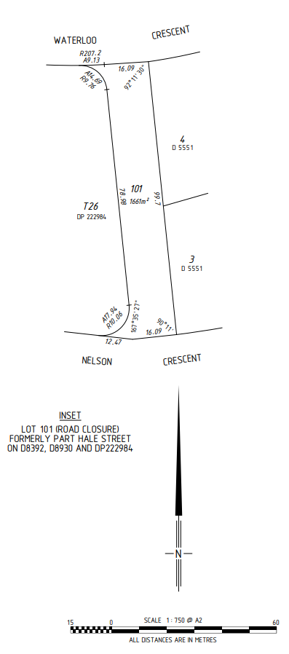

Schedule 3 — Development lot plan
[s. 9]
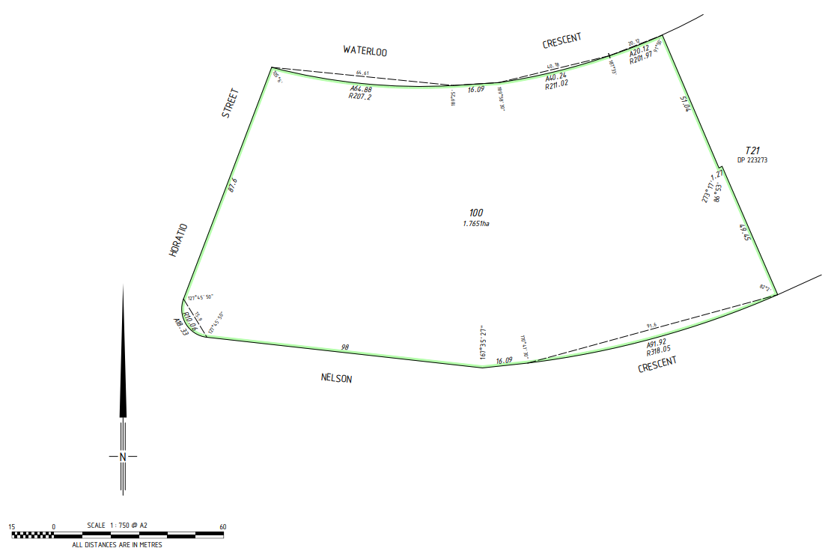


Defined terms

[This is a list of terms defined and the provisions where they are defined. The list is not part of the law.]
Defined term Provision(s)
Central Perth redevelopment area 16(1)
Central Perth Redevelopment Scheme 16(1)
Chevron Agreement 4, 5(1)
City of Perth 4
commencement day 4
development lot 4, 9
freehold 4
government school 4
Hale Street north land 4
interest 4
lot 4
Minister for Education 4
planning approval 11(1)
planning requirement 11(1)
Queens Gardens car park land 4
registered 4
Registrar of Titles 4
relevant indemnity 6(1)
State Government entity 13(5) and (6)
transferred land 4

© State of Western Australia 2024.
This work is licensed under a Creative Commons Attribution 4.0 International Licence (CC BY 4.0). To view relevant information and for a link to a copy of the licence, visit www.legislation.wa.gov.au.
Attribute work as: © State of Western Australia 2024.
By Authority: GEOFF O. LAWN, Government Printer

