
Western Australia
Liquor Control Act 1988

Liquor Control Amendment Regulations 2025

Western Australia
Liquor Control Amendment Regulations 2025
Contents
1. Citation 1
2. Commencement 1
3. Regulations amended 1
4. Regulation 28 amended 1
5. Schedule 4 clause 2 replaced 1
2. Hillarys 2

Liquor Control Act 1988
Liquor Control Amendment Regulations 2025
Made by the Governor in Executive Council.

1. Citation
These regulations are the Liquor Control Amendment Regulations 2025.

2. Commencement
These regulations come into operation as follows —
(a) regulations 1 and 2 — on the day on which these regulations are published on the WA legislation website;
(b) the rest of the regulations — on the day after that day.

3. Regulations amended
These regulations amend the Liquor Control Regulations 1989.

4. Regulation 28 amended
In regulation 28(2) in the Table item 2 delete “1.” and insert:

2.

5. Schedule 4 clause 2 replaced
Delete Schedule 4 clause 2 and insert:

2. Hillarys
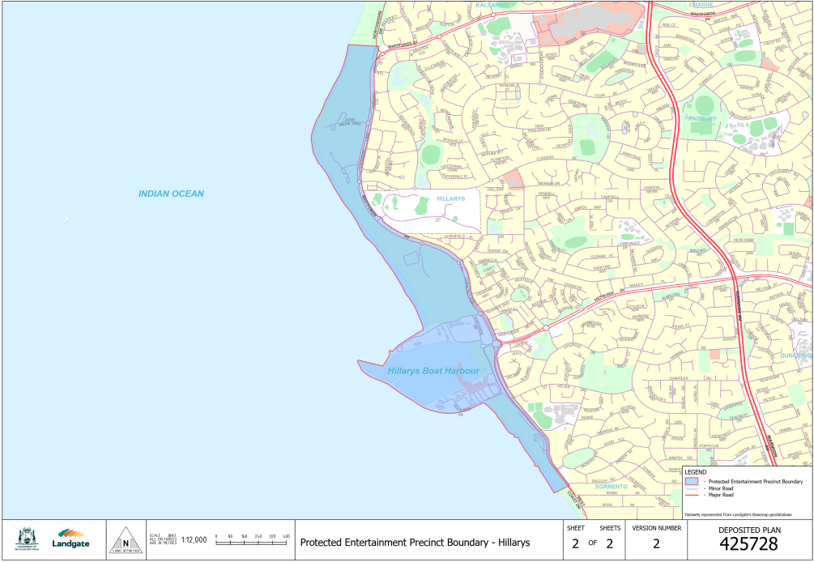

N. HAGLEY, Clerk of the Executive Council
© State of Western Australia 2025.
This work is licensed under a Creative Commons Attribution 4.0 International Licence (CC BY 4.0). To view relevant information and for a link to a copy of the licence, visit www.legislation.wa.gov.au.
Attribute work as: © State of Western Australia 2025.
By Authority: GEOFF O. LAWN, Government Printer

