
Western Australia
Major Events Act 2023

Major Events Amendment Regulations 2025

Western Australia
Major Events Amendment Regulations 2025
Contents
1. Citation 1
2. Commencement 1
3. Regulations amended 1
4. Part 4 inserted 1
Part 4 — AFC Women’s Asian Cup 2026
Division 1 — Preliminary
25. Terms used 1
Division 2 — Establishment of major event
26. AFC Women’s Asian Cup 2026 is major event 3
27. Major event organiser 3
28. Major event areas 3
29. Major event period 4
30. Application of Pt. 5 and 6 of Act to major event areas 5
31. Responsible authorities 5
32. Controlled areas 6
33. Control period 7
34. Application of Pt. 6 of Act to controlled areas 7
Division 3 — Official logos and titles for major event
35. Official logos 7
36. Official titles 8
Division 4 — Miscellaneous
37. Extended application of Act s. 49 9
38. Appointment of authorised officers 9
39. Eligibility for appointment as authorised officer 10
40. Signs must be erected in major event areas and controlled areas 10
5. Schedule 4 inserted 11
Schedule 4 — AFC Women’s Asian Cup 2026 major event areas and controlled areas

Major Events Act 2023
Major Events Amendment Regulations 2025
Made by the Governor in Executive Council.

1. Citation
These regulations are the Major Events Amendment Regulations 2025.

2. Commencement
These regulations come into operation as follows —
(a) regulations 1 and 2 — on the day on which these regulations are published on the WA legislation website;
(b) the rest of the regulations — on the day after that day.

3. Regulations amended
These regulations amend the Major Events Regulations 2023.

4. Part 4 inserted
After regulation 24 insert:

Part 4 — AFC Women’s Asian Cup 2026
Division 1 — Preliminary
25. Terms used
In this Part —
AFC Women’s Asian Cup 2026 means the event known as the AFC Women’s Asian Cup 2026;
match day —
(a) in relation to the Perth Rectangular Stadium major event area, means each of the following days —
(i) 4 March 2026;
(ii) 7 March 2026;
(iii) 9 March 2026;
(iv) 10 March 2026;
(v) 13 March 2026;
(vi) 14 March 2026;
and
(b) in relation to the Perth Stadium major event area, means each of the following days —
(i) 1 March 2026;
(ii) 17 March 2026;
match period —
(a) in relation to the Perth Rectangular Stadium major event area or the Perth Rectangular Stadium controlled area, means each of the following periods —
(i) 4 March 2026, from 10 am to 11 pm;
(ii) 7 March 2026, from 10 am to 11 pm;
(iii) 9 March 2026, from 2 pm to 9 pm;
(iv) 10 March 2026, from 2 pm to 9 pm;
(v) 13 March 2026, from 3 pm to 10 pm;
(vi) 14 March 2026, from 10 am to 5 pm;
and
(b) in relation to the Perth Stadium major event area or the Perth Stadium controlled area, means each of the following periods —
(i) 1 March 2026, from 2 pm to 9 pm;
(ii) 17 March 2026, from 3 pm to 10 pm;
Perth Rectangular Stadium controlled area means the area referred to in regulation 32(1)(a);
Perth Rectangular Stadium major event area means the area referred to in regulation 28(1)(a);
Perth Stadium controlled area means the area referred to in regulation 32(1)(b);
Perth Stadium major event area means the area referred to in regulation 28(1)(b).
Division 2 — Establishment of major event
26. AFC Women’s Asian Cup 2026 is major event
For the purposes of section 6(1) of the Act, the AFC Women’s Asian Cup 2026 is a major event.
27. Major event organiser
For the purposes of section 6(2)(a) of the Act, Local Organising Committee AFC Women’s Asian Cup 2026 Pty Ltd (ACN 681 496 006) is the major event organiser for the AFC Women’s Asian Cup 2026.
28. Major event areas
(1) For the purposes of section 6(2)(b) of the Act, each of the following areas is a major event area for the AFC Women’s Asian Cup 2026 —
(a) the Perth Rectangular Stadium major event area, being the area shown as the Perth Rectangular Stadium major event area on the map entitled “AFC Women’s Asian Cup 2026: Perth Rectangular Stadium major event area and controlled area” —
(i) held by the chief executive officer of the department; and
(ii) certified by the chief executive officer of the department as the map prepared for the purpose of defining the Perth Rectangular Stadium major event area and controlled area;
(b) the Perth Stadium major event area, being the area shown as the Perth Stadium major event area on the map entitled “AFC Women’s Asian Cup 2026: Perth Stadium major event area and controlled area” —
(i) held by the chief executive officer of the department; and
(ii) certified by the chief executive officer of the department as the map prepared for the purpose of defining the Perth Stadium major event area and controlled area.
(2) For information purposes, maps depicting the major event areas referred to in subregulation (1) are in Schedule 4.
29. Major event period
For the purposes of section 6(2)(c) of the Act, the major event period for the AFC Women’s Asian Cup 2026 is the period beginning on 15 February 2026 and ending on 20 March 2026.
30. Application of Pt. 5 and 6 of Act to major event areas
(1) This regulation applies to the AFC Women’s Asian Cup 2026 for the purposes of section 6(2)(e) of the Act.
(2) Sections 38, 39, 41 to 59, 61, 62, 64, 66 and 67 apply to —
(a) the Perth Rectangular Stadium major event area during each match period for that area; and
(b) the Perth Stadium major event area during each match period for that area.
(3) Section 40 of the Act applies to —
(a) the Perth Rectangular Stadium major event area on each match day for that area; and
(b) the Perth Stadium major event area on each match day for that area.
(4) Section 63 of the Act applies during the period beginning on 1 March 2026 and ending on 17 March 2026 to —
(a) the Perth Rectangular Stadium major event area; and
(b) the Perth Stadium major event area.
31. Responsible authorities
For the purposes of section 6(3) of the Act, each of the following is a responsible authority for the AFC Women’s Asian Cup 2026 —
(a) the department;
(b) the Western Australian Tourism Commission established under the Western Australian Tourism Commission Act 1983 section 4(1).
32. Controlled areas
(1) For the purposes of section 6(4)(a) of the Act, each of the following is a controlled area for the AFC Women’s Asian Cup 2026 —
(a) the Perth Rectangular Stadium controlled area, being the area shown as the Perth Rectangular Stadium controlled area on the map entitled “AFC Women’s Asian Cup 2026: Perth Rectangular Stadium major event area and controlled area” —
(i) held by the chief executive officer of the department; and
(ii) certified by the chief executive officer of the department as the map prepared for the purpose of defining the Perth Rectangular Stadium major event area and controlled area;
(b) the Perth Stadium controlled area, being the area shown as the Perth Stadium controlled area on the map entitled “AFC Women’s Asian Cup 2026: Perth Stadium major event area and controlled area” —
(i) held by the chief executive officer of the department; and
(ii) certified by the chief executive officer of the department as the map prepared for the purpose of defining the Perth Stadium major event area and controlled area.
(2) For information purposes, maps depicting the controlled areas referred to in subregulation (1) are in Schedule 4.
33. Control period
For the purposes of section 6(4)(b) of the Act, the control period for the AFC Women’s Asian Cup 2026 is the period beginning on 1 March 2026 and ending on 17 March 2026.
34. Application of Pt. 6 of Act to controlled areas
For the purposes of section 6(4)(c) of the Act —
(a) sections 61, 62, 64, 66 and 67 of the Act apply to —
(i) the Perth Rectangular Stadium controlled area during each match period for that area; and
(ii) the Perth Stadium controlled area during each match period for that area;
and
(b) section 63 of the Act applies during the control period to —
(i) the Perth Rectangular Stadium controlled area; and
(ii) the Perth Stadium controlled area.
Division 3 — Official logos and titles for major event
35. Official logos
For the purposes of section 68(1)(a) of the Act, each of the following is an official logo for the AFC Women’s Asian Cup 2026 —

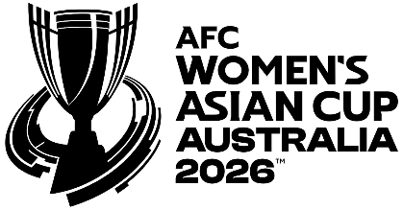
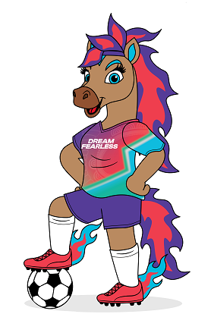
36. Official titles
For the purposes of section 68(1)(b) of the Act, each of the following is an official title for the AFC Women’s Asian Cup 2026 —
(a) AFC Women’s Asian Cup 2026;
(b) AFC Women’s Asian Cup;
(c) AFC WAC 2026;
(d) AFC WAC26;
(e) AFC Women’s Asian Cup Australia 2026;
(f) AFC Women’s Asian Cup Australia;
(g) Asian Football Confederation Women’s Asian Cup 2026;
(h) Asian Football Confederation Women’s Asian Cup;
(i) AFC WAC;
(j) Women’s Asian Cup 2026;
(k) WAC2026;
(l) WAC26.
Division 4 — Miscellaneous
37. Extended application of Act s. 49
(1) For the purposes of section 49(1)(h) of the Act, in its application to the AFC Women’s Asian Cup 2026, displaying a poster on property, including on the outside of a building or structure, is prescribed.
(2) Subregulation (1) does not apply to a poster that was displayed —
(a) before 1 March 2026; and
(b) in connection with the person’s ordinary activities for purposes unrelated to the AFC Women’s Asian Cup 2026.
Note for this regulation:
Regulation 30(2) provides for the major event areas in which, and the periods during which, section 49 of the Act applies to the AFC Women’s Asian Cup 2026.
38. Appointment of authorised officers
For the purposes of section 73(3)(b)(ii) of the Act, it is a requirement that a person appointed as an authorised officer for the AFC Women’s Asian Cup 2026 hold any licence the person to be appointed is required to hold under the Security and Related Activities (Control) Act 1996 in order to perform the functions that are conferred by the appointment.
39. Eligibility for appointment as authorised officer
For the purposes of section 74(1)(f) of the Act, the following classes of persons are prescribed in relation to the AFC Women’s Asian Cup 2026 —
(a) persons who hold either of the following licences under the Security and Related Activities (Control) Act 1996 —
(i) a security officer’s licence;
(ii) a crowd controller’s licence;
(b) employees of the major event organiser;
(c) persons engaged under a contract for services by the major event organiser;
(d) persons employed by a person engaged under a contract for services by the major event organiser.
40. Signs must be erected in major event areas and controlled areas
(1) The major event organiser must erect signs in or at the entrances to each major event area and controlled area for the AFC Women’s Asian Cup 2026 that describe the powers that authorised officers and police officers have in those areas under the Act.
(2) The signs must be in a form, and erected in locations, approved by the chief executive officer of the department.

5. Schedule 4 inserted
After Schedule 3 insert:

Schedule 4 — AFC Women’s Asian Cup 2026 major event areas and controlled areas
[r. 28(2) and 32(2)]
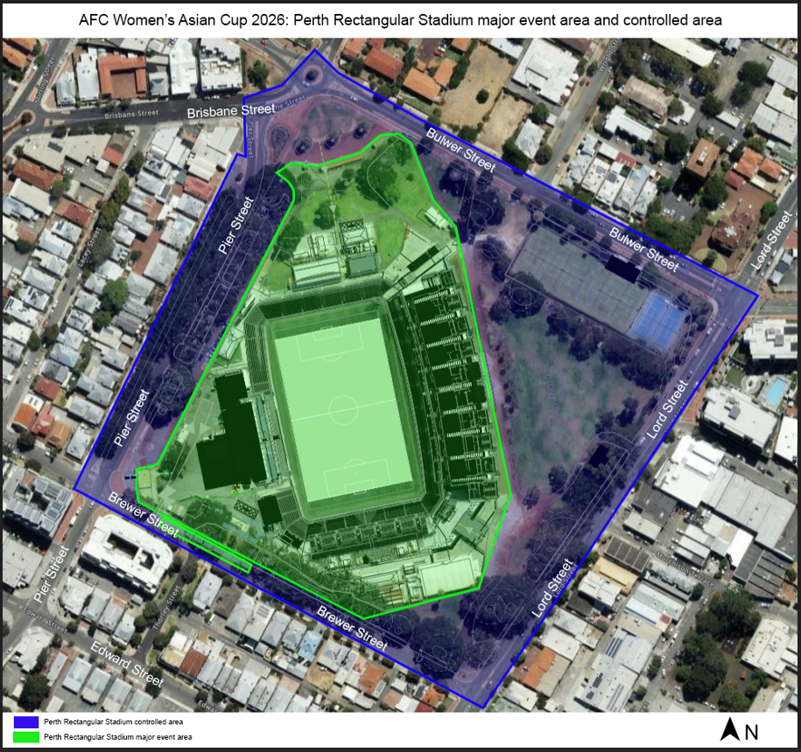
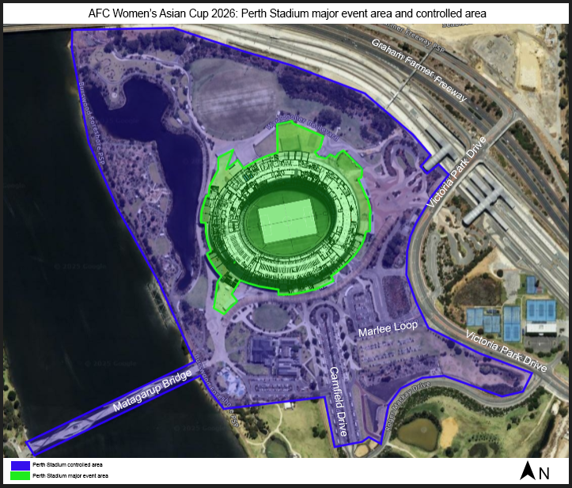

K. COLLERAN, Clerk of the Executive Council

© State of Western Australia 2025.
This work is licensed under a Creative Commons Attribution 4.0 International Licence (CC BY 4.0). To view relevant information and for a link to a copy of the licence, visit www.legislation.wa.gov.au.
Attribute work as: © State of Western Australia 2025.
By Authority: ROGER JACOBS, Acting Government Printer

