
Western Australia
Road Traffic Act 1974

Road Traffic Code Amendment Regulations 2025

Western Australia
Road Traffic Code Amendment Regulations 2025
Contents
1. Citation 1
2. Commencement 1
3. Regulations amended 1
4. Regulation 282B inserted 1
282B. Exemption for drivers of vehicles being driven for ambulance driver practical training course 1
5. Schedule 6 inserted 5
Schedule 6 — Image of deposited plan showing Perth central business district

Road Traffic Act 1974
Road Traffic Code Amendment Regulations 2025
Made by the Governor in Executive Council.

1. Citation
These regulations are the Road Traffic Code Amendment Regulations 2025.

2. Commencement
These regulations come into operation as follows —
(a) regulations 1 and 2 — on the day on which these regulations are published on the WA legislation website;
(b) the rest of the regulations — on the day after that day.

3. Regulations amended
These regulations amend the Road Traffic Code 2000.

4. Regulation 282B inserted
After regulation 282A insert:

282B. Exemption for drivers of vehicles being driven for ambulance driver practical training course
(1) In this regulation —
Deposited Plan, followed by a number, means the deposited plan of that number lodged or deposited with the Western Australian Land Information Authority established by the Land Information Authority Act 2006 section 5(1) and approved under a written law;
provisional licence has the meaning given in the Road Traffic (Authorisation to Drive) Act 2008 section 3(1);
registered training provider means —
(a) a registered training provider as defined in the Vocational Education and Training Act 1996 section 5(1); or
(b) an NVR registered training organisation as defined in the National Vocational Education and Training Regulator Act 2011 (Cth) section 3;
St John Ambulance means St John Ambulance Western Australia Ltd (ACN 165 969 406);
unit of competency, followed by a designation, means the unit of competency having that designation that is published on the National Register (as defined in the National Vocational Education and Training Regulator Act 2011 (Cth) section 3) as in force immediately before the commencement of the Road Traffic Code Amendment Regulations 2025 regulation 4.
(2) A provision of these regulations does not apply to the driver of a vehicle being driven for the purpose of an ambulance driver practical training course approved under subregulation (3) if —
(a) the vehicle —
(i) is an ambulance; and
(ii) is fitted with dual control brakes; and
(iii) displays markings indicating that it is being used for training;
and
(b) the driver —
(i) is an ambulance officer employed or engaged (including on a voluntary basis) by St John Ambulance; and
(ii) holds an Australian driver licence that is not a provisional licence; and
(iii) meets the requirements in subregulation (6);
and
(c) the driver is driving —
(i) at a speed of no more than 20 km/h in excess of the speed limit applicable to the area or zone in which the vehicle is being driven; and
(ii) while displaying a flashing blue or red light on the vehicle or sounding an alarm; and
(iii) in an area that is not a prohibited area mentioned in subregulation (4);
and
(d) the driver is driving under the direct supervision of a person who —
(i) holds an Australian driver licence that is not a provisional licence and that authorises the driving of a motor vehicle of class LR; and
(ii) is approved under subregulation (5);
and
(e) the driver is taking reasonable care; and
(f) it is reasonable in the circumstances that the provision should not apply.
(3) For the purposes of subregulation (2), the CEO of St John Ambulance may approve an ambulance driver practical training course that deals with the practical aspects of safely driving an ambulance when performing the duties of an ambulance officer, including under urgent conditions.
(4) For the purposes of subregulation (2)(c)(iii), each of the following is a prohibited area —
(a) a school zone;
(b) a speed limited area or speed zone in which the speed limit applicable to the area or zone is 40 km/h or less;
(c) a shared zone;
(d) a pedestrian mall;
(e) the Perth central business district as delineated in blue and coloured blue on Deposited Plan 430390 version 1 and as shown, for information purposes only, in Schedule 6;
(f) a roadworks (as defined in regulation 285(4)) site that is identified as a roadworks site by a road sign, road marking or traffic control signal.
(5) For the purposes of subregulation (2)(d)(ii), the CEO of St John Ambulance may approve a person if satisfied that the person —
(a) holds an Australian driver licence that is not a provisional licence and that authorises the driving of a motor vehicle of class LR; and
(b) has completed either of the following courses provided by a registered training provider —
(i) TAE40116 Certificate IV in Training and Assessment;
(ii) TAE40122 Certificate IV in Training and Assessment;
and
(c) meets the requirements in subregulation (6).
Note for this subregulation:
For the purpose of paragraph (b)(i), TAE40116 Certificate IV in Training and Assessment was superseded by TAE40122 Certificate IV in Training and Assessment on 7 December 2022.
(6) For the purposes of subregulations (2)(b)(iii) and (5)(c), the person must have completed —
(a) the unit of competency PUAVEH001 Drive vehicles under operational conditions, provided by a registered training provider permitted by a condition of its registration to deliver that unit of competency; and
(b) an ambulance driver theory training course approved by the CEO of St John Ambulance under subregulation (7).
(7) For the purposes of subregulation (6)(b), the CEO of St John Ambulance may approve an ambulance driver theory training course that deals with the theoretical aspects of safely driving an ambulance when performing the duties of an ambulance officer, including under urgent conditions.

5. Schedule 6 inserted
After Schedule 5 insert:

Schedule 6 — Image of deposited plan showing Perth central business district
[r. 282B(4)]
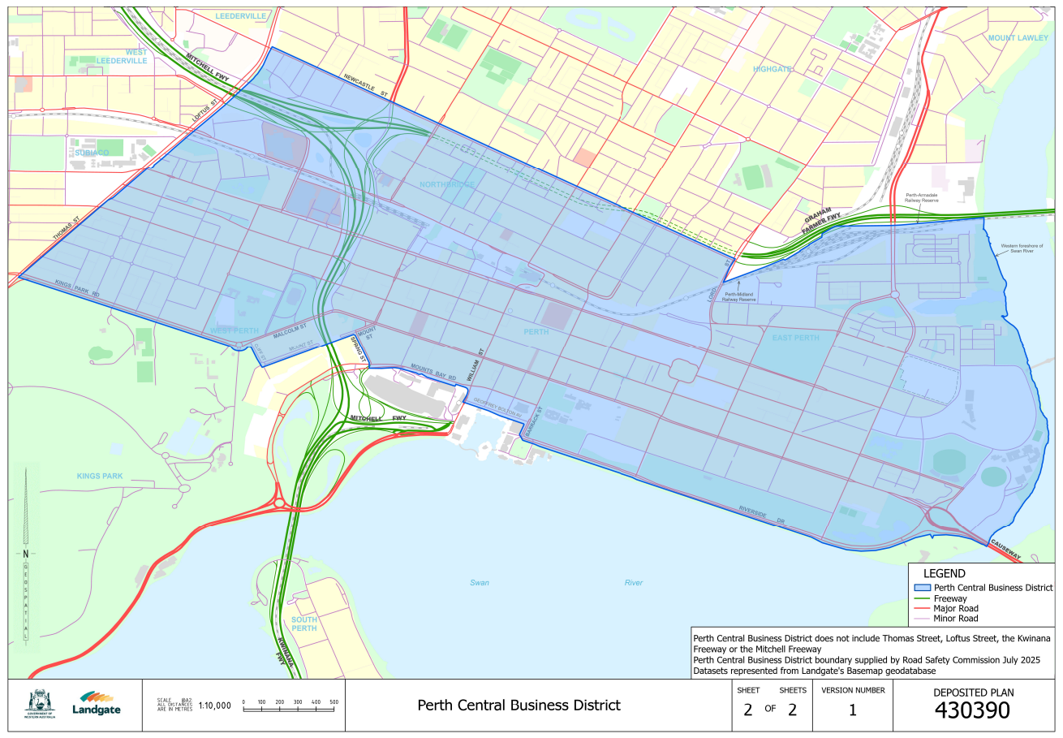

K. COLLERAN, Clerk of the Executive Council
© State of Western Australia 2025.
This work is licensed under a Creative Commons Attribution 4.0 International Licence (CC BY 4.0). To view relevant information and for a link to a copy of the licence, visit www.legislation.wa.gov.au.
Attribute work as: © State of Western Australia 2025.
By Authority: ROGER JACOBS, Acting Government Printer

