
Western Australia
Major Events Act 2023

Major Events Regulations 2023

Western Australia
Major Events Regulations 2023
Contents
Part 1 — Preliminary
1. Citation 1
2. Commencement 1
3. Terms used 1
Part 2 — General matters
4. Exempt advertising on vehicles 2
5. Exempt advertising on vessels 2
6. Insufficient value to justify notice to collect 2
7. Infringement notices: prescribed offences and modified penalties 3
8. Infringement notices: authorised officers and approved officers 3
9. Infringement notices: forms 4
Part 3 — FIFA Women’s World Cup 2023
Division 1 — Preliminary
10. Terms used 5
Division 2 — Establishment of major event
11. FIFA Women’s World Cup 2023 is major event 6
12. Major event organiser 6
13. Major event areas 6
14. Major event period 7
15. Application of Pt. 5 and 6 of Act to major event areas 7
16. Responsible authorities 11
17. Controlled areas and control period 12
18. Application of Pt. 6 of Act to controlled areas 13
Division 3 — Official logos and titles for major event
19. Official logos 14
20. Official titles 15
Division 4 — Miscellaneous
21. Extended application of Act s. 49 16
22. Appointment of authorised officers 16
23. Eligibility for appointment as authorised officer 17
24. Signs must be erected in major event areas and controlled areas 17
Part 4 — AFC Women’s Asian Cup 2026
Division 1 — Preliminary
25. Terms used 18
Division 2 — Establishment of major event
26. AFC Women’s Asian Cup 2026 is major event 19
27. Major event organiser 19
28. Major event areas 20
29. Major event period 21
30. Application of Pt. 5 and 6 of Act to major event areas 21
31. Responsible authorities 21
32. Controlled areas 22
33. Control period 23
34. Application of Pt. 6 of Act to controlled areas 23
Division 3 — Official logos and titles for major event
35. Official logos 23
36. Official titles 24
Division 4 — Miscellaneous
37. Extended application of Act s. 49 25
38. Appointment of authorised officers 25
39. Eligibility for appointment as authorised officer 26
40. Signs must be erected in major event areas and controlled areas 26
Schedule 1 — Prescribed offences and modified penalties
Schedule 2 — Infringement notice forms
Schedule 3 — FIFA Women’s World Cup 2023 major event areas and controlled areas
Schedule 4 — AFC Women’s Asian Cup 2026 major event areas and controlled areas
Notes
Compilation table 39
Defined terms

Major Events Act 2023
Major Events Regulations 2023

Part 1 — Preliminary

1. Citation
These regulations are the Major Events Regulations 2023.

2. Commencement
These regulations come into operation as follows —
(a) Part 1 — on the day on which these regulations are published in the Gazette;
(b) the rest of the regulations — on the day after that day.

3. Terms used
In these regulations —
passenger transport service has the meaning given in the Transport (Road Passenger Services) Act 2018 section 4(1);
public passenger transport service has the meaning given in the Public Transport Authority Act 2003 section 3;
Public Transport Authority means the Public Transport Authority of Western Australia established by the Public Transport Authority Act 2003 section 5.

Part 2 — General matters

4. Exempt advertising on vehicles
(1) For the purposes of section 64(3)(a) of the Act, an advertisement is exempt if —
(a) the vehicle is involved in the provision of a passenger transport service; and
(b) the advertisement does not imply that the advertiser or service or thing advertised is an affiliate of the major event.
(2) Subregulation (1) does not apply to an advertisement on a banner or other sign that is towed by a vehicle.
(3) For the purposes of section 64(3)(b) of the Act, a vehicle involved in the provision of a public passenger transport service by the Public Transport Authority, or by another person under a contract with the Public Transport Authority, is exempt.

5. Exempt advertising on vessels
For the purposes of section 65(3)(b) of the Act, a vessel involved in the provision of a public passenger transport service by the Public Transport Authority, or by another person under a contract with the Public Transport Authority, is exempt.

6. Insufficient value to justify notice to collect
For the purposes of section 82(6) of the Act —
(a) the prescribed value is $500; and
(b) the prescribed manner in which the value of a vehicle or vessel is to be calculated is that the value is to be based on the local private sale value of a vehicle or vessel of the same, or a similar, model or type, year and condition.

7. Infringement notices: prescribed offences and modified penalties
(1) An offence under a section of the Act specified in Schedule 1 is an offence for which an infringement notice may be issued under the Criminal Procedure Act 2004 Part 2.
(2) The amount specified opposite a section of the Act specified in Schedule 1 is the modified penalty for an offence under that section for the purposes of the Criminal Procedure Act 2004 section 5(3).
(3) A description of an offence next to a section of the Act specified in Schedule 1 is for information purposes only and does not limit the reference to the section concerned.

8. Infringement notices: authorised officers and approved officers
(1) The chief executive officer of the department may, in writing, appoint persons or classes of persons to be authorised officers or approved officers for the purposes of the Criminal Procedure Act 2004 Part 2 in relation to infringement notices issued under that Part for an offence under a section of the Act specified in Schedule 1.
(2) The chief executive officer of the department must issue to each person appointed as an authorised officer under subregulation (1) a certificate, badge or identity card identifying the officer as a person authorised to issue infringement notices.
(3) A person appointed as an authorised officer under subregulation (1) may show that they are authorised to issue infringement notices for an offence under a section of the Act specified in Schedule 1 by showing the certificate, badge or identity card issued to them under subregulation (2).

9. Infringement notices: forms
For the purposes of the Criminal Procedure Act 2004 Part 2 —
(a) Schedule 2 Form 1 is the prescribed form for an infringement notice; and
(b) Schedule 2 Form 2 is the prescribed form for the withdrawal of an infringement notice.

Part 3 — FIFA Women’s World Cup 2023

Division 1 — Preliminary

10. Terms used
In this Part —
fan festival operating hours means each of the following periods —
(a) 20 July 2023, from midday to 9 pm;
(b) 21 July 2023, from midday to 10.30 pm;
(c) 22 July 2023, from midday to 11 pm;
(d) 23 July 2023, from midday to 9 pm;
(e) 26 July 2023, from midday to 11 pm;
(f) 27 July 2023, from midday to 9 pm;
(g) 28 July 2023, from midday to 10.30 pm;
(h) 29 July 2023, from midday to 11.30 pm;
(i) 30 July 2023, from midday to 9 pm;
(j) 31 July 2023, from midday to 9 pm;
(k) 1 August 2023, from midday to 10 pm;
(l) 2 August 2023, from midday to 9 pm;
(m) 3 August 2023, from midday to 9 pm;
(n) 5 August 2023, from 3 pm to 10.30 pm;
(o) 6 August 2023, from 3 pm to 9 pm;
(p) 7 August 2023, from 3 pm to 9 pm;
(q) 8 August 2023, from 3 pm to 10 pm;
(r) 11 August 2023, from 3 pm to 10.30 pm;
(s) 12 August 2023, from 3 pm to 10.30 pm;
(t) 15 August 2023, from 3 pm to 9 pm;
(u) 16 August 2023, from 3 pm to 9 pm;
(v) 19 August 2023, from 3 pm to 10.30 pm;
(w) 20 August 2023, from 3 pm to 9 pm;
FIFA Women’s World Cup 2023 means the event known as the FIFA Women’s World Cup Australia & New Zealand 2023;
match periods means each of the following periods —
(a) from 5 pm to midnight on 22 July 2023;
(b) from 5 pm to midnight on 26 July 2023;
(c) from 5.30 pm on 29 July 2023 to 12.30 am on 30 July 2023;
(d) from 4 pm to 11 pm on 1 August 2023;
(e) from 3 pm to 10 pm on 3 August 2023.

Division 2 — Establishment of major event

11. FIFA Women’s World Cup 2023 is major event
For the purposes of section 6(1) of the Act, the FIFA Women’s World Cup 2023 is a major event.

12. Major event organiser
For the purposes of section 6(2)(a) of the Act, FWWC2023 Pty Ltd (ACN 650 853 302) is the major event organiser for the FIFA Women’s World Cup 2023.

13. Major event areas
(1) For the purposes of section 6(2)(b) of the Act, each of the following areas is a major event area for the FIFA Women’s World Cup 2023 —
(a) the Perth Rectangular Stadium major event area, being the area shown as the Perth Rectangular Stadium major event area on the map entitled “FIFA Women’s World Cup 2023: Perth Rectangular Stadium major event area and controlled area” —
(i) held by the chief executive officer of the department; and
(ii) certified by the chief executive officer of the department as the map prepared for the purpose of defining the Perth Rectangular Stadium major event area and controlled area;
(b) the Fan Festival Site major event area, being the area shown as the Fan Festival Site major event area on the map entitled “FIFA Women’s World Cup 2023: Fan Festival Site major event area and controlled area” —
(i) held by the chief executive officer of the department; and
(ii) certified by the chief executive officer of the department as the map prepared for the purpose of defining the Fan Festival Site major event area and controlled area.
(2) For information purposes, maps depicting the major event areas referred to in subregulation (1) are in Schedule 3.

14. Major event period
For the purposes of section 6(2)(c) of the Act, the major event period for the FIFA Women’s World Cup 2023 is the period beginning on 6 July 2023 and ending on 27 August 2023.

15. Application of Pt. 5 and 6 of Act to major event areas
(1) For the purposes of section 6(2)(e) of the Act, a provision of Part 5 or 6 of the Act specified in the 1st column of the Table to this regulation applies to the FIFA Women’s World Cup 2023 as follows —
(a) to the Perth Rectangular Stadium major event area during the period specified opposite the provision in the 2nd column of the Table;
(b) to the Fan Festival Site major event area during the period (if any) specified opposite the provision in the 3rd column of the Table.
(2) The text in brackets next to a reference to a section of the Act in the 1st column of the Table is for information purposes only and does not limit the reference to the section concerned.
Table
Provision of Act | Perth Rectangular Stadium major event area | Fan Festival Site major event area
Section 38 (designated entries and exits) | Match periods | Fan festival operating hours
Section 39 (entry fees) | Match periods
Section 40 (occupant’s passes) | Major event period
Section 41 (entry to playing fields and other areas) | Match periods | Fan festival operating hours
Section 42 (entry to restricted areas) | Match periods | Fan festival operating hours
Section 43 (vehicles in major event areas) | Match periods | Fan festival operating hours
Section 44 (possession of prohibited items) | Match periods | Fan festival operating hours
Section 45 (endangering others or disrupting a major event) | Match periods | Fan festival operating hours
Section 46 (obstructing performers or participants) | Match periods | Fan festival operating hours
Section 47 (possession and consumption of liquor) | Match periods | Fan festival operating hours
Section 49 (other prohibited conduct) | Match periods | Fan festival operating hours
Section 50 (searches and inspection on entry) | Match periods | Fan festival operating hours
Section 51 (surrender of prohibited items and liquor) | Match periods | Fan festival operating hours
Section 52 (production of evidence of right of entry) | Match periods | Fan festival operating hours
Section 53 (refusal of unauthorised entry) | Match periods | Fan festival operating hours
Section 54 (searches and inspection in major event area) | Match periods | Fan festival operating hours
Section 55 (general powers of authorised officers) | Match periods | Fan festival operating hours
Section 56 (provision of personal details) | Match periods | Fan festival operating hours
Section 57 (directions to leave) | Major event period | Major event period
Section 58 (entry bans) | Major event period | Major event period
Section 59 (taking of photographs) | Major event period | Major event period
Section 61 (sale or distribution of things) | Match periods | Fan festival operating hours
Section 62 (ambush marketing) | Match periods | Fan festival operating hours
Section 63 (advertising on buildings or structures) | Period beginning on 22 July 2023 and ending on 3 August 2023 | Period beginning on 20 July 2023 and ending on 20 August 2023
Section 64 (advertising on vehicles) | Match periods
Section 66 (aerial advertising) | Match periods
Section 67 (broadcasting or recording a major event) | Match periods | Fan festival operating hours

16. Responsible authorities
For the purposes of section 6(3) of the Act, each of the following is a responsible authority for the FIFA Women’s World Cup 2023 —
(a) the major event organiser;
(b) the department;
(c) the Western Australian Tourism Commission established under the Western Australian Tourism Commission Act 1983 section 4.

17. Controlled areas and control period
(1) For the purposes of section 6(4)(a) of the Act, each of the following is a controlled area for the FIFA Women’s World Cup 2023 —
(a) the Perth Rectangular Stadium controlled area, being the area shown as the Perth Rectangular Stadium controlled area on the map entitled “FIFA Women’s World Cup 2023: Perth Rectangular Stadium major event area and controlled area” —
(i) held by the chief executive officer of the department; and
(ii) certified by the chief executive officer of the department as the map prepared for the purpose of defining the Perth Rectangular Stadium major event area and controlled area;
(b) the Fan Festival Site controlled area, being the area shown as the Fan Festival Site controlled area on the map entitled “FIFA Women’s World Cup 2023: Fan Festival Site major event area and controlled area” —
(i) held by the chief executive officer of the department; and
(ii) certified by the chief executive officer of the department as the map prepared for the purpose of defining the Fan Festival Site major event area and controlled area.
(2) For information purposes, maps depicting the controlled areas referred to in subregulation (1) are in Schedule 3.
(3) For the purposes of section 6(4)(b) of the Act, the control period for the FIFA Women’s World Cup 2023 is the period beginning on 20 July 2023 and ending on 20 August 2023.

18. Application of Pt. 6 of Act to controlled areas
(1) For the purposes of section 6(4)(c) of the Act, a provision of Part 6 of the Act specified in the 1st column of the Table to this regulation applies —
(a) to the Perth Rectangular Stadium controlled area during the period specified opposite the provision in the 2nd column of the Table; and
(b) to the Fan Festival Site controlled area during the period (if any) specified opposite the provision in the 3rd column of the Table.
(2) The text in brackets next to a reference to a section of the Act in the 1st column of the Table is for information purposes only and does not limit the reference to the section concerned.
Table
Provision of Act | Perth Rectangular Stadium controlled area | Fan Festival Site controlled area
Section 61 (sale or distribution of things) | Match periods | Fan festival operating hours
Section 62 (ambush marketing) | Match periods | Fan festival operating hours
Section 63 (advertising on buildings or structures) | Period beginning on 22 July 2023 and ending on 3 August 2023 | Control period
Section 64 (advertising on vehicles) | Match periods
Section 66 (aerial advertising) | Match periods
Section 67 (broadcasting or recording a major event) | Match periods | Fan festival operating hours

Division 3 — Official logos and titles for major event

19. Official logos
For the purposes of section 68(1)(a) of the Act, each of the following is an official logo for the FIFA Women’s World Cup 2023 —
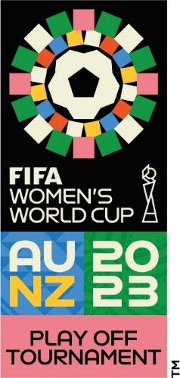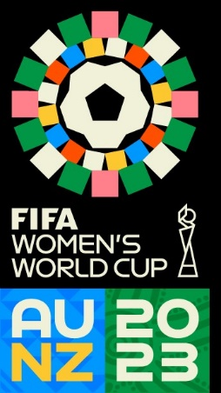
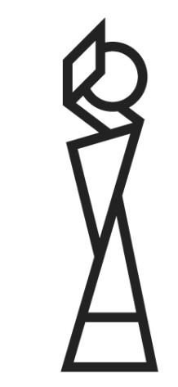

20. Official titles
For the purposes of section 68(1)(b) of the Act, each of the following is an official title for the FIFA Women’s World Cup 2023 —
(a) FIFA Women’s World Cup Australia & New Zealand 2023;
(b) Fédération Internationale de Football Association;
(c) Football Women’s World Cup;
(d) Football Women’s World Cup 2023;
(e) Football Women’s World Cup Australia and New Zealand;
(f) Football Women’s World Cup 2023 Australia and New Zealand;
(g) FIFA Women’s World Cup;
(h) FIFA Women’s World Cup 2023;
(i) FIFA Women’s World Cup Australia and New Zealand;
(j) FIFA Women’s World Cup 2023 Australia and New Zealand;
(k) FWWC2023.

Division 4 — Miscellaneous

21. Extended application of Act s. 49
(1) For the purposes of section 49(1)(h) of the Act, in its application to the FIFA Women’s World Cup 2023, displaying a poster on property, including on the outside of a building or structure, is prescribed.
(2) Subregulation (1) does not apply to a poster that —
(a) was displayed before 6 July 2023; and
(b) was displayed in connection with the person’s ordinary activities for purposes unrelated to the FIFA Women’s World Cup 2023.
Note for this regulation:
Regulation 15 provides for the major event areas in which, and the periods during which, section 49 of the Act applies to the FIFA Women’s World Cup 2023.

22. Appointment of authorised officers
For the purposes of section 73(3)(b)(ii) of the Act, it is a requirement that a person appointed as an authorised officer for the FIFA Women’s World Cup 2023 hold any licence the person to be appointed is required to hold under the Security and Related Activities (Control) Act 1996 in order to perform the functions that are conferred by the appointment.

23. Eligibility for appointment as authorised officer
For the purposes of section 74(1)(f) of the Act, holders of any of the following licences under the Security and Related Activities (Control) Act 1996 are prescribed in relation to the FIFA Women’s World Cup 2023 —
(a) a security officer’s licence;
(b) a crowd controller’s licence.

24. Signs must be erected in major event areas and controlled areas
(1) The major event organiser must erect signs in or at the entrances to each major event area and controlled area for the FIFA Women’s World Cup 2023 that describe the powers that authorised officers and police officers have in those areas under the Act.
(2) The signs must be in a form, and erected in locations, approved by the chief executive officer of the department.

Part 4 — AFC Women’s Asian Cup 2026
[Heading inserted: SL 2025/202 r. 4.]

Division 1 — Preliminary
[Heading inserted: SL 2025/202 r. 4.]

25. Terms used
In this Part —
AFC Women’s Asian Cup 2026 means the event known as the AFC Women’s Asian Cup 2026;
match day —
(a) in relation to the Perth Rectangular Stadium major event area, means each of the following days —
(i) 4 March 2026;
(ii) 7 March 2026;
(iii) 9 March 2026;
(iv) 10 March 2026;
(v) 13 March 2026;
(vi) 14 March 2026;
and
(b) in relation to the Perth Stadium major event area, means each of the following days —
(i) 1 March 2026;
(ii) 17 March 2026;
match period —
(a) in relation to the Perth Rectangular Stadium major event area or the Perth Rectangular Stadium controlled area, means each of the following periods —
(i) 4 March 2026, from 10 am to 11 pm;
(ii) 7 March 2026, from 10 am to 11 pm;
(iii) 9 March 2026, from 2 pm to 9 pm;
(iv) 10 March 2026, from 2 pm to 9 pm;
(v) 13 March 2026, from 3 pm to 10 pm;
(vi) 14 March 2026, from 10 am to 5 pm;
and
(b) in relation to the Perth Stadium major event area or the Perth Stadium controlled area, means each of the following periods —
(i) 1 March 2026, from 2 pm to 9 pm;
(ii) 17 March 2026, from 3 pm to 10 pm;
Perth Rectangular Stadium controlled area means the area referred to in regulation 32(1)(a);
Perth Rectangular Stadium major event area means the area referred to in regulation 28(1)(a);
Perth Stadium controlled area means the area referred to in regulation 32(1)(b);
Perth Stadium major event area means the area referred to in regulation 28(1)(b).
[Regulation 25 inserted: SL 2025/202 r. 4.]

Division 2 — Establishment of major event
[Heading inserted: SL 2025/202 r. 4.]

26. AFC Women’s Asian Cup 2026 is major event
For the purposes of section 6(1) of the Act, the AFC Women’s Asian Cup 2026 is a major event.
[Regulation 26 inserted: SL 2025/202 r. 4.]

27. Major event organiser
For the purposes of section 6(2)(a) of the Act, Local Organising Committee AFC Women’s Asian Cup 2026 Pty Ltd (ACN 681 496 006) is the major event organiser for the AFC Women’s Asian Cup 2026.
[Regulation 27 inserted: SL 2025/202 r. 4.]

28. Major event areas
(1) For the purposes of section 6(2)(b) of the Act, each of the following areas is a major event area for the AFC Women’s Asian Cup 2026 —
(a) the Perth Rectangular Stadium major event area, being the area shown as the Perth Rectangular Stadium major event area on the map entitled “AFC Women’s Asian Cup 2026: Perth Rectangular Stadium major event area and controlled area” —
(i) held by the chief executive officer of the department; and
(ii) certified by the chief executive officer of the department as the map prepared for the purpose of defining the Perth Rectangular Stadium major event area and controlled area;
(b) the Perth Stadium major event area, being the area shown as the Perth Stadium major event area on the map entitled “AFC Women’s Asian Cup 2026: Perth Stadium major event area and controlled area” —
(i) held by the chief executive officer of the department; and
(ii) certified by the chief executive officer of the department as the map prepared for the purpose of defining the Perth Stadium major event area and controlled area.
(2) For information purposes, maps depicting the major event areas referred to in subregulation (1) are in Schedule 4.
[Regulation 28 inserted: SL 2025/202 r. 4.]

29. Major event period
For the purposes of section 6(2)(c) of the Act, the major event period for the AFC Women’s Asian Cup 2026 is the period beginning on 15 February 2026 and ending on 20 March 2026.
[Regulation 29 inserted: SL 2025/202 r. 4.]

30. Application of Pt. 5 and 6 of Act to major event areas
(1) This regulation applies to the AFC Women’s Asian Cup 2026 for the purposes of section 6(2)(e) of the Act.
(2) Sections 38, 39, 41 to 59, 61, 62, 64, 66 and 67 apply to —
(a) the Perth Rectangular Stadium major event area during each match period for that area; and
(b) the Perth Stadium major event area during each match period for that area.
(3) Section 40 of the Act applies to —
(a) the Perth Rectangular Stadium major event area on each match day for that area; and
(b) the Perth Stadium major event area on each match day for that area.
(4) Section 63 of the Act applies during the period beginning on 1 March 2026 and ending on 17 March 2026 to —
(a) the Perth Rectangular Stadium major event area; and
(b) the Perth Stadium major event area.
[Regulation 30 inserted: SL 2025/202 r. 4.]

31. Responsible authorities
For the purposes of section 6(3) of the Act, each of the following is a responsible authority for the AFC Women’s Asian Cup 2026 —
(a) the department;
(b) the Western Australian Tourism Commission established under the Western Australian Tourism Commission Act 1983 section 4(1).
[Regulation 31 inserted: SL 2025/202 r. 4.]

32. Controlled areas
(1) For the purposes of section 6(4)(a) of the Act, each of the following is a controlled area for the AFC Women’s Asian Cup 2026 —
(a) the Perth Rectangular Stadium controlled area, being the area shown as the Perth Rectangular Stadium controlled area on the map entitled “AFC Women’s Asian Cup 2026: Perth Rectangular Stadium major event area and controlled area” —
(i) held by the chief executive officer of the department; and
(ii) certified by the chief executive officer of the department as the map prepared for the purpose of defining the Perth Rectangular Stadium major event area and controlled area;
(b) the Perth Stadium controlled area, being the area shown as the Perth Stadium controlled area on the map entitled “AFC Women’s Asian Cup 2026: Perth Stadium major event area and controlled area” —
(i) held by the chief executive officer of the department; and
(ii) certified by the chief executive officer of the department as the map prepared for the purpose of defining the Perth Stadium major event area and controlled area.
(2) For information purposes, maps depicting the controlled areas referred to in subregulation (1) are in Schedule 4.
[Regulation 32 inserted: SL 2025/202 r. 4.]

33. Control period
For the purposes of section 6(4)(b) of the Act, the control period for the AFC Women’s Asian Cup 2026 is the period beginning on 1 March 2026 and ending on 17 March 2026.
[Regulation 33 inserted: SL 2025/202 r. 4.]

34. Application of Pt. 6 of Act to controlled areas
For the purposes of section 6(4)(c) of the Act —
(a) sections 61, 62, 64, 66 and 67 of the Act apply to —
(i) the Perth Rectangular Stadium controlled area during each match period for that area; and
(ii) the Perth Stadium controlled area during each match period for that area;
and
(b) section 63 of the Act applies during the control period to —
(i) the Perth Rectangular Stadium controlled area; and
(ii) the Perth Stadium controlled area.
[Regulation 34 inserted: SL 2025/202 r. 4.]

Division 3 — Official logos and titles for major event
[Heading inserted: SL 2025/202 r. 4.]

35. Official logos
For the purposes of section 68(1)(a) of the Act, each of the following is an official logo for the AFC Women’s Asian Cup 2026 —

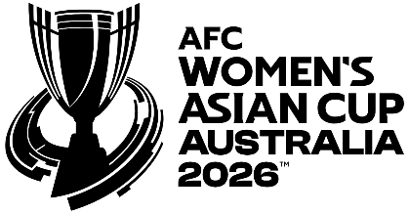
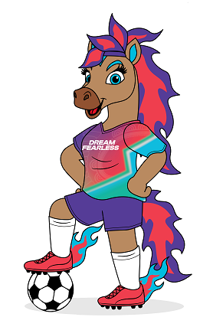
[Regulation 35 inserted: SL 2025/202 r. 4.]

36. Official titles
For the purposes of section 68(1)(b) of the Act, each of the following is an official title for the AFC Women’s Asian Cup 2026 —
(a) AFC Women’s Asian Cup 2026;
(b) AFC Women’s Asian Cup;
(c) AFC WAC 2026;
(d) AFC WAC26;
(e) AFC Women’s Asian Cup Australia 2026;
(f) AFC Women’s Asian Cup Australia;
(g) Asian Football Confederation Women’s Asian Cup 2026;
(h) Asian Football Confederation Women’s Asian Cup;
(i) AFC WAC;
(j) Women’s Asian Cup 2026;
(k) WAC2026;
(l) WAC26.
[Regulation 36 inserted: SL 2025/202 r. 4.]

Division 4 — Miscellaneous
[Heading inserted: SL 2025/202 r. 4.]

37. Extended application of Act s. 49
(1) For the purposes of section 49(1)(h) of the Act, in its application to the AFC Women’s Asian Cup 2026, displaying a poster on property, including on the outside of a building or structure, is prescribed.
(2) Subregulation (1) does not apply to a poster that was displayed —
(a) before 1 March 2026; and
(b) in connection with the person’s ordinary activities for purposes unrelated to the AFC Women’s Asian Cup 2026.
Note for this regulation:
Regulation 30(2) provides for the major event areas in which, and the periods during which, section 49 of the Act applies to the AFC Women’s Asian Cup 2026.
[Regulation 37 inserted: SL 2025/202 r. 4.]

38. Appointment of authorised officers
For the purposes of section 73(3)(b)(ii) of the Act, it is a requirement that a person appointed as an authorised officer for the AFC Women’s Asian Cup 2026 hold any licence the person to be appointed is required to hold under the Security and Related Activities (Control) Act 1996 in order to perform the functions that are conferred by the appointment.
[Regulation 38 inserted: SL 2025/202 r. 4.]

39. Eligibility for appointment as authorised officer
For the purposes of section 74(1)(f) of the Act, the following classes of persons are prescribed in relation to the AFC Women’s Asian Cup 2026 —
(a) persons who hold either of the following licences under the Security and Related Activities (Control) Act 1996 —
(i) a security officer’s licence;
(ii) a crowd controller’s licence;
(b) employees of the major event organiser;
(c) persons engaged under a contract for services by the major event organiser;
(d) persons employed by a person engaged under a contract for services by the major event organiser.
[Regulation 39 inserted: SL 2025/202 r. 4.]

40. Signs must be erected in major event areas and controlled areas
(1) The major event organiser must erect signs in or at the entrances to each major event area and controlled area for the AFC Women’s Asian Cup 2026 that describe the powers that authorised officers and police officers have in those areas under the Act.
(2) The signs must be in a form, and erected in locations, approved by the chief executive officer of the department.
[Regulation 40 inserted: SL 2025/202 r. 4.]

Schedule 1 — Prescribed offences and modified penalties
[r. 7]
Offence under the Act |  | Modified penalty
s. 26(6) | Enter, drive a vehicle on or use road in contravention of closure | $200
s. 28(7) | Enter, or navigate vessel in, waters in contravention of closure | $200
s. 32(1) | Drive a vehicle in a major event lane without authorisation | $300
s. 35(4) | Park or leave vehicle in prohibited area | $300
s. 35(5) | Moor, anchor or leave vessel in prohibited area | $300
s. 38(1) | Enter area otherwise than through designated entrance | $200
s. 38(2) | Exit area otherwise than through designated exit | $200
s. 39(1) | Enter or remain in area without paying fee or holding evidence that fee has been paid | $300
s. 41(1) | Enter or remain on playing field, competition or performance area | $1 000
s. 42(4) | Enter or remain in restricted area | $300
s. 43(1) | Bring vehicle into area on road that is not open to public | $300
s. 44(1) | Bring or be in possession of prohibited item | $300
s. 45(1) | Throw or propel anything that may injure a person or damage property | $1 000
s. 45(2) | Throw or propel anything that may disrupt major event | $300
s. 46(1) | Obstruct performer or participant | $1 000
s. 47(1) | Bring liquor into major event area | $200
s. 47(4) | Consume liquor in prohibited area | $200
s. 49(1) | Engage in prohibited conduct | $300
s. 57(3) | Fail to comply with direction to leave | $300
s. 58(3) | Fail to comply with entry ban | $800
s. 61(1) | Sell or distribute thing on road or in public place | $700
s. 61(5) | Fail to comply with direction to remove thing | $300
s. 62(1) | Promote a person, service or thing | $1 500
s. 62(2) | Do anything that suggests that a person, service or thing is an affiliate of a major event | $1 500
s. 62(6) | Fail to comply with direction to remove or cover thing | $300
s. 63(1) | Display advertisement on building or structure | $10 000
s. 64(1) | Display advertisement on, attached to or towed by vehicle | $5 500
s. 65(1) | Display advertisement on, attached to or towed by vessel | $5 500
s. 67(2) | Broadcast or record major event without authorisation | $5 500
s. 70(2) | Use official logo or official title or logo or title that is substantially identical or deceptively similar | $5 500
s. 77 | Impersonate authorised officer | $1 000

Schedule 2 — Infringement notice forms
[r. 9]
Form 1 — Infringement notice
Major Events Act 2023  INFRINGEMENT NOTICE |  |  |  |  | Infringement  notice no.
Alleged offender | Name
Alleged offender | Address
Alleged offence | Date or period
Alleged offence | Time
Alleged offence | Place
Alleged offence | Details of offence
Alleged offence | Written law contravened
Date | Date of notice
Issuing officer | Name
Issuing officer | Office
Issuing officer | Signature
Modified penalty | $
TAKE NOTICE | It is alleged that you have committed the above offence.  If you do not want to be prosecuted in court for the offence, pay the modified penalty to the Approved Officer within 28 days after the date of this notice.
If you do not pay the modified penalty within 28 days, you may be prosecuted or enforcement action may be taken under the Fines, Penalties and Infringement Notices Enforcement Act 1994. Under that Act, some or all of the following action may be taken — your driver’s licence may be suspended, your vehicle licence may be suspended or cancelled, you may be disqualified from holding or obtaining a driver’s licence or vehicle licence, your vehicle may be immobilised or have its number plates removed, your details may be published on a website, your earnings or bank accounts may be garnished, and your property may be seized and sold.
If you need more time to pay the modified penalty, you can apply for an extension of time by writing to the Approved Officer — Major Events Act 2023 at the postal address below.
Paying the modified penalty will not be regarded as an admission for the purposes of any civil or criminal court case.
If you want this matter to be dealt with by prosecution in court, sign and date here:
__________________________________ / /
and post this notice to the Approved Officer — Major Events Act 2023 at the postal address below within 28 days after the date of this notice.
How to pay | In person | [Insert details for paying in person]
How to pay | By post | [Insert details for paying by post]
How to pay | Online | [Insert details for paying online]
How to pay | By telephone | [Insert details for paying by telephone]
Method of service |  |  |  | Date of service
Form 2 — Withdrawal of infringement notice
Major Events Act 2023  WITHDRAWAL OF INFRINGEMENT NOTICE |  |  |  | Withdrawal no.
Alleged offender | Name
Alleged offender | Address
Details of infringement notice | Infringement notice no.
Details of infringement notice | Date of issue
Alleged offence | Date or period
Alleged offence | Time
Alleged offence | Place
Alleged offence | Details of offence
Alleged offence | Written law contravened
Approved Officer withdrawing notice | Name
Approved Officer withdrawing notice | Office
Approved Officer withdrawing notice | Signature
Date | Date of withdrawal
Withdrawal of infringement notice  [*Delete whichever is not applicable] | The above infringement notice issued against you for the above alleged offence has been withdrawn.  If you have already paid the modified penalty for the alleged offence, you are entitled to a refund.  * Your refund is enclosed  or  * If you have paid the modified penalty but a refund is not enclosed, you may claim your refund by signing and dating this notice and posting it to:  Approved Officer — Major Events Act 2023  [Address]
Your signature |  |  | Date

Schedule 3 — FIFA Women’s World Cup 2023 major event areas and controlled areas
[r. 13(2) and 17(2)]
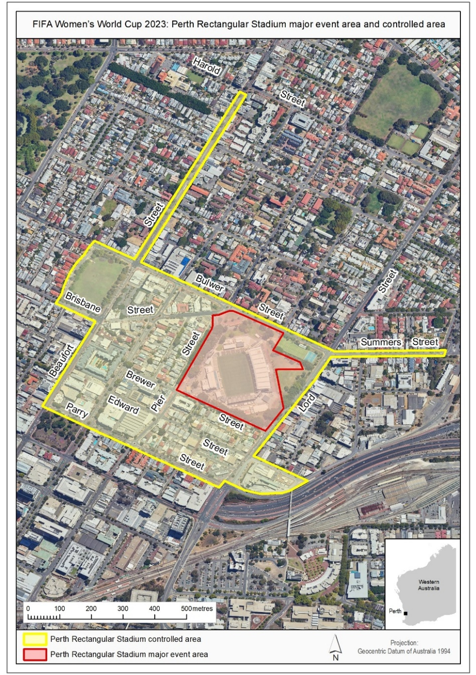
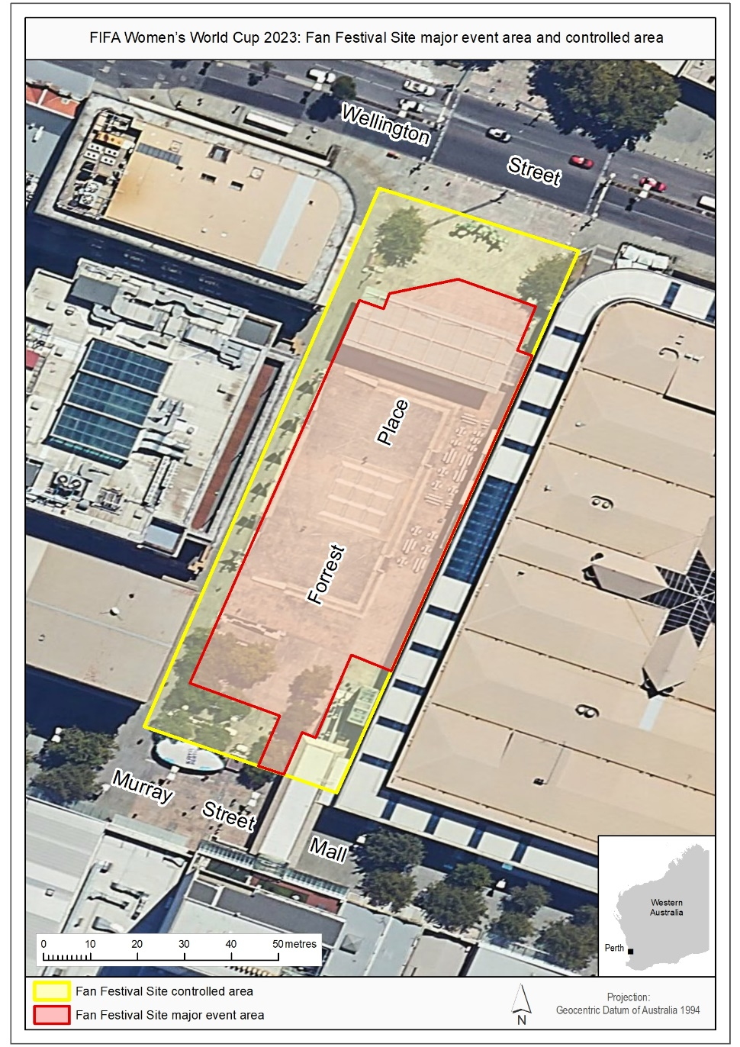

Schedule 4 — AFC Women’s Asian Cup 2026 major event areas and controlled areas
[r. 28(2) and 32(2)]
[Heading inserted: SL 2025/202 r. 5.]
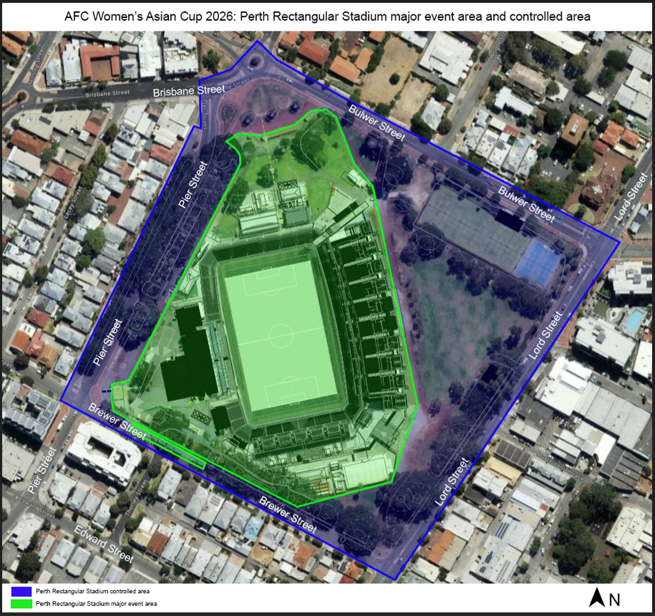
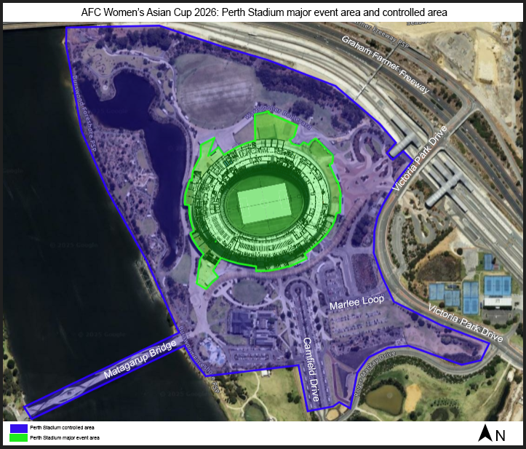
[Schedule 4 inserted: SL 2025/202 r. 5.]


Notes
This is a compilation of the Major Events Regulations 2023 and includes amendments made by other written laws. For provisions that have come into operation see the compilation table.

Compilation table
Citation | Published | Commencement
Major Events Regulations 2023 | SL 2023/99 30 Jun 2023 | Pt. 1: 30 Jun 2023 (see r. 2(a));  Regulations other than Pt. 1: 1 Jul 2023 (see r. 2(b))
Major Events Amendment Regulations 2025 | SL 2025/202 17 Dec 2025 | r. 1 and 2: 17 Dec 2025 (see r. 2(a));  Regulations other than r. 1 and 2: 18 Dec 2025 (see r. 2(b))

Defined terms

[This is a list of terms defined and the provisions where they are defined. The list is not part of the law.]
Defined term Provision(s)
AFC Women’s Asian Cup 2026 25
fan festival operating hours 10
FIFA Women’s World Cup 2023 10
match day 25
match period 25
match periods 10
passenger transport service 3
Perth Rectangular Stadium controlled area 25
Perth Rectangular Stadium major event area 25
Perth Stadium controlled area 25
Perth Stadium major event area 25
public passenger transport service 3
Public Transport Authority 3

© State of Western Australia 2025.
This work is licensed under a Creative Commons Attribution 4.0 International Licence (CC BY 4.0). To view relevant information and for a link to a copy of the licence, visit www.legislation.wa.gov.au.
Attribute work as: © State of Western Australia 2025.
By Authority: ROGER JACOBS, Acting Government Printer

