
Western Australia

Misuse of Drugs Act 1981

Western Australia
Misuse of Drugs Act 1981
Contents
Part I — Preliminary
1. Short title 2
2. Commencement 2
3. Terms used 2
3A. Approved analysts and botanists 6
3B. Specified drugs 6
4. Drugs and plants to which Act applies 7
5A. Authority required for some investigations 7
5B. Authorisation under Medicines and Poisons Act 2014 8
5C. Authorisation under Voluntary Assisted Dying Act 2019 10
Part II — Offences relating to prohibited drugs and prohibited plants
5. Offences concerned with prohibited drugs and prohibited plants in relation to premises and utensils 11
6. Offences concerned with prohibited drugs generally 12
7. Offences concerned with prohibited plants generally 13
7A. Selling or supplying a thing knowing it will be used in hydroponic cultivation of prohibited plants 14
7B. Drug paraphernalia, offences as to 15
8A. Defences relating to industrial hemp or industrial hemp seed 17
Part IIIA — Cannabis intervention
Division 1 — Preliminary
8B. Terms used 21
8C. Operation of Young Offenders Act 1994 unaffected 22
8D. Appointment of authorised persons 22
Division 2 — Cannabis intervention requirements
8E. CIR may be given for minor cannabis related offence 22
8F. Cannabis intervention requirement 23
8G. Young persons — special requirements about CIRs 24
8H. Referral of young persons at risk to juvenile justice teams 25
8I. Withdrawal of CIR 25
Division 3 — Cannabis intervention sessions
8J. Cannabis intervention session 26
8K. Benefit of completing CIS 26
8L. Extension of time to complete CIS 27
8M. Certificate of completion of CIS 27
Part IIIB — Psychoactive substances
8N. Terms used 28
8O. Application of this Part to particular substances 29
8P. Effect of representing substance as psychoactive substance 30
8Q. Manufacture, sale or supply of psychoactive substances 30
8R. Promoting psychoactive substances 31
8S. Powers of police officers for purposes of this Part 31
8T. Powers to seize and dispose of thing suspected of being psychoactive substance 32
8U. Analysis of seized thing may be requested 33
Part III — Procedure
9. Summary trial of some indictable offences 35
10. Alternative verdicts 36
11. Presumption of intent to sell or supply 36
Part IV — Controls relating to possession, sale, supply and storage of certain substances and things
12. Terms used 38
13. Part not applicable to possession, sale or supply of certain substances or things 38
14. Possession of certain substances or things 39
15. Sale or supply of category 1 items 40
16. Storage of category 1 items 41
17. Sale or supply of category 2 items 41
18. Offences relating to declarations under s. 15(1)(c) or 17(1)(b) 42
19. Powers of police officers for purposes of this Part 42
20. Regulations as to category 1 items and category 2 items 44
Part 4A — Targeted searches
Division 1 — Preliminary
20A. Terms used 45
Division 2 — Authorisations
20B. Authorisation to exercise powers to search a vehicle or a person 46
20C. Authorisation to exercise powers to search premises 47
Division 3 — Ancillary provisions in relation to exercising powers
20D. Other written laws 48
20E. Assistance when exercising powers under this Part 48
20F. Use of force 49
Division 4 — Vehicle searches
20G. Powers of police officers in relation to searching vehicle in drug detection area 49
20H. Powers of police officers in relation to searching persons in a drug detection area 51
Division 5 — Searches of delivery business premises
20I. Powers of police officers in relation to premises 52
Division 6 — Offences
20J. Failure to comply with requirement of police officer 53
20K. Application of section 29 to exercise of powers conferred by or under this Part 54
Division 7 — Prescribed procedures
20L. Regulations as to the exercise of powers under this Part 54
Part 4B — Border Search Areas
Division 1 — Preliminary
20M. Terms used 55
20N. Border Search Area (BSA) 55
Division 2 — Ancillary provisions in relation to exercising powers in Division 3
20O. Other written laws 58
20P. Assistance when exercising powers under Division 3 58
20Q. Use of force 58
Division 3 — Powers of authorised officers in public place in BSA
20R. Authorised officers and BSA authorisations 59
20S. Exercise of powers under Division 60
20T. Powers of authorised officers in relation to persons 60
20U. Powers of authorised officers in relation to vehicles 61
Division 4 — Offences
20V. Application of section 29 to exercise of powers conferred by or under this Part 63
20W. Failure to comply with requirement of authorised officer 63
Division 5 — Reporting, oversight and review
20X. Commissioner’s reports 63
20Y. Annual report by Corruption and Crime Commission 64
20Z. Inspection of records by Corruption and Crime Commission 65
20ZA. Review of Part 66
Part V — Location, seizure, detention and disposal of things used in commission of offences
21. Terms used 67
22. Powers of police officers and approved persons in relation to manufacturers, sellers and suppliers of prohibited drugs and cultivators, sellers and suppliers of prohibited plants 67
23. Powers of police officers when things suspected of being used in commission of offences 68
24. Granting of search warrants in connection with prevention or detection of offences 69
25. Powers ancillary to power of search 70
26. Powers of police officers and others when things suspected of being used in commission of offences found, received or acquired 71
26A. Powers of approved analyst or approved botanist 72
27. Disposal of prohibited drugs and prohibited plants 72
27A. Analysis at request of accused 75
27B. Confidentiality 75
28. Compensation for destroyed seized property 76
29. Hindering police officers and approved persons in exercise of powers conferred by or under this Part 77
30. Approved persons 78
Part VI — General
31. Undercover officers 79
32. No limitation 79
32A. Drug trafficking 79
33. Attempts, conspiracies, incitements and accessories after the fact 82
34. Penalties 83
35. Liability of officers for offence by body corporate 87
37. Proof of exceptions 87
38. Certificate of approved analyst or approved botanist 88
38A. Accused may obtain copy of certificate 88
38B. Accused may object to use of certificate 89
38C. Order for costs of approved analyst or approved botanist 89
38D. Evidence of contents of standard 90
39. Delegation by Commissioner 90
40. Civil liability of persons acting under this Act 91
41. Regulations 91
42. Amendment of certain schedules 92
42A. Annual report to Minister on Part 4A 94
42B. Review of Part 4A 95
Part VII — Transitional provisions
Division 1 — Preliminary
43. Interpretation Act 1984 not limited 96
44. Transitional regulations 96
Division 2 — Provisions for Cannabis Law Reform Act 2010
45. Terms used 97
46. CINs continue in force 97
47. Amounts outstanding in 12 months time under a CIN are to be taken to be paid 97
48. Transitional provisions (Sch. IX) 98
Schedule I — Drugs to which Act applies, notwithstanding anything in Medicines and Poisons Act 2014
Schedule II — Plants to which this Act applies
Schedule III — Amounts of prohibited drugs determining court of trial
Division 1 — General
Division 2 — Steroids
Schedule IV — Numbers of prohibited plants determining court of trial
Schedule V — Amounts of prohibited drugs giving rise to presumption of intention to sell or supply same
Division 1 — General
Division 2 — Steroids
Schedule VI — Numbers of prohibited plants giving rise to presumption of intention to sell or supply same or prohibited drugs obtainable from same
Schedule 6A — Border Search Areas
Division 1 — Descriptions of BSAs
Division 2 — Plans of BSAs
1. Broome Port 174
2. Broome Airport 174
3. Port of Port Hedland 175
4. Port Hedland International Airport 176
5. Port of Dampier 177
6. Port of Ashburton (Onslow) 177
7. Port of Geraldton 178
8. Perth Airport 179
9. Fremantle Port (Inner Harbour) 180
10. Fremantle Port (Outer Harbour) 182
11. Jandakot Airport 186
12. Wyndham Port 186
13. Bunbury Port 187
14. Busselton Airport 188
15. Albany Port 189
16. Esperance Port 189
17. Eyre Highway, Eucla (WA/SA border) 190
18. Victoria Highway near Kununurra (WA/NT border) 191
19. Tanami Road (WA/NT border) 191
20. Duncan Road (WA/NT border) 192
21. Great Central Road (WA/NT border) 192
22. Rawlinna Rail Siding 193
Schedule VII — Amounts of prohibited drugs for purposes of drug trafficking
Division 1 — General
Division 2 — Steroids
Schedule VIII — Numbers of prohibited plants for purposes of drug trafficking
Schedule IX — Transitional provisions
1. Property subject to holding orders under repealed s. 28 211
Notes
Compilation table 212
Uncommenced provisions table 217
Other notes 217
Defined terms

Western Australia
Misuse of Drugs Act 1981
An Act to prevent the misuse of certain drugs and plants and to provide for matters incidental thereto or connected therewith.

Part I — Preliminary

1. Short title
This Act may be cited as the Misuse of Drugs Act 1981.

2. Commencement
This Act shall come into operation on a day to be fixed by proclamation.

3. Terms used
(1) In this Act, unless the contrary intention appears —
adult means a person who has reached 18 years of age;
analyst means analyst registered under section 203 of the Health (Miscellaneous Provisions) Act 1911;
approved analyst means —
(a) a person declared under section 3A to be an approved analyst; or
(b) a person belonging to a class prescribed for the purposes of this definition;
approved botanist means a botanist declared under section 3A to be an approved botanist;
authorised prescription means a prescription issued by a prescriber as those terms are defined in the Medicines and Poisons Act 2014 section 7(1);
Border Search Area (BSA) has the meaning given in section 20N(1);
botanist means a person who —
(a) holds a science degree in, or to a major extent in, botany awarded by —
(i) a university in Australia; or
(ii) a prescribed university;
and
(b) has had not less than 2 years practical experience in plant taxonomy;
cannabis means plant of the genus Cannabis (by whatever name designated) or part of that plant;
cannabis resin means separated resin, whether crude or purified, obtained from cannabis;
category 1 item has the meaning given in section 12;
category 2 item has the meaning given in section 12;
child means a person who is under 18 years of age;
Commissioner means the Commissioner of Police appointed under the Police Act 1892;
controlled precursor means a category 1 item or a category 2 item;
dangerous substance means a substance (other than a prohibited drug or prohibited plant) that is noxious or volatile;
drug detection device means an electronic device, or a system that uses or involves an electronic device, of a type approved by the Commissioner for the purpose of detecting the presence of any of the following —
(a) a prohibited drug;
(b) a prohibited plant;
(c) a controlled precursor;
drug detection dog means a dog trained to detect the presence of any of the following —
(a) a prohibited drug;
(b) a prohibited plant;
(c) a controlled precursor;
drug of addiction means —
(a) a Schedule 8 poison as defined in the Medicines and Poisons Act 2014 section 3; or
(b) a Schedule 9 poison as defined in the Medicines and Poisons Act 2014 section 3;
heroin means the drug commonly known as heroin and includes any substance containing diacetylmorphine or its salts and any preparation, admixture or extract containing diacetylmorphine or any such salt;
industrial hemp has the meaning given to that term in section 3(1) of the Industrial Hemp Act 2004;
industrial hemp seed has the meaning given to that term in section 3(1) of the Industrial Hemp Act 2004;
medical practitioner means a person registered under the Health Practitioner Regulation National Law (Western Australia) in the medical profession;
methylamphetamine means the prohibited drug referred to in Schedule VII item 8;
opium means spontaneously coagulated juice obtained from the capsules of the opium poppy Papaver somniferum;
preliminary drug detection test means —
(a) leading or otherwise placing a drug detection dog in the vicinity of a person or property; or
(b) using a drug detection device in relation to a person or property;
processed industrial hemp means any product made from industrial hemp or industrial hemp seed that —
(a) does not contain more than 1% of tetrahydrocannabinol; and
(b) does not contain viable whole cannabis seed; and
(c) is not manufactured in a form to be inhaled;
prohibited drug means drug to which this Act applies by virtue of section 4;
prohibited plant means plant to which this Act applies by virtue of section 4, or part of that plant;
sample, in relation to any thing, means a sample of the thing taken by an approved analyst or an approved botanist under section 26A(a);
simple offence means simple offence under this Act;
specified drug means a substance that is prescribed to be a specified drug by regulations made under section 3B;
summary court means court of summary jurisdiction constituted by a magistrate sitting alone;
to cultivate, in relation to a prohibited plant, includes to grow, sow or scatter the seed produced by, or to plant, nurture, tend or harvest, the prohibited plant;
to possess includes to control or have dominion over, and to have the order or disposition of, and inflections and derivatives of the verb “to possess” have correlative meanings;
to supply includes to deliver, dispense, distribute, forward, furnish, make available, provide, return or send, and it does not matter that something is supplied on behalf of another or on whose behalf it is supplied;
undercover officer means a participant or a corresponding participant as those terms are defined in the Criminal Investigation (Covert Powers) Act 2012 section 5;
undercover operation means an authorised operation or corresponding authorised operation as those terms are defined in the Criminal Investigation (Covert Powers) Act 2012 section 5;
vehicle includes aircraft, hovercraft, vessel and any other means of transportation.
(2) In the case of liquid preparations, percentages shall, unless other provision in that behalf is made by the regulations, be calculated on the basis that a preparation containing 1% of a substance means a preparation in which one gram of the substance, if a solid, or one ml of the substance, if a liquid, is contained in every 100 ml of the preparation, and so in proportion for any greater or lesser percentage.
[Section 3 amended: No. 50 of 1990 s. 7; No. 20 of 1991 s. 57; No. 32 of 1994 s. 3(2); No. 44 of 1995 s. 4; No. 3 of 1998 s. 3; No. 9 of 2003 s. 28; No. 1 of 2004 s. 50; No. 4 of 2004 s. 58; No. 59 of 2004 s. 141; No. 62 of 2004 s. 4; No. 50 of 2006 Sch. 3 cl. 15; No. 22 of 2008 Sch. 3 cl. 37; No. 42 of 2009 s. 21; No. 35 of 2010 s. 118; No. 45 of 2010 s. 5; No. 56 of 2011 s. 4; No. 55 of 2012 s. 118; No. 13 of 2014 s. 166; No. 19 of 2016 s. 101; No. 47 of 2016 s. 4; No. 3 of 2017 s. 4; No. 15 of 2018 s. 6; No. 16 of 2023 s. 4.]

3A. Approved analysts and botanists
(1) The Commissioner may by notice published in the Gazette declare —
(a) an analyst to be an approved analyst for the purposes of this Act; or
(b) a botanist to be an approved botanist for the purposes of this Act.
(2) The Commissioner may by further notice published in the Gazette amend or revoke a notice under this section.
[Section 3A inserted: No. 44 of 1995 s. 5.]

3B. Specified drugs
(1) The Governor may, on the recommendation of the Minister and the Minister responsible for administering the Medicines and Poisons Act 2014, make regulations prescribing a substance to be a specified drug for the purposes of this Act.
(2) A recommendation that a substance be prescribed to be a specified drug may only be made if the relevant Minister is satisfied that there is high propensity for the substance to be misused, abused, used illicitly or diverted for the manufacture of a substance with a high propensity for misuse, abuse or illicit use.
[Section 3B inserted: No. 13 of 2014 s. 167.]

4. Drugs and plants to which Act applies
(1) Subject to subsection (4), the drugs to which this Act applies are —
(a) drugs of addiction; and
(b) specified drugs; and
(c) whether or not they are also drugs of addiction or specified drugs, the drugs specified in Schedule I.
(2) Subject to subsection (3), the plants to which this Act applies are —
(a) plants from which a drug of addiction may be obtained, derived or manufactured; and
(b) whether or not they are also plants referred to in paragraph (a), the plants specified in Schedule II.
(3) This Act does not apply to the non-viable seeds of the opium poppy Papaver somniferum.
(4) This Act does not apply to processed industrial hemp.
[Section 4 amended: No. 1 of 2004 s. 51; No. 13 of 2014 s. 168.]

5A. Authority required for some investigations
This Act is subject to the Criminal Appeals Act 2004 section 46C.
[Section 5A inserted: No. 9 of 2012 s. 10.]

5B. Authorisation under Medicines and Poisons Act 2014
(1) In this section —
appropriate licence has the meaning given in the Medicines and Poisons Act 2014 section 12;
appropriate permit has the meaning given in the Medicines and Poisons Act 2014 section 12;
professional authority has the meaning given in the Medicines and Poisons Act 2014 section 3.
(2) For the purposes of this Act the manufacture or preparation of a prohibited drug is authorised under the Medicines and Poisons Act 2014 if the prohibited drug is manufactured —
(a) under an appropriate licence or a professional authority; and
(b) in accordance with regulations made under that Act.
(3) For the purposes of this Act, the sale or supply of a prohibited drug is authorised under the Medicines and Poisons Act 2014 if the prohibited drug is supplied —
(a) under an appropriate licence, an appropriate permit or a professional authority; and
(b) in accordance with regulations made under that Act.
(4) For the purposes of this Act, a person is authorised under the Medicines and Poisons Act 2014 to manufacture, prepare, sell or supply a prohibited drug if —
(a) the person —
(i) holds an appropriate licence or an appropriate permit that authorises the manufacture or supply of the drug; or
(ii) is authorised by a professional authority to manufacture or supply the drug; or
(iii) is an employee or agent of a person referred to in subparagraph (i) or (ii);
and
(b) the manufacture, preparation, sale or supply is in accordance with the licence, permit or authority.
(5) For the purposes of this Act, a person is authorised under the Medicines and Poisons Act 2014 to possess a prohibited drug if —
(a) the drug is a Schedule 4 or 8 poison as defined in the Medicines and Poisons Act 2014 section 3 and possession of the drug by the person would not be an offence under the Medicines and Poisons Act 2014 section 14(4); or
(b) the drug is a Schedule 9 poison as defined in the Medicines and Poisons Act 2014 section 3 and possession of the drug by the person would not be an offence under Medicines and Poisons Act 2014 section 17.
(6) For the purposes of this Act a person is authorised under the Medicines and Poisons Act 2014 to use a prohibited drug if the drug is prescribed for the person by the holder of a professional authority who is authorised under the Medicines and Poisons Act 2014 to prescribe the drug to the person and the use is in accordance with the instructions of the prescriber.
(7) For the purposes of this Act, an investigator as defined in the Medicines and Poisons Act 2014 section 3 is authorised to supply, obtain or possess a prohibited drug if the drug is supplied, obtained or possessed in the course of conducting an investigation under that Act.
[Section 5B inserted: No. 13 of 2014 s. 169.]

5C. Authorisation under Voluntary Assisted Dying Act 2019
(1) For the purposes of this Act, a person is authorised under the Voluntary Assisted Dying Act 2019 to prepare, sell or supply a prohibited drug if —
(a) the person is authorised by section 58, 59, 63 or 67 of that Act to prepare or supply the drug; and
(b) the preparation or supply is in accordance with that Act.
(2) For the purposes of this Act, a person is authorised under the Voluntary Assisted Dying Act 2019 to possess a prohibited drug if —
(a) the person is authorised by section 58, 59, 63, 67, 75 or 77 of that Act to receive or possess the drug; and
(b) the receipt or possession is in accordance with that Act.
(3) For the purposes of this Act, a person is authorised under the Voluntary Assisted Dying Act 2019 to use a prohibited drug if —
(a) the person is authorised by section 58 or 59 of that Act to prepare, self-administer or administer the drug; and
(b) the preparation, self-administration or administration is in accordance with that Act.
[Section 5C inserted: No. 27 of 2019 s. 181.]

Part II — Offences relating to prohibited drugs and prohibited plants

5. Offences concerned with prohibited drugs and prohibited plants in relation to premises and utensils
(1) A person who —
(a) being the occupier of any premises, knowingly permits those premises to be used for the purpose of —
(i) the manufacture or preparation of a prohibited drug or prohibited plant for use; or
(ii) the manufacture, preparation, sale, supply or use of a prohibited drug or prohibited plant;
or
(b) being the owner or lessee of any premises, knowingly permits those premises to be used for the purpose of using a prohibited drug or prohibited plant; or
(c) is knowingly concerned in the management of any premises used for any of the purposes referred to in paragraphs (a) and (b); or
[(d) deleted]
(e) is found in any place which is then being used for the purpose of smoking a prohibited drug or prohibited plant other than cannabis,
commits a simple offence.
(2) In subsection (1) —
owner, in relation to any premises, includes the person entitled to receive the rent of those premises and the person to whom the rent of those premises is paid.
(3) A person does not commit a simple offence under subsection (1)(a), (b) or (c) by reason only that premises are being used for the purpose of the manufacture, preparation, sale, supply or use of a prohibited drug or prohibited plant if the person proves —
(a) that the manufacture, preparation, sale or supply of the drug or plant was authorised under this Act or the Medicines and Poisons Act 2014; or
(aa) that the preparation, sale or supply of the drug was by a person authorised under the Voluntary Assisted Dying Act 2019 to prepare, sell or supply the drug; or
(b) that the use of the drug or plant was by a person authorised under this Act, the Medicines and Poisons Act 2014 or the Voluntary Assisted Dying Act 2019 to use the drug or plant.
[Section 5 amended: No. 52 of 2003 s. 28; No. 44 of 2010 s. 4; No. 56 of 2011 s. 5; No. 13 of 2014 s. 170; No. 27 of 2019 s. 182.]

6. Offences concerned with prohibited drugs generally
(1) A person commits a crime if the person —
(a) with intent to sell or supply it to another, has in his or her possession a prohibited drug; or
(b) manufactures or prepares a prohibited drug; or
(c) sells or supplies, or offers to sell or supply, a prohibited drug to another person.
(2) A person who has in his or her possession or uses a prohibited drug commits a simple offence.
(3) A person does not commit a crime under subsection (1) or a simple offence under subsection (2) by reason only of the person having in his or her possession a prohibited drug if the person proves that —
(a) he or she was authorised by or under this Act, the Medicines and Poisons Act 2014 or the Voluntary Assisted Dying Act 2019 to have possession of the drug; or
(b) he or she had possession of the drug only for the purpose of delivering it to a person authorised to possess the drug under this Act, the Medicines and Poisons Act 2014 or the Voluntary Assisted Dying Act 2019 and he or she took all reasonable steps to deliver the drug to the person; or
(c) he or she had possession of the drug for the purpose of analysing, examining or otherwise dealing with it for the purposes of this Act in his or her capacity as an analyst, botanist or other expert.
(4) A person does not commit a crime under subsection (1) by reason only that the person manufactures, prepares, sells or supplies a prohibited drug if the person proves that he or she was authorised to manufacture, prepare, sell or supply the drug under this Act, the Medicines and Poisons Act 2014 or the Voluntary Assisted Dying Act 2019.
(5) A person does not commit a simple offence under subsection (2) by reason only of using a prohibited drug if the person proves that he or she was a person authorised under this Act, the Medicines and Poisons Act 2014 or the Voluntary Assisted Dying Act 2019.
[Section 6 inserted: No. 13 of 2014 s. 171; amended: No. 27 of 2019 s. 183.]

7. Offences concerned with prohibited plants generally
(1) A person commits a crime if the person —
(a) with intent to sell or supply a prohibited plant, or any prohibited drug obtainable from a prohibited plant, to another person, has in his or her possession or cultivates the prohibited plant; or
(b) sells or supplies, or offers to sell or supply, a prohibited plant to another person.
(2) A person who has in his or her possession or cultivates a prohibited plant commits a simple offence.
(3) A person does not commit a crime under subsection (1) or a simple offence under subsection (2) by reason only of the person having in his or her possession a prohibited plant if the person proves that —
(a) he or she was authorised by or under this Act, the Medicines and Poisons Act 2014 or the Voluntary Assisted Dying Act 2019 to have possession of a prohibited drug obtainable from the plant; or
(b) he or she had possession of the plant only for the purpose of delivering it to a person authorised to have possession of a drug obtainable from the plant under this Act, the Medicines and Poisons Act 2014 or the Voluntary Assisted Dying Act 2019 and he or she took all reasonable steps to deliver the drug to the person; or
(c) he or she had possession of the plant for the purpose of analysing, examining or otherwise dealing with it for the purposes of this Act in his or her capacity as an analyst, botanist or other expert.
[Section 7 inserted: No. 13 of 2014 s. 171; amended: No. 27 of 2019 s. 184.]

7A. Selling or supplying a thing knowing it will be used in hydroponic cultivation of prohibited plants
(1) A person who sells or supplies, or offers to sell or supply, to another, any thing that the person knows will be used to cultivate a prohibited plant contrary to section 7(1)(a) or (2) by hydroponic means commits an indictable offence.
(2) A court convicting a person of the offence under subsection (1) may, on the application of the Director of Public Prosecutions or a police prosecutor, in addition order that the person be prohibited for a period set by the court (but not exceeding 2 years) from selling or supplying, or offering for sale or supply, to another, any thing that may be used to cultivate plants by hydroponic means.
(3) A person who contravenes an order under subsection (2) is guilty of a simple offence.
[Section 7A inserted: No. 52 of 2003 s. 29.]

7B. Drug paraphernalia, offences as to
(1) In this section —
display, in relation to drug paraphernalia, includes to authorise or allow drug paraphernalia to be displayed;
drug paraphernalia means —
(a) any thing made or modified to be used in connection with manufacturing or preparing a prohibited drug or a prohibited plant —
(i) for administration to a person; or
(ii) for smoking, inhaling or ingesting by a person; or
(iii) to be burned or heated so its smoke or fumes can be smoked or inhaled by a person;
or
(b) any thing made or modified to be used by a person —
(i) to administer a prohibited drug or a prohibited plant to a person; or
(ii) to smoke, inhale or ingest a prohibited drug or a prohibited plant; or
(iii) to smoke or inhale the smoke or fumes resulting from burning or heating a prohibited drug or a prohibited plant.
(2) A person who displays any drug paraphernalia for sale in a retail outlet commits a simple offence.
Penalty: a fine of $10 000.
(3) A person who sells any drug paraphernalia to an adult commits a simple offence.
Penalty: a fine of $10 000.
(4) A person who sells any drug paraphernalia to a child commits a simple offence.
Penalty: a fine of $24 000 or imprisonment for 2 years or both.
(5) It is a defence to a charge of an offence under subsection (2), (3) or (4) to prove —
(a) the accused was a person prescribed; or
(b) the drug paraphernalia displayed or sold was a thing prescribed or of a class prescribed; or
(c) the display or sale occurred in circumstances prescribed,
for the purposes of that subsection.
(6) A person who is in possession of any drug paraphernalia in or on which there is a prohibited drug or a prohibited plant commits a simple offence.
Penalty: a fine of $36 000 or imprisonment for 3 years or both.
(7) It is a defence to a charge of an offence under subsection (6) to prove —
(a) the accused was authorised by or under this Act, the Medicines and Poisons Act 2014 or the Voluntary Assisted Dying Act 2019 to possess the prohibited drug or prohibited plant; or
(b) the accused had possession of the drug paraphernalia —
(i) only for the purpose of delivering it to a person authorised under this Act, the Medicines and Poisons Act 2014 or the Voluntary Assisted Dying Act 2019 to have possession of any prohibited drug or prohibited plant in or on it; and
(ii) in accordance with the authority in writing of the person so authorised,
and that, after taking possession of the drug paraphernalia, the accused took all such steps as were reasonably open to the accused to deliver it into the possession of that person; or
(c) the accused had possession of the drug paraphernalia only for the purpose of analysing material in or on it, examining it or otherwise dealing with it for the purposes of this Act in his or her capacity as an analyst, botanist or other expert.
[Section 7B inserted: No. 56 of 2011 s. 6; amended: No. 13 of 2014 s.172; No. 27 of 2019 s. 185.]

[8. Deleted: No. 13 of 2014 s. 173.]

8A. Defences relating to industrial hemp or industrial hemp seed
(1) In proceedings against —
(a) a person who may process industrial hemp under a licence granted under the Industrial Hemp Act 2004; or
(b) an employee, agent or contractor of a person referred to in paragraph (a),
for an offence against section 5(1)(a)(i) involving the manufacture or preparation of a prohibited drug or prohibited plant for use, it is a defence for the person to prove that the prohibited drug or prohibited plant is industrial hemp or industrial hemp seed.
(2) In proceedings against —
(a) a person who may cultivate, harvest or process industrial hemp under a licence granted under the Industrial Hemp Act 2004; or
(b) an employee, agent or contractor of a person referred to in paragraph (a),
for an offence against section 5(1)(a)(ii) involving the manufacture, preparation, sale, supply or use of a prohibited drug or prohibited plant, it is a defence for the person to prove that the prohibited drug or prohibited plant is industrial hemp or industrial hemp seed.
(3) In proceedings against —
(a) a person who may cultivate, harvest or process industrial hemp under a licence granted under the Industrial Hemp Act 2004; or
(b) an employee, agent or contractor of a person referred to in paragraph (a),
for an offence against section 5(1)(c) involving being knowingly concerned in the management of any premises used for a purpose referred to in section 5(1)(a), it is a defence for the person to prove that the prohibited drug or prohibited plant is industrial hemp or industrial hemp seed.
(4) In proceedings against —
(a) a person who may cultivate, harvest or process industrial hemp under a licence granted under the Industrial Hemp Act 2004; or
(b) an employee, agent or contractor of a person referred to in paragraph (a),
for an offence against section 6(1)(a), it is a defence for the person to prove that the prohibited drug is industrial hemp or industrial hemp seed.
(5) In proceedings against —
(a) a person who may process industrial hemp under a licence granted under the Industrial Hemp Act 2004; or
(b) an employee, agent or contractor of a person referred to in paragraph (a),
for an offence against section 6(1)(b) involving manufacturing or preparing a prohibited drug, it is a defence for the person to prove that the prohibited drug is industrial hemp or industrial hemp seed.
(6) In proceedings against —
(a) a person who may cultivate, harvest or process industrial hemp under a licence granted under the Industrial Hemp Act 2004; or
(b) an employee, agent or contractor of a person referred to in paragraph (a),
for an offence against section 6(1)(c) involving selling or supplying, or offering to sell or supply a prohibited drug to another, it is a defence for the person to prove that the prohibited drug is industrial hemp or industrial hemp seed.
(7) In proceedings against —
(a) a person who may cultivate, harvest or process industrial hemp under a licence granted under the Industrial Hemp Act 2004; or
(b) an employee, agent or contractor of a person referred to in paragraph (a),
for an offence against section 6(2) involving possession or use of a prohibited drug, it is a defence for the person to prove that the prohibited drug is industrial hemp or industrial hemp seed.
(8) In proceedings against —
(a) a person who may cultivate, harvest or process industrial hemp under a licence granted under the Industrial Hemp Act 2004; or
(b) an employee, agent or contractor of a person referred to in paragraph (a),
for an offence against —
(c) section 7(1)(a) involving possessing or cultivating a prohibited plant with intent to sell or supply the prohibited plant or any prohibited drug obtainable therefrom to another; or
(d) section 7(1)(b) involving selling or supplying, or offering to sell or supply, a prohibited plant to another,
it is a defence for the person to prove that the prohibited plant is industrial hemp or industrial hemp seed.
(9) In proceedings against —
(a) a person who may cultivate, harvest or process industrial hemp under a licence granted under the Industrial Hemp Act 2004; or
(b) an employee, agent or contractor of a person referred to in paragraph (a),
for an offence against section 7(2) involving having in his or her possession or cultivating a prohibited plant, it is a defence for the person to prove that the prohibited plant is industrial hemp or industrial hemp seed.
[Section 8A inserted: No. 1 of 2004 s. 54.]

Part IIIA — Cannabis intervention
[Heading inserted: No. 45 of 2010 s. 6.]

Division 1 — Preliminary
[Heading inserted: No. 45 of 2010 s. 6.]

8B. Terms used
(1) In this Part —
adult means a person who is not a young person;
authorised person, in section 8I or 8L, means a person appointed under section 8D to be an authorised person for the purposes of the section in which the term is used;
cannabis intervention requirement means a notice referred to in section 8F;
cannabis intervention session means a cannabis intervention session —
(a) provided by a treatment provider approved under section 8J(2)(b); and
(b) the content of which is approved under section 8J(2)(a);
CEO (Health) has the meaning given in section 38D(1);
minor cannabis related offence means —
(a) an offence under section 7B(6) that involves cannabis; and
(b) an offence under section 6(2) that involves cannabis —
(i) if the amount is not more than 10 g, or such other amount as is prescribed by the regulations; and
(ii) if the offence does not involve a cannabis plant under cultivation, cannabis resin or any other cannabis derivative;
police officer does not include a person appointed by the Commissioner as an authorised person under section 8D;
responsible adult has the meaning given in the Young Offenders Act 1994 section 3;
young person means a person who —
(a) is under 18 years of age; or
(b) in relation to the commission, or alleged commission, of a minor cannabis related offence, was under 18 years of age when the offence was committed, or allegedly committed.
(2) In this Part the following abbreviations are used —
CIR for cannabis intervention requirement;
CIS for cannabis intervention session.
[Section 8B inserted: No. 45 of 2010 s. 6; amended: No. 56 of 2011 s. 7; No. 14 of 2025 s. 28(2).]

8C. Operation of Young Offenders Act 1994 unaffected
Nothing in this Part prevents a young person from being dealt with under the Young Offenders Act 1994 Part 5 in respect of a minor cannabis related offence.
[Section 8C inserted: No. 45 of 2010 s. 6.]

8D. Appointment of authorised persons
The Commissioner may, in writing, appoint persons or classes of persons to be authorised persons for the purposes of section 8I or 8L, or for the purposes of both of those sections.
[Section 8D inserted: No. 45 of 2010 s. 6.]

Division 2 — Cannabis intervention requirements
[Heading inserted: No. 45 of 2010 s. 6.]

8E. CIR may be given for minor cannabis related offence
(1) A police officer who has reason to believe that a person has committed a minor cannabis related offence may give a cannabis intervention requirement to the alleged offender, unless subsection (4) or section 8G(1) applies.
(2) A police officer who believes —
(a) that an alleged offender has committed more than one minor cannabis related offence; and
(b) that the alleged offences have arisen out of the same incident,
may give a single CIR in respect of all or some of the offences.
(3) A CIR is to be given as soon as practicable, and in any event within 60 days, after an alleged offence is believed to have been committed.
(4) A CIR cannot be given in respect of an alleged offence (the new offence) if the alleged offender —
(a) is an adult who, before the new offence was allegedly committed, had been convicted of a minor cannabis related offence or given a CIR; and
(b) was an adult when so convicted or given the CIR.
[Section 8E inserted: No. 45 of 2010 s. 6.]

8F. Cannabis intervention requirement
(1) A CIR is a notice in a form prescribed by the regulations —
(a) containing a description of the alleged offence, or offences; and
(b) informing the alleged offender that —
(i) he or she may, in writing, elect to be prosecuted for the alleged offence, or offences, in a court, and informing the alleged offender how to make that election; and
(ii) if he or she does not wish to be prosecuted for the alleged offence, or offences, in a court, the alleged offender may, within a period of 28 days after the giving of the CIR, complete a CIS;
and
(c) informing the alleged offender as to how the alleged offender may arrange to complete a CIS.
(2) A person need only complete a single CIS for each CIR given to the person, even if the CIR is given in respect of more than one alleged offence.
[Section 8F inserted: No. 45 of 2010 s. 6.]

8G. Young persons — special requirements about CIRs
(1) A CIR cannot be given in respect of an alleged offence (the new offence) if the alleged offender —
(a) is a young person who, before the new offence was allegedly committed, had been convicted of, or given a CIR in respect of, 2 or more minor cannabis related offences; and
(b) at least 2 of those offences arose out of separate incidents, or are alleged to have done so.
(2) A police officer who gives a young person a CIR is to ensure that a responsible adult is given a copy of the CIR as soon as is reasonably practicable after the CIR is given to the young person, unless —
(a) after reasonable enquiry, neither the whereabouts nor the address of a responsible adult can be ascertained; or
(b) in the circumstances it would be inappropriate to give a responsible adult a copy of the CIR.
(3) A young person who has been given 2 CIRs need only complete a single CIS in respect of the CIRs if both CIRs were given before the completion of the CIS.
[Section 8G inserted: No. 45 of 2010 s. 6.]

8H. Referral of young persons at risk to juvenile justice teams
(1) A police officer is to refer a young person at risk to a juvenile justice team where appropriate under the Young Offenders Act 1994 in preference to charging the young person under this Act.
(2) In subsection (1) —
young person at risk means an alleged offender who is a young person —
(a) to whom the police officer would have given a CIR, but for section 8G(1); or
(b) who has been given a CIR and has not completed a CIS within 28 days or any further time allowed under section 8L, unless —
(i) the CIR has been withdrawn under section 8I; or
(ii) the young person has elected to be prosecuted for the alleged offence in a court.
[Section 8H inserted: No. 45 of 2010 s. 6.]

8I. Withdrawal of CIR
(1) An authorised person may withdraw a CIR by sending to the alleged offender a notice in a form prescribed by the regulations stating that the CIR has been withdrawn.
(2) A CIR cannot be withdrawn if the alleged offender has completed a CIS in relation to the CIR.
(3) A CIR that is withdrawn is taken not to have been given to an alleged offender for the purposes of sections 8E(4) and 8G(1).
[Section 8I inserted: No. 45 of 2010 s. 6.]

Division 3 — Cannabis intervention sessions
[Heading inserted: No. 45 of 2010 s. 6.]

8J. Cannabis intervention session
(1) The purpose of a cannabis intervention session is to inform those who complete it about —
(a) the adverse health and social consequences of cannabis use; and
(b) the laws relating to the use, possession and cultivation of cannabis; and
(c) effective strategies to address cannabis using behaviour.
(2) The CEO (Health) may, in writing, do any of the following —
(a) having regard to subsection (1), approve the content of a cannabis intervention session;
(b) approve treatment providers to provide cannabis intervention sessions;
(c) give an approval under paragraph (b) subject to conditions to be obeyed by the treatment provider approved;
(d) cancel or amend an approval given under paragraph (a) or (b).
(3) For the purposes of this section, this Act is to be taken to be a relevant Act as referred to in the Health Legislation Administration Act 1984 section 9.
[Section 8J inserted: No. 45 of 2010 s. 6.]

8K. Benefit of completing CIS
(1) If the alleged offender has completed a CIS in respect of a CIR within 28 days or such further time as is allowed under section 8L, the bringing of proceedings and the imposition of penalties are prevented to the same extent that they would be prevented if the alleged offender had been convicted by a court of, and punished for, the alleged offence.
(2) Completion of a CIS is not to be regarded as an admission for the purposes of any proceedings, whether civil or criminal.
[Section 8K inserted: No. 45 of 2010 s. 6.]

8L. Extension of time to complete CIS
(1) An authorised person may, in a particular case, extend the period of 28 days within which the alleged offender may complete a CIS.
(2) The extension may be allowed whether or not the period of 28 days has elapsed.
[Section 8L inserted: No. 45 of 2010 s. 6.]

8M. Certificate of completion of CIS
(1) A treatment provider approved to provide a CIS under section 8J(2)(b) is to —
(a) give to a person who has completed a CIS a certificate of completion; and
(b) send a copy of the certificate to the Commissioner.
(2) A certificate of completion is to be in a form prescribed by the regulations and is to set out —
(a) the name and address of the person who has completed the CIS; and
(b) the date of completion; and
(c) the details of the CIR in respect of which the CIS was completed.
[Section 8M inserted: No. 45 of 2010 s. 6.]

Part IIIB — Psychoactive substances
[Heading inserted: No. 29 of 2015 s. 4.]

8N. Terms used
(1) In this Part —
Agvet Code of Western Australia has the meaning given in the Agricultural and Veterinary Chemicals (Western Australia) Act 1995;
consume has the meaning given in subsection (2);
manufacture, in relation to a psychoactive substance, means to make, prepare, produce, process (including by extracting or refining), package or label the psychoactive substance;
psychoactive effect, in relation to a person who consumes a substance, means —
(a) the effect of stimulating or depressing the central nervous system of the person, resulting in hallucinations or a significant disturbance in, or significant change to, motor function, thinking, behaviour, perception, awareness or mood; or
(b) the effect of causing a state of dependence, including physical or psychological addiction;
psychoactive substance means any substance that, when consumed by a person, has the capacity to induce a psychoactive effect on the person;
substance includes a natural organism.
(2) For this Part, a person consumes a substance if —
(a) the substance is administered to the person, whether the person self-administers it or it is administered by another person; or
(b) the person smokes, inhales or ingests the substance.
[Section 8N inserted: No. 29 of 2015 s. 4.]

8O. Application of this Part to particular substances
(1) This Part does not apply to any of the following —
(a) either —
(i) a medicine or a Schedule 9 poison as those terms are defined in the Medicines and Poisons Act 2014 section 3; or
(ii) if the Medicines and Poisons Act 2014 section 137 has not commenced — a medicine as defined in the Poisons Act 1964 section 5(1) or included in Schedule 9 under the Poisons Act 1964 ¹;
(b) a therapeutic good included in the Register as defined in the Therapeutic Goods Act 1989 (Commonwealth) section 3(1) or that is exempted from the operation of Part 3-2 of that Act by regulations made under section 18 of that Act;
(c) a tobacco product as defined in the Tobacco Products Control Act 2006 Glossary;
(d) a substance referred to in paragraph (a) or (b) of the definition of liquor in the Liquor Control Act 1988 section 3(1);
(e) a food as defined in the Food Act 2008 section 8;
(f) a substance that is a chemical product as defined in the Agvet Code of Western Australia if —
(i) the active constituents for the chemical product are approved under the Agvet Code of Western Australia Part 2; or
(ii) the chemical product is registered under the Agvet Code of Western Australia Part 2;
(g) a plant or fungus, or an extract from a plant or fungus;
(h) a substance of a class prescribed by the regulations.
(2) Despite subsection (1), this Part applies to a substance listed in subsection (1) if the substance contains, or has added to it, a substance that is not listed in subsection (1).
[Section 8O inserted: No. 29 of 2015 s. 4.]

8P. Effect of representing substance as psychoactive substance
(1) For the purposes of this Part, a substance that is represented in any way as being a psychoactive substance is to be taken to be a psychoactive substance.
(2) For the purposes of this Part, a substance that is represented in any way as being a specified psychoactive substance is to be taken to be the specified psychoactive substance.
[Section 8P inserted: No. 29 of 2015 s. 4.]

8Q. Manufacture, sale or supply of psychoactive substances
(1) A person commits a simple offence if the person manufactures a psychoactive substance.
Penalty: a fine of $48 000 or imprisonment for 4 years or both.
(2) A person commits a simple offence if the person sells or supplies a psychoactive substance.
Penalty: a fine of $48 000 or imprisonment for 4 years or both.
(3) For the purpose of deciding whether or not a person has committed an offence under subsection (1) or (2) in relation to a substance, it is irrelevant that usage instructions concerning the substance given in any manner or form indicate that the substance is not a psychoactive substance or that it is not intended for human consumption.
[Section 8Q inserted: No. 29 of 2015 s. 4.]

8R. Promoting psychoactive substances
(1) A person commits a simple offence if the person —
(a) promotes a substance as having a psychoactive effect on a person who consumes the substance; or
(b) provides information in any form on how or where a psychoactive substance may be acquired.
Penalty: a fine of $24 000 or imprisonment for 2 years or both.
(2) For the purposes of subsection (1)(a), a person promotes a substance if the person takes any action that is intended or apparently intended to publicise or promote the substance, whether visual or auditory means are employed and whether the substance is directly depicted or referred to or symbolism of some kind is employed, including action of a kind prescribed by the regulations.
[Section 8R inserted: No. 29 of 2015 s. 4.]

8S. Powers of police officers for purposes of this Part
(1) A police officer may, for the purposes of this Part, with such assistance as the police officer considers necessary —
(a) enter the premises (other than residential premises) of a person who is suspected on reasonable grounds of —
(i) manufacturing, selling or supplying a psychoactive substance; or
(ii) promoting a substance as having a psychoactive effect on a person who consumes the substance; or
(iii) providing information on how or where a psychoactive substance may be acquired; or
(iv) having done any of the things mentioned in subparagraph (i) to (iii);
and
(b) demand the production of, and inspect, any books, papers or documents relating to any of the things mentioned in paragraph (a)(i) to (iii); and
(c) inspect any substances.
(2) Section 25 applies as if the reference in subsection (1) of that section to a police officer exercising the powers conferred by section 22 or 23 included a reference to a police officer exercising the powers in subsection (1).
(3) Section 29 applies as if —
(a) references in paragraphs (a) and (b) of that section to a police officer acting in the exercise of the powers conferred on the police officer by or under Part V or a person assisting a police officer so acting included a reference to a police officer acting in the exercise of the powers in subsection (1) or a person assisting a police officer so acting; and
(b) the reference in paragraph (b) of that section to books, papers, documents, information or stocks referred to in section 22 included a reference to books, papers, documents or substances referred to in subsection (1).
(4) The powers in subsection (1) are in addition to, and not in derogation of, the powers conferred on police officers by Part V.
[Section 8S inserted: No. 29 of 2015 s. 4.]

8T. Powers to seize and dispose of thing suspected of being psychoactive substance
(1) In this section and section 8U —
destruction notice means a notice that complies with subsections (4) and (5).
(2) If there are reasonable grounds to suspect that any thing found or received during the exercise of the powers conferred by section 8S or by a search warrant is a psychoactive substance, a police officer may seize and detain the thing until it is dealt with under this section or section 8U.
(3) A police officer must give to a person from whom a thing is seized under subsection (2) a destruction notice if —
(a) the police officer is satisfied that no person will be tried with the commission of an offence in relation to the thing; or
(b) a person is tried with the commission of an offence in relation to the thing and the person is not convicted of that offence.
(4) A destruction notice must —
(a) be in writing in the prescribed form; and
(b) identify the thing to which it relates; and
(c) advise that the thing will be destroyed on or after a day specified in the notice unless, before that day, an application is made under section 8U(1) to have a sample of the thing analysed.
(5) The day referred to in subsection (4)(c) cannot be a day that is sooner than 21 days after the day the notice is given.
(6) Subject to section 8U, a police officer may destroy a thing seized under subsection (2) on or after the day specified in a destruction notice given in relation to the thing.
[Section 8T inserted: No. 29 of 2015 s. 4.]

8U. Analysis of seized thing may be requested
(1) On receipt of a destruction notice, a person may apply to the Commissioner to have a sample of the thing identified in the notice analysed by an approved analyst.
(2) An application must be —
(a) made in the prescribed form; and
(b) made within 21 days of the receipt of the notice; and
(c) accompanied by the prescribed fee.
(3) If an application is made under subsection (1), the Commissioner must —
(a) request an approved analyst to analyse a sample of the thing and provide the Commissioner with a report of the analysis; and
(b) direct that the thing not be destroyed under the destruction notice.
(4) After considering a report of the analysis of a sample of a thing provided by an approved analyst, the Commissioner must —
(a) if the Commissioner is satisfied that the thing is a psychoactive substance — order that the thing be destroyed; or
(b) if the Commissioner is satisfied that the thing is not a psychoactive substance but is a relevant thing as defined in section 27(6) — order that the thing be dealt with under section 27 as if it had been seized and detained under section 26; or
(c) if the Commissioner is satisfied that the thing is not a psychoactive substance or a relevant thing —
(i) order that the thing be released to the person from whom it was seized; and
(ii) order that the fee paid by the applicant for a sample of the thing to be analysed be refunded to the applicant.
[Section 8U inserted: No. 29 of 2015 s. 4.]

Part III — Procedure

9. Summary trial of some indictable offences
(1) If a person is charged before a court of summary jurisdiction with —
(a) an offence under section 6(1) in respect of a quantity of a prohibited drug referred to in Schedule III that is less than the quantity specified in that Schedule in relation to that prohibited drug; or
(b) an offence under section 7(1) in respect of a number of prohibited plants of a particular species or genus referred to in Schedule IV that is less than the number specified in that Schedule in relation to that species or genus; or
(c) an offence under section 7A(1),
then, except in a case where the person is charged with conspiring to commit the offence, the summary conviction penalty for the offence is that set out in section 34(2)(b).
(2) A court of summary jurisdiction that tries a person summarily for a charge of an offence referred to in subsection (1) must be constituted by a magistrate sitting alone.
(3) If a person charged before a court of summary jurisdiction with an offence that may be dealt with summarily under subsection (1) is, under section 5 of The Criminal Code, committed for trial or sentence in respect of the offence, the court to which the accused is committed may deal with the charge despite —
(a) the quantity of the prohibited drug to which the charge relates being less than the quantity specified in Schedule III in relation to that prohibited drug; or
(b) the number of prohibited plants of a particular species or genus to which the charge relates being less than the number specified in Schedule IV in relation to that species or genus.
[Section 9 inserted: No. 4 of 2004 s. 58; amended: No. 84 of 2004 s. 82.]

10. Alternative verdicts
A court trying a person charged with having committed a crime under —
(a) section 6(1) may, if the evidence does not establish that that person is guilty of that crime but does establish that he is guilty of a simple offence under section 6(2); or
(b) section 7(1) may, if the evidence does not establish that that person is guilty of that crime but does establish that he is guilty of a simple offence under section 7(2),
convict him of having committed that simple offence and, whether that court is a summary court, the District Court or the Supreme Court, impose on him the penalty referred to in section 34(1)(e).
[Section 10 amended: No. 4 of 2004 s. 58.]

11. Presumption of intent to sell or supply
For the purposes of —
(a) section 6(1)(a), a person shall, unless the contrary is proved, be deemed to have in his possession a prohibited drug with intent to sell or supply it to another if he has in his possession a quantity of the prohibited drug which is not less than the quantity specified in Schedule V in relation to the prohibited drug; or
(b) section 7(1)(a), a person shall, unless the contrary is proved, be deemed to have in his possession, or to cultivate, prohibited plants of a particular species or genus with intent to sell or supply those prohibited plants or any prohibited drug obtainable therefrom to another if he has in his possession, or cultivates, a number of those prohibited plants which is not less than the number specified in Schedule VI in relation to that species or genus.

Part IV — Controls relating to possession, sale, supply and storage of certain substances and things
[Heading inserted: No. 62 of 2004 s. 5.]

12. Terms used
In this Part, unless the contrary intention appears —
category 1 item means a substance or thing designated as a category 1 item by regulations referred to in section 20;
category 2 item means a substance or thing designated as a category 2 item by regulations referred to in section 20;
recipient means a person to whom a category 1 item or category 2 item, as the case requires, is sold or supplied;
substance includes material, compound, preparation and admixture;
supplier means a person who sells or supplies a category 1 item or category 2 item, as the case requires.
[Section 12 inserted: No. 62 of 2004 s. 5.]

13. Part not applicable to possession, sale or supply of certain substances or things
(1) This Part does not apply to or in relation to the possession, sale or supply of a category 1 item or category 2 item if —
(a) the item is, or is contained in, a substance that is designed, packaged and labelled for human or animal therapeutic use; and
(b) the item is in the possession of, or the sale or supply is to or by, a person belonging to a class prescribed for the purposes of this subsection acting in the ordinary course of the person’s occupation.
(2) This Part does not apply to or in relation to the possession or supply of a category 1 item or category 2 item if the item is in the possession of, or the supply is by, a person employed or engaged by an education institution or a research institution acting in the ordinary course of the person’s occupation and the possession or supply is solely for educational or research purposes.
[Section 13 inserted: No. 62 of 2004 s. 5.]

14. Possession of certain substances or things
(1) A person who, without lawful excuse, has in the person’s possession a substance that contains, or substances that together contain, a quantity of a category 1 item or a category 2 item that exceeds the quantity prescribed in relation to the item concerned commits a crime.
Penalty: $20 000 or imprisonment for 5 years or both.
Summary conviction penalty: $12 000 or imprisonment for 3 years or both.
(2) A person who, without lawful excuse, has in the person’s possession a category 1 item or a category 2 item commits a simple offence.
Penalty: $12 000 or imprisonment for 3 years or both.
(3) A person does not commit an offence under subsection (1) or (2) if the person is authorised by or under this Act or by or under the Medicines and Poisons Act 2014to possess the item or substance concerned and does so in accordance with that authority.
(4) A person does not commit an offence under subsection (1) or (2) by reason only of the person having in the person’s possession a category 1 item, a category 2 item or a particular substance if the person proves that —
(a) he or she was authorised by or under this Act or the Medicines and Poisons Act 2014 to have possession of the item or substance; or
(b) he or she had possession of the item or substance only for the purpose of delivering it to a person authorised to have possession of the item or substance under this Act or the Medicines and Poisons Act 2014 and he or she took all reasonable steps to deliver the item or substance to the person; or
(c) he or she had possession of the item or substance for the purpose of analysing, examining or otherwise dealing with it for the purposes of this Act in his or her capacity as an analyst, botanist or other expert.
[Section 14 inserted: No. 62 of 2004 s. 5; amended: No. 13 of 2014 s. 174 .]

15. Sale or supply of category 1 items
(1) A supplier who sells or supplies a category 1 item commits a simple offence unless —
(a) the recipient holds an account with the supplier; and
(b) the sale or supply is a sale or supply on account that occurs after a written order for the item is given to the supplier by or on behalf of the recipient; and
(c) the order is accompanied by a declaration in the prescribed form made by or on behalf of the recipient; and
(d) the person who takes possession of the item produces to the supplier such evidence of the person’s identity as is required by the regulations.
(2) A supplier who sells or supplies a category 1 item commits a simple offence if the supplier gives possession of the item to the recipient, or to a person on behalf of the recipient, within 24 hours after the written order for the item was given to the supplier.
(3) A supplier who sells or supplies a category 1 item commits a simple offence if the supplier fails to give a copy of the declaration under subsection (1)(c) in respect of the sale or supply to the Commissioner in the prescribed manner within 24 hours after the written order for the item was given to the supplier.
[Section 15 inserted: No. 62 of 2004 s. 5.]

16. Storage of category 1 items
(1) A supplier who sells or supplies category 1 items commits a simple offence if the supplier fails to store those items in a manner that prevents access to them by any person other than a person who is authorised in writing by the supplier to have such access.
(2) A person who sells or supplies, or has sold or supplied, category 1 items commits a simple offence if the person fails to retain a copy of each authorisation given for the purposes of subsection (1) while it has effect and for at least 5 years after it ceases to have effect.
[Section 16 inserted: No. 62 of 2004 s. 5.]

17. Sale or supply of category 2 items
(1) A supplier who sells or supplies a category 2 item commits a simple offence unless —
(a) the recipient holds an account with the supplier and the sale or supply is of the kind described in section 15(1)(b); or
(b) at the time of the sale or supply —
(i) a declaration in the prescribed form made by or on behalf of the recipient is given to the supplier; and
(ii) the person who takes possession of the item produces to the supplier such evidence of the person’s identity as is required by the regulations.
(2) A supplier who —
(a) sells or supplies a category 2 item; and
(b) is given a declaration referred to in subsection (1)(b) in respect of the sale or supply,
commits a simple offence if the supplier fails to give a copy of the declaration to the Commissioner in the prescribed manner as soon as practicable after the sale or supply.
[Section 17 inserted: No. 62 of 2004 s. 5.]

18. Offences relating to declarations under s. 15(1)(c) or 17(1)(b)
(1) A person who sells or supplies, or has sold or supplied, category 1 items or category 2 items commits a simple offence if the person fails to retain each declaration given to the person under section 15(1)(c) or 17(1)(b) for at least 5 years after the day on which the sale or supply to which the declaration relates occurred.
(2) A person who gives false or misleading information in a declaration under section 15(1)(c) or 17(1)(b) commits a simple offence.
[Section 18 inserted: No. 62 of 2004 s. 5.]

[19A, 19B. Deleted: No. 56 of 2011 s. 8.]

19. Powers of police officers for purposes of this Part
(1) A police officer may, for the purposes of this Part, with such assistance as the police officer considers necessary —
(a) enter the premises of a person who sells or supplies, or has sold or supplied, category 1 items or category 2 items; and
(b) demand the production of, and inspect —
(i) any books, papers or documents relating to the sale or supply of category 1 items or category 2 items, including any declarations under section 15(1)(c) or 17(1)(b); and
(ii) any authorisations given for the purposes of section 16(1);
and
(c) inspect any stocks of category 1 items or category 2 items.
(2) Section 25 applies as if the reference in subsection (1) of that section to a police officer exercising the powers conferred by section 22 or 23 included a reference to a police officer exercising the powers in subsection (1).
(3) Section 26 applies as if the reference in subsection (1) of that section to the exercise of the powers conferred by section 22 or 23 included a reference to the exercise of the powers in subsection (1).
(4) Section 29 applies as if —
(a) references in paragraphs (a) and (b) of that section to a police officer acting in the exercise of the powers conferred on the police officer by or under Part V or a person assisting a police officer so acting included a reference to a police officer acting in the exercise of the powers in subsection (1) or a person assisting a police officer so acting; and
(b) the reference in paragraph (b) of that section to books, papers, documents or stocks referred to in section 22 included a reference to books, papers, documents, authorisations or stocks referred to in subsection (1).
(5) The powers in subsection (1) are in addition to, and not in derogation of, the powers conferred on police officers by Part V.
[Section 19 inserted: No. 62 of 2004 s. 5.]

20. Regulations as to category 1 items and category 2 items
(1) The regulations may designate a substance or thing specified, or belonging to a class specified, in the regulations as a category 1 item or a category 2 item.
(2) The designation of a substance or thing as a category 1 item indicates that there is a significant likelihood of its use in, or in connection with, the manufacture of a prohibited drug.
(3) The designation of a substance or thing as a category 2 item indicates that there is a reasonable likelihood of its use in, or in connection with, the manufacture of a prohibited drug.
[Section 20 inserted: No. 62 of 2004 s. 5.]

Part 4A — Targeted searches
[Heading inserted: No. 47 of 2016 s. 5.]

Division 1 — Preliminary
[Heading inserted: No. 47 of 2016 s. 5.]

20A. Terms used
In this Part —
Australia Post has the meaning given in the Australian Postal Corporation Act 1989 (Commonwealth) section 3;
consigned article means any article, including a letter, document, envelope, packet, parcel, package, container or wrapper, consigned for delivery by a delivery business;
delivery business means a business that delivers consigned articles but does not include Australia Post;
drug detection area means an area referred to in section 20B(2)(a);
metropolitan region has the meaning given in the Planning and Development Act 2005 section 4(1);
premises search authorisation means an authorisation issued by a senior police officer under section 20C;
senior police officer means a police officer who is, or is acting as, a superintendent or an officer above the rank of superintendent;
vehicle search authorisation means an authorisation issued by a senior police officer under section 20B.
[Section 20A inserted: No. 47 of 2016 s. 5; amended: No. 16 of 2023 s. 5.]

Division 2 — Authorisations
[Heading inserted: No. 47 of 2016 s. 5.]

20B. Authorisation to exercise powers to search a vehicle or a person
(1) A senior police officer may issue a vehicle search authorisation under this section if the senior police officer is satisfied there are reasonable grounds to suspect that an area is being, or is likely to be, used for the transport of any of the following —
(a) a prohibited drug;
(b) a prohibited plant;
(c) a controlled precursor.
(2) A vehicle search authorisation must set out the following —
(a) subject to subsection (3), the boundaries of the area to which the authorisation relates (the drug detection area);
(b) the date and time from which it is to take effect;
(c) the period, not exceeding 14 days, for which it has effect.
(3) A senior police officer must not specify an area under subsection (2)(a) that —
(a) is in the metropolitan region; or
(b) exceeds an area of 5 square kilometres.
(4) A vehicle search authorisation may be subject to any conditions specified in the authorisation by the senior police officer issuing the authorisation.
(5) A vehicle search authorisation —
(a) may be renewed by a senior police officer —
(i) before the vehicle search authorisation expires; and
(ii) for a period not exceeding 14 days; and
(iii) if the senior police officer is satisfied that the requirements set out in subsection (1) are met;
and
(b) may be renewed under paragraph (a) more than once; and
(c) may be revoked or varied by a senior police officer.
(6) A vehicle search authorisation issued when 3 authorisations are already in force has no effect.
(7) A vehicle search authorisation, or the renewal, variation or revocation of a vehicle search authorisation, must be in writing.
[Section 20B inserted: No. 47 of 2016 s. 5.]

20C. Authorisation to exercise powers to search premises
(1) A senior police officer may issue a premises search authorisation under this section in respect of premises used primarily for carrying on a delivery business.
(2) A premises search authorisation must set out the following —
(a) the address of the premises to which the authorisation relates;
(b) the date and time from which it is to take effect;
(c) the period, not exceeding 24 hours, for which it has effect.
(3) A premises search authorisation may be subject to any conditions specified in the authorisation by the senior police officer issuing the authorisation.
(4) A premises search authorisation —
(a) may be renewed by a senior police officer —
(i) before the premises search authorisation expires; and
(ii) for a period not exceeding 24 hours;
and
(b) may be renewed under paragraph (a) more than once; and
(c) may be revoked or varied by a senior police officer.
(5) A premises search authorisation issued when 3 authorisations are already in force has no effect.
(6) A premises search authorisation, or the renewal, variation or revocation of a premises search authorisation, must be in writing.
[Section 20C inserted: No. 47 of 2016 s. 5.]

Division 3 — Ancillary provisions in relation to exercising powers
[Heading inserted: No. 47 of 2016 s. 5.]

20D. Other written laws
Unless the contrary intention appears in this Act or another written law —
(a) this Part does not affect the operation of any other written law; and
(b) the powers in this Part are in addition to, and not in derogation of, the powers conferred on police officers by Part V or any other written law.
[Section 20D inserted: No. 47 of 2016 s. 5.]

20E. Assistance when exercising powers under this Part
(1) A police officer may authorise as many other persons to assist in exercising a power under this Part as are reasonably necessary in the circumstances.
(2) If a police officer authorises other persons to assist in the exercise of powers under this Part, the Criminal Investigation Act 2006 section 15, with any necessary changes, applies to and in relation to the exercise of powers by, or the assistance of, that person.
[Section 20E inserted: No. 47 of 2016 s. 5.]

20F. Use of force
When exercising a power under this Part, a person may use such force as is reasonably necessary and with such assistance as the person considers necessary —
(a) to exercise the power; and
(b) to overcome any resistance to exercising the power that is offered, or that the person exercising the power reasonably suspects will be offered, by any person.
[Section 20F inserted: No. 47 of 2016 s. 5.]

Division 4 — Vehicle searches
[Heading inserted: No. 47 of 2016 s. 5.]

20G. Powers of police officers in relation to searching vehicle in drug detection area
(1) In this section —
search includes doing a preliminary drug detection test.
(2) Under a vehicle search authorisation, a police officer may do one or more of the following in relation to a vehicle in the drug detection area set out in the authorisation —
(a) require the driver of the vehicle to stop the vehicle;
(b) enter and search any part of the vehicle;
(c) detain the vehicle for a reasonable period in order to search the vehicle;
(d) move the vehicle to a place suitable to search the vehicle;
(e) require a person to open any part of the vehicle;
(f) require the driver, or a passenger, of the vehicle not to leave, or to remain in, the vehicle;
(g) take any action that is reasonably necessary in order to search the vehicle.
(3) A police officer has reasonable grounds to suspect that any thing referred to in section 23(1)(a), (b) or (c) is in the possession of a person, if a preliminary drug detection test in relation to a vehicle in which the person is, or was, the driver or a passenger, indicates the detection of any of the following —
(a) a prohibited drug;
(b) a prohibited plant;
(c) a controlled precursor.
(4) Section 25 applies as if the reference in subsection (1) of that section to a police officer exercising the powers conferred by section 22 or 23 included a reference to a police officer exercising the powers conferred by subsection (2) of this section.
(5) Section 26 applies as if —
(a) the reference in subsection (1)(a)(i) and (ii) of that section to a dangerous substance included a reference to a controlled precursor; and
(b) the reference in subsection (1) of that section to the exercise of the powers conferred by section 22 or 23 included a reference to the exercise of the powers conferred by subsection (2) of this section.
[Section 20G inserted: No. 47 of 2016 s. 5.]

20H. Powers of police officers in relation to searching persons in a drug detection area
(1) Under a vehicle search authorisation, a police officer may do a preliminary drug detection test on the following persons —
(a) the driver of a vehicle in the drug detection area; or
(b) a passenger of a vehicle in the drug detection area; or
(c) a person who a police officer has reasonable grounds to suspect has recently left a vehicle that is, or was, in the drug detection area.
(2) A police officer who wishes to do a preliminary drug detection test on a person under subsection (1) may detain the person for a reasonable period in order to do the test.
(3) A police officer has reasonable grounds to suspect that any thing referred to in section 23(1)(a), (b) or (c) is in the possession of a person, if a preliminary drug detection test indicates the detection of any of the following on the person —
(a) a prohibited drug;
(b) a prohibited plant;
(c) a controlled precursor.
(4) Section 25 applies as if the reference in subsection (1) of that section to a police officer exercising the powers conferred by section 22 or 23 included a reference to a police officer exercising the powers conferred by subsection (1) of this section.
(5) Section 26 applies as if —
(a) the reference in subsection (1)(a)(i) and (ii) of that section to a dangerous substance included a reference to a controlled precursor; and
(b) the reference in subsection (1) of that section to the exercise of the powers conferred by section 22 or 23 included a reference to the exercise of the powers conferred by subsection (1) of this section.
[Section 20H inserted: No. 47 of 2016 s. 5.]

Division 5 — Searches of delivery business premises
[Heading inserted: No. 47 of 2016 s. 5.]

20I. Powers of police officers in relation to premises
(1) In this section —
premises includes a vehicle at the premises.
(2) Under a premises search authorisation, a police officer may do one or more of the following in respect of the premises to which the authorisation relates —
(a) enter the premises;
(b) subject to subsection (3), do a preliminary drug detection test on, or in relation to, any consigned article;
(c) take into and use in the premises any equipment that is, or facilities that are, reasonably necessary in order to exercise any power under the authorisation;
(d) make reasonable use of any equipment, facilities or services in the premises in order to exercise any power under the authorisation and for that purpose —
(i) to operate the equipment or facilities; and
(ii) to require an occupier of the premises to do anything that is reasonable and necessary to facilitate that use;
(e) open and examine a consigned article if a preliminary drug detection test indicates the detection of any of the following in relation to the article —
(i) a prohibited drug;
(ii) a prohibited plant;
(iii) a controlled precursor;
(f) take any action that is reasonably necessary in order to search the premises.
(3) A police officer may do a preliminary drug detection test on, or in relation to, a consigned article under subsection (2)(b) only if the consigned article is in a part of the premises used for the purpose of —
(a) storing consigned articles prior to delivery; or
(b) sorting consigned articles prior to delivery; or
(c) dispatching consigned articles for delivery; or
(d) if the consigned article is in a vehicle, parking vehicles.
(4) Section 25 applies as if the reference in subsection (1) of that section to a police officer exercising the powers conferred by section 22 or 23 included a reference to a police officer exercising the powers conferred by subsection (2) of this section.
(5) Section 26 applies as if —
(a) the reference in subsection (1)(a)(i) and (ii) of that section to a dangerous substance included a reference to a controlled precursor; and
(b) the reference in subsection (1) of that section to the exercise of the powers conferred by section 22 or 23 included a reference to the exercise of the powers conferred by subsection (2) of this section.
[Section 20I inserted: No. 47 of 2016 s. 5.]

Division 6 — Offences
[Heading inserted: No. 47 of 2016 s. 5.]

20J. Failure to comply with requirement of police officer
A person who fails to comply, without reasonable excuse, with a requirement of a police officer in the exercise of powers conferred on that police officer under section 20G(2)(a), (e) or (f), or 20I(2)(d)(ii), commits a simple offence.
[Section 20J inserted: No. 47 of 2016 s. 5.]

20K. Application of section 29 to exercise of powers conferred by or under this Part
Section 29 applies as if references in paragraphs (a) and (b) of that section to a police officer acting in the exercise of the powers conferred on the police officer by or under Part V or a person assisting a police officer so acting included a reference to a police officer acting in the exercise of the powers conferred by section 20G(2), 20H(1) or 20I(2) or a person assisting a police officer so acting.
[Section 20K inserted: No. 47 of 2016 s. 5.]

Division 7 — Prescribed procedures
[Heading inserted: No. 47 of 2016 s. 5.]

20L. Regulations as to the exercise of powers under this Part
(1) The regulations may prescribe procedures to be followed in relation to the exercise of the powers conferred by this Part.
(2) Without limiting the generality of subsection (1), regulations may —
(a) provide for the manner in which vehicles may be stopped in a drug detection area, including the establishment of facilities, warnings and other devices to enable vehicles to be stopped in a safe and orderly manner; and
(b) provide for the procedure to be followed in relation to doing a preliminary drug detection test.
[Section 20L inserted: No. 47 of 2016 s. 5.]

Part 4B — Border Search Areas
[Heading inserted: No. 16 of 2023 s. 6.]

Division 1 — Preliminary
[Heading inserted: No. 16 of 2023 s. 6.]

20M. Terms used
In this Part —
authorised officer has the meaning given in section 20R(1);
Corruption and Crime Commission means the Corruption and Crime Commission established under the Corruption, Crime and Misconduct Act 2003;
public place has the meaning given in the Criminal Investigation Act 2006 section 3(1).
[Section 20M inserted: No. 16 of 2023 s. 6.]

20N. Border Search Area (BSA)
(1) For the purposes of this Act, a Border Search Area (BSA) is an area —
(a) described in Schedule 6A Division 1; and
(b) shown for information purposes in a plan in Schedule 6A Division 2.
(2) The power in section 42(1A)(a) cannot be exercised in relation to Schedule 6A to modify a BSA except on the recommendation of the Minister.
(3) The Minister cannot make the recommendation under subsection (2) unless —
(a) the Minister has the approval of the Attorney General to make the recommendation; and
(b) the Minister is satisfied of the matters referred to in subsection (4).
(4) The Minister must be satisfied that —
(a) the modification is necessary for the ongoing effectiveness of the BSA in reducing the transport into the State of any of the following —
(i) a prohibited drug;
(ii) a prohibited plant;
(iii) a controlled precursor;
and
(b) the proposed modified BSA —
(i) is not larger than is reasonably necessary for the effective exercise of the powers in Division 3; and
(ii) in any event, does not exceed 5 km² in area.
(5) The Minister can be satisfied of the matters referred to in subsection (4) only after consultation with each of the following —
(a) the Minister responsible for the administration of the Local Government Act 1995;
(b) the Minister responsible for the administration of the Port Authorities Act 1999;
(c) the Minister responsible for the administration of the Transport Co-ordination Act 1966.
(6) The power in section 42(1A)(b) cannot be exercised in relation to Schedule 6A to establish a new BSA except on the recommendation of the Minister.
(7) The Minister cannot make the recommendation under subsection (6) unless —
(a) the Minister has the approval of the Attorney General to make the recommendation; and
(b) the Minister is satisfied of the matters referred to in subsection (8).
(8) The Minister must be satisfied that —
(a) there are reasonable grounds to suspect that the area comprising the proposed new BSA is being, or is likely to be, used for the transport into the State of any of the following —
(i) a prohibited drug;
(ii) a prohibited plant;
(iii) a controlled precursor;
and
(b) the proposed new BSA —
(i) is not larger than is reasonably necessary for the effective exercise of the powers in Division 3; and
(ii) in any event, does not exceed 5 km² in area.
(9) The Minister can be satisfied of the matters referred to in subsection (8) only after consultation with each of the following —
(a) the Minister responsible for the administration of the Local Government Act 1995;
(b) the Minister responsible for the administration of the Port Authorities Act 1999;
(c) the Minister responsible for the administration of the Transport Co-ordination Act 1966.
[Section 20N inserted: No. 16 of 2023 s. 6.]

Division 2 — Ancillary provisions in relation to exercising powers in Division 3
[Heading inserted: No. 16 of 2023 s. 6.]

20O. Other written laws
Unless the contrary intention appears in this Act or another written law —
(a) this Part does not affect the operation of any other written law; and
(b) the powers in Division 3 are in addition to, and not in derogation of, the powers conferred on police officers by Part 4A or V or any other written law.
[Section 20O inserted: No. 16 of 2023 s. 6.]

20P. Assistance when exercising powers under Division 3
(1) An authorised officer may authorise as many other persons to assist in exercising a power under Division 3 as are reasonably necessary in the circumstances.
(2) If an authorised officer authorises other persons to assist in the exercise of powers under Division 3, the Criminal Investigation Act 2006 section 15, with any necessary changes, applies to and in relation to the exercise of powers by, or the assistance of, that person.
[Section 20P inserted: No. 16 of 2023 s. 6.]

20Q. Use of force
When exercising a power under Division 3, a person may use such force as is reasonably necessary and with such assistance as the person considers necessary —
(a) to exercise the power; and
(b) to overcome any resistance to exercising the power that is offered, or that the person exercising the power reasonably suspects will be offered, by any person.
[Section 20Q inserted: No. 16 of 2023 s. 6.]

Division 3 — Powers of authorised officers in public place in BSA
[Heading inserted: No. 16 of 2023 s. 6.]

20R. Authorised officers and BSA authorisations
(1) A police officer of or above the rank of inspector (an issuing officer) may, by notice in writing (a BSA authorisation), authorise another police officer (an authorised officer) to exercise the powers under this Division.
(2) Except as provided in subsection (4), a BSA authorisation has effect for a period stated in the notice, being a period no longer than 28 days after the notice is issued.
(3) If the issuing officer is of the rank of inspector, the BSA authorisation must, within 24 hours after it is issued, be ratified in writing by a police officer of or above the rank of superintendent.
(4) A BSA authorisation referred to in subsection (3) ceases to have effect 24 hours after it is issued if it is not ratified in accordance with that subsection.
(5) A BSA authorisation must —
(a) contain any directions approved by the Commissioner relating to the exercise of powers under this Division; and
(b) otherwise be in a form approved by the Commissioner.
(6) A BSA authorisation may be revoked or varied by the issuing officer or another police officer of or above the rank of superintendent.
[Section 20R inserted: No. 16 of 2023 s. 6.]

20S. Exercise of powers under Division
(1) Except as provided in subsection (2), the powers under this Division may be exercised in relation to a person or vehicle that is in a public place in a BSA.
(2) The powers under this Division cannot be exercised in relation to a person participating in, or a vehicle being used primarily for, any of the following —
(a) industrial action;
(b) a political protest or demonstration;
(c) a religious or cultural activity;
(d) an educational activity;
(e) the seeking or provision of medical or emergency services;
(f) an activity prescribed by the regulations.
[Section 20S inserted: No. 16 of 2023 s. 6.]

20T. Powers of authorised officers in relation to persons
(1) An authorised officer may do a preliminary drug detection test on a person.
(2) An authorised officer who wishes to do a preliminary drug detection test on a person under subsection (1) may detain the person for a reasonable period in order to do the test.
(3) An authorised officer has reasonable grounds to suspect that any thing referred to in section 23(1)(a), (b) or (c) is in the possession of a person if a preliminary drug detection test indicates the detection of any of the following on the person —
(a) a prohibited drug;
(b) a prohibited plant;
(c) a controlled precursor.
(4) Section 25 applies as if the reference in subsection (1) of that section to a police officer exercising the powers conferred by section 22 or 23 included a reference to an authorised officer exercising the powers conferred by subsections (1) and (2) of this section.
(5) Section 26 applies as if —
(a) the reference in subsection (1)(a)(i) and (ii) of that section to a dangerous substance included a reference to a controlled precursor; and
(b) the reference in subsection (1) of that section to the exercise of the powers conferred by section 22 or 23 included a reference to the exercise of the powers conferred by subsections (1) and (2) of this section.
[Section 20T inserted: No. 16 of 2023 s. 6.]

20U. Powers of authorised officers in relation to vehicles
(1) In this section —
search includes doing a preliminary drug detection test.
(2) An authorised officer may do 1 or more of the following in relation to a vehicle —
(a) require the driver of the vehicle to stop the vehicle;
(b) enter and search any part of the vehicle;
(c) detain the vehicle for a reasonable period in order to search the vehicle;
(d) move the vehicle to a public place in the relevant BSA suitable to search the vehicle;
(e) require the driver, or a passenger, of the vehicle to open any part of the vehicle;
(f) require the driver, or a passenger, of the vehicle not to leave, or to remain in, the vehicle;
(g) take any action that is reasonably necessary in order to search the vehicle.
(3) An authorised officer has reasonable grounds to suspect that any thing referred to in section 23(1)(a), (b) or (c) is in the possession of a person if a preliminary drug detection test in relation to a vehicle in which the person is, or was, the driver or a passenger, indicates the detection of any of the following —
(a) a prohibited drug;
(b) a prohibited plant;
(c) a controlled precursor.
(4) Section 25 applies as if the reference in subsection (1) of that section to a police officer exercising the powers conferred by section 22 or 23 included a reference to an authorised officer exercising the powers conferred by subsection (2) of this section.
(5) Section 26 applies as if —
(a) the reference in subsection (1)(a)(i) and (ii) of that section to a dangerous substance included a reference to a controlled precursor; and
(b) the reference in subsection (1) of that section to the exercise of the powers conferred by section 22 or 23 included a reference to the exercise of the powers conferred by subsection (2) of this section.
[Section 20U inserted: No. 16 of 2023 s. 6.]

Division 4 — Offences
[Heading inserted: No. 16 of 2023 s. 6.]

20V. Application of section 29 to exercise of powers conferred by or under this Part
Section 29 applies as if the references in paragraphs (a) and (b) of that section to a police officer acting in the exercise of the powers conferred on the police officer by or under Part V or a person assisting a police officer so acting included a reference to an authorised officer acting in the exercise of the powers conferred by section 20T(1) or 20U(2) or a person assisting the authorised officer under section 20P.
[Section 20V inserted: No. 16 of 2023 s. 6.]

20W. Failure to comply with requirement of authorised officer
A person who fails to comply, without reasonable excuse, with a requirement of an authorised officer in the exercise of powers conferred on that authorised officer under section 20U(2)(a), (e) or (f) commits a simple offence.
[Section 20W inserted: No. 16 of 2023 s. 6.]

Division 5 — Reporting, oversight and review
[Heading inserted: No. 16 of 2023 s. 6.]

20X. Commissioner’s reports
(1) As soon as practicable after 30 June and 31 December in each year, the Commissioner must submit a report to the Corruption and Crime Commission setting out the details required by subsection (2) in relation to the exercise of powers under Division 3 during the previous 6 months.
(2) The report must include all of the following details —
(a) the number of preliminary drug detection tests carried out in each BSA under section 20T(1);
(b) the number and nature of seizures under section 25 by virtue of sections 20T(4) and 20U(4);
(c) the number of searches carried out in each BSA under section 20U(2);
(d) the number of searches carried out in each BSA under section 23(1) by virtue of sections 20T(3) and 20U(3);
(e) the number and nature of seizures under section 26 by virtue of sections 20T(5) and 20U(5);
(f) the number and nature of arrests and charges resulting from the exercise of the powers conferred by sections 20T and 20U and the results of prosecutions of those charges.
(3) The Corruption and Crime Commission may require the Commissioner to provide additional information in relation to any exercise of a power under Division 3 to which a report relates.
[Section 20X inserted: No. 16 of 2023 s. 6.]

20Y. Annual report by Corruption and Crime Commission
(1) The Corruption and Crime Commission must, as soon as practicable after 30 June in each year, prepare a report of the exercise of powers under Division 3 for the preceding 12 months and give a copy of the report to the Minister and the Commissioner.
(2) The Commissioner must advise the Minister of any information in the report that, in the Commissioner’s opinion, should be excluded from the report before the report is laid before each House of Parliament because the information, if made public, could reasonably be expected to —
(a) endanger a person’s safety; or
(b) prejudice an investigation or prosecution; or
(c) compromise any operational activities or methodologies of the Police Force.
(3) The Minister must —
(a) exclude information from the report if satisfied on the advice of the Commissioner of any of the grounds set out in subsection (2); and
(b) insert a statement to the effect that information has been excluded from the report under paragraph (a).
(4) The Minister is to cause a copy of the report to be laid before each House of Parliament within 15 sitting days from the day on which the report is received by the Minister.
(5) The report must include comments on the comprehensiveness and adequacy of reports provided to the Corruption and Crime Commission by the Commissioner.
[Section 20Y inserted: No. 16 of 2023 s. 6.]

20Z. Inspection of records by Corruption and Crime Commission
(1) In this section —
Department means the department of the Public Service principally assisting in the administration of the Police Act 1892;
officer, of the Department, means a person employed or engaged by the Department.
(2) The Corruption and Crime Commission must, from time to time and at least once every 12 months, inspect the records of the Commissioner to determine the extent of compliance with this Part by the Police Force and police officers.
(3) For the purposes of an inspection under this section, the Corruption and Crime Commission —
(a) after notifying the Commissioner, may enter at any reasonable time premises occupied by the Police Force or Department; and
(b) is entitled to have full and free access at all reasonable times to all records of the Police Force and Department that are relevant to the inspection; and
(c) may require a police officer or officer of the Department to give the Corruption and Crime Commission any information that the Corruption and Crime Commission considers necessary, being information that is in the officer’s possession, or to which the officer has access, and that is relevant to the inspection.
(4) The Corruption and Crime Commission may delegate to an officer of the Commission (as defined in the Corruption, Crime and Misconduct Act 2003 section 3(1)) a power or duty of the Corruption and Crime Commission under this section and, for that purpose, the Corruption, Crime and Misconduct Act 2003 section 185(3) to (6) apply as if the delegation were a delegation under section 185 of that Act.
(5) The Commissioner must ensure that police officers or officers of the Department give the Corruption and Crime Commission any assistance the Corruption and Crime Commission reasonably requires to enable the Corruption and Crime Commission to perform or exercise functions under this section.
[Section 20Z inserted: No. 16 of 2023 s. 6.]

20ZA. Review of Part
(1) The Minister must review the operation and effectiveness of this Part, and prepare a report based on the review, as soon as practicable after the 3rd anniversary of the day on which the Misuse of Drugs Amendment Act 2023 Part 2 comes into operation.
(2) The Minister must cause the report to be laid before each House of Parliament as soon as practicable after it is prepared, but not later than 12 months after the 3rd anniversary.
[Section 20ZA inserted: No. 16 of 2023 s. 6.]

Part V — Location, seizure, detention and disposal of things used in commission of offences

21. Terms used
In this Part, unless the contrary intention appears —
approved person means person who is approved, or belongs to a class of persons which is approved, by the Minister under section 30 for the purposes of this Part, which approval has not been revoked under that section;
search warrant means search warrant granted under section 24.
[Section 21 amended: No. 44 of 2010 s. 5; No. 47 of 2016 s. 6.]

22. Powers of police officers and approved persons in relation to manufacturers, sellers and suppliers of prohibited drugs and cultivators, sellers and suppliers of prohibited plants
A police officer or approved person may, for the purposes of this Act —
(a) enter the premises of a person carrying on the business of —
(i) a manufacturer, seller or supplier of prohibited drugs; or
(ii) a cultivator, seller, or supplier of prohibited plants;
and
(b) demand the production of, and inspect, any books, papers or documents relating to transactions or dealings in a prohibited drug or prohibited plant; and
(c) inspect any stocks of a prohibited drug or prohibited plant.

23. Powers of police officers when things suspected of being used in commission of offences
(1) Subject to this section, if there are reasonable grounds to suspect that any thing whatsoever —
(a) with respect to which an offence has been, or is suspected to have been, or may be committed; or
(b) which has been, or is suspected to have been, or may be used for the purpose of committing an offence; or
(c) which may provide evidence in respect of an offence,
is in the possession of a person, a police officer may, using such force as is reasonably necessary and with such assistance as the officer considers necessary, stop and detain the person and search the person together with any baggage, package, vehicle or other thing of any kind whatsoever found in the person’s possession, and for that purpose may stop and detain any vehicle.
(1A) In relation to a search of a person under subsection (1) conducted by a police officer exercising the powers conferred by section 20T or 20U —
(a) subsections (2), (3) and (4) do not apply; and
(b) the Criminal Investigation Act 2006 sections 70(2) and (3) and 71(2) apply as if the police officer were authorised under that Act to conduct a basic search of the person.
(1B) Nothing in subsection (1A)(b) limits the operation of the Criminal Investigation Act 2006 Part 8 Division 3.
(2) A person must not be searched under subsection (1) except by —
(a) a person of the same sex as the firstmentioned person; or
(b) a medical practitioner.
(3) A police officer who wishes to search a person under subsection (1) may, if it is not then and there practicable to comply with subsection (2) in relation to the person —
(a) detain the person until; or
(b) detain the person and convey him to a place where,
it is practicable for subsection (2) to be complied with in relation to the person.
(4) A person must not be detained, or detained and conveyed, under subsection (3) for longer than is reasonably necessary under the circumstances for the purpose of complying with subsection (2) in relation to the person.
[Section 23 amended: No. 16 of 2023 s. 7.]

24. Granting of search warrants in connection with prevention or detection of offences
(1) A justice of the peace who is satisfied by information on oath that there are reasonable grounds to suspect that any thing referred to in section 23(1)(a), (b) or (c) may be in or on any vehicle, or in or on any premises or other place, may grant to a police officer a search warrant authorising a police officer at any time or times within 30 days from the date of that search warrant to enter any vehicle, or any premises or other place, named in that search warrant and, subject to this section, to search that vehicle or those premises or that other place and any person and any baggage, package or other thing of any kind whatsoever found therein or thereon, using such force as is reasonably necessary and with such assistance as the police officer considers necessary.
(2) A person shall not be searched under a search warrant except by —
(a) a person of the same sex as the firstmentioned person; or
(b) a medical practitioner.
(3) A police officer who wishes to search a person under a search warrant may, if it is not then and there practicable to comply with subsection (2) in relation to the person —
(a) detain the person until; or
(b) detain the person and convey him to a place where,
it is practicable for that subsection to be complied with in relation to the person.
(4) A person shall not be detained, or detained and conveyed, under subsection (3) for longer than is reasonably necessary under the circumstances for the purpose of complying with subsection (2) in relation to the person.
[Section 24 amended: No. 50 of 1990 s. 7.]

25. Powers ancillary to power of search
(1) A police officer or approved person exercising the powers conferred by section 22 or 23 or by a search warrant may for the purposes of this Part —
(a) seize and detain, or make extracts from or copies of, books, papers and documents found during the course of that exercise;
(b) require a person to give, or cause to be given, to the police officer or approved person such information as it is in the power of the person to give or cause to be given, as the case requires.
(2) Subject to subsection (3), a person who —
(a) without reasonable excuse, does not comply with a requirement made to him under subsection (1); or
(b) in purporting to comply with a requirement made to him under subsection (1), gives or causes to be given to the police officer or approved person concerned information that to his knowledge is false or misleading in a material particular,
commits a simple offence.
(3) Notwithstanding anything in subsection (2), a person shall not refuse or fail to comply with a requirement made to him under subsection (1) by reason only that compliance with that requirement would tend to incriminate him or render him liable to any penalty, but the information given or caused to be given by him in compliance with that requirement is not admissible in evidence in any proceedings against him for an offence other than a simple offence under subsection (2)(b).

26. Powers of police officers and others when things suspected of being used in commission of offences found, received or acquired
(1) If there are reasonable grounds to suspect that any thing found or received during the exercise of the powers conferred by section 22 or 23 or by a search warrant or under any other circumstances is a thing referred to in section 23(1)(a), (b) or (c) a police officer or approved person, as the case requires —
(a) in the case of —
(i) a thing that is a prohibited drug, prohibited plant or dangerous substance; or
(ii) a thing that is contaminated by a dangerous substance,
may seize and detain the thing until it is dealt with under section 27; or
(b) in the case of any other thing, may seize it.
(2A) If under subsection (1)(b) a thing may be seized, the Criminal Investigation Act 2006 Part 13, with any necessary changes, applies to and in relation to the exercise of the power to seize the thing.
(2B) If under subsection (1)(b) a thing is seized, the Criminal Investigation Act 2006 Part 13 and the Criminal and Found Property Disposal Act 2006, with any necessary changes, apply to and in relation to it.
(2) A police officer who —
(a) while he or she is an undercover officer acting in the course of an undercover operation, acquires a prohibited drug or prohibited plant; or
(b) acquires a prohibited drug or prohibited plant as a result of its delivery to him by an undercover officer who is not a police officer,
shall detain the prohibited drug or prohibited plant until it is dealt with under section 27.
[Section 26 amended: No. 50 of 1990 s. 7; No. 44 of 1995 s. 6; No. 44 of 2010 s. 6; No. 55 of 2012 s. 119.]

26A. Powers of approved analyst or approved botanist
An approved analyst or approved botanist may for the purposes of this Act —
(a) take a sample or samples of any thing seized under this Act;
(b) analyse or examine any thing seized under this Act or any sample or samples of the thing.
[Section 26A inserted: No. 44 of 1995 s. 7.]

27. Disposal of prohibited drugs and prohibited plants
(1) If, in the case of a relevant thing which is seized or acquired and detained under section 26 —
(a) a police officer is satisfied that no person will be tried with the commission of an offence in relation thereto, and it has not been destroyed under subsection (4), the police officer shall —
(i) cause that relevant thing to be destroyed in accordance with the regulations; or
(ii) if a person who is authorised by or under this Act, the Medicines and Poisons Act 2014 or the Voluntary Assisted Dying Act 2019 to have possession thereof is entitled to have possession of that relevant thing, release that relevant thing to that person;
or
(b) a person is tried with the commission of an offence in relation thereto and it has not been destroyed under subsection (4), the court which so tries the person shall, whether or not the person is convicted of that offence and after having given any other person (in this paragraph called the claimant) claiming to be authorised by or under this Act, the Medicines and Poisons Act 2014 or the Voluntary Assisted Dying Act 2019 to have possession thereof and to be entitled to have possession of that relevant thing, an opportunity to show cause why that relevant thing should be released to him, order that that relevant thing —
(i) be released to the claimant; or
(ii) be destroyed; or
(iii) be forfeited to the Crown.
(2) If, in relation to any relevant thing seized under section 26, the Commissioner is satisfied that —
(a) it is not reasonably practicable (for whatever reason) to detain the thing until it is dealt with under subsection (1); and
(b) sufficient samples have been taken of or from the thing,
the Commissioner may direct that the thing (apart from the samples) be destroyed before it is dealt with under that subsection.
(3) A direction shall be in writing in the prescribed form.
(4) If the Commissioner directs under subsection (2) that any thing be destroyed, a police officer shall as soon as practicable cause the thing to be destroyed in accordance with the regulations.
(5) The Commissioner may in writing amend or revoke a direction before effect is given to it.
(6A) If —
(a) a court convicts a person of an offence under this Act that involved the possession or use of a relevant thing; and
(b) the relevant thing was destroyed under this section,
the court may order the person to pay the costs reasonably incurred by the State in destroying the thing, other than costs relating to the employment of police officers or the use of equipment or facilities under the control or management of the Commissioner.
(6) In this section —
relevant thing means a prohibited drug, prohibited plant or dangerous substance or a thing contaminated with a dangerous substance;
sufficient samples means —
(a) in the case of a thing that has already been analysed or examined by an approved analyst or an approved botanist, sufficient samples to enable any further analysis or examination that might be required under section 27A; or
(b) in any other case, sufficient samples to enable —
(i) analysis or examination by an approved analyst or an approved botanist; and
(ii) any further analysis or examination that might be required under section 27A.
[Section 27 amended: No. 44 of 1995 s. 8; No. 44 of 2010 s. 7; No. 13 of 2014 s. 175; No. 27 of 2019 s. 186.]

27A. Analysis at request of accused
(1) If a direction is given under section 27(2) for the destruction of any thing, any person charged with an offence in relation to the thing may apply to have a sample of the thing analysed or examined by an analyst or botanist chosen by the person.
(2) An application shall be made to the Commissioner or a prescribed person within the prescribed period.
(3) The application shall be in writing in the prescribed form and shall specify the analyst or botanist who is to carry out the examination or analysis.
(4) The analyst or botanist specified shall not be an approved analyst or an approved botanist.
(5) The specified analyst or botanist may, within 21 days after the application is made, analyse or examine a sample of the thing.
(6) This section applies whether or not the thing the subject of the direction has been destroyed.
(7) In this section —
specified means specified in the application.
[Section 27A inserted: No. 44 of 1995 s. 9.]

27B. Confidentiality
(1) In this section —
confidential information means information about —
(a) the place, date or time at which, an analysis or examination referred to in section 27A is to be carried out; or
(b) the place at which a sample is or was stored; or
(c) the security or storage arrangements relating to the keeping of a sample.
(2) Except as provided in subsection (3), a person shall not divulge any confidential information obtained for the purposes of, or as a result of, the person carrying out an analysis or examination referred to in section 27A.
Penalty: $20 000 and imprisonment for 7 years.
(3) Subsection (2) does not apply to the divulging of information —
(a) in the course of the performance of any function under this Act; or
(b) for the purposes of the investigation of any suspected offence; or
(c) in the course of the conduct of proceedings against any person for an offence.
[Section 27B inserted: No. 44 of 1995 s. 9.]

28. Compensation for destroyed seized property
(1) In this section —
seized property means a dangerous substance, or a thing contaminated with a dangerous substance, seized under section 26.
(2) This section does not apply to or in respect of any seized property that has been forfeited to the Crown.
(3) If any seized property is destroyed —
(a) under section 27(1)(a)(i); or
(b) under an order made under section 27(1)(b),
a person who was entitled to possession of it when it was seized is entitled to recover from the State (if necessary, by action in a court of competent jurisdiction) compensation equal to its market value at the time it was seized.
(4) If under section 27(4) any seized property is destroyed and —
(a) in the 12 months after the date on which the property was seized no person is charged with an offence that involved the possession, use, sale or supply of it; or
(b) a person is charged with such an offence but is acquitted, whether at trial or on appeal, and any appeal against the acquittal is concluded,
any person who was entitled to possession of the property when it was seized is entitled to recover from the State (if necessary, by action in a court of competent jurisdiction) compensation equal to its market value at the time it was seized.
[Section 28 inserted: No. 44 of 2010 s. 8.]

29. Hindering police officers and approved persons in exercise of powers conferred by or under this Part
A person who wilfully —
(a) delays or obstructs a police officer or approved person acting in the exercise of the powers conferred on him by or under this Part or a person assisting a police officer or approved person so acting; or
(b) does not produce to, or conceals or attempts to conceal from, a police officer or approved person acting in the exercise of the powers conferred on him by or under this Part or a person assisting a police officer or approved person so acting any books, papers, documents or stocks referred to in section 22 or any thing referred to in section 23(1)(a), (b) or (c),
commits a simple offence.
[Section 29 amended: No. 50 of 1990 s. 7.]

30. Approved persons
The Minister may for the purposes of this Part approve a person, or class of persons, by notice published in the Gazette and may by notice published in the Gazette revoke that approval.

Part VI — General

31. Undercover officers
(1) An undercover officer who is not a police officer commits a simple offence if, after having been warned under subsection (2), the officer acquires a prohibited drug or prohibited plant while acting in the course of an undercover operation and does not deliver the prohibited drug or prohibited plant to a police officer as soon as is reasonably practicable after that acquisition.
(2) The Commissioner must warn in writing an undercover officer who is not a police officer that if, having acquired a prohibited drug or prohibited plant whilst acting in the course of an undercover operation, that undercover officer does not deliver the prohibited drug or prohibited plant to a police officer as soon as is reasonably practicable after that acquisition, that undercover officer commits a simple offence under subsection (1).
[Section 31 inserted: No. 55 of 2012 s. 120.]

32. No limitation
A prosecution for an offence may be brought at any time.

32A. Drug trafficking
(1) If a person is convicted of —
(a) a serious drug offence and has, during the period of 10 years ending on the day, or the first of the days, as the case requires, on which the serious drug offence was committed, been convicted of 2 or more —
(i) serious drug offences; or
(ii) external serious drug offences; or
(iii) offences, one or more of which are serious drug offences and one or more of which are external serious drug offences;
or
(b) a serious drug offence in respect of —
(i) a prohibited drug in a quantity which is not less than the quantity specified in Schedule VII in relation to the prohibited drug; or
(ii) prohibited plants in a number which is not less than the number specified in Schedule VIII in relation to the particular species or genus to which those prohibited plants belong;
or
(c) a relevant drug offence and, at the time of the commission of the offence, was a member of a declared criminal organisation,
the court convicting the person of the serious drug offence first referred to in paragraph (a), or the serious drug offence referred to in paragraph (b), or the relevant drug offence referred to in paragraph (c), as the case requires, shall on the application of the Director of Public Prosecutions or a police prosecutor declare the person to be a drug trafficker.
(2) An application for a declaration under subsection (1) may be made at the time of the conviction giving rise to that application or at any time within 6 months from the day of that conviction, and more than one such application may be made in respect of that conviction.
(3) In this section —
declared criminal organisation has the meaning given in the Criminal Organisations Control Act 2012 section 3(1);
external serious drug offence means —
(a) offence against a law of the Commonwealth, of another State, or of a Territory, which offence is prescribed to correspond to a crime under section 6(1), 7(1) or 33(1)(a) or, under section 33(2), conspiring to commit a crime under section 6(1) or 7(1); or
(b) offence against —
(i) the repealed section 233B of the Customs Act 1901 of the Commonwealth; or
(ii) a law of the Commonwealth, which offence is prescribed to correspond to an offence against that repealed section;
member, of a declared criminal organisation, has the meaning given in the Criminal Organisations Control Act 2012 section 3(1);
relevant drug offence means an offence under any of the following provisions —
(a) section 5(1)(a)(i);
(b) section 5(1)(c), where the premises are used for the purpose referred to in section 5(1)(a)(i);
(c) sections 6(1), 7(1) and 14(1);
(d) section 33, where the principal offence (as defined in that section) is one of the offences listed in paragraphs (a) to (c);
serious drug offence means a crime under section 6(1), 7(1) or 33(1)(a) or, under section 33(2), conspiring to commit a crime under section 6(1) or 7(1).
[Section 32A inserted: No. 50 of 1990 s. 4; amended: No. 69 of 2000 s. 5(2) and (3); No. 4 of 2004 s. 58; No. 62 of 2004 s. 7; No. 40 of 2006 s. 4; No. 49 of 2012 s. 179; No. 3 of 2017 s. 5.]

33. Attempts, conspiracies, incitements and accessories after the fact
(1) A person who attempts to commit an offence under this Act (the principal offence) commits —
(a) if the principal offence is a crime, the crime; or
(b) if the principal offence is a simple offence, the simple offence,
and is liable on conviction to the same penalty to which a person who commits the principal offence is liable.
(2) A person who conspires with another to commit an offence under this Act (the principal offence) commits —
(a) if the principal offence is a crime under section 6(1) that does not involve methylamphetamine, the crime, but is liable on conviction to the penalty referred to in section 34(1)(b); or
(b) if the principal offence is a crime under section 7(1), the crime, but is liable on conviction to the penalty referred to in section 34(1)(ba); or
(c) if the principal offence is a simple offence or a crime other than a crime referred to in paragraph (a) or (b), the simple offence or the crime, as the case requires, and is liable on conviction to the same penalty to which a person who commits the principal offence is liable.
(3) A person who incites another person to commit, or becomes an accessory after the fact to, an offence under this Act (the principal offence) commits —
(a) if the principal offence is a crime, the crime; or
(b) if the principal offence is a simple offence, the simple offence,
but is liable on conviction —
(c) to a fine not exceeding half of the fine to which a person who commits the principal offence is liable; and
(d) to imprisonment for a term not exceeding —
(i) 14 years, in a case where the person who commits the principal offence is liable to imprisonment for life; and
(ii) half of the term to which a person who commits the principal offence is liable, in any other case.
[Section 33 amended: No. 4 of 2004 s. 58; No. 62 of 2004 s. 8; No. 3 of 2017 s. 6.]

34. Penalties
(1A) In this section —
trafficable quantity of methylamphetamine means a quantity of methylamphetamine not less than that specified in Schedule VII item 8.
(1) Subject to subsections (2) and (3), a person who is convicted of —
(a) a crime under section 6(1) that involves a trafficable quantity of methylamphetamine is liable to imprisonment for life; or
(aa) any other crime under section 6(1) is liable to a fine not exceeding $100 000 or to imprisonment for a term not exceeding 25 years or both; or
(ab) a crime under section 7(1) is liable to a fine not exceeding $100 000 or to imprisonment for a term not exceeding 25 years or both; or
(b) conspiring with another to commit a crime under section 6(1) that does not involve methylamphetamine is liable to a fine not exceeding $75 000 or to imprisonment for a term not exceeding 20 years or both; or
(ba) conspiring with another to commit a crime under section 7(1) is liable to a fine not exceeding $75 000 or to imprisonment for a term not exceeding 20 years or both; or
(c) an offence under section 7A(1) is liable —
(i) if convicted on indictment, to a fine not exceeding $20 000 or to imprisonment for a term not exceeding 5 years or both;
(ii) if convicted by a summary court, to a fine not exceeding $2 000 or to imprisonment for a term not exceeding 2 years or both;
or
(d) a simple offence under section 5(1) (other than a simple offence under section 5(1)(e)), 8, 20J, 20W, 25(2) or 29 is liable to a fine not exceeding $3 000 or to imprisonment for a term not exceeding 3 years or both; or
(e) a simple offence under section 5(1)(e), 6(2), 7(2), 7A(3) or 31(1) is liable to a fine not exceeding $2 000 or to imprisonment for a term not exceeding 2 years or both; or
(f) a simple offence under section 15(1), (2) or (3), 16(1) or (2), 17(1) or (2), or 18(1) or (2) is liable to a fine not exceeding $5 000 for a first offence and to a fine not exceeding $15 000 for any subsequent offence under the same provision.
(2) A person who is convicted of a crime under section 6(1) or 7(1) —
(a) being a crime —
(i) relating only to cannabis; and
(ii) not relating to cannabis resin or any other cannabis derivative or to any prohibited drug or a prohibited plant other than cannabis,
is liable, if sentenced by the District Court or the Supreme Court, to a fine not exceeding $20 000 or to imprisonment for a term not exceeding 10 years or both; or
(b) is liable, if sentenced by a summary court, to a fine not exceeding $5 000 or to imprisonment for a term not exceeding 4 years or both.
(3) If a court is sentencing a person for an offence under section 6(1) or 7(1) that involved selling or supplying, or offering to sell or supply, a prohibited drug or a prohibited plant to a child, and the person was an adult when the offence was committed, then, despite the Sentencing Act 1995 Part 5 —
(a) for a first offence the court must use one of only these sentencing options —
(i) suspended imprisonment imposed under the Sentencing Act 1995 section 39 and Part 11;
(ii) conditional suspended imprisonment imposed under section 39 and Part 12 of that Act;
(iii) a term of imprisonment imposed under section 39 and Part 13 of that Act;
and
(b) for any subsequent offence (whether or not under the same provision) the court —
(i) must impose a term of imprisonment of at least 6 months; and
(ii) must not suspend the term of imprisonment.
(4) If a court is sentencing a person for —
(a) an offence under section 6(1)(b); or
(b) an offence under section 7(1)(a) that involved cultivating a prohibited plant; or
(c) an offence under section 14(1),
committed in circumstances where the acts constituting the offence endangered the life, health or safety of a child under 16 years of age, and the person was an adult when the offence was committed, then, despite the Sentencing Act 1995 Part 5 —
(d) for a first offence the court must use one of only these sentencing options —
(i) suspended imprisonment imposed under the Sentencing Act 1995 section 39 and Part 11;
(ii) conditional suspended imprisonment imposed under section 39 and Part 12 of that Act;
(iii) a term of imprisonment imposed under section 39 and Part 13 of that Act;
and
(e) for any subsequent offence (whether or not under the same provision) the court —
(i) must impose a term of imprisonment of at least 6 months; and
(ii) must not suspend the term of imprisonment.
(5) If a court is sentencing a person for —
(a) an offence under section 6(1)(b); or
(b) an offence under section 7(1)(a) that involved cultivating a prohibited plant; or
(c) an offence under section 14(1),
committed in circumstances where the acts constituting the offence caused bodily harm (as defined in The Criminal Code section 1(1) and (4)) to a child under 16 years of age, and the person was an adult when the offence was committed, then, despite the Sentencing Act 1995 Part 5, the court —
(d) must impose a term of imprisonment of at least 12 months; and
(e) must not suspend the term of imprisonment.
(6) The Minister must carry out a review of the operation and effectiveness of the amendments made to this section by the Misuse of Drugs Amendment Act 2011 section 9 as soon as practicable after the expiry of 3 years from the commencement of that section.
(7) The Minister is to lay (or cause to be laid) a report of the review under this section before both Houses of Parliament as soon as practicable after the review is completed.
[Section 34 amended: No. 44 of 1995 s. 12; No. 52 of 2003 s. 31; No. 4 of 2004 s. 58; No. 62 of 2004 s. 6; No. 56 of 2011 s. 9; No. 55 of 2012 s. 121; No. 47 of 2016 s. 7; No. 3 of 2017 s. 7; No. 16 of 2023 s. 8.]

35. Liability of officers for offence by body corporate
The Criminal Code section 39 (which provides for the criminal liability of officers of a body corporate) applies to an offence under a provision of this Act listed in the Table.
Table
s. 5(1) | s. 6(1) and (2)
s. 7(1) and (2) | s. 7A(1) and (3)
s. 18(1)
[Section 35 inserted: No. 9 of 2023 s. 108.]

[36. Deleted: No. 92 of 1994 s. 26.]

37. Proof of exceptions
In any proceedings against a person for an offence, it is not necessary to negative by evidence any authority, licence or other matter of condition, exception, excuse, exemption, proviso or qualification and the burden of proving any such matter lies on the person seeking to avail himself thereof.

38. Certificate of approved analyst or approved botanist
(1) An approved analyst or an approved botanist may give a certificate in the prescribed form relating to any analysis or examination carried out by the approved analyst or approved botanist.
(2) In any proceedings against a person for an offence, production of a certificate purporting to be signed by an approved analyst or an approved botanist stating in relation to any thing —
(a) that the thing was obtained or received by the analyst or botanist for analysis or examination; and
(b) how the thing was obtained, or when and from whom the thing was received; and
(c) a description, and the quantity or mass, of the thing obtained or received; and
(d) that the thing was analysed or examined by the analyst or botanist; and
(e) the method of analysis or examination; and
(f) the results of the analysis or examination; and
(g) any other matters relating to the analysis or examination,
is sufficient evidence of the facts stated in the certificate.
(3) For the purposes of subsection (2), proof is not required —
(a) of the signature of the person purporting to have signed the certificate; or
(b) that the person is an approved analyst or an approved botanist.
[Section 38 amended: No. 44 of 1995 s. 13.]

38A. Accused may obtain copy of certificate
(1) If —
(a) a certificate has been given under section 38(1) in relation to an analysis or examination; and
(b) an accused applies to the Commissioner for a copy of the certificate,
the Commissioner shall as soon as practicable cause a copy of the certificate to be provided to the accused.
(2) An application shall be in writing in the prescribed form and shall specify the address at which a copy of the certificate can be provided to the accused.
[Section 38A inserted: No. 44 of 1995 s. 13; amended: No. 84 of 2004 s. 82.]

38B. Accused may object to use of certificate
(1) Section 38(2) does not apply if, not less than 21 days before the proceedings, the accused delivers notice in writing to the Commissioner requiring the approved analyst or approved botanist to attend as a witness in those proceedings.
(2) An accused shall be afforded a reasonable opportunity to deliver a notice referred to in subsection (1).
(3) An accused shall not in any proceedings adduce evidence in rebuttal of any facts stated in a certificate unless the accused has delivered notice in accordance with subsection (1) requiring the approved analyst or approved botanist to attend as a witness in the proceedings.
[Section 38B inserted: No. 44 of 1995 s. 13; amended: No. 84 of 2004 s. 82.]

38C. Order for costs of approved analyst or approved botanist
A court before which proceedings against a person for an offence are held may, in addition to making any other order as to costs, make such order as it thinks just as to —
(a) the conduct money of an approved analyst or an approved botanist required to attend as a witness in the proceedings; and
(b) the expenses and remuneration to be paid for any analysis or examination carried out by an approved analyst or an approved botanist.
[Section 38C inserted: No. 44 of 1995 s. 13.]

38D. Evidence of contents of standard
(1) In this section —
CEO (Health) has the meaning given to CEO by section 3 of the Health Legislation Administration Act 1984.
(2) In any proceedings under this Act, production of a copy of any code adopted under the Medicines and Poisons Act 2014 section 132 purporting to be certified by the CEO (Health) to be a true copy of the code as at any date or during any period is, without proof of the signature of the CEO (Health), sufficient evidence of the contents of the code as at that date or during that period.
[Section 38D inserted: No. 48 of 1995 s. 43; amended: No. 28 of 2006 s. 394; No. 13 of 2014 s. 176.]

39. Delegation by Commissioner
(1) The Commissioner may, either generally or as otherwise provided by the instrument of delegation, by writing signed by him delegate to a police officer of or above the rank of inspector any of his powers under this Act, other than this power of delegation.
(2) For the purposes of this Act, the exercise of a power by a delegate under this section shall be deemed to be the exercise of the power by the Commissioner.
(3) A delegation under this section may be —
(a) made subject to such conditions, qualifications and exceptions as are set out in the instrument of delegation;
(b) revoked or varied by instrument in writing signed by the Commissioner.
(4) The Commissioner may exercise a power notwithstanding that he has delegated its exercise under this section.
(5) If, under this Act, the exercise of a power by the Commissioner is dependent on his opinion, belief or state of mind in relation to a matter and the power has been delegated under this section, the power may be exercised by the delegate on the opinion, belief or state of mind of the delegate in relation to the matter.
[Section 39 amended: No. 44 of 1995 s. 14.]

40. Civil liability of persons acting under this Act
A person on whom a power is conferred or duty imposed by or under this Act is not personally liable in civil proceedings, and the Crown is not liable, for any act done or default made by him in good faith for the purpose of carrying this Act into effect.

41. Regulations
(1) The Governor may make regulations prescribing all matters that are required or permitted by this Act to be prescribed, or are necessary or convenient to be prescribed, for giving effect to the purposes of this Act and, in particular —
(a) prescribing and providing for the recovery of fees to be paid in respect of matters or things to be done under or for the purposes of this Act;
(b) providing for the manner in which any thing, which is ordered or required under this Act —
(i) to be destroyed, is to be destroyed; and
(ii) to be released to a person, is to be released; and
(iii) to be forfeited to the Crown, is to be dealt with;
(ba) providing for the procedure to be followed in and in relation to the taking, packaging and labelling of samples;
(c) providing for the procedure to be followed in and in relation to —
(i) any analysis or examination under this Act; and
(ii) the admissibility and receipt of evidence relating to any thing obtained or received for an analysis or examination referred to in subparagraph (i);
(d) providing for the manner in which any thing is to be conveyed to and analysed or examined by an analyst, botanist or other expert.
(2) Regulations made under this Act are in addition to and not in derogation of any regulations made under the Medicines and Poisons Act 2014, but if and to the extent that inconsistency exists between regulations made under this Act and regulations made under the Medicines and Poisons Act 2014 the latter regulations shall prevail.
(3) The regulations may create offences and may provide for a penalty not exceeding $1 000.
[Section 41 amended: No. 44 of 1995 s. 15; No. 13 of 2014 s. 177.]

42. Amendment of certain schedules
(1) The Governor may from time to time by Order in Council published in the Gazette amend Schedule III, IV, V, VI, VII or VIII by —
(a) adding thereto or deleting therefrom —
(i) any prohibited drug or any quantity specified in relation thereto; or
(ii) any prohibited plant of a particular species or genus or any number specified in relation thereto,
as the case requires; or
(b) deleting and substituting all or any of the items therein; or
(c) altering any item therein.
(1A) The Governor may from time to time by Order in Council published in the Gazette amend Schedule 6A —
(a) subject to section 20N(2) and (3), to modify a BSA; or
(b) subject to section 20N(6) and (7), to establish a new BSA.
(2) Subject to this section, on the publication in the Gazette of an Order in Council made under subsection (1) or (1A), the Schedule to which that Order in Council relates is amended accordingly and, as so amended, has the same force and effect as if the amendment effected by that Order in Council had been effected by an Act amending this Act.
(3) The Minister shall cause a copy of every Order in Council made under subsection (1) or (1A) to be laid on the Table of each House of Parliament within the first 14 sitting days of that House after the publication of that Order in Council in the Gazette.
(4) If a copy of an Order in Council made under subsection (1) or (1A) is not laid on the Table of a House of Parliament in accordance with subsection (3), that Order in Council ceases to have effect when that copy is not so laid but without affecting the validity or curing the invalidity of anything done or omitted to be done in good faith before that Order in Council so ceases to have effect.
(5) If either House of Parliament passes a resolution, of which notice has been given within the first 14 sitting days of that House after a copy of the relevant Order in Council made under subsection (1) or (1A) has been laid on the Table of that House under subsection (3), that that Order in Council be disallowed, that Order in Council thereupon ceases to have effect, but the disallowance of that Order in Council does not affect the validity or cure the invalidity of anything done or omitted to be done in good faith before the passing of that resolution.
[Section 42 amended: No. 50 of 1990 s. 5; No. 16 of 2023 s. 9.]

42A. Annual report to Minister on Part 4A
(1) The Commissioner must give a report to the Minister that provides the following information for each financial year —
(a) the numbers of vehicle search authorisations and premises search authorisations issued during the financial year;
(b) the areas that were subject to a vehicle search authorisation;
(c) the premises that were subject to a premises search authorisation;
(d) the periods during which any authorisations had effect;
(e) the number of occasions when, as a result of the exercise of the powers conferred by section 20G(2), a prohibited drug, prohibited plant or a controlled precursor was detected by a preliminary drug detection test;
(f) the number of occasions when, as a result of the exercise of the powers conferred by section 20H(1), a prohibited drug, prohibited plant or a controlled precursor was detected by a preliminary drug detection test;
(g) the number of occasions when, as a result of the exercise of the powers conferred by section 20I(2)(e), a prohibited drug, prohibited plant or controlled precursor was detected;
(h) a statement of any defect or irregularity identified in relation to a vehicle search authorisation or premises search authorisation.
(2) The Minister is to cause the report to be laid before each House of Parliament no later than 12 sitting days of that House after receiving the report.
[Section 42A inserted: No. 47 of 2016 s. 8.]

42B. Review of Part 4A
(1) In this section —
commencement day means the day on which the Misuse of Drugs Amendment (Search Powers) Act 2016 section 5 comes into operation.
(2) The Minister must carry out a review of the operation and effectiveness of Part 4A as soon as practicable after the expiration of 5 years from commencement day.
(3) The Minister must lay (or cause to be laid) a report of the review under this section before both Houses of Parliament —
(a) as soon as practicable after the review is completed; but
(b) not later than 2 years after the end of the period of 5 years.
[Section 42B inserted: No. 47 of 2016 s. 8.]

Part VII — Transitional provisions
[Heading inserted: No. 45 of 2010 s. 8.]

Division 1 — Preliminary
[Heading inserted: No. 45 of 2010 s. 8.]

43. Interpretation Act 1984 not limited
This Part does not limit the operation of the Interpretation Act 1984 Part V.
[Section 43 inserted: No. 45 of 2010 s. 8.]

44. Transitional regulations
(1) Regulations may prescribe all matters that are required or necessary or convenient to be prescribed for dealing with any issue or matter of a savings or transitional nature —
(a) that arises as a result of the amendment of this Act by another Act (an amending Act); and
(b) for which there is no sufficient provision in this Act or the amending Act.
(2) Regulations made under this section may provide that specified provisions of this Act do not apply, or apply with modifications specified in the regulations, to or in relation to any matter.
(3) Regulations made under this section may provide that a state of affairs specified in the regulations is to be taken to have existed, or not to have existed, on and from a day that is earlier than the day on which the regulations come into operation but not earlier than the day on which the relevant amending Act, or the relevant provision or provisions of that Act, came into operation.
(4) If the regulations contain a provision referred to in subsection (3), the provision does not operate so as —
(a) to affect in a manner prejudicial to any person (other than the State), the rights of that person existing before the regulations commenced; or
(b) to impose liabilities on any person (other than the State) in respect of anything done or omitted to be done before the regulations commenced.
[Section 44 inserted: No. 45 of 2010 s. 8.]

Division 2 — Provisions for Cannabis Law Reform Act 2010
[Heading inserted: No. 45 of 2010 s. 8.]

45. Terms used
In this Division —
CIN means a cannabis infringement notice given under the Cannabis Control Act 2003 and in force immediately before the repeal of that Act;
commencement day means the day on which the Cannabis Law Reform Act 2010 Part 2 comes into operation.
[Section 45 inserted: No. 45 of 2010 s. 8.]

46. CINs continue in force
Despite the repeal of the Cannabis Control Act 2003, that Act and the Fines, Penalties and Infringement Notices Enforcement Act 1994, continue to apply in respect of a CIN, except in so far as the contrary intention is provided under this Division.
[Section 46 inserted: No. 45 of 2010 s. 8.]

47. Amounts outstanding in 12 months time under a CIN are to be taken to be paid
(1) Subsection (2) applies in respect of a CIN if a licence suspension order was made under the Fines, Penalties and Infringement Notices Enforcement Act 1994 section 19 in respect of the CIN.
(2) If, immediately before —
(a) the day that is 12 months after the day on which the licence suspension order is made in respect of the CIN; or
(b) the commencement day,
whichever is the later in time —
(c) the modified penalty, and enforcement fees, payable under the Fines, Penalties and Infringement Notices Enforcement Act 1994 in respect of the CIN have not been paid; and
(d) an election has not been made under section 21 of that Act,
then, for the purposes of that Act, the amounts referred to in paragraph (c) are to be taken to be paid on that day.
(3) If, due to the operation of subsection (2), a licence suspension order is to be taken as having been cancelled under the Fines, Penalties and Infringement Notices Enforcement Act 1994 section 20(1)(a), then subsections (3) and (4) of that section apply as if the licence suspension order was cancelled under subsection (2) of that section.
[Section 47 inserted: No. 45 of 2010 s. 8.]

48. Transitional provisions (Sch. IX)
Schedule IX sets out transitional provisions.
[Section 48 ² inserted as section 43: No. 44 of 2010 s. 9.]

Schedule I — Drugs to which Act applies, notwithstanding anything in Medicines and Poisons Act 2014
[s. 4(1)(c)]
[Heading amended: No. 19 of 2010 s. 4; No. 13 of 2014 s. 178.]
Item | Prohibited drugs
1. | Cocaine, ecgonine, heroin, morphine and their respective salts.
2. | Opium.
3. | Any preparation, admixture, extract, or other substance containing not less than —
 | (a) 0.2% of morphine, the percentage of morphine being for the purpose of this item calculated as in respect of anhydrous morphine; or
 | (b) 0.1% of cocaine or ecgonine.
4. | Any derivative of cocaine.
5. | Cannabis or cannabis resin or any other cannabis derivative.

Schedule II — Plants to which this Act applies
[Heading inserted: No. 13 of 2014 s. 179.]
[s. 4(2)(b)]
Item | Prohibited plant
1. | Papaver somniferum
2. | Papaver bracteatum
3. | Cannabis

Schedule III — Amounts of prohibited drugs determining court of trial
[s. 9]
[Heading amended: No. 19 of 2010 s. 4.]

Division 1 — General
[Heading inserted: Gazette 29 Aug 2018 p. 2995.]
Item | Prohibited drug | Amount  (in grams  unless  otherwise  stated)
1. | ACETORPHINE | 6.0
2. | ACETYLDIHYDROCODEINE (except when a Schedule 2 or 4 poison as defined in the Medicines and Poisons Act 2014) | 6.0
3. | ACETYLMETHADOL | 6.0
4. | ALLOBARBITONE | 30.0
5. | ALLYLBARBITURIC ACID | 30.0
6. | ALLYLPRODINE | 6.0
7. | ALPHACETYLMETHADOL | 30.0
8. | ALPHAMEPRODINE | 0.6
9. | ALPHAMETHADOL | 0.6
10. | ALPHAPRODINE | 75.0
11. | AMPHETAMINE | 4.0
12. | AMYLOBARBITONE | 30.0
13. | ANILERIDINE | 75.0
14. | APROBARBITONE | 30.0
15. | BARBITONE | 30.0
16. | BENZETHIDINE | 30.0
17A. | BENZOYLINDOLES (plant material) | 60.0
17B. | BENZOYLINDOLES (in any form except plant material) | 4.0
17. | BENZYLMORPHINE | 15.0
18A. | BENZYLPIPERAZINE (BZP) | 4.0
18. | BETACETYLMETHADOL | 15.0
19. | BETAMEPRODINE | 15.0
20. | BETAMETHADOL | 15.0
21. | BETAPRODINE | 15.0
22. | BEZITRAMIDE | 15.0
23. | BUFOTENINE | 6.0
24. | BUTOBARBITONE | 30.0
25A. | 1-BUTYL-3-(1-NAPHTHOYL) INDOLE (JWH-073) (plant material) | 60.0
25B. | 1-BUTYL-3-(1-NAPHTHOYL) INDOLE (JWH-073) (in any form except plant material) | 4.0
25C. | 1-BUTYL-N-(2-PHENYLPROPAN-2-YL)-1H-INDOLE-3-CARBOXAMIDE (CUMYL-BICA) (plant material) | 60.0
25D. | 1-BUTYL-N-(2-PHENYLPROPAN-2-YL)-1H-INDOLE-3-CARBOXAMIDE (CUMYL-BICA) (in any form except plant material) | 4.0
25. | CANNABIS | 500.0
26. | CANNABIS RESIN | 40.0
27. | CANNABIS (in cigarette form) | 400 cigarettes each containing  any portion of cannabis
28. | CLONITAZENE | 15.0
29. | COCAINE | 4.0
30. | CODEINE (except when a Schedule 2, 3 or 4 poison as defined in the Medicines and Poisons Act 2014) | 30.0
31. | CODEINE-N-OXIDE | 30.0
32. | CODOXIME | 30.0
32A. | 1-(4-CYANOBUTYL)-N-(1-METHYL-1-PHENYLETHYL)-1H-INDAZOLE-3-CARBOXAMIDE (SGT-78; 4-CN-CUMYL-BINACA; CUMYL-CB-PINACA; CUMYL-CYBINACA; 4-CYANO CUMYL-BUTINACA) (plant material) | 60.0
32B. | 1-(4-CYANOBUTYL)-N-(1-METHYL-1-PHENYLETHYL)-1H-INDAZOLE-3-CARBOXAMIDE (SGT-78; 4-CN-CUMYL-BINACA; CUMYL-CB-PINACA; CUMYL-CYBINACA; 4-CYANO CUMYL-BUTINACA) (in any form except plant material) | 4.0
33. | CYCLOBARBITONE | 30.0
33A. | 1-CYCLOHEXYL-4-(1,2-DIPHENYLETHYL)PIPERAZINE (MT-45; IC-6) | 6.0
34A. | 1-CYCLOHEXYLETHYL-3-(2-  METHOXYPHENYLACETYL) INDOLE (RCS-8) (plant material) | 60.0
34AA. | 1-CYCLOHEXYLETHYL-3-(2-  METHOXYPHENYLACETYL) INDOLE (RCS-8) (in any form except plant material) | 4.0
34B. | CYCLOHEXYLPHENOLS (plant material) | 60.0
34C. | CYCLOHEXYLPHENOLS (in any form except plant material) | 4.0
34. | DESOMORPHINE | 6.0
35. | DEXAMPHETAMINE | 6.0
36. | DEXTROMORAMIDE | 3.0
37. | DIAMPROMIDE | 15.0
38A. | DIBENZOPYRANS (plant material) | 60.0
38B. | DIBENZOPYRANS (in any form except plant material) | 4.0
38. | DIETHYLTHIAMBUTENE | 15.0
39. | DIFENOXIN (excluding preparations containing, per dosage unit, not more than 0.5 mg of difenoxin and a quantity of atropine sulphate equivalent to at least 5% of the dose of difenoxin) | 30.0
40. | DIHYDROCODEINE (except when a Schedule 2 or 4 poison as defined in the Medicines and Poisons Act 2014) | 30.0
40A. | 2,5-DIHYDRO-2-(1-METHYL-1-PHENYLETHYL)-5-PENTYL-1H-PYRIDO[4,3-B]INDOL-1-ONE (CUMYL-PEGACLONE; SGT-151) (plant material) | 60.0
40B. | 2,5-DIHYDRO-2-(1-METHYL-1-PHENYLETHYL)-5-PENTYL-1H-PYRIDO[4,3-B]INDOL-1-ONE (CUMYL-PEGACLONE; SGT-151) (in any form except plant material) | 4.0
41. | DIHYDROMORPHINE | 30.0
42. | DIMENOXADOL | 30.0
43. | DIMEPHEPTANOL | 30.0
44. | 2,5-DIMETHOXY-4-BROMOAMPHETAMINE | 0.25
45. | 2,5-DIMETHOXY-4-METHYLAMPHETAMINE | 0.25
46A. | DIMETHYLAMPHETAMINE | 4.0
46B. | 5-(1,1-DIMETHYLHEPTYL)-2-[(1R,3S)-3-  HYDROXYCYCLOHEXYL]-PHENOL (CP 47,497) (plant material) | 60.0
46BA. | 5-(1,1-DIMETHYLHEPTYL)-2-[(1R,3S)-3-  HYDROXYCYCLOHEXYL]-PHENOL (CP 47,497) (in any form except plant material) | 4.0
46C. | 5-(1,1-DIMETHYLOCTYL)-2-[(1R,3S)-3-  HYDROXYCYCLOHEXYL]-PHENOL (CANNABICYCLOHEXANOL or CP 47,497 C8 HOMOLOGUE) (plant material) | 60.0
46D. | 5-(1,1-DIMETHYLOCTYL)-2-[(1R,3S)-3-  HYDROXYCYCLOHEXYL]-PHENOL (CANNABICYCLOHEXANOL or CP 47,497 C8 HOMOLOGUE) (in any form except plant material) | 4.0
46. | DIMETHYLTHIAMBUTENE | 60.0
47. | DIMETHYLTRYPTAMINE | 6.0
48. | DIOXAPHETYL BUTYRATE | 6.0
48A. | DIPHENIDINE | 4.0
49. | DIPHENOXYLATE (excluding preparations containing, per dosage unit, not more than 2.5 mg of diphenoxylate calculated as base, and a quantity of atropine sulphate equivalent to at least 1% of the dose of diphenoxylate) | 6.0
50. | DIPIPANONE | 30.0
51. | DROTEBANOL | 0.3
52. | ECGONINE, ITS ESTERS AND DERIVATIVES which are convertible to ECGONINE AND COCAINE | 30.0
52A. | EPHEDRINE | 4.0
53. | ETHYLMETHYLTHIAMBUTENE | 30.0
54. | ETHYLMORPHINE (and substances containing more than 2.5% of ethylmorphine) | 6.0
55. | ETONITAZENE | 15.0
56. | ETORPHINE | 15.0
57. | ETOXERIDINE | 15.0
[58. | deleted]
59A. | 1-(5-FLUOROPENTYL)-3-(2-IODOBENZOYL) INDOLE (AM-694) (plant material) | 60.0
59AA. | 1-(5-FLUOROPENTYL)-3-(2-IODOBENZOYL) INDOLE (AM-694) (in any form except plant material) | 4.0
59AB. | 1-(5-FLUOROPENTYL)-N-(1-METHYL-1-  PHENYLETHYL)-1H-INDAZOLE-3-  CARBOXAMIDE (SGT-25) (plant material) | 60.0
59AC. | 1-(5-FLUOROPENTYL)-N-(1-METHYL-1-  PHENYLETHYL)-1H-INDAZOLE-3-  CARBOXAMIDE (SGT-25) (in any form except plant material) | 4.0
59B. | 1-(5-FLUOROPENTYL)-3-(1-NAPHTHOYL) INDOLE (AM-2201) (plant material) | 60.0
59C. | 1-(5-FLUOROPENTYL)-3-(1-NAPHTHOYL) INDOLE (AM-2201) (in any form except plant material) | 4.0
59D. | 5-(5-FLUOROPENTYL)-2-(2-PHENYLPROPAN-2-YL)-2,5-DIHYDRO-1H-PYRIDO[4,3-B]INDOL-1-ONE (5F-CUMYL-PEGACLONE; 5F SGT-151) (plant material) | 60.0
59E. | 5-(5-FLUOROPENTYL)-2-(2-PHENYLPROPAN-2-YL)-2,5-DIHYDRO-1H-PYRIDO[4,3-B]INDOL-1-ONE (5F-CUMYL-PEGACLONE; 5F SGT-151) (in any form except plant material) | 4.0
59F. | 2-(2-FLUOROPHENYL)-2-METHYLAMINO-CYCLOHEXANONE (2-FLUORODESCHLOROKETAMINE; 2FDCK) | 4.0
59. | FURETHIDINE | 3.0
59AAA. | GAMMA HYDROXY BUTRATE (4-HYDROXYBUTANOIC ACID) | 4.0
60. | HALLUCINOGENIC SUBSTANCES (structurally derived from methoxyphenethylamine) | 0.25
61. | HEPTABARBITONE | 30.0
62. | HEXOBARBITONE | 30.0
63A. | 1-HEXYL-3-(1-NAPHTHOYL) INDOLE (JWH-019) (plant material) | 60.0
63B. | 1-HEXYL-3-(1-NAPHTHOYL) INDOLE (JWH-019) (in any form except plant material) | 4.0
63. | HYDROCODONE | 6.0
64. | HYDROMORPHINOL | 6.0
65. | HYDROMORPHONE | 6.0
66A. | 9-(HYDROXYMETHYL)-6,6-DIMETHYL-3-(2-METHYLOCTAN-2-YL)-6A,7,10,10A-  TETRAHYDROBENZO[C] CHROMEN-1-OL (HU-210) (plant material) | 60.0
66B. | 9-(HYDROXYMETHYL)-6,6-DIMETHYL-3-(2-METHYLOCTAN-2-YL)-6A,7,10,10A-  TETRAHYDROBENZO[C] CHROMEN-1-OL (HU-210) (in any form except plant material) | 4.0
66. | HYDROXYPETHIDINE | 15.0
67. | ISOMETHADONE | 0.6
68. | KETOBEMIDONE | 0.6
69. | LEVOMETHORPHAN | 3.0
70. | LEVOMORAMIDE | 6.0
71. | LEVOPHENACYLMORPHAN | 6.0
72. | LEVORPHANOL | 3.0
73. | LYSERGIC ACID DIETHYLAMIDE (LSD) | 0.004
74. | MESCALINE | 22.5
75. | METAZOCINE | 21.0
76. | METHADONE | 0.6
77. | METHADONE-INTERMEDIATE | 0.6
78. | METHAQUALONE | 150.0
79. | METHARBITONE | 30.0
80A. | METHCATHINONE | 4.0
80AA. | 2-METHOXYDIPHENIDINE (2-MXP or MXP) (plant material) | 60.0
80AB. | 2-METHOXYDIPHENIDINE (2-MXP or MXP) (in any form except plant material) | 4.0
80BA. | 4-METHOXYPHENYL(1-BUTYL-1H-INDOL-3-YL)-METHANONE (RCS-4 (C4)) (plant material) | 60.0
80BAA. | 4-METHOXYPHENYL(1-BUTYL-1H-INDOL-3-YL)-METHANONE (RCS-4 (C4)) (in any form except plant material) | 4.0
80BB. | 2-(4-METHOXYPHENYL)-1-(1-PENTYL-  1H-INDOL-3-YL)-ETHANONE (JWH-201) (plant material) | 60.0
80BBA. | 2-(4-METHOXYPHENYL)-1-(1-PENTYL-  1H-INDOL-3-YL)-ETHANONE (JWH-201) (in any form except plant material) | 4.0
80B. | 2-(2-METHOXYPHENYL)-1-(1-PENTYLINDOL-3-YL) ETHANONE (JWH-250) (plant material) | 60.0
80CA. | 2-(2-METHOXYPHENYL)-1-(1-PENTYLINDOL-3-YL) ETHANONE (JWH-250) (in any form except plant material) | 4.0
80C. | 2-(3-METHOXYPHENYL)-1-(1-PENTYLINDOL-3-YL) ETHANONE (JWH-302) (plant material) | 60.0
80D. | 2-(3-METHOXYPHENYL)-1-(1-PENTYLINDOL-3-YL) ETHANONE (JWH-302) (in any form except plant material) | 4.0
80. | METHYLAMPHETAMINE | 4.0
80AAA. | METHYL 2-(9-(CYCLOHEXYLMETHYL) -9H-CARBAZOLE -3-CARBOXAMIDO)-3,3-DIMETHYLBUTANOATE (MDMB-CHMCZCA) (plant material) | 60.0
80AAB. | METHYL 2-(9-(CYCLOHEXYLMETHYL) -9H-CARBAZOLE -3-CARBOXAMIDO)-3,3-DIMETHYLBUTANOATE (MDMB-CHMCZCA) (in any form except plant material) | 4.0
80AAC. | METHYL 2-[1-(4-FLUOROBENZYL)-1H-INDOLE-3-CARBOXAMIDO]-3-METHYLBUTANOATE (MMB-FUBICA; AMB-FUBICA) (plant material) | 60.0
80AAD. | METHYL 2-[1-(4-FLUOROBENZYL)-1H-INDOLE-3-CARBOXAMIDO]-3-METHYLBUTANOATE (MMB-FUBICA; AMB-FUBICA) (in any form except plant material) | 4.0
80AAE. | METHYL 2-[[1-(4-FLUOROBUTYL)INDAZOLE-3-CARBONYL]AMINO]-3,3-DIMETHYL-BUTANOATE (4F-MDMB-BINACA; 4F-MDMB-BUTINACA) (plant material) | 60.0
80AAF. | METHYL 2-[[1-(4-FLUOROBUTYL)INDAZOLE-3-CARBONYL]AMINO]-3,3-DIMETHYL-BUTANOATE (4F-MDMB-BINACA; 4F-MDMB-BUTINACA) (in any form except plant material) | 4.0
81A. | METHYL (S)-2-[1-(5-FLUOROPENTYL)-1H-  INDAZOLE-3-CARBOXAMIDO]-3,3-DIMETHYLBUTANOATE (5F-ADB) (plant material) | 60.0
81B. | METHYL (S)-2-[1-(5-FLUOROPENTYL)-1H-  INDAZOLE-3-CARBOXAMIDO]-3,3-  DIMETHYLBUTANOATE (5F-ADB) (in any form except plant material) | 4.0
81C. | METHYL 2-(1-(5-FLUOROPENTYL)-1H-  INDAZOLE-3-CARBOXAMIDO)-3-  METHYLBUTANOATE (5F-AMB) (plant material) | 60.0
81D. | METHYL 2-(1-(5-FLUOROPENTYL)-1H-  INDAZOLE-3-CARBOXAMIDO)-3-  METHYLBUTANOATE (5F-AMB)  (in any form except plant material) | 4.0
81E. | METHYL 2-[[1-(5-FLUOROPENTYL)INDOLE-3-CARBONYL]AMINO]-3,3-DIMETHYL-BUTANOATE (5-FLUORO MDMB-PICA; 5F-MDMB-PICA) (plant material) | 60.0
81F. | METHYL 2-[[1-(5-FLUOROPENTYL)INDOLE-3-CARBONYL]AMINO]-3,3-DIMETHYL-BUTANOATE (5-FLUORO MDMB-PICA; 5F-MDMB-PICA) (in any form except plant material) | 4.0
81. | METHYLDESORPHINE | 6.0
82. | METHYLDIHYDROMORPHINE | 6.0
82A. | 3, 4-METHYLENEDIOXYAMPHETAMINE (MDA) | 4.0
82B. | 3, 4-METHYLENEDIOXY-N, ALPHA-DIMETHYLPHENYLETHYLAMINE (MDMA) | 4.0
82C. | 3, 4-METHYLENEDIOXYPYROVALERONE (MDPV) | 4.0
83. | METHYLPHENIDATE | 6.0
84. | METHYLPHENOBARBITONE | 30.0
85. | 1-METHYL-4-PHENYLPIPERIDINE-  4-CARBOXYLIC ACID ESTERS | 6.0
86. | METOPON | 6.0
87. | MORAMIDE-INTERMEDIATE | 3.0
88. | MORPHERIDINE | 6.0
89. | MORPHINE | 6.0
90. | MORPHINE DERIVATIVES (not specifically included elsewhere in this Schedule or not a Schedule 2, 3, 4, 5, 6, 7, 8 or 9 poison as defined in the Medicines and Poisons Act 2014) | 6.0
91. | MORPHINE METHOBROMIDE AND OTHER PENTAVALENT NITROGEN MORPHINE DERIVATIVES | 6.0
92. | MORPHINE-N-OXIDE | 6.0
93. | MORPHINE SUBSTITUTES (not specifically included elsewhere in this Schedule) | 6.0
94A. | 1-[2-(4-MORPHOLINYL) ETHYL]-3-(1-  NAPHTHOYL) INDOLE (JWH-200) (plant material) | 60.0
94B. | 1-[2-(4-MORPHOLINYL) ETHYL]-3-(1-  NAPHTHOYL) INDOLE (JWH-200) (in any form except plant material) | 4.0
94. | MYROPHINE | 60.0
94AA. | N-(1-AMINO-3,3-DIMETHYL-1-OXOBUTAN-2-YL)-1-(CYCLOHEXYLMETHYL)-1H-  INDAZOLE-3-CARBOXAMIDE (MAB-CHMINACA or ADB-CHMINACA) (plant material) | 60.0
94AB. | N-(1-AMINO-3,3-DIMETHYL-1-OXOBUTAN-2-YL)-1-(CYCLOHEXYLMETHYL)-1H-  INDAZOLE-3-CARBOXAMIDE (MAB-CHMINACA or ADB-CHMINACA)  (in any form except plant material) | 4.0
94AC. | N-(1-AMINO-3,3-DIMETHYL-1-OXOBUTAN-2-YL)-1-(5-FLUOROPENTYL)-1H-INDOLE-3-  CARBOXAMIDE (5F-ADBICA) (plant material) | 60.0
94AD. | N-(1-AMINO-3,3-DIMETHYL-1-OXOBUTAN-2-YL)-1-(5-FLUOROPENTYL)-1H-INDOLE-3-  CARBOXAMIDE (5F-ADBICA) (in any form except plant material) | 4.0
94AE. | N-[1-(AMINOCARBONYL)-2,2-  DIMETHYLPROPYL]-1-PENTYL-1H-  INDAZOLE-3-CARBOXAMIDE (ADB-PINACA) (plant material) | 60.0
94AF. | N-[1-(AMINOCARBONYL)-2,2-  DIMETHYLPROPYL]-1-PENTYL-1H-  INDAZOLE-3-CARBOXAMIDE (ADB-PINACA) (in any form except plant material) | 4.0
94AG. | N-(1-[AMINOCARBONYL)-2-  METHYLPROPYL]-1-  (CYCLOHEXYLMETHYL)-1H-INDAZOLE-3-  CARBOXAMIDE (AB-CHMINACA) (plant material) | 60.0
94AH. | N-(1-[AMINOCARBONYL)-2-  METHYLPROPYL]-1-  (CYCLOHEXYLMETHYL)-1H-INDAZOLE-3-  CARBOXAMIDE (AB-CHMINACA) (in any form except plant material) | 4.0
94AI. | N-(1-AMINO-3-METHYL-1-OXOBUTAN-2-YL)-1-(5-FLUOROPENTYL)-1H-INDOLE-3-  CARBOXAMIDE (5F-ABICA) (plant material) | 60.0
94AJ. | N-(1-AMINO-3-METHYL-1-OXOBUTAN-2-YL)-1-(5-FLUOROPENTYL)-1H-INDOLE-3-  CARBOXAMIDE (5F-ABICA) (in any form except plant material) | 4.0
94AK. | N-[(1S)-1-(AMINOCARBONYL)-2-  METHYLPROPYL]-1-(5-FLUOROPENTYL)-1H-INDAZOLE-3-CARBOXAMIDE (5F-AB-PINACA) (plant material) | 60.0
94AL. | N-[(1S)-1-(AMINOCARBONYL)-2-  METHYLPROPYL]-1-(5-FLUOROPENTYL)-1H-INDAZOLE-3-CARBOXAMIDE (5F-AB-PINACA) (in any form except plant material) | 4.0
94AM. | N-[(1S)-1-(AMINOCARBONYL)-2-METHYLPROPYL]-1-(5-FLUOROPENTYL) -1H-PYRROLO[2,3-B] PYRIDINE-3-CARBOXAMIDE (5F-AB-P7AICA) (plant material) | 60.0
94AN. | N-[(1S)-1-(AMINOCARBONYL)-2-METHYLPROPYL]-1-(5-FLUOROPENTYL) -1H-PYRROLO[2,3-B] PYRIDINE-3-CARBOXAMIDE (5F-AB-P7AICA) (in any form except plant material) | 4.0
95A. | NAPHTHOYLINDOLES (plant material) | 60.0
95AB. | NAPHTHOYLINDOLES (in any form except plant material) | 4.0
95B. | NAPHTHYLMETHYLINDOLES (plant material) | 60.0
95BA. | NAPHTHYLMETHYLINDOLES (in any form except plant material) | 4.0
95C. | NAPHTHOYLPYRROLES (plant material) | 60.0
95CA. | NAPHTHOYLPYRROLES (in any form except plant material) | 4.0
95D. | NAPHTHYLMETHYLINDENES (plant material) | 60.0
95DA. | NAPHTHYLMETHYLINDENES (in any form except plant material) | 4.0
95. | NEALBARBITONE | 30.0
96. | NICOCODINE (except when a Schedule 2 or 4 poison as defined in the Medicines and Poisons Act 2014) | 6.0
97. | NICODICODINE (except when a Schedule 2 or 4 poison as defined in the Medicines and Poisons Act 2014) | 6.0
98. | NICOMORPHINE | 6.0
98A. | N-METHYL-1-(THIOPHEN-2-YL)PROPAN-2-AMINE (METHIOPROPAMINE; MPA) | 4.0
98B. | N-(1-NAPHTHYL)-1-(5-FLUOROPENTYL)-1H-INDOLE-3-CARBOXAMIDE (5F-NNEI; 5F-MN-24) (plant material) | 60.0
98C. | N-(1-NAPHTHYL)-1-(5-FLUOROPENTYL)-1H-INDOLE-3-CARBOXAMIDE (5F-NNEI; 5F-MN-24) (in any form except plant material) | 4.0
99. | NORACYMETHADOL | 6.0
100. | NORCODEINE (except when a Schedule 2 or 4 poison as defined in the Medicines and Poisons Act 2014) | 6.0
101. | NORLEVORPHANOL | 6.0
102. | NORMETHADONE | 1.5
103. | NORMORPHINE | 60.0
104. | NORPIPANONE | 30.0
105. | OPIUM | 40.0
106. | OXYCODONE | 15.0
107. | OXYMORPHONE | 6.0
108. | PENTAZOCINE | 30.0
109. | PENTOBARBITONE | 30.0
110AA. | 1-PENTYL-3-(4-CHLORO-1-NAPHTHOYL) INDOLE (JWH-398) (plant material) | 60.0
110AAA. | 1-PENTYL-3-(4-CHLORO-1-NAPHTHOYL) INDOLE (JWH-398) (in any form except plant material) | 4.0
110AB. | 1-PENTYL-3-(2-CHLOROPHENYLACETYL) INDOLE (JWH-203) (plant material) | 60.0
110ABA. | 1-PENTYL-3-(2-CHLOROPHENYLACETYL) INDOLE (JWH-203) (in any form except plant material) | 4.0
110AC. | 1-PENTYL-3-(4-ETHYL-1-NAPHTHOYL) INDOLE (JWH-210) (plant material) | 60.0
110ACA. | 1-PENTYL-3-(4-ETHYL-1-NAPHTHOYL) INDOLE (JWH-210) (in any form except plant material) | 4.0
110AD. | 1-PENTYL-3-[(4-METHOXY)-BENZOYL] INDOLE (RCS-4) (plant material) | 60.0
110ADA. | 1-PENTYL-3-[(4-METHOXY)-BENZOYL] INDOLE (RCS-4) (in any form except plant material) | 4.0
110AE. | 1-PENTYL-3-(4-METHOXY-1-NAPHTHOYL) INDOLE (JWH-081) (plant material) | 60.0
110AEA. | 1-PENTYL-3-(4-METHOXY-1-NAPHTHOYL) INDOLE (JWH-081) (in any form except plant material) | 4.0
110A. | 1-PENTYL-3-(1-NAPHTHOYL) INDOLE (JWH-018) (plant material) | 60.0
110BA. | 1-PENTYL-3-(1-NAPHTHOYL) INDOLE (JWH-018) (in any form except plant material) | 4.0
110B. | 1-PENTYL-3-(4-METHYL-1-NAPHTHOYL) INDOLE (JWH-122) (plant material) | 60.0
110C. | 1-PENTYL-3-(4-METHYL-1-NAPHTHOYL) INDOLE (JWH-122) (in any form except plant material) | 4.0
110. | PETHIDINE | 15.0
111. | PETHIDINE-INTERMEDIATE A | 15.0
112. | PETHIDINE-INTERMEDIATE B | 15.0
113. | PETHIDINE-INTERMEDIATE C | 15.0
114. | PHENADOXONE | 30.0
115. | PHENAMPROMIDE | 30.0
116. | PHENAZOCINE | 3.0
117. | PHENCYCLIDINE | 0.004
118. | PHENMETRAZINE | 6.0
119. | PHENOBARBITONE | 30.0
120. | PHENOMORPHAN | 15.0
121. | PHENOPERIDINE | 3.0
122A. | PHENYLACETYLINDOLES (plant material) | 60.0
122B. | PHENYLACETYLINDOLES (in any form except plant material) | 4.0
122. | PHENYLMETHYLBARBITURIC ACID | 30.0
123. | PHOLCODINE (except when a Schedule 2 or 4 poison as defined in the Medicines and Poisons Act 2014) | 15.0
124. | PIMINODINE | 30.0
125. | PIRITRAMIDE | 3.0
126A. | PRAVADOLINE (WIN 48098) (plant material) | 60.0
126B. | PRAVADOLINE (WIN 48098) (in any form except plant material) | 4.0
126. | PROHEPTAZINE | 3.0
127. | PROPERIDINE | 75.0
128. | PROPIRAM | 12.0
129A. | 1-PROPYL-2-METHYL-3-(1-NAPHTHOYL) INDOLE (JWH-015) (plant material) | 60.0
129B. | 1-PROPYL-2-METHYL-3-(1-NAPHTHOYL) INDOLE (JWH-015) (in any form except plant material) | 4.0
129. | PSILOCIN | 0.3
130. | PSILOCYBIN | 0.3
131. | PSYCHOTOMIMETIC SUBSTANCES (structurally derived from methoxyphenethylamine) | 0.25
132. | QUINALBARBITONE | 30.0
133. | RACEMETHORPHAN | 6.0
134. | RACEMORAMIDE | 3.0
135. | RACEMORPHAN | 6.0
136. | SECBUTOBARBITONE | 30.0
137. | TALBUTAL | 30.0
138. | TETRAHYDROCANNABINOLS | 4.0
139. | THEBACON | 6.0
140. | THEBAINE | 6.0
141. | TRIMEPERIDINE | 30.0
142. | VINBARBITONE | 30.0
[Division 1 amended: No. 48 of 1995 s. 43; No. 13 of 2014 s. 180; amended: Gazette 30 Nov 1990 p. 5937; 29 Nov 1991 p. 6041; 7 Dec 2007 p. 5985; 29 Apr 2011 p. 1533; 1 Jul 2011 p. 2743; 11 Oct 2011 p. 4316-18; 13 Apr 2012 p. 1665; 30 Oct 2012 p. 5194-5; 29 Aug 2018 p. 2995-3006; SL 2023/48 cl. 4(1).]

Division 2 — Steroids
[Heading inserted: Gazette 29 Aug 2018 p. 3006.]
Item | Prohibited drug | Amount (in grams unless otherwise stated)
1A. | ANDROISOXAZOLE | 100.0
1. | ATAMESTANE | 100.0
2. | BOLANDIOL | 100.0
3. | BOLASTERONE | 100.0
4. | BOLANZINE | 100.0
5. | BOLDENONE | 100.0
6. | BOLENOL | 100.0
7. | BOLMANTALATE | 100.0
8. | CALUSTERONE | 100.0
9. | CHLORANDROSTENOLONE | 100.0
10. | CHLOROMETHANDIENONE | 100.0
11. | CHLOROXYDIENONE | 100.0
12. | CHLOROXYMESTERONE (DEHYDROCHLOROMETHYLTESTOSTERONE) | 100.0
13. | CLOSTEBOL (4-CHLOROTESTOSTERONE) | 100.0
14. | DIHYDROLONE | 100.0
15. | DIMETHANDROSTANOLONE | 100.0
16. | DIMETHAZINE | 100.0
17. | DROSTANOLONE | 100.0
18. | ENESTEBOL | 100.0
19. | EPITIOSTANOL | 100.0
20. | ETHYLDIENOLONE | 100.0
21. | ETHYLOESTRENOL | 100.0
22. | FLUOXYMESTERONE | 100.0
23. | FORMEBOLONE | 100.0
24. | FORMYLDIENOLONE | 100.0
25. | FURAZABOL | 100.0
26. | HYDROXYSTENOZOL | 100.0
27. | MEBOLAZINE | 100.0
28. | MEPITIOSTANE | 100.0
29. | MESABOLONE | 100.0
30. | MESTANOLONE (ANDROSTALONE) | 100.0
31. | MESTEROLONE | 100.0
32. | METHANDIENONE | 100.0
33. | METHANDRIOL | 100.0
34. | METHENOLONE | 100.0
35. | METHYLANDROSTANOLONE | 100.0
36. | METHYLCLOSTEBOL | 100.0
37. | METHYLTESTOSTERONE | 100.0
38. | METHYLTRIENOLONE | 100.0
39. | METRIBOLONE | 100.0
40. | MIBOLERONE | 100.0
41. | NANDROLONE | 100.0
42. | NORANDROSTENOLONE | 100.0
43. | NORBOLETHONE | 100.0
44. | NORCLOSTEBOL | 100.0
45. | NORETHANDROLONE | 100.0
46. | NORMETHANDRONE | 100.0
47. | OVANDROTONE | 100.0
48. | OXABOLONE | 100.0
49. | OXANDROLONE | 100.0
50. | OXYMESTERONE | 100.0
51. | OXYMETHOLONE | 100.0
52. | PRASTERONE (DEHYDROEPIANDROSTERONE, DEHRYDROISOANDROSERONE) | 100.0
53. | PROPETANDROL | 100.0
54. | QUINBOLONE | 100.0
55. | ROXIBOLONE | 100.0
56. | SILANDRONE | 100.0
57. | STANOLONE | 100.0
58. | STANOZOLOL | 100.0
59. | STENBOLONE | 100.0
60. | TESTOLACTONE | 100.0
61. | TESTOSTERONE | 100.0
62. | THIMOSTERONE (TIOMESTERONE) | 100.0
63. | TRENBOLONE | 100.0
64. | TRESTOLONE | 100.0
[Division 2 inserted: Gazette 29 Aug 2018 p. 3006-10; amended: SL 2023/48 cl. 4(2).]

Schedule IV — Numbers of prohibited plants determining court of trial
[s. 9]
[Heading amended: No. 19 of 2010 s. 4.]
Item | Prohibited plant | Number
1. | Papaver somniferum | 100
2. | Papaver bracteatum | 100
3. | Cannabis | 20
[Schedule IV amended: Gazette 15 Apr 2011 p. 1426.]

Schedule V — Amounts of prohibited drugs giving rise to presumption of intention to sell or supply same
[s. 11(a)]
[Heading amended: No. 19 of 2010 s. 4.]

Division 1 — General
[Heading inserted: Gazette 29 Aug 2018 p. 3010.]
Item | Prohibited drug | Amount  (in grams  unless otherwise  stated)
1. | ACETORPHINE | 2.0
1A. | ACETYL-ALPHA-METHYLFENTANYL | 0.005
2. | ACETYLDIHYDROCODEINE (except when a Schedule 2 or 4 poison as defined in the Medicines and Poisons Act 2014) | 2.0
3. | ACETYLMETHADOL | 2.0
4. | ALLOBARBITONE | 10.0
5. | ALLYLBARBITURIC ACID | 10.0
6. | ALLYLPRODINE | 2.0
7. | ALPHACETYLMETHADOL | 10.0
8. | ALPHAMEPRODINE | 0.2
9. | ALPHAMETHADOL | 0.2
10. | ALPHAPRODINE | 25.0
11. | AMPHETAMINE | 2.0
12. | AMYLOBARBITONE | 10.0
13. | ANILERIDINE | 25.0
14. | APROBARBITONE | 10.0
15. | BARBITONE | 10.0
16. | BENZETHIDINE | 10.0
17. | BENZYLMORPHINE | 5.0
18A. | BENZYLPIPERAZINE (BZP) | 2.0
18B. | BENZOYLINDOLES (plant material) | 30.0
18C. | BENZOYLINDOLES (in any form except plant material) | 2.0
18. | BETACETYLMETHADOL | 5.0
19. | BETAMEPRODINE | 5.0
20. | BETAMETHADOL | 5.0
21. | BETAPRODINE | 5.0
22. | BEZITRAMIDE | 5.0
23. | BUFOTENINE | 2.0
24. | BUTOBARBITONE | 10.0
25A. | 1-BUTYL-3-(1-NAPHTHOYL) INDOLE (JWH-073) (plant material) | 30.0
25B. | 1-BUTYL-3-(1-NAPHTHOYL) INDOLE (JWH-073) (in any form except plant material) | 2.0
25C. | 1-BUTYL-N-(2-PHENYLPROPAN-2-YL)-1H-INDOLE-3-CARBOXAMIDE (CUMYL-BICA) (plant material) | 30.0
25D. | 1-BUTYL-N-(2-PHENYLPROPAN-2-YL)-1H-INDOLE-3-CARBOXAMIDE (CUMYL-BICA) (in any form except plant material) | 2.0
25. | CANNABIS | 100.0
26. | CANNABIS RESIN | 20.0
27. | CANNABIS (in cigarette form) | 80 cigarettes  each containing  any portion of cannabis
27A. | (E)-4-CHLORO-N-(1-(4-NITROPHENETHYL) PIPERIDIN-2-YLIDENE)  BENZENESULFONAMIDE (W-18) | 0.005
28. | CLONITAZENE | 5.0
29. | COCAINE | 2.0
30. | CODEINE (except when a Schedule 2 or 4 poison as defined in the Medicines and Poisons Act 2014) | 10.0
31. | CODEINE-N-OXIDE | 10.0
32. | CODOXINE | 10.0
32A. | 1-(4-CYANOBUTYL)-N-(1-METHYL-1-PHENYLETHYL)-1H-INDAZOLE-3-CARBOXAMIDE (SGT-78; 4-CN-CUMYL-BINACA; CUMYL-CB-PINACA; CUMYL-CYBINACA; 4-CYANO CUMYL-BUTINACA) (plant material) | 30.0
32B. | 1-(4-CYANOBUTYL)-N-(1-METHYL-1-PHENYLETHYL)-1H-INDAZOLE-3-CARBOXAMIDE (SGT-78; 4-CN-CUMYL-BINACA; CUMYL-CB-PINACA; CUMYL-CYBINACA; 4-CYANO CUMYL-BUTINACA) (in any form except plant material) | 2.0
33. | CYCLOBARBITONE | 10.0
33A. | 1-CYCLOHEXYL-4-(1,2-DIPHENYLETHYL)PIPERAZINE (MT-45; IC-6) | 2.0
34A. | 1-CYCLOHEXYLETHYL-3-(2-  METHOXYPHENYLACETYL) INDOLE (RCS-8) (plant material) | 30.0
34AB. | 1-CYCLOHEXYLETHYL-3-(2-  METHOXYPHENYLACETYL) INDOLE (RCS-8) (in any form except plant material) | 2.0
34B. | CYCLOHEXYLPHENOLS (plant material) | 30.0
34BA. | CYCLOHEXYLPHENOLS (in any form except plant material) | 2.0
34. | DESOMORPHINE | 2.0
35. | DEXAMPHETAMINE | 2.0
36. | DEXTROMORAMIDE | 1.0
37. | DIACETYLMORPHINE | 2.0
38. | DIAMPROMIDE | 5.0
39A. | DIBENZOPYRANS (plant material) | 30.0
39B. | DIBENZOPYRANS (in any form except plant material) | 2.0
39. | DIETHYLTHIAMBUTENE | 5.0
40. | DIFENOXIN (excluding preparations containing, per dosage unit, not more than 0.5 mg of difenoxin and a quantity of atropine sulphate equivalent to at least 5% of the dose of difenoxin) | 10.0
41. | DIHYDROCODEINE (except when a Schedule 2 or 4 poison as defined in the Medicines and Poisons Act 2014) | 10.0
41A. | 2,5-DIHYDRO-2-(1-METHYL-1-PHENYLETHYL)-5-PENTYL-1H-PYRIDO[4,3-B]INDOL-1-ONE (CUMYL-PEGACLONE; SGT-151) (plant material) | 30.0
41B. | 2,5-DIHYDRO-2-(1-METHYL-1-PHENYLETHYL)-5-PENTYL-1H-PYRIDO[4,3-B]INDOL-1-ONE (CUMYL-PEGACLONE; SGT-151) (in any form except plant material) | 2.0
42. | DIHYDROMORPHINE | 10.0
43. | DIMENOXADOL | 10.0
44. | DIMEPHEPTANOL | 10.0
45. | 2, 5-DIMETHOXY-4-BROMOAMPHETAMINE | 0.05
46. | 2, 5-DIMETHOXY-4-METHYLAMPHETAMINE | 0.05
47A. | DIMETHYLAMPHETAMINE | 2.0
47B. | 5-(1,1-DIMETHYLHEPTYL)-2-[(1R,3S)-3-  HYDROXYCYCLOHEXYL]-PHENOL (CP 47,497) (plant material) | 30.0
47BA. | 5-(1,1-DIMETHYLHEPTYL)-2-[(1R,3S)-3-  HYDROXYCYCLOHEXYL]-PHENOL (CP 47,497) (in any form except plant material) | 2.0
47C. | 5-(1,1-DIMETHYLOCTYL)-2-[(1R,3S)- 3-  HYDROXYCYCLOHEXYL]-PHENOL (CANNABICYCLOHEXANOL or CP 47,497 C8 HOMOLOGUE) (plant material) | 30.0
47D. | 5-(1,1-DIMETHYLOCTYL)-2-[(1R,3S)- 3-  HYDROXYCYCLOHEXYL]-PHENOL (CANNABICYCLOHEXANOL or CP 47,497 C8 HOMOLOGUE) (in any form except plant material) | 2.0
47. | DIMETHYLTHIAMBUTENE | 20.0
48. | DIMETHYLTRYPTAMINE | 2.0
49. | DIOXAPHETYL BUTYRATE | 2.0
49A. | DIPHENIDINE | 2.0
50. | DIPHENOXYLATE (excluding preparations containing per dosage unit, not more than 2.5 mg of diphenoxylate calculated as base, and a quantity of atropine sulphate equivalent to at least 1% of the dose of diphenoxylate) | 2.0
51. | DIPIPANONE | 10.0
52. | DROTEBANOL | 0.1
53. | ECGONINE, ITS ESTERS AND DERIVATIVES which are convertible to ECGONINE AND COCAINE | 10.0
53A. | EPHEDRINE | 2.0
54. | ETHYLMETHYLTHIAMBUTENE | 10.0
55. | ETHYLMORPHINE (and substances containing more than 2.5% of ethylmorphine) | 2.0
56. | ETONITAZENE | 5.0
57. | ETORPHINE | 5.0
58. | ETOXERIDINE | 5.0
59. | FENTANYL | 0.005
60A. | 1-(5-FLUOROPENTYL)-3-  (2-IODOBENZOYL) INDOLE (AM-694) (plant material) | 30.0
60AA. | 1-(5-FLUOROPENTYL)-3-  (2-IODOBENZOYL) INDOLE (AM-694) (in any form except plant material) | 2.0
60AB. | 1-(5-FLUOROPENTYL)-N-(1-METHYL-1-  PHENYLETHYL)-1H-INDAZOLE-3-  CARBOXAMIDE (SGT-25) (plant material) | 30.0
60AC. | 1-(5-FLUOROPENTYL)-N-(1-METHYL-1-  PHENYLETHYL)-1H-INDAZOLE-3-  CARBOXAMIDE (SGT-25) (in any form except plant material) | 2.0
60B. | 1-(5-FLUOROPENTYL)-3-(1-NAPHTHOYL) INDOLE (AM-2201) (plant material) | 30.0
60C. | 1-(5-FLUOROPENTYL)-3-(1-NAPHTHOYL) INDOLE (AM-2201) (in any form except plant material) | 2.0
60D. | 5-(5-FLUOROPENTYL)-2-(2-PHENYLPROPAN-2-YL)-2,5-DIHYDRO-1H-PYRIDO[4,3-B]INDOL-1-ONE (5F-CUMYL-PEGACLONE; 5F SGT-151) (plant material) | 30.0
60E. | 5-(5-FLUOROPENTYL)-2-(2-PHENYLPROPAN-2-YL)-2,5-DIHYDRO-1H-PYRIDO[4,3-B]INDOL-1-ONE (5F-CUMYL-PEGACLONE; 5F SGT-151) (in any form except plant material) | 2.0
60F. | 2-(2-FLUOROPHENYL)-2-METHYLAMINO-CYCLOHEXANONE (2-FLUORODESCHLOROKETAMINE; 2FDCK) | 2.0
60. | FURETHIDINE | 1.0
60AAA. | GAMMA HYDROXY BUTRATE (4-HYDROXYBUTANOIC ACID) | 2.0
61. | HALLUCINOGENIC SUBSTANCES (structurally derived from methoxyphenethylamine) | 0.05
62. | HEPTABARBITONE | 10.0
63. | HEROIN | 2.0
64. | HEXOBARBITONE | 10.0
65A. | 1-HEXYL-3-(1-NAPHTHOYL) INDOLE (JWH-019) (plant material) | 30.0
65B. | 1-HEXYL-3-(1-NAPHTHOYL) INDOLE (JWH-019) (in any form except plant material) | 2.0
65. | HYDROCODONE | 2.0
66. | HYDROMORPHINOL | 2.0
67. | HYDROMORPHONE | 2.0
68A. | 9-(HYDROXYMETHYL)-6,6-DIMETHYL-3-  (2-METHYLOCTAN-2-YL)-6A,7,10,10A-  TETRAHYDROBENZO[C] CHROMEN-1-OL (HU-210) (plant material) | 30.0
68B. | 9-(HYDROXYMETHYL)-6,6-DIMETHYL-3-  (2-METHYLOCTAN-2-YL)-6A,7,10,10A-  TETRAHYDROBENZO[C] CHROMEN-1-OL (HU-210) (in any form except plant material) | 2.0
68. | HYDROXYPETHIDINE | 5.0
69. | ISOMETHADONE | 0.2
70. | KETOBEMIDONE | 0.2
71. | LEVOMETHORPHAN | 1.0
72. | LEVOMORAMIDE | 2.0
73. | LEVOPHENACYLMORPHAN | 2.0
74. | LEVORPHANOL | 1.0
75. | LYSERGIC ACID DIETHYLAMIDE (LSD) | 0.002
76. | MESCALINE | 7.5
77. | METAZOCINE | 7.0
78. | METHADONE | 0.2
79. | METHADONE-INTERMEDIATE | 0.2
80. | METHAQUALONE | 50.0
81. | METHARBITONE | 10.0
82A. | METHCATHINONE | 2.0
82AA. | 2-METHOXYDIPHENIDINE (2-MXP or MXP) (plant material) | 30.0
82AB. | 2-METHOXYDIPHENIDINE (2-MXP or MXP) (in any form except plant material) | 2.0
82BA. | 4-METHOXYPHENYL (1-BUTYL-1H-INDOL-3-YL)-METHANONE (RCS-4 (C4) (plant material) | 30.0
82BAA. | 4-METHOXYPHENYL (1-BUTYL-1H-INDOL-3-YL)-METHANONE (RCS-4 (C4) (in any form except plant material) | 2.0
82BB. | 2-(4-METHOXYPHENYL)-1-(1-PENTYL-  1H-INDOL-3-YL)-ETHANONE (JWH-201) (plant material) | 30.0
82BBA. | 2-(4-METHOXYPHENYL)-1-(1-PENTYL-  1H-INDOL-3-YL)-ETHANONE (JWH-201) (in any form except plant material) | 2.0
82B. | 2-(2-METHOXYPHENYL)-1-(1-PENTYLINDOL-3-YL) ETHANONE (JWH-250) (plant material) | 30.0
82CA. | 2-(2-METHOXYPHENYL)-1-(1-PENTYLINDOL-3-YL) ETHANONE (JWH-250) (in any form except plant material) | 2.0
82C. | 2-(3-METHOXYPHENYL)-1-(1-PENTYLINDOL-3-YL) ETHANONE (JWH-302) (plant material) | 30.0
82D. | 2-(3-METHOXYPHENYL)-1-(1-PENTYLINDOL-3-YL) ETHANONE (JWH-302) (in any form except plant material) | 2.0
82 | METHYLAMPHETAMINE | 2.0
82AAA. | METHYL 2-(9-(CYCLOHEXYLMETHYL) -9H-CARBAZOLE -3-CARBOXAMIDO)-3,3-DIMETHYLBUTANOATE (MDMB-CHMCZCA) (plant material) | 30.0
82AAB. | METHYL 2-(9-(CYCLOHEXYLMETHYL) -9H-CARBAZOLE -3-CARBOXAMIDO)-3,3-DIMETHYLBUTANOATE (MDMB-CHMCZCA) (in any form except plant material) | 2.0
[82AAC and 82AAD. deleted]
83. | METHYLDESORPHINE | 2.0
84. | METHYLDIHYDROMORPHINE | 2.0
84A. | 3, 4-METHYLENEDIOXYAMPHETAMINE (MDA) | 2.0
84B. | 3, 4-METHYLENEDIOXY-N, ALPHA-DIMETHYLPHENYLETHYLAMINE (MDMA) | 2.0
84C. | 3, 4-METHYLENEDIOXYPYROVALERONE (MDPV) | 2.0
84D. | METHYL 2-[1-(4-FLUOROBENZYL)-1H-INDOLE-3-CARBOXAMIDO]-3-METHYLBUTANOATE (MMB-FUBICA; AMB-FUBICA) (plant material) | 30.0
84E. | METHYL 2-[1-(4-FLUOROBENZYL)-1H-INDOLE-3-CARBOXAMIDO]-3-METHYLBUTANOATE (MMB-FUBICA; AMB-FUBICA) (in any form except plant material) | 2.0
84F. | METHYL 2-[[1-(4-FLUOROBUTYL)INDAZOLE-3-CARBONYL]AMINO]-3,3-DIMETHYL-BUTANOATE (4F-MDMB-BINACA; 4F-MDMB-BUTINACA) (plant material) | 30.0
84G. | METHYL 2-[[1-(4-FLUOROBUTYL)INDAZOLE-3-CARBONYL]AMINO]-3,3-DIMETHYL-BUTANOATE (4F-MDMB-BINACA; 4F-MDMB-BUTINACA) (in any form except plant material) | 2.0
84H. | METHYL 2-(1-(5-FLUOROPENTYL)-1H-INDAZOLE-3-CARBOXAMIDO)-3-METHYLBUTANOATE (5F-AMB) (plant material) | 30.0
84I. | METHYL 2-(1-(5-FLUOROPENTYL)-1H-INDAZOLE-3-CARBOXAMIDO)-3-METHYLBUTANOATE (5F-AMB) (in any form except plant material) | 2.0
84J. | METHYL 2-[[1-(5-FLUOROPENTYL)INDOLE-3-CARBONYL]AMINO]-3,3-DIMETHYL-BUTANOATE (5-FLUORO MDMB-PICA; 5F-MDMB-PICA) (plant material) | 30.0
84K. | METHYL 2-[[1-(5-FLUOROPENTYL)INDOLE-3-CARBONYL]AMINO]-3,3-DIMETHYL-BUTANOATE (5-FLUORO MDMB-PICA; 5F-MDMB-PICA) (in any form except plant material) | 2.0
85. | METHYLPHENIDATE | 2.0
86. | METHYLPHENOBARBITONE | 10.0
87. | 1-METHYL-4-PHENYLPIPERIDINE-4-  CARBOXYLIC ACID ESTERS | 2.0
87A. | METHYL (S)-2-[1-(5-FLUOROPENTYL)-  1H-INDAZOLE-3-CARBOXAMIDO]-3,3-  DIMETHYLBUTANOATE (5F-ADB) (plant material) | 30.0
87B. | METHYL (S)-2-[1-(5-FLUOROPENTYL)-  1H-INDAZOLE-3-CARBOXAMIDO]-3,3-  DIMETHYLBUTANOATE (5F-ADB) (in any form except plant material) | 2.0
88. | METOPON | 2.0
89. | MORAMIDE-INTERMEDIATE | 1.0
90. | MORPHERIDINE | 2.0
91. | MORPHINE | 2.0
92. | MORPHINE DERIVATIVES (not specifically included elsewhere in this Schedule or not a Schedule 2, 3, 4, 5, 6, 7, 8 or 9 poison as defined in the Medicines and Poisons Act 2014) | 2.0
93. | MORPHINE METHOBROMIDE AND OTHER PENTAVALENT NITROGEN MORPHINE DERIVATIVES | 2.0
94. | MORPHINE-N-OXIDE | 2.0
95. | MORPHINE SUBSTITUTES (not specifically included elsewhere in this Schedule) | 2.0
96A. | 1-[2-(4-MORPHOLINYL)ETHYL]-3-(1-  NAPHTHOYL) INDOLE (JWH-200) (plant material) | 30.0
96B. | 1-[2-(4-MORPHOLINYL)ETHYL]-3-(1-  NAPHTHOYL) INDOLE (JWH-200) (in any form except plant material) | 2.0
96. | MYROPHINE | 20.0
96AA. | N-(1-AMINO-3,3-DIMETHYL-1-OXOBUTAN-2-YL)-1-(CYCLOHEXYLMETHYL)-  1H-INDAZOLE-3-CARBOXAMIDE (MAB-CHMINACA or ADB-CHMINACA) (plant material) | 30.0
96AB. | N-(1-AMINO-3,3-DIMETHYL-1-OXOBUTAN-2-YL)-1-(CYCLOHEXYLMETHYL)-1H-INDAZOLE-3-CARBOXAMIDE (MAB-CHMINACA or ADB-CHMINACA) (in any form except plant material) | 2.0
96AC. | N-(1-AMINO-3,3-DIMETHYL-1-OXOBUTAN-2-YL)-1-(5-FLUOROPENTYL)-1H-INDOLE-3-  CARBOXAMIDE (5F-ADBICA) (plant material) | 30.0
96AD. | N-(1-AMINO-3,3-DIMETHYL-1-OXOBUTAN-2-YL)-1-(5-FLUOROPENTYL)-1H-INDOLE-3-  CARBOXAMIDE (5F-ADBICA) (in any form except plant material) | 2.0
96AE. | N-[1-(AMINOCARBONYL)-2,2-  DIMETHYLPROPYL]-1-PENTYL-1H-INDAZOLE-3-CARBOXAMIDE (ADB-PINACA) (plant material) | 30.0
96AF. | N-[1-(AMINOCARBONYL)-2,2-  DIMETHYLPROPYL]-1-PENTYL-1H-INDAZOLE-3-CARBOXAMIDE (ADB-PINACA) (in any form except plant material) | 2.0
96AG. | N-(1-[AMINOCARBONYL)-2-METHYLPROPYL]-1-(CYCLOHEXYLMETHYL)-1H-INDAZOLE-3-CARBOXAMIDE (AB-CHMINACA) (plant material) | 30.0
94AH. | N-(1-[AMINOCARBONYL)-2-METHYLPROPYL]-1-(CYCLOHEXYLMETHYL)-1H-INDAZOLE-3-CARBOXAMIDE (AB-CHMINACA) (in any form except plant material) | 2.0
96AI. | N-(1-AMINO-3-METHYL-1-OXOBUTAN-2-YL)-1-(5-FLUOROPENTYL)-1H-INDOLE-3-  CARBOXAMIDE (5F-ABICA) (plant material) | 30.0
96AJ. | N-(1-AMINO-3-METHYL-1-OXOBUTAN-2-YL)-1-(5-FLUOROPENTYL)-1H-INDOLE-3-  CARBOXAMIDE (5F-ABICA) (in any form except plant material) | 2.0
96AK. | N-[(1S)-1-(AMINOCARBONYL)-2-  METHYLPROPYL]-1-(5-FLUOROPENTYL)-1H-INDAZOLE-3-CARBOXAMIDE (5F-AB-PINACA) (plant material) | 30.0
96AL. | N-[(1S)-1-(AMINOCARBONYL)-2-  METHYLPROPYL]-1-(5-FLUOROPENTYL)-1H-INDAZOLE-3-CARBOXAMIDE (5F-AB-PINACA) (in any form except plant material) | 2.0
96AM. | N-[(1S)-1-(AMINOCARBONYL)-2-METHYLPROPYL]-1-(5-FLUOROPENTYL) -1H-PYRROLO[2,3-B] PYRIDINE-3-CARBOXAMIDE (5F-AB-P7AICA) (plant material) | 30.0
96AN. | N-[(1S)-1-(AMINOCARBONYL)-2-METHYLPROPYL]-1-(5-FLUOROPENTYL) -1H-PYRROLO[2,3-B] PYRIDINE-3-CARBOXAMIDE (5F-AB-P7AICA) (in any form except plant material) | 2.0
97A. | NAPHTHOYLINDOLES (plant material) | 30.0
97AB. | NAPHTHOYLINDOLES (in any form except plant material) | 2.0
97B. | NAPHTHYLMETHYLINDOLES (plant material) | 30.0
97BA. | NAPHTHYLMETHYLINDOLES (in any form except plant material) | 2.0
97C. | NAPHTHOYLPYRROLES (plant material) | 30.0
97CA. | NAPHTHOYLPYRROLES (in any form except plant material) | 2.0
97D. | NAPHTHYLMETHYLINDENES (plant material) | 30.0
97DA. | NAPHTHYLMETHYLINDENES (in any form except plant material) | 2.0
97. | NEALBARBITONE | 10.0
98. | NICOCODINE (except when a Schedule 2 or 4 poison as defined in the Medicines and Poisons Act 2014) | 2.0
99. | NICODICODINE (except when a Schedule 2 or 4 poison as defined in the Medicines and Poisons Act 2014) | 2.0
100. | NICOMORPHINE | 2.0
100A. | N-METHYL-1-(THIOPHEN-2-YL)PROPAN-2-AMINE (METHIOPROPAMINE; MPA) | 2.0
100B. | N-(1-NAPHTHYL)-1-(5-FLUOROPENTYL)-1H-INDOLE-3-CARBOXAMIDE (5F-NNEI; 5F-MN-24) (plant material) | 30.0
100C. | N-(1-NAPHTHYL)-1-(5-FLUOROPENTYL)-1H-INDOLE-3-CARBOXAMIDE (5F-NNEI; 5F-MN-24) (in any form except plant material) | 2.0
101. | NORACYMETHADOL | 2.0
102. | NORCODEINE (except when a Schedule 2 or 4 poison as defined in the Medicines and Poisons Act 2014) | 2.0
103. | NORLEVORPHANOL | 2.0
104. | NORMETHADONE | 0.5
105. | NORMORPHINE | 20.0
106. | NORPIPANONE | 10.0
107. | OPIUM | 20.0
108. | OXYCODONE | 5.0
109. | OXYMORPHONE | 2.0
110. | PENTAZOCINE | 10.0
111. | PENTOBARBITONE | 10.0
112AA. | 1-PENTYL-3-(4-CHLORO-1-NAPHTHOYL) INDOLE (JWH-398) (plant material) | 30.0
112AAA. | 1-PENTYL-3-(4-CHLORO-1-NAPHTHOYL) INDOLE (JWH-398) (in any form except plant material) | 2.0
112AB. | 1-PENTYL-3-(2-CHLOROPHENYLACETYL) INDOLE (JWH-203) (plant material) | 30.0
112ABA. | 1-PENTYL-3-(2-CHLOROPHENYLACETYL) INDOLE (JWH-203) (in any form except plant material) | 2.0
112AC. | 1-PENTYL-3-(4-ETHYL-1-NAPHTHOYL) INDOLE (JWH-210) (plant material) | 30.0
112ACA. | 1-PENTYL-3-(4-ETHYL-1-NAPHTHOYL) INDOLE (JWH-210) (in any form except plant material) | 2.0
112AD. | 1-PENTYL-3-[(4-METHOXY)-BENZOYL] INDOLE (RCS-4) (plant material) | 30.0
112ADA. | 1-PENTYL-3-[(4-METHOXY)-BENZOYL] INDOLE (RCS-4) (in any form except plant material) | 2.0
112AE. | 1-PENTYL-3-(4-METHOXY-1-NAPHTHOYL) INDOLE (JWH-081) (plant material) | 30.0
112AEA. | 1-PENTYL-3-(4-METHOXY-1-NAPHTHOYL) INDOLE (JWH-081) (in any form except plant material) | 2.0
112A. | 1-PENTYL-3-(1-NAPHTHOYL) INDOLE (JWH-018) (plant material) | 30.0
112BA. | 1-PENTYL-3-(1-NAPHTHOYL) INDOLE (JWH-018) (in any form except plant material) | 2.0
112B. | 1-PENTYL-3-(4-METHYL-1-NAPHTHOYL) INDOLE (JWH-122) (plant material) | 30.0
112C. | 1-PENTYL-3-(4-METHYL-1-NAPHTHOYL) INDOLE (JWH-122) (in any form except plant material) | 2.0
112. | PETHIDINE | 5.0
113. | PETHIDINE-INTERMEDIATE A | 5.0
114. | PETHIDINE-INTERMEDIATE B | 5.0
115. | PETHIDINE-INTERMEDIATE C | 5.0
116. | PHENADOXONE | 10.0
117. | PHENAMPROMIDE | 10.0
118. | PHENAZOCINE | 1.0
119. | PHENCYCLIDINE | 0.002
120. | PHENMETRAZINE | 2.0
121. | PHENOBARBITONE | 10.0
122. | PHENOMORPHAN | 5.0
123. | PHENOPERIDINE | 1.0
124A. | PHENYLACETYLINDOLES (plant material) | 30.0
124B. | PHENYLACETYLINDOLES (in any form except plant material) | 2.0
124. | PHENYLMETHYLBARBITURIC ACID | 10.0
125. | PHOLCODINE (except when a Schedule 2 or 4 poison as defined in the Medicines and Poisons Act 2014) | 5.0
126. | PIMINODINE | 10.0
127. | PIRITRAMIDE | 1.0
128A. | PRAVADOLINE (WIN 48098) (plant material) | 30.0
128B. | PRAVADOLINE (WIN 48098) (in any form except plant material) | 2.0
128. | PROHEPTAZINE | 1.0
129. | PROPERIDINE | 25.0
130. | PROPIRAM | 4.0
131A. | 1-PROPYL-2-METHYL-3-(1-NAPHTHOYL) INDOLE (JWH-015) (plant material) | 30.0
131B. | 1-PROPYL-2-METHYL-3-(1-NAPHTHOYL) INDOLE (JWH-015) (in any form except plant material) | 2.0
131. | PSILOCIN | 0.1
132. | PSILOCYBIN | 0.1
133. | PSYCHOTOMIMETIC SUBSTANCES (structurally derived from methoxyphenethylamine) | 0.05
134. | QUINALBARBITONE | 10.0
135. | RACEMETHORPHAN | 2.0
136. | RACEMORAMIDE | 1.0
137. | RACEMORPHAN | 2.0
138. | SECBUTOBARBITONE | 10.0
139. | TALBUTAL | 10.0
140. | TETRAHYDROCANNABINOLS | 2.0
141. | THEBACON | 2.0
142. | THEBAINE | 10.0
143. | TRIMEPERIDINE | 10.0
144. | VINBARBITONE | 10.0
[Division 1 amended: No. 48 of 1995 s. 43; No. 13 of 2014 s. 181; amended: Gazette 30 Nov 1990 p. 5937; 29 Nov 1991 p. 6041; 29 Apr 2011 p. 1533; 1 Jul 2011 p. 2743-4; 11 Oct 2011 p. 4318-19; 13 Apr 2012 p. 1665; 30 Oct 2012 p. 5195; 29 Aug 2018 p. 3010-21; SL 2023/48 cl. 5(1).]

Division 2 — Steroids
[Heading inserted: Gazette 29 Aug 2018 p. 3021.]
Item | Prohibited drug | Amount (in grams unless otherwise stated)
1A. | ANDROISOXAZOLE | 50.0
1. | ATAMESTANE | 50.0
2. | BOLANDIOL | 50.0
3. | BOLASTERONE | 50.0
4. | BOLANZINE | 50.0
5. | BOLDENONE | 50.0
6. | BOLENOL | 50.0
7. | BOLMANTALATE | 50.0
8. | CALUSTERONE | 50.0
9. | CHLORANDROSTENOLONE | 50.0
10. | CHLOROMETHANDIENONE | 50.0
11. | CHLOROXYDIENONE | 50.0
12. | CHLOROXYMESTERONE (DEHYDROCHLOROMETHYLTESTOSTERONE) | 50.0
13. | CLOSTEBOL (4-CHLOROTESTOSTERONE) | 50.0
14. | DIHYDROLONE | 50.0
15. | DIMETHANDROSTANOLONE | 50.0
16. | DIMETHAZINE | 50.0
17. | DROSTANOLONE | 50.0
18. | ENESTEBOL | 50.0
19. | EPITIOSTANOL | 50.0
20. | ETHYLDIENOLONE | 50.0
21. | ETHYLOESTRENOL | 50.0
22. | FLUOXYMESTERONE | 50.0
23. | FORMEBOLONE | 50.0
24. | FORMYLDIENOLONE | 50.0
25. | FURAZABOL | 50.0
26. | HYDROXYSTENOZOL | 50.0
27. | MEBOLAZINE | 50.0
28. | MEPITIOSTANE | 50.0
29. | MESABOLONE | 50.0
30. | MESTANOLONE (ANDROSTALONE) | 50.0
31. | MESTEROLONE | 50.0
32. | METHANDIENONE | 50.0
33. | METHANDRIOL | 50.0
34. | METHENOLONE | 50.0
35. | METHYLANDROSTANOLONE | 50.0
36. | METHYLCLOSTEBOL | 50.0
37. | METHYLTESTOSTERONE | 50.0
38. | METHYLTRIENOLONE | 50.0
39. | METRIBOLONE | 50.0
40. | MIBOLERONE | 50.0
41. | NANDROLONE | 50.0
42. | NORANDROSTENOLONE | 50.0
43. | NORBOLETHONE | 50.0
44. | NORCLOSTEBOL | 50.0
45. | NORETHANDROLONE | 50.0
46. | NORMETHANDRONE | 50.0
47. | OVANDROTONE | 50.0
48. | OXABOLONE | 50.0
49. | OXANDROLONE | 50.0
50. | OXYMESTERONE | 50.0
51. | OXYMETHOLONE | 50.0
52. | PRASTERONE (DEHYDROEPIANDROSTERONE, DEHRYDROISOANDROSERONE) | 50.0
53. | PROPETANDROL | 50.0
54. | QUINBOLONE | 50.0
55. | ROXIBOLONE | 50.0
56. | SILANDRONE | 50.0
57. | STANOLONE | 50.0
58. | STANOZOLOL | 50.0
59. | STENBOLONE | 50.0
60. | TESTOLACTONE | 50.0
61. | TESTOSTERONE | 50.0
62. | THIMOSTERONE (TIOMESTERONE) | 50.0
63. | TRENBOLONE | 50.0
64. | TRESTOLONE | 50.0
[Division 2 inserted: Gazette 29 Aug 2018 p. 3021-5; amended: SL 2023/48 cl. 5(2).]

Schedule VI — Numbers of prohibited plants giving rise to presumption of intention to sell or supply same or prohibited drugs obtainable from same
[s. 11(b)]
[Heading amended: No. 19 of 2010 s. 4.]
Item | Prohibited plant | Number
1. | Papaver somniferum | 25
2. | Papaver bracteatum | 25
3. | Cannabis | 10
[Schedule VI amended: No. 52 of 2003 s. 32.]

Schedule 6A — Border Search Areas
[s. 20N]
[Heading inserted: No. 16 of 2023 s. 10.]

Division 1 — Descriptions of BSAs
[Heading inserted: No. 16 of 2023 s. 10.]
Item | BSA | Description
1. | Broome Port | The area bounded by a line connecting the following Geocentric Datum of Australia 2020 (GDA2020) coordinates —  18.003261°S 122.212471°E  18.003090°S 122.212433°E  18.003451°S 122.211361°E  18.002760°S 122.208298°E  18.001921°S 122.208732°E  18.001667°S 122.209716°E  18.001137°S 122.210114°E  18.000854°S 122.209552°E  18.001377°S 122.208796°E  18.001982°S 122.208287°E  18.001683°S 122.207736°E  18.002306°S 122.206980°E  18.002861°S 122.207741°E  18.003250°S 122.209108°E  18.004218°S 122.210799°E  18.003261°S 122.212471°E
2. | Broome Airport  Zone 1 | The area bounded by a line connecting the following Geocentric Datum of Australia 2020 (GDA2020) coordinates —  17.954394°S 122.233479°E  17.954606°S 122.234555°E  17.953872°S 122.234761°E  17.953919°S 122.234948°E  17.953314°S 122.235085°E  17.953195°S 122.235197°E  17.953225°S 122.235599°E  17.952628°S 122.235768°E  17.952405°S 122.234863°E  17.952543°S 122.234815°E  17.952442°S 122.234397°E  17.952563°S 122.234098°E  17.952823°S 122.234028°E  17.952786°S 122.233892°E  17.954394°S 122.233479°E
 | Broome Airport  Zone 2 | The area bounded by a line connecting the following Geocentric Datum of Australia 2020 (GDA2020) coordinates —  17.948232°S 122.236649°E  17.948025°S 122.236539°E  17.948463°S 122.235552°E  17.948327°S 122.234852°E  17.947461°S 122.233985°E  17.946095°S 122.228801°E  17.944638°S 122.228795°E  17.944626°S 122.228370°E  17.946400°S 122.228331°E  17.947779°S 122.233572°E  17.948494°S 122.234382°E  17.948810°S 122.235587°E  17.948232°S 122.236649°E
3. | Port of Port Hedland  Zone 1 | The area bounded by a line connecting the following Geocentric Datum of Australia 2020 (GDA2020) coordinates —  20.315172°S 118.580940°E  20.314856°S 118.580885°E  20.315135°S 118.578290°E  20.314359°S 118.578168°E  20.314405°S 118.577878°E  20.315166°S 118.578008°E  20.315241°S 118.577432°E  20.315369°S 118.577124°E  20.315682°S 118.577260°E  20.315582°S 118.577518°E  20.315172°S 118.580940°E
 | Port of Port Hedland  Zone 2 | The area bounded by a line connecting the following Geocentric Datum of Australia 2020 (GDA2020) coordinates —  20.374544°S 118.572507°E  20.373982°S 118.572790°E  20.369228°S 118.563972°E  20.370218°S 118.563539°E  20.374544°S 118.572507°E
4. | Port Hedland International Airport | The area bounded by a line connecting the following Geocentric Datum of Australia 2020 (GDA2020) coordinates —  20.377985°S 118.630928°E  20.378086°S 118.632738°E  20.376182°S 118.632819°E  20.376125°S 118.631389°E  20.374573°S 118.631440°E  20.374560°S 118.631285°E  20.376305°S 118.631006°E  20.377985°S 118.630928°E  but excluding the area bounded by a line connecting the following Geocentric Datum of Australia 2020 (GDA2020) coordinates —  20.377122°S 118.631327°E  20.377177°S 118.632502°E  20.376297°S 118.632539°E  20.376251°S 118.631352°E  20.377122°S 118.631327°E
5. | Port of Dampier | The area bounded by a line connecting the following Geocentric Datum of Australia 2020 (GDA2020) coordinates —  20.690025°S 116.735680°E  20.689844°S 116.736045°E  20.687813°S 116.735131°E  20.687321°S 116.736293°E  20.686538°S 116.736161°E  20.684838°S 116.739973°E  20.681257°S 116.743651°E  20.679962°S 116.742873°E  20.681433°S 116.740057°E  20.683285°S 116.741232°E  20.684638°S 116.739799°E  20.686883°S 116.734736°E  20.684600°S 116.733663°E  20.684785°S 116.733201°E  20.690025°S 116.735680°E
6. | Port of Ashburton (Onslow) | The area bounded by a line connecting the following Geocentric Datum of Australia 2020 (GDA2020) coordinates —  21.710200°S 114.999698°E  21.710171°S 115.000097°E  21.708865°S 115.000214°E  21.707592°S 115.001300°E  21.707048°S 115.000563°E  21.707886°S 114.999809°E  21.707454°S 114.998149°E  21.707347°S 114.998178°E  21.707181°S 114.997529°E  21.707686°S 114.997381°E  21.707477°S 114.996550°E  21.708698°S 114.996185°E  21.708697°S 114.997267°E  21.708035°S 114.997465°E  21.708635°S 114.999630°E  21.710200°S 114.999698°E
7. | Port of Geraldton  Zone 1 | The area bounded by a line connecting the following Geocentric Datum of Australia 2020 (GDA2020) coordinates —  28.775458°S 114.587729°E  28.775477°S 114.588308°E  28.774067°S 114.588337°E  28.773589°S 114.587855°E  28.773589°S 114.587726°E  28.775458°S 114.587729°E
 | Port of Geraldton  Zone 2 | The area bounded by a line connecting the following Geocentric Datum of Australia 2020 (GDA2020) coordinates —  28.776934°S 114.588058°E  28.777106°S 114.588057°E  28.777023°S 114.590086°E  28.776664°S 114.590521°E  28.776662°S 114.591501°E  28.775913°S 114.591492°E  28.775899°S 114.590427°E  28.776537°S 114.590418°E  28.776607°S 114.590079°E  28.776891°S 114.589622°E  28.776934°S 114.588058°E
8. | Perth Airport  Zone 1 | The area bounded by a line connecting the following Geocentric Datum of Australia 2020 (GDA2020) coordinates —  31.936464°S 115.955439°E  31.936415°S 115.955855°E  31.935402°S 115.955781°E  31.935143°S 115.957320°E  31.935829°S 115.957448°E  31.935676°S 115.958625°E  31.935998°S 115.959269°E  31.934709°S 115.960117°E  31.932332°S 115.960841°E  31.932154°S 115.960609°E  31.932304°S 115.960435°E  31.931471°S 115.959421°E  31.931719°S 115.959124°E  31.930849°S 115.958146°E  31.931047°S 115.957914°E  31.931888°S 115.958898°E  31.933035°S 115.957762°E  31.933441°S 115.956292°E  31.932430°S 115.955153°E  31.932459°S 115.954867°E  31.933842°S 115.954353°E  31.935443°S 115.954593°E  31.936464°S 115.955439°E  but excluding the area bounded by a line connecting the following Geocentric Datum of Australia 2020 (GDA2020) coordinates —  31.934658°S 115.955572°E  31.935123°S 115.955823°E  31.934610°S 115.959036°E  31.934682°S 115.959607°E  31.932619°S 115.960207°E  31.932319°S 115.959978°E  31.932188°S 115.959502°E  31.932320°S 115.959061°E  31.933433°S 115.957759°E  31.933577°S 115.957755°E  31.934065°S 115.955690°E  31.934658°S 115.955572°E  and also excluding the area bounded by a line connecting the following Geocentric Datum of Australia 2020 (GDA2020) coordinates —  31.935060°S 115.957563°E  31.934866°S 115.959044°E  31.934942°S 115.959487°E  31.935615°S 115.959055°E  31.935518°S 115.958728°E  31.935642°S 115.957676°E  31.935060°S 115.957563°E
 | Perth Airport  Zone 2 | The area bounded by a line connecting the following Geocentric Datum of Australia 2020 (GDA2020) coordinates —  31.946951°S 115.971608°E  31.947904°S 115.976044°E  31.942743°S 115.977515°E  31.941771°S 115.976408°E  31.941389°S 115.975642°E  31.941371°S 115.974643°E  31.941803°S 115.973539°E  31.942620°S 115.972895°E  31.942400°S 115.972385°E  31.943717°S 115.972022°E  31.943816°S 115.972485°E  31.946951°S 115.971608°E  but excluding the area bounded by a line connecting the following Geocentric Datum of Australia 2020 (GDA2020) coordinates —  31.945692°S 115.974728°E  31.944265°S 115.976445°E  31.944324°S 115.976779°E  31.947583°S 115.975823°E  31.947250°S 115.974241°E  31.945692°S 115.974728°E  and also excluding the area bounded by a line connecting the following Geocentric Datum of Australia 2020 (GDA2020) coordinates —  31.945311°S 115.974177°E  31.945407°S 115.974798°E  31.944270°S 115.976228°E  31.943616°S 115.976671°E  31.943073°S 115.976674°E  31.942214°S 115.976292°E  31.941767°S 115.975552°E  31.941870°S 115.974380°E  31.942498°S 115.973502°E  31.943553°S 115.973366°E  31.944517°S 115.973691°E  31.945311°S 115.974177°E
 | Perth Airport  Zone 3 | The area bounded by a line connecting the following Geocentric Datum of Australia 2020 (GDA2020) coordinates —  31.937351°S 115.957803°E  31.937352°S 115.958140°E  31.935919°S 115.959111°E  31.935840°S 115.958950°E  31.936176°S 115.958724°E  31.936151°S 115.958675°E  31.936860°S 115.958197°E  31.936514°S 115.957393°E  31.939099°S 115.952240°E  31.939385°S 115.952435°E  31.936838°S 115.957417°E  31.937351°S 115.957803°E
9. | Fremantle Port (Inner Harbour)  Zone 1 | The area bounded by a line connecting the following Geocentric Datum of Australia 2020 (GDA2020) coordinates —  32.047839°S 115.748680°E  32.047358°S 115.748044°E  32.048656°S 115.746780°E  32.049147°S 115.747456°E  32.047839°S 115.748680°E
 | Fremantle Port (Inner Harbour)  Zone 2 | The area bounded by a line connecting the following Geocentric Datum of Australia 2020 (GDA2020) coordinates —  32.042445°S 115.753725°E  32.042168°S 115.753753°E  32.042276°S 115.753342°E  32.043306°S 115.753003°E  32.043387°S 115.753186°E  32.042445°S 115.753725°E
 | Fremantle Port (Inner Harbour)  Zone 3 | The area bounded by a line connecting the following Geocentric Datum of Australia 2020 (GDA2020) coordinates —  32.037569°S 115.749676°E  32.036639°S 115.748323°E  32.036908°S 115.747458°E  32.037197°S 115.747632°E  32.037165°S 115.748368°E  32.037567°S 115.748929°E  32.038801°S 115.749250°E  32.038720°S 115.749687°E  32.037569°S 115.749676°E
 | Fremantle Port (Inner Harbour)  Zone 4 | The area bounded by a line connecting the following Geocentric Datum of Australia 2020 (GDA2020) coordinates —  32.038663°S 115.743898°E  32.038823°S 115.744296°E  32.036583°S 115.745436°E  32.036454°S 115.745013°E  32.038663°S 115.743898°E
10. | Fremantle Port (Outer Harbour)  Zone 1 | The area bounded by a line connecting the following Geocentric Datum of Australia 2020 (GDA2020) coordinates —  32.258044°S 115.751293°E  32.257867°S 115.751028°E  32.258336°S 115.750540°E  32.258410°S 115.750650°E  32.258685°S 115.750373°E  32.258801°S 115.750534°E  32.258044°S 115.751293°E
 | Fremantle Port (Outer Harbour)  Zone 2 | The area bounded by a line connecting the following Geocentric Datum of Australia 2020 (GDA2020) coordinates —  32.242937°S 115.763466°E  32.242624°S 115.763499°E  32.242126°S 115.761205°E  32.242266°S 115.761169°E  32.242688°S 115.762864°E  32.242915°S 115.762919°E  32.243068°S 115.763200°E  32.242937°S 115.763466°E
 | Fremantle Port (Outer Harbour)  Zone 3 | The area bounded by a line connecting the following Geocentric Datum of Australia 2020 (GDA2020) coordinates —  32.226675°S 115.776900°E  32.226575°S 115.777040°E  32.225461°S 115.776404°E  32.225117°S 115.776399°E  32.225119°S 115.776136°E  32.225927°S 115.776127°E  32.225930°S 115.776309°E  32.226675°S 115.776900°E
 | Fremantle Port (Outer Harbour)  Zone 4 | The area bounded by a line connecting the following Geocentric Datum of Australia 2020 (GDA2020) coordinates —  32.209989°S 115.770799°E  32.209546°S 115.770890°E  32.208711°S 115.771308°E  32.208629°S 115.771115°E  32.209081°S 115.770691°E  32.209190°S 115.770238°E  32.209499°S 115.770314°E  32.209500°S 115.770588°E  32.209921°S 115.770482°E  32.209989°S 115.770799°E
 | Fremantle Port (Outer Harbour)  Zone 5 | The area bounded by a line connecting the following Geocentric Datum of Australia 2020 (GDA2020) coordinates —  32.189416°S 115.777709°E  32.189384°S 115.777916°E  32.188502°S 115.777894°E  32.187758°S 115.778263°E  32.187135°S 115.779271°E  32.186950°S 115.779112°E  32.187231°S 115.778585°E  32.186644°S 115.777444°E  32.186616°S 115.776234°E  32.186863°S 115.776244°E  32.186894°S 115.777391°E  32.187517°S 115.778199°E  32.188193°S 115.777478°E  32.189416°S 115.777709°E
 | Fremantle Port (Outer Harbour)  Zone 6 | The area bounded by a line connecting the following Geocentric Datum of Australia 2020 (GDA2020) coordinates —  32.189578°S 115.775523°E  32.189583°S 115.775737°E  32.189122°S 115.775807°E  32.188616°S 115.776225°E  32.188577°S 115.775992°E  32.189054°S 115.775606°E  32.189578°S 115.775523°E
 | Fremantle Port (Outer Harbour)  Zone 7 | The area bounded by a line connecting the following Geocentric Datum of Australia 2020 (GDA2020) coordinates —  32.198961°S 115.779122°E  32.198977°S 115.779492°E  32.198346°S 115.779538°E  32.197688°S 115.779396°E  32.197752°S 115.779121°E  32.198202°S 115.779175°E  32.198961°S 115.779122°E
11. | Jandakot Airport | The area bounded by a line connecting the following Geocentric Datum of Australia 2020 (GDA2020) coordinates —  32.094212°S 115.878021°E  32.094402°S 115.878275°E  32.091818°S 115.880700°E  32.091528°S 115.880339°E  32.091922°S 115.879448°E  32.091870°S 115.876605°E  32.091620°S 115.876525°E  32.091602°S 115.876254°E  32.091839°S 115.876209°E  32.091823°S 115.875791°E  32.092134°S 115.875748°E  32.092300°S 115.876295°E  32.094078°S 115.875020°E  32.094204°S 115.875257°E  32.092224°S 115.876890°E  32.092220°S 115.879344°E  32.092702°S 115.879297°E  32.094212°S 115.878021°E
12. | Wyndham Port | The area bounded by a line connecting the following Geocentric Datum of Australia 2020 (GDA2020) coordinates —  15.457087°S 128.103471°E  15.457135°S 128.103676°E  15.454733°S 128.105741°E  15.454466°S 128.104283°E  15.457087°S 128.103471°E
13. | Bunbury Port  Zone 1 | The area bounded by a line connecting the following Geocentric Datum of Australia 2020 (GDA2020) coordinates —  33.311212°S 115.637019°E  33.311523°S 115.638459°E  33.310275°S 115.639139°E  33.309142°S 115.637925°E  33.310777°S 115.636420°E  33.313722°S 115.635657°E  33.313832°S 115.636421°E  33.311212°S 115.637019°E
 | Bunbury Port  Zone 2 | The area bounded by a line connecting the following Geocentric Datum of Australia 2020 (GDA2020) coordinates —  33.331152°S 115.667251°E  33.330890°S 115.667820°E  33.329864°S 115.667414°E  33.324203°S 115.673767°E  33.323919°S 115.673410°E  33.327822°S 115.668995°E  33.329004°S 115.663743°E  33.329708°S 115.663708°E  33.329824°S 115.666710°E  33.331152°S 115.667251°E
 | Bunbury Port  Zone 3 | The area bounded by a line connecting the following Geocentric Datum of Australia 2020 (GDA2020) coordinates —  33.321117°S 115.650779°E  33.321331°S 115.652125°E  33.320277°S 115.652126°E  33.320490°S 115.651119°E  33.320799°S 115.651155°E  33.320775°S 115.650854°E  33.321117°S 115.650779°E
14. | Busselton Airport | The area bounded by a line connecting the following Geocentric Datum of Australia 2020 (GDA2020) coordinates —  33.690023°S 115.389899°E  33.695762°S 115.392592°E  33.687898°S 115.396939°E  33.688091°S 115.397463°E  33.685223°S 115.398968°E  33.684316°S 115.396741°E  33.689542°S 115.391356°E  33.690023°S 115.389899°E
15. | Albany Port | The area bounded by a line connecting the following Geocentric Datum of Australia 2020 (GDA2020) coordinates —  35.033710°S 117.895011°E  35.033063°S 117.895346°E  35.030881°S 117.890339°E  35.030443°S 117.889809°E  35.030588°S 117.889601°E  35.031025°S 117.889670°E  35.031714°S 117.890992°E  35.031570°S 117.891091°E  35.032435°S 117.893027°E  35.033245°S 117.893815°E  35.033710°S 117.895011°E
16. | Esperance Port  Zone 1 | The area bounded by a line connecting the following Geocentric Datum of Australia 2020 (GDA2020) coordinates —  33.869912°S 121.892980°E  33.869925°S 121.893893°E  33.869779°S 121.893903°E  33.869773°S 121.893468°E  33.869072°S 121.893952°E  33.869196°S 121.894198°E  33.868860°S 121.894420°E  33.868194°S 121.894404°E  33.868211°S 121.893783°E  33.868819°S 121.893793°E  33.868817°S 121.892663°E  33.868951°S 121.892667°E  33.868947°S 121.893816°E  33.869751°S 121.893302°E  33.869753°S 121.892978°E  33.869912°S 121.892980°E
 | Esperance Port  Zone 2 | The area bounded by a line connecting the following Geocentric Datum of Australia 2020 (GDA2020) coordinates —  33.875828°S 121.899520°E  33.875688°S 121.899665°E  33.874465°S 121.898185°E  33.874651°S 121.897952°E  33.875236°S 121.898719°E  33.875910°S 121.899000°E  33.875649°S 121.899293°E  33.875828°S 121.899520°E
17. | Eyre Highway, Eucla (WA/SA border) | The area bounded by a line connecting the following Geocentric Datum of Australia 2020 (GDA2020) coordinates —  31.641092°S 129.001961°E  31.636129°S 129.001947°E  31.641512°S 128.990907°E  31.644445°S 128.992598°E  31.641092°S 129.001961°E
18. | Victoria Highway near Kununurra (WA/NT border) | The area bounded by a line connecting the following Geocentric Datum of Australia 2020 (GDA2020) coordinates —  15.982567°S 129.000434°E  15.980833°S 129.000403°E  15.981386°S 128.995436°E  15.983490°S 128.991532°E  15.983848°S 128.991686°E  15.982567°S 129.000434°E
19. | Tanami Road (WA/NT border) | The area bounded by a line connecting the following Geocentric Datum of Australia 2020 (GDA2020) coordinates —  19.878631°S 128.200033°E  19.880070°S 128.199346°E  19.883877°S 128.200062°E  19.884429°S 128.201664°E  19.885895°S 128.218057°E  19.884025°S 128.218744°E  19.878631°S 128.200033°E
20. | Duncan Road (WA/NT border) | The area bounded by a line connecting the following Geocentric Datum of Australia 2020 (GDA2020) coordinates —  18.049033°S 128.888510°E  18.049876°S 128.889096°E  18.044925°S 128.898180°E  18.044035°S 128.898064°E  18.044452°S 128.893729°E  18.039131°S 128.892673°E  18.039172°S 128.891528°E  18.046041°S 128.892115°E  18.049033°S 128.888510°E
21. | Great Central Road (WA/NT border) | The area bounded by a line connecting the following Geocentric Datum of Australia 2020 (GDA2020) coordinates —  25.059389°S 128.321413°E  25.056843°S 128.322064°E  25.052294°S 128.301846°E  25.054551°S 128.301248°E  25.059389°S 128.321413°E
22. | Rawlinna Rail Siding | The area bounded by a line connecting the following Geocentric Datum of Australia 2020 (GDA2020) coordinates —  31.007942°S 125.329615°E  31.009229°S 125.329565°E  31.009333°S 125.340687°E  31.008027°S 125.340723°E  31.007942°S 125.329615°E
[Division 1 inserted: No. 16 of 2023 s. 10.]

Division 2 — Plans of BSAs
[Heading inserted: No. 16 of 2023 s. 10.]

1. Broome Port
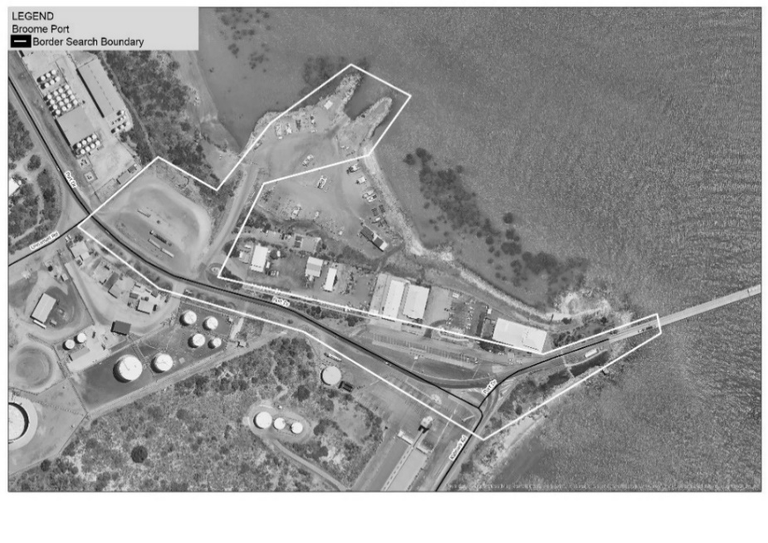

2. Broome Airport
Zone 1
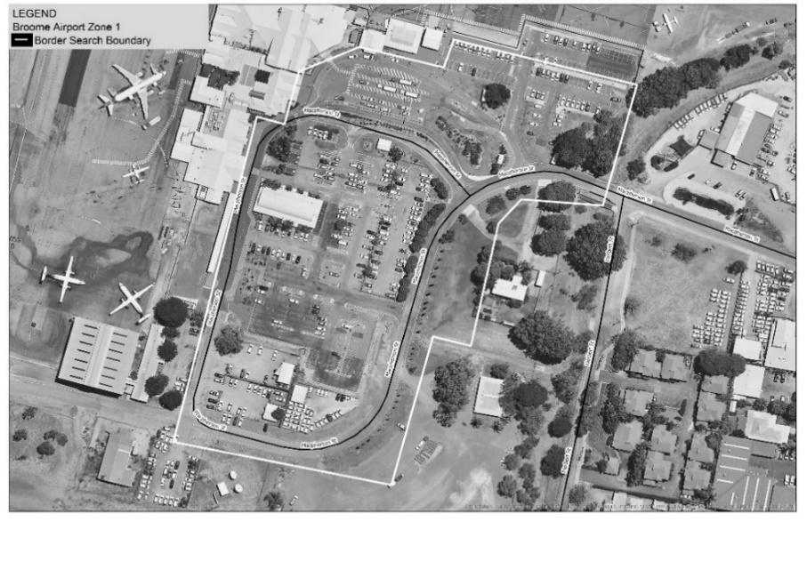
Zone 2
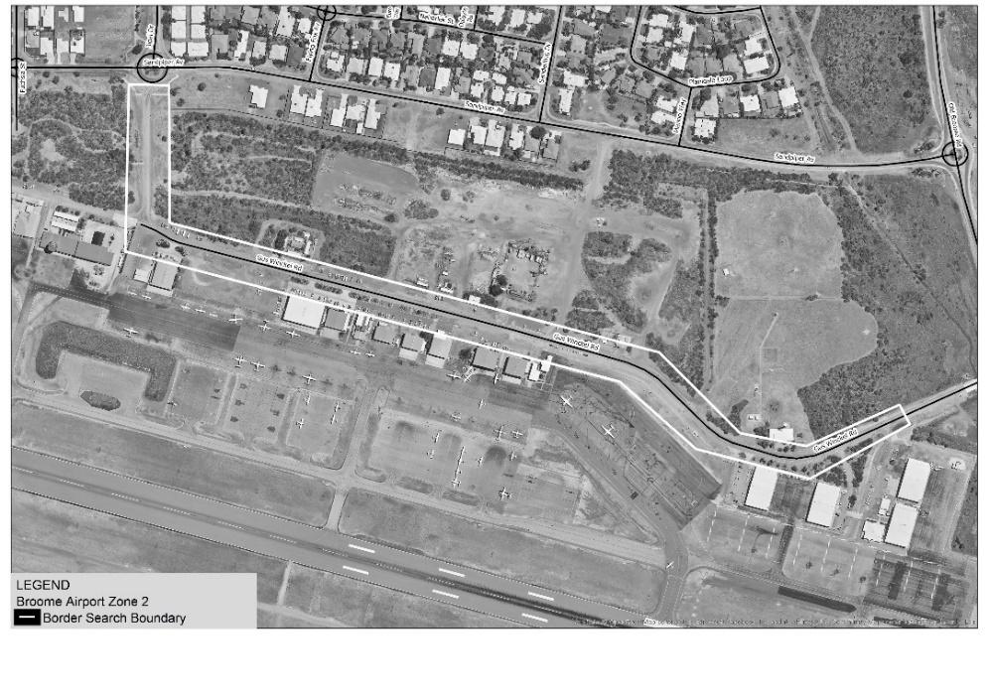

3. Port of Port Hedland
Zone 1
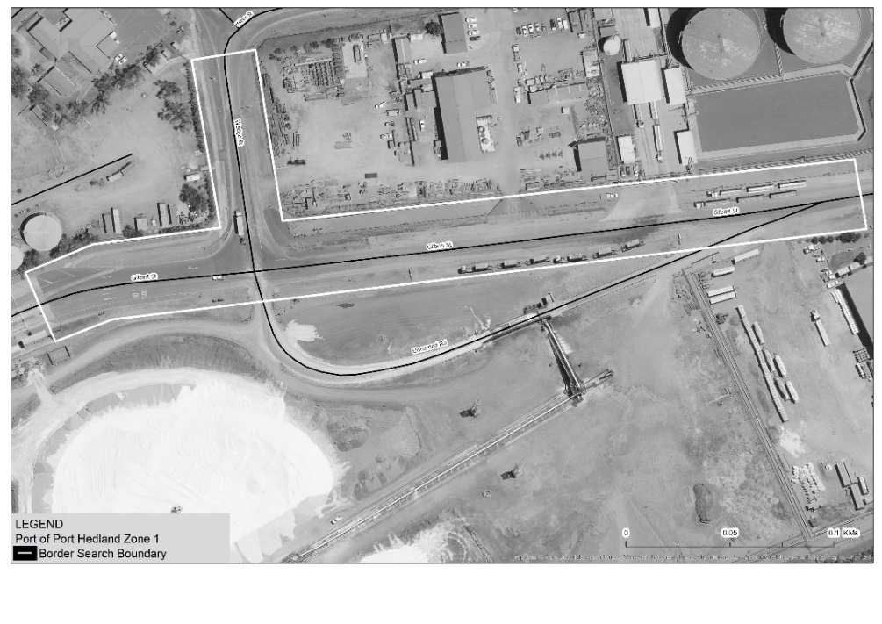
Zone 2
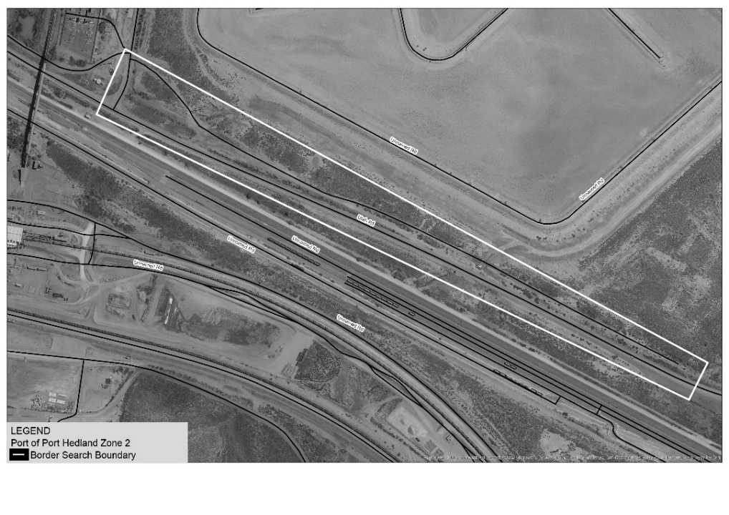

4. Port Hedland International Airport
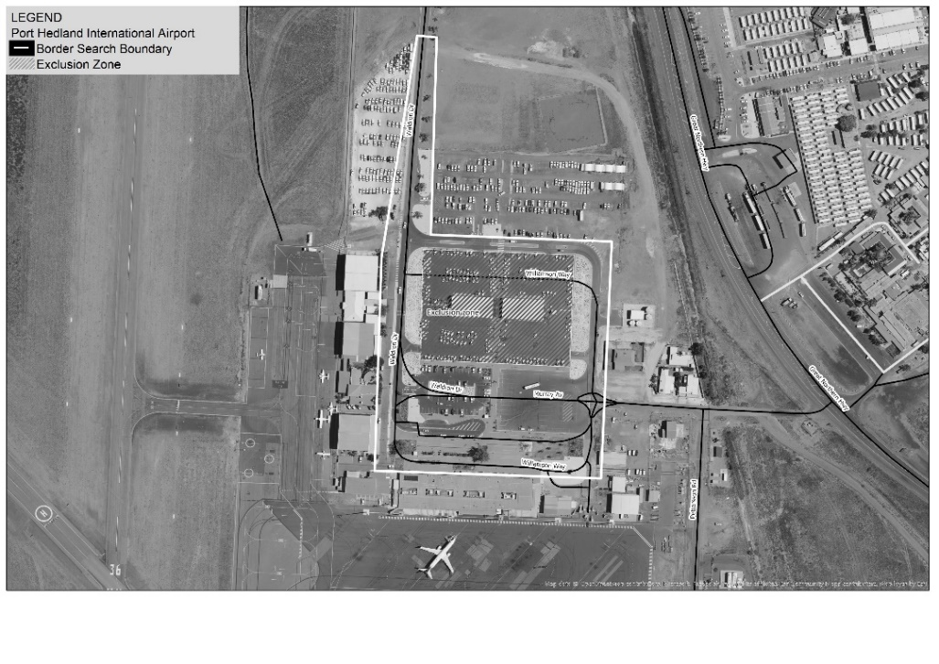

5. Port of Dampier
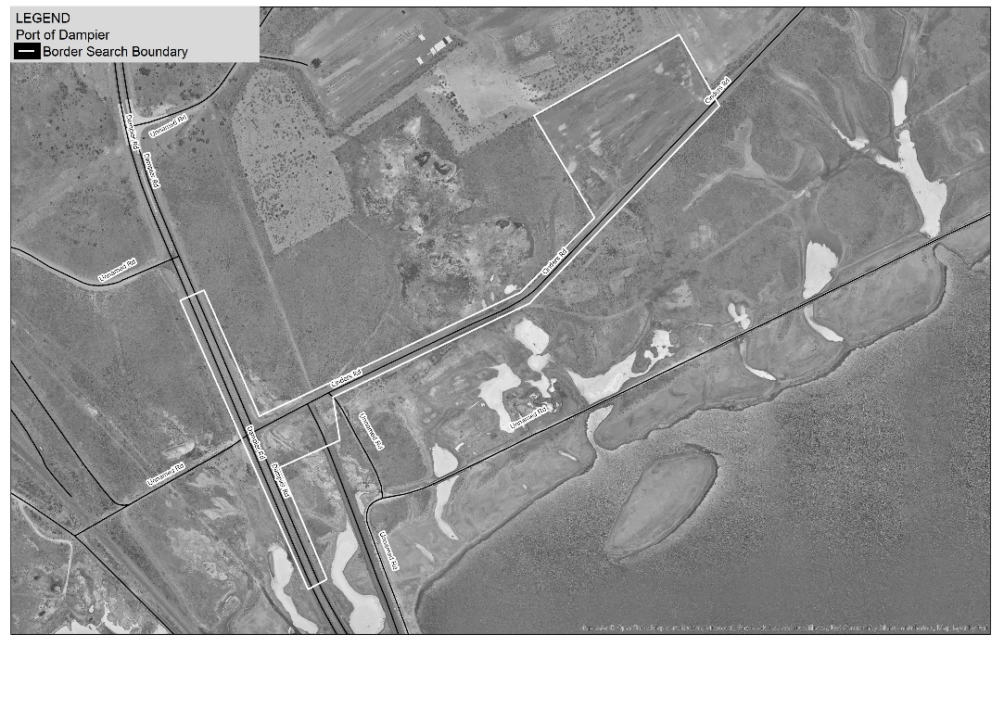

6. Port of Ashburton (Onslow)
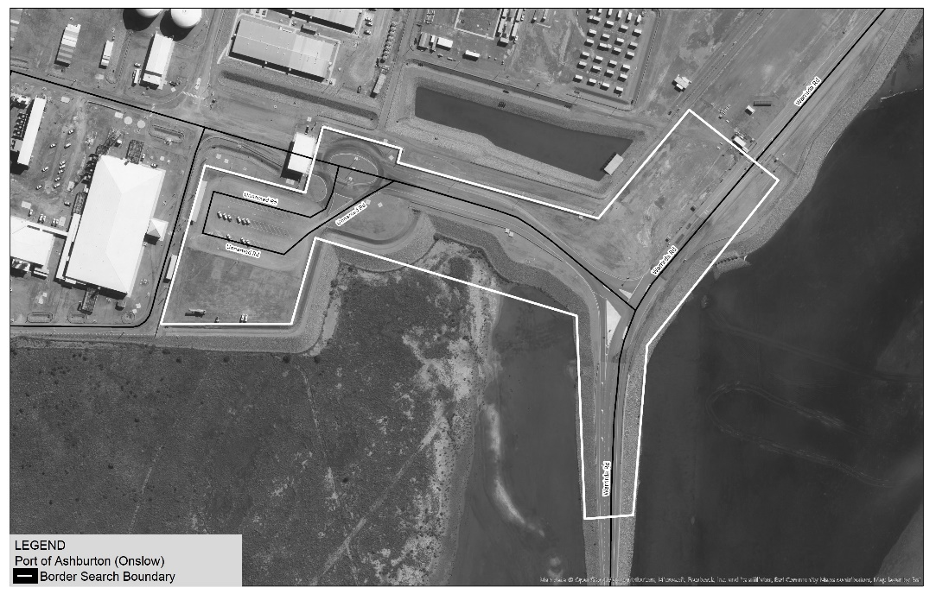

7. Port of Geraldton
Zone 1
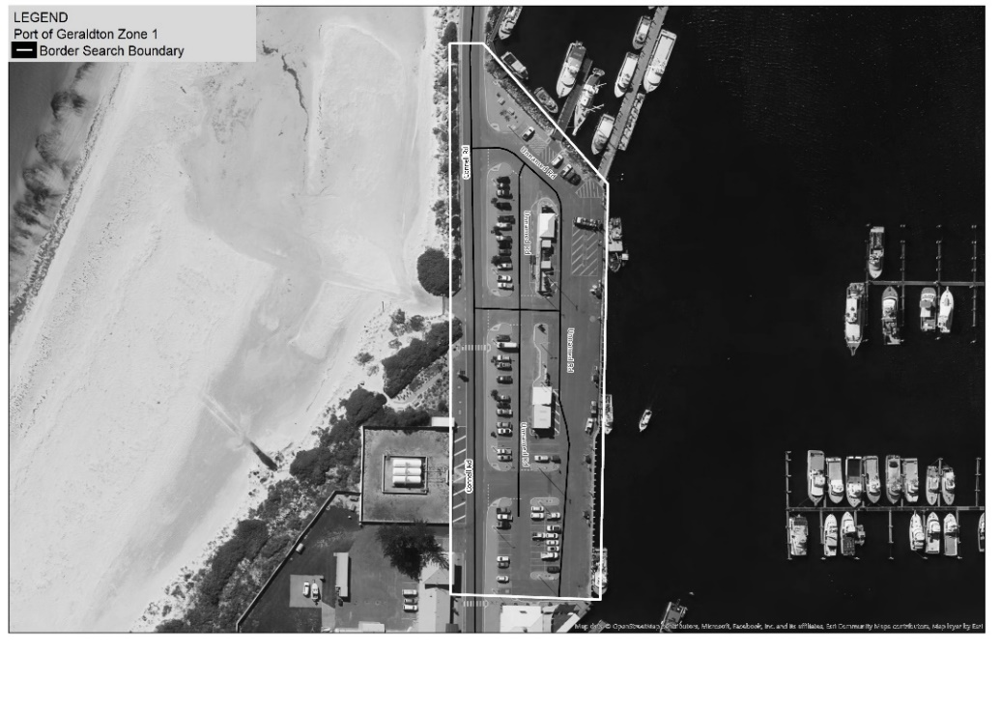
Zone 2
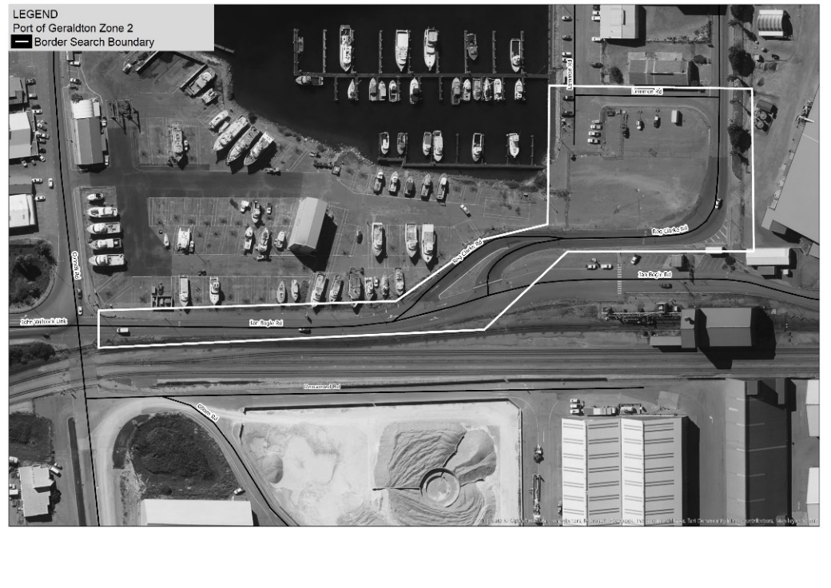

8. Perth Airport
Zone 1
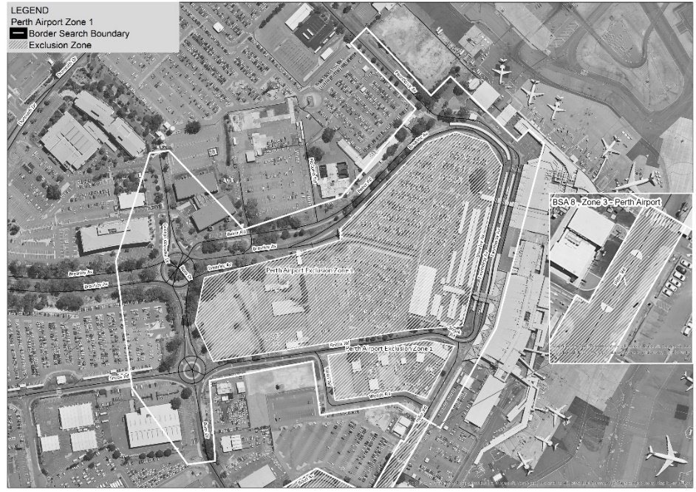
Zone 2
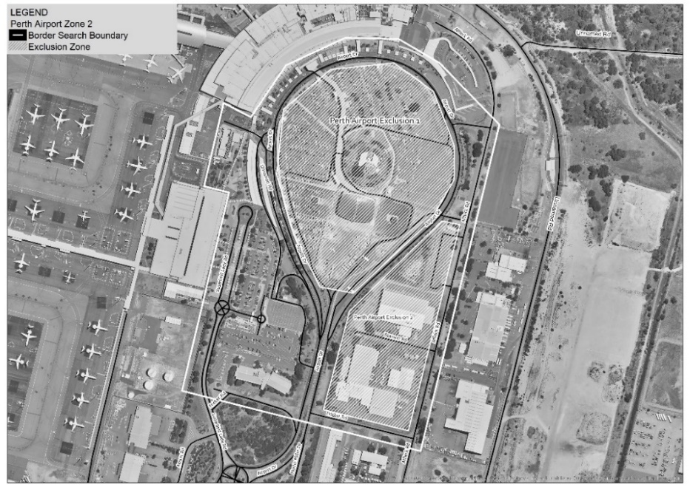
Zone 3
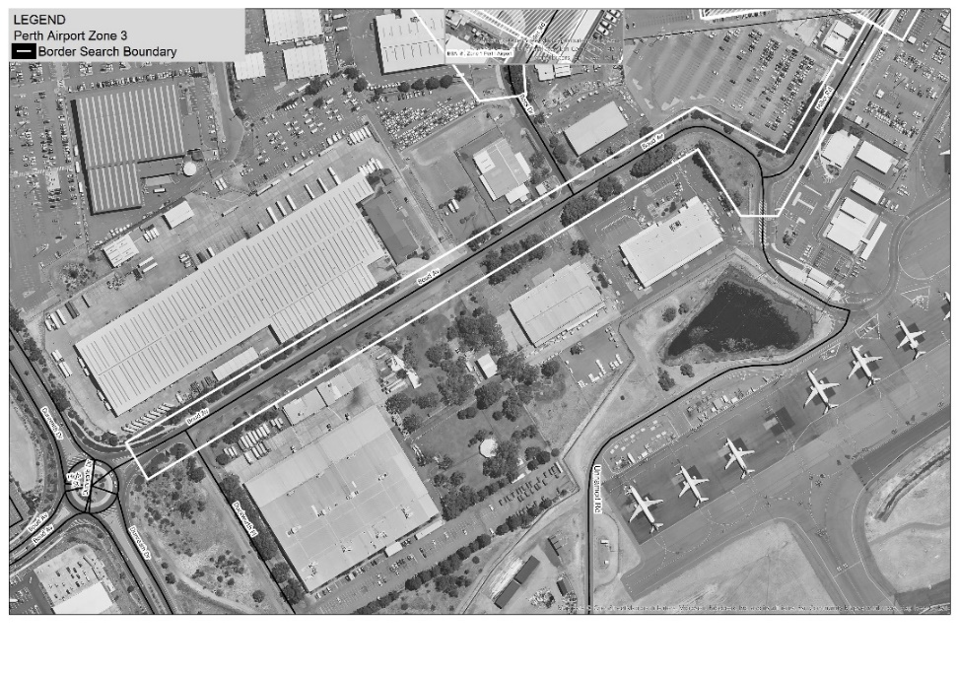

9. Fremantle Port (Inner Harbour)
Zone 1
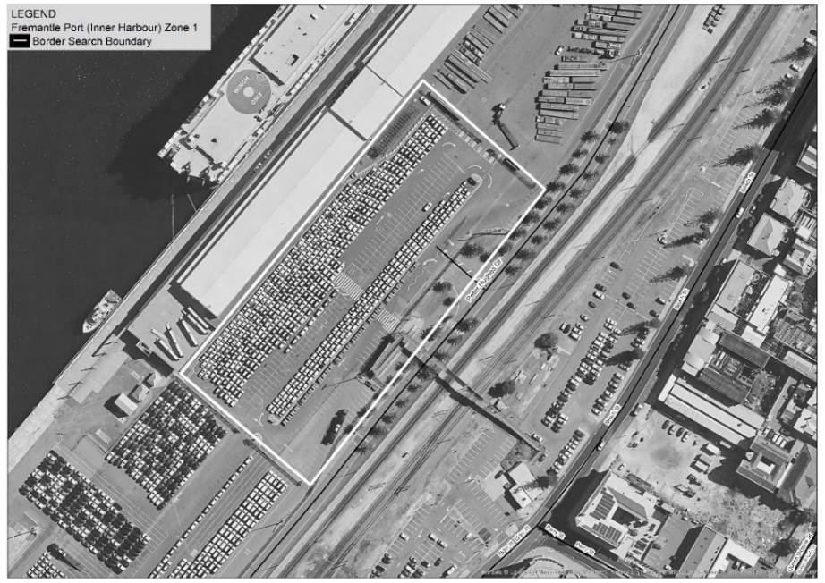
Zone 2
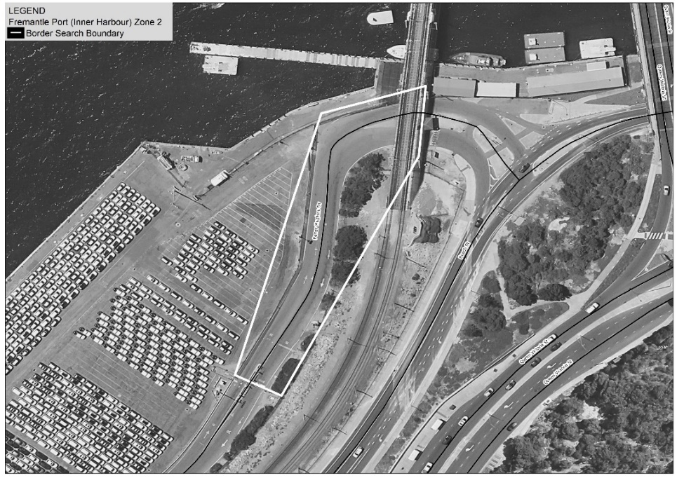
Zone 3
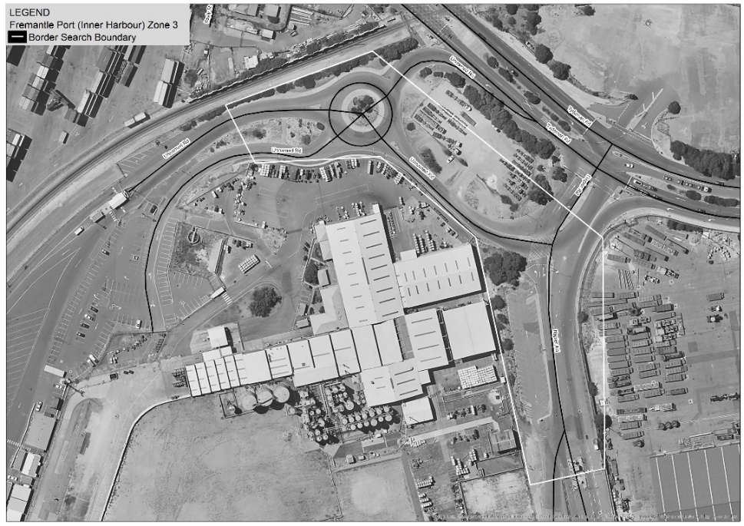
Zone 4
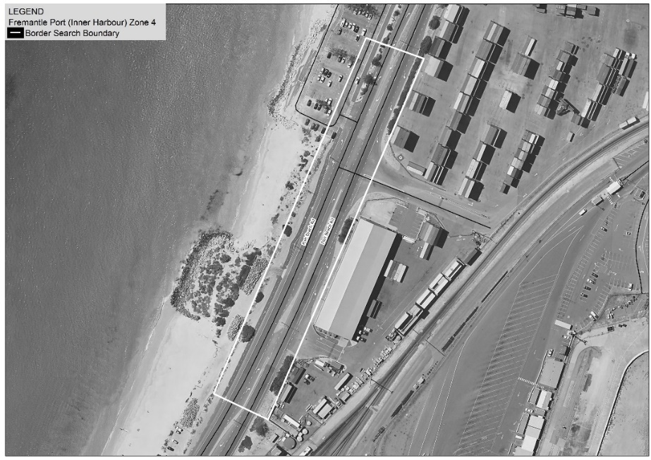

10. Fremantle Port (Outer Harbour)
Zone 1
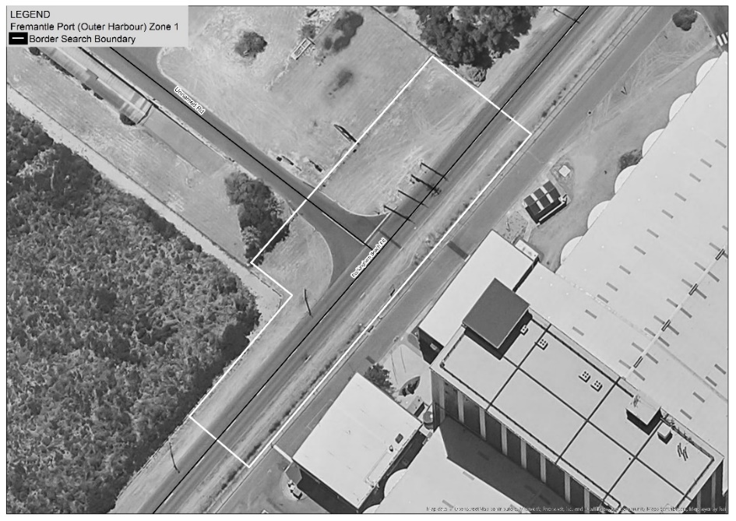
Zone 2
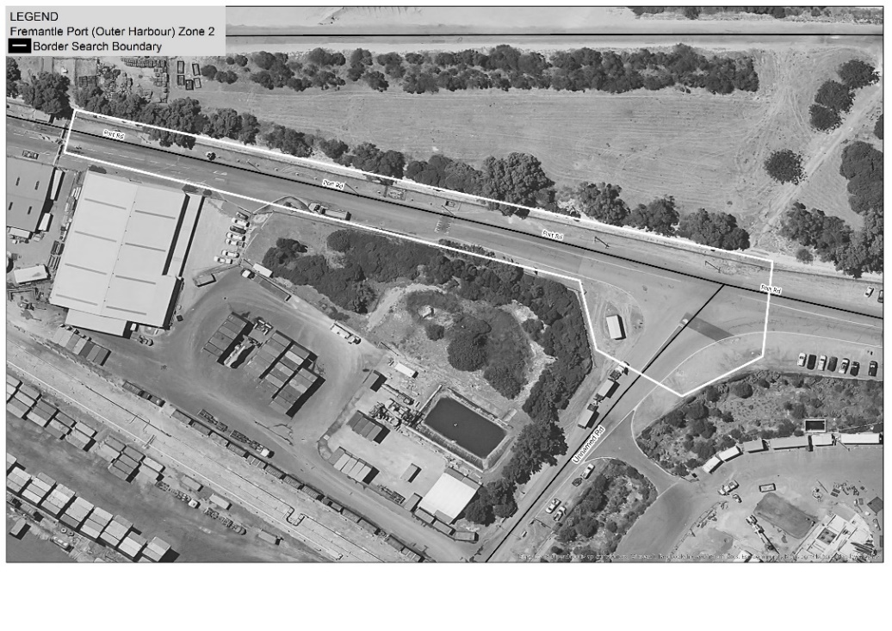
Zone 3
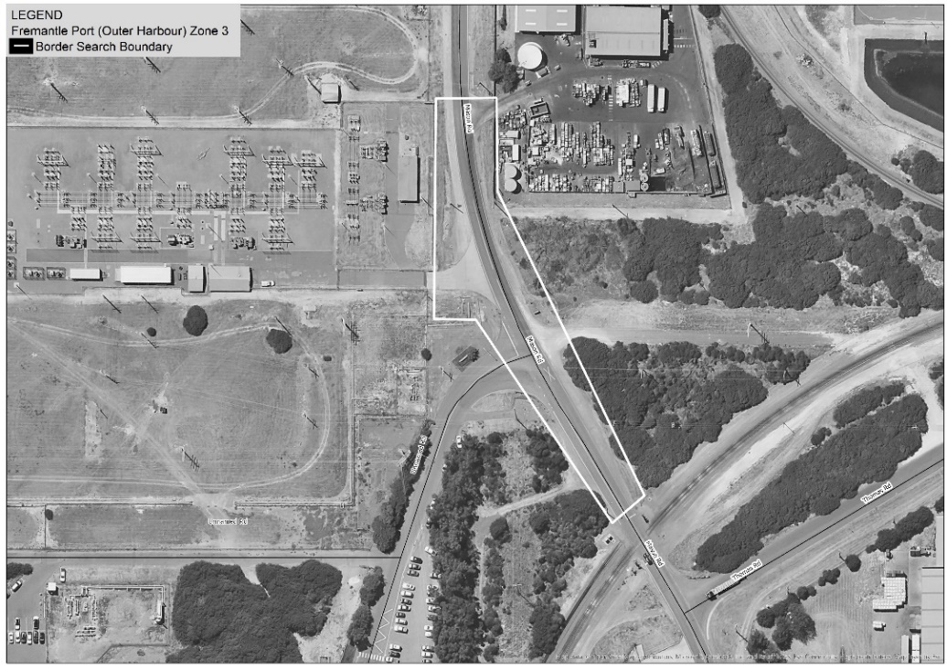
Zone 4
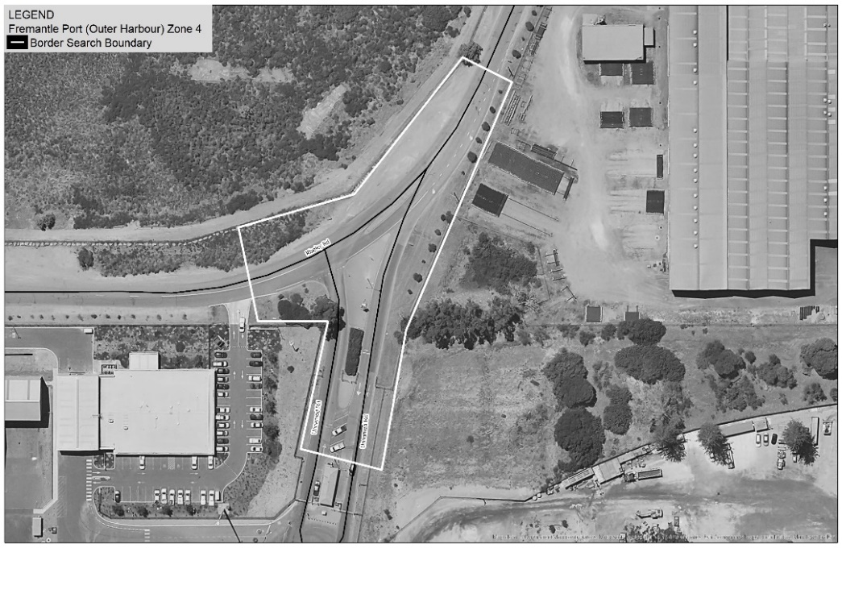
Zone 5
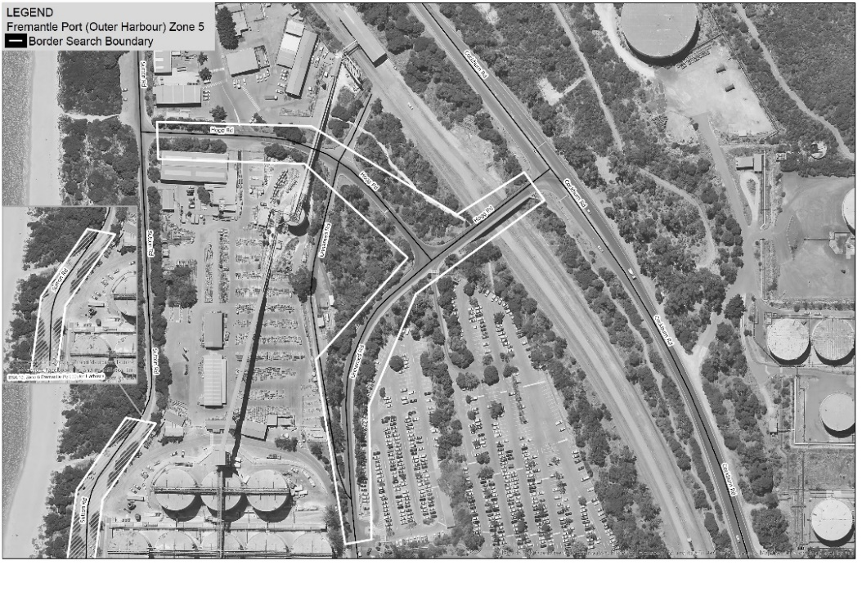
Zone 6
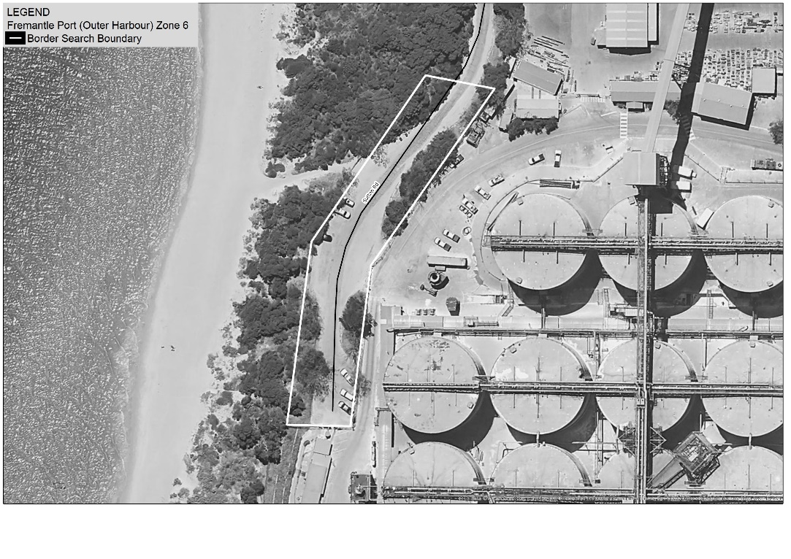
Zone 7
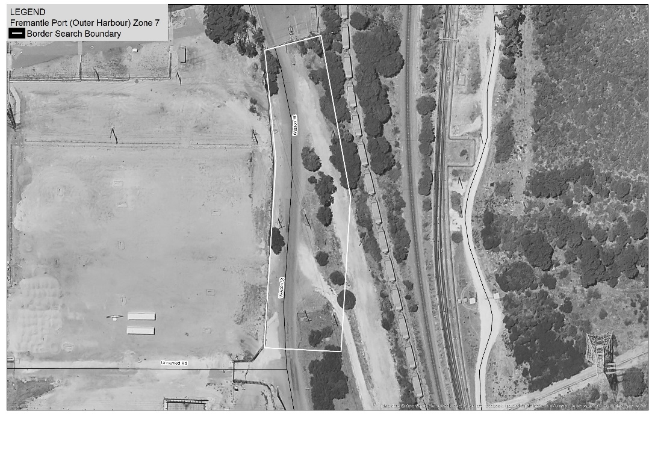

11. Jandakot Airport
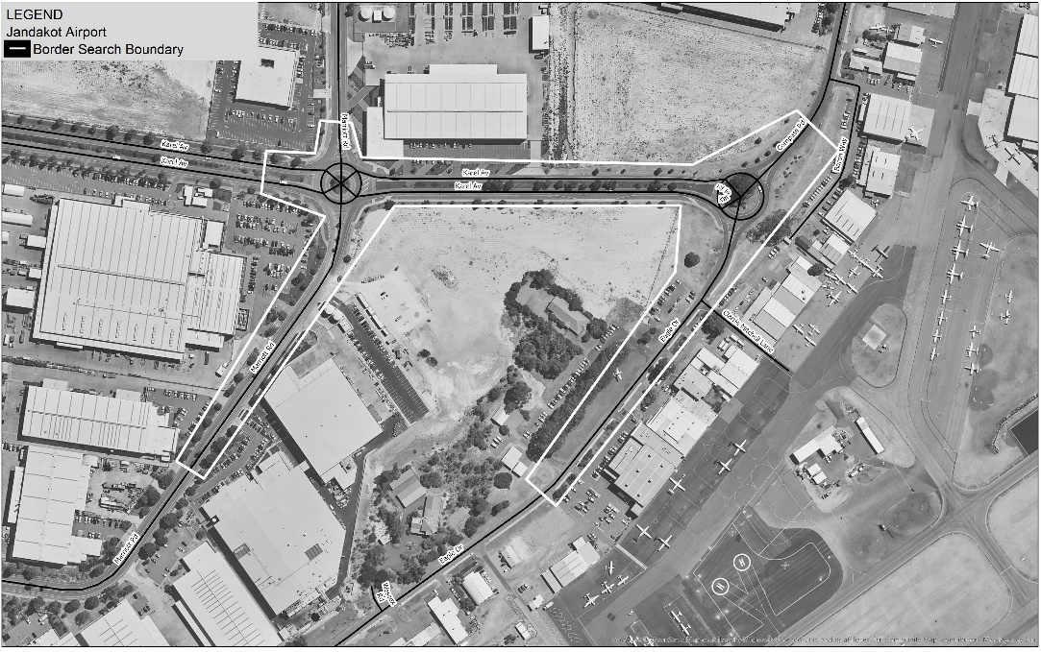

12. Wyndham Port
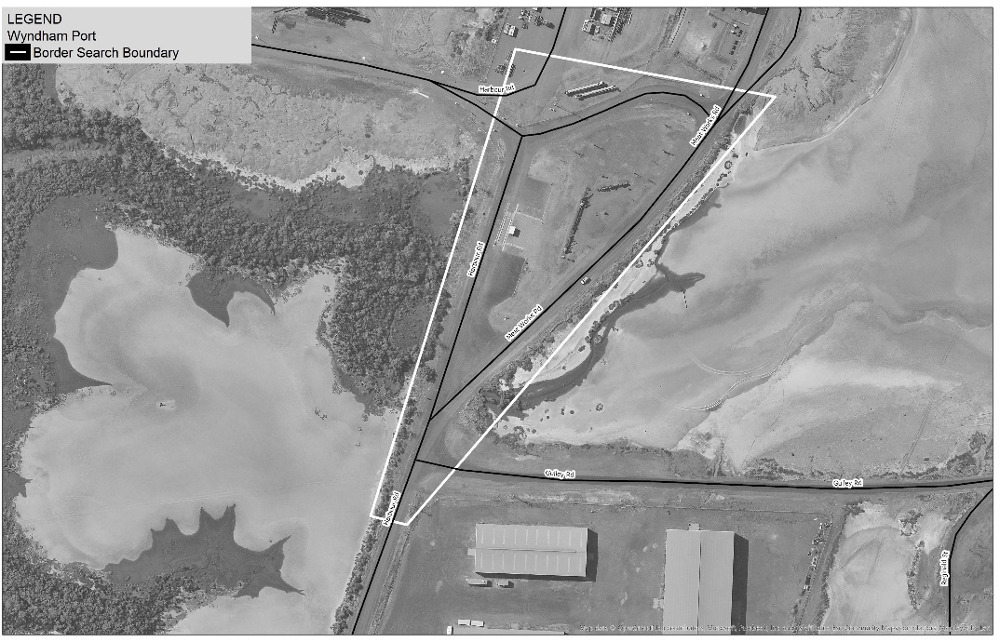

13. Bunbury Port
Zone 1
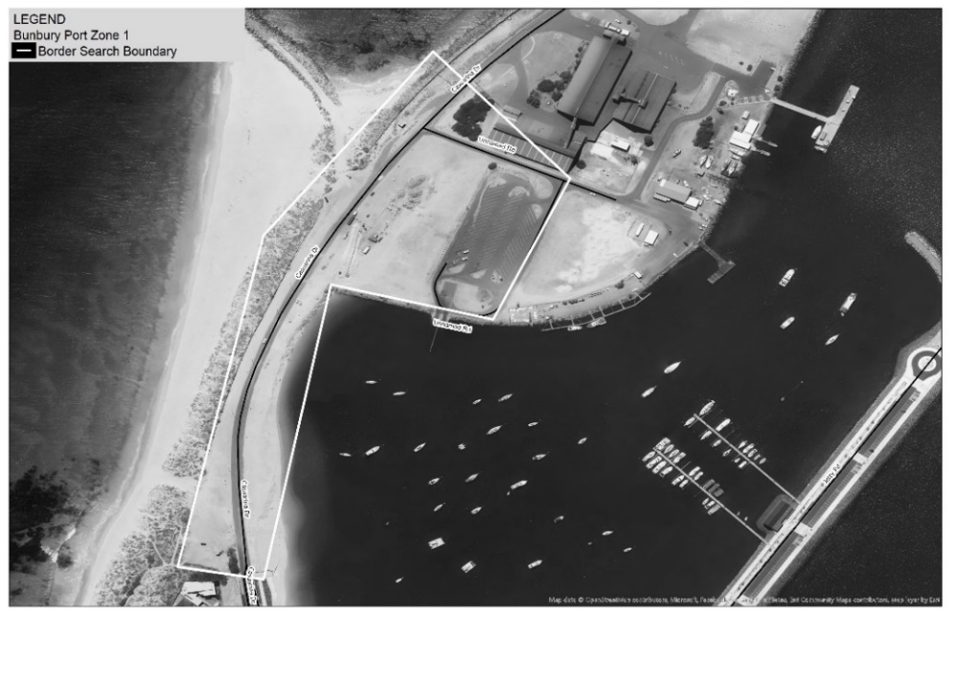
Zone 2
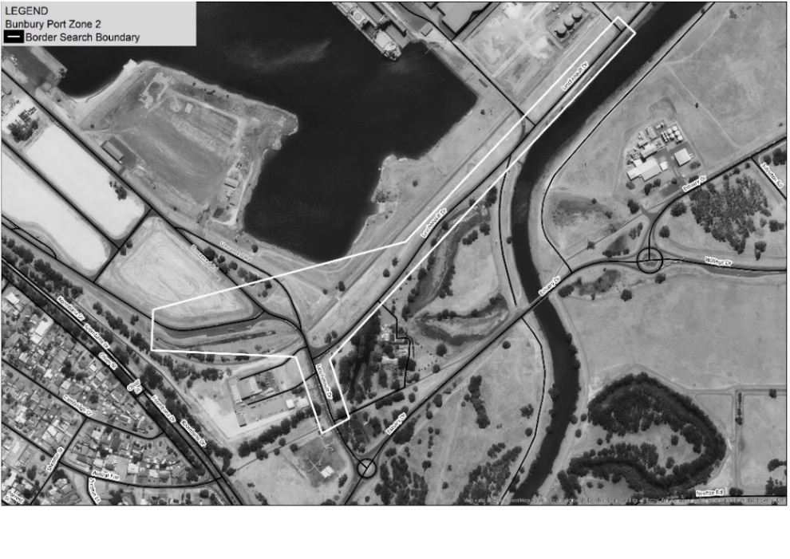
Zone 3
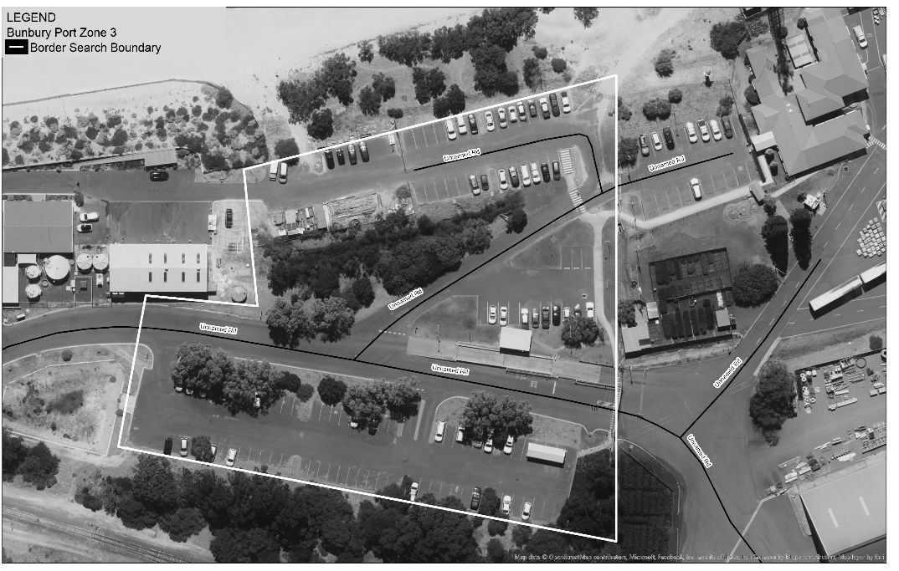

14. Busselton Airport
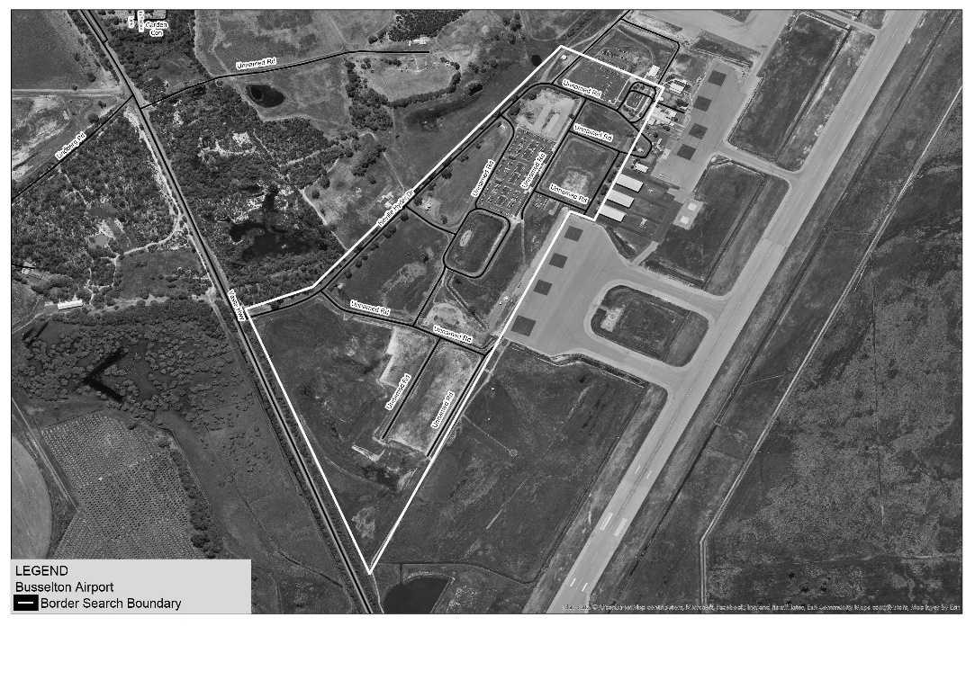

15. Albany Port
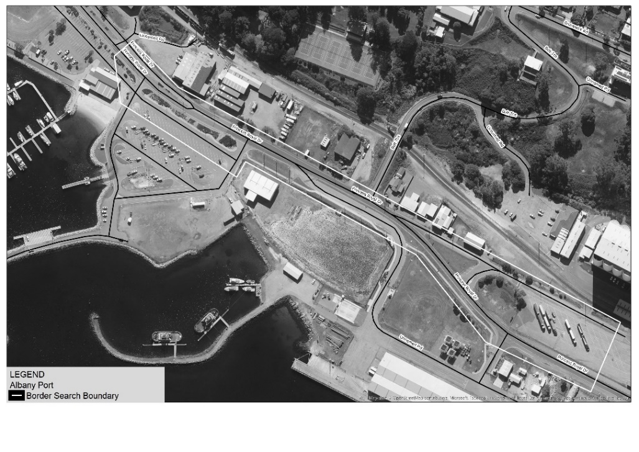

16. Esperance Port
Zone 1
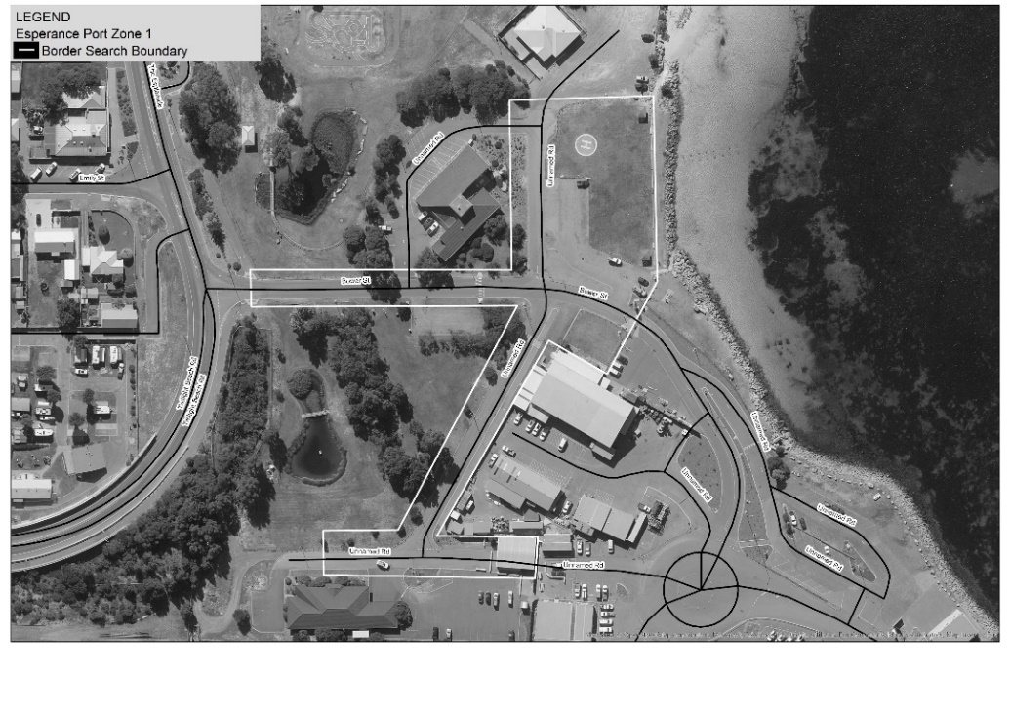
Zone 2
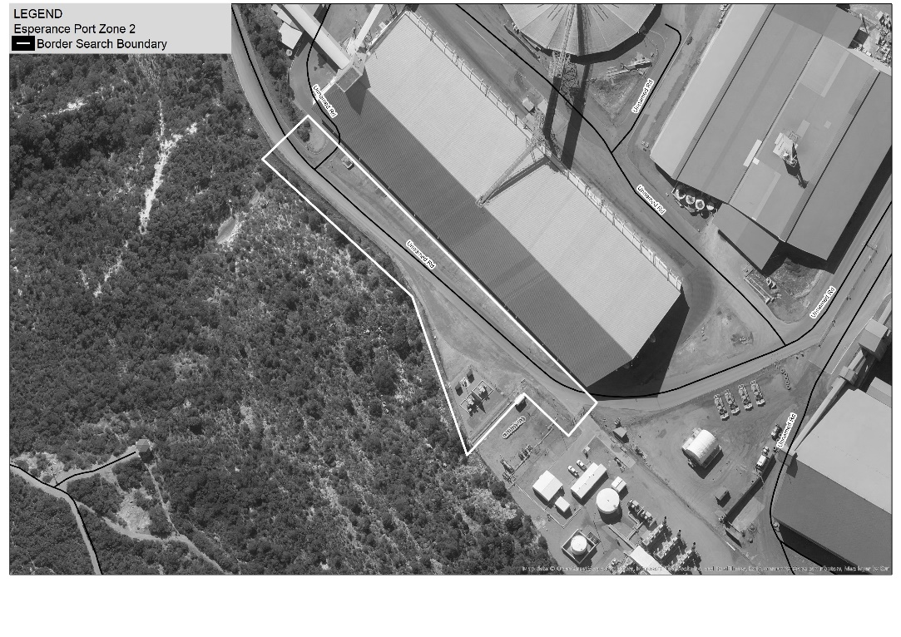

17. Eyre Highway, Eucla (WA/SA border)
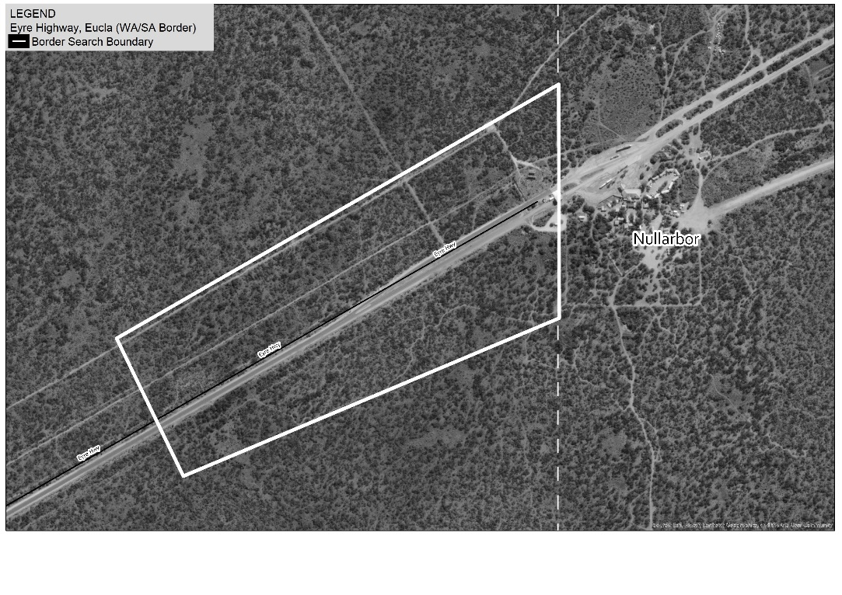

18. Victoria Highway near Kununurra (WA/NT border)
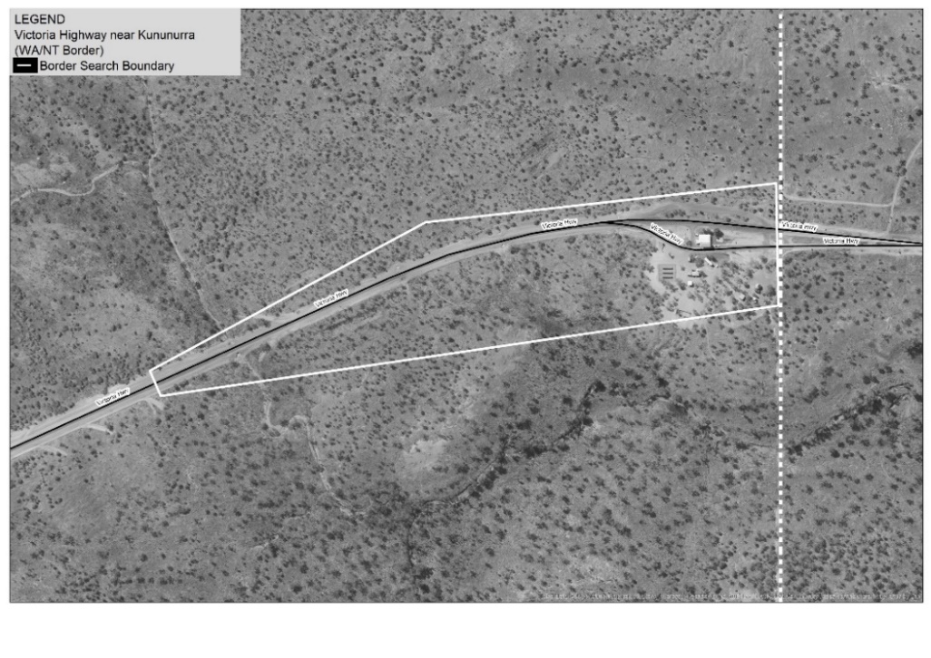

19. Tanami Road (WA/NT border)
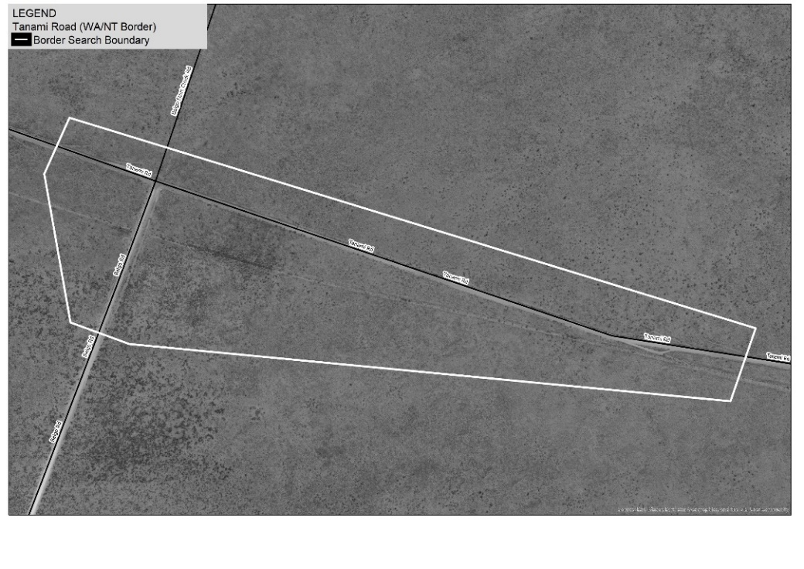

20. Duncan Road (WA/NT border)
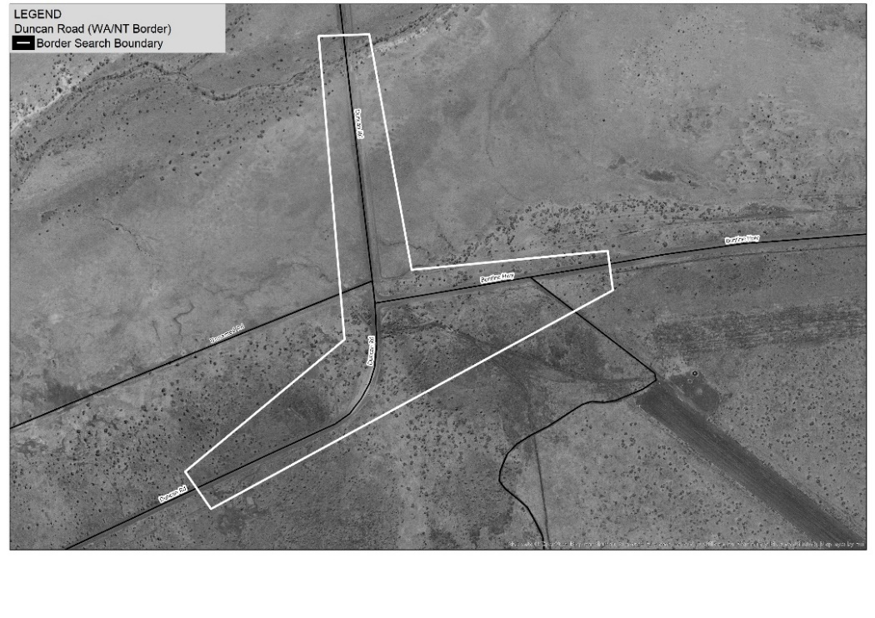

21. Great Central Road (WA/NT border)
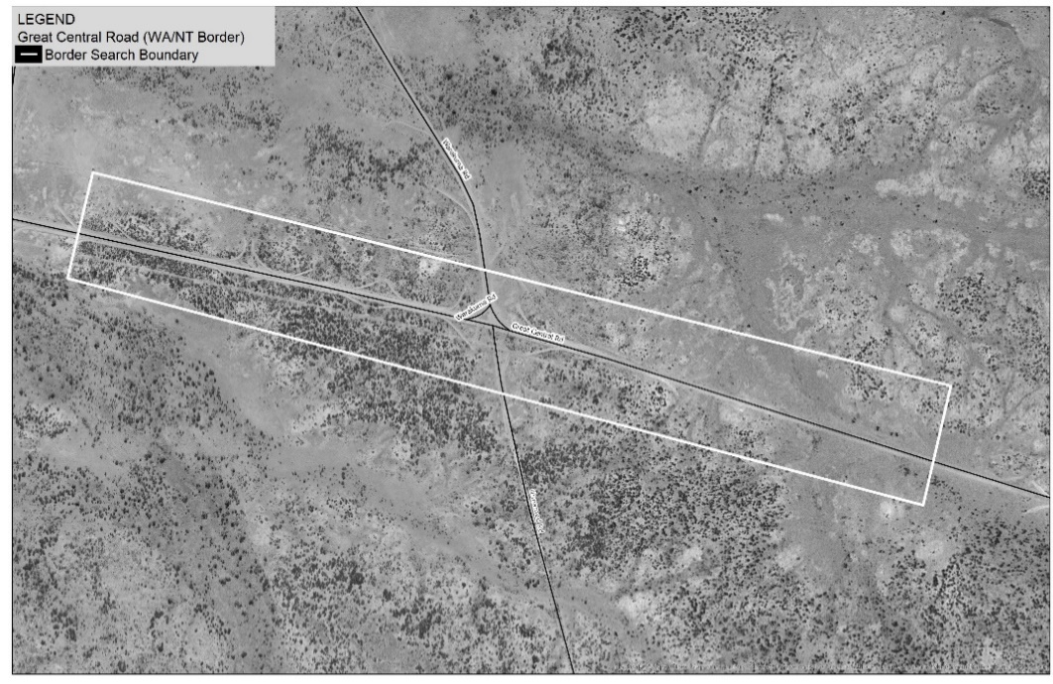

22. Rawlinna Rail Siding
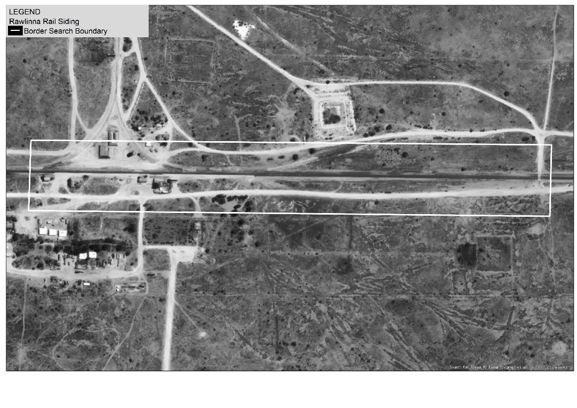
[Division 2 inserted: No. 16 of 2023 s. 10.]

Schedule VII — Amounts of prohibited drugs for purposes of drug trafficking
[s. 32A(1)(b)(i)]
[Heading amended: No. 19 of 2010 s. 4.]

Division 1 — General
[Heading inserted: Gazette 29 Aug 2018 p. 3025.]
Item | Prohibited drug |  | Amount  (in grams  unless  otherwise  stated)
1A. | ACETYL-ALPHA-METHYLFENTANYL |  | 0.070
1. | AMPHETAMINE |  | 28.0
2AA. | BENZOYLINDOLES (plant material) |  | 420.0
2AB. | BENZOYLINDOLES (in any form except plant material) |  | 28.0
2A. | BENZYLPIPERAZINE (BZP) |  | 28.0
2B. | 1-BUTYL-3-(1-NAPHTHOYL) INDOLE (JWH-073) (plant material) |  | 420.0
2BA. | 1-BUTYL-3-(1-NAPHTHOYL) INDOLE (JWH-073) (in any form except plant material) |  | 28.0
2BB. | 1-BUTYL-N-(2-PHENYLPROPAN-2-YL)-1H-INDOLE-3-CARBOXAMIDE (CUMYL-BICA) (plant material) |  | 420.0
2BC. | 1-BUTYL-N-(2-PHENYLPROPAN-2-YL)-1H-INDOLE-3-CARBOXAMIDE (CUMYL-BICA) (in any form except plant material) |  | 28.0
2. | CANNABIS |  | 3.0 kg
3. | CANNABIS RESIN |  | 100.0
4. | COCAINE |  | 28.0
4AAA. | 1-(4-CYANOBUTYL)-N-(1-METHYL-1-PHENYLETHYL)-1H-INDAZOLE-3-CARBOXAMIDE (SGT-78; 4-CN-CUMYL-BINACA; CUMYL-CB-PINACA; CUMYL-CYBINACA; 4-CYANO CUMYL-BUTINACA) (plant material) |  | 420.0
4AAB. | 1-(4-CYANOBUTYL)-N-(1-METHYL-1-PHENYLETHYL)-1H-INDAZOLE-3-CARBOXAMIDE (SGT-78; 4-CN-CUMYL-BINACA; CUMYL-CB-PINACA; CUMYL-CYBINACA; 4-CYANO CUMYL-BUTINACA) (in any form except plant material) |  | 28.0
4AAC. | 1-CYCLOHEXYL-4-(1,2-DIPHENYLETHYL)PIPERAZINE (MT-45; IC-6) |  | 28.0
4A. | 1-CYCLOHEXYLETHYL-3-(2-  METHOXYPHENYLACETYL) INDOLE (RCS-8) (plant material) |  | 420.0
4AB. | 1-CYCLOHEXYLETHYL-3-(2-  METHOXYPHENYLACETYL) INDOLE (RCS-8) (in any form except plant material) |  | 28.0
4B. | CYCLOHEXYLPHENOLS (plant material) |  | 420.0
4C. | CYCLOHEXYLPHENOLS (in any form except plant material) |  | 28.0
5. | DIACETYLMORPHINE |  | 28.0
5AAA. | DIBENZOPYRANS (plant material) |  | 420.0
5AAB. | DIBENZOPYRANS (in any form except plant material) |  | 28.0
5AAC. | 2,5-DIHYDRO-2-(1-METHYL-1-PHENYLETHYL)-5-PENTYL-1H-PYRIDO[4,3-B]INDOL-1-ONE (CUMYL-PEGACLONE; SGT-151) (plant material) |  | 420.0
5AAD. | 2,5-DIHYDRO-2-(1-METHYL-1-PHENYLETHYL)-5-PENTYL-1H-PYRIDO[4,3-B]INDOL-1-ONE (CUMYL-PEGACLONE; SGT-151) (in any form except plant material) |  | 28.0
5AA. | DIMETHYLAMPHETAMINE |  | 28.0
5AB. | 5-(1,1-DIMETHYLHEPTYL)-2-[(1R,3S)-3-  HYDROXYCYCLOHEXYL]-PHENOL (CP 47,497) (plant material) |  | 420.0
5ACA. | 5-(1,1-DIMETHYLHEPTYL)-2-[(1R,3S)-3-  HYDROXYCYCLOHEXYL]-PHENOL (CP 47,497) (in any form except plant material) |  | 28.0
5AC. | 5-(1,1-DIMETHYLOCTYL)-2-[(1R,3S)-3-  HYDROXYCYCLOHEXYL]-PHENOL (CANNABICYCLOHEXANOL or CP 47,497 C8 HOMOLOGUE) (plant material) |  | 420.0
5AD. | 5-(1,1-DIMETHYLOCTYL)-2-[(1R,3S)-3-  HYDROXYCYCLOHEXYL]-PHENOL (CANNABICYCLOHEXANOL or CP 47,497 C8 HOMOLOGUE) (in any form except plant material) |  | 28.0
5AE. | DIPHENIDINE |  | 28.0
5AF. | (E)-4-CHLORO-N-(1-(4-NITROPHENETHYL) PIPERIDIN-2-YLIDENE)BENZENESULFONAMIDE (W-18) |  | 0.070
5A. | EPHEDRINE |  | 28.0
5B. | FENTANYL |  | 0.070
6A. | 1-(5-FLUOROPENTYL)-3-(2-IODOBENZOYL) INDOLE (AM-694) (plant material) |  | 420.0
6AA. | 1-(5-FLUOROPENTYL)-3-(2-IODOBENZOYL) INDOLE (AM-694) (in any form except plant material) |  | 28.0
6AB. | 1-(5-FLUOROPENTYL)-N-(1-METHYL-1-  PHENYLETHYL)-1H-INDAZOLE-3-  CARBOXAMIDE (SGT-25) (plant material) |  | 420.0
6AC. | 1-(5-FLUOROPENTYL)-N-(1-METHYL-1-  PHENYLETHYL)-1H-INDAZOLE-3-  CARBOXAMIDE (SGT-25) (in any form except plant material) |  | 28.0
6B. | 1-(5-FLUOROPENTYL)-3-(1-NAPHTHOYL) INDOLE (AM-2201) (plant material) |  | 420.0
6BA. | 1-(5-FLUOROPENTYL)-3-(1-NAPHTHOYL) INDOLE (AM-2201) (in any form except plant material) |  | 28.0
6BAA. | 5-(5-FLUOROPENTYL)-2-(2-PHENYLPROPAN-2-YL)-2,5-DIHYDRO-1H-PYRIDO[4,3-B]INDOL-1-ONE (5F-CUMYL-PEGACLONE; 5F SGT-151) (plant material) |  | 420.0
6BAB. | 5-(5-FLUOROPENTYL)-2-(2-PHENYLPROPAN-2-YL)-2,5-DIHYDRO-1H-PYRIDO[4,3-B]INDOL-1-ONE (5F-CUMYL-PEGACLONE; 5F SGT-151) (in any form except plant material) |  | 28.0
6BAC. | 2-(2-FLUOROPHENYL)-2-METHYLAMINO-CYCLOHEXANONE (2-FLUORODESCHLOROKETAMINE; 2FDCK) |  | 28.0
6BB. | GAMMA HYDROXY BUTRATE (4-HYDROXYBUTANOIC ACID) |  | 28.0
6BC. | HEROIN |  | 28.0
6C. | 1-HEXYL-3-(1-NAPHTHOYL) INDOLE (JWH-019) (plant material) |  | 420.0
6CA. | 1-HEXYL-3-(1-NAPHTHOYL) INDOLE (JWH-019) (in any form except plant material) |  | 28.0
6D. | 9-(HYDROXYMETHYL)-6,6-DIMETHYL-3-(2-  METHYLOCTAN-2-YL)-6A,7,10,10A-  TETRAHYDROBENZO[C] CHROMEN-1-OL (HU-210) (plant material) |  | 420.0
6DA. | 9-(HYDROXYMETHYL)-6,6-DIMETHYL-3-(2-  METHYLOCTAN-2-YL)-6A,7,10,10A-  TETRAHYDROBENZO[C] CHROMEN-1-OL (HU-210) (in any form except plant material) |  | 28.0
6. | LYSERGIC ACID DIETHYLAMIDE (LSD) |  | 0.01
7. | METHADONE |  | 5.0
8A. | METHCATHINONE |  | 28.0
8AB. | 2-METHOXYDIPHENIDINE (2-MXP or MXP)  (plant material) |  | 420.0
8AC. | 2-METHOXYDIPHENIDINE (2-MXP or MXP)  (in any form except plant material) |  | 28.0
8BA. | 4-METHOXYPHENYL(1-BUTYL-1H-INDOL-3-YL)-METHANONE (RCS-4 (C4) (plant material) |  | 420.0
8BAA. | 4-METHOXYPHENYL(1-BUTYL-1H-INDOL-3-YL)-METHANONE (RCS-4 (C4) (in any form except plant material) |  | 28.0
8BB. | 2-(4-METHOXYPHENYL)-1-(1-PENTYL-1H-INDOL-3-YL)-ETHANONE (JWH-201) (plant material) |  | 420.0
8BBA. | 2-(4-METHOXYPHENYL)-1-(1-PENTYL-1H-INDOL-3-YL)-ETHANONE (JWH-201) (in any form except plant material) |  | 28.0
8B. | 2-(2-METHOXYPHENYL)-1-(1-PENTYLINDOL-3-  YL) ETHANONE (JWH-250) (plant material) |  | 420.0
8BA. | 2-(2-METHOXYPHENYL)-1-(1-PENTYLINDOL-3-  YL) ETHANONE (JWH-250) (in any form except plant material) |  | 28.0
8C. | 2-(3-METHOXYPHENYL)-1-(1-PENTYLINDOL-3-  YL) ETHANONE (JWH-302) (plant material) |  | 420.0
8D. | 2-(3-METHOXYPHENYL)-1-(1-PENTYLINDOL-3-  YL) ETHANONE (JWH-302) (in any form except plant material) |  | 28.0
8. | METHYLAMPHETAMINE |  | 28.0
8AAA. | METHYL 2-(9-(CYCLOHEXYLMETHYL) -9H-CARBAZOLE -3-CARBOXAMIDO)-3,3-DIMETHYLBUTANOATE (MDMB-CHMCZCA) (plant material) |  | 420.0
8AAB. | METHYL 2-(9-(CYCLOHEXYLMETHYL) -9H-CARBAZOLE -3-CARBOXAMIDO)-3,3-DIMETHYLBUTANOATE (MDMB-CHMCZCA) (in any form except plant material) |  | 28.0
[8AAC and 8AAD. deleted]
9. | 3, 4-METHYLENEDIOXYAMPHETAMINE (MDA) |  | 28.0
10. | 3, 4-METHYLENEDIOXY-N, ALPHA-DIMETHYLPHENYLETHYLAMINE (MDMA) |  | 28.0
11A. | 3, 4-METHYLENEDIOXYPYROVALERONE (MDPV) |  | 28.0
11B. | METHYL 2-[1-(4-FLUOROBENZYL)-1H-INDOLE-3-CARBOXAMIDO]-3-METHYLBUTANOATE (MMB-FUBICA; AMB-FUBICA) (plant material) |  | 420.0
11C. | METHYL 2-[1-(4-FLUOROBENZYL)-1H-INDOLE-3-CARBOXAMIDO]-3-METHYLBUTANOATE (MMB-FUBICA; AMB-FUBICA) (in any form except plant material) |  | 28.0
11D. | METHYL 2-[[1-(4-FLUOROBUTYL)INDAZOLE-3-CARBONYL]AMINO]-3,3-DIMETHYL-BUTANOATE (4F-MDMB-BINACA; 4F-MDMB-BUTINACA) (plant material) |  | 420.0
11E. | METHYL 2-[[1-(4-FLUOROBUTYL)INDAZOLE-3-CARBONYL]AMINO]-3,3-DIMETHYL-BUTANOATE (4F-MDMB-BINACA; 4F-MDMB-BUTINACA) (in any form except plant material) |  | 28.0
11F. | METHYL 2-(1-(5-FLUOROPENTYL)-1H-  INDAZOLE-3-CARBOXAMIDO)-3-  METHYLBUTANOATE (5F-AMB) (plant material) |  | 420.0
11G. | METHYL 2-(1-(5-FLUOROPENTYL)-1H-  INDAZOLE-3-CARBOXAMIDO)-3-  METHYLBUTANOATE (5F-AMB) (in any form except plant material) |  | 28.0
11H. | METHYL 2-[[1-(5-FLUOROPENTYL)INDOLE-3-CARBONYL]AMINO]-3,3-DIMETHYL-BUTANOATE (5-FLUORO MDMB-PICA; 5F-MDMB-PICA) (plant material) |  | 420.0
11I. | METHYL 2-[[1-(5-FLUOROPENTYL)INDOLE-3-CARBONYL]AMINO]-3,3-DIMETHYL-BUTANOATE (5-FLUORO MDMB-PICA; 5F-MDMB-PICA) (in any form except plant material) |  | 28.0
11J. | METHYL (S)-2-[1-(5-FLUOROPENTYL)-1H-  INDAZOLE-3-CARBOXAMIDO]-3,3-  DIMETHYLBUTANOATE (5F-ADB) (plant material) |  | 420.0
11K. | METHYL (S)-2-[1-(5-FLUOROPENTYL)-1H-  INDAZOLE-3-CARBOXAMIDO]-3,3-  DIMETHYLBUTANOATE (5F-ADB) (in any form except plant material) |  | 28.0
11. | MORPHINE |  | 28.0
12A. | 1-[2-(4-MORPHOLINYL)ETHYL]-3-  (1-NAPHTHOYL) INDOLE (JWH-200) (plant material) |  | 420.0
12AB. | 1-[2-(4-MORPHOLINYL)ETHYL]-3-  (1-NAPHTHOYL) INDOLE (JWH-200) (in any form except plant material) |  | 28.0
12AC. | N-(1-AMINO-3,3-DIMETHYL-1-OXOBUTAN-2-YL)-1-(CYCLOHEXYLMETHYL)-1H-INDAZOLE-3-  CARBOXAMIDE (MAB-CHMINACA or ADB-CHMINACA) (plant material) |  | 420.0
12AD. | N-(1-AMINO-3,3-DIMETHYL-1-OXOBUTAN-2-YL)-1-(CYCLOHEXYLMETHYL)-1H-IN-DAZOLE-3-  CARBOXAMIDE (MAB-CHMINACA or ADB-CHMINACA) (in any form except plant material) |  | 28.0
12AE. | N-(1-AMINO-3,3-DIMETHYL-1-OXOBUTAN-2-YL)-1-(5-FLUOROPENTYL)-1H-INDOLE-3-  CARBOXAMIDE (5F-ADBICA) (plant material) |  | 420.0
12AF. | N-(1-AMINO-3,3-DIMETHYL-1-OXOBUTAN-2-YL)-1-(5-FLUOROPENTYL)-1H-INDOLE-3-  CARBOXAMIDE (5F-ADBICA) (in any form except plant material) |  | 28.0
12AG. | N-[1-(AMINOCARBONYL)-2,2-  DIMETHYLPROPYL]-1-PENTYL-1H-INDAZOLE-3-CARBOXAMIDE (ADB-PINACA) (plant material) |  | 420.0
12AH. | N-[1-(AMINOCARBONYL)-2,2-  DIMETHYLPROPYL]-1-PENTYL-1H-INDAZOLE-3-CARBOXAMIDE (ADB-PINACA) (in any form except plant material) |  | 28.0
12AI. | N-(1-[AMINOCARBONYL)-2-METHYLPROPYL]-1-  (CYCLOHEXYLMETHYL)-1H-INDAZOLE-3-  CARBOXAMIDE (AB-CHMINACA) (plant material) |  | 420.0
12AJ. | N-(1-[AMINOCARBONYL)-2-METHYLPROPYL]-1-  (CYCLOHEXYLMETHYL)-1H-INDAZOLE-3-  CARBOXAMIDE (AB-CHMINACA) (in any form except plant material) |  | 28.0
12AK. | N-(1-AMINO-3-METHYL-1-OXOBUTAN-2-YL)-1-(5-FLUOROPENTYL)-1H-INDOLE-3-CARBOXAMIDE (5F-ABICA) (plant material) |  | 420.0
12AL. | N-(1-AMINO-3-METHYL-1-OXOBUTAN-2-YL)-1-(5-FLUOROPENTYL)-1H-INDOLE-3-CARBOXAMIDE (5F-ABICA) (in any form except plant material) |  | 28.0
12AM. | N-[(1S)-1-(AMINOCARBONYL)-2-  METHYLPROPYL]-1-(5-FLUOROPENTYL)-1H-  INDAZOLE-3-CARBOXAMIDE (5F-AB-PINACA) (plant material) |  | 420.0
12AN. | N-[(1S)-1-(AMINOCARBONYL)-2-  METHYLPROPYL]-1-(5-FLUOROPENTYL)-1H-  INDAZOLE-3-CARBOXAMIDE (5F-AB-PINACA) (in any form except plant material) |  | 28.0
12AO. | N-[(1S)-1-(AMINOCARBONYL)-2-METHYLPROPYL]-1-(5-FLUOROPENTYL) -1H-PYRROLO[2,3-B] PYRIDINE-3-CARBOXAMIDE (5F-AB-P7AICA) (plant material) |  | 420.0
12AP. | N-[(1S)-1-(AMINOCARBONYL)-2-METHYLPROPYL]-1-(5-FLUOROPENTYL) -1H-PYRROLO[2,3-B] PYRIDINE-3-CARBOXAMIDE (5F-AB-P7AICA) (in any form except plant material) |  | 28.0
12B. | NAPHTHOYLINDOLES (plant material) |  | 420.0
12BA. | NAPHTHOYLINDOLES (in any form except plant material) |  | 28.0
12C. | NAPHTHYLMETHYLINDOLES (plant material) |  | 420.0
12CA. | NAPHTHYLMETHYLINDOLES (in any form except plant material) |  | 28.0
12D. | NAPHTHOYLPYRROLES (plant material) |  | 420.0
12DA. | NAPHTHOYLPYRROLES (in any form except plant material) |  | 28.0
12E. | NAPHTHYLMETHYLINDENES (plant material) |  | 420.0
12F. | NAPHTHYLMETHYLINDENES (in any form except plant material) |  | 28.0
12G. | N-METHYL-1-(THIOPHEN-2-YL)PROPAN-2-AMINE (METHIOPROPAMINE; MPA) |  | 28.0
12H. | N-(1-NAPHTHYL)-1-(5-FLUOROPENTYL)-1H-INDOLE-3-CARBOXAMIDE (5F-NNEI; 5F-MN-24) (plant material) |  | 420.0
12I. | N-(1-NAPHTHYL)-1-(5-FLUOROPENTYL)-1H-INDOLE-3-CARBOXAMIDE (5F-NNEI; 5F-MN-24) (in any form except plant material) |  | 28.0
12. | OPIUM |  | 100.0
13A. | 1-PENTYL-3-(4-CHLORO-1-NAPHTHOYL) INDOLE (JWH-398) (plant material) |  | 420.0
13AB. | 1-PENTYL-3-(4-CHLORO-1-NAPHTHOYL) INDOLE (JWH-398) (in any form except plant material) |  | 28.0
13B. | 1-PENTYL-3-(2-CHLOROPHENYLACETYL) INDOLE (JWH-203) (plant material) |  | 420.0
13BA. | 1-PENTYL-3-(2-CHLOROPHENYLACETYL) INDOLE (JWH-203) (in any form except plant material) |  | 28.0
13C. | 1-PENTYL-3-(4-ETHYL-1-NAPHTHOYL) INDOLE (JWH-210) (plant material) |  | 420.0
13CA. | 1-PENTYL-3-(4-ETHYL-1-NAPHTHOYL) INDOLE (JWH-210) (in any form except plant material) |  | 28.0
13D. | 1-PENTYL-3-[(4-METHOXY)-BENZOYL] INDOLE (RCS-4) (plant material) |  | 420.0
13DA. | 1-PENTYL-3-[(4-METHOXY)-BENZOYL] INDOLE (RCS-4) (in any form except plant material) |  | 28.0
13E. | 1-PENTYL-3-(4-METHOXY-1-NAPHTHOYL) INDOLE (JWH-081) (plant material) |  | 420.0
13EA. | 1-PENTYL-3-(4-METHOXY-1-NAPHTHOYL) INDOLE (JWH-081) (in any form except plant material) |  | 28.0
13. | 1-PENTYL-3-(1-NAPHTHOYL) INDOLE (JWH-018) (plant material) |  | 420.0
13AA. | 1-PENTYL-3-(1-NAPHTHOYL) INDOLE (JWH-018) (in any form except plant material) |  | 28.0
14. | 1-PENTYL-3-(4-METHYL-1-NAPHTHOYL) INDOLE (JWH-122) (plant material) |  | 420.0
14A. | 1-PENTYL-3-(4-METHYL-1-NAPHTHOYL) INDOLE (JWH-122) (in any form except plant material) |  | 28.0
15A. | PHENYLACETYLINDOLES (plant material) |  | 420.0
15B. | PHENYLACETYLINDOLES (in any form except plant material) |  | 28.0
15. | PRAVADOLINE (WIN 48098) (plant material) |  | 420.0
15AA. | PRAVADOLINE (WIN 48098) (in any form except plant material) |  | 28.0
16. | 1-PROPYL-2-METHYL-3-(1-NAPHTHOYL) INDOLE (JWH-015) (plant material) |  | 420.0
16A. | 1-PROPYL-2-METHYL-3-(1-NAPHTHOYL) INDOLE (JWH-015) (in any form except plant material) |  | 28.0
[Division 1 inserted: No. 50 of 1990 s. 6; amended: Gazette 29 Nov 1991 p. 6041; 22 Mar 1994 p. 1245; 29 Apr 2011 p. 1533-4; 1 Jul 2011 p. 2744-5; 11 Oct 2011 p. 4319-20; 13 Apr 2012 p. 1665; 30 Oct 2012 p. 5196; 29 Aug 2018 p. 3025-35; SL 2023/48 cl. 6(1).]

Division 2 — Steroids
[Heading inserted: Gazette 29 Aug 2018 p. 3036.]
Item | Prohibited drug | Amount (in grams unless otherwise stated)
1A. | ANDROISOXAZOLE | 700.0
1. | ATAMESTANE | 700.0
2. | BOLANDIOL | 700.0
3. | BOLASTERONE | 700.0
4. | BOLANZINE | 700.0
5. | BOLDENONE | 700.0
6. | BOLENOL | 700.0
7. | BOLMANTALATE | 700.0
8. | CALUSTERONE | 700.0
9. | CHLORANDROSTENOLONE | 700.0
10. | CHLOROMETHANDIENONE | 700.0
11. | CHLOROXYDIENONE | 700.0
12. | CHLOROXYMESTERONE (DEHYDROCHLOROMETHYLTESTOSTERONE) | 700.0
13. | CLOSTEBOL (4-CHLOROTESTOSTERONE) | 700.0
14. | DIHYDROLONE | 700.0
15. | DIMETHANDROSTANOLONE | 700.0
16. | DIMETHAZINE | 700.0
17. | DROSTANOLONE | 700.0
18. | ENESTEBOL | 700.0
19. | EPITIOSTANOL | 700.0
20. | ETHYLDIENOLONE | 700.0
21. | ETHYLOESTRENOL | 700.0
22. | FLUOXYMESTERONE | 700.0
23. | FORMEBOLONE | 700.0
24. | FORMYLDIENOLONE | 700.0
25. | FURAZABOL | 700.0
26. | HYDROXYSTENOZOL | 700.0
27. | MEBOLAZINE | 700.0
28. | MEPITIOSTANE | 700.0
29. | MESABOLONE | 700.0
30. | MESTANOLONE(ANDROSTALONE) | 700.0
31. | MESTEROLONE | 700.0
32. | METHANDIENONE | 700.0
33. | METHANDRIOL | 700.0
34. | METHENOLONE | 700.0
35. | METHYLANDROSTANOLONE | 700.0
36. | METHYLCLOSTEBOL | 700.0
37. | METHYLTESTOSTERONE | 700.0
38. | METHYLTRIENOLONE | 700.0
39. | METRIBOLONE | 700.0
40. | MIBOLERONE | 700.0
41. | NANDROLONE | 700.0
42. | NORANDROSTENOLONE | 700.0
43. | NORBOLETHONE | 700.0
44. | NORCLOSTEBOL | 700.0
45. | NORETHANDROLONE | 700.0
46. | NORMETHANDRONE | 700.0
47. | OVANDROTONE | 700.0
48. | OXABOLONE | 700.0
49. | OXANDROLONE | 700.0
50. | OXYMESTERONE | 700.0
51. | OXYMETHOLONE | 700.0
52. | PRASTERONE (DEHYDROEPIANDROSTERONE, DEHRYDROISOANDROSERONE) | 700.0
53. | PROPETANDROL | 700.0
54. | QUINBOLONE | 700.0
55. | ROXIBOLONE | 700.0
56. | SILANDRONE | 700.0
57. | STANOLONE | 700.0
58. | STANOZOLOL | 700.0
59. | STENBOLONE | 700.0
60. | TESTOLACTONE | 700.0
61. | TESTOSTERONE | 700.0
62. | THIMOSTERONE (TIOMESTERONE) | 700.0
63. | TRENBOLONE | 700.0
64. | TRESTOLONE | 700.0
[Division 2 inserted: Gazette 29 Aug 2018 p. 3036-9; amended: SL 2023/48 cl. 6(2).]

Schedule VIII — Numbers of prohibited plants for purposes of drug trafficking
[s. 32A(1)(b)(ii)]
[Heading amended: No. 19 of 2010 s. 4.]
Item | Prohibited plants | Number
1. | Cannabis | 20
[Schedule VIII inserted: No. 50 of 1990 s. 6; amended: Gazette 15 Apr 2011 p. 1426.]

Schedule IX — Transitional provisions
[s. 48]
[Heading inserted: No. 44 of 2010 s. 10.]

1. Property subject to holding orders under repealed s. 28
(1) In this clause —
repeal day means the day on which section 28 is repealed by the Misuse of Drugs Amendment Act 2010 section 8.
(2) If immediately before repeal day any property is subject to a holding order granted under section 28, then on repeal day —
(a) the repealed section 28 ceases to apply to and in respect of the property and the holding order; and
(b) the property is to be taken to be seized property for the purposes of the Criminal and Found Property Disposal Act 2006 and that Act applies to and in respect of it accordingly.
[Clause 1 inserted: No. 44 of 2010 s. 10.]

Notes
This is a compilation of the Misuse of Drugs Act 1981 and includes amendments made by other written laws. For provisions that have come into operation, and for information about any reprints, see the compilation table. For provisions that have not yet come into operation see the uncommenced provisions table.

Compilation table
Short title |  | Number and year |  | Assent | Commencement
Misuse of Drugs Act 1981 |  | 66 of 1981 |  | 23 Oct 1981 | 1 Sep 1982 (see s. 2 and Gazette 20 Aug 1982 p. 3250)
Misuse of Drugs (Amounts of Prohibited Drugs) Order 1990 published in Gazette 30 Nov 1990 p. 5937 |  |  |  |  | 30 Nov 1990
Misuse of Drugs Amendment Act 1990 |  | 50 of 1990 |  | 4 Dec 1990 | 4 Dec 1990 (see s. 2)
Conservation and Land Management Amendment Act 1991 s. 57 |  | 20 of 1991 |  | 25 Jun 1991 | 23 Aug 1991 (see s. 2 and Gazette 23 Aug 1991 p. 4353)
Misuse of Drugs (Amounts of Prohibited Drugs) Order 1991 published in Gazette 29 Nov 1991 p. 6040-1 |  |  |  |  | 29 Nov 1991
Misuse of Drugs (Amounts of Prohibited Drugs) Order 1994 published in Gazette 22 Mar 1994 p. 1245 |  |  |  |  | 22 Mar 1994
Poisons Amendment Act 1994 s. 11 |  | 12 of 1994 |  | 15 Apr 1994 | 27 May 1994 (see s. 2 and Gazette 27 May 1994 p. 2205)
Acts Amendment (Public Sector Management) Act 1994 s. 3(2) |  | 32 of 1994 |  | 29 Jun 1994 | 1 Oct 1994 (see s. 2 and Gazette 30 Sep 1994 p. 4948)
Statutes (Repeals and Minor Amendments) Act 1994 s. 4 |  | 73 of 1994 |  | 9 Dec 1994 | 9 Dec 1994 (see s. 2)
Acts Amendment (Fines, Penalties and Infringement Notices) Act 1994 Pt. 15 |  | 92 of 1994 |  | 23 Dec 1994 | 1 Jan 1995 (see s. 2(1) and Gazette 30 Dec 1994 p. 7211)
Misuse of Drugs Amendment Act 1995 ³ |  | 44 of 1995 |  | 18 Oct 1995 | s. 1 and 2: 18 Oct 1995;  Act other than s. 1 and 2: 16 Aug 1996 (see s. 2 and Gazette 16 Aug 1996 p. 4007)
Poisons Amendment Act 1995 s. 43 |  | 48 of 1995 |  | 6 Nov 1995 | 20 Mar 1996 (see s. 2 and Gazette 19 Mar 1996 p. 1203)
Reprint of the Misuse of Drugs Act 1981 as at 11 Nov 1996 (includes amendments listed above)
Misuse of Drugs Amendment Act 1998 |  | 3 of 1998 |  | 26 Mar 1998 | 26 Mar 1998 (see s. 2)
Statutes (Repeals and Minor Amendments) Act 2000 s. 27 |  | 24 of 2000 |  | 4 Jul 2000 | 4 Jul 2000 (see s. 2)
Criminal Property Confiscation (Consequential Provisions) Act 2000 s. 5 ⁴ |  | 69 of 2000 |  | 6 Dec 2000 | 1 Jan 2001 (see s. 2 and Gazette 29 Dec 2000 p. 7903)
Reprint of the Misuse of Drugs Act 1981 as at 11 Jan 2002 (includes amendments listed above)
Nurses Amendment Act 2003 Pt. 3 Div. 2 |  | 9 of 2003 |  | 9 Apr 2003 | 9 Apr 2003 (see s. 2)
Cannabis Control Act 2003 Pt. 5 |  | 52 of 2003 |  | 1 Oct 2003 | 22 Mar 2004 (see s. 2 and Gazette 9 Mar 2004 p. 733)
Industrial Hemp Act 2004 Pt. 7 |  | 1 of 2004 |  | 12 Mar 2004 | 19 May 2004 (see s. 2 and Gazette 18 May 2004 p. 1561)
Criminal Code Amendment Act 2004 s. 58 |  | 4 of 2004 |  | 23 Apr 2004 | 21 May 2004 (see s. 2)
Courts Legislation Amendment and Repeal Act 2004 s. 141 |  | 59 of 2004 |  | 23 Nov 2004 | 1 May 2005 (see s. 2 and Gazette 31 Dec 2004 p. 7128)
Misuse of Drugs Amendment Act 2004 |  | 62 of 2004 |  | 24 Nov 2004 | s. 1 and 2: 24 Nov 2004;  Act other than s. 1 and 2:  1 Jan 2005 (see s. 2 and Gazette 10 Dec 2004 p. 5965)
Criminal Procedure and Appeals (Consequential and Other Provisions) Act 2004 s. 82 |  | 84 of 2004 |  | 16 Dec 2004 | 2 May 2005 (see s. 2 and Gazette 31 Dec 2004 p. 7129 (correction in Gazette 7 Jan 2005 p. 53))
Reprint 3: The Misuse of Drugs Act 1981 as at 1 Jul 2005 (includes amendments listed above)
Machinery of Government (Miscellaneous Amendments) Act 2006 Pt. 14 Div. 2 |  | 28 of 2006 |  | 26 Jun 2006 | 1 Jul 2006 (see s. 2 and Gazette 27 Jun 2006 p. 2347)
Misuse of Drugs Amendment Act 2006 |  | 40 of 2006 |  | 22 Sep 2006 | s. 1 and 2: 22 Sep 2006;  Act other than s. 1 and 2:  28 Apr 2007 (see s. 2 and Gazette 27 Apr 2007 p. 1775)
Nurses and Midwives Act 2006 Sch. 3 cl. 15 |  | 50 of 2006 |  | 6 Oct 2006 | 19 Sep 2007 (see s. 2 and Gazette 18 Sep 2007 p. 4711)
Misuse of Drugs (Amounts of Prohibited Drugs) Order 2007 published in Gazette 7 Dec 2007 p. 5985 |  |  |  |  | cl. 1 and 2: 7 Dec 2007 (see cl. 2(a));  Order other than cl. 1 and 2: 8 Dec 2007 (see cl. 2(b))
Reprint 4: The Misuse of Drugs Act 1981 as at 29 Feb 2008 (includes amendments listed above)
Medical Practitioners Act 2008 Sch. 3 cl. 37 |  | 22 of 2008 |  | 27 May 2008 | 1 Dec 2008 (see s. 2 and Gazette 25 Nov 2008 p. 4989)
Police Amendment Act 2009 s. 21 |  | 42 of 2009 |  | 3 Dec 2009 | 13 Mar 2010 (see s. 2(b) and Gazette 12 Mar 2010 p. 941)
Standardisation of Formatting Act 2010 s. 4 |  | 19 of 2010 |  | 28 Jun 2010 | 11 Sep 2010 (see s. 2(b) and Gazette 10 Sep 2010 p. 4341)
Health Practitioner Regulation National Law (WA) Act 2010 Pt. 5 Div. 37 |  | 35 of 2010 |  | 30 Aug 2010 | 18 Oct 2010 (see s. 2(b) and Gazette 1 Oct 2010 p. 5075-6)
Misuse of Drugs Amendment Act 2010 |  | 44 of 2010 |  | 28 Oct 2010 | s. 1 and 2: 28 Oct 2010 (see s. 2(a));  s. 3, 4 and 7(3) and (4): 22 Jan 2011 (see s. 2(b) and Gazette 21 Jan 2011 p. 157);  s. 5-7(1) and (2) and 8-10: 9 Jul 2011 (see s. 2(b) and Gazette 8 Jul 2011 p. 2895)
Cannabis Law Reform Act 2010 Pt. 3 |  | 45 of 2010 |  | 28 Oct 2010 | 1 Aug 2011 (see s. 2(b) and Gazette 29 Jul 2011 p. 3127)
Misuse of Drugs Amendment Act (No. 2) 2010 Pt. 2 |  | 50 of 2010 |  | 24 Nov 2010 | 25 Nov 2010 (see s. 2(b))
Misuse of Drugs (Numbers of Cannabis Plants) Order 2010 published in Gazette 15 Apr 2011 p. 1425-6 |  |  |  |  | cl. 1 and 2: 15 Apr 2011 (see cl. 2(a));  Order other than cl. 1 and 2: 16 Apr 2011 (see cl. 2(b))
Misuse of Drugs (Amounts of Prohibited Drugs) Order 2011 published in Gazette 29 Apr 2011 p. 1532-4 |  |  |  |  | cl. 1 and 2: 29 Apr 2011 (see cl. 2(a));  Order other than cl. 1 and 2: 30 Apr 2011 (see cl. 2(b))
Misuse of Drugs (Amounts of Prohibited Drugs) Order (No. 2) 2011 published in Gazette 1 Jul 2011 p. 2742-5 |  |  |  |  | cl. 1 and 2: 1 Jul 2011 (see cl. 2(a));  Order other than cl. 1 and 2: 2 Jul 2011 (see cl. 2(b))
Reprint 5: The Misuse of Drugs Act 1981 as at 16 Sep 2011 (includes amendments listed above)
Misuse of Drugs (Amounts of Prohibited Drugs) Order (No. 3) 2011 published in Gazette 11 Oct 2011 p. 4316-20 |  |  |  |  | cl. 1 and 2: 11 Oct 2011 (see cl. 2(a));  Order other than cl. 1 and 2: 12 Oct 2011 (see cl. 2(b))
Misuse of Drugs Amendment Act 2011 Pt. 2 |  | 56 of 2011 |  | 21 Nov 2011 | s. 3, 4 and 9: 24 Mar 2012 (see s. 2(b) and Gazette 23 Mar 2012 p. 1363);  s. 5-8: 30 Jan 2013 (see s. 2(b) and Gazette 29 Jan 2013 p. 324-5)
Misuse of Drugs (Amounts of Prohibited Drugs) Order 2012 published in Gazette 13 Apr 2012 p. 1664-5 |  |  |  |  | cl. 1 and 2: 13 Apr 2012 (see cl. 2(a));  Order other than cl. 1 and 2: 14 Apr 2012 (see cl. 2(b))
Criminal Appeals Amendment (Double Jeopardy) Act 2012 s. 10 |  | 9 of 2012 |  | 21 May 2012 | 26 Sep 2012 (see s. 2(b) and Gazette 25 Sep 2012 p. 4499)
Misuse of Drugs (Amounts of Prohibited Drugs) Order (No. 2) 2012 published in Gazette 30 Oct 2012 p. 5194-6 |  |  |  |  | cl. 1 and 2: 30 Oct 2012 (see cl. 2(a));  Order other than cl. 1 and 2: 31 Oct 2012 (see cl. 2(b))
Criminal Organisations Control Act 2012 s. 179 |  | 49 of 2012 |  | 29 Nov 2012 | 2 Nov 2013 (see s. 2(b) and Gazette 1 Nov 2013 p. 4891)
Criminal Investigation (Covert Powers) Act 2012 Pt. 9 ⁵ |  | 55 of 2012 |  | 3 Dec 2012 | 1 Mar 2013 (see s. 2(b) and Gazette 25 Jan 2013 p. 271)
Reprint 6: The Misuse of Drugs Act 1981 as at 19 Apr 2013 (includes amendments listed above except those in the Criminal Organisations Control Act 2012)
Medicines and Poisons Act 2014 Pt. 11 Div. 3 |  | 13 of 2014 |  | 2 Jul 2014 | 30 Jan 2017 (see s. 2(b) and Gazette 17 Jan 2017 p. 403)
Misuse of Drugs Amendment (Psychoactive Substances) Act 2015 |  | 29 of 2015 |  | 21 Oct 2015 | s. 1 and 2: 21 Oct 2015 (see s. 2(a));  Act other than s. 1 and 2: 18 Nov 2015 (see s. 2(b) and Gazette 17 Nov 2015 p. 4693-4)
Public Health (Consequential Provisions) Act 2016 s. 101 |  | 19 of 2016 |  | 25 Jul 2016 | 24 Jan 2017 (see s. 2(1)(c) and Gazette 10 Jan 2017 p. 165)
Misuse of Drugs Amendment (Search Powers) Act 2016 |  | 47 of 2016 |  | 28 Nov 2016 | s. 1 and 2: 28 Nov 2016 (see s. 2(a));  Act other than s. 1 and 2: 14 Jan 2017 (see s. 2(b) and Gazette 13 Jan 2017 p. 337)
Misuse of Drugs Amendment (Methylamphetamine Offences) Act 2017 Pt. 2 |  | 3 of 2017 |  | 21 Aug 2017 | 18 Sep 2017 (see s. 2(b))
Reprint 7: The Misuse of Drugs Act 1981 as at 1 Dec 2017 (includes amendments listed above)
Industrial Hemp Amendment Act 2018 Pt. 3 |  | 15 of 2018 |  | 28 Aug 2018 | 22 Sep 2018 (see s. 2(b) and Gazette 21 Sep 2018 p. 3533)
Misuse of Drugs (Amounts of Prohibited Drugs) Order 2018 published in Gazette 29 Aug 2018 p. 2995-3039 |  |  |  |  | cl. 1 and 2: 29 Aug 2018 (see cl. 2);  Order other than cl. 1 and 2: 30 Aug 2018 (see cl. 2)
Reprint 8: The Misuse of Drugs Act 1981 as at 19 Jul 2019 (includes amendments listed above)
Voluntary Assisted Dying Act 2019 Pt. 12 Div. 6 | 27 of 2019 |  | 19 Dec 2019 |  | 1 Jul 2021 (see s. 2(b) and SL 2021/83 cl. 2)
Directors’ Liability Reform Act 2023 Pt. 3 Div. 42 | 9 of 2023 |  | 4 Apr 2023 |  | 5 Apr 2023 (see s. 2(j))
Misuse of Drugs (Amounts of Prohibited Drugs) Order 2023 (SL 2023/48) |  |  |  |  | cl. 1 and 2: 19 May 2023 (see cl. 2(a));  Order other than cl. 1 and 2: 20 May 2023 (see cl. 2(b))
Misuse of Drugs Amendment Act 2023 Pt. 2 | 16 of 2023 |  | 26 Jun 2023 |  | 27 Jun 2023 (see s. 2(b))
Statutes (Repeals and Minor Amendments) Act 2025 s. 28 | 14 of 2025 |  | 25 Sep 2025 |  | 26 Sep 2025 (see s. 2(b))

Uncommenced provisions table
To view the text of the uncommenced provisions see Acts as passed on the WA legislation website.
Short title | Number and year | Assent | Commencement
Public Health (Consequential Provisions) Act 2016 Pt. 5 Div. 16 | 19 of 2016 | 25 Jul 2016 | To be proclaimed (see s. 2(1)(c))
Misuse of Drugs Amendment Act 2023 Pt. 3 | 16 of 2023 | 26 Jun 2023 | 27 Jun 2028 (see s. 2(c))
Tobacco Products Control Amendment Act 2026 Pt. 3 | 1 of 2026 | 17 Mar 2026 | To be proclaimed (see s. 2(b))

Other notes
¹ The Poisons Act 1964 was repealed by the Medicines and Poisons Act 2014 s. 137.
² This provision was renumbered under the Reprints Act 1984 s. 7(5)(c)(ii).
³ The Misuse of Drugs Amendment Act 1995 s. 16 is a transitional provision that is of no further effect.
⁴ The Criminal Property Confiscation (Consequential Provisions) Act 2000 s. 3 and 6-11 are savings and transitional provisions.
⁵ The Criminal Investigation (Covert Powers) Act 2012 s. 108 and 109 read as follows:

108. Term used: commencement day
In this Part —
commencement day means the day on which this Part comes into operation.
109. Savings provision relating to Misuse of Drugs Act 1981
(1) In this section —
former authorisation means an authorisation under the Misuse of Drugs Act 1981 section 31(1) as in force immediately before the day on which Part 9 comes into operation.
(2) A former authorisation in force immediately before the commencement day, is, on and after the commencement day, to be taken to be an authority as defined in section 5 granted on the commencement day and Part 2 applies, with any necessary modifications, to that authority.

Defined terms

[This is a list of terms defined and the provisions where they are defined. The list is not part of the law.]
Defined term Provision(s)
adult 3(1), 8B(1)
Agvet Code of Western Australia 8N(1)
amending Act 44(1)
analyst 3(1)
appropriate licence 5B(1)
appropriate permit 5B(1)
approved analyst 3(1)
approved botanist 3(1)
approved person 21
Australia Post 20A
authorised officer 20M, 20R(1)
authorised person 8B(1)
authorised prescription 3(1)
Border Search Area 3(1), 20N(1)
botanist 3(1)
BSA 3(1), 20N(1)
BSA authorisation 20R(1)
cannabis 3(1)
cannabis intervention requirement 8B(1)
cannabis intervention session 8B(1)
cannabis resin 3(1)
category 1 item 3(1), 12
category 2 item 3(1), 11
CEO (Health) 8B(1), 38D(1)
child 3(1)
CIN 45
CIR 8B(2)
CIS 8B(2)
claimant 27(1)
commencement day 42B(1), 45
Commissioner 3(1)
confidential information 27B(1)
consigned article 20A
consume 8N(1)
controlled precursor 3(1)
Corruption and Crime Commission 20M
dangerous substance 2(1)
declared criminal organisation 32A(3)
delivery business 20A
Department 20Z(1)
destruction notice 8T(1)
display 7B(1)
drug detection area 20A, 20B(2)
drug detection device 3(1)
drug detection dog 3(1)
drug of addiction 3(1)
drug paraphernalia 7B(1)
external serious drug offence 32A(3)
heroin 3(1)
industrial hemp 3(1)
industrial hemp seed 3(1)
issuing officer 20R(1)
manufacture 8N(1)
medical practitioner 3(1)
member 32A(3)
methylamphetamine 3(1)
metropolitan region 20A
minor cannabis related offence 8B(1)
new offence 8E(4), 8G(1)
officer 20Z(1)
opium 3(1)
owner 5(2)
police officer 8B(1)
preliminary drug detection test 3(1)
premises 20I(1)
premises search authorisation 20A
principal offence 33(1), (2), (3)
processed industrial hemp 3(1)
professional authority 5B(1)
prohibited drug 3(1)
prohibited plant 3(1)
psychoactive effect 8N(1)
psychoactive substance 8N(1)
public place 20M
recipient 12
relevant drug offence 32A(3)
relevant thing 27(6)
repeal day Sch. IX cl. 1(1)
responsible adult 8B(1)
sample 3(1)
search 20G(1), 20U(1)
search warrant 21
seized property 28(1)
senior police officer 20A
serious drug offence 32(3)
simple offence 3(1)
specified 27A.(7)
specified drug 3(1)
substance 8N(1), 12
sufficient samples 27(6)
summary court 3(1)
supplier 12
to cultivate 3(1)
to possess 3(1)
to supply 3(1)
trafficable quantity of methylamphetamine 34(1A)
undercover officer 3(1)
undercover operation 3(1)
vehicle 3(1)
vehicle search authorisation 20A
young person 8B(1)
young person at risk 8H(2)

© State of Western Australia 2026.
This work is licensed under a Creative Commons Attribution 4.0 International Licence (CC BY 4.0). To view relevant information and for a link to a copy of the licence, visit www.legislation.wa.gov.au.
Attribute work as: © State of Western Australia 2026.
By Authority: ROGER JACOBS, Acting Government Printer

