
Western Australia

Collie Coal (Griffin) Agreement Amendment Act 2026

Western Australia
Collie Coal (Griffin) Agreement Amendment Act 2026
Contents
1. Short title 2
2. Commencement 2
3. Act amended 2
4. Section 2 amended 2
5. Section 6 inserted 3
6. Ratification of 2026 variation agreement 3
6. Schedule 4 inserted 4
Schedule 4 — 2026 variation agreement

Western Australia
Collie Coal (Griffin) Agreement Amendment Act 2026
No. 5 of 2026
An Act to amend the Collie Coal (Griffin) Agreement Act 1979.
[Assented to 18 June 2026]
The Parliament of Western Australia enacts as follows:

1. Short title
This is the Collie Coal (Griffin) Agreement Amendment Act 2026.

2. Commencement
This Act comes into operation as follows —
(a) sections 1 and 2 — on the day on which this Act receives the Royal Assent;
(b) the rest of the Act — on the day after that day.

3. Act amended
This Act amends the Collie Coal (Griffin) Agreement Act 1979.

4. Section 2 amended
(1) In section 2 insert in alphanumerical order:

2026 variation agreement means the agreement a copy of which is set out in Schedule 4;

(2) In section 2 in the definition of Agreement:
(a) in paragraph (c) delete “agreement.” and insert:

agreement; and

(b) after paragraph (c) insert:

(d) as varied by the 2026 variation agreement.

5. Section 6 inserted
After section 5 insert:

6. Ratification of 2026 variation agreement
(1) The 2026 variation agreement is ratified.
(2) The implementation of the 2026 variation agreement is authorised.
(3) Without limiting or otherwise affecting the Government Agreements Act 1979, the 2026 variation agreement operates and takes effect despite any enactment or other law.
(4) The following provisions of the Agreement operate and take effect despite the Environmental Protection Act 1986 section 5, any other provision of that Act and any approved policy under that Act —
(a) clause 17(9) and (10), as inserted in the Agreement by the 2026 variation agreement;
(b) clause 38(2) to (6), as inserted in the Agreement by the 2026 variation agreement.
(5) Subsection (4) does not limit subsection (3).

6. Schedule 4 inserted
After Schedule 3 insert:

Schedule 4 — 2026 variation agreement
[s. 2]
2026

THE HONOURABLE ROGER COOK
PREMIER OF THE STATE OF WESTERN AUSTRALIA
AND
THE GRIFFIN COAL MINING COMPANY PTY LIMITED (RECEIVERS AND MANAGERS APPOINTED) (IN LIQUIDATION)
ACN 008 667 285

COLLIE COAL (GRIFFIN) AGREEMENT 1979
RATIFIED VARIATION AGREEMENT

[Solicitor’s details]

THIS AGREEMENT is made this 19 day of February 2026

BETWEEN

THE HONOURABLE ROGER COOK, M.L.A., Premier of the State of Western Australia, acting for and on behalf of the said State and its instrumentalities from time to time ("the State") of the one part
AND
THE GRIFFIN COAL MINING COMPANY PTY LIMITED ACN 008 667 285 (receivers and managers appointed) (in liquidation) of Level 1, 7 Rheola Street, West Perth, Western Australia ("the Company") of the other part.

RECITALS
A. The State and the Company are the parties to the agreement dated 5 November 1979 (which was ratified by and is scheduled to the Collie Coal (Griffin) Agreement Act 1979) and which as subsequently varied is referred to in this Agreement as the "Principal Agreement".
B. The parties wish to vary the provisions of the Principal Agreement on the terms and conditions set out in this Agreement.
THE PARTIES AGREE AS FOLLOWS:
1. Ratification and operation
(1) This Agreement, other than this clause, does not come into operation except in accordance with subclause (2).
(2) This Agreement, other than this clause, comes into operation on the day on which it is ratified by an Act of the Parliament of Western Australia ("Operative Date") unless, before that day, it terminates under subclauses (4) or (5).
(3) The State must introduce in the Parliament of Western Australia on or before 19 March 2026 or a later date agreed between the parties to this Agreement, a Bill to ratify this Agreement however the State is not obliged to endeavour to secure its passage as an Act.
(4) If by 30 June 2026 this Agreement has not been ratified by an Act of the Parliament of Western Australia then, unless the parties to this Agreement otherwise agree, this Agreement terminates on that day and no party hereto will have any claim against any other party hereto with respect to any matter or thing arising out of, done, performed, or omitted to be done or performed under this Agreement.
(5) The parties agree that if the Principal Agreement is otherwise determined in accordance with its provisions on a day prior to the Operative Date, then this Agreement shall also terminate on and from that day and no party hereto will have any claim against any other party hereto with respect to any matter or thing arising out of, done, performed, or omitted to be done or performed under this Agreement.
(6) The State acknowledges and agrees that, notwithstanding any other provision of this Agreement or the Principal Agreement:
(a) Sean Holmes and Grant Sparks ("Receivers") execute this Agreement as joint and several receivers and managers of the assets of the Company for and on behalf of and as agents of the Company;
(b) the Receivers are not liable in their personal capacity in any way in connection with this Agreement or the Principal Agreement, except to the extent any liability is caused or contributed to by the recklessness, fraud, gross negligence or wilful misconduct of any Receiver;
(c) to the maximum extent permitted by law, the State releases and forever discharges the Receivers personally from any liability under this Agreement or the Principal Agreement, except to the extent any liability is caused or contributed to by the recklessness, fraud, gross negligence or wilful misconduct of any Receiver; and
(d) the limitations on the Receivers’ liability under this Agreement will continue notwithstanding the Receivers ceasing to act as receivers and managers of the assets of the Company or this Agreement being terminated or amended.
2. Variations of the Principal Agreement
The Principal Agreement is varied as follows:
(1) in clause 1 by:
(a) inserting in the appropriate alphabetical position the following new definitions:
"Additional Land Titles" means any interests or rights in or over land held by the Company as at 20 February 2026 and used for the purposes of its operations under this Agreement (including any interest or right referred to in Schedule "E") (each as varied from time to time) and includes any interest or right issued to the Company from time to time in renewal, substitution, conversion or replacement for such interests and rights, in whole or part, together with any further interests or rights in or over land issued to the Company from time to time for the purposes of its operations under this Agreement (but does not include the Company's Coal Mining Leases, Additional Mining Tenements, leases, licences and easements granted pursuant to subclause (1) of Clause 22 and the Company's Freehold Land);
"Additional Mining Tenements" means the mining tenements referred to in Schedule "D" and includes any mining tenement issued to the Company from time to time in renewal, substitution, conversion or replacement for such a mining tenement, in whole or part, together with any further mining tenements issued to the Company from time to time for the purposes of its operations under this Agreement;
"Additional Rights and Approvals" means the statutory rights and approvals (under the laws of the State and the laws of the Commonwealth) referred to in Schedule "F" (each as varied from time to time) and includes any rights or approvals issued from time to time to the Company in renewal, substitution or replacement for such rights or approvals, in whole or part, together with any further statutory rights or approvals issued to the Company from time to time for the purposes of its operations under this Agreement;
"approved proposal" means a proposal approved or determined under this Agreement;
"Change in Control" means, in respect of any person, a change in the person or persons who, directly or indirectly, ultimately Control that person other than as a result of any dealing in securities listed on a recognised stock exchange. In addition:
(i) any change in the identity of; or
(ii) any cessation in the appointment of,
either the receivers and managers or liquidators of the Company from those appointed as at 20 February 2026 will be deemed to be a Change in Control;
"Company's Freehold Land" means the freehold land referred to in Schedule "G" together with any other freehold land owned by the Company from time to time that is wholly or partially within the mining areas (including the areas the subject of the Additional Mining Tenements);
"CALM Act" means the Conservation and Land Management Act 1984;
"Control" has the meaning given in section 50AA of the Corporations Act and in addition a person controls a second person if:
(i) the first person or persons would be taken to control the second person but for sections 50AA(3) and (4) of the Corporations Act); or
(ii) the first person has voting power (as defined in section 610 of the Corporations Act) of at least 50% in the second person;
"Coolangatta Rail Corridor Surrender Land" means the portions of the mining tenements held by the Company as indicatively described in Schedule "I" and as to be more particularly described pursuant to subclause (10)(b) of Clause 17;
"Corporations Act" means the Corporations Act 2001 (Cth);
"EP Act" means the Environmental Protection Act 1986;
"Ewington Rail Infrastructure Surrender Land" means the portions of the mining tenements held by the Company containing the Ewington Rail Infrastructure as indicatively described in Schedule "H" and as to be more particularly described pursuant to subclause (9)(a) of Clause 17;
"FP Act" means the Forest Products Act 2000;
"General Manager" means that term as defined under the FP Act;
"LA Act" means the Land Administration Act 1997;
"Mining Act 1978" means the Mining Act 1978;
"State Entity" means an agency, authority, body corporate or other entity comprising part of the State (including the Public Transport Authority established under the Public Transport Authority Act 2003);
"third variation date" means the date on which Clause 2 of the variation agreement made on or about 20 February 2026 between the Honourable Roger Cook, Premier of the State of Western Australia, acting for and on behalf of the said State and its instrumentalities from time to time and the Company comes into operation;
(b) deleting the existing definition of "associated company";
(c) deleting the existing definitions of "Company's Coal Mining Leases", "Conservator of Forests", "Forests Act", "Land Act", "mining areas", "Minister for Mines" and "Public Works Act" and inserting in the appropriate alphabetical position the following new definitions in substitution:
"Company’s Coal Mining Leases" means such of the coal mining leases referred to in Schedule “A” hereof together with such of the coal mining leases granted to the Company pursuant to Clause 21 as the Company holds from time to time during the currency of this Agreement, and on and from the third variation date this phrase shall also include the Additional Mining Tenements on the basis that:
(i) Clause 11A will apply to future activities on the Additional Mining Tenements (and for the avoidance of doubt the Company will not be required to submit any mining proposals, mine closure plans, programmes of works or other authorising documents under the Mining Act 1978 in respect of their activities on the Additional Mining Tenements) and any activities approved prior to the third variation date (whether under the Mining Act, the Mining Act 1978 or this Agreement) shall be deemed as being the subject of approved proposals under this Agreement;
(ii) the Additional Mining Tenements shall continue to be mining authorisations for the purposes of the Mining Rehabilitation Fund Act 2012;
(iii) Clauses 21 (to the extent of subclauses (5), (8) and (10)), 26, 32, 36 and 37 will apply to the Additional Mining Tenements as if the Additional Mining Tenements were the Company's Coal Mining Leases; and
(iv) subject to the above paragraphs and as in this Agreement otherwise expressly or impliedly provided all provisions of the Mining Act 1978 and the regulations thereunder (to the extent applicable) will apply to the Additional Mining Tenements (including as to rent and renewal) and activities on or under the land the subject of such tenements (including any requirement to comply with tenement conditions);
"Conservator of Forests" means the person for the time being holding or acting in the office of the Conservator of Forests under the provisions of the Forests Act, the CEO under the CALM Act or the General Manager under the FP Act (subject to the context);
"Forests Act" means the Forests Act 1918, the CALM Act or the FP Act (subject to the context);
"Land Act" means the Land Act 1933 or the LA Act (subject to the context);
"mining areas" means the areas over which the Company at the date hereof holds coal mining leases under the Mining Act referred to in Schedule “A” hereof together with the areas in respect of which the Company has at the date hereof applied for coal mining leases under the Mining Act referred to in Schedules “B” and “C” hereof, and on and from the third variation date this term shall also include the areas the subject of the Additional Mining Tenements;
"Minister for Mines" means the Minister in the Government of the State for the time being responsible for the administration of the Mining Act or the Mining Act 1978 (subject to the context);
"Public Works Act" means the Public Works Act 1902 or the LA Act (as the context requires);
(2) in clause 2 by:
(a) renumbering the existing clause as subclause (1), deleting the word "and" at the end of paragraph (c) of the subclause and inserting the following new paragraphs at the end of the subclause before the full stop:
"(e) words in the singular shall include the plural and words in the plural shall include the singular (subject to the context);
(f) reference to another document includes that document as from time to time added to, varied or amended and notwithstanding any change in the identity of the parties;
(g) "including" means "including, but not limited to"; and
(h) reference to a "person" or "third party" includes a body corporate"; and
(b) inserting the following new subclause:
"(2) Nothing in this Agreement shall be construed to exempt:
(a) the State or the Company from compliance with or to require the State or the Company to do anything contrary to the laws relating to native title or any lawful obligation or requirement imposed on the State or the Company as the case may be pursuant to any laws relating to native title; or
(b) the Company from compliance with the provisions of the Aboriginal Heritage Act 1972.";
(3) in clause 11A by inserting after subclause (4) the following new subclauses:
"Extension of timeframes of approved proposals
(4a) Subject to Clause 10 and this Clause generally, all timeframes (whether express or implied) for any activities obliged and authorised to be undertaken by the Company pursuant to this Agreement and approved proposals hereunder (including measures to be taken for the protection and management of the environment) on or prior to 30 June 2026 shall be deemed extended on and from the third variation date to 30 September 2026. For the avoidance of doubt, this deemed extension will also apply in relation to any activities on land the subject of the Additional Mining Tenements that are deemed as being the subject of approved proposals under this Agreement.
Additional proposals for period from 1 October 2026 to 30 June 2031
(4b) The Company shall:
(a) not later than one month after the third variation date (or such extended time as the Minister may allow) submit detailed proposals under and in accordance with Clause 10 for the period from 1 October 2026 to 30 June 2029 for the exploration and development of the coal resource contained in the Company’s Coal Mining Leases and as to such of the matters mentioned in paragraphs (a) to (l) of subclause (1) of Clause 7 as the Minister may require; and
(b) not earlier than 1 January 2029 and not later than 31 March 2029 (or such extended time as the Minister may allow) submit detailed proposals under and in accordance with Clause 10 for the period from 1 July 2029 to 30 June 2031 for the exploration and development of the coal resource contained in the Company’s Coal Mining Leases and as to such of the matters mentioned in paragraphs (a) to (l) of subclause (1) of Clause 7 as the Minister may require,
and in each case such proposals shall be deemed to meet the requirement of Clause 10 that the proposals evidence a significant variation of the Company's activities under this Agreement to a greater extent than those specified in any approved proposals.";
(4) in clause 12 by deleting the clause and inserting the following new clause in substitution:
"Access
12. On reasonable prior notice and subject to compliance with reasonable safety requirements and directions, the Company will permit and facilitate the Minister and any other officer or person authorised by them to enter upon any land and access any works, services or facilities for the purpose of making any survey, inspection or examination relating to the administration or purposes of this Agreement.";
(5) in clause 14 by:
(a) renumbering the existing clause as subclause (1) and deleting from that subclause the word "During" and substituting the words "Subject to subclause (2), during"; and
(b) inserting the following new subclause:
"(2) The parties acknowledge that on and from the third variation date the Company will not be required to furnish any plan pursuant to subclause (1) given that the Company is required to submit detailed proposals for the period from 1 October 2026 to 30 June 2031 pursuant to subclause (4b) of Clause 11A.";
(6) in clause 17 by:
(a) deleting subclause (8) and inserting the following new subclause in substitution:
"(8) Subject to subclauses (9) and (10) of this Clause and Clauses 36 and 37, the Company may, with the prior consent of the Minister, enter into an agreement with a third party (including a State Entity) providing for:
(a) access to the Ewington Rail Infrastructure for the transport of goods (including goods other than coal); and
(b) the connection of railway infrastructure owned or operated by a third party (including a State Entity) to facilitate such access,
and the coal mining leases underlying the Ewington Rail Infrastructure shall be deemed to authorise such access and connection."; and
(b) inserting after subclause (8) the following new subclauses:
"Ewington Rail Infrastructure Surrender Land
(9)(a) Subject to paragraph (b), by notice to the Company from the Minister ("ERIL Surrender Notice"), the Company shall be deemed for all purposes to have in accordance with the Agreement, the Mining Act and the Mining Act 1978 unconditionally surrendered those portions of the mining tenements comprising the Ewington Rail Infrastructure Surrender Land (as more particularly described and delineated in the notice) effective on and from the date of the notice and the Ewington Rail Infrastructure (which for the avoidance of doubt does not include the conveyor, haul road, water pipeline and loading silo within the Ewington Rail Infrastructure Surrender Land and any other excluded infrastructure specified in the ERIL Surrender Notice) shall, for no consideration, become the absolute property of the State or such State Entity as the Minister may nominate in their notice from that same date.
(b) The Minister may only (but is not required to) give the ERIL Surrender Notice under paragraph (a) after consulting with the Company (to the extent the Minister considers appropriate) and being satisfied that for the purposes of this Agreement the Company:
(i) will retain or be immediately (on giving of the notice) granted priority rights of use of the Ewington Rail Infrastructure on reasonable terms and conditions (including without the payment of costs relating to maintenance of, or access to, the Ewington Rail Infrastructure (but may include payment for transport services provided to the Company by the State, a relevant State Entity or any third party operator or manager of the Ewington Rail Infrastructure)); and
(ii) will retain or be immediately (on giving of the notice) granted access rights to use and maintain any excluded infrastructure (including as such infrastructure may be agreed to be relocated) within the Ewington Rail Infrastructure Surrender Land.
(c) Notwithstanding any law including the CALM Act and the EP Act, on and from the date of the ERIL Surrender Notice:
(i) any State forest within the Ewington Rail Infrastructure Surrender Land shall cease to be State forest and will remain or become Crown land within the meaning of the LA Act and sections 9 and 10A the CALM Act are disapplied for the purposes of this subclause; and
(ii) the land the subject of the surrender of any mining tenement (in whole or part) pursuant to this subclause shall be deemed to be land exempted from mining under section 19 of the Mining Act 1978.
(d) The State shall cause a publication to be promptly made in the Gazette advising of any area of land ceasing to be State forest in accordance with paragraph (c) of this subclause.
(e) The State shall cause a notation or other endorsement to be promptly made in the register maintained under the Mining Act 1978 recording the surrender of any mining tenement (in whole or part) pursuant to this subclause and the exemption of such land from mining and such endorsement may be made without any further formalities, approvals or preconditions.
(f) The Company further agrees to do everything reasonably necessary to facilitate the surrender of mining tenements and transfer of infrastructure contemplated by paragraph (a) of this subclause, the vesting or change in tenure of the land formerly comprising the Ewington Rail Infrastructure Surrender Land as described and delineated in the ERIL Surrender Notice), and/or the grant of, or change in, tenure (including by virtue of the creation of a reserve and management order and/or the grant of a lease or easement) by the State in respect to that land to, a State Entity and in that regard, without limitation, the Company agrees:
(i) any such surrender, transfer, vesting, change in tenure and/or grant will not be contrary to Clause 31 or any other clause of this Agreement;
(ii) to transfer to the State, for no consideration and as if the transfer was pursuant to an agreement under section 168 of the LA Act following registration of a notice of intention to take the land, any freehold land it may hold underlying the Ewington Rail Infrastructure Surrender Land required by the State to become Crown land for the purpose of the vesting, change in tenure and/or grant;
(iii) to facilitate the grant of investigative rights and authorisations, whether under the LA Act or otherwise, in relation to the Ewington Rail Infrastructure Surrender Land in anticipation of any vesting, change in tenure and/or grant contemplated by this subclause; and
(iv) to facilitate the redesignation of the light vehicle road on and in vicinity of the Ewington Rail Infrastructure Surrender Land as a public road under the control and management of the Shire of Collie.
(g) For the avoidance of doubt excluded infrastructure specified in the ERIL Surrender Notice remains subject to this Agreement, including subclause (2) of Clause 37 and Clause 50.
Coolangatta Rail Corridor Surrender Land
(10)(a) The Company acknowledges the State's intention to authorise the construction of a railway from a proposed industrial estate at Coolangatta and connecting to the Company's rail loop comprising part of the Ewington Rail Infrastructure as a public work under the Public Works Act and to sponsor a special Act in that regard.
(b) In furtherance of the State's intention described in paragraph (a), the parties acknowledge and agree that:
(i) subject to subparagraph (ii), by notice to the Company from the Minister ("CRC Surrender Notice"), the Company shall be deemed for all purposes in accordance with this Agreement, the Mining Act and the Mining Act 1978 to have unconditionally surrendered those portions of the mining tenements comprising the Coolangatta Rail Corridor Surrender Land (as more particularly described and delineated in the notice) effective on and from the date of the notice and any infrastructure (which for the avoidance of doubt does not include the conveyor, haul road or water pipeline within that land and any other excluded infrastructure specified in the CRC Surrender Notice) shall, for no consideration, become the absolute property of the State or such State Entity as the Minister may nominate in their notice from that same date;
(ii) the Minister may only (but is not required to) give the CRC Surrender Notice under subparagraph (i) after the enactment of the special Act referred to in paragraph (a), consulting with the Company (to the extent the Minister considers appropriate) and being satisfied that for the purposes of this Agreement the Company:
(A) will retain or be immediately (on giving of the notice) granted priority rights of use of any necessary transferred infrastructure on reasonable terms and conditions; and
(B) will retain or be immediately (on giving of the notice) granted access rights to use and maintain any excluded infrastructure (including as such infrastructure may be agreed to be relocated) within the Coolangatta Rail Corridor Surrender Land;
(iii) paragraphs (c) to (g) of subclause (9) of this Clause shall apply mutatis mutandis to this paragraph as if references to the Ewington Rail Infrastructure Surrender Land were to the Coolangatta Rail Corridor Surrender Land, and references to the ERIL Surrender Notice were to the CRC Surrender Notice.";
(7) in clause 21 by:
(a) deleting in subclause (2a) the words "subclause (2b)" and substituting the words "subclauses (2b) and (2c)";
(b) inserting after subclause (2b) the following new subclauses:
"(2c) The term of each coal mining lease, granted to the Company pursuant to subclause (1) of this Clause and subsisting immediately prior to the third variation date, is deemed to continue until 30 June 2031 subject to the sooner determination of such term upon the cessation or determination of this Agreement.";
Extended term of particular coal mining leases comprising Additional Mining Tenements
(2d) The terms of coal mining leases 12/774, 775, 844 and 845, held by the Company and subsisting immediately prior to the third variation date, are deemed to continue until 30 June 2031 subject to the sooner determination of such terms upon the cessation or determination of this Agreement.";
(c) deleting in paragraph (a) of subclause (7) the words "or an associated company"; and
(d) inserting in subclause (10) after the words "provided that" the words ", unless the Minister for Mines otherwise allows,";
(8) in clause 22 by renumbering the existing clause as subclause (1) and inserting the following new subclause:
"(2) On and from the third variation date the Additional Land Titles shall be deemed to be interests and rights granted pursuant to subclause (1) of this Clause on the basis that:
(a) Clause 11A will apply to future activities on the Additional Land Titles and any activities approved or authorised prior to the third variation date (whether under the Land Act or this Agreement) shall be deemed as being the subject of approved proposals under this Agreement;
(b) Clauses 32, 36 and 37 will apply to the Additional Land Titles as if the Additional Land Titles were granted pursuant to subclause (1) of this Clause; and
(c) subject to the above paragraphs and as in this Agreement otherwise expressly or impliedly provided all provisions of the Land Act (to the extent applicable) will apply to the Additional Land Titles (including as to rent and renewal) and activities on or under the land the subject of such interests and rights (including any requirement to comply with terms and conditions of the interests and rights).";
(9) in clause 25 by:
(a) deleting subclause (1) and inserting the following new subclause in substitution:
"(1) The Company shall not, without the prior consent of the Minister, enter into, or vary, any agreement for the sale of coal including for export from the State."; and
(b) deleting subclause (3);
(10) in clause 26 by inserting the following new subclause after subclause (3):
"Application of Part 8A of the Taxation Administration Act 2003
(4) The administration of this Clause is to be read subject to Part 8A of the Taxation Administration Act 2003.";
(11) in clause 32 by:
(a) deleting in paragraph (a) of subclause (1) the words "to an associated company as of right and to any other company or person" and substituting the words "to any person";
(b) deleting in paragraph (b) of subclause (1) the words "as of right an associated company" and the words "other company or";
(c) inserting the following new subclauses after subclause (1):
"(1a) A Change in Control of the Company is deemed, for the purposes of this Clause, to be an assignment requiring the prior consent of the Minister and the Company shall not permit or facilitate the Change in Control without the prior consent of the Minister.
(1b) A breach by the Company of its obligations under subclause (1) of this Clause (including any Change in Control without the prior consent of the Minister as required under subclause (1) by virtue of subclause (1a)) shall, without prejudice to any other remedy or right of the State (including to damages), be deemed a material default of the Company for the purposes of subclause (1) of Clause 36 and the State may, at its election, give notice to the Company:
(a) to remedy, or procure the remedy of, the default; or
(b) immediately determining this Agreement.";
(d) inserting in subclause (2) after the words "under subclause (1) of this Clause" the words "(including any deemed assignment under subclause (1) by virtue of subclause (1a))"; and
(e) inserting in subclause (3):
(i) after the first reference to the words "Mining Act", the words ", Mining Act 1978"; and
(ii) after the second reference to the words "Mining Act", the words "or the Mining Act 1978";
(12) in clause 35 by deleting the clause and inserting the following new clause in substitution:
"Power to vary periods or dates
35. Notwithstanding any provision of this Agreement the Minister may at the request of the Company from time to time vary or further vary any period or date referred to in this Agreement as the Minister thinks fit whether or not the period or the date to be varied has passed.";
(13) in clause 37 by:
(a) in paragraph (a) of subclause (1) deleting the words "coal mining lease granted to the Company pursuant to subclause (1) of Clause 21 or" and inserting the term "Company's Coal Mining Lease" in substitution;
(b) deleting subclause (2) and inserting the following new subclause in substitution:
"(2) Subject to the provisions of subclause (3) of this Clause upon the cessation or determination of this Agreement all buildings erections and other improvements erected on any land the subject of the Company's Coal Mining Leases or any other lease, licence, easement, right or grant made hereunder for the purpose hereof shall, unless the Minister gives prior notice to the Company requiring the Company to, at the Company's cost, remove the relevant improvement and rehabilitate the relevant land, become and remain the absolute property of the State without the payment of any compensation or consideration to the Company or any other party and freed and discharged from all mortgages and other encumbrances and the Company shall do and execute all such deeds documents and other acts matters and things (including surrenders) as the State may reasonably require to give effect to the provisions of this subclause.";
(c) deleting subclause (3) and inserting the following new subclause in substitution:
"(3) In the event of the Company immediately prior to the cessation or determination of this Agreement or subsequently thereto desiring to remove any of its fixed or movable plant and equipment from any part of the land occupied by it at the date of such cessation or determination the Company shall:
(a) give to the State notice of such desire and thereby shall grant to the State the right or option exercisable within 3 months thereafter to purchase in situ the said fixed or movable plant and equipment or any part thereof at a fair valuation to be agreed between the parties or failing agreement determined by arbitration hereunder; and
(b) permit and facilitate the State immediately accessing and using the said fixed or moveable plant and equipment on reasonable terms and conditions pending the giving of notice by the Company and the consideration and exercise of the right or option by the State under paragraph (a)."; and
(d) inserting after subclause (4) the following new subclause:
"(5) For the avoidance of doubt, and without limiting section 114C of the Mining Act 1978, on and following the cessation or determination of this Agreement and notwithstanding subclause (1) of this Clause and subject to subclauses (2) and (3) of this Clause, the Company may (with appropriate access protocols with relevant third party land and interest holders where necessary) enter and re-enter the mining areas with such agents, employees, vehicles, machinery and equipment as may be necessary for the purpose of discharging and satisfying any outstanding decommissioning and rehabilitation obligations or liabilities under this Agreement or the laws of the State.";
(14) in clause 38 by:
(a) renumbering clause 38 as subclause (1) and deleting from that subclause the word "Nothing" and substituting the words "Subject to this Clause, nothing"; and
(b) inserting the following new subclauses after subclause (1):
"(2) Notwithstanding any law including the CALM Act and the EP Act, the Minister (acting with the concurrence of the Minister for the Environment and the Minister for Mines) may, whether at the request of the Company or acting on their own initiative, from time to time determine that certain land, within or contiguous and immediately proximate to the mining areas, shall cease to be State forest and will remain or become Crown land within the meaning of the LA Act.
(3) The Ministers, in considering under subclause (2) whether certain land should cease to be State forest, may:
(a) have regard to the financial and technical capacity for the land to be rehabilitated to local species and the commercial, social and environmental implications of any proposed alternate end land use if the land remained or became Crown land within the meaning of the LA Act and available for such alternate use; and
(b) consult with such persons as they consider appropriate in their absolute discretion.
(4) Section 9 and subsections (1), (2), (3), (5) and (6) of section 10A of the CALM Act are disapplied for the purposes of this Clause and any determination by the Ministers under subclause (2) shall operate for the purposes of section 10A(4) of the CALM Act as a proposal that may be implemented by order of the Governor published in the Gazette and in accordance with section 10A(7) on such publication of the order declaring that the land ceases to be State forest, the land shall remain or become Crown land within the meaning of the LA Act.
(5) Notwithstanding any law of the State relating to the environment (including the EP Act), the Minister (acting with the concurrence of the Minister for the Environment and the Minister for Mines) may, in consequence of a determination made by them under subclause (2) of this Clause and taking into account any proposed alternate end land use for the relevant land, make a further determination modifying the terms of:
(a) any requirement referred to in subclause (1) of this Clause relating to rehabilitation or otherwise relevant to any proposed alternate land use, including any condition or commitment under Ministerial Statement 380; and
(b) any commitment of the Company under approved proposals relating to rehabilitation or otherwise relevant to any proposed alternate land use,
and such modifications shall operate for all purposes, and be notified or published, as if they had been made in accordance with the relevant law of the State or this Agreement (as the case requires).
(6) Notwithstanding any law of the State relating to the environment (including the EP Act), the State may agree to release the Company from its obligations and liabilities relating to decommissioning and rehabilitation under this Agreement, the EP Act or any other law of the State, in whole or in part, on such terms and conditions as it considers appropriate.";
(15) by deleting clause 41;
(16) in clause 42 by:
(a) deleting in subclause (1) the words "their umpire" and inserting the words "a third and presiding arbitrator" in substitution;
(b) deleting in subclause (1) the words "Arbitration Act 1895" and inserting the words "Commercial Arbitration Act 2012" in substitution; and
(c) deleting in subclause (3) the words "or umpire (as the case may be)";
(17) in clause 43 by:
(a) renumbering clause 43 as subclause (1); and
(b) inserting after subclause (1) the following new subclause:
"(2) Subclause (1) of this Clause does not preclude the parties providing notices, consents or other writings required by this Agreement by electronic means in accordance with a protocol agreed from time to time by the parties.";
(18) in clause 44 by deleting the clause and inserting the following in substitution:
"Consultation
44. The Company shall during the currency of this Agreement (and not less frequently than every 3 months) consult with and keep the State fully informed on a confidential basis concerning any action that the Company is considering taking, including with any third party (including the Commonwealth or any Commonwealth constituted agency authority instrumentality or other body), which might significantly affect the interests of the State, including the State's energy security, financial, industrial and environmental interests.";
(19) in clause 45 by inserting the following words at the end of the clause before the full stop:
"provided that the Company shall give prior notice to the State of any proposed material new or varied subcontracting arrangement";
(20) in clause 48 by inserting the following words at the end of the clause before the full stop:
"and except for matters to be referred to arbitration pursuant to this Agreement the parties submit to the exclusive jurisdiction of the courts of Western Australia in relation to any action or proceeding to settle any dispute or question arising out of or in connection with this Agreement";
(21) in clause 49 by inserting after subclause (4) the following new subclauses:
"(5) Subject to the provisions of subclause (6) and Clauses 36 and 37, the parties agree that on and from the third variation date the term of this Agreement is deemed to be extended for a further period of 5 years expiring on 30 June 2031.
(6) The parties may at any time on such terms and conditions mutually agreed determine this Agreement provided that no matter in connection with a failure of the parties to agree under this subclause (6) shall be referable to arbitration hereunder and subclauses (2) and (3) of Clause 33 shall apply as if such an agreement is an agreement varying the provisions of this Agreement in accordance with subclause (1) of that Clause.";
(22) by inserting the following new clause after clause 49:
"Preparatory obligations for potential transfer of the Company's mining operations
50.(1) The State intends to give consideration, whether during the currency of this Agreement or in anticipation of its expiry or determination, to establishing or nominating a third party (including a State Entity) ("the New Entity" ) to own, operate, undertake or otherwise manage all or any part of the Company's mining and/or decommissioning and rehabilitation operations contemplated by this Agreement to better support and manage mining, rehabilitation and orderly transition outcomes in the Collie basin.
(2) Without limiting subclause (1) of Clause 32 or subclause (6) of Clause 49 and acknowledging the State's contemplated course described in subclause (1), the Company agrees to facilitate the continuity of operations (then being undertaken by the Company) by the New Entity, including by the Company:
(a) if and when, and to the extent requested by the Minister after agreeing compensation with the Company, transferring (or where appropriate surrendering to facilitate transfer of operations to the New Entity) its rights under this Agreement, the Company's Coal Mining Leases (including the Additional Mining Tenements), the leases, licences and easements granted pursuant to Clause 22, the Additional Land Titles, the Additional Rights and Approvals, the Company's Freehold Land and any other relevant real or personal property (including plant and equipment, contractual rights (including to the use of plant and equipment), intellectual property and other information) of the Company (in each case discharged from all encumbrances unless the Minister otherwise allows);
(b) not taking any steps, without the prior consent of the Minister, that may materially compromise the intended transfer of operations to the New Entity on a continuous and orderly basis (including the transfer or other disposal of any real or personal property of the Company referred to in paragraph (a));
(c) providing reasonable assistance to procure the transfer by third parties of their plant and equipment (including their contractual rights to use plant and equipment) relevant to the orderly continuity of operations by the New Entity; and
(d) if requested by the Minister, negotiating contractual arrangements with the New Entity (or the State pending the establishment or nomination of the New Entity) to provide mining and/or rehabilitation services.
(3) The Company agrees to do all things reasonably necessary or conducive to fulfilling its obligations under subclause (2) of this Clause (including negotiating in good faith fair compensation having regard to all relevant circumstances (including any release under subclause (6) of Clause 38), making necessary applications for approvals and taking reasonable steps to procure any necessary or conducive assistance of relevant third parties) and any dispute or difference between the parties relating to the determination of compensation or the terms of the contractual arrangements referred to in paragraph (d) of subclause (2) of this Clause is not referable to arbitration hereunder.
(4) The parties acknowledge that this Clause and Clause 31 do not limit any rights or powers of the State to compulsorily acquire at any time any real or personal property referred to in paragraph (a) of subclause (2) of this Clause in furtherance of the State's contemplated course described in subclause (1) of this Clause."; and
(23) by inserting the following new schedules after Schedule "C":

SCHEDULE “D”
Additional Mining Tenements
Coal mining leases 12/774, 775, 844 and 845
Mining leases 12/33 – 39, 44 and 71
General purpose leases 12/1 – 4 and 7
Exploration licence 12/1
Prospecting licences 12/20, 25 and 26
Any mining tenement grant pursuant to the application for:
• mining leases 12/6, 31, 32, 67 and 70
• general purpose lease 12/5
• miscellaneous licence 12/2

SCHEDULE “E”
Additional Land Titles
Easement N830880

SCHEDULE “F”
Additional Rights and Approvals
EPBC Approval 2001/376 (Environment Protection and Biodiversity Conservation Act 1999 (Cth))
Ministerial Statement 380 (Part IV EP Act)
Environmental Licence No. 6363/1995/14 (Part V EP Act)
Licence to Take Water No. 168071(2) (Section 5C Rights in Water and Irrigation Act 1914)
Licence to Construct or Alter Well No. CAW210898(1) (Section 26D Rights in Water and Irrigation Act 1914)
Vegetation Clearing Permits No. 5897/1 and 6946/1 (EP Act)
Indigenous Vegetation Clearing Licences No. LPW1136 and LPW1149 (Country Areas Water Supply Act 1947)
Dangerous Goods Licence No. DGS016475 (Dangerous Goods Safety Act 2004)
Mining Proposals in respect of mining lease 12/34 (dated 3 December 2010), mining lease 12/35 (dated 3 December 2010), mining lease 12/71 (RegID122184), coal mining lease 12/844 (dated 24 August 2007) and coal mining lease 12/846 (RegID92138) (Mining Act 1978)

SCHEDULE “G”
Company's Freehold Land
Lots 4409 and 4110 on Deposited Plan 156809 and being the whole of the land in Certificate of Title Volume 225 Folio 67A
Lot 1394 on Deposited Plan 109004 and being the whole of the land in Certificate of Title Volume 991 Folio 4
Lots 4343 and 4363 on Deposited Plan 156425 and being the whole of the land in Certificate of Title Volume 1070 Folio 576
Lot 1382 on Deposited Plan 109002 and being the whole of the land in Certificate of Title Volume 1118 Folio 63
Lot 1856 on Deposited Plan 120500 and being the whole of the land in Certificate of Title Volume 1188 Folio 969
Lot 1 on Plan 6954 and being the whole of the land in Certificate of Title Volume 1253 Folio 930
Lot 5 on Diagram 27380 and being the whole of the land in Certificate of Title Volume 1255 Folio 641
Lot 2 on Plan 6954 and being the whole of the land in Certificate of Title Volume 1280 Folio 446
Lot 1383 on Deposited Plan 109003 and being the whole of the land in Certificate of Title Volume 1285 Folio 569
Lot 4955 on Deposited Plan 170185 and being the whole of the land in Certificate of Title Volume 1318 Folio 173
Lot 2786 on Deposited Plan 139131 and being the whole of the land in Certificate of Title Volume 1619 Folio 265
Lot 1751 on Deposited Plan 90096 and being the whole of the land in Certificate of Title Volume 1624 Folio 609
Lot 1852 on Deposited Plan 120498 and being the whole of the land in Certificate of Title Volume 1629 Folio 349
Lot 1 on Deposited Plan 74040 and being the whole of the land in Certificate of Title Volume 2870 Folio 96
Lot 1750 on Deposited Plan 115841 and being the whole of the land in Certificate of Title Volume 796 Folio 193
Lot 4494 on Deposited Plan 157656 and being the whole of the land in Certificate of Title Volume 1259 Folio 306
Lot 1736 on Deposited Plan 115844 and being the whole of the land in Certificate of Title Volume 1541 Folio 765
Lot 1676 on Deposited Plan 115838 and being the whole of the land in Certificate of Title Volume 1958 Folio 522
SCHEDULE “H”
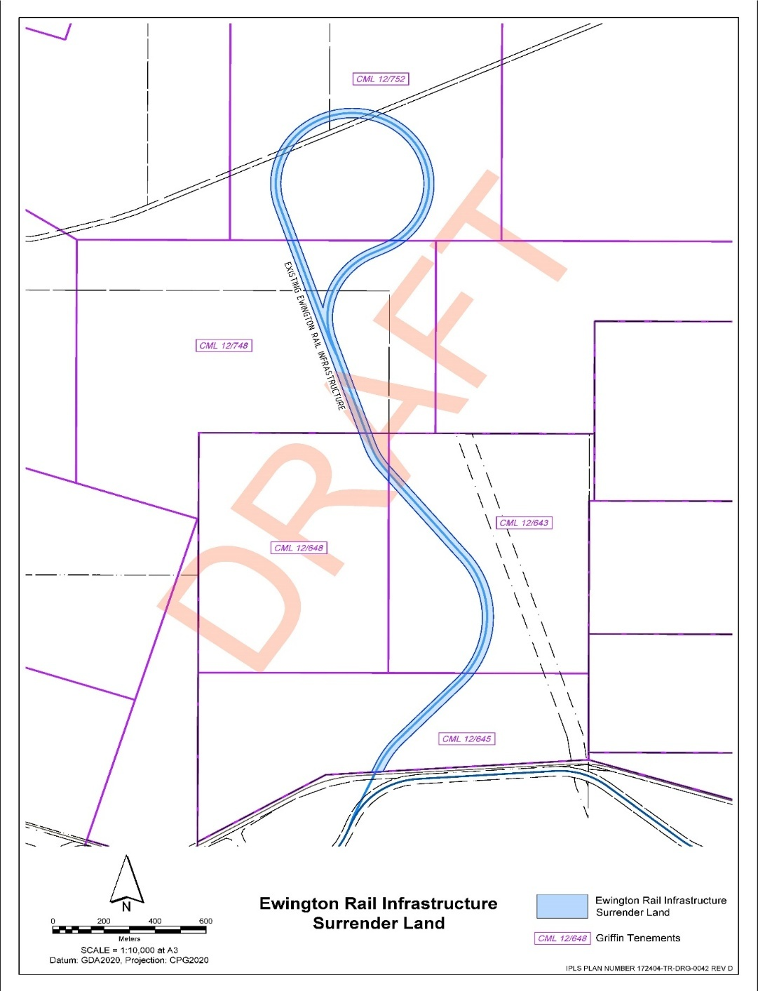
Ewington Rail Infrastructure Surrender Land
SCHEDULE “I”
Coolangatta Rail Corridor Surrender Land
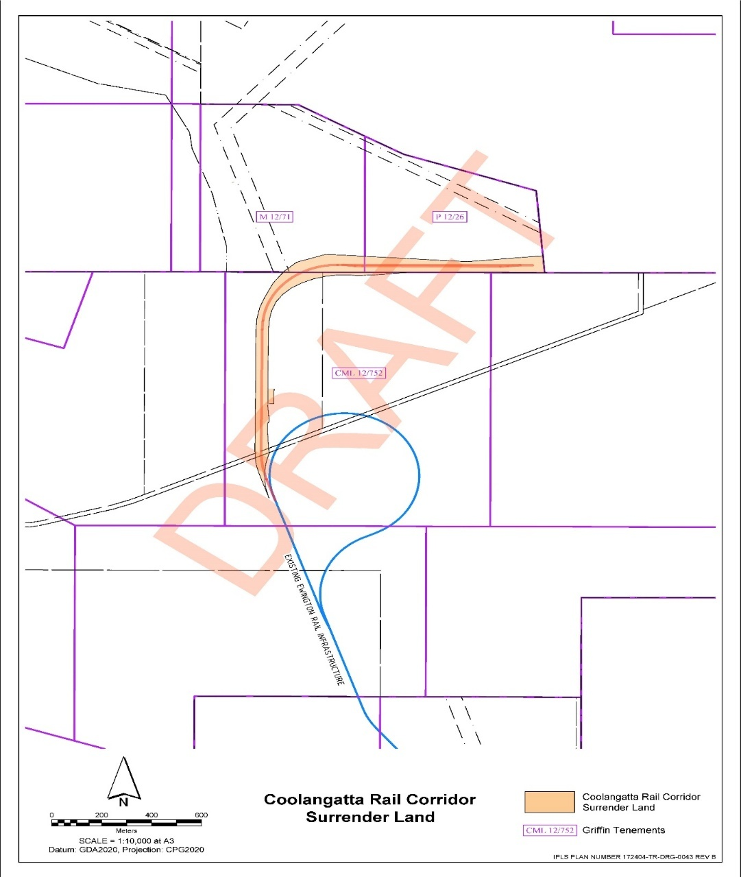
EXECUTED as a deed.

SIGNED by THE HONOURABLE ROGER COOK  in the presence of:  [Signature]  ______________________________  Signature of witness  SHARON KAYE ROBINS  Name of witness (block letters) | )  )  ) | [Signature]

EXECUTED for and on behalf of THE GRIFFIN COAL MINING COMPANY PTY LIMITED (RECEIVERS AND MANAGERS APPOINTED) (IN LIQUIDATION) by its joint and several receiver and manager in the presence of:  [Signature]  ______________________________  Signature of witness  CLAIRE COGHILL  Name of witness (block letters) | )))))  )))))  )))) | [Signature]  __________________________  Signature of receiver and manager  SEAN HOLMES  Name of receiver and manager (block letters)

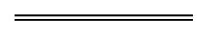

© State of Western Australia 2026.
This work is licensed under a Creative Commons Attribution 4.0 International Licence (CC BY 4.0). To view relevant information and for a link to a copy of the licence, visit www.legislation.wa.gov.au.
Attribute work as: © State of Western Australia 2026.
By Authority: ANDREW JONES, Government Printer

