
Western Australia
Perth Parking Management Act 1999

Perth Parking Management Regulations 1999

Western Australia
Perth Parking Management Regulations 1999
Contents
1. Citation 1
2. Commencement 1
3. Terms used 1
4. Perth parking management area (Sch. 1 and Act s. 6) 2
5. Circumstances prescribed (Act s. 7(c)) 2
6. Applications for parking bay licence, information etc. prescribed (Act s. 8(2)) 3
7. Parking bay licence fees (Sch. 2) 3
8. Application to vary parking bay licence, information etc. prescribed (Act s. 15(2)) 4
9. Infringement notices, offences prescribed (Sch. 3 and Act s. 19(1)) 4
10. Infringement notices, modified penalties prescribed (Sch. 3) 5
11. Infringement notices, form of (Sch. 4 and Act s. 19(2)) 5
12. Notice of withdrawal of infringement notice, form of (Sch. 5 and Act s. 19(6)) 5
Schedule 1 — Perth parking management area
Schedule 2 — Licence fees
Schedule 3 — Infringement notice offences and modified penalties
Schedule 4 — Form of infringement notice
Schedule 5 — Form of notice of withdrawal of infringement notice
Notes
Compilation table 16
Uncommenced provisions table 19
Defined terms

Western Australia
Perth Parking Management Act 1999
Perth Parking Management Regulations 1999

1. Citation
These regulations may be cited as the Perth Parking Management Regulations 1999.

2. Commencement
These regulations come into operation on the day on which section 7 of the Perth Parking Management Act 1999 comes into operation.

3. Terms used
In these regulations, unless the contrary intention appears —
Act means the Perth Parking Management Act 1999;
carriageway has the meaning given to that term in the Road Traffic Code 2000 regulation 3(1);
fire brigade means a brigade as defined in the Fire Brigades Act 1942;
private road has the meaning given in the Land Administration Act 1997 section 3(1);
road has the meaning given in the Land Administration Act 1997 section 3(1);
vehicle of a disabled person means a vehicle —
(a) in which a disabled person is either the driver or a passenger; and
(b) which is identified with a disability parking permit as defined in the Local Government (Parking for People with Disabilities) Regulations 2014 regulation 4.
[Regulation 3 amended: Gazette 16 May 2003 p. 1704; 13 Feb 2015 p. 653; SL 2022/51 r. 4.]

4. Perth parking management area (Sch. 1 and Act s. 6)
The Perth parking management area is the area within the bold dashed line shown as the boundary of the Perth parking management area on the diagrams in Schedule 1.
[Regulation 4 inserted: SL 2022/51 r. 5.]

5. Circumstances prescribed (Act s. 7(c))
For the purposes of section 7(c) of the Act, a vehicle is parked in prescribed circumstances if —
(a) the vehicle is parked in or on a building, or on land on which there is a building, by or for a permanent resident of the building, and is parked in a space set aside for the use of the resident by the owner of the building;
(b) the vehicle is parked in or on a building, or on land on which there is a building, by or for a person who is visiting a permanent resident of the building, and is parked in a space set aside for the use of such visitors by the owner of the building;
(c) the vehicle is parked in or on a building, or on land on which there is a building, by or for a permanent resident of the building who works from his or her home in the building;
(d) the vehicle is parked in an area provided by the City of Perth for the use of people attending a special event, and a person who attends the event is either the driver of the vehicle or a passenger in it;
(e) the vehicle is parked within King’s Park (being all of the land from time to time known as Reserve No. 1720, classified as class A).
[Regulation 5 amended: SL 2022/51 r. 6.]

6. Applications for parking bay licence, information etc. prescribed (Act s. 8(2))
(1) For the purposes of section 8(2) of the Act, an application by the owner of land or a building for a parking bay licence for the land or building is to include or be accompanied by the following information —
(a) the name and address of the applicant;
(b) the address of the land or building;
(c) an approval under the Planning and Development Act 2005 indicating the number of parking bays approved and the uses for which they have been approved.
(2) However, if the approval referred to in subregulation (1)(c) was issued before the commencement of these regulations, then, instead of the approval, the application may be accompanied by a statutory declaration that declares that the approval was issued and that indicates the number of parking bays approved and the uses for which they have been approved.
[Regulation 6 amended: Gazette 11 Sep 2012 p. 4348.]

7. Parking bay licence fees (Sch. 2)
(1) The annual fee payable for the issue or renewal of a parking bay licence for the parking facilities described in the second column of an item in Schedule 2 is the fee set out in the third column of the item.
(2) However, if a licence fee is paid in instalments with the permission of the CEO under section 11(2) of the Act, the annual fee payable for the licence under subregulation (1) is increased by 5%.

8. Application to vary parking bay licence, information etc. prescribed (Act s. 15(2))
(1) For the purposes of section 15(2) of the Act, an application by a licensee for the variation of a parking bay licence is to include or be accompanied by the following information —
(a) the name and address of the licensee; and
(b) the address of the land or building to which the licence applies; and
(c) particulars of the variation sought; and
(d) the approval referred to in subregulation (2), if required.
(2) If the number of parking bays to be permitted by the varied licence would be greater than the number permitted by the approval under the Planning and Development Act 2005 that was lodged with the application for the licence or for an earlier variation, the application for variation must be accompanied by a further approval under that Act indicating approval for the increase in the number of parking bays and indicating the uses for which the additional bays have been approved.
[Regulation 8 amended: Gazette 11 Sep 2012 p. 4348.]

9. Infringement notices, offences prescribed (Sch. 3 and Act s. 19(1))
For the purposes of section 19(1) of the Act, an infringement notice may be given for an offence described in the third column of an item in Schedule 3 that is alleged to have been committed under the provision of the Act specified in the second column of the item.

10. Infringement notices, modified penalties prescribed (Sch. 3)
The modified penalty for an offence referred to in an item in Schedule 3 is the penalty set out in the fourth column of the item.

11. Infringement notices, form of (Sch. 4 and Act s. 19(2))
For the purposes of section 19(2) of the Act, the form of an infringement notice is the form set out in Schedule 4.

12. Notice of withdrawal of infringement notice, form of (Sch. 5 and Act s. 19(6))
For the purposes of section 19(6) of the Act, the form of a notice of withdrawal of an infringement notice is the form set out in Schedule 5.

Schedule 1 — Perth parking management area
[r. 4]
[Heading inserted: SL 2022/51 r. 7
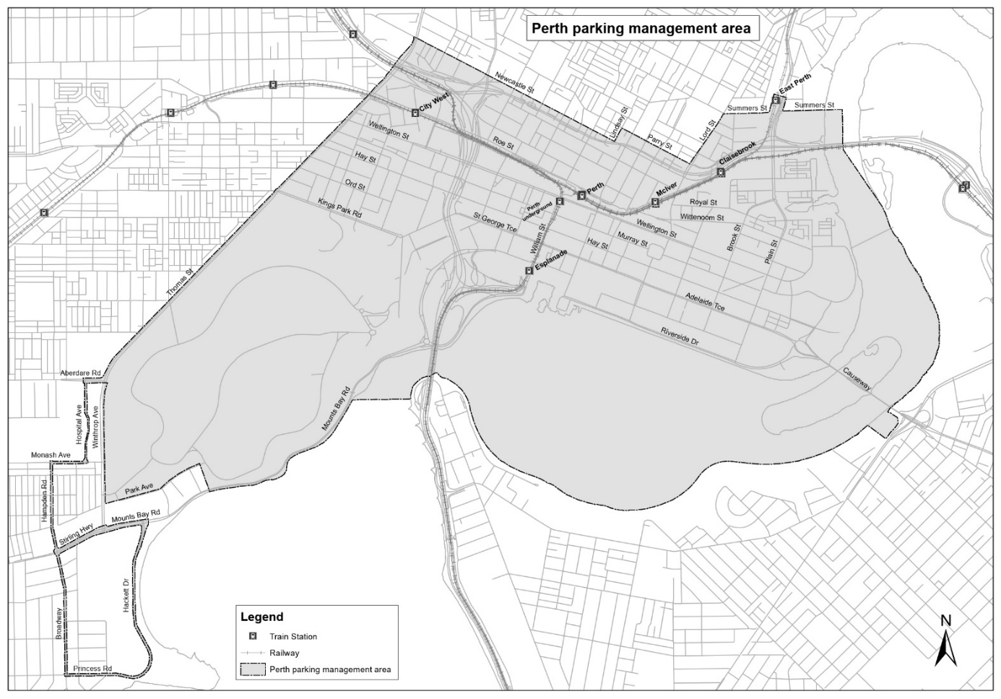
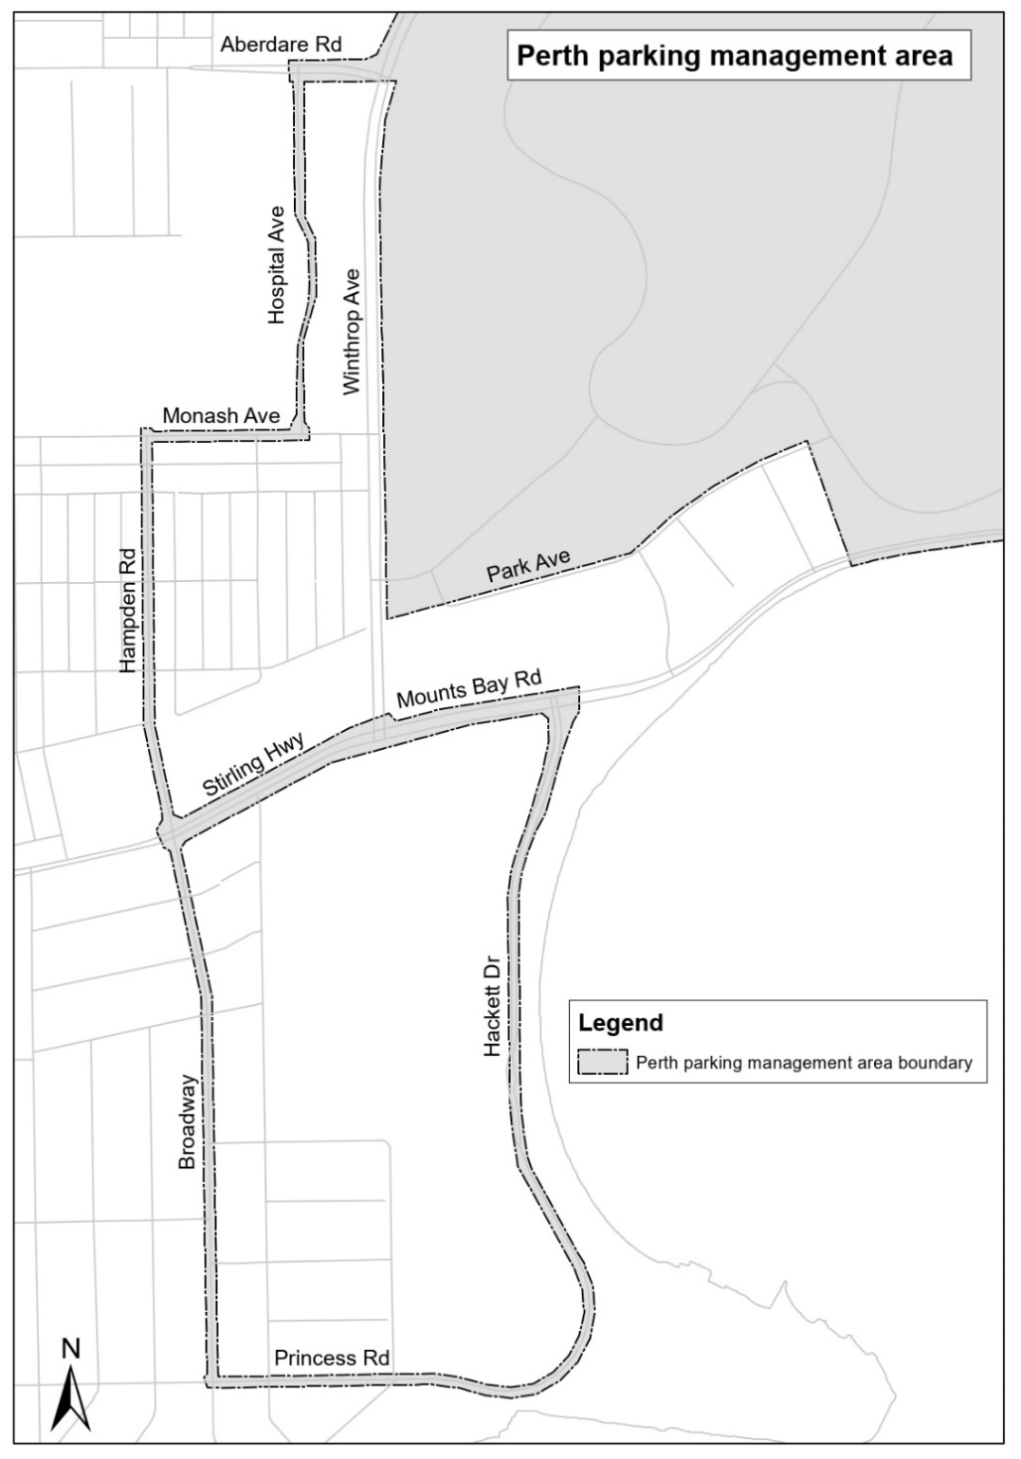
[Schedule 1 inserted: SL 2022/51 r. 7.]

Schedule 2 — Licence fees
[r. 7]
Item | Parking facilities | Annual licence fee  $
1. | a parking facility that has only 5 parking bays or fewer for the use of vehicles (excluding parking bays of a kind referred to in any of items 2 to 10 and 12 to 14) | nil
2. | a permit parking area as defined in the Local Government (Parking for People with Disabilities) Regulations 2014 regulation 4 | nil
3. | a parking bay in a commercial parking facility leased to a resident of the City of Perth who has no access as a resident of the City to exempt parking facilities of the kind referred to in regulation 5(a) or (c) | nil
4. | a parking bay clearly identified as being solely for vehicles engaged in unloading or loading goods or passengers | nil
5. | a parking bay set aside solely for a vehicle being used —  (a) to transport patients or blood; or  (b) to deliver meals to the aged or infirm or to a hospital; or  (c) by a charity to provide frontline services to persons who are vulnerable or in crisis, including, for example, by providing —  (i) meals, blankets or clothes; or  (ii) transport to medical or welfare services or emergency accommodation | nil
6. | a parking bay being used for a vehicle that forms part of a display, such as a vehicle offered as a prize in a raffle | nil
7. | a parking bay set aside for the use of passenger buses during layover periods | nil
8. | a parking bay used solely for parking an ambulance being used for operational purposes or a vehicle being used for operational purposes by a member of the Police Force or a member of a fire brigade | nil
9. | a parking bay —  (a) used solely for servicing, inspecting, repairing, fuelling or maintaining vehicles; or  (b) located on land or in or on a building, used solely for parking a vehicle being used by a person who is servicing, inspecting, repairing or maintaining the land or building | nil
10. | a parking bay used solely for a vehicle that forms part of the stock of a business of a motor vehicle dealer who holds a licence under the Motor Vehicle Dealers Act 1973 | nil
11. | a facility that has more than 5 parking bays for the use of vehicles (excluding a bay set aside for the exclusive use of vehicles referred to in any of items 2 to 10 and 12 to 14) —
 | (a) for each motor cycle bay; | nil
 | (b) for each bay (excluding a bay that is on a carriageway) that is available to the public for use without time constraints; | 1 291.50
 | (c) for each bay that is on a carriageway; | 1 187.40
 | (d) for each bay that is available to the public and in which 50% of the vehicles being parked stay for less than 4 hours and at least 90% stay for less than 6 hours; | 1 187.40
 | (e) for each other bay | 1 349.60
12. | a parking bay for use without charge —  (a) located on the site of —  (i) a place of public worship of a religious body; or  (ii) a school that is formally affiliated with a religious body;  and
 | (b) set aside during the hours of 8.00 a.m. to 6.00 p.m. Monday to Friday solely for a vehicle being used by a person who, throughout the period the vehicle is parked in the bay —  (i) is employed at the place of public worship or the school; or  (ii) does voluntary work at or mainly at the place of public worship or the school; or  (iii) visits the place of public worship or the school for religious purposes or in relation to parish affairs of the religious body; or  (iv) visits the school for school-related purposes | nil
13. | a parking bay for use without charge —  (a) located on or adjacent to a park; and  (b) set aside during the hours of 8.00 a.m. to 6.00 p.m. solely for a vehicle being used by a person or persons who, throughout the period the vehicle is parked in the bay, engages or engage in a recreational activity in the park | nil
14. | a parking bay located on any of the following roads or private roads —
 | (a) Thomas Street | nil
 | (b) Aberdare Road | nil
 | (c) Hospital Avenue | nil
 | (d) Monash Avenue | nil
 | (e) Hampden Road | nil
 | (f) Broadway | nil
 | (g) Princess Road | nil
 | (h) Hackett Drive | nil
 | (i) the part of Mounts Bay Road between Hackett Drive and Winthrop Avenue | nil
 | (j) Stirling Highway | nil
[Schedule 2 amended: Gazette 15 Jun 2001 p. 2976-7; 17 May 2002 p. 2569; 16 May 2003 p. 1704-5; 21 May 2004 p. 1713-14; 10 Jun 2005 p. 2567; 12 May 2006 p. 1788; 12 Jun 2007 p. 2736-7; 28 Sep 2007 p. 4933; 16 May 2008 p. 1913-14; 23 Jun 2009 p. 2490; 30 Jun 2009 p. 2660; 1 Apr 2010 p. 1280; 8 Apr 2011 p. 1292; 29 Apr 2011 p. 1535-6; 1 Jun 2012 p. 2287; 2 Nov 2012 p. 5262-3; 8 Feb 2013 p. 870; 14 Jun 2013 p. 2247; 16 May 2014 p. 1544-5; 13 Feb 2015 p. 653; 15 May 2015 p. 1729-30; 13 May 2016 p. 1428; 26 May 2017 p. 2641; 25 May 2018 p. 1642; SL 2021/92 r. 4; SL 2022/51 r. 8; SL 2022/67 r. 4; SL 2023/45 r. 17; SL 2024/60 r. 4; SL 2025/64 r. 12; SL 2025/181 r. 4; SL 2026/61 r. 4.]

Schedule 3 — Infringement notice offences and modified penalties
[r. 9, 10]
Item | Provision of Act | Description of offence | Modified penalty  $
1. | Section 7 | permitting a vehicle to be parked on the land or in or on a building in the Perth parking management area for which no parking bay licence is in force | 500
2. | Section 14 | failing to give notice of a change in the ownership of land or a building for which a parking bay licence is in force | 200
3. | Section 18(1) | failing to comply with a parking bay licence | 500
4. | Section 18(2) | advertising or otherwise indicating that parking is available on land or in or on a building for which a parking bay licence is in force while the licence does not permit parking as advertised or otherwise indicated | 500
5. | Section 18(3) | advertising or otherwise indicating that parking is available on land or in or on a building in the Perth parking management area for which no parking bay licence is in force | 500
6. | Section 22 | obstructing an inspector in the performance of his or her functions or the exercise of his or her powers under the Act | 500

Schedule 4 — Form of infringement notice
[r. 11]
Perth Parking Management Act 1999
Perth Parking Management Regulations 1999
INFRINGEMENT NOTICE
Date of this notice ......../......../........
To: .........................................................................................................................
of: ..........................................................................................................................
Details of vehicle (if applicable) ...........................................................................
It is alleged that on ......../......../........ at ...............................................................
you committed the following offence —
.................................................................................................................................
................................................................................................................................
................................................................................................................................
contrary to section ................... of the Perth Parking Management Act 1999.
The modified penalty for the alleged offence is $...................
If you do not wish to have a complaint of the alleged offence heard and determined by a court, you may pay the amount of the modified penalty shown above to the CEO of the Department for Planning and Infrastructure ² at ............. ........................................ within 28 days after the date of this notice.
Name and title of inspector giving this notice ......................................................
......................................................
Signature ......................................................
[Schedule 4 amended: Gazette 28 Feb 2003 p. 678.]

Schedule 5 — Form of notice of withdrawal of infringement notice
[r. 12]
Perth Parking Management Act 1999
Perth Parking Management Regulations 1999
NOTICE OF WITHDRAWAL OF
INFRINGEMENT NOTICE
Date of this notice ......../......../........
To: .........................................................................................................................
of: ..........................................................................................................................
Infringement notice No. ................. dated ......../......../........ that was issued for
the alleged offence of ............................................................................................
.................................................................................................................................
.................................................................................................................................
.................................................................................................................................
contrary to section ................. of the Perth Parking Management Act 1999 has been withdrawn.
The modified penalty of $..........................
- was paid, and a refund is enclosed
- was not paid and should not be paid
(delete as appropriate)
Name and title of inspector giving this notice ......................................................
......................................................
Signature ......................................................

Notes
This is a compilation of the Perth Parking Management Regulations 1999 and includes amendments made by other written laws. For provisions that have come into operation, and for information about any reprints, see the compilation table. For provisions that have not yet come into operation see the uncommenced provisions table.

Compilation table
Citation | Published | Commencement
Perth Parking Management Regulations 1999 | 16 Jul 1999  p. 3227-34 | 16 Jul 1999 (see r. 2 and Gazette 16 Jul 1999 p. 3183)
Perth Parking Management Amendment Regulations 2001 | 15 Jun 2001  p. 2976-7 | 1 Jul 2001 (see r. 2)
Perth Parking Management Amendment Regulations 2002 | 17 May 2002 p. 2568-9 | 1 Jul 2002 (see r. 2)
Perth Parking Management Amendment Regulations 2003 | 28 Feb 2003 p. 678 | 28 Feb 2003
Perth Parking Management Amendment Regulations (No. 2) 2003 | 16 May 2003 p. 1704-5 | 16 May 2003
Perth Parking Management Amendment Regulations 2004 | 21 May 2004 p. 1713-14 | 1 Jul 2004 (see r. 2)
Reprint 1: The Perth Parking Management Regulations 1999 as at 21 Jan 2005 (includes amendments listed above)
Perth Parking Management Amendment Regulations 2005 | 10 Jun 2005 p. 2567 | 1 Jul 2005 (see r. 2)
Perth Parking Management Amendment Regulations 2006 | 12 May 2006 p. 1788 | 1 Jul 2006 (see r. 2)
Perth Parking Management Amendment Regulations (No. 2) 2007 | 12 Jun 2007 p. 2736-7 | 1 Jul 2007 (see r. 2)
Perth Parking Management Amendment Regulations 2007 | 28 Sep 2007 p. 4933 | 28 Sep 2007
Perth Parking Management Amendment Regulations 2008 | 16 May 2008 p. 1913-14 | r. 1 and 2: 16 May 2008 (see r. 2(a));  Regulations other than r. 1 and 2: 1 Jul 2008 (see r. 2(b))
Reprint 2: The Perth Parking Management Regulations 1999 as at 12 Sep 2008 (includes amendments listed above)
Perth Parking Management Amendment Regulations 2009 | 23 Jun 2009 p. 2489-90 | r. 1 and 2: 23 Jun 2009 (see r. 2(a));  Regulations other than r. 1 and 2: 24 Jun 2009 (see r. 2(b))
Perth Parking Management Amendment Regulations (No. 2) 2009 | 30 Jun 2009 p. 2659-60 | r. 1 and 2: 30 Jun 2009 (see r. 2(a));  Regulations other than r. 1 and 2: 1 Jul 2009 (see r. 2(b))
Perth Parking Management Amendment Regulations 2010 | 1 Apr 2010 p. 1280 | r. 1 and 2: 1 Apr 2010 (see r. 2(a));  Regulations other than r. 1 and 2: 1 Jul 2010 (see r. 2(b))
Perth Parking Management Amendment Regulations 2011 | 8 Apr 2011 p. 1291-2 | r. 1 and 2: 8 Apr 2011 (see r. 2(a));  Regulations other than r. 1 and 2: 1 Jul 2011 (see r. 2(b))
Perth Parking Management Amendment Regulations (No. 2) 2011 | 29 Apr 2011 p. 1535-6 | r. 1 and 2: 29 Apr 2011 (see r. 2(a));  Regulations other than r. 1 and 2: 30 Apr 2011 (see r. 2(b))
Reprint 3: The Perth Parking Management Regulations 1999 as at 6 Jan 2012 (includes amendments listed above)
Perth Parking Management Amendment Regulations 2012 | 1 Jun 2012 p. 2287 | r. 1 and 2: 1 Jun 2012 (see r. 2(a));  Regulations other than r. 1 and 2: 1 Jul 2012 (see r. 2(b))
Perth Parking Management Amendment Regulations (No. 2) 2012 | 11 Sep 2012 p. 4347-9 | r. 1 and 2: 11 Sep 2012 (see r. 2(a));  Regulations other than r. 1 and 2: 12 Sep 2012 (see r. 2(b))
Perth Parking Management Amendment Regulations (No. 3) 2012 | 2 Nov 2012 p. 5262-3 | r. 1 and 2: 2 Nov 2012 (see r. 2(a));  Regulations other than r. 1 and 2: 3 Nov 2012 (see r. 2(b))
Perth Parking Management Amendment Regulations 2013 | 8 Feb 2013 p. 869-70 | r. 1 and 2: 8 Feb 2013 (see r. 2(a));  Regulations other than r. 1 and 2: 9 Feb 2013 (see r. 2(b))
Perth Parking Management Amendment Regulations (No. 2) 2013 | 14 Jun 2013 p. 2246-7 | r. 1 and 2: 14 Jun 2013 (see r. 2(a));  Regulations other than r. 1 and 2: 1 Jul 2013 (see r. 2(b))
Perth Parking Management Amendment Regulations 2014 | 16 May 2014 p. 1544-5 | r. 1 and 2: 16 May 2014 (see r. 2(a));  Regulations other than r. 1 and 2: 1 Jul 2014 (see r. 2(b))
Reprint 4: The Perth Parking Management Regulations 1999 as at 15 Aug 2014 (includes amendments listed above)
Perth Parking Management Amendment Regulations 2015 | 13 Feb 2015 p. 652-3 | r. 1 and 2: 13 Feb 2015 (see r. 2(a));  Regulations other than r. 1 and 2: 14 Feb 2015 (see r. 2(b))
Perth Parking Management Amendment Regulations (No. 2) 2015 | 15 May 2015 p. 1729-30 | r. 1 and 2: 15 May 2015 (see r. 2(a));  Regulations other than r. 1 and 2: 1 Jul 2015 (see r. 2(b))
Perth Parking Management Amendment Regulations 2016 | 13 May 2016 p. 1428 | r. 1 and 2: 13 May 2016 (see r. 2(a));  Regulations other than r. 1 and 2: 1 Jul 2016 (see r. 2(b))
Transport Regulations Amendment (Fees and Charges) Regulations 2017 Pt. 4 | 26 May 2017 p. 2639-45 | 1 Jul 2017 (see r. 2(b))
Transport Regulations Amendment (Fees and Charges) Regulations 2018 Pt. 3 | 25 May 2018 p. 1640-7 | 1 Jul 2018 (see r. 2(b))
Transport Regulations Amendment (Fees and Charges) Regulations (No. 2) 2021 Pt. 2 | SL 2021/92 18 Jun 2021 | 1 Jul 2021 (see r. 2(c))
Perth Parking Management Amendment Regulations 2022 | SL 2022/51 22 Apr 2022 | r. 1 and 2: 22 Apr 2022 (see r. 2(a));  Regulations other than r. 1 and 2: 23 Apr 2022 (see r. 2(b))
Transport Regulations Amendment (Fees and Charges) Regulations (No. 2) 2022 Pt. 2 | SL 2022/67 3 Jun 2022 | 1 Jul 2022 (see r. 2(b))
Transport Regulations Amendment (Fees and Charges) Regulations 2023 Pt. 5 | SL 2023/45 19 May 2023 | 1 Jul 2023 (see r. 2(c))
Perth Parking Management Amendment Regulations 2024 | SL 2024/60 1 May 2024 | r. 1 and 2: 1 May 2024 (see r. 2(a));  Regulations other than r. 1 and 2: 1 Jul 2024 (see r. 2(b))
Transport Regulations Amendment (Fees and Charges) Regulations (No. 2) 2025 Pt. 6 | SL 2025/64 30 Apr 2025 | 1 Jul 2025 (see r. 2(b))
Perth Parking Management Amendment Regulations 2025 | SL 2025/181 29 Oct 2025 | r. 1 and 2: 29 Oct 2025 (see r. 2(a));  Regulations other than r. 1 and 2: 30 Oct 2025 (see r. 2(b))
Perth Parking Management Amendment Regulations 2026 | SL 2026/61 13 May 2026 | r. 1 and 2: 13 May 2026 (see r. 2(a));  Regulations other than r. 1 and 2: 1 Jul 2026 (see r. 2(b))

Uncommenced provisions table
To view the text of the uncommenced provisions see Acts as passed on the WA legislation website.
Citation | Published | Commencement
Perth Parking Management Act 2024 s. 159 assented to 7 Mar 2024 |  | To be proclaimed (see s. 2(c))

Defined terms

[This is a list of terms defined and the provisions where they are defined. The list is not part of the law.]
Defined term Provision(s)
Act 3
carriageway 3
fire brigade 3
private road 3
road 3
vehicle of a disabled person 2

© State of Western Australia 2026.
This work is licensed under a Creative Commons Attribution 4.0 International Licence (CC BY 4.0). To view relevant information and for a link to a copy of the licence, visit www.legislation.wa.gov.au.
Attribute work as: © State of Western Australia 2026.
By Authority: ANDREW JONES, Government Printer

