
Western Australia
Tobacco and Other Products Control Act 2006

Tobacco and Other Products Control Regulations 2006

Western Australia
Tobacco and Other Products Control Regulations 2006
Contents
Part 1 — Preliminary
1. Citation 1
2. Commencement 1
3. Terms used 1
Part 2 — Regulations for various Glossary definitions
4. Illicit tobacco products (Act s. 126A) 3
5. Tobacco packaging requirements 3
6. Tobacco product requirements 3
Part 3 — Smoking in or near enclosed public places
Division 1 — Preliminary
7. Terms used 4
8. Enclosed public places 4
9. Notional vertical surface area 6
Division 2 — Offences
10. Prohibition on smoking in enclosed public places 6
11. Offence by occupier 7
12. Display of no smoking signs in entrances to liquor licensed premises 7
13. Duty to prevent smoke or emissions entering enclosed public places 8
13A. Prohibitions on smoking near enclosed public places 8
Division 3 — Investigators
14. Investigators to notify occupiers before taking action under Part 3 9
15. Directions by investigators 9
Part 4A — Smoking in outdoor public places
Division 1 — Outdoor eating areas
16A. Term used: non-smoking zone 11
16B. Display of no smoking signs in non-smoking zones 11
16C. Investigators to notify occupiers before taking action under Div. 1 12
Division 2 — Miscellaneous
16D. Directions by investigators 12
Part 5 — Licensing
Division 1 — Licensing procedures
17. Application for licence — proof of individual’s identity 14
18. Application for licence — other evidence 15
19. Application for renewal of licence 16
20. Conditions of general application 17
21. Application to amend licence 18
22. Register of licences 20
Division 2 — Further obligations of licence holders
23. Licence details on invoices etc. 20
24. Records to be kept 20
Division 3 — Fees
25. Fees to be paid on application for issue of licence 21
26. Fees to be paid on application for renewal of licence 21
27. Fee to be paid on application for amendment of licence 21
28. Fee to be paid for extract of registered particulars 22
29. Fee to be paid for duplicate licence 22
Part 6 — Sale and supply
Division 1 — Terms used in this Part
30. Terms used 23
Division 2 — Proof of age
31. Proof of age 24
Division 4 — Location and display of tobacco products and tobacco smoking implements
34. Location of tobacco products or tobacco smoking implements on retail premises 25
36. Type of tobacco products on retail premises and manner of storage 27
37. Display of tobacco products, tobacco smoking implements or product lines by specialist retailer 28
Division 5 — Information about availability, price of tobacco products or tobacco smoking implements
39. Information signs about availability or prices of tobacco products or tobacco smoking implements sold by retailers — location 29
40. Information signs about availability or prices of tobacco products or tobacco smoking implements sold by retailers — contents 29
41. Information signs about availability or prices of tobacco products or tobacco smoking implements sold by retailers — specifications 31
42. Information signs about availability or prices of tobacco products sold by retailers — cigar cabinets 32
43. Price tickets for tobacco products sold by retailers — location and numbers 32
44. Price tickets for tobacco products sold by retailers — contents 33
45. Price tickets for tobacco products sold by retailers — specifications 33
46. Price lists for tobacco products or tobacco smoking implements sold by retailers 34
47. Facsimiles of tobacco products displayed on price list 35
Division 6 — Warnings
48. Warning signs about purchase of tobacco products etc. to underage persons — location 36
49. Warning signs about purchase of tobacco products etc. to underage persons — content and specifications 36
50. Health warning signs — location 37
51. Health warning signs — content and specifications 37
Division 7 — Information and advice
52. Retailers providing purchasers of tobacco products with approved guides 38
53. Retailers making approved guides available to purchasers of tobacco products 39
54. Wholesalers providing retailers with approved guides 39
Division 8 — Vending machines
55. Number of vending machines 39
56. Location of vending machines 40
Division 9 — Smokeless tobacco
57. Smokeless tobacco 40
Division 10 — Therapeutic vaping products
57A. Terms used 40
57B. Sale and supply of therapeutic vaping products 41
57C. Possession of therapeutic vaping products 41
Part 6A — Prescribed quantities
57D. Quantities giving rise to presumptive intention to sell various tobacco products 43
57E. Quantities giving rise to various possession of prohibited product offences 43
Part 6B — Closure orders
57F. Term used: premises 46
57G. Information that must be included in closure orders 46
57H. Information that must be included in closure order variations 46
57I. Reasonable excuse 47
Part 7 — Miscellaneous
58. Confidentiality — exceptions 49
59. Appointment of restricted investigators 50
59A. Supply offences 50
60. Prescribed offences and modified penalties 50
61. Authorised officers and approved officers 51
62. Forms 51
Schedule 1 — Warning signs about purchase of tobacco products
Schedule 2 — Health warning signs for general display or vending machines
Schedule 3 — Health warning signs for display of cigars or cigar cutting implements
Schedule 4 — Prescribed offences and modified penalties
Schedule 5 — Forms
Notes
Compilation table 65
Other notes 68
Defined terms

Tobacco and Other Products Control Act 2006
Tobacco and Other Products Control Regulations 2006

Part 1 — Preliminary

1. Citation
These regulations are the Tobacco and Other Products Control Regulations 2006.
[Regulation 1 amended: SL 2026/59 r. 4.]

2. Commencement
These regulations come into operation on 31 July 2006.

3. Terms used
In these regulations —
BNR Act means the Business Names Registration Act 2011 (Commonwealth);
Business Names Register means the Business Names Register established and maintained under the BNR Act section 22;
liquor licensed premises means licensed premises as defined in the Liquor Control Act 1988 section 3(1);
loose tobacco —
(a) means tobacco in a form prepared for human consumption or use; but
(b) does not include a cigarette or cigar;
representative in relation to a responsible person, means a person acting on behalf of the responsible person;
section means a section of the Act;
specialist retailer has the meaning given in section 23(1);
wall means a wall or any other vertical structure, covering or device, whether fixed or moveable, but does not include a balustrade —
(a) that is 1 m or less in height; and
(b) of which more than 50% of its total vertical surface is open.
[Regulation 3 amended: Gazette 28 Feb 2007 p. 643; 10 Sep 2010 p. 4378; 27 Nov 2012 p. 5734; SL 2026/59 r. 5.]

Part 2 — Regulations for various Glossary definitions
[Heading inserted: SL 2026/59 r. 6.]

4. Illicit tobacco products (Act s. 126A)
For the purposes of paragraph (c) of the definition of illicit tobacco product in clause 1 of the Glossary to the Act, the provisions of the following laws of the Commonwealth are prescribed —
(a) the Customs Act 1901 (Cth);
(b) the Excise Act 1901 (Cth).
[Regulation 4 inserted: SL 2026/59 r. 6.]

5. Tobacco packaging requirements
For the purposes of paragraph (a) of the definition of tobacco packaging requirement in clause 1 of the Glossary to the Act, the following provisions are prescribed —
(a) the Public Health (Tobacco and Other Products) Act 2023 (Cth) Part 3.3 Divisions 1 and 2;
(b) the Public Health (Tobacco and Other Products) Regulations 2024 (Cth) Parts 3.2 to 3.11.
[Regulation 5 inserted: SL 2026/59 r. 6.]

6. Tobacco product requirements
For the purposes of paragraph (a) of the definition of tobacco product requirement in clause 1 of the Glossary to the Act, the following provisions are prescribed —
(a) the Public Health (Tobacco and Other Products) Act 2023 (Cth) Part 3.3 Divisions 3 and 4;
(b) the Public Health (Tobacco and Other Products) Regulations 2024 (Cth) Parts 3.12 (other than regulation 120(3)) and 3.13.
[Regulation 6 inserted: SL 2026/59 r. 6.]

Part 3 — Smoking in or near enclosed public places
[Heading amended: Gazette 12 Mar 2019 p. 657.]

Division 1 — Preliminary

7. Terms used
In this Part —
adequate ventilation means natural or mechanical ventilation that complies with FP4.3, FP4.4 and FP4.5, F4.5, F4.6 and F4.7 of the Building Code of Australia 2006 issued by the Australian Building Codes Board as amended from time to time;
enclosed public place has a meaning affected by regulation 8;
roof includes a ceiling, and any material —
(a) through which air cannot flow; and
(b) that is used for the same purpose as a ceiling or roof.
[Regulation 7 amended: Gazette 10 Sep 2010 p. 4378.]

8. Enclosed public places
(1) A public place or a part of a public place that has the features mentioned in subregulations (2) and (3) is an enclosed public place for the purposes of this Part.
(2) An enclosed public place is covered by a roof or a part of a roof.
(3) An enclosed public place is configured so that the total vertical surface area of the solid material in the walls is more than 50% of the notional vertical surface area of the place as assessed in accordance with regulation 9.
(4) The total vertical surface area of the solid material in the walls is to be assessed by —
(a) multiplying the following —
(i) the length of each wall under the roof or the part of a roof plus the length of each wall and each section of a wall that is 1 m or less beyond the perimeter of the roof or the part of a roof when measured horizontally from the perimeter of the roof or the part of the roof;
(ii) the actual height of the walls and wall sections mentioned in subparagraph (i);
and
(b) deducting the total vertical surface area of the open parts of the walls or wall sections mentioned in paragraph (a)(i).
(5) The total vertical surface area of solid material in a wall is to be assessed as if each window, door or vertical retractable covering in or adjacent to the wall —
(a) is closed; and
(b) forms part of the wall.
(6) A place is not an enclosed public place for the purposes of this Part if it is covered by a roof or a part of a roof and is bounded by only —
(a) one straight wall; or
(b) 2 straight walls that are set in an angle of 90 degrees or more.
(7) A part of a public place may be an enclosed public place even though —
(a) it is part of a public place that is not an enclosed public place; or
(b) it is part of another part of a public place that is not an enclosed public place.
[Regulation 8 amended: Gazette 10 Sep 2010 p. 4379.]

9. Notional vertical surface area
(1) The notional vertical surface area of a public place is to be assessed by multiplying the following —
(a) the length of the perimeter of the roof, or the part of a roof, covering the public place;
(b) the average height of the roof, or the part of a roof, covering the public place.
(2) The notional vertical surface area of a part of a public place is to be assessed by multiplying the following —
(a) the length of the perimeter of the roof, or the part of a roof, covering the part of the public place;
(b) the average height of the roof, or the part of a roof, covering the part of the public place.

Division 2 — Offences

10. Prohibition on smoking in enclosed public places
(1) A person must not smoke in an enclosed public place.
Penalty for this subregulation: a fine of $2 500.
[(2) deleted]
(3) A person does not commit an offence under subregulation (1) if —
(a) the person is an actor, artist or other performer who smokes for the purposes of a performance; and
(b) the occupier of the enclosed public place consented to the person’s smoking for the purposes of the performance; and
(c) the consent was given before the performance commenced.
[Regulation 10 amended: Gazette 12 Mar 2019 p. 665; SL 2021/212 r. 4; SL 2026/59 r. 22.]

11. Offence by occupier
(1) If a person commits an offence under regulation 10(1) the occupier of the enclosed public place commits an offence.
Penalty for this subregulation: a fine of $2 500.
(2) It is a defence to a prosecution for an offence under subregulation (1) that —
(a) neither the accused nor any employee or agent of the accused was aware, or could reasonably be expected to have been aware, that the offence was occurring; or
(b) as soon as the accused or an employee or agent of the accused became aware that the offence was occurring, the accused or an employee or agent of the accused —
(i) informed the person concerned that the person was committing an offence; and
(ii) requested the person to stop smoking in the enclosed public place and, in the case of a person smoking a tobacco product, to properly dispose of the tobacco product; and
(iii) if the person failed to comply with a request under subparagraph (ii) — requested the person to leave the enclosed public place until the person finished smoking.
[Regulation 11 amended: Gazette 12 Mar 2019 p. 665; SL 2026/59 r. 7 and 22.]

12. Display of no smoking signs in entrances to liquor licensed premises
(1) An occupier of an enclosed public place that comprises, or is part of, liquor licensed premises must display, or cause to be displayed, at the place signs that comply with the requirements of subregulation (2) —
(a) in such numbers; and
(b) in such positions,
as would ensure that a sign is clearly visible to a person at a public entrance to the place.
Penalty for this subregulation: a fine of $2 500.
(2) A sign must contain —
(a) the phrase “no smoking” or “smoking prohibited” in letters that are at least 20 mm in height; or
(b) the symbol, designated in Australian Standard 2899.1 — 1986 published by Standards Australia, to indicate that smoking is prohibited and having a diameter of at least 70 mm; or
(c) other words or symbols that indicate clearly that smoking is prohibited.
(3) Subregulation (1) does not apply to an occupier of an enclosed public place that is a subject of a restaurant licence.
[Regulation 12 amended: Gazette 10 Sep 2010 p. 4379; 12 Mar 2019 p. 665; SL 2026/59 r. 22.]

13. Duty to prevent smoke or emissions entering enclosed public places
The occupier of an enclosed public place must, unless the place has adequate ventilation, take reasonable steps to ensure that smoke from a tobacco product or emissions from a vaping device do not enter the place.
Penalty: a fine of $2 500.
[Regulation 13 amended: SL 2026/59 r. 8 and 22.]

13A. Prohibitions on smoking near enclosed public places
(1) A person must not smoke outside an enclosed public place within 5 m of a public entrance to the enclosed public place.
Penalty for this subregulation: a fine of $2 500.
(2) A person must not smoke outside an enclosed public place within 10 m of an air intake for air conditioning equipment that is in or on the enclosed public place.
Penalty for this subregulation: a fine of $2 500.
(3) It is a defence to a prosecution for an offence under subregulation (1) or (2) to prove that the accused was only passing the public entrance or air intake, as the case requires, and did not remain in its vicinity.
[Regulation 13A inserted: Gazette 12 Mar 2019 p. 658; amended: SL 2026/59 r. 22.]

Division 3 — Investigators

14. Investigators to notify occupiers before taking action under Part 3
(1) An investigator must take reasonable steps to notify the occupier of an enclosed public place of the investigator’s presence before the investigator takes any action for purposes connected with the operation of this Part.
(2) Subregulation (1) does not apply to action of a kind mentioned in section 85.

15. Directions by investigators
(1) If an investigator has reason to believe that a person is committing an offence under regulation 10(1) the investigator may direct the person to stop smoking in the enclosed public place.
(1A) If an investigator has reason to believe that a person is committing an offence under regulation 13A(1) or (2) the investigator may direct the person to stop smoking within the prohibited distance.
(1B) In subregulation (1A) —
within the prohibited distance means —
(a) for an offence under regulation 13A(1) — within 5 m of a public entrance to an enclosed public place; or
(b) for an offence under regulation 13A(2) — within 10 m of an air intake for air conditioning equipment that is in or on an enclosed public place.
(2) A direction under subregulation (1) or (1A) may be given orally or in writing and if given orally must be reduced to writing as soon as is practicable.
(3) A person must comply with a direction given to the person under subregulation (1) or (1A).
Penalty for this subregulation: a fine of $2 500.
(4) In proceedings for an offence under subregulation (3) a document purporting to have been signed or certified by the CEO, an investigator or a police officer —
(a) to which is attached a copy of a direction given under subregulation (1) or (1A); and
(b) stating that the direction —
(i) was given by the person referred to in the document; and
(ii) was in force at the time specified in the document,
is, in the absence of evidence to the contrary, evidence of the direction and of the facts stated in the document.
[Regulation 15 amended: Gazette 12 Mar 2019 p. 658-9 and p. 665; SL 2026/59 r. 22.]

Part 4A — Smoking in outdoor public places
[Heading inserted: Gazette 10 Sep 2010 p. 4379.]

Division 1 — Outdoor eating areas
[Heading inserted: Gazette 10 Sep 2010 p. 4379.]

16A. Term used: non-smoking zone
In this Division —
non-smoking zone means a part of an outdoor eating area that is not allocated under section 107B(4).
[Regulation 16A inserted: Gazette 10 Sep 2010 p. 4379.]

16B. Display of no smoking signs in non-smoking zones
(1) A responsible person in relation to liquor licensed premises who allocates a smoking zone for the premises must display, or cause to be displayed, at the non-smoking zones signs that comply with the requirements of subregulation (2) —
(a) in such numbers; and
(b) in such positions,
as would ensure that a sign is clearly visible to a person at a public entrance to the non-smoking zone.
Penalty for this subregulation: a fine of $2 500.
(2) A sign must contain —
(a) the phrase “no smoking” or “smoking prohibited” in letters that are at least 20 mm in height; or
(b) the symbol, designated in Australian Standard 2899.1 — 1986 published by Standards Australia, to indicate that smoking is prohibited and having a diameter of at least 70 mm; or
(c) other words or symbols that indicate clearly that smoking is prohibited.
(3) A responsible person in relation to liquor licensed premises who allocates a smoking zone for the premises must ensure that any adjoining non-smoking zone is separated from the smoking zones by a wall or by some other means as would ensure that the boundary between the zones is clearly identifiable to a person in either zone.
Penalty for this subregulation: a fine of $2 500.
[Regulation 16B inserted: Gazette 10 Sep 2010 p. 4379-80; amended: Gazette 12 Mar 2019 p. 665; SL 2026/59 r. 22.]

16C. Investigators to notify occupiers before taking action under Div. 1
(1) An investigator must take reasonable steps to notify the occupier of an outdoor eating area of the investigator’s presence before the investigator takes any action for the purposes connected with the operation of this Division, section 107B and regulation 16D as far as it relates to section 107B.
(2) Subregulation (1) does not apply to action of a kind mentioned in section 85.
[Regulation 16C inserted: Gazette 10 Sep 2010 p. 4380-1.]

Division 2 — Miscellaneous
[Heading inserted: Gazette 10 Sep 2010 p. 4381.]

16D. Directions by investigators
(1) If an investigator has reason to believe that a person is committing an offence under section 107A, 107B, 107C or 107D, the investigator may direct the person to stop smoking in contravention of that section.
(2) A direction under subregulation (1) may be given orally or in writing and if given orally must be reduced to writing as soon as is practicable.
(3) A person must comply with a direction given to the person under subregulation (1).
Penalty for this subregulation: a fine of $2 500.
(4) In proceedings for an offence under subregulation (3) a document purporting to have been signed or certified by the CEO, an investigator or a police officer —
(a) to which is attached a copy of a direction given under subregulation (1); and
(b) stating that the direction —
(i) was given by the person referred to in the document; and
(ii) was in force at the time specified in the document,
is, in the absence of evidence to the contrary, evidence of the direction and of the facts stated in the document.
[Regulation 16D inserted: Gazette 10 Sep 2010 p. 4381; amended: Gazette 12 Mar 2019 p. 665; SL 2026/59 r. 22.]

[Part 4 (r. 16) deleted: Gazette 26 Jul 2016 p. 3150.]

Part 5 — Licensing
[Heading inserted: Gazette 28 Feb 2007 p. 644.]

Division 1 — Licensing procedures
[Heading inserted: Gazette 28 Feb 2007 p. 644.]

17. Application for licence — proof of individual’s identity
For the purposes of section 37(1)(c)(i), evidence of the identity of an applicant who is not a body corporate is to be by way of —
(a) the applicant’s birth certificate; or
(b) the applicant’s passport if the passport is either current or has not been expired for more than 24 months; or
(c) the applicant’s motor driver’s licence; or
(d) a certificate of the applicant’s Australian citizenship; or
(e) a document establishing the discharge of the applicant from any of the Australian defence forces; or
(f) a document establishing the applicant’s appointment as a Justice of the Peace; or
(g) a certificate of the applicant’s identity issued by the department of the Commonwealth public service responsible for the administration of foreign affairs; or
(h) a certificate of the applicant’s descent issued by the department of the Commonwealth public service responsible for the administration of immigration or issued by a consulate within Australia.
[Regulation 17 inserted: Gazette 28 Feb 2007 p. 644-5.]

18. Application for licence — other evidence
(1) For the purposes of section 37(1)(c)(ii), the following evidence is prescribed for an application for a licence to be held by a body corporate —
(a) written confirmation from 1 of the directors of the body corporate that the applicant is authorised by the body corporate to make the application;
(b) an extract or other evidentiary document obtained under the Corporations Law as to the identity of each of the officers of the body corporate;
(c) a copy of an entry in the Business Names Register, provided under the BNR Act section 60, as to the registration of the business name (if any) applicable to the business to be conducted by the body corporate at the premises that are the subject of the application;
(d) a copy of an entry in the Business Names Register, provided under the BNR Act section 60, as to the person or persons in relation to whom the business name is registered.
(2) For the purposes of section 37(1)(c)(ii), the following evidence is prescribed for an application for a licence to be held by an individual who proposes to conduct a business selling tobacco products by way of retail sale in partnership with 1 or more other persons —
(a) written confirmation from 1 of the partners that the applicant is authorised by the partnership to make the application;
(b) a copy of an entry in the Business Names Register, provided under the BNR Act section 60, as to the registration of the business name (if any) applicable to the business to be conducted by the partnership at the premises that are the subject of the application;
(c) a copy of an entry in the Business Names Register, provided under the BNR Act section 60, as to the person or persons in relation to whom the business name is registered.
[Regulation 18 inserted: Gazette 28 Feb 2007 p. 645-6; amended: Gazette 27 Nov 2012 p. 5734; SL 2026/59 r. 23.]

19. Application for renewal of licence
(1) For the purposes of section 38(1)(c)(i), the following evidence is prescribed for an application for the renewal of a licence held by a body corporate —
(a) a copy of an entry in the Business Names Register, provided under the BNR Act section 60, as to the registration of the business name (if any) applicable to the business conducted by the body corporate at the premises that are the subject of the licence if there has been any change in the business name since the issue or most recent renewal of the licence;
(b) a copy of an entry in the Business Names Register, provided under the BNR Act section 60, as to any change as to the person or persons in relation to whom the business name is registered since the issue or most recent renewal of the licence.
(2) For the purposes of section 38(1)(c)(i), the following evidence is prescribed for an application for the renewal of a licence held by an individual who conducts a business selling tobacco products by way of retail sale in partnership with 1 or more other persons —
(a) a copy of an entry in the Business Names Register, provided under the BNR Act section 60, as to the registration of the business name (if any) applicable to the business conducted by the partnership at the premises that are the subject of the licence if there has been any change in the business name since the issue or most recent renewal of the licence;
(b) a copy of an entry in the Business Names Register, provided under the BNR Act section 60, as to any change as to the person or persons in relation to whom the business name is registered since the issue or most recent renewal of the licence.
[Regulation 19 inserted: Gazette 28 Feb 2007 p. 646-7; amended: Gazette 27 Nov 2012 p. 5734; SL 2026/59 r. 23.]

20. Conditions of general application
(1) For the purposes of section 41(2), a condition that is to be taken to be attached to a retailer’s licence in relation to premises where tobacco products are sold (other than by way of a vending machine) is that before the holder of the licence allows an employee or agent to sell a tobacco product or tobacco smoking implement at the premises, the employee or agent —
(a) is instructed not to sell a tobacco product or a tobacco smoking implement to a person who has not reached 18 years of age; and
(b) is instructed not to sell a tobacco product or a tobacco smoking implement to a person unless the employee or agent —
(i) sees a document mentioned in section 15(1) that satisfies the employee or agent that the person who is to take possession of the tobacco product or tobacco smoking implement has reached 18 years of age; or
(ii) has no reason to believe that the person who is to take possession of the tobacco product or tobacco smoking implement has not reached 18 years of age;
and
(c) is informed of the provisions of the Act Part 2 Division 1; and
(d) is warned that the employee or agent might be charged with an offence if the employee or agent breaches section 6, 8, 10 or 11, as is relevant to the functions of the employee or agent.
(2) For the purposes of section 41(2), a condition that is to be taken to be attached to a retailer’s licence in relation to premises where tobacco products are sold by way of a vending machine is that each representative of the responsible person —
(a) is instructed to take reasonable steps to ensure that a person who has not reached 18 years of age does not obtain a tobacco product from the vending machine; and
(b) is instructed not to allow a person to obtain a tobacco product from a vending machine unless the representative —
(i) sees a document mentioned in section 15(1) that satisfies the representative that the person who is to obtain the tobacco product has reached 18 years of age; or
(ii) has no reason to believe that the person who is to obtain the tobacco product has not reached 18 years of age.
[Regulation 20 inserted: Gazette 28 Feb 2007 p. 647-9; amended: Gazette 10 Sep 2010 p. 4382; SL 2026/59 r. 9 and 21.]

21. Application to amend licence
(1) For the purposes of section 44(2)(c)(i), the following evidence is prescribed for an application for the amendment of a licence held by a body corporate —
(a) written confirmation from 1 of the directors of the body corporate that the applicant is authorised by the body corporate to make the application;
(b) a copy of an entry in the Business Names Register, provided under the BNR Act section 60, as to the registration of the business name (if any) applicable to the business conducted by the body corporate at the premises that are the subject of the application if there has been any change in the business name since the issue or most recent renewal of the licence;
(c) a copy of an entry in the Business Names Register, provided under the BNR Act section 60, as to any change as to the person or persons in relation to whom the business name is registered since the issue or most recent renewal of the licence.
(2) For the purposes of section 44(2)(c)(i), the following evidence is prescribed for an application for the amendment of a licence held by an individual who conducts a business selling tobacco products by way of retail sale in partnership with 1 or more other persons —
(a) written confirmation from 1 of the partners that the applicant is authorised by the partnership to make the application;
(b) a copy of an entry in the Business Names Register, provided under the BNR Act section 60, as to the registration of the business name (if any) applicable to the business conducted by the partnership at the premises that are the subject of the application if there has been any change in the business name since the issue or most recent renewal of the licence;
(c) a copy of an entry in the Business Names Register, provided under the BNR Act section 60, as to any change as to the person or persons in relation to whom the business name is registered since the issue or most recent renewal of the licence.
[Regulation 21 inserted: Gazette 28 Feb 2007 p. 649-50; amended: Gazette 27 Nov 2012 p. 5735; SL 2026/59 r. 23.]

22. Register of licences
Particulars of the offences under the Act for which the holder of the licence has been convicted are prescribed for the purposes of section 45(1)(g).
[Regulation 22 inserted: Gazette 28 Feb 2007 p. 650.]

Division 2 — Further obligations of licence holders
[Heading inserted: Gazette 28 Feb 2007 p. 650.]

23. Licence details on invoices etc.
(1) In the case of the holder of a retailer’s licence or an indirect seller’s licence, the name and address of the person who supplied the tobacco product if —
(a) the tobacco product was supplied from outside Western Australia; and
(b) the supplier was not a person to whom section 56(2) applies,
are prescribed for the purposes of section 56(1) and (3)(d).
(2) The name and address of the person to whom the tobacco product was sold are prescribed for the purposes of section 56(2) and (3)(d).
[Regulation 23 inserted: Gazette 28 Feb 2007 p. 650-1.]

24. Records to be kept
All records containing the particulars that are required to be recorded for the purposes of section 56(1) and (2) are prescribed for the purposes of section 58(1)(a).
[Regulation 24 inserted: Gazette 10 Sep 2010 p. 4382.]

Division 3 — Fees
[Heading inserted: Gazette 28 Feb 2007 p. 651.]

25. Fees to be paid on application for issue of licence
(1) The application fee to be paid for the purposes of section 37(1)(c)(iii) is —
(a) $90.00 for a retailer’s licence; and
(b) $90.00 for an indirect seller’s licence; and
(c) $218.00 for a wholesaler’s licence.
(2) The licence fee to be paid for the purposes of section 37(1)(c)(iii) is —
(a) $256.00 for a retailer’s licence; and
(b) $256.00 for an indirect seller’s licence; and
(c) $624.00 for a wholesaler’s licence.
[Regulation 25 inserted: SL 2026/121 r. 26.]

26. Fees to be paid on application for renewal of licence
The licence fee to be paid for the purposes of section 38(1)(c)(ii) is —
(a) $294.00 for a retailer’s licence; and
(b) $294.00 for an indirect seller’s licence; and
(c) $694.00 for a wholesaler’s licence.
[Regulation 26 inserted: SL 2026/121 r. 26.]

27. Fee to be paid on application for amendment of licence
The application fee to be paid for the purposes of section 44(2)(c)(ii) is $95.00.
[Regulation 27 inserted: Gazette 28 Feb 2007 p. 652; amended: Gazette 20 Aug 2010 p. 4069-70; 12 Dec 2014 p. 4716; 19 May 2015 p. 1758; 17 Jun 2016 p. 2105; 30 Jun 2017 p. 3574; SL 2020/97 r. 16; SL 2021/108 r. 16; SL 2022/136 r. 26; SL 2023/96 r. 24; SL 2024/91 r. 24; SL 2025/104 r. 25; SL 2026/121 r. 27.]

28. Fee to be paid for extract of registered particulars
The fee to be paid for the purposes of section 45(3) is $47.00.
[Regulation 28 inserted: Gazette 28 Feb 2007 p. 652; amended: Gazette 20 Aug 2010 p. 4069-70; 12 Dec 2014 p. 4716; 19 May 2015 p. 1758; 17 Jun 2016 p. 2105; 30 Jun 2017 p. 3574; SL 2020/97 r. 16; SL 2021/108 r. 16; SL 2023/96 r. 25; SL 2024/91 r. 25; SL 2025/104 r. 26; SL 2026/121 r. 28.]

29. Fee to be paid for duplicate licence
The fee to be paid for the purposes of section 54(2) is $47.00.
[Regulation 29 inserted: Gazette 28 Feb 2007 p. 652; amended: Gazette 20 Aug 2010 p. 4069-70; 12 Dec 2014 p. 4716; 19 May 2015 p. 1758; 17 Jun 2016 p. 2105; 30 Jun 2017 p. 3574; SL 2020/97 r. 16; SL 2021/108 r. 16; SL 2023/96 r. 26; SL 2024/91 r. 26; SL 2025/104 r. 27; SL 2026/121 r. 29.]

Part 6 — Sale and supply
[Heading inserted: Gazette 28 Feb 2007 p. 653.]

Division 1 — Terms used in this Part
[Heading inserted: Gazette 28 Feb 2007 p. 653.]

30. Terms used
In this Part —
approved Quitline logo means a logo —
(a) modelled on any logo described as a “Quitline logo” in the document entitled “Quit brand guidelines” published by the Cancer Council of Victoria; and
(b) containing a combination of words or numbers,
that is approved by the CEO for the purposes of these regulations;
cigar cabinet means a fully enclosed cabinet or box that is used to store only cigars;
counter includes any facility across which customers are served;
dispensing unit means a device —
(a) located at premises other than a duty free shop at an airport and —
(i) that stores and dispenses only tobacco products; and
(ii) that does not display tobacco products; and
(iii) that is operated by a retailer or an agent or employee of the retailer; and
(iv) that dispenses only single packets of cigarettes;
or
(b) located at a duty free shop at an airport and —
(i) that stores and dispenses only cartons of cigarettes; and
(ii) that does not display tobacco products; and
(iii) that may be operated by a customer;
humidified room means a room that —
(a) has a humidification system or device to add or remove moisture from the room’s atmosphere; and
(b) is used to display and store only cigars; and
(c) may be entered by potential purchasers of cigars;
price ticket includes the display of price in electronic form;
retail premises, in relation to a retailer’s licence, means premises specified in the licence as premises at which tobacco products and tobacco smoking implements are sold;
retailer means the holder of a retailer’s licence;
sales place, in relation to retail premises, means the place on the premises from which tobacco products and tobacco smoking implements are sold.
[Regulation 30 inserted: Gazette 28 Feb 2007 p. 653-4; amended: Gazette 10 Sep 2010 p. 4382-3; SL 2025/105 r. 4; SL 2026/59 r. 21.]

Division 2 — Proof of age
[Heading inserted: Gazette 28 Feb 2007 p. 654.]

31. Proof of age
For the purposes of section 15(1)(c), the following documents are prescribed —
(a) a current photo card as defined in the Western Australian Photo Card Regulations 2014 regulation 3;
(b) a proof of age card issued to a person under the Liquor Control Regulations 1989 regulation 18B.
[Regulation 31 inserted: Gazette 27 Jun 2014 p. 2331.]

[Division 3 (r. 32) deleted: SL 2026/59 r. 10.]

Division 4 — Location and display of tobacco products and tobacco smoking implements
[Heading inserted: Gazette 10 Sep 2010 p. 4383; amended: SL 2026/59 r. 21.]

[33. Deleted: SL 2026/59 r. 11.]

34. Location of tobacco products or tobacco smoking implements on retail premises
(1) A retailer must ensure that tobacco products and tobacco smoking implements are located —
(a) on premises specified in the retailer’s licence; and
(b) at a place, if any, on premises specified in the retailer’s licence.
Penalty for this subregulation: tier 1 penalty.
(2) A retailer must ensure that tobacco smoking implements are not sold from more than 1 place on the retail premises.
Penalty for this subregulation: tier 1 penalty.
(3) A retailer, except a specialist retailer or a retailer operating from liquor licensed premises, must ensure that —
(a) tobacco products (other than cigars) and tobacco smoking implements kept at the sales place on the premises are located —
(i) behind (but not on) a counter across which customers are served on the seller’s side; or
(ii) directly above a counter across which customers are served so that the vertical distance between the bottom of the storage facility and the floor level on the customer’s side of the counter is at least 1.7 m;
and
(b) cigars kept at the sales place on the premises are kept in 1 or 2 cigar cabinets located in accordance with paragraph (a).
Penalty for this subregulation: tier 1 penalty.
(4) A retailer operating from liquor licensed premises, must ensure that —
(a) tobacco products (other than cigars) and tobacco smoking implements kept at the sales place on the premises are located —
(i) behind (but not on) a counter across which customers are served on the seller’s side; or
(ii) directly above a counter across which customers are served so that the vertical distance between the bottom of the storage facility and the floor level on the customer’s side of the counter is at least 1.7 m;
and
(b) cigars kept at the sales place on the premises are located in accordance with paragraph (a) or in 1 or 2 cigar cabinets on either side of a counter across which customers are served.
Penalty for this subregulation: tier 1 penalty.
(5) A retailer must ensure that tobacco products and tobacco smoking implements kept on the retail premises —
(a) are not located within 1 m of confectionery or products that are designed specifically for, or marketed specifically to, children; or
(b) if at particular premises it is not practicable to comply with paragraph (a), are located at the greatest distance practicable from confectionery or products that are designed specifically for, or marketed specifically to, children.
Penalty for this subregulation: tier 1 penalty.
[Regulation 34 inserted: Gazette 10 Sep 2010 p. 4384-6; amended: Gazette 12 Mar 2019 p. 665; SL 2026/59 r. 12 and 21-23.]

[35. Deleted: Gazette 12 Mar 2019 p. 659.]

36. Type of tobacco products on retail premises and manner of storage
(1) A retailer must ensure that only tobacco products or tobacco smoking implements that are available for sale, or that are usually available for sale, are kept on the retail premises.
Penalty for this subregulation: tier 1 penalty.
(2) A retailer must ensure that tobacco products kept on the retail premises comprise only 1 or more of the following —
(a) unopened packages of tobacco products;
(b) opened packages of single cigars that are intended to be sold separately;
(c) single cigars that are intended to be sold separately.
Penalty for this subregulation: tier 1 penalty.
(3) A retailer, except a specialist retailer, must ensure that tobacco products are stored on the retail premises in such a way that the tobacco products visible at the time of sale —
(a) comprise no more than 150 product lines; and
(b) occupy no more than 1 m² in area.
Penalty for this subregulation: tier 1 penalty.
(4) A retailer, except a specialist retailer, must ensure that tobacco products comprising a product line that is packed in 1 type of package are stored on the retail premises in such a way that only 1 stored package is visible at the time of sale.
Penalty for this subregulation: tier 1 penalty.
(5) A retailer, except a specialist retailer, must ensure that tobacco products comprising a product line that is packed in more than 1 type of package are stored on the retail premises in such a way that only 1 of each type of those stored packages is visible at the time of sale.
Penalty for this subregulation: tier 1 penalty.
[Regulation 36 inserted: Gazette 10 Sep 2010 p. 4387-8; amended: Gazette 12 Mar 2019 p. 665; SL 2026/59 r. 21-23.]

37. Display of tobacco products, tobacco smoking implements or product lines by specialist retailer
A specialist retailer must ensure that any display of tobacco products or tobacco smoking implements —
(a) is not illuminated or otherwise presented so as to make the display stand out from, or appear brighter than, its surroundings; and
(b) does not illuminate or otherwise present a tobacco product, tobacco smoking implement or product line so as to make the tobacco product, implement or product line stand out from, or appear brighter than, its surroundings or any other tobacco product, implement or product line in the display.
Penalty: tier 1 penalty.
[Regulation 37 inserted: Gazette 10 Sep 2010 p. 4388; amended: SL 2026/59 r. 21 and 22.]

[38. Deleted: Gazette 10 Sep 2010 p. 4387.]

Division 5 — Information about availability, price of tobacco products or tobacco smoking implements
[Heading inserted: Gazette 28 Feb 2007 p. 659; amended: Gazette 10 Sep 2010 p. 4388; SL 2026/59 r. 21.]

39. Information signs about availability or prices of tobacco products or tobacco smoking implements sold by retailers — location
(1) For the purposes of section 24(1), but subject to subregulation (2), a sign giving information about the availability or price of tobacco products or tobacco smoking implements —
(a) must be located at the place at which tobacco products or tobacco smoking implements are sold in the premises specified in the licence; and
(b) must be located on the seller’s side of a counter across which customers are served; and
(c) must not be located on a counter across which customers are served.
(2) A sign referred to in regulation 40(2) must not be located at the place referred to in subregulation (1)(a) if price tickets are displayed on a facility used to store the available tobacco products at the place.
[Regulation 39 inserted: Gazette 28 Feb 2007 p. 659; amended: Gazette 10 Sep 2010 p. 4389; 12 Mar 2019 p. 659; SL 2026/59 r. 21.]

40. Information signs about availability or prices of tobacco products or tobacco smoking implements sold by retailers — contents
(1) For the purposes of section 24(1), a sign giving information about the availability or price of tobacco products or tobacco smoking implements must comply with either subregulation (2) or subregulation (3).
(2) The sign —
(a) must not contain information relating to the availability or price other than that describing any of the following —
(i) the product lines available;
(ii) if a product line is packed in more than 1 type of package, the types of package available;
(iii) the country of origin of the available tobacco products or tobacco smoking implements;
(iv) the price or prices of the available tobacco products or tobacco smoking implements;
and
(b) must not contain information appearing more than once about a particular product line but if a product line is packed in more than 1 type of package, may contain information that appears once about each type of those packages; and
[(c) deleted]
(d) must display at the top of the sign an approved Quitline logo that is at least 2 cm in height.
(3) The sign must contain only the words —
(a) “Tobacco products sold here”; or
(b) “Tobacco products and tobacco smoking implements sold here”,
as the case requires.
(4) For the purposes of section 24(1), a health warning sign referred to in regulation 51 must be displayed adjacent to a sign referred to in subregulation (2) or subregulation (3).
[Regulation 40 inserted: Gazette 28 Feb 2007 p. 659-60; amended: Gazette 10 Sep 2010 p. 4389-90; SL 2026/59 r. 13, 21 and 23.]

41. Information signs about availability or prices of tobacco products or tobacco smoking implements sold by retailers — specifications
For the purposes of section 24(1) a sign giving information about the availability or price of tobacco products or tobacco smoking implements —
(a) must not exceed 297 mm x 210 mm; and
[(b) deleted]
(c) must, except for any warning referred to in regulation 40(4), have a white background with black lettering or a black background with white lettering and no other colouring; and
(d) must not contain lettering or numbers that exceed 1 cm in height; and
(e) must not contain lettering or numbers in different sizes or fonts; and
(f) must not present any information about a product line so as to make it stand out from information about any other product line.
[Regulation 41 inserted: Gazette 28 Feb 2007 p. 660-1; amended: Gazette 10 Sep 2010 p. 4390-1; 12 Mar 2019 p. 660; SL 2026/59 r. 21.]

42. Information signs about availability or prices of tobacco products sold by retailers — cigar cabinets
For the purposes of section 24(1), in addition to a sign complying with regulation 41(a), there may be a sign giving information about the availability or price of cigars in a cigar cabinet if —
(a) the sign does not exceed 297 mm x 210 mm; and
(b) the sign is affixed, or located immediately adjacent, to the cigar cabinet; and
(c) there is displayed at the top of the sign an approved Quitline logo that is at least 1 cm in height; and
(d) the sign complies with regulations 40(2)(a) and (b) and 41(c), (d), (e) and (f).
[Regulation 42 inserted: Gazette 28 Feb 2007 p. 661; amended: Gazette 12 Mar 2019 p. 660.]

43. Price tickets for tobacco products sold by retailers — location and numbers
(1) For the purposes of section 24(1) —
(a) there must not be more than 1 price ticket for each product line in a display of tobacco products; and
(b) the price ticket for a product line must be located immediately below the display of the product line; and
(c) if a facility is used to store but not display tobacco products, there must not be more than 1 price ticket displayed on the facility for each product line.
(2) For the purposes of section 24(2) there must not be displayed on a vending machine or dispensing unit more than 4 price tickets for each product line available from the vending machine or dispensing unit.
[Regulation 43 inserted: Gazette 28 Feb 2007 p. 661-2; amended: Gazette 10 Sep 2010 p. 4391; SL 2026/59 r. 23.]

44. Price tickets for tobacco products sold by retailers — contents
For the purposes of section 24(1) and (2) a price ticket may display information about any of the following —
(a) the brand name, nicotine content, tar content or flavour of a tobacco product;
(b) the number of items in a package containing a tobacco product;
(c) the country of origin of a tobacco product;
(d) the price of a tobacco product.
[Regulation 44 inserted: Gazette 28 Feb 2007 p. 662.]

45. Price tickets for tobacco products sold by retailers — specifications
For the purposes of section 24(1) and (2) —
(a) a price ticket must not exceed 35 cm² in area; and
(b) a price ticket must have —
(i) a white background with black lettering; or
(ii) a black background with white lettering; or
(iii) the same colour lettering and the same colour background as the other price tickets displayed in the premises unless the price ticket is in electronic form on a vending machine;
and
(c) all price tickets for tobacco products at the premises must have the same colour lettering and the same colour background; and
(d) a price ticket must not contain a fluorescent colour unless the price ticket is in electronic form on a vending machine; and
(e) a price ticket must not contain lettering or numbers for the product line information exceeding 8 mm in height; and
(f) a price ticket must not contain lettering or numbers for the product line information of a height exceeding that of the lettering or numbers for the price; and
(g) the lettering and numbers for the product line information must be of the same height on all price tickets on vending machines at the premises; and
(h) the lettering and numbers for the product line information must be of the same height on all price tickets for tobacco products for sale at the premises other than by way of a vending machine; and
(i) the lettering and numbers for the price must be of the same height on all price tickets on vending machines at the premises; and
(j) the lettering and numbers for the price must be of the same height on all price tickets for tobacco products for sale at the premises other than by way of a vending machine.
[Regulation 45 inserted: Gazette 28 Feb 2007 p. 662-4.]

46. Price lists for tobacco products or tobacco smoking implements sold by retailers
For the purposes of section 24(1) information about the availability or price of tobacco products or tobacco smoking implements may be displayed in the form of a price list if —
(a) the price list is available only on the request of a customer; and
(b) the price list is not available to be taken away by a customer; and
(c) the price list does not exceed 210 mm x 297 mm; and
(d) in the case of a price list that comprises more than 1 page, the pages are bound or fixed together so that they cannot be separated easily; and
(e) there is displayed at the top of each page of the price list an approved Quitline logo that is at least 1 cm in height.
[Regulation 46 inserted: Gazette 28 Feb 2007 p. 664; amended: Gazette 10 Sep 2010 p. 4392; SL 2026/59 r. 21 and 23.]

47. Facsimiles of tobacco products displayed on price list
For the purposes of section 24(1) and (2), information about the availability of a tobacco product may be displayed in the form of a facsimile of the tobacco product or its package if —
(a) the facsimile is located on a price list mentioned in regulation 46; and
(b) in the case of a facsimile of a package, the size of the facsimile is not greater than 50% of the actual size of the front face of the package; and
(c) in the case of a facsimile of a cigar, the size of the facsimile is not greater than the actual size of the cigar; and
(d) in the case of a facsimile of a package, it is a facsimile of the front face of the package that is labelled as required by section 19.
[Regulation 47 inserted: Gazette 10 Sep 2010 p. 4392.]

Division 6 — Warnings
[Heading inserted: Gazette 28 Feb 2007 p. 666.]

48. Warning signs about purchase of tobacco products etc. to underage persons — location
(1) For the purposes of section 25(1)(d) a sign must be located —
(a) immediately adjacent to the place at which tobacco products are sold in the premises specified in the licence; and
(aa) in such a position as to be clearly visible to a customer when purchasing a tobacco product; and
(b) above the height of the counter across which customers are served.
(2) For the purposes of section 25(2)(a) a sign on a vending machine must be in such a position as to be clearly visible to a customer when purchasing a tobacco product from the vending machine.
[Regulation 48 inserted: Gazette 28 Feb 2007 p. 666; amended: SL 2026/59 r. 14.]

49. Warning signs about purchase of tobacco products etc. to underage persons — content and specifications
For the purposes of section 25(1)(d) and (2)(a) a sign —
(a) must be at least 210 mm x 148 mm; and
(b) must have the content, and be in the form and colouring, set out in Schedule 1; and
(c) may display a reference to the State, the Department of Health, the Act, or more than 1 of those; and
(d) must not display any information other than required under paragraph (b) or allowed under paragraph (c); and
(e) may display any information required under paragraph (b) or allowed under paragraph (c) in a language other than English in addition to the display in the English language.
[Regulation 49 inserted: Gazette 28 Feb 2007 p. 666-7; amended: SL 2026/59 r. 23.]

50. Health warning signs — location
For the purposes of section 25(2)(b) a health warning sign on a vending machine must be in such a position as to be clearly visible to a customer when purchasing a tobacco product from the vending machine.
[Regulation 50 inserted: Gazette 28 Feb 2007 p. 667.]

51. Health warning signs — content and specifications
(1A) For the purposes of section 23(2)(d), a health warning sign —
(a) must be at least 297 mm x 210 mm or, if the display is in a cigar cabinet that is designed to be portable and has a volume not exceeding 50 cm³, at least 105 mm x 74 mm; and
(b) must have the content, and be in the form and colouring, of the sign depicted in Schedule 3.
(1) For the purposes of section 25(2)(b), and for the purposes of section 25(3) and regulation 40(4) in relation to tobacco products (other than cigars in a cigar cabinet or humidified room), a health warning sign —
(a) must be at least 297 mm x 210 mm or in the case of a vending machine that is too small to display a sign of that size, 210 x 148 mm; and
(b) must have the content, and be in the form and colouring, of 1 of the signs depicted in Schedule 2.
(2) For the purposes of section 25(3) and regulation 40(4) in relation to cigars in a cigar cabinet or humidified room, a health warning sign —
(a) must be at least 297 mm x 210 mm or in the case of a cigar cabinet that is designed to be portable and has a volume not exceeding 50 cm³, at least 105 mm x 74 mm; and
(b) must have the content, and be in the form and colouring, of the sign depicted in Schedule 3.
(3) For the purposes of sections 23(2)(d) and 25(2)(b) and (3) and regulation 40(4) a health warning sign —
[(a) deleted]
(b) must not display any information other than required under subregulation (1A)(b), (1)(b) or (2)(b), as is relevant to the case; and
(c) may display any information required under subregulation (1A)(b), (1)(b) or (2)(b), as is relevant to the case, in a language other than English in addition to the display in the English language.
[Regulation 51 inserted: Gazette 28 Feb 2007 p. 667-8; amended: Gazette 10 Sep 2010 p. 4393; 12 Mar 2019 p. 660-1.]

Division 7 — Information and advice
[Heading inserted: Gazette 28 Feb 2007 p. 668.]

52. Retailers providing purchasers of tobacco products with approved guides
For the purposes of section 26(2)(a) the provision of an approved guide must be by way of placing copies of the approved guide —
(a) on a counter across which customers are served at the place at which tobacco products are sold in the premises specified in the licence; and
(b) in such a manner as to enable a purchaser of a tobacco product to easily take a copy of the approved guide without the assistance of the holder of the retailer’s licence or the employee or agent of the holder of a retailer’s licence.
[Regulation 52 inserted: Gazette 28 Feb 2007 p. 668.]

53. Retailers making approved guides available to purchasers of tobacco products
For the purposes of section 26(2)(b) the making available of an approved guide must be by way of displaying the approved guide at the place at which tobacco products are sold in the premises specified in the licence in such a manner as to enable a purchaser of a tobacco product to easily see the approved guide.
[Regulation 53 inserted: Gazette 28 Feb 2007 p. 669.]

54. Wholesalers providing retailers with approved guides
For the purposes of section 26(3) approved guides are to be provided —
(a) to an approved holder of a retailer’s licence; and
(b) in an approved manner; and
(c) at an approved time.
[Regulation 54 inserted: Gazette 28 Feb 2007 p. 669.]

Division 8 — Vending machines
[Heading inserted: Gazette 28 Feb 2007 p. 669.]

55. Number of vending machines
The number of vending machines prescribed for the purposes of section 27(2)(a) is 2.
[Regulation 55 inserted: Gazette 28 Feb 2007 p. 669.]

56. Location of vending machines
For the purposes of section 27(2)(c) a vending machine that can be operated without the assistance of a responsible person in relation to the premises or his or her representative is to be located on the premises so that at all times during which members of the public can obtain a tobacco product from the vending machine, it is visible to the responsible person or a representative.
[Regulation 56 inserted: Gazette 28 Feb 2007 p. 669.]

Division 9 — Smokeless tobacco
[Heading inserted: Gazette 28 Feb 2007 p. 670.]

57. Smokeless tobacco
(1) A tobacco product that comprises tobacco in a powdered form (snuff) is prescribed for the purposes of section 30(2).
(2) The circumstances of the manufacture or sale of snuff that are prescribed for the purposes of section 30(2) are that the snuff is prepared, packed and clearly labelled to be used by way of inhalation through the nostrils.
[Regulation 57 inserted: Gazette 28 Feb 2007 p. 670.]

Division 10 — Therapeutic vaping products
[Heading inserted: SL 2026/59 r. 15.]

57A. Terms used
In this Division —
appropriate licence has the meaning given in the Medicines and Poisons Act 2014 section 12;
appropriate permit has the meaning given in the Medicines and Poisons Act 2014 section 12;
prescriber has the meaning given in paragraph (a) of the definition of prescriber in the Medicines and Poisons Act 2014 section 7(1);
professional authority has the meaning given in the Medicines and Poisons Act 2014 section 3.
[Regulation 57A inserted: SL 2026/59 r. 15.]

57B. Sale and supply of therapeutic vaping products
For the purposes of section 30A(3), section 30A(1) does not apply if the sale or supply of the therapeutic vaping product —
(a) occurs during the wholesale sale of the product in circumstances that satisfy the requirements set out in the Therapeutic Goods Act 1989 (Cth) section 41QB(7) and (8); or
(b) occurs during the sale or supply of the product —
(i) under a professional authority or an appropriate licence; and
(ii) in accordance with the Medicines and Poisons Act 2014.
[Regulation 57B inserted: SL 2026/59 r. 15.]

57C. Possession of therapeutic vaping products
For the purposes of section 30B(6), section 30B(2), (4) and (5) do not apply if —
(a) the person has possession only for the purpose of the wholesale sale of the product in circumstances that satisfy the requirements set out in the Therapeutic Goods Act 1989 (Cth) section 41QB(7); or
(b) the person in possession is —
(i) authorised by a professional authority or an appropriate licence to manufacture the product and has possession of the product for the purpose of, or as a result of, that manufacture; or
(ii) authorised by a professional authority or an appropriate licence to supply the product and has possession of the product for the purpose of that supply; or
(iii) the holder of an appropriate permit and has possession of the product for the purpose specified in the permit;
or
(c) the person in possession was prescribed the product by a prescriber for the product; or
(d) the person in possession —
(i) is a carer of a person referred to in paragraph (c) (the patient); and
(ii) has possession for the purposes of supplying or administering the product to the patient;
or
(e) the person has possession only for the purpose of delivering it to a person referred to in paragraph (b), (c) or (d).
[Regulation 57C inserted: SL 2026/59 r. 15.]

Part 6A — Prescribed quantities
[Heading inserted: SL 2026/59 r. 16.]

57D. Quantities giving rise to presumptive intention to sell various tobacco products
For the purposes of the definition of prescribed quantity in section 18AA(1), the quantity specified in an item in the Table is prescribed for the kind of tobacco product specified in the Table for that item.
Table
Item | Kind of tobacco product | Quantity
1. | Cigarettes | 400 or more
2. | Loose tobacco | 300 g or more
3. | Tobacco products not specified in item 1 or 2 | 300 g or more
[Regulation 57D inserted: SL 2026/59 r. 16.]

57E. Quantities giving rise to various possession of prohibited product offences
(1) For the purposes of the definition of personal use quantity in section 30B(1), the quantity specified in an item in the Table is prescribed for the kind of prohibited products specified in the Table for that item.
Table
Item | Kind of prohibited product | Quantity
1. | Cigarettes that are illicit tobacco products | 50
2. | Loose tobacco that is an illicit tobacco product | 50 g
3. | Illicit tobacco products not specified in item 1 or 2 | 50 g
4. | Vaping devices | 2
5. | Vaping substances | 60 mL
6. | Vaping products that are not —  (a) vaping devices; or  (b) vaping substances | 4
(2) For the purposes of the definition of commercial quantity in section 30B(1), the quantity specified in an item in the Table is prescribed for the kind of prohibited products specified in the Table for that item.
Table
Item | Kind of prohibited product | Quantity
1. | Cigarettes that are illicit tobacco products | 2 500
2. | Loose tobacco that is an illicit tobacco product | 2.5 kg
3. | Illicit tobacco products not specified in item 1 or 2 | 2.5 kg
4. | Vaping devices | 100
5. | Vaping substances | 1 L
6. | Vaping products that are not —  (a) vaping devices; or  (b) vaping substances | 200
(3) For the purposes of the definition of large commercial quantity in section 30B(1), the quantity specified in an item in the Table is prescribed for the kind of prohibited products specified in the Table for that item.
Table
Item | Kind of prohibited product | Quantity
1. | Cigarettes that are illicit tobacco products | 25 000
2. | Loose tobacco that is an illicit tobacco product | 25 kg
3. | Illicit tobacco products not specified in item 1 or 2 | 25 kg
4. | Vaping devices | 500
5. | Vaping substances | 10 L
6. | Vaping products that are not —  (a) vaping devices; or  (b) vaping substances | 1 000
[Regulation 57E inserted: SL 2026/59 r. 16.]

Part 6B — Closure orders
[Heading inserted: SL 2026/59 r. 16.]

57F. Term used: premises
In this Part —
premises, in relation to a closure order, means the premises specified in the closure order.
[Regulation 57F inserted: SL 2026/59 r. 16.]

57G. Information that must be included in closure orders
(1) The following information must be included in a closure order —
(a) the location of the premises;
(b) a description of the premises;
(c) the reason for making the closure order.
(2) If the premises is co-located at an address with other premises, the location of the premises may include the location of the premises relative to the other premises at the same address.
(3) The description of the premises may include the name of the business that is, or was, trading or operating at the premises.
(4) In addition to the information required to be included under subregulation (1), the date and time that the copy of the closure order was affixed to the premises must be included as soon as practicable after the copy is affixed to the premises.
[Regulation 57G inserted: SL 2026/59 r. 16.]

57H. Information that must be included in closure order variations
(1) The following information must be included in a variation of a closure order —
(a) the location of the premises;
(b) a description of the premises;
(c) a description of the way in which the closure order is varied.
(2) If the premises is co-located at an address with other premises, the location of the premises may include the location of the premises relative to the other premises at the same address.
(3) The description of the premises may include the name of the business that is, or was, trading or operating at the premises.
(4) In addition to the information required to be included under subregulation (1), the date and time that the copy of the variation of the closure order was affixed to the premises must be included as soon as practicable after the variation of the closure order is affixed to the premises.
[Regulation 57H inserted: SL 2026/59 r. 16.]

57I. Reasonable excuse
(1) For the purposes of the definition of reasonable excuse in section 120F(1) in relation to an offence under section 120F(2), a person has a reasonable excuse if —
(a) the closure order or variation of the closure order was removed, obscured or interfered with as a result of an emergency at or near the premises; or
(b) it was necessary to remove, obscure or interfere with the closure order or variation of the closure order to enable, facilitate or carry out maintenance or repair work at the premises; or
(c) the person is performing a function or exercising a power under the Act or any other law.
(2) For the purposes of the definition of reasonable excuse in section 120F(1) in relation to an offence under section 120F(3), a person has a reasonable excuse if the person enters or is in the premises for the purpose of —
(a) responding to an emergency at or near the premises; or
(b) carrying out urgent repair works to address a safety hazard at or near the premises; or
(c) accessing an adjoining premises if there is no alternative route to access that adjoining premises; or
(d) performing a function or exercising a power under the Act or any other law.
[Regulation 57I inserted: SL 2026/59 r. 16.]

Part 7 — Miscellaneous
[Heading inserted: Gazette 28 Feb 2007 p. 671.]

58. Confidentiality — exceptions
(1) In this regulation —
Commonwealth agency means —
(a) a department of the Commonwealth public service; or
(b) an instrumentality or agency of the Crown in right of the Commonwealth.
(2) The following circumstances are prescribed for the purposes of section 123(1)(f) —
(a) assisting a police officer in the performance of a function relating to the investigation and enforcement of an offence under a written law;
(b) assisting a member of, or a person performing a function in or for —
(i) the Australian Federal Police; or
[(ii) deleted]
(iii) the Australian Quarantine and Inspection Service,
in the performance of a function relating to the investigation and enforcement of an offence under a Commonwealth law;
(ca) assisting an officer of Customs as defined in the Customs Act 1901 (Commonwealth) section 4(1) in the performance of a function relating to the investigation and enforcement of an offence under a Commonwealth law;
(c) assisting a person employed or engaged by the Commonwealth or a Commonwealth agency in the performance of a function relating to the administration or enforcement of —
(i) a Customs Act within the meaning of the Customs Act 1901 (Commonwealth); or
(ii) an Excise Act within the meaning of the Excise Act 1901 (Commonwealth); or
(iii) a taxation law as defined in the Taxation Administration Act 1953 (Commonwealth) section 2(1),
as that law applies to a prohibited product or tobacco product, or conduct in relation to a prohibited product or tobacco product.
[Regulation 58 inserted: Gazette 28 Feb 2007 p. 671-2; amended: Gazette 25 Aug 2015 p. 3379-80; SL 2026/59 r. 17.]

59. Appointment of restricted investigators
For the purposes of the definition of enforcement agency in section 77(1), the chief executive officer of the department of the Public Service principally assisting in the administration of the Transport Co-ordination Act 1966 is prescribed.
[Regulation 59 inserted: Gazette 12 Mar 2019 p. 662.]

59A. Supply offences
For the purposes of paragraph (b) of the definition of supply offence in section 94, the offences under sections 30A(1), 31(1), (2), (3) and (4), 33(1), 33A(1) and 34 are prescribed.
[Regulation 59A inserted: SL 2026/59 r. 18.]

60. Prescribed offences and modified penalties
(1) The offences specified in Schedule 4 are offences for which an infringement notice may be issued under the Criminal Procedure Act 2004 Part 2.
(2) The modified penalty specified opposite an offence in Schedule 4 is the modified penalty for that offence for the purposes of the Criminal Procedure Act 2004 section 5(3).
[Regulation 60 inserted: Gazette 10 Sep 2010 p. 4394.]

61. Authorised officers and approved officers
(1) The CEO may, in writing, appoint persons or classes of persons to be authorised officers or approved officers for the purposes of the Criminal Procedure Act 2004 Part 2.
(2) The CEO is to issue to each authorised officer a certificate, badge or identity card identifying the officer as a person authorised to issue infringement notices.
[Regulation 61 inserted: Gazette 10 Sep 2010 p. 4394.]

62. Forms
The forms set out in Schedule 5 are prescribed in relation to the matters specified in those forms.
[Regulation 62 inserted: Gazette 10 Sep 2010 p. 4394.]

Schedule 1 — Warning signs about purchase of tobacco products
[r. 49(b)]
[Heading inserted: Gazette 28 Feb 2007 p. 673.]
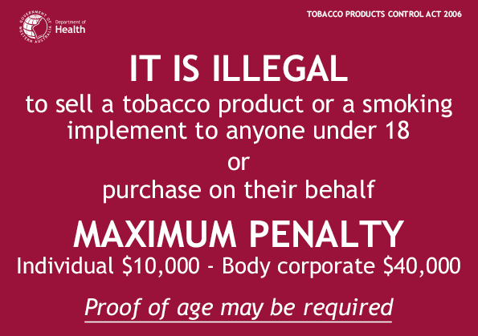
[Schedule 1 inserted: Gazette 28 Feb 2007 p. 673.]

Schedule 2 — Health warning signs for general display or vending machines
[r. 51(1)(b)]
[Heading inserted: Gazette 12 Mar 2019 p. 662.]
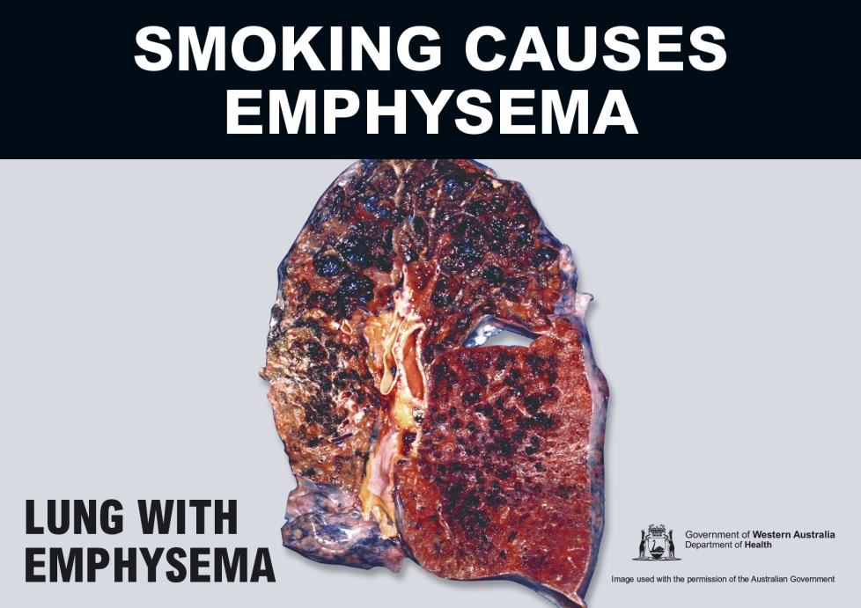
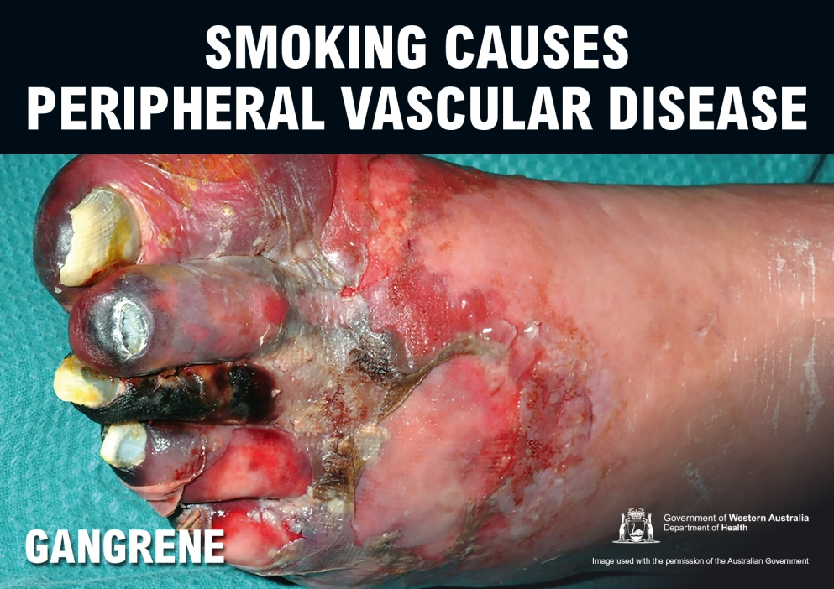
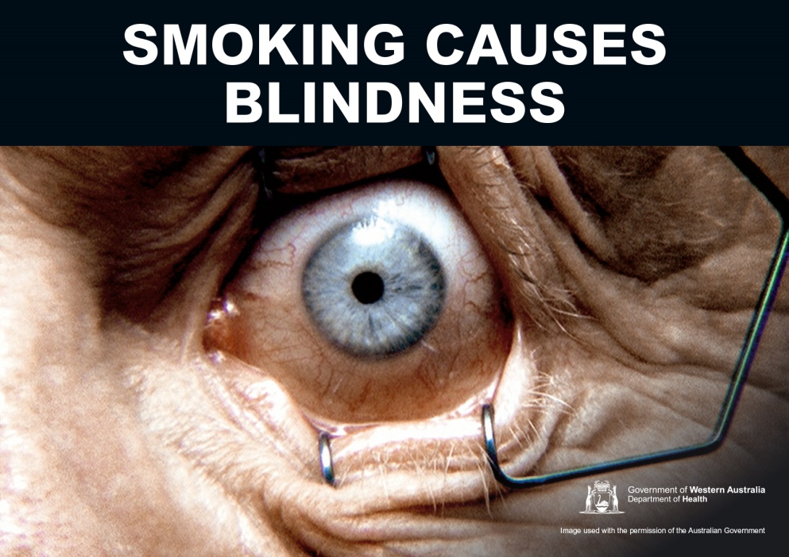
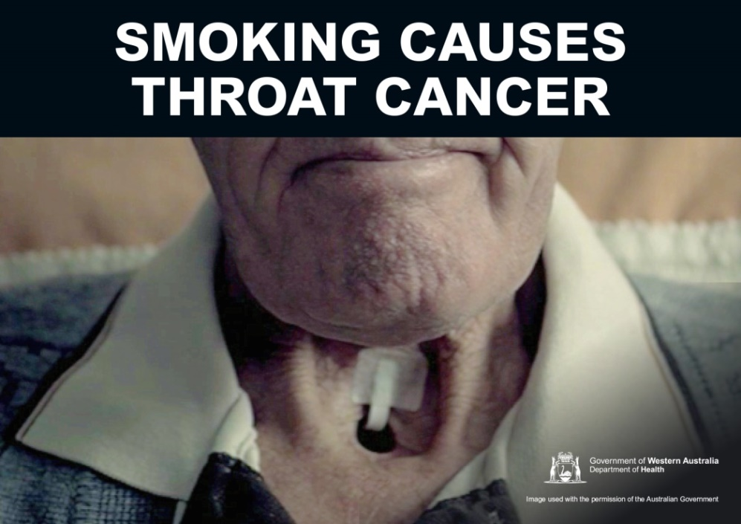 [Schedule 2 inserted: Gazette 12 Mar 2019 p. 662-3.]

Schedule 3 — Health warning signs for display of cigars or cigar cutting implements
[r. 51(1A)(b) and (2)(b)]
[Heading inserted: Gazette 12 Mar 2019 p. 664.]
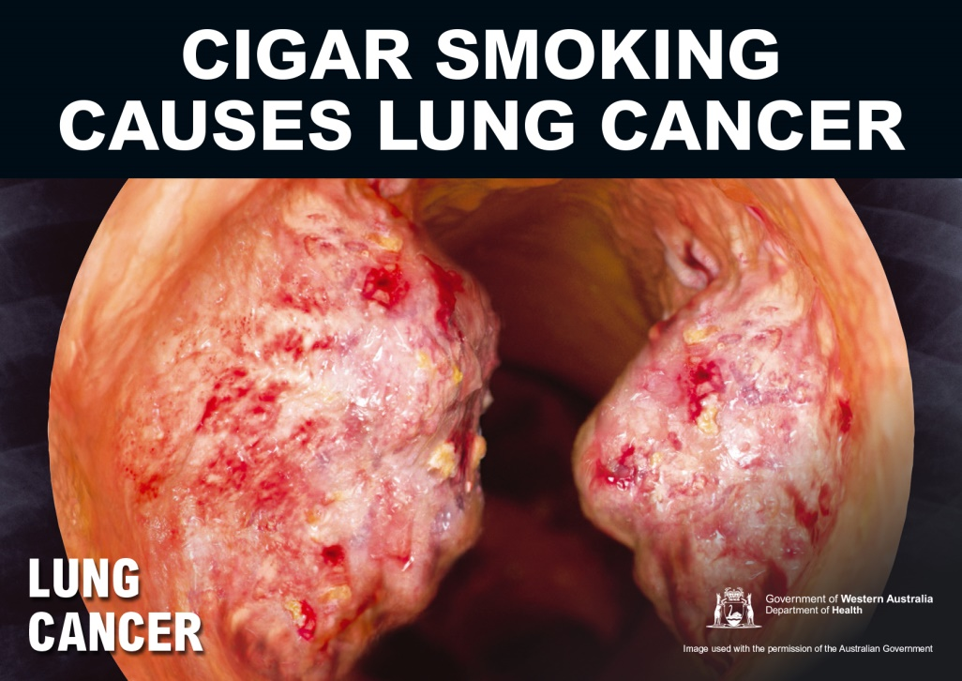
[Schedule 3 inserted: Gazette 12 Mar 2019 p. 664.]

Schedule 4 — Prescribed offences and modified penalties
[r. 60]
[Heading inserted: SL 2026/59 r. 19.]
Offences under Tobacco and Other Products Control Act 2006 | Modified penalty — individual  $ | Modified penalty — body corporate  $
s. 6 | 1 000 | 2 000
s. 7 | 1 000 | 2 000
s. 8(1) | 4 000 | 20 000
s. 8(2) | 4 000 | 20 000
s. 9 | 4 000 | 20 000
s. 10 | 4 000 | 20 000
s. 11 | 4 000 | 20 000
s. 15(2) | 100 | -
s. 18A | 4 000 | 20 000
s. 19(1) | 4 000 | 20 000
s. 19A | 4 000 | 20 000
s. 20(1) | 4 000 | 20 000
s. 22(1) | 8 000 | 40 000
s. 24(1) | 1 000 | 2 000
s. 24(2) | 1 000 | 2 000
s. 25(1) | 1 000 | 2 000
s. 25(2) | 1 000 | 2 000
s. 25(3) | 1 000 | 2 000
s. 25(4) | 1 000 | 2 000
s. 26(2) | 1 000 | 2 000
s. 26(3) | 1 000 | 2 000
s. 27(1) | 4 000 | 20 000
s. 27(2) | 4 000 | 20 000
s. 28(2) | 4 000 | 20 000
s. 28(3) | 4 000 | 20 000
s. 29 | 8 000 | 40 000
s. 31(1) | 8 000 | 40 000
s. 31(2) | 8 000 | 40 000
s. 31(3) | 8 000 | 40 000
s. 31(4) | 8 000 | 40 000
s. 33(1) | 8 000 | 40 000
s. 33A(1) | 8 000 | 40 000
s. 34 | 8 000 | 40 000
s. 35(2) | 8 000 | 40 000
s. 35(3) | 8 000 | 40 000
s. 50(5) | 1 000 | 2 000
s. 51 | 1 000 | 2 000
s. 52(1) | 1 000 | 2 000
s. 53 | 1 000 | 2 000
s. 54(1) | 1 000 | 2 000
s. 55(1) | 1 000 | 2 000
s. 55(2) | 1 000 | 2 000
s. 55(3) | 1 000 | 2 000
s. 56(1) | 1 000 | 2 000
s. 56(2) | 1 000 | 2 000
s. 57(3) | 4 000 | 20 000
s. 57(5) | 4 000 | 20 000
s. 58(1) | 1 000 | 2 000
s. 58(2) | 1 000 | 2 000
s. 90(1) | 4 000 | 20 000
s. 90(2) | 4 000 | 20 000
s. 100(2) | 100 | -
s. 103(1) | 4 000 | 20 000
s. 103(2) | 4 000 | 20 000
s. 104 | 4 000 | 20 000
s. 106 | 4 000 | 20 000
s. 107A | 500 | -
s. 107B(1) | 500 | -
s. 107B(2) | 500 | -
s. 107C | 500 | -
s. 107D(2) | 500 | -
s. 107F(2) | 4 000 | 20 000
s. 120F(2) | 4 000 | 20 000
s. 120F(3) | 8 000 | 40 000

Offences under Tobacco and Other Products Control Regulations 2006 | Modified penalty — individual  $ | Modified penalty — body corporate  $
r. 10(1) | 500 | -
r. 11(1) | 500 | 1 000
r. 12(1) | 500 | 1 000
r. 13 | 500 | 1 000
r. 13A(1) | 500 | -
r. 13A(2) | 500 | -
r. 15(3) | 500 | -
r. 16B(1) | 500 | 1 000
r. 16B(3) | 500 | 1 000
r. 16D(3) | 500 | -
r. 34(1) | 1 000 | 2 000
r. 34(2) | 1 000 | 2 000
r. 34(3) | 1 000 | 2 000
r. 34(4) | 1 000 | 2 000
r. 34(5) | 1 000 | 2 000
r. 36(1) | 1 000 | 2 000
r. 36(2) | 1 000 | 2 000
r. 36(3) | 1 000 | 2 000
r. 36(4) | 1 000 | 2 000
r. 36(5) | 1 000 | 2 000
r. 37 | 1 000 | 2 000
[Schedule 4 inserted: SL 2026/59 r. 19.]

Schedule 5 — Forms
[r. 62]
[Heading inserted: Gazette 10 Sep 2010 p. 4397.]
Form 1 — Infringement notice
Tobacco and Other Products Control Act 2006  Infringement notice |  | Infringement  notice no.
Alleged offender | Name: Family name
Alleged offender | Given names
Alleged offender | or Company name ______________________________________________  ACN
Alleged offender | Address ______________________________________________  Postcode
Alleged offence | Description of offence ______________________________________________
Alleged offence | Tobacco and Other Products Control Act 2006 s.  or  Tobacco and Other Products Control Regulations 2006 r.
Alleged offence | Date / /20 Time a.m./p.m.
Alleged offence | Modified penalty $
Officer issuing notice | Name
Officer issuing notice | Signature
Officer issuing notice | Office
Date | Date of notice / /20
Notice to alleged offender | It is alleged that you have committed the above offence.  If you do not want to be prosecuted in court for the offence, pay the modified penalty within 28 days after the date of this notice.  How to pay  [Insert details for paying]  If you do not pay the modified penalty within 28 days, you may be prosecuted or enforcement action may be taken under the Fines, Penalties and Infringement Notices Enforcement Act 1994. Under that Act, some or all of the following action may be taken — your driver’s licence may be suspended, your vehicle licence may be suspended or cancelled, you may be disqualified from holding or obtaining a driver’s licence or vehicle licence, your vehicle may be immobilised or have its number plates removed, your details may be published on a website, your earnings or bank accounts may be garnished, and your property may be seized and sold.  If you need more time to pay the modified penalty, you can apply for an extension of time by writing to the Approved Officer at the above postal address.  If you want this matter to be dealt with by prosecution in court, sign here: _______________________________________  and post this notice to the Approved Officer at the above postal address within 28 days after the date of this notice.
[Form 1 inserted: Gazette 10 Sep 2010 p. 4397-9; amended: Gazette 20 Aug 2013 p. 3853; SL 2020/168 r. 10; SL 2025/105 r. 6; SL 2026/59 r. 20.]
Form 2 — Withdrawal of infringement notice
Tobacco and Other Products Control Act 2006  Withdrawal of infringement notice |  | Withdrawal no.
Alleged offender | Name: Family name
Alleged offender | Given names
Alleged offender | or Company name ______________________________________________  ACN
Alleged offender | Address ______________________________________________  Postcode
Infringement notice | Infringement notice no.
Infringement notice | Date of issue / /20
Alleged offence | Description of offence ______________________________________________
Alleged offence | Tobacco and Other Products Control Act 2006 s.  or  Tobacco and Other Products Control Regulations 2006 r.
Alleged offence | Date / /20 Time a.m./p.m.
Officer withdrawing notice | Name
Officer withdrawing notice | Signature
Officer withdrawing notice | Office
Date | Date of withdrawal / /20
Withdrawal of infringement notice  [*delete  whichever  is not applicable] | The above infringement notice issued against you has been withdrawn.  If you have already paid the modified penalty for the alleged offence you are entitled to a refund.  * Your refund is enclosed.  or  * If you have paid the modified penalty but a refund is not enclosed, to claim your refund sign this notice and post it to:  Approved Officer — Tobacco and Other Products Control Act 2006  [Relevant authority and address]  Signature / /20
[Form 2 inserted: Gazette 10 Sep 2010 p. 4399-400; amended: SL 2026/59 r. 20.]

Notes
This is a compilation of the Tobacco and Other Products Control Regulations 2006 and includes amendments made by other written laws. For provisions that have come into operation, and for information about any reprints, see the compilation table.

Compilation table
Citation | Published | Commencement
Tobacco Products Control Regulations 2006 ¹ | 25 Jul 2006 p. 2797-808 | 31 Jul 2006 (see r. 2)
Tobacco Products Control Amendment Regulations 2007 | 28 Feb 2007 p. 641-75 | 28 Feb 2007 (see r. 2)
Tobacco Products Control Amendment Regulations 2010 | 20 Aug 2010 p. 4069-70 | r. 1 and 2: 20 Aug 2010 (see r. 2(a));  Regulations other than r. 1 and 2: 1 Sep 2010 (see r. 2(b))
Tobacco Products Control Amendment Regulations (No. 2) 2010 | 10 Sep 2010 p. 4375-400 | r. 1 and 2: 10 Sep 2010 (see r. 2(a));  Regulations other than r. 1, 2 and 26: 22 Sep 2010 (see r. 2(c));  r. 26: 22 Sep 2011 (see r. 2(b))
Reprint 1: The Tobacco Products Control Regulations 2006 as at 7 Jan 2011 (includes amendments listed above)
Tobacco Products Control Amendment Regulations 2011 | 1 Mar 2011 p. 676-7 | r. 1 and 2: 1 Mar 2011 (see r. 2(a));  Regulations other than r. 1 and 2: 2 Mar 2011 (see r. 2(b))
Tobacco Products Control Amendment Regulations 2012 | 18 May 2012 p. 2141 | r. 1 and 2: 18 May 2012 (see r. 2(a));  Regulations other than r. 1 and 2: 19 May 2012 (see r. 2(b))
Tobacco Products Control Amendment Regulations (No. 2) 2012 | 27 Nov 2012 p. 5734-5 | 27 Nov 2012 (see note under r. 1)
Tobacco Products Control Amendment Regulations 2013 | 20 Aug 2013 p. 3853 | r. 1 and 2: 20 Aug 2013 (see r. 2(a));  Regulations other than r. 1 and 2: 21 Aug 2013 (see r. 2(b) and Gazette 20 Aug 2013 p. 3815)
Tobacco Products Control Amendment Regulations (No. 3) 2014 | 20 Jun 2014 p. 2025 | r. 1 and 2: 20 Jun 2014 (see r. 2(a));  Regulations other than r. 1 and 2: 21 Jun 2014 (see r. 2(b))
Tobacco Products Control Amendment Regulations 2014 | 27 Jun 2014 p. 2331 | r. 1 and 2: 27 Jun 2014 (see r. 2(a));  Regulations other than r. 1 and 2: 1 Jul 2014 (see r. 2(b)(i) and Gazette 17 Jun 2014 p. 1955)
Reprint 2: The Tobacco Products Control Regulations 2006 as at 21 Nov 2014 (includes amendments listed above)
Tobacco Products Control Amendment Regulations (No. 4) 2014 | 12 Dec 2014 p. 4715-16 | r. 1 and 2: 12 Dec 2014 (see r. 2(a));  Regulations other than r. 1 and 2: 13 Dec 2014 (see r. 2(b))
Tobacco Products Control Amendment Regulations 2015 | 10 Feb 2015 p. 625 | r. 1 and 2: 10 Feb 2015 (see r. 2(a));  Regulations other than r. 1 and 2: 27 Apr 2015 (see r. 2(b) and Gazette 17 Apr 2015 p. 1371)
Tobacco Products Control Amendment Regulations (No. 3) 2015 | 19 May 2015 p. 1757-8 | r. 1 and 2: 19 May 2015 (see r. 2(a));  Regulations other than r. 1 and 2: 1 Jul 2015 (see r. 2(b))
Tobacco Products Control Amendment Regulations (No. 4) 2015 | 25 Aug 2015 p. 3379-80 | r. 1 and 2: 25 Aug 2015 (see r. 2(a));  Regulations other than r. 1 and 2: 26 Aug 2015 (see r. 2(b))
Tobacco Products Control Amendment Regulations (No. 2) 2016 | 6 May 2016 p. 1382-3 | r. 1 and 2: 6 May 2016 (see r. 2(a));  Regulations other than r. 1 and 2: 7 May 2016 (see r. 2(b))
Health Regulations Amendment (Fees and Charges) Regulations 2016 Pt. 8 | 17 Jun 2016 p. 2101-5 | 1 Jul 2016 (see r. 2(b))
Tobacco Products Control Amendment Regulations (No. 3) 2016 | 26 Jul 2016 p. 3150 | r. 1 and 2: 26 Jul 2016 (see r. 2(a));  Regulations other than r. 1 and 2: 1 Sep 2016 (see r. 2(b) and Gazette 26 Jul 2016 p. 3145)
Health Regulations Amendment (Public Health) Regulations 2016 Pt. 34 | 10 Jan 2017 p. 237-308 | 24 Jan 2017 (see r. 2(b) and Gazette 10 Jan 2017 p. 165)
Health Regulations Amendment (Fees and Charges) Regulations 2017 Pt. 11 | 30 Jun 2017 p. 3568-74 | 1 Jul 2017 (see r. 2(b))
Reprint 3: The Tobacco Products Control Regulations 2006 as at 13 Oct 2017 (includes amendments listed above)
Tobacco Products Control Amendment Regulations 2019 | 12 Mar 2019 p. 657-665 | r. 1 and 2: 12 Mar 2019 (see r. 2(a));  r. 3-15, 16(2)-(5) and 17: 18 Mar 2019 (see r. 2(c));  r. 16(1): 18 Sep 2020 (see r. 2(b))
Health Regulations Amendment (Fees and Charges) Regulations 2019 Pt. 11 | 14 Jun 2019 p. 1883-94 | 1 Jul 2019 (see r. 2(b))
Health Regulations Amendment (Fees and Charges) Regulations 2020 Pt. 8 | SL 2020/97 26 Jun 2020 | 1 Jul 2020 (see r. 2(b))
Health Regulations Amendment (Infringement Notices) Regulations 2020 Pt. 5 | SL 2020/168 25 Sep 2020 | 29 Sep 2020 (see r. 2(b) and SL 2020/159 cl. 2(a))
Health Regulations Amendment (Fees and Charges) Regulations 2021 Pt. 8 | SL 2021/108 29 Jun 2021 | 1 Jul 2021 (see r. 2(b))
Tobacco Products Control Amendment Regulations 2021 | SL 2021/212 17 Dec 2021 | r. 1 and 2: 17 Dec 2021 (see r. 2(a));  Regulations other than r. 1 and 2: 31 Dec 2021 (see r. 2(b))
Health Regulations Amendment (Fees and Charges) Regulations 2022 Pt. 11 | SL 2022/136 15 Jul 2022 | 16 Jul 2022 (see r. 2(b))
Health Regulations Amendment (Fees and Charges) Regulations 2023 Pt. 11 | SL 2023/96 30 Jun 2023 | 1 Jul 2023 (see r. 2(b))
Health Regulations Amendment (Fees and Charges) Regulations 2024 Pt. 11 | SL 2024/91 12 Jun 2024 | 1 Jul 2024 (see r. 2(b))
Health Regulations Amendment (Fees and Charges) Regulations 2025 Pt. 11 | SL 2025/104 25 Jun 2025 | 1 Jul 2025 (see r. 2(b))
Tobacco Products Control Amendment Regulations 2025 | SL 2025/105 25 Jun 2025 | r. 1 and 2: 25 Jun 2025 (see r. 2(a));  Regulations other than r. 1, 2 and 5: 26 Jun 2025 (see r. 2(c));  r. 5: 1 Jul 2025 (see r. 2(b))
Tobacco Products Control Amendment Regulations 2026 | SL 2026/59 12 May 2026 | 13 May 2026 (see r. 2)
Health Regulations Amendment (Fees and Charges) Regulations 2026 Pt. 12 | SL 2026/121 24 Jun 2026 | 1 Jul 2026 (see r. 2(b))

Other notes
¹ Now known as the Tobacco and Other Products Control Regulations 2006; citation changed (see note under r. 1).

Defined terms

[This is a list of terms defined and the provisions where they are defined. The list is not part of the law.]
Defined term Provision(s)
adequate ventilation 7
appropriate licence 57A
appropriate permit 57A
approved Quitline logo 30
BNR Act 3
Business Names Register 3
cigar cabinet 30
Commonwealth agency 58(1)
counter 30
dispensing unit 30
enclosed public place 7
humidified room 30
liquor licensed premises 3
loose tobacco 3
non-smoking zone 16A
patient 57C
premises 57F
prescriber 57A
price ticket 30
professional authority 57A
reasonable excuse 57I(1) and (2)
representative 3
retailer 30
retail premises 30
roof 7
sales place 30
section 3
snuff 57(1)
specialist retailer 3
wall 3
within the prohibited distance 15(1B)

© State of Western Australia 2026.
This work is licensed under a Creative Commons Attribution 4.0 International Licence (CC BY 4.0). To view relevant information and for a link to a copy of the licence, visit www.legislation.wa.gov.au.
Attribute work as: © State of Western Australia 2026.
By Authority: ANDREW JONES, Government Printer

