
Western Australia
Health (Miscellaneous Provisions) Act 1911

Health (Notifications by Midwives) Amendment Regulations 2026

Western Australia
Health (Notifications by Midwives) Amendment Regulations 2026
Contents
1. Citation 1
2. Commencement 1
3. Regulations amended 1
4. Regulation 4 amended 1
5. Schedule amended 1

Health (Miscellaneous Provisions) Act 1911
Health (Notifications by Midwives) Amendment Regulations 2026
Made by the Governor in Executive Council.

1. Citation
These regulations are the Health (Notifications by Midwives) Amendment Regulations 2026.

2. Commencement
These regulations come into operation as follows —
(a) regulations 1 and 2 — on the day on which these regulations are published on the WA legislation website;
(b) the rest of the regulations — on the day after that day.

3. Regulations amended
These regulations amend the Health (Notifications by Midwives) Regulations 1994.

4. Regulation 4 amended
In regulation 4 delete “is to” and insert:

must

5. Schedule amended
In the Schedule delete Form 2 and insert:

Form 2
[r. 4]
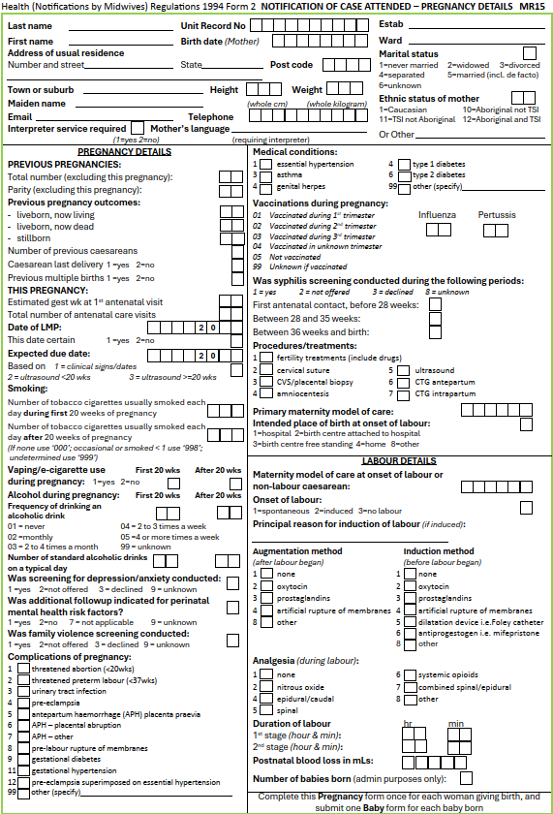

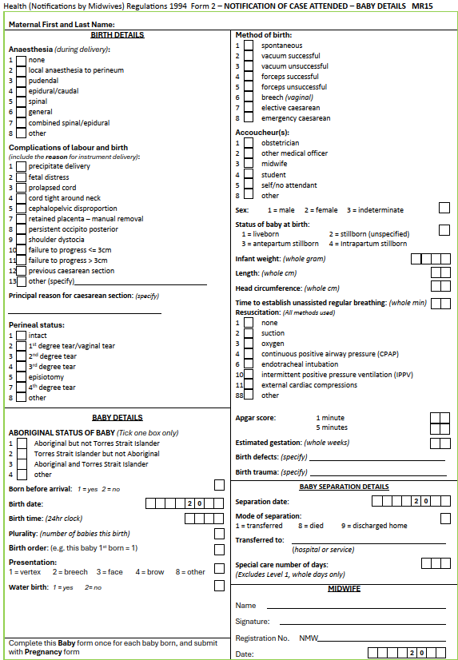

BRENDAN D’SA, Clerk of the Executive Council
© State of Western Australia 2026.
This work is licensed under a Creative Commons Attribution 4.0 International Licence (CC BY 4.0). To view relevant information and for a link to a copy of the licence, visit www.legislation.wa.gov.au.
Attribute work as: © State of Western Australia 2026.
By Authority: ANDREW JONES, Government Printer

