
Western Australia
Environmental Protection Act 1986

Environmental Protection (Darling Range Bauxite Mining Proposal) Exemption Order 2026

Western Australia
Environmental Protection (Darling Range Bauxite Mining Proposal) Exemption Order 2026
Contents
1. Citation 1
2. Commencement 1
3. Terms used 1
4. Declaration of exemption from Act s. 41 2
5. Declaration of exemption from Act s. 41A 2
6. Revocation and repeal 3
Schedule 1 — Conditions to which exemption from Act s. 41A is subject
Division 1 — Preliminary
1. Terms used 4
Division 2 — Controls on activities
2. Limitations and maximum extent 10
3. Prohibited activities 11
4. Restricted activities 11
5. Activities requiring drainage control and stabilisation 12
6. Drainage incidents 14
7. Activities requiring protective measures for particular trees 15
Division 3 — Compliance
8. Term used: compliance 16
9. Appointment of compliance monitor 16
10. Compliance assessment plan 17
11. Reports by Alcoa 19
12. Reports by compliance monitor 19
Division 4 — Miscellaneous
13. Provision of information 20
14. Publication of information 21
15. CEO may authorise people to perform functions 22
Division 5 — Transitional clauses
16. Terms used 22
17. Amount of bauxite and number of drill holes for post-commencement period of commencement year 22
18. Existing drainage control and stabilisation obligations: cl. 4(2) area 23
19. Existing drainage control and stabilisation obligations: cl. 5(3) area 24
20. Existing drainage incident obligations 24
21. Substantive mining activities started in protection area 25
22. Compliance with protective measures for particular trees for existing mining activities 26
23. Reports for calendar month before commencement 27
24. Reports for calendar month of commencement 28
25. Existing publication obligations 29
Defined terms

Environmental Protection Act 1986
Environmental Protection (Darling Range Bauxite Mining Proposal) Exemption Order 2026
Made by the Minister with the approval of the deputy of the Governor under section 6 of the Act.

1. Citation
This order is the Environmental Protection (Darling Range Bauxite Mining Proposal) Exemption Order 2026.

2. Commencement
This order comes into operation as follows —
(a) clauses 1 and 2 — on the day on which this order is published on the WA legislation website;
(b) the rest of the order — on the day after that day.

3. Terms used
(1) In this order —
Act means the Environmental Protection Act 1986;
Alcoa means Alcoa of Australia Limited ACN 004 879 298;
Darling Range bauxite mining proposal means the Bauxite mining on the Darling Range in the southwest of WA for the years 2023 to 2027 proposal of 27 February 2023 —
(a) referred to the Authority under section 38 of the Act; and
(b) as amended on —
(i) 13 May 2025 (including to incorporate the Bauxite mining on the Darling Range in the southwest of WA for the years 2022 to 2026 proposal of 27 February 2023 referred to the Authority under section 38 of the Act); and
(ii) 13 April 2026;
and
(c) being assessed by the Authority under assessment number 2385;
relevant DMA means a decision-making authority that is given notice under section 38G(1)(b)(iii) or (5) of the Act that the Darling Range bauxite mining proposal is going to be assessed.
(2) Unless the contrary intention appears, terms used in this order that are defined in the Act have the same meaning in this order as they have in the Act.

4. Declaration of exemption from Act s. 41
(1) Section 41 of the Act does not apply in respect of a restricted decision by a relevant DMA relating to the Darling Range bauxite mining proposal.
(2) The declaration under subclause (1) has effect for the period —
(a) beginning on the day on which this clause comes into operation; and
(b) ending at the end of 31 December 2027.

5. Declaration of exemption from Act s. 41A
(1) Subject to the conditions specified in Schedule 1, section 41A of the Act does not apply in respect of anything a person does to implement the Darling Range bauxite mining proposal.
(2) The declaration under subclause (1) has effect for the period —
(a) beginning on the day on which this clause comes into operation; and
(b) ending at the end of 31 December 2027.

6. Revocation and repeal
The declarations made under section 6 of the Act by the Environmental Protection (Darling Range Bauxite Mining Proposals) Exemption Order 2023 are revoked and that order is repealed.
Note for this clause:
Under clause 2(b), this clause comes into operation on the same day as clauses 3 to 5 and Schedule 1.

Schedule 1 — Conditions to which exemption from Act s. 41A is subject
[cl. 5]

Division 1 — Preliminary

1. Terms used
(1) In this Schedule —
appropriately qualified, in relation to a person, means —
(a) the person —
(i) holds a tertiary qualification specialising in environmental science or an equivalent discipline; and
(ii) has at least 2 years of professional experience in the identification and surveying of fauna native to the Darling Range;
or
(b) the person has at least 7 years of professional experience in the identification and surveying of fauna native to the Darling Range;
associates, in relation to Alcoa, includes —
(a) contractors and subcontractors engaged in connection with the implementation of the Darling Range bauxite mining proposal; and
(b) any person acting in partnership with, in concert with or on behalf of Alcoa in the implementation of the Darling Range bauxite mining proposal;
black cockatoo nesting tree means a tree that —
(a) contains 1 or more hollows; and
(b) has been identified by an independent fauna specialist as a tree that —
(i) appears to be, or has been, used as a black cockatoo breeding habitat; or
(ii) contains 1 or more hollows conducive to being used as a black cockatoo breeding habitat;
calendar month means a period starting at the beginning of the 1st day of any of the 12 named months and ending immediately before the beginning of the 1st day of the next named month;
clause means a clause of this Schedule, unless a clause of this order is specified;
commencement day means the day on which clause 5 of this order comes into operation;
compliance assessment plan means the plan required by clause 10(1);
compliance monitor means the person or body for the time being appointed and retained under clause 9(2);
disturb —
(a) in relation to fauna, means the following —
(i) to chase, drive, follow, harass, herd or hunt fauna by any means;
(ii) to apply an identifier to fauna by any means;
(iii) to engage in an activity that has the effect, whether directly or indirectly, of altering the natural behaviour of fauna to its detriment;
(iv) to cause or permit anything referred to in subparagraph (i), (ii) or (iii) to be done;
and
(b) in relation to native vegetation and other flora, means the following —
(i) clearing;
(ii) to engage in another activity that has the effect, whether directly or indirectly, of altering the long-term persistence of the flora in its habitat;
(iii) to cause or permit an activity referred to in subparagraph (i) or (ii) to be engaged in;
and
(c) in relation to land, means the following —
(i) to disturb fauna or flora for which the land is a habitat;
(ii) to work the land, or to alter the surface or the subsoil of the land, in a way that renders it unsuitable or less suitable as a habitat for fauna or flora for which it is or was formerly a habitat;
(iii) to cause or permit an activity referred to in subparagraph (i) or (ii) to be engaged in;
disturbance area means an area of land —
(a) on which mining activities associated with the implementation of the Darling Range bauxite mining proposal are being carried out; or
(b) that has been disturbed by an activity mentioned in paragraph (a);
drainage control means measures to manage surface water run-off from a disturbance area to the surrounding environment;
exploration means activities carried out in search of minerals, including (without limitation) —
(a) mapping; and
(b) surveying; and
(c) drilling; and
(d) the collection and assaying of soil, rock, groundwater and mineral samples; and
(e) other activities involving the application of 1 or more of the geological sciences;
figure means a map or plan —
(a) that was prepared by the Department —
(i) in relation to Figure 1 — on 7 May 2026; or
(ii) otherwise — on 7 December 2023;
and
(b) that is held by the CEO and is available for inspection at the head office of the Department during business hours; and
(c) a copy of which is annexed to this Schedule for indicative purposes;
Figure 1 means the figure entitled “Figure 1 — Darling Range exploration disturbance footprint”;
Figure 2 means the figure entitled “Figure 2 — Huntly Mine disturbance footprint”;
Figure 3 means the figure entitled “Figure 3 — Huntly Mine native vegetation disturbance footprint”;
Figure 4 means the figure entitled “Figure 4 — Willowdale Mine disturbance footprint”;
Figure 5 means the figure entitled “Figure 5 — Forest clearing advice area”;
Huntly Mine black cockatoo significant tree means —
(a) a jarrah tree with a diameter of not less than 2 000 mm at a height of 1 300 mm above ground level, measured in accordance with the methodology set out in parts 5.1 and 5.2 of the measurement manual; or
(b) a marri tree with a diameter of not less than 1 500 mm at a height of 1 300 mm above ground level, measured in accordance with the methodology set out in parts 5.1 and 5.2 of the measurement manual;
Huntly Mine disturbance footprint has the meaning given in clause 2(1);
independent fauna specialist means a person who —
(a) is appropriately qualified; and
(b) is not —
(i) an employee of Alcoa or its associates; or
(ii) an agent, contractor or subcontractor of Alcoa or its associates (other than as a result of a contract related to identifying black cockatoo nesting trees or Huntly Mine black cockatoo significant trees for the purposes of this Schedule);
and
(c) does not hold any other position over which Alcoa or its associates may exercise control or significant influence over the person’s conduct;
landscaping means the moving or shaping of land, including but not limited to —
(a) re-sloping or altering disturbed surface topography for the purpose of shaping the landform to blend with the adjacent landscape surface; and
(b) the movement, placement or removal of bauxite or other material; and
(c) ripping for the purpose of shaping the landform to blend with the surrounding environment;
measurement manual means the “Tree measurement manual for farm foresters”, 2nd edition, published by the Australian Government Department of Agriculture, Fisheries and Forestry, 2003;
mining activities means —
(a) extraction and processing of bauxite from mineral reserves below the surface of the earth, including but not limited to —
(i) the removal of topsoil and overburden; and
(ii) blasting, ripping or otherwise breaking caprock to expose bauxite; and
(iii) the removal of bauxite; and
(iv) the crushing of bauxite; and
(v) the transport of bauxite to a refinery;
and
(b) activities that are preparatory to, incidental to or consequential upon extraction and processing of bauxite, including but not limited to —
(i) exploration; and
(ii) land clearing; and
(iii) the construction or maintenance of mining infrastructure; and
(iv) rehabilitation;
mining infrastructure means any structures that enable or support mining activities, including but not limited to —
(a) stockpiles; and
(b) haul roads; and
(c) conveyors; and
(d) crushers; and
(e) structures for water storage; and
(f) water pumps;
prohibited zone has the meaning given in the Metropolitan Water Supply, Sewerage and Drainage By-laws 1981 by-law 4.2.2.2;
protection area has the meaning given in clause 4(2)(d);
rehabilitation, in relation to an area that has been disturbed, includes —
(a) stabilisation of the area; and
(b) restoration of the landforms of the area to a state that is as close as practicable to their original undisturbed state; and
(c) the return of the native vegetation of the area to a state that is as close as practicable to its original undisturbed state;
stabilise, in relation to an area that has been disturbed, means carry out landscaping, ripping and other appropriate operations to prevent erosion of sediment, promote infiltration and manage surface water run-off;
State Development Minister means the Minister to whom the administration of the Alumina Refinery Agreements (Alcoa) Amendment Act 1987 is committed.
(2) In relation to a function of the CEO under this Schedule, a reference to the CEO includes a reference to an officer or member of staff of the Department authorised under clause 15 to perform that function.

Division 2 — Controls on activities

2. Limitations and maximum extent
(1) In this clause —
Darling Range exploration disturbance footprint means the areas measuring in aggregate 129 246 ha that are shaded in blue and outlined in black on Figure 1;
Huntly Mine disturbance footprint means the areas measuring in aggregate 39 047 ha that are shaded in red and outlined in black on Figure 2;
Huntly Mine native vegetation disturbance footprint means the areas measuring in aggregate 3 538 ha that are shaded in green on Figure 3;
Willowdale Mine disturbance footprint means the areas measuring in aggregate 2 136 ha that are shaded in orange and outlined in black on Figure 4.
(2) Mining activities associated with the Huntly Mine —
(a) must not disturb land outside the Huntly Mine disturbance footprint; and
(b) must not disturb native vegetation outside the Huntly Mine native vegetation disturbance footprint.
(3) Mining activities associated with the Willowdale Mine —
(a) must not disturb land outside the Willowdale Mine disturbance footprint; and
(b) must not disturb native vegetation.
(4) Exploration activities associated with the implementation of the Darling Range bauxite mining proposal must not disturb land outside the Darling Range exploration disturbance footprint.
(5) The amount of bauxite extracted, conveyed, crushed or otherwise processed in the implementation of the Darling Range bauxite mining proposal must not exceed 38 megatonnes (wet) in any calendar year.
(6) In carrying out exploration activities in the implementation of the Darling Range bauxite mining proposal Alcoa and its associates must not bore more than 105 000 drill holes in any calendar year.

3. Prohibited activities
(1) In this clause —
forest clearing advice area means an area shaded in yellow on Figure 5.
(2) In implementing the Darling Range bauxite mining proposal, Alcoa and its associates must not engage in clearing or other activities likely to disturb a forest clearing advice area.
(3) Subclause (2) does not apply to —
(a) rehabilitation; or
(b) monitoring activities implemented in accordance with Division 3.

4. Restricted activities
(1) In this clause —
top water level margin, in relation to a water reservoir, means the margin of the surface of the water in the reservoir when the level of water in the reservoir is at the point above which water will spill;
water reservoir means a dam, weir or reservoir for the storage of water for a potable water supply service.
(2) In implementing the Darling Range bauxite mining proposal, Alcoa and its associates must not undertake any mining activities —
(a) before 1 December 2026 —
(i) within 1 km of the top water level margin of any water reservoir; or
(ii) in any area that is within the prohibited zone associated with any water reservoir and that has an average slope (based on the Landgate derived slope dataset) greater than 16%;
or
(b) on and after 1 December 2026 — within 2 km of the top water level margin of any water reservoir; or
(c) within the Serpentine Pipehead Dam Catchment Area (constituted under the Metropolitan Water Supply, Sewerage, and Drainage Act 1909 section 13(a) by a proclamation of 9 November 1982 published in the Gazette on 3 December 1982 at p. 4678); or
(d) within an area (the protection area) that is within 50 metres of a black cockatoo nesting tree or a Huntly Mine black cockatoo significant tree, as measured from the circumference of the base of the trunk of the tree at ground level.
(3) Subclause (2) does not apply to —
(a) rehabilitation; or
(b) monitoring activities implemented in accordance with Division 3; or
(c) use and maintenance of existing mining infrastructure; or
(d) modification of existing road infrastructure; or
(e) construction of drainage control infrastructure.
(4) To avoid doubt, mining activities are not undertaken within the protection area of a black cockatoo nesting tree or a Huntly Mine black cockatoo significant tree for the purposes of subclause (2)(d) merely because erosion occurs within the protection area as a direct or indirect result of mining activities undertaken outside of the protection area.

5. Activities requiring drainage control and stabilisation
(1) In this clause —
stabilisation date —
(a) in relation to an activity, means the earlier of —
(i) 12 months after the day on which the activity ceases; and
(ii) the first 30 April falling more than 6 calendar months after the day on which the activity ceases;
or
(b) in relation to mining activities, means the earlier of —
(i) 12 months after the day on which the activities cease; and
(ii) the first 30 April falling more than 6 calendar months after the day on which the activities cease;
top water level margin, in relation to a water reservoir, has the meaning given in clause 4(1);
water reservoir has the meaning given in clause 4(1).
(2) If, in implementing the Darling Range bauxite mining proposal, an activity mentioned in clause 4(3) is undertaken in an area in which Alcoa and its associates are prohibited from undertaking mining activities under clause 4(2), then, after the activity has ceased, Alcoa must —
(a) implement drainage control until the area affected by the activity is stabilised; and
(b) as soon as practicable, but in any event not later than the stabilisation date for the activity, stabilise the area; and
(c) as soon as practicable, complete the rehabilitation of the area.
(3) The obligations under subclause (2) apply to an activity referred to in the subclause that ceases on or after commencement day, whether the activity started before, on or after commencement day.
(4) Subclause (5) applies if, in implementing the Darling Range bauxite mining proposal, any mining activities are undertaken —
(a) within 1.5 km of the peak of Mount Solus; or
(b) before 1 December 2026 — within 2 km of the top water level margin of any water reservoir.
(5) After the mining activities have ceased, Alcoa must —
(a) as soon as practicable, but in any event not later than the stabilisation date for the mining activities, either —
(i) commence stabilising the area affected by the mining activities; or
(ii) implement drainage control until the area is stabilised;
and
(b) not later than 24 months after the mining activities have ceased, stabilise the area.
(6) The obligations under subclause (5) apply to mining activities referred to in the subclause that cease on or after commencement day, whether the mining activities started before, on or after commencement day.

6. Drainage incidents
(1) In this clause —
containment infrastructure means a basin, pond, sump, culvert or other structure on, or associated with, a disturbance area that —
(a) is designed or intended to contain liquids and sediment that may include environmentally hazardous material; and
(b) is used —
(i) to capture and temporarily store flood water to prevent excessive run-off and channel erosion in receiving environments; and
(ii) to remove particulate-based contaminants and sediment;
drainage incident means —
(a) a run-off from a disturbance area to the surrounding environment of surface water that has a turbidity of at least 25 nephelometric turbidity units for a period of at least 1 hour; or
(b) a discharge from containment infrastructure that includes or may include environmentally hazardous material;
environmentally hazardous material means material which by its characteristics poses a threat or risk to public health, safety or the environment, including but not limited to material that is —
(a) toxic; or
(b) infectious; or
(c) mutagenic; or
(d) carcinogenic; or
(e) teratogenic; or
(f) explosive; or
(g) flammable; or
(h) corrosive; or
(i) oxidising; or
(j) radioactive.
(2) On becoming aware of a drainage incident arising from or associated with the implementation of the Darling Range bauxite mining proposal, Alcoa must —
(a) report the incident to the CEO within 24 hours; and
(b) investigate —
(i) the cause of the incident; and
(ii) the environmental impacts of the incident;
and
(c) within 21 days, advise the CEO of —
(i) the outcome of investigations made under paragraph (b); and
(ii) the measures that have been, are being or will be implemented to rectify the incident; and
(iii) other measures that have been, are being or will be implemented to avoid or minimise the environmental impact of the incident.

7. Activities requiring protective measures for particular trees
(1) Alcoa must, before it or its associates undertake any mining activities in an area in implementing the Darling Range bauxite mining proposal, ensure that an independent fauna specialist undertakes a survey of the following areas to identify any black cockatoo nesting trees and Huntly Mine black cockatoo significant trees located within the areas —
(a) the area (the proposed area) in which mining activities are to be undertaken;
(b) the area that is within 50 metres of the proposed area, as measured from the boundary of the proposed area.
(2) For each black cockatoo nesting tree and Huntly Mine black cockatoo significant tree identified under subclause (1), Alcoa must ensure that —
(a) at least 14 days before Alcoa or its associates undertake any mining activities in the proposed area, the GPS location of the tree is recorded and provided to the CEO; and
(b) before Alcoa or its associates undertake any mining activities in the proposed area and until the mining activities in the area are completed —
(i) the tree is tagged with a clear visual marker that identifies the tree as a black cockatoo nesting tree or a Huntly Mine black cockatoo significant tree, or both; and
(ii) the protection area for the tree is clearly demarcated around the tree through fencing or other similar methods.

Division 3 — Compliance

8. Term used: compliance
In this Division —
compliance means compliance by Alcoa and its associates with the requirements of Division 2.

9. Appointment of compliance monitor
(1) In this clause —
independent qualified expert means a person or body —
(a) that is not owned or controlled by Alcoa or its associates; and
(b) that has appropriate expertise and experience to monitor and report on —
(i) the implementation of the Darling Range bauxite mining proposal; and
(ii) compliance.
(2) With the prior written approval of the Minister, Alcoa must appoint and retain an independent qualified expert —
(a) to undertake continuous monitoring, by means of inspections and measurements made not less frequently than weekly, of —
(i) the implementation of the Darling Range bauxite mining proposal; and
(ii) compliance;
and
(b) to make the reports required by clause 12.
(3) Alcoa must make the first appointment under subclause (2) not later than 60 days after commencement day.
(4) If an appointment made under subclause (2) terminates, Alcoa must —
(a) as soon as practicable, notify the CEO of the termination; and
(b) not later than 30 days after the termination, make a new appointment under subclause (2).
(5) An appointment of a compliance monitor made by Alcoa under Schedule 1 clause 8(2) of the 2023 order (as defined in clause 16) that was in effect immediately before commencement day is taken, for the purposes of the obligations under subclauses (2) and (3), to have been made on commencement day.

10. Compliance assessment plan
(1) Alcoa must —
(a) prepare a plan for assessing compliance; and
(b) not later than 60 days after commencement day, submit to the CEO —
(i) the plan; and
(ii) a statement in writing signed by or on behalf of the compliance monitor to the effect that, in the compliance monitor’s opinion, the plan will be sufficient, if implemented, to enable a failure in compliance to be detected and identified.
(2) The compliance assessment plan must —
(a) state the name, qualifications, address and other contact details of the compliance monitor; and
(b) include an up-to-date professional resume for each member of staff of the compliance monitor who will be engaged in monitoring the implementation of the Darling Range bauxite mining proposal or compliance; and
(c) state what information will be collected and recorded to assess compliance, and when and how the information will be collected; and
(d) state what methods the compliance monitor will use to assess compliance.
(3) Within 6 months after last submitting the compliance assessment plan, or a revised compliance assessment plan, to the CEO under this clause, Alcoa must —
(a) review the compliance assessment plan; and
(b) either —
(i) if no changes to the plan have been made as a result of the review — resubmit the plan to the CEO; or
(ii) if changes have been made to the plan as a result of the review — submit a revised compliance assessment plan to the CEO.
(4) Alcoa must also ensure that the compliance assessment plan is kept up-to-date by submitting to the CEO a revised compliance assessment plan whenever a change is made to —
(a) any of the particulars required by subclause (2) to be included in the plan; or
(b) any other particulars included in the plan.
(5) A plan submitted under subclause (3) or (4) must be accompanied by a new statement in the terms required by subclause (1)(b)(ii) relating to the plan.

11. Reports by Alcoa
(1) In respect of each calendar month, Alcoa must give to the CEO a report in writing that complies with subclause (2).
(2) The report must —
(a) specify the calendar month to which it relates; and
(b) set out the results of any monitoring (including raw monitoring data) undertaken by Alcoa during the specified month; and
(c) set out —
(i) the activities carried out to implement the Darling Range bauxite mining proposal during the specified month; and
(ii) the activities mentioned in clause 4(3), undertaken in an area in which Alcoa and its associates were prohibited from undertaking mining activities under clause 4(2), that have ceased during the specified month and the date on which each activity ceased; and
(iii) the activities proposed to be undertaken to implement the Darling Range bauxite mining proposal during the 2 calendar months following the specified month.
(3) Alcoa must give the report to the CEO not later than 15 days after the end of the specified month.

12. Reports by compliance monitor
(1) Alcoa must appoint the compliance monitor on terms that are effective to ensure that the compliance monitor gives reports as required by this clause.
(2) In respect of each calendar month after the first calendar month in which a compliance monitor is appointed under clause 9(2), the compliance monitor must give to the CEO a report in writing that complies with subclause (3).
(3) The compliance monitor’s report must —
(a) specify the calendar month to which it relates; and
(b) outline the activities undertaken by the compliance monitor during the specified month to assess compliance; and
(c) set out the results of any monitoring (including raw monitoring data) undertaken by the compliance monitor during the specified month; and
(d) say whether, in the compliance monitor’s opinion, the results of the monitoring, together with any additional information provided to the compliance monitor by Alcoa or its associates, is sufficient to enable the compliance monitor to detect and identify a failure in compliance; and
(e) in respect of each condition included in Division 2 —
(i) state the compliance monitor’s opinion as to the extent of compliance during the specified month; and
(ii) identify any incidents of failure of compliance occurring during the specified month that the compliance monitor has detected.
(4) The compliance monitor must give the report to the CEO not later than 15 days after the end of the specified month.

Division 4 — Miscellaneous

13. Provision of information
(1) Alcoa must give the Minister or the CEO information relating to the implementation of the Darling Range bauxite mining proposal as requested by the Minister or the CEO.
(2) A request for information under subclause (1) —
(a) must be in writing; and
(b) must specify the information that Alcoa must provide; and
(c) may specify the form in which Alcoa must provide the information; and
(d) may specify a date by which Alcoa must provide the information.

14. Publication of information
(1) In this clause —
mining and management programme means a mining and management programme submitted by Alcoa and agreed by the State Development Minister under commitment 2 of Schedule 2 to Ministerial Statement 728 published on 14 September 2006 under section 45 of the Act;
sensitive information means confidential information that has commercial value to a person that would be, or could reasonably be expected to be, destroyed or diminished if the confidential information were published.
(2) Subject to subclause (3), Alcoa must publish on its website each document or item of information listed in column 1 of the Table to this subclause at or within the time specified in relation to that document or item of information in column 2 of the Table to this subclause.
Table
Document or item of information | Time limit for publication
All geospatial data in the possession or procurement of Alcoa that is relevant to the conditions in Division 2 | Within 30 days after commencement day
A report given to the CEO under clause 11(1) | Within 60 days after the day by which the report is required under clause 11(3) to be given to the CEO
If the Minister gives Alcoa notice in writing under this subclause requiring publication of a report given to the CEO under clause 12(2) — the report | Within 7 days after the notice is given
If the State Development Minister gives Alcoa notice in writing under this subclause requiring publication of a mining and management programme — the mining and management programme | Within 7 days after the notice is given
(3) If a document or item of information required by subclause (2) to be published includes sensitive information, Alcoa may, with the approval in writing of the Minister, omit the sensitive information when publishing the document or item of information.

15. CEO may authorise people to perform functions
(1) The CEO may, by written instrument, authorise an officer or member of staff of the Department to perform all or any of the functions of the CEO under this Schedule, other than this power of authorisation.
(2) This clause does not limit the ability of the CEO to perform a function through an officer or agent.

Division 5 — Transitional clauses

16. Terms used
In this Division —
2023 order means the Environmental Protection (Darling Range Bauxite Mining Proposals) Exemption Order 2023;
sensitive information has the meaning given in clause 14(1).

17. Amount of bauxite and number of drill holes for post-commencement period of commencement year
(1) In this clause —
commencement year means the calendar year in which commencement day occurs;
post-commencement period means the period starting on commencement day and ending on 31 December of the commencement year;
pre-commencement period means the period starting on 1 January of the commencement year and ending immediately before commencement day.
(2) Subclause (3) states the amount of bauxite extracted, conveyed, crushed or otherwise processed in the implementation of the Darling Range bauxite mining proposal that must not be exceeded during the post-commencement period.
(3) The amount is the amount referred to in clause 2(5) less the amount of bauxite extracted, conveyed, crushed or otherwise processed in the implementation of the Darling Range bauxite mining proposal during the pre-commencement period.
(4) Subclause (5) states the maximum number of drill holes that Alcoa and its associates may bore in carrying out exploration activities in the implementation of the Darling Range bauxite mining proposal during the post-commencement period.
(5) The number is the number of drill holes referred to in clause 2(6) less the number of drill holes bored by Alcoa and its associates in carrying out exploration activities in the implementation of the Darling Range bauxite mining proposal during the pre-commencement period.

18. Existing drainage control and stabilisation obligations: cl. 4(2) area
(1) This clause applies if, in implementing the Darling Range bauxite mining proposal before commencement day —
(a) an activity mentioned in Schedule 1 clause 4(3) of the 2023 order was undertaken in an area mentioned in Schedule 1 clause 4(2)(a), (b), (c) or (d) of that order; and
(b) the activity ceased.
(2) Except to the extent that Alcoa performed the following obligations for the activity before commencement day, Alcoa must —
(a) implement drainage control until the area affected by the activity is stabilised; and
(b) as soon as practicable, but in any event not later than 9 months after commencement day, stabilise the area; and
(c) as soon as practicable, complete the rehabilitation of the area.

19. Existing drainage control and stabilisation obligations: cl. 5(3) area
(1) This clause applies if, in implementing the Darling Range bauxite mining proposal before commencement day —
(a) mining activities were undertaken in an area mentioned in Schedule 1 clause 5(3) of the 2023 order; and
(b) the mining activities ceased.
(2) Except to the extent that Alcoa performed the following obligations for the mining activities before commencement day, Alcoa must —
(a) as soon as practicable, but in any event not later than 9 months after commencement day, either —
(i) commence stabilising the area affected by the mining activities; or
(ii) implement drainage control until the area is stabilised;
and
(b) not later than 24 months after commencement day, stabilise the area.

20. Existing drainage incident obligations
(1) This clause applies if, before commencement day, Alcoa became aware of a drainage incident arising from or associated with the implementation of the Darling Range bauxite mining proposal, as mentioned in Schedule 1 clause 6(2) of the 2023 order.
(2) Except to the extent that Alcoa performed the following obligations for the drainage incident before commencement day, Alcoa must —
(a) report the incident to the CEO within 2 days after commencement day; and
(b) investigate —
(i) the cause of the incident; and
(ii) the environmental impacts of the incident;
and
(c) advise the CEO within 21 days after commencement day of —
(i) the outcome of investigations made under paragraph (b); and
(ii) the measures that have been, are being or will be implemented to rectify the incident; and
(iii) other measures that have been, are being or will be implemented to avoid or minimise the environmental impact of the incident.

21. Substantive mining activities started in protection area
(1) In this clause —
substantive mining activities means mining activities referred to in paragraph (a) of the definition of mining activities.
(2) This clause applies if, before commencement day —
(a) in implementing the Darling Range bauxite mining proposal, Alcoa or its associates were undertaking substantive mining activities within the protection area for a black cockatoo nesting tree or a Huntly Mine black cockatoo significant tree; and
(b) the substantive mining activities within the protection area had not been completed.
(3) Despite clause 4(2)(d), Alcoa and its associates may continue to undertake substantive mining activities within the protection area.
(4) However, Alcoa must not undertake substantive mining activities within an area that is within 10 metres of the black cockatoo nesting tree or Huntly Mine black cockatoo significant tree, as measured from the circumference of the base of the trunk of the tree at ground level.

22. Compliance with protective measures for particular trees for existing mining activities
(1) This clause applies if, before commencement day —
(a) in implementing the Darling Range bauxite mining proposal, Alcoa or its associates were undertaking mining activities in an area; and
(b) the mining activities within the area had not been completed.
(2) The obligations under this clause, and not clause 7, apply in relation to mining activities being undertaken in the area, subject to subclause (6).
(3) Alcoa must ensure that, within 2 months after commencement day, an independent fauna specialist undertakes a survey of the following areas to identify any black cockatoo nesting trees and Huntly Mine black cockatoo significant trees located within the areas —
(a) the area in which mining activities are being undertaken;
(b) the area that is within 50 metres of the area mentioned in paragraph (a), as measured from the boundary of that area.
(4) For each black cockatoo nesting tree and Huntly Mine black cockatoo significant tree identified under subclause (3), Alcoa must ensure that —
(a) within 2 months after commencement day, the GPS location of the tree is recorded and provided to the CEO; and
(b) within 2 months after commencement day and until the mining activities in the area are completed, the tree is tagged with a clear visual marker that identifies the tree as a black cockatoo nesting tree or a Huntly Mine black cockatoo significant tree, or both.
(5) Subclauses (3) and (4) do not apply if mining activities in the area are completed within 2 months after commencement day.
(6) If rehabilitation of the area is completed —
(a) the obligations under this clause cease to apply to the area; and
(b) the obligations under clause 7 apply in relation to any further mining activities undertaken in the area.

23. Reports for calendar month before commencement
(1) In this clause —
preceding month means the calendar month immediately preceding the calendar month in which commencement day occurs.
(2) Subclause (3) applies in relation to an obligation that Alcoa had, before commencement day, to give to the CEO a report for the preceding month under Schedule 1 clause 10 of the 2023 order.
(3) Except to the extent that Alcoa performed the following obligations before commencement day, Alcoa must —
(a) give the report to the CEO not later than 15 days after the end of the preceding month; and
(b) publish the report on its website within 60 days after the day by which the report is required to be given to the CEO.
(4) Subclause (5) applies in relation to an obligation that the compliance monitor appointed and retained under Schedule 1 clause 8(2) of the 2023 order had, before commencement day, to give to the CEO a report for the preceding month under Schedule 1 clause 11 of that order.
(5) Subject to subclause (6) and except to the extent that Alcoa or the compliance monitor performed the following obligations before commencement day —
(a) the compliance monitor must give the report to the CEO not later than 15 days after the end of the preceding month; and
(b) if before, on or after commencement day the Minister gives Alcoa notice in writing requiring publication of the report on Alcoa’s website — Alcoa must publish the report on its website within 7 days after the notice is given.
(6) Subclause (5)(a) does not apply if during the preceding month or within 15 days after the end of the preceding month, the appointment of a compliance monitor made under Schedule 1 clause 8(2) of the 2023 order terminates.
(7) If an approval given under Schedule 1 clause 13(3) of the 2023 order permitted the omission of sensitive information when publishing a report mentioned in subclause (2) or (4), the sensitive information may be omitted when the report is published.
(8) On and after commencement day, clause 14(3) applies in relation to sensitive information in a report mentioned in subclause (2) or (4) (other than sensitive information to which subclause (7) applies) as if it were in a document or item of information required to be published under clause 14(2).

24. Reports for calendar month of commencement
(1) In this clause —
commencement month means the calendar month in which commencement day occurs.
(2) Subclause (3) applies to the report Alcoa is required to give to the CEO under clause 11 for the commencement month.
(3) For the period of the commencement month before commencement day, the report must, for the information required under clause 11(2)(c)(ii), set out the activities mentioned in Schedule 1 clause 4(3) of the 2023 order, undertaken in an area mentioned in Schedule 1 clause 4(2)(a), (b), (c) or (d) of the 2023 order, that have ceased during the month and the date on which each activity ceased.
(4) A compliance monitor appointed because of clause 9(5) is required to give a report to the CEO under clause 12 for the commencement month (unless their appointment is terminated during the commencement month).
(5) Subclause (6) applies to the report a compliance monitor is required to give to the CEO under clause 12 for the commencement month.
(6) For the period of the commencement month before commencement day, the report must, for the information required under clause 12(3)(e), in respect of each condition in Schedule 1 Division 2 of the 2023 order —
(a) state the compliance monitor’s opinion as to the extent of compliance during the month; and
(b) identify any incidents of failure of compliance occurring during the month that the compliance monitor has detected.

25. Existing publication obligations
(1) In this clause —
mining and management programme has the meaning given in clause 14(1).
(2) This clause applies in relation to obligations Alcoa had, before commencement day, to publish documents or items of information under Schedule 1 clause 13(2) of the 2023 order (other than obligations relating to the reports referred to in clause 23).
(3) Except to the extent that Alcoa performed the obligations before commencement day, Alcoa must publish on its website each document or item of information listed in column 1 of the Table to this subclause at or within the time specified in relation to that document or item of information in column 2 of the Table to this subclause.
Table
Document or item of information | Time limit for publication
A report given to the CEO under Schedule 1 clause 10(1) of the 2023 order | Within 60 days after commencement day
If before commencement day the Minister had given Alcoa notice in writing under Schedule 1 clause 13(2) of the 2023 order requiring publication of a report given to the CEO under Schedule 1 clause 11(2) of the 2023 order — the report | Within 7 days after commencement day
If before commencement day the State Development Minister had given Alcoa notice in writing under Schedule 1 clause 13(2) of the 2023 order requiring publication of a mining and management programme — the mining and management programme | Within 7 days after commencement day
(4) If an approval given under Schedule 1 clause 13(3) of the 2023 order permitted the omission of sensitive information when publishing a document or item of information referred to in subclause (3), the sensitive information may be omitted when the document or item of information is published.
(5) On and after commencement day, clause 14(3) applies in relation to sensitive information in a document or item of information to which this clause applies (other than sensitive information to which subclause (4) applies) as if it were in a document or item of information required to be published under clause 14(2).
Figure 1
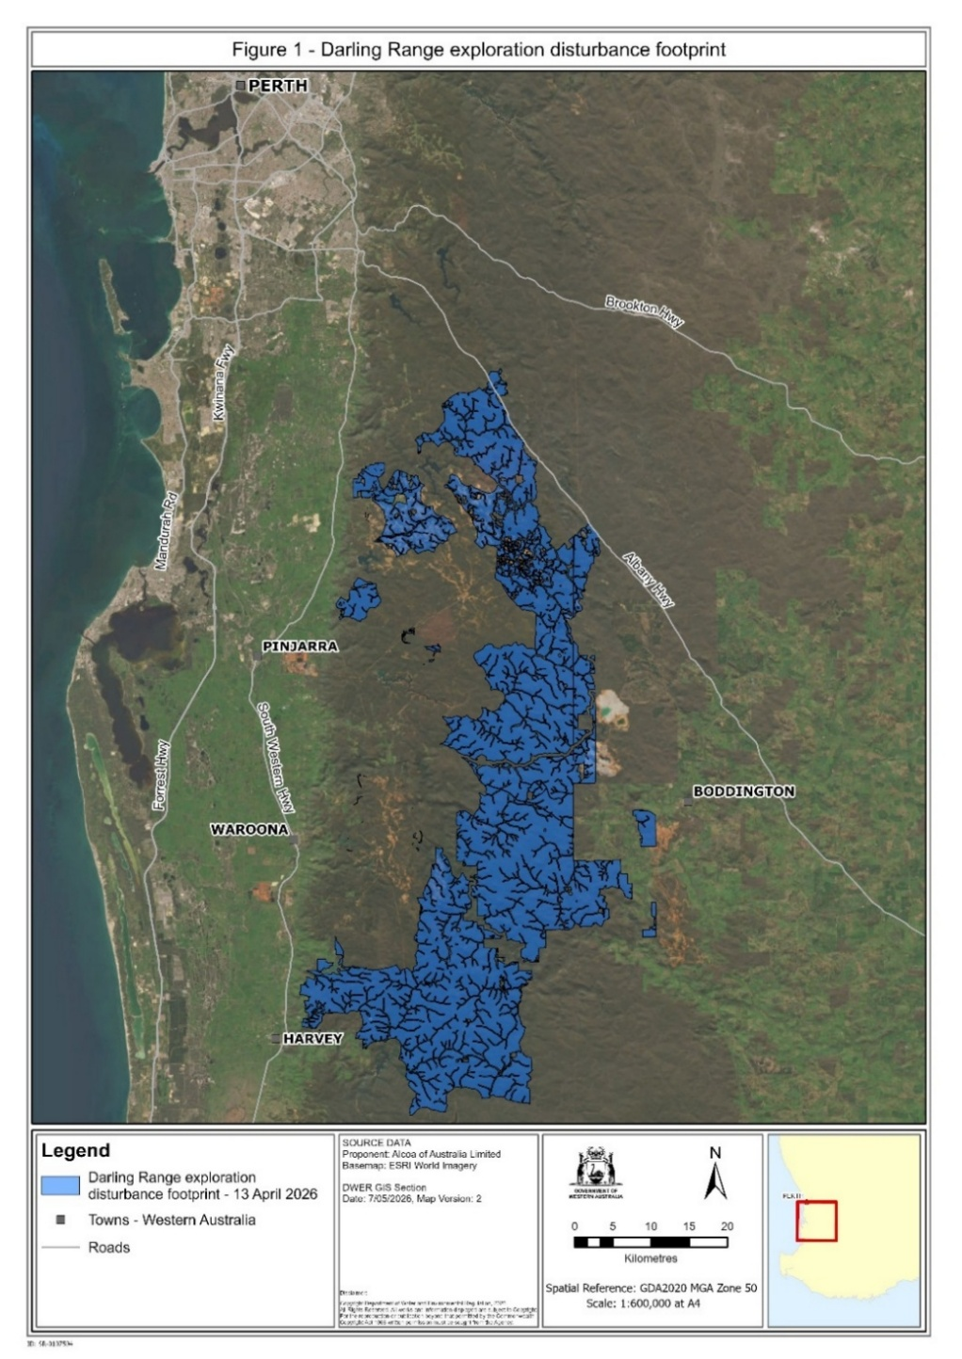
Figure 2
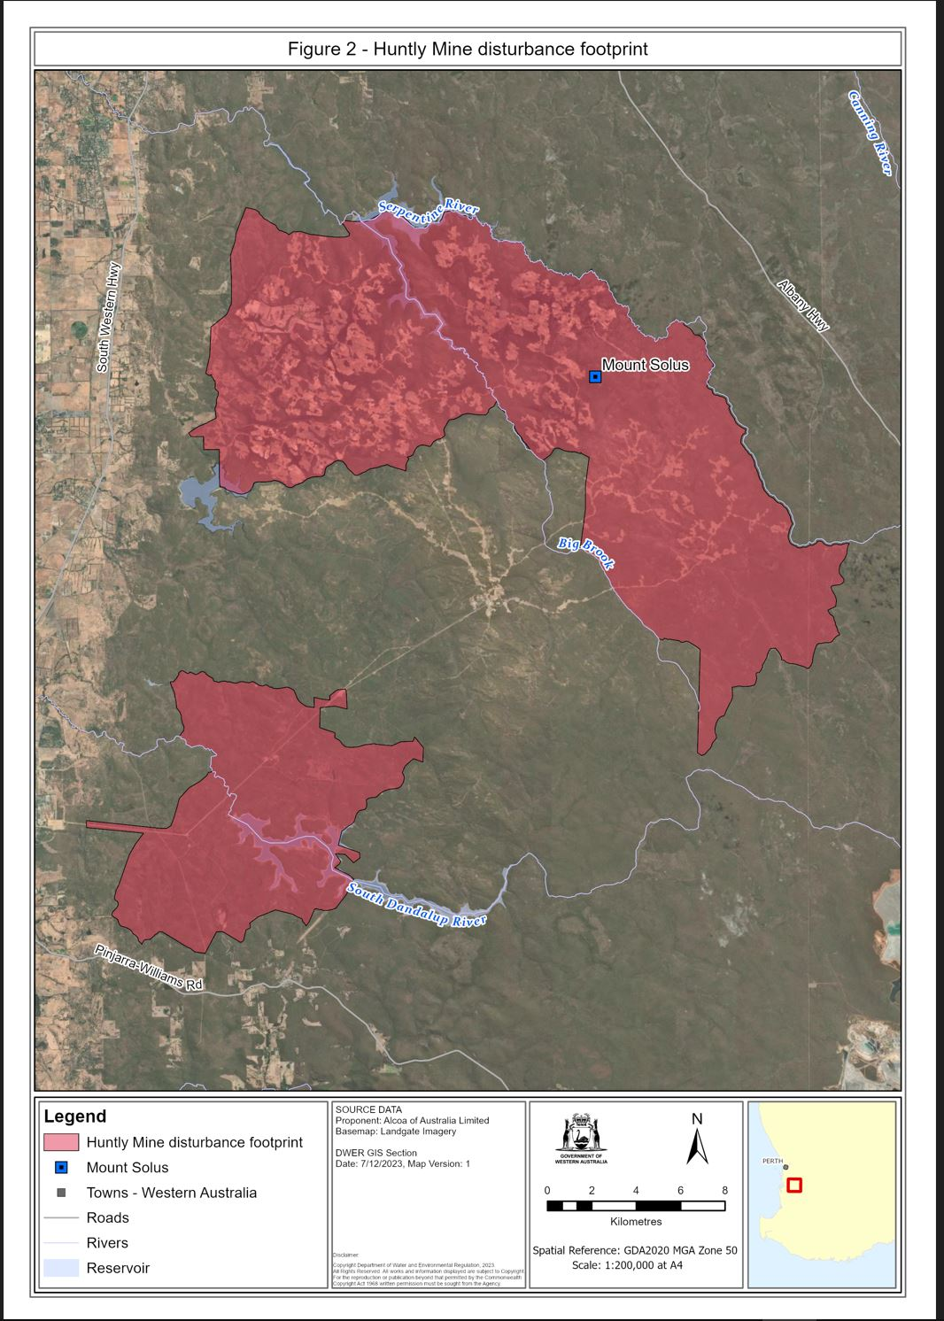
Figure 3
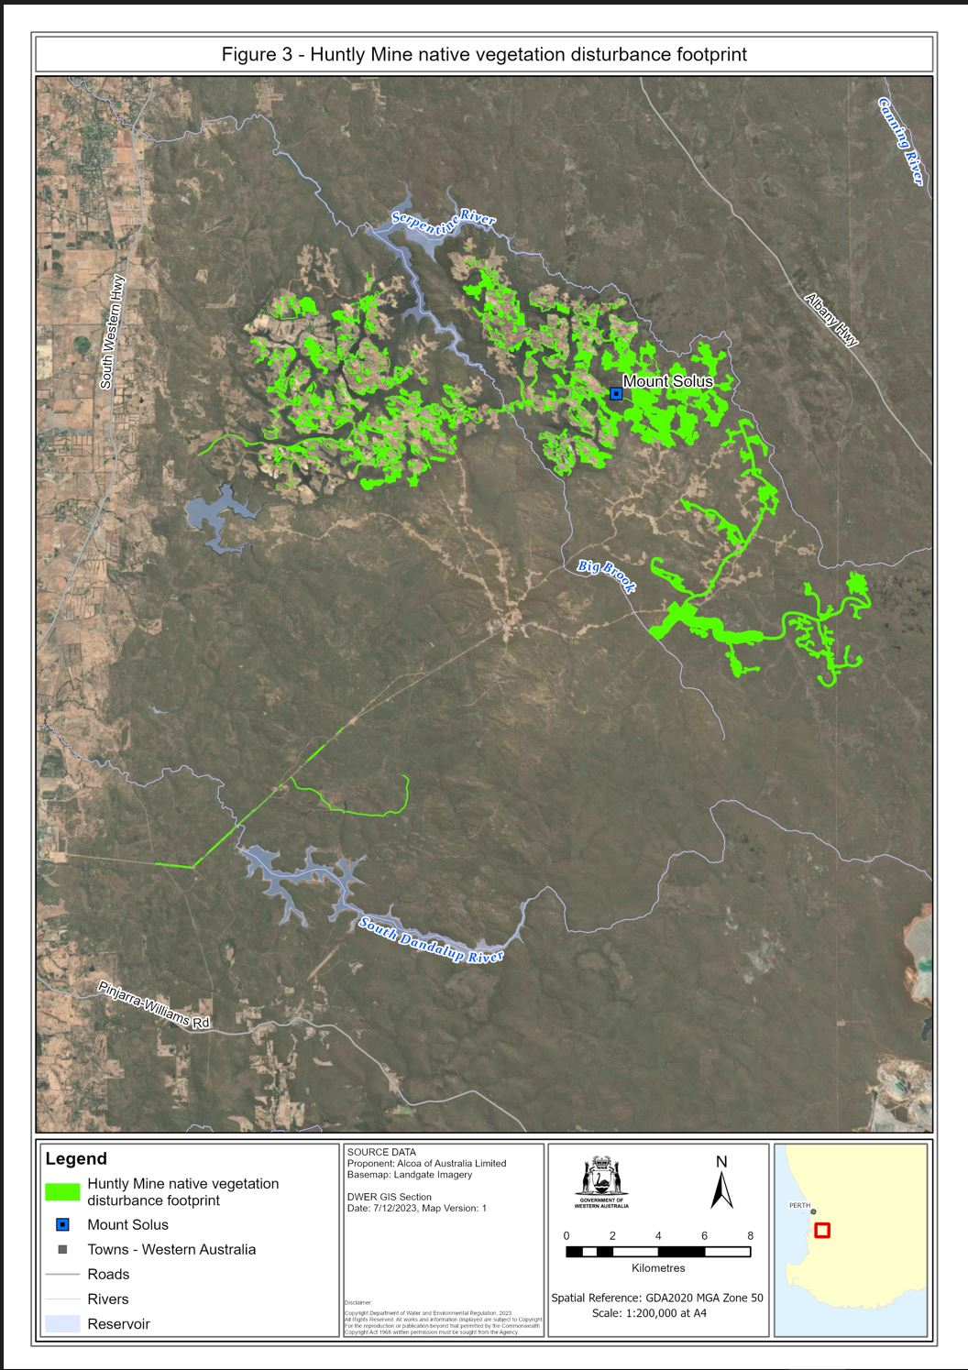
Figure 4
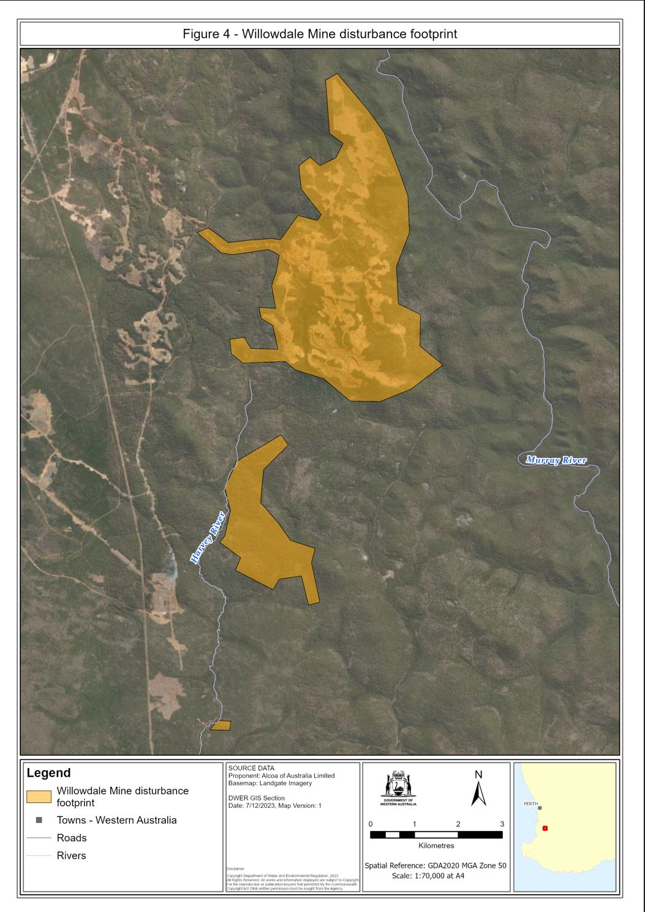
Figure 5
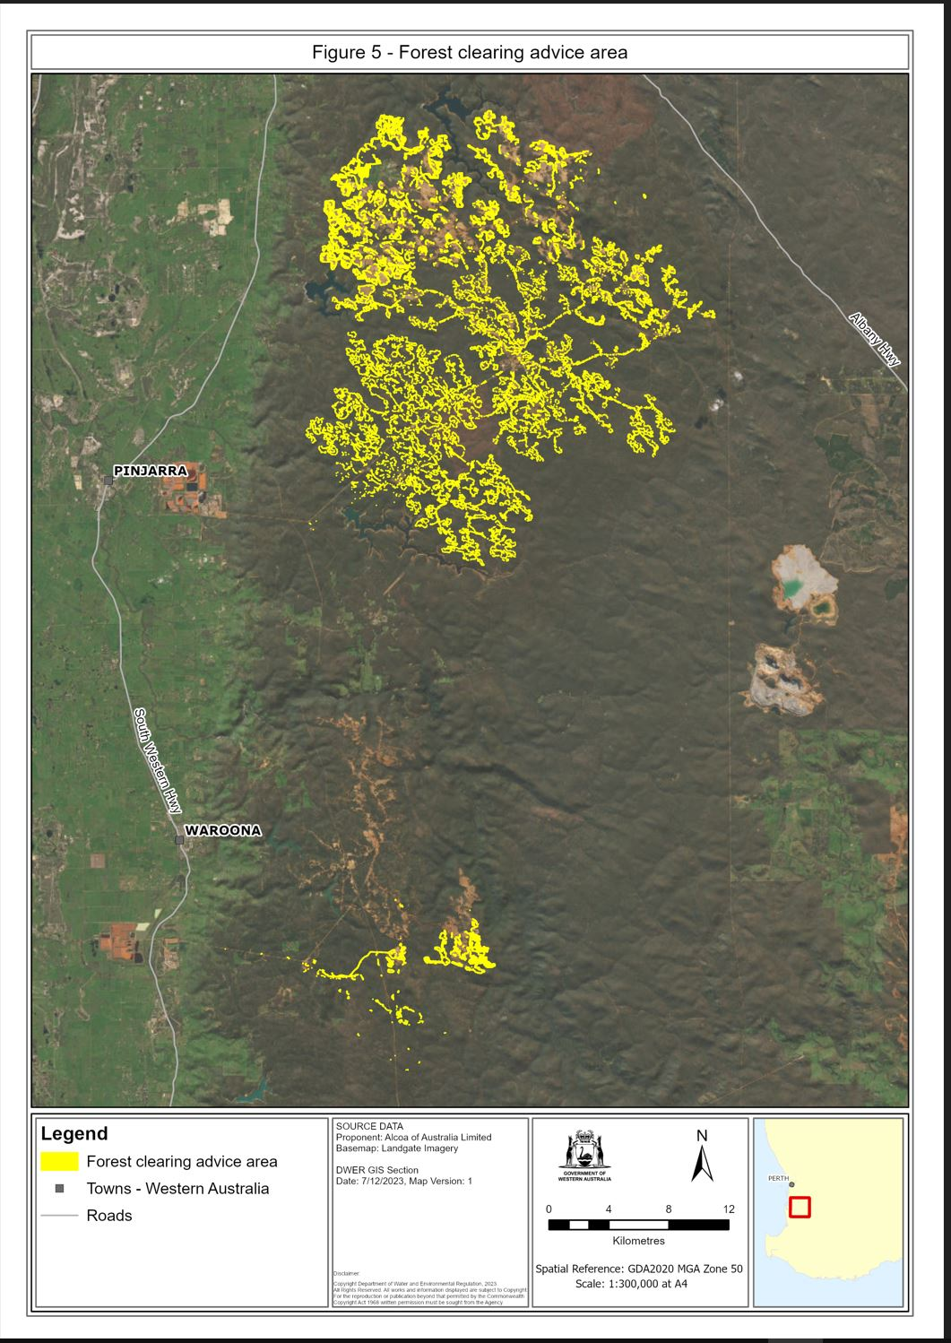
M. Swinbourn, Minister for the Environment

Defined terms

[This is a list of terms defined and the provisions where they are defined. The list is not part of the law.]
Defined term Provision(s)
2023 order Sch. 1 cl. 16
Act 3(1)
Alcoa 3(1)
appropriately qualified Sch. 1 cl. 1(1)
associates Sch. 1 cl. 1(1)
black cockatoo nesting tree Sch. 1 cl. 1(1)
calendar month Sch. 1 cl. 1(1)
CEO Sch. 1 cl. 1(2)
clause Sch. 1 cl. 1(1)
commencement day Sch. 1 cl. 1(1)
commencement month Sch. 1 cl. 24(1)
commencement year Sch. 1 cl. 17(1)
compliance Sch. 1 cl. 8
compliance assessment plan Sch. 1 cl. 1(1)
compliance monitor Sch. 1 cl. 1(1)
containment infrastructure Sch. 1 cl. 6(1)
Darling Range bauxite mining proposal 3(1)
Darling Range exploration disturbance footprint Sch. 1 cl. 2(1)
disturb Sch. 1 cl. 1(1)
disturbance area Sch. 1 cl. 1(1)
drainage control Sch. 1 cl. 1(1)
drainage incident Sch. 1 cl. 6(1)
environmentally hazardous material Sch. 1 cl. 6(1)
exploration Sch. 1 cl. 1(1)
figure Sch. 1 cl. 1(1)
Figure 1 Sch. 1 cl. 1(1)
Figure 2 Sch. 1 cl. 1(1)
Figure 3 Sch. 1 cl. 1(1)
Figure 4 Sch. 1 cl. 1(1)
Figure 5 Sch. 1 cl. 1(1)
forest clearing advice area Sch. 1 cl. 3(1)
Huntly Mine black cockatoo significant tree Sch. 1 cl. 1(1)
Huntly Mine disturbance footprint Sch. 1 cl. 1(1) and 2(1)
Huntly Mine native vegetation disturbance footprint Sch. 1 cl. 2(1)
independent fauna specialist Sch. 1 cl. 1(1)
independent qualified expert Sch. 1 cl. 9(1)
landscaping Sch. 1 cl. 1(1)
measurement manual Sch. 1 cl. 1(1)
mining activities Sch. 1 cl. 1(1)
mining and management programme Sch. 1 cl. 14(1) and 25(1)
mining infrastructure Sch. 1 cl. 1(1)
post-commencement period Sch. 1 cl. 17(1)
preceding month Sch. 1 cl. 23(1)
pre-commencement period Sch. 1 cl. 17(1)
prohibited zone Sch. 1 cl. 1(1)
proposed area Sch. 1 cl. 7(1)
protection area Sch. 1 cl. 1(1) and 4(2)
rehabilitation Sch. 1 cl. 1(1)
relevant DMA 3(1)
sensitive information Sch. 1 cl. 14(1) and 16
stabilisation date Sch. 1 cl. 5(1)
stabilise Sch. 1 cl. 1(1)
State Development Minister Sch. 1 cl. 1(1)
substantive mining activities Sch. 1 cl. 21(1)
top water level margin Sch. 1 cl. 4(1) and 5(1)
water reservoir Sch. 1 cl. 4(1) and 5(1)
Willowdale Mine disturbance footprint Sch. 1 cl. 2(1)

© State of Western Australia 2026.
This work is licensed under a Creative Commons Attribution 4.0 International Licence (CC BY 4.0). To view relevant information and for a link to a copy of the licence, visit www.legislation.wa.gov.au.
Attribute work as: © State of Western Australia 2026.
By Authority: ANDREW JONES, Government Printer

