
Western Australia
Health Act 1911
Health (Meat Hygiene) Regulations 2001

Reprinted under the Reprints Act 1984 as at 3 August 2007
Western Australia
Health (Meat Hygiene) Regulations 2001
CONTENTS
-Part 1 — Preliminary
1. Citation 1
2. Terms used in these regulations 1
3. Animals prescribed as game 3
4. Adoption of standards 3
Part 2 — Inspection, branding and processing of meat
5. Application of Part 2 to primary producers 6
6. Inspection 6
7. Branding carcases fit for human consumption 6
8. Branding carcases unfit for human consumption 8
9. Offences relating to brands 8
10. Restriction on sale of carcases 9
11. Inspection fees 9
12. Local government to lodge returns 10
Part 3 — Premises used in meat production
13. Operator to ensure premises comply with relevant standards 11
14. Operator to ensure slaughter and processing complies with relevant standards 11
Part 4 — Premises used in game meat production
Division 1 — Preliminary
15. Terms used in this Part 12
Division 2 — Premises to be registered
16. Construction and operation of game processing establishments and field depots 12
17. Applications 12
18. Registration or approval 13
19. Certificate of registration 14
20. Duration of registration 14
21. Suspension or cancellation of registration 14
22. Appeal to Minister 15
Division 3 — Operation of field depots and game processing establishments
23. Field depots 15
24. Game processing establishments 15
25. Inspector’s powers 16
Part 5 — Transport of meat
26. Vehicles transporting meat 17
Part 6 — General
27. Offence and penalty 18
Schedule 1 — Brands
1. Health Department of Western Australia brands 19
2. Western Australian Meat Industry Authority brands 19
3. Western Australian brands 20
4. Commonwealth brands 21
Schedule 2 — Fees
Part 1 — Meat inspection fees
Part 2 — Game meat premises fees
Schedule 3 — Forms
Notes
Compilation table 26
Defined Terms


Reprinted under the Reprints Act 1984 as at 3 August 2007
Western Australia
Health Act 1911
Health (Meat Hygiene) Regulations 2001

Part 1 — Preliminary

1. Citation
These regulations may be cited as the Health (Meat Hygiene) Regulations 2001 ¹.

2. Terms used in these regulations
In these regulations —
“abattoir” means a slaughter-house or other premises used for or in connection with the slaughtering of animals, including holding yards and similar places;
“animal” does not include a fish, crustacean or mollusc;
“brand” includes mark or stamp;
“carcase” means the whole or part of the body of a slaughtered animal but excludes any part (such as blood, viscera, head or hide) removed or severed during or immediately following slaughter;
“EDPH” means the Executive Director, Public Health;
“game” has the same meaning as in section 207A of the Health Act 1911;
“inspector” means —
(a) an officer appointed under section 6 of the Health Legislation Administration Act 1984;
(b) an officer appointed under section 27 of the Health Act 1911; or
(c) an authorised officer (including a veterinary officer), meat inspector or food standards officer employed by the Commonwealth under the Public Service Act 1922 ² or the Export Control Act 1982 and performing meat inspection functions in accordance with an arrangement between the Commonwealth and the State;
“poultry” means avian species ordinarily consumed by humans (such as fowls, ducks, geese, turkeys, pigeons, pheasants, quails and guinea fowls) other than ratites;
“processing premises” means —
(a) premises where meat is processed for human consumption;
(b) premises where smallgoods are manufactured; or
(c) butchers’ premises where the butcher supplies meat and meat products for further processing and sale (whether or not in conjunction with retail sales),
but does not include —
(d) butchers’ premises if the sales from the premises are predominantly retail sales; or
(e) field depots or game processing establishments within the meaning of Part 4;
“slaughter” means slaughter for food for human consumption;
“standard” means an Australian Standard published by the Agriculture and Resource Management Council of Australia and New Zealand, as amended from time to time.
[Regulation 2 amended in Gazette 4 Feb 2005 p. 619-20.]

3. Animals prescribed as game
For the purposes of section 207A of the Act, camel is prescribed as game.

4. Adoption of standards
(1) These standards are adopted and form part of these regulations —
(a) the Australian Standard for the Hygienic Production and Transportation of Meat and Meat Products for Human Consumption (“Meat Standard”);
(b) the Australian Standard for Hygienic Production of Rabbit Meat for Human Consumption (“Rabbit Standard”);
(c) the Australian Standard for Hygienic Production of Ratite (Emu/Ostrich) Meat for Human Consumption (“Ratite Standard”);
(d) the Australian Standard for Hygienic Production of Crocodile Meat for Human Consumption (“Crocodile Standard”);
(e) the Australian Standard for Hygienic Production of Game Meat for Human Consumption (“Game Standard”);
(f) the Australian Standard for Construction of Premises and Hygienic Production of Poultry Meat for Human Consumption as varied by subregulation (4) (“Poultry Standard”);
(g) the Australian Standard for the Hygienic Production of Natural Casings for Human Consumption (“Casings Standard”); and
(h) the Australian Standard for the Hygienic Rendering of Animal Products (“Rendering Standard”).
(2) For the purposes of these regulations, in a standard adopted by subregulation (1) —
(a) a reference to the “Controlling Authority” is to be read as a reference to the EDPH; and
(b) a requirement for a material, facility or thing to be adequate, it is to be read as a requirement that it be adequate in the opinion of the EDPH.
(3) The EDPH is not to approve a quality assurance arrangement for a premises to which the —
(a) Meat Standard;
(b) Rabbit Standard;
(c) Ratite Standard;
(d) Crocodile Standard; or
(e) Game Standard,
applies unless satisfied that at least one person who is an inspector within paragraph (a) or (b) of the definition of “inspector” will be present at the premises when carcases are slaughtered.
(4) For the purposes of these regulations Part B of the Australian Standard for the Construction of Premises and Hygiene Production of Poultry Meat for Human Consumption is amended as follows:
(a) in section 15.86 by deleting “a free residual chlorine level shall be detectable in the discharge water” and inserting instead —
“
a minimum bacterial effect equivalent to 5mg per litre free chlorine must be maintained
”;
(b) in section 15.88 by inserting at the end of the first paragraph —
“
When chlorinated water is used a minimum bacterial effect equivalent to 5mg per litre free chlorine must be maintained at all times.
”.
(5) Despite the amendments to the Poultry Standard in subregulation (4), the EDPH may approve an alternative level of free chlorine for poultry processing if it can be demonstrated that the alternative level will achieve the same outcome as the level required by the Poultry Standard as amended by that subregulation.
(6) For the purposes of section 344A(3) of the Act, the following office is prescribed as the place at which the standards adopted by this regulation are available for public inspection —
Environmental Health Services of the Health Department of Western Australia ³,
Grace Vaughan House,
227 Stubbs Terrace,
Shenton Park
[Regulation 4 amended in Gazette 4 Feb 2005 p. 620-1; 31 May 2005 p. 2408.]

Part 2 — Inspection, branding and processing of meat

5. Application of Part 2 to primary producers
(1) This Part does not apply in respect of an animal if the animal is slaughtered —
(a) by or for a primary producer;
(b) on the land on which the primary producer carries on the farming or grazing business; and
(c) for consumption by the primary producer or his or her immediate family or employees.
(2) In subregulation (1) —
“primary producer” means a person who carries out or is engaged in the business of farming or grazing on land that is —
(a) zoned for rural purposes under a town planning scheme; and
(b) used solely or principally for agricultural or grazing purposes or for a combination of those purposes.

6. Inspection
(1) The operator of an abattoir must ensure that every animal slaughtered in the abattoir is inspected by an inspector in accordance with the relevant standard adopted by regulation 4.
(2) Subregulation (1) does not apply in relation to an abattoir in the districts of Kellerberrin or Kondinin.

7. Branding carcases fit for human consumption
(1) When an inspector inspects a carcase and passes it as fit for human consumption the inspector must brand the carcase, or cause it to be branded, as required by this regulation using a brand set out in Schedule 1.
(2) Subregulation (1) does not apply in relation to —
(a) an animal slaughtered in the districts of Kellerberrin or Kondinin; or
(b) poultry.
(3) Except in the case of rabbits, the carcase is to be branded on each side.
(4) If the animal is a bovine the carcase is to be branded —
(a) on the outside of the buttock;
(b) on the outside of the ribs; and
(c) on the shoulder.
(5) If the animal is a sheep, goat or deer the carcase is to be branded —
(a) on the outside of the leg; and
(b) on the shoulder.
(6) If the animal is a pig the carcase is to be branded —
(a) on the outside of the leg;
(b) on the outside of the loin;
(c) on the shoulder; and
(d) on the outside of the cheek.
(7) If the animal is game other than a rabbit, the carcase is to be branded —
(a) on the outside of the buttock; and
(b) on the shoulder.
(8) If the animal is a rabbit the carcase is to be branded on one side of the neck.
(9) A brand affixed under this regulation is to be a red colour as specified in the Schedules of Standard 1.3.1 of the Australia New Zealand Food Standards Code and made from —
(a) one of the synthetic colouring substances specified in Standard A5(2)(d)(i) of Volume 1 of the Australia New Zealand Food Standards Code as adopted by the Health (ANZ Food Standards Code Adoption) Regulations 2001; or
(b) a substance approved by the EDPH.
[Regulation 7 amended in Gazette 4 Feb 2005 p. 621.]

8. Branding carcases unfit for human consumption
(1) When an inspector inspects a carcase, other than poultry, and rejects it as unfit for human consumption the inspector must brand the shoulders, loins and legs of the carcase, or the portion of the carcase that is rejected, with this brand —
 | where A = Identifying number allocated to the establishment by the Western Australian Meat Industry Authority.
(2) A brand affixed under this regulation is to be a blue colour as specified in the Schedules of Standard 1.3.1 of the Australian New Zealand Food Standards Code and made from —
(a) one of the synthetic colouring substances specified in Standard A5(2)(d)(i) of Volume 1 of the Australia New Zealand Food Standards Code as adopted by the Health (ANZ Food Standards Code Adoption) Regulations 2001; or
(b) a substance approved by the EDPH.
[Regulation 8 amended in Gazette 4 Feb 2005 p. 621.]

9. Offences relating to brands
(1) A person other than an inspector or a person acting on the direction of an inspector must not brand a carcase.
(2) A person must not brand a carcase other than in accordance with this Part.
(3) A person must not manufacture a brand set out in Schedule 1, or which purports to be, or resembles, such a brand, unless —
(a) the person has the written authority of the EDPH; or
(b) the brand is made by a local government for use by inspectors in abattoirs in the district of that local government.
(4) A person must not remove from a carcase before it is sold by way of retail sale a brand affixed under this Part.

10. Restriction on sale of carcases
(1) A person must not —
(a) sell;
(b) offer or expose for sale; or
(c) have in his or her possession for the purpose of sale,
a carcase unless the carcase —
(d) is branded in accordance with this Part; or
(e) under regulation 7(2), is not required to be branded.
(2) Subregulation (1) does not apply in relation to the sale, offering or exposure for sale, or possession for sale, in the districts of Kellerberrin or Kondinin of the carcase of an animal slaughtered in that district by a person approved by the EDPH.

11. Inspection fees
(1) Where meat is inspected in accordance with this Part the operator of the premises where the meat is inspected must —
(a) lodge with the relevant local government a written and signed statement in a form approved by the local government; and
(b) pay to that local government the fees specified in Part 1 of Schedule 2 in respect of that local government.
(2) Fees under subregulation (1) are payable weekly, fortnightly or monthly as determined by the local government and are to be paid within 7 days of the end of the week, fortnight or month.
(3) If a determination has not been made under subregulation (2) the fees are payable monthly.

12. Local government to lodge returns
(1) Within 14 days of the end of a quarter, a local government that received fees under regulation 11(1) during that quarter must lodge with the EDPH a statement giving details of the operations in respect of which those fees were received.
(2) In this regulation —
“quarter” means a period of 3 months beginning on 1 July, 1 October, 1 January or 1 April in any year.

Part 3 — Premises used in meat production

13. Operator to ensure premises comply with relevant standards
(1) The operator of an abattoir must ensure that the abattoir complies with, and is operated in accordance with, all relevant standards adopted by regulation 4.
(2) The operator of processing premises must ensure that the premises comply with, and are operated in accordance with, all relevant standards adopted by regulation 4.
[Regulation 13 inserted in Gazette 4 Feb 2005 p. 622.]

14. Operator to ensure slaughter and processing complies with relevant standards
(1) The operator of an abattoir must ensure that the slaughter of animals in that abattoir is done so as to comply with all relevant standards adopted by regulation 4.
(2) The operator of processing premises must ensure that the processing of meat and meat products at the premises is done so as to comply with all relevant standards adopted by regulation 4.
(3) Despite subregulation (1), the operator of an abattoir in the districts of Kellerberrin or Kondinin need not comply with clauses 10.1, 10.2, 10.3, 10.5 and 10.11 of the Meat Standard.
[Regulation 14 inserted in Gazette 4 Feb 2005 p. 622.]

Part 4 — Premises used in game meat production

Division 1 — Preliminary

15. Terms used in this Part
(1) In this Part “field depot” and “game processing establishment” have the same meanings as they have in section 207A of the Health Act 1911.
(2) For the purposes of this Part a reference in the Game Standard to “small game” is to be read as a reference to game other than buffalo, goat, kangaroo, pig and camel.

Division 2 — Premises to be registered

16. Construction and operation of game processing establishments and field depots
(1) A person must not construct a game processing establishment unless the construction has been approved by the EDPH.
(2) A person must not operate a field depot or a game processing establishment unless it is registered under this Division.
(3) The operator of a field depot or game processing establishment must not make structural alterations to the depot or establishment unless the alteration has been approved by the EDPH.

17. Applications
(1) An application for —
(a) approval to construct a game processing establishment;
(b) registration or renewal of registration of a field depot or game processing establishment; or
(c) approval to structurally alter a field depot or game processing establishment,
is to be —
(d) made in the form of Form 1 in Schedule 3;
(e) lodged with the local government of the district in which the field depot is initially to be operated; and
(f) accompanied by —
(i) the information specified in Form 1; and
(ii) the fee set out in Part 2 of Schedule 2.
(2) A local government with which an application is lodged under subregulation (1) —
(a) must forward the application to the EDPH; and
(b) may make recommendations to the EDPH with respect to the application.
(3) A person must not make a statement or give information that the person knows is false or misleading in a material respect in connection with an application under this regulation.

18. Registration or approval
(1) The EDPH must approve an application for the construction of a game processing establishment if satisfied that the establishment will comply with the Game Standard.
(2) The EDPH must approve an application for registration, or renewal of registration, of a field depot or game processing establishment if satisfied that —
(a) the applicant is a fit and proper person to operate the depot or establishment;
(b) in the case of a field depot, the depot complies with Part 6 of the Game Standard; and
(c) in the case of a game processing establishment, the establishment complies with Part 8 of the Game Standard.
(3) The EDPH must approve an application to structurally alter a field depot or game processing establishment if satisfied that the proposed alteration will comply with Part 6 or Part 8 (as the case requires) of the Game Standard.
(4) If an application for registration or renewal of registration is not approved, the registration or renewal fee is to be refunded.

19. Certificate of registration
(1) When the EDPH grants or renews the registration of a field depot or game processing establishment the EDPH is to issue to the applicant a certificate of registration.
(2) The operator of a field depot or game processing establishment must, if directed to do so by the EDPH, return the certificate of registration to the EDPH if the registration is cancelled or suspended or is not renewed.

20. Duration of registration
The registration of a field depot or game processing establishment remains in force for 12 months from the date it is granted unless before then it is cancelled or suspended.
[Regulation 20 amended in Gazette 15 Nov 2005 p. 5602.]

21. Suspension or cancellation of registration
(1) If the operator of a field depot or game processing establishment is convicted of an offence against the Act, the EDPH may, by giving written notice to the operator —
(a) suspend the registration of the field depot or game processing establishment for up to 1 month; or
(b) cancel that registration.
(2) The suspension or cancellation of the registration of a field depot or game processing establishment is not effective unless the EDPH —
(a) has given to the operator written notice of the intention to suspend or cancel the registration stating the grounds on which the suspension or cancellation is intended and allowing the operator 14 days within which to respond to the notice; and
(b) has had due regard to any response to the notice made within that time.

22. Appeal to Minister
(1) A person aggrieved by a decision of the EDPH under this Division may appeal against the decision to the Minister.
(2) An appeal is to be made in writing within 14 days of the decision of the EDPH and must set out the grounds for the appeal.
(3) The operation of the decision to which an appeal relates is not affected by the making of the appeal unless the Minister otherwise orders.
(4) The Minister is to determine the appeal on the material that was before the EDPH and on such other material as the Minister considers relevant.
(5) On determining an appeal the Minister may —
(a) confirm, vary or set aside the decision of the EDPH; or
(b) substitute his or her own decision for that of the EDPH.

Division 3 — Operation of field depots and game processing establishments

23. Field depots
(1) The operator of a field depot must comply with the Game Standard.
(2) The operator of a field depot must not allow a carcase to be stored at the field depot unless it is game and has been game slaughtered and tagged in accordance with the Game Standard.

24. Game processing establishments
(1) The operator of a game processing establishment must comply with the Game Standard.
(2) The operator of a game processing establishment must ensure that carcases of different kinds of game are not processed in the same part of the establishment at the same time.
(3) An operator of a game processing establishment must ensure that the temperature in any part of the establishment where carcases or meat are inspected, branded or processed does not exceed 10°C.

25. Inspector’s powers
An inspector may inspect —
(a) a field depot;
(b) a game processing establishment; or
(c) a vehicle used, or which the inspector reasonably suspects is being used, to transport game carcases or meat.

Part 5 — Transport of meat

26. Vehicles transporting meat
(1) The operator of a vehicle used for the transport of carcases or meat must ensure that the vehicle complies with all relevant standards adopted by regulation 4.
(2) For the purposes of these regulations a reference in the Meat Standard to “a meat carrying compartment”, does not include a reference to a vehicle used by a butcher solely for the purpose of conveying wrapped meat from a retail premises to a customer who purchased the meat by way of retail sale.
[Regulation 26 amended in Gazette 4 Feb 2005 p. 622.]

Part 6 — General

27. Offence and penalty
(1) A person who contravenes these regulations commits an offence.
Penalty:
(a) minimum —
(i) in the case of a first offence, $250;
(ii) in the case of a second offence, $500; and
(iii) in the case of a third or subsequent offence, $1 250;
(b) maximum: $2 500.
(2) If the offence is a continuing offence, the offender is also liable to a daily penalty of not less than $125 nor more than $250 for each day for which the offence continues.

[28. Omitted under the Reprints Act 1984 s. 7(4)(f).]

Schedule 1 — Brands
[r. 7]
1. Health Department of Western Australia ³ brands
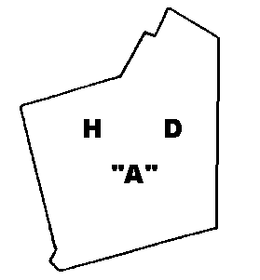 | “A” = Identifying number allocated to the establishment by the Health Department of Western Australia ³
2. Western Australian Meat Industry Authority brands
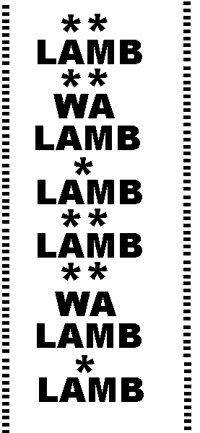 | = Identifying number allocated to the establishment by the Western Australian Meat Industry Authority  = Trade or company name or symbol

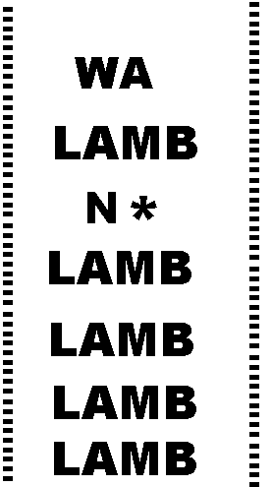 | 
 = Identifying number allocated to the establishment by the Western Australian Meat Industry Authority
3. Western Australian brands
For large stock  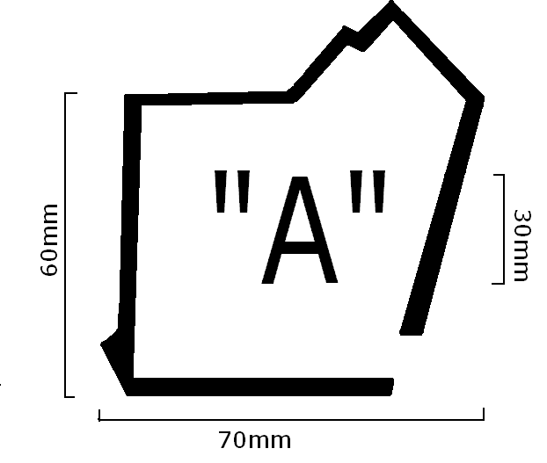 | For rabbits  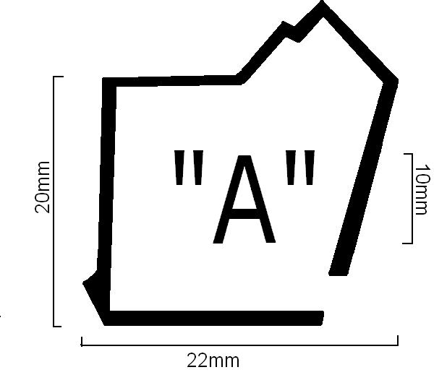 | For other stock  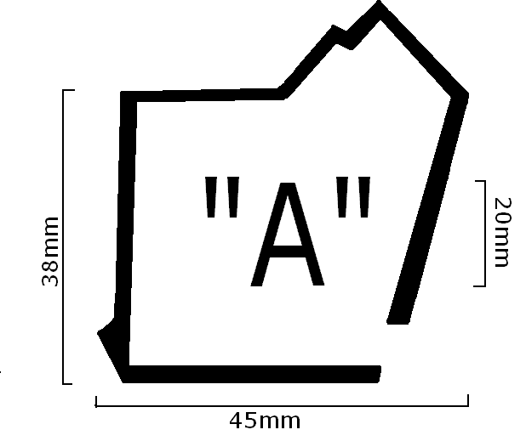
“A” = Identifying number allocated to the establishment by the Western Australian Meat Industry Authority

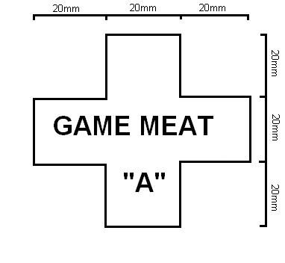 | For game  “A” = Identifying number allocated to the establishment by the Health Department of Western Australia ³
4. Commonwealth brands
 | 
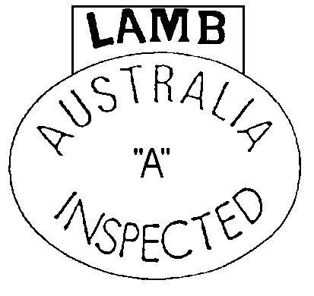 | 
 | For game
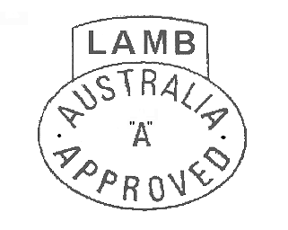
“A” = Identifying number allocated to the establishment by the Commonwealth Department of Agriculture, Fisheries and Forestry
[Clause 4 amended in Gazette 4 Feb 2005 p. 623.]

Schedule 2 — Fees

Part 1 — Meat inspection fees
[Heading inserted in Gazette 22 Feb 2005 p. 811.]
[r. 11]
 | Local government | Fee per animal ($)
 | Local government | Pigs | Bovines  (70kg & under)  Other animals | Bovines (over 70kg)
1 | Augusta-Margaret River ....... | 5.50 | 1.10 | 8.80
2 | Bunbury ................................ | 2.25 | 0.70 | 3.25
3 | Busselton ............................. | — | 0.33 | 2.64
4 | Capel ................................... | — | 0.60 | 3.52
5 | Coolgardie ........................... | 9.90 | 3.85 | —
6 | Corrigin ................................ | 5.27 | 1.02 | 8.75
7 | Esperance ............................ | 3.30 | 0.66 | 5.28
8 | Gingin .................................. | — | 0.33 | 4.23
9 | Greenough ........................... | 6.50 | 1.85 | 10.20
10 | Harvey ................................. | — | 0.83 | 5.28
11 | Manjimup ............................. | 4.12 | 0.82 | 6.60
12 | Merredin .............................. | 1.10 | 0.22 | 1.76
13 | Narrogin .............................. | 2.47 | 0.49 | 3.96
14 | Northam ............................... | — | 0.58 | 4.62
15 | Plantagenet .......................... | — | 0.66 | 5.28
16 | Rockingham ........................ | — | 0.40 | —
17 | Serpentine-Jarrahdale .......... | — | 0.36 | —
18 | Tammin ............................... | — | 1.00 | —
19 | Wyndham/East Kimberley .. | — | 0.55 | 4.40
[Part 1 inserted in Gazette 22 Feb 2005 p. 811-12; amended in Gazette 31 May 2005 p. 2408; 15 Nov 2005 p. 5602; 12 Dec 2006 p. 5493; 30 Jan 2007 p. 213; 26 Jun 2007 p. 3029.]

Part 2 — Game meat premises fees
[r. 17(1)(f)(ii)]
 |  | $
1 | Application to construct game processing establishment ...... | 100
2 | Application for registration or renewal of registration of field depot or game processing establishment ....................... | 250
3 | Application for approval to structurally alter field depot or game processing establishment ............................................. | 100

Schedule 3 — Forms
[r. 17(1)(d)]
Health (Meat Hygiene) Regulations 2001
Game meat premises or field depot
Application
Applicant | Name
Applicant | Address  Postcode
Applicant | Phone No.
Application | New registration  Renewal of registration  For approval to construct  For approval to structurally alter |  | If currently registered —Registration No.  ____________________
Premises | Game processing establishment Field depot
Premises | Address / location
Premises | Local government district
Premises | For field depot, other districts  where depot does or will operate
Information to be provided with application for construction or alteration | Construction of game processing establishment  • details of the kinds of game to be processed and the expected average weekly quantity of carcases processed  • plans and specifications of the establishment including details of compliance with Part 6 of the Australian Standard for Hygienic Production of Game Meat for Human Consumption  Alterations  • plans and specifications of the proposed alterations including details of compliance with Part 6 or Part 8 of the Australian Standard for Hygienic Production of Game Meat for Human Consumption
Applicant | Signature Date

Notes
¹ This reprint is a compilation as at 3 August 2007 of the Health (Meat Hygiene) Regulations 2001 and includes the amendments made by the other written laws referred to in the following table. The table also contains information about any reprint.

Compilation table
Citation | Gazettal | Commencement
Health (Meat Hygiene) Regulations 2001 | 1 Jun 2001 p. 2749-64 | 1 Jun 2001
Health (Meat Hygiene) Amendment Regulations 2001 | 17 Jul 2001 p. 3636 | 17 Jul 2001
Health (Meat Hygiene) Amendment Regulations (No. 2) 2001 | 30 Nov 2001 p. 6073 | 30 Nov 2001
Health (Meat Hygiene) Amendment Regulations 2002 | 12 Mar 2002 p. 1031-2 | 12 Mar 2002
Health (Meat Hygiene) Amendment Regulations (No. 2) 2002 | 13 Aug 2002 p. 4180 | 13 Aug 2002
Health (Meat Hygiene) Amendment Regulations (No. 3) 2002 | 3 Dec 2002 p. 5712 | 3 Dec 2002
Health (Meat Hygiene) Amendment Regulations 2003 | 14 Feb 2003 p. 468 | 14 Feb 2003
Reprint 1: The Health (Meat Hygiene) Regulations 2001 as at 14 Mar 2003 (includes amendments listed above)
Health (Meat Hygiene) Amendment Regulations (No. 2) 2003 | 4 Nov 2003 p. 4613 | 4 Nov 2003
Health (Meat Hygiene) Amendment Regulations 2004 | 27 Jan 2004 p. 345 | 27 Jan 2004
Health (Meat Hygiene) Amendment Regulations (No. 2) 2004 | 18 May 2004 p. 1570 | 18 May 2004
Health (Meat Hygiene) Amendment Regulations (No. 4) 2004 | 18 May 2004 p. 1571 | 18 May 2004
Health (Meat Hygiene) Amendment Regulations (No. 5) 2004 | 25 Jun 2004 p. 2234-5 | 25 Jun 2004
Health (Meat Hygiene) Amendment Regulations 2005 | 4 Feb 2005 p. 619-23 | 4 Feb 2005
Health (Meat Hygiene) Amendment Regulations (No. 2) 2005 | 22 Feb 2005 p. 811-12 | 22 Feb 2005
Reprint 2: The Health (Meat Hygiene) Regulations 2001 as at 1 Apr 2005 (includes amendments listed above)
Health (Meat Hygiene) Amendment Regulations (No. 3) 2005 | 31 May 2005 p. 2408 | 31 May 2005
Health (Meat Hygiene) Amendment Regulations (No. 4) 2005 | 15 Nov 2005 p. 5601-2 | 15 Nov 2005
Health (Meat Hygiene) Amendment Regulations (No. 2) 2006 | 12 Dec 2006 p. 5492-3 | 12 Dec 2006
Health (Meat Hygiene) Amendment Regulations 2007 | 30 Jan 2007 p. 213 | 30 Jan 2007
Health (Meat Hygiene) Amendment Regulations (No. 2) 2007 | 26 Jun 2007 p. 3029 | r. 1 and 2: 26 Jun 2007 (see r. 2(a));  Regulations other than r. 1 and 2: 27 Jun 2007 (see r. 2(b))
Reprint 3: The Health (Meat Hygiene) Regulations 2001 as at 3 Aug 2007 (includes amendments listed above)
² Repealed by the Public Employment (Consequential and Transitional) Amendment Act 1999 (Cwlth) No. 146 of 1999 s. 3. Now see the Public Service Act 1999 (Cwlth) No. 147 of 1999.
³ Under the Alteration of Statutory Designations Order (No. 3) 2001 a reference in any law to the Health Department of Western Australia is read and construed as a reference to the Department of Health.

