Western Australia
Fremantle Improvement Act 1913

Western Australia
Fremantle Improvement Act 1913
Contents
-1. Short title 1
2. Vesting of lands in Municipality 1
3. Compensation 2
4. Poll may be demanded on question whether lands are to be acquired by the Municipality 3
5. Power to borrow money for purposes of this Act 4
6. Portion of lands to be used for widening Market and High Streets 5
7. Powers of Council over remaining portion of land 6
8. Application of rents, profits, and other moneys received from the property 6
9. Ordinary revenue applicable to purposes of this Act 7
10. Interpretation 7
First Schedule
Second Schedule
Notes
Compilation table 10

Western Australia
Fremantle Improvement Act 1913
An Act to empower the Municipality of Fremantle to acquire, use, and dispose of certain lands within the Municipal District for the Benefit and Improvement of the Town.

1. Short title
This Act may be cited as the Fremantle Improvement Act 1913.

2. Vesting of lands in Municipality
On a day to be fixed by proclamation the lands described in the First Schedule and delineated in the plan therein shall by force of this Act vested in the Municipality for an estate in fee simple in possession freed and discharged from all trusts, mortgages, charges, obligations, estates, interests, rights-of-way, and other easements whatsoever, and the Registrar of Titles, shall, on demand of the Municipality and on payment of the proper fees, issue to such Municipality a Certificate of Title to the said lands in accordance with this Act.
Provided —
(a) That neither the date of the issue of the proclamation nor the day fixed thereby shall be earlier than two months or later than twelve months after the commencement of this Act, and
(b) That no such proclamation shall be issued at all if the acquisition of the said lands is disapproved by a majority of the ratepayers voting on the question under the provisions hereinafter contained.

3. Compensation
(1) The estate and interest of every person in any of such lands, whether legal or equitable, shall be converted into a claim for compensation.
(2) Such compensation shall be determined in manner set out in the Public Works Act 1902: Provided that (subject as hereinafter set out) claims for compensation shall be made and the compensation shall be assessed as if the lands had by notice published in the Gazette been taken compulsorily under the said Act for a public purpose and vested in the Municipality on the ninth day of September, nineteen hundred and thirteen, and for the purposes of the said Act the lands shall be deemed to have been so taken and vested.
(3) If the Municipality fails to serve an offer on any claimant for compensation within the time limited by the Public Works Act 1902, then the Minister may serve an offer on behalf of the Municipality, and such offer shall be deemed to be an offer duly made by the Municipality for the purposes of the said Act.
(4) Any compensation awarded shall be paid and applied in manner provided in the said Act.
(5) Notwithstanding anything hereinbefore contained, the Municipality shall not be entitled to any rents and profits of the said lands which have accrued before the proclaimed day; but the rents and profits shall pass to the Municipality as from the vesting of the lands under this Act.
(6) In lieu of the addition authorised by paragraph d. of section sixty-three of the said Act, interest at the rate of six per centum per annum on the amount of the compensation from the proclaimed day till the date of the award shall be added to the award.
(7) Notwithstanding anything in this Act or in the Public Works Act 1902, no machinery affixed to any of the said lands shall be deemed to pass to the Municipality nor shall any allowance be made therefor in assessing the compensation, but such machinery shall as between the Municipality and any person claiming compensation be deemed to be severable from the said land.

4. Poll may be demanded on question whether lands are to be acquired by the Municipality
(1) Within one month after the passing of this Act any twenty ratepayers may, by writing under their respective hands delivered to the town clerk, demand that the question whether or not the aforesaid lands be acquired by the Municipality pursuant to this Act be submitted to the election of the owners of rateable land situated within the Municipal District.
(2) For the purpose of this section the term owner means any person entitled to a legal or equitable estate or interest in rateable land in fee simple, or for a term of years having at least seven years unexpired.
(3) When any such demand has been made, the votes of the owners shall be taken on a day to be fixed by the Mayor, not less than seven days not more than twenty-eight days after the delivery of such demand, and such day shall be notified in some daily newspaper circulating in the district, and on such day a poll shall be taken of the owners on the question aforesaid.
(4) For the taking of such poll a special roll of owners shall be prepared, revised, and authenticated within the times and in the manner prescribed by section Four hundred and forty-seven of the Municipal Corporations Act 1906.
(5) At the taking of such poll voting papers according to the form in the Second Schedule shall be used, and the voter shall record his vote in the manner set forth on the voting paper.
(6) Subject to this Act, the provision contained in the Municipal Corporations Act 1906, applicable to the holding of the election of a mayor, or the taking of the poll thereat, or defining or providing for the punishment of offences connected with such an election, shall apply as nearly as may be to and in respect of a poll hereunder.
(7) the Mayor shall, after the poll, prepare a statement showing the respective numbers of the affirmative and negative votes and the number of voting papers rejected as informal, and shall sign and certify the statement and forward the same to the Minister.
(8) The Minister shall cause the certificate to be published in the Gazette, and any Gazette containing what purports to be a copy of such certificate shall be conclusive evidence of the result of the poll and of the validity and regularity of all antecedent proceedings and of the fulfilment of and compliance with all necessary conditions.

5. Power to borrow money for purposes of this Act
(1) The Council may in manner provided by the Municipal Corporations Act 1906, borrow money on the credit of the Municipality for —
(a) payment of compensation for the said lands;
(b) payment of the cost of erecting buildings on or otherwise improving the said lands or laying out any portion thereof as a street or road or part of a street or road;
(c) payment of costs connected with the acquisition or improvement of the said lands and the assessment of compensation therefore;
(d) repayment of any principal moneys owing by the Municipality on account of any loan that has been raised by virtue of this Act.
(2) Such borrowing shall be deemed to be authorised by the Municipal Corporations Act 1906, and the provision of Part XXIV. of that Act shall have effect in respect thereof accordingly as if such provisions were herein re-enacted: Provided that —
(a) Nothing in section four hundred and thirty-six of the Municipal Corporations Act 1906, shall affect the borrowing powers of the Council under this Act.
(b) Amounts borrowed by virtue of this Act shall not be taken into account in estimating the amount which can be borrowed for other purposes by the Council, and shall not be subtracted from ten times the average revenue of the Municipality in making such estimate, notwithstanding the provisions of Section four hundred and thirty-six of the Municipal Corporations Act 1906.
(c) The Council shall not borrow any amount under this Act unless the consent of the Governor shall be first had and obtained.
(3) If the Council shall have published notice of their intention to borrow money hereunder and shall have obtained the Governor’s consent, then the Council may issue debentures, and such debentures shall be good and valid as against the Municipality.

6. Portion of lands to be used for widening Market and High Streets
(1) As soon as may be after the acquisition of the said lands the Council shall use portions thereof for the purpose of widening High and Market streets as indicated in the plan in the First Schedule: provided that with the consent of the governor the said plan may be modified for the purposes of this section. The Council may do all things necessary for rendering such portions of the said lands fit for the purposes aforesaid.
(2) Any part of the said lands used for the purposes aforesaid shall be dedicated to the use of the public and be part of a street or road within the meaning of the Municipal Corporations Act 1906.

7. Powers of Council over remaining portion of land
Subject as hereinbefore provided, the Council shall have all the powers of an owner over and in respect of the said lands, and may erect buildings thereon and otherwise improve and make use of the same in such manner as the Council may judge best: Provided that no portion thereof shall be sold without the consent of the Governor, and that no part thereof shall at any time be mortgaged or charged with the payment of any money.

8. Application of rents, profits, and other moneys received from the property
(1) Rents, profits, and purchase money received by the Council from the said lands shall, so far as they extend, be applied —
Firstly — In payment of all costs, losses, and outgoings and expenses incurred in and about the collection or production of the same, and in the maintenance and upkeep of the said lands and the improvements thereof (excluding any portion laid out as a street or road or part of a street or road).
Secondly — In payment of interest for the time being due in respect of any debentures issued for any loan raised under this Act.
Thirdly — In or towards the redemption of loans raised under this Act.
Fourthly — In payment into the Municipal Fund.
(2) Nothing in this section shall affect the obligation of the Municipality to contribute to any sinking fund or make any other payment in connection with any loan except in so far as moneys are actually applied in making such contribution or payment under this section.
(3) Moneys applicable under this section in or towards the redemption of loans raised under this Act shall be utilised for that purpose in payment to any then existing sinking fund or the purpose of any debentures or in the creation of any additional sinking fund as the Council with the approval of the Minister may from time to time determine.

9. Ordinary revenue applicable to purposes of this Act
Without prejudice to anything hereinbefore contained it is hereby declared that the Council may apply any part of its ordinary revenue in or towards doing or carrying out anything which the Council is by this Act authorised to do or carry out.

10. Interpretation
(1) In this Act, subject to the context —
Council means the Council of the Municipality;
District means the Municipal District of Fremantle;
Mayor means the Mayor of the Municipality and includes any person lawfully acting as for the Mayor;
Minister means the Minister charged with the administration of the Municipal Corporations Act 1906;
Municipality means the Corporation of the District;
Proclaimed Day means the day fixed by proclamation under Section Two.
Town Clerk means the Town Clerk of the Municipality and includes any person lawfully acting as Town Clerk of the Municipality.
(2) A reference to any Act shall be deemed to extend to its amendments now in force or hereafter to be enacted.

First Schedule
[Section 2]
All those pieces of land being Fremantle Town Lots 328 and 329, and Fremantle Building Lot 329A, (shown on plan 945 deposited in the Office of Titles ²) as the same are delineated in the plan hereunder appearing.
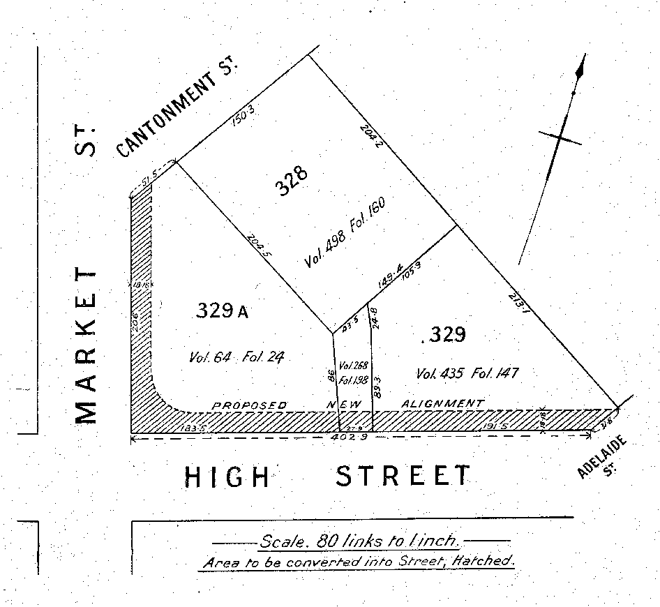

Second Schedule
[Section 4]
VOTING PAPER
Fremantle Improvement Act 1913
MUNICIPAL DISTRICT OF FREMANTLE
Directions to Voter — The voter shall indicate his vote as follows: — If he approves of the acquisition of the lands by the Council, he shall made a cross in the square opposite the word “Yes.” If he disapproves of the acquisition of such lands, he shall make a cross in the square opposite the word “No.”
Question — Do you approve of the acquisition by the Municipality of Fremantle of the lands mentioned and described in the Fremantle Improvement Act 1913?
YES
NO

Notes
¹ This is a compilation of the Fremantle Improvement Act 1913 and includes all amendments effected by the other Acts referred to in the following Table.

Compilation table
Short title | Number and year | Assent | Commencement
Fremantle Improvement Act 1913 | 23 of 1913 | 30 Dec 1913 | 30 Dec 1913
² Plans formerly deposited in the Office of Titles are now being held by the Western Australian Land Information Authority (see the Land Information Authority Act 2006 s. 100).

