Western Australia
Perth Theatre Trust Act 1979

Perth Theatre Trust (Common Seal) Regulations 1980

Western Australia
Perth Theatre Trust (Common Seal) Regulations 1980
Contents
1. Citation 1
2. Form of common seal 1
3. Safe custody of common seal 1
Schedule
Form of common seal of Trust
Notes
Compilation table 3

Western Australia
Perth Theatre Trust Act 1979
Perth Theatre Trust (Common Seal) Regulations 1980

1. Citation
These regulations may be cited as the Perth Theatre Trust (Common Seal) Regulations 1980 ¹.

2. Form of common seal
The form of the common seal of the Trust is the form set out in the Schedule.

3. Safe custody of common seal
The manager or, in his absence, the person appointed to act in his stead shall keep the common seal of the Trust in safe custody.

Schedule
(Regulation 2)

Form of common seal of Trust
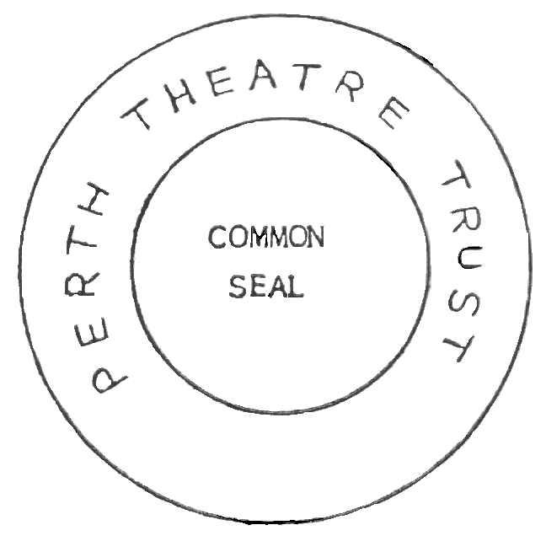

Notes
¹ This is a reprint as at 7 May 2004 of the Perth Theatre Trust (Common Seal) Regulations 1980. The following table contains information about those regulations and any reprint.

Compilation table
Citation | Gazettal | Commencement
Perth Theatre Trust (Common Seal) Regulations 1980 | 1 Feb 1980 p. 340 | 1 Feb 1980 (see Gazette 1 Feb 1980 p. 285)
Reprint 1: The Perth Theatre Trust (Common Seal) Regulations 1980 as at 7 May 2004

