Western Australia

Noise Abatement (Noise Labelling of Equipment) Regulations (No. 2) 1985
Compare between:
[05 Nov 2004, 01-a0-07] and [08 Jan 2015, 01-b0-01]

Western Australia
Environmental Protection Act 1986 ²
Noise Abatement (Noise Labelling of Equipment) Regulations (No. 2) 1985

1. Citation
These regulations may be cited as the Noise Abatement (Noise Labelling of Equipment) Regulations (No. 2) 1985 ¹.

2. Interpretation
In these regulations unless the contrary intention appears —
acoustic output descriptor means the quantity obtained when the test procedure specified in paragraph (b) of the appropriate item in Schedule 3 is used;
equipment means an item of equipment described in Schedule 1.

3. Equipment to be labelled
A person shall not sell, supply or offer for sale, equipment —
(a) the manufacture of which is completed; or
(b) which is imported into the State for the purpose of sale,
on or after a date specified in Schedule 2 for that equipment and which has not been sold or which has been sold but only for the purpose of resale, unless there is securely affixed to it in a conspicuous position, a durable label which —
(c) accords with the label description;
(d) displays the required acoustic output descriptor level which will not be exceeded by the unit when tested in accordance with paragraph (b),
of the item relating to that equipment in Schedule 3.

4. Label to be correct
A person shall not attach a label to any equipment in accordance with these regulations, unless the information on that label is correct in relation to that piece of equipment.

5. Equipment not to be altered
A person shall not alter a piece of equipment which has affixed to it a label in accordance with these regulations, so that the sound level of the equipment exceeds the labelled level of the appropriate acoustic output descriptor.

6. Inspection of equipment
Where an inspector requests to inspect a piece of equipment, or to be supplied with information relating to a piece of equipment, or both, a person shall produce the equipment for inspection, forthwith, and supply any relevant information, in writing, within 14 days of the request.
[7. Omitted under the Reprints Act 1984 s. 7(4)(f).]

Schedule 1

Equipment
1. “Mobile Air Compressor” — any air compressor not permanently fixed in a certain location and capable of being registered under the Road Traffic Act 1974 as a trailer or vehicle for movement on public roads.
2. “Pavement Breaker” — An air-powered device capable of being manually lifted and manoeuvred by a single operator for the purpose of breaking up rock, concrete and other similar substances, and usually attached by a flexible hose to a mobile compressor.
3. “Air-conditioner” — A split or packaged mechanical system that has a cooling capacity of less then 12 kW as determined by Australian Standard 1861-1981 that is designed to control air temperature and distribution and that may also be capable of controlling the humidity and cleanliness of air but does not include evaporative type or heating only mechanical systems.
[Schedule 1 amended in Gazette 27 Mar 1986 p. 1305.]

Schedule 2

Implementation dates
1. Mobile Air Compressor — 19 July 1985.
2. Pavement Breaker — 19 July 1985.
3. Air Conditioner — 1 April 1986.
[Schedule 2 amended in Gazette 27 Mar 1986 p. 1305.]

Schedule 3

Acoustic output descriptors and labels

1. Mobile Air Compressor —
(a) The Mean Sound Level of the unit as defined in Australian Standard AS 2221 Part 1 1979 — Engineering Method for Measurement of Airborne Sound Emitted by Compressor/Primemover Units Intended for Outdoor Use shall be displayed on a label —
(i) with dimensions 9 cm x 10 cm;
(ii) having a permanent clearly visible black legend on a white background; and
(iii) with a format, lettering and numbering which shall approximate the relative scale of the format, lettering and numbering size given in the following example —
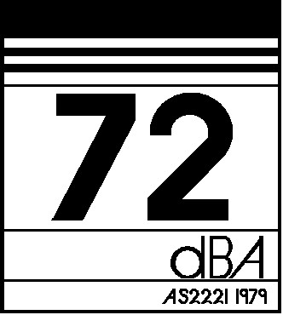
(b) Mean Sound Level — The test procedure to establish the Mean Sound Level shall be in accordance with AS 2221 Part 1 1979 —Engineering Method for Measurement of Airborne Sound Emitted by Compressor/Primemover Units Intended for Outdoor Use.

2. Pavement Breaker —
(a) The Mean Sound Level of the unit as defined in Australian Standard AS 2221 Part 2 1979 — Engineering Method of Measurement of Airborne Sound Emitted by Pneumatic Tools and Machines shall be displayed on a label —
(i) with dimensions 3 cm x 3.5 cm;
(ii) having a permanent clearly visible black legend on a white background; and
(iii) with a format, lettering and numbering which shall approximate the relative scale of the format, lettering and numbering size given in the following example —
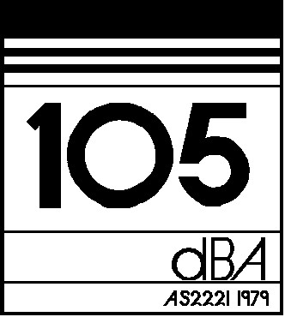
(b) Mean Sound Level — the test procedure to establish the Mean Sound Level shall be in accordance with AS 2221 Part 2 1979 — Engineering Method of Measurement of Airborne Sound Emitted by Pneumatic Tools and Machines.

3. Air-conditioner —
(a) The A-weighted outside sound power level of the unit shall be displayed on a label —
(i) with dimensions 6 cm x 10 cm;
(ii) having a permanent clearly visible black legend on a white or polished metal background; and
(iii) with a format, lettering and numbering which shall approximate the relative scale of the format, lettering and numbering size (with the sound power level displayed in figures at least 1 cm high) given in the following example —
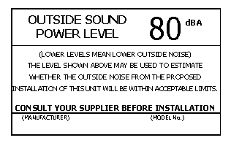
(b) A-weighted Outside Sound Power Level — The A-weighted Outside Sound Power Level shall be determined in accordance with a method approved by the chief executive officer 3.
[Schedule 3 amended in Gazette 27 Mar 1986 p. 1305-6.]

Notes
¹ This is a compilation of the Noise Abatement (Noise Labelling of Equipment) Regulations (No. 2) 1985 and includes the amendments made by the other written laws referred to in the following table ^{1a}. The table also contains information about any reprint.

Compilation table
Citation | Gazettal | Commencement
Noise Abatement (Noise Labelling of Equipment) Regulations (No. 2) 1985 | 19 Jul 1985 p. 2549-51 | 19 Jul 1985
Noise Abatement (Noise Labelling of Equipment) Amendment Regulations 1986 | 27 Mar 1986 p. 1305-6 | 27 Mar 1986
Reprint 1: The Noise Abatement (Noise Labelling of Equipment) Regulations (No. 2) 1985 as at 5 Nov 2004 (includes amendments listed above)
^{1a} On the date as at which this compilation was prepared, provisions referred to in the following table had not come into operation and were therefore not included in this compilation. For the text of the provisions see the endnotes referred to in the table.

Provisions that have not come into operation
Citation | Gazettal | Commencement
Noise Abatement (Noise Labelling of Equipment) Amendment Regulations 2014 r. 3 and 4 ⁴ | 8 Jan 2015 p. 105-6 | Operative on the day fixed under the Road Traffic (Administration) Act 2008 s. 2(b) (see r. 2(b))
² These regulations were originally made under the Noise Abatement Act 1972.
The Environmental Protection Act 1986 Sch. 4 cl. 16 deems these regulations to have been made under that Act. They may be repealed or amended accordingly.
³ Under the Acts Amendment (Public Service) Act 1987 s. 31(1)(f) a reference in a written law to “Permanent Head” is, unless the contrary intention appears, to be construed as if it had been amended to be a reference to the chief executive officer. This reference was amended under the Reprints Act 1984 s. 7(5)(a).
⁴ On the date as at which this compilation was prepared, the Noise Abatement (Noise Labelling of Equipment) Amendment Regulations 2014 r. 3 and 4 had not come into operation. They read as follows:

3. Regulations amended
These regulations amend the Noise Abatement (Noise Labelling of Equipment) Regulations (No. 2) 1985.
4. Schedule 1 amended
In Schedule 1 item 1 delete “registered under the Road Traffic Act 1974 as a trailer or vehicle for movement on public roads.” and insert:

licensed under the Road Traffic (Vehicles) Act 2012 Part 2 as a vehicle that can be used on a road as defined in the Road Traffic (Administration) Act 2008 section 4.

