Western Australia
PIG INDUSTRY COMPENSATION ACT 1942

Pig Industry Compensation Regulations 1943
These regulations were repealed by the Pig, Potato and Poultry Industries (Compensation Legislation) Repeal Act 2004 s. 3 (No. 40 of 2004) as at 1 Feb 2005 (see s. 2 and Gazette 7 Jan 2005 p. 53)

Reprinted under the Reprints Act 1984 as
at 1 February 2005
Western Australia
Pig Industry Compensation Regulations 1943
Contents
1. Citation 1
2. Form of application for compensation 1
4. Time for application for compensation 1
5. Amount of compensation 2
6. Prescribed diseases 2
Schedule A
Notes
Compilation table 5

Reprinted under the Reprints Act 1984 as
at 1 February 2005
Western Australia
PIG INDUSTRY COMPENSATION ACT 1942
Pig Industry Compensation Regulations 1943

1. Citation
These regulations may be cited as the Pig Industry Compensation Regulations 1943.

2. Form of application for compensation
The form of application for compensation under the Pig Industry Compensation Act 1942 for the destruction or death of a pig or the condemnation of a carcass or portion of a carcass by the order of the Chief Veterinary Surgeon or other approved person, and the certificate to accompany the same shall be in the form of Schedule A.
[Regulation 2 inserted in Gazette 5 October 1973 p.3702.]

[3. Regulation 3 repealed in Gazette 5 October 1973 p.3702.]

4. Time for application for compensation
Applications for compensation shall be lodged with the Chief Veterinary Surgeon, Department of Agriculture, Baron-Hay Court, South Perth, within 30 days after —
(a) the destruction or death of the pig; or
(b) the condemnation of the carcass or portion of a carcass,
as the case may be.
[Regulation 4 amended in Gazettes 21 June 1972 p.2025; 5 October 1973 p.3702.]

5. Amount of compensation
The amount of compensation payable in respect of any diseased carcass or portion of a diseased carcass condemned as unfit for human consumption because of disease is, for each kilogram or portion thereof —
(a) where the weight of the carcass does not exceed 50 kg — 173 cents per kg;
(b) where the weight of the carcass exceeds 50 kg but does not exceed 70 kg — 172 cents per kg;
(c) where the weight of the carcass exceeds 70 kg but does not exceed 90 kg — 166 cents per kg;
(d) where the weight of the carcass exceeds 90 kg — 85 cents per kg.
[Regulation 5 inserted in Gazette 12 May 1978 p.1518; amended in Gazettes 4 September 1981 p.3891; 19 March 1982 p.946; 10 September 1982 p.3673; 25 February 1983 p.734; 9 September 1983 p.3343; 30 March 1984 p.911; 17 August 1984 p.2488; 1 March 1985 p.849; 6 September 1985 p.3497; 3 October 1986 p.3797; 20 March 1987 pp.985-86; 30 October 1987 p.4050; 10 June 1988 p.1937.]

6. Prescribed diseases
The diseases Swine Dysentery and Polyarthritis are hereby prescribed as diseases for the purposes of Part II of the Act.
[Regulation 6 inserted in Gazette 5 February 1971 p.365; amended in Gazette 20 February 1987 p.476.]

Schedule A
Western Australia
PIG INDUSTRY COMPENSATION ACT
NOTICE: APPLICATIONS MUST BE FORWARDED SO AS TO REACH THE AGRICULTURE DEPARTMENT, BARON-HAY COURT, SOUTH PERTH WITHIN 30 DAYS OF THE DEATH OR SLAUGHTER OF THE PIGS, OR THE CONDEMNATION OF THE CARCASS.
APPLICATION FOR COMPENSATION IN RESPECT OF CONDEMNED ANIMALS/CARCASSES
To: CHIEF VETERINARY SURGEON,
DEPARTMENT OF AGRICULTURE, BARON-HAY COURT,
SOUTH PERTH 6151.
Please accept this application for payment of compensation under the Pig Industry Compensation Act 1942, in respect to the items detailed in the schedule overleaf, for: —
* (1) Pigs dead or destroyed pursuant to an order because they were suffering from or suspected to be suffering from disease.
(2) A carcass or a portion of a carcass condemned as unfit for human consumption because of disease.
* (Strike out whichever does not apply.)
I certify that —
(a) I am the sole owner of the swine referred to in this claim or
(b) I am the authorized agent of. . . . . . . . . . . . . of. . . . . . . . . . . . . . . the owner of the animals/carcasses referred to in this claim.
(c) The owner of the animals/carcasses referred to in this claim is not indebted to the Government of Western Australia.
(d) The statements made by me within this application are correct.
Signature of Claimant . . . . . . . . . . . . . . . . . . . . . . . .
(Block letters) Name. . . . . . . . . . . . . . . . . . . . . . . . .
Address. . . . . . . . . . . . . . . . . . . . . . . . . . . . . . . . . . . .
Date. . . . . . . . . . . . . . . . . . . . . . .
CERTIFICATION BY PERSON MAKING CONDEMNATION
I hereby certify that details listed under date and particulars overleaf are correct.
Date. . . . . . . . . . . . . . . . . . . . . . . . . . . . . . . . . . . . . . . . . . . . . . . . . . . . . . . .
Veterinary Surgeon, Meat Inspector or Stock Inspector.
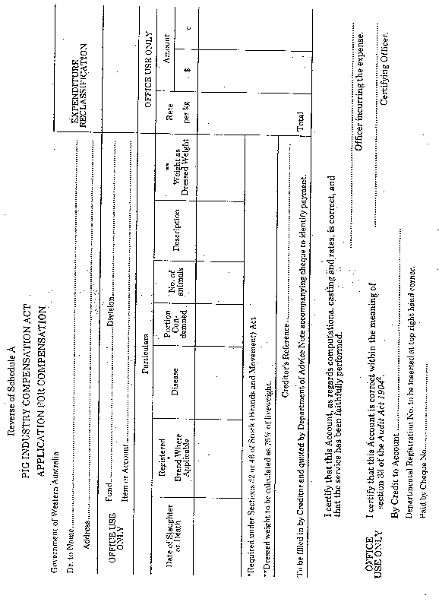
[Schedule A and Schedule B: Schedule A and Schedule B repealed and Schedule A inserted in Gazette 5 October 1973 pp.3702-3.]

Notes
^{1.} This is a compilation of the Pig Industry Compensation Regulations 1943 and includes the amendments referred to in the following Table.

Compilation table
Citation | Gazettal | Commencement
Pig Industry Compensation Regulations 1943 | 14 May 1943 pp.479-81 | 14 May 1943
Amending regulations | 4 Apr 1952  p.822 | 4 Apr 1952
Amending regulations | 28 May 1957  p.1564 | 28 May 1957
Amending regulations | 9 Feb 1970 p.415 | 9 Feb 1970
Amending regulations | 1 Dec 1970 p.3698 | 1 Dec 1970
Amending regulations | 5 Feb 1971 p.365 | 5 Feb 1971
Amending regulations | 25 Jan 1972 pp.164-5 | 25 Jan 1972
Amending regulations | 21 Jun 1972  p.2025 | 21 Jun 1972
Amending regulations | 5 Oct 1973 p.3702 | 5 Oct 1973
Amending regulations | 31 Jan 1975 p.314 | 31 Jan 1975
Amending regulations | 27 Jun 1975  p.2157 | 27 Jun 1975
Amending regulations | 12 May 1978  p.1518 | 12 May 1978
Pig Industry Compensation Amendment Regulations 1981 | 4 Sep 1981 p.3891 | 4 Sep 1981
Pig Industry Compensation Amendment Regulations 1982 | 19 Mar 1982 p.946 | 19 Mar 1982
Pig Industry Compensation Amendment Regulations (No. 2) 1982 | 10 Sep 1982 p.3673 | 10 Sep 1982
Pig Industry Compensation Amendment Regulations 1983 | 25 Feb 1983 p.734 | 25 Feb 1983
Pig Industry Compensation Amendment Regulations (No. 2) 1983 | 9 Sep 1983 p.3343 | 9 Sep 1983
Pig Industry Compensation Amendment Regulations 1984 | 30 Mar 1984 p.911 | 30 Mar 1984
Pig Industry Compensation Amendment Regulations (No. 2) 1984 | 17 Aug 1984 p.2488 | 17 Aug 1984
Pig Industry Compensation Amendment Regulations 1985 | 1 Mar 1985  p.849 | 1 Mar 1985
Pig Industry Compensation Amendment Regulations 1985 | 6 Sep 1985 p.3497 | 6 Sep 1985
Pig Industry Compensation Amendment Regulations 1986 | 3 Oct 1986 p.3797 | 3 Oct 1986
Pig Industry Compensation Amendment Regulations 1987 | 20 Feb 1987 p.476 | 20 Feb 1987
Pig Industry Compensation Amendment Regulations 1987 | 20 Mar 1987 pp.985-6 | 20 Mar 1987
Pig Industry Compensation Amendment Regulations (No. 3) 1987 | 30 Oct 1987 p.4050 | 30 Oct 1987
Pig Industry Compensation Amendment Regulations 1988 | 10 Jun 1988  p.1937 | 10 Jun 1988
These regulations were repealed by the Pig, Potato and Poultry Industries (Compensation Legislation) Repeal Act 2004 s. 3 (No. 40 of 2004) as at 1 Feb 2005 (see s. 2 and Gazette 7 Jan 2005 p. 53
² Now see the Financial and Administration Act 1985

