Western Australia

Pilbara Energy Project Agreement (Termination) Act 2014

Western Australia
Pilbara Energy Project Agreement (Termination) Act 2014
Contents
-1. Short title 2
2. Commencement 2
3. Act amended 2
4. Long title amended 2
5. Section 3 amended 2
6. Section 5 inserted 3
5. Ratification and operation of termination agreement 3
7. Schedule 2 inserted 3
Schedule 2 — Termination agreement

Western Australia
Pilbara Energy Project Agreement (Termination) Act 2014
No. 3 of 2014
An Act to amend the Pilbara Energy Project Agreement Act 1994 to provide for the ratification of an agreement for the termination of the Pilbara Energy Project Agreement and for related purposes.
[Assented to 25 March 2014]
The Parliament of Western Australia enacts as follows:

1. Short title
This is the Pilbara Energy Project Agreement (Termination) Act 2014.

2. Commencement
This Act comes into operation as follows —
(a) sections 1 and 2 — on the day on which this Act receives the Royal Assent;
(b) the rest of the Act — on the day after that day.

3. Act amended
This Act amends the Pilbara Energy Project Agreement Act 1994.

4. Long title amended
In the long title delete “works.” and insert:

works and to ratify a further agreement for the termination of that agreement.

5. Section 3 amended
In section 3 insert in alphabetical order:

termination agreement means the agreement a copy of which is set out in Schedule 2;

6. Section 5 inserted
After section 4 insert:

5. Ratification and operation of termination agreement
(1) The termination agreement is ratified.
(2) Without limiting or otherwise affecting the operation of the Government Agreements Act 1979, the termination agreement is to operate and take effect despite any other Act or law.

7. Schedule 2 inserted
After Schedule 1 insert:

Schedule 2 — Termination agreement
[s. 3]
2013

THE STATE OF WESTERN AUSTRALIA

and

ALINTA DEWAH PTY LTD
ACN 083 051 950

ALINTA DEWAP PTY LTD
ACN 058 070 689

PILBARA ENERGY PROJECT AGREEMENT 1993
TERMINATION AGREEMENT

[Solicitor’s details]
THIS AGREEMENT is made this 8th day of NOVEMBER 2013

BETWEEN

THE HONOURABLE COLIN JAMES BARNETT, MEc., M.L.A., Premier of the State of Western Australia, acting for and on behalf of the said State and its instrumentalities from time to time (hereinafter called “the State”) of the first part,

ALINTA DEWAH PTY LTD ACN 083 051 950 of Level 13, 1 William Street, Perth, Western Australia and ALINTA DEWAP PTY LTD ACN 058 070 689 of Level 13, 1 William Street, Perth, Western Australia (hereinafter called "Joint Venturers" in which term shall be included their successors and permitted assigns) of the second part.

WHEREAS:

A. The State and the Joint Venturers are the parties to the agreement dated 30 November 1993, which agreement was ratified by the Pilbara Energy Project Agreement Act 1994 (WA), as varied by agreements dated 7 June 1994, 16 October 1995 and 31 March 1998. The first mentioned agreement as so varied is referred to in this Agreement as "the Principal Agreement".
B. The State and the Joint Venturers wish to terminate the Principal Agreement in the manner and on the terms set out in this Agreement.

NOW THIS AGREEMENT WITNESSES:
1. Definitions
In this Agreement subject to the context:
"Deed of Assignment and Covenant 1999" means the document entitled "Deed of Assignment, Covenant and Acknowledgment in relation to the Pilbara Energy Project State Agreement" dated 4 February 1999 between the State, the PEPA Minister, Duke Energy WA Holdings Pty Ltd (now known as Alinta DEWAH Pty Ltd), BHP Minerals Pty Ltd, Duke Energy WA Power Pty Ltd (now known as Alinta DEWAP Pty Ltd) and Duke Energy Australian Holdings Pty Ltd (now known as Alinta EH Pty Ltd);
"EP Act" means the Environmental Protection Act 1986 (WA);
"Iron Ore Beneficiation Termination Agreement" means the agreement ratified by and scheduled within Part 7 of the Iron Ore Agreements Legislation (Amendment, Termination and Repeals) Act 2011 (WA);
"Land Act Minister" means the Minister for Lands, a body corporate under section 7 of the Land Administration Act;
"Land Administration Act" means the Land Administration Act 1997 (WA);
"laws relating to native title" means laws applicable from time to time in Western Australia in respect of native title and includes the Native Title Act 1993 (Cth);
"Mining Act" means the Mining Act 1978 (WA);
"Minister" means the Minister in the Government of the State for the time being responsible for the administration of the Act to ratify this Agreement and pending the passing of that Act means the Minister for the time being designated in a notice from the State to the Joint Venturers and includes the successors in office of the Minister;
"Minister for Mines" means the Minister in the Government of the State for the time being responsible for the administration of the Mining Act;
"Newman Facilities" means the power station facilities constructed under or pursuant to the Principal Agreement at Newman comprising:
(a) the turbines;
(b) the electrical switchyard, including associated on-site electrical feeders;
(c) the gas receival facility;
(d) the diesel unloading and forwarding pumps and associated diesel storage tanks;
(e) the oily water treatment system and associated evaporation pond; and
(f) associated plant, equipment and infrastructure, including gas distribution infrastructure,
each at the date of this Agreement located upon Mineral Lease 244SA and contained within the boundaries of the area shown in Plan D of Schedule A;
"Operative Date" has the meaning given in clause 3(2);
"PEPA Minister" means the Minister in the Government of the State for the time being responsible for the administration of the Principal Agreement;
"PEPA Titles" means the following titles granted pursuant to the Principal Agreement and continuing as at the Operative Date:
(a) Crown lease L371264 in respect of the Port Hedland power station; and
(b) any Crown easement granted in respect of the Port Hedland Transmission Lines;
"Port Hedland Facilities" means the power station facilities constructed under or pursuant to the Principal Agreement:
(a) at Port Hedland, comprising;
(i) the Port Hedland power station, at the date of this Agreement on land the subject of lot 255 on deposited plan 192056 contained within Crown land volume 3104 folio 330 and being land the subject of Crown lease L371264 in favour of the Joint Venturers, comprising:
(A) the turbines;
(B) the electrical switchyard, including associated on-site electrical feeders;
(C) the gas receival facility;
(D) the diesel unloading and forwarding pumps and associated diesel storage tanks;
(E) the oily water treatment system and associated evaporation pond; and
(F) associated plant, equipment and infrastructure, including gas distribution infrastructure,
("Port Hedland power station") and contained within the boundaries of the area shown in Plan A of Schedule A;
(ii) the 66kV transmission line from the Port Hedland power station to Boodarie on the area the subject of the proposed easement shown in deposited plans 30122, 32820, 33649 and 400582;
(iii) the 66kV transmission line from the Port Hedland power station to the Wedgefield substation on the area the subject of the proposed easement shown in deposited plans 219101 and 400582; and
(iv) the 66kV transmission line from the Port Hedland power station to the Murdoch Drive substation on the area the subject of the proposed easement shown in deposited plans 219101 and 400582;
(together, "Port Hedland Transmission Lines") and contained within the boundaries of the area shown in Plan B of Schedule A; and
(b) at Boodarie near Port Hedland, comprising:
(i) the turbines;
(ii) the electrical switchyard, including associated on-site electrical feeders;
(iii) the gas receival facility; and
(iv) associated plant, equipment and infrastructure, including gas distribution infrastructure;
located at the date of this Agreement upon General Purpose Leases 45/78, 45/79, 45/89, 45/90, and 45/102 and contained within the boundaries of the areas shown in Plan C of Schedule A ("Boodarie power station"); and
(v) the underground electrical feeders connecting the turbines referred to in paragraph (b)(i) above with the electrical switchyard referred to in paragraph (b)(ii) above as shown in Plan B of Schedule A;
"this Agreement", "hereof" and "hereunder" refer to this Agreement, whether in its original form or as from time to time added to, varied or amended.
2. Interpretation
(1) In this Agreement:
(a) clause headings do not affect interpretation or construction;
(b) words in the singular shall include the plural and words in the plural shall include the singular according to the requirements of the context;
(c) one gender includes the other genders;
(d) a covenant or agreement by more than one person binds, and is enforceable against, those persons jointly and each of them severally;
(e) reference to an Act includes the amendments to that Act for the time being in force and also any Act passed in substitution therefor or in lieu thereof and the regulations for the time being in force thereunder;
(f) reference in this Agreement to any other document includes that document as from time to time added to, varied or amended and notwithstanding any change in the identity of the parties;
(g) reference to a clause or schedule is a reference to a clause in or schedule to this Agreement, and a reference to a subclause or paragraph is a reference to the subclause of the clause or paragraph of the clause or subclause as the case may be in, or in relation to, which the reference is made;
(h) "including" means "including, but not limited to"; and
(i) reference to a "person" includes a body corporate.
(2) Nothing in this Agreement shall be construed to exempt the State or the Joint Venturers from compliance with or to require the State or the Joint Venturers to do anything contrary to any law relating to native title or any lawful obligation or requirement imposed on the State or the Joint Venturers as the case may be pursuant to any law relating to native title. The provisions of this Agreement shall not operate so as to require the State or the Land Act Minister to grant or vary, or cause to be granted or varied, any lease licence or other right or title until all processes necessary (if any) under any laws relating to native title to enable that grant or variation to proceed, have been completed.
(3) Nothing in this Agreement shall be construed to exempt the Joint Venturers from compliance with any requirement in connection with the protection of the environment arising out of or incidental to its activities under this Agreement that may be made by or under the EP Act.
3. Ratification and operation
(1) This Agreement, other than this clause and clauses 1 and 2, does not come into operation except in accordance with subclause (2).
(2) This Agreement, other than this clause and clauses 1 and 2, comes into operation on the day on which it is ratified by an Act of the Parliament of Western Australia ("Operative Date") unless, before that day, it terminates under subclauses (4) or (5).
(3) The State must introduce in the Parliament of Western Australia before 30 April 2014, or a later date agreed between the parties to this Agreement, a Bill to ratify this Agreement and must endeavour to secure its passage as an Act.
(4) If by 30 September 2014 this Agreement has not been ratified by an Act of the Parliament of Western Australia then, unless the parties to this Agreement otherwise agree, this Agreement terminates on that day and no party hereto will have any claim against any other party hereto with respect to any matter or thing arising out of, done, performed, or omitted to be done or performed under this Agreement.
(5) The parties agree that, if the Principal Agreement is otherwise determined in accordance with its provisions on a day prior to the Operative Date, then this Agreement shall also terminate on and from that day and no party hereto will have any claim against any other party hereto with respect to any matter or thing arising out of, done, performed, or omitted to be done or performed under this Agreement.
4. Termination of Principal Agreement
(1) Subject to subclause (2), the Principal Agreement is hereby terminated with effect on and from the Operative Date and, except as otherwise provided in this Agreement, neither the State nor the Joint Venturers shall have any claim against the other with respect to any matter or thing in or arising out of the Principal Agreement.
(2) Notwithstanding subclause (1):
(a) the Joint Venturers shall remain liable for any antecedent breach or default under the Principal Agreement and in respect of any indemnity given under the Principal Agreement; and
(b) clause 14 of the Principal Agreement shall be deemed to subsist in its application to the Port Hedland Facilities and the Newman Facilities respectively until the earlier of:
(i) the grant of electricity generation and electricity transmission licences or integrated regional licences under the Electricity Industry Act 2004 (WA) in relation to the Port Hedland Facilities and the Newman Facilities (as the case may be); or
(ii) the date that is 12 months after the Operative Date, or such later date agreed by the Minister (but not exceeding 15 months after the Operative Date).
(3) (a) Subject to subclause (2) and on and from the Operative Date:
(i) the Joint Venturers as the holders of the PEPA Titles, the Port Hedland Facilities and the Newman Facilities shall cease to have the benefit of any rights and privileges conferred by the Principal Agreement; and
(ii) each PEPA Title shall otherwise continue in force, subject to its terms and conditions and under and subject to the provisions of the Land Administration Act, for a period not exceeding 3 months after the Operative Date (or such greater period agreed by the Minister) pending the variation of its terms and conditions as contemplated by paragraph (b).
(b) The State acknowledges that the Joint Venturers intend to make application for the grant of titles and, having regard to paragraph (a), variation of the PEPA Titles under and in accordance with the Land Administration Act and subject to the interests and rights of third parties and the obligations of the State to third parties, and to the extent relevant having regard to clause 4(3)(e) of the Iron Ore Beneficiation Termination Agreement, for such periods and on such terms and conditions including commercial rentals and renewal rights as the Land Act Minister may consider reasonable having regard to the requirements of the Joint Venturers in respect of the Port Hedland Facilities and the Newman Facilities. As at the date of this Agreement, the parties anticipate the Joint Venturers making the applications described in column 2 of the table to Schedule B in respect of the grant or variation, on or after the Operative Date, of titles relating to the facilities described in column 1 of that table.
(c) The State further acknowledges that the Joint Venturers intend to make application for the grant of easements for the construction and operation of roads to access the Boodarie power station and the Newman power station respectively under and in accordance with the Land Administration Act and subject to the interests and rights of third parties and the obligations of the State to third parties, and to the extent relevant having regard to clause 4(3)(e) of the Iron Ore Beneficiation Termination Agreement, for such periods and on such terms and conditions including commercial easement fees as the Land Act Minister may consider reasonable.
(d) If the registered holders of Mineral Lease 244SA and Crown lease K858923 surrender a portion of the land (including if such surrender is limited to depth) that is subject to those leases for the purpose of facilitating the grant to the Joint Venturers of a lease under section 79 of the Land Administration Act for the Newman Facilities as contemplated by paragraph (b) above, the State shall, notwithstanding the terms of section 19 of the Mining Act, cause the Minister for Mines to exempt that portion of the land from mining under that section for the term of that lease (including as renewed or extended).
(4) (a) On and from the Operative Date the Joint Venturers will indemnify and keep indemnified the State and its employees, agents and contractors in respect of all actions, suits, claims, demands or costs of third parties arising out of or in connection with any work carried out by the Joint Venturers pursuant to the Principal Agreement or relating to their operations under the Principal Agreement or arising out of or in connection with the construction, maintenance or use by the Joint Venturers or their employees, agents, contractors or assignees of the Joint Venturers' works or services the subject of the Principal Agreement or the plant, apparatus or equipment installed in connection with the Principal Agreement.
(b) The indemnity in paragraph (a) shall remain in force for a period ending on the date which is 20 years after:
(i) the date agreed between the State and the Joint Venturers; or
(ii) if the parties fail to agree a date under subparagraph (i), the date determined by the State,
as being the date of cessation of all operations (including as expanded or otherwise modified) originally established under and pursuant to the Principal Agreement (including the Port Hedland Facilities and the Newman Facilities).
(c) The Joint Venturers will indemnify and keep indemnified the State and its employees, agents and contractors in respect of all actions, suits, claims, demands or costs of third parties arising out of or in connection with any works or activities of the Joint Venturers or their employees, agents or contractors or assignees on and subsequent to the Operative Date relating to operations (including as expanded or otherwise modified) that were originally established under or pursuant to the Principal Agreement (including the Port Hedland Facilities and the Newman Facilities).
(d) The indemnity in paragraph (c) remains in force for a period ending on the same date as the indemnity in paragraph (a).
5. Release of State and PEPA Minister from Deed of Assignment and Covenant 1999
On and from the Operative Date, the Joint Venturers release the State and the PEPA Minister from any obligation, liability or claim relating to the acknowledgement and agreement of the State and the PEPA Minister set out in clause 6 of the Deed of Assignment and Covenant 1999.
6. Assignment
A Joint Venturer may only assign, mortgage or charge or otherwise dispose of its rights and obligations under this Agreement with the consent of the Minister and such consent may be given subject to conditions.
7. Applicable Law
This Agreement is to be interpreted according to the law for the time being in force in the State of Western Australia.

SCHEDULE A
PORT HEDLAND FACILITIES AND NEWMAN FACILITIES
Plan A
Port Hedland power station
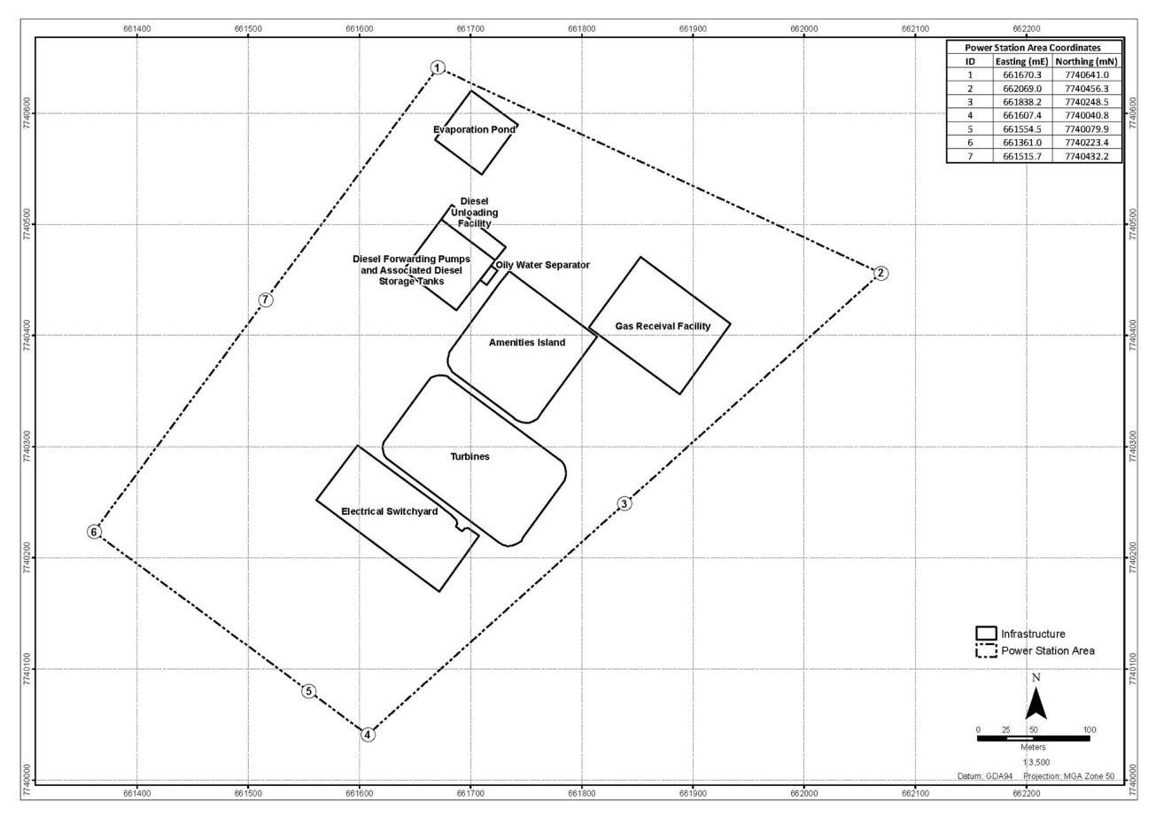

Plan B
Port Hedland Transmission Lines
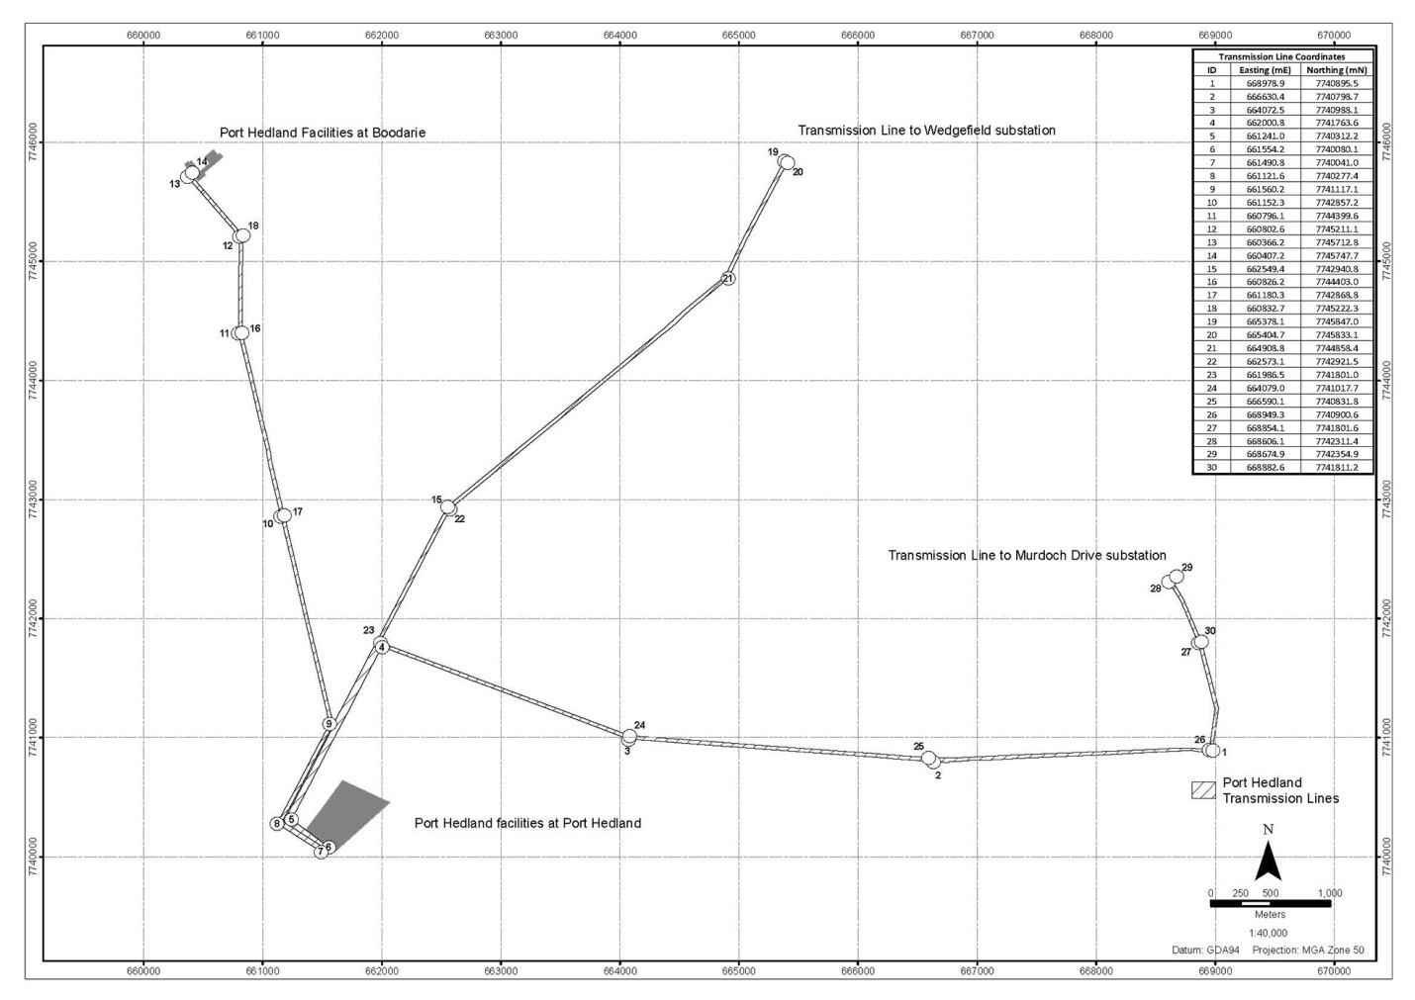

Plan C
Boodarie power station
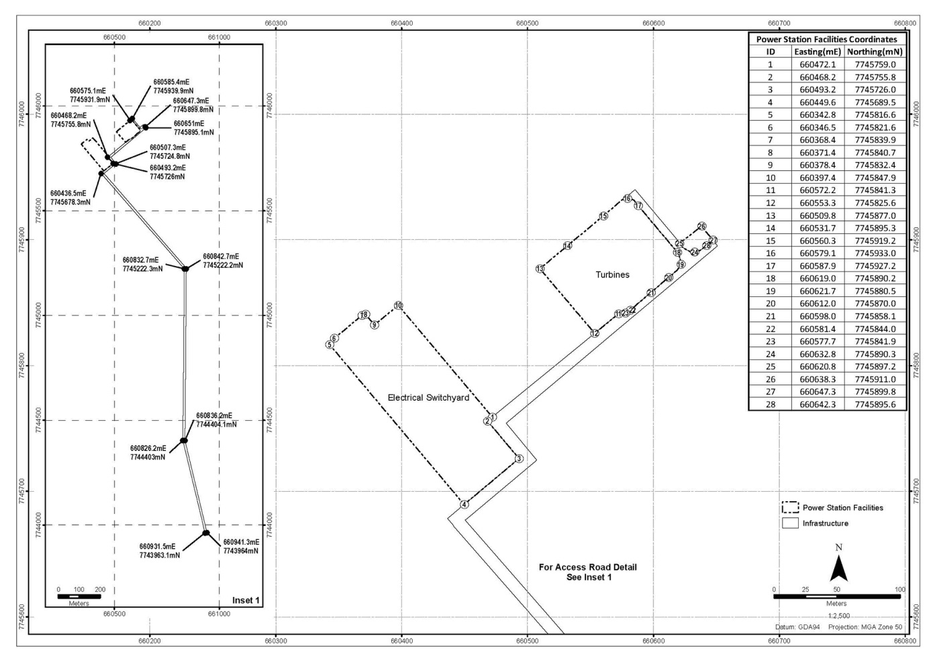

Plan D
Newman Facilities
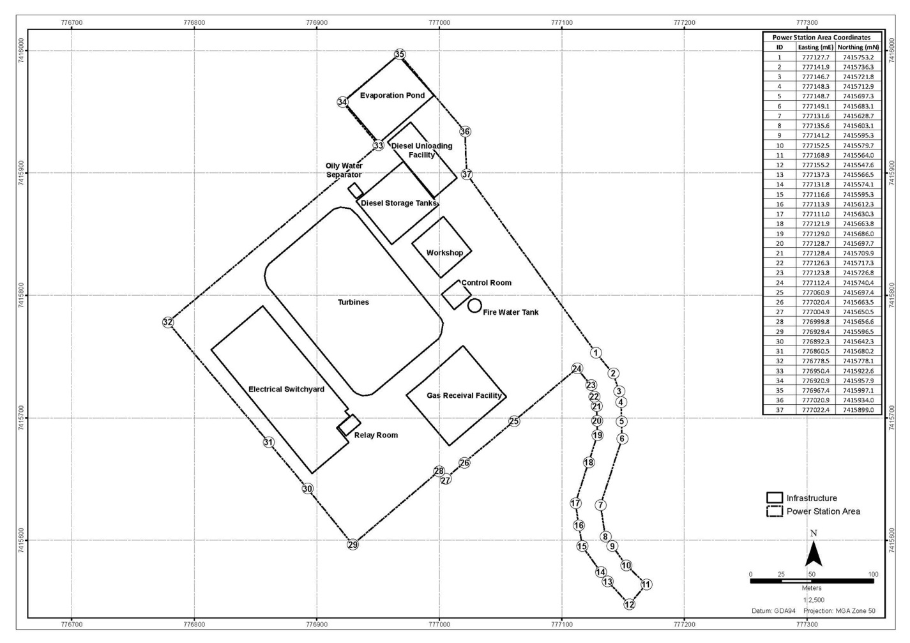

SCHEDULE B
ANTICIPATED TENURE FOR FACILITIES

Port Hedland Facilities | Tenure Application under Land Administration Act (and applicable section reference)
At Port Hedland
Port Hedland power station | Variation to Crown Lease (s79)
Port Hedland Transmission Lines | Crown Easement (s144) or Variation of Easement (s144) if any Crown easement is granted in respect of the Port Hedland Transmission Lines as at the Operative Date.
At Boodarie
Boodarie power station | Crown Lease (s79)
Newman Facilities
Newman power station | Crown Lease (s79)

EXECUTED as a deed.

SIGNED by THE HONOURABLE )
COLIN JAMES BARNETT ) [Signature]
in the presence of: )

[Signature]
Signature of witness

SCOTT FRY
Name of witness

EXECUTED by ALINTA DEWAH )
PTY LTD ACN 083 051 950 )
in accordance with section 127(1) of )
the Corporations Act )

[Signature] [Signature]
Signature of Director Signature of Secretary

KEN WOOLLEY MICHAEL RICHES
Full Name Full Name

EXECUTED by ALINTA DEWAP )
PTY LTD ACN 058 070 689 )
in accordance with section 127(1) of )
the Corporations Act )

[Signature] [Signature]
Signature of Director Signature of Secretary

KEN WOOLLEY MICHAEL RICHES
Full Name Full Name

