Western Australia
Health Act 1911

Emergency Provisions (Ammonia Unloading) Regulations 1989
These regulations ceased on 31 Dec 1989 (see r. 2).

Western Australia
Emergency Provisions (Ammonia Unloading) Regulations 1989
Contents
1. Citation 1
2. Duration 1
3. Interpretation 1
4. Authorized officers 2
5. Executive Director. Public Health may declare exclusion zone to be a prohibited place 2
6. Authorized persons only to be present in exclusion zone while it is a prohibited place 3
7. Direction, prohibition or order of authorized officers to be obeyed in exclusion zone while it is a prohibited place 3
8. Directions, prohibitions and orders 4
9. Limited compensation available 4
10. Penalties 5
The Schedule
Notes
Compilation table 7
Defined terms

Western Australia
Health Act 1911
Emergency Provisions (Ammonia Unloading) Regulations 1989

1. Citation
These regulations may be cited as the Emergency Provisions (Ammonia Unloading) Regulations 1989.

2. Duration
These regulations shall come into operation on the date of publication in the Gazette and shall continue in operation only until 31 December 1989.

3. Interpretation
In these regulations —
ammonia unloading means the unloading of ammonia at the Kwinana Bulk Handling Jetty located within the Port of Fremantle, as defined in the Fremantle Port Authority Act 1902;
authorized officer means an authorized officer as referred to in regulation 4 (1);
exclusion zone means that area of the State shown hatched with double lines on the plan "Annex C" annexed to the document titled "Public Access Control During Ammonia Importation via the Kwinana Bulk Cargo Jetty—Total Exclusion Plan" held by the Health Department of Western Australia at 189 Royal Street, East Perth, a copy of which is reproduced in the Schedule.

4. Authorized officers
(1) The following persons are authorized officers for the purposes of these regulations —
(a) the Executive Director, Public Health;
(b) any health surveyor or medical officer of health within the meaning of the Act;
(c) any member of the Police Force of any State or of the Commonwealth;
(d) any officer who is specifically designated as being an authorized officer by ' the Executive Director, Public Health for the purpose of these regulations and any person acting in the place of such an officer; and
(e) any member of the State Emergency Service or other body authorized under this paragraph by the Executive Director, Public Health.
(2) An authorized officer may —
(a) without notice or warrant enter and search any premises for the purpose of searching for persons present in the exclusion zone in contravention of these regulations, or to determine if ammonia is present;
(b) prevent, or cause to be prevented, by force if necessary, any person from entering the exclusion zone in contravention of these regulations;
(c) remove, or cause the removal of, by force if necessary, any person found in the exclusion zone in contravention of these regulations; and
(d) give a direction, prohibition or order under regulation 8.

5. Executive Director. Public Health may declare exclusion zone to be a prohibited place
(1) Where the Executive Director, Public Health is of the opinion that ammonia unloading that may constitute a hazard to the health of persons in the State is taking place or is due to take place he shall, in writing, declare the exclusion zone to be a prohibited place for the period of time specified in that declaration.
(2) The Executive Director may, in the declaration made under subregulation (1), provide that persons specified or described in the declaration may remain in or enter the exclusion zone while it is a prohibited place.

6. Authorized persons only to be present in exclusion zone while it is a prohibited place
(1) For the period of time that the exclusion zone is declared under regulation 5 to be a prohibited place no person shall be present in, or enter, that zone other than —
(a) a person specified or described in the declaration under regulation 5;
(b) a person authorized to enter or be present in the zone by the Executive Director, Public Health; and
(c) an authorized officer.
(2) A person who contravenes, or who causes, permits or suffers another person to contravene subregulation (1) commits an offence.

7. Direction, prohibition or order of authorized officers to be obeyed in exclusion zone while it is a prohibited place
Every person in the exclusion zone while it is declared under regulation 5 to be a prohibited place shall comply with every direction, prohibition or order directed to him given by an authorized officer under regulation 8 and a person who fails to do so —
(a) may be removed from the exclusion zone by or under the direction of an authorized officer; and
(b) commits an offence.

8. Directions, prohibitions and orders
(1) A direction, prohibition or order may be given by an authorized officer and —
(a) may be made so as to operate for any period or at any time specified therein but not so as to operate for longer than the duration of these regulations;
(b) may be of general operation or of limited operation according to circumstance, conditions or restrictions;
(c) may be written or oral;
(d) may be addressed or directed to any particular person or persons or to any body or association of persons or to persons generally; and
(e) may be brought to the notice of the person or persons to whom it is directed by publication or advertisement in any news media, by appropriate signs or by such other means as appear to the Executive Director, Public Health to be practicable, effectual, and appropriate or expedient in the circumstances.
(2) The expiry or revocation of any direction, prohibition or order under these regulations shall not be taken to have affected the previous operation thereof or the validity of any action taken thereunder or any penalty or punishment incurred in respect of a failure to comply therewith or any proceeding or remedy in respect of any such penalty or punishment.

9. Limited compensation available
(1) A person or body shall not be entitled to compensation from the Crown, any Minister of the Crown, the Executive Director, Public Health, or any person who at the material time acted under the direction or authority of a Minister of the Crown or the Executive Director, Public Health, on account of monetary loss suffered by that person or body by reason of a direction, prohibition or order under these regulations or by reason of complying with such a direction, prohibition or order directed to him or it.
(2) No person or body, including the Crown, shall incur any liability at law on account of anything done without negligence that is —
(a) authorized to be done under these regulations, or a direction, order or authority given under these regulations; or
(b) done in good faith in a belief, on reasonable grounds, that it was authorized to be done.

10. Penalties
The penalty for an offence against these regulations is —
(a) for a first offence, $100;
(b) for a second offence,-$200; and
(c) for a third or subsequent offence, $500.

The Schedule
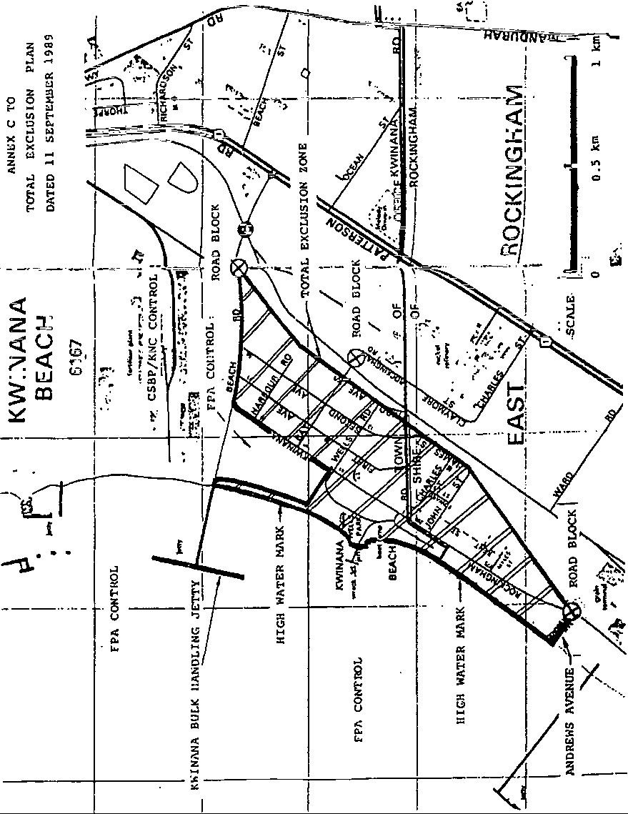

Notes
¹ This is a compilation of the Emergency Provisions (Ammonia Unloading) Regulations 1989 and includes the amendments made by the other written laws referred to in the following table.

Compilation table
Citation | Gazettal | Commencement
Emergency Provisions (Ammonia Unloading) Regulations 1989 | 19 Sep 1989 p. 3447-52 | 19 Sep 1989 (see r. 2)
These regulations ceased on 31 Dec 1989 (see r. 2)

Defined terms

[This is a list of terms defined and the provisions where they are defined. The list is not part of the law.]
Defined term Provision(s)
ammonia unloading 3
authorized officer 3
exclusion zone 3

